Ted Pascua

Final Project

CMPS 371 - Computer Graphics

Boat On Water Waves Simulation

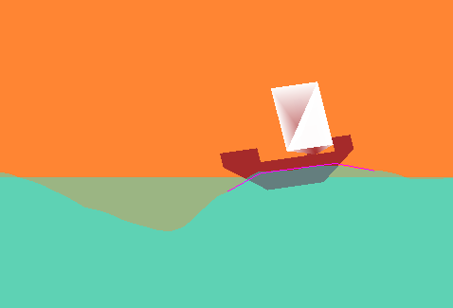

## Summary

My final project is on simulating a boat floating on moving water waves.

The goals were to make:

1. Water Waves
2. Boat interaction with Water Waves
3. Aesthetic Effect

The plan was to get springs codding from homework 4 and convert it to an opengl

window.(I wanted a way to avoid using X11 stuff as it didn’t work on my macbook

correctly.) After that, start learning and using opengl stuff to generate shape while

learning how to configure and use the springs and mass functions.

By learning these I was able to make boat float on water waves.

## Why?

I understand 2 dimensional physics, and Boats on moving water looks fun!

## The Process

I will split my process in 3 parts.

1. Water Waves, 2. Boat Interaction with water, and 3. Aesthetic Effect.

But First, lets talk about springs

NOTE: (this just tells the basic of springs you may skip to Water Waves)

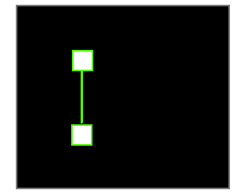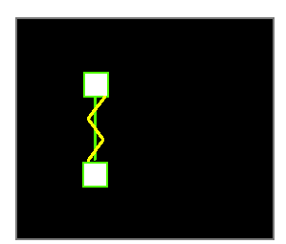On the picture on the left there is 2 points attached with a string. These 2 points are spring tied together. On the picture on the right, the Yellow lines are there to represent springs.

Right now its in **rest state**.

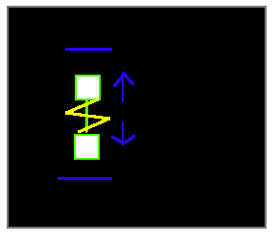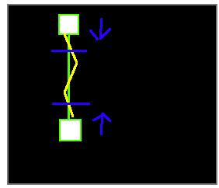The points out of that rest state range will move towards their resting spot distances. It will push inward if its too far apart, and outward if its too close together. (blue points are resting spots)

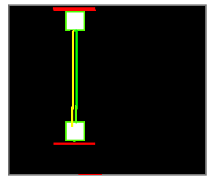They can only extend a certain amount a distance from another.

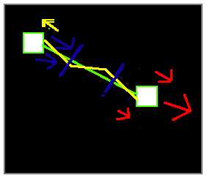(the number of colored arrows determines how strong the movement is.) One point can have a stronger movement than the spring attach point. The least strongest has keep up to that resting point distance.

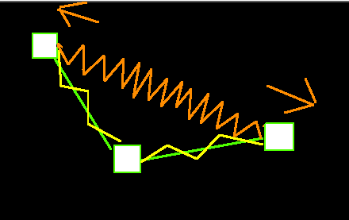It can be used for multiple points and it doesn't have to be the nearest point.

The the result from above will become the one below.

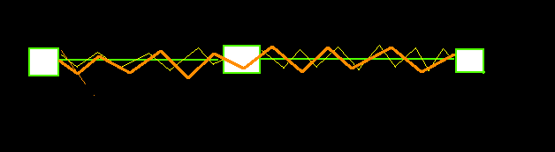

These Spring physics will use for my project.

### 

### 1st Part: Water Waves

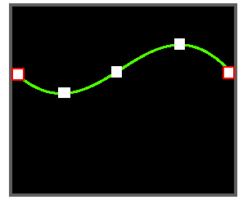Water Wave will be a multiple point spring line. Its ends will be anchored at each ends. The Springs are tied point to each nearest point and the next nearest point.

One or two of the ends of the spring line will move up and down

with differential speed to make a force movement to the line to form a wavelike pattern.

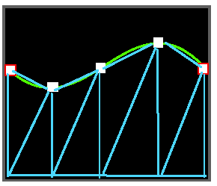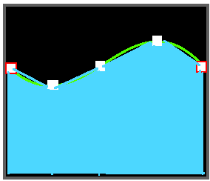

During the rendering part we form a trapezoid for every 2 points of the spring

lines. If these trapezoid are color filled with a blueish color. It will start to look like

water.

### 

### 2nd Part: Boat with interaction with Water Waves

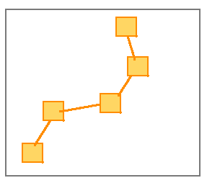Now I made a 5 point spring line, I will call these **boat floats**

The springs are tied the same way as the waves but it also attaches a spring from each

ends of the line.

These points in the line will be influence with gravity and with the water.

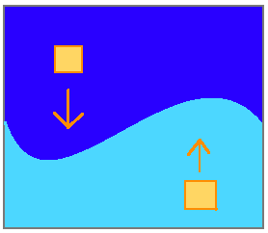 The boat floats are affected by gravity and it will moved

downward. And, if its within or on water the boat floats will move upward.

The Water pushes harder than the gravity.

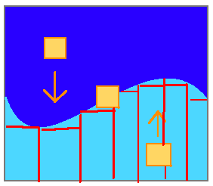It currently detects it a rectangular pattern.   
 For each point of boat floats. it will check for each of point of the waves lines to

the nearest right wave point to see if the boat float is between those wave points and

check if the boat floats is lower than the lowest height of the wave points.

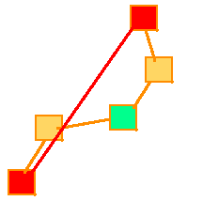The 3 most important part of this 5 point spring line is the middle and ends. The middle will be the position of where the boat will be at. The ends are calculated for their angle and it will be use for the boat.

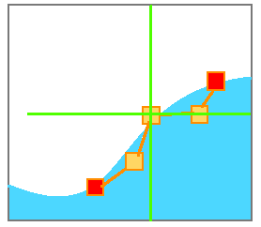I use gltranslatef to make the new coordinates (0,0) at the boat float position. I drew a boat at that position. Then glRotatef that image by the calculated angle.

With All parts placed together it would look like this

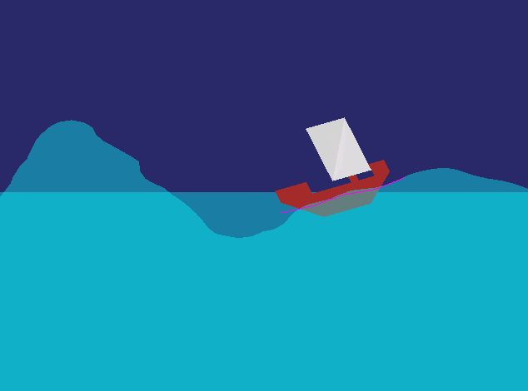

### 3rd Phase; Aesthetics

#### SkyChange

There are 3 variables, r, g, b. it corresponds to the rgb color model.

These variables will increment or decrement to the desired number to a

certain color. the rgb will change like this--

*start loop → (245, 61, 0) → (255, 102, 51) → (51, 255, 51) → (0, 184, 245) →*

*(0, 61, 245) → (41, 41, 92) → end loop.*

during the variables r, g, b increments and decrements, glClearColor was called and it took these values as the new sky. glClearColor(r/255, g/255, b/255).

#### Freeze

if freeze switch is on, decrease all velocity by -50%. or more. and change the wave

color to look icy.

#### FakeDarkness,

Make a transparent black wall with a hole of any shape, let that hole be the middle and gltranslatef towards the boat location. then make that hole shape then make it more transparent than the black wall and gltranslatef to the boat for a bit of light within boat,

The will be some light within the area of the boat, and darkness around the boat.

## 

## What I Learned

I learned a lot about OpenGL.

gltranslatef changes coordinates spot. glrotatef rotate Z like a disc on (0,0,0).

glPushMatrix acts like a save settings. and glPopMatrix loads that save settings.

and functions that allow transparency.

For debugging purposes. I learn its always best to place logs and information about

certain functions and objects.. And, also make it minimal and simple for better fixes and

configuration.

## Problems I Encountered

Many Numbers and Variables often get mixed up in wrong ways,

Before, the boat rotated wrong at a certain point. I thought angle calculation was correct,

and this angle is not fit for rotating the boat. But i realize that the angle calculation

got y coordinates from the x coordinates position.

There were lots of problems like this… it took awhile to fix most of them correctly.

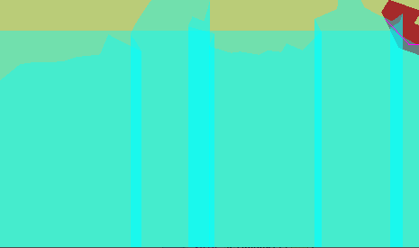There is an issue with the waves.

Trapezoids water overlaps each other if a point.

## Old Design

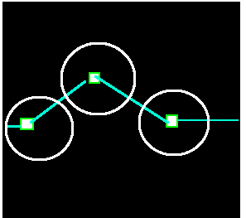My old design was that if the boat floats is near the radius of these points it acts like wall for the boat to slide in. It acts the same as my newer functions but only within that radius.

## The Future

With more time I will ...

add more Polish, Minimalist, and control to the current code.

Mouse Control…(makes it easier to make waves).

Study and make Scrolling, looping screen ends,

Weights on boats, control on waves, splash effects, ripples effects,

and more objects with interference with other objects.

I can also use this as a reference if I make 3d boat float on 3d water.

## Research

1. <https://www.opengl.org/sdk/docs/man2/xhtml/>

this gives more information about a opengl function.

1. <http://gamedevelopment.tutsplus.com/tutorials/make-a-splash-with-dynamic-2d-water-effects--gamedev-236>

this help me design what water should be like -- trapezoids shape and etc.

1. <http://stackoverflow.com>

lots of question were asked and answered in there.