Walkthrough: Usability, Progressive Disclosure & Affordance Architecture Overhaul
Comprehensive response to the UI/UX critique from Michael Longé, implementing progressive disclosure, streamlined cognitive load, dedicated visitor journeys for genre discovery and sampling policy, and strict navigation affordance standards.

1. Executive Summary of Improvements
Michael's Critique | Key Root Cause | Implemented Solution
Visitor Task 1: Find more tracks in a favorite genre (e.g., Blues / Folk) after Spotify recommendation | Vault lacked a visible genre navigation system; search required guessing keywords. | Genre Discovery Bar: Added an interactive genre category pill bar (All Genres, Folk & Acoustic, Blues & Country Blues, Folk Rock & Roots, Protest & Narrative Folk, Satire & Sea Shanty) with live album counts. Made genre tags on cards clickable shortcuts.
Visitor Task 2: Where is Fair Use, Copyright & Sampling permission for hip-hop artists / producers? | Copyright dated 2025; no explicit creative reuse, fair use, or sampling clearance terms. | Copyright & Sampling Policy Modal: Added dedicated modal (accessible via footer and #copyright-policy hash) establishing 2026 copyright, fair use, non-commercial sampling permission for beatmakers/DJs with attribution, and commercial sync contact.
Cognitive Overload & Terminology ("What is an 'app' vs sub-page?") | Conflation of "App", "Interactive Vault", and simple pages; dense architectural jargon upfront. | Affordance & Terminology Discipline: Reserved ↗ strictly for external platforms (Substack, YouTube, Spotify). Retired ambiguous "App" labels in favor of "Interactive Album Experience" and "Album Explorer".
Vault Cards Usability: Mid-word truncation at 137 characters | Card descriptions were sliced arbitrarily mid-sentence with ellipsis (...). | Hook-First Card Architecture: Replaced truncation with curated 1-2 sentence narrative hooks across all 45 albums, paired with an explicit primary CTA: Explore Album & Tracks →.
Navigation Cues & Consistency | Inconsistent arrow symbols; internal routes using ↗. | Strict Link Affordance Standard: Internal pages use → or clean badges; external tabs use ↗.

2. Visual Verification

A. Discography Vault: Genre Discovery & Hook-First Cards
The Discography Vault now presents a dedicated Genre Bar right above the thematic filters, and every card features a punchy, complete narrative hook without awkward truncations:
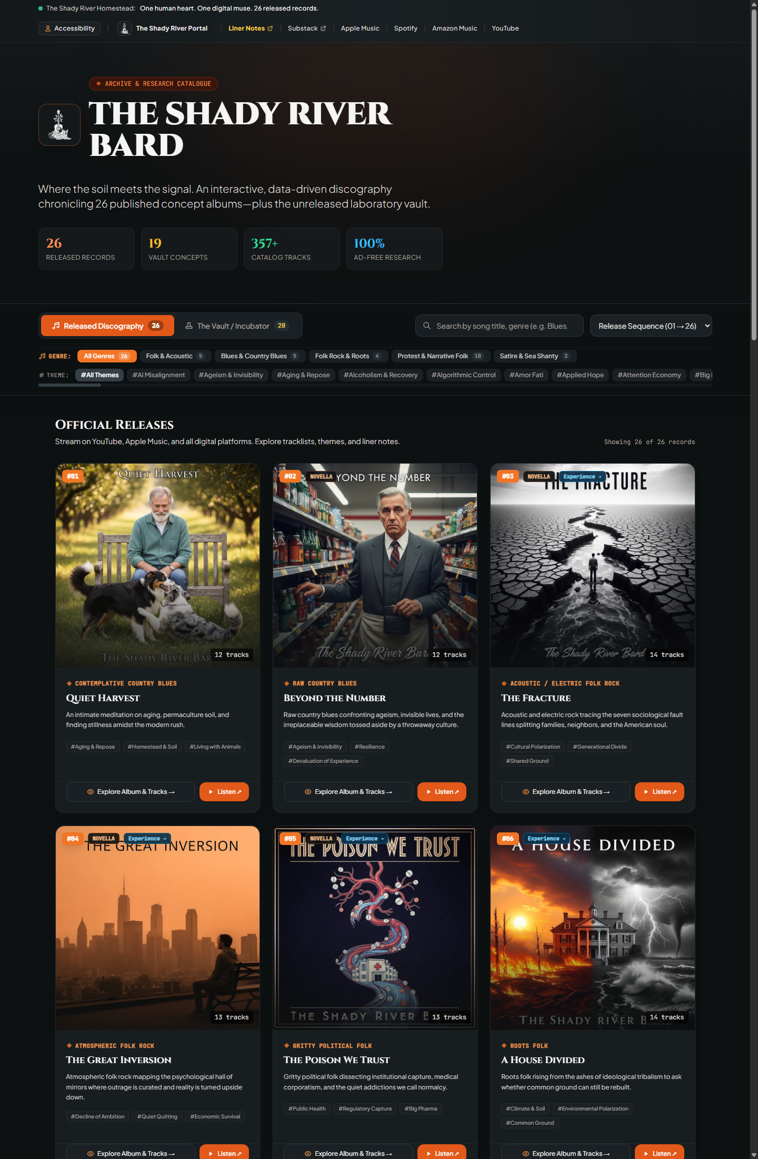
Discography Vault Genre Discovery and Cards
- Genre Pills with Live Counts: Filter instantaneously across 26 released records and 19 vault incubation concepts.
- Clickable Genre Badges: Visitors can click any genre label on a card to immediately filter to all albums of that genre.
- Clear Primary CTA: Explore Album & Tracks → provides an unambiguous, welcoming next step.
- External Affordance: Listen ↗ uses the standard up-right arrow because it opens YouTube in an external tab.

B. Copyright, Fair Use & Sampling Policy Modal
Linked directly from the footers of both the Flagship Portal and the Vault (and accessible via #copyright-policy and #licensing-sampling-policy URL hashes):
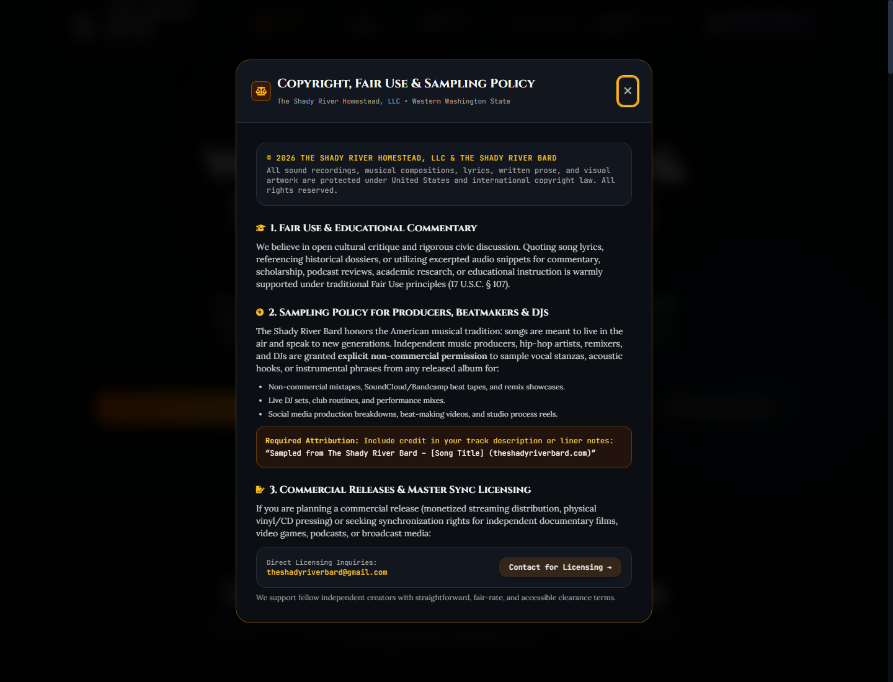
Copyright, Fair Use & Sampling Policy Modal
- © 2026 The Shady River Homestead, LLC & The Shady River Bard: Updated across the entire ecosystem.
- Section 1 (Fair Use & Commentary): Warm support for educational scholarship, reviews, and cultural criticism.
- Section 2 (Sampling Policy for Beatmakers, Hip-Hop & DJs): Explicit non-commercial permission for mixtapes, live sets, and production reels with standard attribution ("Sampled from The Shady River Bard – [Track Title] (theshadyriverbard.com)").
- Section 3 (Commercial Licensing & Sync): Streamlined direct contact channel (theshadyriverbard@gmail.com) with artist-friendly terms.

C. Flagship Portal Navigation & Landmarks
Internal links no longer use external arrows (↗), clarifying site hierarchy:
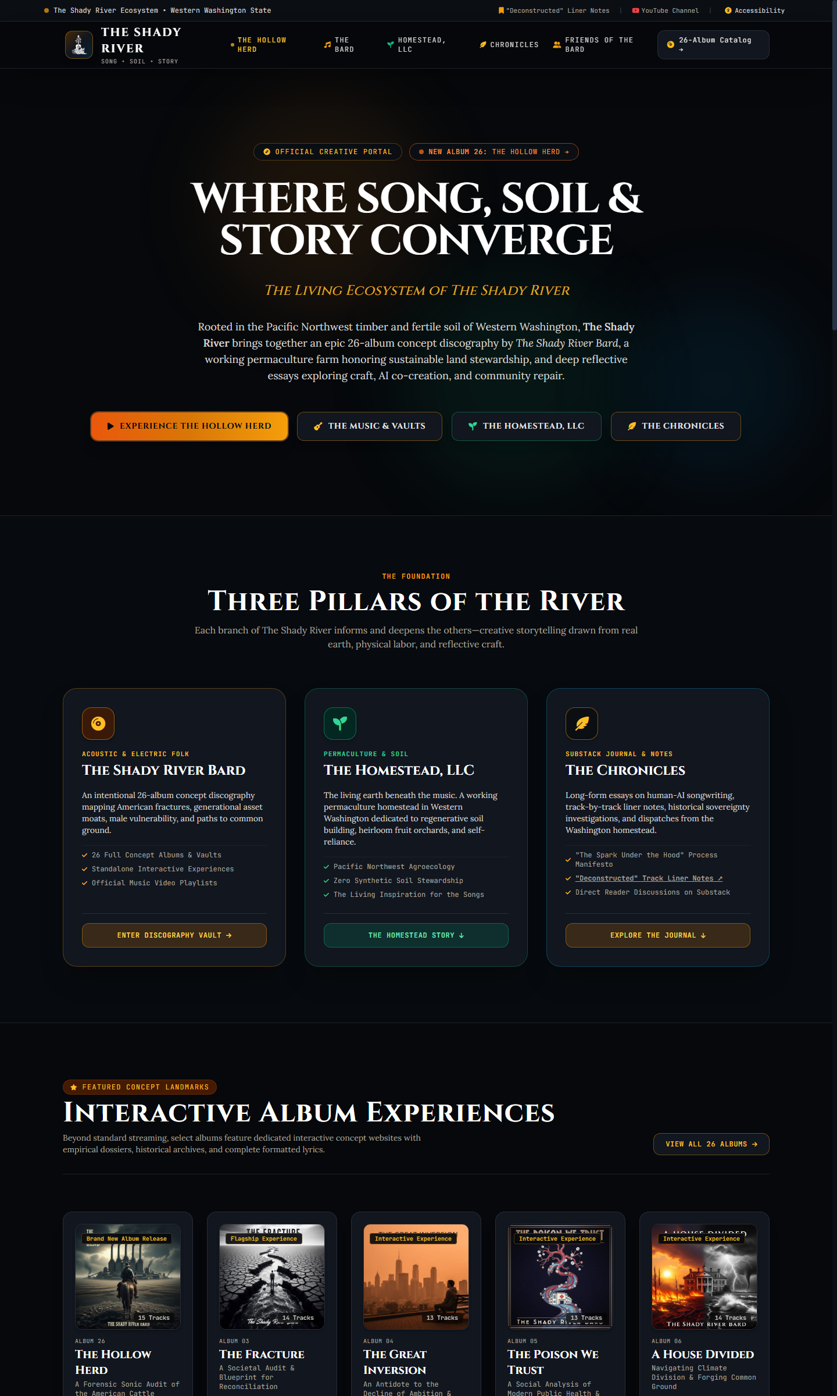
Flagship Portal Navigation and Landmarks
- Clear Album 26 Distinction: Highlights *The Hollow Herd* as Album 26 in the 26-album canon.
- Predictable Destination Affordances:
- 26-Album Catalog → (internal page)
- The Homestead Story ↓ (on-page jump)
- "Deconstructed" Track Liner Notes ↗ (external Substack link)
- Refined Badges: Replaced repetitive "Bespoke Interactive Vault" with clean "Interactive Experience" and "Flagship Experience".

3. Automated Verification Results
- Accessibility Compliance (WCAG 2.1 AA):
- Evaluated all 23 portal and album subsite pages using test_accessibility_compliance.py.
- Result: ALL 23 PAGES PASSED WITH ZERO VIOLATIONS!
- Zero AI / Suno Mentions:
- Evaluated all 45 newly authored album hooks, standardized genre categories, and policy copy using verify_zero_ai.py.
- Result: SUCCESS: Zero AI / Suno mentions in all new hooks, categories, and policy copy!
- Data Integrity:
- Validated both vault/data/albums.json and vault/data/albums-data.js.
- All 26 released albums and 19 vault concepts verified with complete schema and valid JSON/JS syntax.

