Vinyard Burger Bar
Online Ordering and Management System
Final System Project Documentation Paper

Submitted by:
Paul Benedict Sandy V. Tomol

Course/Subject: BSIT 3-A
Instructor: Jeremiah Dela Cruz
Date Submitted: 22/05/2026

Table of Contents
Table of Contents 2
Chapter 2: Introduction 4
2.1 Background of the Project 4
2.2 Purpose of the System 4
2.3 Importance of the Project 4
2.4 Problems the System Aims to Solve 4
Chapter 3: Objectives of the System 6
3.1 General Objective 6
3.2 Specific Objectives 6
Chapter 4: Scope and Limitations 7
4.1 Scope of the System 7
4.2 Limitations and Exclusions 7
Chapter 5: System Description 9
5.1 Overview of the System 9
5.2 Major Modules and Features 9
5.3 User Roles and Functionalities 10
Chapter 6: Technologies Used 11
6.1 Programming Languages 11
6.2 Frameworks and Libraries 11
6.3 Database Management 11
6.4 Development Tools 11
Chapter 7: System Design 13
7.1 System Architecture 13
7.2 Use Case Diagram 13
7.3 System Flowchart 13
7.4 Entity-Relationship (ER) Diagram 13
7.5 Interface Design 13
Chapter 8: Database Structure 15
8.1 User Table 15
8.2 MenuItem Table 15
8.3 Order Table 15
8.4 Review Table 16
8.5 Table Relationships 16
Chapter 9: Implementation and Testing 17
9.1 Development Process 17
9.2 Testing Procedures Performed 17
9.3 Problems Encountered and Solutions Applied 18
Chapter 10: Conclusion 19
10.1 Summary of Achievements 19
10.2 Benefits of the System 19
10.3 Learning Gained 19
Chapter 11: Recommendations 20
11.1 Future Improvements 20
11.2 Additional Features 20

Chapter 1: Introduction

1.1 Background of the Project
The rapid shift towards digital transactions has fundamentally transformed the food service industry worldwide. Customers today expect seamless, efficient, and technologically advanced experiences when interacting with food establishments. Traditional counter-based ordering systems are increasingly being replaced by web-based and mobile ordering platforms that offer greater convenience, accuracy, and transparency.

The Vinyard Burger Bar Online Ordering and Management System was developed in direct response to this industry-wide evolution. The system provides a seamless digital bridge between the restaurant and its customers, allowing patrons to browse the menu, place orders, and earn loyalty points directly from their personal devices, without the need to visit the establishment in person or wait in physical queues.

1.2 Purpose of the System
The primary purpose of this system is to automate and streamline the entire ordering lifecycle of Vinyard Burger Bar. It aims to eliminate long queues, significantly reduce manual order-taking errors inherent in traditional counter operations, and provide an intuitive administrative dashboard for staff to manage orders, customer records, inventory availability, and customer reviews with efficiency and accuracy.

1.3 Importance of the Project
This project holds significant importance for improving operational efficiency and enhancing the overall customer experience of Vinyard Burger Bar. By transitioning to a fully web-based platform, the business gains the ability to handle a greater volume of orders concurrently, track customer loyalty more effectively, and ultimately drive revenue growth while maintaining high levels of customer satisfaction. Furthermore, the digital infrastructure positions the business for future scalability and expansion.

1.4 Problems the System Aims to Solve
The development of this system was motivated by the following key challenges identified in the restaurant's existing operations:

- Manual and error-prone order taking over the counter, which leads to incorrect orders and customer dissatisfaction.
- Lack of an organized and automated customer loyalty tracking system, resulting in missed opportunities for customer retention.
- Difficulty in monitoring real-time order status, making it challenging for both staff and customers to track progress from pending to delivery.
- Inefficient management of customer feedback and reviews, preventing the business from effectively utilizing customer sentiment data.

Chapter 2: Objectives of the System

2.1 General Objective
The general objective of this project is to design, develop, and implement a fully functional web-based online ordering and management system for Vinyard Burger Bar that enhances customer convenience, minimizes operational errors, and streamlines overall restaurant management processes.

2.2 Specific Objectives
The following specific objectives were established to guide the development of the system:

- To provide a user-friendly and responsive interface that enables customers to browse the categorized menu, add items to a shopping cart, and complete orders with ease.
- To implement an automated loyalty points system that rewards customers based on their purchase history and allows them to redeem accumulated points for discounts on future orders.
- To develop a comprehensive Admin Dashboard that enables restaurant staff to monitor, manage, and update order statuses in real-time, from the initial placement to final delivery.
- To create an integrated platform for customers to submit reviews and ratings for their orders, and for administrators to monitor and manage customer feedback effectively.
- To establish a role-based access control system that ensures customers and administrators each access only the features and data relevant to their respective roles.

Chapter 3: Scope and Limitations

3.1 Scope of the System
The Vinyard Burger Bar Online Ordering and Management System covers a broad set of features for both customer-facing and administrative operations, as outlined below.

Customer Features
- User account registration and secure login authentication.
- Menu browsing with category filtering (Burgers, Fries, Beverages, and others).
- Shopping cart management including item addition, quantity adjustment, and removal.
- Checkout process with support for multiple payment options (Cash on Delivery and GCash simulation).
- Order history tracking with real-time status visibility.
- Loyalty points accumulation and redemption for order discounts.
- Submission of reviews and star ratings for completed orders.

Administrative Features
- Dashboard analytics displaying total orders, revenue summaries, active customers, and pending tasks.
- Real-time order status management, updating orders across statuses: Pending, Preparing, Ready, and Delivered.
- Customer account management including viewing registered users and their order histories.
- Review monitoring and moderation for customer-submitted feedback.

3.2 Limitations and Exclusions
The following limitations apply to the current version of the system and represent areas identified for future development:

- Payment Gateway Integration: The system currently simulates payment methods (COD and GCash) and does not integrate with live banking APIs or real-time GCash payment processing. All transactions are handled within the application environment.
- Live GPS Delivery Tracking: The system provides estimated delivery times and status updates but does not feature real-time GPS tracking for delivery personnel.
- Data Persistence: Data management is handled via client-side state mechanisms (Zustand/Local Storage) for demonstration purposes. Migration to a live cloud database is required for full production deployment.
- SMS/Push Notifications: The current version does not support real-time push notifications or SMS alerts, though these are recommended for future implementation.

Chapter 4: System Description

4.1 Overview of the System
The Vinyard Burger Bar system is a modern Single Page Application (SPA) built using the React framework. It provides distinct, role-differentiated experiences based on the authenticated user type. The application features a fully responsive layout engineered to function seamlessly across mobile, tablet, and desktop devices, ensuring accessibility for all users regardless of their preferred platform.

The system operates on a client-side rendering architecture, where all interface logic, state management, and data flow are handled within the browser environment. The React application communicates with a Zustand state store, which serves as the central data layer and persists information through the browser's Local Storage mechanism.

4.2 Major Modules and Features
Authentication Module
This module handles all aspects of user identity, including secure registration and login. It enforces role-based access by identifying whether the authenticated user holds a 'customer' or 'administrator' role and redirecting them to the appropriate interface accordingly.
Menu and Ordering Module
This module displays the restaurant's full menu organized by food categories such as Burgers, Fries, and Beverages. Customers can interact with menu items, view descriptions and pricing, and add selections to their shopping cart. The cart dynamically updates totals and supports quantity modification and item removal.
Loyalty Points Module
The loyalty module automatically computes and awards points to customers upon order completion. Accumulated points are stored in the user's profile and can be applied at checkout to reduce the order total, thereby incentivizing repeat patronage.
Admin Management Module
This is the centralized hub for restaurant staff operations. It consolidates analytics on total orders, revenue, and active users. Administrators can update order statuses, manage menu item availability, view customer accounts, and monitor submitted reviews from a unified dashboard interface.

4.3 User Roles and Functionalities

User Role | Key Functionalities
Customer | Register/login, browse menu, add to cart, checkout, track orders, earn and redeem loyalty points, submit reviews, manage personal profile.
Administrator | Login to admin dashboard, view analytics, update order statuses, manage menu item availability, view customer accounts, monitor and manage customer reviews.

Chapter 5: Technologies Used

5.1 Programming Languages
- TypeScript / JavaScript: The core programming languages used throughout the application. TypeScript provides strong static typing, which improves code reliability, reduces runtime errors, and enhances developer productivity through better tooling support.

5.2 Frameworks and Libraries
- React 19: The primary frontend library used for building the application's interactive user interface. React's component-based architecture enables modular, reusable UI development.
- Vite: Utilized as the build tool and development server. Vite significantly accelerates the development workflow through near-instant hot module replacement and optimized production builds.
- Tailwind CSS: A utility-first CSS framework employed for all styling and layout concerns. Tailwind enabled rapid, consistent, and fully responsive UI design without writing custom CSS files.
- Zustand: A lightweight, scalable state management library used to manage global application state. Zustand serves as the central data store for users, orders, menu items, and cart data, replacing the need for complex prop-drilling across components.
- Lucide React: An icon library providing a comprehensive set of modern, scalable vector icons used throughout the application's user interface.

5.3 Database Management
The system utilizes a mock database architecture managed entirely through Zustand state with Local Storage persistence. This approach simulates a NoSQL document database structure, organizing data into distinct collections for Users, Menu Items, Orders, and Reviews. While sufficient for development and demonstration, this architecture is designed to be replaced with a cloud database service (such as Firebase or Supabase) in a production environment.

5.4 Development Tools

Tool | Purpose
Node.js & npm | JavaScript runtime environment and package manager used to manage dependencies and run the development build system.
Git / GitHub | Version control system used for source code management, collaboration, and tracking development history.
Visual Studio Code | The primary Integrated Development Environment (IDE) used for writing, debugging, and managing the application codebase.

Chapter 6: System Design

6.1 System Architecture
The application follows a Client-Side Rendering (CSR) architecture. The React application handles all UI rendering, and the Zustand store manages global state which is persisted via the browser's Local Storage. The diagram below illustrates the high-level architecture flow:

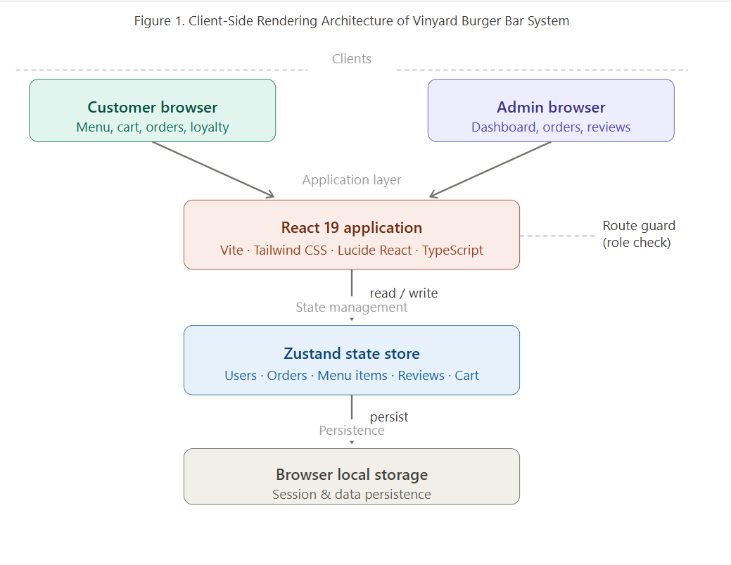

6.2 Use Case Diagram
The use case diagram below illustrates the primary interactions between the two user roles — Customer and Administrator — and the core system functionalities available to each role.

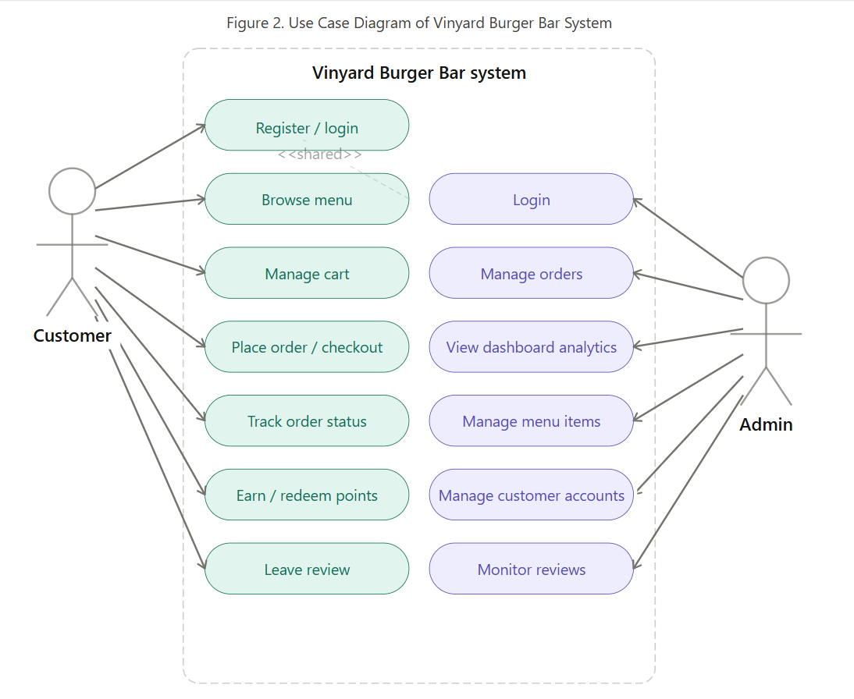

6.3 System Flowchart
The flowchart below illustrates the step-by-step process flow of the customer ordering workflow, from initial authentication through to order placement and confirmation.

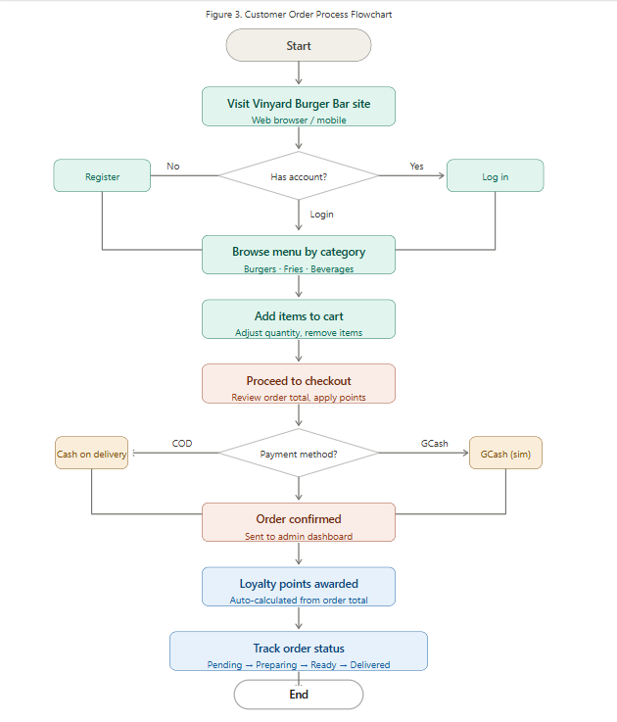

6.4 Entity-Relationship (ER) Diagram
The ER diagram below depicts the relationships between the core data entities of the system: User, MenuItem, Order, and Review.
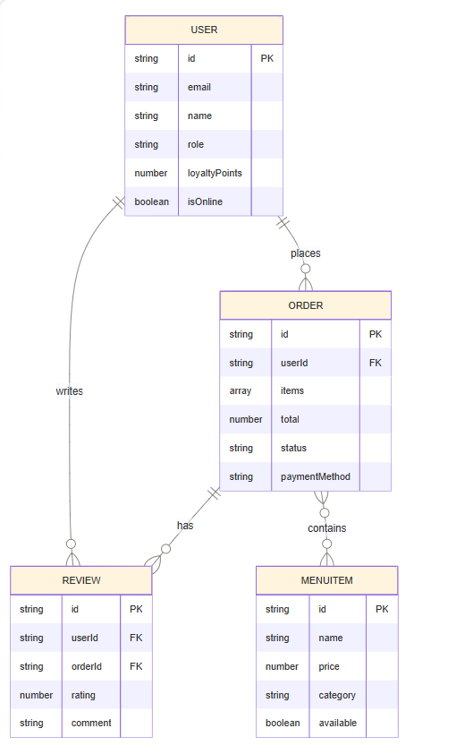
Figure 4. Entity-Relationship Diagram

6.5 Interface Design
The following screenshots illustrate the key screens of the Vinyard Burger Bar system. The interface was designed with a focus on clarity, visual appeal, and intuitive navigation for both customer and administrator users.

[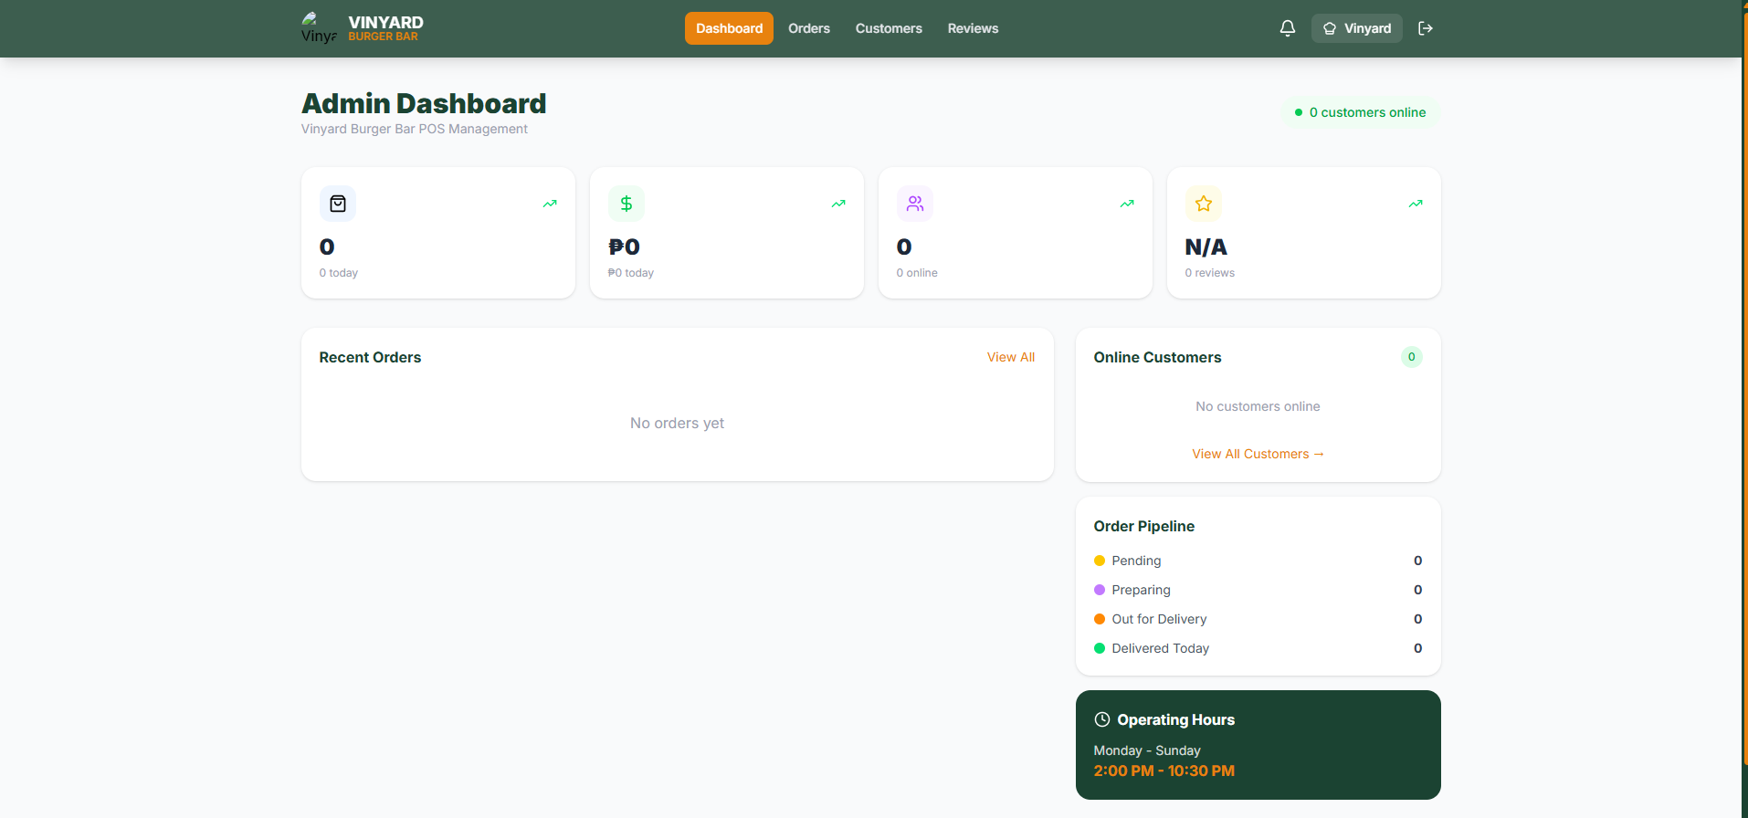

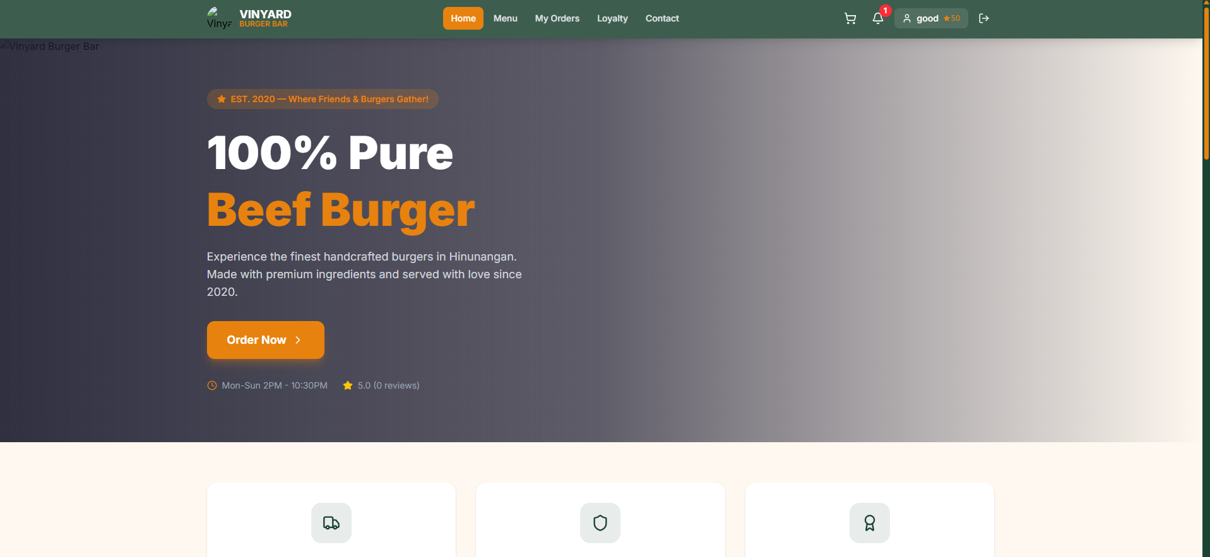
Figure 5. Sample Interface Screenshots of the System

Chapter 7: Database Structure
The system utilizes structured data models representing database collections. Although the current implementation uses in-browser state management, the models are designed to be directly transferable to a cloud database. The following tables describe each data entity, its fields, data types, and purpose.

7.1 User Table
The User table stores all registered user accounts, including both customers and administrators.

Field | Type | Description
id | String | Unique identifier for each user account.
email | String | The user's registered email address, used for authentication.
name | String | The user's full name.
role | String | Defines the account type: 'customer' or 'admin'.
loyaltyPoints | Number | Total accumulated loyalty points from completed purchases.
isOnline | Boolean | Indicates whether the user is currently logged in.

7.2 MenuItem Table
The MenuItem table contains all food and beverage items available on the restaurant's menu.

Field | Type | Description
id | String | Unique identifier for each menu item.
name | String | The name of the food or beverage item.
price | Number | The retail price of the menu item.
category | String | The menu category (e.g., 'burgers', 'fries', 'beverages').
available | Boolean | Indicates whether the item is currently in stock.

7.3 Order Table
The Order table records all orders placed by customers, including their contents, total value, and current processing status.

Field | Type | Description
id | String | Unique reference number for each order.
userId | String | Foreign key referencing the customer who placed the order.
items | Array | A list of Cart Item objects representing the ordered items and quantities.
total | Number | The total monetary cost of the order.
status | String | Current order status: 'pending', 'preparing', 'ready', or 'delivered'.
paymentMethod | String | The selected payment method: 'cod' (Cash on Delivery) or 'gcash'.

7.4 Review Table
The Review table stores customer feedback submitted for completed orders.

Field | Type | Description
id | String | Unique identifier for each review record.
userId | String | Foreign key referencing the customer who submitted the review.
orderId | String | Foreign key referencing the specific order being reviewed.
rating | Number | Numerical star rating from 1 (lowest) to 5 (highest).
comment | String | The customer's written feedback or comment text.

7.5 Table Relationships
The entities described above are related as follows:

- A User can place multiple Orders (one-to-many relationship between User and Order via userId).
- An Order can contain multiple MenuItems represented as an array of cart item objects (many-to-many, managed within the Order entity).
- A Review is associated with exactly one User and one Order, forming a one-to-one relationship from the review's perspective.

Chapter 8: Implementation and Testing

8.1 Development Process
The system was developed using an agile methodology, allowing the team to iteratively build, test, and refine features throughout the project lifecycle. The development process proceeded through the following phases:

- Planning and Requirement Analysis: The team identified core system requirements by analyzing the operational needs of a food ordering business and defining the feature set for both customer and administrator roles.
- UI/UX Wireframing: Initial interface layouts and user flows were wireframed to establish the visual structure and navigation architecture of the application before coding commenced.
- Component-Based Development: The system was built as a collection of modular React components. Each feature area (authentication, menu, cart, checkout, admin panel) was developed as an independent component set, then integrated into the full application.
- State Management Integration: Zustand was integrated as the global state management solution, replacing the need for complex component-level prop-drilling and enabling seamless data sharing across the entire application.
- Testing and Debugging: Iterative testing was conducted throughout development to identify and resolve defects before final integration.

8.2 Testing Procedures Performed
Unit Testing
Individual components were manually tested to verify correct isolated behavior. Tests included navigation routing via the Navbar, cart item increment and decrement functionality, and form input validation on the login and registration screens.
Integration Testing
End-to-end integration tests verified that the complete checkout process accurately computes order totals, applies loyalty point discounts, updates the global Zustand store, and correctly generates the corresponding order entry in the Admin Dashboard view.
Responsive Design Testing
The application's layout integrity was verified across multiple viewport sizes representing mobile phones, tablets, and desktop screens. Tailwind CSS responsive utility classes were used to ensure consistent rendering across all tested breakpoints.

8.3 Problems Encountered and Solutions Applied

Problem Encountered | Solution Applied
Difficulty managing complex global state when passing data between the Cart, Checkout, and Order History components across multiple levels of the component tree. | Implemented Zustand as a centralized global store. This eliminated the need for prop-drilling and provided a clean, globally accessible state for cart contents, user data, and order records.
Implementing protected routes to prevent authenticated customers from accessing administrator-only dashboard pages and vice versa. | Built a custom routing guard using React's useEffect hook within App.tsx. The guard evaluates the currentUser.role property on each route render and redirects unauthorized users to the appropriate interface.

Chapter 9: Conclusion

9.1 Summary of Achievements
The Vinyard Burger Bar Online Ordering and Management System was successfully designed, developed, and implemented as a fully functional, visually polished, and responsive web application. The system effectively achieves all objectives established at the outset of the project. It delivers a seamless end-to-end ordering experience for customers — from menu browsing and cart management to checkout and order tracking — while simultaneously providing restaurant administrators with a powerful management dashboard for real-time operations oversight.

The system successfully implements role-based access control, ensuring a clear and secure separation between customer and administrator functionalities. The integration of the loyalty points module adds a meaningful customer retention mechanism, while the review system creates a feedback loop that can drive continuous service improvement.

9.2 Benefits of the System
The system delivers tangible operational benefits to Vinyard Burger Bar. The automation of the ordering process significantly minimizes human error associated with manual order taking. The loyalty points program provides a structured incentive for customer retention, encouraging repeat patronage. The digital admin dashboard dramatically improves the restaurant's organizational capacity by centralizing order management, customer data, and sales analytics in a single, easily accessible platform, enabling faster and more informed business decisions.

9.3 Learning Gained
Throughout the course of this project's development, the team acquired substantial technical knowledge and practical skills in several key areas. Deep proficiency was developed in modern frontend development practices using React 19, including component architecture and lifecycle management. The application of TypeScript for static typing demonstrated its value in maintaining code quality at scale. The experience of designing and implementing a state management solution using Zustand provided valuable insight into global data flow management. Additionally, the project strengthened the team's capabilities in UI/UX design principles, responsive layout engineering with Tailwind CSS, and structured project organization.

Chapter 10: Recommendations

10.1 Future Improvements
- Cloud Database Migration: It is strongly recommended to migrate the current client-side Local Storage data persistence to a cloud database platform such as Firebase Firestore, Supabase, or MongoDB Atlas. This migration will enable permanent, secure, multi-device data storage and facilitate real-time data synchronization across users.
- Payment Gateway API Integration: The simulated payment process should be replaced with a live payment gateway integration. PayMongo is particularly suitable for the Philippine market and supports GCash, Maya, and card payments. Stripe may also be considered for broader international payment support.
- Backend API Development: Developing a dedicated backend server using Node.js with Express or a similar framework would decouple the data layer from the client, improve security, and enable more complex server-side business logic such as automated order routing and inventory management.

10.2 Additional Features
- Live GPS Delivery Tracking: Integrating a mapping API, such as the Google Maps Platform, would allow customers to track the real-time location of their delivery rider from order dispatch to doorstep arrival, significantly enhancing the post-order customer experience.
- Push Notifications and SMS Alerts: Implementing web push notifications through a service such as Firebase Cloud Messaging (FCM), combined with SMS gateway integration (e.g., Semaphore for the Philippine market), would allow customers to receive instant alerts when their order status changes.
- Inventory and Raw Materials Management: Expanding the administrator dashboard to include a raw ingredient inventory tracking module would allow the system to automatically deduct ingredient quantities based on items ordered, providing staff with real-time stock level visibility and low-stock alerts.
- Analytics and Reporting: Adding advanced reporting features such as daily, weekly, and monthly sales summaries, best-selling item rankings, and customer acquisition trends would provide management with data-driven insights for strategic business planning.
— End of Document —

