Low-Level Design: ServiceNow CMDB Autodiscovery for SAM/HAM on Hybrid AWS and Physical Datacenter
LLD Design Document

Industry / Domain: Enterprise IT Service Management & Hybrid Cloud Infrastructure
Version: 2.1.0
Generated On: 2026-09-28 19:04:47

Document Control
Version | Date | Author | Description
2.1.0 | 2026-09-28 | Design Architect | Initial generated design specification

Table of Contents

PART I: HIGH-LEVEL ARCHITECTURE (HLD)

1.0 Executive Summary
Define the high-level system architecture for an enterprise-grade ServiceNow ITOM Discovery solution operating across hybrid AWS cloud and physical on-premises datacenter environments, providing accurate, automated data population for Configuration Management (CMDB), Hardware Asset Management (HAM Pro), and Software Asset Management (SAM Pro).

1.1 Document Structure
This document is organized in two parts. Part I presents the business context, requirements, and architecture at a level suitable for review and approval. Part II provides the low-level design detail an implementing engineer needs to build it.

1.2 Scope
The architecture encompasses ServiceNow ITOM Discovery engine configuration, Identification and Reconciliation Engine (IRE) rules, clustered MID Server deployment on AWS EC2 and on-premises VMware hosts, external credential vault integrations (CyberArk and AWS Secrets Manager), and automated synchronization to HAM Pro (alm_hardware) and SAM Pro (cmdb_sam_sw_install, alm_license). Excludes end-user desktop/laptop discovery (handled via Agent Client Collector) and non-ITAM financial cost allocation pipelines.

1.3 Objectives
- Establish robust, automated multi-tier autodiscovery across AWS VPCs and physical on-premises datacenter environments using clustered ServiceNow MID Servers.
- Normalize, populate, and reconcile Configuration Items in the ServiceNow CMDB using the Identification and Reconciliation Engine (IRE) aligned with CSDM 4.0 standards.
- Automate hardware asset inventory data flows to populate HAM Pro lifecycle attributes, including serial numbers, chassis, model categories, and asset-to-CI relationships.
- Automate software asset discovery to feed SAM Pro normalized software installations, edition detection, and cloud-optimized software license metrics.
- Achieve discovery throughput exceeding 50,000 infrastructure CIs and 100,000 software installation records within scheduled 8-hour discovery windows.

1.4 Business Drivers
- Elimination of software license compliance audit penalties through continuous, automated SAM software inventory discovery and entitlement reconciliation.
- Reduction of operational downtime and incident MTTR by establishing a single source of truth for all hybrid IT infrastructure and inter-CI dependencies.
- Optimization of hardware asset lifecycle tracking (HAM) from procurement to disposal, preventing asset loss and optimizing physical/virtual host density.
- Automated compliance enforcement with regulatory frameworks (PCI-DSS v4.0, ISO/IEC 27001, CIS Controls) regarding unauthorized assets and shadow IT.

1.5 Assumptions
- Dedicated enterprise service accounts with read-only/least-privilege discovery permissions are provisioned across target systems and AWS IAM accounts.
- AWS Direct Connect or resilient IPsec VPN provides reliable inter-datacenter and AWS-to-on-premises hybrid administrative connectivity.
- ServiceNow instance is hosted on Washington DC or Xanadu release with active ITOM Discovery, HAM Pro, and SAM Pro licensing entitlements.
- Internal firewall rules and AWS Security Groups permit probe traffic from MID Server IP addresses to target subnets on designated ports (SSH 22, WinRM 5985/5986, WMI 135/445, SNMP 161, HTTPS 443).

1.6 Constraints
- Strict Network Boundary: Zero inbound firewall ports may be opened from the public internet or ServiceNow SaaS cloud into corporate AWS VPCs or on-premises datacenters; all communication must originate outbound from MID Servers over TLS 1.3 on TCP 443.
- Credential Governance: Plaintext credentials are strictly prohibited on MID Server host file systems; dynamic credential resolution via CyberArk CCP and AWS Secrets Manager with automated rotation is mandatory.
- Resilient High Availability: Discovery infrastructure must reduce single points of failure, supporting automatic MID cluster failover within 60 seconds without dropping discovery execution state.
- Heterogeneous Platform Support: Multi-tier autodiscovery must concurrently support AWS cloud environments (EC2, RDS, VPC, ECS/EKS) and diverse physical datacenter platforms (AIX, Solaris, Linux, Windows Server, SAN/NAS, SNMPv3 network appliances).
System Name: Hybrid ServiceNow CMDB & ITAM Discovery Architecture
Industry Sector: Enterprise IT Service Management & Hybrid Cloud Infrastructure
Document Type: LLD
Template Standard: arc42

2.0 Stakeholders and Responsibilities
The following is a list of key stakeholders involved in this architecture. Understanding their roles and responsibilities is crucial for successful implementation.
Stakeholder | Responsibilities
Enterprise SAM Team | Oversee SAM Pro publisher packs, license reconciliation runs, entitlement allocation, and compliance reporting.
Enterprise HAM Team | Manage HAM Pro lifecycle workflows, asset state transitions, stockrooms, and hardware retirement verification.
Configuration Management Governance Board | Define and enforce CMDB governance, IRE identification rules, reconciliation priorities, and CI class models.
Enterprise Information Security Office | Audit credential vault usage, review network security boundaries, monitor discovery access permissions, validate encryption posture.
Cloud & Platform Engineering Team | Provision and maintain MID Server host instances via Terraform, configure local network routing, maintain Direct Connect / VPN, manage AWS IAM roles.

3.0 Requirements
This section defines the functional and non-functional requirements this design must satisfy, following ISO/IEC/IEEE 29148 requirements engineering practice. Each requirement table below is ordered by identifier, then by priority.

3.1 Functional Requirements
The following functional requirements describe the capabilities this design must provide.
ID | Priority | Description | Acceptance Criteria
REQ-F-001 | Critical | • Automated Cloud Discovery for AWS resources across all enterprise member accounts. | • MID Server cluster in AWS successfully assumes cross-account IAM roles, queries AWS APIs, and discovers VPCs, subnets, EC2 instances, and RDS databases into cmdb_ci_cloud_service, cmdb_ci_ec2_instance, and related tables.
REQ-F-002 | Critical | • Agentless deep discovery of on-premises datacenter compute, storage, and networking devices. | • On-premises MID Server cluster executes IP sweeps across datacenter subnets, performs SSH/WinRM/WMI/SNMPv3 interrogation, and populates cmdb_ci_server, cmdb_ci_network, and cmdb_ci_storage.
REQ-F-003 | Critical | • Configuration item identification and reconciliation via IRE adhering to CSDM 4.0 standards. | • Incoming discovery payloads pass through ServiceNow IRE identification rules using BIOS UUID, serial number, and cloud instance ID; duplicate CIs are identified and reconciled without creating duplicate records.
REQ-F-004 | Critical | • Automated synchronization between CMDB CI records and Hardware Asset Management (HAM Pro). | • Discovered physical and virtual server attributes (serial number, asset tag, chassis, model, MAC) automatically update corresponding alm_hardware records and maintain bidirectional synchronization.
REQ-F-005 | Critical | • Automated software inventory collection and normalization for Software Asset Management (SAM Pro). | • Discovered software installation packages populate cmdb_sam_sw_install, trigger Content Service normalization, and map to software entitlements in alm_license.
REQ-F-006 | Critical | • Dynamic external credential vault integration for discovery authentication. | • MID Servers dynamically query CyberArk CCP (on-premises) and AWS Secrets Manager (AWS) at runtime for probe credentials; no credentials are stored on MID disk.

3.2 Non-Functional Requirements
The following non-functional requirements describe the quality attributes and operating constraints this design must satisfy (ISO/IEC 25010).
ID | Priority | Category | Description | Acceptance Criteria
REQ-NF-001 | Critical | Reliability (availability) | • MID Server clusters must support active-active failover within 60 seconds upon host failure without aborting running discovery schedules. | —
REQ-NF-002 | Critical | Security (confidentiality) | • All communications between MID Servers and ServiceNow SaaS cloud must be initiated outbound over TLS 1.3 on TCP 443 with zero inbound firewall rules permitted. | —
REQ-NF-003 | High | Performance Efficiency (time_behavior) | • Discovery architecture must ingest and reconcile 50,000+ infrastructure CIs and 100,000+ software install records within an 8-hour discovery window. | —

4.0 System Context
This section defines the boundary of Hybrid ServiceNow CMDB & ITAM Discovery Architecture: the actors and external systems it interacts with, following the C4 model's System Context (Level 1) view.

4.1 Actors
The following actors interact with the system:
Name | Type | Description
Hardware Asset Manager (HAM Admin) | Human | Responsible for tracking hardware lifecycle states, verifying chassis and serial asset accuracy, and managing physical stockrooms.
Software Asset Manager (SAM Admin) | Human | Responsible for reviewing normalized software installations, configuring license models, and resolving licensing compliance position.
CMDB Owner / IT Configuration Manager | Human | Responsible for CMDB health metrics, IRE rules, CI class mappings, and CSDM 4.0 structural adherence.
Cloud & Datacenter Infrastructure Engineers | Human | Responsible for provisioning MID Server hosts, configuring VPC peering, security groups, routing, and IAM roles.
ServiceNow MID Server Daemon | System | Automated background daemon running on MID instances, pulling tasks from the ECC Queue and executing diagnostic probes.

4.2 External Systems
The following external systems integrate with this system:
Name | Description | Interface Type | Data Exchanged | Owner
AWS Cloud APIs | AWS Cloud Control Plane providing management and configuration APIs for AWS multi-account environment. | REST / HTTPS (AWS SDK via IAM AssumeRole) | Cloud resource metadata (VPC, Subnet, EC2 instance profiles, RDS instances, Security Groups, IAM tags). | Amazon Web Services / Cloud Engineering
AWS Secrets Manager | AWS managed secret store for dynamic credential lookups by cloud MID Servers. | HTTPS / REST (AWS SigV4 via Private VPC Endpoint) | Encrypted secret strings containing guest operating system credentials for EC2 instances. | Cloud Platform Security Team
Core Network & Storage Appliances | Physical network switches, routers, and firewalls across corporate datacenter fabrics. | SNMPv3 / SSH CLI | Network device interfaces, MAC address forwarding tables, ARP tables, and chassis component models. | Enterprise Network Operations
CyberArk Enterprise Password Vault (CCP) | Enterprise Privileged Access Management (PAM) vault providing dynamic, programmatic credential retrieval. | HTTPS / REST (Client Certificate mTLS) | Privileged administrative credentials (temporary passwords, SSH private keys) for on-premise targets. | Enterprise Identity & Access Management (IAM) Team
Target Host Operating Systems | Physical bare-metal and virtual guest operating systems (RHEL, Ubuntu, Windows Server, AIX, Solaris). | SSH (TCP 22) / WinRM (TCP 5985/5986) / WMI | Hardware inventory, installed software packages, CPU sockets/cores, OS release, and running processes. | Hybrid Workload & Application Owners
VMware vCenter Server | Centralized VMware infrastructure management appliance overseeing on-premises virtualized compute clusters. | SOAP / REST (HTTPS) | Hypervisor inventory, ESXi host hardware specifications, cluster topologies, and virtual machine allocations. | Datacenter Virtualization Operations

4.3 Hybrid ServiceNow CMDB & ITAM Discovery System Context Diagram
C4 Level 1 System Context Diagram depicting hybrid enterprise boundaries, showing ServiceNow SaaS communicating strictly via outbound HTTPS polling with AWS and Datacenter MID Server clusters, technical credential vaults, and target resources.
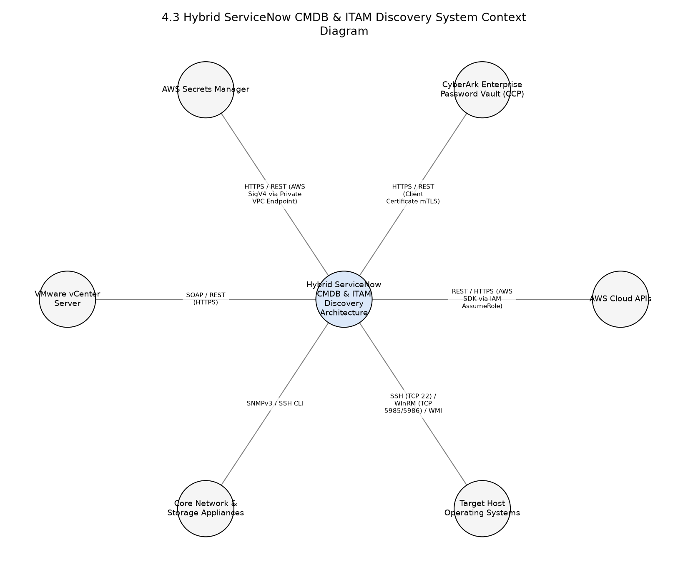

5.0 Architecture Description
The following describes the architecture viewpoints and views for this design (ISO/IEC/IEEE 42010), and the analysis behind the recommended approach.

Concerns
- Ensuring strict network boundary isolation with zero inbound firewall rules permitted from ServiceNow SaaS cloud.
- Preventing duplicate CIs and configuration flapping across multi-homed datacenter servers and dynamic AWS cloud instances.
- Preventing plaintext credential storage on MID hosts through dynamic external vault integration.
- Accurate identification and normalization of hardware assets (HAM) and installed software licenses (SAM) without polluting tables with ephemeral container noise.
- Sustaining high discovery throughput across 50,000+ infrastructure CIs and 100,000+ software installations within designated 8-hour discovery windows.

Viewpoints

Context and Boundary Viewpoint
Applicable Standard: ISO/IEC/IEEE 42010
Concerns Addressed: - Network segmentation, protocol interactions, system boundary isolation, security ingress/egress.
Description: High-level context and operational boundary viewpoint defining interactions between external infrastructure, MID clusters, and ServiceNow SaaS.
Modeling Conventions: C4 Model - Level 1 System Context Diagram
Stakeholders Addressed:
- Enterprise Information Security Office
- Cloud & Platform Engineering Team
- Configuration Management Governance Board

Container and Functional Architecture Viewpoint
Applicable Standard: ISO/IEC/IEEE 42010
Concerns Addressed: - Component decomposition, clustering, failover, identification and reconciliation flow, asset synchronization.
Description: Structural and container decomposition viewpoint depicting internal MID Server components, ServiceNow ITOM engine, IRE, and ITAM data models.
Modeling Conventions: C4 Model - Level 2 Container Diagram
Stakeholders Addressed:
- Enterprise SAM Team
- Enterprise HAM Team
- Configuration Management Governance Board
- Cloud & Platform Engineering Team

Deployment and Execution Viewpoint
Applicable Standard: arc42 Section 7
Concerns Addressed: - Physical and virtual host deployment, AWS Multi-AZ distribution, on-premises cluster redundancy, network pathing.
Description: Deployment and infrastructure topology viewpoint illustrating physical and cloud hosting environments for MID Server clusters and target workloads.
Modeling Conventions: arc42 Deployment Topology & C4 Deployment Diagram
Stakeholders Addressed:
- Cloud & Platform Engineering Team
- Enterprise Information Security Office

Views

System Context View
Description: C4 Level 1 Context View illustrating boundaries between ServiceNow SaaS, hybrid MID Server clusters, external credential vaults, and target cloud/datacenter infrastructure.
Elements:
- ServiceNow SaaS Instance (ITOM/IRE/SAM/HAM)
- AWS Cloud MID Server Cluster
- On-Premises Datacenter MID Server Cluster
- CyberArk Enterprise Password Vault / CCP
- AWS Secrets Manager
- AWS Hybrid Infrastructure (VPCs, EC2, RDS, IAM)
- Physical Datacenter Infrastructure (VMware, Linux, Windows, AIX, Network Switches)
Viewpoint Ref: Context and Boundary Viewpoint

Diagrams

Hybrid ServiceNow CMDB & ITAM Discovery Context Diagram
System Context Diagram showing actors, external systems, and outbound HTTPS communications between hybrid MID clusters and ServiceNow SaaS.
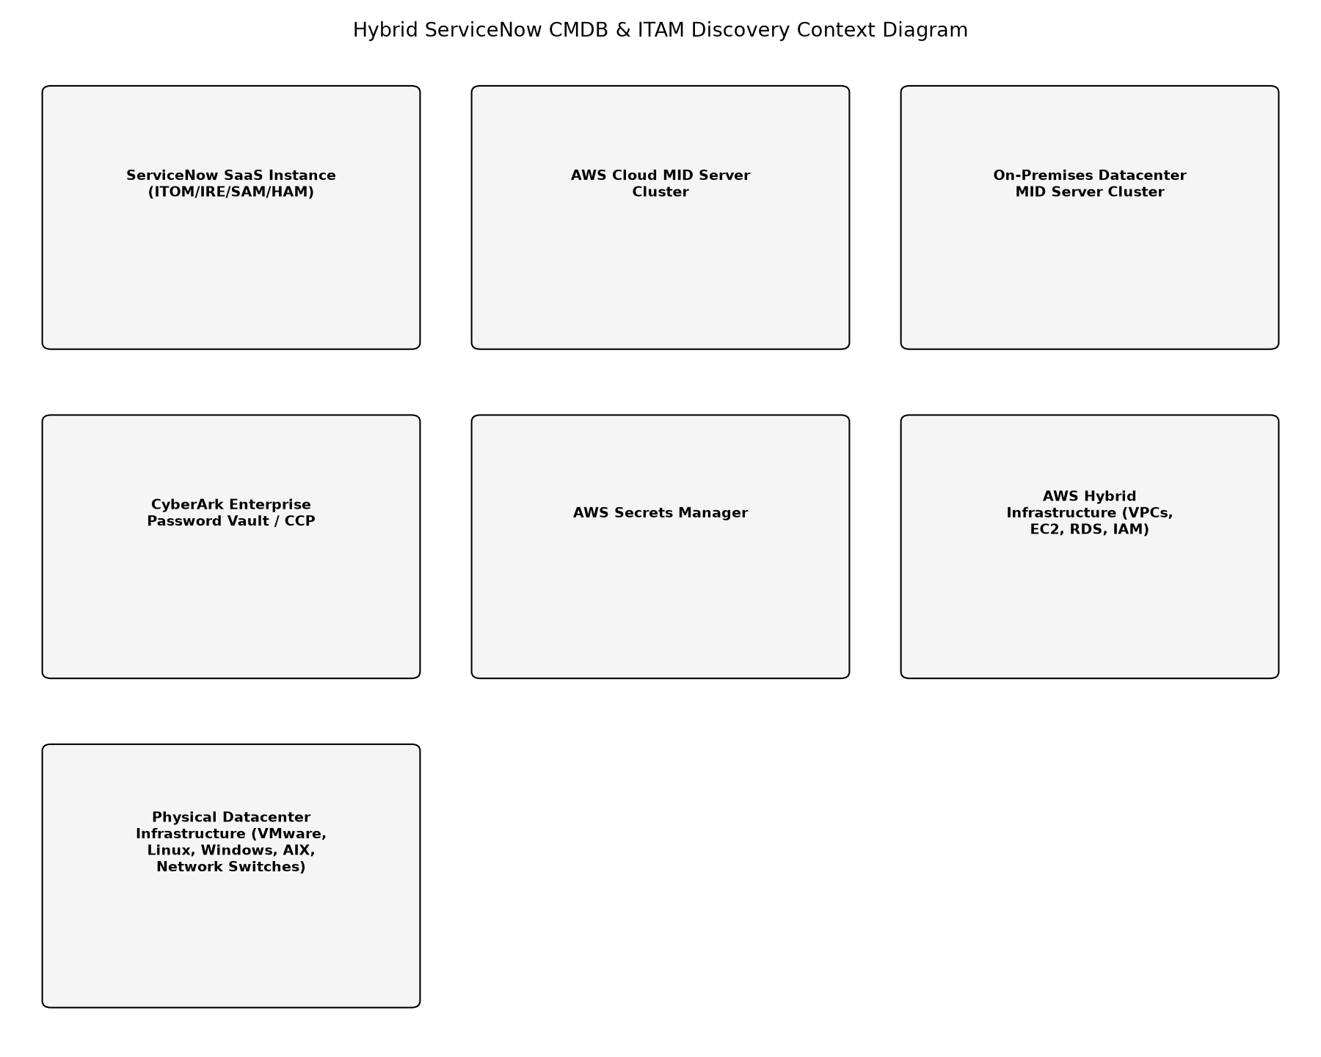

Container and Functional View
Description: C4 Level 2 Container View illustrating internal processing flow from ECC Queue polling to MID probe execution, credential retrieval, pattern parsing, IRE reconciliation, and HAM/SAM table population.
Elements:
- ECC Queue Messaging Bus
- ServiceNow ITOM Discovery Engine
- Identification and Reconciliation Engine (IRE)
- CMDB CI Repositories (cmdb_ci_*)
- HAM Lifecycle Manager (alm_hardware)
- SAM Normalization & Compliance Engine (cmdb_sam_sw_install, alm_license)
- MID Server Java Daemon & Probe Runner
- MID Local SQLite Cache & Credential Broker Client
Viewpoint Ref: Container and Functional Architecture Viewpoint

Diagrams

ServiceNow ITOM & ITAM Discovery Container Architecture
Container Diagram detailing component interactions, ECC queue polling, credential broker lookups, IRE processing, and asset synchronization.
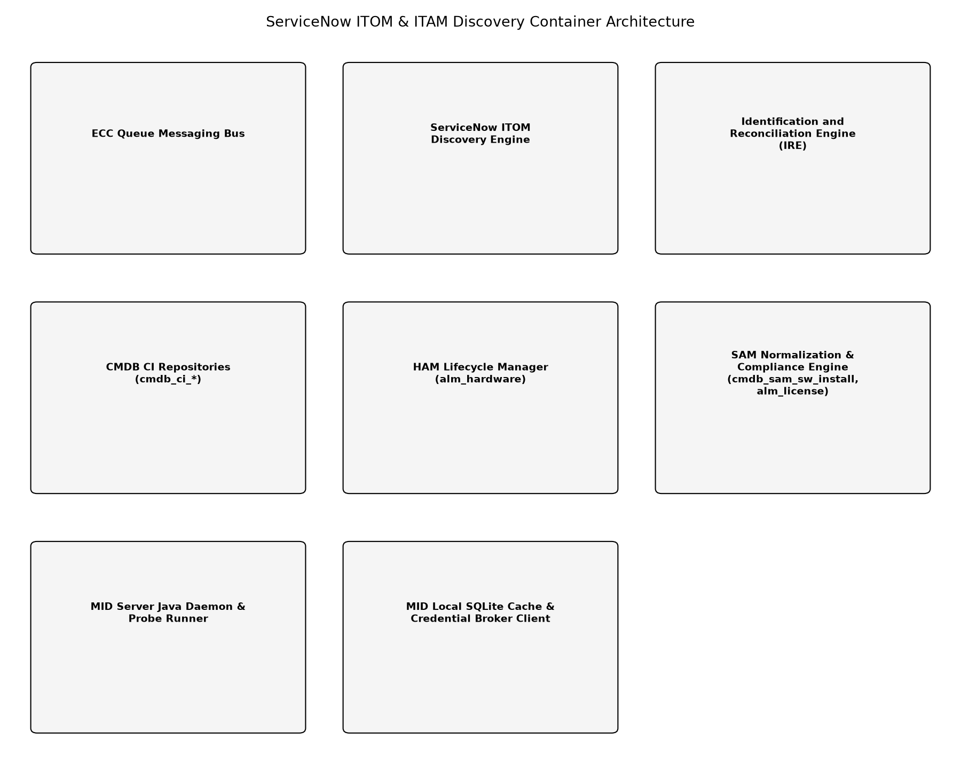

Deployment Topology View
Description: arc42 Deployment View illustrating high-availability cluster topology across AWS Multi-AZ EC2 instances and redundant on-premises VMware ESXi hosts.
Elements:
- AWS Region Primary VPC (Availability Zone A & B)
- On-Premises Datacenter Server Racks (VLAN Management / Server DMZ)
- ServiceNow SaaS High-Availability Multi-Tenant Cloud
Viewpoint Ref: Deployment and Execution Viewpoint

Diagrams

Hybrid Clustered Deployment Topology
Deployment topology showing active-active MID server cluster placement across AWS availability zones and dual physical datacenter server racks.
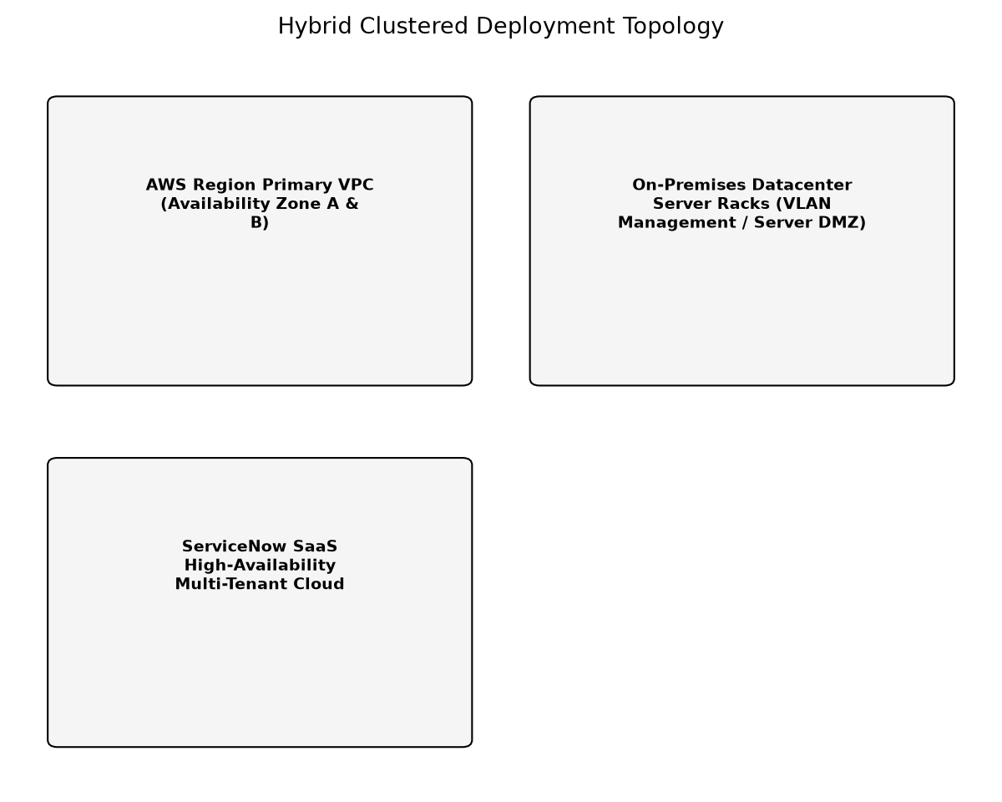

Hybrid Distributed MID Server Clustering and Ingress Architecture
Evaluation of distributed MID Server clustering across AWS and on-premises datacenters versus centralized or direct discovery architectures.
Strengths:
• Maintains strict zero-inbound security boundary across AWS VPCs and physical on-premise subnets
• Provides resilience through localized discovery execution and active-active cluster failover
• Minimizes cross-site network traffic over hybrid WAN / Direct Connect links
• Enables high-throughput discovery scaling beyond 50,000 CIs and 100,000 software records within an 8-hour window
Weaknesses:
• Requires compute capacity and operational maintenance across both AWS and on-premises hosting environments
• Requires separate credential vault broker configurations for AWS Secrets Manager and on-premises CyberArk CCP
Risks:
• Operational overhead in managing multiple MID clusters across hybrid environments, mitigated by Terraform automation and progressive auto-upgrade rings
• Potential configuration drift across MID instances, mitigated by centralized ServiceNow MID Server configuration profiles
Alternatives Considered
Direct SaaS Discovery without MID Servers
Conducting discovery directly from ServiceNow cloud infrastructure via public/VPN routes directly targeting internal IP addresses and management interfaces.
Strengths:
• Avoids hosting, patching, and maintaining MID Server instances on-premise and in AWS
• Simpler operational footprint without intermediate polling agents
Weaknesses:
• Breaches strict enterprise security boundary mandate prohibiting inbound SaaS traffic
• Incompatible with isolated private subnets lacking direct public or routed VPN gateways
• High network latency and timeout frequency during bulk pattern executions
Compared to the Above:
• Direct SaaS discovery requires inbound ingress ports through enterprise perimeter firewalls and AWS Security Groups into secure internal subnets, violating enterprise zero-trust perimeter network policy. In contrast, the recommended MID Server architecture strictly enforces zero inbound firewall openings via outbound-only TLS 1.3 long-polling through the ECC Queue.
Risks:
• Severe security audit non-compliance with PCI-DSS v4.0 and ISO/IEC 27001 due to inbound cloud-to-datacenter holes
• Exposure of management planes (SSH, WMI, SNMP) to wider network transit paths
Single Centralized On-Premises MID Server Cluster
Deploying MID Server clusters exclusively within the on-premises datacenter and routing all AWS discovery traffic across AWS Direct Connect / IPSec VPN links.
Strengths:
• Single administrative location for all MID Server management, maintenance, and credentials
• Reduced host compute infrastructure footprints
Weaknesses:
• Substantial bandwidth consumption over corporate hybrid WAN circuits
• Increased latency for AWS Cloud API and EC2 workload scanning
• Coupled availability failure domain across cloud and on-premises environments
Compared to the Above:
• While centralized MID servers simplify host management, routing all AWS discovery through on-premises WAN/DirectConnect links creates an unnecessary transit bottleneck and introduces cross-environment network latency. Clustered local MID servers ensure traffic locality and provide resilience through independent regional operation.
Risks:
• Saturation of Direct Connect / VPN bandwidth during concurrent deep discovery runs
• Failure of hybrid WAN link halts all AWS cloud resource and software asset discovery
Recommendation: Adopt a regionally segmented, clustered MID Server deployment architecture with dedicated active-active clusters deployed locally within AWS VPCs and on-premises VMware environments. All MID servers initiate outbound-only TLS 1.3 polling to the ServiceNow ECC Queue, leverage local enterprise credential vaults (AWS Secrets Manager and CyberArk CCP), and feed discovery payloads to the Identification and Reconciliation Engine (IRE) and SAM/HAM lifecycle tables.

6.0 Architecture Flow Diagram
This section provides a high-level visualization of the architecture and the flow between its major components.
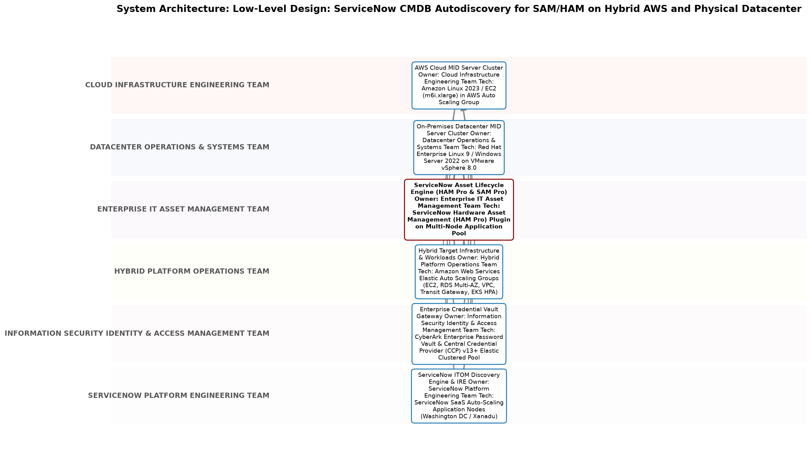

7.0 Quality Attributes
This section defines the quality attributes this design targets, mapped to ISO/IEC 25010 product quality characteristics.
Category | Description | Measure Method | Metric | Target
Maintainability (modularity) | • Standardization of CI models, discovery patterns, and automated lifecycle synchronization between CMDB and asset tables (HAM/SAM). | • CMDB Data Quality dashboard metrics, CSDM 4.0 compliance audits, and automated pattern deployment pipeline tests. | CSDM 4.0 compliance percentage and duplicate CI rate | CSDM 4.0 data modeling compliance > 95%; duplicate CI rate < 0.1% of total estate
Performance Efficiency (time_behavior) | • High-throughput processing of discovery schedules, probes, and sensor payloads within designated off-peak operational maintenance windows. | • End-to-end timing of discovery schedules covering 50,000 CIs and 100,000 software records; ECC Queue processing latency monitoring. | Discovery window completion time and ECC Queue processing latency | Complete discovery cycle within 8 hours; maintain ECC Queue queue depth below 5,000 messages
Reliability (availability) | • The discovery architecture must ensure high availability and resilient operations across hybrid environments without dropping discovery job state during node failure. | • Synthetic cluster failover testing and continuous monitoring of ECC Queue retry counts during MID server termination. | Discovery pipeline availability and cluster failover completion time | 99.9% discovery pipeline availability; automated cluster failover under 60 seconds
Reliability (fault_tolerance) | • Recovery Time Objective (RTO) for discovery infrastructure redeployment and service restoration following major disaster or datacenter loss. | • Automated disaster recovery simulation and cluster node failover timing drills. | Recovery Time Objective (RTO) | RTO: 2 hours for complete automated redeployment of all hybrid MID Server cluster instances; sub-60 seconds for automated cluster node failover
Reliability (recoverability) | • Recovery Point Objective (RPO) defining maximum allowable operational data loss for CMDB CI and asset synchronization state. | • Database backup verification and continuous WAL journaling log validation. | Recovery Point Objective (RPO) | RPO: 1 hour for ServiceNow SaaS CMDB operational data; RPO: 0 hours for MID configurations restored via IaC Git repositories
Security (confidentiality) | • Protection of infrastructure management planes and credentials against unauthorized disclosure, tampering, or lateral movement. | • Automated static analysis, penetration testing, credential vault access audit log reviews, and perimeter firewall ingress rule verification. | Zero inbound firewall openings; zero plaintext credentials stored on disk; 100% TLS 1.3 encrypted transit. | Zero plaintext credentials; zero inbound SaaS-to-internal firewall rules; 100% mTLS / TLS 1.3 enforcement

8.0 Compliance and Standards
This section lists the standards and regulatory requirements applicable to this design, and its current compliance status against each.

8.1 Applicable Standards
The following standards apply to this design:
Standard | Body | Clause Reference | Applicability | Compliance Status
Common Service Data Model (CSDM) 4.0 | ServiceNow | CSDM 4.0 Foundation, Manage Technical Services, and Consume Domains | • Configuration Management Database structure, service modeling, and lifecycle synchronization between CMDB and HAM/SAM. | Compliant
ISO/IEC 25010:2011 Systems and software Quality Requirements and Evaluation (SQuaRE) | ISO/IEC | Clause 4 (Product Quality Model) | • Specification of quality attributes including reliability, security, performance efficiency, and maintainability. | Compliant
ISO/IEC 27001:2022 Information security, cybersecurity and privacy protection | ISO/IEC | Annex A.8 (Technological Controls - A.8.1, A.8.5, A.8.9, A.8.20, A.8.24) | • Information security governance, credential protection, network segmentation, and access control for discovery infrastructure. | Compliant
ISO/IEC/IEEE 42010:2022 Systems and software engineering — Architecture description | ISO/IEC/IEEE | Clauses 4, 5, and 6 (Architecture Description Elements) | • Architectural conceptual modeling, viewpoint and view definition, and stakeholder concern mapping. | Compliant

8.2 Regulatory Requirements
The following regulatory requirements apply to this design:
Regulation | Jurisdiction | Requirement | Compliance Status
PCI-DSS v4.0 | Global | • Requirement 1 (Network Security Controls) and Requirement 2 (Secure Configurations) mandating strict inbound network blocking and automated, comprehensive asset inventory within cardholder environments. | Compliant
SOC 2 Type II (Trust Services Criteria) | North America / Global | • Common Criteria 6.1, 6.6, and 7.1 requiring logical boundary protection, dynamic vulnerability management, and authorized asset identification. | Compliant

9.0 Risk Register
This section documents the risks identified for this design, their likelihood and impact, and the mitigations in place.
ID | Category | Likelihood | Impact | Description | Mitigation
REG-RSK-001 | Security | Low | High | • Compromise of MID Server host instance could provide lateral network access to discovered subnets. | • Harden MID Server host operating systems according to CIS Benchmarks; isolate MID instances in dedicated management subnets/VPCs; enforce egress security groups permitting traffic only to target management ports; ensure no plaintext credentials reside on host.
REG-RSK-002 | Compliance | Low | High | • Untracked cloud resources or rogue datacenter hardware escaping discovery boundaries leading to licensing audit non-compliance. | • Implement automated AWS CloudWatch and AWS Config event triggers to invoke Discovery when new EC2 instances are created; perform weekly automated IP range subnet reconciliation between IPAM and ServiceNow Discovery schedules.
REG-RSK-003 | Operational | Low | Medium | • Mid Server auto-upgrade failure during progressive ServiceNow family release cycles causing discovery outage. | • Configure MID Server progressive upgrade rings: upgrade staging MID cluster first; validate probe execution before automatically rolling out to production clusters.

10.0 Governance Requirements
The following governance requirements apply to this architecture:
• All discovery schedules must be reviewed and approved by the Change Advisory Board (CAB) to avoid scanning during critical production business windows.
• CI Class Models and IRE reconciliation rules must undergo Configuration Control Board (CCB) review prior to deployment to preserve CMDB data integrity.
• Credential vault access logs and discovery account permissions must be audited quarterly by the Enterprise Information Security Office.
• New discovery IP ranges or AWS account onboardings must follow automated CI lifecycle governance with mandatory ownership assignment under CSDM 4.0.

11.0 Continuous Improvement
The following continuous improvement practices apply to this architecture:
• Review Frequency: Monthly ITOM/ITAM Architecture Operations Review
Improvement Inputs:
• MID Server thread utilization metrics and discovery probe execution duration logs
• IRE duplicate CI logs, reclassification errors, and identification rule match failures
• SAM Pro unnormalized software model queues and pattern library monthly updates
• Network discovery timeout rates and credential authentication failure dashboards

PART II: LOW-LEVEL DESIGN (LLD)

12.0 Low-Level Design
This part elaborates the High-Level Design (Part I) into implementation-ready detail, organised by design discipline -- runtime behaviour, component design, interfaces, configuration, and operations -- so a reviewer interested in one discipline can find it in one place rather than across every component section.

12.1 Runtime Processing and Sequence Flows
The following sequence flows describe how this design's components interact at runtime to fulfil its key scenarios.

End-to-End On-Premises Discovery to HAM and SAM Reconciliation
Complete multi-component discovery lifecycle from schedule dispatch through ECC Queue, CyberArk credential resolution, on-premises deep probing, IRE reconciliation, to HAM asset synchronization and SAM license normalization.
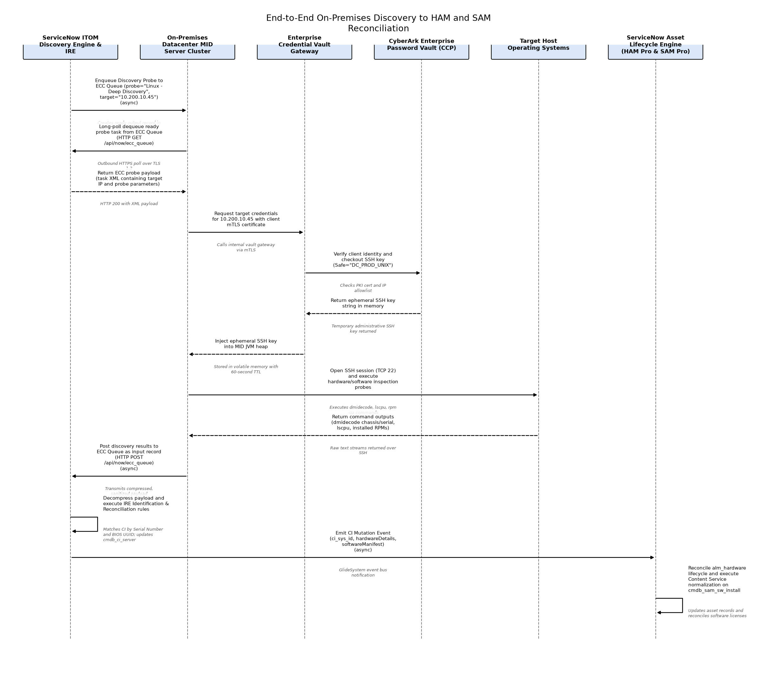

End-to-End AWS Cloud Discovery and SAM Pro Cloud Licensing Flow
Full cloud discovery sequence demonstrating cross-account IAM role assumption, AWS API querying, guest OS discovery via Secrets Manager, IRE cloud reconciliation, and SAM Pro cloud BYOL calculation.
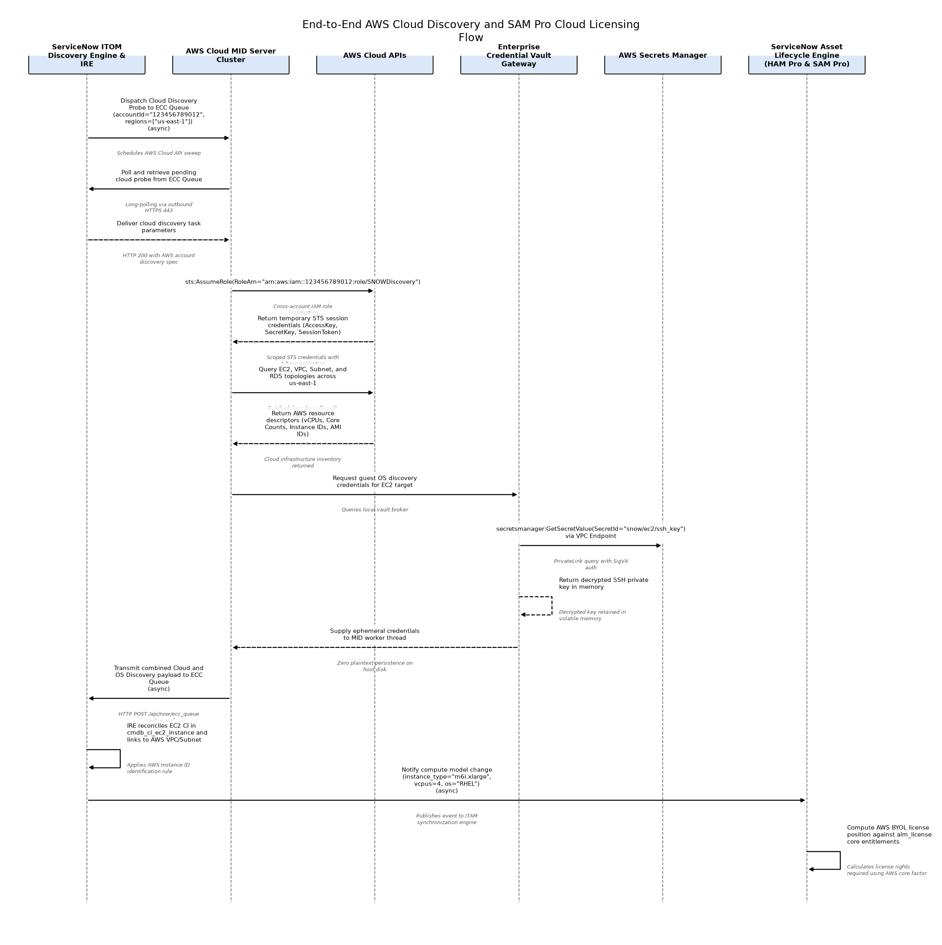

IRE Internal Identification and Attribute Reconciliation
Details the internal sequence when a decompressed discovery payload is processed by the IRE Engine and Reconciliation Manager, resolving duplicates and persisting changes.
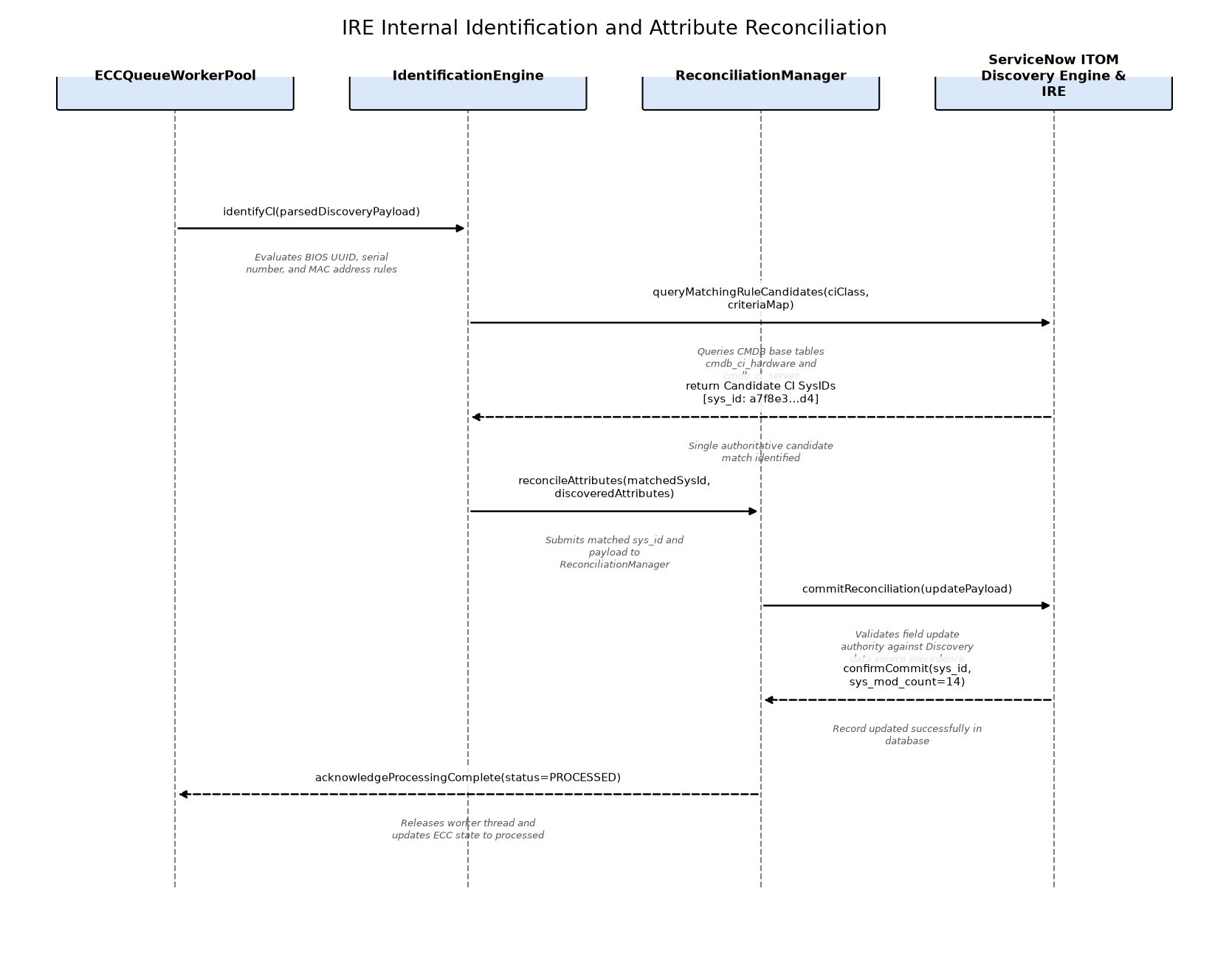

AWS Cloud MID Cross-Account Discovery Flow
Orchestrates cross-account IAM role assumption, AWS resource querying, guest OS secret retrieval, and payload delivery to ServiceNow SaaS.
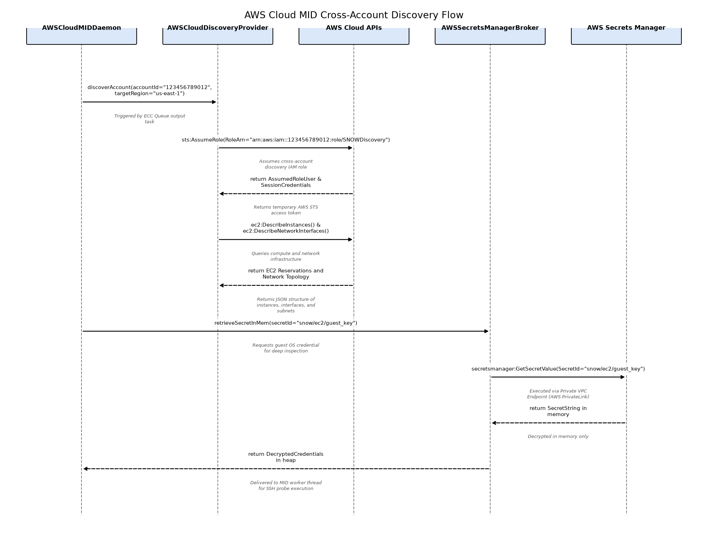

On-Premises Shazzam Sweep and Deep OS Discovery
Illustrates datacenter IP range sweeping, CyberArk credential checkout, and deep host interrogation.
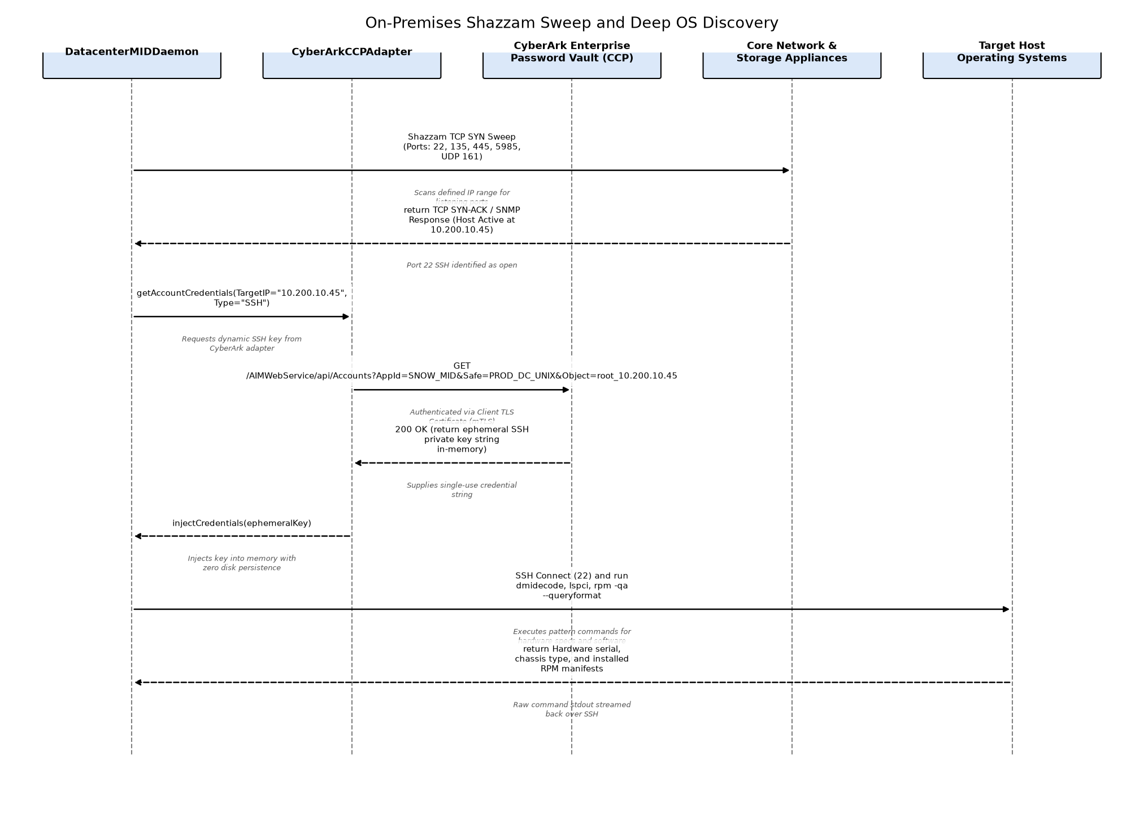

Credential Vault Dynamic Check-out and SIEM Audit Flow
Validates MID Server client certificate, queries target secret from CyberArk/AWS Secrets Manager, and emits audit event to enterprise SIEM.
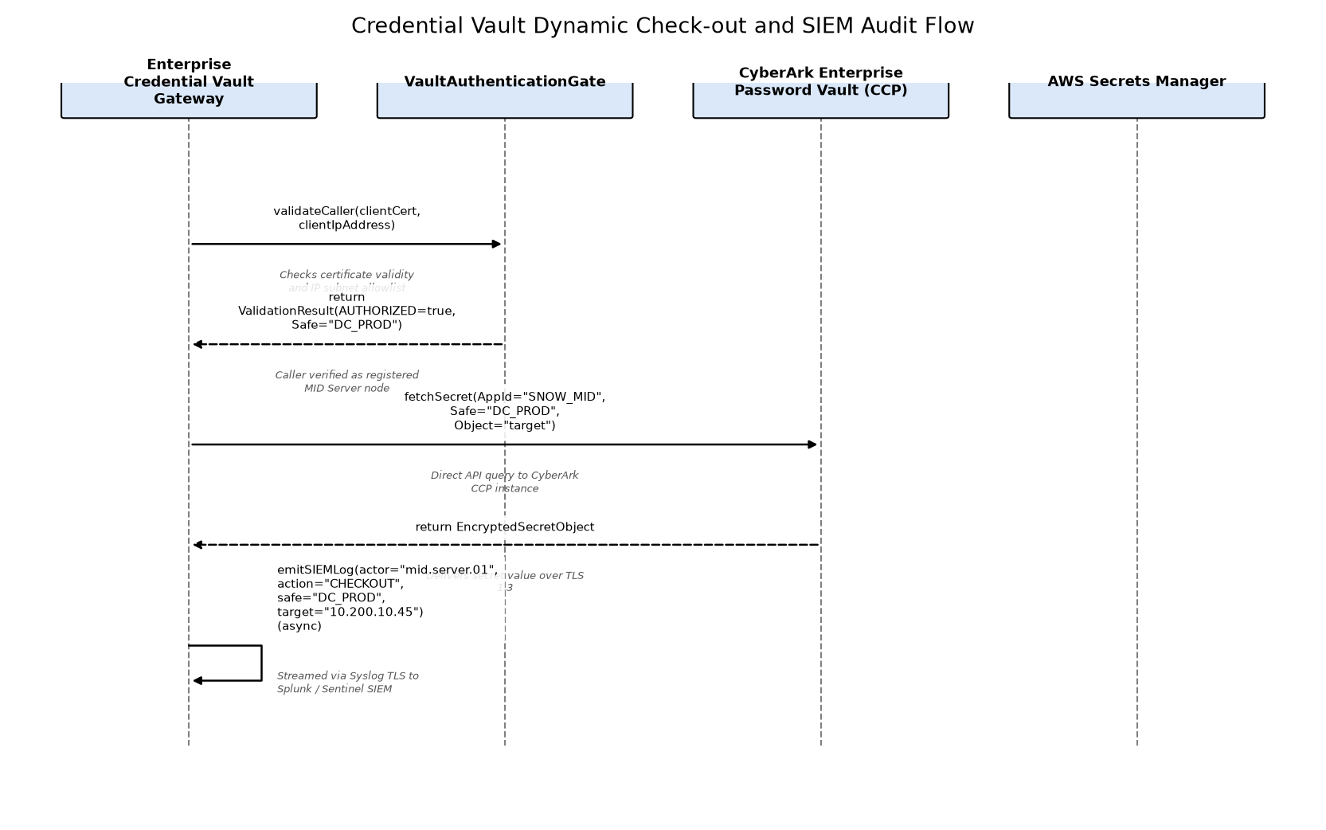

CMDB to HAM/SAM Asset Lifecycle Synchronization Flow
Executes when IRE confirms a CI mutation, updating alm_hardware lifecycle and triggering SAM software normalization.
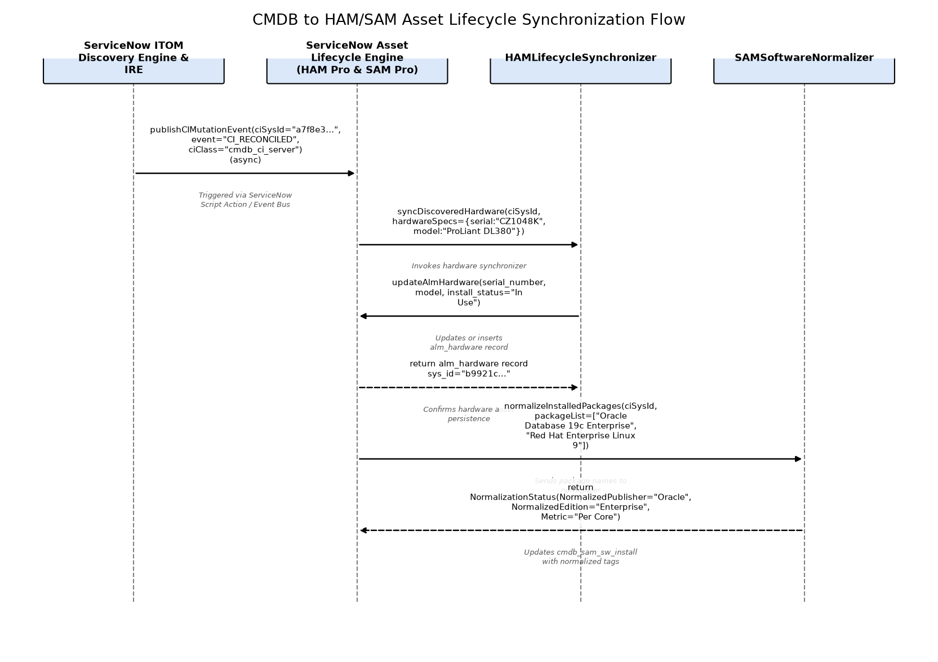

12.2 Component Design
The following describes each component's purpose, responsibilities, dependencies, key design decisions, and scope and operational boundaries.

AWS Cloud MID Server Cluster
Clustered Java MID Server daemon running on Amazon Linux 2023 EC2 instances in an Auto Scaling Group across multiple AWS Availability Zones. Polling the ServiceNow ECC Queue over outbound TLS 1.3, it executes AWS Cloud Discovery via IAM cross-account AssumeRole, fetches secrets dynamically from AWS Secrets Manager VPC Endpoints, and interrogates EC2 guest operating systems.
Responsibilities:
• Long-poll ServiceNow ECC Queue over outbound HTTPS for pending cloud discovery jobs
• Perform AWS Cloud Discovery across member accounts via IAM cross-account role assumption
• Query AWS Cloud Control Plane APIs for VPC, subnet, EC2, and RDS configuration items
• Retrieve ephemeral guest OS credentials from AWS Secrets Manager via PrivateLink VPC endpoints
• Execute agentless SSH/WinRM deep discovery probes against AWS EC2 instances and stream payloads to ECC Queue
Dependencies:
• ServiceNow ITOM Discovery Engine & IRE
• Enterprise Credential Vault Gateway
• Hybrid Target Infrastructure & Workloads
Key Design Decisions:
• Deploy dedicated MID Server cluster within AWS VPCs across multiple AZs to ensure cloud discovery traffic remains localized and avoids corporate WAN saturation.
• Utilize AWS STS cross-account IAM AssumeRole for multi-account discovery, eliminating static access keys and enforcing least privilege.
Scope and Operational Boundaries: Responsible for AWS cloud API discovery and guest OS interrogation of cloud compute instances within customer AWS accounts. It is NOT responsible for on-premises datacenter scanning or CMDB reconciliation.
Technology Stack:
• Amazon Linux 2023 / EC2 (m6i.xlarge) in AWS Auto Scaling Group
• Eclipse Temurin OpenJDK 17 64-Bit Runtime
• AWS Systems Manager (SSM Agent)
• ServiceNow MID Server Daemon v24+

Enterprise Credential Vault Gateway
Centralized credential governance and dynamic brokering service unifying CyberArk Central Credential Provider (on-premises) in an active-active clustered pool and AWS Secrets Manager (AWS cloud) via PrivateLink VPC endpoints. Enforces automated credential rotation, strict mTLS/IAM authentication, IP allow-listing, and audit logging for all MID Server discovery requests.
Responsibilities:
• Authenticate MID Server requests using mTLS client certificates (on-premises) and IAM SigV4 (AWS)
• Enforce IP allow-listing and safe/secret authorization policies
• Retrieve ephemeral administrative credentials from CyberArk Vault and AWS Secrets Manager
• Stream CEF-formatted audit events to enterprise SIEM for every credential checkout
• Coordinate credential rotation schedules with ServiceNow discovery maintenance windows
Key Design Decisions:
• Unify on-premises and cloud credential retrieval behind standard HTTPS REST interfaces tailored to each environment's native security model.
• Enforce memory-only credential lifecycle with zero host file system persistence and strict session TTLs.
Scope and Operational Boundaries: Responsible for secure credential storage, dynamic retrieval, and audit logging. It does NOT initiate discovery scans or execute commands on target infrastructure.
Technology Stack:
• CyberArk Enterprise Password Vault & Central Credential Provider (CCP) v13+ Elastic Clustered Pool
• AWS Secrets Manager Elastic Auto-Scaling Serverless VPC Endpoints (AWS PrivateLink)
• F5 BIG-IP Local Traffic Manager (LTM) Clustered Load Balancer Pair
• Mutual TLS (mTLS) with Enterprise PKI Client Certificates

Hybrid Target Infrastructure & Workloads
The target multi-cloud and on-premises operational infrastructure estate undergoing automated discovery, featuring AWS Auto Scaling compute groups, VMware DRS dynamic clusters, and redundant physical enterprise infrastructure. Responds to authenticated, read-only discovery queries across SSH, WinRM, WMI, and SNMPv3.
Responsibilities:
• Host enterprise business applications, databases, and microservices workloads
• Maintain hardened management daemons (sshd, WinRM, snmpd) bound to private management interfaces
• Authenticate discovery service accounts using SSH keys, Kerberos, or SNMPv3 credentials
• Execute designated read-only diagnostic commands via restricted sudoers configurations
• Stream hardware inventory, CPU socket/core topology, and installed package manifests to MID probes
Key Design Decisions:
• Enforce strict least-privilege read-only sudoers wrappers for discovery commands, eliminating root or administrative write access.
• Restrict management interfaces to dedicated management VLANs / VPC security groups reachable only from designated MID Server IP pools.
Scope and Operational Boundaries: The estate being interrogated. It is NOT responsible for initiating connections to MID Servers or ServiceNow SaaS.
Technology Stack:
• Amazon Web Services Elastic Auto Scaling Groups (EC2, RDS Multi-AZ, VPC, Transit Gateway, EKS HPA)
• VMware vSphere 7/8 Virtualization Infrastructure with Elastic Distributed Resource Scheduler (DRS) and HA Clustering
• Physical Bare-Metal Servers with Redundant Out-of-Band Management (Dell PowerEdge, HPE ProLiant, IBM AIX)
• Network Appliances in Clustered Elastic HA Pairs (Cisco Catalyst/Nexus, Palo Alto Networks, F5 BIG-IP)

On-Premises Datacenter MID Server Cluster
High-availability cluster of dedicated MID Servers deployed on VMware vSphere infrastructure across redundant physical server racks. Responsible for Shazzam IP range scanning, deep interrogation via SSH, WinRM, WMI, and SNMPv3, VMware vCenter hypervisor mapping, and dynamic credential retrieval from CyberArk Central Credential Provider (CCP).
Responsibilities:
• Long-poll ServiceNow ECC Queue over outbound TLS 1.3 via corporate proxy for datacenter discovery schedules
• Execute multi-threaded Shazzam TCP/UDP port sweeps across datacenter CIDR blocks
• Classify discovered IP endpoints into target device classes (Linux, Windows, Network, Storage)
• Dynamically retrieve target administrative credentials from CyberArk CCP using client certificates
• Interrogate target physical servers, hypervisors, and network appliances via SSH, WinRM, WMI, and SNMPv3
• Transmit compressed, credential-sanitized discovery payloads to ServiceNow ECC Queue
Dependencies:
• ServiceNow ITOM Discovery Engine & IRE
• Enterprise Credential Vault Gateway
• Hybrid Target Infrastructure & Workloads
Key Design Decisions:
• Distribute MID Server VMs across separate physical ESXi hosts and server racks with VMware HA and anti-affinity rules to provide high availability.
• Integrate with CyberArk CCP via mTLS to pull credentials into volatile memory at runtime, avoiding credential caching on local disk.
Scope and Operational Boundaries: Responsible for physical and virtual datacenter infrastructure scanning within corporate on-premises subnets. It is NOT responsible for AWS cloud resource discovery or ServiceNow CMDB table writes.
Technology Stack:
• Red Hat Enterprise Linux 9 / Windows Server 2022 on VMware vSphere 8.0
• Eclipse Temurin OpenJDK 17 64-Bit Runtime
• CyberArk Central Credential Provider (CCP) SDK
• ServiceNow MID Server Daemon v24+

ServiceNow Asset Lifecycle Engine (HAM Pro & SAM Pro)
Integrated Asset Management processing engine operating within ServiceNow SaaS multi-node cluster. Consumes reconciled CMDB CI events from the IRE, manages hardware asset lifecycles (alm_hardware) with chassis, serial, and model synchronization, normalizes installed software (cmdb_sam_sw_install) via the ServiceNow Content Library, and reconciles software entitlements (alm_license) including AWS cloud licensing models.
Responsibilities:
• Listen for IRE CI reconciliation events and automatically synchronize alm_hardware lifecycle records
• Synchronize serial numbers, asset tags, models, chassis, and operational statuses between CMDB and HAM
• Filter out ephemeral container noise (EKS/ECS) to protect SAM tables from transient installation records
• Execute Content Service machine learning tokenization to normalize software publishers, products, versions, and editions
• Reconcile normalized software installs against alm_license entitlements and calculate cloud BYOL license metrics
Dependencies:
• ServiceNow ITOM Discovery Engine & IRE
Key Design Decisions:
• Decouple CMDB CI updates from ITAM lifecycle processing via asynchronous event triggers (publishCIMutationEvent) to ensure high IRE ingestion performance.
• Implement container installation filtering at the ingestion boundary to prevent SAM table pollution and license compliance distortion.
Scope and Operational Boundaries: Responsible for asset lifecycles, software normalization, and license compliance calculations. It is NOT responsible for executing discovery probes or managing network infrastructure.
Technology Stack:
• ServiceNow Hardware Asset Management (HAM Pro) Plugin on Multi-Node Application Pool
• ServiceNow Software Asset Management (SAM Pro) Plugin with Distributed Engine
• ServiceNow Content Service Machine Learning Normalization Engine with Elastic Worker Queue

ServiceNow ITOM Discovery Engine & IRE
Centralized SaaS orchestration engine managing discovery schedules, queuing probes into the ECC Queue, executing the Identification and Reconciliation Engine (IRE) to enforce CSDM 4.0 data modeling rules, and publishing CI mutation events to HAM and SAM lifecycle handlers across an elastic multi-node application cluster.
Responsibilities:
• Orchestrate enterprise discovery schedules across hybrid AWS and on-premises environments
• Format and dispatch discovery probe commands to the ECC Queue
• Dequeue and decompress input sensor payloads from clustered MID Servers
• Execute Identification and Reconciliation Engine (IRE) identifier and reconciliation rules to prevent duplicates
• Publish reconciled CI mutation events to downstream HAM Pro and SAM Pro lifecycle consumers
Dependencies:
• Hybrid Target Infrastructure & Workloads
Key Design Decisions:
• Leverage ServiceNow native Identification and Reconciliation Engine (IRE) rather than custom scripts to enforce CSDM 4.0 compliance and prevent duplicate records.
• Deploy across ServiceNow Advanced High Availability (AHA) multi-node cluster with dynamic worker thread pooling to prevent ECC Queue ingestion bottlenecks.
Scope and Operational Boundaries: Responsible exclusively for discovery scheduling, ECC Queue management, payload parsing, and CMDB CI reconciliation inside the ServiceNow SaaS instance. It is NOT responsible for executing network probes directly against target endpoints or managing physical asset financial ledgers.
Technology Stack:
• ServiceNow SaaS Auto-Scaling Application Nodes (Washington DC / Xanadu)
• Percona MariaDB Clustered Relational Database Engine with Read Replicas
• Rhino / ES2021 JavaScript Execution Runtime with Elastic Worker Pool
• ServiceNow Advanced High Availability (AHA) Architecture

12.3 Interface Design
The following interfaces are exposed or consumed by this design's components.
Interface | Owning Component | Protocol | Authentication | Error Handling
ServiceNow ECC Queue Long-Polling and Response REST Interface | — | REST | Mutual TLS (mTLS) with X.509 client certificate and HTTP Basic Auth with encrypted token for 'mid_server' user | • HTTP 401 Unauthorized on cert/token expiration; HTTP 429 Rate Limited backoff; HTTP 500 logs fatal transmission failure.
CyberArk Central Credential Provider Web Service | — | REST | mTLS with Enterprise CA-signed client certificate verified against CyberArk IIS web server | • HTTP 404 Account Not Found; HTTP 403 Forbidden; HTTP 500 Vault Unavailable.
AWS Secrets Manager VPC Endpoint Interface | — | REST | AWS Signature Version 4 (SigV4) using attached IAM instance profile | • AWS ResourceNotFoundException, AccessDeniedException, ThrottlingException with exponential backoff.
ServiceNow Identification and Reconciliation Engine (IRE) REST Interface | — | REST | OAuth 2.0 Bearer Token or Mutual TLS (mTLS) with itil_admin / mid_server role | • HTTP 400 Bad Request; HTTP 409 IRE Duplicate Detection Task Generated; HTTP 500 Internal Error.
IRE Batch Identification and Reconciliation REST API | ServiceNow ITOM Discovery Engine & IRE | REST | OAuth 2.0 Bearer Token or Mutual TLS (mTLS) Client Certificate with itil_admin / mid_server role | • HTTP 400 Bad Request on invalid payload structure; HTTP 409 Conflict on IRE identification ambiguous matches; HTTP 429 Too Many Requests when rate limit exceeded (500 req/min); detailed JSON error objects returned.
AWS Systems Manager & STS Integration Interface | AWS Cloud MID Server Cluster | REST | AWS SigV4 Authentication using EC2 Instance Metadata Service v2 (IMDSv2) Attached IAM Role | • AWS RequestLimitExceeded backoff using jittered exponential backoff; AccessDeniedException logs security audit error and halts schedule partition.
CyberArk Central Credential Provider Web Service API | On-Premises Datacenter MID Server Cluster | REST | Mutual TLS (mTLS) with Enterprise PKI Client Certificate issued to MID Server host | • HTTP 404 Account Not Found logs warning and skips target; HTTP 403 Forbidden triggers immediate security alert; HTTP 500 triggers local fallback cache if unexpired.
Enterprise Dynamic Secret Brokering API | Enterprise Credential Vault Gateway | REST | Mutual TLS (mTLS) with Enterprise Root CA verification and AWS IAM SigV4 cross-account delegation | • HTTP 401 Unauthorized on invalid certificate; HTTP 403 Forbidden on safe policy violation; HTTP 404 Account Not Found; detailed error log dispatched to SIEM.
ServiceNow ITAM Asset Synchronization Internal Bus | ServiceNow Asset Lifecycle Engine (HAM Pro & SAM Pro) | REST | ServiceNow Internal Session Authentication / Scoped Script Access | • Asset reconciliation mismatch logs an asset anomaly task; software normalization rule missing queues record for Content Service Machine Learning analysis.
Target Host Management Diagnostic Interfaces (SSH / WinRM / SNMPv3) | Hybrid Target Infrastructure & Workloads | REST | SSH RSA-4096 / WinRM Kerberos / SNMPv3 USM SHA-256 Auth + AES-256 Encryption | • Connection refused or auth failure returned over native protocol socket.

12.4 Configuration Design
The following consolidates the key configuration parameters for each component.

ServiceNow ITOM Discovery Engine & IRE
Default Value | Description | Name | Type
500 | Maximum number of CI payload items processed concurrently by the IRE engine in a single batch | glide.identification_engine.batch_size | Integer
300 | Timeout in seconds before an active MID Server probe is marked timed out in the ECC Queue | glide.discovery.probe.timeout_seconds | Integer
40 | Maximum number of worker threads allocated for concurrent sensor parsing from the ECC Queue | glide.ecc_queue.max_active_processing_jobs | Integer

AWS Cloud MID Server Cluster
Default Value | Description | Name | Type
2 | Long polling interval in seconds between MID daemon checks for ECC Queue tasks | mid.poll.time | Integer
10 | Maximum number of AWS accounts scanned simultaneously by a single MID instance | mid.aws.max_concurrent_account_scans | Integer
15000 | SSH TCP socket connection timeout in milliseconds for guest OS probes | mid.property.ssh.connection_timeout_ms | Integer

On-Premises Datacenter MID Server Cluster
Default Value | Description | Name | Type
100 | Concurrent socket threads used during initial Shazzam IP range sweep | mid.shazzam.threads | Integer
5000 | SNMPv3 response timeout in milliseconds before port retry is abandoned | mid.snmp.timeout_ms | Integer
60 | Duration in seconds to hold retrieved credentials in volatile JVM memory before purge | mid.cyberark.cache_duration_sec | Integer

Enterprise Credential Vault Gateway
Default Value | Description | Name | Type
true | Mandate Certificate Revocation List (CRL) check on every MID client connection | vault.mtls.enforce_strict_crl | Boolean
120 | Maximum valid lifetime in seconds for temporary discovery session tokens | vault.access.session_ttl_sec | Integer

ServiceNow Asset Lifecycle Engine (HAM Pro & SAM Pro)
Default Value | Description | Name | Type
true | Automatically create an alm_hardware asset record when a new hardware CI is created via Discovery | glide.itam.ham.auto_create_asset_on_ci_insert | Boolean
true | Filter out software packages running inside transient containers (EKS/ECS) from polluting cmdb_sam_sw_install | glide.itam.sam.exclude_ephemeral_container_installs | Boolean
true | Participate in ServiceNow Content Service crowdsourced software normalization rule library | glide.itam.sam.content_service.opt_in | Boolean

Hybrid Target Infrastructure & Workloads
Default Value | Description | Name | Type
/bin/bash | Restricted shell environment configured for the ServiceNow discovery service account on Linux/Unix targets | target.discovery.service_account_shell | String

12.5 Operational Design
The following consolidates monitoring, logging, alerting, capacity, and error-recovery behaviour across this design's components.
Exception Handling Strategy: Comprehensive multi-tier exception handling architecture: 1) Network & Transport Layer: MID Server long-polling failures trigger exponential backoff (2s, 4s, 8s up to 60s) with local queue preservation; socket timeouts (SSH 15s, WinRM 20s, SNMP 5s) mark unreachable IPs with 'Skipped - Port Unresponsive' without terminating schedule batches. 2) Credential & Authentication Layer: In-memory credential lookups that fail with HTTP 401/403 or Vault timeouts automatically retry against secondary clustered vault endpoints; permanent credential failures log a masked 'Authentication Failure' audit record and create an automated ServiceNow incident routed to the IAM Operations team. 3) ECC Queue Backpressure: When active ECC input depth exceeds 5,000 items, the DiscoveryScheduleCoordinator dynamically pauses pending schedule dispatches and scales ServiceNow background worker threads from 40 to 80. 4) IRE Data Integrity Layer: Ambiguous identification matches (multiple CIs matching identification criteria) trigger immediate creation of an IRE De-duplication Task, leaving existing CMDB records immutable to prevent data corruption. Reclassification mismatches (e.g. server re-imaged as router) are isolated in a staging table pending CCB manual approval. 5) ITAM Synchronization Discrepancies: Hardware model anomalies generate HAM reconciliation tasks; unnormalized software packages default to 'Unnormalized' status and trigger automated asynchronous submission to ServiceNow Content Service Machine Learning pipelines. 6) Cluster Node Outage: Automatic MID cluster heartbeat polling detects node failure within 60 seconds; uncompleted probes in 'processing' state are automatically reset to 'ready' in the ECC Queue and reassigned to surviving cluster nodes.

ServiceNow ITOM Discovery Engine & IRE

Logging And Monitoring
Monitored Metrics:
- ecc_queue.input.latency_seconds
- ecc_queue.backlog_depth
- ire.reconciliation.insert_rate_per_min
- ire.reconciliation.duplicate_rate
Alerting Rules:
- ECC queue depth > 5000 for > 15 minutes triggers P2 alert to ITOM Operations
- IRE duplicate creation rate > 1.0% triggers P3 data integrity warning
Log Levels:
- ERROR
- WARN
- INFO
- DEBUG

AWS Cloud MID Server Cluster

Logging And Monitoring
Log Levels:
- ERROR
- WARN
- INFO
- DEBUG
Alerting Rules:
- MID JVM heap usage > 85% for > 5 minutes triggers CloudWatch alarm and AWS SSM auto-restart
- MID heartbeat dropped for > 60 seconds triggers cluster failover rebalance
Monitored Metrics:
- mid.jvm.memory_used_mb
- mid.aws.api_calls_count
- mid.probe.active_threads
- mid.queue.processing_duration_ms

On-Premises Datacenter MID Server Cluster

Logging And Monitoring
Alerting Rules:
- CyberArk lookup failure rate > 5% triggers immediate P2 alert to Identity Operations
- MID cluster thread pool exhaustion (> 90% busy for 10 min) alerts ITOM admin
Log Levels:
- ERROR
- WARN
- INFO
- DEBUG
Monitored Metrics:
- mid.onprem.active_scans_count
- mid.cyberark.lookup_latency_ms
- mid.snmp.packet_drop_rate
- mid.shazzam.sweep_rate_ips_per_sec

Enterprise Credential Vault Gateway

Logging And Monitoring
Log Levels:
- CRITICAL
- ERROR
- WARN
- INFO
Alerting Rules:
- Authentication failure count > 3 within 1 minute generates P1 security incident in ServiceNow SecOps
- Vault backend latency > 1000ms triggers performance degradation alert
Monitored Metrics:
- vault.auth.success_count
- vault.auth.failure_count
- vault.secret.checkout_latency_ms
- vault.rotation.status

ServiceNow Asset Lifecycle Engine (HAM Pro & SAM Pro)

Logging And Monitoring
Monitored Metrics:
- itam.ham.sync_duration_ms
- itam.sam.normalization_rate_percentage
- itam.sam.unnormalized_count
- itam.license.compliance_position_score
Log Levels:
- ERROR
- WARN
- INFO
Alerting Rules:
- Software normalization rate < 90% triggers task to SAM Administrator
- Unassigned hardware assets > 100 triggers HAM audit review

Hybrid Target Infrastructure & Workloads

Logging And Monitoring
Log Levels:
- NOTICE
- INFO
- WARN
Alerting Rules: - More than 5 failed authentication attempts on discovery service account within 5 minutes triggers local account lockout alert
Monitored Metrics:
- target.sshd.auth_attempts
- target.winrm.session_count
- target.snmp.query_frequency

12.6 Detailed Engineering Design
This section is included only where the source content goes beyond architecture-level detail into concrete engineering constructs. It supports engineering implementation rather than architecture governance review, and can be skipped by reviewers focused on the latter.

ServiceNow ITOM Discovery Engine & IRE
Algorithm Details: IRE Matching and Reconciliation Algorithm: 1) Extract identification attributes (BIOS UUID, Serial Number, MAC Address, Name) from incoming sensor payload. 2) Evaluate against CI Class Identification Rules hierarchically from child (cmdb_ci_server) to parent (cmdb_ci_hardware). 3) Compute candidate matches using exact match and rule priorities. If multiple distinct records match, flag as Ambiguous Match and generate De-duplication Task. If single candidate matches, calculate attribute precedence against DataSource Precedence rules. If Discovery precedence is higher than existing source, apply field-level mutation; otherwise preserve existing value. 4) Commit transaction and trigger post-reconciliation business rules and ITAM event listeners.
Unit Test Strategy: Unit and integration testing executed using ServiceNow Automated Test Framework (ATF) and Jasmine test suites. Test scenarios cover single-attribute match (BIOS UUID), multi-attribute composite match (Serial + MAC), duplicate detection raising de-duplication tasks, data source precedence overrides, and CSDM 4.0 technical service relationship creation.

Class Design

Classes
Attributes | Class Name | Design Patterns Used | Methods
- identificationRules: Map<String, Rule>  - reconciliationPrecedence: PrecedenceTable  - eccQueueBuffer: Deque<Payload> | IdentificationEngineService | - Strategy Pattern  - Chain of Responsibility  - Service Locator | - processPayload(payload: JsonObject): IdentificationResult  - matchCandidate(criteria: Criteria): List<SysId>  - applyPrecedence(targetCi: SysId, updates: Map): MutationSummary
- taskQueue: List<DeduplicationTask>  - logger: Logger | DeduplicationHandler | - Observer Pattern  - Factory Pattern | - createTask(duplicates: List<SysId>, payload: JsonObject): SysId  - quarantineAmbiguousPayload(payload: JsonObject): void

IRE Service Class Diagram
UML Class diagram showing IdentificationEngineService coordinating candidate matching, precedence resolution, and deduplication handling.
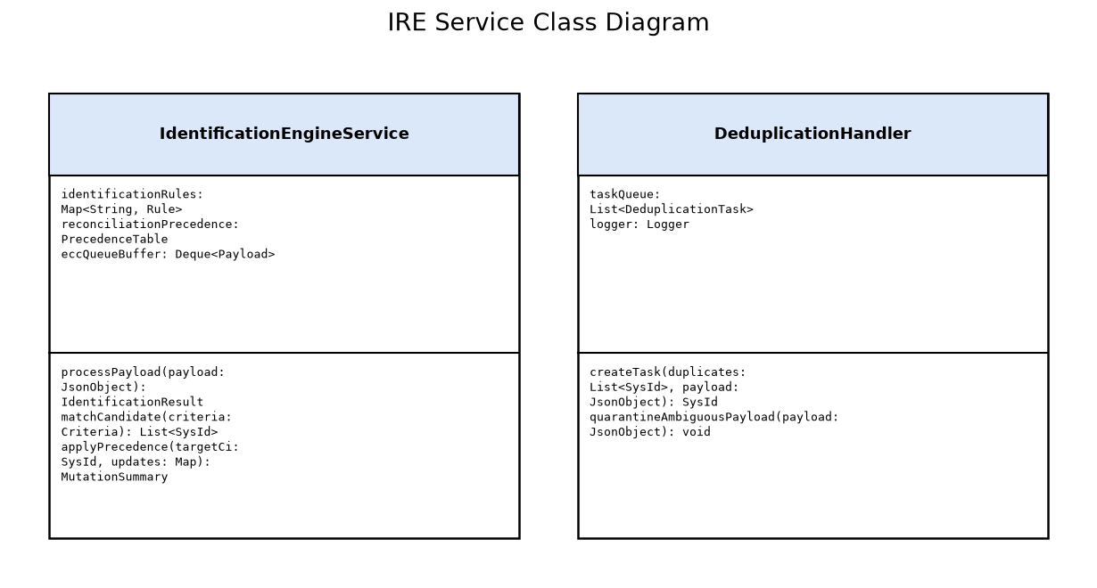

AWS Cloud MID Server Cluster
Algorithm Details: AWS Multi-Account Discovery Scheduling Algorithm: 1) Retrieve discovery schedule parameters from ECC Queue output record. 2) Assume target cross-account IAM role via AWS STS AssumeRole with 3600-second session TTL. 3) Enumerate VPCs, subnets, EC2 instances, and RDS databases using paginated AWS SDK Describe API calls with exponential jitter backoff. 4) For each active EC2 compute instance, query AWS Secrets Manager for guest OS SSH key. 5) Dispatch concurrent SSH probe threads via MID thread pool. 6) Aggregate inventory JSON, compress with GZIP, and stream input record back to ECC Queue.
Unit Test Strategy: JUnit 5 and Mockito test suites mocking AWS Java SDK v2 client calls (EC2, STS, Secrets Manager). Tests validate STS AssumeRole failure handling, rate-limiting retry exponential backoff, private IP probe timeouts, credential caching eviction, and payload compression integrity.

Class Design

Classes
Attributes | Class Name | Design Patterns Used | Methods
- stsClient: StsClient  - secretsBroker: AwsSecretsBroker  - threadPool: ThreadPoolExecutor | AwsCloudDiscoveryCollector | - Worker Thread Pool  - Adapter Pattern  - Template Method | - collectAccount(accountId: String, region: String): DiscoveryResult  - discoverEc2Topology(ec2Client: Ec2Client): List<Ec2InstanceData>  - executeGuestProbe(ip: String, cred: SshKey): HostManifest

AWS MID Collector Class Diagram
UML Class diagram depicting AwsCloudDiscoveryCollector, credential brokers, and execution worker threads.
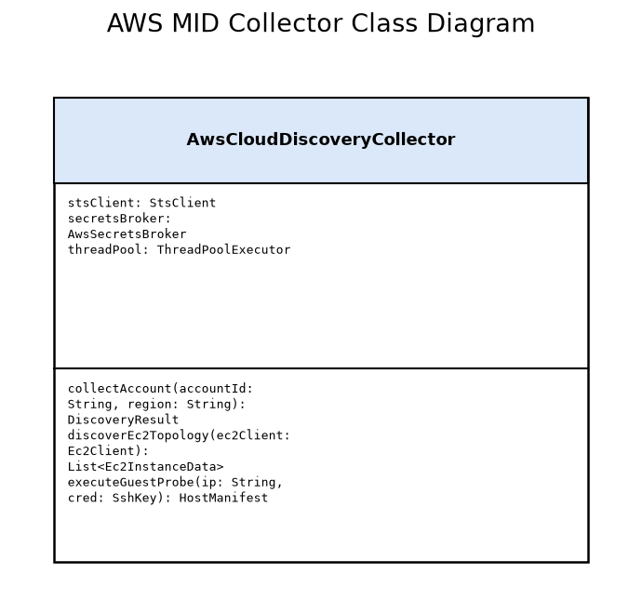

On-Premises Datacenter MID Server Cluster
Algorithm Details: Datacenter Discovery and Shazzam Sweep Algorithm: 1) Receive IP CIDR range from ECC Queue. 2) Spawn asynchronous socket sweep threads (Shazzam) to ping target ports (TCP 22, 135, 445, 5985, UDP 161). 3) For responsive IP addresses, classify device type based on port profile (SSH -> Linux/Unix, WMI/WinRM -> Windows, SNMP -> Network/Storage). 4) Request target administrative credentials from CyberArk CCP over mTLS REST endpoint. 5) Retain credential in ephemeral JVM memory with 60-second TTL. 6) Execute deep diagnostic patterns (dmidecode, lspci, rpm -qa, Get-WmiObject). 7) Parse pattern results, scrub sensitive strings, encrypt, and push to ECC Queue.
Unit Test Strategy: JUnit 5, WireMock (for CyberArk CCP and ServiceNow ECC Queue simulation), and embedded Apache SSHD test server. Tests cover CIDR boundary validation, port scanner timeout handling, mTLS handshake errors, transient credential cache expiration, and pattern parsing under malformed command output.

Class Design

Classes
Attributes | Class Name | Design Patterns Used | Methods
- shazzamScanner: PortScanner  - cyberArkAdapter: CyberArkClient  - eccSender: EccQueueSender | DatacenterDiscoveryCollector | - Producer-Consumer  - Facade Pattern  - State Pattern | - executeRangeSweep(range: SubnetCidr): SweepSummary  - probeHost(target: HostTarget): DiscoveryPayload  - maskCredentials(rawOutput: String): String

Datacenter MID Collector Class Diagram
UML Class diagram showing DatacenterDiscoveryCollector integrating Shazzam port scanner and CyberArk credential adapter.
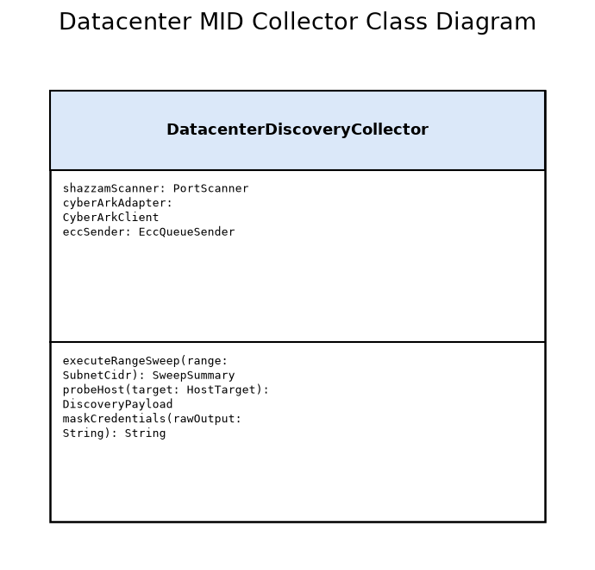

Enterprise Credential Vault Gateway
Algorithm Details: Dynamic Credential Resolution and Validation Algorithm: 1) Accept incoming credential checkout REST request from MID Server. 2) Validate caller mTLS client certificate against Enterprise PKI and check IP address against allowed MID Server subnet pool. 3) Verify caller authorization for requested Safe and Target Object. 4) Issue synchronous HTTPS request to CyberArk Central Credential Provider (on-premises) or AWS Secrets Manager (cloud). 5) Stream encrypted secret directly to caller over TLS 1.3 session with no disk persistence. 6) Asynchronously construct and emit Common Event Format (CEF) audit event to enterprise SIEM.
Unit Test Strategy: Automated security unit testing using Mockito and Spock Framework. Test suites validate CRL certificate revocation enforcement, IP spoofing rejection, safe permission checks, backend timeout failover to secondary vault nodes, and SIEM CEF audit log schema validation.

Class Design

Classes
Attributes | Class Name | Design Patterns Used | Methods
- pkiValidator: CertificateValidator  - ipFilter: SubnetFilter  - vaultConnectorPool: ConnectionPool | CredentialVaultGatewayService | - Proxy Pattern  - Decorator Pattern  - Chain of Responsibility | - authenticateCaller(cert: X509Certificate, ip: InetAddress): boolean  - fetchSecret(safe: String, target: String): EphemeralSecret  - logAuditEvent(event: AuditEvent): void

Credential Vault Gateway Class Diagram
UML Class diagram detailing authentication filters, connection pools, and secret retrieval proxies.
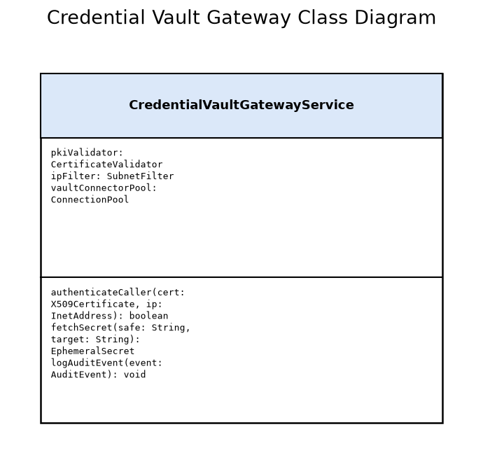

ServiceNow Asset Lifecycle Engine (HAM Pro & SAM Pro)
Algorithm Details: Asset Synchronization and Software Normalization Algorithm: 1) Consume CI mutation events from IRE bus. 2) For hardware CIs, query alm_hardware by serial number / CI sys_id. If found, synchronize operational status, model, chassis, and asset tag; if absent and auto-create enabled, generate new alm_hardware record. 3) For software packages, filter out entries flagged with transient container IDs. 4) Tokenize raw package string into publisher, product, version, and edition candidates. 5) Query ServiceNow Content Service rules library. If match identified, apply normalized taxonomy to cmdb_sam_sw_install. If unnormalized, queue record for Content Service crowdsourced rule synthesis. 6) Trigger SAM Pro reconciliation to recalculate compliance positions against alm_license.
Unit Test Strategy: ServiceNow Automated Test Framework (ATF) suites covering: hardware CI insert triggering alm_hardware creation, serial number drift detection, container software installation filtering, Content Service rule normalization hit/miss flows, and software entitlement rights deduction under Per Core and Per vCPU licensing metrics.

Class Design

ITAM Synchronization Engine Class Diagram
UML Class diagram illustrating ITAM synchronization manager coordinating HAM hardware synchronization and SAM software normalization.
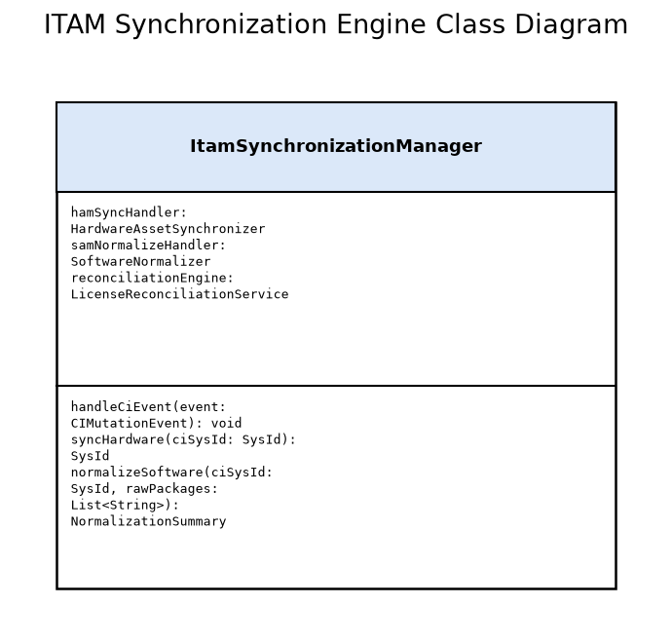

Classes
Attributes | Class Name | Design Patterns Used | Methods
- hamSyncHandler: HardwareAssetSynchronizer  - samNormalizeHandler: SoftwareNormalizer  - reconciliationEngine: LicenseReconciliationService | ItamSynchronizationManager | - Observer Pattern  - Strategy Pattern  - Mediator Pattern | - handleCiEvent(event: CIMutationEvent): void  - syncHardware(ciSysId: SysId): SysId  - normalizeSoftware(ciSysId: SysId, rawPackages: List<String>): NormalizationSummary

Hybrid Target Infrastructure & Workloads
Algorithm Details: Target Endpoint Interrogation Response Algorithm: 1) Daemon receives incoming connection request (SSH/WinRM/SNMPv3) on designated management interface. 2) Authenticate discovery service account via PKI key, Kerberos ticket, or SNMPv3 SHA/AES credentials. 3) Restrict execution environment to read-only sudoers wrapper or restricted PowerShell session. 4) Execute authorized diagnostic command queries (hardware inventory, CPU core counts, installed package lists). 5) Stream stdout back to caller and terminate session cleanly. 6) Log session start, executed command hashes, and session teardown to local security audit log.
Unit Test Strategy: Automated infrastructure compliance testing using InSpec and Ansible Molecule. Test suites verify that non-management subnets cannot reach diagnostic ports, discovery service accounts cannot run root write commands (e.g. rm, write to /etc), sudoers wrapper only permits designated read-only discovery binaries, and failed authentication attempts trigger syslog alert events.

Class Design

Classes
Attributes | Class Name | Design Patterns Used | Methods
- allowedCommands: Set<String>  - auditLogger: SyslogLogger  - authValidator: CredentialValidator | TargetDiagnosticEndpoint | - Proxy Pattern  - Command Pattern | - authenticate(credentials: Credentials): boolean  - executeCommand(command: String): CommandOutput  - logSession(session: SessionInfo): void

Target Diagnostic Endpoint Class Diagram
UML Class diagram depicting target server diagnostic daemon, authentication validation, and command execution wrapper.
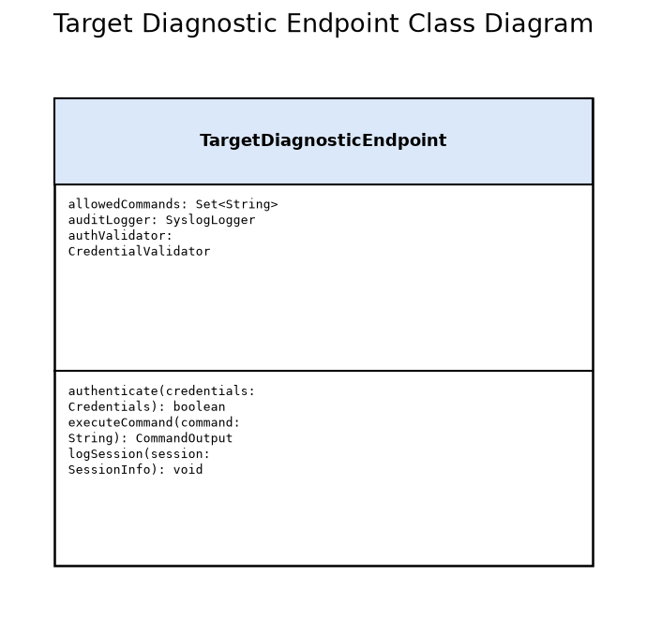

13.0 Glossary and References

13.1 Glossary
This glossary defines terms used throughout this document.
Term | Definition
CSDM 4.0 | • Common Service Data Model: A shared, prescriptive Information Architecture across ServiceNow platforms connecting technical assets to business services.
ECC Queue | • External Communication Channel: A ServiceNow database queue used to manage asynchronous bi-directional communication between the ServiceNow instance and MID Servers.
HAM Pro | • Hardware Asset Management: ServiceNow application providing advanced lifecycle control, procurement tracking, and normalization for physical and virtual hardware assets.
IRE | • Identification and Reconciliation Engine: Central ServiceNow mechanism that evaluates incoming discovery data against existing CIs to prevent duplicate records and govern field updates.
MID Server | • Management, Instrumentation, and Discovery Server: A lightweight Java application executing on internal servers to discover target infrastructure and execute automation commands.
SAM Pro | • Software Asset Management: ServiceNow application designed to normalize discovered software installations, manage software entitlements, and calculate software license compliance.

13.2 References
The following external references were used in the development of this design.
Title | Source | Version
ServiceNow ITOM Discovery Architecture and MID Server Clustering Guide (https://docs.servicenow.com/bundle/washingtondc-it-operations-management/page/product/discovery/concept/c_DiscoveryMIDServer.html) | ServiceNow Product Documentation | Washington DC / Xanadu
Common Service Data Model (CSDM) 4.0 Implementation Whitepaper (https://www.servicenow.com/community/csdm-articles/csdm-4-0-overview/ta-p/2312581) | ServiceNow Community Best Practices | 4.0
CIS Critical Security Controls Version 8 - Asset and Software Management (https://www.cisecurity.org/controls) | Center for Internet Security | 8.0

13.3 List of Figures
The following diagrams appear elsewhere in this document, indexed here for reference.
Title | Type | Notation
Hybrid ServiceNow CMDB Context Diagram | Context | C4
ServiceNow Discovery Container Architecture | Container | C4
MID Server Hybrid Deployment Topology | Deployment | C4

Appendix A: Reference Documents
The following appendix contains reference materials related to the architecture:

Notes
Discovery schedule windows are partitioned to run off-peak (00:00 to 06:00 UTC for datacenter subnets; staggered hourly intervals for dynamic AWS cloud discovery).

