SaaS L0 Value Chain
This document outlines the L0 value chain for a SaaS company, detailing the key phases and their respective processes. It provides a comprehensive overview of the activities involved in delivering and supporting high-quality SaaS products and services to customers.
Industry / Domain: SaaS
Version: 1.0
Generated On: 2026-01-22 22:22:23

Document Control
Version | Date | Author | Description
1.0

Table of Contents
Right-click and select 'Update Field' to generate the Table of Contents.

1.0 Process Overview
This document outlines the L0 value chain for a SaaS company, detailing the key phases and their respective processes. It provides a comprehensive overview of the activities involved in delivering and supporting high-quality SaaS products and services to customers.

1.1 Assumptions
- Sufficient market demand for SaaS products
- Availability of skilled personnel
- Stable economic conditions

1.2 Constraints
- Regulatory compliance (e.g., GDPR, HIPAA)
- Budget limitations
- Limited engineering resources

1.3 Purpose
To deliver and support high-quality SaaS products and services to customers.

1.4 Scope
Encompasses all activities related to the development, marketing, sales, and support of SaaS products.

1.5 Industry Sector
SaaS

2.0 Stakeholders and Responsibilities
The following is a list of key stakeholders involved in this process. Understanding their roles and responsibilities is crucial for successful implementation.
Stakeholder | Responsibilities
CEO | Overall business strategy and direction
CPO | Product strategy and roadmap
CRO | Sales and marketing strategy
CTO | Technology strategy and software development
CSO | Security and compliance
CFO | Financial planning and reporting
VP of Engineering | Software development and operations
VP of Product | Product management and design
VP of Sales | Sales execution and customer acquisition
VP of Customer Success | Customer onboarding and support
HR Director | Human resources management
Finance Director | Financial operations
Security Director | Security operations

3.0 Process Workflow
The following is a list of key steps in the process workflow.

3.1 Strategic Management
Description:
- This phase involves defining the overall business strategy and goals for the SaaS company. It includes market analysis, competitive analysis, and the development of a long-term vision.
Responsible Parties:
- CEO
Inputs:
- Market data
- Competitive intelligence
- Financial performance data
Outputs:
- Strategic goals
- Business initiatives
- Resource allocation plan
Success Criteria:
- Achievement of strategic goals
- Sustainable revenue growth
- Market share expansion

Required Sub Process(es) for the Step "Strategic Management"
The following details the subprocess flows for the step "Strategic Management".
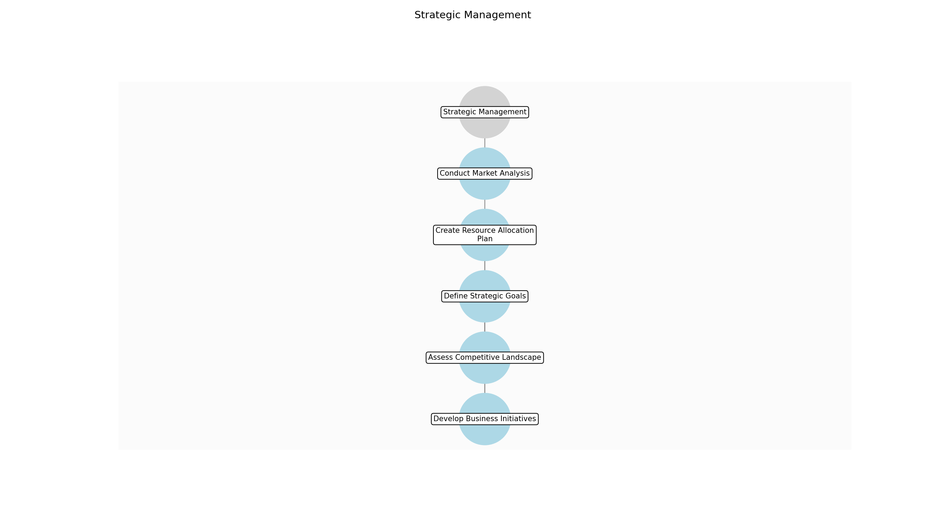

Strategic Management – Conduct Market Analysis
Description:
- The initial step involves a comprehensive analysis of the current market landscape. This includes identifying market trends, understanding customer needs, and assessing the competitive environment. The insights gained from this analysis will inform the development of the overall business strategy.
Responsible Party:
- Market Research Team
Inputs:
- Market data sources
- Industry reports
- Customer feedback
Outputs:
- Market analysis report
- Customer segmentation data
- Competitive analysis
Estimated Duration:
- 2 weeks
Dependencies:
Success Criteria:
- Comprehensive market overview
- Identification of key market trends
- Clear understanding of customer needs
Purpose:
- To gain a deep understanding of the market environment.
Scope:
- Focuses on external market factors and customer insights.
Process Owner:
- VP of Marketing
Triggers:
- Annual strategic planning cycle
- Significant market shifts
End Conditions:
- Completion of market analysis report
Step Risks and Controls:
- Risk: Inaccurate market data
- Control: Verify data from multiple sources
Governance Requirements:
- Regular review of market data sources
Change Management:
- Change Request Process: Formal change control process
- Versioning Rules: Document versioning
Continuous Improvement:
- Review Frequency: Annually
Improvement Inputs:
- Market feedback
- Performance data

Strategic Management – Assess Competitive Landscape
Description:
- This sub-step focuses on evaluating the competitive environment to identify key players, their strategies, and their market positioning. This assessment helps the company understand its competitive advantages and disadvantages, informing strategic decisions related to market positioning and differentiation. The team will analyze competitors' products, pricing, marketing, and sales strategies.
Responsible Party:
- Competitive Intelligence Team
Inputs:
- Market analysis report
- Competitor profiles
- Industry benchmarks
Outputs:
- Competitive landscape assessment
- SWOT analysis
- Competitive positioning matrix
Estimated Duration:
- 1 week
Dependencies:
- Conduct Market Analysis
Success Criteria:
- Identification of key competitors
- Understanding of competitor strategies
- Assessment of competitive advantages
Purpose:
- To understand the competitive environment and identify opportunities for differentiation.
Scope:
- Focuses on competitor analysis and market positioning.
Process Owner:
- VP of Strategy
Triggers:
- Annual strategic planning cycle
- New competitor entry
End Conditions:
- Completion of competitive landscape assessment
Step Risks and Controls:
- Risk: Underestimation of competitor capabilities
- Control: Conduct thorough competitor research
Governance Requirements:
- Regular review of competitor activities
Change Management:
- Change Request Process: Formal change control process
- Versioning Rules: Document versioning
Continuous Improvement:
- Review Frequency: Annually
Improvement Inputs:
- Market feedback
- Performance data

Strategic Management – Define Strategic Goals
Description:
- Based on the market and competitive analysis, this sub-step involves defining the strategic goals for the company. These goals should be specific, measurable, achievable, relevant, and time-bound (SMART). They will guide the development of business initiatives and resource allocation plans. The team will work to align the goals with the overall vision and mission of the company.
Responsible Party:
- Executive Leadership Team
Inputs:
- Market analysis report
- Competitive landscape assessment
- Company vision and mission
Outputs:
- Strategic goals document
- Key performance indicators (KPIs)
- Success criteria
Estimated Duration:
- 1 week
Dependencies:
- Conduct Market Analysis
- Assess Competitive Landscape
Success Criteria:
- Clear and measurable strategic goals
- Alignment with company vision and mission
- Defined KPIs and success criteria
Purpose:
- To establish clear and measurable objectives for the company.
Scope:
- Focuses on defining the overall direction and objectives of the company.
Process Owner:
- CEO
Triggers:
- Annual strategic planning cycle
End Conditions:
- Approval of strategic goals document
Step Risks and Controls:
- Risk: Unrealistic strategic goals
- Control: Conduct feasibility analysis
Governance Requirements:
- Regular board meetings
- Annual strategic review
Change Management:
- Change Request Process: Formal change control process
- Versioning Rules: Document versioning
Continuous Improvement:
- Review Frequency: Annually
Improvement Inputs:
- Market feedback
- Performance data

Strategic Management – Develop Business Initiatives
Description:
- This sub-step involves developing specific business initiatives to achieve the defined strategic goals. These initiatives should be actionable and aligned with the company's capabilities and resources. The team will outline the scope, objectives, and expected outcomes of each initiative. The initiatives will be prioritized based on their potential impact and feasibility.
Responsible Party:
- Business Development Team
Inputs:
- Strategic goals document
- Company capabilities assessment
- Resource availability
Outputs:
- Business initiatives document
- Project plans
- Resource allocation plan
Estimated Duration:
- 2 weeks
Dependencies:
- Define Strategic Goals
Success Criteria:
- Actionable business initiatives
- Alignment with strategic goals
- Defined project plans and resource allocation
Purpose:
- To create actionable plans to achieve the strategic goals.
Scope:
- Focuses on developing specific projects and initiatives.
Process Owner:
- VP of Business Development
Triggers:
- Approval of strategic goals document
End Conditions:
- Completion of business initiatives document
Step Risks and Controls:
- Risk: Lack of alignment between initiatives and goals
- Control: Regular review of initiatives against goals
Governance Requirements:
- Regular project reviews
Change Management:
- Change Request Process: Formal change control process
- Versioning Rules: Document versioning
Continuous Improvement:
- Review Frequency: Annually
Improvement Inputs:
- Market feedback
- Performance data

Strategic Management – Create Resource Allocation Plan
Description:
- This sub-step focuses on creating a detailed resource allocation plan to support the implementation of the business initiatives. This includes allocating financial, human, and technological resources to each initiative. The plan should be realistic and aligned with the company's budget and capabilities. The team will work to optimize resource allocation to maximize the impact of the initiatives.
Responsible Party:
- Finance Department
Inputs:
- Business initiatives document
- Company budget
- Resource availability
Outputs:
- Resource allocation plan
- Budget allocation
- Timeline for resource deployment
Estimated Duration:
- 1 week
Dependencies:
- Develop Business Initiatives
Success Criteria:
- Realistic resource allocation
- Alignment with company budget
- Defined timeline for resource deployment
Purpose:
- To ensure resources are allocated effectively to support the business initiatives.
Scope:
- Focuses on financial, human, and technological resource allocation.
Process Owner:
- CFO
Triggers:
- Completion of business initiatives document
End Conditions:
- Approval of resource allocation plan
Step Risks and Controls:
- Risk: Insufficient resource allocation
- Control: Conduct thorough resource planning
Governance Requirements:
- Regular budget reviews
Change Management:
- Change Request Process: Formal change control process
- Versioning Rules: Document versioning
Continuous Improvement:
- Review Frequency: Annually
Improvement Inputs:
- Market feedback
- Performance data

3.2 Product Strategy
Description:
- This phase focuses on identifying and prioritizing product features and roadmap. It involves understanding customer needs, conducting user research, and defining the product vision.
Responsible Parties:
- CPO
Inputs:
- Customer feedback
- User research data
- Market analysis
Outputs:
- Prioritized feature list
- Product development plan
- Go-to-market strategy
Success Criteria:
- Successful product launches
- High user adoption rates
- Positive customer feedback

Required Sub Process(es) for the Step "Product Strategy"
The following details the subprocess flows for the step "Product Strategy".
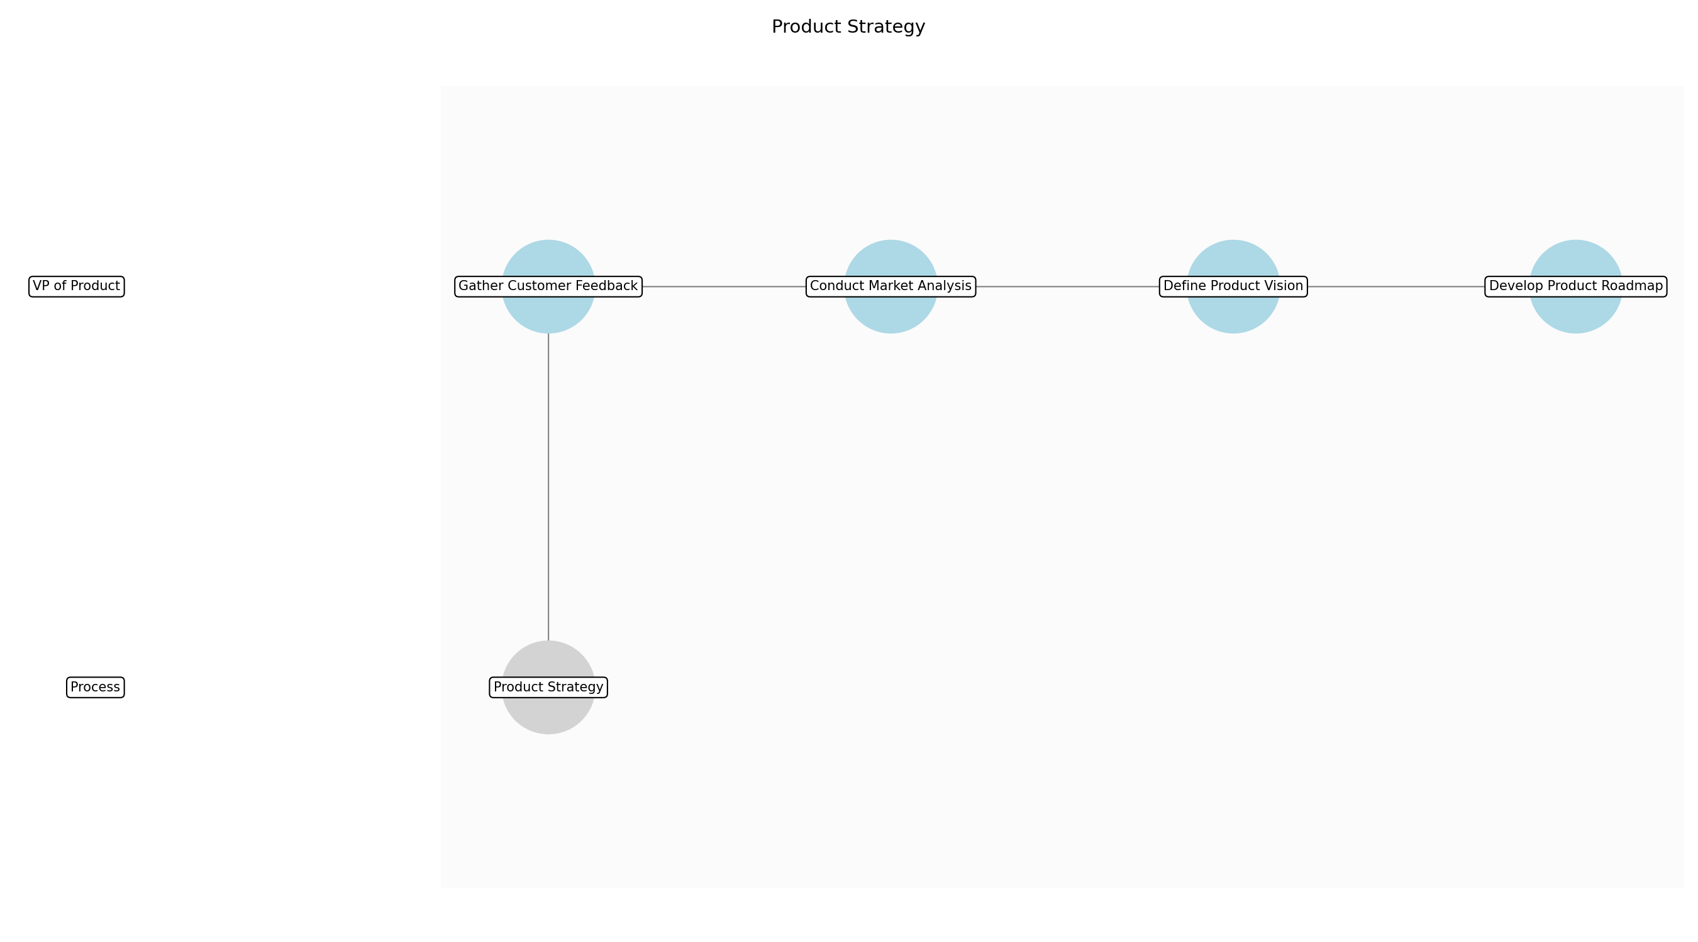

Product Strategy – Gather Customer Feedback
Description:
- Collect and analyze customer feedback from various sources to understand their needs and pain points. This involves gathering data from surveys, user interviews, support tickets, and online reviews to identify common themes and areas for improvement. The goal is to gain a comprehensive understanding of customer expectations and preferences to inform product development decisions.
Responsible Party:
- VP of Product
Inputs:
Outputs:
- Customer feedback data
- User research reports
Estimated Duration:
- 1 week
Dependencies:
Success Criteria:
- Comprehensive collection of customer feedback
- Identification of key customer needs and pain points
Purpose:
- To understand customer needs and pain points.
Scope:
- Encompasses all activities related to gathering and analyzing customer feedback.
Process Owner:
- CPO
Triggers:
- New product releases
- Significant market changes
End Conditions:
- Completion of feedback analysis
- Documentation of key findings
Step Risks and Controls:
- Risk: Inaccurate or biased feedback
- Control: Use multiple feedback sources and methods
Governance Requirements:
- Compliance with data privacy policies
Change Management:
- Change Request Process: Formal change control process
- Versioning Rules: Document versioning
Continuous Improvement:
- Review Frequency: Quarterly
Improvement Inputs:
- Customer feedback
- Usage data

Product Strategy – Conduct Market Analysis
Description:
- Analyze market trends, competitive landscape, and emerging technologies to identify opportunities for product innovation. This involves researching industry reports, attending conferences, and monitoring competitor activities to understand market dynamics and identify potential gaps. The goal is to inform product strategy and ensure the SaaS product remains competitive and relevant.
Responsible Party:
- VP of Product
Inputs:
Outputs:
- Market analysis report
- Competitive analysis report
Estimated Duration:
- 1 week
Dependencies:
Success Criteria:
- Comprehensive market analysis
- Identification of market opportunities and threats
Purpose:
- To identify market opportunities and threats.
Scope:
- Encompasses all activities related to market analysis and competitive intelligence.
Process Owner:
- CPO
Triggers:
- Significant market changes
- New technology advancements
End Conditions:
- Completion of market analysis
- Documentation of key findings
Step Risks and Controls:
- Risk: Inaccurate market data
- Control: Use reliable data sources and validate findings
Governance Requirements:
- Compliance with antitrust regulations
Change Management:
- Change Request Process: Formal change control process
- Versioning Rules: Document versioning
Continuous Improvement:
- Review Frequency: Quarterly
Improvement Inputs:
- Market feedback
- Usage data

Product Strategy – Define Product Vision
Description:
- Define the long-term vision and strategic goals for the SaaS product based on customer feedback and market analysis. This involves articulating the product's purpose, target audience, and key differentiators to guide product development efforts. The goal is to create a clear and compelling vision that aligns with the company's overall business strategy.
Responsible Party:
- VP of Product
Inputs:
- Customer feedback data
- Market analysis report
Outputs:
- Product vision statement
- Strategic goals
Estimated Duration:
- 1 day
Dependencies:
- Gather Customer Feedback
- Conduct Market Analysis
Success Criteria:
- Clear and compelling product vision
- Alignment with company's business strategy
Purpose:
- To create a clear and compelling product vision.
Scope:
- Encompasses all activities related to defining the product vision and strategic goals.
Process Owner:
- CPO
Triggers:
- Completion of customer feedback analysis
- Completion of market analysis
End Conditions:
- Approval of product vision statement
- Documentation of strategic goals
Step Risks and Controls:
- Risk: Misalignment with customer needs
- Control: Regularly validate product vision with customers
Governance Requirements:
- Regular product reviews
Change Management:
- Change Request Process: Formal change control process
- Versioning Rules: Document versioning
Continuous Improvement:
- Review Frequency: Quarterly
Improvement Inputs:
- Customer feedback
- Usage data

Product Strategy – Develop Product Roadmap
Description:
- Create a detailed product roadmap outlining the planned features, releases, and timelines for the SaaS product. This involves prioritizing features based on customer feedback, market analysis, and strategic goals to ensure the product evolves in a way that meets customer needs and drives business value. The goal is to provide a clear and actionable plan for product development.
Responsible Party:
- VP of Product
Inputs:
- Product vision statement
- Strategic goals
Outputs:
- Product roadmap
- Prioritized feature list
Estimated Duration:
- 2 days
Dependencies:
- Define Product Vision
Success Criteria:
- Detailed and actionable product roadmap
- Prioritized feature list
Purpose:
- To provide a clear and actionable plan for product development.
Scope:
- Encompasses all activities related to developing the product roadmap and prioritizing features.
Process Owner:
- CPO
Triggers:
- Approval of product vision statement
- Documentation of strategic goals
End Conditions:
- Approval of product roadmap
- Documentation of prioritized feature list
Step Risks and Controls:
- Risk: Unrealistic timelines
- Control: Involve engineering team in roadmap planning
Governance Requirements:
- Regular product reviews
Change Management:
- Change Request Process: Formal change control process
- Versioning Rules: Document versioning
Continuous Improvement:
- Review Frequency: Quarterly
Improvement Inputs:
- Customer feedback
- Usage data

3.3 Go-To-Market
Description:
- This phase involves developing and executing sales and marketing plans to acquire and retain customers. It includes market segmentation, lead generation, and sales execution.
Responsible Parties:
- CRO
Inputs:
- Product specifications
- Market analysis
- Customer data
Outputs:
- Marketing campaigns
- Sales leads
- Customer acquisition reports
Success Criteria:
- Achievement of sales targets
- Customer acquisition cost (CAC) reduction
- Market share growth

Required Sub Process(es) for the Step "Go-To-Market"
The following details the subprocess flows for the step "Go-To-Market".
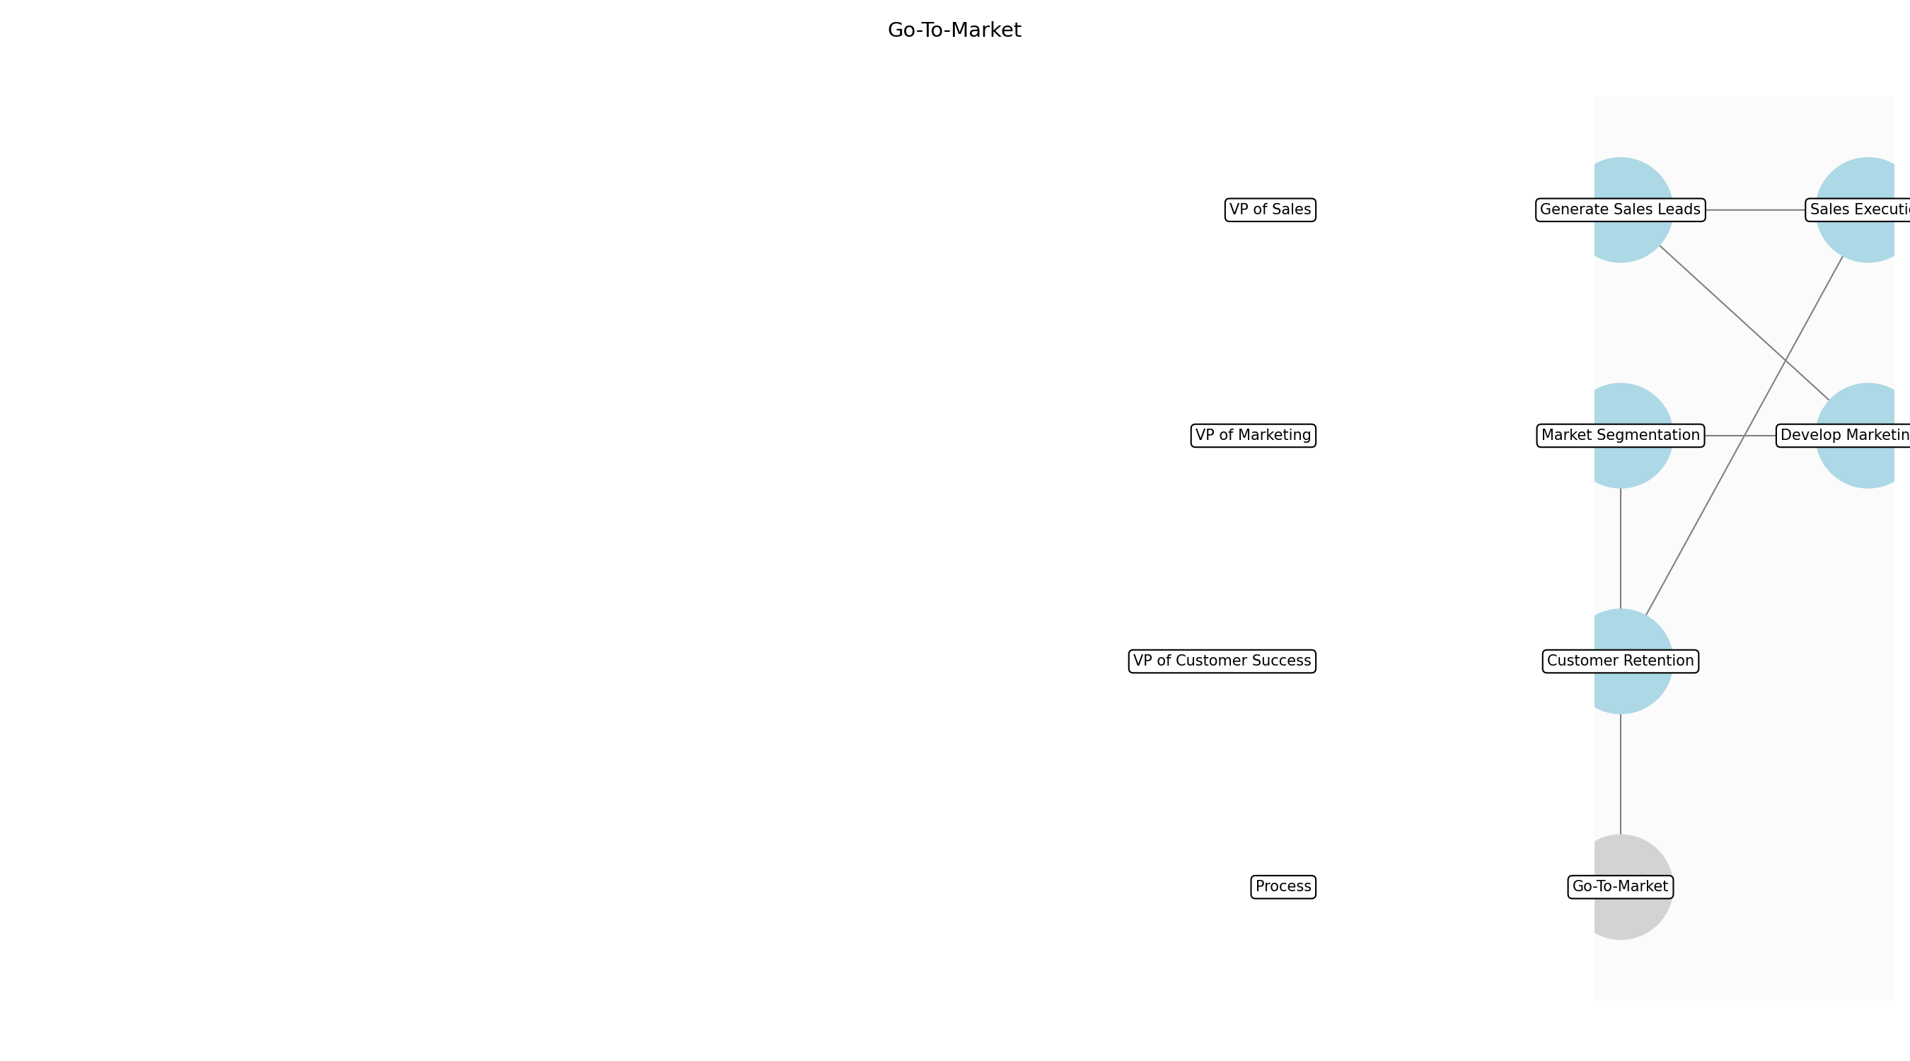

Go-To-Market – Market Segmentation
Description:
- The initial step involves identifying and segmenting the target market based on demographics, psychographics, and behavior. This segmentation allows for tailored marketing and sales strategies. The team analyzes market data and customer profiles to create distinct segments with specific needs and preferences. This ensures that marketing and sales efforts are focused on the most receptive audiences.
Responsible Party:
- VP of Marketing
Inputs:
- Market analysis
- Customer data
Outputs:
- Market segments
- Target customer profiles
Estimated Duration:
- 1 week
Dependencies:
Success Criteria:
- Identification of distinct market segments
- Creation of detailed customer profiles
Purpose:
- To identify and understand the target audience for effective marketing and sales efforts.
Scope:
- Focuses on analyzing market data and customer profiles to create distinct market segments.
Process Owner:
- CRO
Triggers:
- Product launches
- Market opportunities
End Conditions:
- Completion of market segmentation analysis
- Approval of target customer profiles
Step Risks and Controls:
- Risk: Inaccurate market segmentation
- Control: Validate segments with market research
Governance Requirements:
- Compliance with marketing regulations
Change Management:
- Change Request Process: Formal change control process
- Versioning Rules: Document versioning
Continuous Improvement:
- Review Frequency: Monthly
Improvement Inputs:
- Sales data
- Marketing campaign performance

Go-To-Market – Develop Marketing Plan
Description:
- With the market segments defined, the next step is to develop a comprehensive marketing plan. This plan outlines the strategies and tactics to reach and engage the target customers. It includes defining the marketing budget, selecting appropriate channels, and creating compelling messaging. The marketing plan aligns with the overall business goals and product strategy.
Responsible Party:
- VP of Marketing
Inputs:
- Market segments
- Target customer profiles
- Product specifications
Outputs:
- Marketing plan
- Marketing budget
Estimated Duration:
- 2 weeks
Dependencies:
- Market Segmentation
Success Criteria:
- Creation of a comprehensive marketing plan
- Approval of marketing budget
Purpose:
- To create a detailed plan for reaching and engaging the target customers.
Scope:
- Encompasses all activities related to creating the marketing plan, including budget allocation and channel selection.
Process Owner:
- CRO
Triggers:
- Approval of market segments
- Availability of product specifications
End Conditions:
- Completion of the marketing plan
- Approval of the marketing budget
Step Risks and Controls:
- Risk: Ineffective marketing plan
- Control: Regularly monitor and optimize marketing campaigns
Governance Requirements:
- Compliance with marketing regulations
Change Management:
- Change Request Process: Formal change control process
- Versioning Rules: Document versioning
Continuous Improvement:
- Review Frequency: Monthly
Improvement Inputs:
- Sales data
- Marketing campaign performance

Go-To-Market – Generate Sales Leads
Description:
- This sub-step focuses on generating qualified sales leads through various marketing activities. These activities include content marketing, social media campaigns, and email marketing. The goal is to attract potential customers and capture their contact information for further engagement. Lead generation efforts are aligned with the marketing plan and target customer profiles.
Responsible Party:
- VP of Sales
Inputs:
- Marketing plan
- Target customer profiles
Outputs:
- Sales leads
- Lead generation reports
Estimated Duration:
- Ongoing
Dependencies:
- Develop Marketing Plan
Success Criteria:
- Generation of qualified sales leads
- Creation of lead generation reports
Purpose:
- To attract potential customers and capture their contact information for further engagement.
Scope:
- Encompasses all activities related to generating sales leads, including content marketing and social media campaigns.
Process Owner:
- CRO
Triggers:
- Execution of marketing plan
- Market opportunities
End Conditions:
- Generation of a sufficient number of qualified sales leads
- Completion of lead generation reports
Step Risks and Controls:
- Risk: Low lead quality
- Control: Refine targeting and lead qualification criteria
Governance Requirements:
- Compliance with marketing regulations
Change Management:
- Change Request Process: Formal change control process
- Versioning Rules: Document versioning
Continuous Improvement:
- Review Frequency: Monthly
Improvement Inputs:
- Sales data
- Marketing campaign performance

Go-To-Market – Sales Execution
Description:
- The sales team executes the sales plan by engaging with the generated leads. This involves contacting potential customers, conducting product demonstrations, and negotiating sales agreements. The sales team uses a CRM system to track and manage leads. The goal is to convert qualified leads into paying customers.
Responsible Party:
- VP of Sales
Inputs:
- Sales leads
- Product specifications
Outputs:
- Sales agreements
- Customer accounts
Estimated Duration:
- Ongoing
Dependencies:
- Generate Sales Leads
Success Criteria:
- Conversion of qualified leads into paying customers
- Creation of customer accounts
Purpose:
- To convert qualified leads into paying customers through effective sales engagement.
Scope:
- Encompasses all activities related to sales execution, including contacting leads and negotiating agreements.
Process Owner:
- CRO
Triggers:
- Generation of qualified sales leads
- Customer interest
End Conditions:
- Conversion of leads into paying customers
- Creation of customer accounts
Step Risks and Controls:
- Risk: Low conversion rates
- Control: Provide sales training and improve sales processes
Governance Requirements:
- Regular sales reviews
Change Management:
- Change Request Process: Formal change control process
- Versioning Rules: Document versioning
Continuous Improvement:
- Review Frequency: Monthly
Improvement Inputs:
- Sales data
- Marketing campaign performance

Go-To-Market – Customer Retention
Description:
- This sub-step focuses on retaining existing customers through excellent customer service and ongoing engagement. Activities include providing proactive support, offering training programs, and gathering customer feedback. The goal is to ensure customer satisfaction and loyalty. Customer retention efforts are aligned with the customer success strategy.
Responsible Party:
- VP of Customer Success
Inputs:
- Customer accounts
- Customer feedback
Outputs:
- Customer satisfaction scores
- Retention rates
Estimated Duration:
- Ongoing
Dependencies:
- Sales Execution
Success Criteria:
- High customer satisfaction scores
- Low churn rate
Purpose:
- To ensure customer satisfaction and loyalty through excellent service and engagement.
Scope:
- Encompasses all activities related to customer retention, including proactive support and training programs.
Process Owner:
- CRO
Triggers:
- New customer acquisition
- Customer feedback
End Conditions:
- High customer satisfaction
- Low churn rate
Step Risks and Controls:
- Risk: High customer churn
- Control: Proactive customer support and training
Governance Requirements:
- Regular customer satisfaction surveys
Change Management:
- Change Request Process: Formal change control process
- Versioning Rules: Document versioning
Continuous Improvement:
- Review Frequency: Monthly
Improvement Inputs:
- Customer feedback
- Support ticket analysis

3.4 SDLC
Description:
- This phase focuses on designing, developing, and testing software products. It includes requirements gathering, coding, testing, and deployment.
Responsible Parties:
- CTO
Inputs:
- Product specifications
- User stories
- Technical requirements
Outputs:
- Software releases
- Bug fixes
- Performance improvements
Success Criteria:
- High-quality software
- On-time delivery
- Minimal defects

Required Sub Process(es) for the Step "SDLC"
The following details the subprocess flows for the step "SDLC".
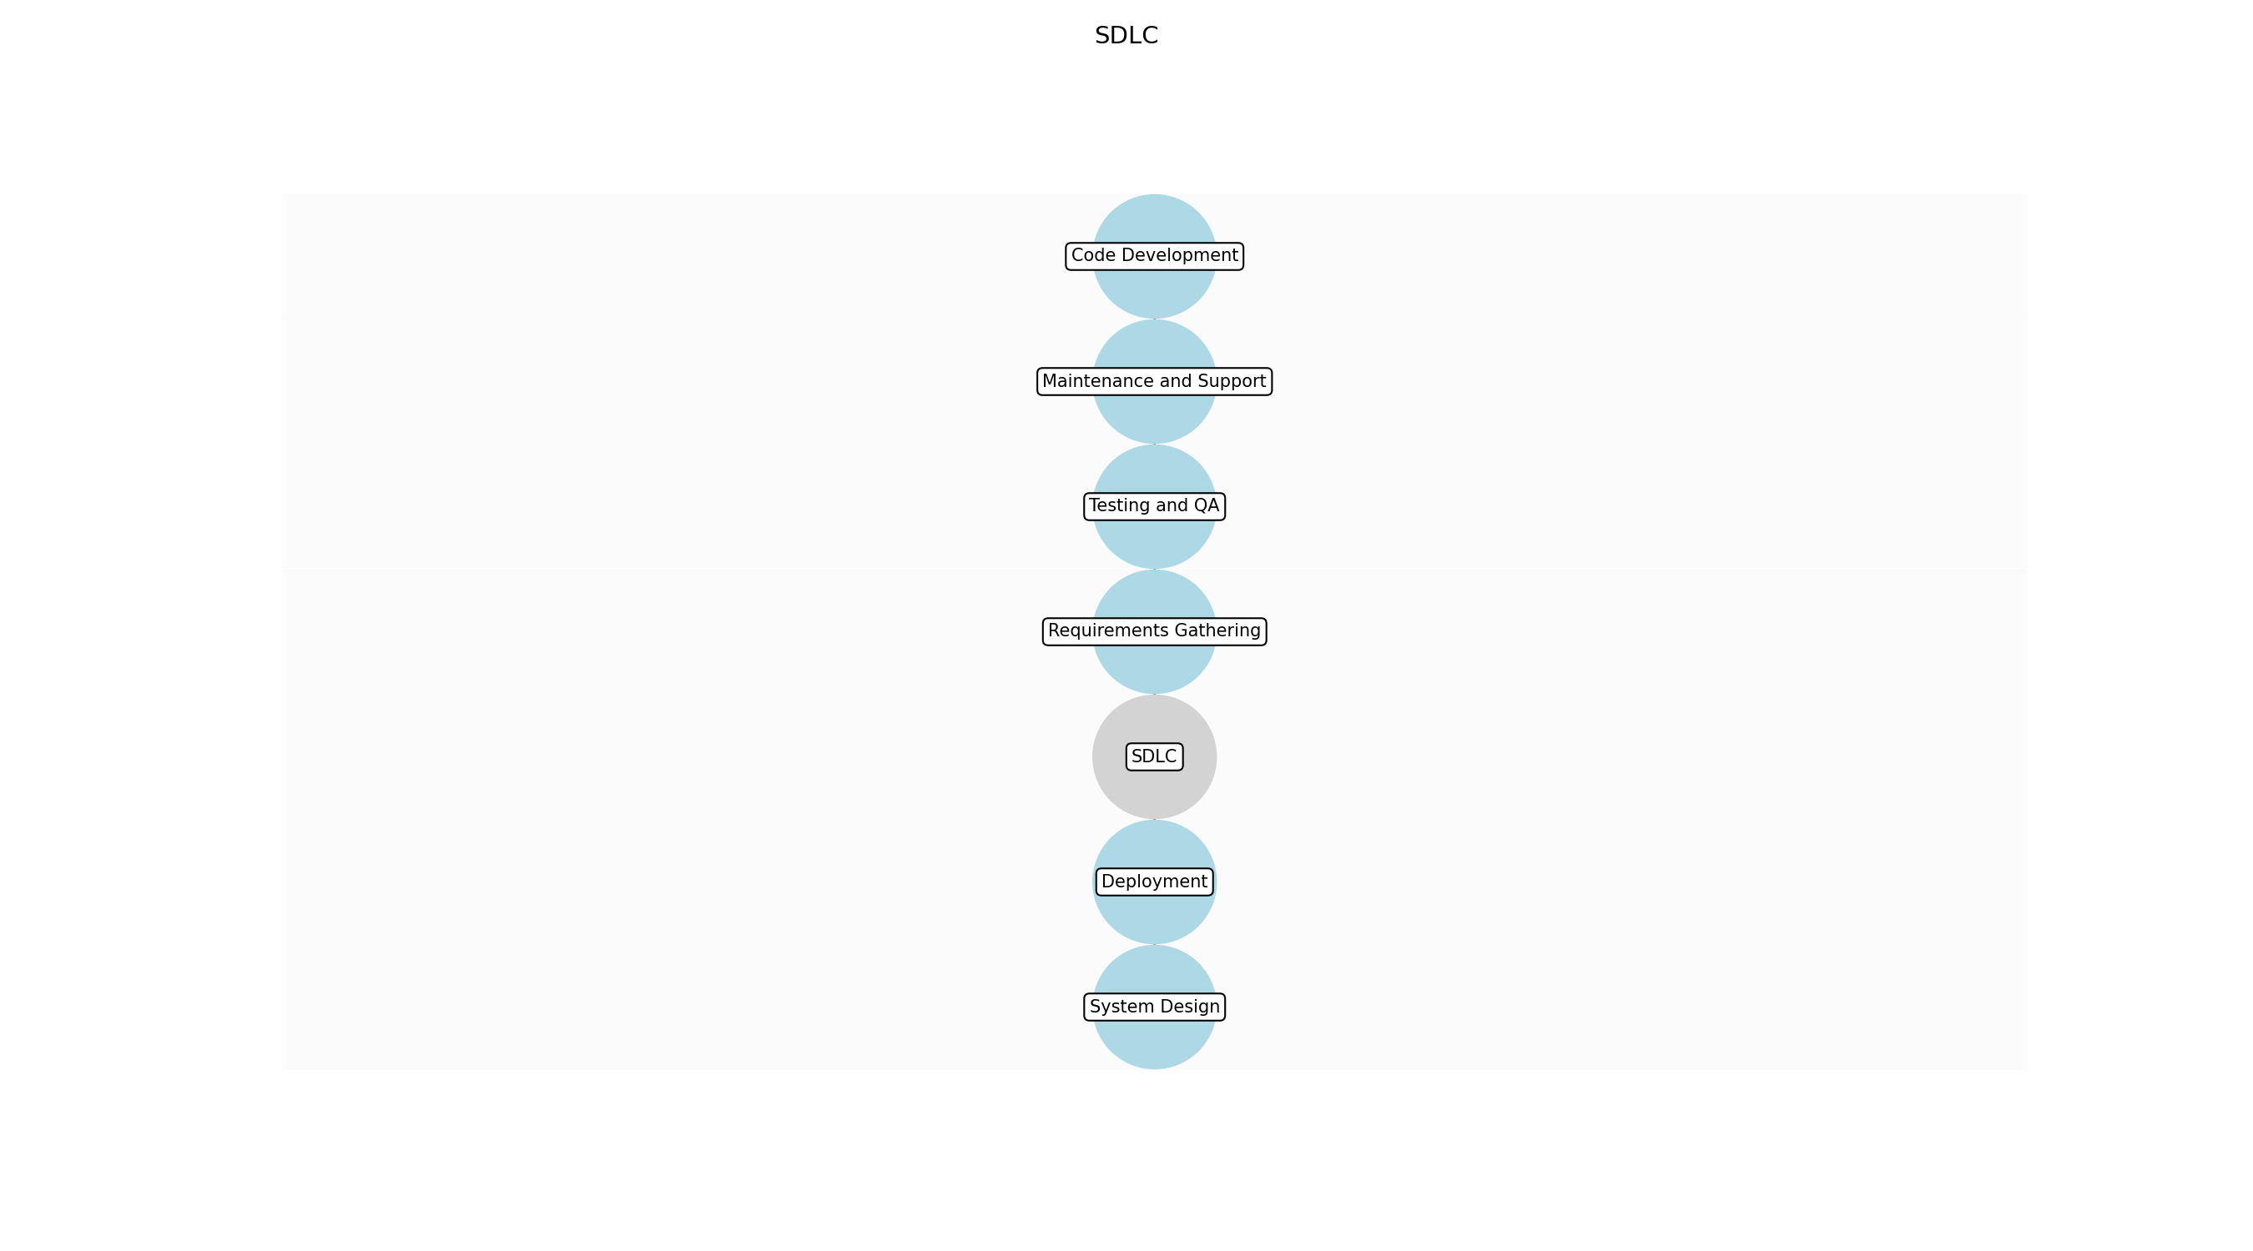

SDLC – Requirements Gathering
Description:
- The initial phase involves collecting and documenting the detailed requirements for the software product. This includes understanding user needs, business objectives, and technical constraints. The Product Manager collaborates with stakeholders to create comprehensive user stories and acceptance criteria.
Responsible Party:
- Product Manager
Inputs:
- Product specifications
- User stories
- Market research data
Outputs:
- Detailed requirements document
- User stories
- Acceptance criteria
Estimated Duration:
- 1–2 weeks
Dependencies:
Success Criteria:
- Comprehensive requirements documentation
- Stakeholder agreement on requirements
- Clear user stories and acceptance criteria
Purpose:
- To define the scope and functionality of the software product.
Scope:
- Encompasses all activities related to gathering and documenting software requirements.
Process Owner:
- Product Manager
Triggers:
- Product roadmap
- Customer requests
- Market analysis
End Conditions:
- Approved requirements document
- Signed-off user stories
Step Risks and Controls:
- Risk: Incomplete or ambiguous requirements
- Control: Conduct thorough stakeholder interviews and workshops
Governance Requirements:
- Regular review of requirements by stakeholders
- Compliance with data privacy regulations
Change Management:
- Change Request Process: Formal change control process
- Versioning Rules: Document versioning
Continuous Improvement:
- Review Frequency: Monthly
Improvement Inputs:
- Customer feedback
- Usage data

SDLC – System Design
Description:
- In this phase, the architecture and design of the software system are created based on the documented requirements. This includes defining the system components, data structures, interfaces, and security considerations. The Architect works closely with the development team to ensure the design is scalable, maintainable, and secure.
Responsible Party:
- Architect
Inputs:
- Detailed requirements document
- User stories
- Acceptance criteria
Outputs:
- System architecture diagram
- Database schema
- API specifications
Estimated Duration:
- 1 week
Dependencies:
- Requirements Gathering
Success Criteria:
- Scalable and maintainable system design
- Secure architecture
- Clear API specifications
Purpose:
- To create a blueprint for the software development process.
Scope:
- Encompasses all activities related to designing the software system architecture.
Process Owner:
- Architect
Triggers:
- Approved requirements document
End Conditions:
- Approved system design document
Step Risks and Controls:
- Risk: Poorly designed architecture
- Control: Conduct architecture reviews and refactoring
Governance Requirements:
- Regular architecture reviews
- Compliance with security standards
Change Management:
- Change Request Process: Formal change control process
- Versioning Rules: Document versioning
Continuous Improvement:
- Review Frequency: Quarterly
Improvement Inputs:
- Performance test results
- Code quality metrics

SDLC – Code Development
Description:
- This phase involves writing the actual software code based on the system design. Developers follow coding standards and best practices to ensure code quality and maintainability. Regular code reviews and unit testing are conducted to identify and fix defects early in the development process.
Responsible Party:
- VP of Engineering
Inputs:
- System architecture diagram
- Database schema
- API specifications
Outputs:
- Software code
- Unit tests
- Code review reports
Estimated Duration:
- Ongoing
Dependencies:
- System Design
Success Criteria:
- High-quality code
- Minimal defects
- Adherence to coding standards
Purpose:
- To implement the software functionality as designed.
Scope:
- Encompasses all activities related to writing and reviewing software code.
Process Owner:
- VP of Engineering
Triggers:
- Approved system design document
End Conditions:
- Completed software code
- Passed unit tests
Step Risks and Controls:
- Risk: Technical debt and software defects
- Control: Implement code reviews and refactoring
Governance Requirements:
- Regular code audits
- Compliance with security standards
Change Management:
- Change Request Process: Formal change control process
- Versioning Rules: Code versioning
Continuous Improvement:
- Review Frequency: Sprintly
Improvement Inputs:
- Code quality metrics
- Performance test results

SDLC – Testing and QA
Description:
- This phase involves testing the software to ensure it meets the specified requirements and is free of defects. Various testing methods, including unit testing, integration testing, system testing, and user acceptance testing (UAT), are employed. The QA team works closely with the development team to resolve any identified issues.
Responsible Party:
- QA Lead
Inputs:
- Software code
- Unit tests
- Code review reports
Outputs:
- Test plans
- Test results
- Bug reports
Estimated Duration:
- 1–2 weeks
Dependencies:
- Code Development
Success Criteria:
- Minimal defects
- Successful completion of all test cases
- User acceptance
Purpose:
- To ensure the software meets quality standards and user expectations.
Scope:
- Encompasses all activities related to testing and ensuring the quality of the software.
Process Owner:
- QA Lead
Triggers:
- Completed software code
End Conditions:
- Passed all test cases
- Approved test results
Step Risks and Controls:
- Risk: Software defects
- Control: Implement thorough testing and bug fixing processes
Governance Requirements:
- Regular testing audits
- Compliance with testing standards
Change Management:
- Change Request Process: Formal change control process
- Versioning Rules: Code versioning
Continuous Improvement:
- Review Frequency: Monthly
Improvement Inputs:
- Test results
- Bug reports

SDLC – Deployment
Description:
- In this phase, the tested software is deployed to the production environment. This includes configuring the environment, deploying the code, and performing final testing to ensure everything is working as expected. The DevOps team automates the deployment process to ensure it is efficient and reliable.
Responsible Party:
- DevOps Engineer
Inputs:
- Software code
- Test plans
- Test results
Outputs:
- Deployment plans
- Configuration files
- Deployment reports
Estimated Duration:
- 1 day
Dependencies:
- Testing and QA
Success Criteria:
- Successful deployment to production
- Minimal downtime
- Stable environment
Purpose:
- To make the software available to users.
Scope:
- Encompasses all activities related to deploying the software to the production environment.
Process Owner:
- DevOps Engineer
Triggers:
- Approved test results
End Conditions:
- Successful deployment
- Verified functionality
Step Risks and Controls:
- Risk: Deployment failures
- Control: Implement automated deployment processes and rollback plans
Governance Requirements:
- Regular deployment audits
- Compliance with security standards
Change Management:
- Change Request Process: Formal change control process
- Versioning Rules: Code versioning
Continuous Improvement:
- Review Frequency: Monthly
Improvement Inputs:
- Deployment reports
- Performance metrics

SDLC – Maintenance and Support
Description:
- This ongoing phase involves providing maintenance and support for the deployed software. This includes monitoring the system, fixing bugs, and providing customer support. The support team works closely with the development team to resolve any issues and ensure the software continues to meet user needs.
Responsible Party:
- Support Team
Inputs:
- Customer feedback
- Bug reports
- Performance data
Outputs:
- Bug fixes
- Performance improvements
- Support documentation
Estimated Duration:
- Ongoing
Dependencies:
- Deployment
Success Criteria:
- High customer satisfaction
- Minimal downtime
- Timely bug fixes
Purpose:
- To ensure the software continues to meet user needs and remains stable.
Scope:
- Encompasses all activities related to maintaining and supporting the deployed software.
Process Owner:
- Support Team Lead
Triggers:
- Customer feedback
- Bug reports
End Conditions:
- Resolved issues
- Satisfied customers
Step Risks and Controls:
- Risk: Software defects and performance issues
- Control: Implement monitoring and bug fixing processes
Governance Requirements:
- Regular support audits
- Compliance with service level agreements (SLAs)
Change Management:
- Change Request Process: Formal change control process
- Versioning Rules: Code versioning
Continuous Improvement:
- Review Frequency: Monthly
Improvement Inputs:
- Customer feedback
- Support ticket analysis

3.5 Customer Success
Description:
- This phase focuses on onboarding, supporting, and retaining customers. It includes customer onboarding, training, and ongoing support.
Responsible Parties:
- VP of Customer Success
Inputs:
- Customer feedback
- Usage data
- Support tickets
Outputs:
- Customer satisfaction scores
- Retention rates
- Customer success stories
Success Criteria:
- High customer satisfaction
- Low churn rate
- Increased customer lifetime value (CLTV)

Required Sub Process(es) for the Step "Customer Success"
The following details the subprocess flows for the step "Customer Success".
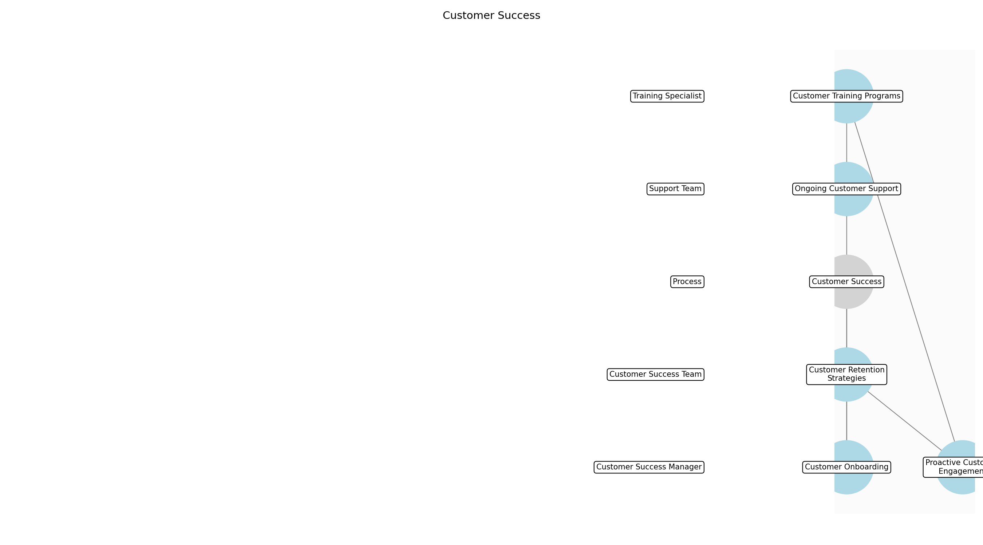

Customer Success – Customer Onboarding
Description:
- The customer onboarding process begins immediately after a new customer signs up for the SaaS product. This involves setting up the customer's account, providing initial training, and ensuring they understand the basic functionalities of the software. The goal is to make the customer feel welcome and confident in using the product.
Responsible Party:
- Customer Success Manager
Inputs:
- New customer data
- Sales handover notes
Outputs:
- Customer account setup
- Onboarding completion report
- Initial training materials
Estimated Duration:
- 1-3 days
Dependencies:
Success Criteria:
- Customer account successfully set up
- Customer completes initial training
- Positive initial customer feedback
Purpose:
- To ensure new customers are properly set up and trained to use the SaaS product.
Scope:
- Encompasses all activities related to setting up a new customer's account and providing initial training.
Process Owner:
- VP of Customer Success
Triggers:
- New customer acquisition
End Conditions:
- Customer completes onboarding process
Step Risks and Controls:
- Risk: Incomplete onboarding leading to customer frustration
- Control: Standardized onboarding checklist and process
Governance Requirements:
- Regular review of onboarding process
- Customer satisfaction surveys
Change Management:
- Change Request Process: Formal change control process
- Versioning Rules: Document versioning
Continuous Improvement:
- Review Frequency: Monthly
Improvement Inputs:
- Customer feedback
- Onboarding completion rates

Customer Success – Ongoing Customer Support
Description:
- Providing ongoing support to customers is crucial for addressing their questions, resolving issues, and ensuring they continue to derive value from the SaaS product. This includes responding to support tickets, providing technical assistance, and offering guidance on best practices. The aim is to maintain high levels of customer satisfaction and prevent churn.
Responsible Party:
- Support Team
Inputs:
- Support tickets
- Customer inquiries
- Usage data
Outputs:
- Resolved support tickets
- Customer satisfaction ratings
- Knowledge base articles
Estimated Duration:
- Ongoing
Dependencies:
- Customer Onboarding
Success Criteria:
- Timely resolution of support tickets
- High customer satisfaction ratings
- Reduced churn rate
Purpose:
- To provide continuous support and assistance to customers, ensuring they derive maximum value from the SaaS product.
Scope:
- Encompasses all activities related to addressing customer inquiries, resolving issues, and providing technical assistance.
Process Owner:
- VP of Customer Success
Triggers:
- Support requests
- Customer feedback
End Conditions:
- Support ticket resolved
- Customer issue addressed
Step Risks and Controls:
- Risk: Delayed or inadequate support leading to customer dissatisfaction
- Control: Service level agreements (SLAs) and support ticket prioritization
Governance Requirements:
- Regular monitoring of support ticket resolution times
- Customer satisfaction surveys
Change Management:
- Change Request Process: Formal change control process
- Versioning Rules: Document versioning
Continuous Improvement:
- Review Frequency: Monthly
Improvement Inputs:
- Support ticket analysis
- Customer satisfaction ratings

Customer Success – Customer Training Programs
Description:
- Developing and delivering customer training programs is essential for ensuring customers fully understand and utilize the SaaS product's features. These programs can include webinars, online courses, and in-person training sessions. The goal is to empower customers to maximize their use of the product and achieve their desired outcomes.
Responsible Party:
- Training Specialist
Inputs:
- Customer feedback
- Usage data
- Product updates
Outputs:
- Training materials
- Webinar recordings
- Training completion reports
Estimated Duration:
- 1 week per program
Dependencies:
- Customer Onboarding
Success Criteria:
- High attendance rates for training programs
- Positive customer feedback on training content
- Increased product usage among trained customers
Purpose:
- To provide comprehensive training programs that enable customers to fully utilize the SaaS product.
Scope:
- Encompasses all activities related to developing and delivering customer training programs.
Process Owner:
- VP of Customer Success
Triggers:
- Product updates
- Customer feedback
- Low product usage
End Conditions:
- Training program completed
- Training materials updated
Step Risks and Controls:
- Risk: Irrelevant or outdated training content
- Control: Regular review and update of training materials
Governance Requirements:
- Regular review of training program effectiveness
- Customer feedback surveys
Change Management:
- Change Request Process: Formal change control process
- Versioning Rules: Document versioning
Continuous Improvement:
- Review Frequency: Quarterly
Improvement Inputs:
- Customer feedback
- Training completion rates

Customer Success – Proactive Customer Engagement
Description:
- Proactively engaging with customers helps identify potential issues before they escalate and ensures customers are continuously deriving value from the SaaS product. This involves regular check-in calls, usage data analysis, and personalized recommendations. The objective is to build strong customer relationships and foster long-term loyalty.
Responsible Party:
- Customer Success Manager
Inputs:
- Usage data
- Customer feedback
- Support tickets
Outputs:
- Customer engagement reports
- Personalized recommendations
- Customer success stories
Estimated Duration:
- Ongoing
Dependencies:
- Customer Onboarding
- Ongoing Customer Support
Success Criteria:
- Increased customer engagement
- Reduced churn rate
- Positive customer feedback
Purpose:
- To proactively engage with customers, identify potential issues, and ensure they continuously derive value from the SaaS product.
Scope:
- Encompasses all activities related to proactively engaging with customers and providing personalized support.
Process Owner:
- VP of Customer Success
Triggers:
- Low product usage
- Customer feedback
- Upcoming contract renewal
End Conditions:
- Customer issue addressed
- Customer engagement goals achieved
Step Risks and Controls:
- Risk: Lack of proactive engagement leading to customer churn
- Control: Regular check-in calls and usage data analysis
Governance Requirements:
- Regular monitoring of customer engagement metrics
- Customer satisfaction surveys
Change Management:
- Change Request Process: Formal change control process
- Versioning Rules: Document versioning
Continuous Improvement:
- Review Frequency: Monthly
Improvement Inputs:
- Customer feedback
- Customer engagement metrics

Customer Success – Customer Retention Strategies
Description:
- Implementing effective customer retention strategies is critical for minimizing churn and maximizing customer lifetime value. This includes loyalty programs, personalized offers, and continuous improvement of the SaaS product based on customer feedback. The goal is to ensure customers remain satisfied and continue to renew their subscriptions.
Responsible Party:
- Customer Success Team
Inputs:
- Customer feedback
- Churn analysis
- Usage data
Outputs:
- Loyalty program materials
- Personalized offers
- Retention reports
Estimated Duration:
- Ongoing
Dependencies:
- Proactive Customer Engagement
Success Criteria:
- Reduced churn rate
- Increased customer lifetime value (CLTV)
- High customer satisfaction
Purpose:
- To implement effective strategies that minimize churn and maximize customer lifetime value.
Scope:
- Encompasses all activities related to implementing customer retention strategies.
Process Owner:
- VP of Customer Success
Triggers:
- High churn rate
- Customer feedback
- Market trends
End Conditions:
- Retention goals achieved
- Customer contract renewed
Step Risks and Controls:
- Risk: Ineffective retention strategies leading to customer churn
- Control: Regular review and optimization of retention strategies
Governance Requirements:
- Regular monitoring of churn rate and CLTV
- Customer satisfaction surveys
Change Management:
- Change Request Process: Formal change control process
- Versioning Rules: Document versioning
Continuous Improvement:
- Review Frequency: Monthly
Improvement Inputs:
- Customer feedback
- Churn analysis

3.6 Corporate Functions
Description:
- This phase encompasses all the essential corporate functions that support the SaaS business, including Human Resources (HR), Finance, and Security. These functions ensure the smooth and compliant operation of the company.
Responsible Parties:
- CFO, HR Director, Security Director
Inputs:
- Business performance data
- Employee data
- Security threat intelligence
Outputs:
- Financial reports
- Employee training programs
- Security incident reports
Success Criteria:
- Financial stability
- Employee satisfaction
- Secure operating environment

Required Sub Process(es) for the Step "Corporate Functions"
The following details the subprocess flows for the step "Corporate Functions".
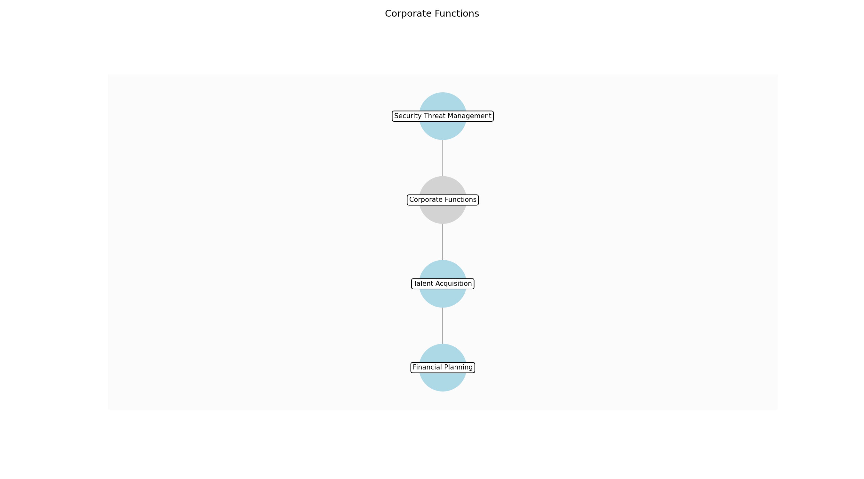

Corporate Functions – Financial Planning
Description:
- Develop the annual budget and financial forecasts. This includes projecting revenue, expenses, and cash flow. The finance team analyzes market trends, historical data, and strategic initiatives to create realistic and achievable financial targets. They also monitor performance against the budget and make adjustments as needed.
Responsible Party:
- CFO, Finance Director
Inputs:
- Business strategy document
- Market analysis report
- Historical financial data
Outputs:
- Annual budget
- Financial forecasts
- Capital expenditure plan
Estimated Duration:
- 2-4 weeks
Dependencies:
Success Criteria:
- Realistic and achievable financial targets
- Alignment with business strategy
- Accurate financial forecasts
Purpose:
- To establish a financial roadmap for the company and ensure financial stability.
Scope:
- Encompasses all financial planning activities, including budgeting, forecasting, and capital expenditure planning.
Process Owner:
- CFO
Triggers:
- Annual planning cycle
- Significant market changes
- Strategic initiatives
End Conditions:
- Approval of annual budget
- Completion of financial forecasts
Step Risks and Controls:
- Risk: Inaccurate financial forecasts
- Control: Conduct thorough market research and analysis
- Risk: Budget overruns
- Control: Regularly monitor performance against the budget
Governance Requirements:
- Regular financial audits
- Compliance with accounting standards
Change Management:
- Change Request Process: Formal change control process
- Versioning Rules: Document versioning
Continuous Improvement:
- Review Frequency: Annually
Improvement Inputs:
- Financial performance data
- Market feedback

Corporate Functions – Talent Acquisition
Description:
- Manage the recruitment and hiring process for all positions within the company. This includes sourcing candidates, conducting interviews, and making job offers. The HR team works closely with hiring managers to understand their needs and ensure that the company attracts and retains top talent. They also manage onboarding to ensure new employees are set up for success.
Responsible Party:
- HR Director
Inputs:
- Approved headcount
- Job descriptions
- Recruitment budget
Outputs:
- Job postings
- Candidate resumes
- Job offers
Estimated Duration:
- Ongoing
Dependencies:
Success Criteria:
- Timely filling of open positions
- High-quality hires
- Positive candidate experience
Purpose:
- To attract and retain top talent to support the company's growth and success.
Scope:
- Encompasses all activities related to recruitment, hiring, and onboarding.
Process Owner:
- HR Director
Triggers:
- Employee attrition
- Business growth
- New projects
End Conditions:
- Filling of open positions
- Completion of onboarding process
Step Risks and Controls:
- Risk: Difficulty attracting top talent
- Control: Offer competitive compensation and benefits
- Risk: High employee turnover
- Control: Provide opportunities for professional development
Governance Requirements:
- Compliance with employment laws
- Regular HR audits
Change Management:
- Change Request Process: Formal change control process
- Versioning Rules: Document versioning
Continuous Improvement:
- Review Frequency: Annually
Improvement Inputs:
- Employee feedback
- Turnover rates

Corporate Functions – Security Threat Management
Description:
- Monitor and respond to security threats to protect company data and systems. This includes conducting regular security audits, implementing security measures, and responding to security incidents. The security team works closely with IT to ensure that the company's infrastructure is secure and compliant with industry standards. They also provide security awareness training to employees.
Responsible Party:
- Security Director
Inputs:
- Security threat intelligence
- Security audit reports
- Security incident reports
Outputs:
- Security protocols
- Security incident reports
- Security awareness training programs
Estimated Duration:
- Ongoing
Dependencies:
Success Criteria:
- Minimal security incidents
- Compliance with security standards
- High level of security awareness among employees
Purpose:
- To protect company data and systems from security threats and ensure a secure operating environment.
Scope:
- Encompasses all activities related to security threat management, including monitoring, prevention, and response.
Process Owner:
- Security Director
Triggers:
- Security threats
- Security incidents
- Regulatory changes
End Conditions:
- Resolution of security incidents
- Implementation of security measures
Step Risks and Controls:
- Risk: Data breach
- Control: Implement security measures and regular security audits
- Risk: Inadequate security awareness
- Control: Provide security awareness training to employees
Governance Requirements:
- Compliance with data privacy policies
- Regular security audits
Change Management:
- Change Request Process: Formal change control process
- Versioning Rules: Document versioning
Continuous Improvement:
- Review Frequency: Annually
Improvement Inputs:
- Security incident reports
- Security audit reports

4.0 Supporting Systems and Tools
The following tools and platforms support this process:
Category | Tools
CRM | Salesforce, HubSpot
Project Management | Jira, Asana
CI/CD | Jenkins, GitLab CI
Customer Support | Zendesk, Intercom
Financial Accounting | NetSuite, QuickBooks
HR Management | Workday, BambooHR
SIEM | Splunk, QRadar

5.0 Metrics and Key Performance Indicators (KPIs)
The following is a list of key metrics associated with this process. These metrics help monitor performance and ensure alignment with business objectives.
Metric | Description | Measurement / Frequency | Target
ARR Growth Rate | Annual Recurring Revenue Growth Rate | Monthly | 20%
Customer Acquisition Cost (CAC) | Cost to acquire a new customer | Monthly | $500
Customer Churn Rate | Percentage of customers who cancel their subscriptions | Monthly | 5%
Customer Lifetime Value (CLTV) | Predicted revenue from a customer during their relationship with the company | Quarterly | $5,000
Gross Margin | Revenue less cost of goods sold | Monthly | 70%
Employee Satisfaction | Level of employee satisfaction | Annually | 80%
Security Incident Count | Number of security incidents | Monthly | 0

6.0 Critical Success Factors (CSF)
The following is a list of key CSFs associated with this process.
Success Factor | Description
Effective strategic planning and execution | Ability to develop and implement a clear and effective business strategy
Development of innovative and market-leading products | Ability to create products that meet customer needs and differentiate from competitors
Efficient go-to-market strategy | Ability to effectively reach and engage target customers
High-quality software development | Ability to develop and deliver reliable and scalable software
Exceptional customer success and retention | Ability to ensure customers are successful and remain loyal
Strong corporate governance | Adherence to ethical and legal standards

7.0 Critical Failure Factors (CFF)
The following is a list of key CFFs associated with this process.
Failure Factor | Description
Poor strategic decision-making | Inability to make effective business decisions
Lack of product-market fit | Failure to develop products that meet customer needs
Ineffective sales and marketing efforts | Inability to reach and engage target customers
Technical debt and software defects | Accumulation of technical debt and defects in the software
Poor customer service and support | Failure to provide adequate customer service and support
Inadequate security measures | Failure to protect sensitive data and systems

8.0 Reporting and Analytics
The following are key reporting and analytics associated with this process.
Metric | Description
Executive dashboards | Real-time view of key business metrics
Sales performance reports | Analysis of sales performance
Customer churn analysis | Analysis of customer churn
Financial statements | Reports of financial performance
Security incident reports | Reports of security incidents

9.0 System Requirements
The following system requirements are essential for the successful implementation of this process.
Name | Details
CRM system (e.g., Salesforce) | Customer relationship management system
Project management software (e.g., Jira) | Software for managing projects
CI/CD pipeline (e.g., Jenkins) | Continuous integration and continuous delivery pipeline
Customer support platform (e.g., Zendesk) | Platform for managing customer support requests
Financial accounting software (e.g., NetSuite) | Software for managing financial accounting
HR management system (e.g., Workday) | Software for managing human resources
Security Information and Event Management (SIEM) system | System for monitoring security events

10.0 Process Flow Diagram
The following diagram provides a high-level visualization of the process flow as defined in the normalized JSON source.
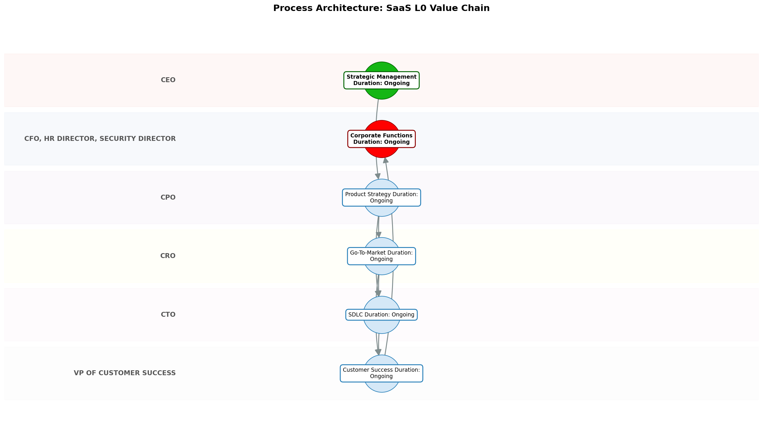

11.0 Process Performance Report
The following metrics are based on a Monte Carlo discrete-event simulation running 2,000 iterations. All time-based values are reported in hours.
Operational Metric | Simulated Value
Average Cycle Time | 5.50 hours
Cycle Time Variance | 0.60 hours
Contention Risk Profile | Low

Identified Bottlenecks
- SDLC
- Strategic Management
- Product Strategy

Detailed Step Performance
Process Step | Avg. Duration (hours)
Strategic Management | 1.34
Product Strategy | 1.33
Go-To-Market | 1.33
SDLC | 1.35
Customer Success | 1.33
Corporate Functions | 1.33

12.0 Governance Requirements
There following are the list of governance requirements used in this process.
- Regular audits
- Compliance with industry standards
- Data privacy policies

13.0 Risks and Controls
The following risks and associated controls apply to this process.
Risk | Control
Data breach | Implement security measures
Customer churn | Proactive customer support
Technical debt | Code reviews and refactoring

14.0 Process Triggers
There following are triggers that kick processes off.
- Market trends
- Customer feedback
- Competitive pressures
- New technology advancements

15.0 Process End Conditions
There following are a list of the process end conditions.
- Customer contract termination
- Product sunset
- Business closure

16.0 Change Management
There following are list of the change management procedures.
- Change Request Process: Change control board
- Versioning Rules: Impact assessment

17.0 Continuous Improvement
The following are the items used for continuous improvement.
- Review Frequency: Regular process reviews
Improvement Inputs:
- Customer feedback analysis
- Performance monitoring

Appendix B: Additional Source Data
This appendix contains additional structured data from the normalized source JSON that is not covered in the main sections.
Process Owner: Chief Operating Officer (COO)
Scope: Encompasses all activities related to the development, marketing, sales, and support of SaaS products.
Purpose: To deliver and support high-quality SaaS products and services to customers.

Appendix C: Glossary
This glossary contains definitions of common terms used in the process documentation.
Term | Definition
Business Process | A set of related activities or tasks performed to achieve a specific organizational goal.
KPI | Key Performance Indicator used to measure the success or health of a process.
Stakeholder | Any individual or group with an interest in the outcomes of the process.
Continuous Improvement | Ongoing effort to improve products, services or processes.

