Agile SDLC using Scrum
This document details an Agile Software Development Life Cycle (SDLC) process leveraging the Scrum framework, specifically tailored for small teams. The process emphasizes iterative development, close collaboration, and a high degree of adaptability to deliver high-quality software that aligns closely with customer needs. It is designed to be lightweight and efficient, placing a strong emphasis on continuous improvement and a rapid response to evolving requirements, while acknowledging the constraints typically found in smaller development environments.
Industry / Domain: Software Development
Version: 1.0
Generated On: 2026-01-08 13:54:10

Document Control
Version | Date | Author | Description
1.0 | 2026-01-08 | Process Architect | Initial generated process specification

Table of Contents
Document Control 2
Table of Contents 3
1.0 Process Overview 5
1.1 Assumptions 5
1.2 Constraints 5
2.0 Stakeholders and Responsibilities 6
3.0 Process Workflow 7
3.1 Product Backlog Creation 7
Required Sub Process(es) for the Step "Product Backlog Creation" 7
3.2 Sprint Planning 11
Required Sub Process(es) for the Step "Sprint Planning" 12
3.3 Daily Scrum 17
Required Sub Process(es) for the Step "Daily Scrum" 17
3.4 Sprint Review 22
Required Sub Process(es) for the Step "Sprint Review" 22
3.5 Sprint Retrospective 27
Required Sub Process(es) for the Step "Sprint Retrospective" 28
3.6 Backlog Refinement 33
Required Sub Process(es) for the Step "Backlog Refinement" 33
4.0 Supporting Systems and Tools 39
5.0 Metrics and Key Performance Indicators (KPIs) 40
Velocity 40
Customer Satisfaction 40
Defect Rate 40
On-time Delivery 40
6.0 Reporting and Analytics 41
7.0 System Requirements 42
8.0 Process Flow Diagram 43
9.0 Process Performance Report 44
Identified Bottlenecks 44
Detailed Step Performance 44
Appendix B: Additional Source Data 45
Appendix C: Glossary 46

1.0 Process Overview
This document details an Agile Software Development Life Cycle (SDLC) process leveraging the Scrum framework, specifically tailored for small teams. The process emphasizes iterative development, close collaboration, and a high degree of adaptability to deliver high-quality software that aligns closely with customer needs. It is designed to be lightweight and efficient, placing a strong emphasis on continuous improvement and a rapid response to evolving requirements, while acknowledging the constraints typically found in smaller development environments.

1.1 Assumptions
- The team possesses a foundational understanding of Agile principles and Scrum practices, enabling effective collaboration and process adherence.
- The Product Owner remains readily available to provide clear guidance, promptly address inquiries, and actively participate in feedback loops.
- The team possesses the requisite skills, expertise, and experience to successfully develop and deliver the software according to specifications.

1.2 Constraints
- Small Team Size: Necessitates efficient communication channels, streamlined workflows, and a high degree of individual accountability.
- Limited Resources: Requires meticulous prioritization, strategic allocation of resources, and a relentless focus on delivering maximum value.
- Changing Requirements: Demands adaptability, flexibility, and a proactive approach to managing scope changes while minimizing disruption.
Industry Sector: Software Development

2.0 Stakeholders and Responsibilities
The following is a list of key stakeholders involved in this process. Understanding their roles and responsibilities is crucial for successful implementation.
Stakeholder | Responsibilities
Product Owner | Defining and meticulously managing the product backlog, ensuring it remains current and reflective of stakeholder needs.  Prioritizing user stories within the backlog based on a clear understanding of business value, impact, and strategic alignment.  Serving as the primary point of contact for clarifying requirements and ensuring the development team has a comprehensive understanding.  Actively participating in sprint reviews to accept or reject completed work based on predefined acceptance criteria and stakeholder feedback.
Scrum Master | Expertly facilitating the Scrum process, ensuring adherence to Agile principles and Scrum practices across the team.  Proactively identifying and removing impediments and obstacles that hinder the development team's progress and productivity.  Providing coaching and mentorship to the team on Agile and Scrum principles, fostering a culture of continuous learning and improvement.  Ensuring Scrum practices are consistently followed, while remaining flexible to adapt the process to the team's specific needs.
Development Team | Developing and delivering high-quality software that meets the defined requirements and exceeds stakeholder expectations.  Actively participating in sprint planning, daily scrums, sprint reviews, and sprint retrospectives, contributing to team collaboration and knowledge sharing.  Accurately estimating effort for user stories, considering technical complexity, dependencies, and potential risks.  Collaborating effectively with the product owner and scrum master to ensure clear communication, shared understanding, and alignment on project goals.

3.0 Process Workflow
The following is a list of key steps in the process workflow.

3.1 Product Backlog Creation
The Product Owner takes the lead in creating and meticulously maintaining a prioritized list of features, bug fixes, and other essential tasks slated for completion. This dynamic backlog undergoes continuous refinement and regular updates to accurately reflect evolving requirements and shifting business priorities. It serves as the singular, authoritative source of truth, guiding the team's efforts and ensuring alignment with strategic objectives. The process ensures all items are clearly defined, estimated, and prioritized based on value and risk, ensuring the team always works on the most impactful items.
Responsible Parties: Product Owner
Success Criteria:
- The backlog accurately reflects current business priorities and strategic objectives.
- User stories are comprehensively defined, meticulously estimated, and consistently prioritized.

Required Sub Process(es) for the Step "Product Backlog Creation"
The following details the subprocess flows for the step "Product Backlog Creation".
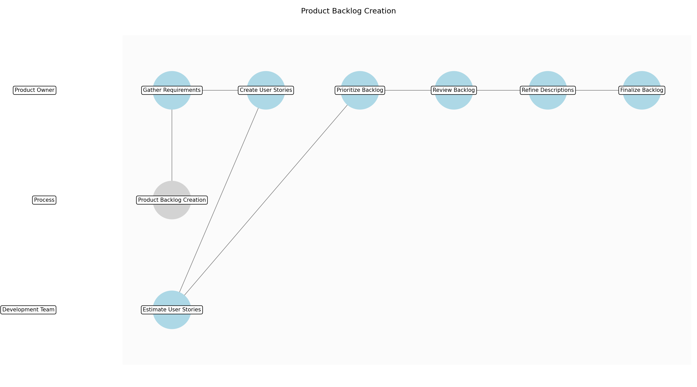

Product Backlog Creation – Gather Requirements
Description: Collect and document all known requirements from stakeholders, user feedback, market research, and business strategy documents. Ensure all requirements are captured in a central repository.
Responsible Parties: Product Owner
Inputs:
- User Feedback
- Market Research
- Business Strategy
Outputs:
- Initial Requirements Document
Dependencies:
Estimated Duration: 1-2 days
Success Criteria:
- Comprehensive list of initial requirements is documented.

Product Backlog Creation – Create User Stories
Description: Transform the gathered requirements into user stories, following the INVEST principle (Independent, Negotiable, Valuable, Estimable, Small, Testable). Each user story should clearly define the 'who', 'what', and 'why'.
Responsible Parties: Product Owner
Inputs:
- Initial Requirements Document
Outputs:
- Initial User Stories
Dependencies:
- Gather Requirements
Estimated Duration: 2-3 days
Success Criteria:
- User stories are well-formed and adhere to the INVEST principle.

Product Backlog Creation – Estimate User Stories
Description: Assign estimates (e.g., story points) to each user story, reflecting the effort, complexity, and risk involved in their implementation. Use techniques like Planning Poker to involve the development team in the estimation process.
Responsible Parties: Development Team
Inputs:
- Initial User Stories
Outputs:
- Estimated User Stories
Dependencies:
- Create User Stories
Estimated Duration: 1 day
Success Criteria:
- All user stories have effort estimates assigned.

Product Backlog Creation – Prioritize Backlog
Description: Prioritize the user stories in the backlog based on business value, urgency, risk, and dependencies. Use techniques like MoSCoW (Must have, Should have, Could have, Won't have) or Value vs. Effort matrix to aid in prioritization.
Responsible Parties: Product Owner
Inputs:
- Estimated User Stories
Outputs:
- Prioritized Product Backlog
Dependencies:
- Estimate User Stories
Estimated Duration: 1 day
Success Criteria:
- User stories are ranked in order of priority.

Product Backlog Creation – Review Backlog
Description: Review the prioritized product backlog with stakeholders to ensure alignment with business goals and gather feedback. Incorporate the feedback into the user stories and reprioritize as necessary.
Responsible Parties: Product Owner
Inputs:
- Prioritized Product Backlog
Outputs:
- Reviewed Product Backlog
Dependencies:
- Prioritize Backlog
Estimated Duration: 0.5 day
Success Criteria:
- Stakeholder feedback is incorporated into the backlog.

Product Backlog Creation – Refine Descriptions
Description: Ensure all user stories have clear, concise, and complete descriptions, including acceptance criteria. Acceptance criteria define the conditions that must be met for a user story to be considered complete.
Responsible Parties: Product Owner
Inputs:
- Reviewed Product Backlog
Outputs:
- Refined User Stories
Dependencies:
- Review Backlog
Estimated Duration: 1-2 days
Success Criteria:
- User stories have clear descriptions and acceptance criteria.

Product Backlog Creation – Finalize Backlog
Description: Finalize the product backlog by ensuring that all user stories are estimated, prioritized, and have clear descriptions and acceptance criteria. The backlog is now ready for sprint planning.
Responsible Parties: Product Owner
Inputs:
- Refined User Stories
Outputs:
- Final Product Backlog
Dependencies:
- Refine Descriptions
Estimated Duration: 0.5 day
Success Criteria:
- The product backlog is ready for sprint planning.

3.2 Sprint Planning
At the commencement of each sprint, the Development Team actively participates in selecting user stories from the Product Backlog to be addressed during the upcoming sprint. The team collaborates closely to collaboratively define a clear and concise Sprint Goal and create a detailed Sprint Backlog, effectively outlining all tasks necessary to successfully complete the selected user stories. Careful effort estimation is performed for each task, ensuring that sprint commitments remain realistic, achievable, and aligned with team capacity. This planning session also identifies potential risks and dependencies, setting the stage for a productive sprint.
Responsible Parties: Development Team
Success Criteria:
- A clear, concise, and measurable sprint goal is collaboratively defined and agreed upon.
- The resulting sprint backlog is realistic, well-defined, and demonstrably achievable within the sprint timeframe.

Required Sub Process(es) for the Step "Sprint Planning"
The following details the subprocess flows for the step "Sprint Planning".
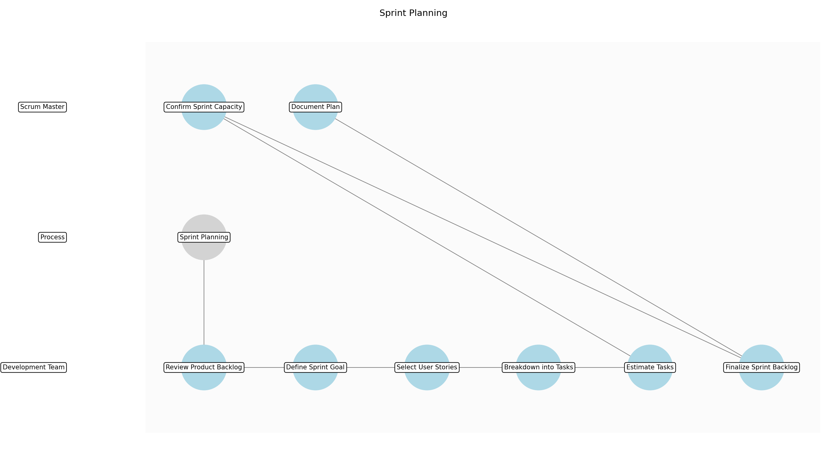

Sprint Planning – Review Product Backlog
Description: The Development Team, Scrum Master, and Product Owner review the prioritized Product Backlog to understand the available user stories, their estimates, and acceptance criteria. This ensures everyone has a shared understanding of the work to be considered for the sprint.
Responsible Parties: Development Team
Inputs:
- Prioritized Product Backlog
- Team Velocity
Outputs:
- Understood Product Backlog
Dependencies:
Estimated Duration: 30 minutes
Success Criteria:
- All team members have a clear understanding of the product backlog items.

Sprint Planning – Define Sprint Goal
Description: The Development Team collaborates with the Product Owner to define a clear and concise Sprint Goal that aligns with the overall product vision and business objectives. The Sprint Goal provides focus and direction for the sprint.
Responsible Parties: Development Team
Inputs:
- Understood Product Backlog
Outputs:
- Draft Sprint Goal
Dependencies:
- Review Product Backlog
Estimated Duration: 30 minutes
Success Criteria:
- A draft sprint goal is defined.

Sprint Planning – Select User Stories
Description: The Development Team selects user stories from the Product Backlog that align with the Sprint Goal and can be realistically completed within the sprint timeframe, considering team capacity and velocity. The team discusses dependencies and potential risks associated with each user story.
Responsible Parties: Development Team
Inputs:
- Draft Sprint Goal
- Understood Product Backlog
Outputs:
- Candidate User Stories for Sprint
Dependencies:
- Define Sprint Goal
Estimated Duration: 1 hour
Success Criteria:
- A set of candidate user stories is selected.

Sprint Planning – Breakdown into Tasks
Description: The Development Team breaks down the selected user stories into smaller, actionable tasks required for implementation. Each task should be clearly defined and estimated in hours.
Responsible Parties: Development Team
Inputs:
- Candidate User Stories for Sprint
Outputs:
- Sprint Backlog Tasks
Dependencies:
- Select User Stories
Estimated Duration: 1.5 hours
Success Criteria:
- User stories are broken down into tasks.

Sprint Planning – Estimate Tasks
Description: The Development Team estimates the effort required to complete each task in the Sprint Backlog, typically in hours. This ensures that the team has a realistic understanding of the workload for the sprint.
Responsible Parties: Development Team
Inputs:
- Sprint Backlog Tasks
Outputs:
- Estimated Sprint Backlog Tasks
Dependencies:
- Breakdown into Tasks
Estimated Duration: 30 minutes
Success Criteria:
- All tasks have effort estimates assigned.

Sprint Planning – Confirm Sprint Capacity
Description: The Scrum Master verifies that the total estimated effort for all tasks in the Sprint Backlog does not exceed the Development Team's capacity for the sprint, considering any planned time off or other commitments. If the workload is too high, user stories may need to be removed or tasks re-estimated.
Responsible Parties: Scrum Master
Inputs:
- Estimated Sprint Backlog Tasks
- Team Capacity
Outputs:
- Confirmed Sprint Capacity
Dependencies:
- Estimate Tasks
Estimated Duration: 15 minutes
Success Criteria:
- Sprint workload aligns with team capacity.

Sprint Planning – Finalize Sprint Backlog
Description: The Development Team, Product Owner, and Scrum Master finalize the Sprint Backlog, ensuring that it contains all the necessary tasks to achieve the Sprint Goal and that the workload is realistic and achievable. The Sprint Backlog is then committed to by the Development Team.
Responsible Parties: Development Team
Inputs:
- Confirmed Sprint Capacity
Outputs:
- Final Sprint Backlog
Dependencies:
- Confirm Sprint Capacity
Estimated Duration: 15 minutes
Success Criteria:
- The sprint backlog is finalized.

Sprint Planning – Document Plan
Description: Document the final Sprint Goal and Sprint Backlog in the project management tool. Make it visible to the entire team and stakeholders, ensuring transparency and alignment.
Responsible Parties: Scrum Master
Inputs:
- Final Sprint Backlog
- Draft Sprint Goal
Outputs:
- Documented Sprint Plan
Dependencies:
- Finalize Sprint Backlog
Estimated Duration: 15 minutes
Success Criteria:
- Sprint plan is documented and visible.

3.3 Daily Scrum
The Development Team diligently conducts a focused, daily meeting, typically lasting no more than 15 minutes, to facilitate transparent communication, track progress, promptly identify impediments, and strategically plan for the subsequent 24 hours. Each team member concisely answers three pivotal questions: What specific tasks did I accomplish yesterday? What tasks will I focus on today? Are there any impediments currently hindering my progress? The Scrum Master plays a vital role in facilitating the meeting and actively removes any identified impediments, ensuring the team remains productive and focused, and that any roadblocks are addressed swiftly.
Responsible Parties: Scrum Master
Success Criteria:
- All team members maintain a clear awareness of each other's progress, fostering transparency and collaboration.
- Any impediments are promptly identified, actively addressed, and effectively resolved, minimizing disruption to the team's workflow.

Required Sub Process(es) for the Step "Daily Scrum"
The following details the subprocess flows for the step "Daily Scrum".
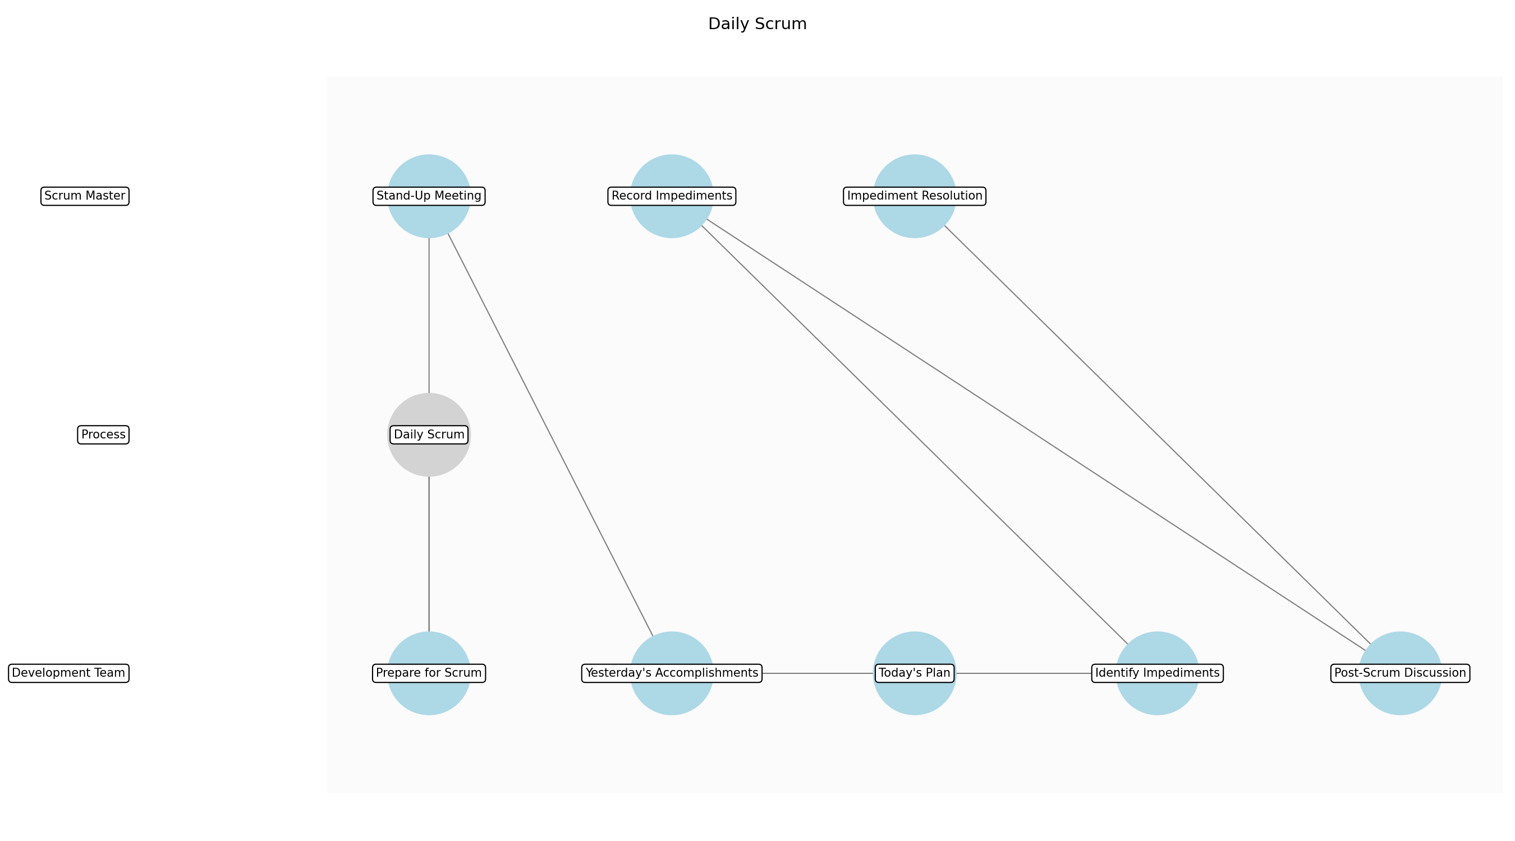

Daily Scrum – Prepare for Scrum
Description: Each Development Team member prepares to share their updates by reviewing their progress on assigned tasks and identifying any impediments encountered.
Responsible Parties: Development Team
Inputs:
- Sprint Backlog
Outputs:
- Prepared Updates
Dependencies:
Estimated Duration: 2 minutes
Success Criteria:
- Team members are ready to provide concise updates.

Daily Scrum – Stand-Up Meeting
Description: The Development Team gathers for the Daily Scrum, typically standing up to encourage brevity. The Scrum Master ensures the meeting stays within the 15-minute timebox and focuses on the three key questions.
Responsible Parties: Scrum Master
Inputs:
- Prepared Updates
Outputs:
- Meeting in Progress
Dependencies:
- Prepare for Scrum
Estimated Duration: 1 minute
Success Criteria:
- The team gathers promptly for the Daily Scrum.

Daily Scrum – Yesterday's Accomplishments
Description: Each Development Team member answers the first question: What specific tasks did I accomplish yesterday that contributed to the Sprint Goal? Updates should be concise and focused on completed work.
Responsible Parties: Development Team
Inputs:
- Meeting in Progress
Outputs:
- Shared Accomplishments
Dependencies:
- Stand-Up Meeting
Estimated Duration: 5 minutes
Success Criteria:
- Each team member shares their accomplishments from the previous day.

Daily Scrum – Today's Plan
Description: Each Development Team member answers the second question: What tasks will I focus on today to move closer to achieving the Sprint Goal? Plans should be realistic and aligned with the Sprint Backlog.
Responsible Parties: Development Team
Inputs:
- Shared Accomplishments
Outputs:
- Shared Plans
Dependencies:
- Yesterday's Accomplishments
Estimated Duration: 5 minutes
Success Criteria:
- Each team member shares their plan for the current day.

Daily Scrum – Identify Impediments
Description: Each Development Team member answers the third question: Are there any impediments currently hindering my progress or blocking me from completing my tasks? Impediments should be clearly identified and articulated.
Responsible Parties: Development Team
Inputs:
- Shared Plans
Outputs:
- Identified Impediments
Dependencies:
- Today's Plan
Estimated Duration: 2 minutes
Success Criteria:
- Any impediments are identified and clearly stated.

Daily Scrum – Record Impediments
Description: The Scrum Master captures all identified impediments and assigns ownership for resolution. This ensures that no impediment is overlooked and that someone is responsible for addressing it.
Responsible Parties: Scrum Master
Inputs:
- Identified Impediments
Outputs:
- Recorded Impediments
Dependencies:
- Identify Impediments
Estimated Duration: 1 minute
Success Criteria:
- All impediments are recorded and assigned for resolution.

Daily Scrum – Post-Scrum Discussion
Description: If necessary, team members engage in brief discussions to clarify points or offer assistance. However, detailed problem-solving is deferred to after the Daily Scrum to maintain the timebox.
Responsible Parties: Development Team
Inputs:
- Recorded Impediments
Outputs:
- Clarified Issues
Dependencies:
- Record Impediments
Estimated Duration: Up to 3 minutes
Success Criteria:
- Issues are clarified without exceeding the timebox.

Daily Scrum – Impediment Resolution
Description: The Scrum Master takes immediate action to remove any identified impediments, escalating as necessary. The goal is to keep the Development Team focused and productive.
Responsible Parties: Scrum Master
Inputs:
- Recorded Impediments
- Clarified Issues
Outputs:
- Resolved Impediments
Dependencies:
- Post-Scrum Discussion
Estimated Duration: Ongoing
Success Criteria:
- Impediments are actively addressed and resolved in a timely manner.

3.4 Sprint Review
Upon completion of each sprint, the Development Team formally demonstrates the completed work to the Product Owner and key Stakeholders. Feedback is actively solicited, carefully considered, and strategically used to inform future sprints. The Sprint Review provides a valuable opportunity to meticulously inspect the increment of work and adapt the Product Backlog as needed, ensuring continuous alignment with evolving requirements and stakeholder expectations. This also serves as a platform for showcasing progress and gathering buy-in, fostering a collaborative environment.
Responsible Parties: Product Owner
Success Criteria:
- Stakeholders actively provide valuable, actionable feedback, contributing to continuous improvement.
- The completed work demonstrably meets predefined acceptance criteria, confirming alignment with requirements and expectations.

Required Sub Process(es) for the Step "Sprint Review"
The following details the subprocess flows for the step "Sprint Review".
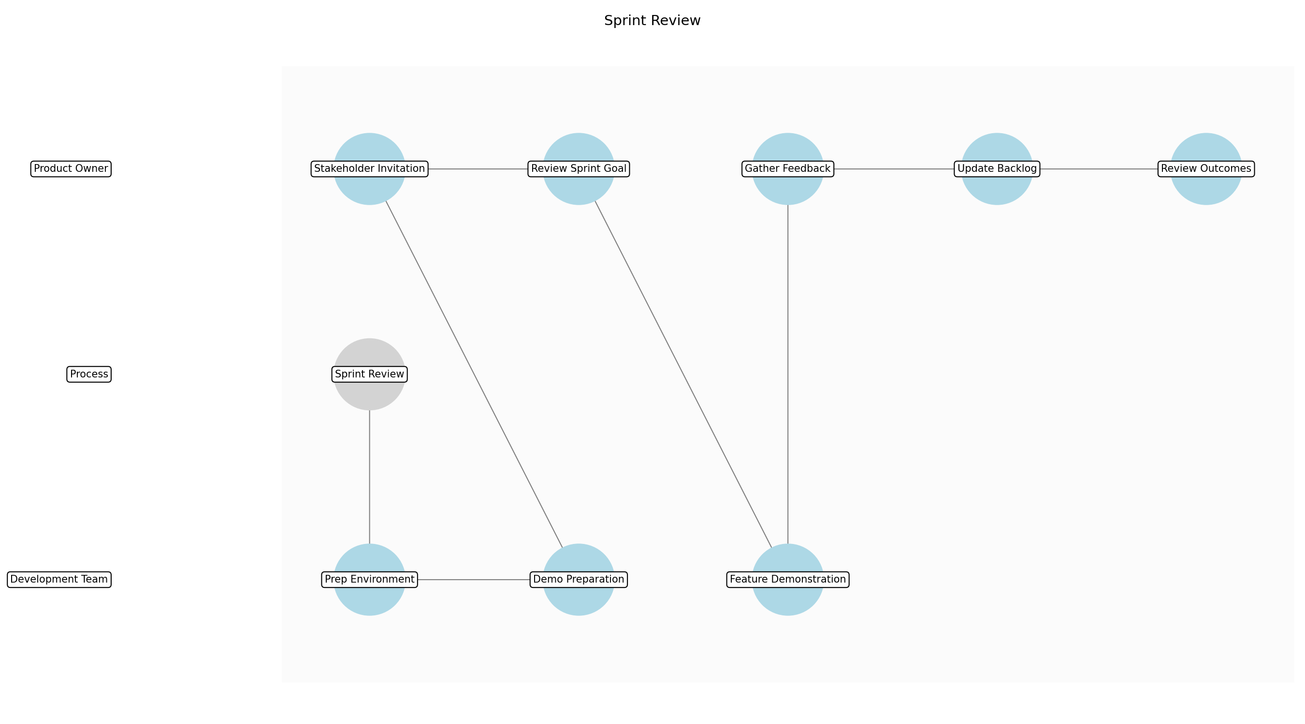

Sprint Review – Prep Environment
Description: The Development Team prepares the demonstration environment, ensuring that all necessary software, hardware, and data are properly configured and accessible. This includes setting up any required test environments or staging areas.
Responsible Parties: Development Team
Inputs:
- Completed Work
- Sprint Goal
Outputs:
- Prepared Demo Environment
Dependencies:
Estimated Duration: 30 minutes
Success Criteria:
- The demonstration environment is fully configured and ready for use.

Sprint Review – Demo Preparation
Description: The Development Team selects the most relevant and impactful features to demonstrate, aligning with the Sprint Goal and showcasing the value delivered. They rehearse the demonstration to ensure a smooth and engaging presentation.
Responsible Parties: Development Team
Inputs:
- Prepared Demo Environment
Outputs:
- Rehearsed Demo
Dependencies:
- Prep Environment
Estimated Duration: 30 minutes
Success Criteria:
- The team is prepared to demonstrate the key features completed during the sprint.

Sprint Review – Stakeholder Invitation
Description: The Product Owner invites key stakeholders to the Sprint Review, ensuring that all relevant parties are informed and available to attend. This includes sending out meeting invitations and providing any necessary context or pre-reading materials.
Responsible Parties: Product Owner
Inputs:
Outputs:
- Stakeholder Attendance
Dependencies:
Estimated Duration: 15 minutes
Success Criteria:
- Key stakeholders are invited and confirm their attendance.

Sprint Review – Review Sprint Goal
Description: The Product Owner restates the Sprint Goal at the beginning of the Sprint Review, reminding everyone of the objectives for the sprint. This sets the context for the demonstration and helps stakeholders understand the value delivered.
Responsible Parties: Product Owner
Inputs:
- Sprint Goal
Outputs:
- Restated Sprint Goal
Dependencies:
- Stakeholder Invitation
Estimated Duration: 5 minutes
Success Criteria:
- The Sprint Goal is clearly restated and understood by all attendees.

Sprint Review – Feature Demonstration
Description: The Development Team demonstrates the completed work, showcasing the new features and functionality that were delivered during the sprint. The demonstration should be interactive and engaging, allowing stakeholders to ask questions and provide feedback.
Responsible Parties: Development Team
Inputs:
- Restated Sprint Goal
- Rehearsed Demo
Outputs:
- Demonstrated Features
Dependencies:
- Review Sprint Goal
Estimated Duration: 45 minutes
Success Criteria:
- All key features completed during the sprint are demonstrated effectively.

Sprint Review – Gather Feedback
Description: The Product Owner actively solicits feedback from stakeholders on the demonstrated features, capturing their thoughts, suggestions, and concerns. This feedback is crucial for informing future sprints and ensuring that the product aligns with stakeholder expectations.
Responsible Parties: Product Owner
Inputs:
- Demonstrated Features
Outputs:
- Collected Feedback
Dependencies:
- Feature Demonstration
Estimated Duration: 15 minutes
Success Criteria:
- Stakeholders provide valuable and actionable feedback on the demonstrated features.

Sprint Review – Update Backlog
Description: The Product Owner updates the Product Backlog based on the feedback received from stakeholders, adding new user stories, modifying existing ones, or reprioritizing items as necessary. This ensures that the backlog reflects the latest stakeholder input and business priorities.
Responsible Parties: Product Owner
Inputs:
- Collected Feedback
- Prioritized Product Backlog
Outputs:
- Updated Product Backlog
Dependencies:
- Gather Feedback
Estimated Duration: 15 minutes
Success Criteria:
- The Product Backlog is updated to reflect stakeholder feedback and current business priorities.

Sprint Review – Review Outcomes
Description: The Product Owner summarizes the key outcomes of the Sprint Review, including the feedback received, the changes made to the Product Backlog, and any action items identified. This ensures that everyone is aligned on the next steps and that the Sprint Review has a clear conclusion.
Responsible Parties: Product Owner
Inputs:
- Updated Product Backlog
Outputs:
- Summarized Outcomes
Dependencies:
- Update Backlog
Estimated Duration: 5 minutes
Success Criteria:
- The key outcomes of the Sprint Review are summarized and communicated to all attendees.

3.5 Sprint Retrospective
Following the Sprint Review, the Development Team engages in a reflective Sprint Retrospective, critically examining the completed sprint and proactively identifying areas for improvement. The team openly discusses what aspects went well, what areas could be enhanced, and what concrete actions can be implemented to improve the overall process in future sprints. The Sprint Retrospective promotes a culture of continuous improvement, fostering team learning, and encouraging proactive problem-solving. This ensures the team adapts and optimizes their workflow, leading to increased efficiency and effectiveness.
Responsible Parties: Scrum Master
Success Criteria:
- Specific, measurable, achievable, relevant, and time-bound (SMART) action items are identified and systematically tracked.
- Team morale is demonstrably improved through open communication, collaborative problem-solving, and a shared commitment to continuous improvement.

Required Sub Process(es) for the Step "Sprint Retrospective"
The following details the subprocess flows for the step "Sprint Retrospective".
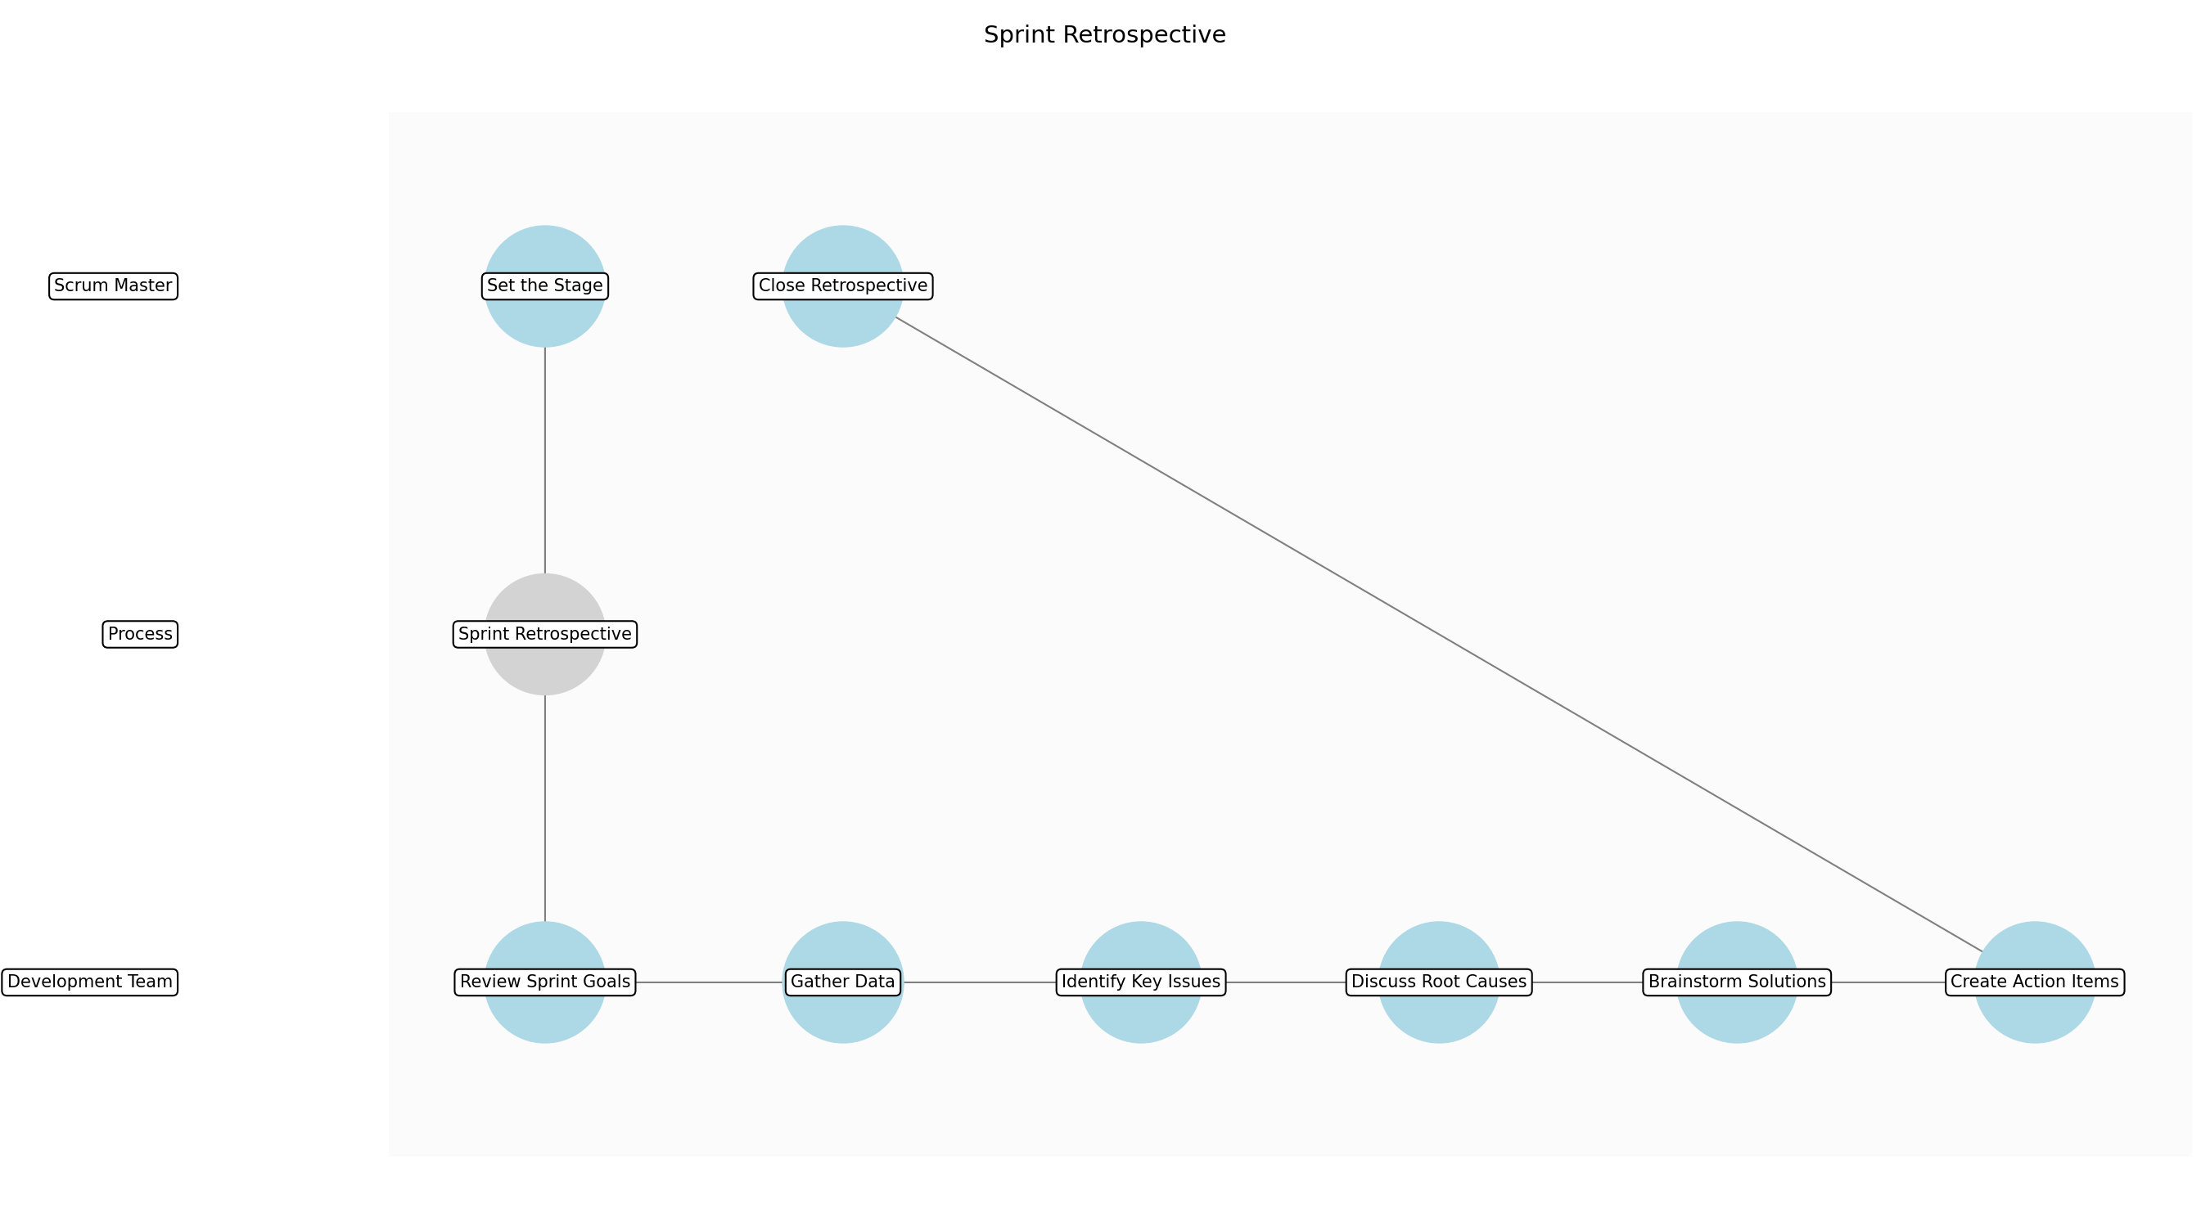

Sprint Retrospective – Set the Stage
Description: The Scrum Master sets the stage for the Sprint Retrospective by explaining the purpose of the meeting, emphasizing the importance of open and honest communication, and establishing a safe environment for sharing feedback. They may also review the ground rules for the retrospective.
Responsible Parties: Scrum Master
Inputs:
- Sprint Review Feedback
- Team Observations
Outputs:
- Established Safe Environment
Dependencies:
Estimated Duration: 5 minutes
Success Criteria:
- A safe and open environment is established for the retrospective.

Sprint Retrospective – Review Sprint Goals
Description: The team reviews the Sprint Goal and the Sprint Backlog to refresh their memories of what they set out to achieve and what they actually accomplished. This provides context for the discussion and helps the team identify areas for improvement.
Responsible Parties: Development Team
Inputs:
- Established Safe Environment
Outputs:
- Refreshed Sprint Context
Dependencies:
- Set the Stage
Estimated Duration: 5 minutes
Success Criteria:
- The team has a shared understanding of the sprint goals and accomplishments.

Sprint Retrospective – Gather Data
Description: The team gathers data about the sprint, focusing on what went well, what could have been better, and what puzzles remain. This can be done using various techniques, such as brainstorming, sticky notes, or online collaboration tools. Examples include: What went well?, What could be improved?, What did we learn?, What still puzzles us?
Responsible Parties: Development Team
Inputs:
- Refreshed Sprint Context
Outputs:
- Collected Data Points
Dependencies:
- Review Sprint Goals
Estimated Duration: 20 minutes
Success Criteria:
- A diverse range of data points are collected, representing different perspectives on the sprint.

Sprint Retrospective – Identify Key Issues
Description: The team analyzes the collected data points and identifies the key issues that had the most significant impact on the sprint. This involves grouping similar data points, identifying common themes, and prioritizing the issues based on their importance.
Responsible Parties: Development Team
Inputs:
- Collected Data Points
Outputs:
- Identified Key Issues
Dependencies:
- Gather Data
Estimated Duration: 20 minutes
Success Criteria:
- The most impactful issues are identified and prioritized.

Sprint Retrospective – Discuss Root Causes
Description: For each key issue, the team discusses the underlying root causes, exploring the factors that contributed to the issue. This involves asking 'why' repeatedly to drill down to the fundamental reasons behind the problem.
Responsible Parties: Development Team
Inputs:
- Identified Key Issues
Outputs:
- Understood Root Causes
Dependencies:
- Identify Key Issues
Estimated Duration: 20 minutes
Success Criteria:
- The root causes of the key issues are understood and documented.

Sprint Retrospective – Brainstorm Solutions
Description: The team brainstorms potential solutions to address the root causes, generating a wide range of ideas without judgment. This encourages creative thinking and helps the team explore different approaches to solving the problems.
Responsible Parties: Development Team
Inputs:
- Understood Root Causes
Outputs:
- Brainstormed Solutions
Dependencies:
- Discuss Root Causes
Estimated Duration: 20 minutes
Success Criteria:
- A variety of potential solutions are brainstormed for each key issue.

Sprint Retrospective – Create Action Items
Description: The team selects the most promising solutions and translates them into concrete action items, assigning ownership and deadlines for each action item. This ensures that the solutions are implemented and that progress is tracked.
Responsible Parties: Development Team
Inputs:
- Brainstormed Solutions
Outputs:
- Action Items for Improvement
Dependencies:
- Brainstorm Solutions
Estimated Duration: 15 minutes
Success Criteria:
- Specific, measurable, achievable, relevant, and time-bound (SMART) action items are created and assigned.

Sprint Retrospective – Close Retrospective
Description: The Scrum Master closes the Sprint Retrospective by summarizing the key takeaways, thanking the team for their participation, and reminding them of the importance of implementing the action items. They may also ask for feedback on the retrospective itself to improve future retrospectives.
Responsible Parties: Scrum Master
Inputs:
- Action Items for Improvement
Outputs:
- Retrospective Closure
Dependencies:
- Create Action Items
Estimated Duration: 5 minutes
Success Criteria:
- The retrospective is closed with a clear summary of the key takeaways and action items.

3.6 Backlog Refinement
On a consistent and recurring basis, the Product Owner and Development Team actively collaborate to refine the Product Backlog. This collaborative effort involves adding granular details to user stories, accurately estimating effort, and strategically prioritizing items to ensure maximum value delivery. Backlog Refinement ensures that the Product Backlog remains consistently up-to-date, well-organized, and fully prepared for efficient and effective Sprint Planning, minimizing ambiguity and maximizing team productivity. This also helps in identifying dependencies and risks early on, ensuring a smooth and predictable development process.
Responsible Parties: Product Owner
Success Criteria:
- User stories are comprehensively defined, meticulously estimated, and consistently reflect current requirements.
- The backlog is strategically prioritized based on a clear understanding of business value, stakeholder priorities, and strategic alignment.

Required Sub Process(es) for the Step "Backlog Refinement"
The following details the subprocess flows for the step "Backlog Refinement".
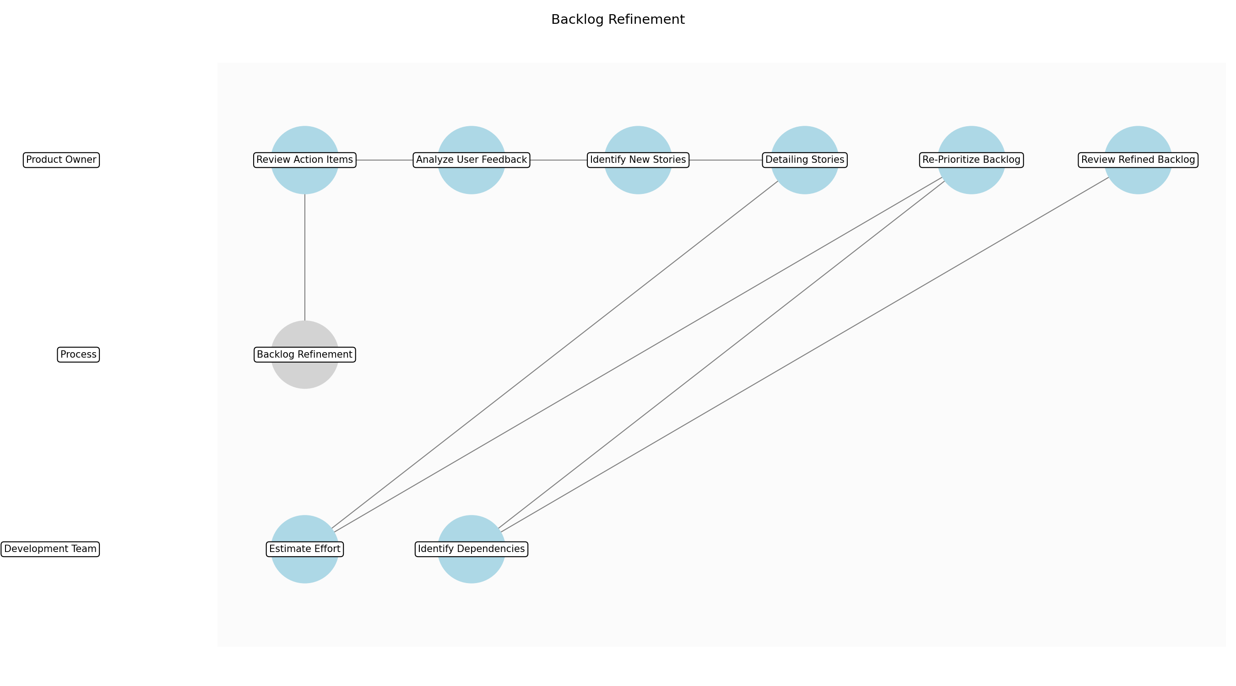

Backlog Refinement – Review Action Items
Description: The Product Owner and Development Team review action items from the Sprint Retrospective to ensure they are being addressed and incorporated into the backlog refinement process. This ensures continuous improvement based on past sprint experiences.
Responsible Parties: Product Owner
Inputs:
- Product Backlog
- User Feedback
Outputs:
- Reviewed Action Items
Dependencies:
Estimated Duration: 15 minutes
Success Criteria:
- Action items from the Sprint Retrospective are reviewed and understood.

Backlog Refinement – Analyze User Feedback
Description: The Product Owner analyzes user feedback collected from various sources (e.g., Sprint Reviews, user surveys, support tickets) to identify new requirements, pain points, and areas for improvement. This ensures that the backlog reflects the latest user needs and expectations.
Responsible Parties: Product Owner
Inputs:
- Reviewed Action Items
Outputs:
- Analyzed User Feedback
Dependencies:
- Review Action Items
Estimated Duration: 30 minutes
Success Criteria:
- User feedback is analyzed and documented.

Backlog Refinement – Identify New Stories
Description: Based on the analyzed user feedback and business priorities, the Product Owner identifies and drafts new user stories to be added to the Product Backlog. These user stories should clearly define the desired functionality and the value they provide.
Responsible Parties: Product Owner
Inputs:
- Analyzed User Feedback
Outputs:
- Drafted User Stories
Dependencies:
- Analyze User Feedback
Estimated Duration: 30 minutes
Success Criteria:
- New user stories are drafted and added to the Product Backlog.

Backlog Refinement – Detailing Stories
Description: The Product Owner and Development Team collaborate to add details to the existing and newly drafted user stories, including acceptance criteria, mockups, and any other relevant information. This ensures that the user stories are well-defined and ready for estimation.
Responsible Parties: Product Owner
Inputs:
- Drafted User Stories
Outputs:
- Detailed User Stories
Dependencies:
- Identify New Stories
Estimated Duration: 30 minutes
Success Criteria:
- User stories have clear descriptions and acceptance criteria.

Backlog Refinement – Estimate Effort
Description: The Development Team estimates the effort required to implement the detailed user stories, using techniques such as story points or t-shirt sizing. This provides a basis for prioritizing the user stories and planning future sprints.
Responsible Parties: Development Team
Inputs:
- Detailed User Stories
Outputs:
- Estimated User Stories
Dependencies:
- Detailing Stories
Estimated Duration: 30 minutes
Success Criteria:
- All user stories have effort estimates assigned.

Backlog Refinement – Re-Prioritize Backlog
Description: The Product Owner re-prioritizes the Product Backlog based on the estimated effort, business value, and any other relevant factors. This ensures that the most valuable user stories are at the top of the backlog and ready for implementation in the next sprint.
Responsible Parties: Product Owner
Inputs:
- Estimated User Stories
- Product Backlog
Outputs:
- Re-Prioritized Backlog
Dependencies:
- Estimate Effort
Estimated Duration: 15 minutes
Success Criteria:
- User stories are ranked in order of priority.

Backlog Refinement – Identify Dependencies
Description: The Development Team identifies any dependencies between user stories or with external systems, and documents them in the Product Backlog. This helps to avoid delays and ensure a smooth development process.
Responsible Parties: Development Team
Inputs:
- Re-Prioritized Backlog
Outputs:
- Documented Dependencies
Dependencies:
- Re-Prioritize Backlog
Estimated Duration: 15 minutes
Success Criteria:
- Dependencies are identified and documented.

Backlog Refinement – Review Refined Backlog
Description: The Product Owner and Development Team review the refined Product Backlog to ensure that it is up-to-date, well-organized, and ready for Sprint Planning. This is the final check before the next sprint planning meeting.
Responsible Parties: Product Owner
Inputs:
- Documented Dependencies
Outputs:
- Refined Product Backlog
Dependencies:
- Identify Dependencies
Estimated Duration: 10 minutes
Success Criteria:
- The product backlog is ready for sprint planning.

4.0 Supporting Systems and Tools
The following tools and platforms support this process:
Category | Tools
Project Management Tool | Used for meticulously tracking user stories, tasks, and sprints, facilitating efficient workflow management (e.g., Jira, Asana).
Version Control System | Used for robustly managing source code, ensuring code integrity, and facilitating seamless collaboration (e.g., Git).
Ci/Cd Pipeline | Used for automating the build, rigorous testing, and seamless deployment processes, accelerating delivery cycles.

5.0 Metrics and Key Performance Indicators (KPIs)
The following is a list of key metrics associated with this process. These metrics help monitor performance and ensure alignment with business objectives.

Velocity
Accurately measures the amount of work completed per sprint, providing insights into team productivity and capacity.

Customer Satisfaction
Quantified through surveys, direct feedback, and Net Promoter Score (NPS), reflecting the level of customer delight.

Defect Rate
Tracks the number of defects discovered in production, highlighting areas for code quality improvement and process refinement.

On-time Delivery
Measures the percentage of sprints completed precisely on schedule, indicating the team's ability to meet commitments.

6.0 Reporting and Analytics
The following are key reporting and analytics associated with this process.
Metric / Key | Description / Value
Sprint Burndown Charts | Visually track progress during a sprint, providing a clear indication of remaining work and potential roadblocks.
Velocity Charts | Analyze the team's velocity over time, identifying trends, patterns, and opportunities for performance optimization.
Defect Reports | Monitor the number and severity of defects, enabling proactive identification of quality issues and targeted improvement efforts.
Customer Satisfaction Reports | Track customer satisfaction trends, providing valuable insights into product quality and user experience.

7.0 System Requirements
The following system requirements are essential for the successful implementation of this process.
- Project Management Tool (e.g., Jira, Asana): Essential for collaborative task management, sprint planning, and progress tracking.
- Version Control System (e.g., Git): Crucial for secure source code management, version control, and collaborative development workflows.
- Continuous Integration/Continuous Delivery (CI/CD) Pipeline: Vital for automating build processes, rigorous testing, and rapid deployment cycles.

8.0 Process Flow Diagram
The following diagram provides a high-level visualization of the process flow as defined in the normalized JSON source.
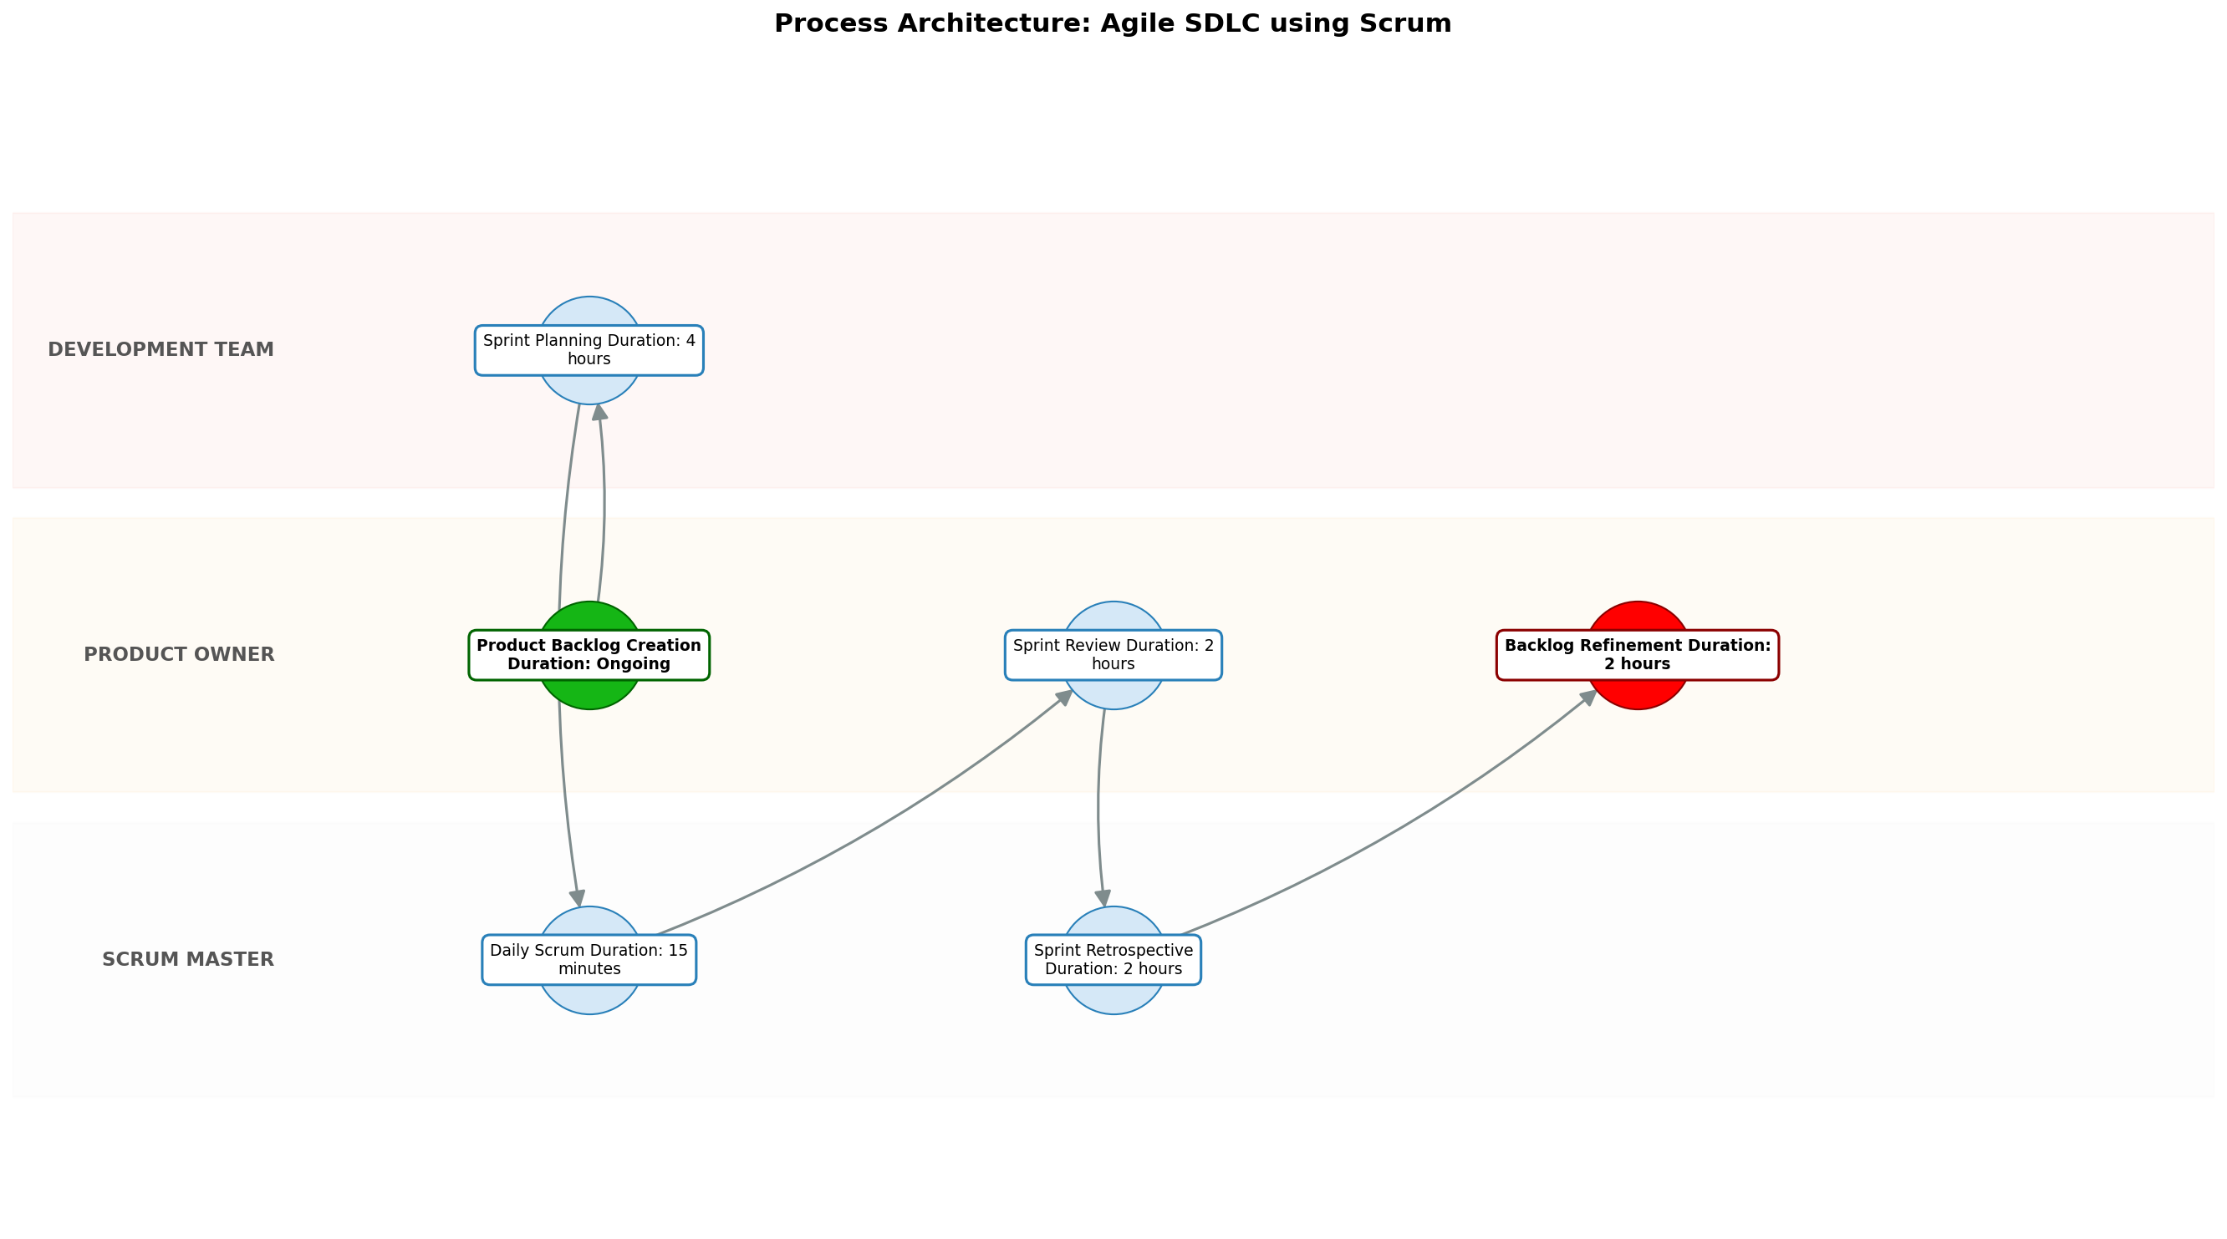

9.0 Process Performance Report
The following metrics are based on a Monte Carlo discrete-event simulation running 2,000 iterations. All time-based values are reported in hours.
Operational Metric | Simulated Value
Average Cycle Time | 34.54 hours
Cycle Time Variance | 4.82 hours
Contention Risk Profile | Low

Identified Bottlenecks
- Daily Scrum
- Sprint Planning
- Sprint Review

Detailed Step Performance
Process Step | Avg. Duration (hours)
Product Backlog Creation | 1.34
Sprint Planning | 5.35
Daily Scrum | 19.83
Sprint Review | 2.68
Sprint Retrospective | 2.67
Backlog Refinement | 2.67

Appendix B: Additional Source Data
This appendix contains additional structured data from the normalized source JSON that is not covered in the main sections.
Assumptions:
- The team possesses a foundational understanding of Agile principles and Scrum practices, enabling effective collaboration and process adherence.
- The Product Owner remains readily available to provide clear guidance, promptly address inquiries, and actively participate in feedback loops.
- The team possesses the requisite skills, expertise, and experience to successfully develop and deliver the software according to specifications.
Constraints:
- Small Team Size: Necessitates efficient communication channels, streamlined workflows, and a high degree of individual accountability.
- Limited Resources: Requires meticulous prioritization, strategic allocation of resources, and a relentless focus on delivering maximum value.
- Changing Requirements: Demands adaptability, flexibility, and a proactive approach to managing scope changes while minimizing disruption.

Appendix C: Glossary
This glossary contains definitions of common terms used in the process documentation.
Term | Definition
Business Process | A set of related activities or tasks performed to achieve a specific organizational goal.
KPI | Key Performance Indicator used to measure the success or health of a process.
Stakeholder | Any individual or group with an interest in the outcomes of the process.
Continuous Improvement | Ongoing effort to improve products, services or processes.

