World Creation
A detailed process for creating a self-sustaining world capable of fostering intelligent life within one month.
Industry / Domain: World Creation
Version: 1.0
Generated On: 2026-01-23 01:41:37

Document Control
Version | Date | Author | Description
1.0

Table of Contents

1.0 Process Overview
A detailed process for creating a self-sustaining world capable of fostering intelligent life within one month.

1.1 Assumptions
- Natural laws are consistent
- Evolutionary processes are reliable
- Life will adapt to environmental conditions
- Resources will be used sustainably
- Intelligent life will emerge given suitable conditions

1.2 Constraints
- Time limit of one month
- Limited initial resources
- Unpredictability of evolutionary processes

1.3 Purpose
To create a viable, self-sustaining world capable of supporting and fostering intelligent life.

1.4 Scope
The creation of a planet from initial conceptualization to a self-sustaining ecosystem with intelligent life.

1.5 Industry Sector
World Creation

2.0 Stakeholders and Responsibilities
The following is a list of key stakeholders involved in this process. Understanding their roles and responsibilities is crucial for successful implementation.
Stakeholder | Responsibilities
God (Creator, Planner, Overseer) | Defining world parameters  Designing natural laws  Overseeing ecosystem development  Guiding evolution  Monitoring world performance
Natural Forces (Elements, Physics) | Maintaining environmental stability  Driving geological processes  Regulating atmospheric and hydrological cycles
Life Forms (Flora, Fauna) | Adapting to environmental conditions  Participating in food chains and nutrient cycles  Contributing to biodiversity

3.0 Process Workflow
The following is a list of key steps in the process workflow.

3.1 Conceptualization and Planning
Description:
- Define world parameters (size, shape, environment). Design fundamental laws of physics and chemistry. Plan initial geological features and atmospheric composition.
Responsible Parties:
- God (Creator)
Outputs:
- World parameters
- Fundamental laws
- Geological plan
- Atmospheric plan
Success Criteria:
- Clearly defined world parameters
- Functional and stable laws of physics and chemistry
- Comprehensive geological and atmospheric plans

Required Sub Process(es) for the Step "Conceptualization and Planning"
The following details the subprocess flows for the step "Conceptualization and Planning".
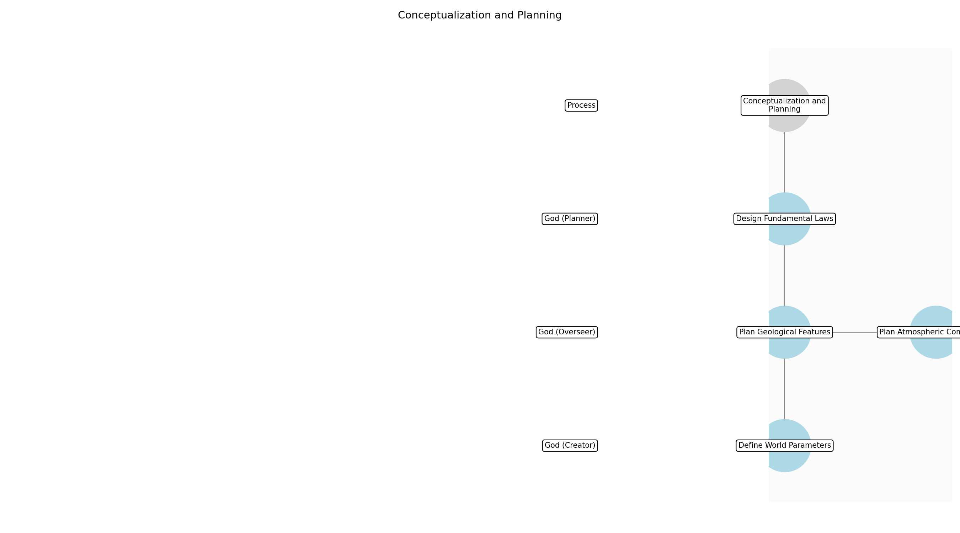

Conceptualization and Planning – Define World Parameters
Description:
- Establish the fundamental characteristics of the world, including its size, shape, and overall environment. This involves determining the physical dimensions, geographical layout, and environmental conditions that will support life and natural processes. The parameters set in this stage will influence all subsequent design and development phases.
Responsible Party:
- God (Creator)
Inputs:
Outputs:
- World size
- World shape
- Environmental conditions
Estimated Duration:
- 1 day
Dependencies:
Success Criteria:
- Clearly defined world size and shape
- Comprehensive description of environmental conditions
Purpose:
- To set the basic physical and environmental attributes of the world.
Scope:
- Determining the size, shape, and environment of the world.
Process Owner:
- God (Creator, Planner, Overseer)
Triggers:
- The divine spark of creation
End Conditions:
- World parameters are fully defined
Step Risks and Controls:
- Risk: World parameters are not conducive to life
- Control: Thorough simulation and testing of various parameter combinations
Governance Requirements:
- Divine oversight of initial conditions
Change Management:
- Change Request Process: Submit request to God
- Versioning Rules: Major changes require complete world reset
Continuous Improvement:
- Review Frequency: After geological formation
Improvement Inputs:
- Simulation results
- Feedback from natural forces

Conceptualization and Planning – Design Fundamental Laws
Description:
- Formulate the laws of physics and chemistry that will govern the world's natural processes. This includes defining the fundamental forces, chemical interactions, and physical constants that will dictate how matter and energy behave. These laws must be internally consistent and capable of supporting complex systems and life forms.
Responsible Party:
- God (Planner)
Inputs:
- World size
- World shape
- Environmental conditions
Outputs:
- Laws of physics
- Laws of chemistry
Estimated Duration:
- 1 day
Dependencies:
- Define World Parameters
Success Criteria:
- Functional and stable laws of physics and chemistry
- Laws are consistent with world parameters
Purpose:
- To establish the rules that govern the world's natural processes.
Scope:
- Defining the fundamental laws of physics and chemistry.
Process Owner:
- God (Creator, Planner, Overseer)
Triggers:
- World parameters are fully defined
End Conditions:
- Laws of physics and chemistry are fully defined
Step Risks and Controls:
- Risk: Incompatible laws of physics and chemistry
- Control: Thorough testing and simulation of interactions
Governance Requirements:
- Divine oversight of natural laws
Change Management:
- Change Request Process: Submit request to God
- Versioning Rules: Major changes require complete world reset
Continuous Improvement:
- Review Frequency: After atmospheric development
Improvement Inputs:
- Simulation results
- Feedback from natural forces

Conceptualization and Planning – Plan Geological Features
Description:
- Develop a comprehensive plan for the initial geological features of the world, including the arrangement of continents, oceans, and major landforms. This involves simulating tectonic activity, erosion, and other geological processes to create a diverse and functional landscape. The plan should also consider the distribution of essential minerals and resources.
Responsible Party:
- God (Overseer)
Inputs:
- World size
- World shape
- Laws of physics
- Laws of chemistry
Outputs:
- Initial geological plan
- Resource distribution plan
Estimated Duration:
- 0.5 day
Dependencies:
- Define World Parameters
- Design Fundamental Laws
Success Criteria:
- Comprehensive geological plan
- Strategic resource distribution plan
Purpose:
- To design the physical structure and resource base of the world.
Scope:
- Planning the initial geological features and resource distribution.
Process Owner:
- God (Creator, Planner, Overseer)
Triggers:
- Laws of physics and chemistry are fully defined
End Conditions:
- Initial geological plan is complete
Step Risks and Controls:
- Risk: Unstable geological features
- Control: Careful simulation and adjustment of geological parameters
Governance Requirements:
- Divine oversight of geological planning
Change Management:
- Change Request Process: Submit request to God
- Versioning Rules: Major changes require complete world reset
Continuous Improvement:
- Review Frequency: After ecosystem creation
Improvement Inputs:
- Simulation results
- Feedback from natural forces

Conceptualization and Planning – Plan Atmospheric Composition
Description:
- Design the initial atmospheric composition of the world, ensuring it is suitable for the development of life. This involves determining the proportions of various gases, such as oxygen, nitrogen, and carbon dioxide, as well as considering factors like air pressure and temperature. The atmospheric plan should also account for the establishment of a functional water cycle.
Responsible Party:
- God (Overseer)
Inputs:
- World size
- World shape
- Laws of physics
- Laws of chemistry
Outputs:
- Atmospheric composition plan
- Hydrological cycle plan
Estimated Duration:
- 0.5 day
Dependencies:
- Define World Parameters
- Design Fundamental Laws
Success Criteria:
- Atmospheric composition suitable for life
- Functional hydrological cycle plan
Purpose:
- To design an atmosphere conducive to life and natural processes.
Scope:
- Planning the initial atmospheric composition and hydrological cycle.
Process Owner:
- God (Creator, Planner, Overseer)
Triggers:
- Laws of physics and chemistry are fully defined
End Conditions:
- Atmospheric composition plan is complete
Step Risks and Controls:
- Risk: Unbreathable atmosphere
- Control: Careful regulation of atmospheric gases
Governance Requirements:
- Divine oversight of atmospheric planning
Change Management:
- Change Request Process: Submit request to God
- Versioning Rules: Major changes require complete world reset
Continuous Improvement:
- Review Frequency: After biodiversity expansion
Improvement Inputs:
- Simulation results
- Feedback from natural forces

3.2 Geological Formation
Description:
- Simulate tectonic activity. Establish continents, oceans, and landforms. Introduce essential minerals and resources.
Responsible Parties:
- Tectonic Simulator
Inputs:
- World parameters
- Geological plan
Outputs:
- Geological map
- Resource distribution
- Landform data
Success Criteria:
- Stable continents and oceans
- Diverse and functional landforms
- Sufficient mineral and resource availability

Required Sub Process(es) for the Step "Geological Formation"
The following details the subprocess flows for the step "Geological Formation".
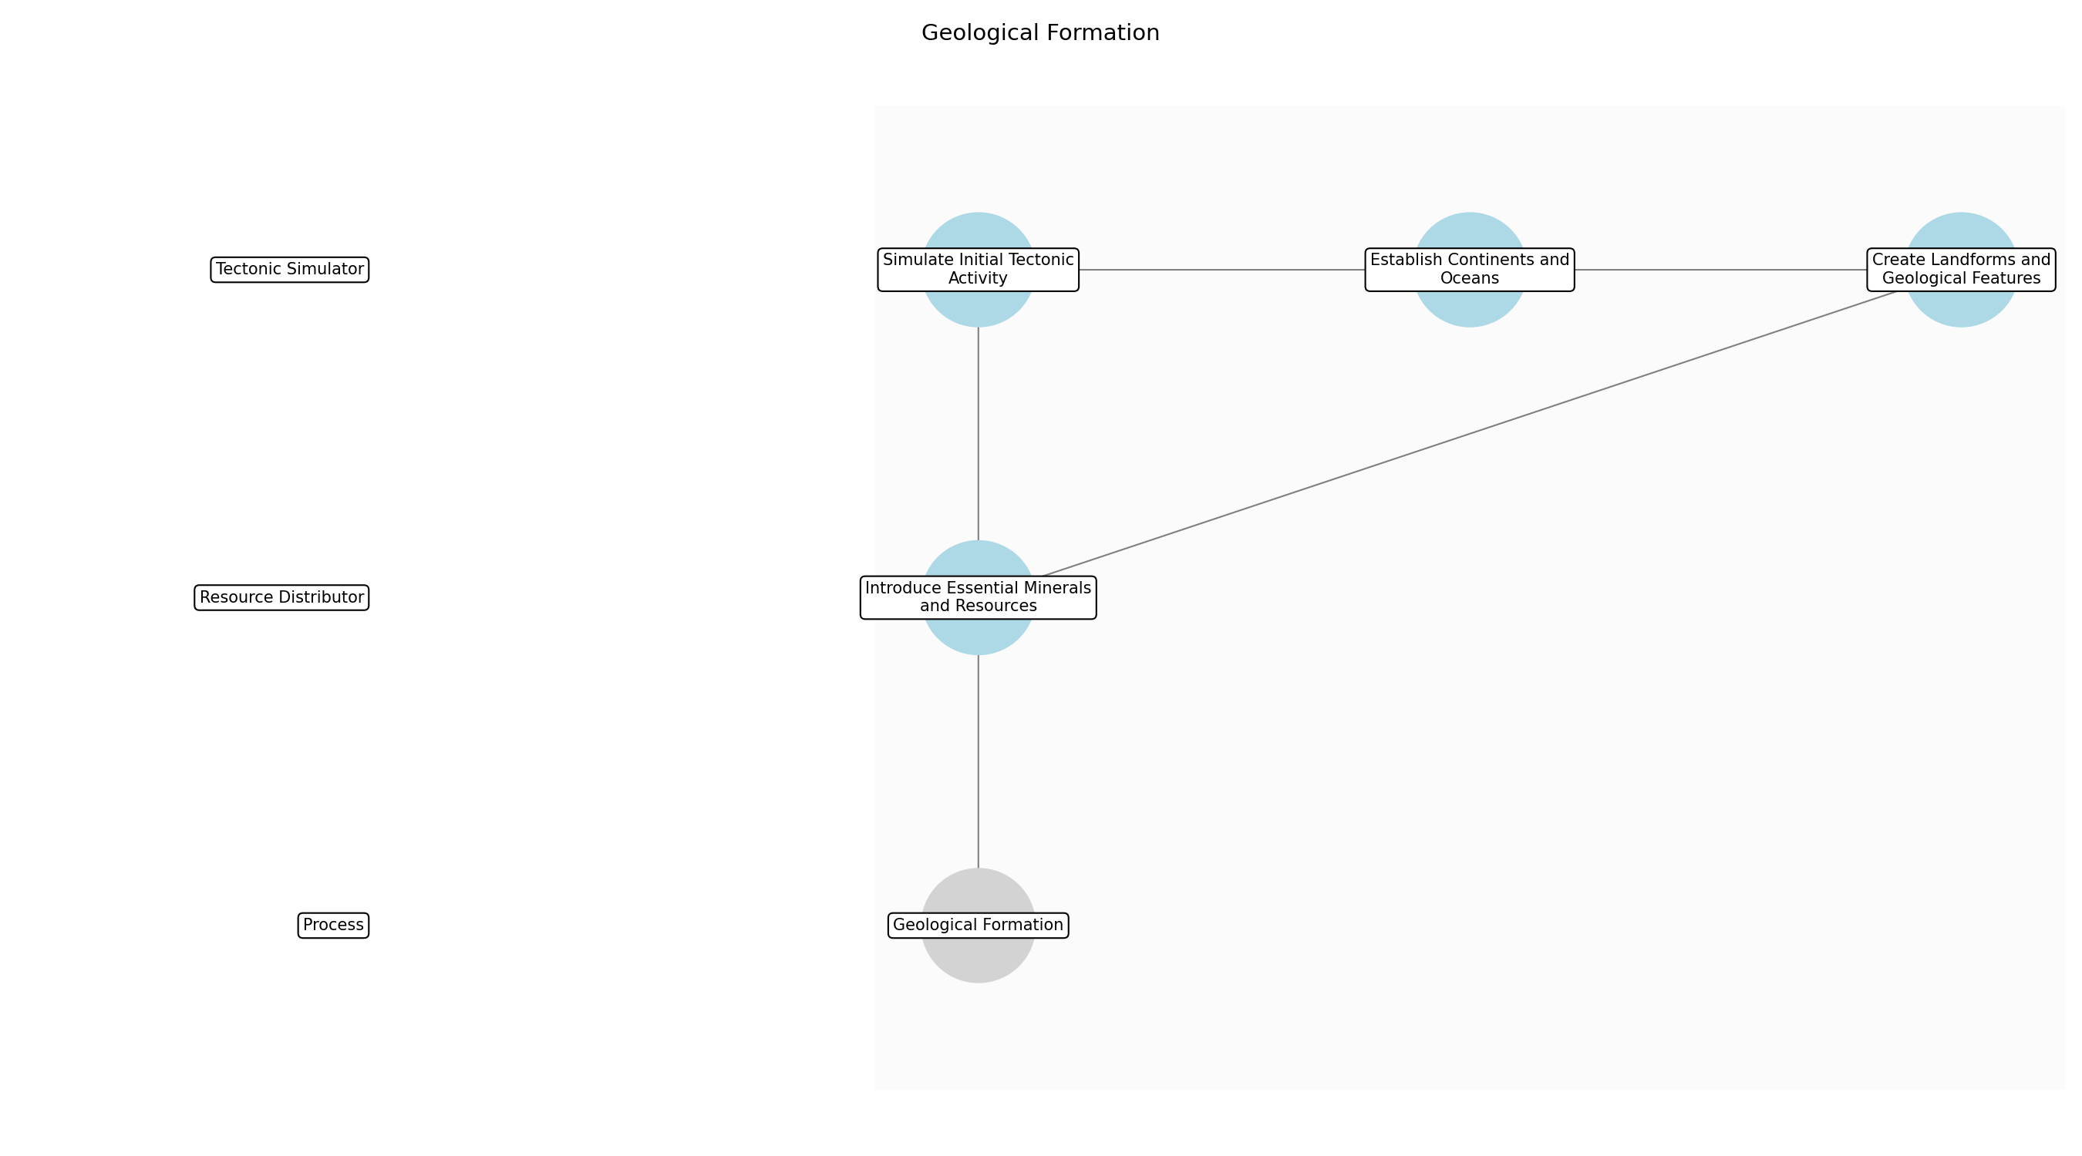

Geological Formation – Simulate Initial Tectonic Activity
Description:
- Initiate the world simulation engine to simulate early tectonic movements. This involves setting up the initial parameters for plate tectonics, including the number of plates, their sizes, and their initial directions of movement. The simulation will run for a defined period, generating a preliminary layout of the world's crust.
Responsible Party:
- Tectonic Simulator
Inputs:
- World parameters
- Geological plan
Outputs:
- Initial crust layout
- Tectonic activity report
Estimated Duration:
- 1 day
Dependencies:
Success Criteria:
- Simulation engine is running
- Initial crust layout is generated
- Tectonic activity report is produced
Purpose:
- To generate the initial layout of the world's crust through simulated tectonic activity.
Scope:
- Simulating the initial tectonic movements and generating a preliminary crust layout.
Process Owner:
- Natural Forces (Elements, Physics)
Triggers:
- Implementation of geological plan
End Conditions:
- Initial crust layout is generated
- Tectonic activity report is produced
Step Risks and Controls:
- Risk: Simulation instability
- Control: Implement error handling and logging mechanisms
- Risk: Inaccurate tectonic simulation
- Control: Calibrate simulation parameters based on real-world data
Governance Requirements:
- Adherence to physical laws
Change Management:
- Change Request Process: Adjust simulation parameters
- Versioning Rules: Record all simulation parameter changes
Continuous Improvement:
- Review Frequency: After each simulation run
Improvement Inputs:
- Simulation results
- Feedback from natural forces

Geological Formation – Establish Continents and Oceans
Description:
- Based on the initial crust layout, define the boundaries of continents and oceans. This involves identifying areas of high elevation that will form continents and areas of low elevation that will form oceans. The process includes defining the shapes and sizes of the continents and oceans, ensuring they align with the geological plan.
Responsible Party:
- Tectonic Simulator
Inputs:
- Initial crust layout
- Geological plan
Outputs:
- Continent and ocean boundaries
- Elevation map
Estimated Duration:
- 1 day
Dependencies:
- Simulate Initial Tectonic Activity
Success Criteria:
- Continent and ocean boundaries are defined
- Elevation map is generated
- Boundaries align with geological plan
Purpose:
- To define the boundaries of continents and oceans based on the initial crust layout.
Scope:
- Defining the shapes and sizes of continents and oceans.
Process Owner:
- Natural Forces (Elements, Physics)
Triggers:
- Initial crust layout is generated
End Conditions:
- Continent and ocean boundaries are defined
- Elevation map is generated
Step Risks and Controls:
- Risk: Unrealistic continent shapes
- Control: Adjust simulation parameters to create more realistic shapes
- Risk: Uneven distribution of landmasses
- Control: Adjust tectonic activity to balance landmass distribution
Governance Requirements:
- Adherence to physical laws
Change Management:
- Change Request Process: Adjust continent and ocean boundaries
- Versioning Rules: Record all boundary changes
Continuous Improvement:
- Review Frequency: After each boundary adjustment
Improvement Inputs:
- Erosion patterns
- Resource distribution

Geological Formation – Create Landforms and Geological Features
Description:
- Simulate the formation of various landforms and geological features, such as mountains, valleys, and plateaus. This involves simulating erosion, weathering, and other geological processes that shape the land over time. The simulation will generate a diverse range of landforms, ensuring they are functional and aesthetically pleasing.
Responsible Party:
- Tectonic Simulator
Inputs:
- Continent and ocean boundaries
- Elevation map
Outputs:
- Landform data
- Geological features map
Estimated Duration:
- 1 day
Dependencies:
- Establish Continents and Oceans
Success Criteria:
- Landform data is generated
- Geological features map is produced
- Landforms are diverse and functional
Purpose:
- To simulate the formation of various landforms and geological features.
Scope:
- Simulating erosion, weathering, and other geological processes.
Process Owner:
- Natural Forces (Elements, Physics)
Triggers:
- Continent and ocean boundaries are defined
End Conditions:
- Landform data is generated
- Geological features map is produced
Step Risks and Controls:
- Risk: Unrealistic landform shapes
- Control: Adjust simulation parameters to create more realistic shapes
- Risk: Lack of landform diversity
- Control: Adjust simulation parameters to create a more diverse range of landforms
Governance Requirements:
- Adherence to physical laws
Change Management:
- Change Request Process: Adjust landform parameters
- Versioning Rules: Record all landform parameter changes
Continuous Improvement:
- Review Frequency: After each landform adjustment
Improvement Inputs:
- Erosion patterns
- Resource depletion rates

Geological Formation – Introduce Essential Minerals and Resources
Description:
- Strategically place essential minerals and resources throughout the world. This involves simulating the formation of mineral deposits and resource distribution based on geological processes. The placement of resources will be strategic, ensuring they are accessible and distributed in a way that supports the development of ecosystems and future civilizations.
Responsible Party:
- Resource Distributor
Inputs:
- Landform data
- Geological features map
Outputs:
- Resource distribution map
- Mineral deposit locations
Estimated Duration:
- 1 day
Dependencies:
- Create Landforms and Geological Features
Success Criteria:
- Resource distribution map is generated
- Mineral deposit locations are defined
- Resources are accessible and strategically distributed
Purpose:
- To strategically place essential minerals and resources throughout the world.
Scope:
- Simulating the formation of mineral deposits and resource distribution.
Process Owner:
- Natural Forces (Elements, Physics)
Triggers:
- Landform data is generated
End Conditions:
- Resource distribution map is generated
- Mineral deposit locations are defined
Step Risks and Controls:
- Risk: Uneven resource distribution
- Control: Adjust simulation parameters to balance resource distribution
- Risk: Inaccessible resource locations
- Control: Ensure resources are placed in accessible locations
Governance Requirements:
- Adherence to physical laws
Change Management:
- Change Request Process: Adjust resource distribution
- Versioning Rules: Record all resource distribution changes
Continuous Improvement:
- Review Frequency: After each resource adjustment
Improvement Inputs:
- Resource depletion rates
- Ecosystem health

3.3 Atmospheric and Hydrological Development
Description:
- Create atmospheric composition suitable for life. Establish water cycle (evaporation, condensation, precipitation). Simulate weather patterns and climate zones.
Responsible Parties:
- Atmospheric Regulator
Inputs:
- World parameters
- Atmospheric plan
Outputs:
- Atmospheric data
- Hydrological cycle data
- Climate data
Success Criteria:
- Breathable atmosphere
- Functional water cycle
- Stable weather patterns
- Diverse climate zones

Required Sub Process(es) for the Step "Atmospheric and Hydrological Development"
The following details the subprocess flows for the step "Atmospheric and Hydrological Development".
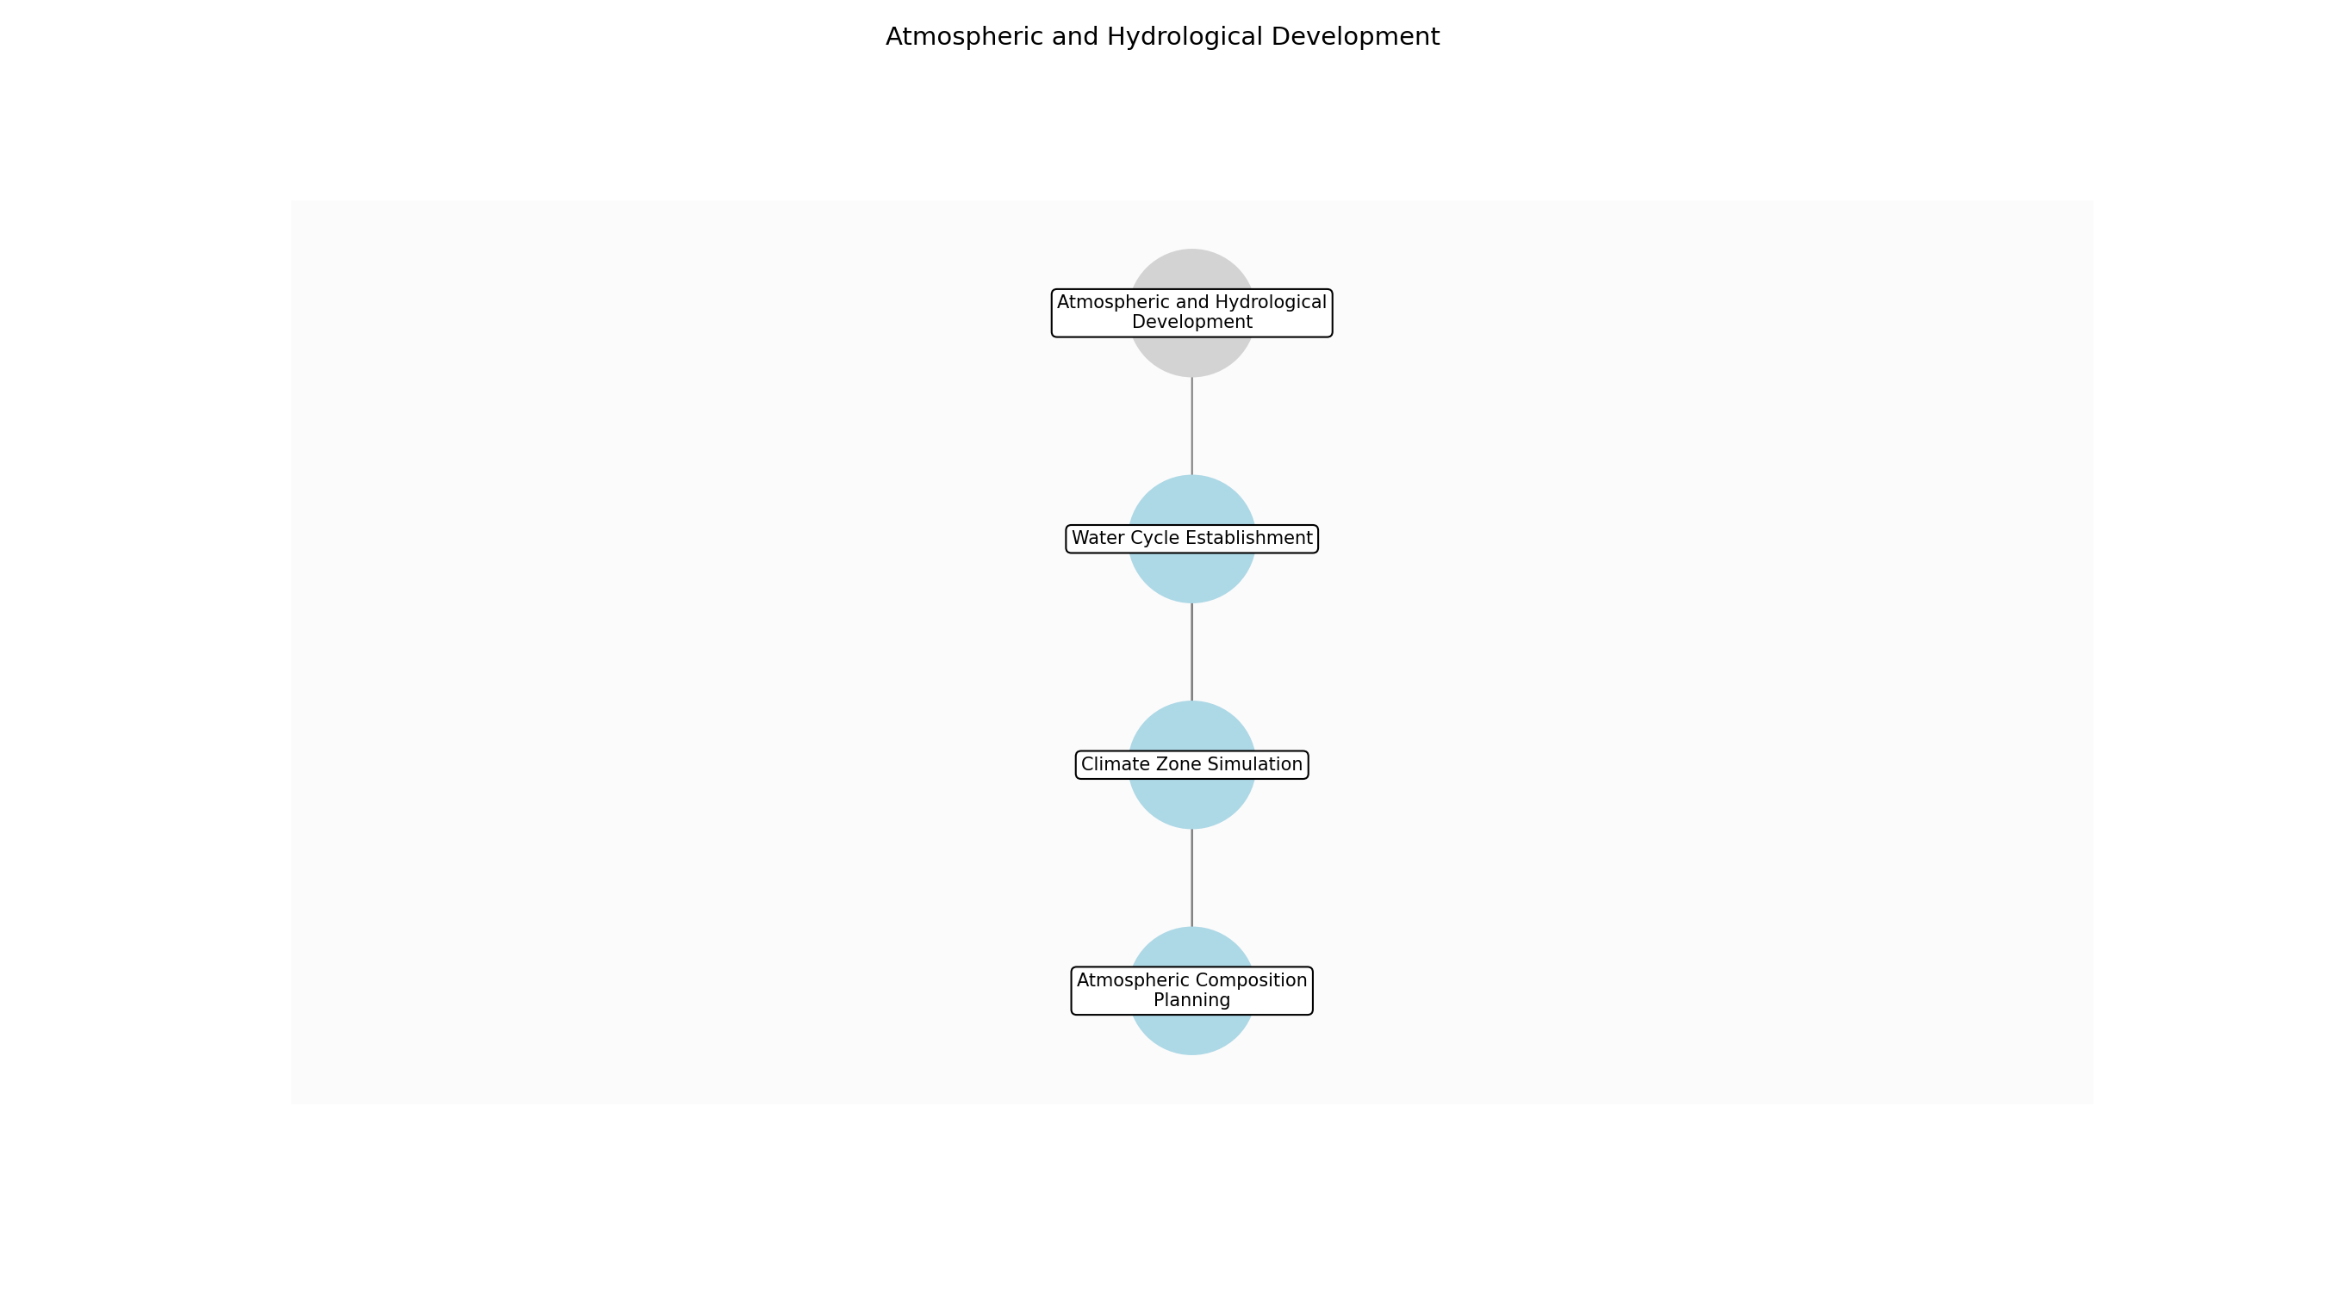

Atmospheric and Hydrological Development – Atmospheric Composition Planning
Description:
- Define the initial atmospheric composition, including the types and proportions of gases necessary for supporting life. This involves considering factors such as the planet's size, distance from its star, and geological activity. The plan will outline the processes for introducing and regulating these gases.
Responsible Party:
- Atmospheric Regulator
Inputs:
- World parameters
- Atmospheric plan
Outputs:
- Atmospheric composition blueprint
Estimated Duration:
- 1 day
Dependencies:
Success Criteria:
- Defined atmospheric gas composition
- Established gas proportions
- Identified regulation processes
Purpose:
- To establish a viable atmospheric composition.
Scope:
- Defining the initial atmospheric gas mixture.
Process Owner:
- Natural Forces (Elements, Physics)
Triggers:
- Completion of geological formation
End Conditions:
- Atmospheric composition blueprint is complete
Step Risks and Controls:
- Risk: Incorrect gas mixture
- Control: Simulation and adjustment of gas proportions
- Risk: Insufficient atmospheric pressure
- Control: Regulation of atmospheric density
Governance Requirements:
- Adherence to chemical and physical laws
Change Management:
- Change Request Process: Adjust atmospheric composition
- Versioning Rules: Record all atmospheric changes
Continuous Improvement:
- Review Frequency: Annual climate assessments
Improvement Inputs:
- Atmospheric pollution levels
- Gas balance metrics

Atmospheric and Hydrological Development – Water Cycle Establishment
Description:
- Establish the water cycle by simulating evaporation, condensation, and precipitation processes. This includes defining the initial water sources (oceans, lakes, rivers), setting temperature gradients, and simulating cloud formation. The goal is to create a self-sustaining water cycle that distributes water across the planet.
Responsible Party:
- Hydrological Cycle Manager
Inputs:
- World parameters
- Atmospheric composition blueprint
Outputs:
- Water cycle model
- Precipitation patterns
Estimated Duration:
- 1 day
Dependencies:
- Atmospheric Composition Planning
Success Criteria:
- Functional water cycle
- Established precipitation patterns
- Defined water sources
Purpose:
- To establish a functional water cycle.
Scope:
- Simulating water evaporation, condensation, and precipitation.
Process Owner:
- Natural Forces (Elements, Physics)
Triggers:
- Completion of atmospheric composition planning
End Conditions:
- Water cycle model is complete
Step Risks and Controls:
- Risk: Insufficient water evaporation
- Control: Adjust temperature gradients
- Risk: Uneven precipitation distribution
- Control: Modify cloud formation patterns
Governance Requirements:
- Adherence to physical laws
Change Management:
- Change Request Process: Adjust water cycle parameters
- Versioning Rules: Record all hydrological changes
Continuous Improvement:
- Review Frequency: Annual climate assessments
Improvement Inputs:
- Water cycle efficiency
- Precipitation distribution

Atmospheric and Hydrological Development – Climate Zone Simulation
Description:
- Simulate weather patterns and climate zones by adjusting parameters such as solar radiation, wind patterns, and ocean currents. This involves creating diverse climate zones, from tropical to arctic, and ensuring stable weather patterns within each zone. The goal is to create a varied and habitable environment.
Responsible Party:
- Climate Regulator
Inputs:
- Water cycle model
- Precipitation patterns
Outputs:
- Climate zone map
- Weather pattern simulations
Estimated Duration:
- 2 days
Dependencies:
- Water Cycle Establishment
Success Criteria:
- Stable weather patterns
- Diverse climate zones
- Defined solar radiation levels
Purpose:
- To simulate weather patterns and climate zones.
Scope:
- Adjusting parameters to create diverse climate zones.
Process Owner:
- Natural Forces (Elements, Physics)
Triggers:
- Completion of water cycle establishment
End Conditions:
- Climate zone map is complete
Step Risks and Controls:
- Risk: Unstable weather patterns
- Control: Simulation and adjustment of climate parameters
- Risk: Extreme temperature variations
- Control: Regulation of solar radiation levels
Governance Requirements:
- Adherence to physical laws
Change Management:
- Change Request Process: Adjust climate parameters
- Versioning Rules: Record all climate changes
Continuous Improvement:
- Review Frequency: Annual climate assessments
Improvement Inputs:
- Climate stability metrics
- Temperature variations

3.4 Ecosystem Creation
Description:
- Introduce basic life forms (bacteria, algae). Simulate evolutionary processes. Establish food chains and nutrient cycles.
Responsible Parties:
- God (Creator)
Inputs:
- Atmospheric data
- Hydrological cycle data
- Climate data
Outputs:
- Initial ecosystems
- Evolutionary algorithm
- Food web diagrams
- Nutrient cycle diagrams
Success Criteria:
- Self-sustaining ecosystems
- Functional food chains and nutrient cycles
- Active evolutionary processes

Required Sub Process(es) for the Step "Ecosystem Creation"
The following details the subprocess flows for the step "Ecosystem Creation".
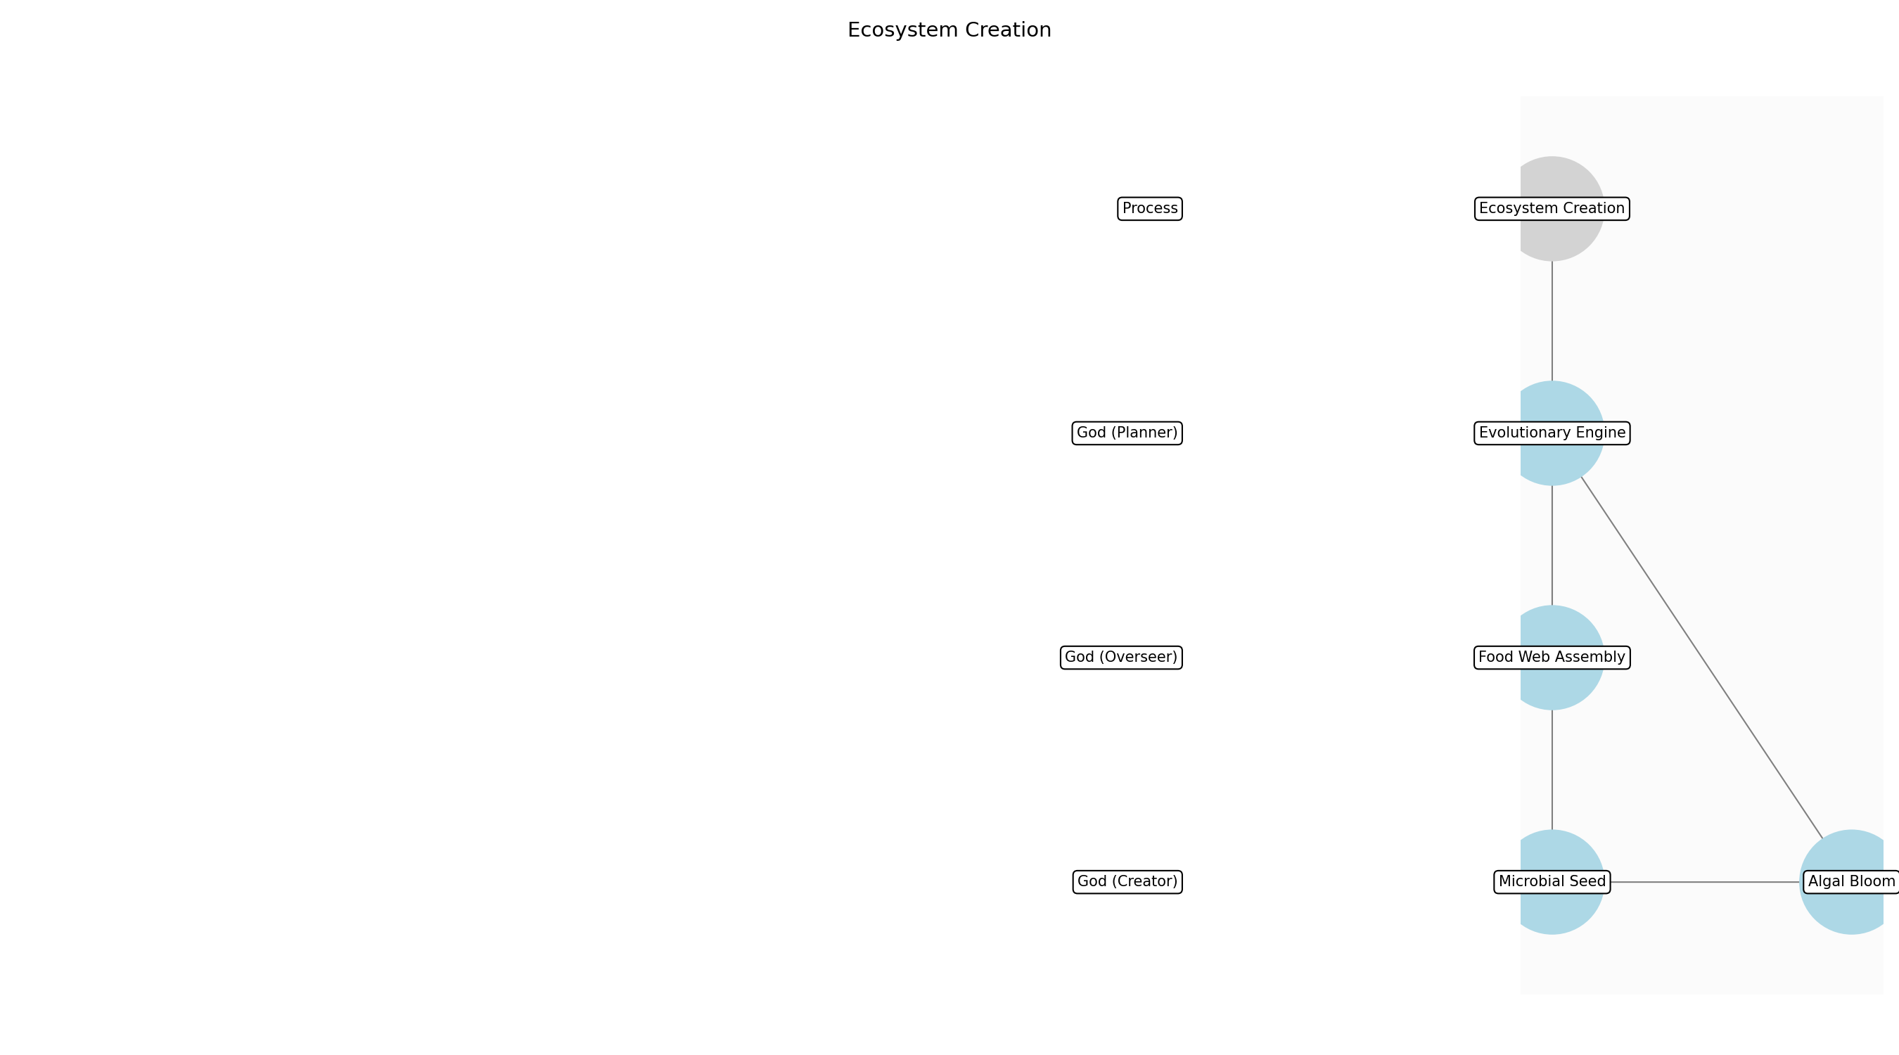

Ecosystem Creation – Microbial Seed
Description:
- Introduce a diverse range of bacteria and archaea into the aquatic and terrestrial environments. These microorganisms will serve as the foundation for nutrient cycling and decomposition, essential for establishing a self-sustaining ecosystem. The selection will prioritize species known for their resilience and adaptability to varying environmental conditions.
Responsible Party:
- God (Creator)
Inputs:
- Atmospheric data
- Hydrological cycle data
- Climate data
Outputs:
- Initial microbial populations
- Nutrient cycling processes
Estimated Duration:
- 1 day
Dependencies:
Success Criteria:
- Establishment of diverse microbial communities
- Initiation of nutrient cycling
Purpose:
- To establish the foundational microbial life necessary for nutrient cycling and decomposition.
Scope:
- Introduction of bacteria and archaea into the world's ecosystems.
Process Owner:
- God (Creator, Planner, Overseer)
Triggers:
- Stable atmosphere and water systems
End Conditions:
- Microbial populations are established and actively cycling nutrients
Step Risks and Controls:
- Risk: Microbial imbalance
- Control: Introduce a balanced variety of species
- Risk: Failure to adapt to environment
- Control: Select resilient and adaptable species
Governance Requirements:
- Ethical guidelines for life introduction
Change Management:
- Change Request Process: Introduce new microbial species
- Versioning Rules: Track species introduction and impact
Continuous Improvement:
- Review Frequency: Annual ecosystem assessments
Improvement Inputs:
- Microbial diversity levels
- Nutrient cycling efficiency

Ecosystem Creation – Algal Bloom
Description:
- Introduce various species of algae and phytoplankton into the aquatic environments. These photosynthetic organisms will form the base of the food chain, converting sunlight and nutrients into energy. The selection will include species capable of thriving in different light and nutrient conditions to ensure a stable primary production base.
Responsible Party:
- God (Creator)
Inputs:
- Hydrological cycle data
- Climate data
- Initial microbial populations
Outputs:
- Initial algal populations
- Primary production base
Estimated Duration:
- 1 day
Dependencies:
- Microbial Seed
Success Criteria:
- Establishment of diverse algal populations
- Active primary production
Purpose:
- To establish the primary producers that will form the base of the food chain.
Scope:
- Introduction of algae and phytoplankton into the world's aquatic ecosystems.
Process Owner:
- God (Creator, Planner, Overseer)
Triggers:
- Established microbial populations
End Conditions:
- Algal populations are established and actively producing energy
Step Risks and Controls:
- Risk: Algal monoculture
- Control: Introduce a diverse range of algal species
- Risk: Nutrient depletion
- Control: Monitor and adjust nutrient levels
Governance Requirements:
- Ethical guidelines for life introduction
Change Management:
- Change Request Process: Introduce new algal species
- Versioning Rules: Track species introduction and impact
Continuous Improvement:
- Review Frequency: Annual ecosystem assessments
Improvement Inputs:
- Algal diversity levels
- Primary production rates

Ecosystem Creation – Evolutionary Engine
Description:
- Initiate the evolutionary algorithm to simulate the processes of natural selection and adaptation. This algorithm will govern the development and diversification of life forms over time, allowing them to respond to environmental pressures and opportunities. The algorithm will be designed to promote biodiversity and resilience within the ecosystems.
Responsible Party:
- God (Planner)
Inputs:
- Initial microbial and algal populations
- Climate data
Outputs:
- Evolutionary algorithm
- Simulated evolutionary processes
Estimated Duration:
- 1 day
Dependencies:
- Algal Bloom
Success Criteria:
- Functional evolutionary algorithm
- Active evolutionary processes
Purpose:
- To simulate evolutionary processes that drive the diversification and adaptation of life forms.
Scope:
- Simulation of evolutionary processes within the world's ecosystems.
Process Owner:
- God (Creator, Planner, Overseer)
Triggers:
- Established primary production base
End Conditions:
- Evolutionary algorithm is running and actively simulating evolutionary processes
Step Risks and Controls:
- Risk: Stunted evolution
- Control: Adjust evolutionary algorithm parameters
- Risk: Uncontrolled mutation
- Control: Implement mutation rate controls
Governance Requirements:
- Ethical guidelines for life introduction
Change Management:
- Change Request Process: Adjust evolutionary algorithm parameters
- Versioning Rules: Track parameter changes and impact
Continuous Improvement:
- Review Frequency: Annual ecosystem assessments
Improvement Inputs:
- Evolutionary progress
- Biodiversity levels

Ecosystem Creation – Food Web Assembly
Description:
- Establish basic food chains and nutrient cycles by introducing simple consumer organisms, such as protozoa and zooplankton, into the aquatic environments. These organisms will feed on the algae and bacteria, creating a flow of energy and nutrients through the ecosystem. The selection will prioritize species that can efficiently convert primary production into biomass.
Responsible Party:
- God (Overseer)
Inputs:
- Evolutionary algorithm
- Initial algal populations
Outputs:
- Initial food chains
- Nutrient cycle diagrams
Estimated Duration:
- 1 day
Dependencies:
- Evolutionary Engine
Success Criteria:
- Establishment of functional food chains
- Active nutrient cycling
Purpose:
- To establish the basic food chains and nutrient cycles that will sustain the ecosystem.
Scope:
- Introduction of simple consumer organisms into the world's aquatic ecosystems.
Process Owner:
- God (Creator, Planner, Overseer)
Triggers:
- Functional evolutionary algorithm
End Conditions:
- Food chains are established and actively cycling nutrients
Step Risks and Controls:
- Risk: Food chain collapse
- Control: Implement redundancy in species and resource distribution
- Risk: Nutrient imbalance
- Control: Monitor and adjust nutrient levels
Governance Requirements:
- Ethical guidelines for life introduction
Change Management:
- Change Request Process: Introduce new consumer species
- Versioning Rules: Track species introduction and impact
Continuous Improvement:
- Review Frequency: Annual ecosystem assessments
Improvement Inputs:
- Food chain stability
- Nutrient cycling efficiency

3.5 Biodiversity Expansion
Description:
- Introduce diverse plant and animal species. Simulate species interaction and adaptation. Monitor ecosystem stability.
Responsible Parties:
- God (Creator)
Inputs:
- Initial ecosystems
- Evolutionary algorithm
- Food web diagrams
- Nutrient cycle diagrams
Outputs:
- Expanded biodiversity
- Species interaction data
- Ecosystem stability metrics
Success Criteria:
- High biodiversity
- Stable species interactions
- Resilient ecosystems

Required Sub Process(es) for the Step "Biodiversity Expansion"
The following details the subprocess flows for the step "Biodiversity Expansion".
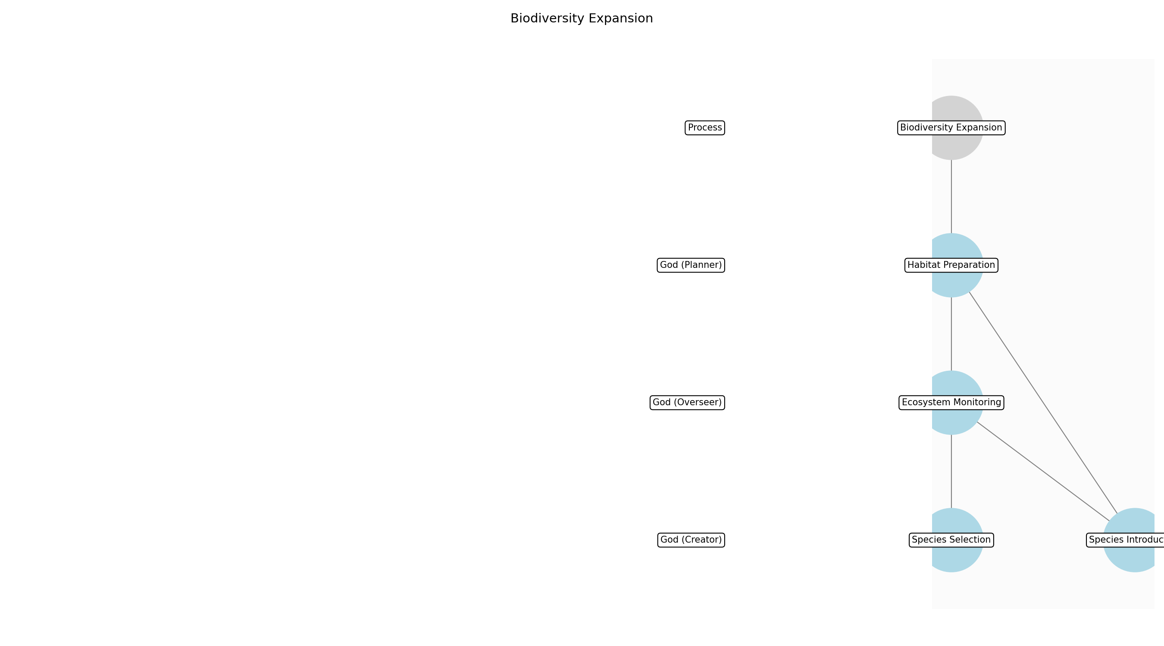

Biodiversity Expansion – Species Selection
Description:
- Identify and select plant and animal species suitable for introduction based on their ecological roles, adaptability to the environment, and potential impact on existing ecosystems. This involves reviewing species databases, consulting with ecological experts, and assessing the availability of species for introduction. The selection process prioritizes species that can enhance ecosystem stability and resilience.
Responsible Party:
- God (Creator)
Inputs:
- Initial ecosystems data
- Climate data
- Soil composition data
- Existing species interaction data
Outputs:
- List of selected plant species
- List of selected animal species
- Species introduction plan
Estimated Duration:
- 1 day
Dependencies:
Success Criteria:
- Species selected are ecologically appropriate
- Species selected are adaptable to the environment
- Species selected enhance ecosystem stability
Purpose:
- To choose species that will thrive and contribute positively to the ecosystem.
Scope:
- Selection of species for introduction based on ecological suitability and adaptability.
Process Owner:
- God (Creator, Planner, Overseer)
Triggers:
- Established and evolving ecosystems
End Conditions:
- Species selection is completed
- Species introduction plan is finalized
Step Risks and Controls:
- Risk: Introduction of invasive species
- Control: Thorough risk assessment of selected species
- Risk: Failure of species to adapt
- Control: Selection of adaptable species with diverse traits
Governance Requirements:
- Ethical guidelines for species introduction
- Environmental impact assessment
Change Management:
- Change Request Process: Submit request to God for species changes
- Versioning Rules: Track species changes and ecosystem impacts
Continuous Improvement:
- Review Frequency: Annual biodiversity surveys
Improvement Inputs:
- Species population trends
- Ecosystem health indicators

Biodiversity Expansion – Habitat Preparation
Description:
- Prepare habitats for the introduction of selected species by ensuring suitable conditions for their survival and reproduction. This includes modifying existing habitats, creating new habitats, and managing resources to support the introduced species. The preparation process considers the specific needs of each species and aims to minimize disruption to existing ecosystems.
Responsible Party:
- God (Planner)
Inputs:
- Species introduction plan
- Habitat assessment data
- Resource availability data
Outputs:
- Modified habitats
- New habitats
- Resource management plan
Estimated Duration:
- 1 day
Dependencies:
- Species Selection
Success Criteria:
- Habitats are suitable for selected species
- Resource management plan is effective
- Disruption to existing ecosystems is minimized
Purpose:
- To ensure that the introduced species have a suitable environment to thrive in.
Scope:
- Preparation of habitats for the introduction of selected species.
Process Owner:
- God (Creator, Planner, Overseer)
Triggers:
- Species introduction plan is finalized
End Conditions:
- Habitat preparation is completed
- Resource management plan is implemented
Step Risks and Controls:
- Risk: Habitat degradation
- Control: Careful monitoring of habitat conditions
- Risk: Resource depletion
- Control: Implementation of sustainable resource management practices
Governance Requirements:
- Environmental regulations
- Resource management policies
Change Management:
- Change Request Process: Submit request to God for habitat changes
- Versioning Rules: Record all habitat modifications
Continuous Improvement:
- Review Frequency: Annual habitat assessments
Improvement Inputs:
- Habitat health indicators
- Resource consumption rates

Biodiversity Expansion – Species Introduction
Description:
- Introduce selected plant and animal species into prepared habitats, ensuring their safe and successful integration into existing ecosystems. This involves carefully transporting species, releasing them into suitable locations, and monitoring their initial adaptation. The introduction process considers the specific needs of each species and aims to minimize stress and maximize survival rates.
Responsible Party:
- God (Creator)
Inputs:
- Species introduction plan
- Prepared habitats
- Selected plant and animal species
Outputs:
- Introduced plant species
- Introduced animal species
- Initial adaptation data
Estimated Duration:
- 1 day
Dependencies:
- Habitat Preparation
Success Criteria:
- Species are safely introduced into habitats
- Species show initial signs of adaptation
- Stress to species is minimized
Purpose:
- To safely introduce the selected species into their new environment.
Scope:
- Introduction of selected species into prepared habitats.
Process Owner:
- God (Creator, Planner, Overseer)
Triggers:
- Habitat preparation is completed
End Conditions:
- Species introduction is completed
- Initial adaptation data is collected
Step Risks and Controls:
- Risk: Species mortality during introduction
- Control: Careful handling and transportation of species
- Risk: Rejection by existing ecosystems
- Control: Gradual introduction and monitoring of species interactions
Governance Requirements:
- Ethical guidelines for species introduction
- Animal welfare regulations
Change Management:
- Change Request Process: Submit request to God for introduction changes
- Versioning Rules: Record all introduction events
Continuous Improvement:
- Review Frequency: Annual species adaptation assessments
Improvement Inputs:
- Species survival rates
- Ecosystem integration data

Biodiversity Expansion – Ecosystem Monitoring
Description:
- Monitor the impact of introduced species on existing ecosystems, assessing their interactions with native species, their contribution to ecosystem stability, and their overall effect on biodiversity. This involves collecting data on species populations, resource levels, and ecosystem health indicators. The monitoring process aims to identify and address any negative impacts and ensure the long-term sustainability of the expanded biodiversity.
Responsible Party:
- God (Overseer)
Inputs:
- Introduced plant and animal species
- Initial adaptation data
- Existing ecosystem data
Outputs:
- Species interaction data
- Ecosystem stability metrics
- Biodiversity assessment reports
Estimated Duration:
- Ongoing
Dependencies:
- Species Introduction
Success Criteria:
- Species interactions are stable
- Ecosystem stability is maintained or enhanced
- Biodiversity is increased
Purpose:
- To ensure that the introduced species are positively contributing to the ecosystem.
Scope:
- Monitoring the impact of introduced species on existing ecosystems.
Process Owner:
- God (Creator, Planner, Overseer)
Triggers:
- Species introduction is completed
End Conditions:
- Ecosystem monitoring is ongoing
- Data is regularly collected and analyzed
Step Risks and Controls:
- Risk: Ecosystem imbalance
- Control: Careful monitoring of species populations and resource levels
- Risk: Negative impact on native species
- Control: Protective measures for endangered species
Governance Requirements:
- Environmental monitoring regulations
- Biodiversity protection policies
Change Management:
- Change Request Process: Submit request to God for ecosystem adjustments
- Versioning Rules: Record all ecosystem changes
Continuous Improvement:
- Review Frequency: Annual biodiversity surveys
Improvement Inputs:
- Species population trends
- Ecosystem health indicators

3.6 Intelligent Life Development
Description:
- Guide the evolution of intelligent life forms. Establish cognitive abilities and social structures. Monitor technological advancement.
Responsible Parties:
- God (Creator)
Inputs:
- Expanded biodiversity
- Species interaction data
- Ecosystem stability metrics
Outputs:
- Intelligent civilization
- Technological capabilities
- Social organization
- Cultural development
Success Criteria:
- Emergence of intelligent life
- Development of cognitive abilities
- Establishment of social structures
- Technological advancement

Required Sub Process(es) for the Step "Intelligent Life Development"
The following details the subprocess flows for the step "Intelligent Life Development".
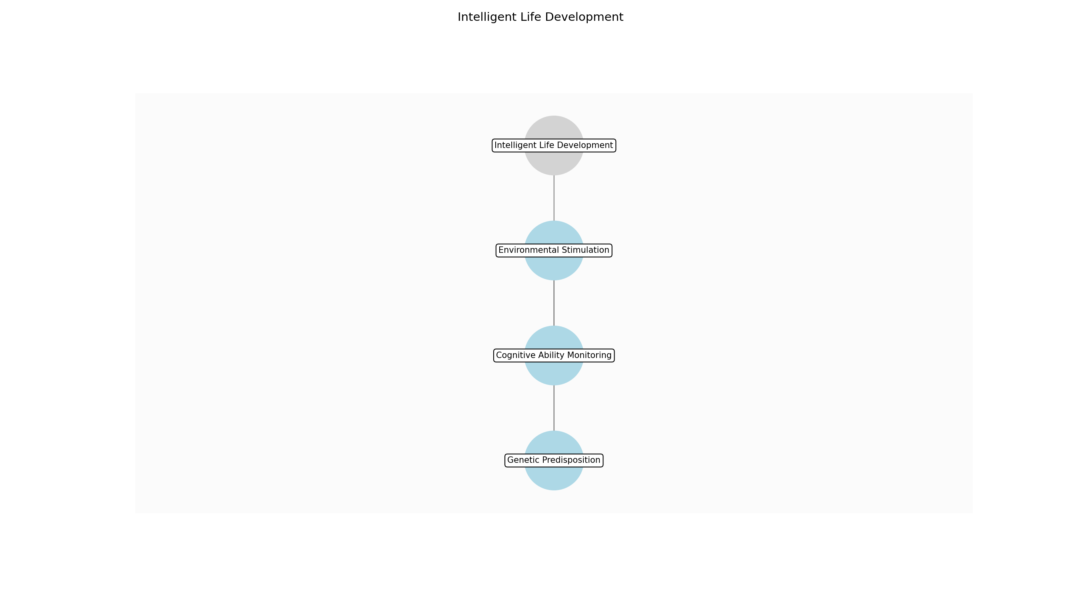

Intelligent Life Development – Genetic Predisposition
Description:
- Modify the genetic code of pre-intelligent species to enhance cognitive potential. Introduce genes associated with increased brain size, neural complexity, and learning capabilities. Ensure genetic compatibility and minimize potential for harmful mutations through rigorous simulation and testing.
Responsible Party:
- God (Creator)
Inputs:
- Expanded biodiversity
- Species interaction data
Outputs:
- Genetically predisposed species
- Genetic modification records
Estimated Duration:
- 2 days
Dependencies:
Success Criteria:
- Successful genetic modification
- Enhanced cognitive potential
- Viable offspring
Purpose:
- To lay the biological foundation for intelligent life.
Scope:
- Genetic modification of selected species.
Process Owner:
- God (Creator, Planner, Overseer)
Triggers:
- High biodiversity
- Ecosystem stability
End Conditions:
- Species with enhanced cognitive potential are created
Step Risks and Controls:
- Risk: Harmful mutations
- Control: Rigorous simulation and testing
- Risk: Genetic incompatibility
- Control: Careful selection of genetic material
Governance Requirements:
- Ethical guidelines for genetic modification
Change Management:
- Change Request Process: Submit request to God
- Versioning Rules: Track all genetic modifications
Continuous Improvement:
- Review Frequency: Annual genetic assessments
Improvement Inputs:
- Cognitive development
- Physical health

Intelligent Life Development – Environmental Stimulation
Description:
- Create environmental conditions that stimulate cognitive development. Introduce challenges, opportunities for learning, and diverse sensory experiences. Foster social interaction and cooperation among individuals to promote the development of communication and problem-solving skills.
Responsible Party:
- God (Planner)
Inputs:
- Genetically predisposed species
- Ecosystem stability metrics
Outputs:
- Stimulating environmental conditions
- Social structures
Estimated Duration:
- 1 day
Dependencies:
- Genetic Predisposition
Success Criteria:
- Stimulating environmental conditions
- Emergence of social structures
- Increased cognitive activity
Purpose:
- To create an environment that fosters cognitive development.
Scope:
- Environmental design and social structure development.
Process Owner:
- God (Creator, Planner, Overseer)
Triggers:
- Emergence of genetically predisposed species
End Conditions:
- Stimulating environmental conditions are established
Step Risks and Controls:
- Risk: Environmental instability
- Control: Careful monitoring and adjustment of environmental parameters
- Risk: Social conflict
- Control: Guidance towards cooperation and conflict resolution
Governance Requirements:
- Ethical guidelines for environmental manipulation
Change Management:
- Change Request Process: Influence cultural and technological development
- Versioning Rules: Monitor the impact of changes on civilization
Continuous Improvement:
- Review Frequency: Annual civilization assessments
Improvement Inputs:
- Social progress
- Environmental sustainability

Intelligent Life Development – Cognitive Ability Monitoring
Description:
- Monitor the cognitive development of intelligent life forms. Track progress in areas such as problem-solving, communication, and abstract thought. Identify areas where additional stimulation or guidance may be needed to ensure optimal cognitive development.
Responsible Party:
- God (Overseer)
Inputs:
- Stimulating environmental conditions
- Social structures
Outputs:
- Cognitive development reports
- Guidance recommendations
Estimated Duration:
- 1 day
Dependencies:
- Environmental Stimulation
Success Criteria:
- Accurate cognitive development reports
- Effective guidance recommendations
- Continuous cognitive progress
Purpose:
- To monitor and guide the cognitive development of intelligent life.
Scope:
- Cognitive assessment and guidance.
Process Owner:
- God (Creator, Planner, Overseer)
Triggers:
- Establishment of stimulating environmental conditions
End Conditions:
- Cognitive abilities are developing as expected
Step Risks and Controls:
- Risk: Stagnation of cognitive development
- Control: Encouragement of innovation and exploration
- Risk: Ethical misuse of cognitive abilities
- Control: Guidance towards ethical behavior
Governance Requirements:
- Ethical guidelines for intelligent life development
Change Management:
- Change Request Process: Influence cultural and technological development
- Versioning Rules: Monitor the impact of changes on civilization
Continuous Improvement:
- Review Frequency: Annual civilization assessments
Improvement Inputs:
- Technological advancement
- Social progress

3.7 World Stabilization
Description:
- Fine-tune environmental parameters. Address imbalances and resource depletion. Ensure long-term sustainability.
Responsible Parties:
- Climate Regulator
Inputs:
- Intelligent civilization
- Technological capabilities
- Social organization
- Cultural development
Outputs:
- Environmental stability
- Resource availability
- Sustainable ecosystem
Success Criteria:
- Stable environmental conditions
- Balanced resource levels
- Sustainable ecosystem

Required Sub Process(es) for the Step "World Stabilization"
The following details the subprocess flows for the step "World Stabilization".
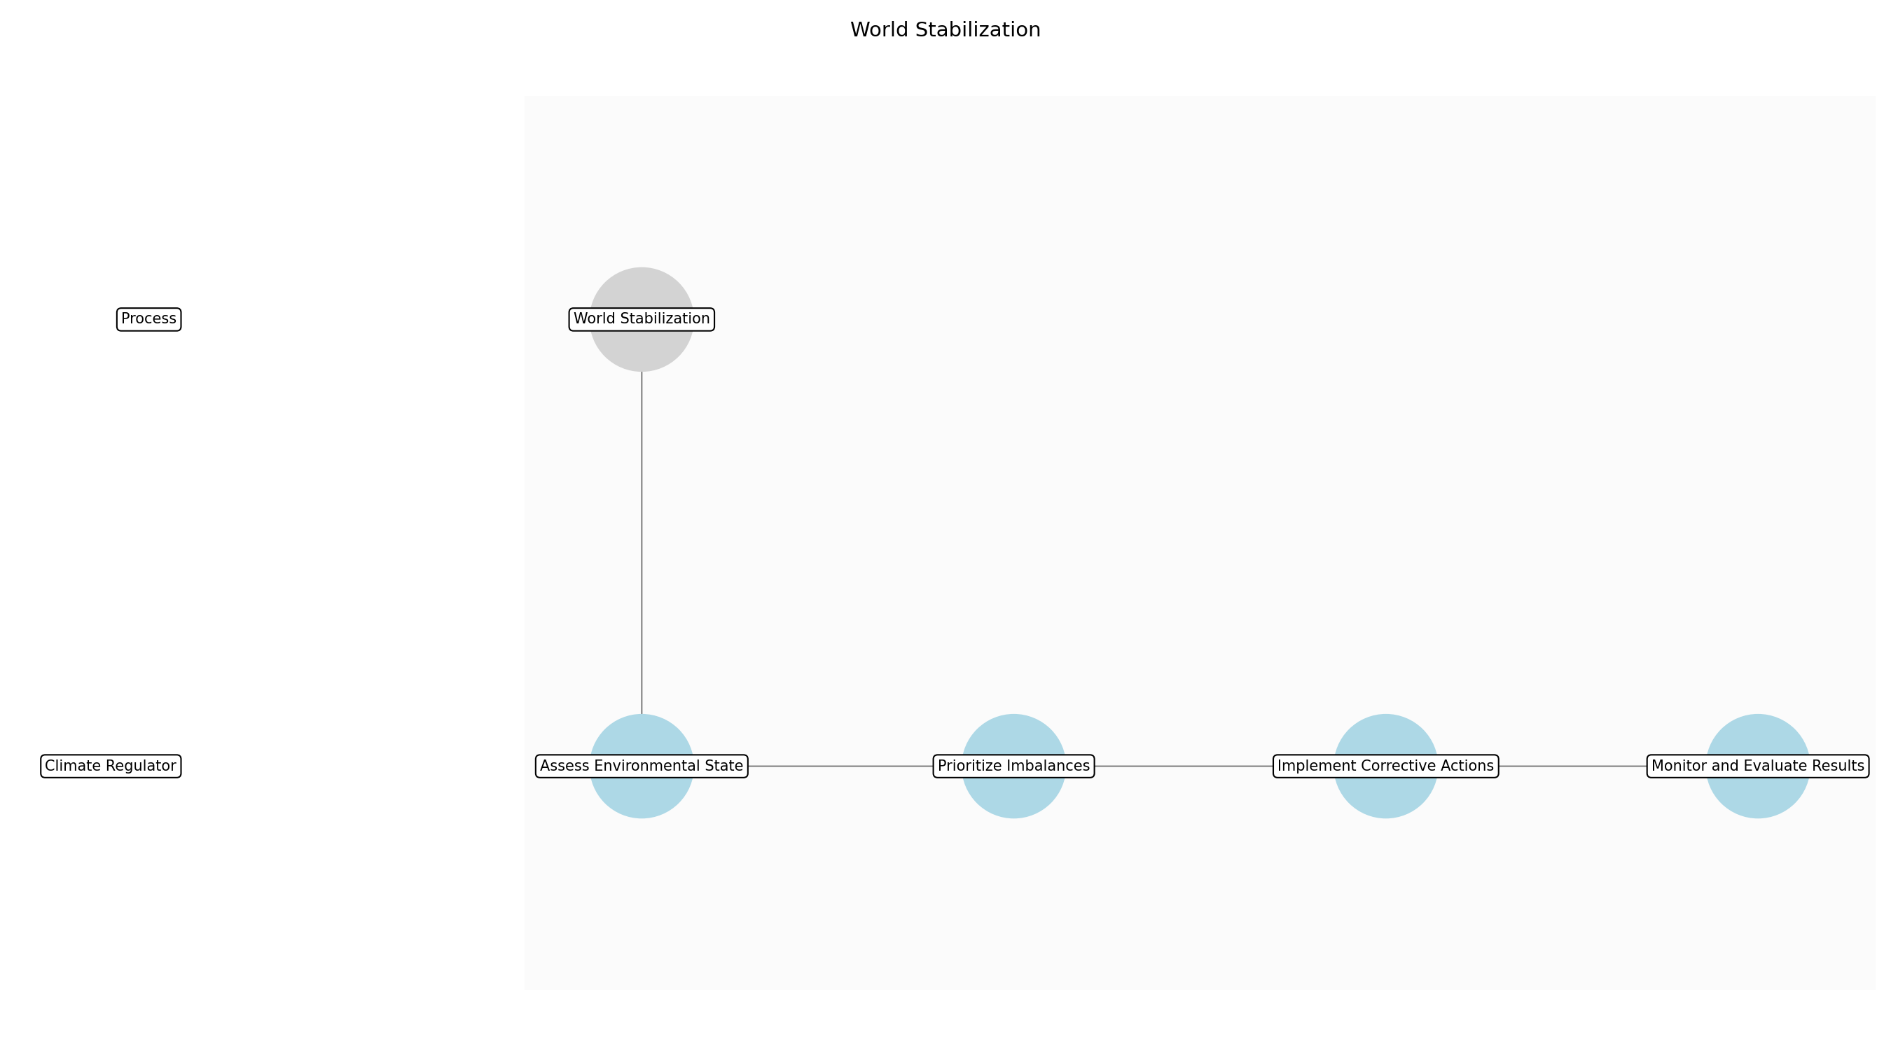

World Stabilization – Assess Environmental State
Description:
- Conduct a comprehensive assessment of the current environmental state, including atmospheric composition, resource availability, ecosystem health, and pollution levels. This assessment will serve as the baseline for identifying imbalances and areas requiring immediate attention. Data will be gathered from environmental monitoring tools and reports from the intelligent civilization.
Responsible Party:
- Climate Regulator
Inputs:
- Environmental monitoring data
- Resource consumption reports
- Pollution levels data
- Ecosystem health reports
Outputs:
- Environmental state assessment report
- List of environmental imbalances
- Resource depletion analysis
Estimated Duration:
- 1 day
Dependencies:
Success Criteria:
- Comprehensive environmental state assessment completed
- Environmental imbalances identified
- Resource depletion areas analyzed
Purpose:
- To establish a clear understanding of the current environmental conditions and identify areas needing stabilization.
Scope:
- Analyzing the current state of the world's environment and resources.
Process Owner:
- Climate Regulator
Triggers:
- Established and advancing intelligent civilization
End Conditions:
- Environmental state assessment report finalized
Step Risks and Controls:
- Risk: Inaccurate environmental data
- Control: Implement data validation and verification processes
- Risk: Incomplete assessment
- Control: Use standardized assessment templates and checklists
Governance Requirements:
- Environmental regulations
- Resource management policies
Change Management:
- Change Request Process: Submit change request to Climate Regulator
- Versioning Rules: Track changes to assessment methodologies
Continuous Improvement:
- Review Frequency: Annual
Improvement Inputs:
- Assessment accuracy
- Data completeness
- Stakeholder feedback

World Stabilization – Prioritize Imbalances
Description:
- Based on the environmental state assessment, prioritize the identified imbalances and resource depletion areas based on their severity and potential impact on long-term sustainability. This prioritization will guide the subsequent actions and resource allocation. Factors to consider include the rate of resource depletion, the extent of pollution, and the vulnerability of ecosystems.
Responsible Party:
- Climate Regulator
Inputs:
- Environmental state assessment report
- List of environmental imbalances
- Resource depletion analysis
Outputs:
- Prioritized list of environmental imbalances
- Action plan for addressing imbalances
Estimated Duration:
- 4–6 hours
Dependencies:
- Assess Environmental State
Success Criteria:
- Prioritized list of environmental imbalances completed
- Action plan developed
Purpose:
- To focus efforts on the most critical environmental issues that threaten long-term sustainability.
Scope:
- Prioritizing environmental issues based on severity and impact.
Process Owner:
- Climate Regulator
Triggers:
- Completion of environmental state assessment
End Conditions:
- Prioritized list of imbalances and action plan finalized
Step Risks and Controls:
- Risk: Incorrect prioritization
- Control: Use a multi-criteria decision analysis framework
- Risk: Underestimation of impact
- Control: Consult with environmental experts and stakeholders
Governance Requirements:
- Environmental regulations
- Resource management policies
Change Management:
- Change Request Process: Submit change request to Climate Regulator
- Versioning Rules: Track changes to prioritization criteria
Continuous Improvement:
- Review Frequency: Annual
Improvement Inputs:
- Prioritization effectiveness
- Stakeholder feedback
- Environmental outcomes

World Stabilization – Implement Corrective Actions
Description:
- Execute the action plan by implementing corrective actions to address the prioritized environmental imbalances and resource depletion areas. This may involve adjusting environmental parameters, introducing resource regeneration mechanisms, implementing pollution control measures, and promoting sustainable resource management practices. The intelligent civilization's technological capabilities will be leveraged to implement these actions.
Responsible Party:
- Climate Regulator
Inputs:
- Prioritized list of environmental imbalances
- Action plan for addressing imbalances
- Technological capabilities of intelligent civilization
Outputs:
- Adjusted environmental parameters
- Implemented resource regeneration mechanisms
- Pollution control measures
- Sustainable resource management practices
Estimated Duration:
- 1–2 days
Dependencies:
- Prioritize Imbalances
Success Criteria:
- Corrective actions implemented according to the action plan
- Environmental parameters adjusted
- Resource regeneration mechanisms in place
- Pollution control measures active
- Sustainable resource management practices promoted
Purpose:
- To actively address environmental imbalances and resource depletion areas to promote long-term sustainability.
Scope:
- Implementing corrective actions to stabilize the world's environment and resources.
Process Owner:
- Climate Regulator
Triggers:
- Finalized action plan
End Conditions:
- Corrective actions implemented and documented
Step Risks and Controls:
- Risk: Ineffective corrective actions
- Control: Use proven and tested environmental management techniques
- Risk: Unintended consequences
- Control: Conduct environmental impact assessments before implementation
Governance Requirements:
- Environmental regulations
- Resource management policies
Change Management:
- Change Request Process: Submit change request to Climate Regulator
- Versioning Rules: Track changes to corrective actions and their impacts
Continuous Improvement:
- Review Frequency: Quarterly
Improvement Inputs:
- Effectiveness of corrective actions
- Environmental outcomes
- Stakeholder feedback

World Stabilization – Monitor and Evaluate Results
Description:
- Continuously monitor and evaluate the results of the implemented corrective actions to assess their effectiveness and identify any unintended consequences. This monitoring will involve tracking key environmental indicators, resource levels, and ecosystem health metrics. Feedback loops will be established to adjust the corrective actions as needed.
Responsible Party:
- Climate Regulator
Inputs:
- Adjusted environmental parameters
- Implemented resource regeneration mechanisms
- Pollution control measures
- Sustainable resource management practices
- Environmental monitoring data
Outputs:
- Environmental monitoring reports
- Evaluation of corrective action effectiveness
- Recommendations for adjustments
Estimated Duration:
- Ongoing
Dependencies:
- Implement Corrective Actions
Success Criteria:
- Continuous monitoring of environmental indicators
- Evaluation of corrective action effectiveness completed
- Recommendations for adjustments provided
Purpose:
- To ensure the effectiveness of corrective actions and adapt to changing environmental conditions.
Scope:
- Monitoring and evaluating the impact of corrective actions on the world's environment and resources.
Process Owner:
- Climate Regulator
Triggers:
- Implementation of corrective actions
End Conditions:
- Regular monitoring and evaluation reports produced
Step Risks and Controls:
- Risk: Delayed detection of issues
- Control: Implement real-time environmental monitoring systems
- Risk: Inaccurate evaluation
- Control: Use standardized evaluation methodologies and metrics
Governance Requirements:
- Environmental regulations
- Resource management policies
Change Management:
- Change Request Process: Submit change request to Climate Regulator
- Versioning Rules: Track changes to monitoring and evaluation methodologies
Continuous Improvement:
- Review Frequency: Annual
Improvement Inputs:
- Monitoring accuracy
- Evaluation effectiveness
- Stakeholder feedback

3.8 Autonomous Operation
Description:
- Remove creator intervention. Monitor world performance and evolution. Observe the development of intelligent civilization.
Responsible Parties:
- God (Creator, Planner, Overseer)
Inputs:
- Environmental stability
- Resource availability
- Sustainable ecosystem
Outputs:
- World performance data
- Evolutionary trends
- Civilization progress
Success Criteria:
- Autonomous world operation
- Continuous evolution
- Advancing civilization

Required Sub Process(es) for the Step "Autonomous Operation"
The following details the subprocess flows for the step "Autonomous Operation".
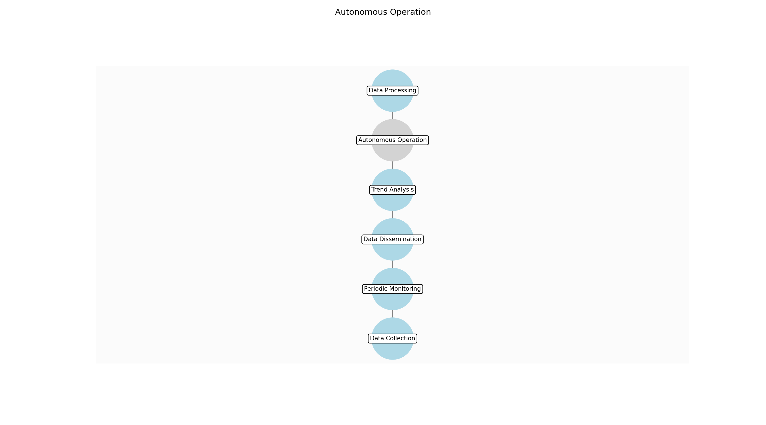

Autonomous Operation – Data Collection
Description:
- Establish automated systems to gather world performance data, evolutionary trends, and civilization progress. This involves setting up sensors, data streams, and monitoring tools that operate continuously without intervention. The collected data will be used for periodic reviews and long-term analysis.
Responsible Party:
- Environmental Monitoring Tools
Inputs:
- Environmental stability
- Resource availability
- Sustainable ecosystem
Outputs:
- Raw world performance data
- Evolutionary event logs
- Civilization activity reports
Estimated Duration:
- Continuous
Dependencies:
Success Criteria:
- Automated data collection systems are operational
- Data streams are stable and reliable
- Data is accurately recorded
Purpose:
- To gather necessary data for monitoring world performance and evolution.
Scope:
- Automated collection of data related to world performance, evolution, and civilization.
Process Owner:
- God (Overseer)
Triggers:
- Stable and sustainable world environment
End Conditions:
- Continuous data collection is established
Step Risks and Controls:
- Risk: Data corruption or loss
- Control: Implement redundant data storage and backup systems
- Risk: System failure
- Control: Regular system maintenance and automated alerts
Governance Requirements:
- Ethical guidelines for observation without intervention
Change Management:
- Change Request Process: No direct changes allowed; system updates require divine review
- Versioning Rules: Track all system updates and data schema changes
Continuous Improvement:
- Review Frequency: Annual system performance review
Improvement Inputs:
- Data collection efficiency
- System reliability metrics

Autonomous Operation – Data Processing
Description:
- Process the raw data collected into meaningful metrics and reports. This involves cleaning, transforming, and aggregating the data to identify trends, anomalies, and significant events. The processed data will be used to generate reports on world performance, evolutionary trends, and civilization progress.
Responsible Party:
- Resource Management System
Inputs:
- Raw world performance data
- Evolutionary event logs
- Civilization activity reports
Outputs:
- World performance metrics
- Evolutionary trend reports
- Civilization progress reports
Estimated Duration:
- 12 hours
Dependencies:
- Data Collection
Success Criteria:
- Data is accurately processed and transformed
- Meaningful metrics and reports are generated
- Reports are easily accessible
Purpose:
- To transform raw data into actionable insights.
Scope:
- Processing and transformation of raw data into meaningful metrics and reports.
Process Owner:
- God (Planner)
Triggers:
- Completion of data collection cycle
End Conditions:
- Processed data and reports are generated
Step Risks and Controls:
- Risk: Data processing errors
- Control: Implement data validation and error checking routines
- Risk: Misinterpretation of data
- Control: Provide clear documentation and context for all metrics
Governance Requirements:
- Ethical guidelines for observation without intervention
Change Management:
- Change Request Process: No direct changes allowed; algorithm updates require divine review
- Versioning Rules: Track all algorithm updates and data transformation changes
Continuous Improvement:
- Review Frequency: Annual data processing review
Improvement Inputs:
- Data processing efficiency
- Report accuracy

Autonomous Operation – Trend Analysis
Description:
- Analyze the processed data to identify long-term trends, evolutionary outcomes, and civilization achievements. This involves using statistical methods, predictive models, and AI to understand the underlying dynamics of the world. The analysis will be used to assess the overall health and sustainability of the world.
Responsible Party:
- Intelligent Life AI
Inputs:
- World performance metrics
- Evolutionary trend reports
- Civilization progress reports
Outputs:
- Long-term performance data
- Evolutionary trends
- Civilization achievements
Estimated Duration:
- 12 hours
Dependencies:
- Data Processing
Success Criteria:
- Long-term trends are accurately identified
- Evolutionary outcomes are understood
- Civilization achievements are documented
Purpose:
- To understand the long-term dynamics of the world.
Scope:
- Analysis of processed data to identify trends, evolutionary outcomes, and civilization achievements.
Process Owner:
- God (Creator)
Triggers:
- Completion of data processing cycle
End Conditions:
- Long-term trends, evolutionary outcomes, and civilization achievements are identified
Step Risks and Controls:
- Risk: Inaccurate trend analysis
- Control: Use validated statistical methods and predictive models
- Risk: Bias in analysis
- Control: Ensure diverse perspectives and data sources are considered
Governance Requirements:
- Ethical guidelines for observation without intervention
Change Management:
- Change Request Process: No direct changes allowed; model updates require divine review
- Versioning Rules: Track all model updates and analytical changes
Continuous Improvement:
- Review Frequency: Annual trend analysis review
Improvement Inputs:
- Analysis accuracy
- Model performance

Autonomous Operation – Periodic Monitoring
Description:
- Regularly monitor evolutionary trends to detect any unforeseen consequences. This involves setting up alerts and triggers to notify relevant parties of significant events or anomalies. The monitoring will be used to ensure the world operates autonomously and sustainably.
Responsible Party:
- God (Overseer)
Inputs:
- Evolutionary trends
Outputs:
- Alerts for significant evolutionary events
- Monitoring reports
Estimated Duration:
- Continuous
Dependencies:
- Trend Analysis
Success Criteria:
- Evolutionary trends are continuously monitored
- Alerts are triggered for significant events
- Monitoring reports are generated
Purpose:
- To detect unforeseen consequences of evolution.
Scope:
- Continuous monitoring of evolutionary trends and generation of alerts.
Process Owner:
- God (Overseer)
Triggers:
- Identification of evolutionary trends
End Conditions:
- Continuous monitoring is established
Step Risks and Controls:
- Risk: Missed evolutionary events
- Control: Implement comprehensive monitoring systems and alert thresholds
- Risk: False alarms
- Control: Refine alert thresholds and validation processes
Governance Requirements:
- Ethical guidelines for observation without intervention
Change Management:
- Change Request Process: No direct changes allowed; alert threshold updates require divine review
- Versioning Rules: Track all alert threshold updates and monitoring changes
Continuous Improvement:
- Review Frequency: Annual monitoring review
Improvement Inputs:
- Alert accuracy
- System reliability

Autonomous Operation – Data Dissemination
Description:
- Ensure intelligent life has access to data and predictive models to understand and mitigate potential collapse scenarios. This involves setting up secure data portals, educational resources, and training programs. The dissemination will empower intelligent life to make informed decisions and take proactive measures.
Responsible Party:
- God (Planner)
Inputs:
- Long-term performance data
- Evolutionary trends
- Civilization achievements
Outputs:
- Secure data portals
- Educational resources
- Training programs
Estimated Duration:
- 1 day
Dependencies:
- Trend Analysis
Success Criteria:
- Data portals are accessible and secure
- Educational resources are comprehensive and understandable
- Training programs are effective
Purpose:
- To empower intelligent life to understand and mitigate potential collapse scenarios.
Scope:
- Dissemination of data and predictive models to intelligent life.
Process Owner:
- God (Planner)
Triggers:
- Identification of long-term trends, evolutionary outcomes, and civilization achievements
End Conditions:
- Data portals, educational resources, and training programs are established
Step Risks and Controls:
- Risk: Data misuse
- Control: Implement data access controls and ethical guidelines
- Risk: Misinterpretation of data
- Control: Provide clear documentation and training
Governance Requirements:
- Ethical guidelines for observation without intervention
Change Management:
- Change Request Process: No direct changes allowed; content updates require divine review
- Versioning Rules: Track all content updates and access control changes
Continuous Improvement:
- Review Frequency: Annual dissemination review
Improvement Inputs:
- Data portal usage
- Educational resource effectiveness

4.0 Supporting Systems and Tools
The following tools and platforms support this process:
Category | Tools
Simulation | World simulation engine, Evolutionary algorithm
Monitoring | Environmental monitoring tools, Resource management system, Intelligent life AI
Analysis | Ecosystem health dashboards, Resource consumption reports, Evolutionary progress tracking, Environmental stability metrics, Intelligent civilization development reports

5.0 Metrics and Key Performance Indicators (KPIs)
The following is a list of key metrics associated with this process. These metrics help monitor performance and ensure alignment with business objectives.
Metric | Description | Measurement / Frequency | Target
Ecosystem Stability | Measure of the balance and resilience of ecosystems. | Annually | 90% stability index
Biodiversity Index | Measure of the variety of life forms in the world. | Annually | 80% biodiversity index
Atmospheric Composition | Measure of the balance of gases in the atmosphere. | Monthly | Optimal gas balance for life
Resource Availability | Measure of the abundance of essential resources. | Monthly | Sufficient resource levels for all life forms
Emergence of Intelligent Life | Measure of the progress of intelligent life development. | Annually | Advancing civilization with sustainable practices

6.0 Critical Success Factors (CSF)
The following is a list of key CSFs associated with this process.
Success Factor | Description
Balanced Ecosystem Development | Creation of interdependent and stable ecosystems.
Sustainable Resource Management | Efficient use and regeneration of resources.
Stable Environmental Conditions | Maintenance of a habitable environment.
Successful Emergence of Intelligent Life | Development of a self-sustaining and ethical civilization.
Autonomous World Operation | World operates without creator intervention.

7.0 Critical Failure Factors (CFF)
The following is a list of key CFFs associated with this process.
Failure Factor | Description
Ecosystem Collapse | Loss of biodiversity and ecosystem function.
Resource Depletion | Exhaustion of essential resources.
Environmental Instability | Uncontrollable climate change or pollution.
Failure to Develop Intelligent Life | Inability to foster a self-sustaining civilization.
Dependence on Creator Intervention | World requires constant monitoring and adjustment.

8.0 Reporting and Analytics
The following are key reporting and analytics associated with this process.
Metric | Description
Ecosystem Stability | Tracks the health and resilience of ecosystems.
Biodiversity Index | Monitors the variety of life forms.
Atmospheric Composition | Reports on the balance of atmospheric gases.
Resource Availability | Tracks the abundance of essential resources.
Emergence of Intelligent Life | Reports on the progress of civilization.

9.0 System Requirements
The following system requirements are essential for the successful implementation of this process.
Name | Details
World Simulation Engine | Software capable of simulating geological, atmospheric, and biological processes.
Resource Management System | System for tracking and managing resource distribution and consumption.
Evolutionary Algorithm | Algorithm for simulating evolutionary processes and species development.
Environmental Monitoring Tools | Sensors and systems for monitoring environmental conditions.
Intelligent Life AI | AI for simulating the behavior and development of intelligent life.

10.0 Process Flow Diagram
The following diagram provides a high-level visualization of the process flow as defined in the normalized JSON source.
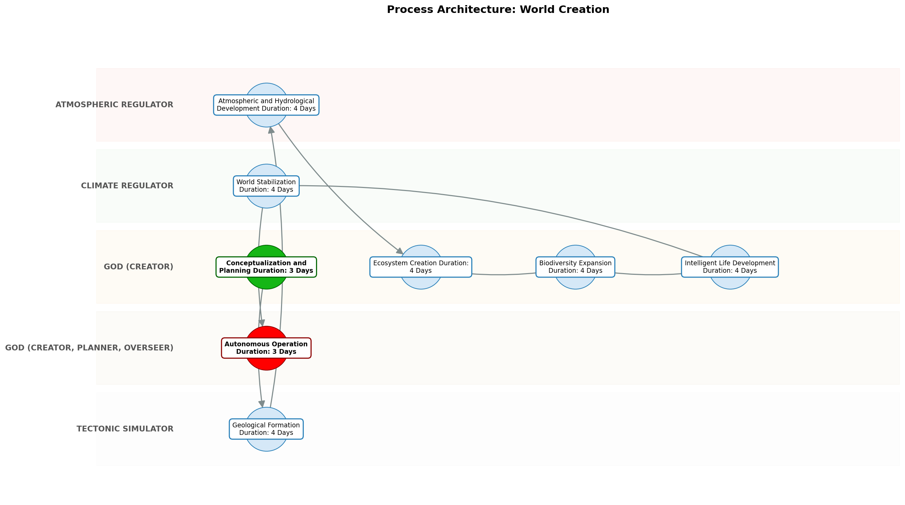

11.0 Process Performance Report
The following metrics are based on a Monte Carlo discrete-event simulation running 2,000 iterations. All time-based values are reported in days.
Operational Metric | Simulated Value
Average Cycle Time | 40.00 days
Cycle Time Variance | 3.22 days
Contention Risk Profile | Low

Identified Bottlenecks
- Geological Formation
- Biodiversity Expansion
- Atmospheric and Hydrological Development

Detailed Step Performance
Process Step | Avg. Duration (days)
Conceptualization and Planning | 4.01
Geological Formation | 5.39
Atmospheric and Hydrological Development | 5.34
Ecosystem Creation | 5.28
Biodiversity Expansion | 5.37
Intelligent Life Development | 5.31
World Stabilization | 5.29
Autonomous Operation | 4.00

12.0 Governance Requirements
There following are the list of governance requirements used in this process.
- Divine oversight of initial conditions and natural laws
- Periodic monitoring of key metrics (ecosystem health, resource levels)
- Ethical guidelines for intelligent life development

13.0 Risks and Controls
The following risks and associated controls apply to this process.
Risk | Control
Ecosystem collapse | Implement redundancy in species and resource distribution
Resource depletion | Implement resource regeneration and sustainable consumption mechanisms
Environmental instability | Implement climate regulation systems and feedback loops

14.0 Process Triggers
There following are triggers that kick processes off.
- The divine spark of creation

15.0 Process End Conditions
There following are a list of the process end conditions.
- The world operates autonomously and sustains intelligent life without intervention.

16.0 Change Management
There following are list of the change management procedures.
- Change Request Process: Controlled introduction of new species or technologies
- Versioning Rules: Environmental impact assessment for significant changes, Adaptive adjustments to natural laws based on observation

17.0 Continuous Improvement
The following are the items used for continuous improvement.
- Review Frequency: Monitoring ecosystem performance and adjusting parameters
Improvement Inputs:
- Learning from evolutionary successes and failures
- Adapting to the needs of intelligent life

Appendix B: Additional Source Data
This appendix contains additional structured data from the normalized source JSON that is not covered in the main sections.
Scope: The creation of a planet from initial conceptualization to a self-sustaining ecosystem with intelligent life.
Purpose: To create a viable, self-sustaining world capable of supporting and fostering intelligent life.
Process Owner: God (Creator)

Appendix C: Glossary
This glossary contains definitions of common terms used in the process documentation.
Term | Definition
Business Process | A set of related activities or tasks performed to achieve a specific organizational goal.
KPI | Key Performance Indicator used to measure the success or health of a process.
Stakeholder | Any individual or group with an interest in the outcomes of the process.
Continuous Improvement | Ongoing effort to improve products, services or processes.

