Agile Scrum SDLC for Web Development

1. Process Flow Visualization
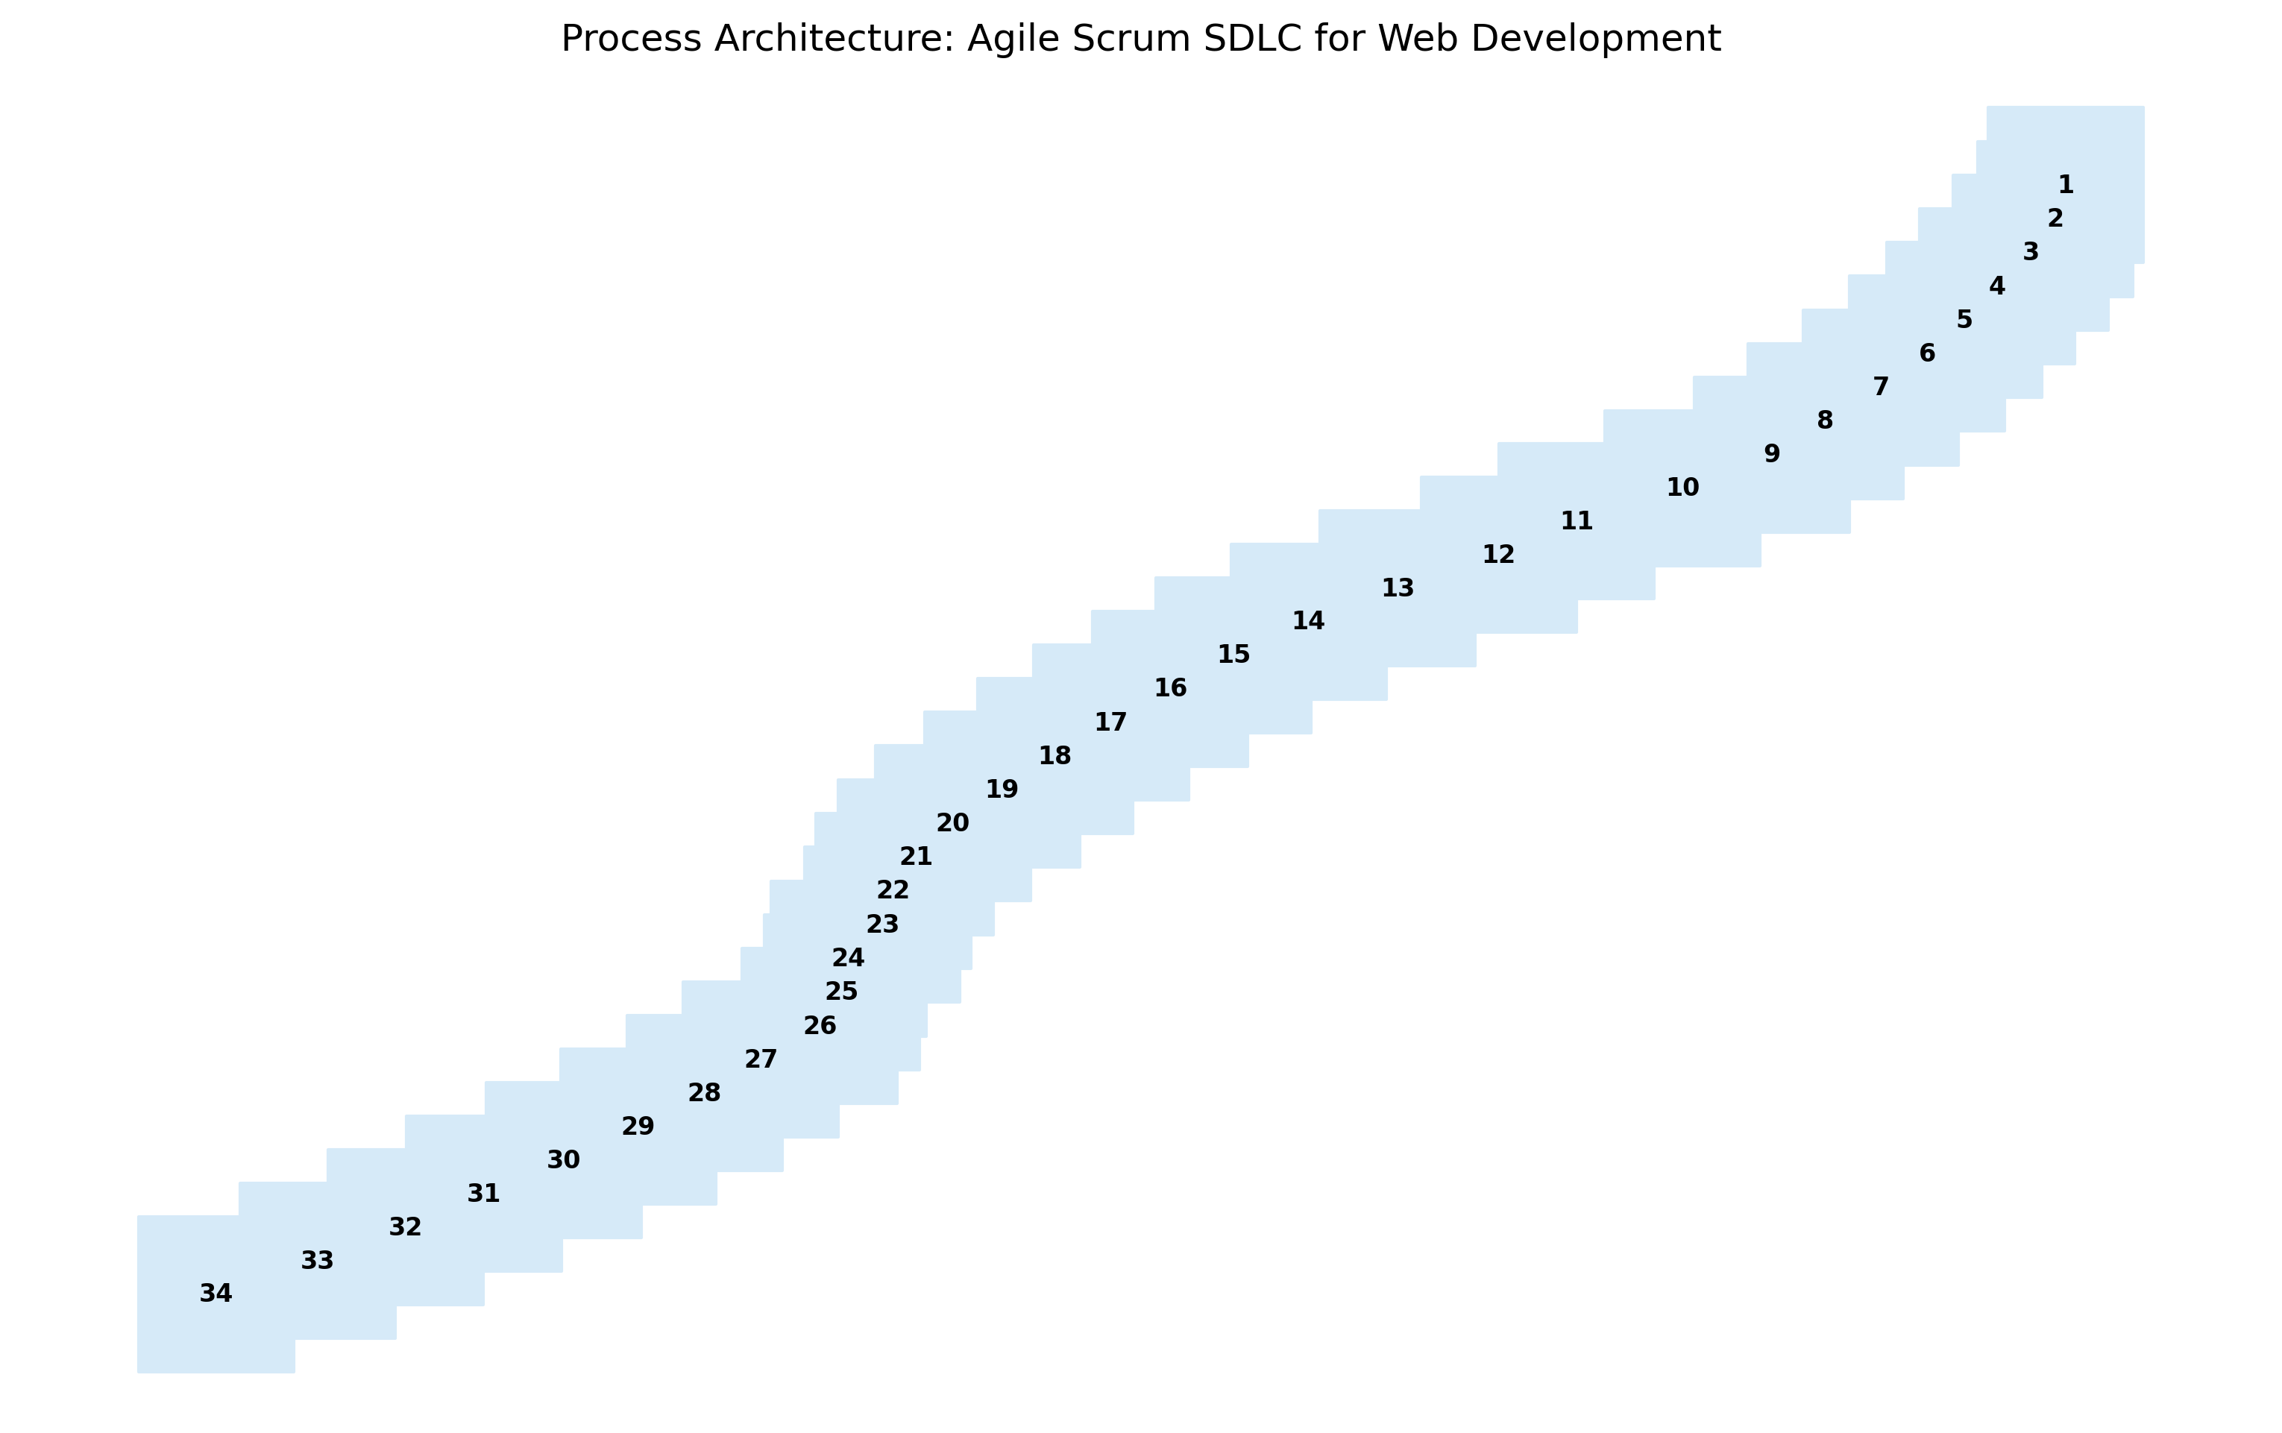

2. Process Details

I. Pre-Sprint Planning & Backlog Creation
1. Actor: Product Owner Action: Elicits and gathers requirements from stakeholders (customers, end-users, business stakeholders).
2. Actor: Product Owner Action: Documents requirements in the form of User Stories. Each User Story should follow the INVEST principle (Independent, Negotiable, Valuable, Estimable, Small, Testable).
3. Actor: Product Owner Action: Creates and maintains the Product Backlog – a prioritized list of User Stories representing the desired functionality of the web application. Prioritization is based on business value, risk, and dependencies.
4. Actor: Product Owner, Stakeholders Action: Refines the Product Backlog. This involves clarifying User Stories, adding acceptance criteria, and breaking down large stories into smaller, manageable tasks (story splitting).
5. Actor: Development Team, Product Owner Action: Estimating User Stories: The Development Team estimates the effort required to complete each User Story, typically using story points or other relative estimation techniques.

II. Sprint Planning
6. Actor: Scrum Master Action: Facilitates the Sprint Planning meeting.
7. Actor: Product Owner Action: Presents the prioritized User Stories from the Product Backlog to the Development Team. Explains the business value and acceptance criteria.
8. Actor: Development Team Action: Selects User Stories from the Product Backlog to be included in the Sprint Backlog. The Development Team commits to completing these stories within the sprint.
9. Actor: Development Team Action: Breaks down User Stories into smaller tasks. These tasks represent the concrete steps required to implement the User Story.
10. Actor: Development Team Action: Estimates the effort required for each task, typically in hours.
11. Actor: Development Team Action: Commits to a Sprint Goal. This is a brief statement describing what the team intends to achieve during the sprint.
12. Actor: Scrum Master Action: Ensures the Sprint Backlog is visible and accessible to the entire team.

III. Sprint Execution
13. Actor: Development Team Action: Develops, tests, and integrates code according to the tasks defined in the Sprint Backlog.
14. Actor: Development Team Action: Participates in Daily Scrum (Daily Stand-up) meetings. Each team member answers the following questions: What did I do yesterday? What will I do today? Are there any impediments blocking my progress?
15. Actor: Scrum Master Action: Facilitates the Daily Scrum, ensuring it remains time-boxed (typically 15 minutes) and focused.
16. Actor: Scrum Master Action: Removes impediments that are blocking the Development Team's progress.
17. Actor: Development Team Action: Updates the Sprint Burndown chart to track progress against the Sprint Goal.

IV. Sprint Review & Retrospective
18. Actor: Development Team Action: Presents the completed User Stories to the Product Owner and stakeholders during the Sprint Review meeting. Demonstrates the functionality and gathers feedback.
19. Actor: Product Owner, Stakeholders Action: Provides feedback on the completed User Stories. Accepts or rejects the delivered functionality based on the acceptance criteria.
20. Actor: Development Team Action: Documents any bugs or issues identified during the Sprint Review.
21. Actor: Scrum Master Action: Facilitates the Sprint Retrospective meeting.
22. Actor: Development Team, Scrum Master, Product Owner (Optional) Action: Discusses what went well, what could be improved, and what actions can be taken to improve the process in the next sprint. Focuses on continuous improvement.
23. Actor: Scrum Master Action: Documents the action items identified during the Sprint Retrospective.
24. Actor: Scrum Master Action: Ensures the action items from the retrospective are addressed in the next sprint.

V. Release & Maintenance
25. Actor: Development Team, Product Owner Action: Releases the web application to production based on the agreed-upon release plan.
26. Actor: Development Team Action: Monitors the web application for performance, stability, and security.
27. Actor: Development Team Action: Addresses any bugs or issues reported after the release.
28. Actor: Product Owner Action: Gathers feedback from users and stakeholders on the released web application.
29. Actor: Product Owner Action: Incorporates feedback into the Product Backlog for future sprints. This creates a continuous cycle of development and improvement.

VI. Ongoing Activities
30. Actor: Development Team Action: Performs Code Reviews to maintain code quality and consistency.
31. Actor: Development Team Action: Writes and maintains automated tests to ensure the stability and reliability of the web application.
32. Actor: Scrum Master Action: Coaches the team on Agile principles and practices.
33. Actor: Product Owner Action: Continuously refines and updates the Product Backlog based on changing business needs and user feedback.
34. Actor: All Action: Track and analyze success metrics (Velocity, Sprint Burndown, Release Burndown, Customer Satisfaction, Number of Defects/Bugs, On-time Delivery, Business Value Delivered, Team Satisfaction, Code Quality, Test Coverage) to identify areas for improvement.

