Data Governance and Management Process for AI
This data governance and management process strategy establishes a comprehensive framework for managing corporate data assets used in AI strategies. It ensures data quality, compliance, and security, enabling effective AI model development and deployment, and fostering trust in AI-driven insights. The strategy outlines key stakeholders, process steps, and critical success factors for successful data governance, providing a roadmap for organizations to leverage data as a strategic asset while mitigating risks and adhering to regulatory requirements. By implementing this strategy, organizations can unlock the full potential of their data, driving innovation and achieving a sustainable competitive advantage.
Industry / Domain: Data Governance
Version: 1.0
Generated On: 2026-01-16 02:51:15

Document Control
Version | Date | Author | Description
1.0 | 2026-01-16 | Process Architect | Initial generated process specification

Table of Contents

1.0 Process Overview
This data governance and management process strategy establishes a comprehensive framework for managing corporate data assets used in AI strategies. It ensures data quality, compliance, and security, enabling effective AI model development and deployment, and fostering trust in AI-driven insights. The strategy outlines key stakeholders, process steps, and critical success factors for successful data governance, providing a roadmap for organizations to leverage data as a strategic asset while mitigating risks and adhering to regulatory requirements. By implementing this strategy, organizations can unlock the full potential of their data, driving innovation and achieving a sustainable competitive advantage.

1.1 Assumptions
- Data sources are well-defined
- Stakeholders are committed to data governance
- Sufficient data literacy exists within the organization

1.2 Constraints
- Regulatory compliance (e.g., GDPR, CCPA)
- Budget limitations for tools and personnel
- Legacy systems with limited integration capabilities
Industry Sector: Data Governance

2.0 Stakeholders and Responsibilities
The following is a list of key stakeholders involved in this process. Understanding their roles and responsibilities is crucial for successful implementation.
Stakeholder | Responsibilities
Data Scientists | Utilize governed data for AI model development  Provide feedback on data quality and relevance  Adhere to data governance policies and procedures
AI Engineers | Deploy AI models using governed data  Ensure data security and access controls  Monitor AI model performance and data usage
Data Governance Team | Define and enforce data governance policies  Monitor data quality and compliance  Provide data literacy training and support
IT Department | Maintain data infrastructure and systems  Implement data security measures  Provide data access and support
Business Analysts | Define data requirements for AI initiatives  Analyze data to identify trends and insights  Ensure data accuracy and completeness
Compliance Officers | Ensure data governance policies comply with regulations  Monitor data usage for compliance violations  Manage data-related risks
Executive Sponsors | Champion data governance initiatives  Secure funding and resources  Promote a data-driven culture

3.0 Process Workflow
The following is a list of key steps in the process workflow.

3.1 Define Data Governance Policies
Establish comprehensive data governance policies and procedures that align with regulatory requirements and business objectives. These policies should cover data quality, security, access control, and data lifecycle management. The policies are developed through a collaborative process involving key stakeholders, including data scientists, IT, business analysts, and compliance officers. Input from these stakeholders is gathered through workshops, surveys, and interviews to ensure that the policies reflect the diverse needs of the organization. The policies are maintained through regular reviews and updates to reflect changes in regulations, business needs, and technology. A data governance committee is responsible for overseeing the development and maintenance of the policies.
Responsible Parties: Data Governance Team
Inputs:
- Business requirements
- Regulatory requirements
- Data audit reports
Outputs:
- Data governance policies
- Data quality rules
- Data security guidelines
Success Criteria:
- Approval of data governance policies by executive sponsors
- Documentation of data quality standards
- Implementation of data security protocols

Required Sub Process(es) for the Step "Define Data Governance Policies"
The following details the subprocess flows for the step "Define Data Governance Policies".
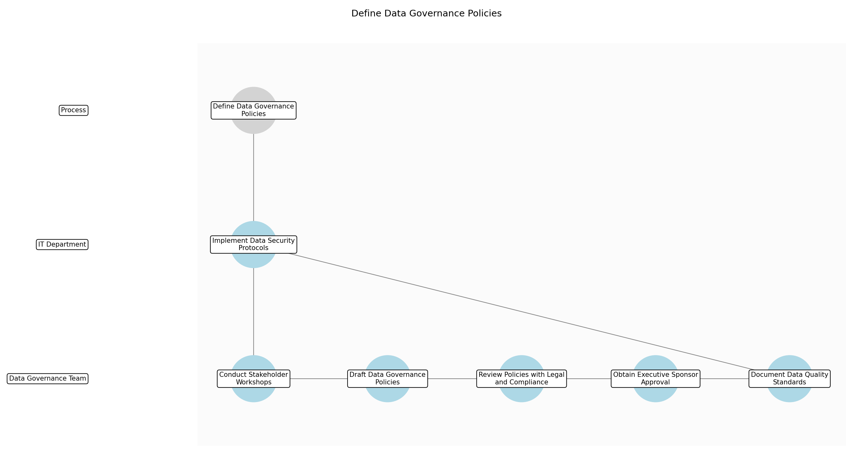

Define Data Governance Policies – Conduct Stakeholder Workshops
Description: Organize workshops with data scientists, IT, business analysts, and compliance officers to gather input on data governance needs and priorities. These workshops will help identify key data assets, potential risks, and compliance requirements. The goal is to ensure that the data governance policies reflect the diverse needs of the organization and align with business objectives.
Responsible Parties: Data Governance Team
Inputs:
- Business requirements
- Regulatory requirements
Outputs:
- Stakeholder input
- Prioritized data governance needs
Dependencies:
Estimated Duration: 1 week
Success Criteria:
- Completion of stakeholder workshops
- Documentation of stakeholder input
- Identification of prioritized data governance needs

Define Data Governance Policies – Draft Data Governance Policies
Description: Based on the input gathered from stakeholders, draft comprehensive data governance policies and procedures. These policies should cover data quality, security, access control, and data lifecycle management. The policies should be clear, concise, and easy to understand. They should also be aligned with regulatory requirements and business objectives.
Responsible Parties: Data Governance Team
Inputs:
- Stakeholder input
- Prioritized data governance needs
Outputs:
- Draft data governance policies
- Draft data quality rules
- Draft data security guidelines
Dependencies:
- Conduct Stakeholder Workshops
Estimated Duration: 1 week
Success Criteria:
- Completion of draft data governance policies
- Documentation of data quality rules
- Documentation of data security guidelines

Define Data Governance Policies – Review Policies with Legal and Compliance
Description: Review the draft data governance policies with legal and compliance teams to ensure they meet all regulatory requirements. This review will help identify any potential legal or compliance risks and ensure that the policies are aligned with industry best practices. The goal is to ensure that the data governance policies are legally sound and compliant with all applicable regulations.
Responsible Parties: Data Governance Team
Inputs:
- Draft data governance policies
- Regulatory requirements
Outputs:
- Legal and compliance feedback
- Revised data governance policies
Dependencies:
- Draft Data Governance Policies
Estimated Duration: 0.5 week
Success Criteria:
- Completion of legal and compliance review
- Documentation of legal and compliance feedback
- Revision of data governance policies based on feedback

Define Data Governance Policies – Obtain Executive Sponsor Approval
Description: Present the revised data governance policies to executive sponsors for approval. This approval will demonstrate executive support for the data governance initiatives and ensure that the policies are aligned with business objectives. The goal is to secure executive sponsorship and commitment to the data governance policies.
Responsible Parties: Data Governance Team
Inputs:
- Revised data governance policies
Outputs:
- Executive sponsor approval
- Final data governance policies
Dependencies:
- Review Policies with Legal and Compliance
Estimated Duration: 0.5 week
Success Criteria:
- Obtain executive sponsor approval
- Documentation of final data governance policies

Define Data Governance Policies – Document Data Quality Standards
Description: Create detailed documentation of data quality standards, including data accuracy, completeness, consistency, and timeliness. These standards will serve as a benchmark for measuring data quality and identifying areas for improvement. The goal is to establish clear and measurable data quality standards.
Responsible Parties: Data Governance Team
Inputs:
- Final data governance policies
Outputs:
- Data quality standards documentation
Dependencies:
- Obtain Executive Sponsor Approval
Estimated Duration: 0.5 week
Success Criteria:
- Completion of data quality standards documentation
- Documentation of data accuracy standards
- Documentation of data completeness standards
- Documentation of data consistency standards
- Documentation of data timeliness standards

Define Data Governance Policies – Implement Data Security Protocols
Description: Implement data security protocols, including access controls, encryption, and data masking, to protect data from unauthorized access and breaches. These protocols will ensure data confidentiality, integrity, and availability. The goal is to establish robust data security measures.
Responsible Parties: IT Department
Inputs:
- Final data governance policies
- Data security guidelines
Outputs:
- Data security protocols implementation
- Access control lists
- Encryption keys
Dependencies:
- Obtain Executive Sponsor Approval
Estimated Duration: 1 week
Success Criteria:
- Implementation of data security protocols
- Establishment of access control lists
- Generation of encryption keys

3.2 Identify Data Owners
Identify and assign data owners for each critical data asset. Data owners are responsible for ensuring the quality, accuracy, and security of their data. They should also be involved in defining data governance policies and procedures. The process of identifying data owners involves mapping data assets to business functions and identifying individuals who have the most knowledge about and responsibility for those data assets. Criteria used for selecting data owners include their understanding of the data, their ability to influence data quality, and their commitment to data governance. Data owners are typically business unit leaders or subject matter experts.
Responsible Parties: Data Governance Team
Inputs:
- Data inventory
- Data governance policies
Outputs:
- Data ownership assignments
- Data owner responsibilities
Success Criteria:
- Assignment of data owners for all critical data assets
- Data owners understand their responsibilities

Required Sub Process(es) for the Step "Identify Data Owners"
The following details the subprocess flows for the step "Identify Data Owners".
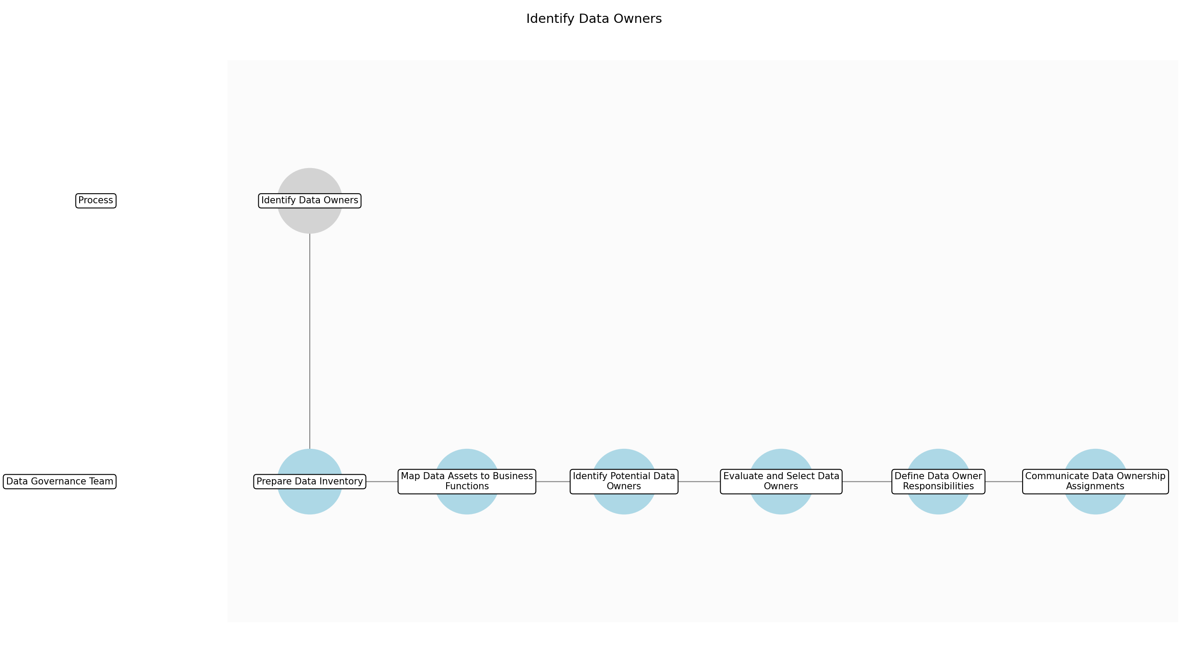

Identify Data Owners – Prepare Data Inventory
Description: Compile and validate the existing data inventory to ensure it accurately reflects all critical data assets within the organization. This involves reviewing existing documentation, consulting with data stewards, and performing data discovery exercises to identify any gaps or inconsistencies in the inventory. The data inventory should include details such as data asset names, descriptions, locations, formats, and classifications.
Responsible Parties: Data Governance Team
Inputs:
- Existing data inventory
- Data governance policies
Outputs:
- Validated data inventory
Dependencies:
Estimated Duration: 3-5 days
Success Criteria:
- Data inventory is complete and accurate
- All critical data assets are identified and documented

Identify Data Owners – Map Data Assets to Business Functions
Description: Analyze the validated data inventory and map each data asset to the relevant business functions or processes that utilize it. This involves collaborating with business analysts and subject matter experts to understand how data flows through the organization and which business units rely on specific data assets. The mapping should identify the primary business purpose of each data asset and its role in supporting key business activities.
Responsible Parties: Data Governance Team
Inputs:
- Validated data inventory
- Business process documentation
Outputs:
- Data asset to business function mapping
Dependencies:
- Prepare Data Inventory
Estimated Duration: 2-3 days
Success Criteria:
- All data assets are mapped to relevant business functions
- Business functions understand their data dependencies

Identify Data Owners – Identify Potential Data Owners
Description: Based on the data asset to business function mapping, identify potential data owners for each critical data asset. This involves identifying individuals who have the most knowledge about and responsibility for the data asset within the relevant business function. Consider individuals who are business unit leaders, subject matter experts, or data stewards with a deep understanding of the data and its usage.
Responsible Parties: Data Governance Team
Inputs:
- Data asset to business function mapping
- Organizational charts
Outputs:
- List of potential data owners
Dependencies:
- Map Data Assets to Business Functions
Estimated Duration: 1-2 days
Success Criteria:
- Potential data owners are identified for all critical data assets
- Potential data owners have relevant expertise and responsibility

Identify Data Owners – Evaluate and Select Data Owners
Description: Evaluate the list of potential data owners based on predefined criteria, such as their understanding of the data, their ability to influence data quality, and their commitment to data governance. Conduct interviews or discussions with potential data owners to assess their suitability and willingness to take on the responsibilities of a data owner. Select the most appropriate data owner for each critical data asset.
Responsible Parties: Data Governance Team
Inputs:
- List of potential data owners
- Data governance policies
Outputs:
- Selected data owners
Dependencies:
- Identify Potential Data Owners
Estimated Duration: 2-3 days
Success Criteria:
- Data owners are selected based on predefined criteria
- Selected data owners are committed to data governance

Identify Data Owners – Define Data Owner Responsibilities
Description: Clearly define the responsibilities of data owners, including their role in ensuring data quality, accuracy, and security. Document these responsibilities in a data ownership matrix or similar document. Ensure that data owners understand their responsibilities and have the necessary training and resources to fulfill them. Responsibilities include approving data access requests, defining data quality rules, and participating in data governance meetings.
Responsible Parties: Data Governance Team
Inputs:
- Selected data owners
- Data governance policies
Outputs:
- Data owner responsibilities
Dependencies:
- Evaluate and Select Data Owners
Estimated Duration: 1-2 days
Success Criteria:
- Data owner responsibilities are clearly defined and documented
- Data owners understand their responsibilities

Identify Data Owners – Communicate Data Ownership Assignments
Description: Communicate the data ownership assignments to all relevant stakeholders, including data owners, data stewards, business users, and IT personnel. This involves publishing the data ownership matrix, conducting training sessions, and providing ongoing support to data owners. Ensure that stakeholders understand the roles and responsibilities of data owners and how to engage with them.
Responsible Parties: Data Governance Team
Inputs:
- Data owner responsibilities
- Selected data owners
Outputs:
- Data ownership assignments communicated
Dependencies:
- Define Data Owner Responsibilities
Estimated Duration: 2-3 days
Success Criteria:
- Data ownership assignments are communicated to all relevant stakeholders
- Stakeholders understand the roles and responsibilities of data owners

3.3 Implement Data Quality Checks
Implement automated data quality checks to monitor data accuracy, completeness, and consistency. These checks should be integrated into data pipelines and workflows. Examples of data quality checks include data profiling, data validation, and data cleansing. Data profiling involves analyzing data to identify patterns and anomalies. Data validation involves verifying that data meets predefined rules and standards. Data cleansing involves correcting or removing inaccurate or incomplete data. The data quality checks are monitored through data quality dashboards and reports. These dashboards and reports provide insights into data quality trends and identify potential data quality issues. Alerts are triggered when data quality thresholds are exceeded, and these alerts are sent to the Data Governance Team and the IT Department for investigation and resolution.
Responsible Parties: IT Department
Inputs:
- Data quality standards
- Data governance policies
Outputs:
- Data quality metrics
- Data quality alerts
- Data quality issue logs
Success Criteria:
- Implementation of automated data quality checks
- Identification and resolution of data quality issues
- Improvement in data quality scores

Required Sub Process(es) for the Step "Implement Data Quality Checks"
The following details the subprocess flows for the step "Implement Data Quality Checks".
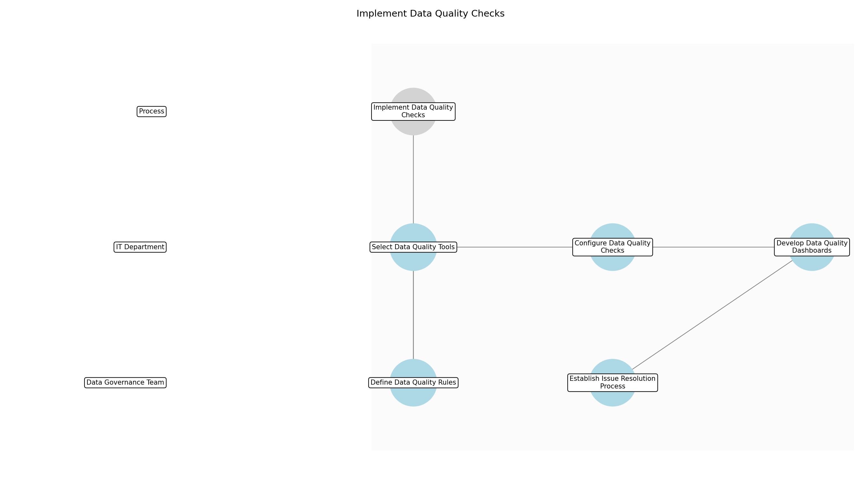

Implement Data Quality Checks – Define Data Quality Rules
Description: Establish specific, measurable, achievable, relevant, and time-bound (SMART) data quality rules based on the defined data quality standards and data governance policies. These rules should cover various aspects of data quality, including accuracy, completeness, consistency, validity, and timeliness. Document these rules in a central repository for easy access and reference.
Responsible Parties: Data Governance Team
Inputs:
- Data quality standards
- Data governance policies
Outputs:
- Data quality rules
Dependencies:
Estimated Duration: 1 week
Success Criteria:
- Definition of SMART data quality rules
- Documentation of data quality rules in a central repository

Implement Data Quality Checks – Select Data Quality Tools
Description: Evaluate and select appropriate data quality tools to automate data quality checks and monitoring. Consider factors such as functionality, scalability, integration capabilities, and cost. The selected tools should support data profiling, data validation, data cleansing, and data monitoring. Ensure that the tools are compatible with the existing data infrastructure and workflows.
Responsible Parties: IT Department
Inputs:
- Data quality rules
- System requirements
Outputs:
- List of selected data quality tools
Dependencies:
- Define Data Quality Rules
Estimated Duration: 1 week
Success Criteria:
- Selection of appropriate data quality tools
- Compatibility of tools with existing data infrastructure

Implement Data Quality Checks – Configure Data Quality Checks
Description: Configure the selected data quality tools to implement the defined data quality rules. This involves setting up automated data quality checks within data pipelines and workflows. Ensure that the checks are comprehensive and cover all critical data elements. Define thresholds for data quality metrics and configure alerts to be triggered when these thresholds are exceeded.
Responsible Parties: IT Department
Inputs:
- List of selected data quality tools
- Data quality rules
Outputs:
- Configured data quality checks
Dependencies:
- Select Data Quality Tools
Estimated Duration: 2 weeks
Success Criteria:
- Implementation of automated data quality checks
- Configuration of alerts for data quality issues

Implement Data Quality Checks – Develop Data Quality Dashboards
Description: Create data quality dashboards to monitor data quality metrics and trends. These dashboards should provide a visual representation of data quality scores, compliance rates, and other relevant metrics. Ensure that the dashboards are user-friendly and provide insights into potential data quality issues. Make the dashboards accessible to relevant stakeholders, including data owners, data stewards, and the Data Governance Team.
Responsible Parties: IT Department
Inputs:
- Configured data quality checks
Outputs:
- Data quality monitoring dashboards
Dependencies:
- Configure Data Quality Checks
Estimated Duration: 1 week
Success Criteria:
- Development of user-friendly data quality dashboards
- Accessibility of dashboards to relevant stakeholders

Implement Data Quality Checks – Establish Issue Resolution Process
Description: Define a clear process for identifying, investigating, and resolving data quality issues. This process should include roles and responsibilities for issue resolution, escalation procedures, and timelines for resolution. Document the issue resolution process and communicate it to all relevant stakeholders. Ensure that the process is integrated with the data quality monitoring dashboards and alerts.
Responsible Parties: Data Governance Team
Inputs:
- Data quality monitoring dashboards
- Data quality alerts
Outputs:
- Data quality issue resolution process
Dependencies:
- Develop Data Quality Dashboards
Estimated Duration: 1 week
Success Criteria:
- Documentation of data quality issue resolution process
- Integration of issue resolution process with data quality monitoring

3.4 Monitor Data Usage
Monitor data usage to ensure compliance with data governance policies and security protocols. Track data access patterns and identify potential security risks. Methods used to monitor data usage include data access logging, data usage reporting, and data loss prevention (DLP) tools. Data access logging involves tracking who is accessing what data and when. Data usage reporting involves generating reports on data access patterns. DLP tools are used to prevent sensitive data from leaving the organization. Potential security risks are identified by analyzing data access patterns and looking for anomalies. For example, if a user is accessing data that they do not normally access, this could be a sign of a security breach.
Responsible Parties: IT Department
Inputs:
- Data governance policies
- Data security protocols
Outputs:
- Data usage metrics
- Data access patterns
- Security risk assessments
Success Criteria:
- Implementation of data usage monitoring
- Identification of security risks
- Compliance with data governance policies

Required Sub Process(es) for the Step "Monitor Data Usage"
The following details the subprocess flows for the step "Monitor Data Usage".
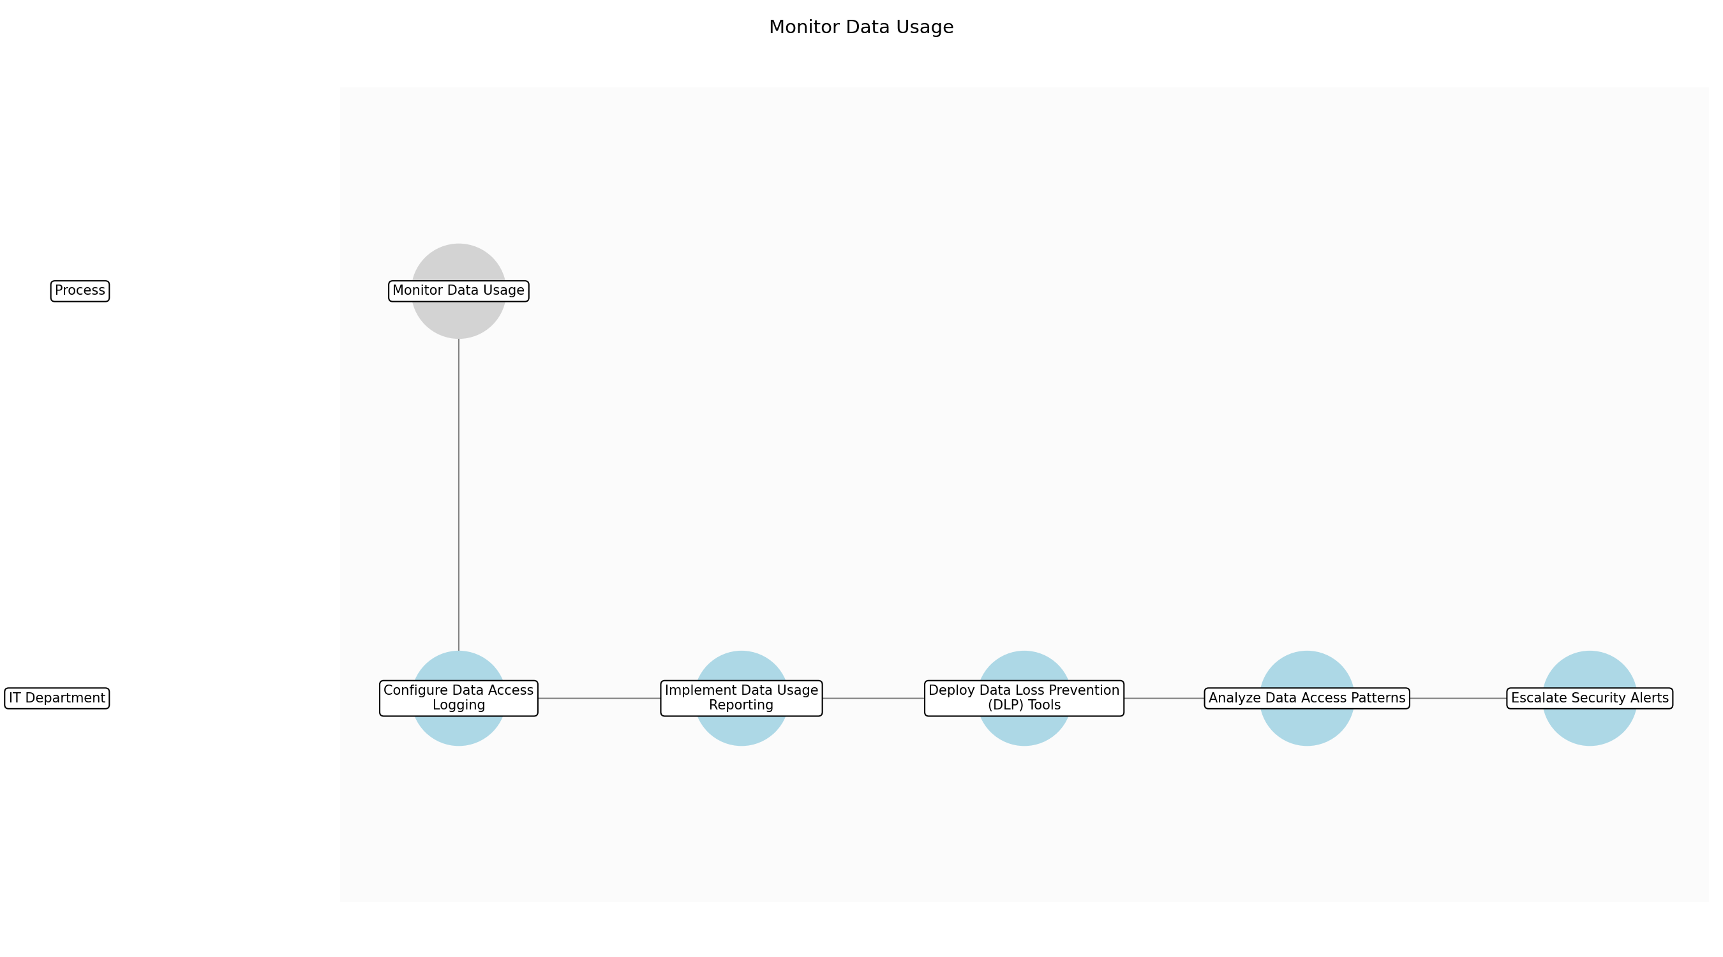

Monitor Data Usage – Configure Data Access Logging
Description: Establish and configure data access logging mechanisms to capture detailed information about data access events. This includes specifying the types of events to log (e.g., read, write, delete), the data elements to capture (e.g., user ID, timestamp, data accessed), and the storage location for the logs. Ensure that the logging configuration complies with data governance policies and regulatory requirements.
Responsible Parties: IT Department
Inputs:
- Data governance policies
- Data security protocols
- Data inventory
Outputs:
- Data access logging configuration
- Data access logs
Dependencies:
Estimated Duration: 1 week
Success Criteria:
- Data access logging is enabled for all critical data assets
- Data access logs are stored securely
- Logging configuration complies with data governance policies

Monitor Data Usage – Implement Data Usage Reporting
Description: Develop and implement data usage reporting capabilities to generate reports on data access patterns. This includes defining the types of reports to generate (e.g., daily, weekly, monthly), the data elements to include in the reports (e.g., user ID, data accessed, access frequency), and the distribution list for the reports. Ensure that the reporting configuration complies with data governance policies and regulatory requirements.
Responsible Parties: IT Department
Inputs:
- Data governance policies
- Data security protocols
- Data access logs
Outputs:
- Data usage reporting configuration
- Data usage reports
Dependencies:
- Configure Data Access Logging
Estimated Duration: 1 week
Success Criteria:
- Data usage reporting is enabled for all critical data assets
- Data usage reports are generated on a regular basis
- Reporting configuration complies with data governance policies

Monitor Data Usage – Deploy Data Loss Prevention (DLP) Tools
Description: Deploy and configure Data Loss Prevention (DLP) tools to prevent sensitive data from leaving the organization. This includes defining the types of data to protect (e.g., personally identifiable information, financial data, intellectual property), the channels to monitor (e.g., email, web, file transfer), and the actions to take when sensitive data is detected (e.g., block, quarantine, alert). Ensure that the DLP configuration complies with data governance policies and regulatory requirements.
Responsible Parties: IT Department
Inputs:
- Data governance policies
- Data security protocols
- Data classification
Outputs:
- DLP configuration
- DLP alerts
Dependencies:
- Implement Data Usage Reporting
Estimated Duration: 2 weeks
Success Criteria:
- DLP tools are deployed and configured for all critical data assets
- DLP tools are effective at preventing sensitive data from leaving the organization
- DLP configuration complies with data governance policies

Monitor Data Usage – Analyze Data Access Patterns
Description: Analyze data access patterns to identify potential security risks. This includes looking for anomalies in data access patterns, such as users accessing data that they do not normally access, users accessing data outside of normal business hours, or users accessing data from unusual locations. Use data analytics techniques to identify these anomalies and generate alerts for further investigation.
Responsible Parties: IT Department
Inputs:
- Data access logs
- Data usage reports
- DLP alerts
Outputs:
- Security risk assessments
- Security alerts
Dependencies:
- Deploy Data Loss Prevention (DLP) Tools
Estimated Duration: Ongoing
Success Criteria:
- Security risks are identified in a timely manner
- Security alerts are generated for all potential security risks
- Security risk assessments are accurate and comprehensive

Monitor Data Usage – Escalate Security Alerts
Description: Escalate security alerts to the security incident response team for investigation and resolution. This includes defining the escalation process, the roles and responsibilities of the security incident response team, and the service level agreements (SLAs) for responding to security alerts. Ensure that the escalation process complies with data governance policies and regulatory requirements.
Responsible Parties: IT Department
Inputs:
- Security alerts
- Data governance policies
- Data security protocols
Outputs:
- Escalation process
- Security incident reports
Dependencies:
- Analyze Data Access Patterns
Estimated Duration: 1 day
Success Criteria:
- Security alerts are escalated to the security incident response team in a timely manner
- Security incident response team responds to security alerts within the SLAs
- Escalation process complies with data governance policies

3.5 Enforce Security Protocols
Enforce robust security protocols to protect data from unauthorized access and breaches. Implement access controls, encryption, and data masking to ensure data confidentiality and integrity. Specific examples of security protocols enforced include multi-factor authentication, role-based access control, and data encryption. Multi-factor authentication requires users to provide multiple forms of identification before they can access data. Role-based access control restricts data access to only those users who have a specific role within the organization. Data encryption protects data by scrambling it so that it cannot be read by unauthorized users. These protocols protect data by preventing unauthorized access, ensuring data confidentiality, and maintaining data integrity.
Responsible Parties: IT Department
Inputs:
- Data governance policies
- Regulatory requirements such as GDPR and CCPA
Outputs:
- Data security measures
- Data access restrictions
- Data encryption
Success Criteria:
- Implementation of data security measures
- Prevention of data breaches
- Compliance with data security policies

Required Sub Process(es) for the Step "Enforce Security Protocols"
The following details the subprocess flows for the step "Enforce Security Protocols".
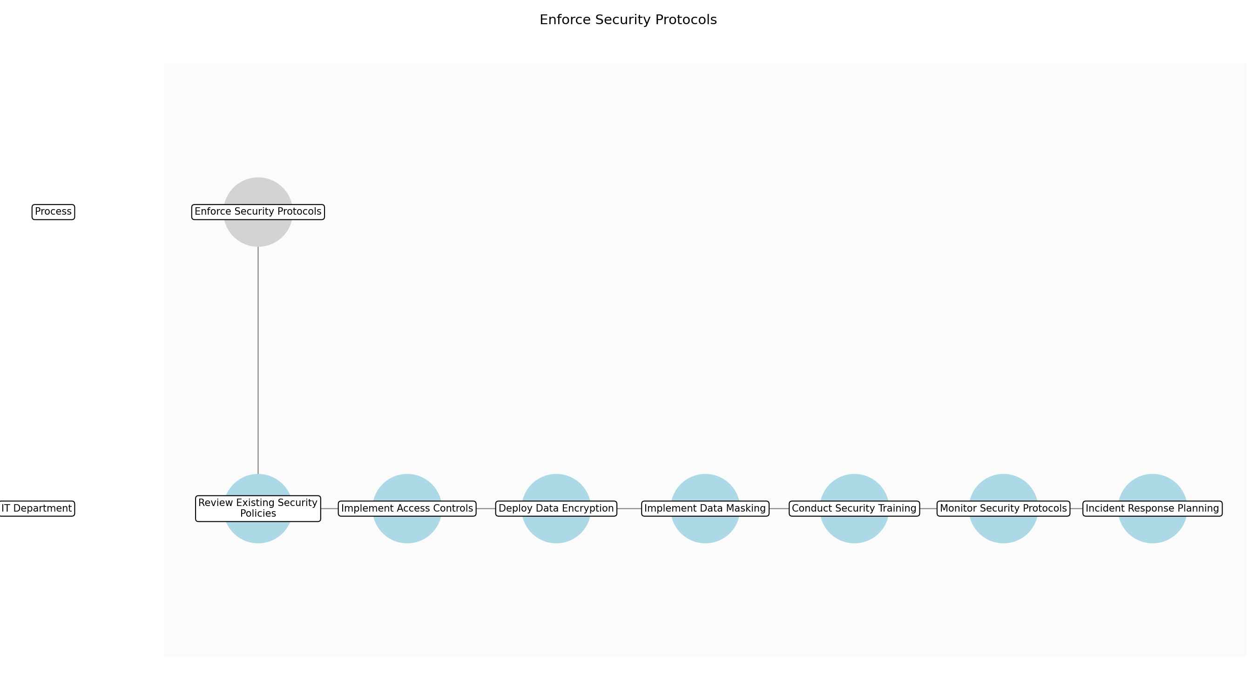

Enforce Security Protocols – Review Existing Security Policies
Description: The first step is to thoroughly review the existing data security policies and procedures to identify any gaps or areas that need improvement. This review should consider the current threat landscape, regulatory requirements, and industry best practices. The goal is to ensure that the existing policies are up-to-date and effective in protecting data from unauthorized access and breaches.
Responsible Parties: IT Department
Inputs:
- Data governance policies
- Regulatory requirements such as GDPR and CCPA
- Data security policies
Outputs:
- Gap analysis report
- Updated security requirements
Dependencies:
Estimated Duration: 1 week
Success Criteria:
- Completion of gap analysis
- Identification of areas for improvement

Enforce Security Protocols – Implement Access Controls
Description: Implement robust access controls to restrict data access to only authorized users. This includes implementing role-based access control (RBAC) to ensure that users only have access to the data they need to perform their job duties. Regularly review and update access control lists to reflect changes in user roles and responsibilities. Access control systems should be integrated with identity management systems to streamline user provisioning and deprovisioning.
Responsible Parties: IT Department
Inputs:
- Updated security requirements
- Data ownership assignments
- Role-based access control matrix
Outputs:
- Access control lists
- User access rights
Dependencies:
- Review Existing Security Policies
Estimated Duration: 2 weeks
Success Criteria:
- Implementation of role-based access control
- Restriction of data access to authorized users

Enforce Security Protocols – Deploy Data Encryption
Description: Deploy data encryption to protect data at rest and in transit. This includes implementing encryption for databases, file systems, and network communications. Use strong encryption algorithms and key management practices to ensure data confidentiality and integrity. Regularly review and update encryption keys to prevent unauthorized access. Data encryption software should be compliant with industry standards and regulations.
Responsible Parties: IT Department
Inputs:
- Updated security requirements
- Encryption keys
- Data classification
Outputs:
- Encrypted data
- Encryption keys
Dependencies:
- Implement Access Controls
Estimated Duration: 3 weeks
Success Criteria:
- Implementation of data encryption at rest and in transit
- Protection of data confidentiality and integrity

Enforce Security Protocols – Implement Data Masking
Description: Implement data masking techniques to protect sensitive data from unauthorized access. This includes masking data in non-production environments, such as development and testing. Use appropriate data masking techniques, such as substitution, shuffling, and redaction, to ensure data confidentiality. Regularly review and update data masking rules to reflect changes in data sensitivity and regulatory requirements.
Responsible Parties: IT Department
Inputs:
- Updated security requirements
- Data classification
- Data masking rules
Outputs:
- Masked data
- Data masking rules
Dependencies:
- Deploy Data Encryption
Estimated Duration: 2 weeks
Success Criteria:
- Implementation of data masking in non-production environments
- Protection of sensitive data from unauthorized access

Enforce Security Protocols – Conduct Security Training
Description: Provide data security training to all stakeholders to raise awareness of security risks and best practices. This includes training on topics such as password security, phishing awareness, and data handling procedures. Regularly conduct security training to ensure that stakeholders are up-to-date on the latest threats and security measures. Security training should be tailored to the specific roles and responsibilities of each stakeholder.
Responsible Parties: IT Department
Inputs:
- Data governance policies
- Security awareness training materials
Outputs:
- Trained stakeholders
- Security awareness
Dependencies:
- Implement Data Masking
Estimated Duration: Ongoing
Success Criteria:
- Completion of security training by all stakeholders
- Improved security awareness

Enforce Security Protocols – Monitor Security Protocols
Description: Continuously monitor the effectiveness of security protocols and identify potential vulnerabilities. This includes monitoring data access patterns, security logs, and system configurations. Implement security information and event management (SIEM) tools to automate security monitoring and incident response. Regularly review and update security protocols to address emerging threats and vulnerabilities.
Responsible Parties: IT Department
Inputs:
- Data access logs
- Security logs
- System configurations
Outputs:
- Security alerts
- Security reports
Dependencies:
- Conduct Security Training
Estimated Duration: Ongoing
Success Criteria:
- Implementation of security monitoring
- Identification of security vulnerabilities

Enforce Security Protocols – Incident Response Planning
Description: Develop and maintain an incident response plan to address data breaches and security incidents. This plan should outline the steps to be taken in the event of a security incident, including incident detection, containment, eradication, and recovery. Regularly test and update the incident response plan to ensure its effectiveness. The incident response plan should be aligned with industry best practices and regulatory requirements.
Responsible Parties: IT Department
Inputs:
- Security alerts
- Incident response plan template
Outputs:
- Incident response plan
- Incident response procedures
Dependencies:
- Monitor Security Protocols
Estimated Duration: 2 weeks
Success Criteria:
- Development of incident response plan
- Testing of incident response plan

4.0 Supporting Systems and Tools
The following tools and platforms support this process:
Category | Tools
Data Catalog | A centralized repository for metadata management, providing a comprehensive view of data assets.
Data Loss Prevention (Dlp) Tools | Tools used to prevent sensitive data from leaving the organization.
Data Quality Tools | Software solutions for monitoring and improving data quality, including data profiling, cleansing, and validation.
Data Encryption Software | Software for encrypting data at rest and in transit, protecting it from unauthorized access.
Data Lineage Tools | Tools for tracking the origin and movement of data, enabling better understanding and management of data flows.
Access Control Systems | Systems for managing user access to data, ensuring only authorized individuals can access sensitive information.

5.0 Metrics and Key Performance Indicators (KPIs)
The following is a list of key metrics associated with this process. These metrics help monitor performance and ensure alignment with business objectives.

Data Quality Scores
Quantifiable measures of data accuracy, completeness, and consistency.

Compliance Rate
Percentage of data compliant with data governance policies and regulations.

AI Model Accuracy
Performance metrics of AI models trained on governed data.

Time to Access Data
The time it takes for authorized users to access data.

Data Breach Incidents
Number of security breaches involving corporate data.

6.0 Critical Success Factors (CSF)
The following is a list of key CSFs associated with this process.
Success Factor | Description
Executive Sponsorship | Strong support from executive leadership to drive data governance initiatives.
Cross-Functional Collaboration | Collaboration between data scientists, IT, business analysts, and compliance officers.
Clearly Defined Roles and Responsibilities | Clearly defined roles and responsibilities for data owners, stewards, and users.
Data Literacy Training | Training programs to improve data literacy among all stakeholders.
Effective Data Quality Monitoring | Continuous monitoring of data quality to identify and resolve issues.

7.0 Critical Failure Factors (CFF)
The following is a list of key CFFs associated with this process.
Failure Factor | Description
Lack of Executive Support | Insufficient support from executive leadership, leading to underfunding and lack of prioritization.
Siloed Data | Data stored in isolated systems, making it difficult to access and integrate.
Poor Data Quality | Inaccurate, incomplete, or inconsistent data, leading to unreliable AI models.
Lack of Training | Insufficient training for data owners and users, leading to non-compliance.
Inadequate Security Measures | Weak security protocols, leading to data breaches and unauthorized access.

8.0 Reporting and Analytics
The following are key reporting and analytics associated with this process.
Metric / Key | Description / Value
Data Usage Reports | Reports that track data access patterns and identify potential security risks.
Data Quality Dashboards | Visual representations of data quality metrics, providing insights into data accuracy and completeness.
Compliance Reports | Reports that demonstrate compliance with data governance policies and regulations.
Ai Model Performance Reports | Reports that monitor the performance of AI models and identify data-related issues.

9.0 System Requirements
The following system requirements are essential for the successful implementation of this process.
- Data catalog
- Data quality tools
- Data lineage tools
- Access control systems
- Data encryption software
- Data Loss Prevention (DLP) tools

10.0 Process Flow Diagram
The following diagram provides a high-level visualization of the process flow as defined in the normalized JSON source.
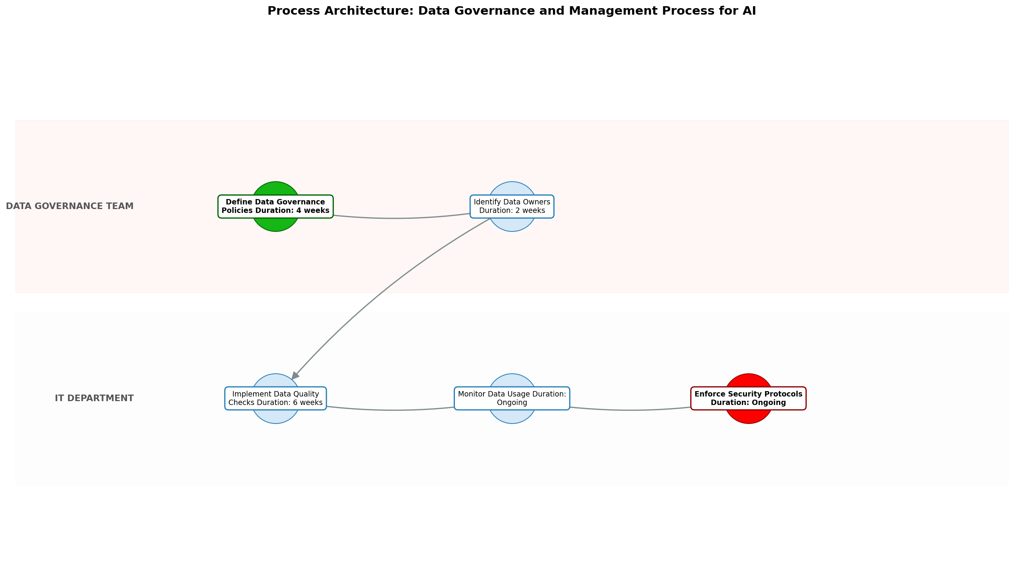

11.0 Process Performance Report
The following metrics are based on a Monte Carlo discrete-event simulation running 2,000 iterations. All time-based values are reported in weeks.
Operational Metric | Simulated Value
Average Cycle Time | 18.61 weeks
Cycle Time Variance | 2.41 weeks
Contention Risk Profile | Low

Identified Bottlenecks
- Implement Data Quality Checks
- Define Data Governance Policies
- Identify Data Owners

Detailed Step Performance
Process Step | Avg. Duration (weeks)
Define Data Governance Policies | 5.29
Identify Data Owners | 2.67
Implement Data Quality Checks | 7.99
Monitor Data Usage | 1.33
Enforce Security Protocols | 1.33

Appendix B: Additional Source Data
This appendix contains additional structured data from the normalized source JSON that is not covered in the main sections.
Assumptions:
- Data sources are well-defined
- Stakeholders are committed to data governance
- Sufficient data literacy exists within the organization
Constraints:
- Regulatory compliance (e.g., GDPR, CCPA)
- Budget limitations for tools and personnel
- Legacy systems with limited integration capabilities

Appendix C: Glossary
This glossary contains definitions of common terms used in the process documentation.
Term | Definition
Business Process | A set of related activities or tasks performed to achieve a specific organizational goal.
KPI | Key Performance Indicator used to measure the success or health of a process.
Stakeholder | Any individual or group with an interest in the outcomes of the process.
Continuous Improvement | Ongoing effort to improve products, services or processes.

