MetroLink Supplier Onboarding Portal Proposal Response
Response to Proposal

Generated On: 2026-11-04 16:52:46

Document Control
Version | Date | Author | Description
1.0 | 2026-11-04 | Proposal Response | Initial generated proposal response

Table of Contents

1.0 Executive Summary
Harborlight Digital is pleased to submit this proposal for the MetroLink Supplier Onboarding Portal. Our solution provides a secure, integrated, and accessible platform to modernize MetroLink's supplier lifecycle, ensuring efficient reviews and seamless data synchronization with the existing finance platform.

1.1 Understanding of Client Objectives
MetroLink currently faces challenges with a fragmented or manual supplier onboarding process that lacks centralization and real-time integration with their core finance platform. This results in administrative overhead, potential data inconsistencies, and a sub-optimal experience for both suppliers and internal staff. The primary business driver is to modernize this lifecycle through a secure, user-centric digital portal that serves as a single point of entry for all supplier engagements.
The key targets for this engagement include providing a seamless 'save and resume' capability for suppliers, a robust internal review workflow for MetroLink staff, and a reliable integration layer that synchronizes approved records with the existing MetroLink finance platform. Compliance with UK data residency requirements and high standards of accessibility (WCAG) are non-negotiable pillars of the future state, ensuring the system is inclusive and secure by design.
Furthermore, the solution must operate within the constraints of the existing MetroLink infrastructure, necessitating a sophisticated integration approach that avoids the need for core system redesign. The ultimate goal is to provide a scalable, sustainable platform that reduces the time-to-onboard while maintaining the highest levels of data integrity and auditability.

1.2 Expected Outcomes & ROI
- Streamlined and modernized supplier onboarding process.
- Automated synchronization of data with the MetroLink finance platform.
- Secure and centralized storage for all supplier evidence documents.
- Full transparency and auditability of the approval workflow.
- Enhanced supplier experience through a user-friendly digital interface.

1.3 Benefits Realisation
Benefit | Measure | Expected Outcome
Reduced Manual Processing | Reduction in time-to-onboard for new suppliers. | • Streamlined internal review workflows and automated data synchronization.
Enhanced Data Quality | Decrease in record errors in the MetroLink system. | • Validation at source and direct integration with the finance platform.
Improved Compliance and Security | Successful security audit and adherence to UK data residency. | • Secure document storage, MFA, and full audit trails.

1.4 Summary of Proposed Solution
Harborlight Digital proposes a secure, cloud-native Supplier Onboarding Portal featuring a user-friendly interface for suppliers and a robust review workflow for MetroLink staff. The solution includes a dedicated integration layer to seamlessly synchronize approved supplier data with the existing MetroLink finance platform while maintaining strict UK data residency and accessibility standards.

2.0 Why We Are Best Placed to Deliver

2.1 Differentiators & Value Proposition
- Proven expertise in public sector digital transformation and secure portal delivery.
- Deep understanding of UK cloud residency and security compliance requirements.
- Robust integration approach that handles legacy system constraints without requiring core system changes.
- Commitment to WCAG accessibility standards as a core design principle.

2.2 Industry / Domain Expertise
Our team possesses extensive domain expertise in procurement technology and supplier lifecycle management. We understand the complexities of onboarding and the critical importance of data integrity between front-end portals and financial systems of record.

2.3 Domain-Specific Accelerators
- Reusable Supplier Portal Framework
- Configurable Workflow Engine for Review Queues
- Standardized Integration Connectors for Finance Platforms

3.0 Proposed Solution
The proposed Harborlight Digital solution is a cloud-native Supplier Onboarding Portal designed to be deployed directly into MetroLink's UK cloud subscription. The architecture is modular, comprising a frontend supplier portal, a backend administration and review module, and a dedicated integration service. The supplier portal provides an intuitive interface for account creation, form completion, and secure document uploading, ensuring that sensitive business evidence is captured and stored directly in MetroLink's managed repositories. This 'save and resume' functionality is critical for complex applications that require multiple pieces of evidence.
For internal staff, the solution offers a comprehensive review queue where applications can be assigned, audited, and processed. This module includes built-in communication tools for requesting clarifications from suppliers, ensuring a transparent and efficient approval loop. The system automatically routes applications based on pre-defined rules, reducing manual assignment effort and ensuring that the right reviewers are notified at the right time.
The integration layer is the critical bridge to the MetroLink finance platform, supporting both real-time API calls and scheduled encrypted file transfers to accommodate the specific technical constraints of the legacy environment. This layer performs necessary data transformations to ensure that approved supplier records match the target system's schema exactly. Security is baked into every layer, featuring Multi-Factor Authentication (MFA), role-based access controls, and full audit logging of all system interactions. The entire solution is optimized for accessibility, meeting WCAG standards to ensure a high-quality experience for all users regardless of their assistive technology needs.

4.0 Solution Architecture
The following diagram provides a high-level visualization of the proposed solution's architecture.
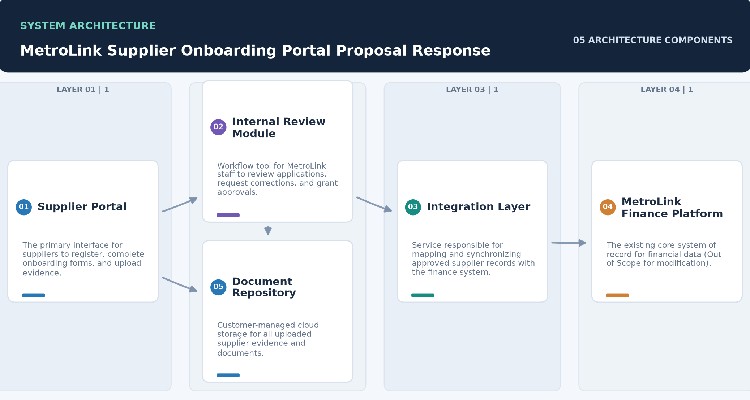

Component | Description
Supplier Portal | • The primary interface for suppliers to register, complete onboarding forms, and upload evidence.
Internal Review Module | • Workflow tool for MetroLink staff to review applications, request corrections, and grant approvals.
Integration Layer | • Service responsible for mapping and synchronizing approved supplier records with the finance system.
MetroLink Finance Platform | • The existing core system of record for financial data (Out of Scope for modification).
Document Repository | • Customer-managed cloud storage for all uploaded supplier evidence and documents.

5.0 Scope of Work & Boundaries

5.1 Services in Scope
- Technical Discovery and Design
- Portal Development and Configuration
- Workflow Engine Implementation
- Integration Layer Development
- Cloud Deployment and Environment Setup
- UAT Support and Training
- Post-Launch Support Service

5.2 Functional Coverage
This proposal provides a response to all 10 requirements identified in the requirements register: 10 Fully Compliant.

5.3 Environments & Platforms Covered
- Customer-controlled Azure/AWS UK Production Tenant
- Staging/UAT Environment
- Development/Sandbox Environment

5.4 Key Deliverables & Artifacts
- Authenticated Supplier Onboarding Portal
- Internal Staff Review and Approval Module
- Integration Layer for MetroLink Finance Platform
- System Administration and Reporting Dashboard
- Technical Documentation and Handover Pack
- Post-Launch Support and Maintenance Service

5.5 Out-of-Scope Activities
- Replacement or redesign of the MetroLink finance platform.
- Legal, tax, or financial advice for supplier applicants.
- Migration or handling of historical closed supplier records.
- Manual scanning of paper archives.

5.6 Key Technical Constraints
- Integration must accommodate MetroLink's existing API or file transfer capabilities.
- Solution must be deployed within a customer-managed UK cloud region.
- No modifications are permitted to the core MetroLink finance platform.

6.0 Compliance Matrix
This section addresses each identified requirement in turn, stating our compliance status and response.
ID | Requirement | Status | Response | Evidence / Location
FR-001 | • Authenticated supplier portal for application management including saving/resuming forms and uploading evidence. | Fully Compliant | • The proposed solution includes a secure, authenticated portal with full save/resume functionality and integrated document upload capabilities. | • See Proposed Solution
FR-002 | • Internal review queues with correction requests, assignment capabilities, and approval routing. | Fully Compliant | • The Internal Review Module provides dedicated queues, role-based assignment, and structured approval/rejection workflows. | • See Proposed Solution
FR-003 | • Integration layer to exchange approved supplier records with the MetroLink finance platform. | Fully Compliant | • Our integration layer supports API and scheduled file transfers to ensure seamless data synchronization with MetroLink. | • See Proposed Solution / Integration Layer
FR-004 | • Supplier document collection and storage in a customer-managed repository. | Fully Compliant | • The system is configured to store all supplier documents directly in MetroLink's managed cloud storage. | • See Proposed Solution
FR-005 | • System-generated expiry reminders and a comprehensive audit history for all records. | Fully Compliant | • Automated reminders and a detailed audit log for every action are core features of the proposed platform. | • See Proposed Solution
FR-006 | • Monthly service reporting on system performance, incidents, and workflow metrics. | Fully Compliant | • Harborlight Digital will provide comprehensive monthly reports covering availability, incident trends, and throughput. | • See Implementation Plan / Phase 5
NFR-001 | • Application deployment into a customer-controlled cloud subscription in a UK region. | Fully Compliant | • The solution is designed for cloud-native deployment within the customer's UK-based tenant. | • See Environment Setup
NFR-002 | • Role-based access permissions for supplier-facing and staff-facing screens sharing a common record model. | Fully Compliant | • Granular RBAC ensures that users only access the screens and data relevant to their specific roles. | • See Proposed Solution
NFR-003 | • Implementation of encryption, MFA, audit logging, and backup/recovery procedures. | Fully Compliant | • The platform incorporates enterprise-grade security including MFA and end-to-end encryption. | • See Proposed Solution / Security
NFR-004 | • System accessibility including keyboard-only navigation and assistive-technology compatibility. | Fully Compliant | • The portal is built to WCAG standards, ensuring full accessibility for all users including keyboard-only navigation. | • See Quality Validation Approach

7.0 Delivery & Engagement Approach

7.1 Core Delivery Approach
We follow an iterative, phased delivery methodology that prioritizes early discovery and technical validation. This ensures that the integration layer and portal features are perfectly aligned with MetroLink's operational needs before full-scale development.

7.2 Platform / Application Approach
The platform is built using a modern, scalable tech stack optimized for cloud deployment. It utilizes a common record model to ensure consistency between supplier and staff views, while maintaining strict role-based isolation.

7.3 Data & Quality Validation Approach
Quality is ensured through a multi-layered testing strategy including unit testing, integration testing, and User Acceptance Testing (UAT). We specifically include accessibility testing with assistive technologies to guarantee compliance with NFR-004.

7.4 Automation & Tooling Approach
We will utilize CI/CD pipelines for automated deployment and testing. Automated accessibility scans will be integrated into the build process to ensure continuous compliance with WCAG standards.

7.6 Recommended Tooling Stack
- React.js (Frontend)
- Node.js / TypeScript (Backend)
- RESTful APIs / SFTP (Integration)
- Cloud-native SQL Database
- Customer-managed Cloud Storage (e.g., Azure Blob / AWS S3)

7.7 SLAs & Quality KPIs
Metric | Target
System Availability | • 99.9% (TBC during Mobilisation)
Incident Response Time | • To be agreed during Mobilisation
Application Sync Success Rate | • 100% for approved records

7.8 Mobilisation & Phased Roadmap
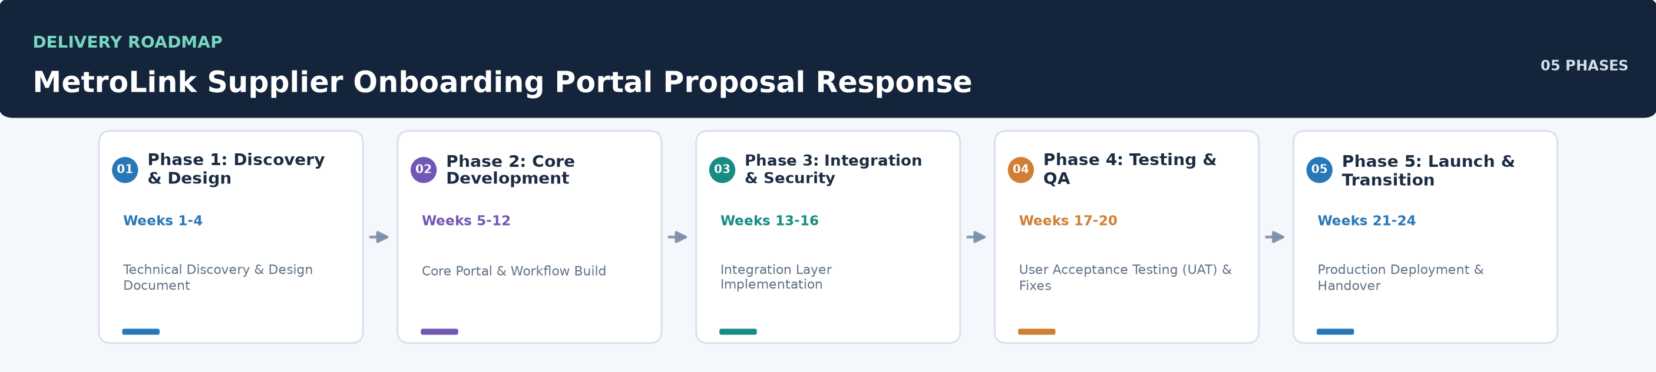

Phase | Timing | Deliverable | Acceptance Criteria
Phase 1: Discovery & Design | Weeks 1-4 | • Technical Discovery & Design Document | • Signed-off Discovery Report including field mapping and technical architecture.
Phase 2: Core Development | Weeks 5-12 | • Core Portal & Workflow Build | • Functional supplier portal and internal review queues in the development environment.
Phase 3: Integration & Security | Weeks 13-16 | • Integration Layer Implementation | • Successful data exchange between the portal and the MetroLink sandbox.
Phase 4: Testing & QA | Weeks 17-20 | • User Acceptance Testing (UAT) & Fixes | • Successful completion of UAT and accessibility testing by MetroLink stakeholders.
Phase 5: Launch & Transition | Weeks 21-24 | • Production Deployment & Handover | • Production-ready system deployed and operational in the customer tenant.

7.9 Transition to Business-As-Usual
Following successful deployment, we will conduct a formal knowledge transfer to MetroLink's internal teams. This includes providing comprehensive documentation and training sessions. Ongoing support will be provided via our UK-based service desk as per the agreed SLA.

8.0 Governance Model, Roles & Responsibilities

8.1 Governance Framework
The project will be governed by a joint Steering Committee and a weekly Project Board. This structure ensures strategic alignment, timely decision-making, and effective risk management throughout the engagement.

8.2 RACI Matrix
Activity | Responsible | Accountable | Consulted | Informed
• Project Governance | Project Manager | Delivery Director | Steering Committee | MetroLink Sponsor
• Portal Development | Lead Developer | Project Manager | UX Lead | MetroLink Staff
• System Integration | Integration Specialist | Lead Architect | MetroLink Finance Team | Project Manager

8.3 Escalation Paths & Decision-Making
- Level 1: Project Manager
- Level 2: Delivery Director
- Level 3: Account Executive

8.4 Meeting Cadence & Stakeholder Engagement
Meeting | Frequency | Attendees
Project Status Meeting | Weekly | • Project Manager, Lead Architect, MetroLink Counterparts
Steering Committee Meeting | Monthly | • Delivery Director, MetroLink Project Sponsor
Daily Stand-up | Daily | • Development Team

9.0 Indicative Profiles & Team Structure

9.1 Team Structure & Allocation
Role | Allocation
Project Manager | 100%
Lead Solution Architect | 100%
Senior Portal Developer (x2) | 100%
QA & Accessibility Specialist | 50%
Delivery Director | 25%

9.2 Key Personnel Profiles
Role | Responsibilities | Experience | Certifications
Project Manager | • Overall project delivery, stakeholder management, and budget control. | • 10+ years in public sector IT delivery. | —
Lead Solution Architect | • Technical leadership, architecture design, and integration strategy. | • Expertise in cloud-native architecture and secure integrations. | —
Senior Portal Developer | • Frontend development and accessibility compliance. | • Specialist in building accessible, user-centric web applications. | —

9.3 Skills Matrix & Certifications
- Cloud Architecture (Azure/AWS)
- Full-Stack Web Development (React/Node.js)
- API and Integration Design
- WCAG Accessibility Compliance
- Agile Project Management (Prince2 Agile/Scrum)

10.0 Qualifications
Harborlight Digital brings extensive experience in delivering complex digital transformation projects within the UK public sector. Our team specializes in creating secure, accessible portals that bridge the gap between user-facing services and legacy back-office systems. We have a proven track record of implementing robust integration layers that handle sensitive financial and organizational data with the highest levels of integrity.
Our delivery model is centered on partnership and transparency, ensuring that MetroLink stakeholders are involved at every stage of the lifecycle—from initial technical discovery and field mapping to final deployment and service transition. We pride ourselves on our ability to navigate the technical and compliance complexities of public sector cloud environments, providing a solution that is not only functional but also sustainable and secure. Our consultants are experts in Agile delivery, ensuring that value is realized early and often throughout the project.

10.1 Company Overview
Harborlight Digital is a technology consultancy specializing in digital transformation and secure portal solutions for the public sector. Based in the UK, we focus on bridging the gap between user-centric front-end services and complex back-office systems.

10.2 Relevant Experience
We have successfully delivered similar supplier and citizen portals for other UK public sector bodies, focusing on secure document handling and integration with legacy ERP and finance systems.

10.3 Certifications
Harborlight Digital maintains organizational certifications relevant to secure public sector delivery, including Cyber Essentials and alignment with ISO 27001 standards for information security management.

10.4 Delivery Capability
Harborlight Digital maintains a dedicated UK-based delivery team with deep expertise in cloud architecture, integration, and user-centric design. We have the capacity to scale our resources to meet project timelines while maintaining high quality.

11.0 Future Roadmap & Innovation
The following represent potential future enhancements for consideration beyond the scope of this initial engagement -- not commitments of this proposal.
- AI-assisted document verification for automated evidence checking.
- Advanced supplier performance analytics and dashboarding.
- Integration with external credit check and business verification services.
- Mobile application for on-the-go review and approvals.

12.0 Key Assumptions & Dependencies

12.1 Project Assumptions
- The Authority (customer) owns the document retention schedule and legal hold decisions.
- MetroLink provides process owners, policies, data dictionary, test users, and timely decisions.
- MetroLink/platform providers supply API documentation, sandbox access, and required credentials.
- The application is deployed into a customer-controlled cloud subscription in a UK region.

12.2 Client Responsibilities & Dependencies
- Provision of API documentation and sandbox access for the MetroLink finance platform.
- Access to the customer-managed UK cloud subscription for deployment.
- Availability of MetroLink process owners and technical stakeholders for discovery sessions.
- Definition of document retention policies and legal hold requirements.

12.3 Risk Management & Mitigation Matrix
Risk | Mitigation
• Integration success depends on the availability of technical documentation and sandbox access for MetroLink. | • Early technical discovery and sandbox access request in Phase 1.
• Deployment is subject to architecture review and service availability within the customer's cloud subscription. | • Direct collaboration with MetroLink IT for early architecture review.

13.0 Commercial Proposal & Total Cost of Ownership (TCO)

13.1 Fixed-Fee Implementation Schedule
Our pricing model is based on a fixed-price delivery for the implementation phases, followed by a recurring monthly service fee for support and maintenance. This provides MetroLink with budget certainty and long-term cost transparency.
Item | Basis | Price
Phase 1: Discovery & Design | • One-time Project Fee | TBD
Phase 2-4: Development, Integration & Testing | • One-time Project Fee | TBD
Phase 5: Deployment & Handover | • One-time Project Fee | TBD
Ongoing Support & Maintenance | • Recurring Monthly Fee | TBD

13.2 Ongoing Managed Support & Operational Expenses
Ongoing costs will include a fixed monthly fee for service desk support, platform maintenance, and minor enhancements. These costs will be detailed in the final Service Level Agreement.

13.3 Rate Cards & Change Control Mechanics
Any changes to the agreed scope will be managed through a formal Change Control Procedure. Standard day rates for additional services will be provided in the final contract.

14.0 Open Questions for Clarification
- FR-006: What are the specific response and restoration targets for the service desk support?
- FR-003: What is the preferred integration method (API vs. encrypted file transfer) for the MetroLink platform?
- FR-006: What are the specific metric definitions and data sources required for monthly reporting?

15.0 Unaddressed Items
The following items were flagged in the original requirements analysis as inferred or as coverage gaps, not as stated requirements -- they are noted here for completeness but are not addressed as formal compliance items above.
- Data Privacy & Compliance: Specific compliance standards (e.g., GDPR, Cyber Essentials) are not detailed beyond general mentions of encryption and MFA.
- Performance & Scalability: No specific targets for concurrent users, throughput, or system response times are provided.
- functional

Appendix A: Additional Source Data
This appendix contains additional structured data from the normalized source JSON that is not covered in the main sections.
Factory Approach: Not Applicable

