Data Center Migration
The Data Center Migration process outlines the comprehensive steps required to move IT infrastructure from one physical location to another, ensuring minimal disruption to business operations. This process focuses on meticulous planning, secure execution, and continuous monitoring to maintain data integrity and system performance. It incorporates automated escalation workflows and compliance checks to proactively address potential issues and adhere to regulatory standards, thereby ensuring a smooth and secure transition.
Industry / Domain: N/A
Version: 1.2
Generated On: 2025-12-27 23:23:52

Document Control
Version | Date | Author | Description
1.2 | 2025-12-27 | Process Architect | Initial generated process specification

Table of Contents

1.0 Process Overview
The Data Center Migration process outlines the comprehensive steps required to move IT infrastructure from one physical location to another, ensuring minimal disruption to business operations. This process focuses on meticulous planning, secure execution, and continuous monitoring to maintain data integrity and system performance. It incorporates automated escalation workflows and compliance checks to proactively address potential issues and adhere to regulatory standards, thereby ensuring a smooth and secure transition.

2.0 Stakeholders and Responsibilities
Stakeholder | Responsibilities
Project Sponsor | Provides overall direction and resources for the data center migration project.
Project Manager | Responsible for planning, execution, and monitoring the data center migration project.
Data Center Team | Responsible for the physical migration of servers and equipment.
IT Operations Team | Responsible for maintaining IT services during and after the migration.
Security Team | Ensures security compliance throughout the migration process.
Application Owners | Responsible for testing and validating applications after migration.
Compliance Team | Ensures regulatory compliance throughout the migration.
Business Units | Represent the business users who rely on the data center's services.

3.0 Process Workflow

3.1 Planning
The Planning phase involves developing a detailed migration plan that includes timelines, resource allocation, and risk mitigation strategies. This phase sets the foundation for a successful migration by clearly defining the project's scope, objectives, and stakeholder roles. A comprehensive communication plan and risk management plan are also established to ensure all team members are informed and potential issues are proactively addressed.
Responsible Parties: Project Manager, Data Center Team, IT Operations Team
Success Criteria:
- Comprehensive migration plan developed and approved by stakeholders.
- Communication plan established and communicated to all stakeholders.
- Risk management plan developed and potential risks identified.

3.2 Preparation
The Preparation phase focuses on setting up the target data center environment to ensure it is ready for the migrated systems. This includes installing and configuring hardware and software, establishing network connectivity, and thoroughly testing the target environment. The goal is to create a stable and secure environment that mirrors the existing infrastructure, minimizing potential issues during the migration process.
Responsible Parties: Data Center Team, IT Operations Team
Success Criteria:
- Target data center infrastructure set up and configured.
- Hardware and software installed and tested.
- Network connectivity established and verified.
- Target environment tested and ready for migration.

3.3 Migration
The Migration phase involves the actual transfer of systems and data from the old data center to the new data center. This includes backing up data, migrating applications and data, testing migrated systems, and addressing any issues that arise during the process. The primary objective is to ensure a seamless transition with minimal downtime and zero data loss, maintaining the integrity and availability of critical systems.
Responsible Parties: Data Center Team, IT Operations Team, Application Owners
Success Criteria:
- Data backed up and secured.
- Applications and data migrated successfully.
- Migrated systems tested and validated.
- Issues addressed and resolved promptly.

3.4 Testing
The Testing phase is critical to ensure that all migrated systems and applications are functioning correctly in the new data center. This involves conducting functional testing, performance testing, and security testing to identify and resolve any issues. Obtaining sign-off from application owners confirms that the systems meet the required standards and are ready for go-live.
Responsible Parties: IT Operations Team, Application Owners, Security Team
Success Criteria:
- Functional testing completed with satisfactory results.
- Performance testing completed and performance maintained or improved.
- Security testing completed and security compliance maintained.
- Sign-off obtained from application owners.

3.5 Go-Live
The Go-Live phase involves cutting over to the new data center and decommissioning the old data center. This includes switching over to migrated systems, monitoring system performance, and ensuring a smooth transition for all users. The goal is to minimize disruption to business operations and ensure that all systems are running efficiently in the new environment.
Responsible Parties: IT Operations Team, Data Center Team
Success Criteria:
- Systems switched over to the new data center successfully.
- System performance monitored and maintained.
- Old data center decommissioned securely.

3.6 Post-Migration
The Post-Migration phase focuses on monitoring and optimizing the new data center environment. This includes monitoring system performance, optimizing system configuration, and addressing any remaining issues. The objective is to ensure the long-term stability and efficiency of the new data center, providing a reliable and high-performing infrastructure for business operations.
Responsible Parties: IT Operations Team
Success Criteria:
- System performance monitored and optimized.
- System configuration optimized for efficiency.
- Remaining issues addressed and resolved.
- Data center environment stable and efficient.

3.7 Escalation Process
The Escalation Process provides a detailed plan for escalating issues when key milestones are missed or at risk. This includes defining escalation criteria, establishing automated data gathering for initial issue assessment, implementing granular monitoring for pre-emptive issue identification, and establishing clear escalation paths. The goal is to ensure timely resolution of issues and minimize any negative impact on the migration project.
Responsible Parties: Project Manager, Project Sponsor, IT Operations Team
Success Criteria:
- Escalation criteria defined and documented.
- Automated data gathering established for issue assessment.
- Granular monitoring implemented for pre-emptive issue identification.
- Escalation paths established and communicated.
- Contact list maintained and accessible.

3.8 Progress Tracking
The Progress Tracking phase involves implementing a system for tracking progress against the migration plan. This includes using project management software, establishing regular status meetings, creating progress reports with key milestones, and implementing a dashboard to visualize progress. The objective is to provide real-time visibility into the project's status and ensure that it stays on track.
Responsible Parties: Project Manager, Project Team
Success Criteria:
- Project management software implemented and utilized.
- Regular status meetings held and documented.
- Progress reports created and distributed.
- Project dashboard implemented and updated regularly.

3.9 Risk Management
The Risk Management phase focuses on identifying, assessing, and mitigating risks associated with the data center migration. This includes identifying potential risks, assessing their likelihood and impact, developing mitigation strategies, and monitoring and managing risks throughout the migration. The goal is to minimize the potential for disruptions and ensure the project's success.
Responsible Parties: Project Manager, Security Team
Success Criteria:
- Potential risks identified and documented in the risk register.
- Likelihood and impact of each risk assessed.
- Mitigation strategies developed for each identified risk.
- Risks monitored and managed throughout the migration.

3.10 Communication
The Communication phase involves communicating regularly with stakeholders about the progress of the migration. This includes establishing a communication schedule, developing communication materials, holding regular stakeholder meetings, and maintaining open communication channels. The objective is to keep all stakeholders informed and engaged throughout the migration process.
Responsible Parties: Project Manager, Communication Team
Success Criteria:
- Communication schedule established and followed.
- Communication materials developed and distributed.
- Regular stakeholder meetings held and documented.
- Open communication channels maintained.

3.11 Training
The Training phase provides training to IT staff on the new data center environment. This includes identifying training needs, developing training materials, conducting training sessions, and evaluating training effectiveness. The goal is to ensure that IT staff are fully prepared to manage and support the new data center environment.
Responsible Parties: Training Team, IT Operations Team
Success Criteria:
- Training needs identified and documented.
- Training materials developed and approved.
- Training sessions conducted and attended by IT staff.
- Training effectiveness evaluated and documented.

3.12 Compliance Review
The Compliance Review phase ensures compliance with regulatory requirements (HIPAA, GDPR, PCI DSS, KYC, etc.) throughout the migration process. This includes reviewing the migration plan for compliance, conducting compliance audits at key milestones, addressing any compliance gaps identified, and documenting compliance activities and findings. The objective is to maintain regulatory compliance and protect sensitive data during and after the migration.
Responsible Parties: Compliance Team
Success Criteria:
- Migration plan reviewed for compliance with relevant regulations.
- Compliance audits conducted at key milestones.
- Compliance gaps identified and addressed.
- Compliance activities and findings documented.

4.0 Supporting Systems and Tools
The following tools and platforms support this process:
Category | Tools
Project Management Software | Used for planning, tracking, and reporting on the migration project.
Monitoring Tools | Used for monitoring system performance and identifying issues.
Backup And Recovery Tools | Used for backing up and restoring data.
Testing Tools | Used for testing migrated systems and applications.
Security Tools | Used for ensuring security compliance.
Automated Monitoring Tools | Used for pre-emptive issue identification.
Reporting Tools | Used for automated issue reports.

5.0 Metrics and Key Performance Indicators (KPIs)

Downtime
Minimize downtime during the migration to reduce impact on business operations.

Data Loss
Ensure zero data loss during the migration to maintain data integrity.

Application Performance
Maintain or improve application performance after migration to ensure user satisfaction.

Security Compliance
Maintain security compliance throughout the migration to protect sensitive data.

Budget
Complete the migration within the allocated budget to ensure financial responsibility.

Timeline
Complete the migration within the defined timeline to meet project deadlines.

6.0 Reporting and Analytics
Metric / Key | Description / Value
Progress Reports | Regular reports on the progress of the migration, including key milestones and any issues.
Performance Reports | Reports on the performance of migrated systems and applications.
Risk Reports | Reports on the status of identified risks and mitigation strategies.
Incident Reports | Reports on any incidents that occur during the migration.
Escalation Reports | Document the escalation process with reasons and actions taken.
Automated Issue Reports | Automated reports generated by monitoring tools.

7.0 System Requirements
- Project Management Software
- Monitoring Tools
- Backup and Recovery Tools
- Testing Tools
- Security Tools
- Automated Monitoring Tools
- Reporting Tools

8.0 Process Flow Diagram
The following diagram provides a high-level visualization of the process flow as defined in the normalized JSON source.
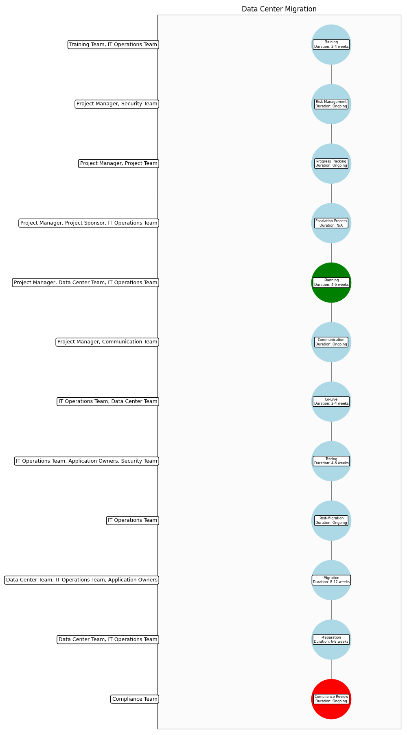

9.0 Process Performance Report
Metric | Value
Avg Cycle Time | 115.23084513747175
Cycle Time Variance | 12.994016004859573
Resource Contention Risk | Low

Identified Bottlenecks
- Migration
- Preparation
- Planning and Design

Per-Step Average Duration
Step | Average Duration (Simulated Units)
Planning and Design | 18.59
Preparation | 28.03
Migration | 36.94
Validation and Testing | 18.56
Post-Migration | 13.12
Escalation Process | 9.41

Appendix C: Glossary
Business Process: A set of related activities or tasks performed to achieve a specific organizational goal.
KPI: Key Performance Indicator used to measure the success or health of a process.
Stakeholder: Any individual or group with an interest in the outcomes of the process.
Continuous Improvement: Ongoing effort to improve products, services or processes.

