Drug Development Value Chain
End-to-end Level 0 Value Chain for a drug development company, covering the lifecycle from Discovery and Pre-Clinical testing through Clinical Development, Regulatory approval, Manufacturing, and Commercial market access.
Industry / Domain: Pharmaceuticals
Version: 1.0
Generated On: 2026-01-23 19:57:10

Document Control
Version | Date | Author | Description
1.0

Table of Contents

1.0 Process Overview
End-to-end Level 0 Value Chain for a drug development company, covering the lifecycle from Discovery and Pre-Clinical testing through Clinical Development, Regulatory approval, Manufacturing, and Commercial market access.

1.1 Assumptions
- Scientific breakthroughs will occur", "Clinical trials will be successful", "Regulatory approval will be granted", "Manufacturing processes will be scalable", "Market demand will exist", "Funding will be available

1.2 Constraints
- Regulatory requirements (e.g., FDA, EMA)
- Budget limitations
- Resource constraints (e.g., personnel, equipment)
- Patent protection
- Competition
- Ethical considerations

1.3 Purpose
To discover, develop, manufacture, and commercialize innovative drugs to improve patient health and generate shareholder value.

1.4 Scope
End-to-end drug development lifecycle from discovery to commercialization.

1.5 Industry Sector
Pharmaceuticals

2.0 Stakeholders and Responsibilities
The following is a list of key stakeholders involved in this process. Understanding their roles and responsibilities is crucial for successful implementation.
Stakeholder | Responsibilities
Research Scientists | Target identification and validation  Lead discovery and optimization  Pre-clinical study design and execution
Clinical Development Team | Clinical trial design and management  Data analysis and reporting  Medical affairs
Regulatory Affairs | Regulatory submissions and approvals  Liaison with regulatory agencies  Compliance management
Manufacturing Team | Drug substance and drug product manufacturing  Quality control and assurance  Supply chain management
Commercial Team | Market access and pricing  Sales and marketing  Distribution and logistics
Executive Leadership | Strategic direction and resource allocation  Portfolio management  Risk management

3.0 Process Workflow
The following is a list of key steps in the process workflow.

3.1 Discovery and Pre-Clinical
Description:
- Target identification, lead discovery, pre-clinical studies
Responsible Parties:
- Research Scientists
Outputs:
- Identified drug target
- Lead compound
- Pre-clinical data
Success Criteria:
- Identification of a promising drug target and lead compound with favorable pre-clinical data.

Required Sub Process(es) for the Step "Discovery and Pre-Clinical"
The following details the subprocess flows for the step "Discovery and Pre-Clinical".
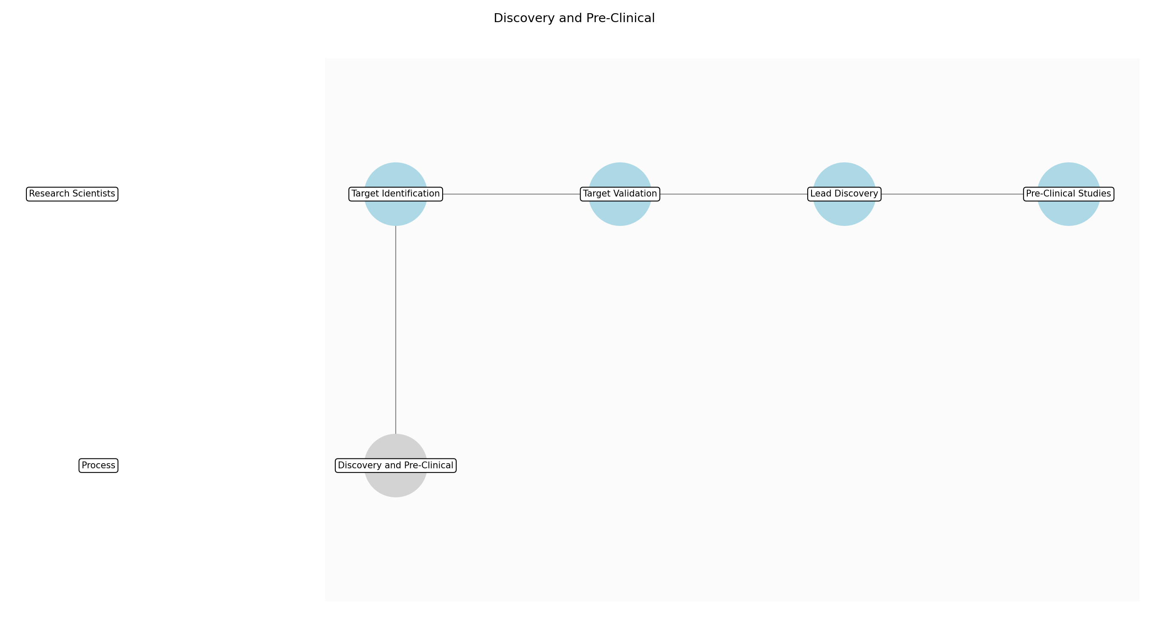

Discovery and Pre-Clinical – Target Identification
Description:
- The initial phase involves identifying potential drug targets based on scientific literature, disease understanding, and technological advancements. Research scientists analyze disease pathways, genetic data, and protein structures to pinpoint molecules that play a critical role in disease progression. This step requires collaboration across multiple scientific disciplines to ensure a comprehensive understanding of the target's relevance and potential for therapeutic intervention.
Responsible Party:
- Research Scientists
Inputs:
- New scientific findings
- Unmet medical need
- Disease pathways
- Genetic data
- Protein structures
Outputs:
- Identified drug target
Estimated Duration:
- 3-6 months
Dependencies:
Success Criteria:
- Identification of a relevant drug target with a clear role in disease progression
Purpose:
- To identify a specific biological target for therapeutic intervention.
Scope:
- Analysis of scientific data and literature to identify potential drug targets.
Process Owner:
- VP, Research
Triggers:
- New scientific findings
- Unmet medical need
End Conditions:
- Selection of a drug target for further validation
Step Risks and Controls:
- Risk: Selection of an irrelevant or non-druggable target
- Control: Thorough target validation and assessment of druggability
Governance Requirements:
- Compliance with ethical guidelines for scientific research
Change Management:
- Change Request Process: Changes to the target identification process require review and approval by the VP, Research.
- Versioning Rules: Document versioning.
Continuous Improvement:
- Review Frequency: Annually
Improvement Inputs:
- Pre-clinical study results
- Literature review

Discovery and Pre-Clinical – Target Validation
Description:
- Once a potential drug target is identified, it undergoes rigorous validation to confirm its role in the disease and its suitability for therapeutic intervention. This involves conducting in vitro and in vivo experiments to assess the target's function, expression, and impact on disease-related phenotypes. Successful validation provides confidence in the target's relevance and increases the likelihood of developing effective therapies.
Responsible Party:
- Research Scientists
Inputs:
- Identified drug target
Outputs:
- Validated drug target
Estimated Duration:
- 6-12 months
Dependencies:
- Target Identification
Success Criteria:
- Confirmation of the target's role in disease progression through in vitro and in vivo experiments
Purpose:
- To confirm the relevance and suitability of the identified drug target for therapeutic intervention.
Scope:
- In vitro and in vivo experiments to validate the target's function and expression.
Process Owner:
- VP, Research
Triggers:
- Identification of a potential drug target
End Conditions:
- Validation of the drug target's role in disease progression
Step Risks and Controls:
- Risk: Failure to validate the target's role in disease
- Control: Employ multiple validation methods and orthogonal approaches
Governance Requirements:
- Compliance with GLP (Good Laboratory Practice)
Change Management:
- Change Request Process: Changes to the target validation process require review and approval by the VP, Research.
- Versioning Rules: Document versioning.
Continuous Improvement:
- Review Frequency: Annually
Improvement Inputs:
- Pre-clinical study results
- Literature review

Discovery and Pre-Clinical – Lead Discovery
Description:
- With a validated drug target in hand, the next step is to identify lead compounds that can modulate the target's activity. This involves screening large libraries of chemical compounds using high-throughput screening (HTS) assays or employing structure-based drug design techniques. Promising lead compounds are then optimized to improve their potency, selectivity, and pharmacokinetic properties.
Responsible Party:
- Research Scientists
Inputs:
- Validated drug target
Outputs:
- Lead compound
Estimated Duration:
- 6-12 months
Dependencies:
- Target Validation
Success Criteria:
- Identification of a lead compound with favorable potency, selectivity, and pharmacokinetic properties
Purpose:
- To identify chemical compounds that can modulate the activity of the validated drug target.
Scope:
- Screening of chemical libraries and optimization of lead compounds.
Process Owner:
- VP, Research
Triggers:
- Validation of the drug target
End Conditions:
- Identification of a lead compound for further development
Step Risks and Controls:
- Risk: Identification of a lead compound with poor drug-like properties
- Control: Employ rigorous screening and optimization strategies
Governance Requirements:
- Compliance with ethical guidelines for chemical compound handling
Change Management:
- Change Request Process: Changes to the lead discovery process require review and approval by the VP, Research.
- Versioning Rules: Document versioning.
Continuous Improvement:
- Review Frequency: Annually
Improvement Inputs:
- Pre-clinical study results
- Literature review

Discovery and Pre-Clinical – Pre-Clinical Studies
Description:
- The final phase involves conducting pre-clinical studies to evaluate the safety and efficacy of the lead compound in relevant animal models. These studies assess the compound's pharmacokinetic and pharmacodynamic properties, as well as its potential toxicity. Successful pre-clinical studies provide critical data to support the advancement of the lead compound into clinical development.
Responsible Party:
- Research Scientists
Inputs:
- Lead compound
Outputs:
- Pre-clinical data
Estimated Duration:
- 6-12 months
Dependencies:
- Lead Discovery
Success Criteria:
- Demonstration of safety and efficacy in relevant animal models
Purpose:
- To evaluate the safety and efficacy of the lead compound in relevant animal models.
Scope:
- In vivo studies to assess the compound's pharmacokinetic, pharmacodynamic, and toxicity properties.
Process Owner:
- VP, Research
Triggers:
- Identification of a lead compound
End Conditions:
- Completion of pre-clinical studies with favorable safety and efficacy data
Step Risks and Controls:
- Risk: Pre-clinical toxicity
- Control: Thorough pre-clinical safety testing
- Risk: Lack of efficacy in animal models
- Control: Use of relevant and predictive animal models
Governance Requirements:
- Compliance with GLP (Good Laboratory Practice)
- Adherence to animal welfare regulations
Change Management:
- Change Request Process: Changes to the pre-clinical study protocols require review and approval by the VP, Research and the Institutional Animal Care and Use Committee (IACUC).
- Versioning Rules: Document versioning.
Continuous Improvement:
- Review Frequency: Annually
Improvement Inputs:
- Pre-clinical study results
- Literature review

3.2 Clinical Development
Description:
- Phase 1, 2, and 3 clinical trials
Responsible Parties:
- Clinical Development Team
Inputs:
- Lead compound
- Pre-clinical data
Outputs:
- Clinical trial data
- Clinical study reports
Success Criteria:
- Demonstration of safety and efficacy in clinical trials.

Required Sub Process(es) for the Step "Clinical Development"
The following details the subprocess flows for the step "Clinical Development".
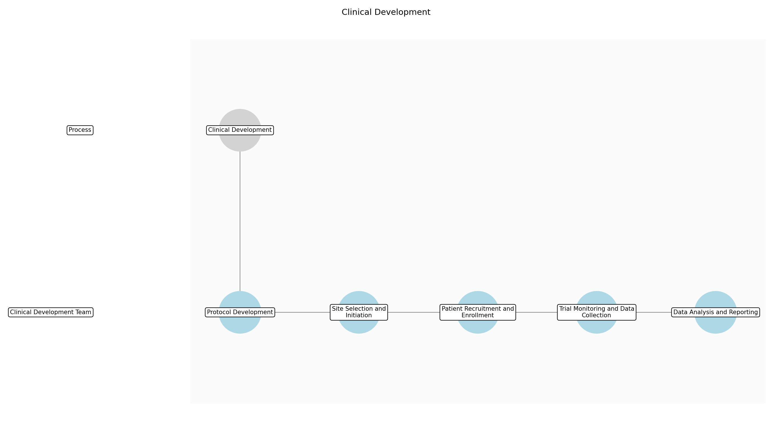

Clinical Development – Protocol Development
Description:
- The clinical trial protocol is a detailed document that outlines the objectives, design, methodology, statistical considerations, and organization of a clinical trial. It ensures the safety and well-being of trial participants and the integrity of the data collected. This substep involves defining the study population, treatment regimen, data collection methods, and endpoints. The protocol must adhere to ethical guidelines and regulatory requirements.
Responsible Party:
- Clinical Development Team
Inputs:
- Lead compound
- Pre-clinical data
- Regulatory guidelines
Outputs:
- Clinical trial protocol
- Informed consent form
Estimated Duration:
- 2-4 months
Dependencies:
Success Criteria:
- Protocol approval by ethics committee
- Regulatory acceptance of protocol
Purpose:
- To create a comprehensive plan for conducting the clinical trial.
Scope:
- Development of the clinical trial protocol and related documents.
Process Owner:
- VP, Clinical Development
Triggers:
- Selection of a lead compound for clinical development
End Conditions:
- Finalized and approved clinical trial protocol
Step Risks and Controls:
- Risk: Inadequate protocol design
- Control: Expert review and consultation
- Risk: Ethical concerns
- Control: Ethics committee review and approval
Governance Requirements:
- Compliance with GCP (Good Clinical Practice)
- Adherence to ethical guidelines
Change Management:
- Change Request Process: The clinical trial protocol amendment process is a formal procedure for managing changes to the clinical trial protocol. This process ensures that any modifications to the protocol are thoroughly reviewed, scientifically justified, and ethically sound. It involves a multidisciplinary team that assesses the potential impact of the changes on patient safety, data integrity, and the overall objectives of the clinical trial. All amendments must be approved by the relevant regulatory authorities and ethics committees before implementation.
- Versioning Rules: Protocol versioning.
Continuous Improvement:
- Review Frequency: Ongoing
Improvement Inputs:
- Feedback from investigators
- Regulatory feedback

Clinical Development – Site Selection and Initiation
Description:
- Selecting appropriate clinical trial sites is crucial for successful trial execution. This substep involves identifying and evaluating potential sites based on their patient population, infrastructure, and experience. Once sites are selected, initiation activities include training site personnel, obtaining necessary approvals, and ensuring the site is ready to enroll patients. A thorough site initiation process ensures that the trial is conducted according to the protocol and regulatory requirements.
Responsible Party:
- Clinical Development Team
Inputs:
- Clinical trial protocol
- Site selection criteria
Outputs:
- List of selected clinical trial sites
- Site initiation reports
Estimated Duration:
- 1-3 months
Dependencies:
- Protocol Development
Success Criteria:
- Selection of qualified clinical trial sites
- Successful site initiation
Purpose:
- To identify and prepare clinical trial sites for patient enrollment.
Scope:
- Selection and initiation of clinical trial sites.
Process Owner:
- VP, Clinical Development
Triggers:
- Finalized clinical trial protocol
End Conditions:
- All selected sites are initiated and ready for patient enrollment
Step Risks and Controls:
- Risk: Inadequate site infrastructure
- Control: Thorough site evaluation and qualification
- Risk: Lack of trained personnel
- Control: Comprehensive site training program
Governance Requirements:
- Compliance with GCP (Good Clinical Practice)
- Site audits and inspections
Change Management:
- Change Request Process: The site management change control process is a formal procedure for managing changes related to clinical trial sites. This process ensures that any modifications to site personnel, equipment, or procedures are thoroughly reviewed, scientifically justified, and ethically sound. It involves a multidisciplinary team that assesses the potential impact of the changes on patient safety, data integrity, and the overall objectives of the clinical trial. All changes must be approved by the relevant regulatory authorities and ethics committees before implementation.
- Versioning Rules: Site management plan versioning.
Continuous Improvement:
- Review Frequency: Ongoing
Improvement Inputs:
- Site performance data
- Investigator feedback

Clinical Development – Patient Recruitment and Enrollment
Description:
- Recruiting and enrolling patients into a clinical trial is a critical step that can significantly impact the trial's success. This substep involves developing and implementing a recruitment strategy to attract eligible patients. Enrollment activities include screening patients, obtaining informed consent, and ensuring that patients meet the inclusion/exclusion criteria. Effective patient recruitment and enrollment are essential for achieving the trial's objectives.
Responsible Party:
- Clinical Development Team
Inputs:
- Clinical trial protocol
- Recruitment plan
- Informed consent form
Outputs:
- Enrolled patients
- Patient enrollment data
Estimated Duration:
- Variable (dependent on patient population)
Dependencies:
- Site Selection and Initiation
Success Criteria:
- Achievement of target enrollment
- Compliance with inclusion/exclusion criteria
Purpose:
- To enroll eligible patients into the clinical trial.
Scope:
- Recruitment and enrollment of patients into the clinical trial.
Process Owner:
- VP, Clinical Development
Triggers:
- Site initiation completion
End Conditions:
- Target enrollment achieved
Step Risks and Controls:
- Risk: Slow patient recruitment
- Control: Comprehensive recruitment strategy
- Risk: Enrollment of ineligible patients
- Control: Rigorous screening process
Governance Requirements:
- Compliance with GCP (Good Clinical Practice)
- Patient privacy and data protection
Change Management:
- Change Request Process: The patient recruitment change control process is a formal procedure for managing changes to the patient recruitment strategy. This process ensures that any modifications to the recruitment plan are thoroughly reviewed, scientifically justified, and ethically sound. It involves a multidisciplinary team that assesses the potential impact of the changes on patient enrollment, data integrity, and the overall objectives of the clinical trial. All changes must be approved by the relevant regulatory authorities and ethics committees before implementation.
- Versioning Rules: Recruitment plan versioning.
Continuous Improvement:
- Review Frequency: Ongoing
Improvement Inputs:
- Recruitment data
- Patient feedback

Clinical Development – Trial Monitoring and Data Collection
Description:
- Monitoring the clinical trial and collecting data are essential for ensuring data integrity and patient safety. This substep involves regular monitoring of trial sites, data collection, and data validation. Monitoring activities include reviewing patient records, verifying data accuracy, and ensuring compliance with the protocol. Accurate and reliable data collection is crucial for generating meaningful results.
Responsible Party:
- Clinical Development Team
Inputs:
- Clinical trial protocol
- Patient data
- Monitoring plan
Outputs:
- Validated clinical trial data
- Monitoring reports
Estimated Duration:
- Ongoing throughout the trial
Dependencies:
- Patient Recruitment and Enrollment
Success Criteria:
- Accurate and complete data collection
- Compliance with monitoring plan
Purpose:
- To ensure data integrity and patient safety throughout the trial.
Scope:
- Monitoring of clinical trial sites and data collection.
Process Owner:
- VP, Clinical Development
Triggers:
- Patient enrollment
End Conditions:
- Completion of data collection
Step Risks and Controls:
- Risk: Data errors
- Control: Data validation procedures
- Risk: Protocol deviations
- Control: Regular site monitoring
Governance Requirements:
- Compliance with GCP (Good Clinical Practice)
- Data security and privacy
Change Management:
- Change Request Process: The data management change control process is a formal procedure for managing changes to data collection and handling procedures. This process ensures that any modifications to the data management plan are thoroughly reviewed, scientifically justified, and ethically sound. It involves a multidisciplinary team that assesses the potential impact of the changes on data integrity, statistical analysis, and the overall objectives of the clinical trial. All changes must be approved by the relevant regulatory authorities and ethics committees before implementation.
- Versioning Rules: Data management plan versioning.
Continuous Improvement:
- Review Frequency: Ongoing
Improvement Inputs:
- Data quality metrics
- Monitoring reports

Clinical Development – Data Analysis and Reporting
Description:
- Analyzing the collected data and generating reports are crucial for determining the safety and efficacy of the drug candidate. This substep involves statistical analysis of the data, interpretation of results, and preparation of clinical study reports. The reports must adhere to regulatory requirements and provide a comprehensive overview of the trial's findings. Accurate and transparent reporting is essential for regulatory submissions and clinical practice.
Responsible Party:
- Clinical Development Team
Inputs:
- Validated clinical trial data
- Statistical analysis plan
Outputs:
- Clinical study reports
- Statistical analysis reports
Estimated Duration:
- 4-8 months
Dependencies:
- Trial Monitoring and Data Collection
Success Criteria:
- Accurate statistical analysis
- Comprehensive clinical study reports
Purpose:
- To analyze the clinical trial data and generate reports on the safety and efficacy of the drug candidate.
Scope:
- Statistical analysis and reporting of clinical trial data.
Process Owner:
- VP, Clinical Development
Triggers:
- Completion of data collection
End Conditions:
- Finalized clinical study reports
Step Risks and Controls:
- Risk: Statistical errors
- Control: Expert statistical review
- Risk: Biased interpretation of results
- Control: Independent data review
Governance Requirements:
- Compliance with GCP (Good Clinical Practice)
- Statistical analysis plan adherence
Change Management:
- Change Request Process: The statistical analysis change control process is a formal procedure for managing changes to the statistical analysis plan. This process ensures that any modifications to the analysis plan are thoroughly reviewed, scientifically justified, and ethically sound. It involves a multidisciplinary team that assesses the potential impact of the changes on data interpretation, statistical significance, and the overall objectives of the clinical trial. All changes must be approved by the relevant regulatory authorities and ethics committees before implementation.
- Versioning Rules: Statistical analysis plan versioning.
Continuous Improvement:
- Review Frequency: Annually
Improvement Inputs:
- Statistical analysis reports
- Regulatory feedback

3.3 Regulatory Approval
Description:
- Submission and review of regulatory filings
Responsible Parties:
- Regulatory Affairs
Inputs:
- Clinical trial data
- Clinical study reports
Outputs:
- Regulatory approval
Success Criteria:
- Obtaining regulatory approval from relevant authorities (e.g., FDA, EMA).

Required Sub Process(es) for the Step "Regulatory Approval"
The following details the subprocess flows for the step "Regulatory Approval".
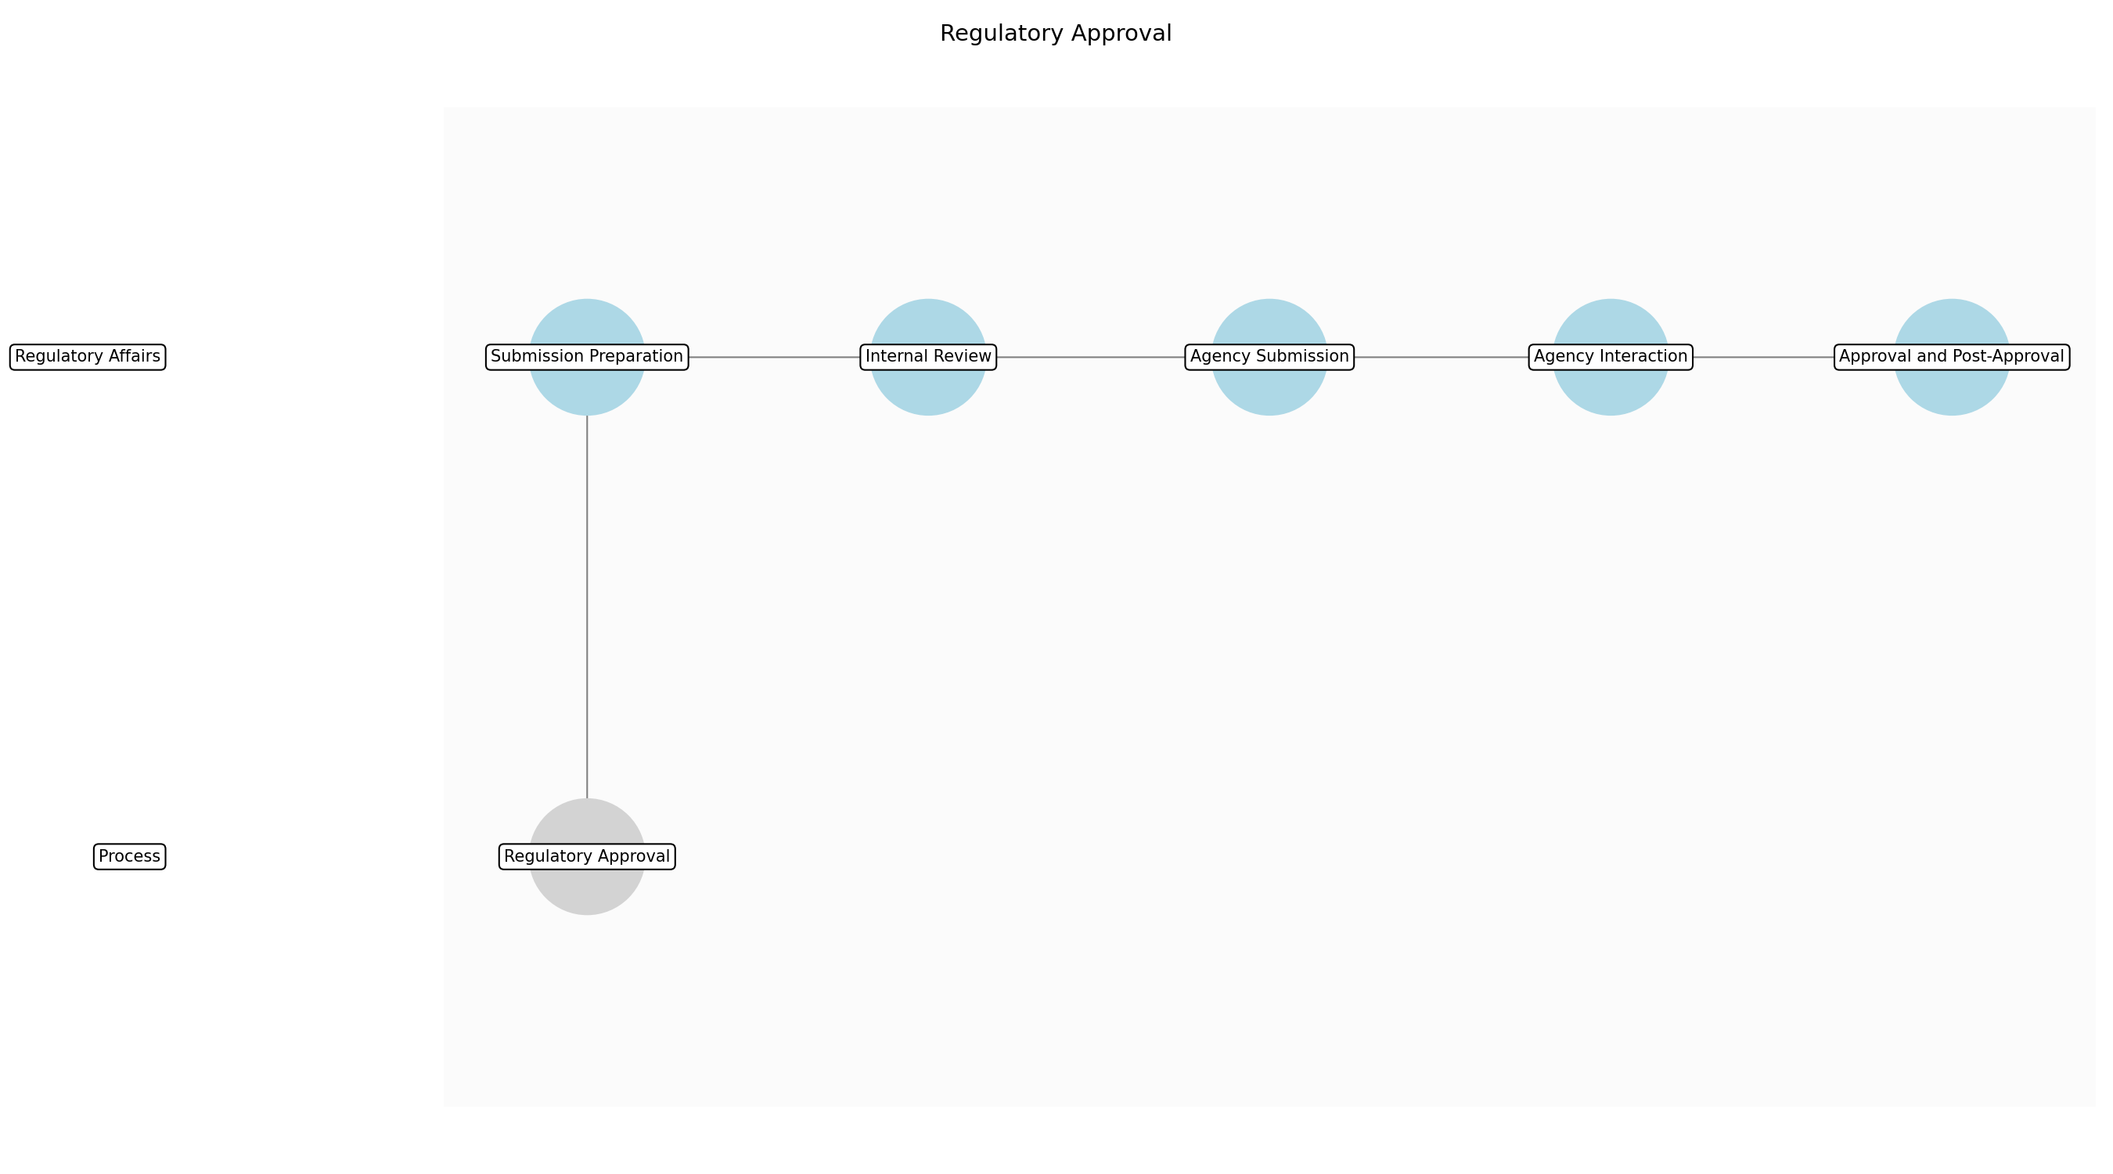

Regulatory Approval – Submission Preparation
Description:
- The Regulatory Submission Preparation sub-step involves gathering, organizing, and formatting all necessary documentation and data required for submission to regulatory agencies. This includes clinical trial data, manufacturing information, pre-clinical study reports, and any other relevant information. The goal is to ensure that the submission is complete, accurate, and compliant with all applicable regulatory guidelines and requirements, facilitating a smooth and efficient review process.
Responsible Party:
- Regulatory Affairs
Inputs:
- Clinical trial data
- Clinical study reports
- Manufacturing information
- Pre-clinical study reports
Outputs:
- Draft regulatory submission
Estimated Duration:
- 2-4 months
Dependencies:
Success Criteria:
- Complete and accurate draft submission
- Compliance with regulatory guidelines
Purpose:
- To compile all necessary information for regulatory review.
Scope:
- Preparation of the initial regulatory submission package.
Process Owner:
- VP, Regulatory Affairs
Triggers:
- Completion of clinical trials
- Availability of all required data
End Conditions:
- Draft regulatory submission is complete and ready for review
Step Risks and Controls:
- Risk: Incomplete submission
- Control: Checklists and thorough review processes.
- Risk: Data errors
- Control: Data validation and verification procedures.
Governance Requirements:
- Compliance with regulatory requirements (e.g., FDA, EMA)
Change Management:
- Change Request Process: Changes to the submission preparation process are managed through a formal change control process, ensuring that all changes are documented, reviewed, and approved before implementation.
- Versioning Rules: Document versioning.
Continuous Improvement:
- Review Frequency: Annually
Improvement Inputs:
- Feedback from regulatory agencies
- Internal audit results

Regulatory Approval – Internal Review
Description:
- The Internal Review sub-step involves a thorough review of the draft regulatory submission by internal stakeholders, including medical, scientific, and regulatory experts. This review ensures that the submission is scientifically sound, medically accurate, and compliant with all applicable regulatory requirements. The goal is to identify and address any potential issues or gaps in the submission before it is formally submitted to regulatory agencies.
Responsible Party:
- Regulatory Affairs
Inputs:
- Draft regulatory submission
Outputs:
- Revised regulatory submission
Estimated Duration:
- 1-2 months
Dependencies:
- Submission Preparation
Success Criteria:
- Internal stakeholders approve the submission
- All identified issues are addressed
Purpose:
- To ensure the quality and accuracy of the submission.
Scope:
- Internal review and approval of the regulatory submission.
Process Owner:
- VP, Regulatory Affairs
Triggers:
- Completion of draft regulatory submission
End Conditions:
- Internal stakeholders approve the submission
Step Risks and Controls:
- Risk: Errors in submission
- Control: Multi-disciplinary review team.
- Risk: Oversight of critical data
- Control: Checklists and verification processes.
Governance Requirements:
- Compliance with regulatory requirements (e.g., FDA, EMA)
Change Management:
- Change Request Process: Changes identified during the internal review are managed through a formal change control process, ensuring that all changes are documented, reviewed, and approved before implementation.
- Versioning Rules: Document versioning.
Continuous Improvement:
- Review Frequency: Annually
Improvement Inputs:
- Feedback from internal stakeholders
- Root cause analysis of identified issues

Regulatory Approval – Agency Submission
Description:
- The Agency Submission sub-step involves the formal submission of the regulatory filing to the appropriate regulatory agency (e.g., FDA, EMA). This includes submitting the required documentation and data in the specified format and through the designated submission portal. The goal is to ensure that the submission is received and accepted by the regulatory agency, initiating the review process.
Responsible Party:
- Regulatory Affairs
Inputs:
- Revised regulatory submission
Outputs:
- Submission confirmation
Estimated Duration:
- 1 week
Dependencies:
- Internal Review
Success Criteria:
- Submission is successfully received by the regulatory agency
- Confirmation of receipt is obtained
Purpose:
- To formally submit the application to the regulatory agency.
Scope:
- Submission of the regulatory filing to the agency.
Process Owner:
- VP, Regulatory Affairs
Triggers:
- Approval from internal stakeholders
End Conditions:
- Submission confirmation is received from the regulatory agency
Step Risks and Controls:
- Risk: Submission errors
- Control: Validation of submission format and content.
- Risk: System failures
- Control: Backup submission methods and technical support.
Governance Requirements:
- Compliance with regulatory requirements (e.g., FDA, EMA)
Change Management:
- Change Request Process: Any changes required after submission are managed through a formal amendment process, ensuring that all changes are documented, reviewed, and approved before implementation.
- Versioning Rules: Submission versioning.
Continuous Improvement:
- Review Frequency: Annually
Improvement Inputs:
- Feedback from regulatory agencies
- Analysis of submission errors

Regulatory Approval – Agency Interaction
Description:
- The Agency Interaction sub-step involves ongoing communication and interaction with the regulatory agency during the review process. This includes responding to requests for additional information, clarifying any questions or concerns, and participating in meetings or teleconferences with agency reviewers. The goal is to facilitate a timely and positive review outcome by providing the agency with all necessary information and addressing any issues that may arise.
Responsible Party:
- Regulatory Affairs
Inputs:
- Submission confirmation
- Agency requests for information
Outputs:
- Responses to agency requests
- Meeting minutes
Estimated Duration:
- 6-18 months
Dependencies:
- Agency Submission
Success Criteria:
- Timely and accurate responses to agency requests
- Positive and productive interactions with agency reviewers
Purpose:
- To address agency questions and facilitate the review process.
Scope:
- Communication and interaction with the regulatory agency.
Process Owner:
- VP, Regulatory Affairs
Triggers:
- Receipt of agency requests for information
End Conditions:
- All agency requests are addressed
- Review process is completed
Step Risks and Controls:
- Risk: Delays in response
- Control: Dedicated regulatory affairs team and tracking system.
- Risk: Misinterpretation of data
- Control: Clear and concise communication with agency reviewers.
Governance Requirements:
- Compliance with regulatory requirements (e.g., FDA, EMA)
Change Management:
- Change Request Process: Changes to the submission based on agency feedback are managed through a formal amendment process, ensuring that all changes are documented, reviewed, and approved before implementation.
- Versioning Rules: Submission versioning.
Continuous Improvement:
- Review Frequency: Annually
Improvement Inputs:
- Feedback from regulatory agencies
- Analysis of agency requests and responses

Regulatory Approval – Approval and Post-Approval
Description:
- The Approval and Post-Approval sub-step involves receiving the regulatory approval letter from the agency and ensuring compliance with any post-approval requirements. This includes implementing any required post-market surveillance studies, submitting periodic safety reports, and complying with any other conditions of approval. The goal is to ensure that the drug product remains safe and effective throughout its lifecycle and that all regulatory requirements are met.
Responsible Party:
- Regulatory Affairs
Inputs:
- Agency approval letter
Outputs:
- Post-approval compliance reports
Estimated Duration:
- Ongoing
Dependencies:
- Agency Interaction
Success Criteria:
- Receipt of regulatory approval letter
- Compliance with all post-approval requirements
Purpose:
- To obtain final approval and maintain compliance.
Scope:
- Post-approval activities and compliance.
Process Owner:
- VP, Regulatory Affairs
Triggers:
- Receipt of agency approval letter
End Conditions:
- All post-approval requirements are met
Step Risks and Controls:
- Risk: Non-compliance with post-approval requirements
- Control: Dedicated regulatory affairs team and tracking system.
- Risk: Safety issues
- Control: Post-market surveillance and adverse event reporting.
Governance Requirements:
- Compliance with regulatory requirements (e.g., FDA, EMA)
Change Management:
- Change Request Process: Changes to post-approval activities are managed through a formal change control process, ensuring that all changes are documented, reviewed, and approved before implementation.
- Versioning Rules: Submission versioning.
Continuous Improvement:
- Review Frequency: Annually
Improvement Inputs:
- Feedback from regulatory agencies
- Analysis of post-market surveillance data

3.4 Manufacturing
Description:
- Scale-up and commercial manufacturing
Responsible Parties:
- Manufacturing Team
Inputs:
- Regulatory approval
Outputs:
- Drug substance
- Drug product
Success Criteria:
- Successful scale-up and commercial manufacturing of the drug product.

Required Sub Process(es) for the Step "Manufacturing"
The following details the subprocess flows for the step "Manufacturing".
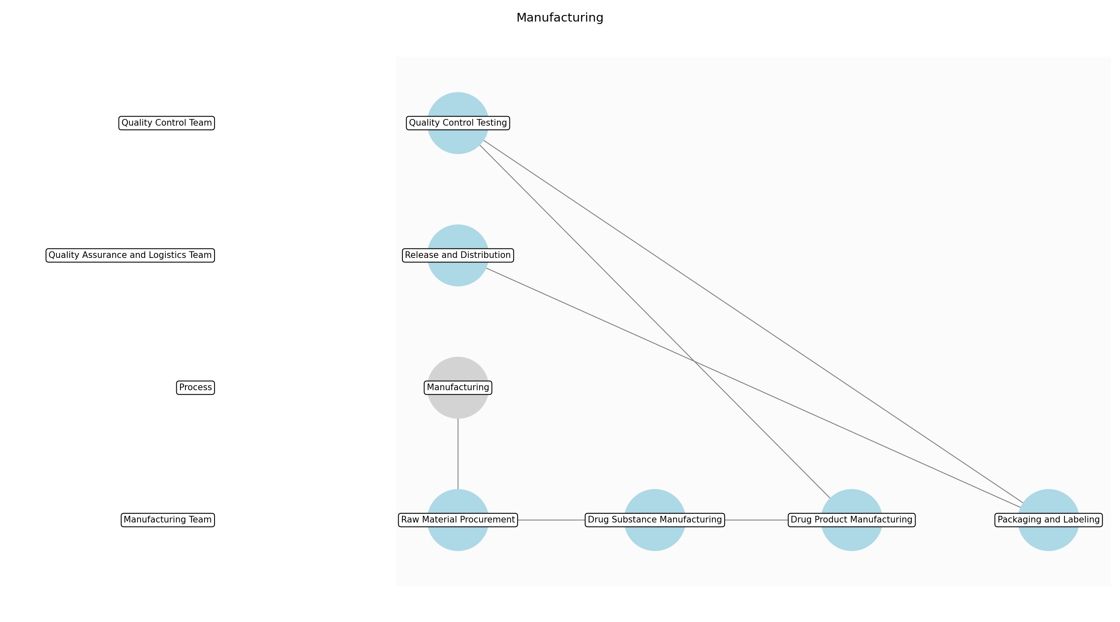

Manufacturing – Raw Material Procurement
Description:
- The initial sub-step involves the procurement of all necessary raw materials, including active pharmaceutical ingredients (APIs), excipients, and packaging components. This includes vendor selection, quality assessment of materials, and ensuring compliance with regulatory standards. Robust supply chain management is critical to mitigate risks associated with material availability and quality.
Responsible Party:
- Manufacturing Team
Inputs:
- Regulatory approval
- Bill of Materials (BOM)
- Quality specifications
Outputs:
- Raw materials
- Vendor documentation
- Material certificates of analysis
Estimated Duration:
- 2-4 weeks
Dependencies:
Success Criteria:
- Availability of all required raw materials
- Materials meet quality specifications
- Vendor compliance with regulatory standards
Purpose:
- To ensure the availability of high-quality raw materials for drug product manufacturing.
Scope:
- Sourcing, qualification, and procurement of raw materials.
Process Owner:
- Supply Chain Manager
Triggers:
- Regulatory approval
- Production schedule
End Conditions:
- Raw materials received and quarantined
Step Risks and Controls:
- Risk: Supply chain disruptions
- Control: Multiple qualified vendors, safety stock levels.
- Risk: Material quality defects
- Control: Vendor audits, material testing, and certificates of analysis.
Governance Requirements:
- Compliance with GMP
- Vendor qualification audits
Change Management:
- Change Request Process: Changes to raw material vendors or specifications require a formal change control process, including impact assessment and approval by quality assurance.
- Versioning Rules: Raw material specifications and vendor documentation are version-controlled.
Continuous Improvement:
- Review Frequency: Annually
Improvement Inputs:
- Vendor performance data
- Material quality data
- Audit findings

Manufacturing – Drug Substance Manufacturing
Description:
- This sub-step involves the actual manufacturing of the drug substance (API) according to validated manufacturing processes. This includes weighing, mixing, reaction, purification, and drying of the drug substance. In-process controls and monitoring are implemented to ensure product quality and consistency. Equipment validation and calibration are also critical components.
Responsible Party:
- Manufacturing Team
Inputs:
- Raw materials
- Validated manufacturing process
- Equipment validation reports
Outputs:
- Drug substance (API)
- In-process control data
- Batch records
Estimated Duration:
- 1-6 months
Dependencies:
- Raw Material Procurement
Success Criteria:
- Drug substance meets quality specifications
- Manufacturing process adheres to validated parameters
- Complete and accurate batch records
Purpose:
- To produce the drug substance (API) at the required quality and yield.
Scope:
- Manufacturing of the drug substance from raw materials.
Process Owner:
- Production Manager
Triggers:
- Availability of raw materials
- Production schedule
End Conditions:
- Drug substance released by quality control
Step Risks and Controls:
- Risk: Process deviations
- Control: Validated manufacturing process, trained personnel, and deviation management system.
- Risk: Equipment malfunction
- Control: Preventive maintenance, equipment validation, and backup equipment.
Governance Requirements:
- Compliance with GMP
- Batch record review
Change Management:
- Change Request Process: Changes to the manufacturing process or equipment require a formal change control process, including impact assessment and approval by quality assurance.
- Versioning Rules: Manufacturing process documents and equipment validation reports are version-controlled.
Continuous Improvement:
- Review Frequency: Ongoing
Improvement Inputs:
- Manufacturing yield data
- In-process control data
- Deviation reports

Manufacturing – Drug Product Manufacturing
Description:
- The drug product manufacturing sub-step involves formulating the drug substance into the final drug product dosage form (e.g., tablets, capsules, injections). This includes blending, granulation, tableting, encapsulation, filling, and packaging. Stringent quality control measures are implemented throughout the process to ensure product quality, safety, and efficacy. Environmental monitoring and cleaning validation are also essential.
Responsible Party:
- Manufacturing Team
Inputs:
- Drug substance (API)
- Excipients
- Packaging components
- Validated manufacturing process
Outputs:
- Drug product
- Finished product specifications
- Packaging records
Estimated Duration:
- 2-8 weeks
Dependencies:
- Drug Substance Manufacturing
Success Criteria:
- Drug product meets quality specifications
- Manufacturing process adheres to validated parameters
- Packaging integrity and labeling accuracy
Purpose:
- To formulate the drug substance into the final drug product dosage form.
Scope:
- Formulation, filling, and packaging of the drug product.
Process Owner:
- Production Manager
Triggers:
- Availability of drug substance
- Production schedule
End Conditions:
- Drug product released by quality control
Step Risks and Controls:
- Risk: Cross-contamination
- Control: Dedicated equipment, cleaning validation, and environmental monitoring.
- Risk: Dosage form defects
- Control: In-process controls, equipment calibration, and trained personnel.
Governance Requirements:
- Compliance with GMP
- Batch record review
Change Management:
- Change Request Process: Changes to the manufacturing process, equipment, or packaging require a formal change control process, including impact assessment and approval by quality assurance.
- Versioning Rules: Manufacturing process documents, equipment validation reports, and packaging specifications are version-controlled.
Continuous Improvement:
- Review Frequency: Ongoing
Improvement Inputs:
- Manufacturing yield data
- In-process control data
- Deviation reports
- Customer complaints

Manufacturing – Quality Control Testing
Description:
- This sub-step involves rigorous quality control testing of both the drug substance and drug product to ensure compliance with established specifications. This includes analytical testing, microbiological testing, and stability testing. Testing is performed according to validated analytical methods, and results are reviewed and approved by quality control personnel. Reference standards and controls are used to ensure accuracy and reliability.
Responsible Party:
- Quality Control Team
Inputs:
- Drug substance (API)
- Drug product
- Validated analytical methods
- Reference standards
Outputs:
- Quality control test results
- Certificates of analysis
- Stability data
Estimated Duration:
- 1-4 weeks
Dependencies:
- Drug Substance Manufacturing
- Drug Product Manufacturing
Success Criteria:
- Drug substance and drug product meet quality specifications
- Analytical methods are validated and accurate
- Complete and accurate test records
Purpose:
- To ensure the drug substance and drug product meet established quality specifications.
Scope:
- Analytical and microbiological testing of drug substance and drug product.
Process Owner:
- Quality Control Manager
Triggers:
- Completion of manufacturing
- Stability testing schedule
End Conditions:
- Drug substance and drug product released by quality control
Step Risks and Controls:
- Risk: Testing errors
- Control: Validated analytical methods, trained personnel, and reference standards.
- Risk: Out-of-specification results
- Control: Investigation of OOS results, corrective actions, and retesting.
Governance Requirements:
- Compliance with GMP
- Analytical method validation
Change Management:
- Change Request Process: Changes to analytical methods or testing procedures require a formal change control process, including validation and approval by quality assurance.
- Versioning Rules: Analytical methods and testing procedures are version-controlled.
Continuous Improvement:
- Review Frequency: Annually
Improvement Inputs:
- Testing error rates
- OOS investigation reports
- Method validation data

Manufacturing – Packaging and Labeling
Description:
- This sub-step involves the packaging and labeling of the drug product according to regulatory requirements and marketing specifications. This includes primary packaging (e.g., blister packs, vials), secondary packaging (e.g., cartons), and labeling. Labeling accuracy and packaging integrity are critical to ensure product identification, safety, and compliance. Serialization and track-and-trace systems may be implemented to prevent counterfeiting.
Responsible Party:
- Manufacturing Team
Inputs:
- Drug product
- Packaging components
- Labels
- Packaging specifications
Outputs:
- Packaged and labeled drug product
- Packaging records
- Serialization data
Estimated Duration:
- 1-2 weeks
Dependencies:
- Quality Control Testing
Success Criteria:
- Packaging integrity and labeling accuracy
- Compliance with regulatory requirements
- Serialization and track-and-trace data accuracy
Purpose:
- To package and label the drug product for distribution and sale.
Scope:
- Packaging, labeling, and serialization of the drug product.
Process Owner:
- Packaging Supervisor
Triggers:
- Release of drug product by quality control
- Production schedule
End Conditions:
- Packaged and labeled drug product ready for shipment
Step Risks and Controls:
- Risk: Labeling errors
- Control: Automated labeling systems, barcode scanning, and label reconciliation.
- Risk: Packaging defects
- Control: Automated inspection systems, packaging material testing, and trained personnel.
Governance Requirements:
- Compliance with GMP
- Label control procedures
Change Management:
- Change Request Process: Changes to packaging materials, labels, or packaging processes require a formal change control process, including impact assessment and approval by quality assurance.
- Versioning Rules: Packaging specifications and label artwork are version-controlled.
Continuous Improvement:
- Review Frequency: Annually
Improvement Inputs:
- Packaging defect rates
- Labeling error rates
- Customer complaints

Manufacturing – Release and Distribution
Description:
- The final sub-step involves the release of the finished drug product by quality assurance and its subsequent distribution to commercial markets. This includes final product inspection, documentation review, and approval for shipment. Distribution is managed according to established procedures to maintain product integrity and prevent diversion. Temperature monitoring and cold chain management are critical for temperature-sensitive products.
Responsible Party:
- Quality Assurance and Logistics Team
Inputs:
- Packaged and labeled drug product
- Quality control test results
- Batch records
- Distribution procedures
Outputs:
- Released drug product
- Shipping records
- Temperature monitoring data
Estimated Duration:
- 1-2 weeks
Dependencies:
- Packaging and Labeling
Success Criteria:
- Drug product meets all release criteria
- Distribution is managed according to established procedures
- Product integrity is maintained during shipment
Purpose:
- To release the finished drug product for distribution and sale.
Scope:
- Final product inspection, release, and distribution to commercial markets.
Process Owner:
- Quality Assurance Manager and Logistics Manager
Triggers:
- Completion of packaging and labeling
- Customer orders
End Conditions:
- Drug product shipped to distribution centers
Step Risks and Controls:
- Risk: Product diversion
- Control: Secure distribution channels, track-and-trace systems, and inventory controls.
- Risk: Temperature excursions
- Control: Temperature-controlled transportation, temperature monitoring devices, and cold chain management procedures.
Governance Requirements:
- Compliance with GMP
- Distribution agreements
Change Management:
- Change Request Process: Changes to distribution procedures or transportation methods require a formal change control process, including impact assessment and approval by quality assurance.
- Versioning Rules: Distribution procedures and transportation validation reports are version-controlled.
Continuous Improvement:
- Review Frequency: Quarterly
Improvement Inputs:
- Distribution deviation reports
- Temperature excursion data
- Customer complaints

3.5 Commercialization
Description:
- Market launch and sales
Responsible Parties:
- Commercial Team
Inputs:
- Drug product
Outputs:
- Sales revenue
- Market share
Success Criteria:
- Successful market launch and achievement of sales targets.

Required Sub Process(es) for the Step "Commercialization"
The following details the subprocess flows for the step "Commercialization".
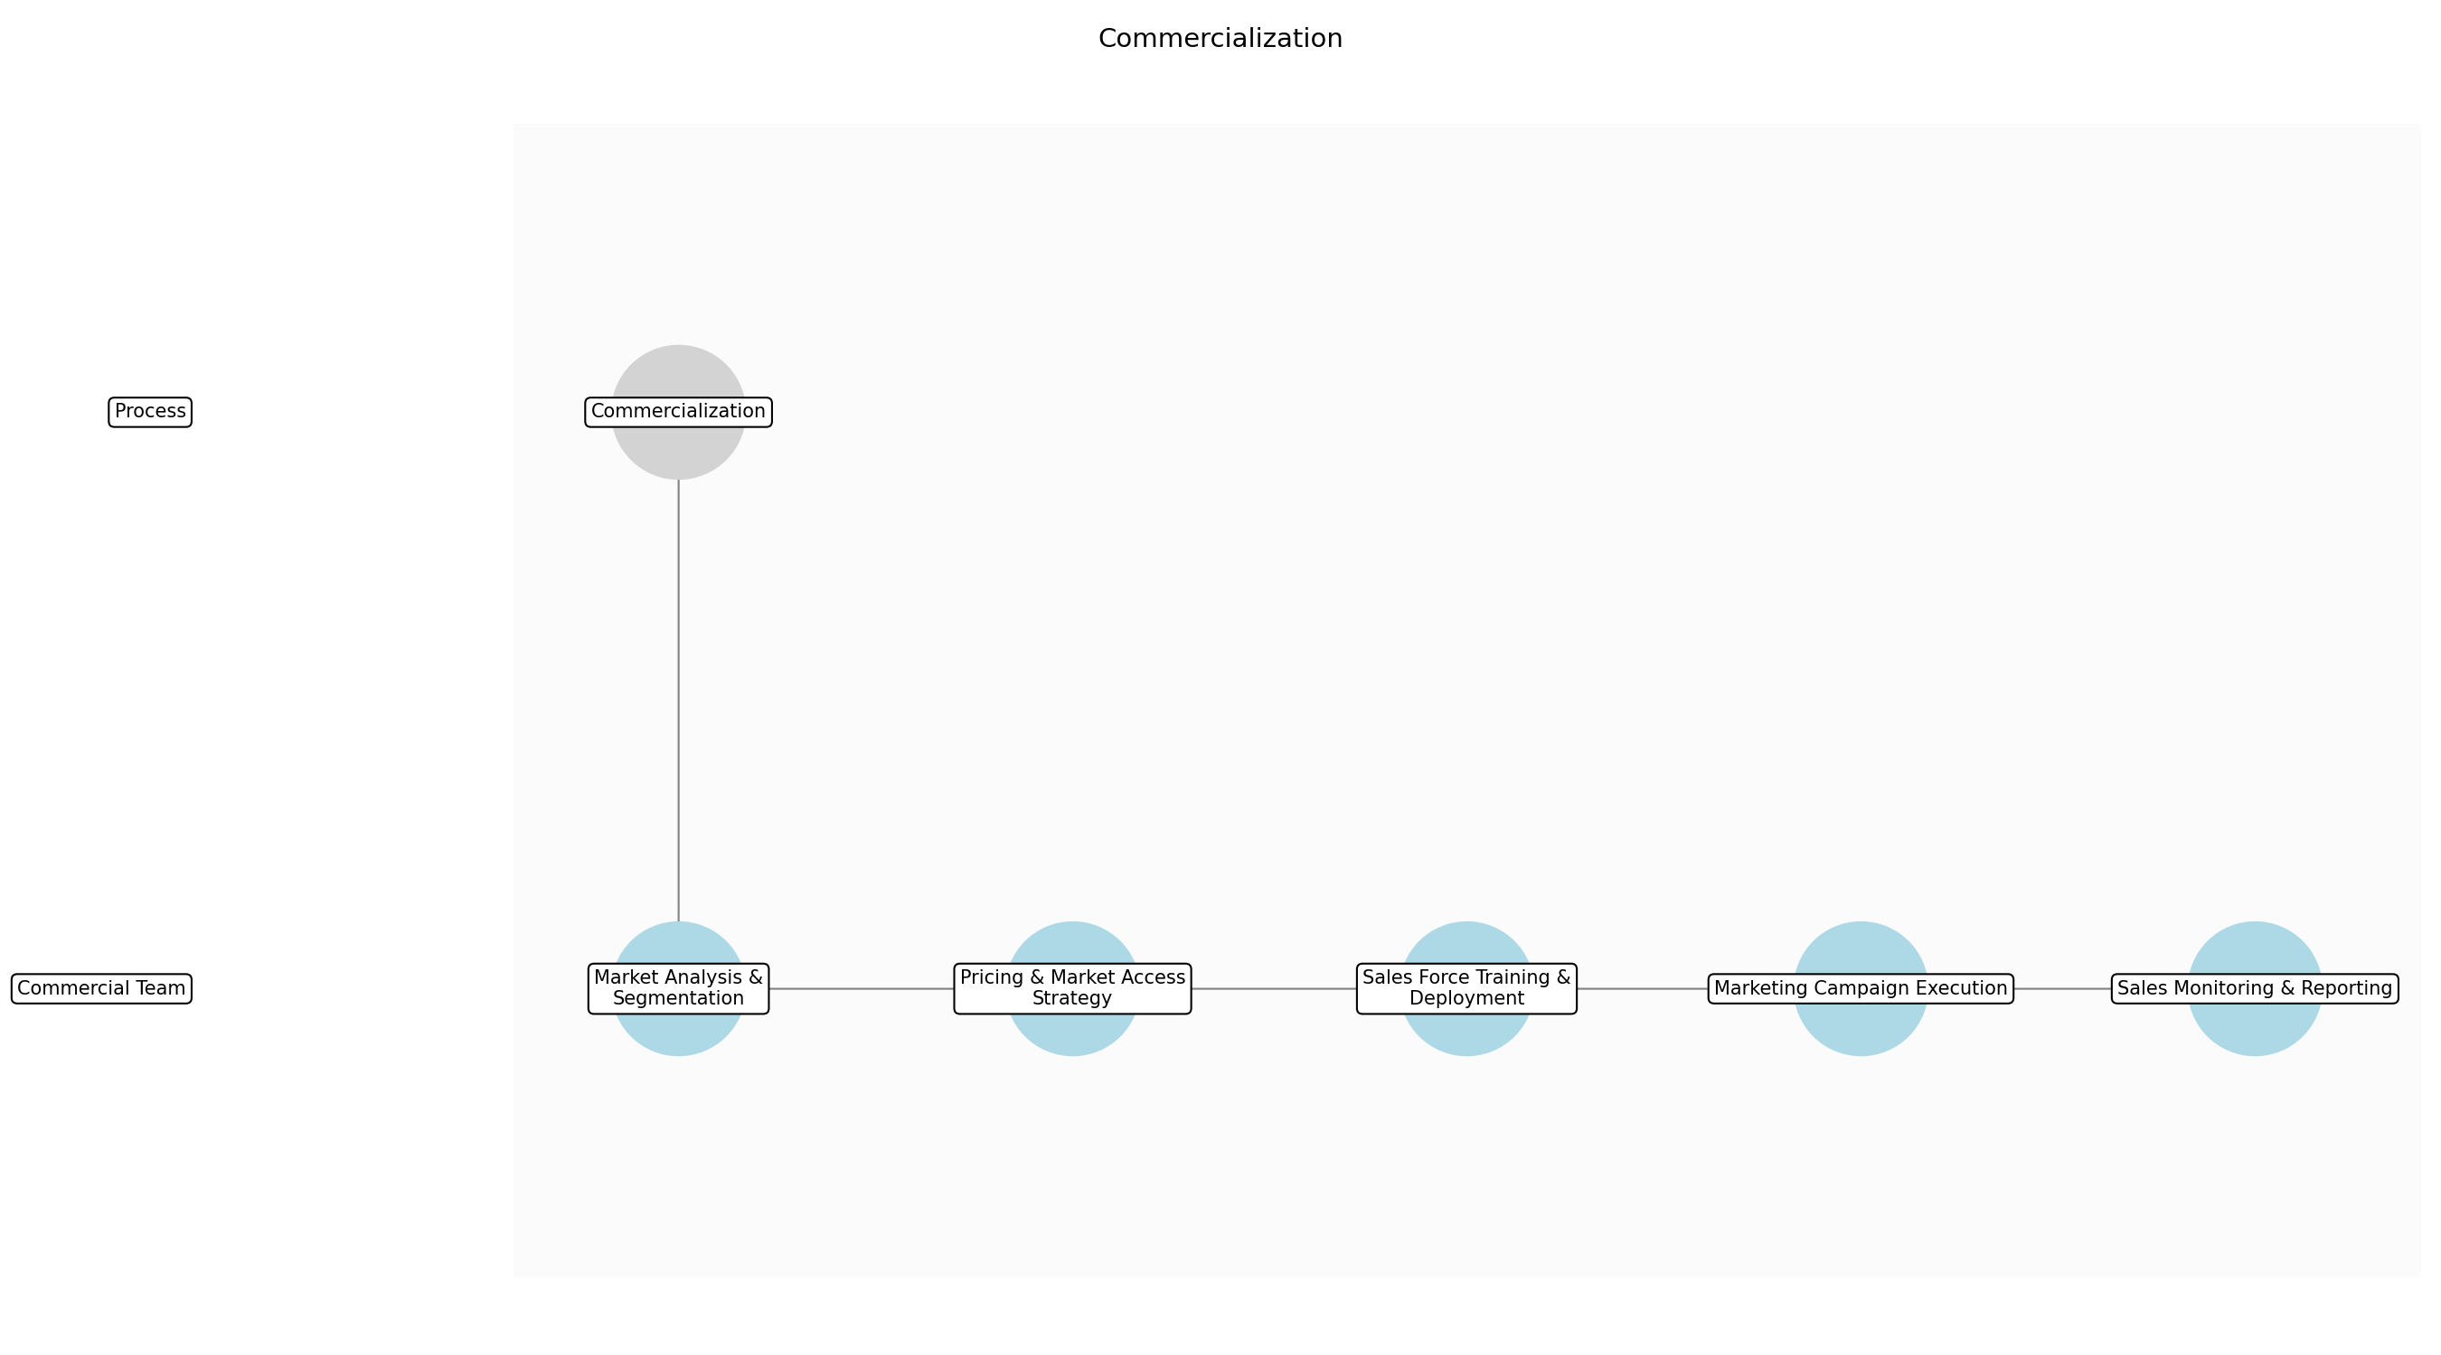

Commercialization – Market Analysis & Segmentation
Description:
- The Commercial Team conducts a thorough analysis of the target market to identify key segments and their specific needs. This involves gathering data on patient demographics, disease prevalence, treatment patterns, and competitive landscape. The team also assesses market access barriers and opportunities to inform the development of targeted commercialization strategies.
Responsible Party:
- Commercial Team
Inputs:
- Drug product
- Market research data
Outputs:
- Market segmentation report
- Target customer profiles
Estimated Duration:
- 2-4 weeks
Dependencies:
Success Criteria:
- Identification of key market segments
- Development of target customer profiles
Purpose:
- To understand the market landscape and identify the most promising customer segments for the drug product.
Scope:
- Global commercial markets.
Process Owner:
- VP, Commercial
Triggers:
- Availability of drug product for commercial distribution
End Conditions:
- Completion of market segmentation report
Step Risks and Controls:
- Risk: Inaccurate market segmentation
- Control: Conduct thorough market research and data analysis.
- Risk: Failure to identify key market segments
- Control: Engage with key opinion leaders and patient advocacy groups.
Governance Requirements:
- Compliance with market research regulations
Change Management:
- Change Request Process: Changes to the market analysis and segmentation strategy require approval from the VP, Commercial.
- Versioning Rules: Market analysis reports are version controlled.
Continuous Improvement:
- Review Frequency: Quarterly
Improvement Inputs:
- Sales data
- Market feedback
- Customer surveys

Commercialization – Pricing & Market Access Strategy
Description:
- The Commercial Team develops a comprehensive pricing and market access strategy to ensure optimal reimbursement and patient access. This involves analyzing pricing benchmarks, negotiating with payers, and developing value propositions that highlight the drug product's clinical and economic benefits. The team also works to secure formulary listings and navigate regulatory hurdles to facilitate market access.
Responsible Party:
- Commercial Team
Inputs:
- Market segmentation report
- Target customer profiles
- Clinical trial data
- Economic models
Outputs:
- Pricing strategy document
- Market access plan
- Payer negotiation strategy
Estimated Duration:
- 4-6 weeks
Dependencies:
- Market Analysis & Segmentation
Success Criteria:
- Development of a pricing strategy that maximizes revenue and market share
- Securing favorable reimbursement terms with payers
- Gaining formulary listings
Purpose:
- To establish a pricing and market access strategy that ensures optimal reimbursement and patient access.
Scope:
- Global commercial markets.
Process Owner:
- VP, Commercial
Triggers:
- Completion of market analysis and segmentation
End Conditions:
- Approval of pricing strategy and market access plan
Step Risks and Controls:
- Risk: Unfavorable reimbursement terms
- Control: Develop strong value propositions and negotiate effectively with payers.
- Risk: Market access barriers
- Control: Engage with regulatory agencies and patient advocacy groups to address market access hurdles.
Governance Requirements:
- Compliance with pricing regulations
- Compliance with anti-kickback statutes
Change Management:
- Change Request Process: Changes to the pricing and market access strategy require approval from the VP, Commercial and CFO.
- Versioning Rules: Pricing strategy documents are version controlled.
Continuous Improvement:
- Review Frequency: Quarterly
Improvement Inputs:
- Sales data
- Reimbursement rates
- Market feedback

Commercialization – Sales Force Training & Deployment
Description:
- The Commercial Team trains and deploys a sales force to promote the drug product to healthcare providers. This involves developing training materials, conducting sales training sessions, and establishing sales territories. The team also sets sales targets and monitors sales performance to ensure that the sales force is effectively reaching target customers.
Responsible Party:
- Commercial Team
Inputs:
- Pricing strategy document
- Market access plan
- Target customer profiles
- Sales training materials
Outputs:
- Trained sales force
- Sales territories
- Sales targets
Estimated Duration:
- 2-4 weeks
Dependencies:
- Pricing & Market Access Strategy
Success Criteria:
- Completion of sales force training
- Establishment of sales territories
- Setting of sales targets
Purpose:
- To train and deploy a sales force to effectively promote the drug product to healthcare providers.
Scope:
- Global commercial markets.
Process Owner:
- VP, Commercial
Triggers:
- Approval of pricing strategy and market access plan
End Conditions:
- Deployment of trained sales force
Step Risks and Controls:
- Risk: Ineffective sales force
- Control: Provide ongoing sales training and coaching.
- Risk: Failure to meet sales targets
- Control: Monitor sales performance and adjust sales strategies as needed.
Governance Requirements:
- Compliance with marketing regulations
- Compliance with ethical guidelines for pharmaceutical sales
Change Management:
- Change Request Process: Changes to the sales force training and deployment strategy require approval from the VP, Commercial.
- Versioning Rules: Sales training materials are version controlled.
Continuous Improvement:
- Review Frequency: Quarterly
Improvement Inputs:
- Sales data
- Sales force feedback
- Customer feedback

Commercialization – Marketing Campaign Execution
Description:
- The Commercial Team executes a comprehensive marketing campaign to raise awareness of the drug product and drive demand. This involves developing marketing materials, conducting promotional events, and engaging with healthcare providers and patients through various channels. The team also tracks marketing campaign performance and adjusts marketing strategies as needed to maximize impact.
Responsible Party:
- Commercial Team
Inputs:
- Sales training materials
- Marketing materials
- Promotional event plans
Outputs:
- Marketing campaign materials
- Promotional events
- Marketing campaign performance reports
Estimated Duration:
- Ongoing
Dependencies:
- Sales Force Training & Deployment
Success Criteria:
- Successful execution of marketing campaign
- Increased awareness of the drug product
- Increased demand for the drug product
Purpose:
- To raise awareness of the drug product and drive demand through a comprehensive marketing campaign.
Scope:
- Global commercial markets.
Process Owner:
- VP, Commercial
Triggers:
- Deployment of trained sales force
End Conditions:
- Completion of marketing campaign
Step Risks and Controls:
- Risk: Ineffective marketing campaign
- Control: Monitor marketing campaign performance and adjust marketing strategies as needed.
- Risk: Negative publicity
- Control: Develop a crisis communication plan and respond promptly to any negative publicity.
Governance Requirements:
- Compliance with marketing regulations
- Compliance with advertising standards
Change Management:
- Change Request Process: Changes to the marketing campaign require approval from the VP, Commercial.
- Versioning Rules: Marketing materials are version controlled.
Continuous Improvement:
- Review Frequency: Quarterly
Improvement Inputs:
- Sales data
- Marketing campaign performance reports
- Customer feedback

Commercialization – Sales Monitoring & Reporting
Description:
- The Commercial Team monitors sales performance and generates regular sales reports to track progress against sales targets. This involves collecting sales data, analyzing sales trends, and identifying areas for improvement. The team also uses sales reports to inform decision-making and adjust commercialization strategies as needed.
Responsible Party:
- Commercial Team
Inputs:
- Sales data
- Marketing campaign performance reports
- Customer feedback
Outputs:
- Sales reports
- Sales forecasts
- Commercial performance dashboards
Estimated Duration:
- Ongoing
Dependencies:
- Marketing Campaign Execution
Success Criteria:
- Regular generation of sales reports
- Accurate tracking of sales performance
- Identification of areas for improvement
Purpose:
- To monitor sales performance and generate regular sales reports to track progress against sales targets.
Scope:
- Global commercial markets.
Process Owner:
- VP, Commercial
Triggers:
- Ongoing sales activity
End Conditions:
- Regular generation of sales reports
Step Risks and Controls:
- Risk: Inaccurate sales data
- Control: Implement robust data collection and validation procedures.
- Risk: Failure to identify areas for improvement
- Control: Conduct regular sales performance reviews and solicit feedback from the sales force.
Governance Requirements:
- Compliance with data privacy regulations
Change Management:
- Change Request Process: Changes to the sales monitoring and reporting process require approval from the VP, Commercial.
- Versioning Rules: Sales reports are version controlled.
Continuous Improvement:
- Review Frequency: Quarterly
Improvement Inputs:
- Sales data
- Sales force feedback
- Customer feedback

4.0 Supporting Systems and Tools
The following tools and platforms support this process:
Category | Tools
Laboratory | LIMS (Laboratory Information Management System)
Clinical | CTMS (Clinical Trial Management System)
Regulatory | Regulatory Information Management System (RIMS)
Enterprise | ERP (Enterprise Resource Planning), CRM (Customer Relationship Management)

5.0 Metrics and Key Performance Indicators (KPIs)
The following is a list of key metrics associated with this process. These metrics help monitor performance and ensure alignment with business objectives.
Metric | Description | Measurement / Frequency | Target
Time to market | Time from target identification to market launch | Annual | <10 years
R&D spend | Total R&D expenditure | Annual | <$1 billion
Clinical trial success rate | Percentage of clinical trials that are successful | Annual | >50%
Regulatory approval rate | Percentage of regulatory submissions that are approved | Annual | >90%
Manufacturing cost | Cost of manufacturing per dose | Quarterly | <$10 per dose
Market share | Percentage of the market captured | Annual | >10%
Return on investment (ROI) | Return on investment | Annual | >15%
Patient reach | Number of patients treated | Annual | >1 million patients

6.0 Critical Success Factors (CSF)
The following is a list of key CSFs associated with this process.
Success Factor | Description
Strong scientific leadership | Experienced and innovative scientific leadership
Efficient clinical trial execution | Well-designed and executed clinical trials
Successful regulatory submissions | High-quality regulatory submissions
Robust manufacturing processes | Reliable and scalable manufacturing processes
Effective commercialization strategy | Well-executed commercialization strategy
Access to funding | Securing sufficient funding

7.0 Critical Failure Factors (CFF)
The following is a list of key CFFs associated with this process.
Failure Factor | Description
Lack of scientific innovation | Insufficient innovation in drug discovery
Clinical trial failures | Failure to demonstrate safety and efficacy in clinical trials
Regulatory delays or rejection | Delays or rejection of regulatory submissions
Manufacturing disruptions | Disruptions in manufacturing processes
Poor market access | Limited market access
Insufficient funding | Lack of sufficient funding

8.0 Reporting and Analytics
The following are key reporting and analytics associated with this process.
Metric | Description
R&D pipeline reports | Reports on the status of the R&D pipeline
Clinical trial results | Reports on the results of clinical trials
Regulatory submission status | Reports on the status of regulatory submissions
Manufacturing yield | Reports on manufacturing yield
Sales data | Reports on sales data
Market analysis | Reports on market analysis

9.0 System Requirements
The following system requirements are essential for the successful implementation of this process.
Name | Details
LIMS (Laboratory Information Management System) | System for managing laboratory data
CTMS (Clinical Trial Management System) | System for managing clinical trials
Regulatory Information Management System (RIMS) | System for managing regulatory information
ERP (Enterprise Resource Planning) | System for enterprise resource planning
CRM (Customer Relationship Management) | System for customer relationship management

10.0 Process Flow Diagram
The following diagram provides a high-level visualization of the process flow as defined in the normalized JSON source.
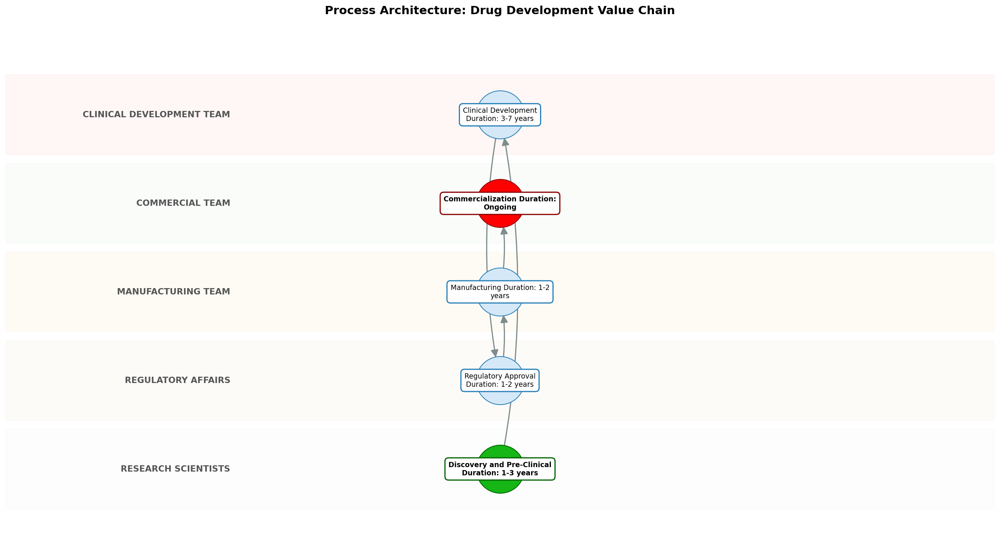

11.0 Process Performance Report
The following metrics are based on a Monte Carlo discrete-event simulation running 2,000 iterations. All time-based values are reported in years.
Operational Metric | Simulated Value
Average Cycle Time | 6.66 years
Cycle Time Variance | 0.69 years
Contention Risk Profile | Low

Identified Bottlenecks
- Commercialization
- Discovery and Pre-Clinical
- Clinical Development

Detailed Step Performance
Process Step | Avg. Duration (years)
Discovery and Pre-Clinical | 1.34
Clinical Development | 1.33
Regulatory Approval | 1.33
Manufacturing | 1.32
Commercialization | 1.34

12.0 Governance Requirements
There following are the list of governance requirements used in this process.
- Compliance with regulations (e.g., GCP, GMP)
- Internal audits
- External inspections

13.0 Risks and Controls
The following risks and associated controls apply to this process.
Risk | Control
Clinical trial failure | Robust trial design, data monitoring, and adaptive trial design
Regulatory rejection | Early engagement with regulatory agencies, thorough documentation, and compliance
Manufacturing disruptions | Redundant manufacturing capacity, quality control, and supply chain management

14.0 Process Triggers
There following are triggers that kick processes off.
- Identification of a new drug target
- Positive pre-clinical data
- Successful clinical trial results
- Regulatory approval

15.0 Process End Conditions
There following are a list of the process end conditions.
- Drug is successfully commercialized and generating revenue
- Drug is discontinued due to safety or efficacy concerns
- Patent expires and generic competition enters the market

16.0 Change Management
There following are list of the change management procedures.
- Change Request Process: Change control procedures
- Versioning Rules: Versioning rules

17.0 Continuous Improvement
The following are the items used for continuous improvement.
- Review Frequency: Process monitoring
Improvement Inputs:
- Data analysis
- Root cause analysis
- Implementation of corrective actions

Appendix B: Additional Source Data
This appendix contains additional structured data from the normalized source JSON that is not covered in the main sections.
Purpose: To discover, develop, manufacture, and commercialize innovative drugs to improve patient health and generate shareholder value.
Process Owner: Chief Operating Officer (COO)
Scope: End-to-end drug development lifecycle from discovery to commercialization.

Appendix C: Glossary
This glossary contains definitions of common terms used in the process documentation.
Term | Definition
Business Process | A set of related activities or tasks performed to achieve a specific organizational goal.
KPI | Key Performance Indicator used to measure the success or health of a process.
Stakeholder | Any individual or group with an interest in the outcomes of the process.
Continuous Improvement | Ongoing effort to improve products, services or processes.

