GenAI Augmented HR Process
This process outlines the integration of generative AI (GenAI) into various HR functions to improve efficiency, reduce costs, and enhance employee experience. Robust safeguards are implemented to ensure human oversight and ethical compliance. GenAI will augment tasks such as CV review, job specification creation, employee reviews, employee grievance processes, and other standard HR processes.
Industry / Domain: Human Resources
Version: 1.0
Generated On: 2026-01-16 21:12:38

Document Control
Version | Date | Author | Description
1.0 | 2026-01-16 | Process Architect | Initial generated process specification

Table of Contents
Document Control 2
Table of Contents 3
1.0 Process Overview 5
1.1 Assumptions 5
1.2 Constraints 5
2.0 Stakeholders and Responsibilities 6
3.0 Process Workflow 7
3.1 CV Review 7
Required Sub Process(es) for the Step "CV Review" 7
3.2 Job Specification Creation 10
Required Sub Process(es) for the Step "Job Specification Creation" 10
3.3 Employee Reviews 14
Required Sub Process(es) for the Step "Employee Reviews" 15
3.4 Employee Grievances 19
Required Sub Process(es) for the Step "Employee Grievances" 20
3.5 Training and Development 25
Required Sub Process(es) for the Step "Training and Development" 25
3.6 Onboarding 31
Required Sub Process(es) for the Step "Onboarding" 32
3.7 HR Reporting 36
Required Sub Process(es) for the Step "HR Reporting" 37
4.0 Supporting Systems and Tools 42
5.0 Metrics and Key Performance Indicators (KPIs) 43
Time Saved per Task 43
Employee Satisfaction with AI Tools 43
Reduction in Manual Errors 43
Improved Candidate Quality 43
Cost Savings 43
6.0 Critical Success Factors (CSF) 44
7.0 Critical Failure Factors (CFF) 45
8.0 Reporting and Analytics 46
9.0 System Requirements 47
10.0 Process Flow Diagram 48
11.0 Process Performance Report 49
Identified Bottlenecks 49
Detailed Step Performance 49
Appendix B: Additional Source Data 51
Appendix C: Glossary 52

1.0 Process Overview
This process outlines the integration of generative AI (GenAI) into various HR functions to improve efficiency, reduce costs, and enhance employee experience. Robust safeguards are implemented to ensure human oversight and ethical compliance. GenAI will augment tasks such as CV review, job specification creation, employee reviews, employee grievance processes, and other standard HR processes.

1.1 Assumptions
- Data quality is high
- Employees will adopt AI tools
- AI algorithms are unbiased

1.2 Constraints
- Regulatory compliance (GDPR, CCPA)
- Budget limitations
- Data privacy concerns
Industry Sector: Human Resources

2.0 Stakeholders and Responsibilities
The following is a list of key stakeholders involved in this process. Understanding their roles and responsibilities is crucial for successful implementation.
Stakeholder | Responsibilities
HR Manager | Oversee GenAI implementation  Approve AI-driven decisions  Ensure regulatory compliance
HR Specialist | Train GenAI models  Monitor AI performance  Handle employee grievances
Employees | Utilize AI tools for self-service  Provide feedback on AI performance  Report AI-related issues
IT Department | Maintain AI infrastructure  Ensure data security  Provide technical support
Legal Counsel | Ensure legal compliance  Advise on ethical AI usage  Review AI policies

3.0 Process Workflow
The following is a list of key steps in the process workflow.

3.1 CV Review
GenAI screens CVs, ranks candidates based on qualifications and experience. Human reviewers then assess the top candidates identified by GenAI for cultural fit and soft skills.
Responsible Parties: HR Specialist
Inputs:
- CVs
- Job requirements
Outputs:
- Ranked candidate list
- Shortlisted candidates
Success Criteria:
- Reduced time to screen CVs
- Improved candidate quality

Required Sub Process(es) for the Step "CV Review"
The following details the subprocess flows for the step "CV Review".
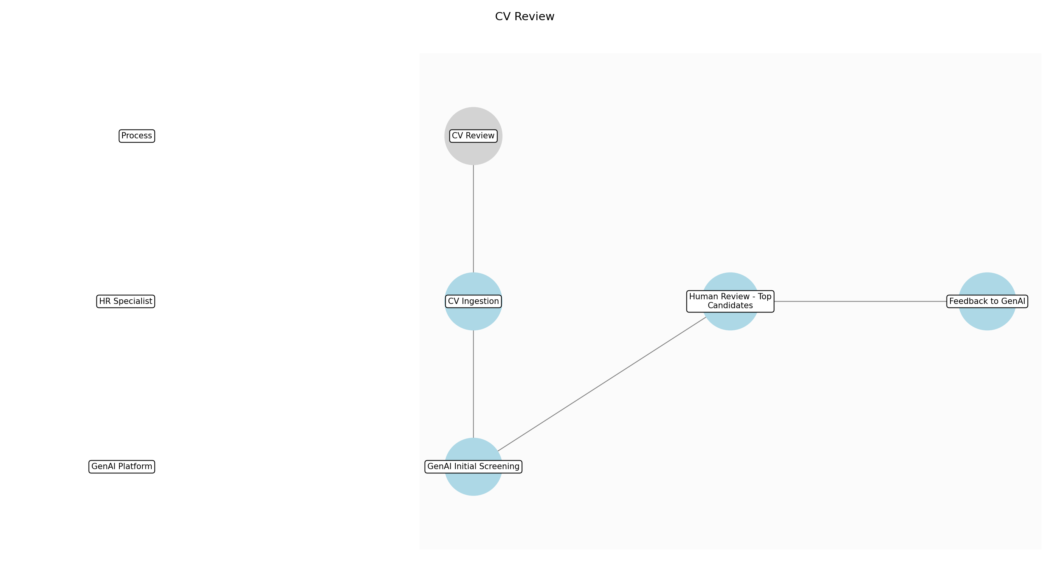

CV Review – CV Ingestion
Description: CVs are collected from various sources, such as online job boards, company websites, and recruitment agencies. These CVs are then uploaded into the GenAI platform for initial processing. The system ensures that all CVs are stored securely and in compliance with data privacy regulations.
Responsible Parties: HR Specialist
Inputs:
- CVs
- Job requirements
Outputs:
- Uploaded CVs
- Data privacy compliance confirmation
Dependencies:
Estimated Duration: 2-4 hours
Success Criteria:
- All CVs successfully uploaded
- Data privacy compliance confirmed

CV Review – GenAI Initial Screening
Description: The GenAI platform analyzes the uploaded CVs, extracting key information such as qualifications, experience, and skills. It then ranks the candidates based on how well they match the job requirements. The GenAI system uses natural language processing (NLP) to understand the context of the CVs and identify the most relevant candidates.
Responsible Parties: GenAI Platform
Inputs:
- Uploaded CVs
- Job requirements
Outputs:
- Ranked candidate list
Dependencies:
- CV Ingestion
Estimated Duration: 4-6 hours
Success Criteria:
- CVs screened and ranked based on qualifications and experience
- Reduced time to screen CVs

CV Review – Human Review - Top Candidates
Description: HR specialists review the top candidates identified by GenAI, focusing on cultural fit, soft skills, and other qualitative aspects that are difficult for AI to assess. This review involves assessing the candidate's communication skills, teamwork abilities, and overall personality. Human reviewers ensure that the shortlisted candidates align with the company's values and culture.
Responsible Parties: HR Specialist
Inputs:
- Ranked candidate list
Outputs:
- Shortlisted candidates
Dependencies:
- GenAI Initial Screening
Estimated Duration: 4-8 hours
Success Criteria:
- Top candidates assessed for cultural fit and soft skills
- Improved candidate quality

CV Review – Feedback to GenAI
Description: The HR specialists provide feedback to the GenAI platform on the quality of the candidates it identified and ranked. This feedback helps to improve the AI's accuracy and relevance over time. The feedback loop ensures that the GenAI system continuously learns and adapts to the company's specific needs and preferences.
Responsible Parties: HR Specialist
Inputs:
- Shortlisted candidates
- Ranked candidate list
Outputs:
- GenAI training data
Dependencies:
- Human Review - Top Candidates
Estimated Duration: 1-2 hours
Success Criteria:
- Feedback provided to GenAI platform
- Improved AI accuracy and relevance

3.2 Job Specification Creation
GenAI drafts initial job descriptions based on role requirements and industry standards. HR edits and approves the descriptions, ensuring accuracy and compliance with company policies.
Responsible Parties: HR Manager
Inputs:
- Role requirements
- Industry standards
Outputs:
- Draft job description
- Approved job description
Success Criteria:
- Faster job description creation
- Improved accuracy of job descriptions

Required Sub Process(es) for the Step "Job Specification Creation"
The following details the subprocess flows for the step "Job Specification Creation".
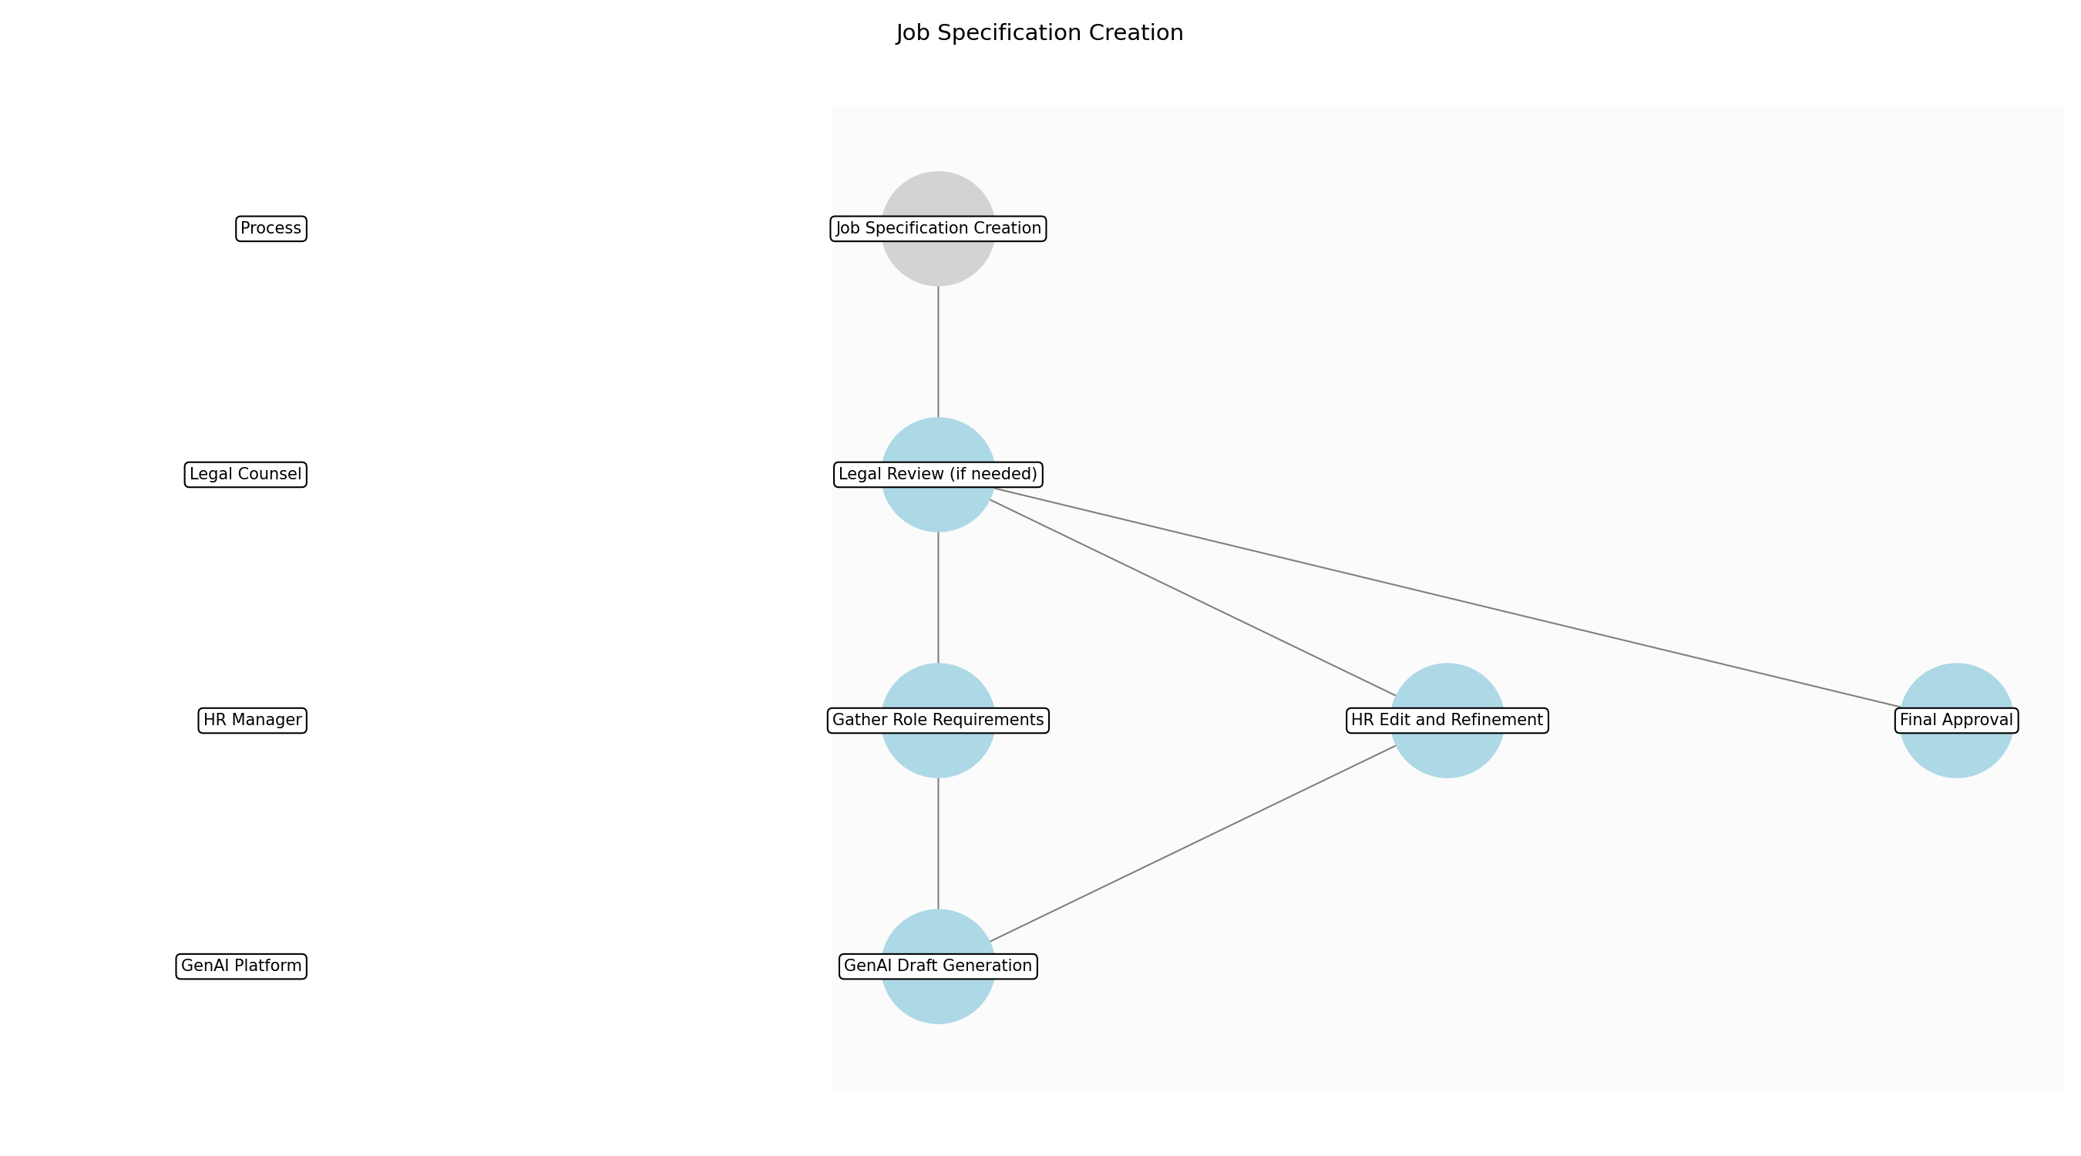

Job Specification Creation – Gather Role Requirements
Description: The HR Manager initiates the job specification process by collecting detailed role requirements from the hiring manager. This includes the necessary skills, experience, educational background, and key responsibilities for the position. The HR Manager also clarifies any specific needs or expectations for the role to ensure a comprehensive understanding.
Responsible Parties: HR Manager
Inputs:
- Hiring manager input
- Organizational chart
- Department goals
Outputs:
- Documented role requirements
Dependencies:
Estimated Duration: 2-4 hours
Success Criteria:
- Comprehensive role requirements documented
- Alignment with department goals

Job Specification Creation – GenAI Draft Generation
Description: Using the documented role requirements and industry standards, the GenAI platform generates an initial draft of the job description. The GenAI tool leverages its training data to create a well-structured and informative job description that includes a summary of the role, key responsibilities, required skills, and qualifications. The draft is designed to be a starting point for further refinement by HR.
Responsible Parties: GenAI Platform
Inputs:
- Documented role requirements
- Industry standards
Outputs:
- Draft job description
Dependencies:
- Gather Role Requirements
Estimated Duration: 30 minutes
Success Criteria:
- GenAI generates a complete draft job description
- Draft includes all key elements (summary, responsibilities, skills)

Job Specification Creation – HR Edit and Refinement
Description: The HR Manager reviews the GenAI-generated draft job description and refines it to ensure accuracy, clarity, and compliance with company policies and legal regulations. This includes verifying the job title, responsibilities, required skills, and qualifications. The HR Manager also adjusts the language to align with the company's tone and culture, ensuring the job description is engaging and attractive to potential candidates.
Responsible Parties: HR Manager
Inputs:
- Draft job description
- Company policies
- Legal regulations
Outputs:
- Edited job description
Dependencies:
- GenAI Draft Generation
Estimated Duration: 2-4 hours
Success Criteria:
- Job description is accurate and clear
- Compliance with company policies and legal regulations
- Alignment with company tone and culture

Job Specification Creation – Legal Review (if needed)
Description: If the role involves sensitive responsibilities or requires specific legal compliance, the edited job description is sent to the Legal Counsel for review. The Legal Counsel ensures that the job description does not contain any discriminatory language or violate any employment laws. This step is crucial for mitigating legal risks and ensuring ethical hiring practices.
Responsible Parties: Legal Counsel
Inputs:
- Edited job description
Outputs:
- Legal approval (if needed)
Dependencies:
- HR Edit and Refinement
Estimated Duration: 1-2 hours
Success Criteria:
- Legal Counsel approves the job description
- No legal risks identified

Job Specification Creation – Final Approval
Description: The HR Manager submits the edited job description (and legal approval, if applicable) to the hiring manager for final approval. The hiring manager reviews the job description to ensure it accurately reflects the role requirements and aligns with their expectations. Once approved, the job description is considered final and ready for use in the recruitment process.
Responsible Parties: HR Manager
Inputs:
- Edited job description
- Legal approval (if needed)
- Hiring manager feedback
Outputs:
- Approved job description
Dependencies:
- HR Edit and Refinement
- Legal Review (if needed)
Estimated Duration: 1-2 hours
Success Criteria:
- Hiring manager approves the job description
- Job description is final and ready for recruitment

3.3 Employee Reviews
GenAI analyzes performance data from various sources (e.g., project reports, 360 feedback) to provide initial performance insights. Managers then provide personalized feedback and conduct performance reviews.
Responsible Parties: HR Manager
Inputs:
- Performance data
- 360 feedback
Outputs:
- Performance insights
- Performance review
Success Criteria:
- Data-driven performance insights
- Improved employee feedback

Required Sub Process(es) for the Step "Employee Reviews"
The following details the subprocess flows for the step "Employee Reviews".
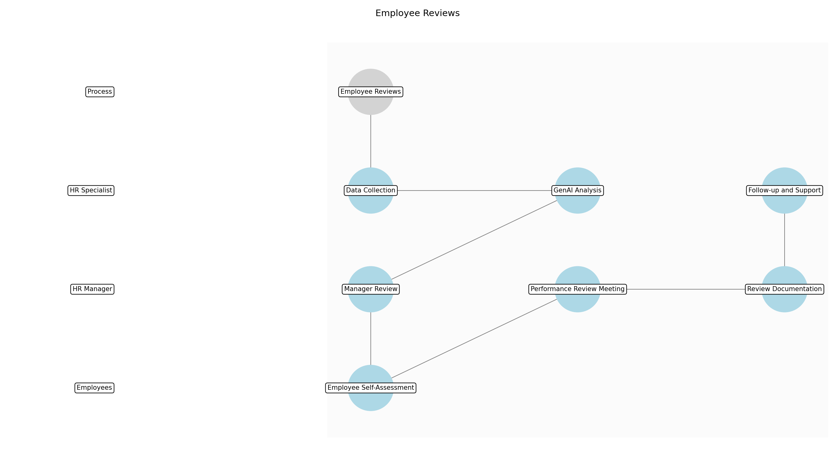

Employee Reviews – Data Collection
Description: Gather relevant performance data from various sources, including project reports, performance metrics, and 360-degree feedback. Ensure data is comprehensive and covers the review period. Data should be stored securely and accessed according to data privacy policies.
Responsible Parties: HR Specialist
Inputs:
- Project reports
- Performance metrics
- 360 feedback
- HRIS data
Outputs:
- Consolidated performance data
Dependencies:
Estimated Duration: 4-8 hours
Success Criteria:
- Complete and accurate data collection
- Data privacy compliance

Employee Reviews – GenAI Analysis
Description: Utilize GenAI to analyze the consolidated performance data and identify key performance insights, strengths, and areas for improvement. The GenAI should be configured to avoid bias and ensure fairness in its analysis. The analysis should be documented and auditable.
Responsible Parties: HR Specialist
Inputs:
- Consolidated performance data
Outputs:
- Initial performance insights
- Areas for improvement
Dependencies:
- Data Collection
Estimated Duration: 2-4 hours
Success Criteria:
- Data-driven performance insights
- Unbiased AI analysis

Employee Reviews – Manager Review
Description: Managers review the initial performance insights generated by GenAI, adding their own observations and context based on their direct interactions with the employee. Managers should validate the accuracy of the AI-generated insights and provide additional qualitative feedback.
Responsible Parties: HR Manager
Inputs:
- Initial performance insights
- Areas for improvement
Outputs:
- Manager validated performance insights
- Personalized feedback points
Dependencies:
- GenAI Analysis
Estimated Duration: 2-4 hours
Success Criteria:
- Accurate and validated performance insights
- Meaningful manager feedback

Employee Reviews – Employee Self-Assessment
Description: Provide employees with the opportunity to conduct a self-assessment, reflecting on their performance, achievements, and challenges during the review period. This self-assessment provides valuable context and perspective for the performance review process.
Responsible Parties: Employees
Inputs:
Outputs:
- Employee self-assessment
Dependencies:
Estimated Duration: 2-4 hours
Success Criteria:
- Completed employee self-assessment
- Thoughtful reflection on performance

Employee Reviews – Performance Review Meeting
Description: Conduct a formal performance review meeting between the manager and employee to discuss performance insights, feedback, and development goals. The meeting should be a constructive dialogue, focusing on both strengths and areas for improvement. Document key discussion points and agreed-upon actions.
Responsible Parties: HR Manager
Inputs:
- Manager validated performance insights
- Personalized feedback points
- Employee self-assessment
Outputs:
- Performance review document
- Development goals
Dependencies:
- Manager Review
- Employee Self-Assessment
Estimated Duration: 1-2 hours
Success Criteria:
- Productive performance review meeting
- Clear and actionable development goals

Employee Reviews – Review Documentation
Description: Finalize the performance review document, incorporating feedback from the meeting and agreed-upon development goals. Ensure the document is accurate, fair, and compliant with company policies and legal regulations. Store the document securely in the HRIS system.
Responsible Parties: HR Manager
Inputs:
- Performance review document
- Development goals
Outputs:
- Finalized performance review
- Updated HRIS data
Dependencies:
- Performance Review Meeting
Estimated Duration: 1-2 hours
Success Criteria:
- Complete and accurate performance review document
- Compliance with policies and regulations

Employee Reviews – Follow-up and Support
Description: Provide ongoing support and resources to employees to help them achieve their development goals. Regularly check in with employees to monitor progress and provide additional guidance as needed. Track the effectiveness of development plans and make adjustments as necessary.
Responsible Parties: HR Specialist
Inputs:
- Finalized performance review
- Updated HRIS data
Outputs:
- Employee development progress
- Adjusted development plans
Dependencies:
- Review Documentation
Estimated Duration: Ongoing
Success Criteria:
- Employee progress towards development goals
- Effective support and resources

3.4 Employee Grievances
GenAI triages employee complaints, analyzes the nature of grievances, and suggests potential resolutions. To ensure compliance with GDPR and other privacy regulations, the process includes a step to anonymize sensitive employee data where possible during triage. HR investigates and resolves grievances, ensuring fairness and compliance.
Responsible Parties: HR Specialist
Inputs:
- Employee complaints
- Company policies
Outputs:
- Grievance report
- Proposed resolutions
Success Criteria:
- Efficient grievance handling
- Fair and compliant resolutions

Required Sub Process(es) for the Step "Employee Grievances"
The following details the subprocess flows for the step "Employee Grievances".
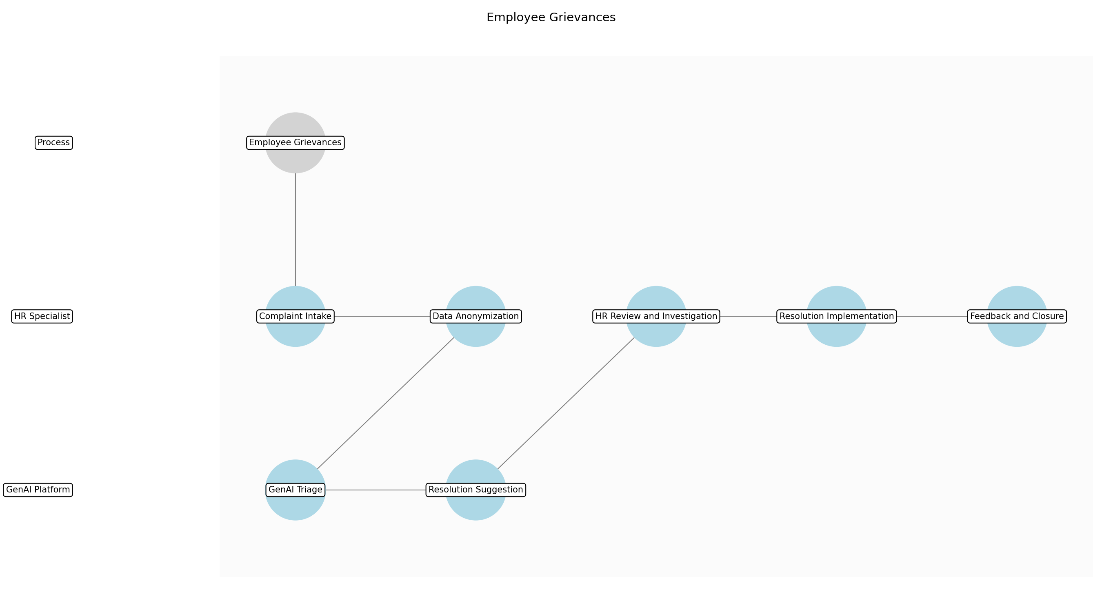

Employee Grievances – Complaint Intake
Description: The initial step involves receiving employee complaints through various channels such as email, HR portal, or in-person submissions. Each complaint is logged into the HRIS system, and an acknowledgment is sent to the employee to confirm receipt. The intake process ensures that all necessary information is captured for further analysis.
Responsible Parties: HR Specialist
Inputs:
- Employee complaints
Outputs:
- Logged complaint in HRIS
- Acknowledgment to employee
Dependencies:
Estimated Duration: 2-4 hours
Success Criteria:
- All complaints are logged
- Employees receive acknowledgment within 24 hours

Employee Grievances – Data Anonymization
Description: Before GenAI processes the complaint, sensitive employee data is anonymized to comply with GDPR and other privacy regulations. This involves removing or masking personally identifiable information (PII) from the complaint details. The anonymized data is then stored securely for analysis.
Responsible Parties: HR Specialist
Inputs:
- Logged complaint in HRIS
Outputs:
- Anonymized complaint data
Dependencies:
- Complaint Intake
Estimated Duration: 1-2 hours
Success Criteria:
- PII is removed from complaint data
- Data is stored securely

Employee Grievances – GenAI Triage
Description: GenAI analyzes the anonymized complaint data to identify the nature of the grievance, categorize the issue, and assess its severity. The AI uses natural language processing (NLP) to understand the context and extract relevant information. This triage process helps in prioritizing complaints and routing them to the appropriate HR personnel.
Responsible Parties: GenAI Platform
Inputs:
- Anonymized complaint data
- Company policies
Outputs:
- Categorized grievance
- Severity assessment
Dependencies:
- Data Anonymization
Estimated Duration: 30-60 minutes
Success Criteria:
- Grievances are accurately categorized
- Severity is correctly assessed

Employee Grievances – Resolution Suggestion
Description: Based on the triage results, GenAI suggests potential resolutions that align with company policies and legal requirements. These suggestions are tailored to the specific nature and severity of the grievance. The AI considers past cases and best practices to provide effective and fair resolution options.
Responsible Parties: GenAI Platform
Inputs:
- Categorized grievance
- Severity assessment
- Company policies
Outputs:
- Proposed resolutions
Dependencies:
- GenAI Triage
Estimated Duration: 30-60 minutes
Success Criteria:
- Resolutions align with company policies
- Resolutions are fair and effective

Employee Grievances – HR Review and Investigation
Description: An HR Specialist reviews the GenAI's triage and resolution suggestions. The HR Specialist conducts a thorough investigation, gathering additional information if necessary, and validates the AI's findings. This step ensures human oversight and prevents over-reliance on AI-generated outputs.
Responsible Parties: HR Specialist
Inputs:
- Categorized grievance
- Severity assessment
- Proposed resolutions
Outputs:
- Validated grievance report
- Investigation findings
Dependencies:
- Resolution Suggestion
Estimated Duration: 1-2 days
Success Criteria:
- Investigation is thorough
- Findings are accurate and complete

Employee Grievances – Resolution Implementation
Description: The HR Specialist implements the proposed resolution, ensuring that it is communicated clearly to all parties involved. This may involve mediation, disciplinary action, or policy changes. The implementation process is documented in the HRIS system for future reference.
Responsible Parties: HR Specialist
Inputs:
- Validated grievance report
- Investigation findings
- Proposed resolutions
Outputs:
- Implemented resolution
- Updated HRIS record
Dependencies:
- HR Review and Investigation
Estimated Duration: 2-4 hours
Success Criteria:
- Resolution is implemented effectively
- All parties are informed

Employee Grievances – Feedback and Closure
Description: Feedback is collected from the employee who filed the complaint to assess their satisfaction with the resolution. The grievance case is then closed in the HRIS system. This step ensures that the resolution is satisfactory and provides valuable insights for improving the grievance handling process.
Responsible Parties: HR Specialist
Inputs:
- Implemented resolution
Outputs:
- Employee feedback
- Closed grievance case
Dependencies:
- Resolution Implementation
Estimated Duration: 1-2 hours
Success Criteria:
- Employee provides feedback
- Grievance case is closed in HRIS

3.5 Training and Development
GenAI identifies employee skill gaps through performance data and recommends relevant training programs. HR facilitates training and development opportunities for employees.
Responsible Parties: HR Specialist, HR Manager
Inputs:
- Performance data
- Training catalogs
Outputs:
- Skill gap analysis
- Training recommendations
Success Criteria:
- Targeted training programs
- Improved employee skills

Required Sub Process(es) for the Step "Training and Development"
The following details the subprocess flows for the step "Training and Development".
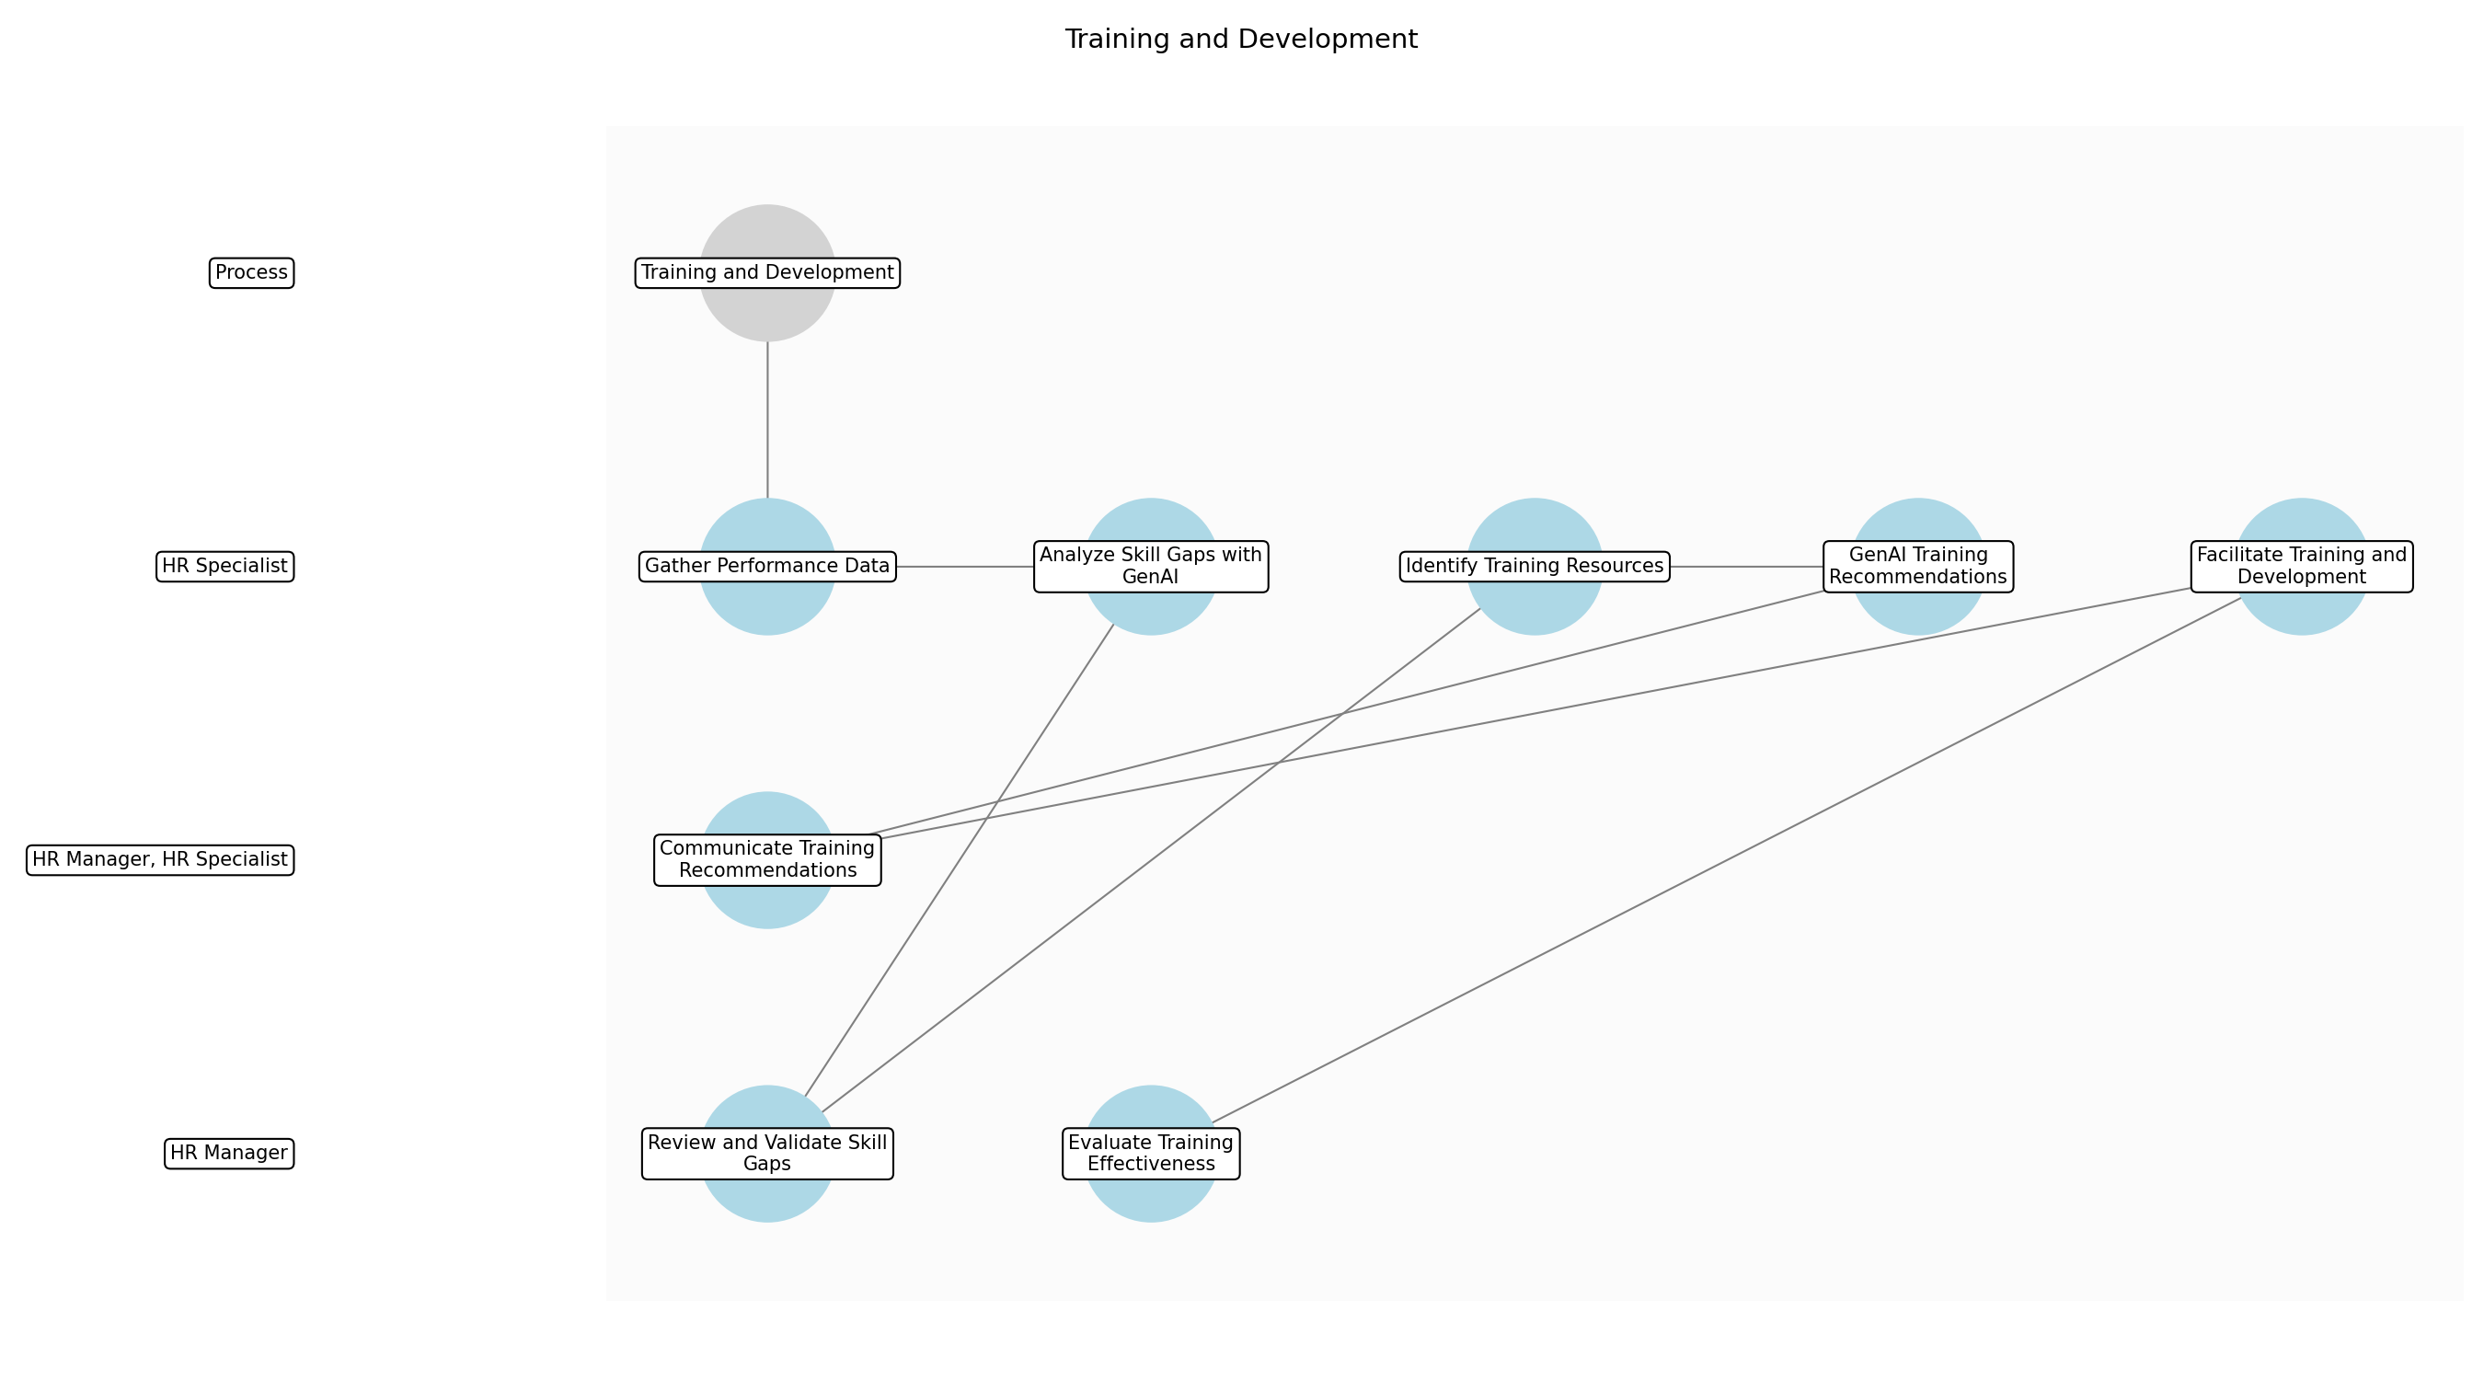

Training and Development – Gather Performance Data
Description: Collect employee performance data from various sources, including performance reviews, project reports, and 360-degree feedback. Ensure data is anonymized where necessary to comply with privacy regulations. Consolidate the data into a structured format suitable for GenAI analysis.
Responsible Parties: HR Specialist
Inputs:
- Performance reviews
- Project reports
- 360-degree feedback
Outputs:
- Consolidated performance data
Dependencies:
Estimated Duration: 2-4 hours
Success Criteria:
- Comprehensive data collection
- Data anonymization where required
- Structured data format

Training and Development – Analyze Skill Gaps with GenAI
Description: Utilize GenAI to analyze the consolidated performance data and identify skill gaps across different employee groups and roles. GenAI compares current skill levels against required competencies for their positions and future organizational needs. The analysis should highlight areas where employees need additional training or development.
Responsible Parties: HR Specialist
Inputs:
- Consolidated performance data
- Role requirements
- Competency frameworks
Outputs:
- Preliminary skill gap analysis
Dependencies:
- Gather Performance Data
Estimated Duration: 4-6 hours
Success Criteria:
- Accurate skill gap identification
- Clear gap analysis report
- Alignment with organizational needs

Training and Development – Review and Validate Skill Gaps
Description: HR Manager reviews the preliminary skill gap analysis generated by GenAI. Validate the identified skill gaps with department heads and team leads to ensure accuracy and relevance. Incorporate feedback from managers to refine the analysis and identify any additional skill gaps not captured by GenAI.
Responsible Parties: HR Manager
Inputs:
- Preliminary skill gap analysis
- Manager feedback
Outputs:
- Validated skill gap analysis
Dependencies:
- Analyze Skill Gaps with GenAI
Estimated Duration: 2-4 hours
Success Criteria:
- Accurate validation of skill gaps
- Incorporation of manager feedback
- Refined skill gap analysis

Training and Development – Identify Training Resources
Description: Based on the validated skill gaps, identify relevant training resources, including internal training programs, external courses, online learning platforms, and mentorship opportunities. Evaluate the quality and suitability of each training resource to ensure it meets the specific needs of the employees. Compile a catalog of recommended training programs.
Responsible Parties: HR Specialist
Inputs:
- Validated skill gap analysis
- Training catalogs
- Learning and development budget
Outputs:
- Recommended training programs
- Training resource catalog
Dependencies:
- Review and Validate Skill Gaps
Estimated Duration: 4-6 hours
Success Criteria:
- Comprehensive training resource identification
- High-quality training programs
- Alignment with skill gaps

Training and Development – GenAI Training Recommendations
Description: Use GenAI to match employees with the most relevant training programs based on their individual skill gaps, learning preferences, and career goals. GenAI generates personalized training recommendations for each employee, considering factors such as learning style, availability, and previous training history. Ensure recommendations align with budget constraints and regulatory requirements.
Responsible Parties: HR Specialist
Inputs:
- Recommended training programs
- Employee data
- Learning preferences
Outputs:
- Personalized training recommendations
Dependencies:
- Identify Training Resources
Estimated Duration: 2-4 hours
Success Criteria:
- Personalized training recommendations
- Alignment with employee needs
- Compliance with budget and regulations

Training and Development – Communicate Training Recommendations
Description: Communicate the personalized training recommendations to employees and their managers. Provide clear instructions on how to access and enroll in the recommended training programs. Offer support and guidance to employees throughout the training process. Address any questions or concerns regarding the training recommendations.
Responsible Parties: HR Manager, HR Specialist
Inputs:
- Personalized training recommendations
- Employee contact information
Outputs:
- Employee training plans
Dependencies:
- GenAI Training Recommendations
Estimated Duration: 2-4 hours
Success Criteria:
- Effective communication of training plans
- Employee understanding and acceptance
- Support and guidance provided

Training and Development – Facilitate Training and Development
Description: HR facilitates the training and development opportunities for employees. This includes scheduling training sessions, coordinating logistics, and providing necessary resources. Monitor employee participation and progress in the training programs. Collect feedback from employees on the effectiveness of the training.
Responsible Parties: HR Specialist
Inputs:
- Employee training plans
- Training resources
Outputs:
- Completed training programs
- Training feedback
Dependencies:
- Communicate Training Recommendations
Estimated Duration: Ongoing
Success Criteria:
- High employee participation rate
- Effective training delivery
- Positive employee feedback

Training and Development – Evaluate Training Effectiveness
Description: Evaluate the effectiveness of the training programs by measuring improvements in employee skills, performance, and job satisfaction. Use data from performance reviews, project outcomes, and employee surveys to assess the impact of the training. Identify areas for improvement in the training programs and adjust future training plans accordingly.
Responsible Parties: HR Manager
Inputs:
- Completed training programs
- Training feedback
- Performance data
Outputs:
- Training effectiveness report
- Adjusted training plans
Dependencies:
- Facilitate Training and Development
Estimated Duration: 1 day
Success Criteria:
- Measurable improvements in employee skills
- Positive impact on performance
- Data-driven training adjustments

3.6 Onboarding
GenAI automates onboarding paperwork, provides initial training materials, and answers frequently asked questions. HR conducts in-person onboarding sessions and provides support to new hires.
Responsible Parties: HR Manager, HR Specialist
Inputs:
- Employee data
- Onboarding materials
Outputs:
- Automated paperwork
- Initial training materials
Success Criteria:
- Efficient onboarding process
- Improved new hire experience

Required Sub Process(es) for the Step "Onboarding"
The following details the subprocess flows for the step "Onboarding".
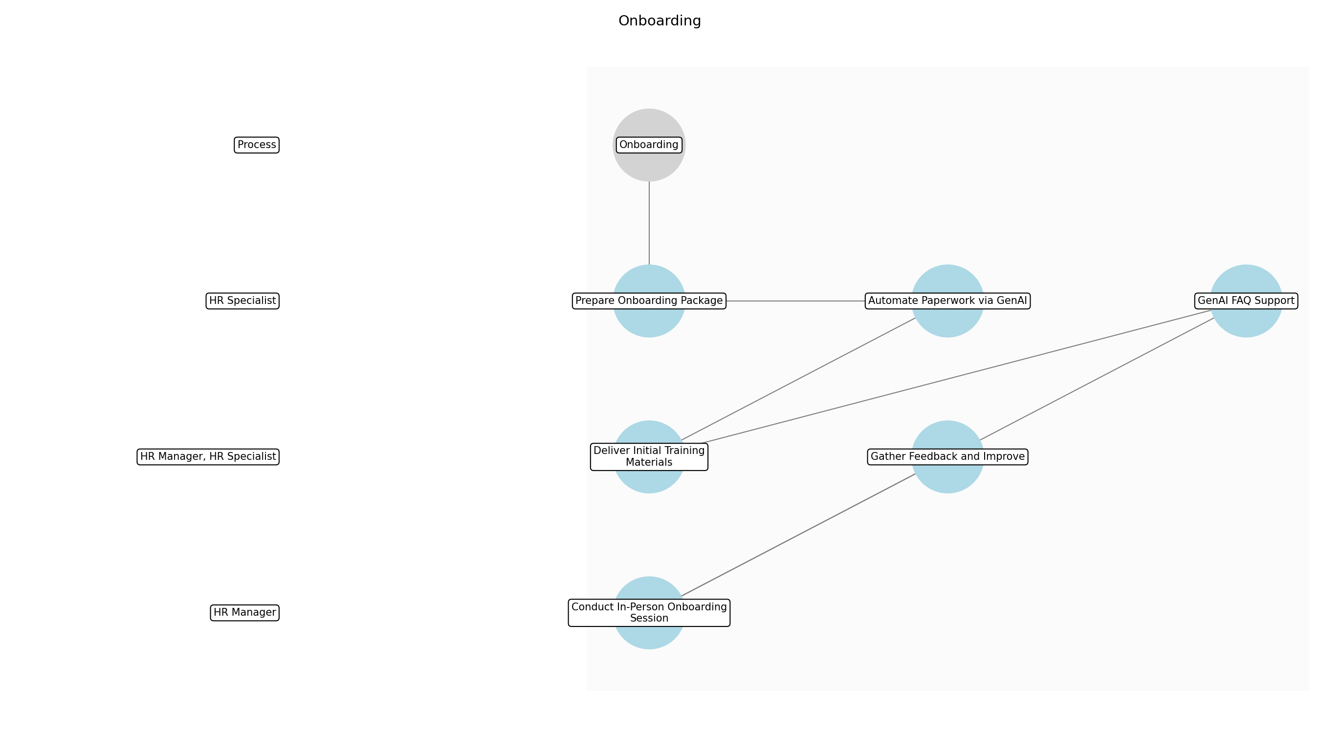

Onboarding – Prepare Onboarding Package
Description: The HR Specialist compiles all necessary onboarding documents, including employment contracts, benefits enrollment forms, and company policy manuals. GenAI assists in personalizing these documents with the new hire's information, ensuring accuracy and completeness. This step ensures that all required paperwork is ready for the new employee.
Responsible Parties: HR Specialist
Inputs:
- Employee data
- Onboarding materials
Outputs:
- Personalized onboarding documents
- Benefits enrollment forms
- Company policy manuals
Dependencies:
Estimated Duration: 2-4 hours
Success Criteria:
- All onboarding documents are personalized and accurate
- Onboarding package is complete and ready for distribution

Onboarding – Automate Paperwork via GenAI
Description: GenAI automates the generation of standard onboarding paperwork, such as tax forms (W-4, I-9) and direct deposit authorization forms. The system pre-fills these forms with available employee data, reducing manual input and potential errors. This automation streamlines the paperwork process and improves efficiency.
Responsible Parties: HR Specialist
Inputs:
- Personalized onboarding documents
- Employee data
Outputs:
- Automated tax forms
- Direct deposit authorization forms
Dependencies:
- Prepare Onboarding Package
Estimated Duration: 1-2 hours
Success Criteria:
- Tax forms and direct deposit forms are automatically generated
- Reduced manual input and errors in paperwork

Onboarding – Deliver Initial Training Materials
Description: GenAI curates and delivers initial training materials tailored to the new hire's role and department. These materials may include introductory videos, training modules, and access to the company's learning management system (LMS). This step ensures that new hires have the resources they need to start learning about their roles and the company.
Responsible Parties: HR Manager, HR Specialist
Inputs:
- Automated tax forms
- Direct deposit authorization forms
- Role-specific training content
Outputs:
- Initial training materials
- Access to LMS
- Introductory videos
Dependencies:
- Automate Paperwork via GenAI
Estimated Duration: 2-4 hours
Success Criteria:
- New hires receive tailored training materials
- Access to LMS is granted
- Training materials are relevant and up-to-date

Onboarding – GenAI FAQ Support
Description: GenAI provides a chatbot or virtual assistant to answer frequently asked questions from new hires. This system can address common queries about benefits, company policies, and onboarding procedures. This step reduces the burden on HR staff and provides immediate support to new employees.
Responsible Parties: HR Specialist
Inputs:
- Initial training materials
- FAQ database
Outputs:
- Answers to FAQs
- Chatbot support
- Virtual assistant support
Dependencies:
- Deliver Initial Training Materials
Estimated Duration: Ongoing
Success Criteria:
- New hires receive prompt answers to their questions
- HR staff workload is reduced
- Chatbot/virtual assistant is accurate and helpful

Onboarding – Conduct In-Person Onboarding Session
Description: HR conducts an in-person onboarding session to welcome new hires, provide additional information, and answer any remaining questions. This session includes introductions to team members, a tour of the facilities, and a review of company culture and values. This step provides a personal touch and ensures that new hires feel welcomed and supported.
Responsible Parties: HR Manager
Inputs:
- Answers to FAQs
- New hire feedback
Outputs:
- In-person onboarding session
- Team introductions
- Facility tour
Dependencies:
- GenAI FAQ Support
Estimated Duration: 2-4 hours
Success Criteria:
- New hires attend in-person onboarding session
- Team introductions are made
- New hires feel welcomed and supported

Onboarding – Gather Feedback and Improve
Description: HR gathers feedback from new hires about their onboarding experience and uses this feedback to improve the process. This may involve surveys, interviews, or focus groups. GenAI analyzes the feedback to identify trends and areas for improvement. This step ensures that the onboarding process remains effective and relevant.
Responsible Parties: HR Manager, HR Specialist
Inputs:
- In-person onboarding session
- New hire feedback
Outputs:
- Feedback analysis
- Process improvements
- Updated onboarding materials
Dependencies:
- Conduct In-Person Onboarding Session
Estimated Duration: Ongoing
Success Criteria:
- Feedback is gathered from new hires
- Feedback is analyzed to identify areas for improvement
- Onboarding process is continuously improved

3.7 HR Reporting
GenAI generates reports on key HR metrics, such as employee turnover, satisfaction, and training effectiveness. HR analyzes reports to identify trends and improve HR strategies.
Responsible Parties: HR Manager
Inputs:
- HR data
Outputs:
- HR reports
- Trend analysis
Success Criteria:
- Data-driven HR decisions
- Improved HR strategies

Required Sub Process(es) for the Step "HR Reporting"
The following details the subprocess flows for the step "HR Reporting".
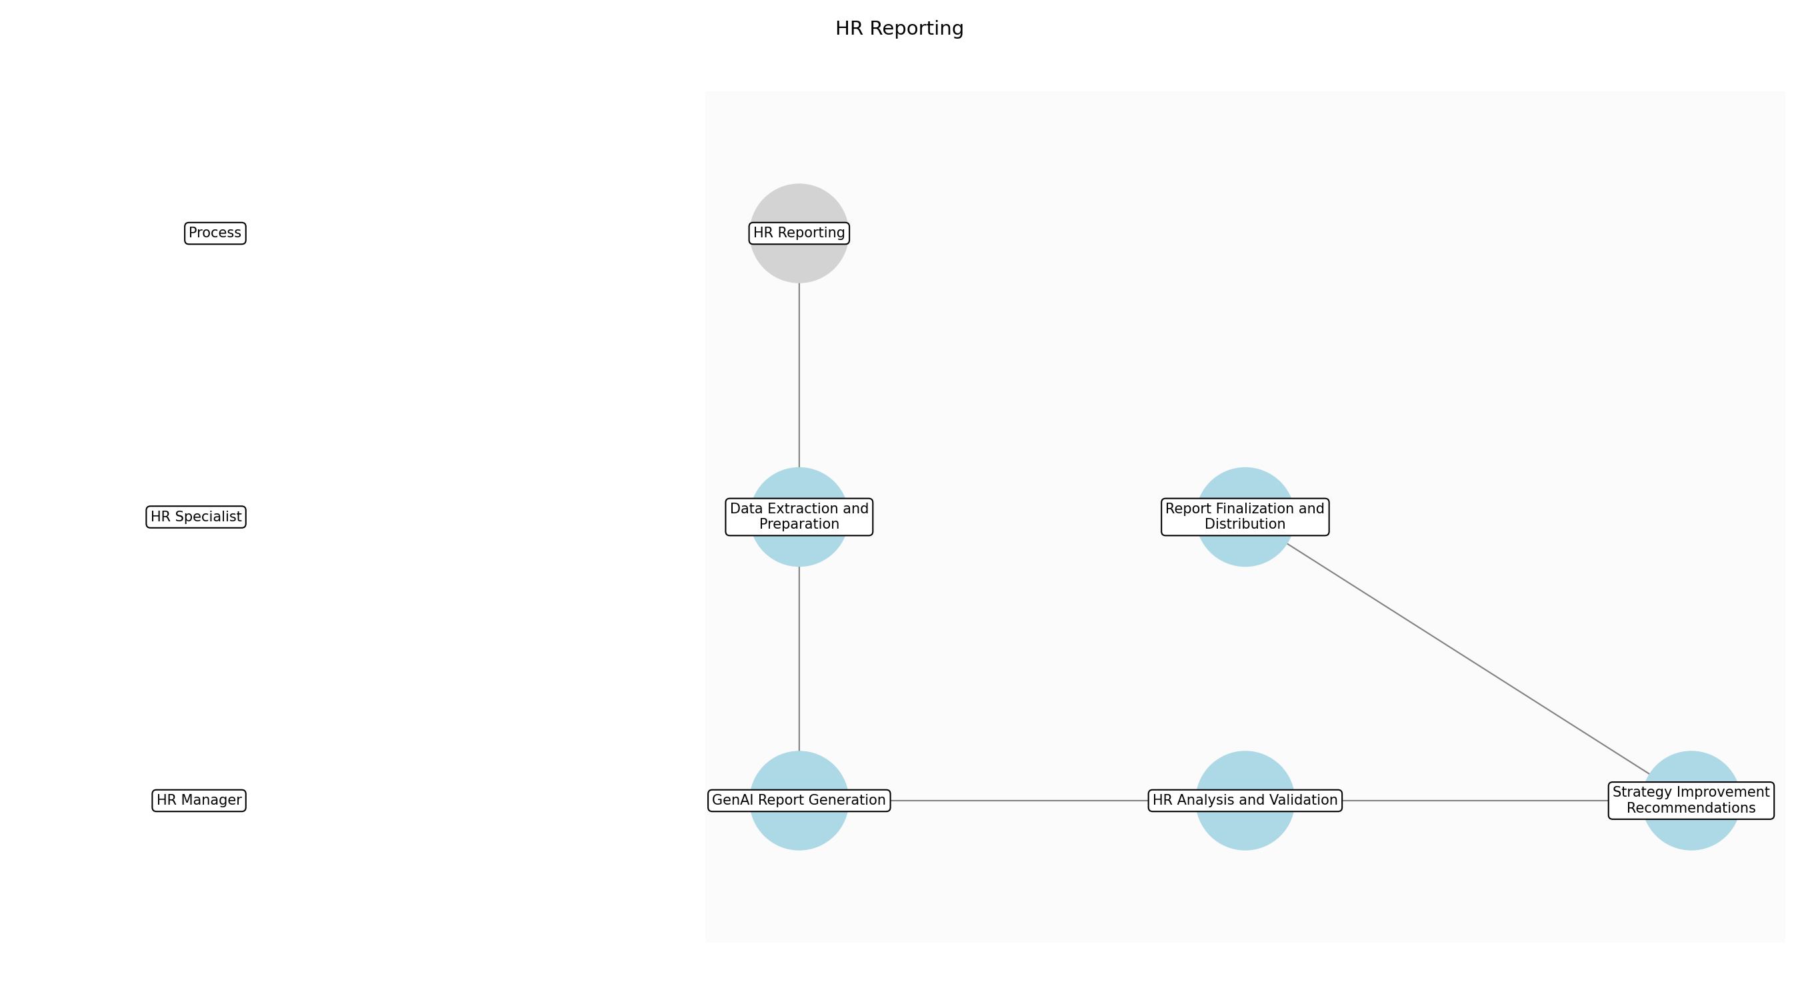

HR Reporting – Data Extraction and Preparation
Description: The initial step involves extracting relevant HR data from various sources, including the HRIS system, performance management tools, and employee satisfaction surveys. This data is then prepared for GenAI processing by cleaning, transforming, and structuring it into a suitable format. Data privacy and security are paramount during this phase, ensuring compliance with GDPR and other regulations.
Responsible Parties: HR Specialist
Inputs:
- HR data
- HRIS system
- Performance management tools
- Employee satisfaction surveys
Outputs:
- Cleaned HR data
- Structured HR data
Dependencies:
Estimated Duration: 2-4 hours
Success Criteria:
- Complete data extraction
- Data is cleaned and structured
- Compliance with data privacy regulations

HR Reporting – GenAI Report Generation
Description: With the prepared data, GenAI algorithms are employed to generate comprehensive reports on key HR metrics. These metrics include employee turnover rates, employee satisfaction levels, training effectiveness, and other relevant indicators. The GenAI models analyze the data to identify patterns, correlations, and anomalies that may not be immediately apparent through traditional reporting methods.
Responsible Parties: HR Manager
Inputs:
- Cleaned HR data
- Structured HR data
Outputs:
- Draft HR reports
- Initial trend analysis
Dependencies:
- Data Extraction and Preparation
Estimated Duration: 4-6 hours
Success Criteria:
- Generation of draft HR reports
- Identification of initial trends
- Accurate data analysis

HR Reporting – HR Analysis and Validation
Description: HR professionals review the draft reports and initial trend analysis generated by GenAI. This step involves validating the accuracy of the findings, interpreting the results in the context of the organization's HR strategies, and identifying actionable insights. Human expertise is crucial to ensure that the AI-generated reports align with the company's goals and values.
Responsible Parties: HR Manager
Inputs:
- Draft HR reports
- Initial trend analysis
Outputs:
- Validated HR reports
- Refined trend analysis
Dependencies:
- GenAI Report Generation
Estimated Duration: 2-4 hours
Success Criteria:
- Validation of report accuracy
- Identification of actionable insights
- Alignment with HR strategies

HR Reporting – Strategy Improvement Recommendations
Description: Based on the validated reports and refined trend analysis, HR professionals develop recommendations for improving HR strategies. These recommendations may include adjustments to recruitment processes, training programs, employee engagement initiatives, or other areas. The goal is to leverage the data-driven insights to enhance HR practices and achieve better organizational outcomes.
Responsible Parties: HR Manager
Inputs:
- Validated HR reports
- Refined trend analysis
Outputs:
- HR strategy recommendations
Dependencies:
- HR Analysis and Validation
Estimated Duration: 2 hours
Success Criteria:
- Development of actionable recommendations
- Clear and concise strategy proposals
- Potential for improved HR outcomes

HR Reporting – Report Finalization and Distribution
Description: The final step involves finalizing the HR reports, incorporating the refined trend analysis and strategy improvement recommendations. The reports are then distributed to relevant stakeholders, such as senior management, department heads, and HR team members. The distribution process ensures that the insights are shared with those who can take action to implement the recommended strategies.
Responsible Parties: HR Specialist
Inputs:
- HR strategy recommendations
Outputs:
- Final HR reports
- Distributed reports
Dependencies:
- Strategy Improvement Recommendations
Estimated Duration: 1-2 hours
Success Criteria:
- Finalized and accurate reports
- Timely distribution to stakeholders
- Stakeholder awareness of key insights

4.0 Supporting Systems and Tools
The following tools and platforms support this process:
Category | Tools
Access Control System | Manages user access to HR systems.
Data Encryption Tools | Secures sensitive HR data.
Genai Platform | Provides AI capabilities for various HR tasks.
Hris System | Stores and manages employee data.
Monitoring And Alerting Tools | Monitors AI performance and alerts on anomalies.

5.0 Metrics and Key Performance Indicators (KPIs)
The following is a list of key metrics associated with this process. These metrics help monitor performance and ensure alignment with business objectives.

Time Saved per Task
Measures the reduction in time spent on HR tasks due to GenAI automation.

Employee Satisfaction with AI Tools
Assesses employee satisfaction with GenAI tools through surveys and feedback.

Reduction in Manual Errors
Tracks the decrease in manual errors due to GenAI assistance.

Improved Candidate Quality
Evaluates the quality of candidates hired through GenAI-assisted screening.

Cost Savings
Calculates the cost savings achieved through GenAI implementation.

6.0 Critical Success Factors (CSF)
The following is a list of key CSFs associated with this process.
Success Factor | Description
Accurate AI Predictions | Ensuring GenAI provides accurate and reliable predictions and insights.
High Employee Adoption Rate | Encouraging employees to actively use and trust GenAI tools.
Strong Data Privacy and Security | Protecting sensitive HR data and ensuring compliance with data privacy regulations.
Effective Human Oversight | Maintaining human oversight and intervention in critical HR decisions.
Fair and Unbiased AI Decisions | Ensuring GenAI algorithms are free from bias and make fair decisions.

7.0 Critical Failure Factors (CFF)
The following is a list of key CFFs associated with this process.
Failure Factor | Description
Data Breaches | Compromise of sensitive employee data.
Biased AI Outputs | AI algorithms producing unfair or discriminatory results.
Lack of Employee Trust | Employees not trusting or adopting GenAI tools.
Regulatory Violations | Failure to comply with data privacy and ethical usage regulations.
System Downtime | Unavailability of GenAI systems impacting HR operations.

8.0 Reporting and Analytics
The following are key reporting and analytics associated with this process.
Metric / Key | Description / Value
Audit Logs | Records all AI-driven decisions and actions. Audit logs are retained for 3 years to comply with data retention policies and regulatory requirements.
Compliance Reports | Ensures adherence to regulatory requirements.
Dashboard With Key Hr Metrics | Provides a real-time overview of HR performance.
Employee Satisfaction Surveys | Gathers feedback on employee satisfaction with HR processes.
Reports On Ai Performance | Tracks the performance of GenAI algorithms.

9.0 System Requirements
The following system requirements are essential for the successful implementation of this process.
- GenAI platform
- HRIS system
- Data encryption tools
- Access control system
- Monitoring and alerting tools

10.0 Process Flow Diagram
The following diagram provides a high-level visualization of the process flow as defined in the normalized JSON source.
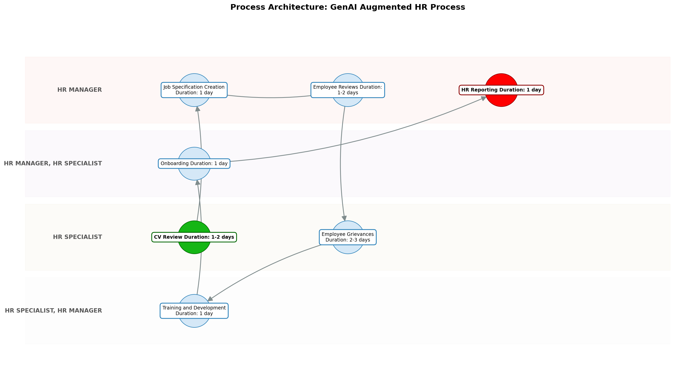

11.0 Process Performance Report
The following metrics are based on a Monte Carlo discrete-event simulation running 2,000 iterations. All time-based values are reported in day.
Operational Metric | Simulated Value
Average Cycle Time | 1.80 day
Cycle Time Variance | 0.20 day
Contention Risk Profile | Low

Identified Bottlenecks
- Job Specification Creation
- Training and Development
- HR Reporting

Detailed Step Performance
Process Step | Avg. Duration (day)
CV Review | 1.34
Job Specification Creation | 1.35
Employee Reviews | 1.33
Employee Grievances | 1.33
Training and Development | 1.34
Onboarding | 1.33
HR Reporting | 1.34

Appendix B: Additional Source Data
This appendix contains additional structured data from the normalized source JSON that is not covered in the main sections.
Assumptions:
- Data quality is high
- Employees will adopt AI tools
- AI algorithms are unbiased
Constraints:
- Regulatory compliance (GDPR, CCPA)
- Budget limitations
- Data privacy concerns

Appendix C: Glossary
This glossary contains definitions of common terms used in the process documentation.
Term | Definition
Business Process | A set of related activities or tasks performed to achieve a specific organizational goal.
KPI | Key Performance Indicator used to measure the success or health of a process.
Stakeholder | Any individual or group with an interest in the outcomes of the process.
Continuous Improvement | Ongoing effort to improve products, services or processes.

