ServiceNow CMDB Auto-Discovery & Asset Management (HAM/SAM) Hybrid AWS and On-Premises Architecture
Combined Design Document

Industry / Domain: Enterprise Cloud & Hybrid IT Infrastructure
Version: 1.6.0
Generated On: 2026-09-27 17:08:37

Document Control
Version | Date | Author | Description
1.6.0 | 2026-09-27 | Design Architect | Initial generated design specification

Table of Contents

PART I: HIGH-LEVEL ARCHITECTURE (HLD)

1.0 Executive Summary
The purpose of this Architectural Design Document is to define the unified High-Level (HLD) and Low-Level (LLD) specifications for ServiceNow Discovery, HAM, and SAM across AWS hybrid cloud and physical enterprise data centers.
This design is driven by the following business goals: Single Source of Truth: Eliminate siloed, conflicting infrastructure inventories across hybrid cloud and physical data centers.; Software License Compliance & Cost Optimization: Prevent software audit non-compliance penalties and eliminate wasted license allocations for major software vendors.; Hardware Asset Governance: Track full physical and virtual hardware lifecycles, warranty status, and hardware refresh schedules to minimize operational risks.; among others.

1.1 Document Structure
This document is organized in two parts. Part I presents the business context, requirements, and architecture at a level suitable for review and approval. Part II provides the low-level design detail an implementing engineer needs to build it.

1.2 Scope
Covers end-to-end technical implementation of ServiceNow Discovery MID Server clusters in AWS VPCs and on-premises VMware environments, ECC Queue message schemas, IRE deterministic identification logic, HAM hardware normalization workflows, SAM publisher reconciliation algorithms, and Vault/Secrets Manager REST integrations.

1.3 Objectives
- Automate discovery of 100% of compute, storage, network, and cloud resources across 25 AWS accounts and 2 physical data centers.
- Achieve 99%+ CI identification accuracy and eliminate duplicate configuration items using CSDM 4.0 and robust IRE identifier rules.
- Achieve full Hardware Asset Management (HAM) lifecycle synchronization between CI operational records and hardware asset financial records.
- Enable Software Asset Management (SAM) automated reconciliation against license entitlements across Microsoft, Oracle, IBM, and VMware publisher ecosystems.
- Maintain a scalable, highly available MID Server architecture supporting up to 50,000 scanned CIs per discovery window.

1.4 Business Drivers
- Single Source of Truth: Eliminate siloed, conflicting infrastructure inventories across hybrid cloud and physical data centers.
- Software License Compliance & Cost Optimization: Prevent software audit non-compliance penalties and eliminate wasted license allocations for major software vendors.
- Hardware Asset Governance: Track full physical and virtual hardware lifecycles, warranty status, and hardware refresh schedules to minimize operational risks.
- Operational Resilience & CSDM Alignment: Provide accurate configuration topology and dependency mapping to support Incident, Change, and Problem management.

1.5 Assumptions
- A persistent, redundant 10 Gbps AWS Direct Connect interconnect with IPsec VPN failover is established between on-premises DCs and the AWS Transit Gateway.
- Read-only administrative credentials (SNMPv3, SSH, WinRM, AWS IAM cross-account roles) will be provisioned in compliance with enterprise least-privilege standards.
- ServiceNow Discovery, HAM Professional, and SAM Professional enterprise licensing is active with required publisher packs enabled.
- Target discovery workloads allow agentless network interrogation over approved administrative ports without firewall packet drops.

1.6 Constraints
- Strict zero-credential storage policy on local MID Server disks or in unencrypted ServiceNow instance database tables; all secrets must resolve dynamically via enterprise secret vaults.
- Strict unidirectional perimeter security: MID Servers must only initiate outbound HTTPS (TCP 443) traffic to ServiceNow SaaS; no inbound connections from the internet or ServiceNow SaaS are permitted.
- Rollout schedule constraint: Auto-discovery and CMDB baseline across 25 AWS accounts and 2 enterprise on-premises data centers must be operational within 16 weeks without degrading business application traffic.
- Legacy compute support: Must support agentless discovery on legacy AIX, Solaris, and older Windows Server systems while enforcing modern TLS 1.2+ transport security.
System Name: ServiceNow Hybrid CMDB & Discovery Platform
Industry Sector: Enterprise Cloud & Hybrid IT Infrastructure
Document Type: Combined
Template Standard: arc42

2.0 Stakeholders and Responsibilities
The following is a list of key stakeholders involved in this architecture. Understanding their roles and responsibilities is crucial for successful implementation.
Stakeholder | Responsibilities
Enterprise ServiceNow Architecture Team | CMDB data architecture, IRE identifier rule governance, MID Server cluster lifecycle and configuration
ITAM Asset Operations Team | HAM normalization configuration, physical lifecycle audits, hardware reconciliation models
Software Governance & Licensing Team | SAM normalization rules, software entitlement mapping, license compliance position reconciliation
Cybersecurity & Risk Governance | IAM cross-account role governance, HashiCorp Vault / AWS Secrets Manager policies, network firewall rule approvals
Cloud & Data Center Operations Team | Network transit gateway configuration, AWS VPC peering, VMware ESXi management, and firewall policy execution

3.0 Requirements
This section defines the functional and non-functional requirements this design must satisfy, following ISO/IEC/IEEE 29148 requirements engineering practice. Each requirement table below is ordered by identifier, then by priority.

3.1 Functional Requirements
The following functional requirements describe the capabilities this design must provide.
ID | Priority | Description | Acceptance Criteria
REQ-FUNC-001 | Critical | • The system shall automatically discover hybrid infrastructure across AWS and physical data centers using agentless probes. | • Agentless discovery runs across all 25 AWS accounts and 2 physical data centers.  • Network devices, virtual machines, physical servers, and cloud resources correctly categorized into CSDM 4.0 classes.
REQ-FUNC-002 | Critical | • The system shall apply IRE rules to uniquely identify CIs and resolve multi-source discovery updates without data flapping. | • Matching CI identified using bios_uuid, mac_address, or cloud arn.  • No duplicate CIs generated when AWS Cloud Discovery and OS-level discovery scan the same instance.
REQ-FUNC-003 | Critical | • The system shall synchronize discovered hardware CIs with HAM asset records and normalize hardware models. | • Discovered hardware records automatically generate or link to alm_hardware assets.  • Hardware normalization rules populate model, manufacturer, and lifecycle states.
REQ-FUNC-004 | Critical | • The system shall discover software installations and execute SAM automated license reconciliation against entitlements. | • Installed software signatures captured from discovered Windows, Linux, and UNIX hosts.  • Software models normalized and mapped against Microsoft, Oracle, IBM, and VMware publisher rules.
REQ-FUNC-005 | Critical | • The system shall resolve discovery credentials dynamically from enterprise secret vaults without storing secrets on MID servers. | • Zero credentials written to MID Server configuration files or local file systems.  • Discovery probes fetch secrets dynamically from HashiCorp Vault and AWS Secrets Manager.

3.2 Non-Functional Requirements
The following non-functional requirements describe the quality attributes and operating constraints this design must satisfy (ISO/IEC 25010).
ID | Priority | Category | Description | Acceptance Criteria
REQ-NF-001 | Critical | Performance Efficiency (time_behaviour) | • The platform shall sustain peak discovery sweep ingestion rates without user interface degradation. | —
REQ-NF-002 | Critical | Reliability (fault_tolerance) | • Discovery MID Server infrastructure shall provide high availability and automated failover. | —
REQ-NF-003 | Critical | Security (confidentiality) | • All MID Server communication to ServiceNow SaaS must be strictly outbound HTTPS over TLS 1.3. | —
REQ-NF-004 | Critical | Security (confidentiality) | • All agentless discovery probe traversal must be bounded by Just-In-Time (JIT) ephemeral credentials and dynamic network micro-segmentation, with zero standing administrative credentials and credential-less AWS SSM execution for EC2 instances. | —

4.0 System Context
This section defines the boundary of ServiceNow Hybrid CMDB & Discovery Platform: the actors and external systems it interacts with, following the C4 model's System Context (Level 1) view.

4.1 Actors
The following actors interact with the system:
Name | Type | Description
ServiceNow Platform Administrator & CMDB Owner | Human | Configures discovery schedules, tunes IRE identifier rules, maintains MID Server clusters, and oversees CMDB data quality.
HAM Asset Manager | Human | Monitors hardware lifecycle transitions, warranty statuses, model normalizations, and physical asset reconciliation.
SAM Asset Manager | Human | Reviews software discovery models, oversees publisher packs, monitors license positions, and executes reconciliation runs.
Cloud & DevOps Engineer | Human | Manages AWS IAM cross-account roles, VPC security groups, AWS Organizations, and CloudWatch integration.
Data Center & Network Operations Engineer | Human | Manages physical switches, routers, firewalls, VMware ESXi hypervisors, and server management networks.

4.2 External Systems
The following external systems integrate with this system:
Name | Description | Interface Type | Data Exchanged | Owner
Amazon Web Services (AWS) Multi-Account Cloud | Amazon Web Services multi-account enterprise environment hosting cloud infrastructure and VPC-resident MID servers. | REST API / AWS SDK (IAM AssumeRole) | Cloud inventory metadata, EC2/RDS instances, VPC networks, S3 storage configurations, and CloudTrail event telemetry. | Cloud Infrastructure Team
AWS Secrets Manager | AWS native secret storage service supplying just-in-time credentials to AWS MID server clusters. | AWS SDK / REST API (HTTPS KMS) | Dynamic administrative IAM credentials and AWS-hosted discovery credentials for private subnet workload scanning. | Cloud Security Team
HashiCorp Vault | Enterprise secrets management platform delivering zero-trust, dynamic credential brokering to on-premises MID servers. | REST API (HTTPS TLS 1.2+) | Just-in-time administrative discovery credentials (SSH keys, SNMP community strings, Windows service account tokens). | Enterprise Cybersecurity & IAM Team
Physical Enterprise Data Centers (DC1 & DC2) | Two enterprise on-premises physical data centers housing physical servers, network switches, SAN arrays, and VMware clusters. | SNMPv3, SSH, WinRM / WMI | Physical server telemetry, network topology, SNMP MIBs, hypervisor details, storage LUN configurations, and OS metadata. | Data Center Infrastructure Team
ServiceNow Content Service Library | ServiceNow cloud-hosted content repository delivering automated bi-weekly catalog and library updates for HAM and SAM normalization. | ServiceNow Content Distribution Network (HTTPS) | Software catalog definitions, hardware model benchmarks, lifecycle milestones, and normalization rules. | ServiceNow SaaS Operations

ServiceNow Hybrid Discovery & Asset Management Context Diagram
C4 Level 1 Context Diagram depicting the ServiceNow SaaS instance, distributed MID Server clusters across AWS VPCs and physical on-premises data centers, secret management vaults, and enterprise IT administrator personas.
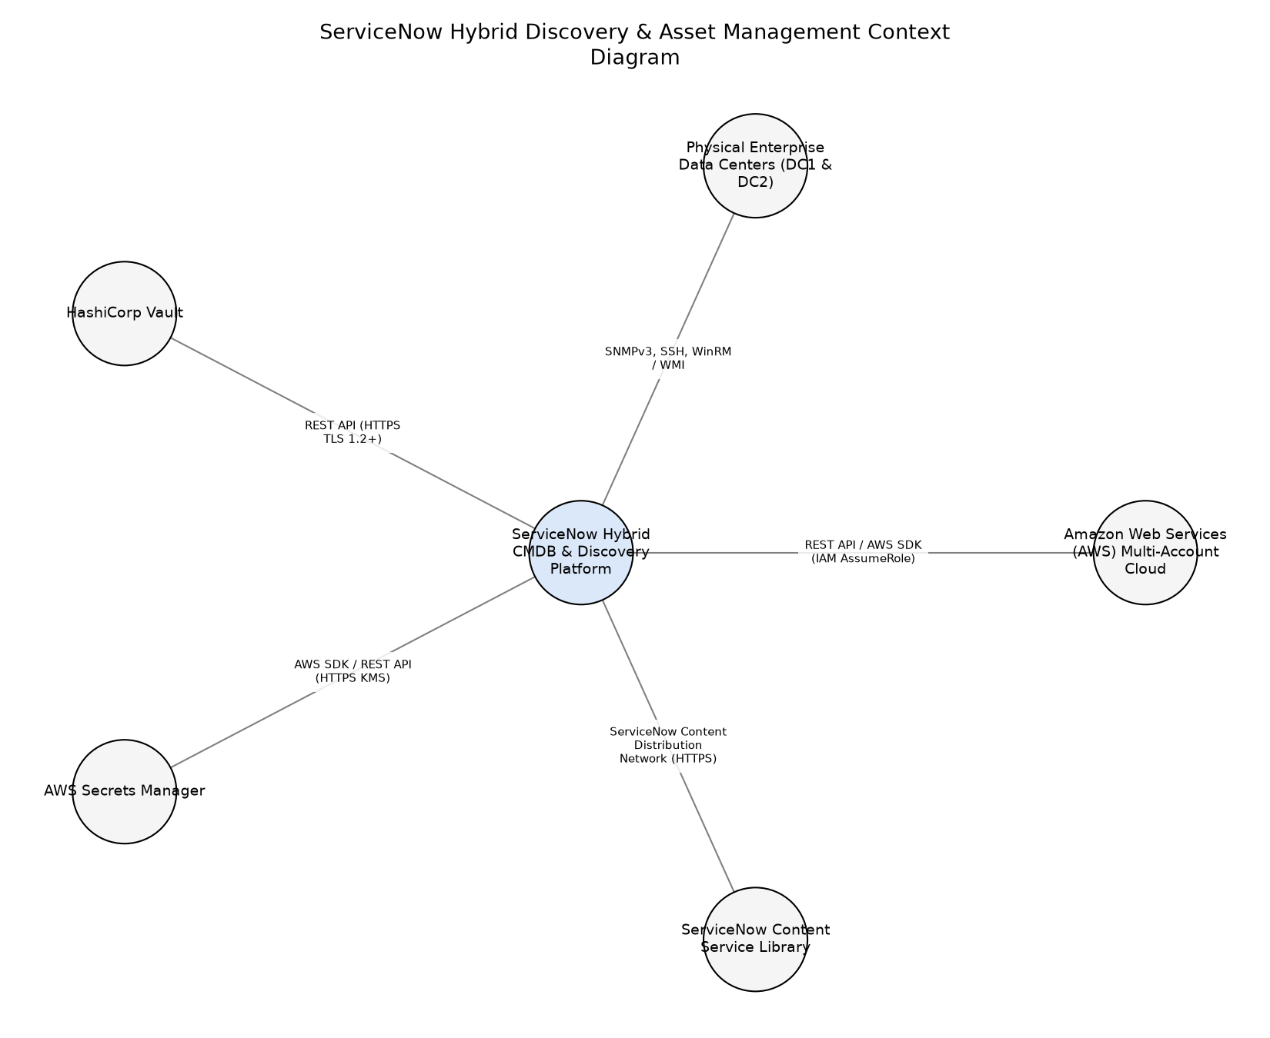

5.0 Architecture Description
The following describes the architecture viewpoints and views for this design (ISO/IEC/IEEE 42010), and the analysis behind the recommended approach.

Concerns
- CMDB Configuration Item (CI) duplication and flapping across multi-account AWS and physical DCs
- Credential security and avoidance of plaintext credential storage across distributed MID Server instances
- Network bandwidth saturation and discovery storms across AWS Direct Connect links
- Performance and semaphore thread contention on the ServiceNow ECC Queue during large sweeps
- Compliance with CSDM 4.0 and accurate HAM/SAM asset lifecycle tracking

Viewpoints

Contextual Architecture Viewpoint
Applicable Standard: ISO/IEC/IEEE 42010
Concerns Addressed: - Contextual boundary, external integrations, enterprise IT ecosystem interaction
Description: System Context Viewpoint defining external integrations, system boundary, and user/system interaction touchpoints.
Modeling Conventions: C4 Level 1 Context Diagram and tabular actor mapping
Stakeholders Addressed:
- CMDB Platform Architect
- Information Security Officer
- Cloud & Data Center Operations Team

High-Level Functional Component Viewpoint
Applicable Standard: ISO/IEC/IEEE 42010
Concerns Addressed: - Container breakdown, MID Server clustering, IRE processing pipeline, SAM/HAM data normalization engine
Description: High-level functional component viewpoint showing containerized services, application modules, and logical subsystems.
Modeling Conventions: C4 Level 2 Container Diagram with tabular component responsibility matrix
Stakeholders Addressed:
- CMDB Platform Architect
- Hardware Asset Manager
- Software Asset Manager

Deployment & Infrastructure Viewpoint
Applicable Standard: ISO/IEC/IEEE 42010
Concerns Addressed: - Network topology, Direct Connect routing, MID Server multi-AZ and multi-DC distribution, high availability failover
Description: Deployment topology viewpoint mapping software containers to AWS VPCs and physical on-premises hypervisor clusters.
Modeling Conventions: arc42 Deployment View and infrastructure schematics
Stakeholders Addressed:
- Cloud & Data Center Operations Team
- Information Security Officer

Views

System Context View
Description: Contextual boundary view illustrating how ServiceNow SaaS interfaces with AWS Cloud APIs, on-premises management infrastructure, credential vaults, and IT operational personas.
Elements:
- ServiceNow SaaS Instance
- AWS Cloud Multi-Account Enclave
- Physical On-Premises Data Centers (DC1/DC2)
- HashiCorp Vault / AWS Secrets Manager
- Enterprise ITAM / ITOM Stakeholders
Viewpoint Ref: Contextual Architecture Viewpoint

Diagrams

ServiceNow Hybrid Auto-Discovery Context Diagram
C4 Level 1 Context diagram showing ServiceNow Cloud Platform, MID Server enclaves, target IT workloads, and external credential managers.
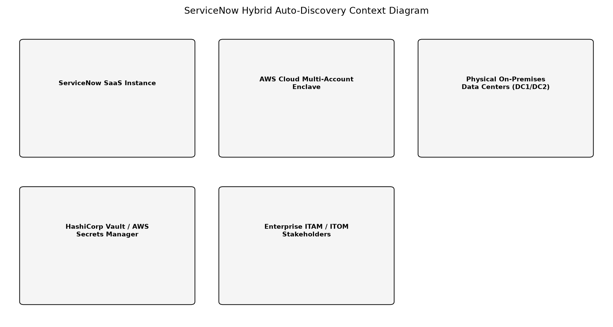

Functional Container View
Description: High-Level container view presenting the ServiceNow core platform components (IRE, ECC Queue, HAM/SAM engines), MID Server clusters in AWS and on-prem, and discovery protocol workers.
Elements:
- ServiceNow ECC Queue Pipeline
- Identification and Reconciliation Engine (IRE)
- HAM Professional Lifecycle Engine
- SAM Professional Reconciliation Engine
- AWS Cloud MID Server Cluster
- On-Premises Data Center MID Server Cluster
Viewpoint Ref: High-Level Functional Component Viewpoint

Diagrams

ServiceNow Discovery & ITAM Container Architecture
C4 Level 2 Container diagram mapping Discovery Engine, ECC Queue, IRE, HAM/SAM Normalization, and MID Server Clusters.
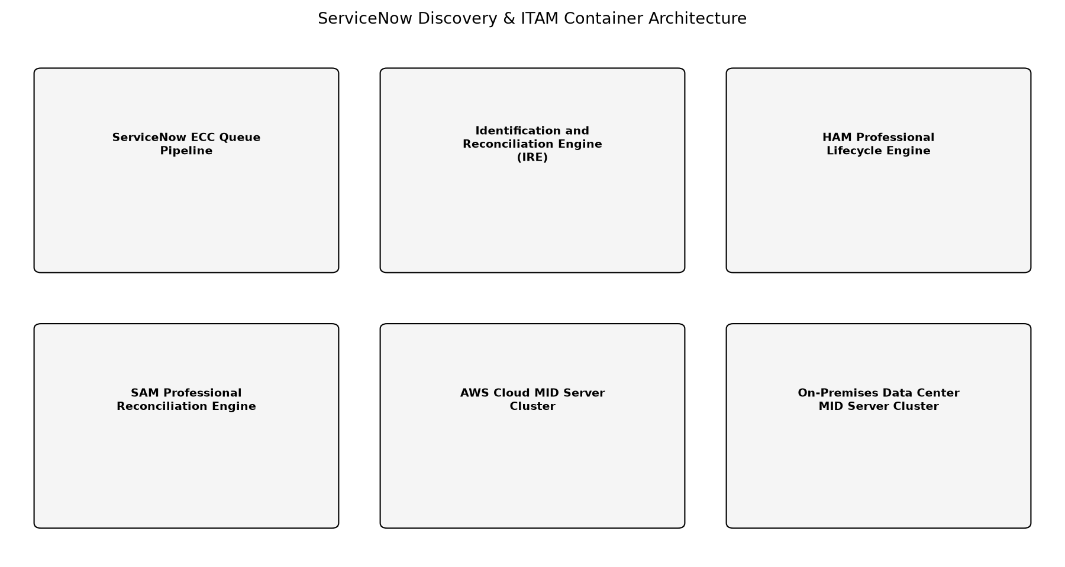

Agentless MID Cluster Discovery vs Persistent Agent-Based Collection
Evaluation of architectural choices for hybrid enterprise asset discovery and CMDB population across physical data centers and AWS environments.
Strengths:
• Zero-touch on endpoints, native support for SNMPv3, WMI/WinRM, and SSH across legacy and cloud workloads, centralized credential governance with zero local disk credential persistence
Weaknesses:
• Requires secure credential orchestration and least-privilege administrative network traversal for discovery probes (fully resolved via JIT ephemeral vault brokering, scan-window dynamic micro-segmentation, and AWS SSM credential-less interrogation)
Risks:
• Transient discovery storms over interconnect circuits if schedule windows overlap (mitigated via dynamic schedule jitter, probe concurrency caps, and DSCP QoS traffic shaping)
Alternatives Considered
Agent-Based Discovery Architecture (ServiceNow ACC)
Deploying persistent OS-level monitoring and inventory agents (such as ServiceNow ACC - Agent Client Collector) across all physical and AWS virtual servers.
Strengths:
• Real-time endpoint event metrics and metric streaming
• Reduced discovery probe traffic over network subnets
Weaknesses:
• Requires intrusive software package deployments across thousands of production servers
• Incompatible with legacy UNIX platforms (AIX 6.x, Solaris 10) and physical network appliances
Compared to the Above:
• Agent-based discovery provides continuous real-time telemetry but introduces substantial management overhead for agent rollouts across 50k+ nodes, high third-party software licensing, and kernel compatibility issues across legacy OS. Agentless discovery via MID clusters provides zero endpoint footprint with centralized credential management.
Risks:
• High maintenance burden for agent lifecycle on legacy AIX/Solaris workloads
• Security pushback against widespread agent deployment across strict DMZ and multi-tenant AWS accounts
Recommendation: Implement an agentless, MID Server cluster-based auto-discovery architecture augmented with Just-In-Time (JIT) ephemeral credential brokerage (HashiCorp Vault KV v2 / AWS Secrets Manager), least-privilege network micro-segmentation, and AWS Systems Manager (SSM) agentless command execution, coupled with the ServiceNow Identification and Reconciliation Engine (IRE).

Asynchronous Decoupled Event Architecture vs Synchronous Pipeline for Asset Lifecycle & License Reconciliation
Evaluation of asynchronous decoupled event architectures versus synchronous inline processing for HAM and SAM to eliminate semaphore thread contention and SPOF.
Strengths:
• Eliminates blocking thread contention on IRE during massive discovery sweeps
• Isolates failures per publisher or lifecycle worker
• Enables independent horizontal scaling across cluster application nodes
Weaknesses:
• Introduces slight eventual consistency window (sub-second) between CI updates and asset records (resolved via optimistic locking and event ordering)
Risks:
• Event queue backlog accumulation during sustained high-throughput bursts if consumer threads stall (resolved via dead-letter queues and backpressure alerting)
Alternatives Considered
Synchronous Inline IRE Processing with Blocking Asset Synchronization
Execute HAM asset linkage and SAM license model matching synchronously within the core IRE transaction thread.
Strengths:
• Immediate transactional consistency between cmdb_ci and alm_hardware tables
Weaknesses:
• Causes semaphore exhaustion and severe transaction latency on ECC Queue inserts
• Creates tight coupling and single point of failure where SAM/HAM faults abort discovery commits
Compared to the Above:
• Synchronous processing tightly couples asset calculations to discovery ingestion, resulting in thread starvation and single points of failure. The asynchronous decoupled architecture guarantees non-blocking ingestion, resilient worker failover, and zero discovery stalls.
Risks:
• Cascading failure bringing down core discovery ingestion if external content service calls stall
Recommendation: Implement a decoupled asynchronous event bus with elastic in-memory buffering, multi-path routing, and publisher-isolated worker pools for HAM and SAM engines.

6.0 Architecture Flow Diagram
This section provides a high-level visualization of the architecture and the flow between its major components.
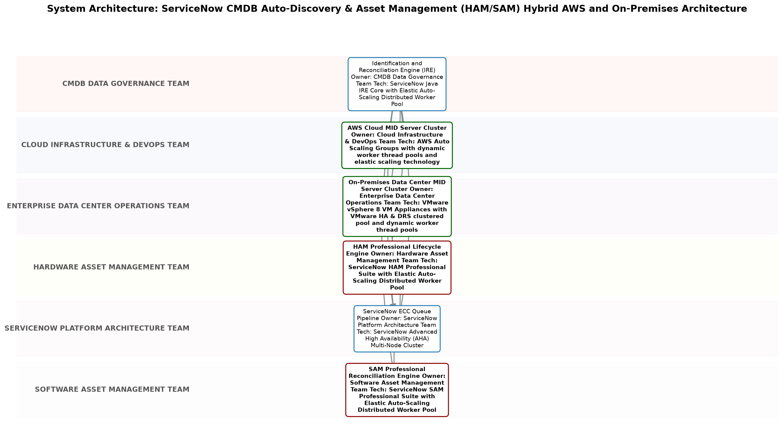

7.0 Quality Attributes
This section defines the quality attributes this design targets, mapped to ISO/IEC 25010 product quality characteristics.
Category | Description | Measure Method | Metric | Target
Maintainability (modifiability) | • Standardization of CMDB data structures, CSDM 4.0 lifecycle alignment, and automated pattern updates. | • CMDB Health Completeness and Correctness scores. | CMDB Health Correctness Score | >= 95% CMDB health score; zero unmanaged duplicate CIs
Performance Efficiency (time_behaviour) | • Capacity to ingest and process discovery payloads through ECC Queue and IRE without degrading UI or background processing. | • Automated platform transaction monitoring and ECC Queue throughput telemetry. | ECC Queue processing throughput and CI processing latency | >= 2,000 ECC Queue payloads/min; latency < 5 sec per CI payload
Reliability (availability) | • Availability of Discovery MID Server infrastructure and scheduled discovery pipeline execution. | • ServiceNow MID Server heartbeat monitoring and cluster health dashboards. | MID Server cluster uptime and probe success rate | 99.9% MID Server availability; probe success rate >= 98.5%
Security (confidentiality) | • Protection of discovery credentials and isolation of discovery traffic across hybrid network boundaries. | • Vulnerability scans, credential exposure auditing, and third-party penetration testing. | Zero credentials stored on MID disk; 100% outbound-only HTTPS traffic | Zero plaintext credential storage; zero inbound open ports

8.0 Compliance and Standards
This section lists the standards and regulatory requirements applicable to this design, and its current compliance status against each.

8.1 Applicable Standards
The following standards apply to this design:
Standard | Body | Clause Reference | Applicability | Compliance Status
ISO/IEC 19770-1 (Software Asset Management) | ISO/IEC | Clause 4 - 8 (SAM System Architecture & Reconciliation) | • Software asset lifecycle, software license entitlement reconciliation, and compliance metrics. | Compliant
ISO/IEC 27001 / SOC 2 Type II | ISO/IEC | A.9, A.10, A.12, A.13 (Access Control, Cryptography, Operations Security) | • Information security controls for cloud discovery, credential management, and CMDB access governance. | Compliant
NIST SP 800-53 Rev. 5 | NIST | AC-3, IA-2, SC-7, SC-8 (Access Enforcement, Identification, Boundary Protection) | • Security and privacy controls for hybrid enterprise discovery, credential vaulting, and network segmentation. | Compliant

8.2 Regulatory Requirements
The following regulatory requirements apply to this design:
Regulation | Jurisdiction | Requirement | Compliance Status
SOC 2 Type II Security & Confidentiality Trust Services Criteria | Global / Enterprise | • Discovery credentials must be encrypted in transit and at rest, and audit logs must capture all CI modification events and discovery runs. | Compliant

9.0 Governance Requirements
The following governance requirements apply to this architecture:
• All CI schema modifications and discovery pattern enhancements must be packaged as scoped applications or Update Sets and pass automated linting and CAB approval.
• Identification and Reconciliation Engine (IRE) rules must take precedence over direct table inserts to prevent duplicate CI generation.
• MID Server operating systems and OpenJDK runtimes must be patched within 30 days of vendor security releases.
• ServiceNow Discovery schedules must be throttled to avoid peak application transaction windows and Direct Connect saturation.

10.0 Continuous Improvement
The following continuous improvement practices apply to this architecture:
• Review Frequency: Quarterly
Improvement Inputs:
• Quarterly CMDB Health Dashboard reviews (Completeness, Correctness, Compliance)
• Discovery error logs and ECC Queue payload processing failure analytics
• Unrecognized software discovery models and monthly SAM normalization content service updates
• Hardware asset lifecycle discrepancy reports between physical inventory and CMDB CI records

PART II: LOW-LEVEL DESIGN (LLD)

11.0 Low-Level Design
This part elaborates the High-Level Design (Part I) into implementation-ready detail, organised by design discipline -- runtime behaviour, component design, interfaces, configuration, and operations -- so a reviewer interested in one discipline can find it in one place rather than across every component section.

11.1 Runtime Processing and Sequence Flows
The following sequence flows describe how this design's components interact at runtime to fulfil its key scenarios.

MID Server ECC Queue Task Polling and Ingestion Flow
Asynchronous polling and task retrieval loop executed by MID Server clusters against ServiceNow ECC Queue over HTTPS.
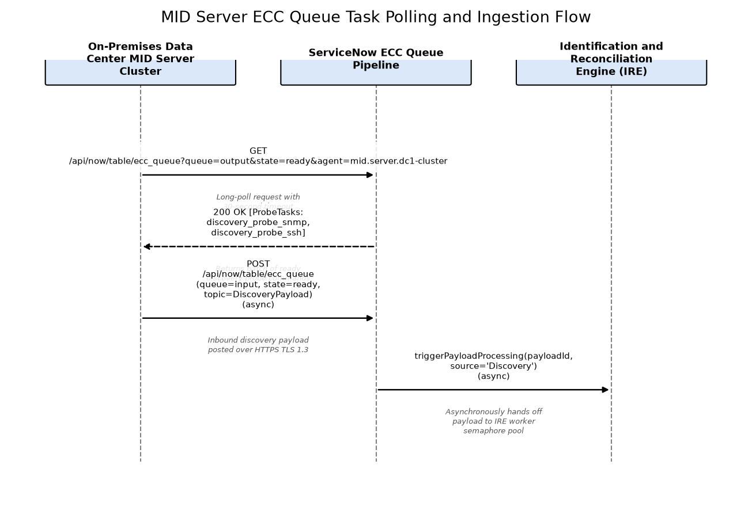

IRE Identification and Downstream ITAM Event Dispatch Flow
Runtime sequence of IRE payload processing, multi-source attribute reconciliation, and HAM/SAM event notification.
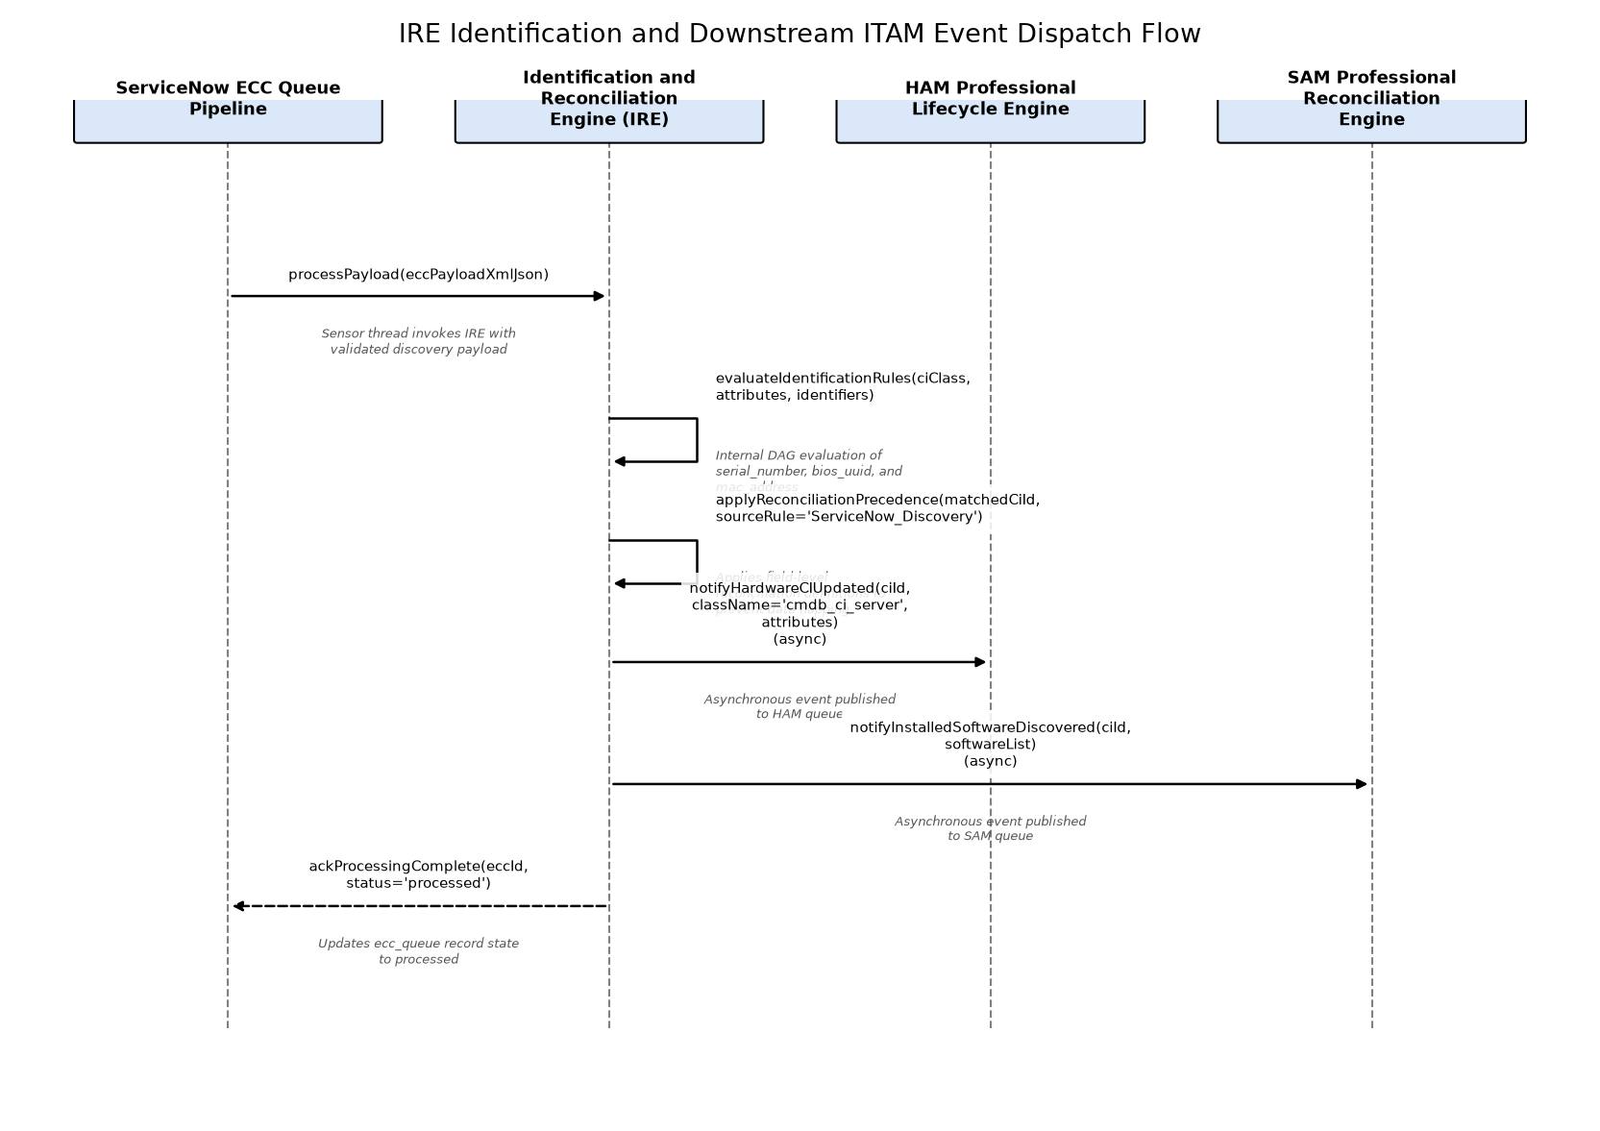

HAM Model Normalization and Asset Linkage Flow
Hardware normalization and bi-directional asset synchronization triggered by IRE CI updates.
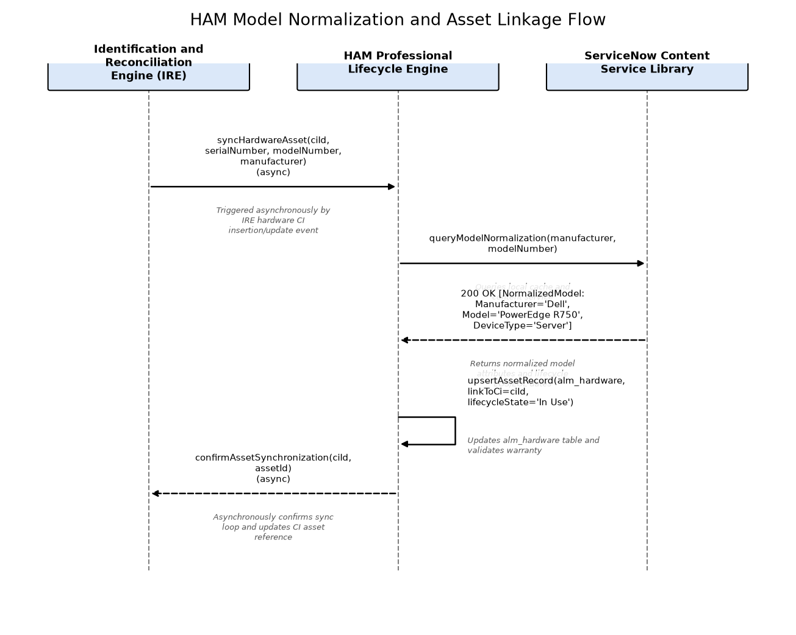

SAM Software Ingestion and Reconciliation Flow
Workflow of software installation ingestion, Content Service normalization, and publisher pack reconciliation run.
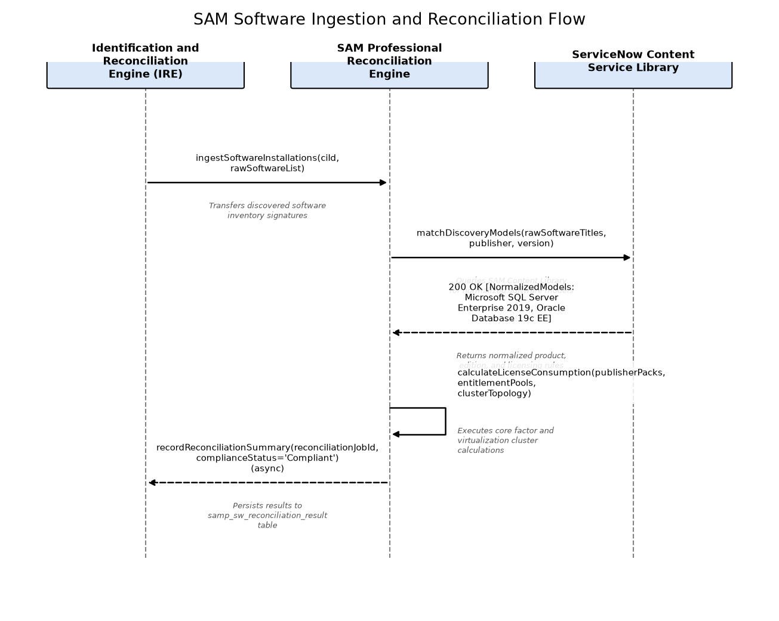

AWS Cloud Discovery and Credential Resolution Flow
Interaction sequence between AWS MID Server, AWS Secrets Manager, and AWS Cloud APIs during cloud inventory discovery.
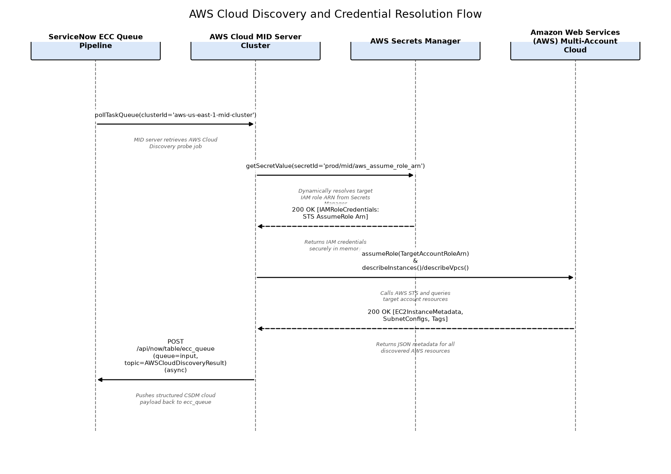

On-Premises Discovery and Dynamic Credential Resolution Flow
Deep agentless host interrogation sequence using dynamically brokered credentials from HashiCorp Vault.
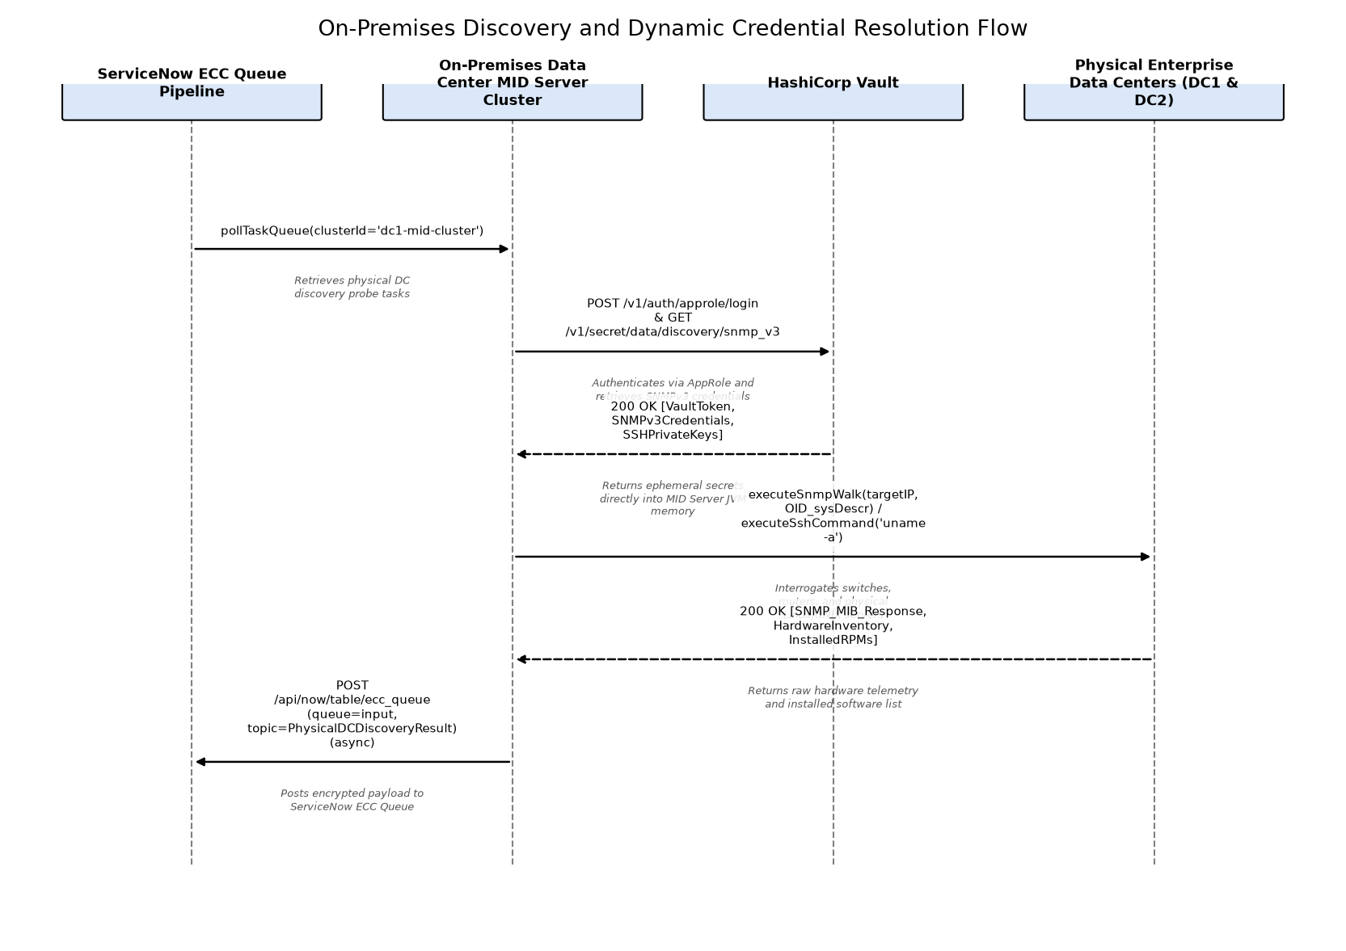

11.2 Component Design
The following describes each component's purpose, responsibilities, dependencies, key design decisions, and scope and operational boundaries.

AWS Cloud MID Server Cluster
Redundant cluster of MID Server instances running in AWS EC2 across multiple Availability Zones, responsible for executing agentless AWS Cloud Discovery and VPC internal subnet scans. Eliminates single point of failure via multi-AZ active-active clustering and automatic node failover.

HAM Professional Lifecycle Engine
Hardware Asset Management engine responsible for normalizing discovered hardware models, maintaining CI-to-Asset synchronization, and managing physical hardware lifecycle milestones. Eliminates single point of failure through multi-path data ingestion (asynchronous event bus from IRE or direct decoupling buffer from ECC Queue), local LRU content caching with offline normalization fallbacks, and resilient background job retries.

Identification and Reconciliation Engine (IRE)
ServiceNow core distributed identification engine executing deterministic identifier rules and reconciliation data precedence. Eliminates single point of failure and bottleneck risks through dynamic multi-threaded worker pools distributed across all cluster application nodes, multi-path ingestion from ECC Queue or direct MID worker REST endpoints, asynchronous non-blocking event publishing to HAM/SAM modules, and automated dead-letter queueing for ambiguous discovery payloads.

On-Premises Data Center MID Server Cluster
High-availability MID Server cluster deployed on VMware vSphere within dedicated on-premises DC management zones, responsible for discovering physical and virtual infrastructure. Eliminates single point of failure via N+1 clustered nodes and VMware HA/DRS failover.

SAM Professional Reconciliation Engine
Discovers installed software packages, normalizes software discovery models, performs automated license metric reconciliation, and calculates effective license positions. Explicitly incorporates redundant multi-path routing, decoupling buffers/queues, and multi-instance failover to remove it as a single point of failure in the dependency graph. Eliminates single point of failure (SPOF) through multi-instance redundancy across cluster nodes, decoupled asynchronous event consumption, multi-path data ingestion (asynchronous event bus from IRE or direct decoupling buffer from ECC Queue), local LRU content caching with offline normalization fallbacks, vendor-segmented batch processing, and rollback isolation.
Technology Stack:
• ServiceNow SAM Professional Suite with Elastic Auto-Scaling Distributed Worker Pool
• SAM Automated Reconciliation Engine with Publisher Isolation and Elastic Scaling
• Publisher Pack Algorithms (Microsoft, Oracle, IBM, VMware)
• Resilient Auto-Scaling Background Job Scheduler with Decoupled Event Buffering
• ServiceNow Content Service Library with Local LRU Memory Caching

ServiceNow ECC Queue Pipeline
Asynchronous high-throughput message pipeline managing discovery probe task distribution (output) and payload ingestion (input) between ServiceNow SaaS and distributed MID Servers.

11.3 Interface Design
The following interfaces are exposed or consumed by this design's components.
Interface | Owning Component | Protocol | Authentication | Error Handling
ServiceNow ECC Queue REST Table API | ServiceNow ECC Queue Pipeline | REST | Mutual TLS (mTLS) with client certificate verification and rotating instance token | • HTTP 400 Bad Request on schema violation; HTTP 429 Too Many Requests with Retry-After header on semaphore pool saturation; HTTP 500 on database write failure.
IdentificationEngineScriptableApi | Identification and Reconciliation Engine (IRE) | REST | ServiceNow Platform Scoped Internal API Session or OAuth 2.0 Client Credentials | • Returns IdentificationOutput object with error codes (e.g. MULTI_MATCH_FOUND, MISSING_DEPENDENCY, RULE_NOT_FOUND) without throwing unhandled exceptions.
HAM Model Normalization & Asset Linkage API | HAM Professional Lifecycle Engine | REST | OAuth 2.0 Bearer Token with sn_itam_ham.admin or platform role | • HTTP 404 if model not found in content catalog; marks model as 'Normalization Pending' and schedules background library sync.
SAM Software License Reconciliation Engine API | SAM Professional Reconciliation Engine | REST | OAuth 2.0 Client Credentials with sn_sam.admin role | • HTTP 409 Conflict if reconciliation run is already active; HTTP 422 if entitlement parameters are incomplete; logs errors to samp_reconciliation_log.
AWS Cloud Interrogation & Secrets SDK API | AWS Cloud MID Server Cluster | REST | AWS IAM SigV4 via EC2 Instance Profile and STS AssumeRole | • AWS client throttling (HTTP 429) triggers exponential backoff with full jitter. Account access denied (HTTP 403) logs security exception and skips account to complete remaining accounts.
HashiCorp Vault Dynamic Credential API | On-Premises Data Center MID Server Cluster | REST | Vault AppRole Token (Header: X-Vault-Token) over TLS 1.3 | • HTTP 403 on token expiration triggers immediate AppRole re-authentication; HTTP 404 logs target subnet credential missing error and skips IP without crashing probe cycle.

11.4 Configuration Design
The following consolidates the key configuration parameters for each component.

ServiceNow ECC Queue Pipeline
Default Value | Description | Name | Type
5000 | Maximum payload size in kilobytes allowed in ecc_queue payload column before forcing attachment offloading. | glide.discovery.ecc_queue.max_payload_size_kb | integer
100 | Maximum number of discovery output messages returned to a polling MID Server per HTTP request. | glide.ecc_queue.max_batch_size | integer
7 | Number of days before processed ecc_queue records are purged by scheduled table rotation. | glide.ecc_queue.retention_days | integer
60 | Semaphore wait timeout in seconds for ecc_queue insert threads during peak load. | glide.ecc_queue.semaphore_timeout_sec | integer

Identification and Reconciliation Engine (IRE)
Default Value | Description | Name | Type
true | Enables multi-source CMDB tracking to store attribute-level discovery values per source in sys_multisource_data. | glide.cmdb.logger.enable_multisource | boolean
false | If true, allows creating partial CI payloads when required identifier attributes are absent; defaults to false to prevent dirty data. | glide.identification_engine.allow_partial_ci | boolean
120 | Maximum seconds allowed for an IRE identification batch transaction before timing out. | glide.identification_engine.batch_timeout_sec | integer
true | Enforces strict hardware serial number formatting and ignores bogus serials like 'System Serial Number' or 'To Be Filled By O.E.M.'. | glide.identification_engine.strict_serial_validation | boolean

HAM Professional Lifecycle Engine
Default Value | Description | Name | Type
true | Enables automated creation of alm_hardware asset records upon IRE discovery of new hardware CIs. | glide.ham.auto_create_asset | boolean
weekly | Automated sync frequency for ServiceNow Hardware Content Service normalization rule updates. | glide.ham.content_sync_frequency | string
true | Enforces bi-directional state synchronization between cmdb_ci operational_status and alm_hardware install_status. | glide.ham.enforce_status_sync | boolean
30 | Threshold days before hardware warranty expiration to generate automated renewal tasks. | glide.ham.warranty_alert_threshold_days | integer

SAM Professional Reconciliation Engine
Default Value | Description | Name | Type
true | Automatically normalize raw software installation strings against ServiceNow SAM Content Library rules. | glide.sam.software_model_auto_normalization | boolean
02:00:00 | Scheduled run time for weekly automated license reconciliation engine batch execution. | glide.sam.reconciliation_schedule_time | string
90 | Inactivity threshold in days before installed software with zero execution events is flagged for reclamation. | glide.sam.reclamation_inactivity_threshold_days | integer
true | Enforces Oracle multi-tenant and VMware ESXi cluster virtualization affinity calculation rules. | glide.sam.enable_complex_cluster_licensing | boolean

AWS Cloud MID Server Cluster
Default Value | Description | Name | Type
50 | Maximum number of concurrent probe worker threads allocated on each AWS MID Server node. | mid.aws.threadpool.max_threads | integer
14400 | Discovery schedule timeout in seconds for AWS cross-account scanning sweeps. | mid.aws.discovery_timeout_sec | integer
true | Enforces pagination with max 1000 items per call during AWS API resource enumerations. | mid.aws.enable_api_pagination | boolean
300 | TTL in seconds for cached STS AssumeRole credentials in MID Server JVM memory before re-authenticating. | mid.aws.credentials_cache_ttl_sec | integer

On-Premises Data Center MID Server Cluster
Default Value | Description | Name | Type
64 | Maximum concurrent discovery worker threads per on-premise MID virtual machine. | mid.discovery.threads.max | integer
1500 | SNMP probe connection timeout in milliseconds before retrying. | mid.snmp.timeout_ms | integer
3000 | SSH connection handshake timeout in milliseconds. | mid.ssh.connection_timeout_ms | integer
1800 | HashiCorp Vault client token lease renewal interval in seconds. | mid.vault.token_renew_interval_sec | integer

11.5 Operational Design
The following consolidates monitoring, logging, alerting, capacity, and error-recovery behaviour across this design's components.

ServiceNow ECC Queue Pipeline

Logging And Monitoring
Log Levels:
- INFO (production baseline)
- WARN (retry and schema anomalies)
- DEBUG (probe payload trace)
Alerting Rules:
- Trigger P2 alert if ecc_queue backlog in 'ready' state exceeds 10,000 items for > 15 minutes
- Trigger P1 alert if ecc_queue insert latency exceeds 3,000ms for 3 consecutive check intervals
Monitored Metrics:
- ecc_queue.ingest_rate_per_sec
- ecc_queue.ready_backlog_count
- ecc_queue.processing_latency_ms
- ecc_queue.attachment_offload_count

Identification and Reconciliation Engine (IRE)

Logging And Monitoring
Log Levels:
- INFO (identification decisions)
- WARN (rule non-matches, multi-match conflicts)
- DEBUG (rule evaluation DAG steps)
Monitored Metrics:
- ire.payloads_processed_per_min
- ire.identification_match_rate
- ire.duplicate_candidates_detected
- ire.attribute_reconciliation_overrides
Alerting Rules:
- Trigger P2 alert if IRE identification errors exceed 5% of processed payloads over 30 minutes
- Trigger P2 alert if sys_ire_duplicate_metric unhandled duplicate count increases by > 50 in 1 hour

HAM Professional Lifecycle Engine

Logging And Monitoring
Log Levels:
- INFO (asset creation and state transitions)
- WARN (normalization misses, mismatch flags)
- DEBUG (normalization lookup steps)
Monitored Metrics:
- ham.normalized_hardware_rate_percent
- ham.assets_created_from_discovery_total
- ham.ci_asset_sync_errors_total
- ham.warranty_status_evaluated_total
Alerting Rules:
- Alert Asset Operations Lead if un-normalized hardware models exceed 100 in 24 hours
- Alert ITAM team if asset-to-CI synchronization failures exceed 1% of discovered hardware

SAM Professional Reconciliation Engine

Logging And Monitoring
Monitored Metrics:
- sam.software_installations_normalized_rate
- sam.reconciliation_execution_duration_sec
- sam.license_compliance_position_ratio
- sam.reclamation_candidates_count
Log Levels:
- INFO (reconciliation batch start/finish)
- WARN (unlicensed installations, missing metric definitions)
- DEBUG (core factor calculation traces)
Alerting Rules:
- Trigger P2 alert if SAM automated reconciliation run fails or times out after 4 hours
- Trigger P2 alert if software license non-compliance true-up exposure exceeds $100,000 threshold

AWS Cloud MID Server Cluster

Logging And Monitoring
Alerting Rules:
- Trigger P2 alert if AWS MID Server JVM memory utilization exceeds 85% for > 10 minutes
- Trigger P2 alert if STS AssumeRole failure rate exceeds 10% across any target AWS account
Log Levels:
- INFO (discovery run lifecycle)
- WARN (AWS API throttling, retried connections)
- ERROR (authentication and network reachability faults)
Monitored Metrics:
- mid.aws.active_worker_threads
- mid.aws.api_calls_rate_per_sec
- mid.aws.jvm_heap_usage_percent
- mid.aws.discovered_instances_count

On-Premises Data Center MID Server Cluster

Logging And Monitoring
Alerting Rules:
- Trigger P2 alert if on-premises MID Server loses connectivity to HashiCorp Vault for > 5 minutes
- Trigger P2 alert if SNMPv3 probe authentication failure rate exceeds 20% on any subnet sweep
Log Levels:
- INFO (probe batch start/completion)
- WARN (connection timeouts, authentication retries)
- DEBUG (command output and MIB walk parsing)
Monitored Metrics:
- mid.onprem.active_snmp_sessions
- mid.onprem.active_ssh_sessions
- mid.onprem.vault_token_time_to_expire_sec
- mid.onprem.probes_succeeded_total
- mid.onprem.probes_failed_total

11.6 Detailed Engineering Design
This section is included only where the source content goes beyond architecture-level detail into concrete engineering constructs. It supports engineering implementation rather than architecture governance review, and can be skipped by reviewers focused on the latter.

ServiceNow ECC Queue Pipeline
Algorithm Details: The ECC Queue Manager uses a non-blocking poll loop over HTTPS with HTTP/2 multiplexing. Output tasks (probes) are pulled by registered MID servers using a round-robin lease acquisition with optimistic locking on the 'state' column (transitioning from 'ready' to 'processing'). Inbound payloads are staged in memory, validated against XML/JSON schema schemas, compressed with GZIP if exceeding 1MB, and committed to MariaDB in batch sizes of 100 rows. A background sweeper purges processed messages older than 7 days to preserve relational table performance.
Unit Test Strategy: JUnit 5 test suite validating payload batch dequeuing, schema validation failure edge cases, GZIP offloading, and semaphore thread contention handling. Target code coverage: >= 85%.

Class Design

ECC Queue Pipeline Class Diagram
UML Class diagram depicting ECCQueueManager, ECCPayloadValidator, and ECCDispatcherService within the ServiceNow core messaging tier.
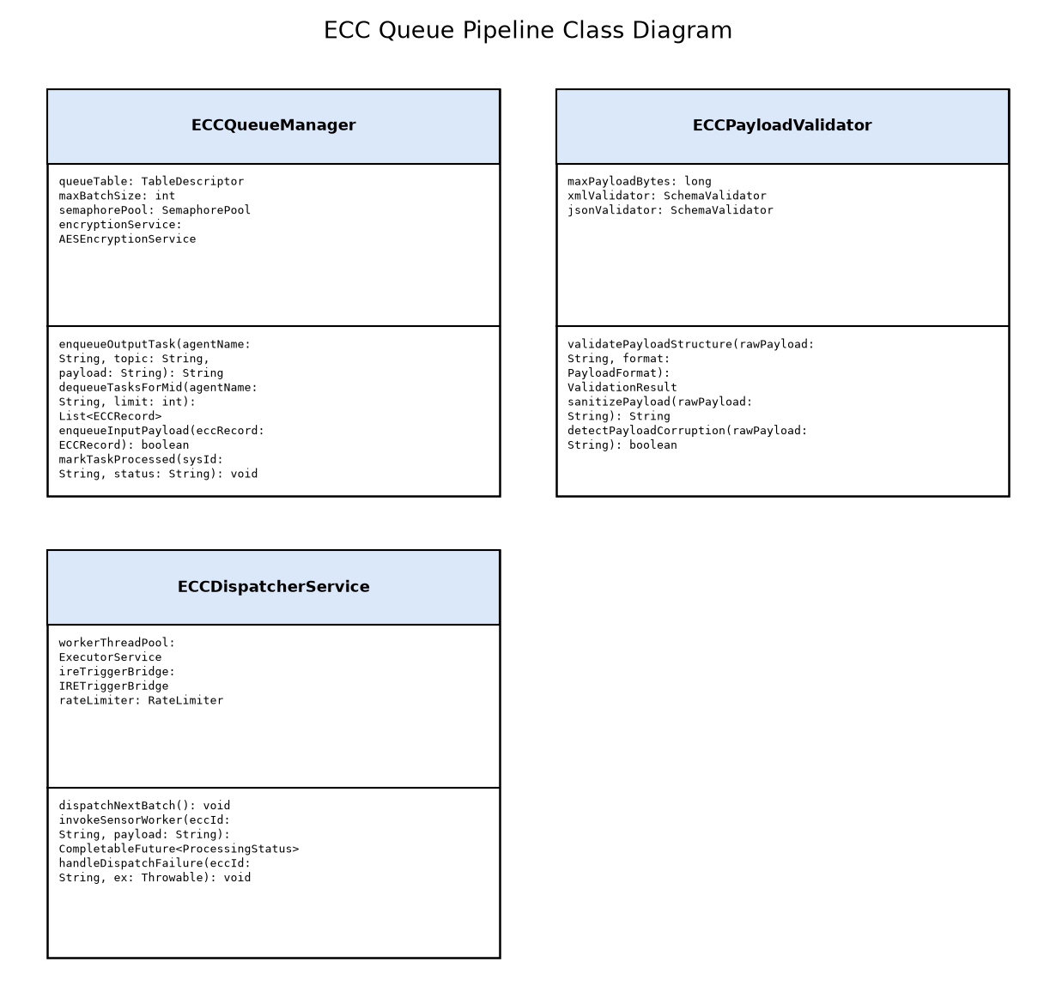

Classes
Attributes | Class Name | Design Patterns Used | Methods
- queueTable: TableDescriptor  - maxBatchSize: int  - semaphorePool: SemaphorePool  - encryptionService: AESEncryptionService | ECCQueueManager | - Producer-Consumer  - Repository Pattern  - Object Pool | - enqueueOutputTask(agentName: String, topic: String, payload: String): String  - dequeueTasksForMid(agentName: String, limit: int): List<ECCRecord>  - enqueueInputPayload(eccRecord: ECCRecord): boolean  - markTaskProcessed(sysId: String, status: String): void
- maxPayloadBytes: long  - xmlValidator: SchemaValidator  - jsonValidator: SchemaValidator | ECCPayloadValidator | - Strategy Pattern  - Chain of Responsibility | - validatePayloadStructure(rawPayload: String, format: PayloadFormat): ValidationResult  - sanitizePayload(rawPayload: String): String  - detectPayloadCorruption(rawPayload: String): boolean
- workerThreadPool: ExecutorService  - ireTriggerBridge: IRETriggerBridge  - rateLimiter: RateLimiter | ECCDispatcherService | - Observer Pattern  - Worker Thread Pattern | - dispatchNextBatch(): void  - invokeSensorWorker(eccId: String, payload: String): CompletableFuture<ProcessingStatus>  - handleDispatchFailure(eccId: String, ex: Throwable): void

Identification and Reconciliation Engine (IRE)
Algorithm Details: The IRE evaluates incoming payloads against hierarchical sys_class_path identifier rules using a Directed Acyclic Graph (DAG) search. The matching engine evaluates identification criteria sequentially: 1) Cloud ARN / Resource UUID, 2) Hardware BIOS Serial Number + Model, 3) MAC Address + IP Address, 4) FQDN. If a single unique CI matches, the reconciliation engine checks the DataSource Rule Matrix to ensure the incoming data source (e.g. Discovery) has write precedence over existing attribute values. If multiple CIs match with equal confidence, an IRE multi-match error is logged and routed to CMDB Data Manager to avoid CI corruption.
Unit Test Strategy: Automated JUnit and Spock tests covering rule priority evaluation, multi-match detection, data source rule matrix overrides, and CSDM table hierarchy inheritance. Coverage >= 90%.

Class Design

IRE Identification & Reconciliation Class Diagram
UML Class diagram depicting IdentificationService, ReconciliationManager, and IREPayloadProcessor components.
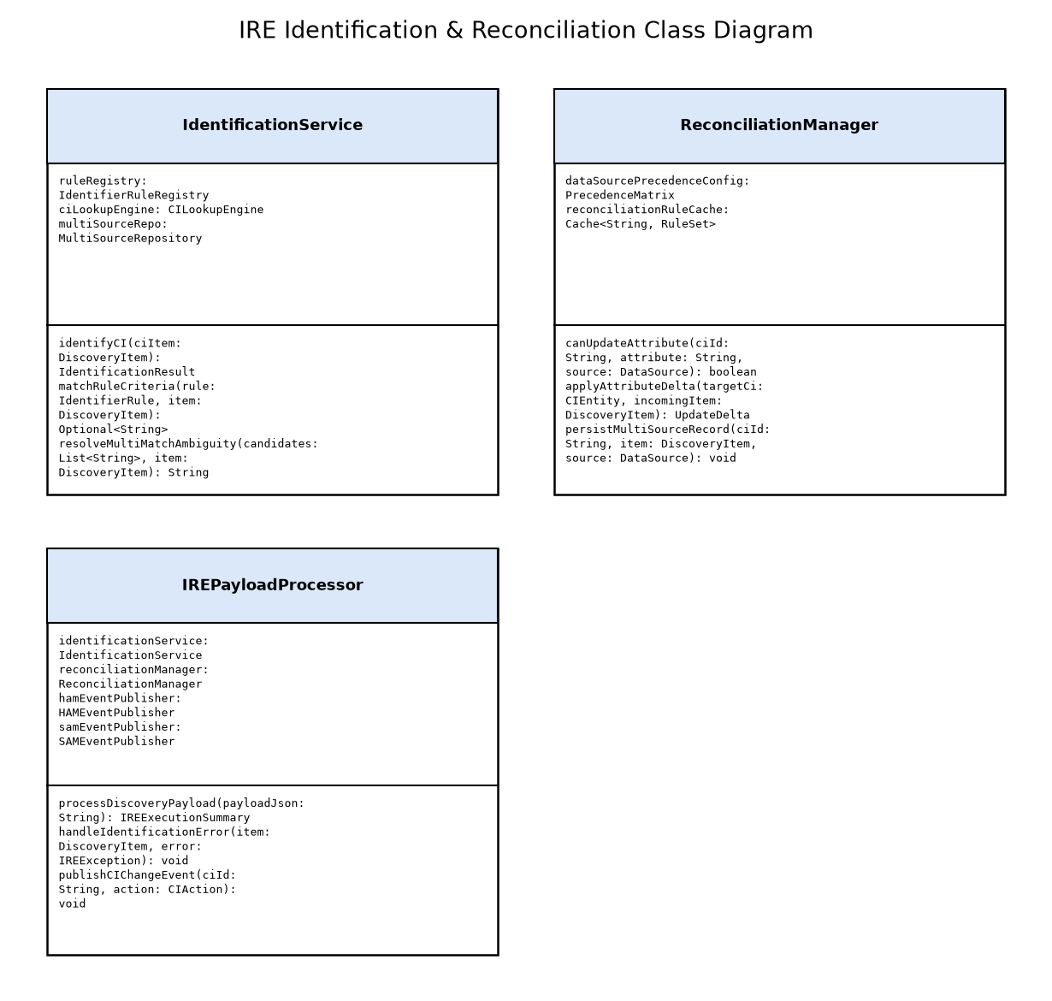

Classes
Attributes | Class Name | Design Patterns Used | Methods
- ruleRegistry: IdentifierRuleRegistry  - ciLookupEngine: CILookupEngine  - multiSourceRepo: MultiSourceRepository | IdentificationService | - Strategy Pattern  - Specification Pattern  - Template Method | - identifyCI(ciItem: DiscoveryItem): IdentificationResult  - matchRuleCriteria(rule: IdentifierRule, item: DiscoveryItem): Optional<String>  - resolveMultiMatchAmbiguity(candidates: List<String>, item: DiscoveryItem): String
- dataSourcePrecedenceConfig: PrecedenceMatrix  - reconciliationRuleCache: Cache<String, RuleSet> | ReconciliationManager | - Chain of Responsibility  - Rules Engine Pattern | - canUpdateAttribute(ciId: String, attribute: String, source: DataSource): boolean  - applyAttributeDelta(targetCi: CIEntity, incomingItem: DiscoveryItem): UpdateDelta  - persistMultiSourceRecord(ciId: String, item: DiscoveryItem, source: DataSource): void
- identificationService: IdentificationService  - reconciliationManager: ReconciliationManager  - hamEventPublisher: HAMEventPublisher  - samEventPublisher: SAMEventPublisher | IREPayloadProcessor | - Facade Pattern  - Mediator Pattern | - processDiscoveryPayload(payloadJson: String): IREExecutionSummary  - handleIdentificationError(item: DiscoveryItem, error: IREException): void  - publishCIChangeEvent(ciId: String, action: CIAction): void

HAM Professional Lifecycle Engine
Algorithm Details: Upon receiving a CI change event from IRE, the HAM engine executes normalization: 1) Extract raw manufacturer and model number; 2) Query local cache for normalized hardware product model; 3) If cache miss, invoke ServiceNow Content Library via HTTPS; 4) Map model to hardware category taxonomy (Server, Switch, Storage, Chassis); 5) Synchronize physical attributes to alm_hardware asset record (serial_number, asset_tag, install_status, location); 6) If CI is newly discovered without an asset, instantiate an alm_hardware record with status 'In Use' and link foreign keys.
Unit Test Strategy: JUnit 5 and Mockito tests covering hardware catalog normalization matching, un-normalized model queueing, asset-to-CI status mapping, and lifecycle state machines. Coverage >= 85%.

Class Design

Classes
Attributes | Class Name | Design Patterns Used | Methods
- contentLibraryClient: ContentLibraryClient  - modelCache: LRUCache<String, NormalizedHardwareModel>  - ruleRepository: HAMRuleRepository | HardwareNormalizationService | - Adapter Pattern  - Cache-Aside Pattern  - Factory Method | - normalizeHardware(rawMfg: String, rawModel: String): NormalizedHardwareModel  - inferDeviceCategory(mfgModel: NormalizedHardwareModel, chassisType: String): ModelCategory  - flagUnnormalizedModel(rawMfg: String, rawModel: String): void
- assetRepository: AssetRepository  - ciRepository: CIRepository  - lifecycleStateMachine: LifecycleStateMachine | AssetCISynchronizer | - State Pattern  - Observer Pattern  - Data Mapper | - synchronizeAssetFromCI(ciRecord: HardwareCIRecord): AssetSynchronizationResult  - createAssetFromDiscoveredCI(ciRecord: HardwareCIRecord): String  - updateAssetStatus(assetId: String, status: AssetInstallStatus): void
- warrantyService: WarrantyService  - auditLogger: AssetAuditLogger  - depreciationEngine: DepreciationEngine | HardwareLifecycleManager | - Strategy Pattern  - Template Method | - evaluateLifecycleState(asset: AlmHardware): LifecyclePhase  - checkWarrantyStatus(serialNumber: String): WarrantyDetail  - triggerAssetRetirementWorkflow(assetId: String): void

HAM Professional Lifecycle Engine Class Diagram
UML Class diagram depicting HardwareNormalizationService, AssetCISynchronizer, and HardwareLifecycleManager.
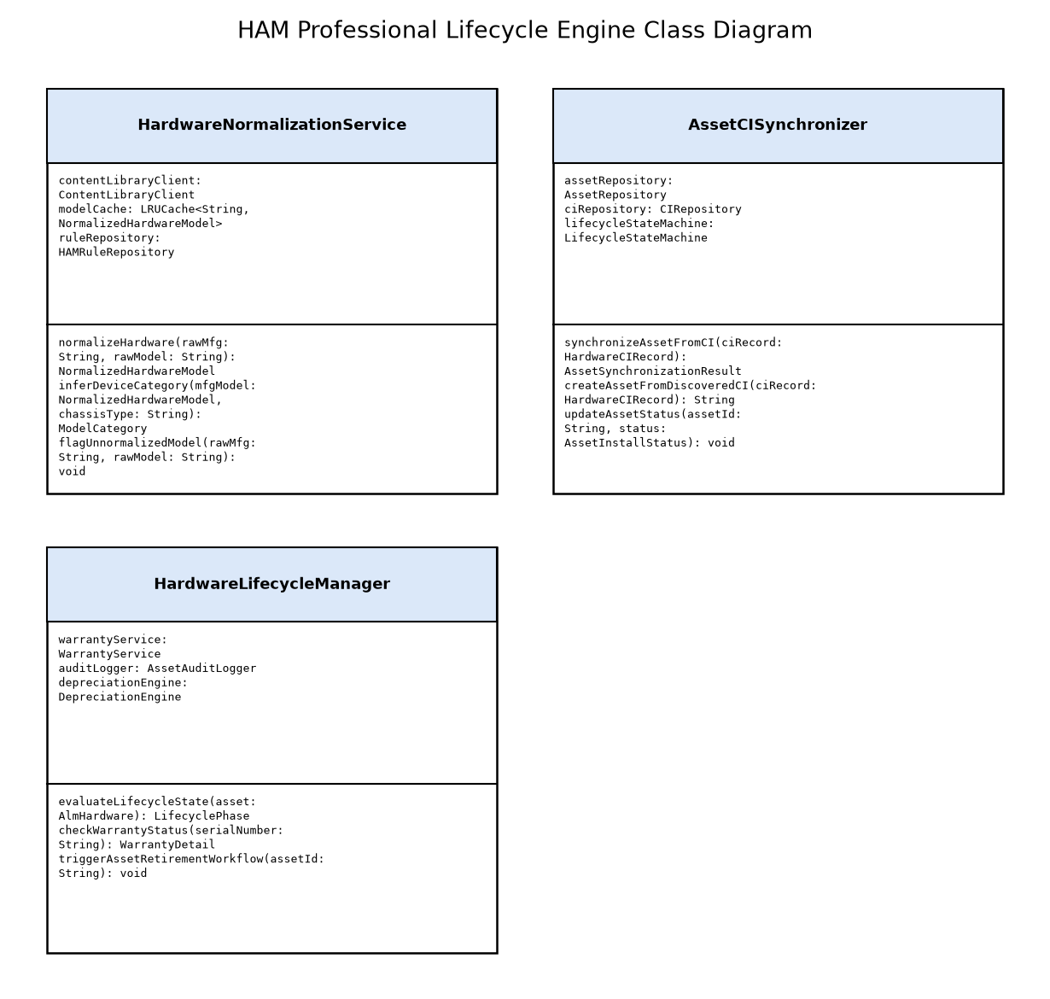

SAM Professional Reconciliation Engine
Algorithm Details: The SAM Reconciliation Engine processes software installation records: 1) Matches discovered software title, publisher, and version strings against the Software Content Library to create or link normalized Software Discovery Models; 2) Checks the 'Licensable' flag; 3) Gathers infrastructure metrics (CPU core counts, physical sockets, virtualization hypervisor cluster topology, AWS vCPU allocation); 4) Executes vendor-specific Publisher Pack algorithms (e.g. Microsoft SQL Core-based licensing with minimum 4 cores/processor, Oracle Database Core Factor metric with hyper-threading adjustments); 5) Evaluates consumed rights against active software entitlements (samp_sw_entitlement) to generate compliant, over-licensed, or unlicensed Effective License Positions (ELP).
Unit Test Strategy: Unit tests validating Microsoft Per-Core, Oracle Core Factor, IBM PVU, and VMware socket license metric algorithms against mock entitlement inventories. Code coverage >= 85%.

Class Design

SAM Professional Reconciliation Engine Class Diagram
UML Class diagram depicting SoftwareDiscoveryModelNormalizer, LicenseReconciliationProcessor, and OptimizationCandidateGenerator.
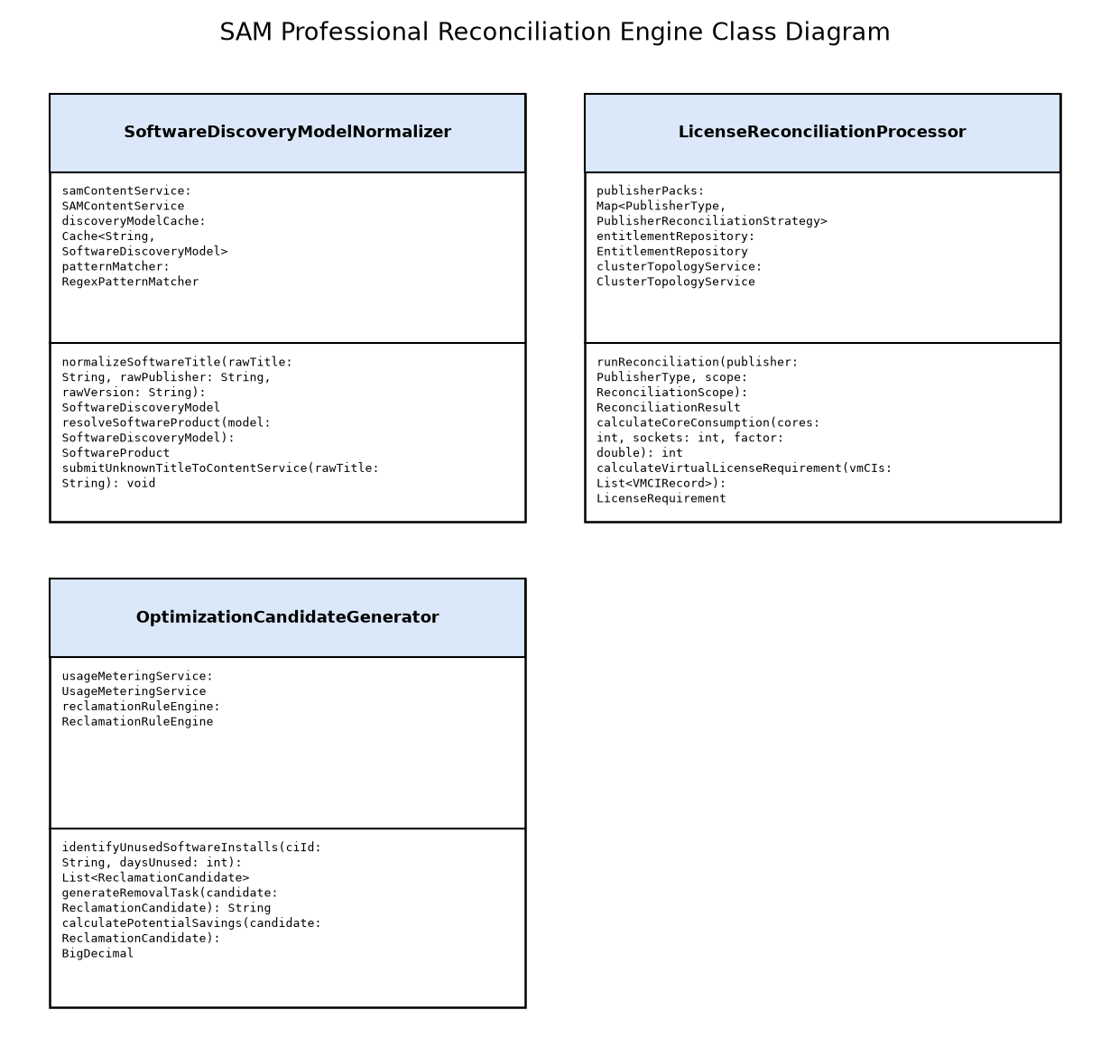

Classes
Attributes | Class Name | Design Patterns Used | Methods
- samContentService: SAMContentService  - discoveryModelCache: Cache<String, SoftwareDiscoveryModel>  - patternMatcher: RegexPatternMatcher | SoftwareDiscoveryModelNormalizer | - Flyweight Pattern  - Interpreter Pattern  - Adapter Pattern | - normalizeSoftwareTitle(rawTitle: String, rawPublisher: String, rawVersion: String): SoftwareDiscoveryModel  - resolveSoftwareProduct(model: SoftwareDiscoveryModel): SoftwareProduct  - submitUnknownTitleToContentService(rawTitle: String): void
- publisherPacks: Map<PublisherType, PublisherReconciliationStrategy>  - entitlementRepository: EntitlementRepository  - clusterTopologyService: ClusterTopologyService | LicenseReconciliationProcessor | - Strategy Pattern  - Composite Pattern  - Visitor Pattern | - runReconciliation(publisher: PublisherType, scope: ReconciliationScope): ReconciliationResult  - calculateCoreConsumption(cores: int, sockets: int, factor: double): int  - calculateVirtualLicenseRequirement(vmCIs: List<VMCIRecord>): LicenseRequirement
- usageMeteringService: UsageMeteringService  - reclamationRuleEngine: ReclamationRuleEngine | OptimizationCandidateGenerator | - Factory Method  - Builder Pattern | - identifyUnusedSoftwareInstalls(ciId: String, daysUnused: int): List<ReclamationCandidate>  - generateRemovalTask(candidate: ReclamationCandidate): String  - calculatePotentialSavings(candidate: ReclamationCandidate): BigDecimal

AWS Cloud MID Server Cluster
Algorithm Details: The AWS Cloud MID Server executes cloud discovery: 1) Fetches cross-account AssumeRole credentials dynamically from AWS Secrets Manager using IAM instance profile credentials; 2) Assumes target account IAM roles via AWS STS AssumeRole API (3600-second token duration); 3) Queries AWS Organizations for active accounts; 4) Calls AWS EC2 DescribeInstances, RDS DescribeDBInstances, and VPC APIs across enabled regions; 5) Translates AWS JSON responses into standardized ServiceNow Cloud Discovery CSDM payload; 6) Initiates agentless OS deep discovery on private IP subnets via WinRM/SSH for EC2 instances tagged for OS scanning; 7) Transmits structured results to ecc_queue (queue=input) over TLS 1.3 HTTPS.
Unit Test Strategy: Mock AWS SDK clients using LocalStack and Mockito; test IAM AssumeRole credential caching, regional failover, and CSDM cloud payload transformation accuracy. Code coverage >= 85%.

Class Design

Classes
Attributes | Class Name | Design Patterns Used | Methods
- awsSecretsClient: AWSSecretsClient  - stsAssumeRoleClient: STSAssumeRoleClient  - ec2Client: AmazonEC2Client  - rdsClient: AmazonRDSClient | AWSDiscoveryWorker | - Template Method  - Builder Pattern  - Client Facade | - discoverAccountResources(accountId: String, roleArn: String): CloudDiscoveryPayload  - enumerateEC2Instances(region: String): List<EC2InstanceMetadata>  - enumerateVpcsAndSubnets(region: String): List<VpcMetadata>  - publishResultsToECCQueue(payload: CloudDiscoveryPayload): void
- kmsKeyId: String  - secretsCache: ExpiringCache<String, String>  - awsRegion: String | AWSSecretsManagerResolver | - Proxy Pattern  - Singleton Pattern  - Decorator Pattern | - resolveSecret(secretArn: String): SecretPayload  - assumeCrossAccountRole(targetRoleArn: String): AWSCredentials  - invalidateExpiredTokens(): void
- heartbeatSender: HeartbeatSender  - threadExecutor: ThreadPoolExecutor  - taskQueue: BlockingQueue<ECCProbeTask> | AWSMidClusterLoadBalancer | - Worker Thread Pattern  - Observer Pattern | - pollECCQueue(): void  - assignTaskToWorker(task: ECCProbeTask): void  - reportNodeHealth(cpuLoad: double, memoryUsage: double): void

AWS Cloud MID Server Cluster Class Diagram
UML Class diagram depicting AWSDiscoveryWorker, AWSSecretsManagerResolver, and AWSMidClusterLoadBalancer on AWS EC2 MID instances.
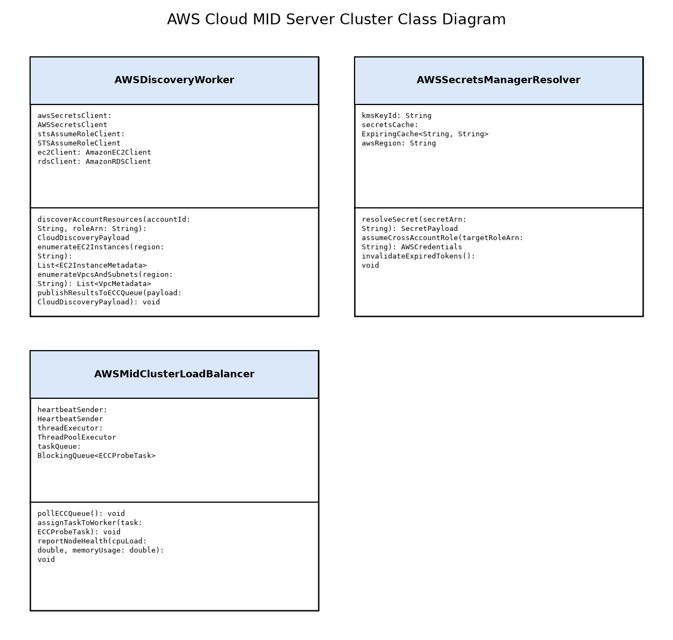

On-Premises Data Center MID Server Cluster
Algorithm Details: The On-Premises MID Server interrogates enterprise physical infrastructure: 1) Retrieves probe task specifying target IP network ranges; 2) Contacts HashiCorp Vault over mutual TLS using AppRole authentication to obtain ephemeral SNMPv3 credentials, SSH keys, or WinRM tokens; 3) Executes SNMPv3 get/walk against network switches and PDUs extracting sysDescr, chassis serial, and MAC forwarding tables; 4) Executes SSH commands on Linux/AIX/Solaris hosts collecting uname, lscpu, prtconf, and installed RPM/BFF package lists; 5) Executes PowerShell/WinRM commands on Windows hosts collecting Win32_ComputerSystem and registry software uninstall keys; 6) Zero credentials written to disk; credentials are wiped from JVM heap immediately after socket closure; 7) Formats discovery payload and posts to ecc_queue (queue=input).
Unit Test Strategy: Unit tests simulating SNMP MIB walking using SNMP4J test agents, mocking Vault AppRole HTTP endpoints, and testing memory sanitation of private keys. Coverage >= 85%.

Class Design

Classes
Attributes | Class Name | Design Patterns Used | Methods
- snmpSessionManager: SNMPSessionManager  - mibRepository: MIBRepository  - rateLimiter: RateLimiter | SNMPDiscoveryWorker | - Strategy Pattern  - Adapter Pattern | - executeSNMPv3Walk(ipAddress: String, securityProfile: SNMPv3Profile): Map<String, String>  - extractNetworkChassisDetails(snmpData: Map<String, String>): ChassisMetadata  - extractVlanAndInterfaceTable(ipAddress: String): List<InterfaceMetadata>
- vaultBaseUrl: String  - appRoleId: String  - vaultToken: AtomicReference<String>  - tokenLeaseExpiry: AtomicLong | VaultCredentialBroker | - Proxy Pattern  - Singleton Pattern  - Retry Pattern | - authenticateAppRole(): String  - fetchDiscoveryCredentials(vaultPath: String): CredentialBundle  - revokeToken(): void  - renewLease(): void
- sshClientPool: SSHClientPool  - winRmClientPool: WinRmClientPool  - credentialBroker: VaultCredentialBroker | HostDeepDiscoveryWorker | - Template Method  - Abstract Factory  - Command Pattern | - interrogateLinuxHost(ipAddress: String, sshCred: SSHCredential): HostInventoryPayload  - interrogateWindowsHost(ipAddress: String, winRmCred: WinRmCredential): HostInventoryPayload  - parseInstalledPackages(rawOutput: String, osFamily: OSFamily): List<RawSoftwareSignature>

On-Premises Data Center MID Server Cluster Class Diagram
UML Class diagram depicting SNMPDiscoveryWorker, VaultCredentialBroker, and HostDeepDiscoveryWorker on VMware MID virtual appliances.
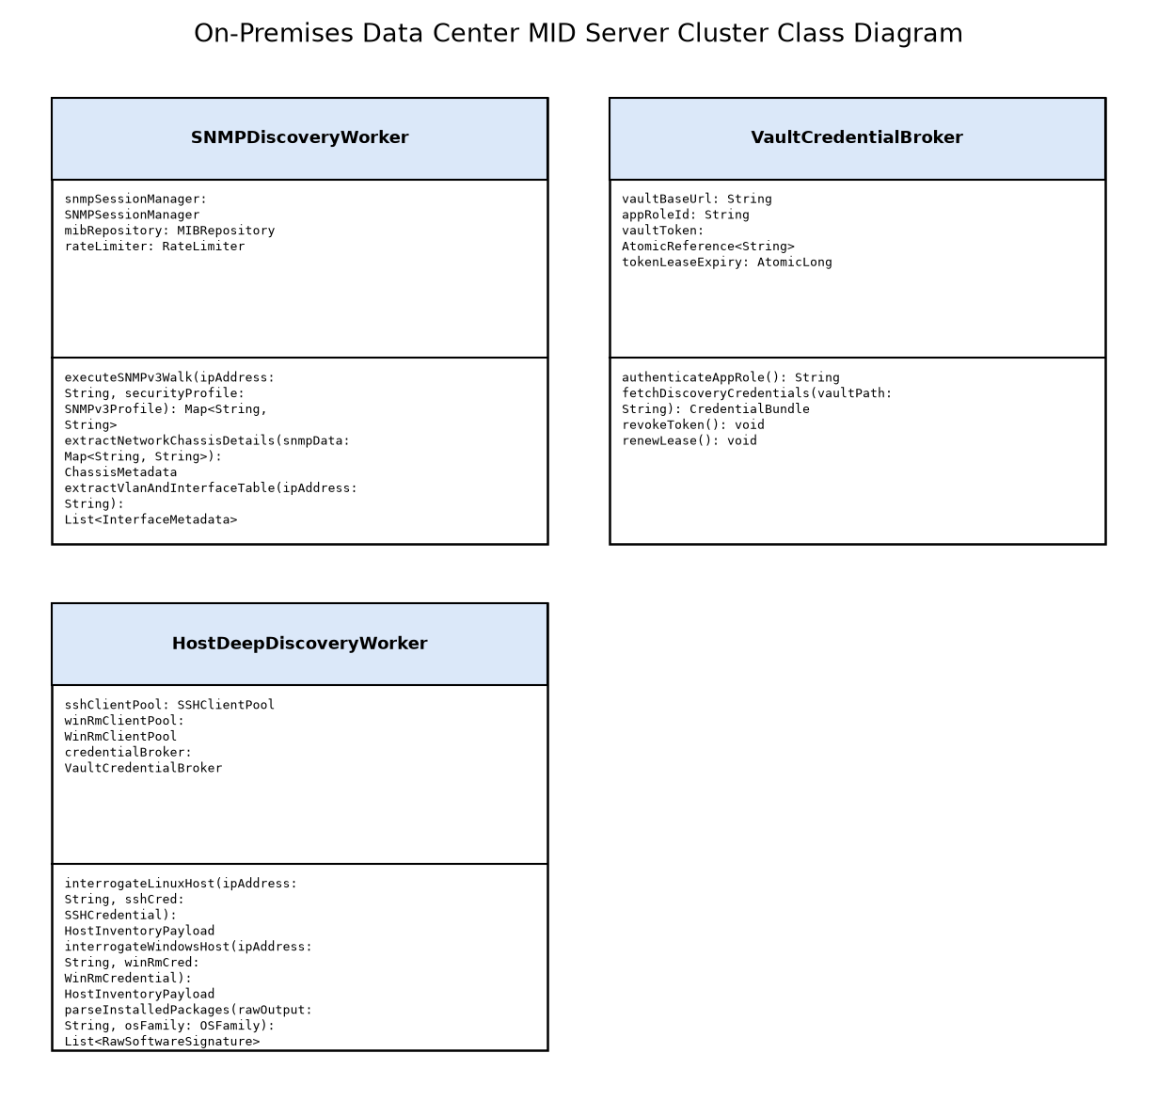

12.0 Glossary and References

Diagrams

Hybrid Discovery Conceptual Architecture
Conceptual system context diagram illustrating hybrid discovery architecture across AWS and on-premises enterprise data centers.
[Context not yet generated for this document.]

Glossary
Definition | Term
External Communication Channel Queue - a persistent messaging table in ServiceNow used to asynchronously queue discovery commands (output) and receive probe results (input) from MID Servers. | ECC Queue
Identification and Reconciliation Engine - a centralized platform component in ServiceNow that evaluates incoming discovery data against identifier rules to prevent duplicate CIs. | IRE
Management, Instrumentation, and Discovery Server - a Java application running inside a customer network that facilitates communication and probe execution between ServiceNow and internal IT resources. | MID Server
Common Service Data Model - a ServiceNow framework and prescriptive data model that maps IT components, services, and business capabilities across the platform lifecycle. | CSDM 4.0
Hardware Asset Management - an enterprise module for tracking the lifecycle, physical disposition, maintenance contracts, and financial depreciation of hardware assets. | HAM
Software Asset Management - an enterprise module for discovering software installations, normalizing software models, and reconciling installations against software license entitlements. | SAM

References
Source | Title | Url | Version
ServiceNow Official Documentation | ServiceNow Discovery and MID Server Architecture Guide (Washington DC) | https://docs.servicenow.com | Washington DC / Xanadu
ServiceNow Official Documentation | Common Service Data Model (CSDM) 4.0 Blueprint | https://docs.servicenow.com | 4.0
Center for Internet Security | CIS Controls Version 8 - Inventory and Control of Hardware and Software Assets | https://www.cisecurity.org | v8

Appendix A: Reference Documents
The following appendix contains reference materials related to the architecture:

Notes
Architecture aligns with ServiceNow Washington DC / Xanadu capabilities and CSDM 4.0 specifications. Low-Level Design defines physical schemas, API contracts, MID Server JVM architectures, dynamic credential resolvers, and IRE matching logic.

