TOGAF Enterprise Architecture Management
End-to-End Level 0 Value Stream Map

Industry / Domain: Technology
Version: 1.0
Generated On: 2026-02-09 21:40:09

Document Control
Version | Date | Author | Description
1.0 | 2026-02-09 | Process Architect | Initial generated process specification

Table of Contents

1.0 Process Overview
This document outlines the TOGAF-based Enterprise Architecture Management process for managing integrated products across different teams and cadences.

1.1 Assumptions
- Stakeholders are committed to the architecture process
- Adequate resources are available
- The business strategy is stable

1.2 Constraints
- Regulatory compliance requirements (e.g., data privacy laws)
- Budget limitations for architecture tools and training
- Resource constraints in terms of skilled architects and developers

1.3 Purpose
To manage the enterprise architecture for different integrated products, ensuring alignment with business strategy and coordination among development teams.

1.4 Scope
The entire enterprise, including all business units, IT systems, and development teams.

1.5 Industry Sector
Technology

2.0 Stakeholders and Responsibilities
The following is a list of key stakeholders involved in this process. Understanding their roles and responsibilities is crucial for successful implementation.
Stakeholder | Responsibilities
Enterprise Architect | Define and maintain the enterprise architecture  Ensure alignment of IT with business strategy  Oversee architecture governance
Development Teams | Develop and implement software products  Adhere to architectural standards  Coordinate dependencies with other teams
Architecture Review Board | Review and approve architectural designs  Enforce architectural standards  Resolve architectural conflicts
Product Owners | Define product vision and roadmap  Prioritize features  Manage product backlog
Project Managers | Plan and execute projects  Manage resources  Track progress

3.0 Process Workflow
The following is a list of key steps in the process workflow.

3.1 1. Architecture Vision

Description:
Define the business goals, strategic drivers, and constraints.

Purpose:
To establish the foundation for the architecture effort.

Scope:
Enterprise-wide

Inputs:
The following inputs are required for this step:
• Business Strategy
• IT Strategy

Outputs:
This step produces the following outputs:
• Architecture Principles
• Scope of Architecture

Success Criteria:
Success for this step is measured by:
• Clearly defined business goals and strategic drivers

Process Triggers:
This step is initiated by:
• New product development
• Major system upgrades

Process End Conditions:
This step is considered complete when:
• Approved Architecture Vision Document

Deliverables:
This step produces the following deliverables:
• Architecture Vision Document

Governance Requirements:
The following governance requirements apply:
• Architecture Review Board approval

Risks and Controls:
The following risks and controls apply:
• Risk: Misalignment with business strategy
• Control: Regular reviews with business stakeholders

Change Management:
The following change management rules apply:
• Versioning Rules: Major.Minor.Patch
• Change Request Process: Formal change request process

Continuous Improvement:
The following continuous improvement practices apply:
• Improvement Inputs:
• Stakeholder feedback
• Performance data
• Review Frequency: Annually

Estimated Duration:
The estimated duration for this step is:
• 1 week

Process Owner:
The following process owner is accountable:
• Enterprise Architect

Responsible Parties:
The following parties are responsible for this step:
• Enterprise Architect

Required Sub Process(es) for the Step "1. Architecture Vision"
The following details the subprocess flows for the step "1. Architecture Vision".
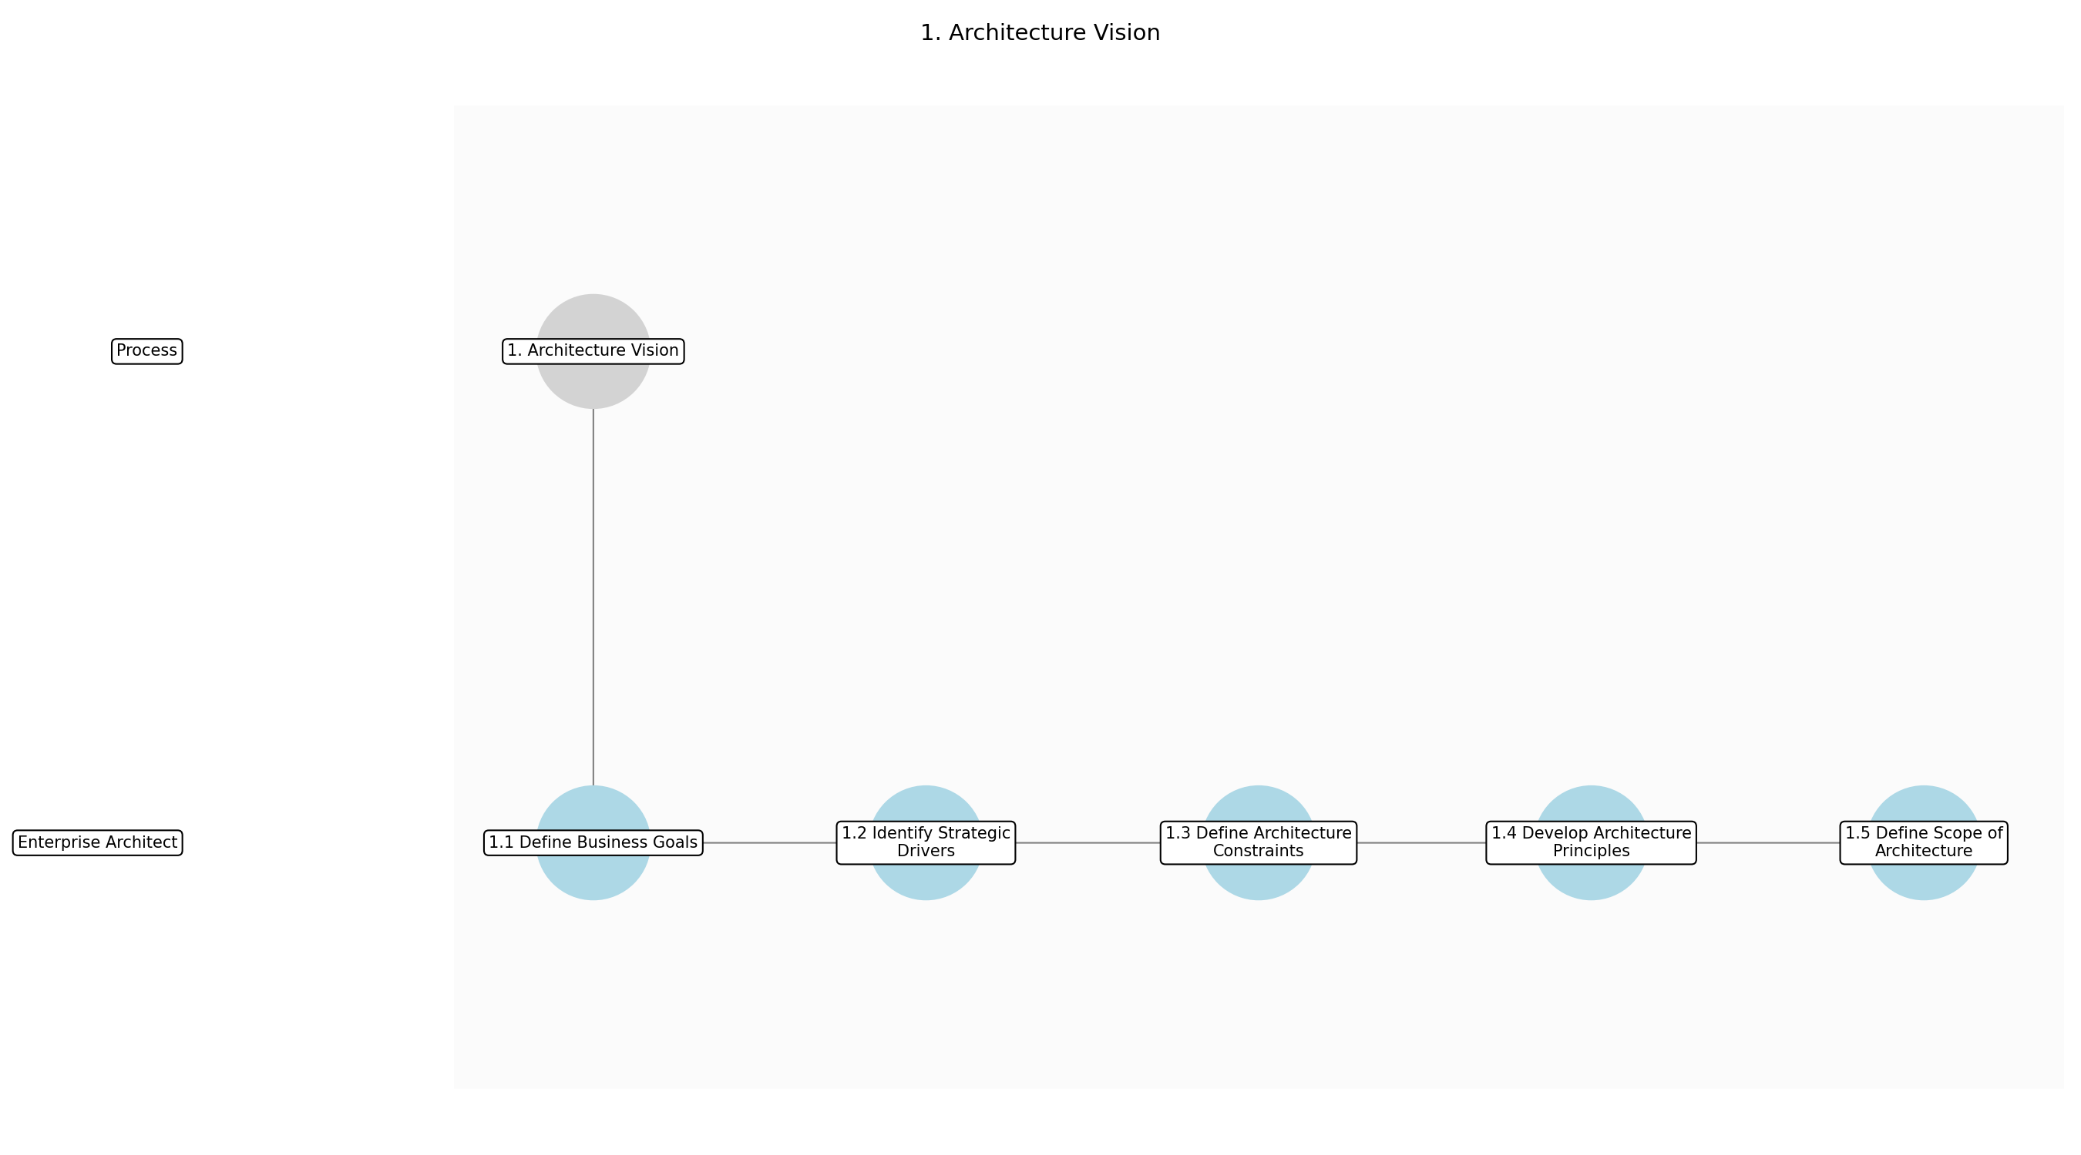

3.1.1 1.1 Define Business Goals
This subprocess describes the activities required to complete '1.1 Define Business Goals'.

Description:
The first step in establishing the architecture vision is to clearly define the business goals that the architecture is intended to support. This involves gathering input from key stakeholders across the organization to understand their strategic objectives and priorities. The defined goals should be specific, measurable, achievable, relevant, and time-bound (SMART) to provide a clear direction for the architecture effort.

Purpose:
To establish a clear understanding of the business objectives that the architecture must support.

Scope:
Enterprise-wide

Inputs:
The following inputs are required for this subprocess:
• Business Strategy
• IT Strategy

Outputs:
This subprocess produces the following outputs:
• Defined Business Goals

Success Criteria:
Success for this subprocess is measured by:
• Clearly defined and documented business goals
• Alignment with overall business strategy

Triggers:
This subprocess is initiated by:
• New product development
• Major system upgrades

End Conditions:
This subprocess is considered complete when:
• Documented and approved business goals

Governance Requirements:
The following governance requirements apply:
• Architecture Review Board review

Risks and Controls:
The following risks and controls apply:
• Risk: Misalignment with actual business needs
• Control: Regular reviews with business stakeholders

Change Management:
The following change management rules apply:
• Change Request Process: Formal change request process
• Versioning Rules: Major.Minor.Patch

Continuous Improvement:
The following continuous improvement practices apply:
• Review Frequency: Annually
• Improvement Inputs:
• Stakeholder feedback
• Performance data

Estimated Duration:
The estimated duration for this subprocess is:
• 2 days

Process Owner:
The following process owner is accountable:
• Enterprise Architect

Responsible Party:
The following parties are responsible for this subprocess:
• Enterprise Architect

3.1.2 1.2 Identify Strategic Drivers
This subprocess describes the activities required to complete '1.2 Identify Strategic Drivers'.

Description:
Identifying the strategic drivers that will influence the architecture is crucial for ensuring its relevance and effectiveness. This involves analyzing the external and internal factors that will shape the organization's future direction. These drivers may include market trends, technological advancements, regulatory changes, and competitive pressures. Understanding these drivers will help the architecture team anticipate future needs and design a flexible and adaptable architecture.

Purpose:
To understand the key factors that will shape the future direction of the architecture.

Scope:
Enterprise-wide

Inputs:
The following inputs are required for this subprocess:
• Defined Business Goals
• Market Analysis Reports

Outputs:
This subprocess produces the following outputs:
• Identified Strategic Drivers

Success Criteria:
Success for this subprocess is measured by:
• Comprehensive list of strategic drivers
• Prioritization of key drivers

Triggers:
This subprocess is initiated by:
• New product development
• Major system upgrades

End Conditions:
This subprocess is considered complete when:
• Documented and prioritized strategic drivers

Dependencies:
This subprocess depends on the following:
• 1.1 Define Business Goals

Governance Requirements:
The following governance requirements apply:
• Architecture Review Board review

Risks and Controls:
The following risks and controls apply:
• Risk: Ignoring key strategic drivers
• Control: Regular environmental scanning and stakeholder interviews

Change Management:
The following change management rules apply:
• Change Request Process: Formal change request process
• Versioning Rules: Major.Minor.Patch

Continuous Improvement:
The following continuous improvement practices apply:
• Review Frequency: Annually
• Improvement Inputs:
• Stakeholder feedback
• Performance data

Estimated Duration:
The estimated duration for this subprocess is:
• 1 day

Process Owner:
The following process owner is accountable:
• Enterprise Architect

Responsible Party:
The following parties are responsible for this subprocess:
• Enterprise Architect

3.1.3 1.3 Define Architecture Constraints
This subprocess describes the activities required to complete '1.3 Define Architecture Constraints'.

Description:
Defining the constraints that will limit the architecture is essential for ensuring its feasibility and practicality. These constraints may include budget limitations, regulatory requirements, technology limitations, and resource constraints. Understanding these constraints will help the architecture team make informed decisions about the scope and design of the architecture. The constraints should be clearly documented and communicated to all stakeholders.

Purpose:
To understand the limitations that will impact the design and implementation of the architecture.

Scope:
Enterprise-wide

Inputs:
The following inputs are required for this subprocess:
• Identified Strategic Drivers
• Budget Information
• Regulatory Requirements

Outputs:
This subprocess produces the following outputs:
• Defined Architecture Constraints

Success Criteria:
Success for this subprocess is measured by:
• Comprehensive list of architecture constraints
• Prioritization of key constraints

Triggers:
This subprocess is initiated by:
• New product development
• Major system upgrades

End Conditions:
This subprocess is considered complete when:
• Documented and prioritized architecture constraints

Dependencies:
This subprocess depends on the following:
• 1.2 Identify Strategic Drivers

Governance Requirements:
The following governance requirements apply:
• Architecture Review Board review

Risks and Controls:
The following risks and controls apply:
• Risk: Ignoring critical constraints
• Control: Regular reviews with relevant stakeholders

Change Management:
The following change management rules apply:
• Change Request Process: Formal change request process
• Versioning Rules: Major.Minor.Patch

Continuous Improvement:
The following continuous improvement practices apply:
• Review Frequency: Annually
• Improvement Inputs:
• Stakeholder feedback
• Performance data

Estimated Duration:
The estimated duration for this subprocess is:
• 1 day

Process Owner:
The following process owner is accountable:
• Enterprise Architect

Responsible Party:
The following parties are responsible for this subprocess:
• Enterprise Architect

3.1.4 1.4 Develop Architecture Principles
This subprocess describes the activities required to complete '1.4 Develop Architecture Principles'.

Description:
Developing a set of architecture principles is crucial for guiding the design and implementation of the architecture. These principles should be based on the business goals, strategic drivers, and constraints identified in the previous steps. The principles should be clear, concise, and easy to understand. They should also be aligned with the organization's values and culture. The architecture principles will serve as a foundation for making consistent and informed decisions about the architecture.

Purpose:
To establish a set of guiding principles for the architecture.

Scope:
Enterprise-wide

Inputs:
The following inputs are required for this subprocess:
• Defined Architecture Constraints
• Business Strategy
• IT Strategy

Outputs:
This subprocess produces the following outputs:
• Architecture Principles

Success Criteria:
Success for this subprocess is measured by:
• Well-defined and documented architecture principles
• Alignment with business goals and strategic drivers

Triggers:
This subprocess is initiated by:
• New product development
• Major system upgrades

End Conditions:
This subprocess is considered complete when:
• Documented and approved architecture principles

Dependencies:
This subprocess depends on the following:
• 1.3 Define Architecture Constraints

Governance Requirements:
The following governance requirements apply:
• Architecture Review Board approval

Risks and Controls:
The following risks and controls apply:
• Risk: Unclear or conflicting architecture principles
• Control: Regular reviews with relevant stakeholders

Change Management:
The following change management rules apply:
• Change Request Process: Formal change request process
• Versioning Rules: Major.Minor.Patch

Continuous Improvement:
The following continuous improvement practices apply:
• Review Frequency: Annually
• Improvement Inputs:
• Stakeholder feedback
• Performance data

Estimated Duration:
The estimated duration for this subprocess is:
• 2 days

Process Owner:
The following process owner is accountable:
• Enterprise Architect

Responsible Party:
The following parties are responsible for this subprocess:
• Enterprise Architect

3.1.5 1.5 Define Scope of Architecture
This subprocess describes the activities required to complete '1.5 Define Scope of Architecture'.

Description:
Defining the scope of the architecture is essential for ensuring that the architecture effort is focused and manageable. This involves determining the boundaries of the architecture, including the business units, IT systems, and technologies that will be included. The scope should be aligned with the business goals, strategic drivers, and constraints identified in the previous steps. The scope should be clearly documented and communicated to all stakeholders to avoid misunderstandings and ensure that the architecture effort is aligned with the organization's priorities.

Purpose:
To define the boundaries of the architecture effort.

Scope:
Enterprise-wide

Inputs:
The following inputs are required for this subprocess:
• Architecture Principles
• Business Strategy
• IT Strategy

Outputs:
This subprocess produces the following outputs:
• Scope of Architecture

Success Criteria:
Success for this subprocess is measured by:
• Clearly defined and documented scope of architecture
• Alignment with business goals and strategic drivers

Triggers:
This subprocess is initiated by:
• New product development
• Major system upgrades

End Conditions:
This subprocess is considered complete when:
• Documented and approved scope of architecture

Dependencies:
This subprocess depends on the following:
• 1.4 Develop Architecture Principles

Governance Requirements:
The following governance requirements apply:
• Architecture Review Board approval

Risks and Controls:
The following risks and controls apply:
• Risk: Scope creep
• Control: Regular reviews with relevant stakeholders

Change Management:
The following change management rules apply:
• Change Request Process: Formal change request process
• Versioning Rules: Major.Minor.Patch

Continuous Improvement:
The following continuous improvement practices apply:
• Review Frequency: Annually
• Improvement Inputs:
• Stakeholder feedback
• Performance data

Estimated Duration:
The estimated duration for this subprocess is:
• 1 day

Process Owner:
The following process owner is accountable:
• Enterprise Architect

Responsible Party:
The following parties are responsible for this subprocess:
• Enterprise Architect

3.2 2. Business Architecture

Description:
Develop a business architecture that describes the organization’s structure, processes, and capabilities.

Purpose:
To understand the business context for the architecture.

Scope:
Enterprise-wide

Inputs:
The following inputs are required for this step:
• Architecture Vision Document

Outputs:
This step produces the following outputs:
• Business Capabilities Model
• Value Stream Map

Success Criteria:
Success for this step is measured by:
• Comprehensive understanding of the business architecture

Process Triggers:
This step is initiated by:
• Business strategy changes

Process End Conditions:
This step is considered complete when:
• Approved Business Architecture Document

Dependencies:
This step depends on the following:
• 1. Architecture Vision

Deliverables:
This step produces the following deliverables:
• Business Architecture Document

Governance Requirements:
The following governance requirements apply:
• Architecture Review Board approval

Risks and Controls:
The following risks and controls apply:
• Control: Validation with business stakeholders
• Risk: Inaccurate business model

Change Management:
The following change management rules apply:
• Versioning Rules: Major.Minor.Patch
• Change Request Process: Formal change request process

Continuous Improvement:
The following continuous improvement practices apply:
• Improvement Inputs:
• Stakeholder feedback
• Performance data
• Review Frequency: Annually

Estimated Duration:
The estimated duration for this step is:
• 2 weeks

Process Owner:
The following process owner is accountable:
• Enterprise Architect

Responsible Parties:
The following parties are responsible for this step:
• Enterprise Architect

Required Sub Process(es) for the Step "2. Business Architecture"
The following details the subprocess flows for the step "2. Business Architecture".
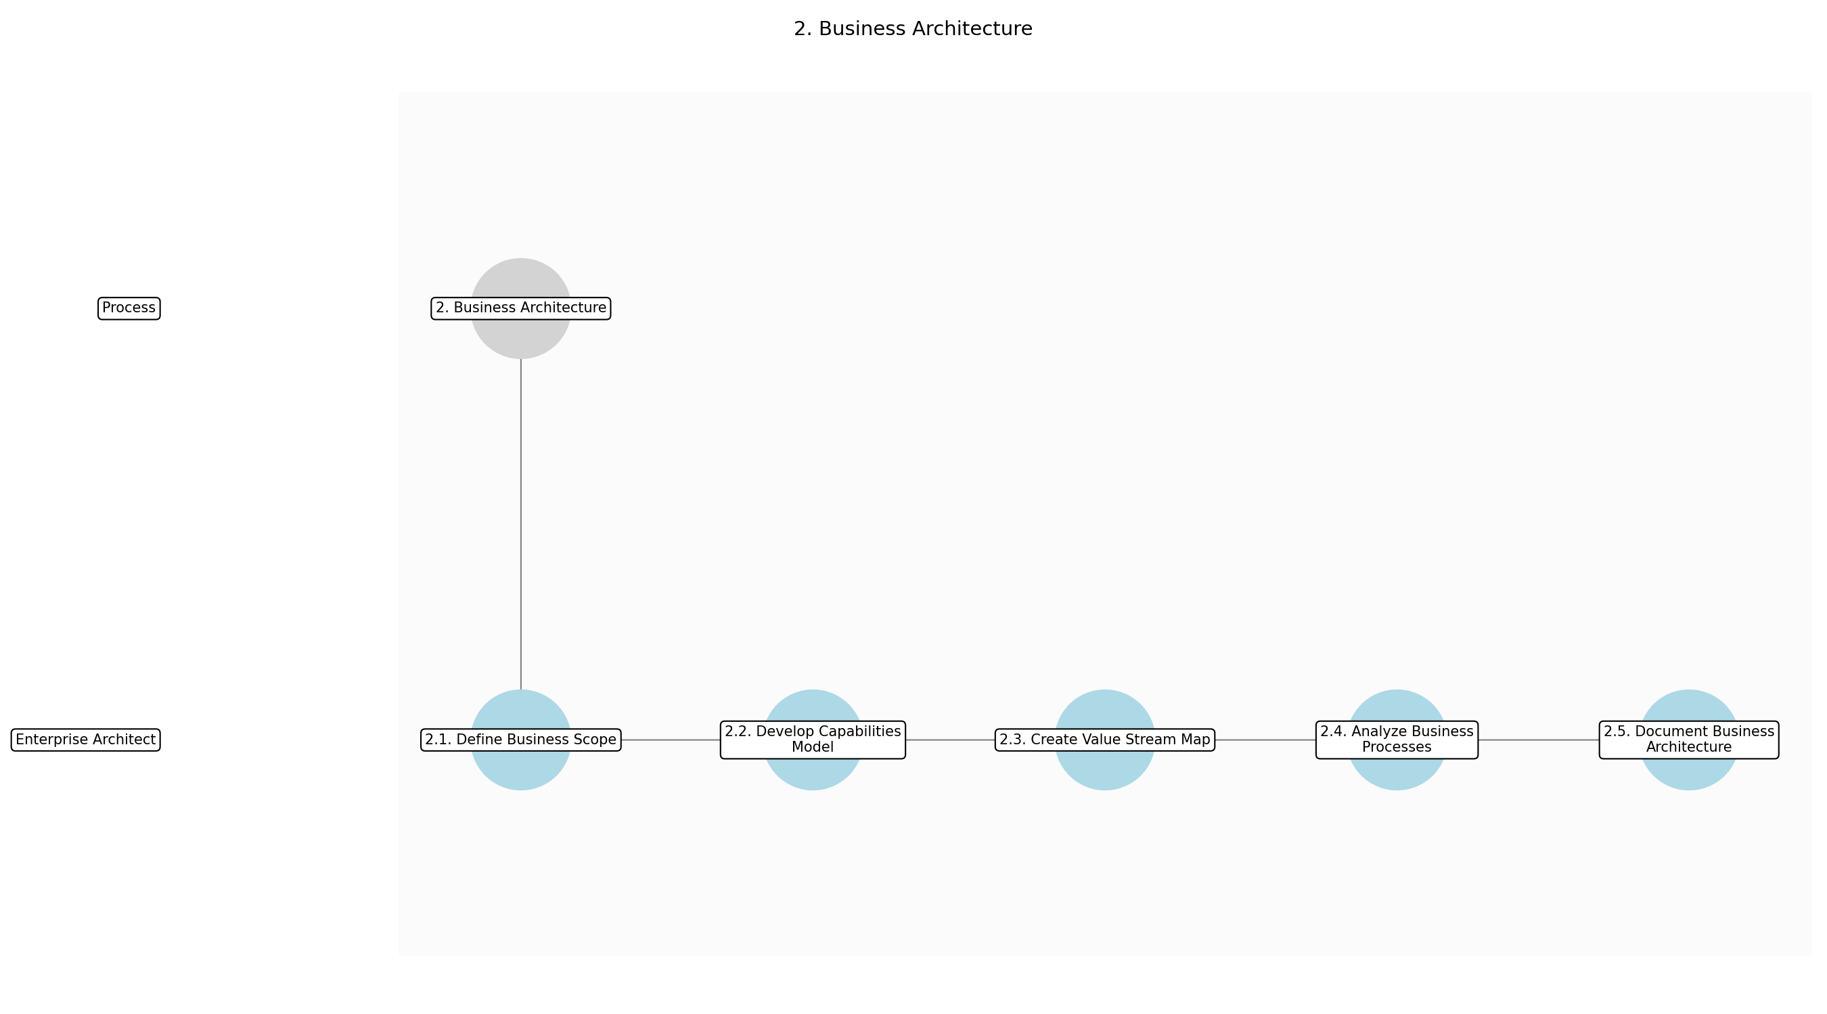

3.2.1 2.1. Define Business Scope
This subprocess describes the activities required to complete '2.1. Define Business Scope'.

Description:
Clearly define the scope of the business architecture effort, including the organizational units, geographies, and business functions to be covered. This involves identifying the key stakeholders and their expectations, as well as establishing the boundaries of the architecture domain. The scope should align with the architecture vision and strategic objectives.

Purpose:
To establish the boundaries and focus of the business architecture effort.

Scope:
Enterprise-wide

Inputs:
The following inputs are required for this subprocess:
• Architecture Vision Document

Outputs:
This subprocess produces the following outputs:
• Business Architecture Scope Document

Success Criteria:
Success for this subprocess is measured by:
• Clearly defined business architecture scope
• Stakeholder alignment on scope

Triggers:
This subprocess is initiated by:
• Business strategy changes

End Conditions:
This subprocess is considered complete when:
• Approved Business Architecture Scope Document

Governance Requirements:
The following governance requirements apply:
• Architecture Review Board approval

Risks and Controls:
The following risks and controls apply:
• Risk: Scope creep
• Control: Regular scope reviews with stakeholders

Change Management:
The following change management rules apply:
• Change Request Process: Formal change request process
• Versioning Rules: Major.Minor.Patch

Continuous Improvement:
The following continuous improvement practices apply:
• Review Frequency: Annually
• Improvement Inputs:
• Stakeholder feedback
• Performance data

Estimated Duration:
The estimated duration for this subprocess is:
• 2 days

Process Owner:
The following process owner is accountable:
• Enterprise Architect

Responsible Party:
The following parties are responsible for this subprocess:
• Enterprise Architect

3.2.2 2.2. Develop Capabilities Model
This subprocess describes the activities required to complete '2.2. Develop Capabilities Model'.

Description:
Create a comprehensive business capabilities model that represents the organization’s key functions and activities. This model should be hierarchical, with high-level capabilities decomposed into more granular sub-capabilities. The capabilities model should be technology-agnostic and focus on what the business does, not how it does it. It serves as a foundation for aligning IT investments with business strategy.

Purpose:
To provide a structured view of the organization’s business functions.

Scope:
Enterprise-wide

Inputs:
The following inputs are required for this subprocess:
• Business Architecture Scope Document

Outputs:
This subprocess produces the following outputs:
• Business Capabilities Model

Success Criteria:
Success for this subprocess is measured by:
• Comprehensive and accurate business capabilities model
• Alignment with business strategy

Triggers:
This subprocess is initiated by:
• Business strategy changes

End Conditions:
This subprocess is considered complete when:
• Approved Business Capabilities Model

Dependencies:
This subprocess depends on the following:
• 2.1. Define Business Scope

Governance Requirements:
The following governance requirements apply:
• Architecture Review Board approval

Risks and Controls:
The following risks and controls apply:
• Risk: Inaccurate capabilities model
• Control: Validation with business stakeholders

Change Management:
The following change management rules apply:
• Change Request Process: Formal change request process
• Versioning Rules: Major.Minor.Patch

Continuous Improvement:
The following continuous improvement practices apply:
• Review Frequency: Annually
• Improvement Inputs:
• Stakeholder feedback
• Performance data

Estimated Duration:
The estimated duration for this subprocess is:
• 3 days

Process Owner:
The following process owner is accountable:
• Enterprise Architect

Responsible Party:
The following parties are responsible for this subprocess:
• Enterprise Architect

3.2.3 2.3. Create Value Stream Map
This subprocess describes the activities required to complete '2.3. Create Value Stream Map'.

Description:
Develop a value stream map that illustrates the end-to-end flow of activities required to deliver value to customers. This map should identify the key steps, actors, and information flows involved in the value stream. It should also highlight any bottlenecks, inefficiencies, or pain points in the process. The value stream map provides insights into how the organization creates value and identifies opportunities for improvement.

Purpose:
To visualize the flow of value creation within the organization.

Scope:
Enterprise-wide

Inputs:
The following inputs are required for this subprocess:
• Business Capabilities Model

Outputs:
This subprocess produces the following outputs:
• Value Stream Map

Success Criteria:
Success for this subprocess is measured by:
• Accurate and detailed value stream map
• Identification of key value streams

Triggers:
This subprocess is initiated by:
• Business strategy changes

End Conditions:
This subprocess is considered complete when:
• Approved Value Stream Map

Dependencies:
This subprocess depends on the following:
• 2.2. Develop Capabilities Model

Governance Requirements:
The following governance requirements apply:
• Architecture Review Board approval

Risks and Controls:
The following risks and controls apply:
• Risk: Oversimplification of value streams
• Control: Detailed analysis of value stream components

Change Management:
The following change management rules apply:
• Change Request Process: Formal change request process
• Versioning Rules: Major.Minor.Patch

Continuous Improvement:
The following continuous improvement practices apply:
• Review Frequency: Annually
• Improvement Inputs:
• Stakeholder feedback
• Performance data

Estimated Duration:
The estimated duration for this subprocess is:
• 3 days

Process Owner:
The following process owner is accountable:
• Enterprise Architect

Responsible Party:
The following parties are responsible for this subprocess:
• Enterprise Architect

3.2.4 2.4. Analyze Business Processes
This subprocess describes the activities required to complete '2.4. Analyze Business Processes'.

Description:
Analyze the organization’s key business processes to understand their structure, inputs, outputs, and dependencies. This analysis should identify any redundancies, inefficiencies, or gaps in the processes. It should also assess the alignment of the processes with the business capabilities and value streams. The process analysis provides insights into how the organization operates and identifies opportunities for process improvement and optimization.

Purpose:
To understand and improve the organization’s business processes.

Scope:
Enterprise-wide

Inputs:
The following inputs are required for this subprocess:
• Value Stream Map

Outputs:
This subprocess produces the following outputs:
• Business Process Analysis Report

Success Criteria:
Success for this subprocess is measured by:
• Comprehensive analysis of key business processes
• Identification of process improvement opportunities

Triggers:
This subprocess is initiated by:
• Business strategy changes

End Conditions:
This subprocess is considered complete when:
• Approved Business Process Analysis Report

Dependencies:
This subprocess depends on the following:
• 2.3. Create Value Stream Map

Governance Requirements:
The following governance requirements apply:
• Architecture Review Board approval

Risks and Controls:
The following risks and controls apply:
• Risk: Incomplete process analysis
• Control: Cross-functional process reviews

Change Management:
The following change management rules apply:
• Change Request Process: Formal change request process
• Versioning Rules: Major.Minor.Patch

Continuous Improvement:
The following continuous improvement practices apply:
• Review Frequency: Annually
• Improvement Inputs:
• Stakeholder feedback
• Performance data

Estimated Duration:
The estimated duration for this subprocess is:
• 3 days

Process Owner:
The following process owner is accountable:
• Enterprise Architect

Responsible Party:
The following parties are responsible for this subprocess:
• Enterprise Architect

3.2.5 2.5. Document Business Architecture
This subprocess describes the activities required to complete '2.5. Document Business Architecture'.

Description:
Compile all the artifacts and findings from the previous sub-steps into a comprehensive Business Architecture Document. This document should include the business architecture scope, capabilities model, value stream map, process analysis report, and any other relevant information. The document should be well-organized, clearly written, and easily accessible to stakeholders. It serves as a reference guide for understanding the organization’s business architecture and aligning IT investments with business strategy.

Purpose:
To create a comprehensive record of the organization’s business architecture.

Scope:
Enterprise-wide

Inputs:
The following inputs are required for this subprocess:
• Business Architecture Scope Document
• Business Capabilities Model
• Value Stream Map
• Business Process Analysis Report

Outputs:
This subprocess produces the following outputs:
• Business Architecture Document

Success Criteria:
Success for this subprocess is measured by:
• Complete and accurate Business Architecture Document
• Stakeholder approval of the document

Triggers:
This subprocess is initiated by:
• Business strategy changes

End Conditions:
This subprocess is considered complete when:
• Approved Business Architecture Document

Dependencies:
This subprocess depends on the following:
• 2.4. Analyze Business Processes

Governance Requirements:
The following governance requirements apply:
• Architecture Review Board approval

Risks and Controls:
The following risks and controls apply:
• Risk: Outdated documentation
• Control: Regular document reviews and updates

Change Management:
The following change management rules apply:
• Change Request Process: Formal change request process
• Versioning Rules: Major.Minor.Patch

Continuous Improvement:
The following continuous improvement practices apply:
• Review Frequency: Annually
• Improvement Inputs:
• Stakeholder feedback
• Performance data

Estimated Duration:
The estimated duration for this subprocess is:
• 2 days

Process Owner:
The following process owner is accountable:
• Enterprise Architect

Responsible Party:
The following parties are responsible for this subprocess:
• Enterprise Architect

3.3 3. Information Systems Architecture

Description:
Develop an information systems architecture that describes the data, applications, and technology that support the business.

Purpose:
To define the information systems that support the business.

Scope:
Enterprise-wide

Inputs:
The following inputs are required for this step:
• Business Architecture Document

Outputs:
This step produces the following outputs:
• Application Portfolio
• Data Model

Success Criteria:
Success for this step is measured by:
• Well-defined information systems architecture

Process Triggers:
This step is initiated by:
• Major system upgrades

Process End Conditions:
This step is considered complete when:
• Approved Information Systems Architecture Document

Dependencies:
This step depends on the following:
• 2. Business Architecture

Deliverables:
This step produces the following deliverables:
• Information Systems Architecture Document

Governance Requirements:
The following governance requirements apply:
• Architecture Review Board approval

Risks and Controls:
The following risks and controls apply:
• Risk: Data silos
• Control: Data governance policies

Change Management:
The following change management rules apply:
• Versioning Rules: Major.Minor.Patch
• Change Request Process: Formal change request process

Continuous Improvement:
The following continuous improvement practices apply:
• Improvement Inputs:
• Stakeholder feedback
• Performance data
• Review Frequency: Annually

Estimated Duration:
The estimated duration for this step is:
• 3 weeks

Process Owner:
The following process owner is accountable:
• Enterprise Architect

Responsible Parties:
The following parties are responsible for this step:
• Enterprise Architect

Required Sub Process(es) for the Step "3. Information Systems Architecture"
The following details the subprocess flows for the step "3. Information Systems Architecture".
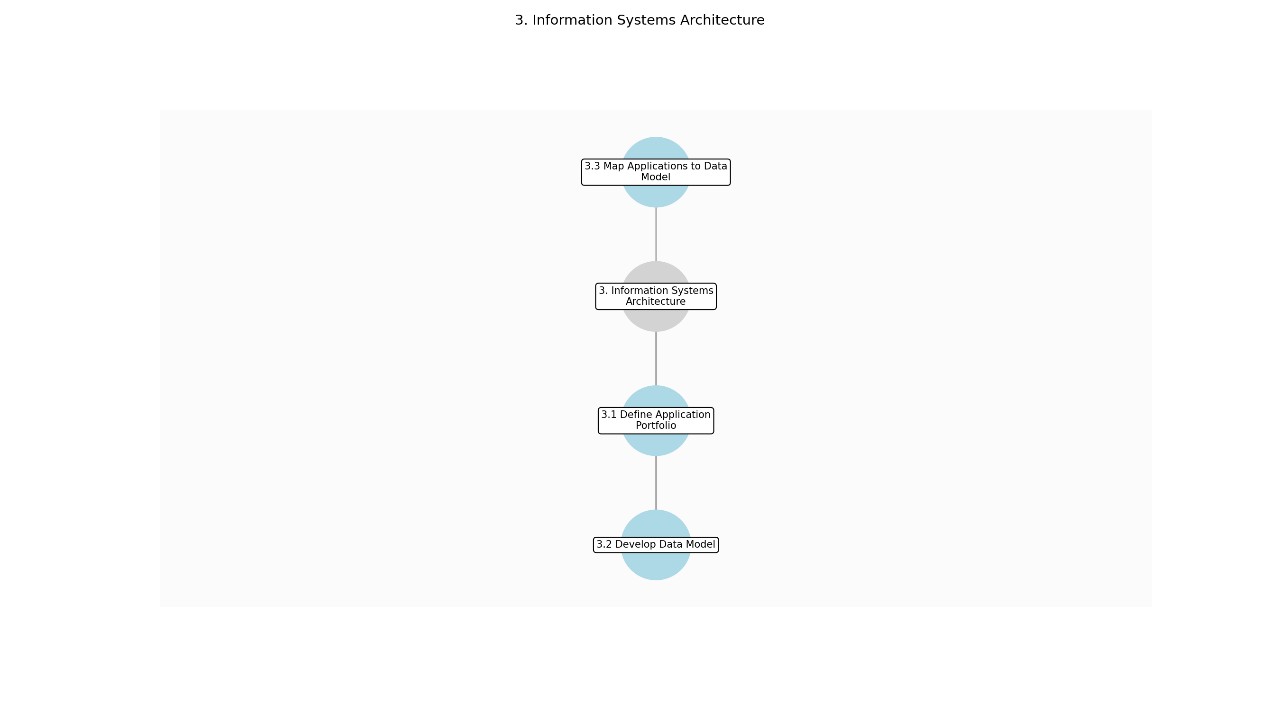

3.3.1 3.1 Define Application Portfolio
This subprocess describes the activities required to complete '3.1 Define Application Portfolio'.

Description:
Identify and document all applications within the enterprise. This involves gathering information on each application's purpose, functionality, technical specifications, and business value. The application portfolio will serve as a baseline for future architectural decisions.

Purpose:
To create a comprehensive inventory of all applications within the enterprise.

Scope:
Enterprise-wide

Inputs:
The following inputs are required for this subprocess:
• Business Architecture Document
• Existing Application Inventory (if available)

Outputs:
This subprocess produces the following outputs:
• Draft Application Portfolio

Success Criteria:
Success for this subprocess is measured by:
• Comprehensive list of all enterprise applications
• Each application's purpose and functionality are clearly documented

Triggers:
This subprocess is initiated by:
• Major system upgrades
• New application requests

End Conditions:
This subprocess is considered complete when:
• Draft Application Portfolio completed

Governance Requirements:
The following governance requirements apply:
• Architecture Review Board review

Risks and Controls:
The following risks and controls apply:
• Risk: Incomplete application inventory
• Control: Cross-validation with IT and business stakeholders

Change Management:
The following change management rules apply:
• Change Request Process: Formal change request process
• Versioning Rules: Major.Minor.Patch

Continuous Improvement:
The following continuous improvement practices apply:
• Review Frequency: Annually
• Improvement Inputs:
• Stakeholder feedback
• Application performance data

Estimated Duration:
The estimated duration for this subprocess is:
• 1 week

Process Owner:
The following process owner is accountable:
• Enterprise Architect

Responsible Party:
The following parties are responsible for this subprocess:
• Enterprise Architect

3.3.2 3.2 Develop Data Model
This subprocess describes the activities required to complete '3.2 Develop Data Model'.

Description:
Create a conceptual and logical data model that represents the data entities, attributes, and relationships within the enterprise. This involves analyzing the data requirements of the business and defining a standardized data structure. The data model will ensure data consistency and integrity across applications.

Purpose:
To define a standardized data structure for the enterprise.

Scope:
Enterprise-wide

Inputs:
The following inputs are required for this subprocess:
• Business Architecture Document
• Draft Application Portfolio
• Existing Data Models (if available)

Outputs:
This subprocess produces the following outputs:
• Draft Data Model

Success Criteria:
Success for this subprocess is measured by:
• Comprehensive data model that represents all key data entities
• Data entities, attributes, and relationships are clearly defined

Triggers:
This subprocess is initiated by:
• Major system upgrades
• New application requests
• Data integration projects

End Conditions:
This subprocess is considered complete when:
• Draft Data Model completed

Dependencies:
This subprocess depends on the following:
• 3.1 Define Application Portfolio

Governance Requirements:
The following governance requirements apply:
• Data Governance Committee review
• Architecture Review Board review

Risks and Controls:
The following risks and controls apply:
• Risk: Inconsistent data definitions
• Control: Data governance policies and standards

Change Management:
The following change management rules apply:
• Change Request Process: Formal change request process
• Versioning Rules: Major.Minor.Patch

Continuous Improvement:
The following continuous improvement practices apply:
• Review Frequency: Annually
• Improvement Inputs:
• Stakeholder feedback
• Data quality metrics

Estimated Duration:
The estimated duration for this subprocess is:
• 1 week

Process Owner:
The following process owner is accountable:
• Enterprise Architect

Responsible Party:
The following parties are responsible for this subprocess:
• Data Architect

3.3.3 3.3 Map Applications to Data Model
This subprocess describes the activities required to complete '3.3 Map Applications to Data Model'.

Description:
Map the applications in the application portfolio to the data entities in the data model. This involves identifying which applications use which data entities and how the data flows between applications. This mapping will help identify data silos and integration opportunities.

Purpose:
To understand how applications use and share data.

Scope:
Enterprise-wide

Inputs:
The following inputs are required for this subprocess:
• Draft Application Portfolio
• Draft Data Model

Outputs:
This subprocess produces the following outputs:
• Application-Data Mapping Document

Success Criteria:
Success for this subprocess is measured by:
• Complete mapping of applications to data entities
• Data flows between applications are clearly documented

Triggers:
This subprocess is initiated by:
• Major system upgrades
• New application requests
• Data integration projects

End Conditions:
This subprocess is considered complete when:
• Application-Data Mapping Document completed

Dependencies:
This subprocess depends on the following:
• 3.2 Develop Data Model

Governance Requirements:
The following governance requirements apply:
• Architecture Review Board review

Risks and Controls:
The following risks and controls apply:
• Risk: Inaccurate application-data mapping
• Control: Validation with application owners and data stewards

Change Management:
The following change management rules apply:
• Change Request Process: Formal change request process
• Versioning Rules: Major.Minor.Patch

Continuous Improvement:
The following continuous improvement practices apply:
• Review Frequency: Annually
• Improvement Inputs:
• Stakeholder feedback
• Data integration project outcomes

Estimated Duration:
The estimated duration for this subprocess is:
• 1 week

Process Owner:
The following process owner is accountable:
• Enterprise Architect

Responsible Party:
The following parties are responsible for this subprocess:
• Solution Architect

3.4 4. Technology Architecture

Description:
Develop a technology architecture that describes the hardware, software, and infrastructure that support the information systems.

Purpose:
To define the technology infrastructure that supports the information systems.

Scope:
Enterprise-wide

Inputs:
The following inputs are required for this step:
• Information Systems Architecture Document

Outputs:
This step produces the following outputs:
• Technology Standards
• Infrastructure Diagram

Success Criteria:
Success for this step is measured by:
• Robust and scalable technology architecture

Process Triggers:
This step is initiated by:
• Technology upgrades

Process End Conditions:
This step is considered complete when:
• Approved Technology Architecture Document

Dependencies:
This step depends on the following:
• 3. Information Systems Architecture

Deliverables:
This step produces the following deliverables:
• Technology Architecture Document

Governance Requirements:
The following governance requirements apply:
• Architecture Review Board approval

Risks and Controls:
The following risks and controls apply:
• Risk: Technology obsolescence
• Control: Regular technology reviews

Change Management:
The following change management rules apply:
• Versioning Rules: Major.Minor.Patch
• Change Request Process: Formal change request process

Continuous Improvement:
The following continuous improvement practices apply:
• Improvement Inputs:
• Stakeholder feedback
• Performance data
• Review Frequency: Annually

Estimated Duration:
The estimated duration for this step is:
• 2 weeks

Process Owner:
The following process owner is accountable:
• Enterprise Architect

Responsible Parties:
The following parties are responsible for this step:
• Enterprise Architect

Required Sub Process(es) for the Step "4. Technology Architecture"
The following details the subprocess flows for the step "4. Technology Architecture".
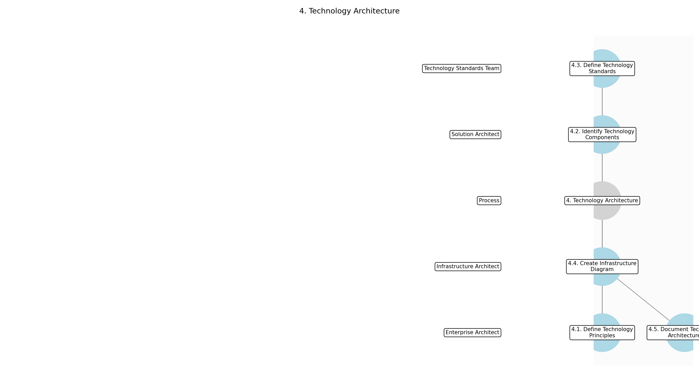

3.4.1 4.1. Define Technology Principles
This subprocess describes the activities required to complete '4.1. Define Technology Principles'.

Description:
Establish a clear set of technology principles that will guide technology decisions and ensure alignment with the overall enterprise architecture. These principles should be documented and communicated to all relevant stakeholders. This involves reviewing existing principles, gathering input from stakeholders, and documenting the final set of principles.

Purpose:
To provide a foundation for making consistent and informed technology decisions.

Scope:
Enterprise-wide

Inputs:
The following inputs are required for this subprocess:
• Information Systems Architecture Document
• Architecture Principles

Outputs:
This subprocess produces the following outputs:
• Technology Principles Document

Success Criteria:
Success for this subprocess is measured by:
• Documented and approved technology principles
• Stakeholder alignment on technology principles

Triggers:
This subprocess is initiated by:
• Technology upgrades
• New project initiation

End Conditions:
This subprocess is considered complete when:
• Approved Technology Principles Document

Governance Requirements:
The following governance requirements apply:
• Architecture Review Board approval

Risks and Controls:
The following risks and controls apply:
• Risk: Inconsistent technology decisions
• Control: Enforce adherence to technology principles

Change Management:
The following change management rules apply:
• Change Request Process: Formal change request process
• Versioning Rules: Major.Minor.Patch

Continuous Improvement:
The following continuous improvement practices apply:
• Review Frequency: Annually
• Improvement Inputs:
• Stakeholder feedback
• Technology trends

Estimated Duration:
The estimated duration for this subprocess is:
• 3 days

Process Owner:
The following process owner is accountable:
• Enterprise Architect

Responsible Party:
The following parties are responsible for this subprocess:
• Enterprise Architect

3.4.2 4.2. Identify Technology Components
This subprocess describes the activities required to complete '4.2. Identify Technology Components'.

Description:
Identify the necessary technology components (hardware, software, infrastructure) required to support the information systems architecture. This includes evaluating existing components and identifying any gaps that need to be addressed. The components should be categorized and documented.

Purpose:
To create an inventory of the technology building blocks needed for the architecture.

Scope:
Enterprise-wide

Inputs:
The following inputs are required for this subprocess:
• Technology Principles Document
• Information Systems Architecture Document

Outputs:
This subprocess produces the following outputs:
• Technology Component List

Success Criteria:
Success for this subprocess is measured by:
• Comprehensive list of technology components
• Categorization of technology components

Triggers:
This subprocess is initiated by:
• Technology upgrades
• New project requirements

End Conditions:
This subprocess is considered complete when:
• Completed Technology Component List

Dependencies:
This subprocess depends on the following:
• 4.1. Define Technology Principles

Governance Requirements:
The following governance requirements apply:
• Architecture Review Board review

Risks and Controls:
The following risks and controls apply:
• Risk: Missing critical technology components
• Control: Conduct thorough component analysis

Change Management:
The following change management rules apply:
• Change Request Process: Formal change request process
• Versioning Rules: Major.Minor.Patch

Continuous Improvement:
The following continuous improvement practices apply:
• Review Frequency: Annually
• Improvement Inputs:
• Stakeholder feedback
• Technology advancements

Estimated Duration:
The estimated duration for this subprocess is:
• 2 days

Process Owner:
The following process owner is accountable:
• Enterprise Architect

Responsible Party:
The following parties are responsible for this subprocess:
• Solution Architect

3.4.3 4.3. Define Technology Standards
This subprocess describes the activities required to complete '4.3. Define Technology Standards'.

Description:
Define technology standards for each component, including versions, configurations, and security requirements. These standards should be aligned with industry best practices and organizational policies. Document the standards in a clear and concise manner.

Purpose:
To ensure consistency and interoperability across the technology landscape.

Scope:
Enterprise-wide

Inputs:
The following inputs are required for this subprocess:
• Technology Component List
• Security Policies

Outputs:
This subprocess produces the following outputs:
• Technology Standards Document

Success Criteria:
Success for this subprocess is measured by:
• Documented technology standards for each component
• Alignment with industry best practices

Triggers:
This subprocess is initiated by:
• Technology upgrades
• Security vulnerability

End Conditions:
This subprocess is considered complete when:
• Approved Technology Standards Document

Dependencies:
This subprocess depends on the following:
• 4.2. Identify Technology Components

Governance Requirements:
The following governance requirements apply:
• Architecture Review Board approval
• Compliance audits

Risks and Controls:
The following risks and controls apply:
• Risk: Incompatible technology components
• Control: Enforce adherence to technology standards

Change Management:
The following change management rules apply:
• Change Request Process: Formal change request process
• Versioning Rules: Major.Minor.Patch

Continuous Improvement:
The following continuous improvement practices apply:
• Review Frequency: Annually
• Improvement Inputs:
• Stakeholder feedback
• Security audits

Estimated Duration:
The estimated duration for this subprocess is:
• 3 days

Process Owner:
The following process owner is accountable:
• Enterprise Architect

Responsible Party:
The following parties are responsible for this subprocess:
• Technology Standards Team

3.4.4 4.4. Create Infrastructure Diagram
This subprocess describes the activities required to complete '4.4. Create Infrastructure Diagram'.

Description:
Develop an infrastructure diagram that visually represents the technology architecture, including the relationships between components and their deployment locations. This diagram should be detailed enough to provide a clear understanding of the technology infrastructure. The diagram should be reviewed and updated regularly.

Purpose:
To provide a visual representation of the technology infrastructure for better understanding and communication.

Scope:
Enterprise-wide

Inputs:
The following inputs are required for this subprocess:
• Technology Standards Document
• Network Diagrams

Outputs:
This subprocess produces the following outputs:
• Infrastructure Diagram

Success Criteria:
Success for this subprocess is measured by:
• Detailed and accurate infrastructure diagram
• Clear representation of component relationships

Triggers:
This subprocess is initiated by:
• Technology upgrades
• Infrastructure changes

End Conditions:
This subprocess is considered complete when:
• Approved Infrastructure Diagram

Dependencies:
This subprocess depends on the following:
• 4.3. Define Technology Standards

Governance Requirements:
The following governance requirements apply:
• Architecture Review Board approval

Risks and Controls:
The following risks and controls apply:
• Risk: Inaccurate representation of infrastructure
• Control: Regular diagram reviews and updates

Change Management:
The following change management rules apply:
• Change Request Process: Formal change request process
• Versioning Rules: Major.Minor.Patch

Continuous Improvement:
The following continuous improvement practices apply:
• Review Frequency: Annually
• Improvement Inputs:
• Stakeholder feedback
• Infrastructure performance data

Estimated Duration:
The estimated duration for this subprocess is:
• 2 days

Process Owner:
The following process owner is accountable:
• Enterprise Architect

Responsible Party:
The following parties are responsible for this subprocess:
• Infrastructure Architect

3.4.5 4.5. Document Technology Architecture
This subprocess describes the activities required to complete '4.5. Document Technology Architecture'.

Description:
Compile all the artifacts created in the previous steps into a comprehensive Technology Architecture Document. This document should provide a complete overview of the technology architecture, including principles, components, standards, and diagrams. The document should be reviewed and approved by the Architecture Review Board.

Purpose:
To consolidate all technology architecture information into a single, accessible document.

Scope:
Enterprise-wide

Inputs:
The following inputs are required for this subprocess:
• Technology Principles Document
• Technology Standards Document
• Infrastructure Diagram

Outputs:
This subprocess produces the following outputs:
• Technology Architecture Document

Success Criteria:
Success for this subprocess is measured by:
• Complete and accurate Technology Architecture Document
• Architecture Review Board approval

Triggers:
This subprocess is initiated by:
• Technology upgrades
• New project initiation

End Conditions:
This subprocess is considered complete when:
• Approved Technology Architecture Document

Dependencies:
This subprocess depends on the following:
• 4.1. Define Technology Principles
• 4.2. Identify Technology Components
• 4.3. Define Technology Standards
• 4.4. Create Infrastructure Diagram

Governance Requirements:
The following governance requirements apply:
• Architecture Review Board approval

Risks and Controls:
The following risks and controls apply:
• Risk: Incomplete or outdated architecture documentation
• Control: Regular document reviews and updates

Change Management:
The following change management rules apply:
• Change Request Process: Formal change request process
• Versioning Rules: Major.Minor.Patch

Continuous Improvement:
The following continuous improvement practices apply:
• Review Frequency: Annually
• Improvement Inputs:
• Stakeholder feedback
• Architecture compliance reports

Estimated Duration:
The estimated duration for this subprocess is:
• 3 days

Process Owner:
The following process owner is accountable:
• Enterprise Architect

Responsible Party:
The following parties are responsible for this subprocess:
• Enterprise Architect

3.5 5. Opportunities & Solutions

Description:
Identify and evaluate potential solutions that meet the business needs.

Purpose:
To identify and evaluate potential solutions.

Scope:
Project-specific

Inputs:
The following inputs are required for this step:
• Technology Architecture Document

Outputs:
This step produces the following outputs:
• Solution Options
• Cost-Benefit Analysis

Success Criteria:
Success for this step is measured by:
• Identification of viable solutions

Process Triggers:
This step is initiated by:
• New product development

Process End Conditions:
This step is considered complete when:
• Approved Solutions Architecture Document

Dependencies:
This step depends on the following:
• 4. Technology Architecture

Deliverables:
This step produces the following deliverables:
• Solutions Architecture Document

Governance Requirements:
The following governance requirements apply:
• Architecture Review Board approval

Risks and Controls:
The following risks and controls apply:
• Control: Thorough evaluation process
• Risk: Selection of inappropriate solution

Change Management:
The following change management rules apply:
• Versioning Rules: Major.Minor.Patch
• Change Request Process: Formal change request process

Continuous Improvement:
The following continuous improvement practices apply:
• Review Frequency: Annually
• Improvement Inputs:
• Stakeholder feedback
• Performance data

Estimated Duration:
The estimated duration for this step is:
• 2 weeks

Process Owner:
The following process owner is accountable:
• Enterprise Architect

Responsible Parties:
The following parties are responsible for this step:
• Enterprise Architect

Required Sub Process(es) for the Step "5. Opportunities & Solutions"
The following details the subprocess flows for the step "5. Opportunities & Solutions".
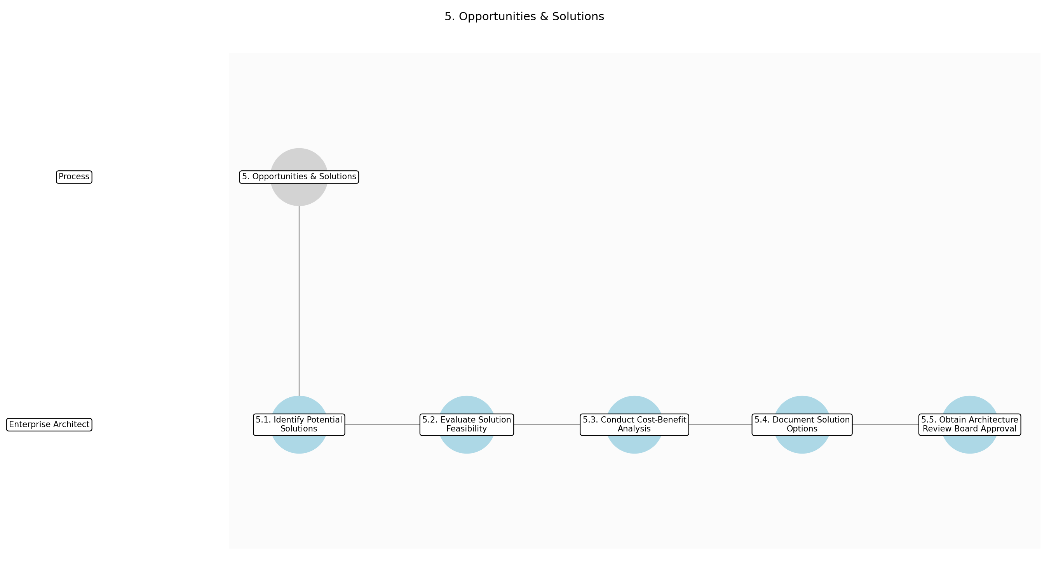

3.5.1 5.1. Identify Potential Solutions
This subprocess describes the activities required to complete '5.1. Identify Potential Solutions'.

Description:
The Enterprise Architect identifies a range of potential solutions that could address the business needs outlined in the Technology Architecture Document. This involves brainstorming, researching industry best practices, and considering innovative approaches. The solutions should align with the organization's strategic goals and architectural principles.

Purpose:
To generate a comprehensive list of possible solutions to address the identified business needs.

Scope:
Project-specific

Inputs:
The following inputs are required for this subprocess:
• Technology Architecture Document

Outputs:
This subprocess produces the following outputs:
• List of Potential Solutions

Success Criteria:
Success for this subprocess is measured by:
• A diverse range of potential solutions is identified
• Solutions align with business needs and architectural principles

Triggers:
This subprocess is initiated by:
• Technology Architecture Document completion

End Conditions:
This subprocess is considered complete when:
• List of Potential Solutions is compiled

Governance Requirements:
The following governance requirements apply:
• Adherence to architectural principles

Risks and Controls:
The following risks and controls apply:
• Risk: Missing viable solutions
• Control: Broad brainstorming and research

Change Management:
The following change management rules apply:
• Change Request Process: Informal discussion
• Versioning Rules: Draft.Review.Final

Continuous Improvement:
The following continuous improvement practices apply:
• Review Frequency: Ad-hoc
• Improvement Inputs:
• Feedback from solution evaluation

Estimated Duration:
The estimated duration for this subprocess is:
• 3 days

Process Owner:
The following process owner is accountable:
• Enterprise Architect

Responsible Party:
The following parties are responsible for this subprocess:
• Enterprise Architect

3.5.2 5.2. Evaluate Solution Feasibility
This subprocess describes the activities required to complete '5.2. Evaluate Solution Feasibility'.

Description:
The Enterprise Architect evaluates the feasibility of each potential solution. This includes assessing technical feasibility, operational feasibility, and financial feasibility. A preliminary assessment of risks and benefits is also conducted to understand the potential impact of each solution.

Purpose:
To determine which solutions are viable based on technical, operational, and financial considerations.

Scope:
Project-specific

Inputs:
The following inputs are required for this subprocess:
• List of Potential Solutions

Outputs:
This subprocess produces the following outputs:
• Feasibility Assessment Report

Success Criteria:
Success for this subprocess is measured by:
• Feasibility of each solution is thoroughly assessed
• Risks and benefits are identified

Triggers:
This subprocess is initiated by:
• List of Potential Solutions completion

End Conditions:
This subprocess is considered complete when:
• Feasibility Assessment Report is completed

Dependencies:
This subprocess depends on the following:
• 5.1. Identify Potential Solutions

Governance Requirements:
The following governance requirements apply:
• Compliance with financial guidelines

Risks and Controls:
The following risks and controls apply:
• Risk: Inaccurate feasibility assessment
• Control: Expert review and validation

Change Management:
The following change management rules apply:
• Change Request Process: Formal change request
• Versioning Rules: Major.Minor.Patch

Continuous Improvement:
The following continuous improvement practices apply:
• Review Frequency: Annually
• Improvement Inputs:
• Stakeholder feedback
• Performance data

Estimated Duration:
The estimated duration for this subprocess is:
• 3 days

Process Owner:
The following process owner is accountable:
• Enterprise Architect

Responsible Party:
The following parties are responsible for this subprocess:
• Enterprise Architect

3.5.3 5.3. Conduct Cost-Benefit Analysis
This subprocess describes the activities required to complete '5.3. Conduct Cost-Benefit Analysis'.

Description:
For the feasible solutions, a detailed cost-benefit analysis is conducted. This involves quantifying the costs associated with implementing and maintaining each solution, as well as quantifying the benefits in terms of increased efficiency, reduced costs, and improved business outcomes. The analysis should consider both short-term and long-term impacts.

Purpose:
To provide a financial justification for each viable solution.

Scope:
Project-specific

Inputs:
The following inputs are required for this subprocess:
• Feasibility Assessment Report

Outputs:
This subprocess produces the following outputs:
• Cost-Benefit Analysis

Success Criteria:
Success for this subprocess is measured by:
• Costs and benefits are accurately quantified
• Short-term and long-term impacts are considered

Triggers:
This subprocess is initiated by:
• Feasibility Assessment Report completion

End Conditions:
This subprocess is considered complete when:
• Cost-Benefit Analysis is completed

Dependencies:
This subprocess depends on the following:
• 5.2. Evaluate Solution Feasibility

Governance Requirements:
The following governance requirements apply:
• Compliance with financial reporting standards

Risks and Controls:
The following risks and controls apply:
• Risk: Inaccurate cost-benefit analysis
• Control: Independent review by finance team

Change Management:
The following change management rules apply:
• Change Request Process: Formal change request
• Versioning Rules: Major.Minor.Patch

Continuous Improvement:
The following continuous improvement practices apply:
• Review Frequency: Annually
• Improvement Inputs:
• Actual vs. projected costs and benefits

Estimated Duration:
The estimated duration for this subprocess is:
• 2 days

Process Owner:
The following process owner is accountable:
• Enterprise Architect

Responsible Party:
The following parties are responsible for this subprocess:
• Enterprise Architect

3.5.4 5.4. Document Solution Options
This subprocess describes the activities required to complete '5.4. Document Solution Options'.

Description:
The Enterprise Architect documents the viable solution options, including their feasibility assessments and cost-benefit analyses. This documentation should provide a clear and concise overview of each solution, its potential benefits, and its associated risks. The documentation serves as the basis for decision-making by the Architecture Review Board.

Purpose:
To create a comprehensive document that presents the viable solution options for review and approval.

Scope:
Project-specific

Inputs:
The following inputs are required for this subprocess:
• Feasibility Assessment Report
• Cost-Benefit Analysis

Outputs:
This subprocess produces the following outputs:
• Solution Options Document

Success Criteria:
Success for this subprocess is measured by:
• Solution options are clearly and concisely documented
• Documentation includes feasibility assessments and cost-benefit analyses

Triggers:
This subprocess is initiated by:
• Cost-Benefit Analysis completion

End Conditions:
This subprocess is considered complete when:
• Solution Options Document is completed

Dependencies:
This subprocess depends on the following:
• 5.3. Conduct Cost-Benefit Analysis

Governance Requirements:
The following governance requirements apply:
• Document version control

Risks and Controls:
The following risks and controls apply:
• Risk: Incomplete or unclear documentation
• Control: Peer review of documentation

Change Management:
The following change management rules apply:
• Change Request Process: Formal change request
• Versioning Rules: Major.Minor.Patch

Continuous Improvement:
The following continuous improvement practices apply:
• Review Frequency: Annually
• Improvement Inputs:
• Feedback from Architecture Review Board

Estimated Duration:
The estimated duration for this subprocess is:
• 2 days

Process Owner:
The following process owner is accountable:
• Enterprise Architect

Responsible Party:
The following parties are responsible for this subprocess:
• Enterprise Architect

3.5.5 5.5. Obtain Architecture Review Board Approval
This subprocess describes the activities required to complete '5.5. Obtain Architecture Review Board Approval'.

Description:
The Solution Options Document is presented to the Architecture Review Board for review and approval. The board evaluates the proposed solutions against the organization's architectural principles, strategic goals, and risk tolerance. The board's decision is documented and communicated to the relevant stakeholders.

Purpose:
To ensure that the selected solution aligns with the organization's architectural standards and strategic goals.

Scope:
Project-specific

Inputs:
The following inputs are required for this subprocess:
• Solution Options Document

Outputs:
This subprocess produces the following outputs:
• Approved Solutions Architecture Document

Success Criteria:
Success for this subprocess is measured by:
• Architecture Review Board approves the solution options
• Decision is documented and communicated

Triggers:
This subprocess is initiated by:
• Solution Options Document completion

End Conditions:
This subprocess is considered complete when:
• Approved Solutions Architecture Document is obtained

Dependencies:
This subprocess depends on the following:
• 5.4. Document Solution Options

Governance Requirements:
The following governance requirements apply:
• Architecture Review Board charter

Risks and Controls:
The following risks and controls apply:
• Risk: Rejection by Architecture Review Board
• Control: Early engagement with the board

Change Management:
The following change management rules apply:
• Change Request Process: Formal change request
• Versioning Rules: Major.Minor.Patch

Continuous Improvement:
The following continuous improvement practices apply:
• Review Frequency: Annually
• Improvement Inputs:
• Post-implementation review

Estimated Duration:
The estimated duration for this subprocess is:
• 2 days

Process Owner:
The following process owner is accountable:
• Enterprise Architect

Responsible Party:
The following parties are responsible for this subprocess:
• Enterprise Architect

3.6 6. Migration Planning

Description:
Develop a plan for migrating to the new architecture.

Purpose:
To plan the migration to the new architecture.

Scope:
Project-specific

Inputs:
The following inputs are required for this step:
• Solutions Architecture Document

Outputs:
This step produces the following outputs:
• Migration Schedule
• Resource Allocation

Success Criteria:
Success for this step is measured by:
• Realistic and achievable migration plan

Process Triggers:
This step is initiated by:
• Project initiation

Process End Conditions:
This step is considered complete when:
• Approved Migration Plan Document

Dependencies:
This step depends on the following:
• 5. Opportunities & Solutions

Deliverables:
This step produces the following deliverables:
• Migration Plan Document

Governance Requirements:
The following governance requirements apply:
• Project Management Office approval

Risks and Controls:
The following risks and controls apply:
• Control: Contingency planning
• Risk: Migration delays

Change Management:
The following change management rules apply:
• Change Request Process: Formal change request process
• Versioning Rules: Major.Minor.Patch

Continuous Improvement:
The following continuous improvement practices apply:
• Review Frequency: Post-migration
• Improvement Inputs:
• Lessons learned

Estimated Duration:
The estimated duration for this step is:
• 2 weeks

Process Owner:
The following process owner is accountable:
• Project Manager

Responsible Parties:
The following parties are responsible for this step:
• Project Manager

Required Sub Process(es) for the Step "6. Migration Planning"
The following details the subprocess flows for the step "6. Migration Planning".
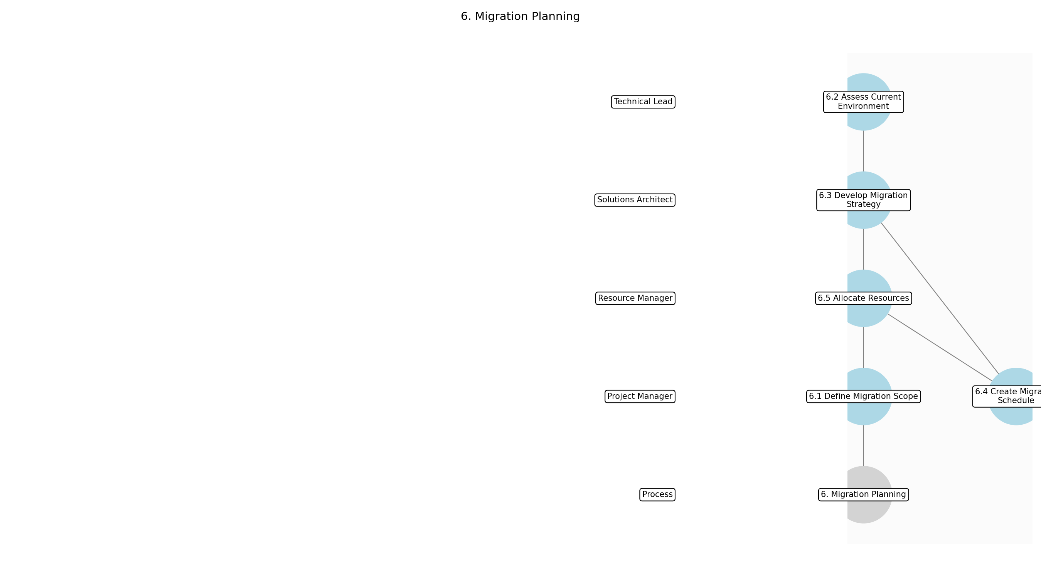

3.6.1 6.1 Define Migration Scope
This subprocess describes the activities required to complete '6.1 Define Migration Scope'.

Description:
Clearly define the scope of the migration, including the systems, applications, and data to be migrated. This involves identifying the boundaries of the migration effort and setting realistic expectations. The scope should align with the overall project goals and the solutions architecture document.

Purpose:
To establish the boundaries and focus of the migration effort.

Scope:
Project-specific

Inputs:
The following inputs are required for this subprocess:
• Solutions Architecture Document

Outputs:
This subprocess produces the following outputs:
• Migration Scope Definition

Success Criteria:
Success for this subprocess is measured by:
• Clearly defined migration scope
• Alignment with project goals

Triggers:
This subprocess is initiated by:
• Project initiation

End Conditions:
This subprocess is considered complete when:
• Approved Migration Scope Definition

Governance Requirements:
The following governance requirements apply:
• Project Management Office approval

Risks and Controls:
The following risks and controls apply:
• Risk: Scope creep
• Control: Formal scope change request process

Change Management:
The following change management rules apply:
• Change Request Process: Formal change request process
• Versioning Rules: Major.Minor.Patch

Continuous Improvement:
The following continuous improvement practices apply:
• Review Frequency: Post-migration
• Improvement Inputs:
• Lessons learned

Estimated Duration:
The estimated duration for this subprocess is:
• 3 days

Process Owner:
The following process owner is accountable:
• Project Manager

Responsible Party:
The following parties are responsible for this subprocess:
• Project Manager

3.6.2 6.2 Assess Current Environment
This subprocess describes the activities required to complete '6.2 Assess Current Environment'.

Description:
Evaluate the current IT environment to understand its complexity and identify potential migration challenges. This includes assessing the existing infrastructure, applications, and data, as well as any dependencies or integrations. The assessment should provide a clear picture of the current state and inform the migration strategy.

Purpose:
To understand the current IT environment and identify potential migration challenges.

Scope:
Project-specific

Inputs:
The following inputs are required for this subprocess:
• Migration Scope Definition

Outputs:
This subprocess produces the following outputs:
• Current Environment Assessment Report

Success Criteria:
Success for this subprocess is measured by:
• Comprehensive assessment of current environment
• Identification of migration challenges

Triggers:
This subprocess is initiated by:
• Approved Migration Scope Definition

End Conditions:
This subprocess is considered complete when:
• Completed Current Environment Assessment Report

Dependencies:
This subprocess depends on the following:
• 6.1 Define Migration Scope

Governance Requirements:
The following governance requirements apply:
• Technical review

Risks and Controls:
The following risks and controls apply:
• Risk: Inaccurate assessment
• Control: Peer review of assessment report

Change Management:
The following change management rules apply:
• Change Request Process: Formal change request process
• Versioning Rules: Major.Minor.Patch

Continuous Improvement:
The following continuous improvement practices apply:
• Review Frequency: Post-migration
• Improvement Inputs:
• Lessons learned

Estimated Duration:
The estimated duration for this subprocess is:
• 3 days

Process Owner:
The following process owner is accountable:
• Project Manager

Responsible Party:
The following parties are responsible for this subprocess:
• Technical Lead

3.6.3 6.3 Develop Migration Strategy
This subprocess describes the activities required to complete '6.3 Develop Migration Strategy'.

Description:
Create a detailed migration strategy that outlines the approach, timeline, and resources required for the migration. This involves selecting the appropriate migration method (e.g., lift and shift, re-platform, re-architect), defining the migration phases, and identifying any dependencies or constraints. The strategy should be realistic and achievable, considering the current environment and project goals.

Purpose:
To define the approach, timeline, and resources required for the migration.

Scope:
Project-specific

Inputs:
The following inputs are required for this subprocess:
• Current Environment Assessment Report

Outputs:
This subprocess produces the following outputs:
• Migration Strategy Document

Success Criteria:
Success for this subprocess is measured by:
• Realistic and achievable migration strategy
• Alignment with project goals and current environment

Triggers:
This subprocess is initiated by:
• Completed Current Environment Assessment Report

End Conditions:
This subprocess is considered complete when:
• Approved Migration Strategy Document

Dependencies:
This subprocess depends on the following:
• 6.2 Assess Current Environment

Governance Requirements:
The following governance requirements apply:
• Architecture Review Board approval

Risks and Controls:
The following risks and controls apply:
• Risk: Unrealistic strategy
• Control: Review by experienced migration consultants

Change Management:
The following change management rules apply:
• Change Request Process: Formal change request process
• Versioning Rules: Major.Minor.Patch

Continuous Improvement:
The following continuous improvement practices apply:
• Review Frequency: Post-migration
• Improvement Inputs:
• Lessons learned

Estimated Duration:
The estimated duration for this subprocess is:
• 2 days

Process Owner:
The following process owner is accountable:
• Project Manager

Responsible Party:
The following parties are responsible for this subprocess:
• Solutions Architect

3.6.4 6.4 Create Migration Schedule
This subprocess describes the activities required to complete '6.4 Create Migration Schedule'.

Description:
Develop a detailed migration schedule that outlines the tasks, dependencies, and timelines for each phase of the migration. This involves breaking down the migration strategy into smaller, manageable tasks, assigning resources, and estimating the duration of each task. The schedule should be realistic and achievable, considering any dependencies or constraints.

Purpose:
To outline the tasks, dependencies, and timelines for each phase of the migration.

Scope:
Project-specific

Inputs:
The following inputs are required for this subprocess:
• Migration Strategy Document

Outputs:
This subprocess produces the following outputs:
• Migration Schedule

Success Criteria:
Success for this subprocess is measured by:
• Realistic and achievable migration schedule
• Clear task assignments and timelines

Triggers:
This subprocess is initiated by:
• Approved Migration Strategy Document

End Conditions:
This subprocess is considered complete when:
• Approved Migration Schedule

Dependencies:
This subprocess depends on the following:
• 6.3 Develop Migration Strategy

Governance Requirements:
The following governance requirements apply:
• Project Management Office review

Risks and Controls:
The following risks and controls apply:
• Risk: Schedule delays
• Control: Regular schedule monitoring and updates

Change Management:
The following change management rules apply:
• Change Request Process: Formal change request process
• Versioning Rules: Major.Minor.Patch

Continuous Improvement:
The following continuous improvement practices apply:
• Review Frequency: Post-migration
• Improvement Inputs:
• Lessons learned

Estimated Duration:
The estimated duration for this subprocess is:
• 2 days

Process Owner:
The following process owner is accountable:
• Project Manager

Responsible Party:
The following parties are responsible for this subprocess:
• Project Manager

3.6.5 6.5 Allocate Resources
This subprocess describes the activities required to complete '6.5 Allocate Resources'.

Description:
Identify and allocate the resources required for the migration, including personnel, hardware, software, and budget. This involves determining the skills and expertise needed for each phase of the migration, securing the necessary resources, and assigning them to specific tasks. Resource allocation should align with the migration schedule and project goals.

Purpose:
To identify and allocate the resources required for the migration.

Scope:
Project-specific

Inputs:
The following inputs are required for this subprocess:
• Migration Schedule

Outputs:
This subprocess produces the following outputs:
• Resource Allocation Plan

Success Criteria:
Success for this subprocess is measured by:
• Adequate resource allocation
• Alignment with migration schedule and project goals

Triggers:
This subprocess is initiated by:
• Approved Migration Schedule

End Conditions:
This subprocess is considered complete when:
• Approved Resource Allocation Plan

Dependencies:
This subprocess depends on the following:
• 6.4 Create Migration Schedule

Governance Requirements:
The following governance requirements apply:
• Resource Management Office review

Risks and Controls:
The following risks and controls apply:
• Risk: Resource constraints
• Control: Contingency planning for resource shortages

Change Management:
The following change management rules apply:
• Change Request Process: Formal change request process
• Versioning Rules: Major.Minor.Patch

Continuous Improvement:
The following continuous improvement practices apply:
• Review Frequency: Post-migration
• Improvement Inputs:
• Lessons learned

Estimated Duration:
The estimated duration for this subprocess is:
• 1 day

Process Owner:
The following process owner is accountable:
• Project Manager

Responsible Party:
The following parties are responsible for this subprocess:
• Resource Manager

3.7 7. Implementation Governance

Description:
Oversee the implementation of the new architecture.

Purpose:
To ensure compliance with the architecture during implementation.

Scope:
Project-specific

Inputs:
The following inputs are required for this step:
• Migration Plan Document

Outputs:
This step produces the following outputs:
• Architecture Compliance
• Risk Mitigation

Success Criteria:
Success for this step is measured by:
• Successful implementation of the new architecture

Process Triggers:
This step is initiated by:
• Project execution

Process End Conditions:
This step is considered complete when:
• Compliant implementation

Dependencies:
This step depends on the following:
• 6. Migration Planning

Deliverables:
This step produces the following deliverables:
• Compliance Reports

Governance Requirements:
The following governance requirements apply:
• Architecture Review Board oversight

Risks and Controls:
The following risks and controls apply:
• Risk: Architecture violations
• Control: Regular compliance checks

Change Management:
The following change management rules apply:
• Versioning Rules: Major.Minor.Patch
• Change Request Process: Formal change request process

Continuous Improvement:
The following continuous improvement practices apply:
• Review Frequency: Quarterly
• Improvement Inputs:
• Compliance data

Estimated Duration:
The estimated duration for this step is:
• Ongoing

Process Owner:
The following process owner is accountable:
• Architecture Review Board

Responsible Parties:
The following parties are responsible for this step:
• Architecture Review Board

Required Sub Process(es) for the Step "7. Implementation Governance"
The following details the subprocess flows for the step "7. Implementation Governance".
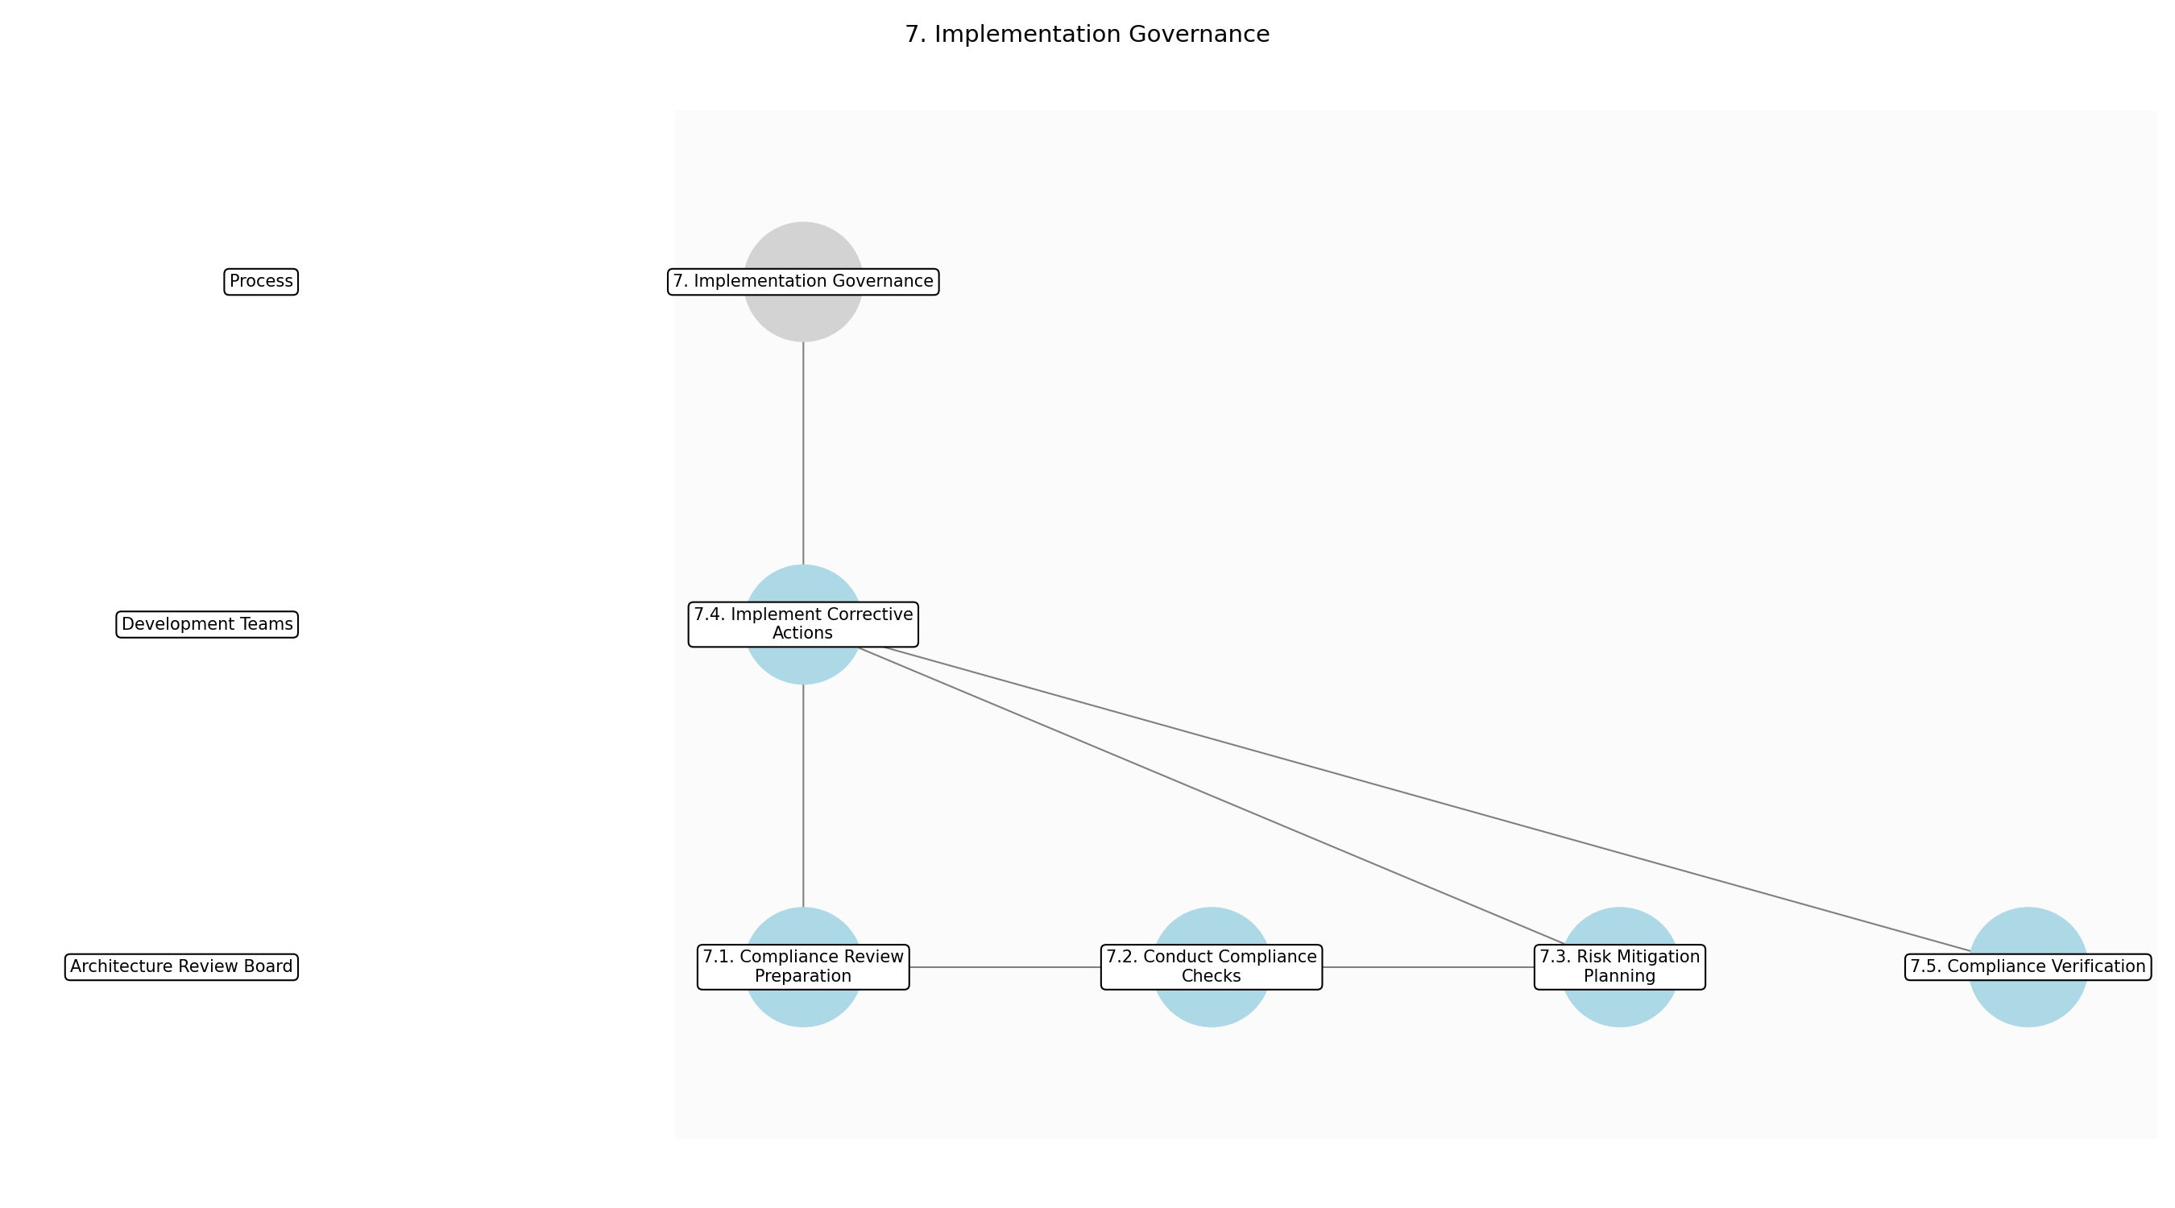

3.7.1 7.1. Compliance Review Preparation
This subprocess describes the activities required to complete '7.1. Compliance Review Preparation'.

Description:
The Architecture Review Board (ARB) prepares for the compliance review by gathering all necessary documentation, including the Migration Plan Document, architecture specifications, and any relevant implementation artifacts. This involves ensuring that all documents are up-to-date and readily accessible for review. The ARB also defines the scope and criteria for the compliance check to ensure a consistent and thorough evaluation.

Purpose:
To prepare for a thorough and consistent compliance review.

Scope:
Project-specific

Inputs:
The following inputs are required for this subprocess:
• Migration Plan Document
• Architecture Specifications
• Implementation Artifacts

Outputs:
This subprocess produces the following outputs:
• Review Scope
• Compliance Criteria

Success Criteria:
Success for this subprocess is measured by:
• All necessary documentation is gathered and up-to-date
• Review scope and compliance criteria are clearly defined

Triggers:
This subprocess is initiated by:
• Project execution phase reached

End Conditions:
This subprocess is considered complete when:
• Review scope and compliance criteria are defined

Governance Requirements:
The following governance requirements apply:
• Architecture Review Board oversight

Risks and Controls:
The following risks and controls apply:
• Risk: Incomplete documentation
• Control: Document checklist and verification process

Change Management:
The following change management rules apply:
• Change Request Process: Formal change request process
• Versioning Rules: Major.Minor.Patch

Continuous Improvement:
The following continuous improvement practices apply:
• Review Frequency: Quarterly
• Improvement Inputs:
• Compliance data
• Review feedback

Estimated Duration:
The estimated duration for this subprocess is:
• 1 day

Process Owner:
The following process owner is accountable:
• Architecture Review Board

Responsible Party:
The following parties are responsible for this subprocess:
• Architecture Review Board

3.7.2 7.2. Conduct Compliance Checks
This subprocess describes the activities required to complete '7.2. Conduct Compliance Checks'.

Description:
The Architecture Review Board conducts regular compliance checks to ensure that the implementation aligns with the defined architecture. This involves comparing the actual implementation against the architecture specifications and identifying any deviations or violations. Automated compliance tools and manual inspections are used to thoroughly assess the implementation.

Purpose:
To identify any deviations from the defined architecture during implementation.

Scope:
Project-specific

Inputs:
The following inputs are required for this subprocess:
• Review Scope
• Compliance Criteria
• Implementation Artifacts

Outputs:
This subprocess produces the following outputs:
• Compliance Findings
• Deviation Reports

Success Criteria:
Success for this subprocess is measured by:
• Implementation aligns with architecture specifications
• Deviations and violations are identified and documented

Triggers:
This subprocess is initiated by:
• Regular intervals during implementation
• Significant implementation milestones

End Conditions:
This subprocess is considered complete when:
• Compliance checks are completed and documented

Dependencies:
This subprocess depends on the following:
• 7.1. Compliance Review Preparation

Governance Requirements:
The following governance requirements apply:
• Architecture Review Board oversight

Risks and Controls:
The following risks and controls apply:
• Risk: Architecture violations
• Control: Automated compliance checks

Change Management:
The following change management rules apply:
• Change Request Process: Formal change request process
• Versioning Rules: Major.Minor.Patch

Continuous Improvement:
The following continuous improvement practices apply:
• Review Frequency: Quarterly
• Improvement Inputs:
• Compliance data
• Deviation reports

Estimated Duration:
The estimated duration for this subprocess is:
• Ongoing

Process Owner:
The following process owner is accountable:
• Architecture Review Board

Responsible Party:
The following parties are responsible for this subprocess:
• Architecture Review Board

3.7.3 7.3. Risk Mitigation Planning
This subprocess describes the activities required to complete '7.3. Risk Mitigation Planning'.

Description:
Based on the compliance findings, the Architecture Review Board develops risk mitigation plans to address any identified architecture violations. This involves defining specific actions to correct the deviations and prevent future occurrences. The risk mitigation plans are documented and communicated to the implementation team.

Purpose:
To address and correct any identified architecture violations.

Scope:
Project-specific

Inputs:
The following inputs are required for this subprocess:
• Compliance Findings
• Deviation Reports

Outputs:
This subprocess produces the following outputs:
• Risk Mitigation Plans
• Corrective Actions

Success Criteria:
Success for this subprocess is measured by:
• Risk mitigation plans are developed for all identified architecture violations
• Corrective actions are clearly defined and documented

Triggers:
This subprocess is initiated by:
• Identification of architecture violations

End Conditions:
This subprocess is considered complete when:
• Risk mitigation plans are documented and communicated

Dependencies:
This subprocess depends on the following:
• 7.2. Conduct Compliance Checks

Governance Requirements:
The following governance requirements apply:
• Architecture Review Board oversight

Risks and Controls:
The following risks and controls apply:
• Risk: Inadequate mitigation plans
• Control: Expert review of mitigation plans

Change Management:
The following change management rules apply:
• Change Request Process: Formal change request process
• Versioning Rules: Major.Minor.Patch

Continuous Improvement:
The following continuous improvement practices apply:
• Review Frequency: Quarterly
• Improvement Inputs:
• Compliance data
• Effectiveness of mitigation plans

Estimated Duration:
The estimated duration for this subprocess is:
• 1-2 days

Process Owner:
The following process owner is accountable:
• Architecture Review Board

Responsible Party:
The following parties are responsible for this subprocess:
• Architecture Review Board

3.7.4 7.4. Implement Corrective Actions
This subprocess describes the activities required to complete '7.4. Implement Corrective Actions'.

Description:
The implementation team implements the corrective actions defined in the risk mitigation plans. This involves making the necessary changes to the implementation to align with the architecture specifications. The implementation team documents all changes and provides evidence of compliance to the Architecture Review Board.

Purpose:
To correct deviations and ensure compliance with the architecture.

Scope:
Project-specific

Inputs:
The following inputs are required for this subprocess:
• Risk Mitigation Plans
• Corrective Actions

Outputs:
This subprocess produces the following outputs:
• Updated Implementation Artifacts
• Compliance Evidence

Success Criteria:
Success for this subprocess is measured by:
• Corrective actions are implemented effectively
• Implementation aligns with architecture specifications
• Compliance evidence is provided

Triggers:
This subprocess is initiated by:
• Approval of risk mitigation plans

End Conditions:
This subprocess is considered complete when:
• Corrective actions are implemented and documented

Dependencies:
This subprocess depends on the following:
• 7.3. Risk Mitigation Planning

Governance Requirements:
The following governance requirements apply:
• Architecture Review Board oversight

Risks and Controls:
The following risks and controls apply:
• Risk: Incorrect implementation of corrective actions
• Control: Code review and testing

Change Management:
The following change management rules apply:
• Change Request Process: Formal change request process
• Versioning Rules: Major.Minor.Patch

Continuous Improvement:
The following continuous improvement practices apply:
• Review Frequency: Quarterly
• Improvement Inputs:
• Compliance data
• Feedback from implementation team

Estimated Duration:
The estimated duration for this subprocess is:
• Ongoing

Process Owner:
The following process owner is accountable:
• Project Manager

Responsible Party:
The following parties are responsible for this subprocess:
• Development Teams

3.7.5 7.5. Compliance Verification
This subprocess describes the activities required to complete '7.5. Compliance Verification'.

Description:
The Architecture Review Board verifies that the corrective actions have been implemented effectively and that the implementation now complies with the architecture specifications. This involves reviewing the updated implementation artifacts and compliance evidence. If compliance is verified, the implementation is approved; otherwise, further corrective actions are required.

Purpose:
To verify that the implementation now complies with the architecture.

Scope:
Project-specific

Inputs:
The following inputs are required for this subprocess:
• Updated Implementation Artifacts
• Compliance Evidence

Outputs:
This subprocess produces the following outputs:
• Compliance Reports
• Implementation Approval

Success Criteria:
Success for this subprocess is measured by:
• Implementation complies with architecture specifications
• Compliance is verified and documented

Triggers:
This subprocess is initiated by:
• Completion of corrective actions

End Conditions:
This subprocess is considered complete when:
• Compliance is verified and documented

Dependencies:
This subprocess depends on the following:
• 7.4. Implement Corrective Actions

Governance Requirements:
The following governance requirements apply:
• Architecture Review Board oversight

Risks and Controls:
The following risks and controls apply:
• Risk: Inaccurate compliance verification
• Control: Independent review of compliance evidence

Change Management:
The following change management rules apply:
• Change Request Process: Formal change request process
• Versioning Rules: Major.Minor.Patch

Continuous Improvement:
The following continuous improvement practices apply:
• Review Frequency: Quarterly
• Improvement Inputs:
• Compliance data
• Feedback from verification process

Estimated Duration:
The estimated duration for this subprocess is:
• 1 day

Process Owner:
The following process owner is accountable:
• Architecture Review Board

Responsible Party:
The following parties are responsible for this subprocess:
• Architecture Review Board

3.8 8. Architecture Change Management

Description:
Manage changes to the architecture.

Purpose:
To manage changes to the architecture in a controlled manner.

Scope:
Enterprise-wide

Inputs:
The following inputs are required for this step:
• Implementation Feedback

Outputs:
This step produces the following outputs:
• Approved Changes
• Architecture Updates

Success Criteria:
Success for this step is measured by:
• Controlled and documented changes to the architecture

Process Triggers:
This step is initiated by:
• Change requests

Process End Conditions:
This step is considered complete when:
• Approved and implemented changes

Dependencies:
This step depends on the following:
• 7. Implementation Governance

Deliverables:
This step produces the following deliverables:
• Change Requests
• Updated Architecture Documents

Governance Requirements:
The following governance requirements apply:
• Architecture Review Board approval

Risks and Controls:
The following risks and controls apply:
• Control: Change management process
• Risk: Uncontrolled changes

Change Management:
The following change management rules apply:
• Versioning Rules: Major.Minor.Patch
• Change Request Process: Formal change request process

Continuous Improvement:
The following continuous improvement practices apply:
• Review Frequency: Annually
• Improvement Inputs:
• Change request data

Estimated Duration:
The estimated duration for this step is:
• Ongoing

Process Owner:
The following process owner is accountable:
• Enterprise Architect

Responsible Parties:
The following parties are responsible for this step:
• Enterprise Architect

Required Sub Process(es) for the Step "8. Architecture Change Management"
The following details the subprocess flows for the step "8. Architecture Change Management".
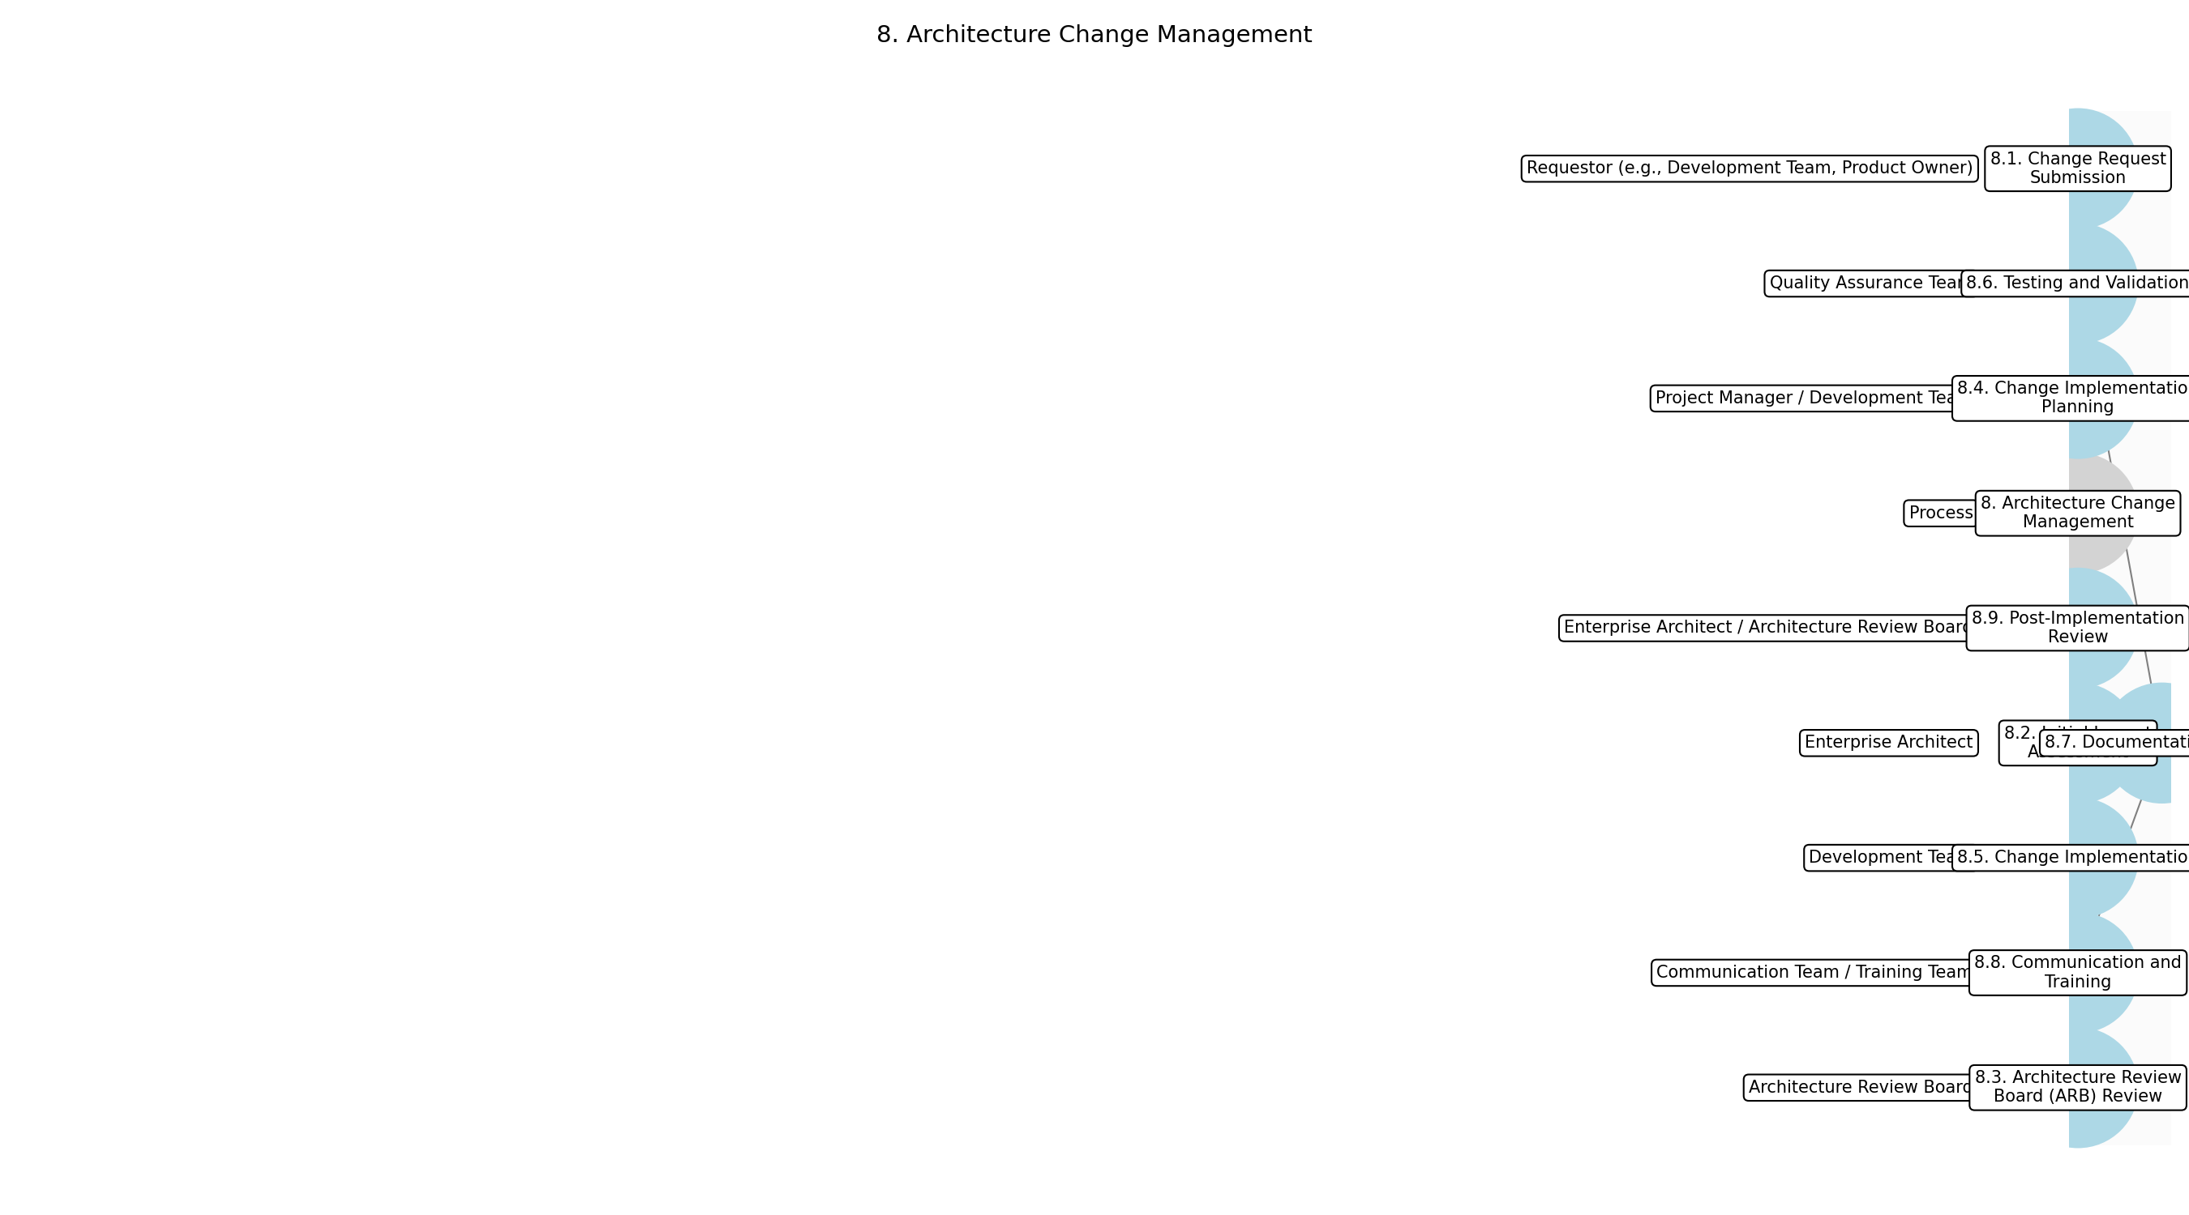

3.8.1 8.1. Change Request Submission
This subprocess describes the activities required to complete '8.1. Change Request Submission'.

Description:
The process begins with the submission of a formal change request. This request should clearly outline the proposed change to the architecture, the rationale behind it, and the potential impact on existing systems and business processes. The requestor must provide sufficient detail to allow for a thorough evaluation of the change.

Purpose:
To formally initiate the change management process.

Scope:
Enterprise-wide

Outputs:
This subprocess produces the following outputs:
• Change Request

Success Criteria:
Success for this subprocess is measured by:
• Complete and well-documented change request submitted

Triggers:
This subprocess is initiated by:
• Identification of a needed architecture change

End Conditions:
This subprocess is considered complete when:
• Change request is formally submitted and logged

Governance Requirements:
The following governance requirements apply:
• Change request must adhere to the organization's change management policy

Risks and Controls:
The following risks and controls apply:
• Risk: Incomplete or poorly defined change requests
• Control: Standardized change request template and guidelines

Change Management:
The following change management rules apply:
• Change Request Process: Formal change request process
• Versioning Rules: Major.Minor.Patch

Continuous Improvement:
The following continuous improvement practices apply:
• Review Frequency: Annually
• Improvement Inputs:
• Change request data
• Feedback from stakeholders

Estimated Duration:
The estimated duration for this subprocess is:
• 1-2 hours

Process Owner:
The following process owner is accountable:
• Enterprise Architect

Responsible Party:
The following parties are responsible for this subprocess:
• Requestor (e.g., Development Team, Product Owner)

3.8.2 8.2. Initial Impact Assessment
This subprocess describes the activities required to complete '8.2. Initial Impact Assessment'.

Description:
Upon receiving the change request, an initial impact assessment is conducted by the Enterprise Architect. This assessment aims to identify the potential impact of the proposed change on various aspects of the architecture, including systems, data, and business processes. The assessment also considers the dependencies and potential risks associated with the change.

Purpose:
To understand the potential impact of the proposed change.

Scope:
Enterprise-wide

Inputs:
The following inputs are required for this subprocess:
• Change Request

Outputs:
This subprocess produces the following outputs:
• Initial Impact Assessment Report

Success Criteria:
Success for this subprocess is measured by:
• Comprehensive initial impact assessment completed

Triggers:
This subprocess is initiated by:
• Receipt of a change request

End Conditions:
This subprocess is considered complete when:
• Initial impact assessment report is generated

Dependencies:
This subprocess depends on the following:
• 8.1. Change Request Submission

Governance Requirements:
The following governance requirements apply:
• Impact assessment must be documented and auditable

Risks and Controls:
The following risks and controls apply:
• Risk: Inaccurate or incomplete impact assessment
• Control: Experienced architects and thorough review process

Change Management:
The following change management rules apply:
• Change Request Process: Formal change request process
• Versioning Rules: Major.Minor.Patch

Continuous Improvement:
The following continuous improvement practices apply:
• Review Frequency: Annually
• Improvement Inputs:
• Impact assessment data
• Feedback from stakeholders

Estimated Duration:
The estimated duration for this subprocess is:
• 2-4 hours

Process Owner:
The following process owner is accountable:
• Enterprise Architect

Responsible Party:
The following parties are responsible for this subprocess:
• Enterprise Architect

3.8.3 8.3. Architecture Review Board (ARB) Review
This subprocess describes the activities required to complete '8.3. Architecture Review Board (ARB) Review'.

Description:
The change request and the initial impact assessment are then presented to the Architecture Review Board (ARB) for review. The ARB evaluates the proposed change against the enterprise architecture principles, standards, and roadmap. They assess the alignment of the change with the business strategy and its potential impact on the overall architecture.

Purpose:
To ensure alignment with architecture principles and standards.

Scope:
Enterprise-wide

Inputs:
The following inputs are required for this subprocess:
• Change Request
• Initial Impact Assessment Report

Outputs:
This subprocess produces the following outputs:
• ARB Review Decision (Approval, Rejection, or Revision Required)

Success Criteria:
Success for this subprocess is measured by:
• ARB review completed and decision documented

Triggers:
This subprocess is initiated by:
• Completion of initial impact assessment

End Conditions:
This subprocess is considered complete when:
• ARB decision is formally documented

Dependencies:
This subprocess depends on the following:
• 8.2. Initial Impact Assessment

Governance Requirements:
The following governance requirements apply:
• ARB review must be documented and auditable

Risks and Controls:
The following risks and controls apply:
• Risk: ARB decision not aligned with business strategy
• Control: Regular communication between ARB and business stakeholders

Change Management:
The following change management rules apply:
• Change Request Process: Formal change request process
• Versioning Rules: Major.Minor.Patch

Continuous Improvement:
The following continuous improvement practices apply:
• Review Frequency: Annually
• Improvement Inputs:
• ARB review data
• Feedback from stakeholders

Estimated Duration:
The estimated duration for this subprocess is:
• 1 day

Process Owner:
The following process owner is accountable:
• Enterprise Architect

Responsible Party:
The following parties are responsible for this subprocess:
• Architecture Review Board

3.8.4 8.4. Change Implementation Planning
This subprocess describes the activities required to complete '8.4. Change Implementation Planning'.

Description:
If the ARB approves the change, a detailed implementation plan is developed. This plan outlines the specific steps required to implement the change, the resources needed, the timeline for implementation, and the testing and validation procedures. The plan also addresses any potential risks and mitigation strategies.

Purpose:
To create a roadmap for implementing the approved change.

Scope:
Project-specific

Inputs:
The following inputs are required for this subprocess:
• ARB Review Decision (Approval)
• Change Request
• Initial Impact Assessment Report

Outputs:
This subprocess produces the following outputs:
• Change Implementation Plan

Success Criteria:
Success for this subprocess is measured by:
• Detailed and realistic implementation plan created

Triggers:
This subprocess is initiated by:
• ARB approval of the change request

End Conditions:
This subprocess is considered complete when:
• Change implementation plan is finalized and approved

Dependencies:
This subprocess depends on the following:
• 8.3. Architecture Review Board (ARB) Review

Governance Requirements:
The following governance requirements apply:
• Implementation plan must be approved by relevant stakeholders

Risks and Controls:
The following risks and controls apply:
• Risk: Unrealistic or incomplete implementation plan
• Control: Experienced project managers and thorough review process

Change Management:
The following change management rules apply:
• Change Request Process: Formal change request process
• Versioning Rules: Major.Minor.Patch

Continuous Improvement:
The following continuous improvement practices apply:
• Review Frequency: Post-implementation
• Improvement Inputs:
• Lessons learned
• Implementation data

Estimated Duration:
The estimated duration for this subprocess is:
• 1-2 weeks

Process Owner:
The following process owner is accountable:
• Project Manager

Responsible Party:
The following parties are responsible for this subprocess:
• Project Manager / Development Team

3.8.5 8.5. Change Implementation
This subprocess describes the activities required to complete '8.5. Change Implementation'.

Description:
The approved change is then implemented according to the implementation plan. This involves making the necessary modifications to the architecture, systems, and data. Throughout the implementation process, regular monitoring and communication are maintained to ensure that the change is implemented correctly and on schedule.

Purpose:
To execute the approved change.

Scope:
Project-specific

Inputs:
The following inputs are required for this subprocess:
• Change Implementation Plan

Outputs:
This subprocess produces the following outputs:
• Implemented Change

Success Criteria:
Success for this subprocess is measured by:
• Change implemented according to the implementation plan

Triggers:
This subprocess is initiated by:
• Approval of the change implementation plan

End Conditions:
This subprocess is considered complete when:
• Change is fully implemented and tested

Dependencies:
This subprocess depends on the following:
• 8.4. Change Implementation Planning

Governance Requirements:
The following governance requirements apply:
• Implementation must adhere to the organization's development standards

Risks and Controls:
The following risks and controls apply:
• Risk: Implementation errors or delays
• Control: Experienced development team and regular monitoring

Change Management:
The following change management rules apply:
• Change Request Process: Formal change request process
• Versioning Rules: Major.Minor.Patch

Continuous Improvement:
The following continuous improvement practices apply:
• Review Frequency: Post-implementation
• Improvement Inputs:
• Implementation data
• Feedback from stakeholders

Estimated Duration:
The estimated duration for this subprocess is:
• Varies (depending on the complexity of the change)

Process Owner:
The following process owner is accountable:
• Project Manager

Responsible Party:
The following parties are responsible for this subprocess:
• Development Team

3.8.6 8.6. Testing and Validation
This subprocess describes the activities required to complete '8.6. Testing and Validation'.

Description:
After implementation, the change is thoroughly tested and validated to ensure that it functions as expected and does not negatively impact existing systems or data. Testing includes functional testing, performance testing, and security testing. Any issues identified during testing are addressed and resolved.

Purpose:
To ensure the quality and stability of the implemented change.

Scope:
Project-specific

Inputs:
The following inputs are required for this subprocess:
• Implemented Change

Outputs:
This subprocess produces the following outputs:
• Test Results
• Validation Report

Success Criteria:
Success for this subprocess is measured by:
• Change thoroughly tested and validated

Triggers:
This subprocess is initiated by:
• Completion of change implementation

End Conditions:
This subprocess is considered complete when:
• Validation report is generated and approved

Dependencies:
This subprocess depends on the following:
• 8.5. Change Implementation

Governance Requirements:
The following governance requirements apply:
• Testing must adhere to the organization's testing standards

Risks and Controls:
The following risks and controls apply:
• Risk: Undetected errors or vulnerabilities
• Control: Comprehensive testing and validation procedures

Change Management:
The following change management rules apply:
• Change Request Process: Formal change request process
• Versioning Rules: Major.Minor.Patch

Continuous Improvement:
The following continuous improvement practices apply:
• Review Frequency: Post-implementation
• Improvement Inputs:
• Test results
• Feedback from stakeholders

Estimated Duration:
The estimated duration for this subprocess is:
• 1-2 weeks

Process Owner:
The following process owner is accountable:
• Project Manager

Responsible Party:
The following parties are responsible for this subprocess:
• Quality Assurance Team

3.8.7 8.7. Documentation Update
This subprocess describes the activities required to complete '8.7. Documentation Update'.

Description:
Once the change has been successfully tested and validated, the architecture documentation is updated to reflect the implemented change. This includes updating architecture diagrams, specifications, and other relevant documents. Accurate and up-to-date documentation is essential for maintaining the integrity of the architecture.

Purpose:
To maintain accurate and up-to-date architecture documentation.

Scope:
Enterprise-wide

Inputs:
The following inputs are required for this subprocess:
• Validation Report
• Change Implementation Plan

Outputs:
This subprocess produces the following outputs:
• Updated Architecture Documents

Success Criteria:
Success for this subprocess is measured by:
• Architecture documentation accurately reflects the implemented change

Triggers:
This subprocess is initiated by:
• Successful validation of the implemented change

End Conditions:
This subprocess is considered complete when:
• Architecture documentation is fully updated

Dependencies:
This subprocess depends on the following:
• 8.6. Testing and Validation

Governance Requirements:
The following governance requirements apply:
• Documentation must adhere to the organization's documentation standards

Risks and Controls:
The following risks and controls apply:
• Risk: Outdated or inaccurate documentation
• Control: Regular documentation reviews and updates

Change Management:
The following change management rules apply:
• Change Request Process: Formal change request process
• Versioning Rules: Major.Minor.Patch

Continuous Improvement:
The following continuous improvement practices apply:
• Review Frequency: Annually
• Improvement Inputs:
• Documentation feedback
• Usage data

Estimated Duration:
The estimated duration for this subprocess is:
• 1-2 days

Process Owner:
The following process owner is accountable:
• Enterprise Architect

Responsible Party:
The following parties are responsible for this subprocess:
• Enterprise Architect

3.8.8 8.8. Communication and Training
This subprocess describes the activities required to complete '8.8. Communication and Training'.

Description:
Relevant stakeholders are informed about the implemented change and provided with any necessary training or guidance. This ensures that stakeholders are aware of the change and can effectively utilize the updated architecture. Communication channels include email, meetings, and training sessions.

Purpose:
To ensure stakeholders are aware of and can utilize the updated architecture.

Scope:
Enterprise-wide

Inputs:
The following inputs are required for this subprocess:
• Updated Architecture Documents

Outputs:
This subprocess produces the following outputs:
• Communication Materials
• Training Materials

Success Criteria:
Success for this subprocess is measured by:
• Stakeholders are informed and trained on the implemented change

Triggers:
This subprocess is initiated by:
• Completion of documentation update

End Conditions:
This subprocess is considered complete when:
• Communication and training activities are completed

Dependencies:
This subprocess depends on the following:
• 8.7. Documentation Update

Governance Requirements:
The following governance requirements apply:
• Communication and training activities must be documented

Risks and Controls:
The following risks and controls apply:
• Risk: Lack of awareness or understanding of the change
• Control: Effective communication and training programs

Change Management:
The following change management rules apply:
• Change Request Process: Formal change request process
• Versioning Rules: Major.Minor.Patch

Continuous Improvement:
The following continuous improvement practices apply:
• Review Frequency: Annually
• Improvement Inputs:
• Feedback from stakeholders
• Training effectiveness data

Estimated Duration:
The estimated duration for this subprocess is:
• 1 week

Process Owner:
The following process owner is accountable:
• Communication Manager / Training Manager

Responsible Party:
The following parties are responsible for this subprocess:
• Communication Team / Training Team

3.8.9 8.9. Post-Implementation Review
This subprocess describes the activities required to complete '8.9. Post-Implementation Review'.

Description:
A post-implementation review is conducted to evaluate the effectiveness of the change management process and the implemented change. This review assesses whether the change achieved its intended objectives, identified any unexpected issues, and identifies areas for improvement in the change management process. The findings of the review are documented and used to improve future change management activities.

Purpose:
To evaluate the effectiveness of the change and identify areas for improvement.

Scope:
Enterprise-wide

Inputs:
The following inputs are required for this subprocess:
• Communication Materials
• Training Materials
• Implementation Feedback

Outputs:
This subprocess produces the following outputs:
• Post-Implementation Review Report

Success Criteria:
Success for this subprocess is measured by:
• Post-implementation review completed and documented

Triggers:
This subprocess is initiated by:
• Completion of communication and training activities

End Conditions:
This subprocess is considered complete when:
• Post-implementation review report is finalized

Dependencies:
This subprocess depends on the following:
• 8.8. Communication and Training

Governance Requirements:
The following governance requirements apply:
• Review report must be approved by relevant stakeholders

Risks and Controls:
The following risks and controls apply:
• Risk: Failure to identify areas for improvement
• Control: Thorough and objective review process

Change Management:
The following change management rules apply:
• Change Request Process: Formal change request process
• Versioning Rules: Major.Minor.Patch

Continuous Improvement:
The following continuous improvement practices apply:
• Review Frequency: Annually
• Improvement Inputs:
• Review findings
• Feedback from stakeholders

Estimated Duration:
The estimated duration for this subprocess is:
• 1 week

Process Owner:
The following process owner is accountable:
• Enterprise Architect

Responsible Party:
The following parties are responsible for this subprocess:
• Enterprise Architect / Architecture Review Board

3.9 9. Architecture Monitoring

Description:
Continuously monitor the architecture and identify areas for improvement.

Purpose:
To continuously improve the architecture.

Scope:
Enterprise-wide

Inputs:
The following inputs are required for this step:
• Architecture Updates

Outputs:
This step produces the following outputs:
• Improvement Recommendations

Success Criteria:
Success for this step is measured by:
• Proactive identification of areas for improvement

Process Triggers:
This step is initiated by:
• Regular reviews

Process End Conditions:
This step is considered complete when:
• Identified improvement areas

Dependencies:
This step depends on the following:
• 8. Architecture Change Management

Deliverables:
This step produces the following deliverables:
• Monitoring Reports

Governance Requirements:
The following governance requirements apply:
• Regular reporting

Risks and Controls:
The following risks and controls apply:
• Risk: Stagnant architecture
• Control: Regular monitoring and reviews

Change Management:
The following change management rules apply:
• Versioning Rules: Major.Minor.Patch
• Change Request Process: Formal change request process

Continuous Improvement:
The following continuous improvement practices apply:
• Review Frequency: Annually
• Improvement Inputs:
• Monitoring data

Estimated Duration:
The estimated duration for this step is:
• Ongoing

Process Owner:
The following process owner is accountable:
• Enterprise Architect

Responsible Parties:
The following parties are responsible for this step:
• Enterprise Architect

Required Sub Process(es) for the Step "9. Architecture Monitoring"
The following details the subprocess flows for the step "9. Architecture Monitoring".
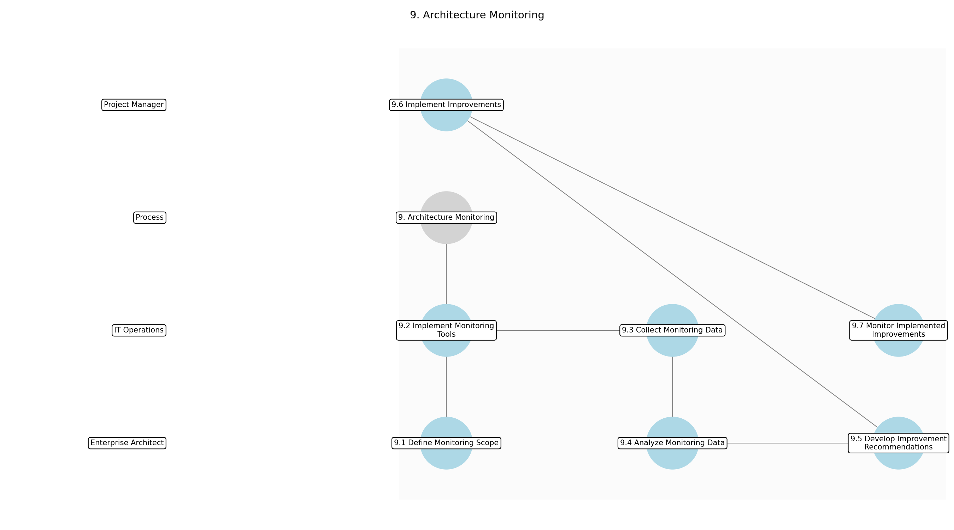

3.9.1 9.1 Define Monitoring Scope
This subprocess describes the activities required to complete '9.1 Define Monitoring Scope'.

Description:
The first step in architecture monitoring is to define the scope of what will be monitored. This involves identifying the key architectural components, interfaces, and dependencies that are critical to the overall performance and stability of the enterprise architecture. The scope should align with the architecture vision and business objectives, ensuring that monitoring efforts are focused on the most important areas.

Purpose:
To establish the boundaries and focus of the monitoring activities.

Scope:
Enterprise-wide

Inputs:
The following inputs are required for this subprocess:
• Architecture Updates
• Architecture Vision Document

Outputs:
This subprocess produces the following outputs:
• Monitoring Scope Definition

Success Criteria:
Success for this subprocess is measured by:
• Clearly defined monitoring scope
• Alignment with architecture vision

Triggers:
This subprocess is initiated by:
• Regular reviews
• New architecture deployments

End Conditions:
This subprocess is considered complete when:
• Approved Monitoring Scope Definition

Governance Requirements:
The following governance requirements apply:
• Review by Architecture Review Board

Risks and Controls:
The following risks and controls apply:
• Risk: Monitoring irrelevant components
• Control: Regular review of monitoring scope

Change Management:
The following change management rules apply:
• Change Request Process: Formal change request process
• Versioning Rules: Major.Minor.Patch

Continuous Improvement:
The following continuous improvement practices apply:
• Review Frequency: Annually
• Improvement Inputs:
• Stakeholder feedback
• Monitoring data

Estimated Duration:
The estimated duration for this subprocess is:
• 1 week

Process Owner:
The following process owner is accountable:
• Enterprise Architect

Responsible Party:
The following parties are responsible for this subprocess:
• Enterprise Architect

3.9.2 9.2 Implement Monitoring Tools
This subprocess describes the activities required to complete '9.2 Implement Monitoring Tools'.

Description:
Once the monitoring scope is defined, the next step is to implement the necessary monitoring tools and infrastructure. This includes selecting and configuring tools that can collect and analyze data on the performance, availability, and security of the architectural components. The tools should be integrated with the existing IT environment and configured to provide real-time alerts and notifications when issues are detected.

Purpose:
To set up the technical infrastructure for collecting monitoring data.

Scope:
Enterprise-wide

Inputs:
The following inputs are required for this subprocess:
• Monitoring Scope Definition
• Technology Architecture Document

Outputs:
This subprocess produces the following outputs:
• Configured Monitoring Tools
• Monitoring Infrastructure

Success Criteria:
Success for this subprocess is measured by:
• Functional monitoring tools
• Integration with IT environment

Triggers:
This subprocess is initiated by:
• New architecture deployments
• Technology upgrades

End Conditions:
This subprocess is considered complete when:
• Operational monitoring tools

Dependencies:
This subprocess depends on the following:
• 9.1 Define Monitoring Scope

Governance Requirements:
The following governance requirements apply:
• Compliance with security policies

Risks and Controls:
The following risks and controls apply:
• Risk: Inadequate monitoring tools
• Control: Regular evaluation of monitoring tools

Change Management:
The following change management rules apply:
• Change Request Process: Formal change request process
• Versioning Rules: Major.Minor.Patch

Continuous Improvement:
The following continuous improvement practices apply:
• Review Frequency: Annually
• Improvement Inputs:
• Performance data
• User feedback

Estimated Duration:
The estimated duration for this subprocess is:
• 2 weeks

Process Owner:
The following process owner is accountable:
• IT Operations Manager

Responsible Party:
The following parties are responsible for this subprocess:
• IT Operations

3.9.3 9.3 Collect Monitoring Data
This subprocess describes the activities required to complete '9.3 Collect Monitoring Data'.

Description:
With the monitoring tools in place, the next step is to collect data on the performance, availability, and security of the architectural components. This involves configuring the tools to collect data on key metrics, such as response time, error rates, and resource utilization. The data should be collected in a consistent and reliable manner, ensuring that it is accurate and up-to-date.

Purpose:
To gather the necessary data for analyzing architecture performance.

Scope:
Enterprise-wide

Inputs:
The following inputs are required for this subprocess:
• Configured Monitoring Tools
• Monitoring Infrastructure

Outputs:
This subprocess produces the following outputs:
• Monitoring Data

Success Criteria:
Success for this subprocess is measured by:
• Consistent data collection
• Accurate and up-to-date data

Triggers:
This subprocess is initiated by:
• Regular intervals
• System events

End Conditions:
This subprocess is considered complete when:
• Continuous data collection

Dependencies:
This subprocess depends on the following:
• 9.2 Implement Monitoring Tools

Governance Requirements:
The following governance requirements apply:
• Compliance with data privacy policies

Risks and Controls:
The following risks and controls apply:
• Risk: Data loss
• Control: Regular data backups

Change Management:
The following change management rules apply:
• Change Request Process: Formal change request process
• Versioning Rules: Major.Minor.Patch

Continuous Improvement:
The following continuous improvement practices apply:
• Review Frequency: Annually
• Improvement Inputs:
• Data quality metrics
• Tool performance

Estimated Duration:
The estimated duration for this subprocess is:
• Ongoing

Process Owner:
The following process owner is accountable:
• IT Operations Manager

Responsible Party:
The following parties are responsible for this subprocess:
• IT Operations

3.9.4 9.4 Analyze Monitoring Data
This subprocess describes the activities required to complete '9.4 Analyze Monitoring Data'.

Description:
The collected monitoring data is then analyzed to identify areas for improvement. This involves using data analytics techniques to identify trends, patterns, and anomalies in the data. The analysis should focus on identifying the root causes of performance issues, security vulnerabilities, and other architectural problems.

Purpose:
To identify areas where the architecture can be improved.

Scope:
Enterprise-wide

Inputs:
The following inputs are required for this subprocess:
• Monitoring Data

Outputs:
This subprocess produces the following outputs:
• Analysis Reports

Success Criteria:
Success for this subprocess is measured by:
• Identification of performance issues
• Root cause analysis

Triggers:
This subprocess is initiated by:
• Regular reviews
• Performance alerts

End Conditions:
This subprocess is considered complete when:
• Completed analysis reports

Dependencies:
This subprocess depends on the following:
• 9.3 Collect Monitoring Data

Governance Requirements:
The following governance requirements apply:
• Compliance with reporting standards

Risks and Controls:
The following risks and controls apply:
• Risk: Inaccurate analysis
• Control: Peer review of analysis reports

Change Management:
The following change management rules apply:
• Change Request Process: Formal change request process
• Versioning Rules: Major.Minor.Patch

Continuous Improvement:
The following continuous improvement practices apply:
• Review Frequency: Annually
• Improvement Inputs:
• Analysis accuracy
• Stakeholder feedback

Estimated Duration:
The estimated duration for this subprocess is:
• 2 weeks

Process Owner:
The following process owner is accountable:
• Enterprise Architect

Responsible Party:
The following parties are responsible for this subprocess:
• Enterprise Architect

3.9.5 9.5 Develop Improvement Recommendations
This subprocess describes the activities required to complete '9.5 Develop Improvement Recommendations'.

Description:
Based on the analysis of the monitoring data, improvement recommendations are developed. These recommendations should be specific, measurable, achievable, relevant, and time-bound (SMART). They should address the root causes of the identified issues and propose concrete actions to improve the performance, availability, and security of the enterprise architecture.

Purpose:
To propose actionable steps for improving the architecture.

Scope:
Enterprise-wide

Inputs:
The following inputs are required for this subprocess:
• Analysis Reports

Outputs:
This subprocess produces the following outputs:
• Improvement Recommendations

Success Criteria:
Success for this subprocess is measured by:
• SMART recommendations
• Address root causes

Triggers:
This subprocess is initiated by:
• Completed analysis reports

End Conditions:
This subprocess is considered complete when:
• Approved improvement recommendations

Dependencies:
This subprocess depends on the following:
• 9.4 Analyze Monitoring Data

Governance Requirements:
The following governance requirements apply:
• Alignment with business objectives

Risks and Controls:
The following risks and controls apply:
• Risk: Unrealistic recommendations
• Control: Stakeholder review of recommendations

Change Management:
The following change management rules apply:
• Change Request Process: Formal change request process
• Versioning Rules: Major.Minor.Patch

Continuous Improvement:
The following continuous improvement practices apply:
• Review Frequency: Annually
• Improvement Inputs:
• Recommendation effectiveness
• Stakeholder feedback

Estimated Duration:
The estimated duration for this subprocess is:
• 1 week

Process Owner:
The following process owner is accountable:
• Enterprise Architect

Responsible Party:
The following parties are responsible for this subprocess:
• Enterprise Architect

3.9.6 9.6 Implement Improvements
This subprocess describes the activities required to complete '9.6 Implement Improvements'.

Description:
The approved improvement recommendations are then implemented. This involves working with the relevant stakeholders to plan and execute the necessary changes to the enterprise architecture. The implementation should be carefully managed to minimize disruption to the business and ensure that the changes are effective.

Purpose:
To put the improvement recommendations into action.

Scope:
Enterprise-wide

Inputs:
The following inputs are required for this subprocess:
• Improvement Recommendations

Outputs:
This subprocess produces the following outputs:
• Implemented Improvements

Success Criteria:
Success for this subprocess is measured by:
• Successful implementation
• Minimal disruption

Triggers:
This subprocess is initiated by:
• Approved improvement recommendations

End Conditions:
This subprocess is considered complete when:
• Completed implementation

Dependencies:
This subprocess depends on the following:
• 9.5 Develop Improvement Recommendations

Governance Requirements:
The following governance requirements apply:
• Project Management Office oversight

Risks and Controls:
The following risks and controls apply:
• Risk: Implementation delays
• Control: Contingency planning

Change Management:
The following change management rules apply:
• Change Request Process: Formal change request process
• Versioning Rules: Major.Minor.Patch

Continuous Improvement:
The following continuous improvement practices apply:
• Review Frequency: Post-implementation
• Improvement Inputs:
• Lessons learned
• Performance data

Estimated Duration:
The estimated duration for this subprocess is:
• Ongoing

Process Owner:
The following process owner is accountable:
• Project Manager

Responsible Party:
The following parties are responsible for this subprocess:
• Project Manager

3.9.7 9.7 Monitor Implemented Improvements
This subprocess describes the activities required to complete '9.7 Monitor Implemented Improvements'.

Description:
After the improvements have been implemented, their effectiveness is monitored. This involves collecting data on the performance, availability, and security of the architectural components to determine whether the changes have had the desired effect. The monitoring data is then analyzed to identify any remaining issues or areas for further improvement.

Purpose:
To verify the effectiveness of the implemented improvements.

Scope:
Enterprise-wide

Inputs:
The following inputs are required for this subprocess:
• Implemented Improvements
• Monitoring Data

Outputs:
This subprocess produces the following outputs:
• Post-Implementation Monitoring Data

Success Criteria:
Success for this subprocess is measured by:
• Improved performance
• Reduced issues

Triggers:
This subprocess is initiated by:
• Regular intervals
• System events

End Conditions:
This subprocess is considered complete when:
• Continuous monitoring

Dependencies:
This subprocess depends on the following:
• 9.6 Implement Improvements

Governance Requirements:
The following governance requirements apply:
• Compliance with reporting standards

Risks and Controls:
The following risks and controls apply:
• Risk: Ineffective improvements
• Control: Regular review of monitoring data

Change Management:
The following change management rules apply:
• Change Request Process: Formal change request process
• Versioning Rules: Major.Minor.Patch

Continuous Improvement:
The following continuous improvement practices apply:
• Review Frequency: Annually
• Improvement Inputs:
• Performance data
• Stakeholder feedback

Estimated Duration:
The estimated duration for this subprocess is:
• Ongoing

Process Owner:
The following process owner is accountable:
• IT Operations Manager

Responsible Party:
The following parties are responsible for this subprocess:
• IT Operations

4.0 Supporting Systems and Tools
The following tools and platforms support this process:
Category | Tools
Architecture Modeling | Enterprise Architect, Archi
Collaboration | Confluence, SharePoint
Project Management | Jira, Asana

5.0 Metrics and Key Performance Indicators (KPIs)
The following metrics help monitor performance and ensure alignment with business objectives.
Metric | Description | Measurement / Frequency | Target
Number of architecture violations | Number of deviations from the defined architecture. | Monthly | Less than 5
Time to market for new products | Time taken to release new products. | Quarterly | Reduce by 10%
Level of alignment between IT and business strategy | Degree to which IT initiatives support business goals. | Annually | 90% alignment
Team satisfaction with the architecture process | Satisfaction level of development teams with the architecture process. | Annually | 4 out of 5
Number of approved architecture changes | Number of architecture changes approved by the Architecture Review Board. | Monthly | Greater than 10

6.0 Critical Success Factors (CSF)
The following is a list of key CSFs associated with this process.
Success Factor | Description
Strong leadership support | Executive support for the architecture process.
Clear communication | Effective communication of architecture principles and standards.
Effective governance | Robust governance processes for architecture compliance.
Collaboration | Collaboration among stakeholders.
Automation | Automation of architecture compliance checks.

7.0 Critical Failure Factors (CFF)
The following is a list of key CFFs associated with this process.
Failure Factor | Description
Lack of communication | Poor communication among stakeholders.
Poor governance | Weak governance processes.
Resistance to change | Resistance from stakeholders.
Inadequate resources | Insufficient resources for the architecture process.
Lack of alignment | Misalignment with business strategy.

8.0 Reporting and Analytics
The following reporting and analytics capabilities support monitoring and decision-making:
Report / Dashboard | Description
Report | Reports on compliance with architecture standards.
Report | Reports on the status of projects implementing the architecture.
Report | Assessments of architectural risks.
Report | Dashboards displaying key architecture metrics.
Report | Reports on architecture changes.

9.0 System Requirements
The following system requirements are essential for the successful implementation of this process.
Name | Details
Architecture repository | A central repository for storing architecture artifacts.
Modeling tools | Tools for creating architecture models.
Collaboration platform | A platform for collaboration among stakeholders.
Workflow engine | A workflow engine for managing architecture processes.
Reporting and analytics tools | Tools for reporting and analyzing architecture data.

10.0 Process Flow Diagram
The following diagram provides a high-level visualization of the process flow.
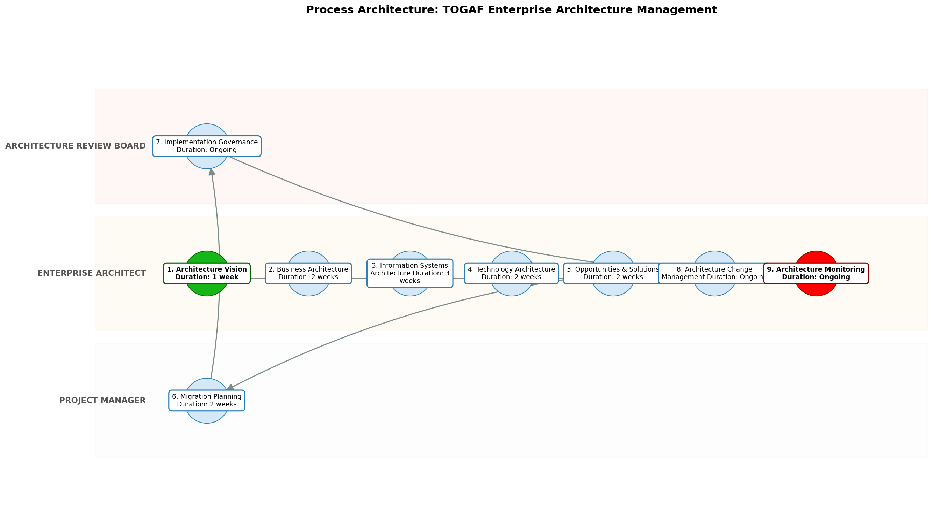

11.0 Process Performance Report
The following metrics are based on a Monte Carlo discrete-event simulation running 2,000 iterations. All time-based values are reported in weeks.
Operational Metric | Simulated Value
Average Cycle Time | 19.95 weeks
Cycle Time Variance | 1.64 weeks
Contention Risk Profile | Low

Identified Bottlenecks
- 3. Information Systems Architecture
- 4. Technology Architecture
- 2. Business Architecture

Detailed Step Performance
Process Step | Avg. Duration (weeks)
1. Architecture Vision | 1.33
2. Business Architecture | 2.66
3. Information Systems Architecture | 3.98
4. Technology Architecture | 2.67
5. Opportunities & Solutions | 2.66
6. Migration Planning | 2.63
7. Implementation Governance | 1.33
8. Architecture Change Management | 1.34
9. Architecture Monitoring | 1.34

12.0 Governance Requirements
The following governance requirements apply to this process:
• Architecture Review Board approval
• Compliance audits
• Regular architecture reviews

13.0 Risks and Controls
The following risks and associated controls apply to this process:
Risk | Control
Architecture violations | Automated compliance checks
Lack of alignment with business strategy | Regular architecture reviews
Resistance to change | Communication and training

14.0 Process Triggers
The following triggers initiate this process:
• New product development
• Major system upgrades
• Business strategy changes
• Regulatory changes

15.0 Process End Conditions
The following conditions indicate completion of the process:
• The new architecture is implemented and operational
• The business goals are achieved
• The architectural risks are mitigated

16.0 Change Management
The following change management practices apply to this process:
• Change Request Process: Formal change request process
• Versioning Rules: Major.Minor.Patch

17.0 Continuous Improvement
The following continuous improvement practices apply to this process:
• Review Frequency: Regular architecture reviews
Improvement Inputs:
• Feedback from stakeholders
• Performance monitoring

Appendix B: Additional Source Data
This appendix contains additional structured data from the normalized source JSON that is not covered in the main sections.
Field | Value
Process Owner | Enterprise Architect
Purpose | To manage the enterprise architecture for different integrated products, ensuring alignment with business strategy and coordination among development teams.
Scope | The entire enterprise, including all business units, IT systems, and development teams.

Appendix C: Glossary
This glossary contains definitions of common terms used in the process documentation:
Term | Definition
Business Process | A set of related activities or tasks performed to achieve a specific organizational goal.
KPI | Key Performance Indicator used to measure the success or health of a process.
Stakeholder | Any individual or group with an interest in the outcomes of the process.
Continuous Improvement | Ongoing effort to improve products, services, or processes.

