High-Level Design for ServiceNow ITOM Discovery (AWS & On-Prem)
Combined Design Document

Industry / Domain: IT Operations / Enterprise Software
Version: 1.2
Generated On: 2026-11-03 12:53:59

Document Control
Version | Date | Author | Description
1.2 | 2026-11-03 | Design Architect | Initial generated design specification

Table of Contents

PART I: HIGH-LEVEL ARCHITECTURE (HLD)

1.0 Executive Summary
To provide a unified view of IT assets across AWS cloud and on-premises environments using ServiceNow ITOM Discovery.

1.1 Document Structure
This document is organized in two parts. Part I presents the business context, requirements, and architecture at a level suitable for review and approval. Part II provides the low-level design detail an implementing engineer needs to build it.

1.2 Scope
ServiceNow-based Configuration Management and Discovery platform covering AWS and on-premises infrastructure.

1.3 Objectives
- Establish automated discovery for AWS and on-premises infrastructure.
- Ensure 99.9% availability for discovery infrastructure.
- Minimize duplicate records in the CMDB.

1.4 Business Drivers
- Need for a single source of truth for all IT assets.
- Cloud migration visibility requirements.
- Compliance with IT governance standards.

1.5 Assumptions
- The ServiceNow instance is a SaaS-hosted environment with the ITOM Discovery plugin active.
- Appropriate IAM roles/credentials for AWS and service accounts for on-premises targets are available.
- Network connectivity exists between AWS VPCs and the on-premises environment where MID Servers are hosted if cross-environment discovery is required.

1.6 Constraints
- All on-premises discovery must be performed via MID Server clusters.
- Data ingestion must pass through the Identification & Reconciliation Engine (IRE).
- Communication between MID Servers and ServiceNow must be outbound-only over HTTPS (Port 443).
System Name: ServiceNow ITOM Discovery Platform
Industry Sector: IT Operations / Enterprise Software
Document Type: Combined

2.0 Stakeholders and Responsibilities
The following is a list of key stakeholders involved in this architecture. Understanding their roles and responsibilities is crucial for successful implementation.
Stakeholder | Responsibilities
CMDB Manager | Defining identification and reconciliation rules.  Overseeing data quality in the CMDB.  Process Owner  Concerns: CMDB data integrity; Automated asset tracking
IT Operations Team | Managing MID Server infrastructure.  Configuring discovery schedules.  System Administrator  Concerns: System availability; MID Server maintenance
Security Team | Reviewing security posture.  Managing service account permissions.  Security Reviewer  Concerns: Credential security; Network port requirements

3.0 Requirements
This section defines the functional and non-functional requirements this design must satisfy, following ISO/IEC/IEEE 29148 requirements engineering practice. Each requirement table below is ordered by identifier, then by priority.

3.1 Functional Requirements
The following functional requirements describe the capabilities this design must provide.
ID | Priority | Description | Acceptance Criteria
FR-001 | Critical | • The system shall discover AWS resources including EC2, RDS, S3, Lambda, and VPC configurations via Cloud Discovery. | • AWS CIs are successfully populated in the CMDB with correct relationships.  • Cloud Discovery schedules complete without authentication errors.
FR-002 | Critical | • The system shall discover on-premises servers (Linux/Windows) and network devices (Cisco/F5) using MID Server clusters. | • On-prem CIs are discovered via SSH/WMI/SNMP.  • MID Server clusters load-balance the discovery probes.
FR-003 | High | • All discovery data must be processed by the Identification & Reconciliation Engine (IRE). | • No duplicate CIs are created for the same resource discovered via different paths.  • Reconciliation rules prioritize authoritative data sources.

3.2 Non-Functional Requirements
The following non-functional requirements describe the quality attributes and operating constraints this design must satisfy (ISO/IEC 25010).
ID | Priority | Category | Description | Acceptance Criteria
NFR-001 | High | Reliability (Availability) | • MID Server clusters must maintain 99.9% availability for discovery operations. | • Discovery jobs continue if a single MID Server in a cluster fails.
NFR-002 | Medium | Performance Efficiency (Time-behavior) | • The system shall process ECC Queue records within a maximum latency of 5 minutes during peak discovery windows. | • ECC Queue 'Ready' state records do not exceed 5000 for more than 10 minutes.
NFR-003 | Critical | Security (Confidentiality) | • All discovery traffic between the MID Server and targets must be encrypted. | • Use of SSH (v2), WMI (with encryption), and SNMP (v3) is enforced.

4.0 System Context
This section defines the boundary of ServiceNow ITOM Discovery Platform: the actors and external systems it interacts with, following the C4 model's System Context (Level 1) view.

4.1 Actors
The following actors interact with the system:
Name | Type | Description
ITOM Administrator | Human | Manages discovery schedules, patterns, and MID Server configurations.
Cloud Administrator | Human | Manages AWS IAM roles and permissions for discovery.

4.2 External Systems
The following external systems integrate with this system:
Name | Description | Interface Type | Data Exchanged | Owner
AWS Cloud API | Amazon Web Services public cloud. | REST API | Cloud resource metadata (EC2, RDS, etc.) | Amazon
On-Premises Infrastructure | Local data center infrastructure. | SSH/WMI/SNMP | Server and network device configuration data. | Enterprise IT

4.3 ServiceNow ITOM Discovery Context Diagram
Context diagram showing ServiceNow ITOM Discovery interacting with AWS and On-Premises environments.
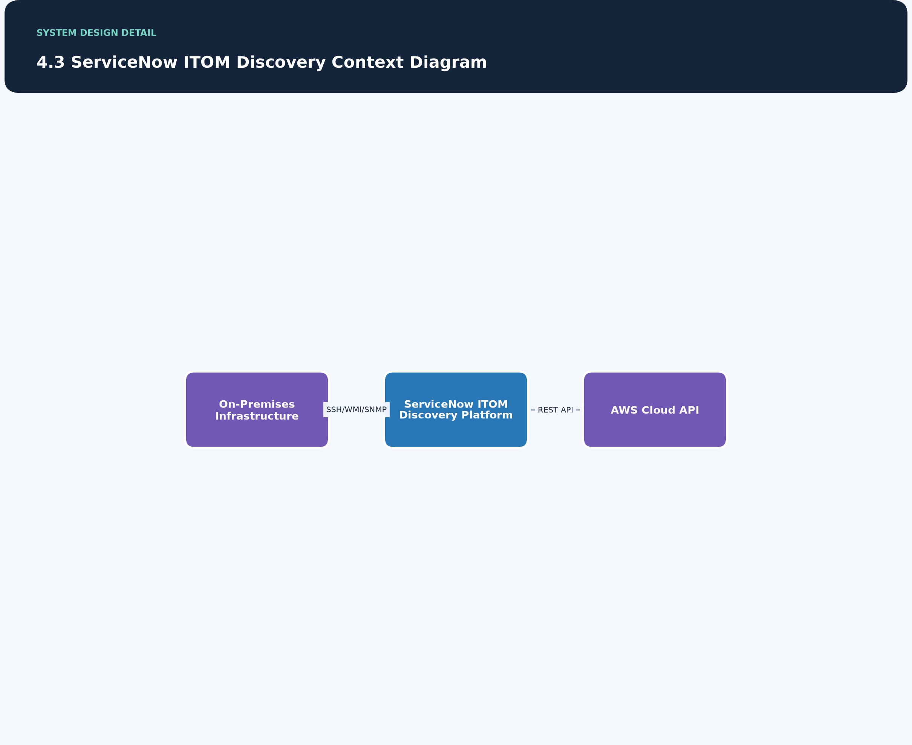

5.0 Architecture Description
The following describes the architecture viewpoints and views for this design (ISO/IEC/IEEE 42010), and the analysis behind the recommended approach.

Concerns
- Data accuracy and duplication.
- Security of stored credentials.
- Impact of discovery traffic on production networks.

Viewpoints

Integration Viewpoint
Applicable Standard: ISO/IEC 42010
Concerns Addressed:
- System integration
- Data flow
Description: Describes how components interact to perform discovery.
Modeling Conventions: C4 Model / Block Diagram
Stakeholders Addressed:
- IT Operations
- Cloud Architects

Views

System Integration View
Description: High-level overview of discovery components and their interactions.
Viewpoint Ref: Integration Viewpoint

MID Server-Based Discovery Pattern
The architecture leverages ServiceNow MID Servers as an intermediary to perform discovery across disparate environments while maintaining a secure, outbound-only connection to the ServiceNow SaaS instance.
Strengths:
• Secure outbound-only communication.
• Centralized management of credentials.
• Scalable through clustering.
Weaknesses:
• Requires infrastructure management for MID Server hosts.
• Dependency on network connectivity between MID and targets.
Risks:
• Single point of failure if clusters are not properly sized.
• Network latency affecting discovery windows.
Recommendation: Proceed with MID Server clusters for both AWS and on-prem to ensure security compliance and high availability.

5.1 Architecture Detail
The following elaborates the high-level design's own components, integration points, deployment topology, and cross-cutting security, scalability, and availability characteristics.
Solution Overview: A ServiceNow-based ITOM Discovery solution that uses MID Server clusters to scan AWS and On-Premises environments. Data is reconciled via the IRE to maintain a clean CMDB.
Architecture Style: Distributed Agent-less Discovery Architecture

Components

ServiceNow Instance
Description: SaaS platform hosting the CMDB, Discovery engine, and IRE. The platform utilizes a multi-instance architecture with native load balancing and horizontal scaling managed by ServiceNow's Site Reliability Engineering teams.
Interfaces: - HTTPS/443 (Inbound from MID)
Owner: ServiceNow Platform Team
Technology Stack: - ServiceNow Vancouver/Washington DC (Multi-instance SaaS)
Type: SaaS Platform/Cloud

MID Server Cluster (On-Prem)
Dependencies:
- ServiceNow Instance
- On-Prem Targets
Description: Cluster of MID Servers hosted on-premises to discover local infrastructure.
Interfaces:
- SSH
- WMI
- SNMP
Owner: IT Operations Team
Technology Stack:
- Windows/Linux Server
- ServiceNow MID Software
Type: Infrastructure Component

MID Server Cluster (AWS)
Dependencies:
- ServiceNow Instance
- AWS Cloud API
Description: Cluster of MID Servers hosted in AWS to discover cloud resources.
Interfaces: - AWS SDK/API
Owner: Cloud Operations Team
Technology Stack:
- EC2 Instances
- ServiceNow MID Software
Type: Infrastructure Component

AWS Cloud API
Description: AWS APIs used for cloud resource discovery.
Interfaces: - REST API
Owner: AWS
Technology Stack: - AWS SDK
Type: External Service

On-Prem Targets
Description: Physical and virtual servers, network devices on-premises.
Interfaces:
- SSH
- WMI
- SNMP
Owner: Various Infrastructure Owners
Technology Stack:
- Linux
- Windows
- Cisco
- F5
Type: Target System

Integration Points
Description: Communication for discovery tasks and results.
Integration Pattern: Polling / Asynchronous
Protocol: HTTPS/443
Source: MID Server Cluster (On-Prem)
Target: ServiceNow Instance

Description: Cloud resource discovery.
Integration Pattern: API Call
Protocol: HTTPS/443 (AWS API)
Source: MID Server Cluster (AWS)
Target: AWS Cloud API

Description: On-prem infrastructure discovery.
Integration Pattern: Remote Execution / Management Protocols
Protocol: SSH, WMI, SNMP
Source: MID Server Cluster (On-Prem)
Target: On-Prem Targets

Data Flow Overview: Discovery schedules trigger probes/patterns. ServiceNow sends tasks to the ECC Queue. MID Servers poll the ECC Queue, execute probes against targets, and return results to the ECC Queue. ServiceNow processes results via IRE and updates the CMDB.

Technology Stack
Category: Platform
Justification: Enterprise standard for ITOM.
License: Commercial
Technology: ServiceNow Vancouver/Washington DC Release
Version: Vancouver/Washington DC

Category: Infrastructure Agent
Justification: Required for secure communication with ServiceNow SaaS.
License: Included with ServiceNow
Technology: ServiceNow MID Server
Version: Latest Compatible

Category: Cloud Provider
Justification: Primary cloud infrastructure.
License: Commercial
Technology: AWS
Version: N/A

Deployment Topology

Environments
Description | Infrastructure | Name
Production ServiceNow instance and MID Server clusters. | SaaS, AWS VPC, On-Prem Data Center | Production

Deployment Topology Diagram
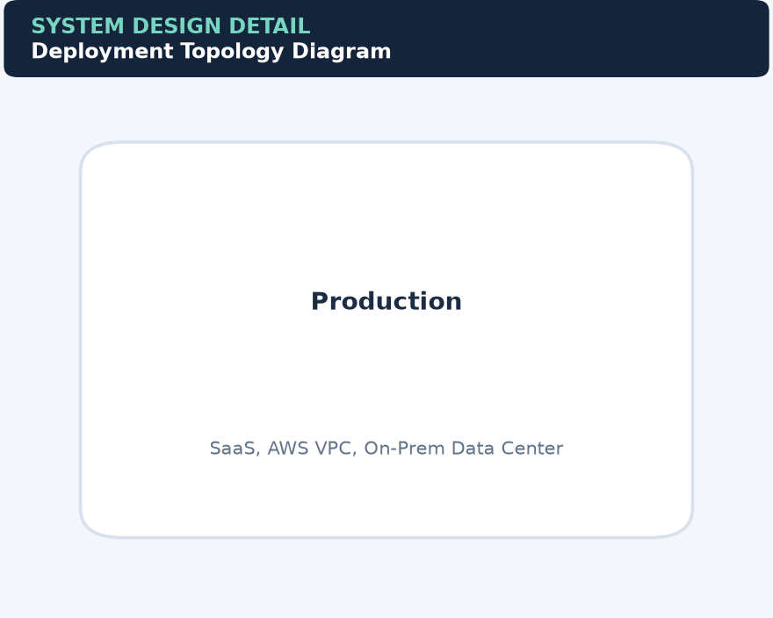

Security Architecture
Authentication Mechanism: Mutual Authentication or API Key for MID Servers; SSH Keys/Service Accounts for targets; Just-in-time credential retrieval from external vaults.
Threat Model Reference: STRIDE analysis for MID Server communication.
Data Protection Measures:
- Encryption at rest for credentials.
- Encryption in transit (HTTPS/SSH).
- Integration with external credential vaults (e.g., CyberArk, HashiCorp) to avoid storing high-privilege credentials locally within the ServiceNow instance.
Authorization Model: Role-Based Access Control (RBAC) in ServiceNow.

Scalability and Performance
Expected Load: Discovery of thousands of CIs across multi-cloud and on-prem.
Scaling Strategy: Horizontal scaling of MID Servers within clusters.

Performance Targets
Metric | Target
ECC Queue Latency | < 5 minutes during peak windows

Availability and Resilience
Backup Strategy: MID Server configuration files are backed up; ServiceNow instance is backed up by the provider.
Rto: 4 hours
Availability Target: 99.9%
Rpo: 1 hour (for discovery data)
Disaster Recovery Plan: Failover to secondary MID Servers in the cluster.
Redundancy Strategy: MID Server Clustering (N+1 redundancy).

Architecture-Level Risks and Mitigations

RM-001
Category: Performance
Description: ECC Queue Congestion due to high volume of discovery data.
Impact: medium
Likelihood: medium
Mitigation: Configure MID Server threading and horizontal scaling of clusters.
Owner: IT Operations Team
Status: open

RM-002
Category: Security
Description: Credential Exposure if the ServiceNow vault is compromised.
Impact: high
Likelihood: low
Mitigation: Use ServiceNow encrypted credential store and integrate with external vaults (CyberArk/HashiCorp) to ensure that sensitive credentials are never stored in plain text or permanently on the platform. MID Servers retrieve credentials just-in-time.
Owner: Security Team
Status: open

RM-003
Category: Reliability
Description: AWS API Throttling during large-scale discovery.
Impact: medium
Likelihood: medium
Mitigation: Optimize discovery schedules and use Cloud Events for incremental updates.
Owner: Cloud Architects
Status: open

RM-004
Category: Data Integrity
Description: CMDB Data Corruption or Duplicates.
Impact: high
Likelihood: medium
Mitigation: Strict enforcement of IRE rules and identification criteria.
Owner: CMDB Manager
Status: open

6.0 Architecture Flow Diagram
This section provides a high-level visualization of the architecture and the flow between its major components.
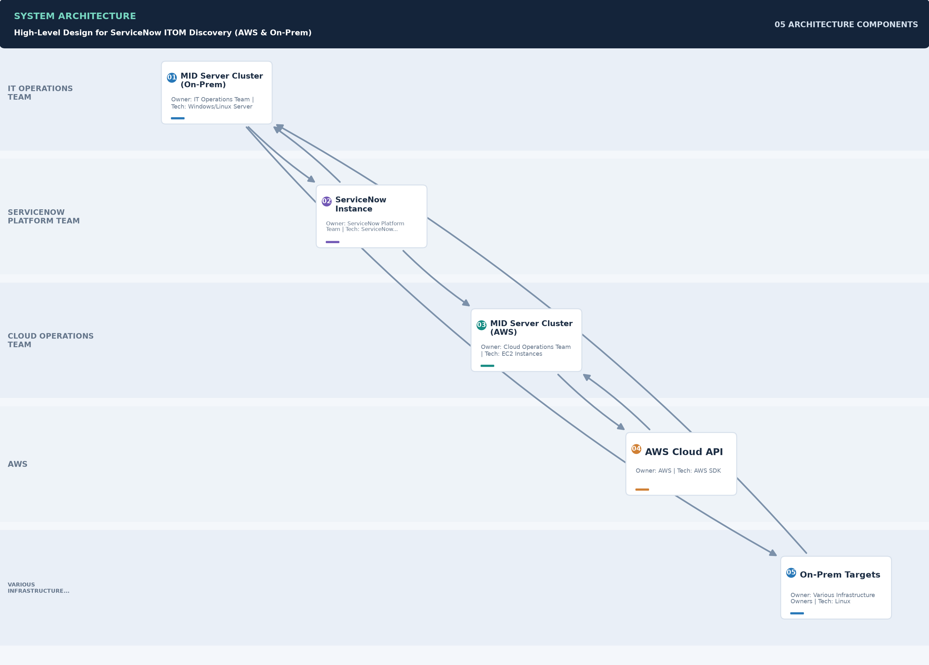

7.0 Quality Attributes
This section defines the quality attributes this design targets, mapped to ISO/IEC 25010 product quality characteristics.
Category | Description | Measure Method | Metric | Target
Functional Suitability (Functional Completeness) | • Completeness of AWS and on-prem resource discovery. | • CMDB audit against known assets. | Discovery Coverage | > 95% of known assets
Performance Efficiency (Time-behavior) | • Discovery data must be processed within acceptable timeframes. | • ECC Queue processing time analysis. | Latency | < 5 minutes
Reliability (Availability) | • The system must provide consistent discovery results and handle failures gracefully. | • Availability monitoring of MID Server clusters. | Uptime | 99.9%
Security (Confidentiality) | • Protection of discovery credentials and data in transit. | • Security audit and penetration testing. | Encryption Compliance | 100% of traffic encrypted

8.0 Compliance and Standards
This section lists the standards and regulatory requirements applicable to this design, and its current compliance status against each.

8.1 Applicable Standards
The following standards apply to this design:
Standard | Body | Clause Reference | Applicability | Compliance Status
ISO/IEC 42010 | ISO/IEC | N/A | • Standard for describing software architectures. | Compliant

8.2 Regulatory Requirements
The following regulatory requirements apply to this design:
Regulation | Jurisdiction | Requirement | Compliance Status
GDPR / Data Privacy | Global | • Ensure no PII is collected during infrastructure discovery. | In Scope

9.0 Risk Register
This section documents the risks identified for this design, their likelihood and impact, and the mitigations in place.
ID | Category | Likelihood | Impact | Description | Mitigation | Owner | Status
RR-001 | Performance | Medium | Medium | • ECC Queue Congestion due to high volume of discovery data. | • Configure MID Server threading and horizontal scaling of clusters. | IT Operations Team | Open
RR-002 | Security | Low | High | • Credential Exposure if the ServiceNow vault is compromised. | • Use ServiceNow encrypted credential store and integrate with external vaults (CyberArk/HashiCorp) to ensure that sensitive credentials are never stored in plain text or permanently on the platform. MID Servers retrieve credentials just-in-time. | Security Team | Open
RR-003 | Reliability | Medium | Medium | • AWS API Throttling during large-scale discovery. | • Optimize discovery schedules and use Cloud Events for incremental updates. | Cloud Architects | Open
RR-004 | Data Integrity | Medium | High | • CMDB Data Corruption or Duplicates. | • Strict enforcement of IRE rules and identification criteria. | CMDB Manager | Open

10.0 Governance Requirements
The following governance requirements apply to this architecture:
• All discovery patterns must be peer-reviewed before deployment to production.
• Credential access must be audited monthly.

11.0 Continuous Improvement
The following continuous improvement practices apply to this architecture:
• Review Frequency: Quarterly
Improvement Inputs:
• Discovery log analysis
• ECC queue performance metrics
• CMDB health reports

PART II: LOW-LEVEL DESIGN (LLD)

12.0 Low-Level Design
This part elaborates the High-Level Design (Part I) into implementation-ready detail, organised by design discipline -- runtime behaviour, component design, interfaces, configuration, and operations -- so a reviewer interested in one discipline can find it in one place rather than across every component section.

12.1 Runtime Processing and Sequence Flows
The following sequence flows describe how this design's components interact at runtime to fulfil its key scenarios.

On-Premises Discovery Flow
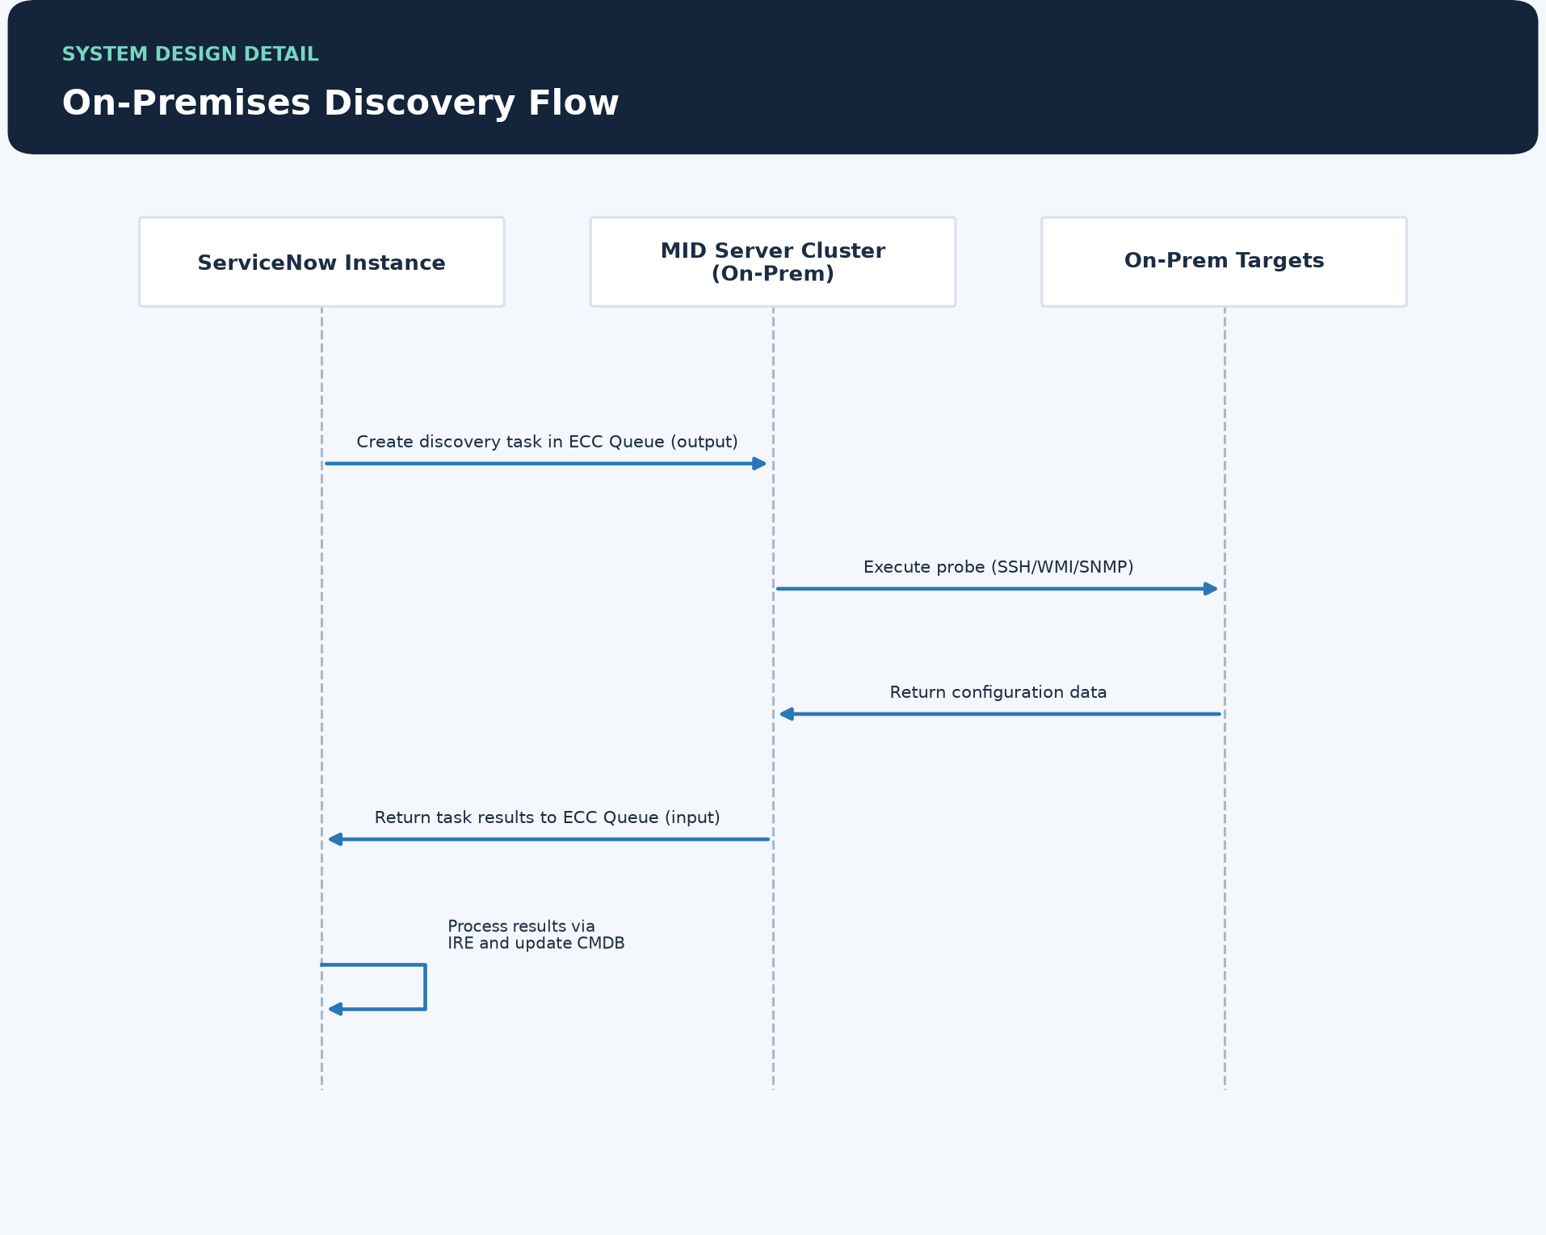

AWS Cloud Discovery Flow
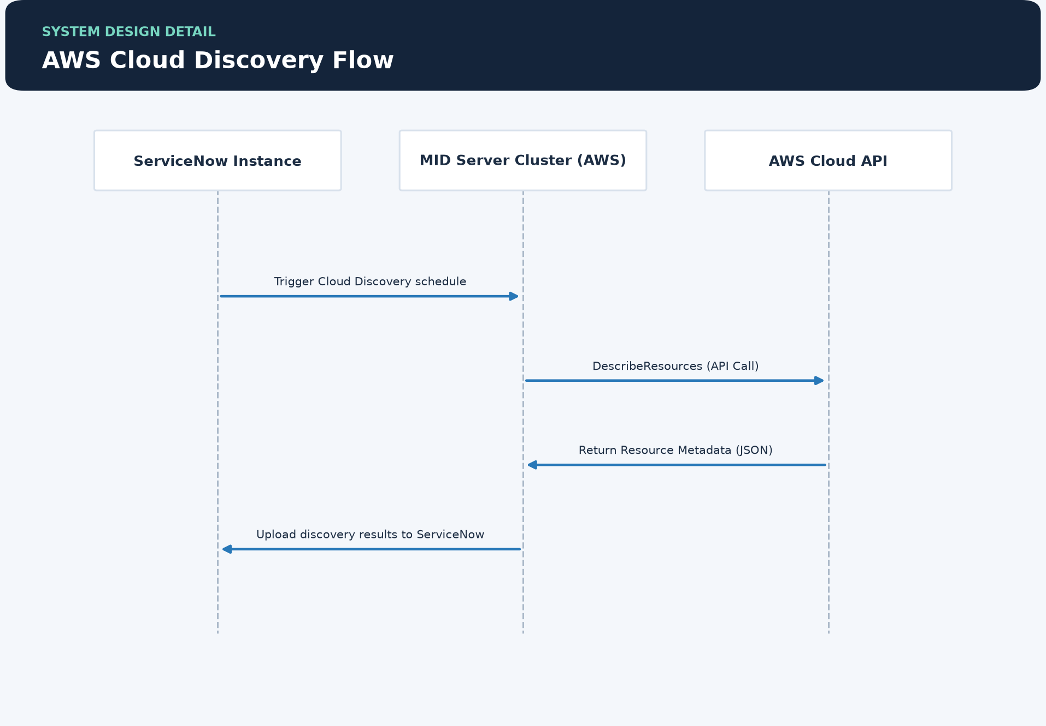

12.2 Component Design
The following describes each component's purpose, responsibilities, dependencies, key design decisions, and scope and operational boundaries.

AWS Cloud API
Responsibilities:
• Providing standardized endpoints for resource queries.
• Enforcing IAM-based authorization for discovery requests.

MID Server Cluster (AWS)
Responsibilities:
• Discovering AWS resources via Cloud Discovery patterns.
• Authenticating with AWS using IAM roles or access keys.
• Mapping cloud metadata to ServiceNow CMDB classes.

MID Server Cluster (On-Prem)
Responsibilities:
• Establishing secure outbound connection to ServiceNow.
• Polling the ECC Queue for 'ready' output records.
• Executing discovery probes against on-premises targets.
• Parsing probe results and returning them to the ECC Queue.

On-Prem Targets
Responsibilities:
• Allowing secure access for discovery service accounts.
• Providing system configuration details upon request.

ServiceNow Instance
Responsibilities:
• Scheduling discovery jobs.
• Managing the ECC Queue (External Communication Channel).
• Running the Identification & Reconciliation Engine (IRE).
• Hosting the Configuration Management Database (CMDB).

12.3 Interface Design
The following interfaces are exposed or consumed by this design's components.
Interface | Owning Component | Protocol | Authentication | Error Handling
 | ServiceNow Instance | HTTPS/443 |  | —
 | MID Server Cluster (On-Prem) | HTTPS/443 |  | —
 | MID Server Cluster (On-Prem) | SSH/WMI/SNMP |  | —
 | MID Server Cluster (AWS) | HTTPS/443 |  | —
 | AWS Cloud API | HTTPS/443 (REST) |  | —
 | On-Prem Targets | SSH/WMI/SNMP |  | —

12.4 Configuration Design
The following consolidates the key configuration parameters for each component.

ServiceNow Instance
Default Value | Description | Name
true | Main switch for discovery functionality. | glide.discovery.active
5000 | Maximum number of results to return per probe execution. | glide.discovery.max_results_per_probe

MID Server Cluster (On-Prem)
Default Value | Description | Name
40000 | Interval in milliseconds for polling the ECC queue. | mid.poll.interval
25 | Maximum concurrent worker threads for processing tasks. | mid.max_threads

MID Server Cluster (AWS)
Default Value | Description | Name
N/A | IAM Role ARN for cross-account AWS discovery. | mid.aws.assume_role_arn

13.0 Glossary and References

13.1 Glossary
This glossary defines terms used throughout this document.
Term | Definition
CMDB | • Configuration Management Database
IRE | • Identification & Reconciliation Engine
MID Server | • Management, Instrumentation, and Discovery Server

13.2 References
The following external references were used in the development of this design.
Title | Source | Version
ITOM Discovery Overview (https://docs.servicenow.com/) | ServiceNow Product Documentation | Vancouver/Washington DC

