Responsible AI RFP Standard for Consulting
Process Model Document

Industry / Domain: Consulting and Professional Services
Version: 1.1
Generated On: 2026-02-28 19:18:36

Document Control
Version | Date | Author | Description
1.1 | 2026-02-28 | Process Architect | Initial generated process specification

Table of Contents

1.0 Process Overview
This process establishes a standard for responding to RFPs that promote the responsible use of GenAI and Agentic systems in consulting engagements. It ensures that AI technology is applied ethically and effectively, providing genuine value to clients while mitigating risks associated with data privacy, security, and technical feasibility.

1.1 Assumptions
- Clients have sufficient data quality and infrastructure to support AI/Agentic implementation.
- The consulting firm's internal legal and technical teams have the bandwidth to review all AI-related RFP responses.
- AI and Agentic technologies proposed are legally compliant within the client's specific jurisdictions.

1.2 Constraints
- Adherence to international AI regulations (e.g., EU AI Act) and data privacy laws (GDPR).
- Strict budgetary limits for pre-sales technical architecture and ethical impact assessments.
- Limited availability of senior AI ethics and solution architect subject matter experts.

1.3 Purpose
To establish a consistent, ethical, and high-quality standard for proposing AI and Agentic solutions to consulting clients, ensuring technology is applied only where it adds genuine, responsible value.

1.4 Scope
All RFP, RFI, and unsolicited proposal responses originating from the consulting firm that include Generative AI or Agentic System components.

1.5 Industry Sector
Consulting and Professional Services

2.0 Stakeholders and Responsibilities
The following is a list of key stakeholders involved in this process. Understanding their roles and responsibilities is crucial for successful implementation.
Stakeholder | Responsibilities
Enterprise Director | Overall strategy, revenue targets, and adherence to the RFP standard.
AI Solution Architect | Qualifies the technical feasibility and designs the agentic architecture.
Responsible AI / Legal Lead | Evaluates proposals for ethical risks, bias mitigation, and regulatory compliance.
Bid/RFP Manager | Manages the RFP timeline and coordinates inputs from various departments.

3.0 Process Workflow
The following is a list of key steps in the process workflow.

3.1 Opportunity Identification & Intake

Description:
Review client requirements to determine if AI or Agentic systems are requested or potentially beneficial. This initial screening ensures that AI opportunities are identified early in the RFP lifecycle.

Purpose:
To identify potential AI use cases early in the RFP lifecycle.

Scope:
Initial intake and screening of all incoming RFPs.

Inputs:
The following inputs are required for this step:
• RFP/RFI Document
• Client Opportunity Brief

Outputs:
This step produces the following outputs:
• Initial AI Opportunity Assessment

Success Criteria:
Success for this step is measured by:
• All RFPs screened for AI potential within 24 hours of receipt.

Process Triggers:
This step is initiated by:
• Receipt of an RFP or RFI mentioning AI/Automation, or an identified opportunity by a Client Partner.

Process End Conditions:
This step is considered complete when:
• Opportunity is either qualified for AI assessment or routed to traditional RFP process.

Deliverables:
This step produces the following deliverables:
• Qualified Opportunity Record

Estimated Duration:
The estimated duration for this step is:
• 1 day

Process Owner:
The following process owner is accountable:
• Bid/RFP Manager

Responsible Parties:
The following parties are responsible for this step:
• Bid/RFP Manager

Required Sub Process(es) for the Step "Opportunity Identification & Intake"
The following details the subprocess flows for the step "Opportunity Identification & Intake".
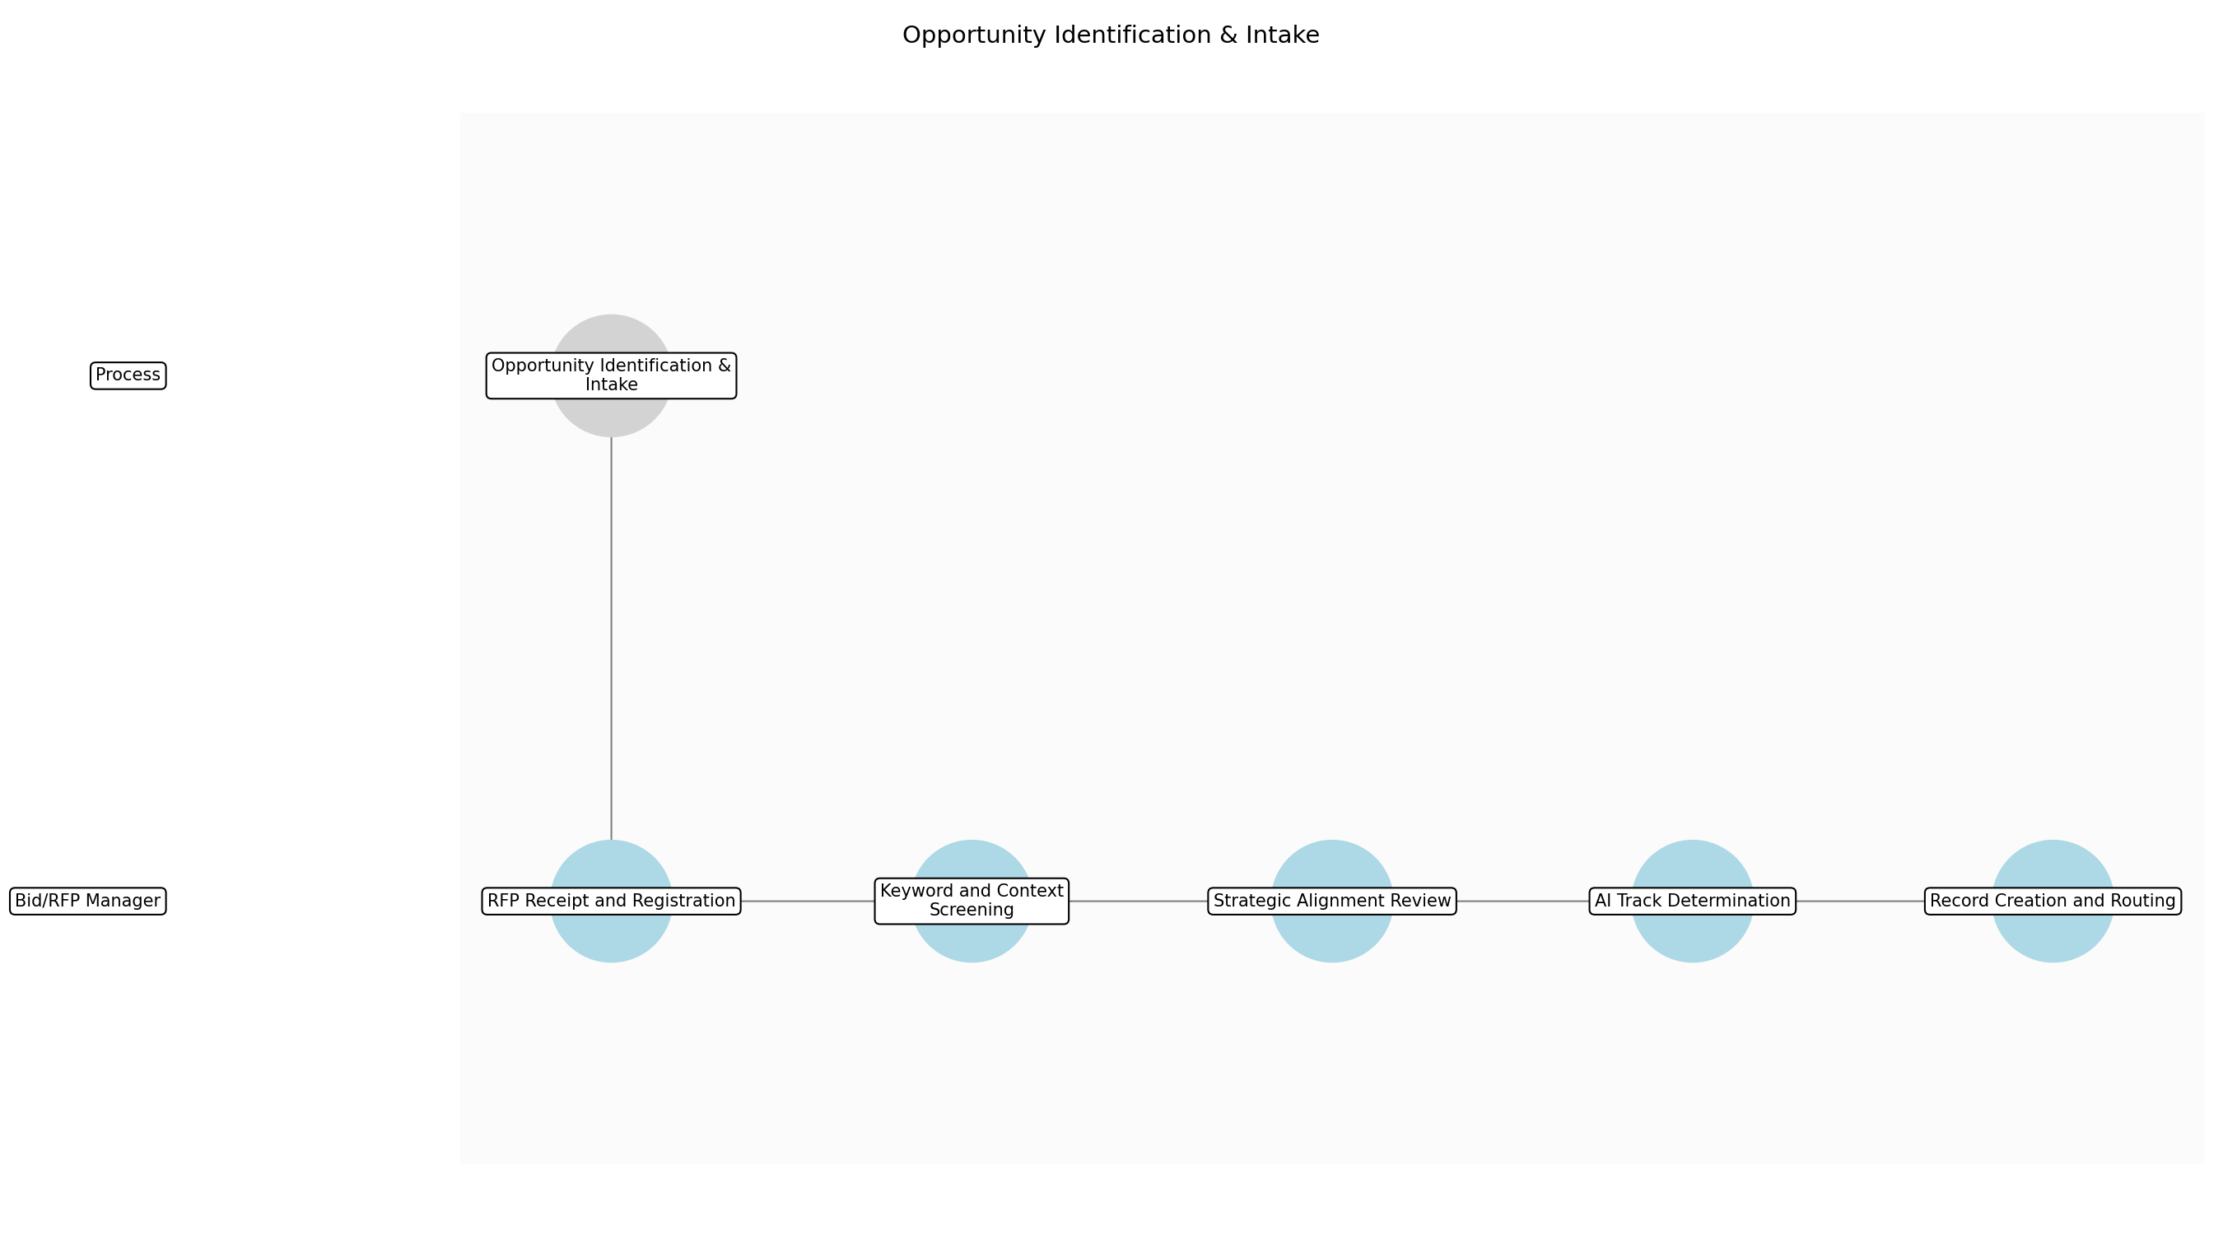

3.1.1 RFP Receipt and Registration
This subprocess describes the activities required to complete 'RFP Receipt and Registration'.

Description:
Formally receive the RFP/RFI document and log it into the bid management system. This ensures every incoming request is tracked from the moment of arrival and assigned a unique identifier for auditability.

Purpose:
To ensure all incoming requests are tracked and accounted for.

Scope:
Initial logging of the physical or digital RFP document.

Inputs:
The following inputs are required for this subprocess:
• RFP/RFI Document

Outputs:
This subprocess produces the following outputs:
• Registered Bid Entry

Success Criteria:
Success for this subprocess is measured by:
• RFP logged in the system within 1 hour of receipt.

Triggers:
This subprocess is initiated by:
• Receipt of an RFP or RFI document.

End Conditions:
This subprocess is considered complete when:
• Bid entry is visible in the tracking system.

Governance Requirements:
The following governance requirements apply:
• Compliance with corporate data retention policies for incoming bids.

Risks and Controls:
The following risks and controls apply:
• Risk: RFP documents are lost or not registered.
• Control: Automated email intake monitoring and mandatory registration checklist.

Change Management:
The following change management rules apply:
• Change Request Process: Requests for intake process changes must be submitted to the Bid Office Director.
• Versioning Rules: Process documentation follows standard semantic versioning.

Continuous Improvement:
The following continuous improvement practices apply:
• Review Frequency: Quarterly
• Improvement Inputs:
• Intake delay metrics
• Registration error logs

Estimated Duration:
The estimated duration for this subprocess is:
• 1 hour

Process Owner:
The following process owner is accountable:
• Bid/RFP Manager

Responsible Party:
The following parties are responsible for this subprocess:
• Bid/RFP Manager

3.1.2 Keyword and Context Screening
This subprocess describes the activities required to complete 'Keyword and Context Screening'.

Description:
Utilize the Knowledge Management System to scan the RFP for keywords such as 'AI', 'Machine Learning', or 'Agentic'. Simultaneously, perform a manual review of the Client Opportunity Brief to identify business problems where AI could provide a competitive advantage.

Purpose:
To rapidly identify potential AI use cases within the client's request.

Scope:
Scanning and high-level analysis of the RFP content.

Inputs:
The following inputs are required for this subprocess:
• RFP/RFI Document
• Client Opportunity Brief

Outputs:
This subprocess produces the following outputs:
• Keyword Scan Report
• Contextual Analysis Notes

Success Criteria:
Success for this subprocess is measured by:
• All explicit and implicit AI requirements identified.

Triggers:
This subprocess is initiated by:
• Completion of bid registration.

End Conditions:
This subprocess is considered complete when:
• Screening report is finalized.

Dependencies:
This subprocess depends on the following:
• RFP Receipt and Registration

Governance Requirements:
The following governance requirements apply:
• Audit trail of keyword search terms used.

Risks and Controls:
The following risks and controls apply:
• Risk: Implicit AI opportunities are overlooked.
• Control: Use of a standardized AI Opportunity Identification Checklist.

Change Management:
The following change management rules apply:
• Change Request Process: Keyword list updates are managed by the AI Strategy team.
• Versioning Rules: Keyword library is version-controlled in the Knowledge Management System.

Continuous Improvement:
The following continuous improvement practices apply:
• Review Frequency: Monthly
• Improvement Inputs:
• Feedback from AI Solution Architects on screening accuracy.

Estimated Duration:
The estimated duration for this subprocess is:
• 4 hours

Process Owner:
The following process owner is accountable:
• Bid/RFP Manager

Responsible Party:
The following parties are responsible for this subprocess:
• Bid/RFP Manager

3.1.3 Strategic Alignment Review
This subprocess describes the activities required to complete 'Strategic Alignment Review'.

Description:
Consult with the Client Partner to understand the client's strategic goals and appetite for innovation. This step ensures that proposing an AI solution aligns with the broader account strategy and client relationship nuances.

Purpose:
To ensure AI proposals are strategically viable for the specific client.

Scope:
Internal consultation with account leadership.

Inputs:
The following inputs are required for this subprocess:
• Contextual Analysis Notes
• Client Opportunity Brief

Outputs:
This subprocess produces the following outputs:
• Stakeholder Feedback

Success Criteria:
Success for this subprocess is measured by:
• Confirmation of client interest in AI or innovative solutions.

Triggers:
This subprocess is initiated by:
• Identification of potential AI use cases.

End Conditions:
This subprocess is considered complete when:
• Client Partner sign-off on the AI track.

Dependencies:
This subprocess depends on the following:
• Keyword and Context Screening

Governance Requirements:
The following governance requirements apply:
• Documentation of stakeholder approval for the proposed solution track.

Risks and Controls:
The following risks and controls apply:
• Risk: Proposing AI to a client with low risk tolerance.
• Control: Mandatory consultation with the Client Partner before qualifying the AI track.

Change Management:
The following change management rules apply:
• Change Request Process: Strategic review criteria changes require Enterprise Director approval.
• Versioning Rules: Review templates are versioned annually.

Continuous Improvement:
The following continuous improvement practices apply:
• Review Frequency: Bi-annually
• Improvement Inputs:
• Win/Loss analysis related to strategic alignment.

Estimated Duration:
The estimated duration for this subprocess is:
• 2 hours

Process Owner:
The following process owner is accountable:
• Bid/RFP Manager

Responsible Party:
The following parties are responsible for this subprocess:
• Bid/RFP Manager

3.1.4 AI Track Determination
This subprocess describes the activities required to complete 'AI Track Determination'.

Description:
Synthesize the scan results and stakeholder feedback to determine if the opportunity warrants a formal AI suitability assessment. A decision is made to either route the bid to the AI track or the traditional RFP process.

Purpose:
To qualify the opportunity for specialized AI solutioning.

Scope:
Decision-making regarding the bid response path.

Inputs:
The following inputs are required for this subprocess:
• Keyword Scan Report
• Stakeholder Feedback

Outputs:
This subprocess produces the following outputs:
• Initial AI Opportunity Assessment

Success Criteria:
Success for this subprocess is measured by:
• Clear 'Go/No-Go' decision for the AI track.

Triggers:
This subprocess is initiated by:
• Completion of stakeholder consultation.

End Conditions:
This subprocess is considered complete when:
• Initial assessment document is signed off.

Dependencies:
This subprocess depends on the following:
• Strategic Alignment Review

Governance Requirements:
The following governance requirements apply:
• Adherence to the 'AI Fit' qualification standards.

Risks and Controls:
The following risks and controls apply:
• Risk: Incorrectly routing a complex AI bid to the traditional track.
• Control: Secondary review of 'No-Go' decisions by a Senior Bid Manager.

Change Management:
The following change management rules apply:
• Change Request Process: Qualification criteria updates are reviewed by the AI Strategy committee.
• Versioning Rules: Qualification logic is versioned in the Bid Playbook.

Continuous Improvement:
The following continuous improvement practices apply:
• Review Frequency: Quarterly
• Improvement Inputs:
• Percentage of bids correctly routed to the AI track.

Estimated Duration:
The estimated duration for this subprocess is:
• 2 hours

Process Owner:
The following process owner is accountable:
• Bid/RFP Manager

Responsible Party:
The following parties are responsible for this subprocess:
• Bid/RFP Manager

3.1.5 Record Creation and Routing
This subprocess describes the activities required to complete 'Record Creation and Routing'.

Description:
Create the Qualified Opportunity Record in the CRM and route the bid to the appropriate technical team. If qualified for AI, the record is sent to the AI Solution Architect; otherwise, it follows the traditional RFP workflow.

Purpose:
To formalize the intake and initiate the solutioning phase.

Scope:
Data entry and workflow initiation in the CRM/Bid system.

Inputs:
The following inputs are required for this subprocess:
• Initial AI Opportunity Assessment

Outputs:
This subprocess produces the following outputs:
• Qualified Opportunity Record

Success Criteria:
Success for this subprocess is measured by:
• Opportunity record created and assigned to the correct Solution Architect.

Triggers:
This subprocess is initiated by:
• Finalization of the AI Track Determination.

End Conditions:
This subprocess is considered complete when:
• Solution Architect acknowledges receipt of the assignment.

Dependencies:
This subprocess depends on the following:
• AI Track Determination

Governance Requirements:
The following governance requirements apply:
• CRM data integrity and mandatory field completion.

Risks and Controls:
The following risks and controls apply:
• Risk: Assignment delays due to system errors.
• Control: Automated escalation if assignment is not acknowledged within 4 hours.

Change Management:
The following change management rules apply:
• Change Request Process: CRM workflow changes must be approved by Sales Operations.
• Versioning Rules: System workflows are versioned via the CRM change log.

Continuous Improvement:
The following continuous improvement practices apply:
• Review Frequency: Monthly
• Improvement Inputs:
• Time-to-assignment metrics
• Solution Architect feedback on intake quality.

Estimated Duration:
The estimated duration for this subprocess is:
• 2 hours

Process Owner:
The following process owner is accountable:
• Bid/RFP Manager

Responsible Party:
The following parties are responsible for this subprocess:
• Bid/RFP Manager

3.2 AI Suitability & Ethics Screening

Description:
Evaluate the use case against an 'AI Fit Matrix' using optimized screening criteria to ensure GenAI/Agents are the right solution and ethically viable. This step prevents the misapplication of AI in scenarios where traditional logic is more appropriate.

Purpose:
To prevent pushing AI into situations where it is not a good fit or is ethically risky.

Scope:
Technical and ethical screening of the proposed AI application.

Inputs:
The following inputs are required for this step:
• Initial AI Opportunity Assessment
• AI Fit Matrix Tool

Outputs:
This step produces the following outputs:
• AI Suitability Report

Success Criteria:
Success for this step is measured by:
• Completed AI Fit Matrix with clear 'Go/No-Go' recommendation.

Process Triggers:
This step is initiated by:
• Qualification of an AI-related opportunity.

Process End Conditions:
This step is considered complete when:
• AI suitability and ethical viability confirmed or rejected.

Dependencies:
This step depends on the following:
• Opportunity Identification & Intake

Deliverables:
This step produces the following deliverables:
• AI Fit Matrix Report
• Ethical Risk Assessment

Governance Requirements:
The following governance requirements apply:
• Adherence to internal Ethical AI guidelines.

Risks and Controls:
The following risks and controls apply:
• Control: Mandatory 'AI Fit' checklist and review by a lead AI Architect.
• Risk: Overselling AI capabilities or recommending AI for unsuitable use cases.

Estimated Duration:
The estimated duration for this step is:
• 1.5 days

Process Owner:
The following process owner is accountable:
• AI Solution Architect

Responsible Parties:
The following parties are responsible for this step:
• AI Solution Architect

Required Sub Process(es) for the Step "AI Suitability & Ethics Screening"
The following details the subprocess flows for the step "AI Suitability & Ethics Screening".
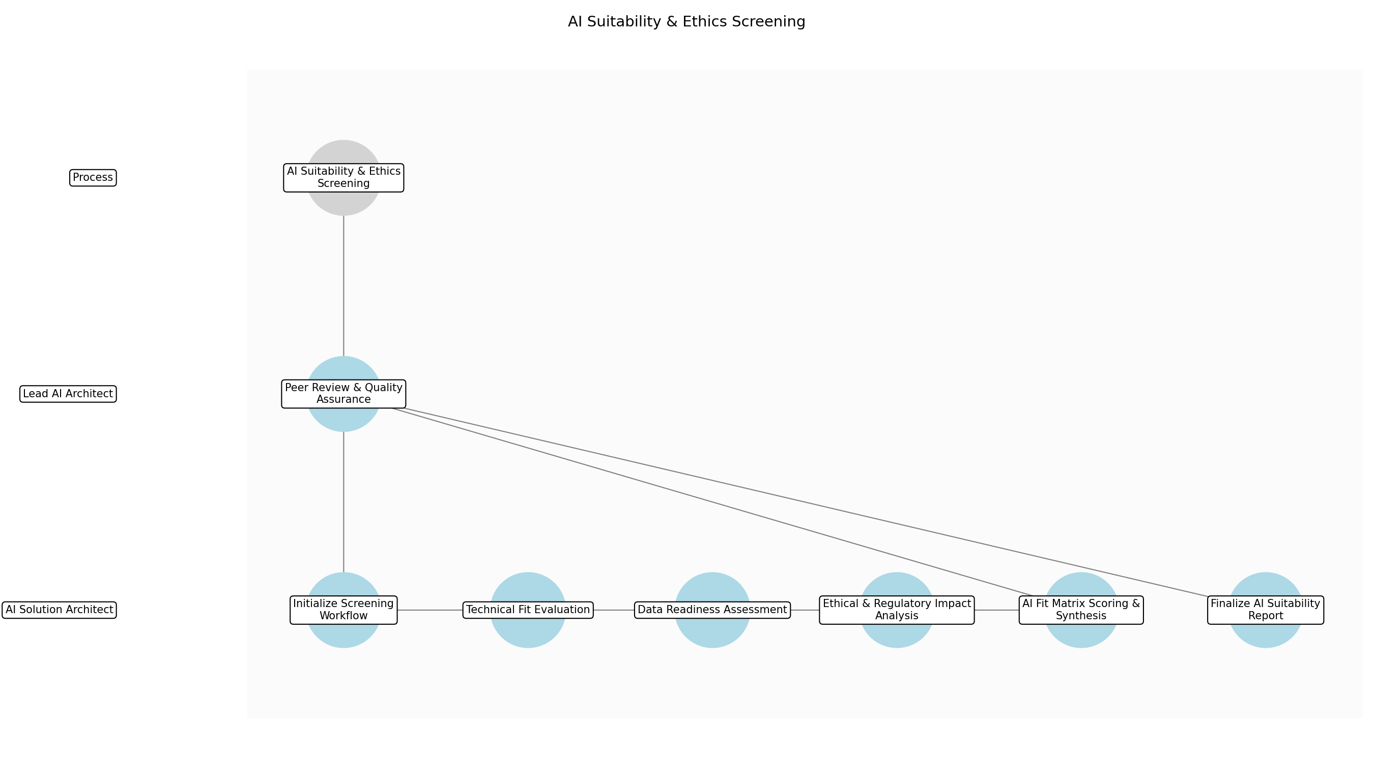

3.2.1 Initialize Screening Workflow
This subprocess describes the activities required to complete 'Initialize Screening Workflow'.

Description:
The AI Solution Architect initiates the screening process by reviewing the Initial AI Opportunity Assessment and configuring the AI Fit Assessment Matrix tool. This involves setting the project context, identifying specific client industry constraints, and ensuring all preliminary data from the intake phase is accessible for evaluation.

Purpose:
To prepare the necessary tools and data for a structured and efficient evaluation of the AI opportunity.

Scope:
Administrative setup and data gathering phase for the screening process.

Inputs:
The following inputs are required for this subprocess:
• Initial AI Opportunity Assessment
• AI Fit Assessment Matrix tool

Outputs:
This subprocess produces the following outputs:
• Screening Project Workspace

Success Criteria:
Success for this subprocess is measured by:
• Screening environment established
• All prerequisite documents gathered and indexed

Triggers:
This subprocess is initiated by:
• Qualification of an AI-related opportunity

End Conditions:
This subprocess is considered complete when:
• Ready to begin technical evaluation

Governance Requirements:
The following governance requirements apply:
• Standard project setup protocols

Risks and Controls:
The following risks and controls apply:
• Risk: Incomplete data for assessment leading to delays.
• Control: Mandatory checklist for required intake information before starting.

Change Management:
The following change management rules apply:
• Change Request Process: Notification to Bid Manager for missing data.
• Versioning Rules: v1.0 initial setup

Continuous Improvement:
The following continuous improvement practices apply:
• Review Frequency: Quarterly
• Improvement Inputs:
• Intake quality metrics

Estimated Duration:
The estimated duration for this subprocess is:
• 2 hours

Process Owner:
The following process owner is accountable:
• AI Solution Architect

Responsible Party:
The following parties are responsible for this subprocess:
• AI Solution Architect

3.2.2 Technical Fit Evaluation
This subprocess describes the activities required to complete 'Technical Fit Evaluation'.

Description:
Analyze the proposed use case to determine if Generative AI or Agentic systems are the optimal solution compared to traditional deterministic logic. The architect evaluates the complexity of the problem, the need for probabilistic reasoning, and whether the desired outcomes require the specific capabilities of LLMs or autonomous agents.

Purpose:
To ensure AI technology is only proposed for problems where it provides a distinct advantage over traditional software.

Scope:
Technical logic analysis and solution feasibility.

Inputs:
The following inputs are required for this subprocess:
• Initial AI Opportunity Assessment

Outputs:
This subprocess produces the following outputs:
• Technical Fit Score

Success Criteria:
Success for this subprocess is measured by:
• Clear distinction between AI and traditional logic requirements documented
• Technical fit score assigned based on matrix criteria

Triggers:
This subprocess is initiated by:
• Completion of screening initialization

End Conditions:
This subprocess is considered complete when:
• Technical fit confirmed or flagged as unsuitable

Dependencies:
This subprocess depends on the following:
• Initialize Screening Workflow

Governance Requirements:
The following governance requirements apply:
• Technical Architecture Standards

Risks and Controls:
The following risks and controls apply:
• Risk: Misidentifying a deterministic problem as an AI problem.
• Control: Comparison against a standardized 'Traditional vs AI' decision tree.

Change Management:
The following change management rules apply:
• Change Request Process: Architectural Review Board submission if fit is borderline.
• Versioning Rules: Linked to RFP version

Continuous Improvement:
The following continuous improvement practices apply:
• Review Frequency: Monthly
• Improvement Inputs:
• Win/Loss technical feedback

Estimated Duration:
The estimated duration for this subprocess is:
• 4 hours

Process Owner:
The following process owner is accountable:
• AI Solution Architect

Responsible Party:
The following parties are responsible for this subprocess:
• AI Solution Architect

3.2.3 Data Readiness Assessment
This subprocess describes the activities required to complete 'Data Readiness Assessment'.

Description:
Evaluate the availability, quality, and volume of client data required to support the proposed AI solution. This involves assessing whether the client has the necessary data infrastructure to support grounding (RAG) or fine-tuning, and identifying any significant data engineering hurdles that could impact implementation success.

Purpose:
To verify that the client's data environment can realistically support the proposed AI/Agentic architecture.

Scope:
Data quality and infrastructure readiness review.

Inputs:
The following inputs are required for this subprocess:
• Client Data Samples (if available)
• Initial AI Opportunity Assessment

Outputs:
This subprocess produces the following outputs:
• Data Readiness Report

Success Criteria:
Success for this subprocess is measured by:
• Data gaps identified and documented
• Feasibility of data integration confirmed

Triggers:
This subprocess is initiated by:
• Confirmation of technical fit

End Conditions:
This subprocess is considered complete when:
• Data readiness status determined

Dependencies:
This subprocess depends on the following:
• Technical Fit Evaluation

Governance Requirements:
The following governance requirements apply:
• Data Privacy and Security Standards

Risks and Controls:
The following risks and controls apply:
• Risk: Underestimating data preparation effort.
• Control: Use of standardized data quality assessment templates.

Change Management:
The following change management rules apply:
• Change Request Process: Update to solution scope if data is insufficient.
• Versioning Rules: Data assessment log

Continuous Improvement:
The following continuous improvement practices apply:
• Review Frequency: Quarterly
• Improvement Inputs:
• Project implementation data logs

Estimated Duration:
The estimated duration for this subprocess is:
• 4 hours

Process Owner:
The following process owner is accountable:
• AI Solution Architect

Responsible Party:
The following parties are responsible for this subprocess:
• AI Solution Architect

3.2.4 Ethical & Regulatory Impact Analysis
This subprocess describes the activities required to complete 'Ethical & Regulatory Impact Analysis'.

Description:
Conduct a deep dive into potential ethical risks, including algorithmic bias, transparency requirements, and compliance with regulations like the EU AI Act or GDPR. This step ensures the solution aligns with internal Ethical AI guidelines and identifies any high-risk scenarios that require specific mitigation strategies.

Purpose:
To ensure the proposed AI solution is ethically viable and legally compliant.

Scope:
Ethical, legal, and regulatory impact analysis.

Inputs:
The following inputs are required for this subprocess:
• Internal Ethical AI Guidelines
• Regulatory Requirements

Outputs:
This subprocess produces the following outputs:
• Ethical Risk Assessment

Success Criteria:
Success for this subprocess is measured by:
• All potential ethical risks identified and categorized
• Compliance with EU AI Act and GDPR verified for the use case

Triggers:
This subprocess is initiated by:
• Completion of data readiness assessment

End Conditions:
This subprocess is considered complete when:
• Ethical viability confirmed or rejected

Dependencies:
This subprocess depends on the following:
• Data Readiness Assessment

Governance Requirements:
The following governance requirements apply:
• Adherence to internal Ethical AI guidelines
• EU AI Act compliance

Risks and Controls:
The following risks and controls apply:
• Risk: Overlooking subtle biases or regulatory nuances.
• Control: Mandatory consultation with the Responsible AI / Legal Lead for high-risk use cases.

Change Management:
The following change management rules apply:
• Change Request Process: Legal review request for high-risk flags.
• Versioning Rules: Ethical assessment versioning

Continuous Improvement:
The following continuous improvement practices apply:
• Review Frequency: Bi-annually
• Improvement Inputs:
• Regulatory update feeds

Estimated Duration:
The estimated duration for this subprocess is:
• 6 hours

Process Owner:
The following process owner is accountable:
• AI Solution Architect

Responsible Party:
The following parties are responsible for this subprocess:
• AI Solution Architect

3.2.5 AI Fit Matrix Scoring & Synthesis
This subprocess describes the activities required to complete 'AI Fit Matrix Scoring & Synthesis'.

Description:
Input all findings from technical, data, and ethical evaluations into the AI Fit Assessment Matrix tool. The tool synthesizes these inputs to generate a quantitative score and a preliminary 'Go/No-Go' recommendation based on weighted criteria established by the enterprise AI strategy.

Purpose:
To provide a data-driven, objective basis for the final suitability recommendation.

Scope:
Quantitative scoring and synthesis of assessment data.

Inputs:
The following inputs are required for this subprocess:
• Technical Fit Score
• Data Readiness Report
• Ethical Risk Assessment

Outputs:
This subprocess produces the following outputs:
• Draft AI Fit Matrix Report

Success Criteria:
Success for this subprocess is measured by:
• Matrix fully populated with evidence-based scores
• Preliminary recommendation generated

Triggers:
This subprocess is initiated by:
• Completion of all individual assessment components

End Conditions:
This subprocess is considered complete when:
• Draft report ready for peer review

Dependencies:
This subprocess depends on the following:
• Ethical & Regulatory Impact Analysis

Governance Requirements:
The following governance requirements apply:
• Standardized Assessment Methodology

Risks and Controls:
The following risks and controls apply:
• Risk: Subjective bias in scoring.
• Control: Weighted scoring system with clear definitions for each numeric value.

Change Management:
The following change management rules apply:
• Change Request Process: Matrix weight adjustment via Strategy Committee.
• Versioning Rules: Matrix tool versioning

Continuous Improvement:
The following continuous improvement practices apply:
• Review Frequency: Quarterly
• Improvement Inputs:
• Win/Loss analysis data

Estimated Duration:
The estimated duration for this subprocess is:
• 2 hours

Process Owner:
The following process owner is accountable:
• AI Solution Architect

Responsible Party:
The following parties are responsible for this subprocess:
• AI Solution Architect

3.2.6 Peer Review & Quality Assurance
This subprocess describes the activities required to complete 'Peer Review & Quality Assurance'.

Description:
A Lead AI Architect reviews the draft assessment to ensure objectivity, technical accuracy, and adherence to ethical standards. This peer review acts as a critical control to prevent the overselling of AI capabilities and ensures that the recommendation is defensible and aligned with the firm's risk appetite.

Purpose:
To provide an independent check on the suitability assessment to maintain high quality and ethical integrity.

Scope:
Internal quality assurance and peer review.

Inputs:
The following inputs are required for this subprocess:
• Draft AI Fit Matrix Report

Outputs:
This subprocess produces the following outputs:
• Peer Review Feedback
• Validated Assessment

Success Criteria:
Success for this subprocess is measured by:
• Lead Architect sign-off on the assessment accuracy
• All feedback items addressed by the Solution Architect

Triggers:
This subprocess is initiated by:
• Submission of draft report for review

End Conditions:
This subprocess is considered complete when:
• Assessment validated and approved for finalization

Dependencies:
This subprocess depends on the following:
• AI Fit Matrix Scoring & Synthesis

Governance Requirements:
The following governance requirements apply:
• Internal Peer Review Policy

Risks and Controls:
The following risks and controls apply:
• Risk: Overselling AI capabilities or recommending unsuitable use cases.
• Control: Mandatory review by a lead AI Architect with veto power.

Change Management:
The following change management rules apply:
• Change Request Process: Revision cycle within the screening project.
• Versioning Rules: Review log tracking

Continuous Improvement:
The following continuous improvement practices apply:
• Review Frequency: Monthly
• Improvement Inputs:
• Reviewer feedback trends

Estimated Duration:
The estimated duration for this subprocess is:
• 4 hours

Process Owner:
The following process owner is accountable:
• AI Solution Architect

Responsible Party:
The following parties are responsible for this subprocess:
• Lead AI Architect

3.2.7 Finalize AI Suitability Report
This subprocess describes the activities required to complete 'Finalize AI Suitability Report'.

Description:
Incorporate feedback from the peer review and finalize the AI Suitability Report. This document provides the definitive 'Go/No-Go' recommendation, summarizes the technical and ethical findings, and serves as the primary input for the subsequent Solution Architecture & Guardrail Design stage.

Purpose:
To document the final decision on AI suitability and provide a foundation for the technical proposal.

Scope:
Final reporting and deliverable production.

Inputs:
The following inputs are required for this subprocess:
• Validated Assessment
• Peer Review Feedback

Outputs:
This subprocess produces the following outputs:
• AI Suitability Report
• AI Fit Matrix Report

Success Criteria:
Success for this subprocess is measured by:
• Final report delivered to the Bid/RFP Manager
• Clear 'Go/No-Go' recommendation stated with supporting evidence

Triggers:
This subprocess is initiated by:
• Approval from Lead AI Architect

End Conditions:
This subprocess is considered complete when:
• AI suitability and ethical viability confirmed or rejected

Dependencies:
This subprocess depends on the following:
• Peer Review & Quality Assurance

Governance Requirements:
The following governance requirements apply:
• Final Sign-off Authority

Risks and Controls:
The following risks and controls apply:
• Risk: Inconsistent reporting format leading to confusion.
• Control: Use of a standardized AI Suitability Report template.

Change Management:
The following change management rules apply:
• Change Request Process: Formal revision request if client requirements change.
• Versioning Rules: Final PDF with timestamp and version ID

Continuous Improvement:
The following continuous improvement practices apply:
• Review Frequency: Quarterly
• Improvement Inputs:
• Client feedback on proposal quality

Estimated Duration:
The estimated duration for this subprocess is:
• 2 hours

Process Owner:
The following process owner is accountable:
• AI Solution Architect

Responsible Party:
The following parties are responsible for this subprocess:
• AI Solution Architect

3.3 Technical Solution Architecture

Description:
Develop the core technical approach incorporating GenAI/Agents based on client requirements. The architecture is designed to meet performance and functional needs while ensuring technical feasibility.

Purpose:
To design a robust technical agentic architecture.

Scope:
Technical design of the AI solution.

Inputs:
The following inputs are required for this step:
• AI Suitability Report
• Client Technical Requirements

Outputs:
This step produces the following outputs:
• Proposed AI Technical Architecture

Success Criteria:
Success for this step is measured by:
• Architecture meets client performance and functional requirements.

Process Triggers:
This step is initiated by:
• Approval from AI Suitability & Ethics Screening.

Process End Conditions:
This step is considered complete when:
• Technical architecture design complete.

Dependencies:
This step depends on the following:
• AI Suitability & Ethics Screening

Deliverables:
This step produces the following deliverables:
• Technical Architecture Document

Estimated Duration:
The estimated duration for this step is:
• 3 days

Process Owner:
The following process owner is accountable:
• AI Solution Architect

Responsible Parties:
The following parties are responsible for this step:
• AI Solution Architect

Required Sub Process(es) for the Step "Technical Solution Architecture"
The following details the subprocess flows for the step "Technical Solution Architecture".
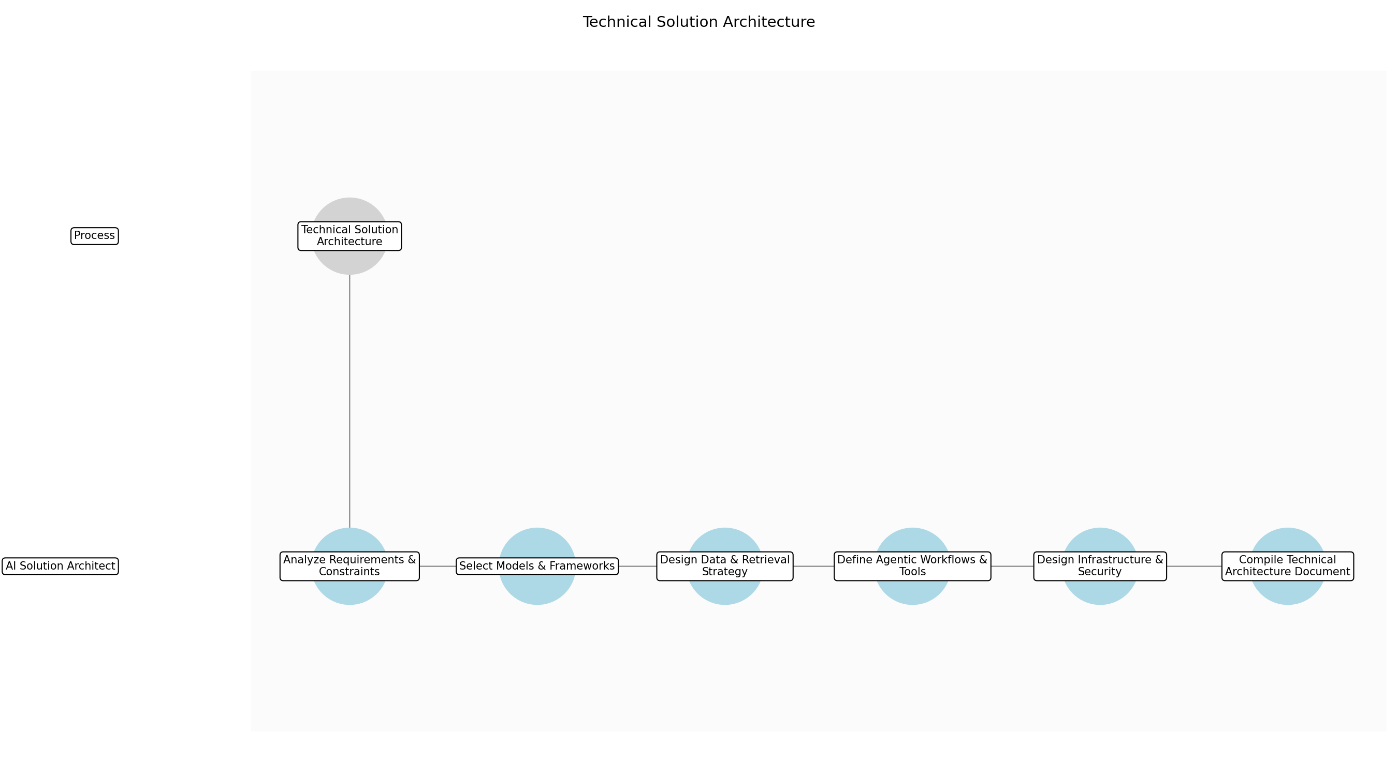

3.3.1 Analyze Requirements & Constraints
This subprocess describes the activities required to complete 'Analyze Requirements & Constraints'.

Description:
Conduct a detailed review of the Client Technical Requirements and the AI Suitability Report. This involves identifying specific performance benchmarks, security constraints, and integration points with existing client systems to ensure the architecture is grounded in actual client needs.

Purpose:
To ensure the architecture is grounded in actual client needs.

Scope:
Requirement analysis and constraint identification.

Inputs:
The following inputs are required for this subprocess:
• AI Suitability Report
• Client Technical Requirements

Outputs:
This subprocess produces the following outputs:
• Refined Technical Requirements List

Success Criteria:
Success for this subprocess is measured by:
• All technical constraints and performance targets are documented.

Triggers:
This subprocess is initiated by:
• Approval from AI Suitability & Ethics Screening.

End Conditions:
This subprocess is considered complete when:
• Requirements analysis document finalized.

Governance Requirements:
The following governance requirements apply:
• Alignment with client data sovereignty policies.

Risks and Controls:
The following risks and controls apply:
• Risk: Misinterpretation of client constraints.
• Control: Stakeholder review of refined requirements.

Change Management:
The following change management rules apply:
• Change Request Process: Requirements changes must be logged in the RFP management tool.
• Versioning Rules: v1.0 for initial analysis.

Continuous Improvement:
The following continuous improvement practices apply:
• Review Frequency: Per project
• Improvement Inputs:
• Client feedback on requirement accuracy.

Estimated Duration:
The estimated duration for this subprocess is:
• 4 hours

Process Owner:
The following process owner is accountable:
• AI Solution Architect

Responsible Party:
The following parties are responsible for this subprocess:
• AI Solution Architect

3.3.2 Select Models & Frameworks
This subprocess describes the activities required to complete 'Select Models & Frameworks'.

Description:
Evaluate and select the most appropriate foundation models (LLMs) and agentic orchestration frameworks based on the refined requirements. Consider factors like latency, cost, and specific capabilities such as reasoning or tool-calling to establish the core technology stack.

Purpose:
To establish the core technology stack for the solution.

Scope:
Technology selection and model evaluation.

Inputs:
The following inputs are required for this subprocess:
• Refined Technical Requirements List

Outputs:
This subprocess produces the following outputs:
• Model and Framework Selection Report

Success Criteria:
Success for this subprocess is measured by:
• Selected stack aligns with performance and cost constraints.

Triggers:
This subprocess is initiated by:
• Completion of requirements analysis.

End Conditions:
This subprocess is considered complete when:
• Technology stack finalized.

Dependencies:
This subprocess depends on the following:
• Analyze Requirements & Constraints

Governance Requirements:
The following governance requirements apply:
• Compliance with approved vendor lists.

Risks and Controls:
The following risks and controls apply:
• Risk: Selection of incompatible or overly expensive models.
• Control: Cost-benefit analysis and compatibility check.

Change Management:
The following change management rules apply:
• Change Request Process: Model changes require architect lead approval.
• Versioning Rules: Tracked via selection report versions.

Continuous Improvement:
The following continuous improvement practices apply:
• Review Frequency: Monthly
• Improvement Inputs:
• New model release benchmarks.

Estimated Duration:
The estimated duration for this subprocess is:
• 6 hours

Process Owner:
The following process owner is accountable:
• AI Solution Architect

Responsible Party:
The following parties are responsible for this subprocess:
• AI Solution Architect

3.3.3 Design Data & Retrieval Strategy
This subprocess describes the activities required to complete 'Design Data & Retrieval Strategy'.

Description:
Define the data architecture, including vector database selection, indexing strategies, and retrieval-augmented generation (RAG) pipelines. Ensure data privacy and security protocols are integrated into the data flow to provide secure information access.

Purpose:
To ensure the AI has access to the right information securely.

Scope:
Data and retrieval design.

Inputs:
The following inputs are required for this subprocess:
• Refined Technical Requirements List
• Model and Framework Selection Report

Outputs:
This subprocess produces the following outputs:
• Data Architecture Diagram
• Retrieval Strategy Document

Success Criteria:
Success for this subprocess is measured by:
• Data flow ensures low latency and high relevance in retrieval.

Triggers:
This subprocess is initiated by:
• Technology stack finalized.

End Conditions:
This subprocess is considered complete when:
• Data architecture design complete.

Dependencies:
This subprocess depends on the following:
• Select Models & Frameworks

Governance Requirements:
The following governance requirements apply:
• GDPR and data privacy compliance.

Risks and Controls:
The following risks and controls apply:
• Risk: Data leakage or inefficient retrieval.
• Control: Security review of data flow and indexing optimization.

Change Management:
The following change management rules apply:
• Change Request Process: Schema changes must be reviewed by the data lead.
• Versioning Rules: Diagram versioning in design repository.

Continuous Improvement:
The following continuous improvement practices apply:
• Review Frequency: Quarterly
• Improvement Inputs:
• Retrieval accuracy metrics from previous pilots.

Estimated Duration:
The estimated duration for this subprocess is:
• 8 hours

Process Owner:
The following process owner is accountable:
• AI Solution Architect

Responsible Party:
The following parties are responsible for this subprocess:
• AI Solution Architect

3.3.4 Define Agentic Workflows & Tools
This subprocess describes the activities required to complete 'Define Agentic Workflows & Tools'.

Description:
Map out the specific agent roles, their responsibilities, and the tools they will interact with. Define the communication protocols between agents and the human-in-the-loop touchpoints to establish the operational logic of the system.

Purpose:
To define the operational logic of the agentic system.

Scope:
Workflow and tool design.

Inputs:
The following inputs are required for this subprocess:
• Model and Framework Selection Report
• Data Architecture Diagram

Outputs:
This subprocess produces the following outputs:
• Agentic Workflow Specification
• Tool Integration Map

Success Criteria:
Success for this subprocess is measured by:
• Workflows cover all functional requirements identified in the intake.

Triggers:
This subprocess is initiated by:
• Data architecture design complete.

End Conditions:
This subprocess is considered complete when:
• Agentic workflows fully mapped.

Dependencies:
This subprocess depends on the following:
• Design Data & Retrieval Strategy

Governance Requirements:
The following governance requirements apply:
• Auditability of agent actions.

Risks and Controls:
The following risks and controls apply:
• Risk: Over-complex workflows leading to agent loops or failures.
• Control: Workflow simplification and logic validation.

Change Management:
The following change management rules apply:
• Change Request Process: Workflow logic changes require peer review.
• Versioning Rules: Workflow v1.x.

Continuous Improvement:
The following continuous improvement practices apply:
• Review Frequency: Per project
• Improvement Inputs:
• Agent performance logs from similar use cases.

Estimated Duration:
The estimated duration for this subprocess is:
• 1 day

Process Owner:
The following process owner is accountable:
• AI Solution Architect

Responsible Party:
The following parties are responsible for this subprocess:
• AI Solution Architect

3.3.5 Design Infrastructure & Security
This subprocess describes the activities required to complete 'Design Infrastructure & Security'.

Description:
Design the hosting environment and the security architecture, including defining VPCs, IAM roles, and encryption protocols. This ensures a secure and scalable foundation for the AI solution that meets client standards.

Purpose:
To provide a secure and scalable foundation for the AI solution.

Scope:
Infrastructure and security design.

Inputs:
The following inputs are required for this subprocess:
• Agentic Workflow Specification
• Refined Technical Requirements List

Outputs:
This subprocess produces the following outputs:
• Infrastructure Design Document
• Security Configuration Plan

Success Criteria:
Success for this subprocess is measured by:
• Infrastructure design meets client security and scalability standards.

Triggers:
This subprocess is initiated by:
• Agentic workflows mapped.

End Conditions:
This subprocess is considered complete when:
• Infrastructure and security design finalized.

Dependencies:
This subprocess depends on the following:
• Define Agentic Workflows & Tools

Governance Requirements:
The following governance requirements apply:
• Adherence to ISO 27001 or client-specific security frameworks.

Risks and Controls:
The following risks and controls apply:
• Risk: Infrastructure costs exceed budget.
• Control: Cloud cost estimation and resource optimization.

Change Management:
The following change management rules apply:
• Change Request Process: Infrastructure changes require security lead sign-off.
• Versioning Rules: Infrastructure as Code (IaC) versioning.

Continuous Improvement:
The following continuous improvement practices apply:
• Review Frequency: Bi-annually
• Improvement Inputs:
• Cloud provider security updates.

Estimated Duration:
The estimated duration for this subprocess is:
• 6 hours

Process Owner:
The following process owner is accountable:
• AI Solution Architect

Responsible Party:
The following parties are responsible for this subprocess:
• AI Solution Architect

3.3.6 Compile Technical Architecture Document
This subprocess describes the activities required to complete 'Compile Technical Architecture Document'.

Description:
Consolidate all design components into a comprehensive Technical Architecture Document. This document serves as the primary technical deliverable for the RFP response, detailing the solution's feasibility and performance.

Purpose:
To produce the final technical deliverable for the parent step.

Scope:
Documentation and finalization.

Inputs:
The following inputs are required for this subprocess:
• Model and Framework Selection Report
• Data Architecture Diagram
• Agentic Workflow Specification
• Infrastructure Design Document

Outputs:
This subprocess produces the following outputs:
• Proposed AI Technical Architecture
• Technical Architecture Document

Success Criteria:
Success for this subprocess is measured by:
• Document is complete, professional, and meets all RFP technical requirements.

Triggers:
This subprocess is initiated by:
• All design components finalized.

End Conditions:
This subprocess is considered complete when:
• Technical architecture design complete.

Dependencies:
This subprocess depends on the following:
• Design Infrastructure & Security

Governance Requirements:
The following governance requirements apply:
• Final sign-off from the Lead AI Architect.

Risks and Controls:
The following risks and controls apply:
• Risk: Incomplete documentation of critical technical details.
• Control: Peer review of the final document.

Change Management:
The following change management rules apply:
• Change Request Process: Final document edits via tracked changes.
• Versioning Rules: Final v1.0.

Continuous Improvement:
The following continuous improvement practices apply:
• Review Frequency: Quarterly
• Improvement Inputs:
• Win/Loss analysis feedback on technical quality.

Estimated Duration:
The estimated duration for this subprocess is:
• 4 hours

Process Owner:
The following process owner is accountable:
• AI Solution Architect

Responsible Party:
The following parties are responsible for this subprocess:
• AI Solution Architect

3.4 Guardrail & Safety Design

Description:
Design built-in guardrails and responsible AI monitoring systems for the proposed architecture. This safety engineering step ensures that the agentic system operates within safe and ethical bounds.

Purpose:
To ensure the agentic system operates within safe and ethical bounds.

Scope:
Safety engineering and guardrail design.

Inputs:
The following inputs are required for this step:
• Proposed AI Technical Architecture

Outputs:
This step produces the following outputs:
• Safety and Guardrail Specification

Success Criteria:
Success for this step is measured by:
• Design includes specific monitoring and guardrail components for risk mitigation.

Process Triggers:
This step is initiated by:
• Completion of core technical architecture.

Process End Conditions:
This step is considered complete when:
• Safety measures integrated into the technical design.

Dependencies:
This step depends on the following:
• Technical Solution Architecture

Deliverables:
This step produces the following deliverables:
• Guardrail Specification

Estimated Duration:
The estimated duration for this step is:
• 2 days

Process Owner:
The following process owner is accountable:
• AI Solution Architect

Responsible Parties:
The following parties are responsible for this step:
• AI Solution Architect

Required Sub Process(es) for the Step "Guardrail & Safety Design"
The following details the subprocess flows for the step "Guardrail & Safety Design".
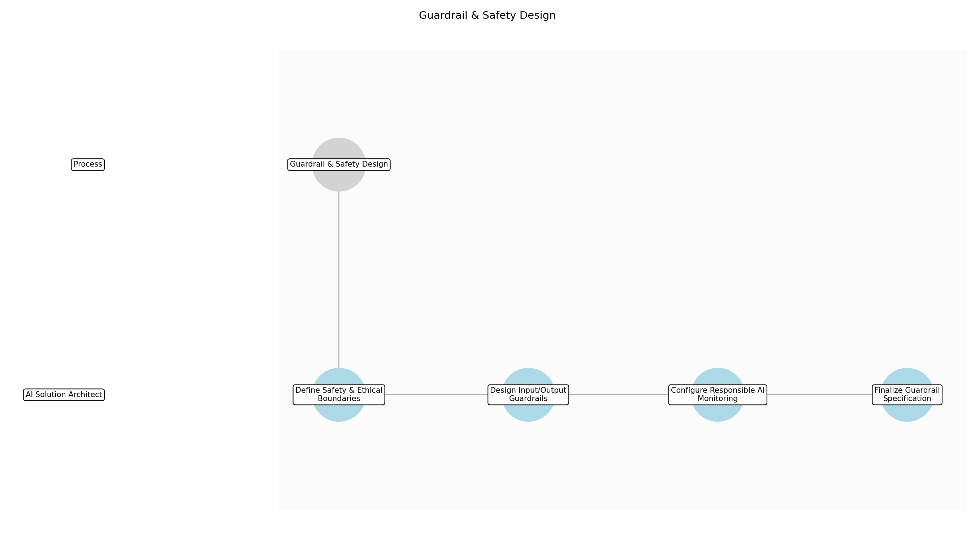

3.4.1 Define Safety & Ethical Boundaries
This subprocess describes the activities required to complete 'Define Safety & Ethical Boundaries'.

Description:
Establish the specific safety and ethical constraints for the agentic system based on the proposed architecture. This involves identifying potential misuse cases, bias risks, and operational limits that the system must adhere to during execution.

Purpose:
To set the foundational rules for what the agentic system can and cannot do.

Scope:
Ethical and operational boundary setting.

Inputs:
The following inputs are required for this subprocess:
• Proposed AI Technical Architecture
• Ethical Risk Assessment

Outputs:
This subprocess produces the following outputs:
• Safety Boundary Definition

Success Criteria:
Success for this subprocess is measured by:
• Documented list of prohibited actions and ethical constraints.

Triggers:
This subprocess is initiated by:
• Completion of core technical architecture.

End Conditions:
This subprocess is considered complete when:
• Safety boundaries are formally documented.

Governance Requirements:
The following governance requirements apply:
• Alignment with internal Ethical AI guidelines.

Risks and Controls:
The following risks and controls apply:
• Risk: Vague boundary definitions leading to bypassable safety measures.
• Control: Use of a standardized safety taxonomy and peer review of constraints.

Change Management:
The following change management rules apply:
• Change Request Process: Submit boundary revisions to the AI Strategy committee.
• Versioning Rules: Major version increment for any new prohibited action.

Continuous Improvement:
The following continuous improvement practices apply:
• Review Frequency: Quarterly
• Improvement Inputs:
• New regulatory requirements
• Industry safety benchmarks

Estimated Duration:
The estimated duration for this subprocess is:
• 4 hours

Process Owner:
The following process owner is accountable:
• AI Solution Architect

Responsible Party:
The following parties are responsible for this subprocess:
• AI Solution Architect

3.4.2 Design Input/Output Guardrails
This subprocess describes the activities required to complete 'Design Input/Output Guardrails'.

Description:
Develop technical filters and validation layers that inspect data entering and leaving the agentic system. This includes prompt injection detection for inputs and PII/toxicity filtering for outputs to ensure safe interactions.

Purpose:
To prevent malicious inputs and unsafe or non-compliant outputs.

Scope:
Technical design of filtering and validation components.

Inputs:
The following inputs are required for this subprocess:
• Safety Boundary Definition
• Proposed AI Technical Architecture

Outputs:
This subprocess produces the following outputs:
• I/O Guardrail Technical Design

Success Criteria:
Success for this subprocess is measured by:
• Design includes specific filtering logic for prompt injection and data leakage.

Triggers:
This subprocess is initiated by:
• Safety boundaries defined.

End Conditions:
This subprocess is considered complete when:
• I/O guardrail specifications are integrated into the architecture.

Dependencies:
This subprocess depends on the following:
• Define Safety & Ethical Boundaries

Governance Requirements:
The following governance requirements apply:
• Compliance with GDPR data minimization principles.

Risks and Controls:
The following risks and controls apply:
• Risk: Guardrails introduce excessive latency to the system.
• Control: Performance benchmarking of filtering layers during the design phase.

Change Management:
The following change management rules apply:
• Change Request Process: Technical design review board approval.
• Versioning Rules: Documented in the Technical Architecture version log.

Continuous Improvement:
The following continuous improvement practices apply:
• Review Frequency: Per project post-mortem
• Improvement Inputs:
• False positive/negative rates from testing

Estimated Duration:
The estimated duration for this subprocess is:
• 6 hours

Process Owner:
The following process owner is accountable:
• AI Solution Architect

Responsible Party:
The following parties are responsible for this subprocess:
• AI Solution Architect

3.4.3 Configure Responsible AI Monitoring
This subprocess describes the activities required to complete 'Configure Responsible AI Monitoring'.

Description:
Specify the telemetry and logging requirements for tracking the system's adherence to safety rules in real-time. This includes setting up alerts for boundary violations and performance drift that could impact safety.

Purpose:
To provide visibility into the system's safety performance during operation.

Scope:
Monitoring, logging, and alerting configuration.

Inputs:
The following inputs are required for this subprocess:
• I/O Guardrail Technical Design
• Safety Boundary Definition

Outputs:
This subprocess produces the following outputs:
• Monitoring & Alerting Specification

Success Criteria:
Success for this subprocess is measured by:
• Specification includes real-time alerting for safety violations.

Triggers:
This subprocess is initiated by:
• Guardrail design complete.

End Conditions:
This subprocess is considered complete when:
• Monitoring plan is approved by the technical lead.

Dependencies:
This subprocess depends on the following:
• Design Input/Output Guardrails

Governance Requirements:
The following governance requirements apply:
• Audit trail requirements for AI decision-making.

Risks and Controls:
The following risks and controls apply:
• Risk: Alert fatigue from overly sensitive safety triggers.
• Control: Definition of severity levels and tiered alerting logic.

Change Management:
The following change management rules apply:
• Change Request Process: Standard IT change management for monitoring tools.
• Versioning Rules: Alerting thresholds tracked in configuration management.

Continuous Improvement:
The following continuous improvement practices apply:
• Review Frequency: Monthly
• Improvement Inputs:
• Operational incident logs
• Monitoring dashboard analytics

Estimated Duration:
The estimated duration for this subprocess is:
• 4 hours

Process Owner:
The following process owner is accountable:
• AI Solution Architect

Responsible Party:
The following parties are responsible for this subprocess:
• AI Solution Architect

3.4.4 Finalize Guardrail Specification
This subprocess describes the activities required to complete 'Finalize Guardrail Specification'.

Description:
Consolidate the boundary definitions, technical guardrail designs, and monitoring plans into a single comprehensive specification document. This document serves as the safety blueprint for the implementation team.

Purpose:
To provide a unified deliverable for safety engineering.

Scope:
Documentation and final synthesis.

Inputs:
The following inputs are required for this subprocess:
• Safety Boundary Definition
• I/O Guardrail Technical Design
• Monitoring & Alerting Specification

Outputs:
This subprocess produces the following outputs:
• Guardrail Specification
• Safety and Guardrail Specification

Success Criteria:
Success for this subprocess is measured by:
• Complete document signed off by the AI Solution Architect.

Triggers:
This subprocess is initiated by:
• All safety design components complete.

End Conditions:
This subprocess is considered complete when:
• Safety measures integrated into the technical design.

Dependencies:
This subprocess depends on the following:
• Configure Responsible AI Monitoring

Governance Requirements:
The following governance requirements apply:
• Final sign-off required for the RFP submission package.

Risks and Controls:
The following risks and controls apply:
• Risk: Inconsistencies between the technical design and safety specification.
• Control: Final cross-reference check against the core Technical Architecture Document.

Change Management:
The following change management rules apply:
• Change Request Process: Formal document revision process.
• Versioning Rules: Version 1.0 released upon final sign-off.

Continuous Improvement:
The following continuous improvement practices apply:
• Review Frequency: Annual
• Improvement Inputs:
• Template effectiveness feedback from delivery teams

Estimated Duration:
The estimated duration for this subprocess is:
• 2 hours

Process Owner:
The following process owner is accountable:
• AI Solution Architect

Responsible Party:
The following parties are responsible for this subprocess:
• AI Solution Architect

3.5 Internal Review & Governance Approval

Description:
Streamlined parallel reviews by SMEs and Legal teams to verify technical feasibility, regulatory compliance, and ethical alignment. This efficient review process ensures that all proposals meet high standards before submission.

Purpose:
To ensure the proposal meets all regulatory and ethical standards efficiently.

Scope:
Internal compliance and quality review.

Inputs:
The following inputs are required for this step:
• Proposed AI Technical Architecture
• Safety and Guardrail Specification
• Draft RFP Response

Outputs:
This step produces the following outputs:
• Approved Proposal Content

Success Criteria:
Success for this step is measured by:
• Zero non-compliance issues identified post-submission.

Process Triggers:
This step is initiated by:
• Completion of safety and guardrail design.

Process End Conditions:
This step is considered complete when:
• Formal approval received from all required governance bodies.

Dependencies:
This step depends on the following:
• Guardrail & Safety Design

Deliverables:
This step produces the following deliverables:
• Governance Approval Sign-off

Governance Requirements:
The following governance requirements apply:
• Mandatory sign-off from Legal/Ethics committee.

Risks and Controls:
The following risks and controls apply:
• Control: Inclusion of a standardized 'Responsible AI' clause and methodology in every proposal.
• Risk: Reputational damage due to unethical AI implementation.

Estimated Duration:
The estimated duration for this step is:
• 2 days

Process Owner:
The following process owner is accountable:
• Responsible AI / Legal Lead

Responsible Parties:
The following parties are responsible for this step:
• Responsible AI / Legal Lead

Required Sub Process(es) for the Step "Internal Review & Governance Approval"
The following details the subprocess flows for the step "Internal Review & Governance Approval".
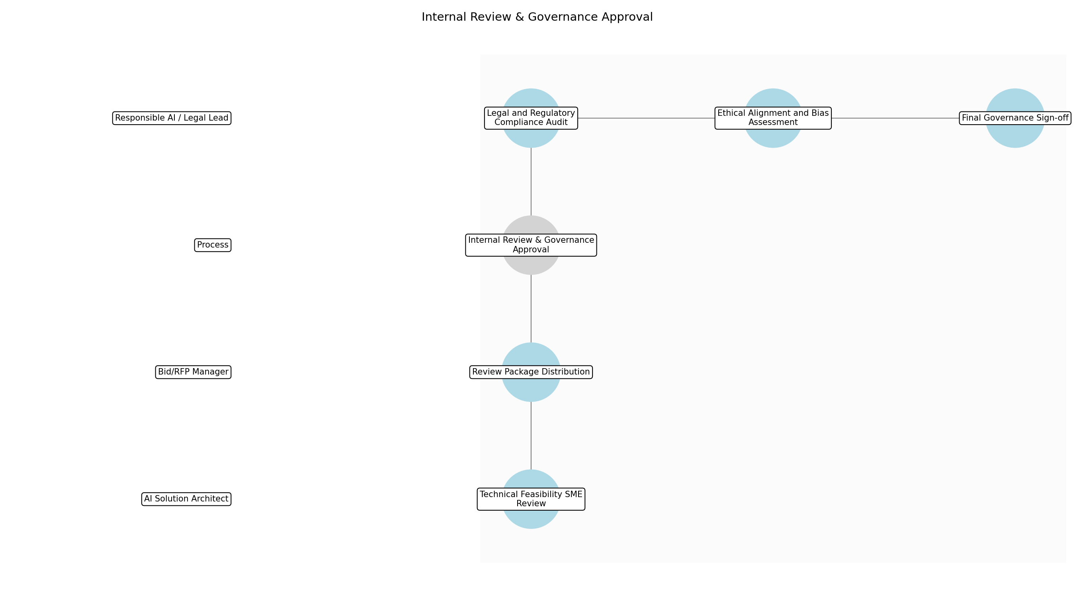

3.5.1 Review Package Distribution
This subprocess describes the activities required to complete 'Review Package Distribution'.

Description:
The Bid/RFP Manager compiles the Proposed AI Technical Architecture, Safety and Guardrail Specification, and Draft RFP Response into a standardized review package. This package is then distributed to the AI Solution Architect, Legal Lead, and Responsible AI Lead for parallel evaluation to ensure all reviewers have the same baseline information.

Purpose:
To initiate the parallel review process by providing all necessary documentation to stakeholders.

Scope:
Internal distribution to SME, Legal, and Ethics teams.

Inputs:
The following inputs are required for this subprocess:
• Proposed AI Technical Architecture
• Safety and Guardrail Specification
• Draft RFP Response

Outputs:
This subprocess produces the following outputs:
• Review Package Distribution Confirmation

Success Criteria:
Success for this subprocess is measured by:
• All reviewers confirm receipt of the complete package.

Triggers:
This subprocess is initiated by:
• Completion of safety and guardrail design.

End Conditions:
This subprocess is considered complete when:
• Reviewers have access to all materials.

Governance Requirements:
The following governance requirements apply:
• Audit trail of document distribution.

Risks and Controls:
The following risks and controls apply:
• Risk: Incomplete documentation sent to reviewers
• Control: Automated checklist in the Knowledge Management System.

Change Management:
The following change management rules apply:
• Change Request Process: Email to Bid Manager
• Versioning Rules: v1.0

Continuous Improvement:
The following continuous improvement practices apply:
• Review Frequency: Quarterly
• Improvement Inputs:
• Distribution cycle time data

Estimated Duration:
The estimated duration for this subprocess is:
• 2 hours

Process Owner:
The following process owner is accountable:
• Bid/RFP Manager

Responsible Party:
The following parties are responsible for this subprocess:
• Bid/RFP Manager

3.5.2 Technical Feasibility SME Review
This subprocess describes the activities required to complete 'Technical Feasibility SME Review'.

Description:
The AI Solution Architect conducts a deep-dive review of the Proposed AI Technical Architecture to ensure it meets client performance requirements and is technically viable. This includes verifying that the agentic systems are correctly integrated with existing client infrastructure and that the proposed solution is scalable.

Purpose:
To verify that the proposed AI architecture is technically sound and implementable.

Scope:
Technical architecture and performance metrics.

Inputs:
The following inputs are required for this subprocess:
• Proposed AI Technical Architecture

Outputs:
This subprocess produces the following outputs:
• Technical Feasibility Report

Success Criteria:
Success for this subprocess is measured by:
• Technical architecture validated for scalability and performance.

Triggers:
This subprocess is initiated by:
• Receipt of Review Package.

End Conditions:
This subprocess is considered complete when:
• Technical Feasibility Report issued.

Dependencies:
This subprocess depends on the following:
• Review Package Distribution

Governance Requirements:
The following governance requirements apply:
• Technical standards compliance check.

Risks and Controls:
The following risks and controls apply:
• Risk: Technical debt or unscalable design
• Control: Peer review by senior architects.

Change Management:
The following change management rules apply:
• Change Request Process: Architecture Review Board
• Versioning Rules: v1.1

Continuous Improvement:
The following continuous improvement practices apply:
• Review Frequency: Bi-annually
• Improvement Inputs:
• Post-implementation technical audits

Estimated Duration:
The estimated duration for this subprocess is:
• 8 hours

Process Owner:
The following process owner is accountable:
• AI Solution Architect

Responsible Party:
The following parties are responsible for this subprocess:
• AI Solution Architect

3.5.3 Legal and Regulatory Compliance Audit
This subprocess describes the activities required to complete 'Legal and Regulatory Compliance Audit'.

Description:
The Legal Lead reviews the Draft RFP Response and Technical Architecture against international regulations such as the EU AI Act and GDPR. This audit ensures that all data handling and AI processing activities are legally compliant within the client's jurisdiction and that contractual risks are mitigated.

Purpose:
To ensure the proposal adheres to international and local data privacy and AI regulations.

Scope:
Legal and regulatory compliance.

Inputs:
The following inputs are required for this subprocess:
• Draft RFP Response
• Proposed AI Technical Architecture

Outputs:
This subprocess produces the following outputs:
• Legal Compliance Sign-off

Success Criteria:
Success for this subprocess is measured by:
• Zero legal non-compliance issues identified.

Triggers:
This subprocess is initiated by:
• Receipt of Review Package.

End Conditions:
This subprocess is considered complete when:
• Legal Compliance Sign-off received.

Dependencies:
This subprocess depends on the following:
• Review Package Distribution

Governance Requirements:
The following governance requirements apply:
• Regulatory compliance audit.

Risks and Controls:
The following risks and controls apply:
• Risk: Non-compliance with data privacy laws
• Control: Standardized Legal/Ethics checklist.

Change Management:
The following change management rules apply:
• Change Request Process: Legal Counsel review
• Versioning Rules: L-v1

Continuous Improvement:
The following continuous improvement practices apply:
• Review Frequency: Quarterly
• Improvement Inputs:
• Regulatory update logs

Estimated Duration:
The estimated duration for this subprocess is:
• 1 day

Process Owner:
The following process owner is accountable:
• Responsible AI / Legal Lead

Responsible Party:
The following parties are responsible for this subprocess:
• Responsible AI / Legal Lead

3.5.4 Ethical Alignment and Bias Assessment
This subprocess describes the activities required to complete 'Ethical Alignment and Bias Assessment'.

Description:
The Responsible AI Lead evaluates the Safety and Guardrail Specification and Draft RFP Response for ethical risks, potential biases, and alignment with the firm's Responsible AI principles. This assessment focuses on transparency, fairness, and accountability of the agentic systems to prevent reputational damage.

Purpose:
To evaluate the proposal for ethical risks, bias, and alignment with corporate AI principles.

Scope:
Ethical impact and bias mitigation.

Inputs:
The following inputs are required for this subprocess:
• Safety and Guardrail Specification
• Draft RFP Response

Outputs:
This subprocess produces the following outputs:
• Ethical Review Approval

Success Criteria:
Success for this subprocess is measured by:
• Ethical risks identified and mitigated via guardrails.

Triggers:
This subprocess is initiated by:
• Receipt of Review Package.

End Conditions:
This subprocess is considered complete when:
• Ethical Review Approval issued.

Dependencies:
This subprocess depends on the following:
• Review Package Distribution

Governance Requirements:
The following governance requirements apply:
• Ethics Committee oversight.

Risks and Controls:
The following risks and controls apply:
• Risk: Algorithmic bias in proposed solution
• Control: Mandatory bias impact assessment documentation.

Change Management:
The following change management rules apply:
• Change Request Process: Ethics Board petition
• Versioning Rules: E-v1

Continuous Improvement:
The following continuous improvement practices apply:
• Review Frequency: Quarterly
• Improvement Inputs:
• Client trust scores

Estimated Duration:
The estimated duration for this subprocess is:
• 1 day

Process Owner:
The following process owner is accountable:
• Responsible AI / Legal Lead

Responsible Party:
The following parties are responsible for this subprocess:
• Responsible AI / Legal Lead

3.5.5 Final Governance Sign-off
This subprocess describes the activities required to complete 'Final Governance Sign-off'.

Description:
The Responsible AI / Legal Lead consolidates the Technical Feasibility Report, Legal Compliance Sign-off, and Ethical Review Approval. A final review is conducted to ensure all SME feedback has been addressed, culminating in the formal governance sign-off required for proposal submission.

Purpose:
To provide final authorization for the proposal content from the designated governance bodies.

Scope:
Final governance approval.

Inputs:
The following inputs are required for this subprocess:
• Technical Feasibility Report
• Legal Compliance Sign-off
• Ethical Review Approval
• Draft RFP Response

Outputs:
This subprocess produces the following outputs:
• Approved Proposal Content
• Governance Approval Sign-off

Success Criteria:
Success for this subprocess is measured by:
• Formal approval received from all required governance bodies.

Triggers:
This subprocess is initiated by:
• Completion of all parallel reviews.

End Conditions:
This subprocess is considered complete when:
• Governance Approval Sign-off archived.

Dependencies:
This subprocess depends on the following:
• Technical Feasibility SME Review
• Legal and Regulatory Compliance Audit
• Ethical Alignment and Bias Assessment

Governance Requirements:
The following governance requirements apply:
• Mandatory sign-off from Legal/Ethics committee.

Risks and Controls:
The following risks and controls apply:
• Risk: Reputational damage due to unethical AI implementation
• Control: Inclusion of a standardized 'Responsible AI' clause.

Change Management:
The following change management rules apply:
• Change Request Process: Formal change request to Bid Manager
• Versioning Rules: Final-v1

Continuous Improvement:
The following continuous improvement practices apply:
• Review Frequency: Quarterly
• Improvement Inputs:
• Win/Loss analysis

Estimated Duration:
The estimated duration for this subprocess is:
• 4 hours

Process Owner:
The following process owner is accountable:
• Responsible AI / Legal Lead

Responsible Party:
The following parties are responsible for this subprocess:
• Responsible AI / Legal Lead

3.6 Proposal Finalization & Submission

Description:
Finalize RFP response, highlighting the commitment to responsible AI and specific value propositions of the agentic systems. The final package is assembled and submitted to the client according to their requirements.

Purpose:
To deliver a high-quality, responsible AI proposal to the client.

Scope:
Final assembly and submission.

Inputs:
The following inputs are required for this step:
• Approved Proposal Content
• RFP Submission Templates

Outputs:
This step produces the following outputs:
• Final RFP Response

Success Criteria:
Success for this step is measured by:
• Proposal submitted on time with all Responsible AI components included.

Process Triggers:
This step is initiated by:
• Receipt of governance approval.

Process End Conditions:
This step is considered complete when:
• Proposal submitted to client and archived.

Dependencies:
This step depends on the following:
• Internal Review & Governance Approval

Deliverables:
This step produces the following deliverables:
• Final RFP Submission Package

Estimated Duration:
The estimated duration for this step is:
• 2 days

Process Owner:
The following process owner is accountable:
• Bid/RFP Manager

Responsible Parties:
The following parties are responsible for this step:
• Bid/RFP Manager

Required Sub Process(es) for the Step "Proposal Finalization & Submission"
The following details the subprocess flows for the step "Proposal Finalization & Submission".
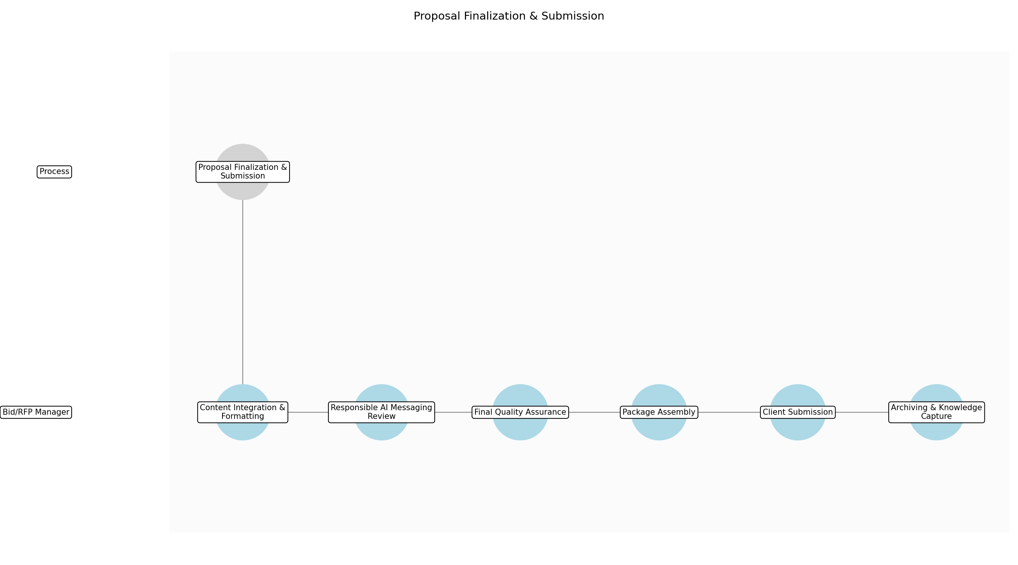

3.6.1 Content Integration & Formatting
This subprocess describes the activities required to complete 'Content Integration & Formatting'.

Description:
Consolidate all approved technical, ethical, and commercial sections into the final RFP submission template. This involves ensuring consistent branding, typography, and layout across the entire document to present a professional and unified response.

Purpose:
To create a cohesive and professionally formatted draft of the full proposal.

Scope:
Formatting and structural assembly of the proposal document.

Inputs:
The following inputs are required for this subprocess:
• Approved Proposal Content
• RFP Submission Templates

Outputs:
This subprocess produces the following outputs:
• Draft Final Proposal

Success Criteria:
Success for this subprocess is measured by:
• Document follows all client-specified formatting guidelines.
• Visual consistency across all sections.

Triggers:
This subprocess is initiated by:
• Receipt of governance approval.

End Conditions:
This subprocess is considered complete when:
• Draft proposal is ready for final messaging review.

Governance Requirements:
The following governance requirements apply:
• Adherence to corporate branding standards.

Risks and Controls:
The following risks and controls apply:
• Risk: Formatting errors leading to a non-compliant submission.
• Control: Use of standardized, pre-validated RFP templates.

Change Management:
The following change management rules apply:
• Change Request Process: Minor formatting changes handled by Bid Manager; content changes require SME re-approval.
• Versioning Rules: Incremental versioning (e.g., v0.1 to v0.2) during assembly.

Continuous Improvement:
The following continuous improvement practices apply:
• Review Frequency: Quarterly
• Improvement Inputs:
• Feedback from design team on template usability.

Estimated Duration:
The estimated duration for this subprocess is:
• 4 hours

Process Owner:
The following process owner is accountable:
• Bid/RFP Manager

Responsible Party:
The following parties are responsible for this subprocess:
• Bid/RFP Manager

3.6.2 Responsible AI Messaging Review
This subprocess describes the activities required to complete 'Responsible AI Messaging Review'.

Description:
Perform a targeted review of the proposal to ensure the 'Responsible AI' value proposition is prominent and clearly articulated. This step verifies that the ethical guardrails and monitoring strategies are presented as a competitive advantage rather than just a compliance checkbox.

Purpose:
To ensure the firm's commitment to responsible AI is a central theme of the proposal.

Scope:
Review of narrative and value proposition sections related to AI.

Inputs:
The following inputs are required for this subprocess:
• Draft Final Proposal

Outputs:
This subprocess produces the following outputs:
• Refined AI Messaging

Success Criteria:
Success for this subprocess is measured by:
• Responsible AI sections are highlighted and easy to find.
• Messaging aligns with the firm's ethical AI positioning.

Triggers:
This subprocess is initiated by:
• Completion of initial document assembly.

End Conditions:
This subprocess is considered complete when:
• AI messaging is optimized for client impact.

Dependencies:
This subprocess depends on the following:
• Content Integration & Formatting

Governance Requirements:
The following governance requirements apply:
• Alignment with the firm's Public AI Ethics Statement.

Risks and Controls:
The following risks and controls apply:
• Risk: Dilution of the AI value proposition during formatting.
• Control: Final narrative check by the Bid Manager against the original solution brief.

Change Management:
The following change management rules apply:
• Change Request Process: Messaging tweaks approved by the Enterprise Director.
• Versioning Rules: Major version update (e.g., v0.9 to v1.0).

Continuous Improvement:
The following continuous improvement practices apply:
• Review Frequency: Per RFP
• Improvement Inputs:
• Client feedback on the clarity of the AI value proposition.

Estimated Duration:
The estimated duration for this subprocess is:
• 2 hours

Process Owner:
The following process owner is accountable:
• Bid/RFP Manager

Responsible Party:
The following parties are responsible for this subprocess:
• Bid/RFP Manager

3.6.3 Final Quality Assurance
This subprocess describes the activities required to complete 'Final Quality Assurance'.

Description:
Conduct a comprehensive proofreading and cross-referencing check. This ensures all client questions are answered and that technical specifications for agentic systems match the executive summary and pricing sections.

Purpose:
To eliminate errors and ensure 100% compliance with RFP requirements.

Scope:
Proofreading, cross-referencing, and compliance checking.

Inputs:
The following inputs are required for this subprocess:
• Refined AI Messaging

Outputs:
This subprocess produces the following outputs:
• QA-Cleared Proposal

Success Criteria:
Success for this subprocess is measured by:
• Zero typos or grammatical errors.
• All RFP requirements are mapped to a response section.

Triggers:
This subprocess is initiated by:
• Completion of messaging refinement.

End Conditions:
This subprocess is considered complete when:
• Proposal is error-free and ready for packaging.

Dependencies:
This subprocess depends on the following:
• Responsible AI Messaging Review

Governance Requirements:
The following governance requirements apply:
• Final sign-off on document accuracy.

Risks and Controls:
The following risks and controls apply:
• Risk: Missing a mandatory RFP requirement.
• Control: Use of a compliance matrix to track every requirement to a page number.

Change Management:
The following change management rules apply:
• Change Request Process: QA findings must be addressed by the original content owner.
• Versioning Rules: Final review versioning.

Continuous Improvement:
The following continuous improvement practices apply:
• Review Frequency: Monthly
• Improvement Inputs:
• Error rates found during QA.

Estimated Duration:
The estimated duration for this subprocess is:
• 3 hours

Process Owner:
The following process owner is accountable:
• Bid/RFP Manager

Responsible Party:
The following parties are responsible for this subprocess:
• Bid/RFP Manager

3.6.4 Package Assembly
This subprocess describes the activities required to complete 'Package Assembly'.

Description:
Compile the main proposal document along with all required appendices, such as the AI Fit Matrix Report, Ethical Risk Assessment, and Governance Sign-offs. Convert all files to the client-requested formats (e.g., PDF) and ensure file sizes are within portal limits.

Purpose:
To prepare the complete set of deliverables for submission.

Scope:
File conversion, naming, and compilation.

Inputs:
The following inputs are required for this subprocess:
• QA-Cleared Proposal
• AI Fit Matrix Report
• Ethical Risk Assessment
• Governance Approval Sign-off

Outputs:
This subprocess produces the following outputs:
• Final RFP Submission Package

Success Criteria:
Success for this subprocess is measured by:
• All required documents are present in the package.
• Files are correctly named and formatted.

Triggers:
This subprocess is initiated by:
• QA clearance of the main proposal.

End Conditions:
This subprocess is considered complete when:
• Submission package is ready for upload.

Dependencies:
This subprocess depends on the following:
• Final Quality Assurance

Governance Requirements:
The following governance requirements apply:
• Verification of all mandatory attachments.

Risks and Controls:
The following risks and controls apply:
• Risk: Corrupted files or incorrect file formats.
• Control: Manual verification of every file in the package before submission.

Change Management:
The following change management rules apply:
• Change Request Process: No changes allowed at this stage without restarting QA.
• Versioning Rules: Final Submission Version (vFINAL).

Continuous Improvement:
The following continuous improvement practices apply:
• Review Frequency: Quarterly
• Improvement Inputs:
• Portal upload success rates.

Estimated Duration:
The estimated duration for this subprocess is:
• 2 hours

Process Owner:
The following process owner is accountable:
• Bid/RFP Manager

Responsible Party:
The following parties are responsible for this subprocess:
• Bid/RFP Manager

3.6.5 Client Submission
This subprocess describes the activities required to complete 'Client Submission'.

Description:
Submit the final package to the client via their specified portal or email address. This step includes confirming receipt if possible and ensuring the submission occurs well before the deadline to avoid technical issues.

Purpose:
To deliver the proposal to the client.

Scope:
Transmission of the proposal package.

Inputs:
The following inputs are required for this subprocess:
• Final RFP Submission Package

Outputs:
This subprocess produces the following outputs:
• Submission Confirmation

Success Criteria:
Success for this subprocess is measured by:
• Submission timestamp is before the RFP deadline.
• Receipt confirmation received from client or portal.

Triggers:
This subprocess is initiated by:
• Completion of package assembly.

End Conditions:
This subprocess is considered complete when:
• Proposal is in the client's possession.

Dependencies:
This subprocess depends on the following:
• Package Assembly

Governance Requirements:
The following governance requirements apply:
• Audit trail of submission time and date.

Risks and Controls:
The following risks and controls apply:
• Risk: Submission portal failure or internet outage.
• Control: Submission target set for 4 hours prior to the actual deadline.

Change Management:
The following change management rules apply:
• Change Request Process: Post-submission changes only via formal client-approved addenda.
• Versioning Rules: Locked version.

Continuous Improvement:
The following continuous improvement practices apply:
• Review Frequency: Per RFP
• Improvement Inputs:
• Submission timing data.

Estimated Duration:
The estimated duration for this subprocess is:
• 1 hour

Process Owner:
The following process owner is accountable:
• Bid/RFP Manager

Responsible Party:
The following parties are responsible for this subprocess:
• Bid/RFP Manager

3.6.6 Archiving & Knowledge Capture
This subprocess describes the activities required to complete 'Archiving & Knowledge Capture'.

Description:
Upload the final submission and all supporting artifacts to the internal Knowledge Management System. Tag the content with relevant metadata, such as AI use cases and client industry, to facilitate future reuse of high-quality AI proposal components.

Purpose:
To preserve the proposal for future reference and knowledge sharing.

Scope:
Internal data entry and file storage.

Inputs:
The following inputs are required for this subprocess:
• Final RFP Submission Package
• Submission Confirmation

Outputs:
This subprocess produces the following outputs:
• Archived Proposal Record

Success Criteria:
Success for this subprocess is measured by:
• Record is searchable in the KMS.
• All metadata fields are accurately populated.

Triggers:
This subprocess is initiated by:
• Receipt of submission confirmation.

End Conditions:
This subprocess is considered complete when:
• Proposal is archived and process is closed.

Dependencies:
This subprocess depends on the following:
• Client Submission

Governance Requirements:
The following governance requirements apply:
• Compliance with data retention policies.

Risks and Controls:
The following risks and controls apply:
• Risk: Loss of intellectual property or successful AI solution patterns.
• Control: Mandatory archiving step before project closure.

Change Management:
The following change management rules apply:
• Change Request Process: Archive updates managed by the KMS administrator.
• Versioning Rules: Archived as 'Submitted Version'.

Continuous Improvement:
The following continuous improvement practices apply:
• Review Frequency: Bi-Annually
• Improvement Inputs:
• Search analytics from the Knowledge Management System.

Estimated Duration:
The estimated duration for this subprocess is:
• 2 hours

Process Owner:
The following process owner is accountable:
• Bid/RFP Manager

Responsible Party:
The following parties are responsible for this subprocess:
• Bid/RFP Manager

4.0 Supporting Systems and Tools
The following tools and platforms support this process:
Category | Tools
Assessment | AI Fit Assessment Matrix tool
Content Management | Responsible AI template library, Knowledge Management System

5.0 Metrics and Key Performance Indicators (KPIs)
The following metrics help monitor performance and ensure alignment with business objectives.
Metric | Description | Measurement / Frequency | Target
AI RFP Win Rate | RFP Win Rate for AI-related projects. | Monthly | 25%
AI Fit Assessment Duration | Time to complete 'AI Fit Assessment' phase. | Per RFP | 48 hours
Client Ethical Trust Score | Client 'Trust' score regarding ethical AI positioning in feedback surveys. | Post-Submission | 4.5/5.0
Pilot Conversion Rate | Percentage of proposed AI solutions that proceed to successful pilot. | Quarterly | 60%

6.0 Critical Success Factors (CSF)
The following is a list of key CSFs associated with this process.
Success Factor | Description
Accurate AI Suitability Assessment | Accurate identification of 'AI-fit' versus 'traditional-fit' use cases.
Transparency and Ethical Disclosure | Transparency regarding AI limitations and potential biases in the proposal.
Robust Responsible AI Framework Demonstration | Demonstration of a robust Responsible AI framework to the client.

7.0 Critical Failure Factors (CFF)
The following is a list of key CFFs associated with this process.
Failure Factor | Description
Misalignment of Technology to Problem | Proposing AI solutions for problems that require traditional deterministic logic.
Privacy and Security Oversight | Failure to address data privacy and security concerns in the proposal.
Estimation Inaccuracy | Inaccurate estimation of AI implementation timelines and costs.

8.0 Reporting and Analytics
The following reporting and analytics capabilities support monitoring and decision-making:
Report / Dashboard | Description
Report | Dashboard tracking the pipeline of AI proposals, win/loss reasons, and common ethical concerns raised by clients.

9.0 System Requirements
The following system requirements are essential for the successful implementation of this process.
Name | Details
AI Fit Assessment Matrix tool | Tool for evaluating use cases against technical and ethical criteria.
Responsible AI template library | Standardized clauses and methodology for AI proposals.
Knowledge Management System | Centralized repository for past AI proposal components.

10.0 Process Flow Diagram
The following diagram provides a high-level visualization of the process flow.
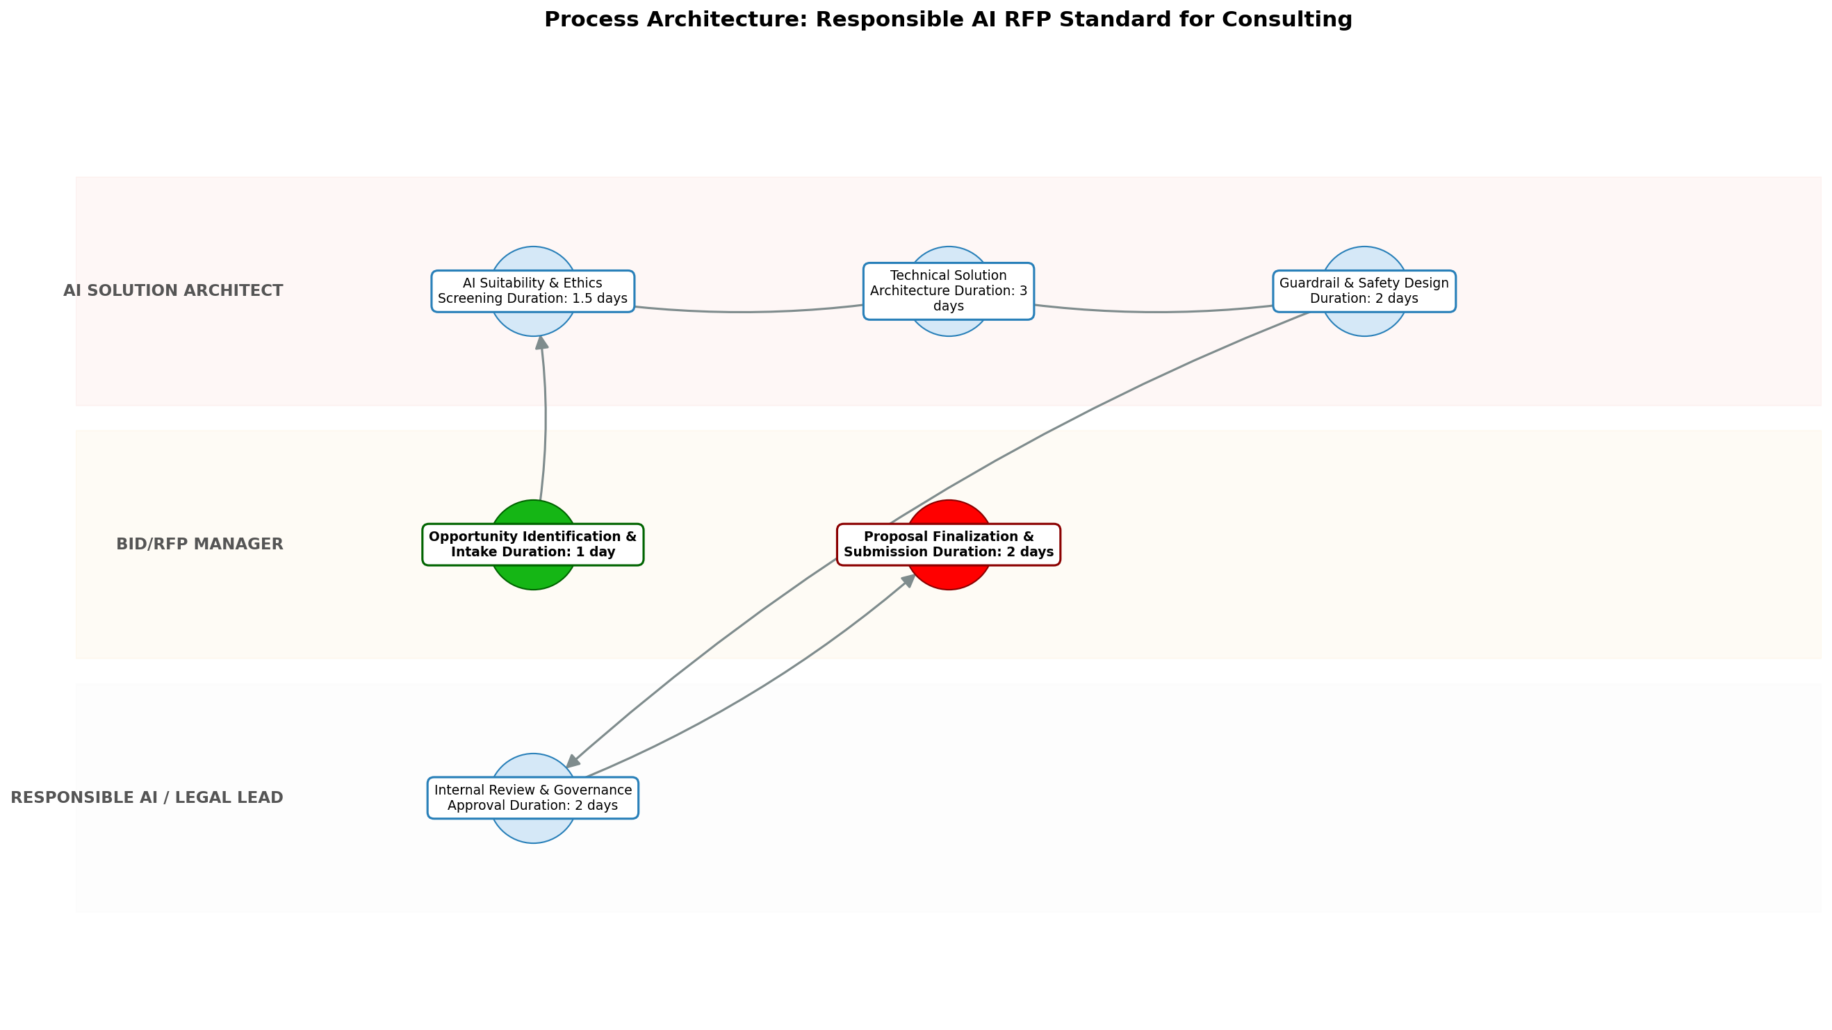

11.0 Process Performance Report
The following metrics are based on a Monte Carlo discrete-event simulation running 2,000 iterations. All time-based values are reported in days.
Operational Metric | Simulated Value
Average Cycle Time | 17.30 days
Cycle Time Variance | 2.04 days
Contention Risk Profile | Low

Identified Bottlenecks
- Solution Architecture & Guardrail Design
- Internal Review & Governance Approval
- AI Suitability & Ethics Screening

Detailed Step Performance
Process Step | Avg. Duration (days)
Opportunity Identification & Intake | 1.34
AI Suitability & Ethics Screening | 2.65
Solution Architecture & Guardrail Design | 6.65
Internal Review & Governance Approval | 4.02
Proposal Finalization & Submission | 2.64

12.0 Governance Requirements
The following governance requirements apply to this process:
• All AI-inclusive RFPs must undergo a 'Responsible AI' audit and receive sign-off from the Legal/Ethics committee before submission.

13.0 Risks and Controls
The following risks and associated controls apply to this process:
Risk | Control
Overselling AI capabilities or recommending AI for unsuitable use cases. | Mandatory 'AI Fit' checklist and review by a lead AI Architect.
Reputational damage due to unethical AI implementation. | Inclusion of a standardized 'Responsible AI' clause and methodology in every proposal.

14.0 Process Triggers
The following triggers initiate this process:
• Receipt of an RFP or RFI mentioning AI/Automation, or an identified opportunity by a Client Partner where AI could provide significant value.

15.0 Process End Conditions
The following conditions indicate completion of the process:
• Final proposal submission to client and internal archiving of the technical solution and ethical assessment.

16.0 Change Management
The following change management practices apply to this process:
• Change Request Process: The RFP standard will be updated quarterly based on technological advancements and regulatory changes.
• Versioning Rules: Mandatory training for the sales and solutioning teams upon each version update.

17.0 Continuous Improvement
The following continuous improvement practices apply to this process:
• Review Frequency: Quarterly review to refine the 'AI Fit Assessment' criteria.
Improvement Inputs:
• Post-proposal win/loss analysis specifically targeting AI components to refine the 'AI Fit Assessment' criteria.

Appendix B: Additional Source Data
This appendix contains additional structured data from the normalized source JSON that is not covered in the main sections.
Field | Value
Process Owner | Enterprise Director of AI Strategy
Purpose | To establish a consistent, ethical, and high-quality standard for proposing AI and Agentic solutions to consulting clients, ensuring technology is applied only where it adds genuine, responsible value.
Scope | All RFP, RFI, and unsolicited proposal responses originating from the consulting firm that include Generative AI or Agentic System components.

Appendix C: Glossary
This glossary contains definitions of common terms used in the process documentation:
Term | Definition
Business Process | A set of related activities or tasks performed to achieve a specific organizational goal.
KPI | Key Performance Indicator used to measure the success or health of a process.
Stakeholder | Any individual or group with an interest in the outcomes of the process.
Continuous Improvement | Ongoing effort to improve products, services, or processes.

