AI Regulatory Compliance Framework (NIST & EU AI Act)
Process Model Document

Industry / Domain: Financial Services
Version: 1.0.2
Generated On: 2026-03-10 00:40:11

Document Control
Version | Date | Author | Description
1.0.2 | 2026-03-10 | Process Architect | Initial generated process specification

Table of Contents
Right-click and select 'Update Field' to generate the Table of Contents.

1.0 Process Overview
This framework establishes a comprehensive approach for AI governance in the financial sector, ensuring compliance with the EU AI Act and NIST AI Risk Management Framework.

1.1 Assumptions
- The regulatory requirements for high-risk AI systems in finance will remain stable for the next 12 months.
- Internal data sources are sufficient and cleaned for bias mitigation.
- The organization possesses the necessary budget for external legal and technical audits.

1.2 Constraints
- Must meet the strict implementation deadlines set by the EU AI Act.
- Limited availability of subject matter experts in both AI and financial regulation.
- Hardware limitations for performing extensive stress testing on complex models.

1.3 Purpose
To provide a structured and compliant framework for developing, deploying, and managing AI systems within the financial sector.

1.4 Scope
All AI-driven models and processes within the financial institution, specifically targeting those categorized as high-risk under EU law.

1.5 Industry Sector
Financial Services

2.0 Stakeholders and Responsibilities
The following is a list of key stakeholders involved in this process. Understanding their roles and responsibilities is crucial for successful implementation.
Stakeholder | Responsibilities
Chief Compliance Officer | Overall oversight of regulatory alignment.
AI Architect | Designing the framework according to technical standards.
Data Protection Officer | Ensuring GDPR and EU AI Act data privacy compliance.
Risk Management Team | Monitoring AI risks and performance.

3.0 Process Workflow
The following is a list of key steps in the process workflow.

3.1 Identify AI use cases and risk classification

Description:
Identify potential AI use cases and classify them based on risk levels defined by the EU AI Act.

Purpose:
To determine the regulatory requirements applicable to the AI system.

Scope:
Initial project assessment phase.

Inputs:
The following inputs are required for this step:
• AI Project Proposal

Outputs:
This step produces the following outputs:
• Risk Classification Report

Success Criteria:
Success for this step is measured by:
• Formal approval of risk classification by Chief Compliance Officer.

Process Triggers:
This step is initiated by:
• Initiation of a new AI project.

Process End Conditions:
This step is considered complete when:
• Risk level is formally assigned.

Deliverables:
This step produces the following deliverables:
• Risk Classification Report

Governance Requirements:
The following governance requirements apply:
• EU AI Act Risk Classification Guidelines

Risks and Controls:
The following risks and controls apply:
• Control: Standardized risk assessment templates.
• Risk: Incorrect risk classification.

Estimated Duration:
The estimated duration for this step is:
• 2 weeks

Process Owner:
The following process owner is accountable:
• Head of AI Governance

Responsible Parties:
The following parties are responsible for this step:
• AI Architect

Required Sub Process(es) for the Step "Identify AI use cases and risk classification"
The following details the subprocess flows for the step "Identify AI use cases and risk classification".
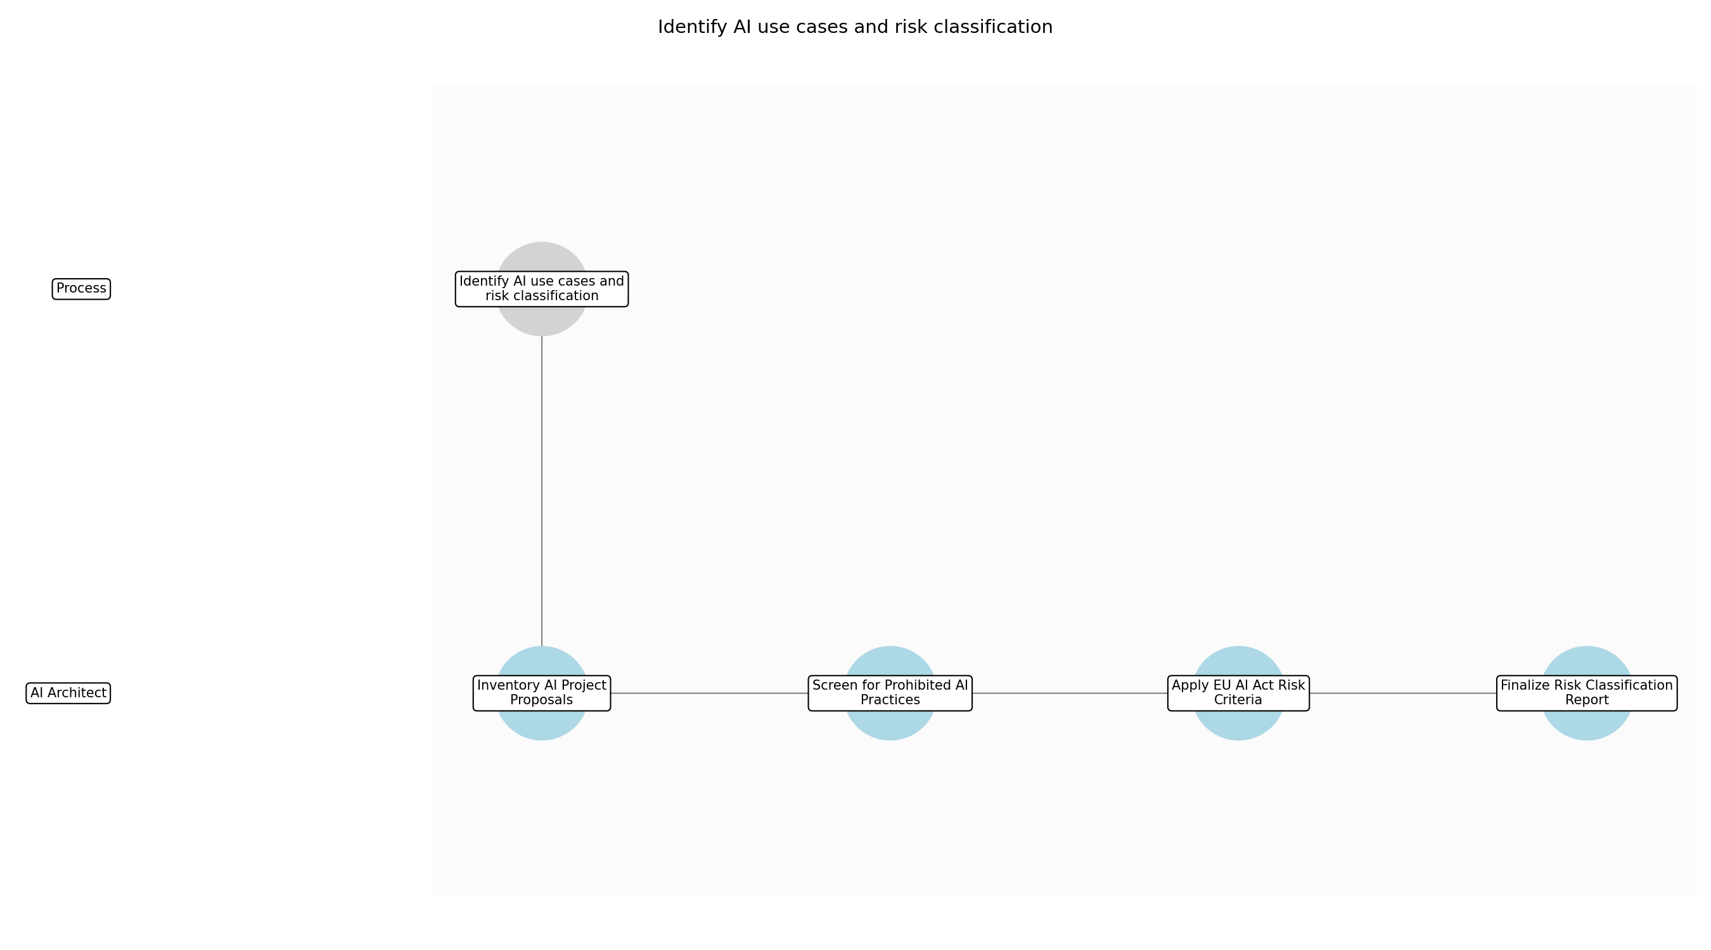

3.1.1 Inventory AI Project Proposals
This subprocess describes the activities required to complete 'Inventory AI Project Proposals'.

Description:
Collect and catalog all incoming AI project proposals from various business units. This involves reviewing the initial project documentation to understand the intended purpose, target users, and technical architecture of the proposed AI system.

Purpose:
To create a comprehensive list of AI systems requiring assessment.

Scope:
All new and significantly modified AI projects within the organization.

Inputs:
The following inputs are required for this subprocess:
• AI Project Proposal

Outputs:
This subprocess produces the following outputs:
• Consolidated AI Project Inventory

Success Criteria:
Success for this subprocess is measured by:
• All active AI proposals are captured in the central inventory.

Triggers:
This subprocess is initiated by:
• Initiation of a new AI project.

End Conditions:
This subprocess is considered complete when:
• Inventory is updated with the latest project details.

Governance Requirements:
The following governance requirements apply:
• EU AI Act Article 51 (Inventory Requirements)

Risks and Controls:
The following risks and controls apply:
• Risk: Shadow AI projects bypass the inventory process.
• Control: Mandatory procurement and cloud-spend reviews.

Change Management:
The following change management rules apply:
• Change Request Process: Standard project intake change request.
• Versioning Rules: Inventory list versioned weekly.

Continuous Improvement:
The following continuous improvement practices apply:
• Review Frequency: Monthly
• Improvement Inputs:
• Project intake logs
• Stakeholder feedback

Estimated Duration:
The estimated duration for this subprocess is:
• 2 days

Process Owner:
The following process owner is accountable:
• Head of AI Governance

Responsible Party:
The following parties are responsible for this subprocess:
• AI Architect

3.1.2 Screen for Prohibited AI Practices
This subprocess describes the activities required to complete 'Screen for Prohibited AI Practices'.

Description:
Evaluate each AI use case against the list of prohibited practices defined by the EU AI Act, such as social scoring or untargeted scraping of facial images. This step ensures that no project proceeds if it violates fundamental ethical or legal boundaries.

Purpose:
To prevent the development of illegal AI systems.

Scope:
Ethical and legal boundary screening.

Inputs:
The following inputs are required for this subprocess:
• Consolidated AI Project Inventory
• EU AI Act Prohibited Practices List

Outputs:
This subprocess produces the following outputs:
• Prohibited Practice Screening Report

Success Criteria:
Success for this subprocess is measured by:
• Confirmation that the use case does not fall under prohibited categories.

Triggers:
This subprocess is initiated by:
• Project entry into the inventory.

End Conditions:
This subprocess is considered complete when:
• Screening report is signed off by legal counsel.

Dependencies:
This subprocess depends on the following:
• Inventory AI Project Proposals

Governance Requirements:
The following governance requirements apply:
• EU AI Act Title II (Prohibited AI Practices)

Risks and Controls:
The following risks and controls apply:
• Risk: Misinterpretation of prohibited practice definitions.
• Control: Legal department review of all screening reports.

Change Management:
The following change management rules apply:
• Change Request Process: Legal review update process.
• Versioning Rules: Screening criteria updated with regulatory changes.

Continuous Improvement:
The following continuous improvement practices apply:
• Review Frequency: Quarterly
• Improvement Inputs:
• Regulatory updates
• Legal case studies

Estimated Duration:
The estimated duration for this subprocess is:
• 3 days

Process Owner:
The following process owner is accountable:
• Head of AI Governance

Responsible Party:
The following parties are responsible for this subprocess:
• AI Architect

3.1.3 Apply EU AI Act Risk Criteria
This subprocess describes the activities required to complete 'Apply EU AI Act Risk Criteria'.

Description:
Assess the AI system against the high-risk criteria specified in the EU AI Act, focusing on its application in critical infrastructure, education, employment, and financial services. This involves determining if the system is a safety component or intended for use in sensitive sectors.

Purpose:
To categorize the AI system for regulatory compliance mapping.

Scope:
Regulatory risk classification.

Inputs:
The following inputs are required for this subprocess:
• Prohibited Practice Screening Report
• EU AI Act Risk Classification Guidelines

Outputs:
This subprocess produces the following outputs:
• Draft Risk Classification

Success Criteria:
Success for this subprocess is measured by:
• Risk level (Unacceptable, High, Limited, Minimal) is assigned based on regulatory criteria.

Triggers:
This subprocess is initiated by:
• Successful completion of prohibited practice screening.

End Conditions:
This subprocess is considered complete when:
• Draft classification is ready for executive review.

Dependencies:
This subprocess depends on the following:
• Screening for Prohibited AI Practices

Governance Requirements:
The following governance requirements apply:
• EU AI Act Annex III (High-Risk AI Systems)

Risks and Controls:
The following risks and controls apply:
• Risk: Incorrect risk classification.
• Control: Standardized risk assessment templates.

Change Management:
The following change management rules apply:
• Change Request Process: Classification appeal process.
• Versioning Rules: Classification records versioned per project.

Continuous Improvement:
The following continuous improvement practices apply:
• Review Frequency: Bi-annually
• Improvement Inputs:
• Audit findings
• Industry benchmarking

Estimated Duration:
The estimated duration for this subprocess is:
• 4 days

Process Owner:
The following process owner is accountable:
• Head of AI Governance

Responsible Party:
The following parties are responsible for this subprocess:
• AI Architect

3.1.4 Finalize Risk Classification Report
This subprocess describes the activities required to complete 'Finalize Risk Classification Report'.

Description:
Compile the findings from the inventory, screening, and classification steps into a formal Risk Classification Report. This report serves as the definitive document for the project's regulatory standing and dictates the subsequent compliance requirements.

Purpose:
To document the final risk standing of the AI system.

Scope:
Final documentation and approval.

Inputs:
The following inputs are required for this subprocess:
• Draft Risk Classification
• AI Project Proposal

Outputs:
This subprocess produces the following outputs:
• Risk Classification Report

Success Criteria:
Success for this subprocess is measured by:
• Formal approval of risk classification by Chief Compliance Officer.

Triggers:
This subprocess is initiated by:
• Completion of risk assessment.

End Conditions:
This subprocess is considered complete when:
• Risk level is formally assigned.

Dependencies:
This subprocess depends on the following:
• Apply EU AI Act Risk Criteria

Governance Requirements:
The following governance requirements apply:
• EU AI Act Documentation Standards

Risks and Controls:
The following risks and controls apply:
• Risk: Incomplete documentation in the final report.
• Control: Peer review of the report before submission.

Change Management:
The following change management rules apply:
• Change Request Process: Formal document revision process.
• Versioning Rules: Major versioning for approved reports.

Continuous Improvement:
The following continuous improvement practices apply:
• Review Frequency: Annual
• Improvement Inputs:
• Compliance officer feedback
• External audit results

Estimated Duration:
The estimated duration for this subprocess is:
• 1 day

Process Owner:
The following process owner is accountable:
• Head of AI Governance

Responsible Party:
The following parties are responsible for this subprocess:
• AI Architect

3.2 Conduct Data Protection Impact Assessment (DPIA)

Description:
Conduct a Data Protection Impact Assessment to ensure compliance with GDPR and EU AI Act data privacy requirements.

Purpose:
To mitigate data privacy risks.

Scope:
Data privacy and protection.

Inputs:
The following inputs are required for this step:
• Risk Classification Report
• Data Architecture Diagrams

Outputs:
This step produces the following outputs:
• DPIA Report

Success Criteria:
Success for this step is measured by:
• DPO approval of the DPIA.

Process Triggers:
This step is initiated by:
• Completion of risk classification.

Process End Conditions:
This step is considered complete when:
• DPIA is signed off by DPO.

Dependencies:
This step depends on the following:
• Identify AI use cases and risk classification

Deliverables:
This step produces the following deliverables:
• DPIA Report

Governance Requirements:
The following governance requirements apply:
• GDPR Compliance Standards

Risks and Controls:
The following risks and controls apply:
• Risk: Data Privacy Breach
• Control: Differential privacy techniques and Carney access controls.

Estimated Duration:
The estimated duration for this step is:
• 3 weeks

Process Owner:
The following process owner is accountable:
• Head of AI Governance

Responsible Parties:
The following parties are responsible for this step:
• Data Protection Officer

Required Sub Process(es) for the Step "Conduct Data Protection Impact Assessment (DPIA)"
The following details the subprocess flows for the step "Conduct Data Protection Impact Assessment (DPIA)".
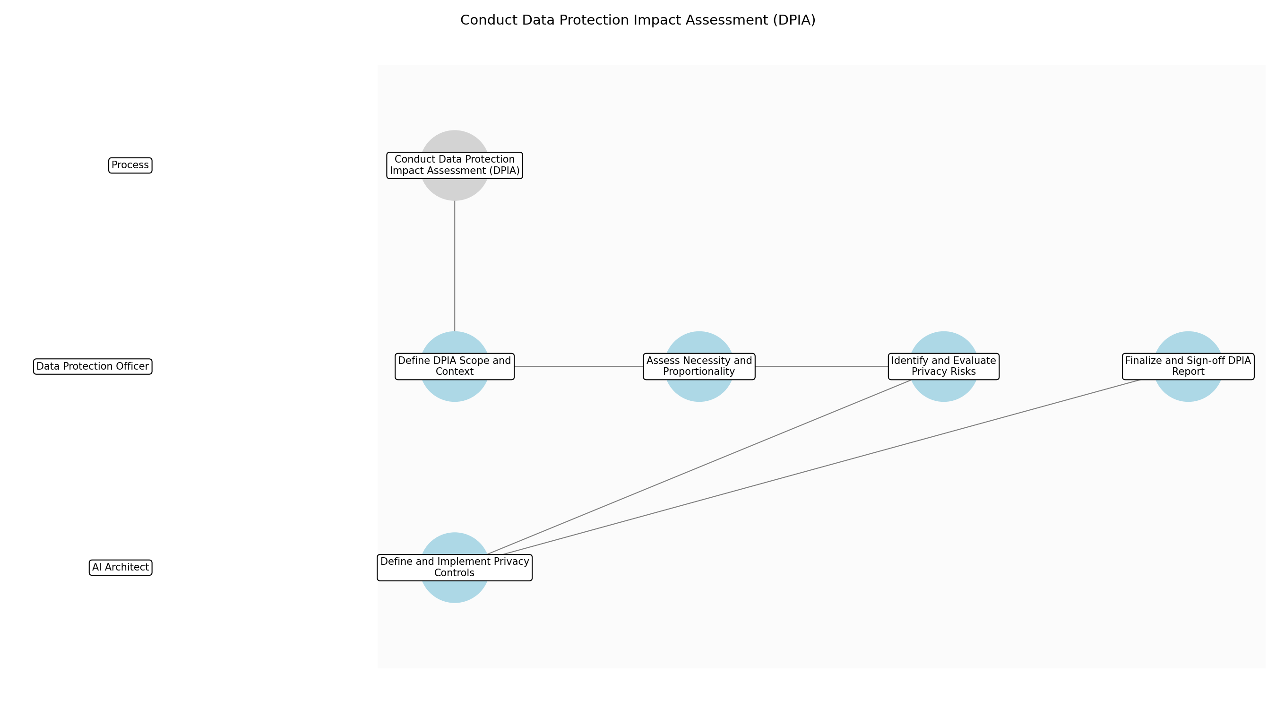

3.2.1 Define DPIA Scope and Context
This subprocess describes the activities required to complete 'Define DPIA Scope and Context'.

Description:
Establish the specific boundaries of the assessment by mapping the flow of personal data within the AI system. This involves identifying the types of data collected, the legal basis for processing, and the specific financial use case to ensure all regulatory touchpoints are identified.

Purpose:
To ensure the assessment covers all relevant data processing activities.

Scope:
Data mapping and regulatory boundary setting.

Inputs:
The following inputs are required for this subprocess:
• Risk Classification Report
• Data Architecture Diagrams

Outputs:
This subprocess produces the following outputs:
• DPIA Scope Document

Success Criteria:
Success for this subprocess is measured by:
• Formal agreement on data processing boundaries by the AI Architect.

Triggers:
This subprocess is initiated by:
• Completion of risk classification.

End Conditions:
This subprocess is considered complete when:
• Scope document is finalized and approved.

Governance Requirements:
The following governance requirements apply:
• GDPR Article 35 Compliance

Risks and Controls:
The following risks and controls apply:
• Risk: Incomplete data mapping leading to overlooked privacy risks.
• Control: Cross-functional review of data architecture diagrams.

Change Management:
The following change management rules apply:
• Change Request Process: Formal email request to the DPO.
• Versioning Rules: Major version increments for scope changes.

Continuous Improvement:
The following continuous improvement practices apply:
• Review Frequency: Quarterly
• Improvement Inputs:
• Regulatory update logs

Estimated Duration:
The estimated duration for this subprocess is:
• 2 days

Process Owner:
The following process owner is accountable:
• Head of AI Governance

Responsible Party:
The following parties are responsible for this subprocess:
• Data Protection Officer

3.2.2 Assess Necessity and Proportionality
This subprocess describes the activities required to complete 'Assess Necessity and Proportionality'.

Description:
Evaluate whether the data processing is necessary for the AI model's objectives and if the amount of data used is proportionate. This step ensures that the principle of data minimization is upheld in accordance with financial privacy standards.

Purpose:
To validate that data usage is legally and ethically justified.

Scope:
Data minimization and legal justification analysis.

Inputs:
The following inputs are required for this subprocess:
• DPIA Scope Document
• AI Project Proposal

Outputs:
This subprocess produces the following outputs:
• Necessity Assessment Report

Success Criteria:
Success for this subprocess is measured by:
• Documented justification for every data field used in the model.

Triggers:
This subprocess is initiated by:
• Approval of DPIA Scope Document.

End Conditions:
This subprocess is considered complete when:
• Necessity report is signed off by the DPO.

Dependencies:
This subprocess depends on the following:
• Define DPIA Scope and Context

Governance Requirements:
The following governance requirements apply:
• GDPR Data Minimization Standards

Risks and Controls:
The following risks and controls apply:
• Risk: Excessive data collection violating GDPR principles.
• Control: Mandatory data minimization review by the AI Ethics Committee.

Change Management:
The following change management rules apply:
• Change Request Process: Submission via Governance Portal.
• Versioning Rules: Minor versioning for justification updates.

Continuous Improvement:
The following continuous improvement practices apply:
• Review Frequency: Bi-annually
• Improvement Inputs:
• Internal audit findings

Estimated Duration:
The estimated duration for this subprocess is:
• 3 days

Process Owner:
The following process owner is accountable:
• Head of AI Governance

Responsible Party:
The following parties are responsible for this subprocess:
• Data Protection Officer

3.2.3 Identify and Evaluate Privacy Risks
This subprocess describes the activities required to complete 'Identify and Evaluate Privacy Risks'.

Description:
Systematically identify potential threats to the rights and freedoms of data subjects, such as unauthorized access or re-identification. Each risk is evaluated based on its likelihood and impact within the context of high-risk financial AI applications.

Purpose:
To identify vulnerabilities in the data lifecycle.

Scope:
Risk identification and impact scoring.

Inputs:
The following inputs are required for this subprocess:
• Necessity Assessment Report
• Data Architecture Diagrams

Outputs:
This subprocess produces the following outputs:
• Privacy Risk Register

Success Criteria:
Success for this subprocess is measured by:
• Comprehensive list of risks mapped to specific AI components.

Triggers:
This subprocess is initiated by:
• Completion of Necessity Assessment.

End Conditions:
This subprocess is considered complete when:
• Risk register is populated and impact scores are assigned.

Dependencies:
This subprocess depends on the following:
• Assess Necessity and Proportionality

Governance Requirements:
The following governance requirements apply:
• EU AI Act High-Risk AI Requirements

Risks and Controls:
The following risks and controls apply:
• Risk: Failure to identify emerging AI-specific privacy threats.
• Control: Use of updated NIST AI RMF threat catalogs.

Change Management:
The following change management rules apply:
• Change Request Process: Risk Management Team review.
• Versioning Rules: Real-time updates with timestamping.

Continuous Improvement:
The following continuous improvement practices apply:
• Review Frequency: Monthly
• Improvement Inputs:
• External threat intelligence

Estimated Duration:
The estimated duration for this subprocess is:
• 1 week

Process Owner:
The following process owner is accountable:
• Head of AI Governance

Responsible Party:
The following parties are responsible for this subprocess:
• Data Protection Officer

3.2.4 Define and Implement Privacy Controls
This subprocess describes the activities required to complete 'Define and Implement Privacy Controls'.

Description:
Select and apply technical and organizational measures to mitigate identified risks. This includes implementing differential privacy, Carney access controls, and encryption protocols to ensure data remains protected throughout the AI training and inference phases.

Purpose:
To reduce privacy risks to an acceptable residual level.

Scope:
Technical and organizational control selection.

Inputs:
The following inputs are required for this subprocess:
• Privacy Risk Register

Outputs:
This subprocess produces the following outputs:
• Privacy Control Implementation Plan

Success Criteria:
Success for this subprocess is measured by:
• All high-impact risks have at least one verified mitigating control.

Triggers:
This subprocess is initiated by:
• Finalization of the Privacy Risk Register.

End Conditions:
This subprocess is considered complete when:
• Controls are documented and implementation is verified.

Dependencies:
This subprocess depends on the following:
• Identify and Evaluate Privacy Risks

Governance Requirements:
The following governance requirements apply:
• NIST Privacy Framework Standards

Risks and Controls:
The following risks and controls apply:
• Risk: Controls degrade model performance or accuracy.
• Control: Performance benchmarking during control implementation.

Change Management:
The following change management rules apply:
• Change Request Process: Technical Change Board approval.
• Versioning Rules: Configuration management tracking.

Continuous Improvement:
The following continuous improvement practices apply:
• Review Frequency: Per project phase
• Improvement Inputs:
• Technical performance metrics

Estimated Duration:
The estimated duration for this subprocess is:
• 1 week

Process Owner:
The following process owner is accountable:
• Head of AI Governance

Responsible Party:
The following parties are responsible for this subprocess:
• AI Architect

3.2.5 Finalize and Sign-off DPIA Report
This subprocess describes the activities required to complete 'Finalize and Sign-off DPIA Report'.

Description:
Consolidate all findings, assessments, and control implementations into a formal DPIA report. The Data Protection Officer reviews the final document to ensure it meets all GDPR and EU AI Act requirements before providing the formal sign-off required for project progression.

Purpose:
To provide formal evidence of privacy compliance.

Scope:
Final report consolidation and executive approval.

Inputs:
The following inputs are required for this subprocess:
• Privacy Control Implementation Plan
• Privacy Risk Register
• Necessity Assessment Report

Outputs:
This subprocess produces the following outputs:
• DPIA Report

Success Criteria:
Success for this subprocess is measured by:
• DPO signature on the final DPIA Report.

Triggers:
This subprocess is initiated by:
• Verification of control implementation.

End Conditions:
This subprocess is considered complete when:
• DPIA is signed off by DPO.

Dependencies:
This subprocess depends on the following:
• Define and Implement Privacy Controls

Governance Requirements:
The following governance requirements apply:
• GDPR Compliance Standards

Risks and Controls:
The following risks and controls apply:
• Risk: Report fails to meet regulatory audit standards.
• Control: Use of official regulatory DPIA templates.

Change Management:
The following change management rules apply:
• Change Request Process: Formal revision request to the DPO.
• Versioning Rules: Final version locking and archiving.

Continuous Improvement:
The following continuous improvement practices apply:
• Review Frequency: Annual
• Improvement Inputs:
• Regulatory audit feedback

Estimated Duration:
The estimated duration for this subprocess is:
• 3 days

Process Owner:
The following process owner is accountable:
• Head of AI Governance

Responsible Party:
The following parties are responsible for this subprocess:
• Data Protection Officer

3.3 Implement NIST AI RMF - Govern and Map

Description:
Implement the 'Govern' and 'Map' core functions of the NIST AI Risk Management Framework to establish governance structures and identify contextual risks.

Purpose:
To establish AI governance and map organizational risks.

Scope:
NIST AI RMF Initial Phases.

Inputs:
The following inputs are required for this step:
• DPIA Report

Outputs:
This step produces the following outputs:
• NIST AI RMF Govern & Map Report

Success Criteria:
Success for this step is measured by:
• Defined governance roles and complete risk map.

Process Triggers:
This step is initiated by:
• Completion of DPIA.

Process End Conditions:
This step is considered complete when:
• Governance and risk mapping are established.

Dependencies:
This step depends on the following:
• Conduct Data Protection Impact Assessment (DPIA)

Deliverables:
This step produces the following deliverables:
• NIST AI RMF Govern & Map Report

Governance Requirements:
The following governance requirements apply:
• NIST AI RMF 1.0 (Govern, Map)

Risks and Controls:
The following risks and controls apply:
• Control: Governance committee oversight.
• Risk: Misalignment with organizational goals.

Estimated Duration:
The estimated duration for this step is:
• 4 weeks

Process Owner:
The following process owner is accountable:
• Head of AI Governance

Responsible Parties:
The following parties are responsible for this step:
• AI Architect

Required Sub Process(es) for the Step "Implement NIST AI RMF - Govern and Map"
The following details the subprocess flows for the step "Implement NIST AI RMF - Govern and Map".
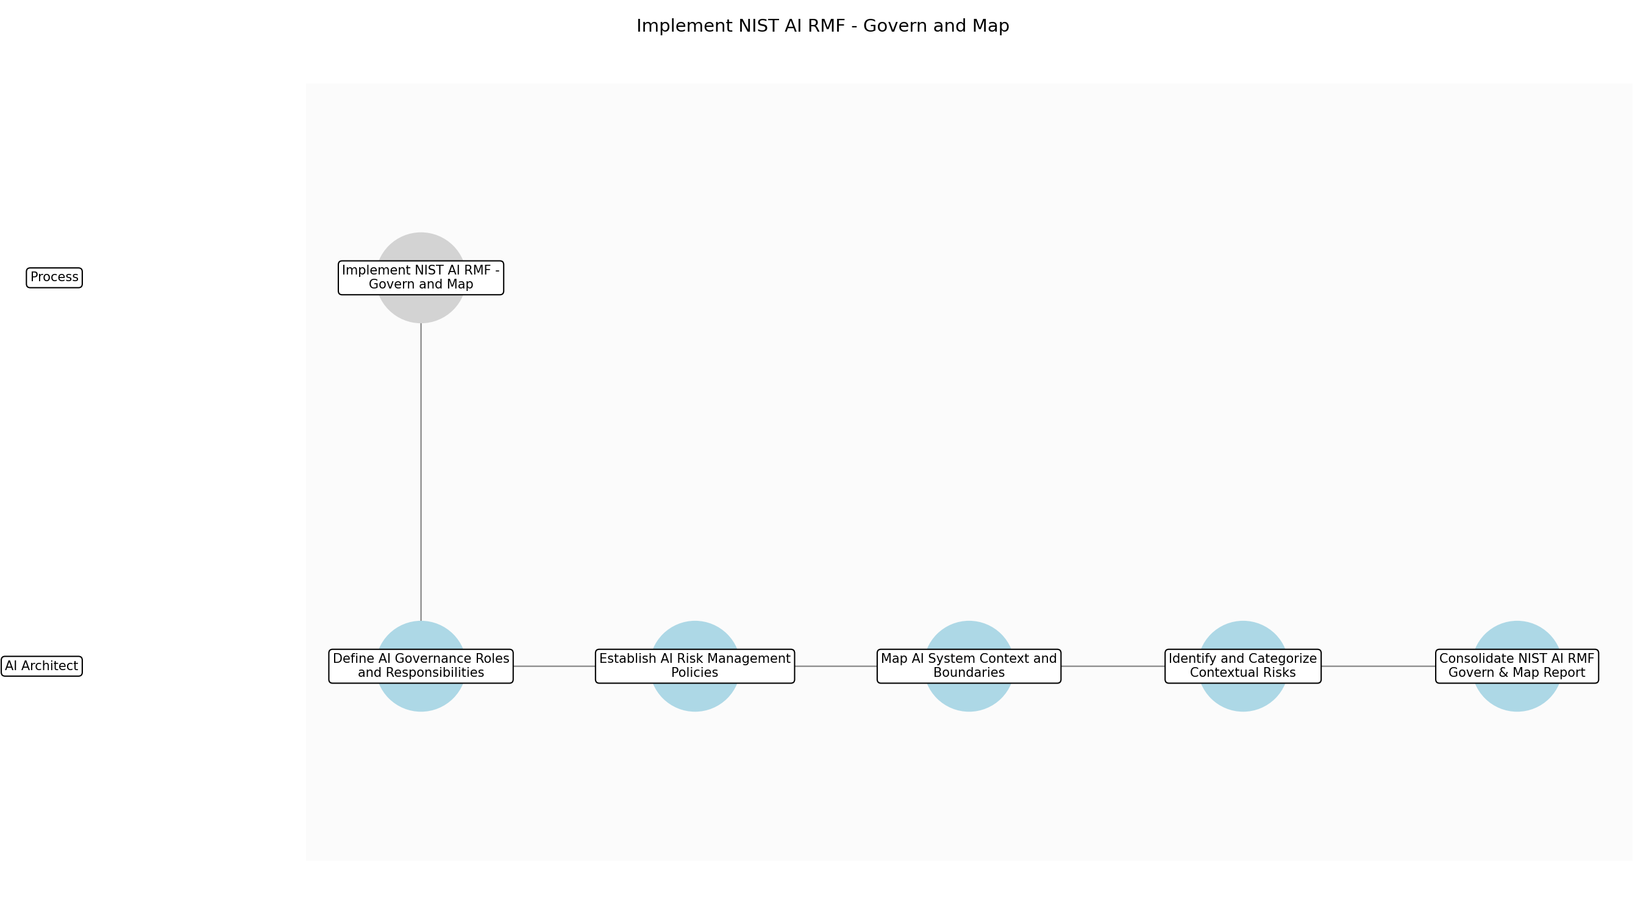

3.3.1 Define AI Governance Roles and Responsibilities
This subprocess describes the activities required to complete 'Define AI Governance Roles and Responsibilities'.

Description:
This sub-step involves identifying and documenting the specific roles required for effective AI oversight within the organization. It includes defining the responsibilities of the AI Architect, the AI Ethics Committee, and other key stakeholders to ensure clear accountability and decision-making authority throughout the AI system's lifecycle.

Purpose:
To establish clear accountability for AI risk management.

Scope:
Internal organizational roles related to the specific AI project.

Inputs:
The following inputs are required for this subprocess:
• DPIA Report
• Organizational Chart

Outputs:
This subprocess produces the following outputs:
• AI Governance Role Matrix

Success Criteria:
Success for this subprocess is measured by:
• Formal approval of the role matrix by the Head of AI Governance.

Triggers:
This subprocess is initiated by:
• Completion of DPIA.

End Conditions:
This subprocess is considered complete when:
• Role matrix is documented and approved.

Governance Requirements:
The following governance requirements apply:
• NIST AI RMF 1.0 Govern Function

Risks and Controls:
The following risks and controls apply:
• Risk: Role ambiguity
• Control: Detailed job descriptions and RACI matrix.

Change Management:
The following change management rules apply:
• Change Request Process: Standard HR/Governance change request.
• Versioning Rules: Major version change for role additions.

Continuous Improvement:
The following continuous improvement practices apply:
• Review Frequency: Annual
• Improvement Inputs:
• Stakeholder feedback

Estimated Duration:
The estimated duration for this subprocess is:
• 1 week

Process Owner:
The following process owner is accountable:
• Head of AI Governance

Responsible Party:
The following parties are responsible for this subprocess:
• AI Architect

3.3.2 Establish AI Risk Management Policies
This subprocess describes the activities required to complete 'Establish AI Risk Management Policies'.

Description:
In this sub-step, the team develops and formalizes the policies that will guide AI risk management activities. These policies must align with the NIST AI RMF 1.0 'Govern' core function and provide a structured approach for identifying, assessing, and managing risks specific to the financial sector's regulatory environment.

Purpose:
To provide a standardized framework for risk-related decision making.

Scope:
Policy development for AI risk management.

Inputs:
The following inputs are required for this subprocess:
• AI Governance Role Matrix
• NIST AI RMF 1.0

Outputs:
This subprocess produces the following outputs:
• AI Risk Management Policy

Success Criteria:
Success for this subprocess is measured by:
• Policy document is signed off by the Chief Compliance Officer.

Triggers:
This subprocess is initiated by:
• Approval of AI Governance Role Matrix.

End Conditions:
This subprocess is considered complete when:
• Policy is published in the internal repository.

Dependencies:
This subprocess depends on the following:
• Define AI Governance Roles and Responsibilities

Governance Requirements:
The following governance requirements apply:
• NIST AI RMF 1.0 Govern Function

Risks and Controls:
The following risks and controls apply:
• Risk: Policy non-compliance
• Control: Mandatory training and periodic audits.

Change Management:
The following change management rules apply:
• Change Request Process: Policy review board submission.
• Versioning Rules: Semantic versioning for policy updates.

Continuous Improvement:
The following continuous improvement practices apply:
• Review Frequency: Bi-annual
• Improvement Inputs:
• Regulatory updates
• Audit findings

Estimated Duration:
The estimated duration for this subprocess is:
• 1 week

Process Owner:
The following process owner is accountable:
• Head of AI Governance

Responsible Party:
The following parties are responsible for this subprocess:
• AI Architect

3.3.3 Map AI System Context and Boundaries
This subprocess describes the activities required to complete 'Map AI System Context and Boundaries'.

Description:
This sub-step focuses on defining the operational context of the AI system, including its intended purpose, target users, and the environment in which it will operate. By mapping these boundaries, the organization can better understand the potential impacts on individuals and society, which is a critical component of the NIST 'Map' function.

Purpose:
To identify the scope of potential risks based on system usage.

Scope:
Technical and operational boundaries of the AI system.

Inputs:
The following inputs are required for this subprocess:
• AI Project Proposal
• DPIA Report

Outputs:
This subprocess produces the following outputs:
• AI System Context Map

Success Criteria:
Success for this subprocess is measured by:
• Context map accurately reflects the system's operational environment.

Triggers:
This subprocess is initiated by:
• Publication of AI Risk Management Policy.

End Conditions:
This subprocess is considered complete when:
• Context map is finalized and reviewed by technical leads.

Dependencies:
This subprocess depends on the following:
• Establish AI Risk Management Policies

Governance Requirements:
The following governance requirements apply:
• NIST AI RMF 1.0 Map Function

Risks and Controls:
The following risks and controls apply:
• Risk: Scope creep
• Control: Strict definition of system boundaries in the context map.

Change Management:
The following change management rules apply:
• Change Request Process: Technical review board approval.
• Versioning Rules: Version tracking via model inventory system.

Continuous Improvement:
The following continuous improvement practices apply:
• Review Frequency: Per project phase
• Improvement Inputs:
• Technical debt logs

Estimated Duration:
The estimated duration for this subprocess is:
• 1 week

Process Owner:
The following process owner is accountable:
• Head of AI Governance

Responsible Party:
The following parties are responsible for this subprocess:
• AI Architect

3.3.4 Identify and Categorize Contextual Risks
This subprocess describes the activities required to complete 'Identify and Categorize Contextual Risks'.

Description:
Building on the system context map, this sub-step involves identifying specific risks that could arise from the AI system's deployment. Risks are categorized according to their potential impact on organizational goals, data privacy, and regulatory compliance, ensuring that all relevant threats are captured in the project's risk register.

Purpose:
To populate the risk register with context-specific threats.

Scope:
Risk identification and categorization.

Inputs:
The following inputs are required for this subprocess:
• AI System Context Map
• AI Risk Management Policy

Outputs:
This subprocess produces the following outputs:
• Initial AI Risk Register

Success Criteria:
Success for this subprocess is measured by:
• Comprehensive list of risks identified and categorized.

Triggers:
This subprocess is initiated by:
• Finalization of AI System Context Map.

End Conditions:
This subprocess is considered complete when:
• Risk register is updated with initial mapping results.

Dependencies:
This subprocess depends on the following:
• Map AI System Context and Boundaries

Governance Requirements:
The following governance requirements apply:
• NIST AI RMF 1.0 Map Function

Risks and Controls:
The following risks and controls apply:
• Risk: Incomplete risk identification
• Control: Multi-disciplinary risk brainstorming sessions.

Change Management:
The following change management rules apply:
• Change Request Process: Risk management team review.
• Versioning Rules: Incremental versioning for risk register updates.

Continuous Improvement:
The following continuous improvement practices apply:
• Review Frequency: Monthly
• Improvement Inputs:
• Incident reports
• Threat intelligence

Estimated Duration:
The estimated duration for this subprocess is:
• 1 week

Process Owner:
The following process owner is accountable:
• Head of AI Governance

Responsible Party:
The following parties are responsible for this subprocess:
• AI Architect

3.3.5 Consolidate NIST AI RMF Govern & Map Report
This subprocess describes the activities required to complete 'Consolidate NIST AI RMF Govern & Map Report'.

Description:
The final sub-step involves aggregating all findings from the governance and mapping activities into a single, comprehensive report. This document provides a clear overview of the established governance structures and the identified risk landscape, serving as the foundational artifact for subsequent measurement and management phases.

Purpose:
To provide a formal record of the Govern and Map phase results.

Scope:
Reporting and documentation consolidation.

Inputs:
The following inputs are required for this subprocess:
• AI Governance Role Matrix
• AI Risk Management Policy
• Initial AI Risk Register

Outputs:
This subprocess produces the following outputs:
• NIST AI RMF Govern & Map Report

Success Criteria:
Success for this subprocess is measured by:
• Report is complete and meets all NIST AI RMF 1.0 documentation standards.

Triggers:
This subprocess is initiated by:
• Completion of risk categorization.

End Conditions:
This subprocess is considered complete when:
• Report is signed off and distributed to stakeholders.

Dependencies:
This subprocess depends on the following:
• Identify and Categorize Contextual Risks

Governance Requirements:
The following governance requirements apply:
• NIST AI RMF 1.0 (Govern, Map)

Risks and Controls:
The following risks and controls apply:
• Risk: Inaccurate reporting
• Control: Peer review and sign-off by the Head of AI Governance.

Change Management:
The following change management rules apply:
• Change Request Process: Formal document control process.
• Versioning Rules: Major versioning for final report release.

Continuous Improvement:
The following continuous improvement practices apply:
• Review Frequency: Post-phase review
• Improvement Inputs:
• Stakeholder feedback on report clarity

Estimated Duration:
The estimated duration for this subprocess is:
• 3 days

Process Owner:
The following process owner is accountable:
• Head of AI Governance

Responsible Party:
The following parties are responsible for this subprocess:
• AI Architect

3.4 Implement NIST AI RMF - Measure and Manage

Description:
Implement the 'Measure' and 'Manage' core functions of the NIST AI Risk Management Framework, utilizing automated tools where possible to quantify and mitigate risks.

Purpose:
To quantify and manage identified AI risks.

Scope:
NIST AI RMF Measurement and Mitigation.

Inputs:
The following inputs are required for this step:
• NIST AI RMF Govern & Map Report

Outputs:
This step produces the following outputs:
• NIST AI RMF Measure & Manage Report

Success Criteria:
Success for this step is measured by:
• Successful quantification of risks and implementation of mitigation controls.

Process Triggers:
This step is initiated by:
• Completion of Govern and Map phase.

Process End Conditions:
This step is considered complete when:
• Risk measurement and management protocols are active.

Dependencies:
This step depends on the following:
• Implement NIST AI RMF - Govern and Map

Deliverables:
This step produces the following deliverables:
• NIST AI RMF Measure & Manage Report

Governance Requirements:
The following governance requirements apply:
• NIST AI RMF 1.0 (Measure, Manage)

Risks and Controls:
The following risks and controls apply:
• Control: Automated risk monitoring tools.
• Risk: Inaccurate risk measurement.

Estimated Duration:
The estimated duration for this step is:
• 4 weeks

Process Owner:
The following process owner is accountable:
• Head of AI Governance

Responsible Parties:
The following parties are responsible for this step:
• AI Architect

Required Sub Process(es) for the Step "Implement NIST AI RMF - Measure and Manage"
The following details the subprocess flows for the step "Implement NIST AI RMF - Measure and Manage".
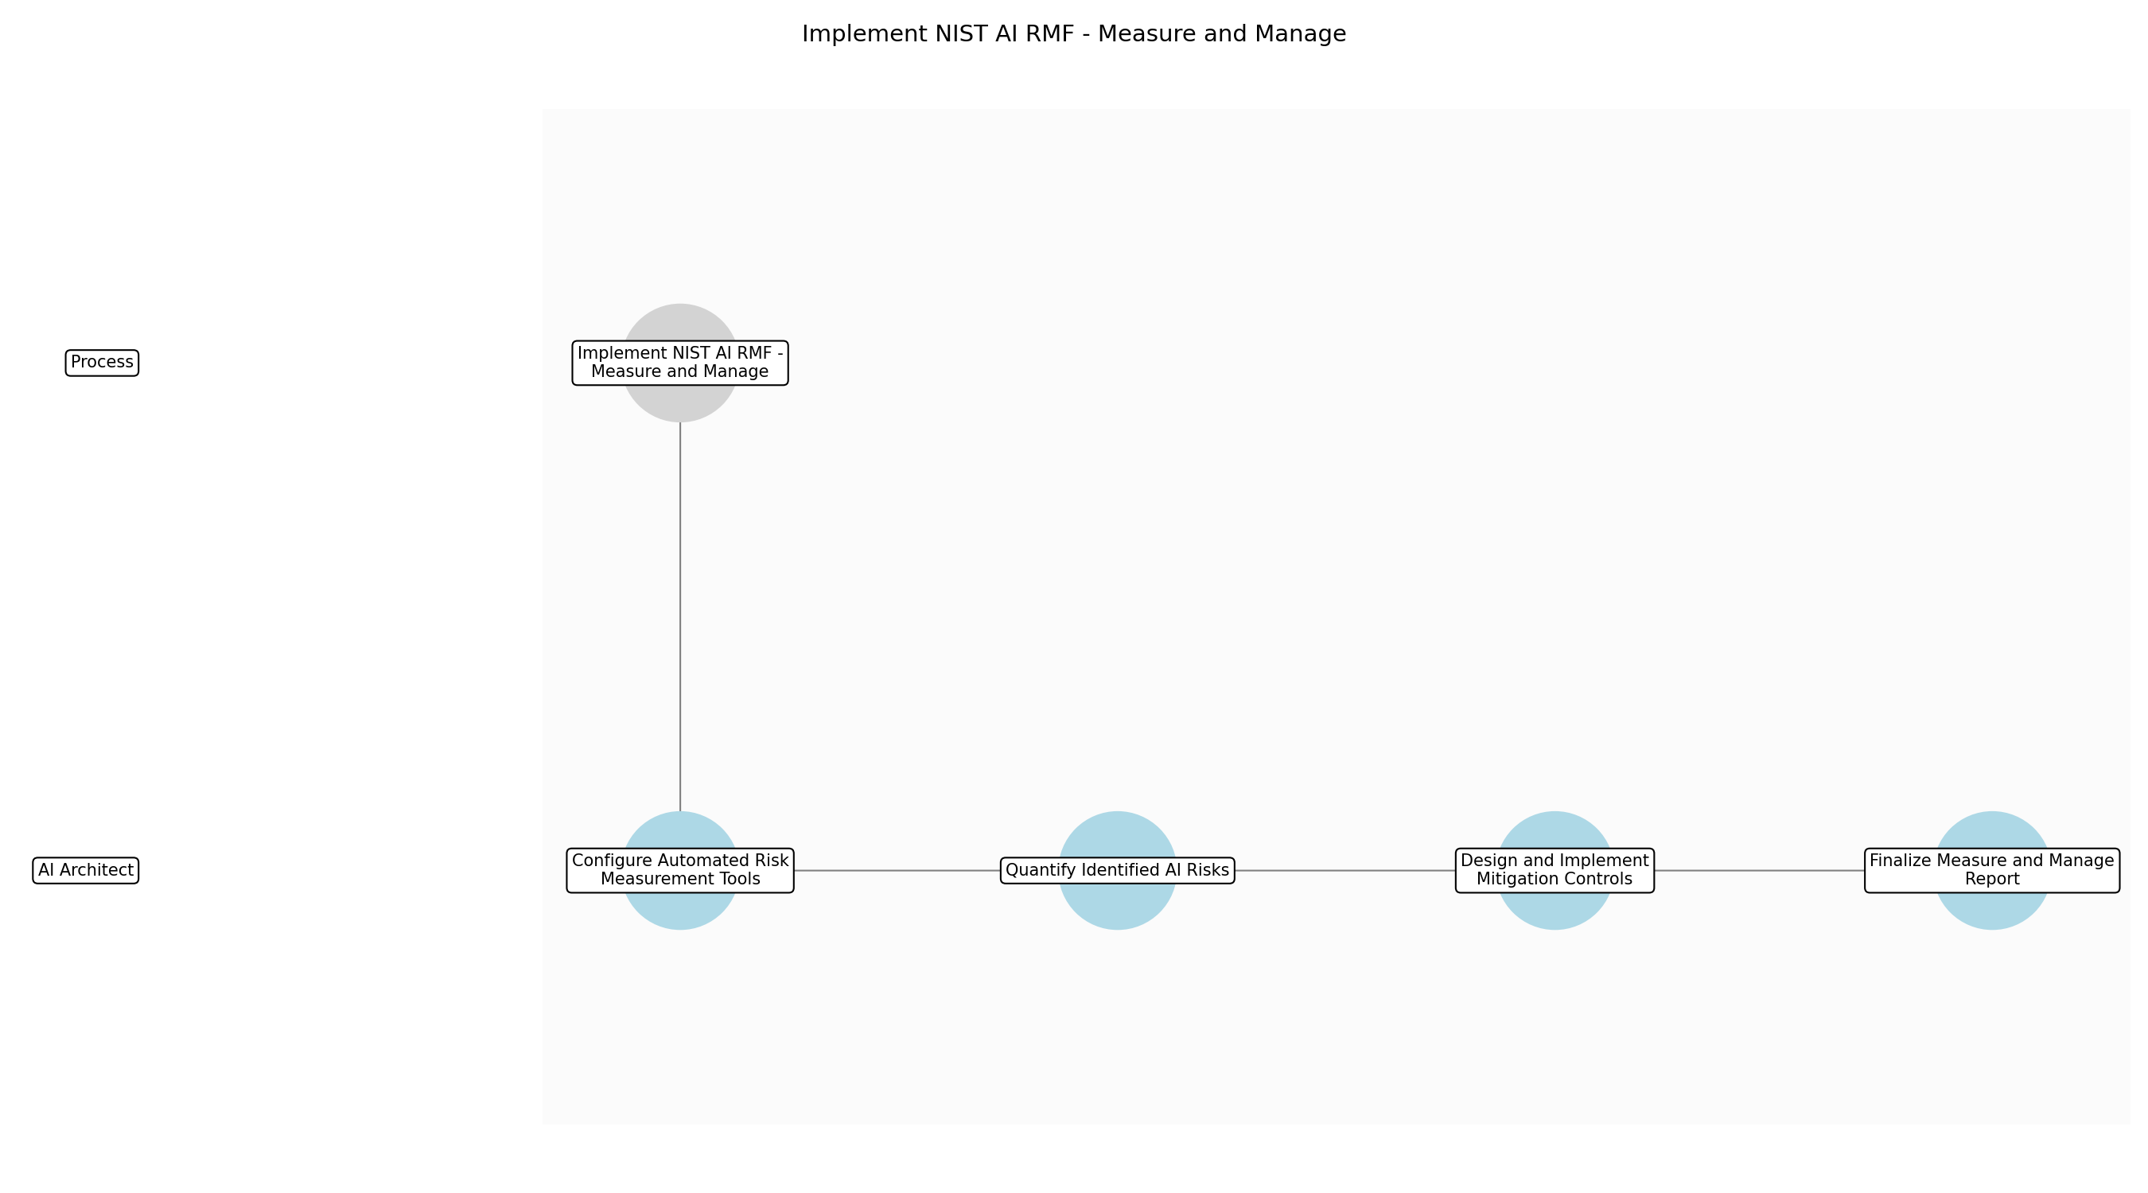

3.4.1 Configure Automated Risk Measurement Tools
This subprocess describes the activities required to complete 'Configure Automated Risk Measurement Tools'.

Description:
The AI Architect initiates the measurement phase by configuring automated risk monitoring and quantification tools. This involves setting up technical parameters to track model performance, data quality, and security vulnerabilities in real-time, ensuring that the measurement process is consistent and scalable across the financial institution's AI portfolio.

Purpose:
To establish a technical foundation for continuous and automated risk quantification.

Scope:
Technical configuration of risk monitoring software and integration with existing model pipelines.

Triggers:
This subprocess is initiated by:
• Completion of NIST AI RMF Govern and Map phase.

End Conditions:
This subprocess is considered complete when:
• Risk measurement tools are fully integrated and reporting data.

Governance Requirements:
The following governance requirements apply:
• NIST AI RMF 1.0 (Measure Function)

Risks and Controls:
The following risks and controls apply:
• Risk: Incompatible tool integration with legacy financial systems.
• Control: Pre-deployment API compatibility testing and sandbox validation.

Change Management:
The following change management rules apply:
• Change Request Process: Standard IT change request for tool configuration updates.
• Versioning Rules: Configuration scripts stored in version-controlled repositories.

Continuous Improvement:
The following continuous improvement practices apply:
• Review Frequency: Monthly
• Improvement Inputs:
• Tool performance logs
• System error rates

Process Owner:
The following process owner is accountable:
• Head of AI Governance

Responsible Party:
The following parties are responsible for this subprocess:
• AI Architect

3.4.2 Quantify Identified AI Risks
This subprocess describes the activities required to complete 'Quantify Identified AI Risks'.

Description:
Using the reports from the 'Govern and Map' phase, the AI Architect applies quantitative methods to measure the impact and likelihood of identified risks. This includes stress testing models against financial market volatility and assessing the potential severity of bias or privacy breaches using standardized metrics.

Purpose:
To provide a data-driven assessment of risk levels for prioritization.

Scope:
Quantitative analysis of all risks mapped in the previous phase.

Triggers:
This subprocess is initiated by:
• Risk measurement tools are active.

End Conditions:
This subprocess is considered complete when:
• Risk scores are assigned to all identified AI risks.

Governance Requirements:
The following governance requirements apply:
• NIST AI RMF 1.0 (Measure Function)
• EU AI Act Risk Assessment Standards

Risks and Controls:
The following risks and controls apply:
• Risk: Inaccurate risk quantification due to poor data quality.
• Control: Data integrity checks and statistical validation of measurement models.

Change Management:
The following change management rules apply:
• Change Request Process: Peer review of quantification methodology changes.
• Versioning Rules: Methodology documents versioned in the compliance portal.

Continuous Improvement:
The following continuous improvement practices apply:
• Review Frequency: Quarterly
• Improvement Inputs:
• Audit findings
• Industry risk benchmarks

Process Owner:
The following process owner is accountable:
• Head of AI Governance

Responsible Party:
The following parties are responsible for this subprocess:
• AI Architect

3.4.3 Design and Implement Mitigation Controls
This subprocess describes the activities required to complete 'Design and Implement Mitigation Controls'.

Description:
The AI Architect designs specific technical and procedural controls to mitigate risks that exceed the organization's risk appetite. This includes implementing differential privacy layers, enhancing model explainability modules, and establishing automated 'kill-switches' for models that exhibit unintended behavior in production environments.

Purpose:
To reduce AI risk to acceptable levels through active management.

Scope:
Development and deployment of technical risk mitigations.

Triggers:
This subprocess is initiated by:
• Risk quantification identifies high-priority risks.

End Conditions:
This subprocess is considered complete when:
• Mitigation controls are active and verified.

Governance Requirements:
The following governance requirements apply:
• NIST AI RMF 1.0 (Manage Function)
• Financial Sector Operational Resilience Guidelines

Risks and Controls:
The following risks and controls apply:
• Risk: Mitigation controls negatively impacting model accuracy.
• Control: Performance-impact trade-off analysis during control design.

Change Management:
The following change management rules apply:
• Change Request Process: Formal approval from the AI Ethics Committee for new controls.
• Versioning Rules: Control logic versioned alongside model code.

Continuous Improvement:
The following continuous improvement practices apply:
• Review Frequency: Bi-annually
• Improvement Inputs:
• Incident reports
• Control effectiveness metrics

Process Owner:
The following process owner is accountable:
• Head of AI Governance

Responsible Party:
The following parties are responsible for this subprocess:
• AI Architect

3.4.4 Finalize Measure and Manage Report
This subprocess describes the activities required to complete 'Finalize Measure and Manage Report'.

Description:
The AI Architect compiles all measurement data and management actions into the final NIST AI RMF Measure & Manage Report. This document provides a comprehensive audit trail of how risks were quantified and what specific actions were taken to manage them, serving as a critical deliverable for regulatory compliance.

Purpose:
To document the risk management process for internal and external stakeholders.

Scope:
Compilation of all measurement data, mitigation actions, and residual risk assessments.

Triggers:
This subprocess is initiated by:
• Verification of mitigation control implementation.

End Conditions:
This subprocess is considered complete when:
• NIST AI RMF Measure & Manage Report is signed off by the Head of AI Governance.

Governance Requirements:
The following governance requirements apply:
• NIST AI RMF 1.0 (Measure, Manage)
• EU AI Act Transparency Requirements

Risks and Controls:
The following risks and controls apply:
• Risk: Incomplete reporting of residual risks.
• Control: Independent review of the report by the Risk Management Team.

Change Management:
The following change management rules apply:
• Change Request Process: Document revision process via the compliance management system.
• Versioning Rules: Major versioning for final reports; minor versioning for drafts.

Continuous Improvement:
The following continuous improvement practices apply:
• Review Frequency: Annual
• Improvement Inputs:
• Regulatory feedback
• Stakeholder transparency scores

Process Owner:
The following process owner is accountable:
• Head of AI Governance

Responsible Party:
The following parties are responsible for this subprocess:
• AI Architect

3.5 Perform bias testing and model validation

Description:
Perform rigorous bias testing and model validation using automated bias testing tools and standardized validation suites to streamline technical accuracy checks.

Purpose:
To minimize operational risk associated with AI bias via automated validation.

Scope:
Technical validation and fairness.

Inputs:
The following inputs are required for this step:
• Training Datasets
• Model Architecture

Outputs:
This step produces the following outputs:
• Model Validation Report

Success Criteria:
Success for this step is measured by:
• Validation report confirms model meets all internal and regulatory benchmarks.

Process Triggers:
This step is initiated by:
• Model development completion.

Process End Conditions:
This step is considered complete when:
• Model meets fairness and accuracy thresholds.
• Bias testing results are within acceptable limits.

Dependencies:
This step depends on the following:
• Implement NIST AI RMF - Measure and Manage

Deliverables:
This step produces the following deliverables:
• Model Validation Report
• Bias Testing Results

Governance Requirements:
The following governance requirements apply:
• Fairness and Accuracy Standards

Risks and Controls:
The following risks and controls apply:
• Risk: Model Bias
• Control: Automated fairness audits and standardized validation suites.

Estimated Duration:
The estimated duration for this step is:
• 4 weeks

Process Owner:
The following process owner is accountable:
• Head of AI Governance

Responsible Parties:
The following parties are responsible for this step:
• Risk Management Team

Required Sub Process(es) for the Step "Perform bias testing and model validation"
The following details the subprocess flows for the step "Perform bias testing and model validation".
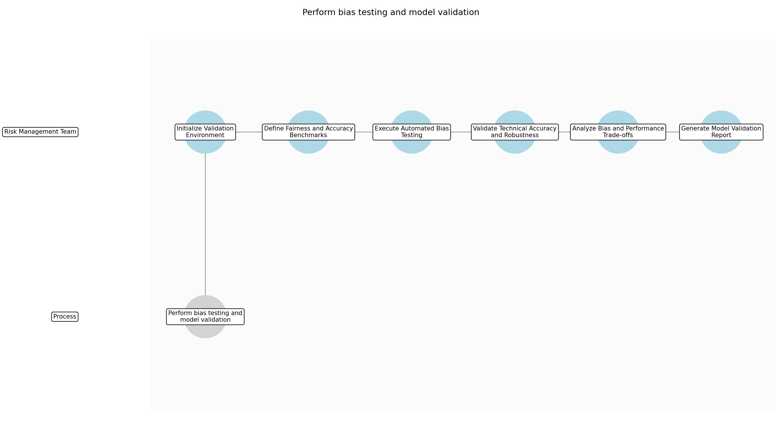

3.5.1 Initialize Validation Environment
This subprocess describes the activities required to complete 'Initialize Validation Environment'.

Description:
This sub-step involves the setup and configuration of the technical environment required for model validation. The Risk Management Team ensures that all automated bias testing tools and standardized validation suites are correctly installed and integrated with the model's architecture to ensure consistent testing conditions.

Purpose:
To ensure a stable and standardized environment for technical accuracy checks.

Scope:
Technical environment setup and tool configuration.

Inputs:
The following inputs are required for this subprocess:
• Model Architecture
• Training Datasets

Outputs:
This subprocess produces the following outputs:
• Configured Validation Environment

Success Criteria:
Success for this subprocess is measured by:
• Validation tools are operational and connected to the model environment.

Triggers:
This subprocess is initiated by:
• Model development completion.

End Conditions:
This subprocess is considered complete when:
• Environment is ready for testing.

Governance Requirements:
The following governance requirements apply:
• Fairness and Accuracy Standards

Risks and Controls:
The following risks and controls apply:
• Risk: Tool Misconfiguration
• Control: Standardized setup checklists and environment verification tests.

Change Management:
The following change management rules apply:
• Change Request Process: Submit ticket to IT/DevOps for environment changes.
• Versioning Rules: Track environment configuration versions in Git.

Continuous Improvement:
The following continuous improvement practices apply:
• Review Frequency: Quarterly
• Improvement Inputs:
• Tool performance logs
• User feedback

Estimated Duration:
The estimated duration for this subprocess is:
• 3 days

Process Owner:
The following process owner is accountable:
• Head of AI Governance

Responsible Party:
The following parties are responsible for this subprocess:
• Risk Management Team

3.5.2 Define Fairness and Accuracy Benchmarks
This subprocess describes the activities required to complete 'Define Fairness and Accuracy Benchmarks'.

Description:
The team establishes quantitative benchmarks for fairness and accuracy based on internal policies and regulatory requirements. This involves selecting specific metrics such as disparate impact ratios, equalized odds, and precision-recall thresholds that the model must satisfy to pass validation.

Purpose:
To establish clear pass/fail criteria for the validation process.

Scope:
Metric selection and threshold setting.

Inputs:
The following inputs are required for this subprocess:
• Fairness and Accuracy Standards
• Model Architecture

Outputs:
This subprocess produces the following outputs:
• Validation Threshold Document

Success Criteria:
Success for this subprocess is measured by:
• Benchmarks are documented and approved by the Head of AI Governance.

Triggers:
This subprocess is initiated by:
• Environment initialization completion.

End Conditions:
This subprocess is considered complete when:
• Thresholds are formally defined.

Dependencies:
This subprocess depends on the following:
• Initialize Validation Environment

Governance Requirements:
The following governance requirements apply:
• Fairness and Accuracy Standards

Risks and Controls:
The following risks and controls apply:
• Risk: Inappropriate Thresholds
• Control: Peer review of benchmarks by the AI Ethics Committee.

Change Management:
The following change management rules apply:
• Change Request Process: Formal review by the Risk Management lead.
• Versioning Rules: Threshold documents are versioned in the Model Inventory System.

Continuous Improvement:
The following continuous improvement practices apply:
• Review Frequency: Bi-annually
• Improvement Inputs:
• Regulatory updates
• Industry best practices

Estimated Duration:
The estimated duration for this subprocess is:
• 2 days

Process Owner:
The following process owner is accountable:
• Head of AI Governance

Responsible Party:
The following parties are responsible for this subprocess:
• Risk Management Team

3.5.3 Execute Automated Bias Testing
This subprocess describes the activities required to complete 'Execute Automated Bias Testing'.

Description:
Using the configured environment, the team runs automated fairness audits against the training datasets and model outputs. This process identifies potential biases across protected attributes and generates detailed scores for each selected fairness metric.

Purpose:
To identify and quantify algorithmic bias using automated tools.

Scope:
Automated fairness auditing.

Inputs:
The following inputs are required for this subprocess:
• Training Datasets
• Configured Validation Environment
• Validation Threshold Document

Outputs:
This subprocess produces the following outputs:
• Bias Testing Results

Success Criteria:
Success for this subprocess is measured by:
• Bias testing suite completes without errors and generates a full results set.

Triggers:
This subprocess is initiated by:
• Benchmark definition completion.

End Conditions:
This subprocess is considered complete when:
• Bias scores are recorded for all protected attributes.

Dependencies:
This subprocess depends on the following:
• Define Fairness and Accuracy Benchmarks

Governance Requirements:
The following governance requirements apply:
• Fairness and Accuracy Standards

Risks and Controls:
The following risks and controls apply:
• Risk: Incomplete Data Coverage
• Control: Data profiling to ensure all protected classes are represented in the test set.

Change Management:
The following change management rules apply:
• Change Request Process: Request for additional test data via Data Governance team.
• Versioning Rules: Test results are timestamped and linked to model versions.

Continuous Improvement:
The following continuous improvement practices apply:
• Review Frequency: Per project
• Improvement Inputs:
• Bias detection accuracy
• False positive rates

Estimated Duration:
The estimated duration for this subprocess is:
• 1 week

Process Owner:
The following process owner is accountable:
• Head of AI Governance

Responsible Party:
The following parties are responsible for this subprocess:
• Risk Management Team

3.5.4 Validate Technical Accuracy and Robustness
This subprocess describes the activities required to complete 'Validate Technical Accuracy and Robustness'.

Description:
The team performs rigorous technical validation to ensure the model meets performance requirements. This includes calculating accuracy, F1-scores, and AUC-ROC, as well as conducting stress tests and robustness checks to ensure the model remains stable under varying data conditions.

Purpose:
To ensure the model is technically sound and reliable.

Scope:
Performance and robustness testing.

Inputs:
The following inputs are required for this subprocess:
• Model Architecture
• Training Datasets
• Validation Threshold Document

Outputs:
This subprocess produces the following outputs:
• Technical Performance Metrics

Success Criteria:
Success for this subprocess is measured by:
• Model performance metrics meet or exceed the defined thresholds.

Triggers:
This subprocess is initiated by:
• Benchmark definition completion.

End Conditions:
This subprocess is considered complete when:
• Performance metrics are finalized and documented.

Dependencies:
This subprocess depends on the following:
• Define Fairness and Accuracy Benchmarks

Governance Requirements:
The following governance requirements apply:
• Fairness and Accuracy Standards

Risks and Controls:
The following risks and controls apply:
• Risk: Overfitting to Test Data
• Control: Use of independent hold-out sets and cross-validation techniques.

Change Management:
The following change management rules apply:
• Change Request Process: Model retraining request if performance is insufficient.
• Versioning Rules: Performance logs are stored in the centralized model repository.

Continuous Improvement:
The following continuous improvement practices apply:
• Review Frequency: Quarterly
• Improvement Inputs:
• Model drift data
• Production performance feedback

Estimated Duration:
The estimated duration for this subprocess is:
• 1 week

Process Owner:
The following process owner is accountable:
• Head of AI Governance

Responsible Party:
The following parties are responsible for this subprocess:
• Risk Management Team

3.5.5 Analyze Bias and Performance Trade-offs
This subprocess describes the activities required to complete 'Analyze Bias and Performance Trade-offs'.

Description:
The Risk Management Team reviews the intersection of bias results and technical performance. They analyze whether achieving fairness requires adjustments that significantly degrade accuracy and determine if the current model balance is acceptable under regulatory guidelines.

Purpose:
To make informed decisions regarding model optimization and fairness.

Scope:
Comparative analysis and trade-off evaluation.

Inputs:
The following inputs are required for this subprocess:
• Bias Testing Results
• Technical Performance Metrics

Outputs:
This subprocess produces the following outputs:
• Validation Analysis Summary

Success Criteria:
Success for this subprocess is measured by:
• Analysis clearly identifies the impact of bias mitigation on model utility.

Triggers:
This subprocess is initiated by:
• Completion of bias and accuracy testing.

End Conditions:
This subprocess is considered complete when:
• Analysis summary is signed off by the Risk Management lead.

Dependencies:
This subprocess depends on the following:
• Execute Automated Bias Testing
• Validate Technical Accuracy and Robustness

Governance Requirements:
The following governance requirements apply:
• Fairness and Accuracy Standards

Risks and Controls:
The following risks and controls apply:
• Risk: Subjective Interpretation of Results
• Control: Standardized analysis templates and multi-stakeholder review.

Change Management:
The following change management rules apply:
• Change Request Process: Escalation to AI Ethics Committee for unresolved trade-offs.
• Versioning Rules: Analysis reports are version-controlled.

Continuous Improvement:
The following continuous improvement practices apply:
• Review Frequency: Annually
• Improvement Inputs:
• Ethics committee feedback
• Regulatory case studies

Estimated Duration:
The estimated duration for this subprocess is:
• 4 days

Process Owner:
The following process owner is accountable:
• Head of AI Governance

Responsible Party:
The following parties are responsible for this subprocess:
• Risk Management Team

3.5.6 Generate Model Validation Report
This subprocess describes the activities required to complete 'Generate Model Validation Report'.

Description:
The final sub-step involves compiling all testing results, analysis summaries, and compliance evidence into a comprehensive Model Validation Report. This report provides the formal confirmation that the model meets all internal and regulatory benchmarks for fairness and accuracy.

Purpose:
To provide a formal audit trail and certification of model compliance.

Scope:
Report compilation and final review.

Inputs:
The following inputs are required for this subprocess:
• Validation Analysis Summary
• Bias Testing Results
• Technical Performance Metrics

Outputs:
This subprocess produces the following outputs:
• Model Validation Report

Success Criteria:
Success for this subprocess is measured by:
• Validation report confirms model meets all internal and regulatory benchmarks.

Triggers:
This subprocess is initiated by:
• Completion of trade-off analysis.

End Conditions:
This subprocess is considered complete when:
• Model Validation Report is published and archived.

Dependencies:
This subprocess depends on the following:
• Analyze Bias and Performance Trade-offs

Governance Requirements:
The following governance requirements apply:
• Fairness and Accuracy Standards

Risks and Controls:
The following risks and controls apply:
• Risk: Incomplete Reporting
• Control: Automated report generation from validated data sources.

Change Management:
The following change management rules apply:
• Change Request Process: Formal document revision process.
• Versioning Rules: Final reports are locked and archived with unique version IDs.

Continuous Improvement:
The following continuous improvement practices apply:
• Review Frequency: Bi-annually
• Improvement Inputs:
• Audit findings
• Stakeholder feedback

Estimated Duration:
The estimated duration for this subprocess is:
• 4 days

Process Owner:
The following process owner is accountable:
• Head of AI Governance

Responsible Party:
The following parties are responsible for this subprocess:
• Risk Management Team

3.6 Document technical specifications for EU AI Act compliance

Description:
Compile all technical specifications and documentation required for EU AI Act compliance, initiating internal pre-assessment reviews to streamline the subsequent conformity phase.

Purpose:
To ensure transparency and prepare for conformity assessment.

Scope:
Regulatory documentation and pre-assessment.

Inputs:
The following inputs are required for this step:
• Model Validation Report
• NIST AI RMF Measure & Manage Report

Outputs:
This step produces the following outputs:
• Technical Documentation Package

Success Criteria:
Success for this step is measured by:
• Documentation package passes initial pre-assessment review.

Process Triggers:
This step is initiated by:
• Successful model validation.

Process End Conditions:
This step is considered complete when:
• Documentation is complete and pre-reviewed.

Dependencies:
This step depends on the following:
• Perform bias testing and model validation

Deliverables:
This step produces the following deliverables:
• Technical Documentation Package

Governance Requirements:
The following governance requirements apply:
• EU AI Act Documentation Requirements

Risks and Controls:
The following risks and controls apply:
• Risk: Incomplete documentation.
• Control: Pre-assessment review checklists.

Estimated Duration:
The estimated duration for this step is:
• 3 weeks

Process Owner:
The following process owner is accountable:
• Head of AI Governance

Responsible Parties:
The following parties are responsible for this step:
• AI Architect

Required Sub Process(es) for the Step "Document technical specifications for EU AI Act compliance"
The following details the subprocess flows for the step "Document technical specifications for EU AI Act compliance".
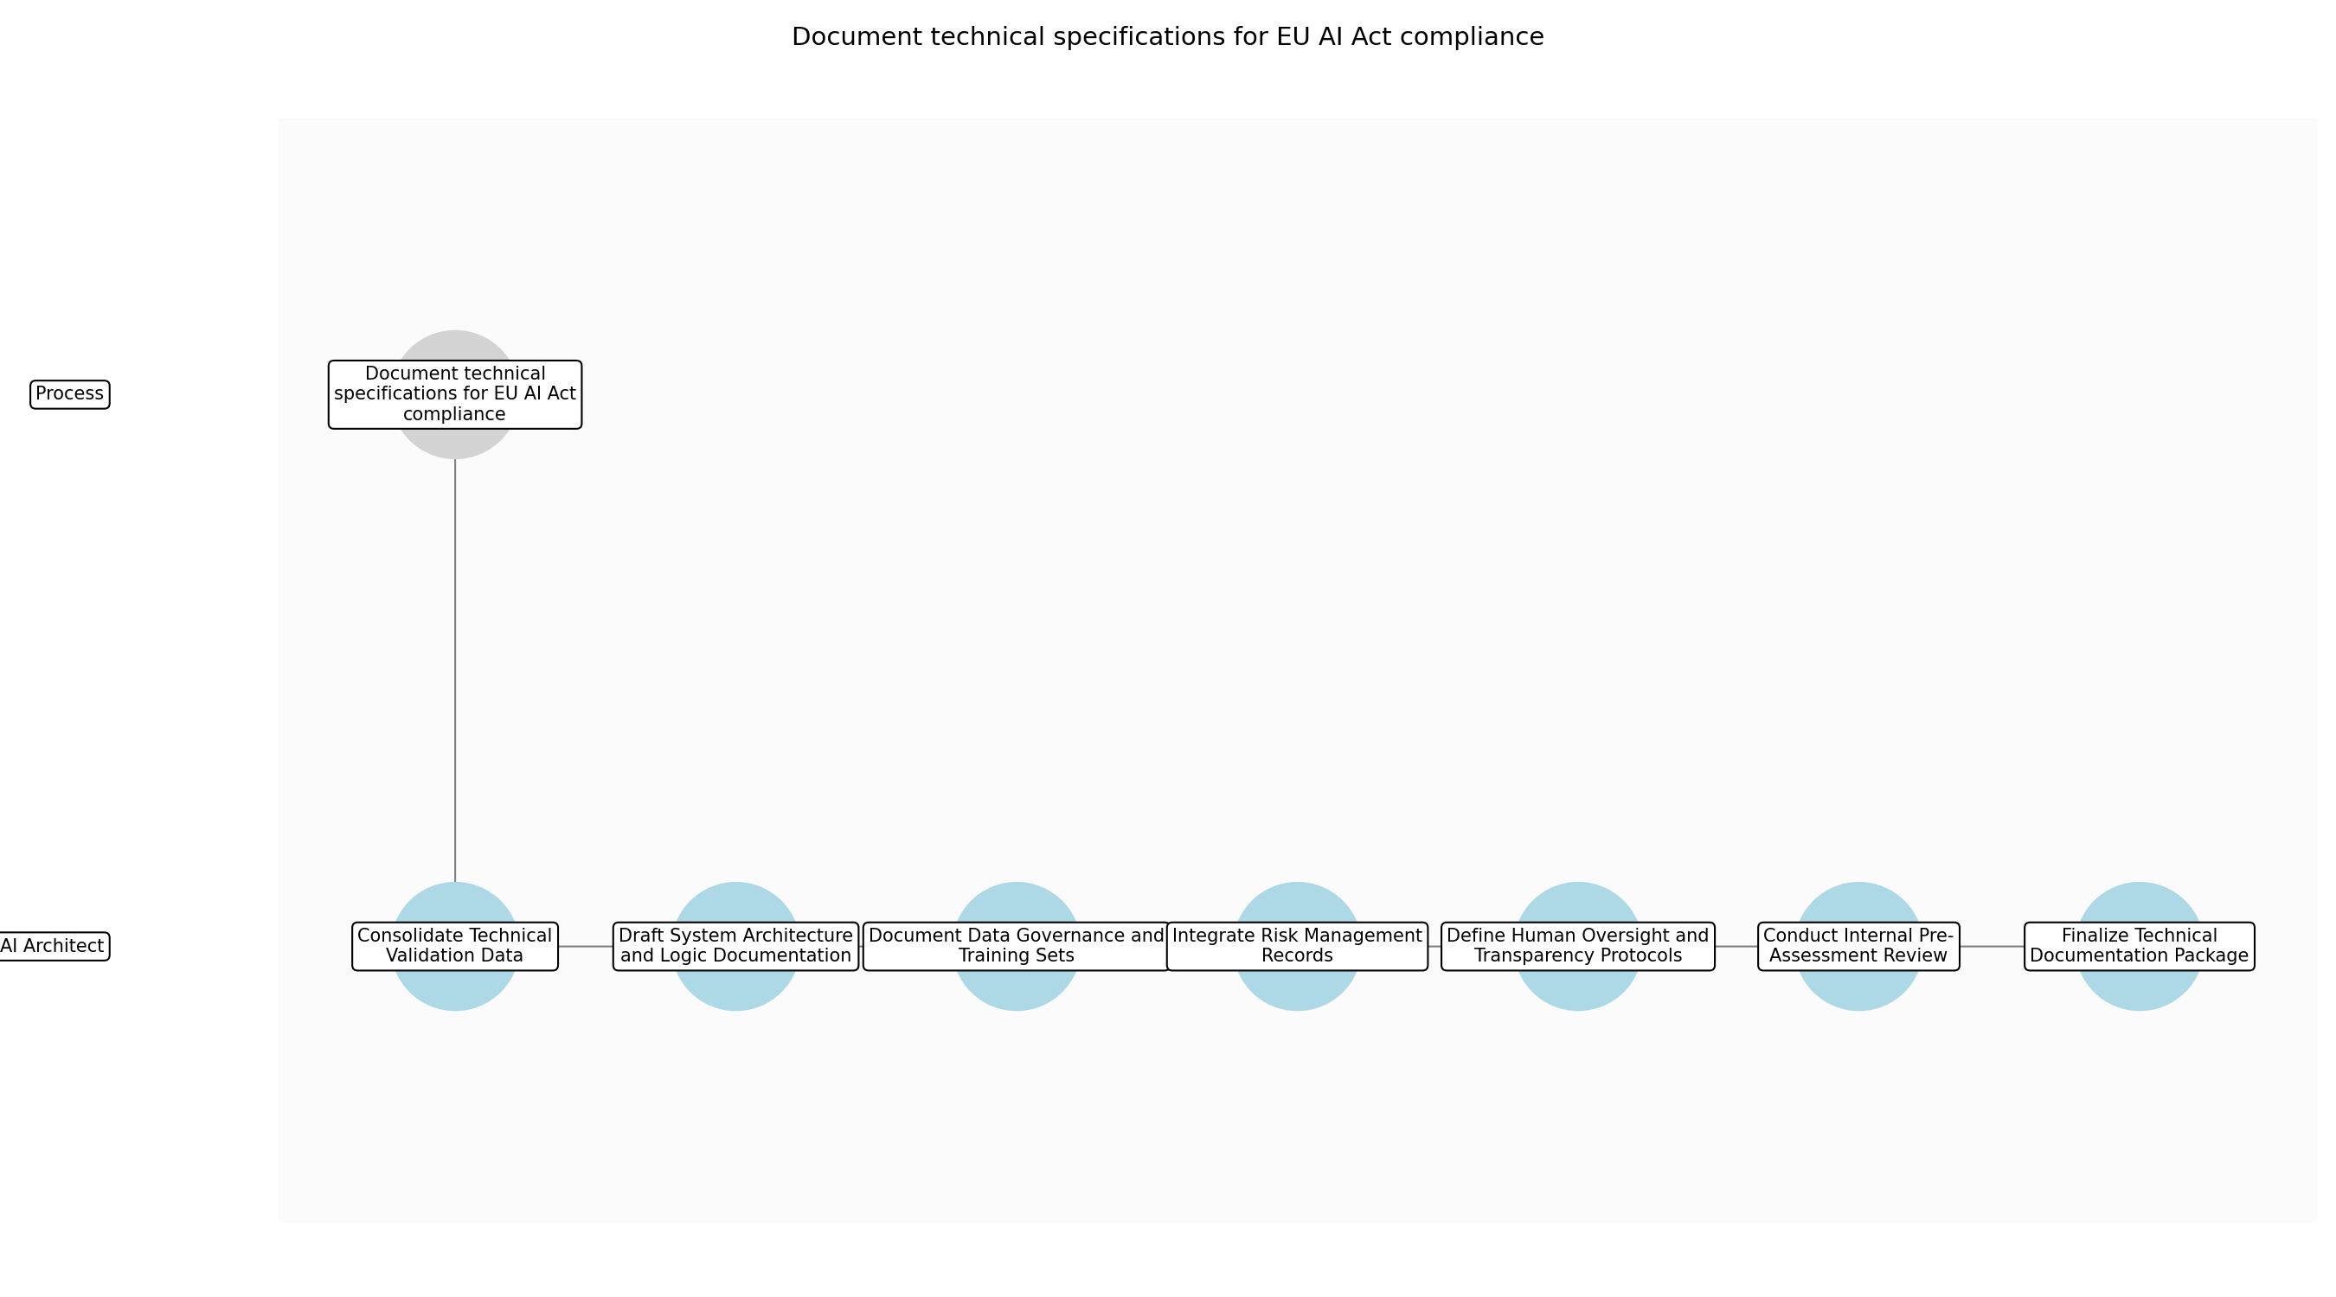

3.6.1 Consolidate Technical Validation Data
This subprocess describes the activities required to complete 'Consolidate Technical Validation Data'.

Description:
Gather and organize all technical artifacts produced during the validation phase, including the Model Validation Report and NIST AI RMF Measure & Manage Report. This step ensures that the AI Architect has a centralized and verified data set to begin drafting the formal compliance documentation.

Purpose:
To ensure all foundational data is available for drafting the technical specifications.

Scope:
Collection and verification of existing technical reports.

Inputs:
The following inputs are required for this subprocess:
• Model Validation Report
• NIST AI RMF Measure & Manage Report

Outputs:
This subprocess produces the following outputs:
• Consolidated Technical Data Set

Success Criteria:
Success for this subprocess is measured by:
• All required validation and risk reports are present and verified for accuracy.

Triggers:
This subprocess is initiated by:
• Successful model validation.

End Conditions:
This subprocess is considered complete when:
• All input reports are verified and stored in the compliance repository.

Governance Requirements:
The following governance requirements apply:
• EU AI Act Documentation Requirements

Risks and Controls:
The following risks and controls apply:
• Risk: Missing or outdated validation data.
• Control: Data inventory checklist and timestamp verification.

Change Management:
The following change management rules apply:
• Change Request Process: Standard document change request via the governance portal.
• Versioning Rules: Major version increment for new data sets.

Continuous Improvement:
The following continuous improvement practices apply:
• Review Frequency: Quarterly
• Improvement Inputs:
• Audit feedback on data completeness.

Estimated Duration:
The estimated duration for this subprocess is:
• 2 days

Process Owner:
The following process owner is accountable:
• Head of AI Governance

Responsible Party:
The following parties are responsible for this subprocess:
• AI Architect

3.6.2 Draft System Architecture and Logic Documentation
This subprocess describes the activities required to complete 'Draft System Architecture and Logic Documentation'.

Description:
Detail the AI system's architecture, design specifications, and algorithmic logic as required by the EU AI Act. This includes a comprehensive explanation of the model's functionality, its intended purpose, and the technical methods used to achieve its objectives.

Purpose:
To provide a clear technical blueprint of the AI system for regulatory review.

Scope:
Technical description of model architecture and logic.

Inputs:
The following inputs are required for this subprocess:
• Consolidated Technical Data Set

Outputs:
This subprocess produces the following outputs:
• Draft Architecture Documentation

Success Criteria:
Success for this subprocess is measured by:
• Architecture diagrams and logic descriptions meet EU AI Act transparency standards.

Triggers:
This subprocess is initiated by:
• Availability of consolidated technical data.

End Conditions:
This subprocess is considered complete when:
• Draft architecture document is completed and uploaded.

Dependencies:
This subprocess depends on the following:
• Consolidate Technical Validation Data

Governance Requirements:
The following governance requirements apply:
• EU AI Act Article 11 (Technical Documentation)

Risks and Controls:
The following risks and controls apply:
• Risk: Insufficient detail in algorithmic descriptions.
• Control: Peer review by senior AI engineers.

Change Management:
The following change management rules apply:
• Change Request Process: Architectural review board approval for logic changes.
• Versioning Rules: Semantic versioning for architecture drafts.

Continuous Improvement:
The following continuous improvement practices apply:
• Review Frequency: Bi-annual
• Improvement Inputs:
• Regulatory updates on documentation standards.

Estimated Duration:
The estimated duration for this subprocess is:
• 5 days

Process Owner:
The following process owner is accountable:
• Head of AI Governance

Responsible Party:
The following parties are responsible for this subprocess:
• AI Architect

3.6.3 Document Data Governance and Training Sets
This subprocess describes the activities required to complete 'Document Data Governance and Training Sets'.

Description:
Document the data collection, cleaning, and labeling processes used during model development. This sub-step must provide specific details on the datasets used for training, validation, and testing, ensuring that data quality and bias mitigation efforts are transparently recorded.

Purpose:
To demonstrate compliance with data governance requirements under the EU AI Act.

Scope:
Documentation of data lifecycle and training methodologies.

Inputs:
The following inputs are required for this subprocess:
• Consolidated Technical Data Set

Outputs:
This subprocess produces the following outputs:
• Data Governance and Training Report

Success Criteria:
Success for this subprocess is measured by:
• Data lineage and quality metrics are fully documented and traceable.

Triggers:
This subprocess is initiated by:
• Availability of consolidated technical data.

End Conditions:
This subprocess is considered complete when:
• Data governance report is finalized and signed off by the Data Protection Officer.

Dependencies:
This subprocess depends on the following:
• Consolidate Technical Validation Data

Governance Requirements:
The following governance requirements apply:
• EU AI Act Article 10 (Data and Data Governance)

Risks and Controls:
The following risks and controls apply:
• Risk: Incomplete data lineage records.
• Control: Automated data lineage tracking tools.

Change Management:
The following change management rules apply:
• Change Request Process: Data governance committee review for dataset changes.
• Versioning Rules: Dataset versioning linked to model versioning.

Continuous Improvement:
The following continuous improvement practices apply:
• Review Frequency: Per project
• Improvement Inputs:
• DPO review comments.

Estimated Duration:
The estimated duration for this subprocess is:
• 4 days

Process Owner:
The following process owner is accountable:
• Head of AI Governance

Responsible Party:
The following parties are responsible for this subprocess:
• AI Architect

3.6.4 Integrate Risk Management Records
This subprocess describes the activities required to complete 'Integrate Risk Management Records'.

Description:
Map the findings from the NIST AI RMF Measure & Manage phase into the specific documentation format required by the EU AI Act. This involves detailing the identified risks and the specific technical controls implemented to mitigate them throughout the system's lifecycle.

Purpose:
To align NIST risk management outputs with EU AI Act documentation standards.

Scope:
Mapping of risk assessments to technical controls.

Inputs:
The following inputs are required for this subprocess:
• NIST AI RMF Measure & Manage Report

Outputs:
This subprocess produces the following outputs:
• Risk Mitigation Documentation

Success Criteria:
Success for this subprocess is measured by:
• All high-priority risks identified in the NIST report are mapped to specific controls in the documentation.

Triggers:
This subprocess is initiated by:
• Completion of NIST AI RMF Measure & Manage phase.

End Conditions:
This subprocess is considered complete when:
• Risk mitigation documentation is integrated into the technical package.

Dependencies:
This subprocess depends on the following:
• Consolidate Technical Validation Data

Governance Requirements:
The following governance requirements apply:
• EU AI Act Article 9 (Risk Management System)

Risks and Controls:
The following risks and controls apply:
• Risk: Misalignment between NIST risk categories and EU AI Act requirements.
• Control: Cross-walk mapping template for NIST and EU AI Act.

Change Management:
The following change management rules apply:
• Change Request Process: Risk management team approval for control modifications.
• Versioning Rules: Risk register versioning.

Continuous Improvement:
The following continuous improvement practices apply:
• Review Frequency: Annual
• Improvement Inputs:
• Internal audit findings on risk control effectiveness.

Estimated Duration:
The estimated duration for this subprocess is:
• 3 days

Process Owner:
The following process owner is accountable:
• Head of AI Governance

Responsible Party:
The following parties are responsible for this subprocess:
• AI Architect

3.6.5 Define Human Oversight and Transparency Protocols
This subprocess describes the activities required to complete 'Define Human Oversight and Transparency Protocols'.

Description:
Specify the technical mechanisms designed for human-in-the-loop oversight and the transparency measures provided to end-users. This includes drafting user instructions, oversight manuals, and defining the triggers for human intervention in the AI system's operation.

Purpose:
To ensure the system can be effectively monitored and understood by human operators.

Scope:
Documentation of human-in-the-loop and user transparency measures.

Inputs:
The following inputs are required for this subprocess:
• Draft Architecture Documentation

Outputs:
This subprocess produces the following outputs:
• Human Oversight and Transparency Protocol

Success Criteria:
Success for this subprocess is measured by:
• Oversight protocols are clear, actionable, and meet regulatory transparency requirements.

Triggers:
This subprocess is initiated by:
• Completion of architecture documentation draft.

End Conditions:
This subprocess is considered complete when:
• Human oversight protocol is approved by the Risk Management Team.

Dependencies:
This subprocess depends on the following:
• Draft System Architecture and Logic Documentation

Governance Requirements:
The following governance requirements apply:
• EU AI Act Article 13 (Transparency) and Article 14 (Human Oversight)

Risks and Controls:
The following risks and controls apply:
• Risk: Vague oversight instructions leading to operator error.
• Control: Usability testing of oversight manuals with end-users.

Change Management:
The following change management rules apply:
• Change Request Process: Formal review by the AI Ethics Committee.
• Versioning Rules: Manual versioning tracked in the document management system.

Continuous Improvement:
The following continuous improvement practices apply:
• Review Frequency: Bi-annual
• Improvement Inputs:
• Operator feedback from production monitoring.

Estimated Duration:
The estimated duration for this subprocess is:
• 3 days

Process Owner:
The following process owner is accountable:
• Head of AI Governance

Responsible Party:
The following parties are responsible for this subprocess:
• AI Architect

3.6.6 Conduct Internal Pre-Assessment Review
This subprocess describes the activities required to complete 'Conduct Internal Pre-Assessment Review'.

Description:
Perform a comprehensive internal review of the compiled documentation package against a pre-defined EU AI Act compliance checklist. This review identifies any gaps or inconsistencies in the documentation before it is submitted for formal conformity assessment.

Purpose:
To identify and remediate documentation gaps prior to formal audit.

Scope:
Internal audit of the complete technical documentation package.

Inputs:
The following inputs are required for this subprocess:
• Draft Architecture Documentation
• Data Governance and Training Report
• Risk Mitigation Documentation
• Human Oversight and Transparency Protocol

Outputs:
This subprocess produces the following outputs:
• Pre-Assessment Review Findings

Success Criteria:
Success for this subprocess is measured by:
• Review report identifies all potential compliance gaps with clear remediation steps.

Triggers:
This subprocess is initiated by:
• Completion of all documentation drafts.

End Conditions:
This subprocess is considered complete when:
• Review findings are documented and remediation tasks are assigned.

Dependencies:
This subprocess depends on the following:
• Draft System Architecture and Logic Documentation
• Document Data Governance and Training Sets
• Integrate Risk Management Records
• Define Human Oversight and Transparency Protocols

Governance Requirements:
The following governance requirements apply:
• Internal Compliance Audit Standards

Risks and Controls:
The following risks and controls apply:
• Risk: Oversight of critical regulatory nuances.
• Control: Joint review session with Legal and Compliance teams.

Change Management:
The following change management rules apply:
• Change Request Process: Remediation tasks tracked in the project management tool.
• Versioning Rules: Review findings report versioning.

Continuous Improvement:
The following continuous improvement practices apply:
• Review Frequency: Per project
• Improvement Inputs:
• External auditor feedback from previous assessments.

Estimated Duration:
The estimated duration for this subprocess is:
• 3 days

Process Owner:
The following process owner is accountable:
• Head of AI Governance

Responsible Party:
The following parties are responsible for this subprocess:
• AI Architect

3.6.7 Finalize Technical Documentation Package
This subprocess describes the activities required to complete 'Finalize Technical Documentation Package'.

Description:
Address all findings from the internal pre-assessment review and finalize the Technical Documentation Package. This step includes final formatting, cross-referencing, and ensuring that the package is correctly versioned and stored for the subsequent conformity phase.

Purpose:
To produce the final, audit-ready technical documentation deliverable.

Scope:
Final edits, formatting, and packaging of compliance documentation.

Inputs:
The following inputs are required for this subprocess:
• Pre-Assessment Review Findings

Outputs:
This subprocess produces the following outputs:
• Technical Documentation Package

Success Criteria:
Success for this subprocess is measured by:
• Documentation package passes final internal legal review and is ready for audit.

Triggers:
This subprocess is initiated by:
• Completion of pre-assessment remediation tasks.

End Conditions:
This subprocess is considered complete when:
• Documentation is complete and pre-reviewed.

Dependencies:
This subprocess depends on the following:
• Conduct Internal Pre-Assessment Review

Governance Requirements:
The following governance requirements apply:
• EU AI Act Documentation Requirements

Risks and Controls:
The following risks and controls apply:
• Risk: Version mismatch between documentation and model code.
• Control: Automated document assembly tools linked to code repositories.

Change Management:
The following change management rules apply:
• Change Request Process: Final sign-off by the Head of AI Governance.
• Versioning Rules: Final release versioning (e.g., v1.0).

Continuous Improvement:
The following continuous improvement practices apply:
• Review Frequency: Annual
• Improvement Inputs:
• Success rate of documentation in formal conformity assessments.

Estimated Duration:
The estimated duration for this subprocess is:
• 2 days

Process Owner:
The following process owner is accountable:
• Head of AI Governance

Responsible Party:
The following parties are responsible for this subprocess:
• AI Architect

3.7 EU AI Act Conformity Assessment and Registration

Description:
Conduct a conformity assessment (internal or via a notified body) for high-risk AI systems to ensure compliance with the EU AI Act and register the system in the EU database as per Article 51. Utilize parallel pre-assessment data to expedite.

Purpose:
To legally certify the AI system for the EU market.

Scope:
Regulatory compliance and market entry authorization.

Inputs:
The following inputs are required for this step:
• Technical Documentation Package
• Model Validation Report

Outputs:
This step produces the following outputs:
• Conformity Certificate
• Registration ID

Success Criteria:
Success for this step is measured by:
• Official certification of conformity obtained.
• Successful entry in the EU public database.

Process Triggers:
This step is initiated by:
• Completion of technical documentation and pre-assessment.

Process End Conditions:
This step is considered complete when:
• System is registered and certified.

Dependencies:
This step depends on the following:
• Document technical specifications for EU AI Act compliance

Deliverables:
This step produces the following deliverables:
• Certificate of Conformity
• EU Declaration of Conformity
• EU Database Registration Confirmation

Governance Requirements:
The following governance requirements apply:
• EU AI Act Article 43 (Conformity Assessment)
• EU AI Act Article 51 (Registration)

Risks and Controls:
The following risks and controls apply:
• Risk: Failure to meet conformity standards.
• Control: Pre-assessment audits and legal review.

Estimated Duration:
The estimated duration for this step is:
• 4 weeks

Process Owner:
The following process owner is accountable:
• Head of AI Governance

Responsible Parties:
The following parties are responsible for this step:
• Chief Compliance Officer

Required Sub Process(es) for the Step "EU AI Act Conformity Assessment and Registration"
The following details the subprocess flows for the step "EU AI Act Conformity Assessment and Registration".
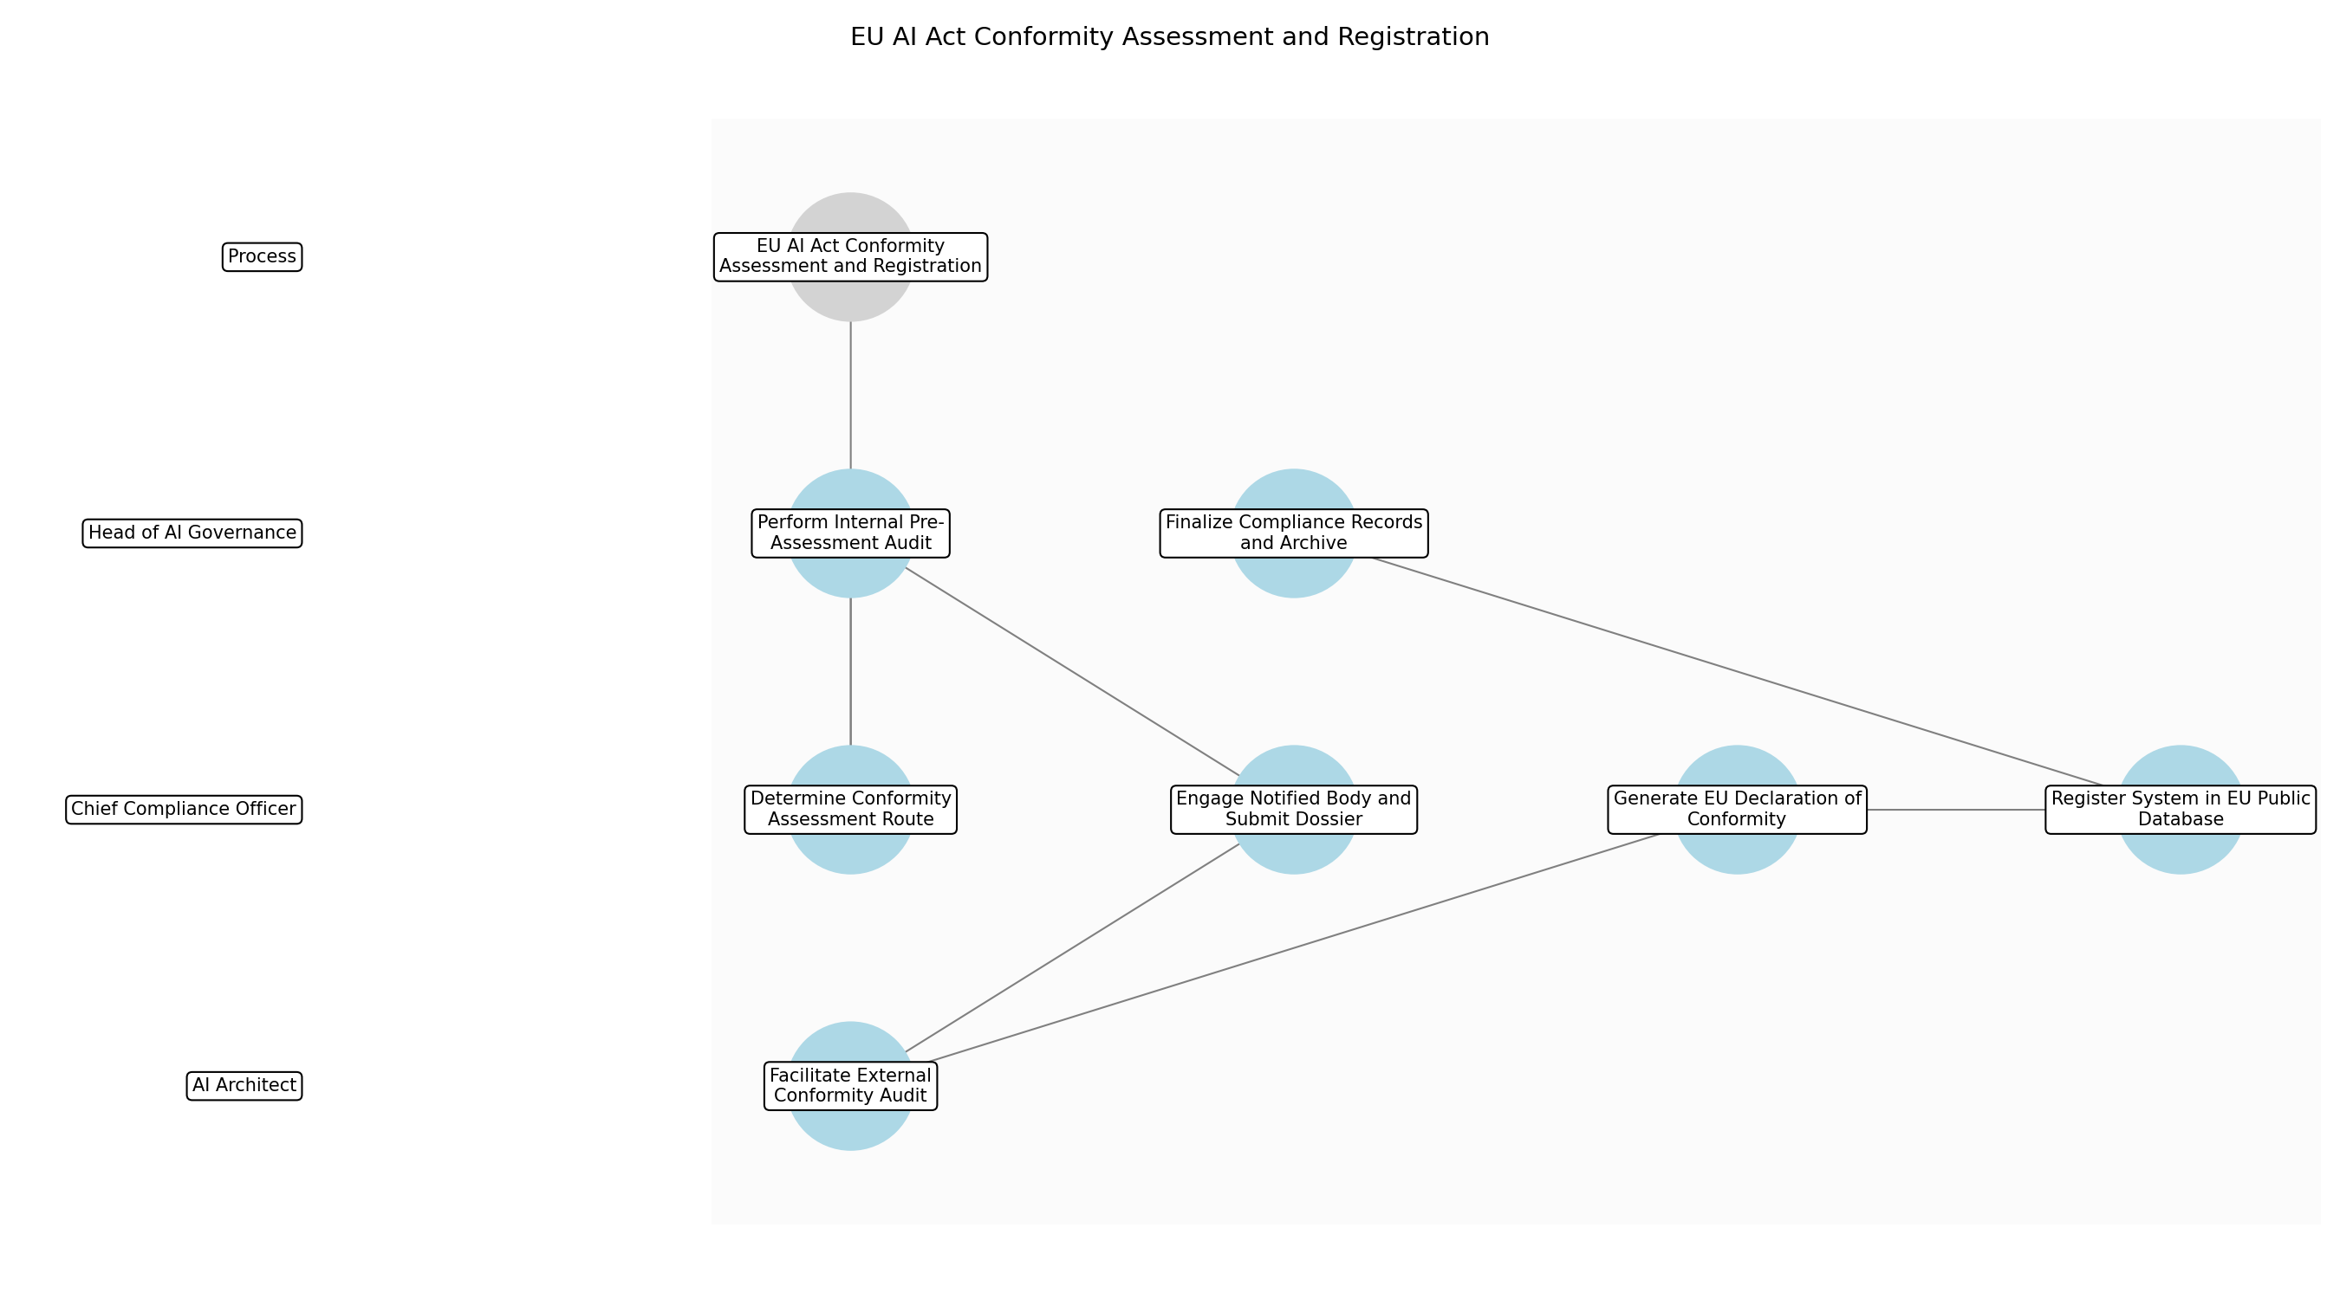

3.7.1 Determine Conformity Assessment Route
This subprocess describes the activities required to complete 'Determine Conformity Assessment Route'.

Description:
Evaluate the AI system's specific classification and technical characteristics against EU AI Act Article 43 to decide between an internal control-based assessment or a third-party assessment by a notified body. This decision is critical for resource planning and timeline management.

Purpose:
To select the legally required path for certification based on system risk.

Scope:
Regulatory strategy and legal interpretation of the EU AI Act.

Inputs:
The following inputs are required for this subprocess:
• Technical Documentation Package
• Risk Classification Report

Outputs:
This subprocess produces the following outputs:
• Assessment Route Decision Document

Success Criteria:
Success for this subprocess is measured by:
• Formal approval of the assessment route by the AI Ethics Committee.
• Clear identification of the applicable conformity assessment procedure.

Triggers:
This subprocess is initiated by:
• Completion of technical documentation and pre-assessment.

End Conditions:
This subprocess is considered complete when:
• Assessment route is finalized and documented.

Governance Requirements:
The following governance requirements apply:
• EU AI Act Article 43

Risks and Controls:
The following risks and controls apply:
• Risk: Incorrect selection of assessment route leading to legal invalidity.
• Control: Legal counsel review of the assessment route decision.

Change Management:
The following change management rules apply:
• Change Request Process: Formal submission to the AI Governance Board.
• Versioning Rules: Major version update for route changes.

Continuous Improvement:
The following continuous improvement practices apply:
• Review Frequency: Annual
• Improvement Inputs:
• Updated EU Commission guidelines on AI Act implementation.

Estimated Duration:
The estimated duration for this subprocess is:
• 3 days

Process Owner:
The following process owner is accountable:
• Head of AI Governance

Responsible Party:
The following parties are responsible for this subprocess:
• Chief Compliance Officer

3.7.2 Perform Internal Pre-Assessment Audit
This subprocess describes the activities required to complete 'Perform Internal Pre-Assessment Audit'.

Description:
Conduct a comprehensive internal review of the Technical Documentation Package and Model Validation Report to identify potential gaps or non-conformities before formal submission to a notified body or final internal sign-off. This step utilizes parallel pre-assessment data to expedite the process.

Purpose:
To minimize the risk of failure during the formal conformity assessment.

Scope:
Internal quality assurance and documentation review.

Inputs:
The following inputs are required for this subprocess:
• Technical Documentation Package
• Model Validation Report

Outputs:
This subprocess produces the following outputs:
• Pre-Assessment Gap Analysis Report

Success Criteria:
Success for this subprocess is measured by:
• Identification of all high-priority compliance gaps.
• Verification of documentation completeness against Annex IV requirements.

Triggers:
This subprocess is initiated by:
• Finalization of the Technical Documentation Package.

End Conditions:
This subprocess is considered complete when:
• Gap analysis is complete and remediation tasks are assigned.

Dependencies:
This subprocess depends on the following:
• Determine Conformity Assessment Route

Governance Requirements:
The following governance requirements apply:
• Internal Quality Management System (QMS) standards.

Risks and Controls:
The following risks and controls apply:
• Risk: Overlooking critical technical non-conformities.
• Control: Use of standardized EU AI Act compliance checklists.

Change Management:
The following change management rules apply:
• Change Request Process: Standard internal audit change protocol.
• Versioning Rules: Audit report versioning.

Continuous Improvement:
The following continuous improvement practices apply:
• Review Frequency: Per project
• Improvement Inputs:
• Audit findings from previous AI system assessments.

Estimated Duration:
The estimated duration for this subprocess is:
• 1 week

Process Owner:
The following process owner is accountable:
• Head of AI Governance

Responsible Party:
The following parties are responsible for this subprocess:
• Head of AI Governance

3.7.3 Engage Notified Body and Submit Dossier
This subprocess describes the activities required to complete 'Engage Notified Body and Submit Dossier'.

Description:
Formalize the engagement with an accredited EU Notified Body for systems requiring third-party assessment. This involves submitting the complete technical dossier, including the Model Validation Report and Quality Management System documentation, for formal review.

Purpose:
To initiate the formal external certification process.

Scope:
External vendor management and regulatory submission.

Inputs:
The following inputs are required for this subprocess:
• Technical Documentation Package
• Assessment Route Decision Document
• Pre-Assessment Gap Analysis Report

Outputs:
This subprocess produces the following outputs:
• Submission Confirmation
• Notified Body Engagement Contract

Success Criteria:
Success for this subprocess is measured by:
• Successful receipt of the dossier by the Notified Body.
• Contractual agreement on audit timelines and scope.

Triggers:
This subprocess is initiated by:
• Resolution of high-priority gaps identified in pre-assessment.

End Conditions:
This subprocess is considered complete when:
• Dossier is officially under review by the Notified Body.

Dependencies:
This subprocess depends on the following:
• Perform Internal Pre-Assessment Audit

Governance Requirements:
The following governance requirements apply:
• EU AI Act Article 44 (Notified Bodies)

Risks and Controls:
The following risks and controls apply:
• Risk: Delays in Notified Body availability.
• Control: Early engagement and multi-vendor sourcing strategy.

Change Management:
The following change management rules apply:
• Change Request Process: Contract amendment process.
• Versioning Rules: Submission package version tracking.

Continuous Improvement:
The following continuous improvement practices apply:
• Review Frequency: Annual
• Improvement Inputs:
• Notified Body performance metrics and feedback.

Estimated Duration:
The estimated duration for this subprocess is:
• 1 week

Process Owner:
The following process owner is accountable:
• Head of AI Governance

Responsible Party:
The following parties are responsible for this subprocess:
• Chief Compliance Officer

3.7.4 Facilitate External Conformity Audit
This subprocess describes the activities required to complete 'Facilitate External Conformity Audit'.

Description:
Support the Notified Body during their evaluation of the AI system's design, development, and quality management system. This includes providing access to technical staff, answering queries, and facilitating on-site or virtual inspections of the development environment.

Purpose:
To demonstrate compliance to an external regulatory authority.

Scope:
Technical audit support and evidence provision.

Inputs:
The following inputs are required for this subprocess:
• Technical Documentation Package
• Model Validation Report
• Submission Confirmation

Outputs:
This subprocess produces the following outputs:
• Audit Findings Report
• Conformity Certificate

Success Criteria:
Success for this subprocess is measured by:
• Completion of all audit interviews and inspections.
• Issuance of a formal Conformity Certificate (if successful).

Triggers:
This subprocess is initiated by:
• Notification of audit start date from the Notified Body.

End Conditions:
This subprocess is considered complete when:
• Audit is concluded and final report is received.

Dependencies:
This subprocess depends on the following:
• Engage Notified Body and Submit Dossier

Governance Requirements:
The following governance requirements apply:
• EU AI Act Annex VII

Risks and Controls:
The following risks and controls apply:
• Risk: Failure to provide adequate evidence during the audit.
• Control: Pre-audit briefing for all technical stakeholders.

Change Management:
The following change management rules apply:
• Change Request Process: Audit remediation request process.
• Versioning Rules: Audit response document versioning.

Continuous Improvement:
The following continuous improvement practices apply:
• Review Frequency: Per audit
• Improvement Inputs:
• External auditor feedback and recommendations.

Estimated Duration:
The estimated duration for this subprocess is:
• 2 weeks

Process Owner:
The following process owner is accountable:
• Head of AI Governance

Responsible Party:
The following parties are responsible for this subprocess:
• AI Architect

3.7.5 Generate EU Declaration of Conformity
This subprocess describes the activities required to complete 'Generate EU Declaration of Conformity'.

Description:
Draft and sign the official EU Declaration of Conformity (DoC), asserting that the AI system meets all applicable requirements of the EU AI Act. This document must be kept for 10 years after the AI system has been placed on the market.

Purpose:
To provide a legal statement of compliance for market entry.

Scope:
Legal documentation and corporate authorization.

Inputs:
The following inputs are required for this subprocess:
• Conformity Certificate
• Technical Documentation Package

Outputs:
This subprocess produces the following outputs:
• EU Declaration of Conformity

Success Criteria:
Success for this subprocess is measured by:
• Declaration of Conformity signed by an authorized representative.
• Document contains all elements required by Annex IX.

Triggers:
This subprocess is initiated by:
• Receipt of the Conformity Certificate from the Notified Body.

End Conditions:
This subprocess is considered complete when:
• Declaration of Conformity is signed and archived.

Dependencies:
This subprocess depends on the following:
• Facilitate External Conformity Audit

Governance Requirements:
The following governance requirements apply:
• EU AI Act Article 48
• EU AI Act Annex IX

Risks and Controls:
The following risks and controls apply:
• Risk: Incomplete or inaccurate Declaration of Conformity.
• Control: Legal review of the DoC template against Annex IX.

Change Management:
The following change management rules apply:
• Change Request Process: Legal document revision process.
• Versioning Rules: Strict version control for legal declarations.

Continuous Improvement:
The following continuous improvement practices apply:
• Review Frequency: Annual
• Improvement Inputs:
• Changes in EU legal templates for declarations.

Estimated Duration:
The estimated duration for this subprocess is:
• 2 days

Process Owner:
The following process owner is accountable:
• Head of AI Governance

Responsible Party:
The following parties are responsible for this subprocess:
• Chief Compliance Officer

3.7.6 Register System in EU Public Database
This subprocess describes the activities required to complete 'Register System in EU Public Database'.

Description:
Upload the required system information, including the provider details and the EU Declaration of Conformity, to the EU public database as mandated by Article 51 for high-risk AI systems. This ensures transparency and public accountability.

Purpose:
To fulfill the mandatory registration requirement for high-risk AI systems.

Scope:
Regulatory reporting and public disclosure.

Inputs:
The following inputs are required for this subprocess:
• EU Declaration of Conformity
• Technical Documentation Package

Outputs:
This subprocess produces the following outputs:
• Registration ID
• EU Database Registration Confirmation

Success Criteria:
Success for this subprocess is measured by:
• Successful generation of a unique Registration ID.
• System status marked as 'Registered' in the EU database.

Triggers:
This subprocess is initiated by:
• Signing of the EU Declaration of Conformity.

End Conditions:
This subprocess is considered complete when:
• Registration ID is received and recorded in the internal inventory.

Dependencies:
This subprocess depends on the following:
• Generate EU Declaration of Conformity

Governance Requirements:
The following governance requirements apply:
• EU AI Act Article 51
• EU AI Act Annex VIII

Risks and Controls:
The following risks and controls apply:
• Risk: Data entry errors in the public database.
• Control: Four-eyes review of all data before final submission.

Change Management:
The following change management rules apply:
• Change Request Process: Database update request via EU portal.
• Versioning Rules: Registration record versioning.

Continuous Improvement:
The following continuous improvement practices apply:
• Review Frequency: Bi-annual
• Improvement Inputs:
• EU database portal updates and technical documentation.

Estimated Duration:
The estimated duration for this subprocess is:
• 3 days

Process Owner:
The following process owner is accountable:
• Head of AI Governance

Responsible Party:
The following parties are responsible for this subprocess:
• Chief Compliance Officer

3.7.7 Finalize Compliance Records and Archive
This subprocess describes the activities required to complete 'Finalize Compliance Records and Archive'.

Description:
Consolidate all certification documents, audit reports, and registration IDs into the finalized compliance dossier. Ensure all records are securely archived in the Model Inventory System for the mandatory retention period.

Purpose:
To ensure long-term auditability and regulatory readiness.

Scope:
Records management and compliance archiving.

Inputs:
The following inputs are required for this subprocess:
• Registration ID
• EU Declaration of Conformity
• Conformity Certificate
• Audit Findings Report

Outputs:
This subprocess produces the following outputs:
• Finalized Compliance Dossier

Success Criteria:
Success for this subprocess is measured by:
• All documents successfully uploaded to the Model Inventory System.
• Audit trail for the entire certification process is complete.

Triggers:
This subprocess is initiated by:
• Receipt of the Registration ID.

End Conditions:
This subprocess is considered complete when:
• System is registered and certified, and records are locked.

Dependencies:
This subprocess depends on the following:
• Register System in EU Public Database

Governance Requirements:
The following governance requirements apply:
• EU AI Act Article 50 (Retention of Records)

Risks and Controls:
The following risks and controls apply:
• Risk: Loss of critical compliance documentation.
• Control: Redundant secure cloud storage and automated backup.

Change Management:
The following change management rules apply:
• Change Request Process: Archive access and modification request.
• Versioning Rules: Immutable record-keeping for finalized dossiers.

Continuous Improvement:
The following continuous improvement practices apply:
• Review Frequency: Annual
• Improvement Inputs:
• Internal data retention policy reviews.

Estimated Duration:
The estimated duration for this subprocess is:
• 2 days

Process Owner:
The following process owner is accountable:
• Head of AI Governance

Responsible Party:
The following parties are responsible for this subprocess:
• Head of AI Governance

3.8 Deploy and monitor with human oversight

Description:
Deploy the AI system with continuous monitoring and established human-in-the-loop oversight protocols.

Purpose:
To maintain operational integrity and compliance in production.

Scope:
Production monitoring and oversight.

Inputs:
The following inputs are required for this step:
• Technical Documentation Package
• Production Environment Access

Outputs:
This step produces the following outputs:
• Monitoring Dashboard

Success Criteria:
Success for this step is measured by:
• Continuous operation within defined performance and compliance parameters.

Process Triggers:
This step is initiated by:
• Final certification and approval.

Process End Conditions:
This step is considered complete when:
• System is decommissioned.

Dependencies:
This step depends on the following:
• EU AI Act Conformity Assessment and Registration

Deliverables:
This step produces the following deliverables:
• Monitoring Dashboard
• Human Oversight Protocol

Governance Requirements:
The following governance requirements apply:
• Human Oversight Requirements (EU AI Act)

Risks and Controls:
The following risks and controls apply:
• Control: Real-time drift detection and human intervention triggers.
• Risk: Model Drift or Unintended Behavior

Estimated Duration:
The estimated duration for this step is:
• Ongoing

Process Owner:
The following process owner is accountable:
• Head of AI Governance

Responsible Parties:
The following parties are responsible for this step:
• Risk Management Team

Required Sub Process(es) for the Step "Deploy and monitor with human oversight"
The following details the subprocess flows for the step "Deploy and monitor with human oversight".
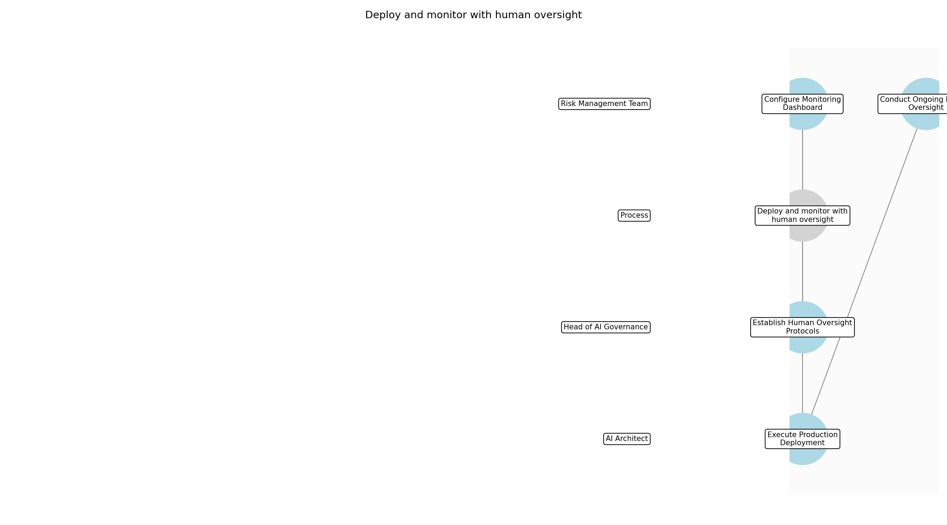

3.8.1 Establish Human Oversight Protocols
This subprocess describes the activities required to complete 'Establish Human Oversight Protocols'.

Description:
Define and document the specific mechanisms for human intervention, including the roles, responsibilities, and authority of human overseers. This includes setting clear thresholds for when a human must override an automated decision to ensure safety and compliance with the EU AI Act.

Purpose:
To ensure that the AI system remains under meaningful human control as required by regulation.

Scope:
Governance and procedural definition of human-in-the-loop mechanisms.

Inputs:
The following inputs are required for this subprocess:
• Technical Documentation Package
• Human Oversight Requirements (EU AI Act)

Outputs:
This subprocess produces the following outputs:
• Human Oversight Protocol

Success Criteria:
Success for this subprocess is measured by:
• Protocol is formally approved by the AI Ethics Committee.
• Intervention thresholds are clearly defined and measurable.

Triggers:
This subprocess is initiated by:
• Final certification and approval.

End Conditions:
This subprocess is considered complete when:
• Human Oversight Protocol is finalized and signed off.

Governance Requirements:
The following governance requirements apply:
• EU AI Act Human Oversight (Article 14)

Risks and Controls:
The following risks and controls apply:
• Risk: Ambiguous intervention authority.
• Control: Explicitly documented decision-making hierarchy in the protocol.

Change Management:
The following change management rules apply:
• Change Request Process: Formal submission to the AI Governance Board.
• Versioning Rules: Major version increment for changes to intervention thresholds.

Continuous Improvement:
The following continuous improvement practices apply:
• Review Frequency: Quarterly
• Improvement Inputs:
• Intervention logs
• Overseer feedback

Estimated Duration:
The estimated duration for this subprocess is:
• 1 week

Process Owner:
The following process owner is accountable:
• Head of AI Governance

Responsible Party:
The following parties are responsible for this subprocess:
• Head of AI Governance

3.8.2 Configure Monitoring Dashboard
This subprocess describes the activities required to complete 'Configure Monitoring Dashboard'.

Description:
Set up and calibrate the automated monitoring tools to track real-time performance metrics, data drift, and model accuracy. The dashboard must be configured to trigger alerts based on the thresholds defined in the Human Oversight Protocol.

Purpose:
To provide visibility into the operational health and compliance of the AI system.

Scope:
Technical configuration of monitoring and alerting infrastructure.

Inputs:
The following inputs are required for this subprocess:
• Production Environment Access
• Human Oversight Protocol
• Technical Documentation Package

Outputs:
This subprocess produces the following outputs:
• Monitoring Dashboard
• Alert Configuration Profile

Success Criteria:
Success for this subprocess is measured by:
• Dashboard displays real-time drift and performance metrics.
• Alerting system successfully notifies the Risk Management Team during test triggers.

Triggers:
This subprocess is initiated by:
• Approval of Human Oversight Protocol.

End Conditions:
This subprocess is considered complete when:
• Dashboard is live and monitoring production data.

Dependencies:
This subprocess depends on the following:
• Establish Human Oversight Protocols

Governance Requirements:
The following governance requirements apply:
• NIST AI RMF Measure Function
• Audit Trail Logging Requirements

Risks and Controls:
The following risks and controls apply:
• Risk: Monitoring tool failure or latency.
• Control: Redundant monitoring streams and heartbeat checks.

Change Management:
The following change management rules apply:
• Change Request Process: IT Change Management Ticket.
• Versioning Rules: Configuration as code (Git) versioning.

Continuous Improvement:
The following continuous improvement practices apply:
• Review Frequency: Monthly
• Improvement Inputs:
• False positive alert rates
• System performance data

Estimated Duration:
The estimated duration for this subprocess is:
• 3 days

Process Owner:
The following process owner is accountable:
• Head of AI Governance

Responsible Party:
The following parties are responsible for this subprocess:
• Risk Management Team

3.8.3 Execute Production Deployment
This subprocess describes the activities required to complete 'Execute Production Deployment'.

Description:
Deploy the AI model into the production environment following the organization's standard release management procedures. This includes final smoke testing and verification that the monitoring dashboard is correctly capturing production telemetry.

Purpose:
To transition the AI system from a certified state to active operational use.

Scope:
Technical release and environment verification.

Inputs:
The following inputs are required for this subprocess:
• Technical Documentation Package
• Monitoring Dashboard

Outputs:
This subprocess produces the following outputs:
• Deployment Log
• Production System Status

Success Criteria:
Success for this subprocess is measured by:
• System is accessible in production.
• Initial production outputs meet accuracy benchmarks.

Triggers:
This subprocess is initiated by:
• Successful dashboard configuration and testing.

End Conditions:
This subprocess is considered complete when:
• System is fully operational in the production environment.

Dependencies:
This subprocess depends on the following:
• Configure Monitoring Dashboard

Governance Requirements:
The following governance requirements apply:
• Standard ITIL Release Management Standards

Risks and Controls:
The following risks and controls apply:
• Risk: Environment mismatch leading to performance degradation.
• Control: Automated environment parity checks and rollback scripts.

Change Management:
The following change management rules apply:
• Change Request Process: Production Release Board approval.
• Versioning Rules: Semantic versioning for model and infrastructure.

Continuous Improvement:
The following continuous improvement practices apply:
• Review Frequency: Post-deployment
• Improvement Inputs:
• Deployment post-mortem
• Initial performance metrics

Estimated Duration:
The estimated duration for this subprocess is:
• 1 day

Process Owner:
The following process owner is accountable:
• Head of AI Governance

Responsible Party:
The following parties are responsible for this subprocess:
• AI Architect

3.8.4 Conduct Ongoing Human Oversight
This subprocess describes the activities required to complete 'Conduct Ongoing Human Oversight'.

Description:
Perform continuous monitoring of the AI system's outputs and behavior. Human overseers must review alerts, investigate anomalies, and exercise intervention or 'kill-switch' protocols if the system drifts outside of acceptable compliance or performance boundaries.

Purpose:
To maintain operational integrity and regulatory compliance through active human vigilance.

Scope:
Daily operational monitoring and intervention activities.

Inputs:
The following inputs are required for this subprocess:
• Monitoring Dashboard
• Human Oversight Protocol

Outputs:
This subprocess produces the following outputs:
• Oversight Activity Logs
• Incident Reports

Success Criteria:
Success for this subprocess is measured by:
• 100% of high-priority alerts are investigated within defined SLAs.
• System operates within performance and compliance parameters.

Triggers:
This subprocess is initiated by:
• System deployment
• Automated alerts

End Conditions:
This subprocess is considered complete when:
• System is decommissioned.

Dependencies:
This subprocess depends on the following:
• Execute Production Deployment

Governance Requirements:
The following governance requirements apply:
• EU AI Act Human Oversight Requirements
• NIST AI RMF Manage Function

Risks and Controls:
The following risks and controls apply:
• Risk: Model Drift or Unintended Behavior.
• Control: Real-time drift detection and human intervention triggers.
• Risk: Overseer fatigue or complacency.
• Control: Rotation of oversight staff and mandatory peer reviews of interventions.

Change Management:
The following change management rules apply:
• Change Request Process: Incident Management Process.
• Versioning Rules: Log versioning linked to system timestamps.

Continuous Improvement:
The following continuous improvement practices apply:
• Review Frequency: Bi-annual
• Improvement Inputs:
• Incident trends
• Regulatory updates

Estimated Duration:
The estimated duration for this subprocess is:
• Ongoing

Process Owner:
The following process owner is accountable:
• Head of AI Governance

Responsible Party:
The following parties are responsible for this subprocess:
• Risk Management Team

4.0 Supporting Systems and Tools
The following tools and platforms support this process:
Category | Tools
Governance & Compliance | Model Inventory System, Audit Logging Tool
Monitoring & Analytics | Drift Detection Software, Explainability Dashboards, Automated Bias Testing Tools

5.0 Metrics and Key Performance Indicators (KPIs)
The following metrics help monitor performance and ensure alignment with business objectives.
Metric | Description | Measurement / Frequency | Target
Compliance audit pass rate | Percentage of successful compliance audits. | Annual | 100%
Model explainability score | Quantitative measure of model transparency and interpretability. | Per model deployment | High
Time-to-market for AI solutions | Average time taken to bring AI solutions to market. | Quarterly | Optimized per project
Incident response time for AI failures | Time taken to respond to and resolve AI failures. | Real-time | Minimal

6.0 Critical Success Factors (CSF)
The following is a list of key CSFs associated with this process.
Success Factor | Description
Regulatory Alignment | Alignment with EU AI Act high-risk AI requirements and integration with NIST AI RMF.
Executive Sponsorship | Board-level support for AI governance.

7.0 Critical Failure Factors (CFF)
The following is a list of key CFFs associated with this process.
Failure Factor | Description
Regulatory Non-Compliance | Lack of data transparency and failure to update models according to changing regulations.
Operational Oversight Failure | Insufficient human-in-the-loop oversight leading to unmanaged AI errors.

8.0 Reporting and Analytics
The following reporting and analytics capabilities support monitoring and decision-making:
Report / Dashboard | Description
Report | Quarterly reports on compliance status.
Report | Real-time monitoring of model performance and drift.
Report | Reports provided to stakeholders regarding AI system transparency.

9.0 System Requirements
The following system requirements are essential for the successful implementation of this process.
Name | Details
Model inventory management system | Centralized repository for all AI models and their metadata.
Automated monitoring and alerting tools | Tools for real-time performance tracking and alerting.
Secure data storage with encryption | Encrypted storage for sensitive training and operational data.
Audit trail logging | Comprehensive logging of all system and user actions for audit purposes.

10.0 Process Flow Diagram
The following diagram provides a high-level visualization of the process flow.
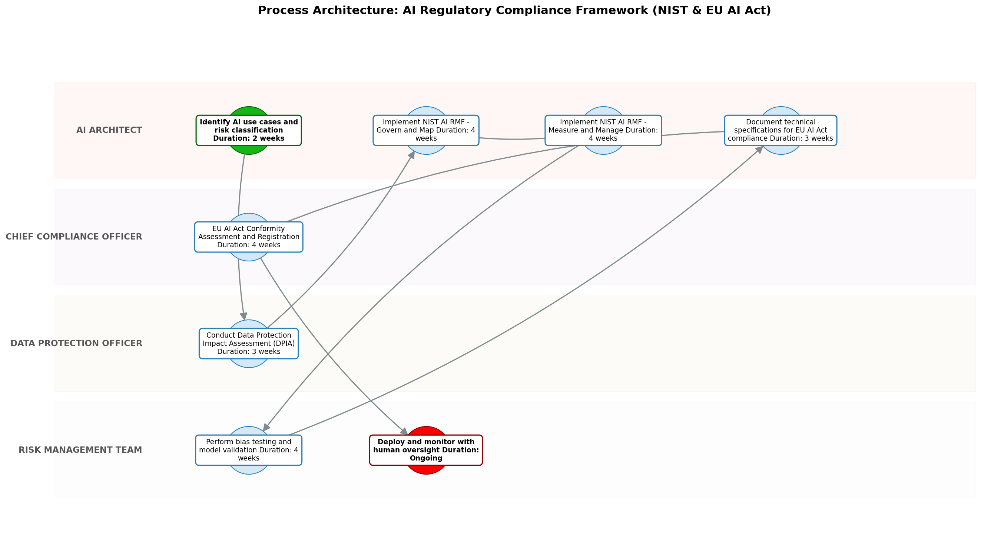

11.0 Process Performance Report
The following metrics are based on a Monte Carlo discrete-event simulation running 2,000 iterations. All time-based values are reported in weeks.
Operational Metric | Simulated Value
Average Cycle Time | 30.68 weeks
Cycle Time Variance | 3.07 weeks
Contention Risk Profile | Low

Identified Bottlenecks
- Implement NIST AI RMF Core Functions
- EU AI Act Conformity Assessment and Registration
- Perform bias testing and model validation

Detailed Step Performance
Process Step | Avg. Duration (weeks)
Identify AI use cases and risk classification | 2.68
Conduct Data Protection Impact Assessment (DPIA) | 3.99
Implement NIST AI RMF Core Functions | 8.04
Perform bias testing and model validation | 5.29
Document technical specifications for EU AI Act compliance | 3.99
EU AI Act Conformity Assessment and Registration | 5.35
Deploy and monitor with human oversight | 1.35

12.0 Governance Requirements
The following governance requirements apply to this process:
• Establishment of an AI Ethics Committee.
• Mandatory documentation of model architecture and training data.
• Annual independent third-party audits.

13.0 Risks and Controls
The following risks and associated controls apply to this process:
Risk | Control
Model Bias | Regular fairness audits and diverse training datasets.
Data Privacy Breach | Differential privacy techniques and strict access controls.

14.0 Process Triggers
The following triggers initiate this process:
• Initiation of a new AI project.
• Updates to NIST or EU AI Act regulations.
• Significant changes to an existing AI model.

15.0 Process End Conditions
The following conditions indicate completion of the process:
• AI system is decommissioned.
• AI system passes final certification and is in production with continuous monitoring.

16.0 Change Management
The following change management practices apply to this process:
• Change Request Process: Formal review process for any logic or data changes.
• Versioning Rules: Version control for all model iterations and training sessions for staff on framework updates.

17.0 Continuous Improvement
The following continuous improvement practices apply to this process:
• Review Frequency: Bi-annual review of the framework effectiveness.
Improvement Inputs:
• Feedback loops from production monitoring into the development stage.
• Adoption of emerging best practices in AI safety.

Appendix B: Additional Source Data
This appendix contains additional structured data from the normalized source JSON that is not covered in the main sections.
Field | Value
Process Owner | Head of AI Governance
Purpose | To provide a structured and compliant framework for developing, deploying, and managing AI systems within the financial sector.
Scope | All AI-driven models and processes within the financial institution, specifically targeting those categorized as high-risk under EU law.

Appendix C: Glossary
This glossary contains definitions of common terms used in the process documentation:
Term | Definition
Business Process | A set of related activities or tasks performed to achieve a specific organizational goal.
KPI | Key Performance Indicator used to measure the success or health of a process.
Stakeholder | Any individual or group with an interest in the outcomes of the process.
Continuous Improvement | Ongoing effort to improve products, services, or processes.

