MoJ AI and Data Governance Framework
Process Model Document

Industry / Domain: Public Sector / Justice
Version: 1.0.0
Generated On: 2026-02-24 02:41:03

Document Control
Version | Date | Author | Description
1.0.0 | 2026-02-24 | Process Architect | Initial generated process specification

Table of Contents
Document Control 2
Table of Contents 3
1.0 Process Overview 5
1.1 Assumptions 5
1.2 Constraints 5
1.3 Purpose 5
1.4 Scope 5
1.5 Industry Sector 5
2.0 Stakeholders and Responsibilities 6
3.0 Process Workflow 7
3.1 Project Registration 7
Required Sub Process(es) for the Step "Project Registration" 9
3.2 Data Classification & Inventory 22
Required Sub Process(es) for the Step "Data Classification & Inventory" 24
3.3 Risk & Impact Assessment 35
Required Sub Process(es) for the Step "Risk & Impact Assessment" 37
3.4 Control Implementation 50
Required Sub Process(es) for the Step "Control Implementation" 52
3.5 Verification & Audit 69
Required Sub Process(es) for the Step "Verification & Audit" 71
3.6 Governance Sign-off 84
Required Sub Process(es) for the Step "Governance Sign-off" 86
3.7 Operational Monitoring 97
Required Sub Process(es) for the Step "Operational Monitoring" 99
4.0 Supporting Systems and Tools 116
5.0 Metrics and Key Performance Indicators (KPIs) 117
6.0 Critical Success Factors (CSF) 118
7.0 Critical Failure Factors (CFF) 119
8.0 Reporting and Analytics 120
9.0 System Requirements 121
10.0 Process Flow Diagram 122
11.0 Process Performance Report 123
Identified Bottlenecks 123
Detailed Step Performance 123
12.0 Governance Requirements 124
13.0 Risks and Controls 125
14.0 Process Triggers 126
15.0 Process End Conditions 127
16.0 Change Management 128
17.0 Continuous Improvement 129
Appendix B: Additional Source Data 131
Appendix C: Glossary 132

1.0 Process Overview
This process establishes a consistent, secure, and ethical framework for AI and data management within the Ministry of Justice (MoJ) to mitigate risk and improve public service outcomes. This framework is designed to ensure that all AI-driven initiatives are developed and deployed with the highest standards of integrity, transparency, and accountability. By standardizing governance procedures, the MoJ aims to foster public trust and ensure that data-driven decisions are both legally compliant and ethically sound.

1.1 Assumptions
- All MoJ projects have access to the centralized data catalog and governance toolkit.
- Project teams have sufficient technical capability to implement data quality controls.
- Central governance boards meet at a frequency that does not create delivery bottlenecks.

1.2 Constraints
- Strict adherence to UK GDPR and the Data Protection Act 2018.
- Mandatory alignment with Government Security Classifications (GSC) for all data assets.
- Limited availability of specialized AI and data governance subject matter experts.

1.3 Purpose
To establish a consistent, secure, and ethical framework for AI and data management within the Ministry of Justice to mitigate risk and improve public service outcomes.

1.4 Scope
All internal MoJ digital projects and third-party vendor solutions processing justice-related data or utilizing AI.

1.5 Industry Sector
Public Sector / Justice

2.0 Stakeholders and Responsibilities
The following is a list of key stakeholders involved in this process. Understanding their roles and responsibilities is crucial for successful implementation.
Stakeholder | Responsibilities
Chief Data Officer (CDO) | Accountable for the enterprise framework and final policy decisions.
Project Managers / Delivery Leads | Responsible for ensuring project-level compliance with the standard.
Data Protection Officer (DPO) | Providing oversight on data protection and legal risks.
Data Scientists / Engineers | Developing AI models and implementing technical quality controls.

3.0 Process Workflow
The following is a list of key steps in the process workflow.

3.1 Project Registration

Description:
Formal intent to use AI/Data is logged with the Data Office. This step ensures that the central governance body is aware of all emerging AI projects, allowing for early intervention and guidance on compliance requirements.

Purpose:
To ensure visibility of all AI/Data projects within the MoJ.

Scope:
All MoJ digital projects.

Inputs:
The following inputs are required for this step:
• Project Brief
• Initial Data Requirements

Outputs:
This step produces the following outputs:
• Registered Project ID

Success Criteria:
Success for this step is measured by:
• Project ID issued and logged in central inventory.

Process Triggers:
This step is initiated by:
• Project Initiation

Process End Conditions:
This step is considered complete when:
• Registration confirmed

Deliverables:
This step produces the following deliverables:
• Project Registration Record

Governance Requirements:
The following governance requirements apply:
• Central AI model inventory entry

Risks and Controls:
The following risks and controls apply:
• Risk: Shadow AI projects.
• Control: Mandatory registration portal.

Change Management:
The following change management rules apply:
• Versioning Rules: N/A
• Change Request Process: Standard project change request.

Continuous Improvement:
The following continuous improvement practices apply:
• Review Frequency: Annual
• Improvement Inputs:
• Registration feedback

Estimated Duration:
The estimated duration for this step is:
• 2 days

Process Owner:
The following process owner is accountable:
• Chief Data Officer (CDO)

Responsible Parties:
The following parties are responsible for this step:
• Project Managers / Delivery Leads

Required Sub Process(es) for the Step "Project Registration"
The following details the subprocess flows for the step "Project Registration".
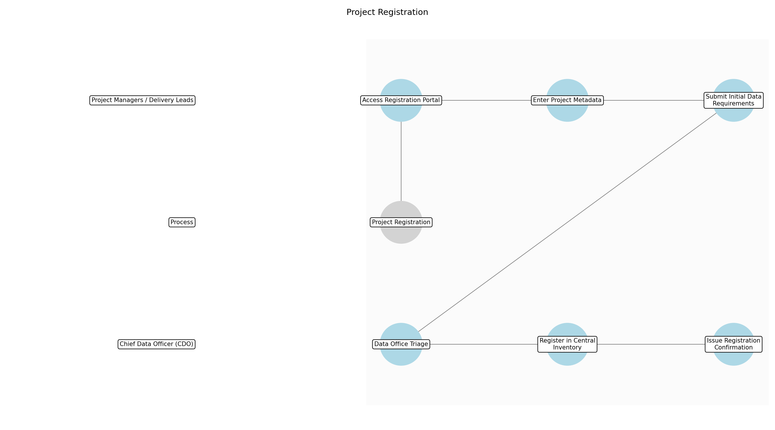

3.1.1 Access Registration Portal
This subprocess describes the activities required to complete 'Access Registration Portal'.

Description:
The Project Manager or Delivery Lead logs into the MoJ central AI and Data registration portal using their corporate credentials. This portal serves as the single entry point for all data-driven initiatives to ensure centralized visibility and tracking from the earliest stage of the project lifecycle.

Purpose:
To provide a standardized and secure entry point for logging AI project intent.

Scope:
MoJ internal governance portal access.

Inputs:
The following inputs are required for this subprocess:
• Project Brief

Outputs:
This subprocess produces the following outputs:
• Active Registration Session

Success Criteria:
Success for this subprocess is measured by:
• Portal access granted via SSO
• New registration entry initialized

Triggers:
This subprocess is initiated by:
• Project Initiation

End Conditions:
This subprocess is considered complete when:
• Registration session active

Governance Requirements:
The following governance requirements apply:
• User authentication audit log

Risks and Controls:
The following risks and controls apply:
• Risk: Unauthorized access to the registration system.
• Control: Single Sign-On (SSO) and Role-Based Access Control (RBAC).

Change Management:
The following change management rules apply:
• Change Request Process: N/A
• Versioning Rules: N/A

Continuous Improvement:
The following continuous improvement practices apply:
• Review Frequency: Annual
• Improvement Inputs:
• Portal access logs
• User login feedback

Estimated Duration:
The estimated duration for this subprocess is:
• 15 minutes

Process Owner:
The following process owner is accountable:
• Chief Data Officer (CDO)

Responsible Party:
The following parties are responsible for this subprocess:
• Project Managers / Delivery Leads

3.1.2 Enter Project Metadata
This subprocess describes the activities required to complete 'Enter Project Metadata'.

Description:
The user inputs core project details including the project name, department, primary objectives, and a high-level description of the intended AI or data usage. This metadata is used by the Data Office to categorize the project and determine the appropriate governance path based on complexity and potential impact.

Purpose:
To capture the essential scope and intent of the AI project for governance triage.

Scope:
Project-level descriptive metadata.

Inputs:
The following inputs are required for this subprocess:
• Project Brief
• Active Registration Session

Outputs:
This subprocess produces the following outputs:
• Draft Registration Record

Success Criteria:
Success for this subprocess is measured by:
• All mandatory metadata fields completed
• Project objectives clearly defined

Triggers:
This subprocess is initiated by:
• Portal session initialized

End Conditions:
This subprocess is considered complete when:
• Metadata saved in draft

Dependencies:
This subprocess depends on the following:
• Access Registration Portal

Governance Requirements:
The following governance requirements apply:
• Data quality standards for registration entries

Risks and Controls:
The following risks and controls apply:
• Risk: Incomplete or vague project descriptions hindering triage.
• Control: Mandatory field validation and descriptive tooltips in the portal.

Change Management:
The following change management rules apply:
• Change Request Process: Standard project change request.
• Versioning Rules: Draft versioning within portal.

Continuous Improvement:
The following continuous improvement practices apply:
• Review Frequency: Quarterly
• Improvement Inputs:
• Metadata completeness reports

Estimated Duration:
The estimated duration for this subprocess is:
• 1 hour

Process Owner:
The following process owner is accountable:
• Chief Data Officer (CDO)

Responsible Party:
The following parties are responsible for this subprocess:
• Project Managers / Delivery Leads

3.1.3 Submit Initial Data Requirements
This subprocess describes the activities required to complete 'Submit Initial Data Requirements'.

Description:
The Project Manager uploads documentation or specifies the datasets required for the project, including source systems and preliminary data sensitivity levels. This allows the Data Office to perform an early assessment of data protection requirements and potential security constraints.

Purpose:
To provide the Data Office with early insight into the data assets involved.

Scope:
Preliminary data sourcing and sensitivity identification.

Inputs:
The following inputs are required for this subprocess:
• Initial Data Requirements
• Draft Registration Record

Outputs:
This subprocess produces the following outputs:
• Completed Registration Submission

Success Criteria:
Success for this subprocess is measured by:
• Data requirements document successfully attached
• Sensitivity levels declared

Triggers:
This subprocess is initiated by:
• Metadata entry complete

End Conditions:
This subprocess is considered complete when:
• Submission sent to Data Office

Dependencies:
This subprocess depends on the following:
• Enter Project Metadata

Governance Requirements:
The following governance requirements apply:
• Alignment with MoJ Data Handling Policy

Risks and Controls:
The following risks and controls apply:
• Risk: Sensitive data included in the registration brief itself.
• Control: Automated scanning for PII/Sensitive terms in attachments.

Change Management:
The following change management rules apply:
• Change Request Process: Standard project change request.
• Versioning Rules: Submission timestamping.

Continuous Improvement:
The following continuous improvement practices apply:
• Review Frequency: Annual
• Improvement Inputs:
• Data requirement accuracy feedback

Estimated Duration:
The estimated duration for this subprocess is:
• 30 minutes

Process Owner:
The following process owner is accountable:
• Chief Data Officer (CDO)

Responsible Party:
The following parties are responsible for this subprocess:
• Project Managers / Delivery Leads

3.1.4 Data Office Triage
This subprocess describes the activities required to complete 'Data Office Triage'.

Description:
The Data Office Governance Team reviews the registration submission for completeness and validity. They check for potential overlaps with existing MoJ projects and identify if the project involves high-risk AI use cases that require immediate escalation to the Ethics Committee or DPO.

Purpose:
To ensure the quality of registration data and identify high-risk projects early.

Scope:
Governance and risk triage.

Inputs:
The following inputs are required for this subprocess:
• Completed Registration Submission

Outputs:
This subprocess produces the following outputs:
• Triage Approval

Success Criteria:
Success for this subprocess is measured by:
• Submission verified as complete
• Risk level assigned

Triggers:
This subprocess is initiated by:
• Submission received

End Conditions:
This subprocess is considered complete when:
• Triage status updated to Approved

Dependencies:
This subprocess depends on the following:
• Submit Initial Data Requirements

Governance Requirements:
The following governance requirements apply:
• Central AI model inventory entry criteria

Risks and Controls:
The following risks and controls apply:
• Risk: Review bottlenecks delaying project initiation.
• Control: SLA-based tracking and automated reminders for the governance team.

Change Management:
The following change management rules apply:
• Change Request Process: Governance appeal process.
• Versioning Rules: N/A

Continuous Improvement:
The following continuous improvement practices apply:
• Review Frequency: Quarterly
• Improvement Inputs:
• Triage cycle time metrics

Estimated Duration:
The estimated duration for this subprocess is:
• 1 day

Process Owner:
The following process owner is accountable:
• Chief Data Officer (CDO)

Responsible Party:
The following parties are responsible for this subprocess:
• Chief Data Officer (CDO)

3.1.5 Register in Central Inventory
This subprocess describes the activities required to complete 'Register in Central Inventory'.

Description:
Upon triage approval, the project is formally recorded in the MoJ Central AI Model Inventory (e.g., Collibra). A unique Project ID is generated, which must be used in all subsequent governance, security, and data quality documentation throughout the project lifecycle.

Purpose:
To maintain a single source of truth for all AI projects within the MoJ.

Scope:
Central Inventory management.

Inputs:
The following inputs are required for this subprocess:
• Triage Approval

Outputs:
This subprocess produces the following outputs:
• Registered Project ID
• Project Registration Record

Success Criteria:
Success for this subprocess is measured by:
• Unique Project ID generated
• Record visible in central inventory

Triggers:
This subprocess is initiated by:
• Triage approval finalized

End Conditions:
This subprocess is considered complete when:
• Inventory record created

Dependencies:
This subprocess depends on the following:
• Data Office Triage

Governance Requirements:
The following governance requirements apply:
• Central AI model inventory entry

Risks and Controls:
The following risks and controls apply:
• Risk: Duplicate project entries in the inventory.
• Control: Unique ID constraints and automated duplicate detection logic.

Change Management:
The following change management rules apply:
• Change Request Process: Inventory record update request.
• Versioning Rules: Audit trail of record changes.

Continuous Improvement:
The following continuous improvement practices apply:
• Review Frequency: Annual
• Improvement Inputs:
• Inventory data accuracy audits

Estimated Duration:
The estimated duration for this subprocess is:
• 2 hours

Process Owner:
The following process owner is accountable:
• Chief Data Officer (CDO)

Responsible Party:
The following parties are responsible for this subprocess:
• Chief Data Officer (CDO)

3.1.6 Issue Registration Confirmation
This subprocess describes the activities required to complete 'Issue Registration Confirmation'.

Description:
The Data Office issues a formal confirmation to the Project Manager, providing the unique Project ID and a summary of the next mandatory governance steps (e.g., Data Classification, DPIA). This step ensures the project team is aware of their compliance obligations.

Purpose:
To formally close the registration step and provide compliance guidance.

Scope:
Governance communication.

Inputs:
The following inputs are required for this subprocess:
• Registered Project ID

Outputs:
This subprocess produces the following outputs:
• Registration Confirmation Record

Success Criteria:
Success for this subprocess is measured by:
• Confirmation email sent to Project Manager
• Project ID correctly communicated

Triggers:
This subprocess is initiated by:
• Inventory record creation

End Conditions:
This subprocess is considered complete when:
• Registration confirmed

Dependencies:
This subprocess depends on the following:
• Register in Central Inventory

Governance Requirements:
The following governance requirements apply:
• Formal notification of registration

Risks and Controls:
The following risks and controls apply:
• Risk: Project team unaware of next governance steps.
• Control: Automated issuance of a 'Governance Roadmap' with the confirmation.

Change Management:
The following change management rules apply:
• Change Request Process: N/A
• Versioning Rules: N/A

Continuous Improvement:
The following continuous improvement practices apply:
• Review Frequency: Annual
• Improvement Inputs:
• Registration feedback

Estimated Duration:
The estimated duration for this subprocess is:
• 1 hour

Process Owner:
The following process owner is accountable:
• Chief Data Officer (CDO)

Responsible Party:
The following parties are responsible for this subprocess:
• Chief Data Officer (CDO)

3.2 Data Classification & Inventory

Description:
Identification and tagging of data assets according to Government Security Classifications (GSC). This step is critical for ensuring that data is handled with the appropriate level of security and that privacy controls are applied based on the sensitivity of the information.

Purpose:
To ensure data is handled according to its sensitivity.

Scope:
Project-specific data assets.

Inputs:
The following inputs are required for this step:
• Source Data Systems
• Data Dictionary

Outputs:
This step produces the following outputs:
• Classified Data Catalog

Success Criteria:
Success for this step is measured by:
• 100% of project data assets classified and inventoried.

Process Triggers:
This step is initiated by:
• Registration completion

Process End Conditions:
This step is considered complete when:
• All assets tagged

Dependencies:
This step depends on the following:
• Project Registration

Deliverables:
This step produces the following deliverables:
• Data Asset Inventory
• GSC Labels

Governance Requirements:
The following governance requirements apply:
• GSC Compliance

Risks and Controls:
The following risks and controls apply:
• Risk: Incorrect data classification.
• Control: Automated classification scanning.

Change Management:
The following change management rules apply:
• Versioning Rules: Data versioning policy.
• Change Request Process: Data schema update request.

Continuous Improvement:
The following continuous improvement practices apply:
• Review Frequency: Quarterly
• Improvement Inputs:
• Data profiling results

Estimated Duration:
The estimated duration for this step is:
• 5 days

Process Owner:
The following process owner is accountable:
• Chief Data Officer (CDO)

Responsible Parties:
The following parties are responsible for this step:
• Data Scientists / Engineers

Required Sub Process(es) for the Step "Data Classification & Inventory"
The following details the subprocess flows for the step "Data Classification & Inventory".
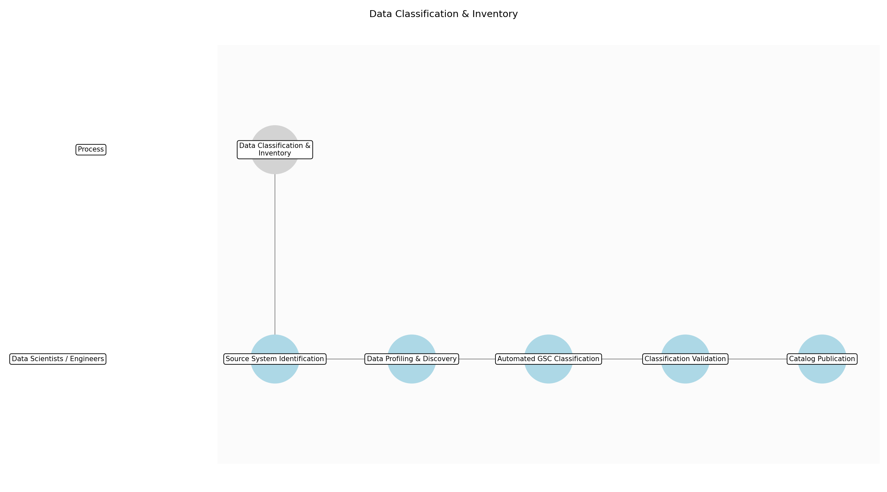

3.2.1 Source System Identification
This subprocess describes the activities required to complete 'Source System Identification'.

Description:
Identify and document all source data systems, databases, and file repositories that will be utilized for the AI project. This involves mapping technical locations to the project's data requirements to ensure no assets are overlooked.

Purpose:
To define the technical scope of the data inventory.

Scope:
Project-specific data sources.

Inputs:
The following inputs are required for this subprocess:
• Source Data Systems
• Project Brief

Outputs:
This subprocess produces the following outputs:
• List of Data Sources

Success Criteria:
Success for this subprocess is measured by:
• Comprehensive list of all data locations documented.

Triggers:
This subprocess is initiated by:
• Registration completion

End Conditions:
This subprocess is considered complete when:
• Source list finalized

Governance Requirements:
The following governance requirements apply:
• GSC Compliance

Risks and Controls:
The following risks and controls apply:
• Risk: Missing data sources in the inventory.
• Control: Cross-reference with project brief and architecture diagrams.

Change Management:
The following change management rules apply:
• Change Request Process: Data schema update request.
• Versioning Rules: Data versioning policy.

Continuous Improvement:
The following continuous improvement practices apply:
• Review Frequency: Quarterly
• Improvement Inputs:
• Data profiling results

Estimated Duration:
The estimated duration for this subprocess is:
• 1 day

Process Owner:
The following process owner is accountable:
• Chief Data Officer (CDO)

Responsible Party:
The following parties are responsible for this subprocess:
• Data Scientists / Engineers

3.2.2 Data Profiling & Discovery
This subprocess describes the activities required to complete 'Data Profiling & Discovery'.

Description:
Execute automated profiling tools to analyze the structure, content, and quality of the identified data sources. This step identifies potential PII, sensitive fields, and data patterns that inform classification.

Purpose:
To understand data content prior to classification.

Scope:
Identified data sources.

Inputs:
The following inputs are required for this subprocess:
• List of Data Sources
• Automated Data Profiling tools

Outputs:
This subprocess produces the following outputs:
• Data Profiling Reports

Success Criteria:
Success for this subprocess is measured by:
• Profiling reports generated for all identified sources.

Triggers:
This subprocess is initiated by:
• Source list finalized

End Conditions:
This subprocess is considered complete when:
• Profiling reports generated

Dependencies:
This subprocess depends on the following:
• Source System Identification

Governance Requirements:
The following governance requirements apply:
• GSC Compliance

Risks and Controls:
The following risks and controls apply:
• Risk: Incomplete profiling of large datasets.
• Control: Use automated discovery tools with sampling logic.

Change Management:
The following change management rules apply:
• Change Request Process: Data schema update request.
• Versioning Rules: Data versioning policy.

Continuous Improvement:
The following continuous improvement practices apply:
• Review Frequency: Quarterly
• Improvement Inputs:
• Data profiling results

Estimated Duration:
The estimated duration for this subprocess is:
• 1 day

Process Owner:
The following process owner is accountable:
• Chief Data Officer (CDO)

Responsible Party:
The following parties are responsible for this subprocess:
• Data Scientists / Engineers

3.2.3 Automated GSC Classification
This subprocess describes the activities required to complete 'Automated GSC Classification'.

Description:
Apply automated scanning rules based on MoJ Government Security Classifications (GSC) standards to tag data assets. This process automatically assigns draft labels such as Official or Official-Sensitive based on metadata and content analysis.

Purpose:
To efficiently classify large volumes of data.

Scope:
Profiled data assets.

Inputs:
The following inputs are required for this subprocess:
• Data Profiling Reports
• GSC Policy

Outputs:
This subprocess produces the following outputs:
• Draft GSC Labels

Success Criteria:
Success for this subprocess is measured by:
• All data fields assigned a draft classification label.

Triggers:
This subprocess is initiated by:
• Profiling reports generated

End Conditions:
This subprocess is considered complete when:
• Draft labels applied

Dependencies:
This subprocess depends on the following:
• Data Profiling & Discovery

Governance Requirements:
The following governance requirements apply:
• GSC Compliance

Risks and Controls:
The following risks and controls apply:
• Risk: Incorrect automated data classification.
• Control: Automated classification scanning with regular rule updates.

Change Management:
The following change management rules apply:
• Change Request Process: Data schema update request.
• Versioning Rules: Data versioning policy.

Continuous Improvement:
The following continuous improvement practices apply:
• Review Frequency: Quarterly
• Improvement Inputs:
• Data profiling results

Estimated Duration:
The estimated duration for this subprocess is:
• 1 day

Process Owner:
The following process owner is accountable:
• Chief Data Officer (CDO)

Responsible Party:
The following parties are responsible for this subprocess:
• Data Scientists / Engineers

3.2.4 Classification Validation
This subprocess describes the activities required to complete 'Classification Validation'.

Description:
Manually review and validate the automated classification tags, focusing on edge cases or high-sensitivity justice data. This ensures that the context of the data is correctly interpreted according to MoJ standards.

Purpose:
To ensure human oversight on sensitive justice data.

Scope:
Draft classified assets.

Inputs:
The following inputs are required for this subprocess:
• Draft GSC Labels
• Data Dictionary

Outputs:
This subprocess produces the following outputs:
• Validated GSC Labels

Success Criteria:
Success for this subprocess is measured by:
• 100% accuracy in classification tags verified by a human.

Triggers:
This subprocess is initiated by:
• Draft labels applied

End Conditions:
This subprocess is considered complete when:
• Labels validated

Dependencies:
This subprocess depends on the following:
• Automated GSC Classification

Governance Requirements:
The following governance requirements apply:
• GSC Compliance

Risks and Controls:
The following risks and controls apply:
• Risk: Human error in manual validation.
• Control: Peer review of classifications for sensitive datasets.

Change Management:
The following change management rules apply:
• Change Request Process: Data schema update request.
• Versioning Rules: Data versioning policy.

Continuous Improvement:
The following continuous improvement practices apply:
• Review Frequency: Quarterly
• Improvement Inputs:
• Data profiling results

Estimated Duration:
The estimated duration for this subprocess is:
• 1 day

Process Owner:
The following process owner is accountable:
• Chief Data Officer (CDO)

Responsible Party:
The following parties are responsible for this subprocess:
• Data Scientists / Engineers

3.2.5 Catalog Publication
This subprocess describes the activities required to complete 'Catalog Publication'.

Description:
Integrate the validated inventory and classification metadata into the Enterprise Data Catalog. This step makes the inventory discoverable and ensures that security labels are visible to all authorized project stakeholders.

Purpose:
To provide a single source of truth for data assets.

Scope:
Validated data inventory.

Inputs:
The following inputs are required for this subprocess:
• Validated GSC Labels
• Enterprise Data Catalog

Outputs:
This subprocess produces the following outputs:
• Classified Data Catalog

Success Criteria:
Success for this subprocess is measured by:
• Catalog updated and accessible to authorized users.

Triggers:
This subprocess is initiated by:
• Labels validated

End Conditions:
This subprocess is considered complete when:
• All assets tagged in catalog

Dependencies:
This subprocess depends on the following:
• Classification Validation

Governance Requirements:
The following governance requirements apply:
• GSC Compliance

Risks and Controls:
The following risks and controls apply:
• Risk: Catalog synchronization failure.
• Control: Manual verification of catalog entry post-publication.

Change Management:
The following change management rules apply:
• Change Request Process: Data schema update request.
• Versioning Rules: Data versioning policy.

Continuous Improvement:
The following continuous improvement practices apply:
• Review Frequency: Quarterly
• Improvement Inputs:
• Data profiling results

Estimated Duration:
The estimated duration for this subprocess is:
• 1 day

Process Owner:
The following process owner is accountable:
• Chief Data Officer (CDO)

Responsible Party:
The following parties are responsible for this subprocess:
• Data Scientists / Engineers

3.3 Risk & Impact Assessment

Description:
Conduct Data Protection Impact Assessments (DPIAs) and AI ethical risk assessments. This phase involves a deep dive into the potential risks associated with data processing and AI model behavior, ensuring that mitigation strategies are integrated into the project design.

Purpose:
To identify and mitigate privacy and ethical risks.

Scope:
Privacy and ethical impact of the AI system.

Inputs:
The following inputs are required for this step:
• Classified Data Catalog
• AI Model Design

Outputs:
This step produces the following outputs:
• Risk Mitigation Plan

Success Criteria:
Success for this step is measured by:
• DPIA and Ethical Assessment signed off.

Process Triggers:
This step is initiated by:
• Data classification finalized

Process End Conditions:
This step is considered complete when:
• Assessments approved by DPO

Dependencies:
This step depends on the following:
• Data Classification & Inventory

Deliverables:
This step produces the following deliverables:
• DPIA Report
• AI Ethical Risk Assessment

Governance Requirements:
The following governance requirements apply:
• UK GDPR Compliance

Risks and Controls:
The following risks and controls apply:
• Control: Mandatory DPO review.
• Risk: Non-compliance with UK GDPR.

Change Management:
The following change management rules apply:
• Change Request Process: Impact assessment update.
• Versioning Rules: DPIA versioning.

Continuous Improvement:
The following continuous improvement practices apply:
• Improvement Inputs:
• Legal updates
• Review Frequency: Quarterly

Estimated Duration:
The estimated duration for this step is:
• 10 days

Process Owner:
The following process owner is accountable:
• Chief Data Officer (CDO)

Responsible Parties:
The following parties are responsible for this step:
• Data Protection Officer (DPO)

Required Sub Process(es) for the Step "Risk & Impact Assessment"
The following details the subprocess flows for the step "Risk & Impact Assessment".
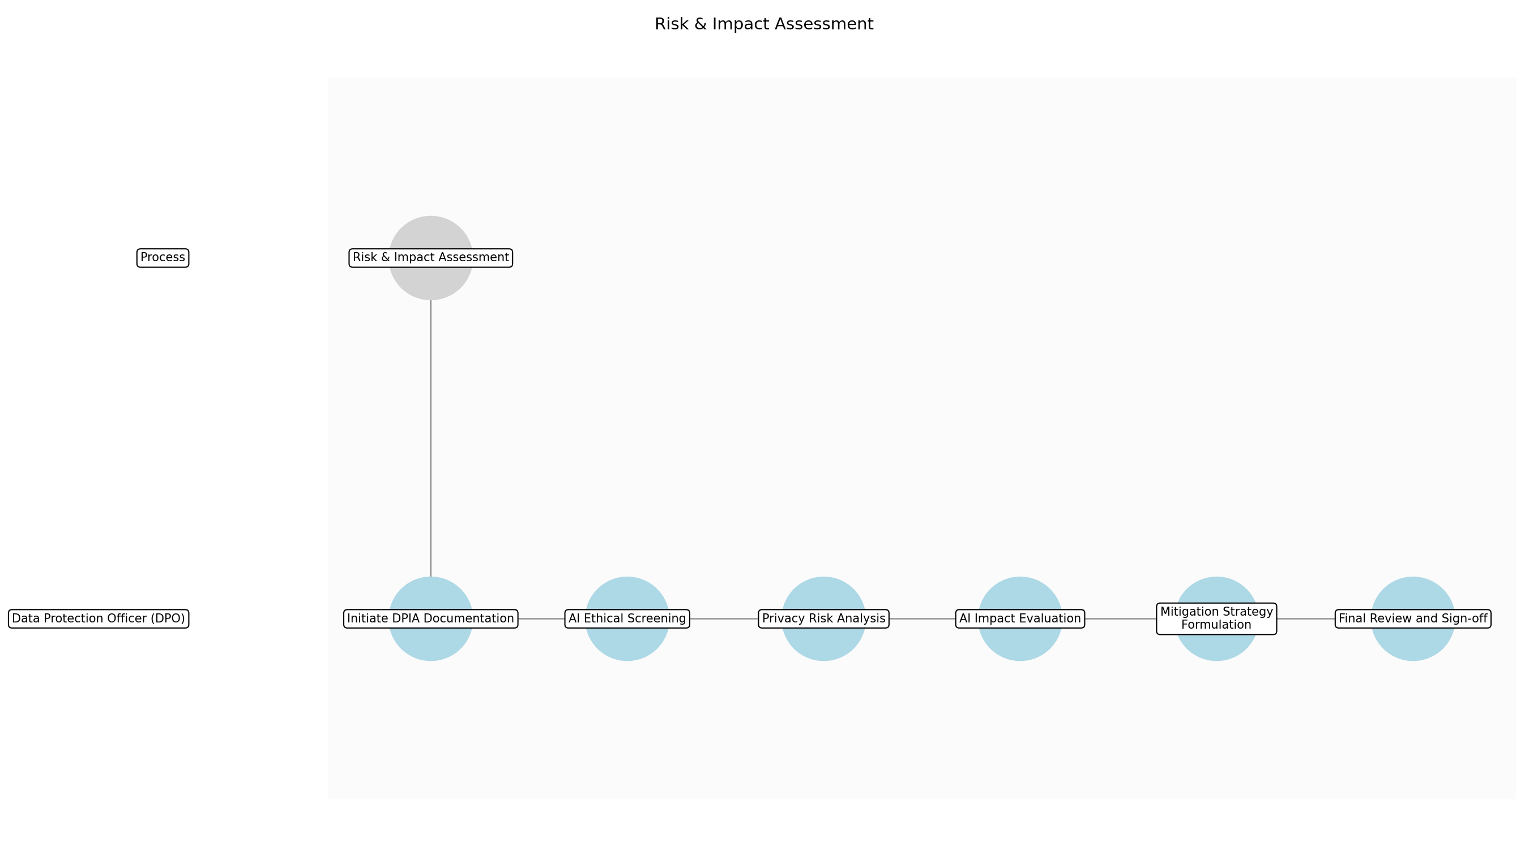

3.3.1 Initiate DPIA Documentation
This subprocess describes the activities required to complete 'Initiate DPIA Documentation'.

Description:
This sub-step involves the formal initiation of the Data Protection Impact Assessment (DPIA) process. The Data Protection Officer (DPO) utilizes the Classified Data Catalog to map out data flows, identify the types of personal data being processed, and establish the legal basis for processing within the AI project. This ensures that the assessment is grounded in the actual data architecture of the system.

Purpose:
To establish the foundation for privacy risk assessment.

Scope:
Data flow mapping and legal basis identification.

Inputs:
The following inputs are required for this subprocess:
• Classified Data Catalog

Outputs:
This subprocess produces the following outputs:
• Draft DPIA Document

Success Criteria:
Success for this subprocess is measured by:
• Data flows mapped
• Legal basis identified

Triggers:
This subprocess is initiated by:
• Data classification finalized

End Conditions:
This subprocess is considered complete when:
• Draft DPIA document created

Governance Requirements:
The following governance requirements apply:
• UK GDPR Compliance

Risks and Controls:
The following risks and controls apply:
• Risk: Incomplete data flow mapping
• Control: Cross-reference with Classified Data Catalog

Change Management:
The following change management rules apply:
• Change Request Process: DPIA update request
• Versioning Rules: DPIA versioning

Continuous Improvement:
The following continuous improvement practices apply:
• Review Frequency: Quarterly
• Improvement Inputs:
• Legal updates

Estimated Duration:
The estimated duration for this subprocess is:
• 1 day

Process Owner:
The following process owner is accountable:
• Chief Data Officer (CDO)

Responsible Party:
The following parties are responsible for this subprocess:
• Data Protection Officer (DPO)

3.3.2 AI Ethical Screening
This subprocess describes the activities required to complete 'AI Ethical Screening'.

Description:
The DPO conducts an initial screening of the AI Model Design against the Ministry of Justice's ethical AI principles. This involves evaluating the model's intended use, potential for bias, and the level of transparency provided to end-users or subjects of automated decisions. The screening identifies high-level ethical concerns that require deeper investigation in subsequent steps.

Purpose:
To identify high-level ethical concerns early in the design phase.

Scope:
AI model behavior and transparency.

Inputs:
The following inputs are required for this subprocess:
• AI Model Design

Outputs:
This subprocess produces the following outputs:
• Ethical Screening Report

Success Criteria:
Success for this subprocess is measured by:
• Ethical risks identified
• Screening report completed

Triggers:
This subprocess is initiated by:
• DPIA initiation complete

End Conditions:
This subprocess is considered complete when:
• Ethical screening report finalized

Dependencies:
This subprocess depends on the following:
• Initiate DPIA Documentation

Governance Requirements:
The following governance requirements apply:
• MoJ Ethical AI Standards

Risks and Controls:
The following risks and controls apply:
• Risk: Unidentified algorithmic bias
• Control: Mandatory ethical framework checklist

Change Management:
The following change management rules apply:
• Change Request Process: Ethical assessment update
• Versioning Rules: Assessment versioning

Continuous Improvement:
The following continuous improvement practices apply:
• Review Frequency: Quarterly
• Improvement Inputs:
• Ethical guidelines updates

Estimated Duration:
The estimated duration for this subprocess is:
• 2 days

Process Owner:
The following process owner is accountable:
• Chief Data Officer (CDO)

Responsible Party:
The following parties are responsible for this subprocess:
• Data Protection Officer (DPO)

3.3.3 Privacy Risk Analysis
This subprocess describes the activities required to complete 'Privacy Risk Analysis'.

Description:
A deep-dive analysis into the privacy risks associated with the project is performed. The DPO evaluates the necessity and proportionality of data processing, assesses risks to data subjects' rights, and identifies potential vulnerabilities in data handling procedures. All identified risks are documented in a formal register with assigned impact and likelihood scores.

Purpose:
To quantify and document specific privacy risks.

Scope:
GDPR-related privacy risks.

Inputs:
The following inputs are required for this subprocess:
• Draft DPIA Document
• Classified Data Catalog

Outputs:
This subprocess produces the following outputs:
• Privacy Risk Register

Success Criteria:
Success for this subprocess is measured by:
• Privacy risks documented
• Impact levels assigned

Triggers:
This subprocess is initiated by:
• Draft DPIA available

End Conditions:
This subprocess is considered complete when:
• Privacy Risk Register completed

Dependencies:
This subprocess depends on the following:
• Initiate DPIA Documentation

Governance Requirements:
The following governance requirements apply:
• UK GDPR Compliance

Risks and Controls:
The following risks and controls apply:
• Risk: Underestimation of privacy impact
• Control: Standardized impact scoring matrix

Change Management:
The following change management rules apply:
• Change Request Process: Risk register update
• Versioning Rules: Register versioning

Continuous Improvement:
The following continuous improvement practices apply:
• Review Frequency: Quarterly
• Improvement Inputs:
• Privacy audit findings

Estimated Duration:
The estimated duration for this subprocess is:
• 2 days

Process Owner:
The following process owner is accountable:
• Chief Data Officer (CDO)

Responsible Party:
The following parties are responsible for this subprocess:
• Data Protection Officer (DPO)

3.3.4 AI Impact Evaluation
This subprocess describes the activities required to complete 'AI Impact Evaluation'.

Description:
This sub-step involves a detailed evaluation of the AI model's impact on judicial outcomes and individual fairness. The DPO assesses the potential for discriminatory outputs and ensures that the model's logic is explainable and aligns with justice system requirements. This evaluation is critical for maintaining public trust in automated judicial processes.

Purpose:
To ensure AI models do not compromise judicial integrity.

Scope:
Model fairness and explainability.

Inputs:
The following inputs are required for this subprocess:
• AI Model Design
• Ethical Screening Report

Outputs:
This subprocess produces the following outputs:
• AI Ethical Risk Assessment

Success Criteria:
Success for this subprocess is measured by:
• Impact on fairness evaluated
• Explainability requirements met

Triggers:
This subprocess is initiated by:
• Ethical screening complete

End Conditions:
This subprocess is considered complete when:
• AI Ethical Risk Assessment finalized

Dependencies:
This subprocess depends on the following:
• AI Ethical Screening

Governance Requirements:
The following governance requirements apply:
• UK GDPR Compliance
• MoJ Ethical AI Standards

Risks and Controls:
The following risks and controls apply:
• Risk: Non-transparent model logic
• Control: Explainability documentation review

Change Management:
The following change management rules apply:
• Change Request Process: Impact assessment update
• Versioning Rules: Assessment versioning

Continuous Improvement:
The following continuous improvement practices apply:
• Review Frequency: Quarterly
• Improvement Inputs:
• Model performance data

Estimated Duration:
The estimated duration for this subprocess is:
• 2 days

Process Owner:
The following process owner is accountable:
• Chief Data Officer (CDO)

Responsible Party:
The following parties are responsible for this subprocess:
• Data Protection Officer (DPO)

3.3.5 Mitigation Strategy Formulation
This subprocess describes the activities required to complete 'Mitigation Strategy Formulation'.

Description:
Based on the identified privacy and ethical risks, the DPO collaborates with project teams to develop specific mitigation strategies. These include technical controls such as anonymization and bias correction, as well as organizational measures like staff training and human-in-the-loop protocols. The resulting plan provides a roadmap for implementing safeguards.

Purpose:
To create an actionable plan for risk reduction.

Scope:
Technical and organizational risk mitigations.

Inputs:
The following inputs are required for this subprocess:
• Privacy Risk Register
• AI Ethical Risk Assessment

Outputs:
This subprocess produces the following outputs:
• Risk Mitigation Plan

Success Criteria:
Success for this subprocess is measured by:
• Mitigations defined for all high risks
• Plan agreed with project team

Triggers:
This subprocess is initiated by:
• Risk assessments complete

End Conditions:
This subprocess is considered complete when:
• Risk Mitigation Plan finalized

Dependencies:
This subprocess depends on the following:
• Privacy Risk Analysis
• AI Impact Evaluation

Governance Requirements:
The following governance requirements apply:
• UK GDPR Compliance

Risks and Controls:
The following risks and controls apply:
• Risk: Inadequate mitigation measures
• Control: Peer review of mitigation plan

Change Management:
The following change management rules apply:
• Change Request Process: Mitigation plan update
• Versioning Rules: Plan versioning

Continuous Improvement:
The following continuous improvement practices apply:
• Review Frequency: Quarterly
• Improvement Inputs:
• Mitigation effectiveness reviews

Estimated Duration:
The estimated duration for this subprocess is:
• 2 days

Process Owner:
The following process owner is accountable:
• Chief Data Officer (CDO)

Responsible Party:
The following parties are responsible for this subprocess:
• Data Protection Officer (DPO)

3.3.6 Final Review and Sign-off
This subprocess describes the activities required to complete 'Final Review and Sign-off'.

Description:
The final sub-step involves the formal review and approval of the DPIA Report and AI Ethical Risk Assessment. The DPO reviews the consolidated evidence and the Risk Mitigation Plan to ensure all regulatory and ethical requirements are met. Formal sign-off is granted only when the DPO is satisfied that all risks have been appropriately addressed or accepted.

Purpose:
To provide formal governance approval for the risk assessment phase.

Scope:
Final approval of all assessment artifacts.

Inputs:
The following inputs are required for this subprocess:
• Draft DPIA Document
• AI Ethical Risk Assessment
• Risk Mitigation Plan

Outputs:
This subprocess produces the following outputs:
• DPIA Report
• Signed AI Ethical Risk Assessment

Success Criteria:
Success for this subprocess is measured by:
• DPO signature obtained
• Assessments archived in central inventory

Triggers:
This subprocess is initiated by:
• Mitigation plan finalized

End Conditions:
This subprocess is considered complete when:
• Assessments approved by DPO

Dependencies:
This subprocess depends on the following:
• Mitigation Strategy Formulation

Governance Requirements:
The following governance requirements apply:
• UK GDPR Compliance
• Board Approval

Risks and Controls:
The following risks and controls apply:
• Risk: Unauthorized sign-off
• Control: Mandatory DPO digital signature

Change Management:
The following change management rules apply:
• Change Request Process: Post-approval change request
• Versioning Rules: DPIA versioning

Continuous Improvement:
The following continuous improvement practices apply:
• Review Frequency: Quarterly
• Improvement Inputs:
• Governance board feedback

Estimated Duration:
The estimated duration for this subprocess is:
• 1 day

Process Owner:
The following process owner is accountable:
• Chief Data Officer (CDO)

Responsible Party:
The following parties are responsible for this subprocess:
• Data Protection Officer (DPO)

3.4 Control Implementation

Description:
Implementation of technical controls for security, privacy, and quality. This step translates the risk mitigation plan into actionable technical safeguards, such as encryption, access controls, and automated data quality checks.

Purpose:
To apply necessary safeguards to the data and AI model.

Scope:
Technical implementation of the AI solution.

Inputs:
The following inputs are required for this step:
• Risk Mitigation Plan
• Technical Architecture

Outputs:
This step produces the following outputs:
• Hardened AI Environment

Success Criteria:
Success for this step is measured by:
• All identified risks have corresponding technical controls.

Process Triggers:
This step is initiated by:
• Risk assessment approval

Process End Conditions:
This step is considered complete when:
• Controls implemented and tested

Dependencies:
This step depends on the following:
• Risk & Impact Assessment

Deliverables:
This step produces the following deliverables:
• Security Controls Documentation
• Data Quality Rules

Governance Requirements:
The following governance requirements apply:
• MoJ Security Standards

Risks and Controls:
The following risks and controls apply:
• Risk: Unauthorized data access.
• Control: Encryption at rest/transit.

Change Management:
The following change management rules apply:
• Versioning Rules: Code versioning.
• Change Request Process: Technical change control.

Continuous Improvement:
The following continuous improvement practices apply:
• Review Frequency: Monthly
• Improvement Inputs:
• Security audit logs

Estimated Duration:
The estimated duration for this step is:
• 15 days

Process Owner:
The following process owner is accountable:
• Chief Data Officer (CDO)

Responsible Parties:
The following parties are responsible for this step:
• Data Scientists / Engineers

Required Sub Process(es) for the Step "Control Implementation"
The following details the subprocess flows for the step "Control Implementation".
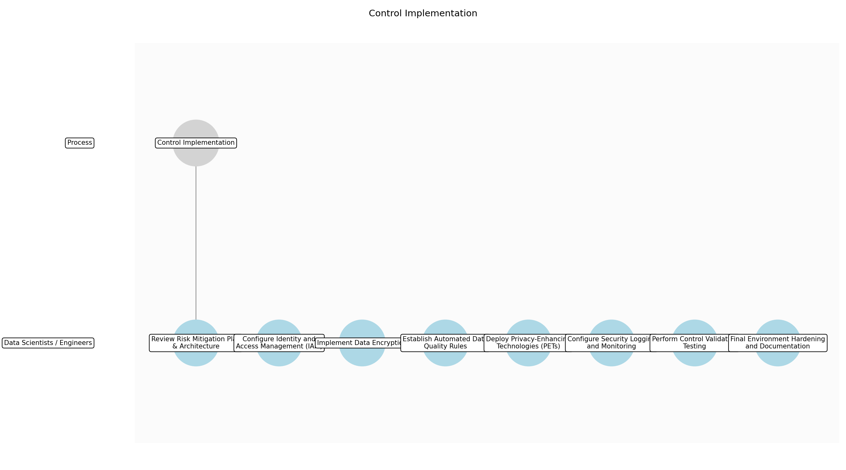

3.4.1 Review Risk Mitigation Plan & Architecture
This subprocess describes the activities required to complete 'Review Risk Mitigation Plan & Architecture'.

Description:
Analyze the approved Risk Mitigation Plan and Technical Architecture to identify specific technical requirements for security, privacy, and quality controls. This ensures that the implementation phase is directly aligned with the identified risks and the overall system design.

Purpose:
To translate high-level risk mitigations into a technical execution plan.

Scope:
Analysis of risk and architecture documents for the specific AI project.

Inputs:
The following inputs are required for this subprocess:
• Risk Mitigation Plan
• Technical Architecture

Outputs:
This subprocess produces the following outputs:
• Control Implementation Roadmap

Success Criteria:
Success for this subprocess is measured by:
• All risks mapped to specific technical implementation tasks.
• Roadmap approved by the project lead.

Triggers:
This subprocess is initiated by:
• Risk assessment approval

End Conditions:
This subprocess is considered complete when:
• Implementation roadmap finalized

Governance Requirements:
The following governance requirements apply:
• MoJ Security Standards

Risks and Controls:
The following risks and controls apply:
• Risk: Misinterpretation of risk requirements.
• Control: Peer review of the implementation roadmap.

Change Management:
The following change management rules apply:
• Change Request Process: Technical change control.
• Versioning Rules: Code versioning.

Continuous Improvement:
The following continuous improvement practices apply:
• Review Frequency: Monthly
• Improvement Inputs:
• Security audit logs

Estimated Duration:
The estimated duration for this subprocess is:
• 1 day

Process Owner:
The following process owner is accountable:
• Chief Data Officer (CDO)

Responsible Party:
The following parties are responsible for this subprocess:
• Data Scientists / Engineers

3.4.2 Configure Identity and Access Management (IAM)
This subprocess describes the activities required to complete 'Configure Identity and Access Management (IAM)'.

Description:
Define and implement granular access controls, roles, and permissions for the AI environment. This involves setting up service accounts, user groups, and resource-level permissions to ensure the principle of least privilege is strictly enforced across all justice data assets.

Purpose:
To prevent unauthorized access to the AI system and its data.

Scope:
User and service account permissions within the project environment.

Inputs:
The following inputs are required for this subprocess:
• Control Implementation Roadmap
• MoJ Security Standards

Outputs:
This subprocess produces the following outputs:
• Configured IAM Roles

Success Criteria:
Success for this subprocess is measured by:
• Access restricted to authorized personnel only.
• Roles verified against the architecture.

Triggers:
This subprocess is initiated by:
• Roadmap finalization

End Conditions:
This subprocess is considered complete when:
• IAM roles deployed and verified

Dependencies:
This subprocess depends on the following:
• Review Risk Mitigation Plan & Architecture

Governance Requirements:
The following governance requirements apply:
• MoJ Security Standards

Risks and Controls:
The following risks and controls apply:
• Risk: Over-privileged accounts.
• Control: Automated IAM policy scanning.

Change Management:
The following change management rules apply:
• Change Request Process: Technical change control.
• Versioning Rules: Code versioning.

Continuous Improvement:
The following continuous improvement practices apply:
• Review Frequency: Monthly
• Improvement Inputs:
• Security audit logs

Estimated Duration:
The estimated duration for this subprocess is:
• 2 days

Process Owner:
The following process owner is accountable:
• Chief Data Officer (CDO)

Responsible Party:
The following parties are responsible for this subprocess:
• Data Scientists / Engineers

3.4.3 Implement Data Encryption
This subprocess describes the activities required to complete 'Implement Data Encryption'.

Description:
Apply encryption protocols for data at rest within storage systems and data in transit across network layers. This step utilizes MoJ-approved cryptographic standards to protect sensitive justice data from interception or unauthorized viewing during the AI lifecycle.

Purpose:
To ensure data confidentiality at all stages of the AI lifecycle.

Scope:
Data storage and network communication layers.

Inputs:
The following inputs are required for this subprocess:
• Configured IAM Roles
• MoJ Security Standards

Outputs:
This subprocess produces the following outputs:
• Encrypted Data Pipelines
• Encrypted Storage

Success Criteria:
Success for this subprocess is measured by:
• Encryption verified for all data paths and storage buckets.
• Keys managed via central KMS.

Triggers:
This subprocess is initiated by:
• IAM configuration complete

End Conditions:
This subprocess is considered complete when:
• Encryption protocols active

Dependencies:
This subprocess depends on the following:
• Configure Identity and Access Management (IAM)

Governance Requirements:
The following governance requirements apply:
• MoJ Security Standards

Risks and Controls:
The following risks and controls apply:
• Risk: Unauthorized data access.
• Control: Encryption at rest/transit.

Change Management:
The following change management rules apply:
• Change Request Process: Technical change control.
• Versioning Rules: Code versioning.

Continuous Improvement:
The following continuous improvement practices apply:
• Review Frequency: Monthly
• Improvement Inputs:
• Security audit logs

Estimated Duration:
The estimated duration for this subprocess is:
• 2 days

Process Owner:
The following process owner is accountable:
• Chief Data Officer (CDO)

Responsible Party:
The following parties are responsible for this subprocess:
• Data Scientists / Engineers

3.4.4 Establish Automated Data Quality Rules
This subprocess describes the activities required to complete 'Establish Automated Data Quality Rules'.

Description:
Develop and integrate automated scripts and rules to validate data integrity, completeness, and accuracy. These rules are applied at ingestion and during processing to ensure the AI model operates on high-fidelity data, minimizing the risk of biased judicial outcomes.

Purpose:
To maintain high data standards and prevent model degradation.

Scope:
Data validation logic within the AI pipeline.

Inputs:
The following inputs are required for this subprocess:
• Technical Architecture

Outputs:
This subprocess produces the following outputs:
• Data Quality Rules
• Automated Data Quality Scripts

Success Criteria:
Success for this subprocess is measured by:
• Automated alerts triggered for data quality violations.
• Validation logic covers all critical data fields.

Triggers:
This subprocess is initiated by:
• Encryption implementation complete

End Conditions:
This subprocess is considered complete when:
• Quality scripts integrated into pipeline

Dependencies:
This subprocess depends on the following:
• Implement Data Encryption

Governance Requirements:
The following governance requirements apply:
• MoJ Security Standards

Risks and Controls:
The following risks and controls apply:
• Risk: Poor data quality leading to biased outcomes.
• Control: Automated data profiling and validation.

Change Management:
The following change management rules apply:
• Change Request Process: Technical change control.
• Versioning Rules: Code versioning.

Continuous Improvement:
The following continuous improvement practices apply:
• Review Frequency: Monthly
• Improvement Inputs:
• Security audit logs

Estimated Duration:
The estimated duration for this subprocess is:
• 3 days

Process Owner:
The following process owner is accountable:
• Chief Data Officer (CDO)

Responsible Party:
The following parties are responsible for this subprocess:
• Data Scientists / Engineers

3.4.5 Deploy Privacy-Enhancing Technologies (PETs)
This subprocess describes the activities required to complete 'Deploy Privacy-Enhancing Technologies (PETs)'.

Description:
Implement technical privacy safeguards such as data masking, anonymization, or differential privacy as specified in the Risk Mitigation Plan. This ensures that person-identifiable information (PII) is protected during model training and inference phases.

Purpose:
To protect individual privacy while enabling data-driven insights.

Scope:
Privacy transformations applied to project data.

Inputs:
The following inputs are required for this subprocess:
• Risk Mitigation Plan
• Automated Data Quality Scripts

Outputs:
This subprocess produces the following outputs:
• Privacy-Protected Data Sets

Success Criteria:
Success for this subprocess is measured by:
• PII is appropriately masked or anonymized according to the DPIA.
• Data utility remains sufficient for model performance.

Triggers:
This subprocess is initiated by:
• Data quality rules established

End Conditions:
This subprocess is considered complete when:
• PETs active in the environment

Dependencies:
This subprocess depends on the following:
• Establish Automated Data Quality Rules

Governance Requirements:
The following governance requirements apply:
• MoJ Security Standards

Risks and Controls:
The following risks and controls apply:
• Risk: Re-identification of anonymized data.
• Control: K-anonymity and L-diversity checks.

Change Management:
The following change management rules apply:
• Change Request Process: Technical change control.
• Versioning Rules: Code versioning.

Continuous Improvement:
The following continuous improvement practices apply:
• Review Frequency: Monthly
• Improvement Inputs:
• Security audit logs

Estimated Duration:
The estimated duration for this subprocess is:
• 3 days

Process Owner:
The following process owner is accountable:
• Chief Data Officer (CDO)

Responsible Party:
The following parties are responsible for this subprocess:
• Data Scientists / Engineers

3.4.6 Configure Security Logging and Monitoring
This subprocess describes the activities required to complete 'Configure Security Logging and Monitoring'.

Description:
Set up comprehensive logging for all system access, data modifications, and model executions. These logs are integrated with the MoJ central security monitoring system to enable real-time threat detection and maintain a robust audit trail.

Purpose:
To provide visibility into system activity and support incident response.

Scope:
Logging and monitoring configuration for the AI environment.

Inputs:
The following inputs are required for this subprocess:
• MoJ Security Standards
• Privacy-Protected Data Sets

Outputs:
This subprocess produces the following outputs:
• Security Audit Logs
• Monitoring Dashboards

Success Criteria:
Success for this subprocess is measured by:
• Logs are successfully ingested by the central monitoring platform.
• Dashboards reflect real-time security status.

Triggers:
This subprocess is initiated by:
• PETs deployment complete

End Conditions:
This subprocess is considered complete when:
• Monitoring active and alerting configured

Dependencies:
This subprocess depends on the following:
• Deploy Privacy-Enhancing Technologies (PETs)

Governance Requirements:
The following governance requirements apply:
• MoJ Security Standards

Risks and Controls:
The following risks and controls apply:
• Risk: Undetected security breaches.
• Control: Real-time alerting on anomalous activity.

Change Management:
The following change management rules apply:
• Change Request Process: Technical change control.
• Versioning Rules: Code versioning.

Continuous Improvement:
The following continuous improvement practices apply:
• Review Frequency: Monthly
• Improvement Inputs:
• Security audit logs

Estimated Duration:
The estimated duration for this subprocess is:
• 2 days

Process Owner:
The following process owner is accountable:
• Chief Data Officer (CDO)

Responsible Party:
The following parties are responsible for this subprocess:
• Data Scientists / Engineers

3.4.7 Perform Control Validation Testing
This subprocess describes the activities required to complete 'Perform Control Validation Testing'.

Description:
Execute rigorous testing to ensure that all implemented technical controls (security, privacy, and quality) are functioning correctly. This includes functional testing of encryption, access control verification, and data quality rule validation.

Purpose:
To verify the effectiveness of implemented safeguards.

Scope:
Functional and security testing of all technical controls.

Inputs:
The following inputs are required for this subprocess:
• Security Audit Logs
• Automated Data Quality Scripts

Outputs:
This subprocess produces the following outputs:
• Control Test Results

Success Criteria:
Success for this subprocess is measured by:
• 100% pass rate for all security and quality control tests.
• No critical vulnerabilities identified.

Triggers:
This subprocess is initiated by:
• Monitoring configuration complete

End Conditions:
This subprocess is considered complete when:
• Test report finalized

Dependencies:
This subprocess depends on the following:
• Configure Security Logging and Monitoring

Governance Requirements:
The following governance requirements apply:
• MoJ Security Standards

Risks and Controls:
The following risks and controls apply:
• Risk: Ineffective controls.
• Control: Automated security regression testing.

Change Management:
The following change management rules apply:
• Change Request Process: Technical change control.
• Versioning Rules: Code versioning.

Continuous Improvement:
The following continuous improvement practices apply:
• Review Frequency: Monthly
• Improvement Inputs:
• Security audit logs

Estimated Duration:
The estimated duration for this subprocess is:
• 2 days

Process Owner:
The following process owner is accountable:
• Chief Data Officer (CDO)

Responsible Party:
The following parties are responsible for this subprocess:
• Data Scientists / Engineers

3.4.8 Final Environment Hardening and Documentation
This subprocess describes the activities required to complete 'Final Environment Hardening and Documentation'.

Description:
Finalize the configuration of the AI environment by applying final security patches and locking down network ports. All implemented controls are documented in detail to support the subsequent verification and audit phase.

Purpose:
To prepare the environment for production use and audit.

Scope:
Final system configuration and documentation.

Inputs:
The following inputs are required for this subprocess:
• Control Test Results
• Technical Architecture

Outputs:
This subprocess produces the following outputs:
• Hardened AI Environment
• Security Controls Documentation

Success Criteria:
Success for this subprocess is measured by:
• Environment is locked down according to MoJ standards.
• Documentation is complete and accurate.

Triggers:
This subprocess is initiated by:
• Successful control validation

End Conditions:
This subprocess is considered complete when:
• Controls implemented and tested

Dependencies:
This subprocess depends on the following:
• Perform Control Validation Testing

Governance Requirements:
The following governance requirements apply:
• MoJ Security Standards

Risks and Controls:
The following risks and controls apply:
• Risk: Incomplete documentation.
• Control: Documentation review checklist.

Change Management:
The following change management rules apply:
• Change Request Process: Technical change control.
• Versioning Rules: Code versioning.

Continuous Improvement:
The following continuous improvement practices apply:
• Review Frequency: Monthly
• Improvement Inputs:
• Security audit logs

Estimated Duration:
The estimated duration for this subprocess is:
• 1 day

Process Owner:
The following process owner is accountable:
• Chief Data Officer (CDO)

Responsible Party:
The following parties are responsible for this subprocess:
• Data Scientists / Engineers

3.5 Verification & Audit

Description:
Independent verification of data quality and security posture. An objective review is conducted to ensure that all implemented controls are functioning as intended and that the system meets the MoJ's rigorous security and quality standards.

Purpose:
To provide assurance that controls are effective.

Scope:
Verification of security and quality controls.

Inputs:
The following inputs are required for this step:
• Security Controls Documentation
• Data Quality Scores

Outputs:
This step produces the following outputs:
• Audit Certification

Success Criteria:
Success for this step is measured by:
• Verification report confirms control effectiveness.

Process Triggers:
This step is initiated by:
• Implementation completion

Process End Conditions:
This step is considered complete when:
• Verification complete

Dependencies:
This step depends on the following:
• Control Implementation

Deliverables:
This step produces the following deliverables:
• Verification Report

Governance Requirements:
The following governance requirements apply:
• Independent Audit Requirement

Risks and Controls:
The following risks and controls apply:
• Control: Independent third-party review.
• Risk: Ineffective controls.

Change Management:
The following change management rules apply:
• Change Request Process: Audit finding remediation.
• Versioning Rules: N/A

Continuous Improvement:
The following continuous improvement practices apply:
• Review Frequency: Annual
• Improvement Inputs:
• Audit reports

Estimated Duration:
The estimated duration for this step is:
• 7 days

Process Owner:
The following process owner is accountable:
• Chief Data Officer (CDO)

Responsible Parties:
The following parties are responsible for this step:
• Data Protection Officer (DPO)

Required Sub Process(es) for the Step "Verification & Audit"
The following details the subprocess flows for the step "Verification & Audit".
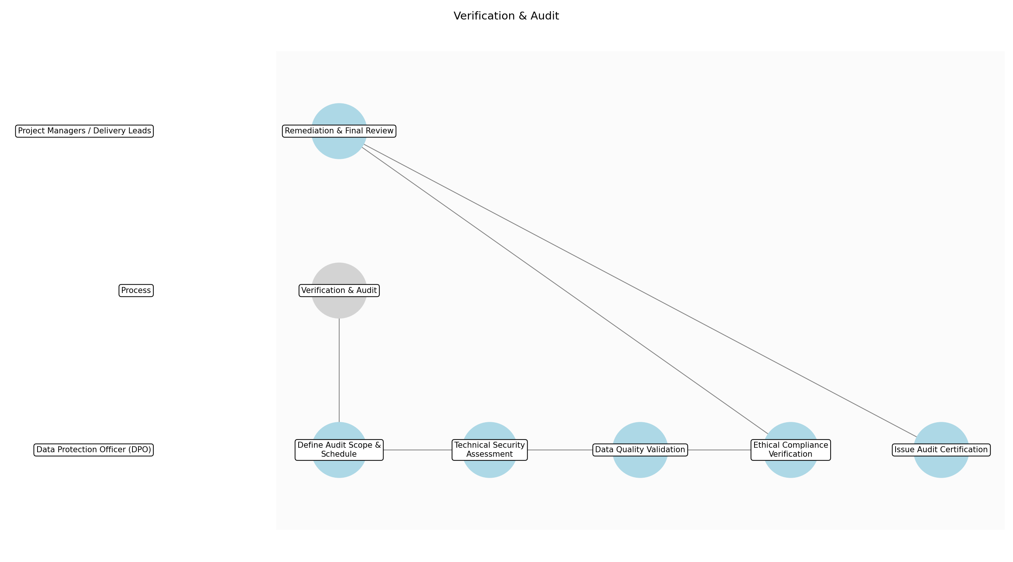

3.5.1 Define Audit Scope & Schedule
This subprocess describes the activities required to complete 'Define Audit Scope & Schedule'.

Description:
Establish the specific boundaries, technical components, and timeline for the independent audit. This involves identifying the AI models, data pipelines, and security infrastructure to be reviewed based on the project's risk profile.

Purpose:
To ensure the audit is focused, efficient, and covers all high-risk areas.

Scope:
Planning and scheduling of the verification activities.

Inputs:
The following inputs are required for this subprocess:
• Security Controls Documentation
• AI Model Design
• Risk Mitigation Plan

Outputs:
This subprocess produces the following outputs:
• Audit Plan
• Audit Schedule

Success Criteria:
Success for this subprocess is measured by:
• Audit Plan approved by the Chief Data Officer (CDO).
• Stakeholders notified of the audit timeline.

Triggers:
This subprocess is initiated by:
• Implementation completion

End Conditions:
This subprocess is considered complete when:
• Audit Plan finalized

Governance Requirements:
The following governance requirements apply:
• Independent Audit Requirement

Risks and Controls:
The following risks and controls apply:
• Risk: Incomplete audit scope.
• Control: Cross-reference scope with the initial Risk & Impact Assessment.

Change Management:
The following change management rules apply:
• Change Request Process: Audit scope amendment request.
• Versioning Rules: N/A

Continuous Improvement:
The following continuous improvement practices apply:
• Review Frequency: Annual
• Improvement Inputs:
• Audit reports

Estimated Duration:
The estimated duration for this subprocess is:
• 1 day

Process Owner:
The following process owner is accountable:
• Chief Data Officer (CDO)

Responsible Party:
The following parties are responsible for this subprocess:
• Data Protection Officer (DPO)

3.5.2 Technical Security Assessment
This subprocess describes the activities required to complete 'Technical Security Assessment'.

Description:
Conduct rigorous testing of the implemented security controls, including penetration testing of the hardened AI environment and verification of encryption protocols at rest and in transit.

Purpose:
To verify the technical security posture of the AI system.

Scope:
Technical security infrastructure and environment hardening.

Inputs:
The following inputs are required for this subprocess:
• Hardened AI Environment
• Security Controls Documentation

Outputs:
This subprocess produces the following outputs:
• Security Test Results
• Vulnerability Assessment Report

Success Criteria:
Success for this subprocess is measured by:
• All security controls tested against MoJ Security Standards.
• No unresolved 'Critical' or 'High' vulnerabilities.

Triggers:
This subprocess is initiated by:
• Audit Plan approval

End Conditions:
This subprocess is considered complete when:
• Security testing complete

Dependencies:
This subprocess depends on the following:
• Define Audit Scope & Schedule

Governance Requirements:
The following governance requirements apply:
• MoJ Security Standards compliance

Risks and Controls:
The following risks and controls apply:
• Risk: Undetected security flaws.
• Control: Use of automated vulnerability scanning and manual penetration testing.

Change Management:
The following change management rules apply:
• Change Request Process: Technical remediation request.
• Versioning Rules: N/A

Continuous Improvement:
The following continuous improvement practices apply:
• Review Frequency: Annual
• Improvement Inputs:
• Security audit logs

Estimated Duration:
The estimated duration for this subprocess is:
• 2 days

Process Owner:
The following process owner is accountable:
• Chief Data Officer (CDO)

Responsible Party:
The following parties are responsible for this subprocess:
• Data Protection Officer (DPO)

3.5.3 Data Quality Validation
This subprocess describes the activities required to complete 'Data Quality Validation'.

Description:
Validate the accuracy and reliability of the data quality scores provided by the project team. This includes re-running profiling tools on sample datasets to ensure consistency with reported metrics.

Purpose:
To ensure data integrity and fidelity for AI outcomes.

Scope:
Validation of data quality metrics and profiling results.

Inputs:
The following inputs are required for this subprocess:
• Data Quality Scores
• Data Quality Rules
• Source Data Systems

Outputs:
This subprocess produces the following outputs:
• Data Quality Validation Report

Success Criteria:
Success for this subprocess is measured by:
• Data quality scores verified within a 5% variance of project reports.
• Data lineage is transparent and documented.

Triggers:
This subprocess is initiated by:
• Audit Plan approval

End Conditions:
This subprocess is considered complete when:
• Data quality verification complete

Dependencies:
This subprocess depends on the following:
• Define Audit Scope & Schedule

Governance Requirements:
The following governance requirements apply:
• Data Integrity Standards

Risks and Controls:
The following risks and controls apply:
• Risk: Inaccurate data quality reporting.
• Control: Independent re-profiling of sample data subsets.

Change Management:
The following change management rules apply:
• Change Request Process: Data quality rule adjustment.
• Versioning Rules: N/A

Continuous Improvement:
The following continuous improvement practices apply:
• Review Frequency: Annual
• Improvement Inputs:
• Data profiling results

Estimated Duration:
The estimated duration for this subprocess is:
• 1 day

Process Owner:
The following process owner is accountable:
• Chief Data Officer (CDO)

Responsible Party:
The following parties are responsible for this subprocess:
• Data Protection Officer (DPO)

3.5.4 Ethical Compliance Verification
This subprocess describes the activities required to complete 'Ethical Compliance Verification'.

Description:
Review the AI model's performance against the ethical risk assessment to ensure no unintended bias or discriminatory patterns have emerged during the implementation phase.

Purpose:
To maintain public trust and ensure ethical integrity of AI decisions.

Scope:
Review of model fairness and ethical alignment.

Inputs:
The following inputs are required for this subprocess:
• AI Ethical Risk Assessment
• Model Performance Baselines
• Hardened AI Environment

Outputs:
This subprocess produces the following outputs:
• Ethical Compliance Memo

Success Criteria:
Success for this subprocess is measured by:
• Confirmation that model behavior aligns with MoJ ethical standards.
• Bias testing results are within acceptable thresholds.

Triggers:
This subprocess is initiated by:
• Audit Plan approval

End Conditions:
This subprocess is considered complete when:
• Ethical review complete

Dependencies:
This subprocess depends on the following:
• Define Audit Scope & Schedule

Governance Requirements:
The following governance requirements apply:
• AI Ethical Framework compliance

Risks and Controls:
The following risks and controls apply:
• Risk: Algorithmic bias.
• Control: Mandatory bias testing using diverse datasets.

Change Management:
The following change management rules apply:
• Change Request Process: Model logic adjustment request.
• Versioning Rules: N/A

Continuous Improvement:
The following continuous improvement practices apply:
• Review Frequency: Annual
• Improvement Inputs:
• Ethical review feedback

Estimated Duration:
The estimated duration for this subprocess is:
• 1 day

Process Owner:
The following process owner is accountable:
• Chief Data Officer (CDO)

Responsible Party:
The following parties are responsible for this subprocess:
• Data Protection Officer (DPO)

3.5.5 Remediation & Final Review
This subprocess describes the activities required to complete 'Remediation & Final Review'.

Description:
Collaborate with the project team to address any non-conformities or vulnerabilities identified during the technical and data audits. Verify that corrective actions have been successfully implemented.

Purpose:
To ensure the system meets all standards before formal certification.

Scope:
Corrective actions and final verification of fixes.

Inputs:
The following inputs are required for this subprocess:
• Security Test Results
• Data Quality Validation Report
• Ethical Compliance Memo

Outputs:
This subprocess produces the following outputs:
• Remediation Evidence
• Final Audit Findings

Success Criteria:
Success for this subprocess is measured by:
• All 'Critical' and 'High' findings resolved.
• Evidence of remediation provided and verified by DPO.

Triggers:
This subprocess is initiated by:
• Identification of audit non-conformities

End Conditions:
This subprocess is considered complete when:
• All critical findings addressed

Dependencies:
This subprocess depends on the following:
• Technical Security Assessment
• Data Quality Audit
• Ethical Compliance Verification

Governance Requirements:
The following governance requirements apply:
• Audit finding remediation policy

Risks and Controls:
The following risks and controls apply:
• Risk: Ineffective remediation.
• Control: Mandatory re-testing of failed controls.

Change Management:
The following change management rules apply:
• Change Request Process: Audit finding remediation.
• Versioning Rules: N/A

Continuous Improvement:
The following continuous improvement practices apply:
• Review Frequency: Annual
• Improvement Inputs:
• Remediation logs

Estimated Duration:
The estimated duration for this subprocess is:
• 1 day

Process Owner:
The following process owner is accountable:
• Chief Data Officer (CDO)

Responsible Party:
The following parties are responsible for this subprocess:
• Project Managers / Delivery Leads

3.5.6 Issue Audit Certification
This subprocess describes the activities required to complete 'Issue Audit Certification'.

Description:
Finalize the Verification Report and issue the formal Audit Certification. This document signals to the Governance Board that the project has met all security, quality, and ethical requirements.

Purpose:
To provide formal assurance for the Governance Sign-off stage.

Scope:
Final reporting and certification issuance.

Inputs:
The following inputs are required for this subprocess:
• Final Audit Findings
• Remediation Evidence

Outputs:
This subprocess produces the following outputs:
• Verification Report
• Audit Certification

Success Criteria:
Success for this subprocess is measured by:
• Signed Audit Certification issued.
• Verification Report archived in the central governance repository.

Triggers:
This subprocess is initiated by:
• Successful remediation of audit findings

End Conditions:
This subprocess is considered complete when:
• Verification complete

Dependencies:
This subprocess depends on the following:
• Remediation & Final Review

Governance Requirements:
The following governance requirements apply:
• Independent Audit Requirement

Risks and Controls:
The following risks and controls apply:
• Risk: Unauthorized certification issuance.
• Control: Dual-signature requirement (DPO and Lead Auditor).

Change Management:
The following change management rules apply:
• Change Request Process: N/A
• Versioning Rules: N/A

Continuous Improvement:
The following continuous improvement practices apply:
• Review Frequency: Annual
• Improvement Inputs:
• Audit reports

Estimated Duration:
The estimated duration for this subprocess is:
• 1 day

Process Owner:
The following process owner is accountable:
• Chief Data Officer (CDO)

Responsible Party:
The following parties are responsible for this subprocess:
• Data Protection Officer (DPO)

3.6 Governance Sign-off

Description:
Presentation of evidence to the MoJ Governance Board for approval. This final gate involves a comprehensive review of all project documentation and audit results to grant formal authorization for the system to go live.

Purpose:
To obtain formal organizational approval for operation.

Scope:
Final governance review.

Inputs:
The following inputs are required for this step:
• Audit Certification
• DPIA Report

Outputs:
This step produces the following outputs:
• Formal Approval Document

Success Criteria:
Success for this step is measured by:
• Issuance of Authorization to Operate (AtO).

Process Triggers:
This step is initiated by:
• Audit certification issued

Process End Conditions:
This step is considered complete when:
• AtO issued

Dependencies:
This step depends on the following:
• Verification & Audit

Deliverables:
This step produces the following deliverables:
• Authorization to Operate (AtO)

Governance Requirements:
The following governance requirements apply:
• Board Approval

Risks and Controls:
The following risks and controls apply:
• Control: Executive sign-off.
• Risk: Lack of organizational accountability.

Change Management:
The following change management rules apply:
• Change Request Process: Governance appeal process.
• Versioning Rules: N/A

Continuous Improvement:
The following continuous improvement practices apply:
• Review Frequency: Quarterly
• Improvement Inputs:
• Governance board feedback

Estimated Duration:
The estimated duration for this step is:
• 5 days

Process Owner:
The following process owner is accountable:
• Chief Data Officer (CDO)

Responsible Parties:
The following parties are responsible for this step:
• Chief Data Officer (CDO)

Required Sub Process(es) for the Step "Governance Sign-off"
The following details the subprocess flows for the step "Governance Sign-off".
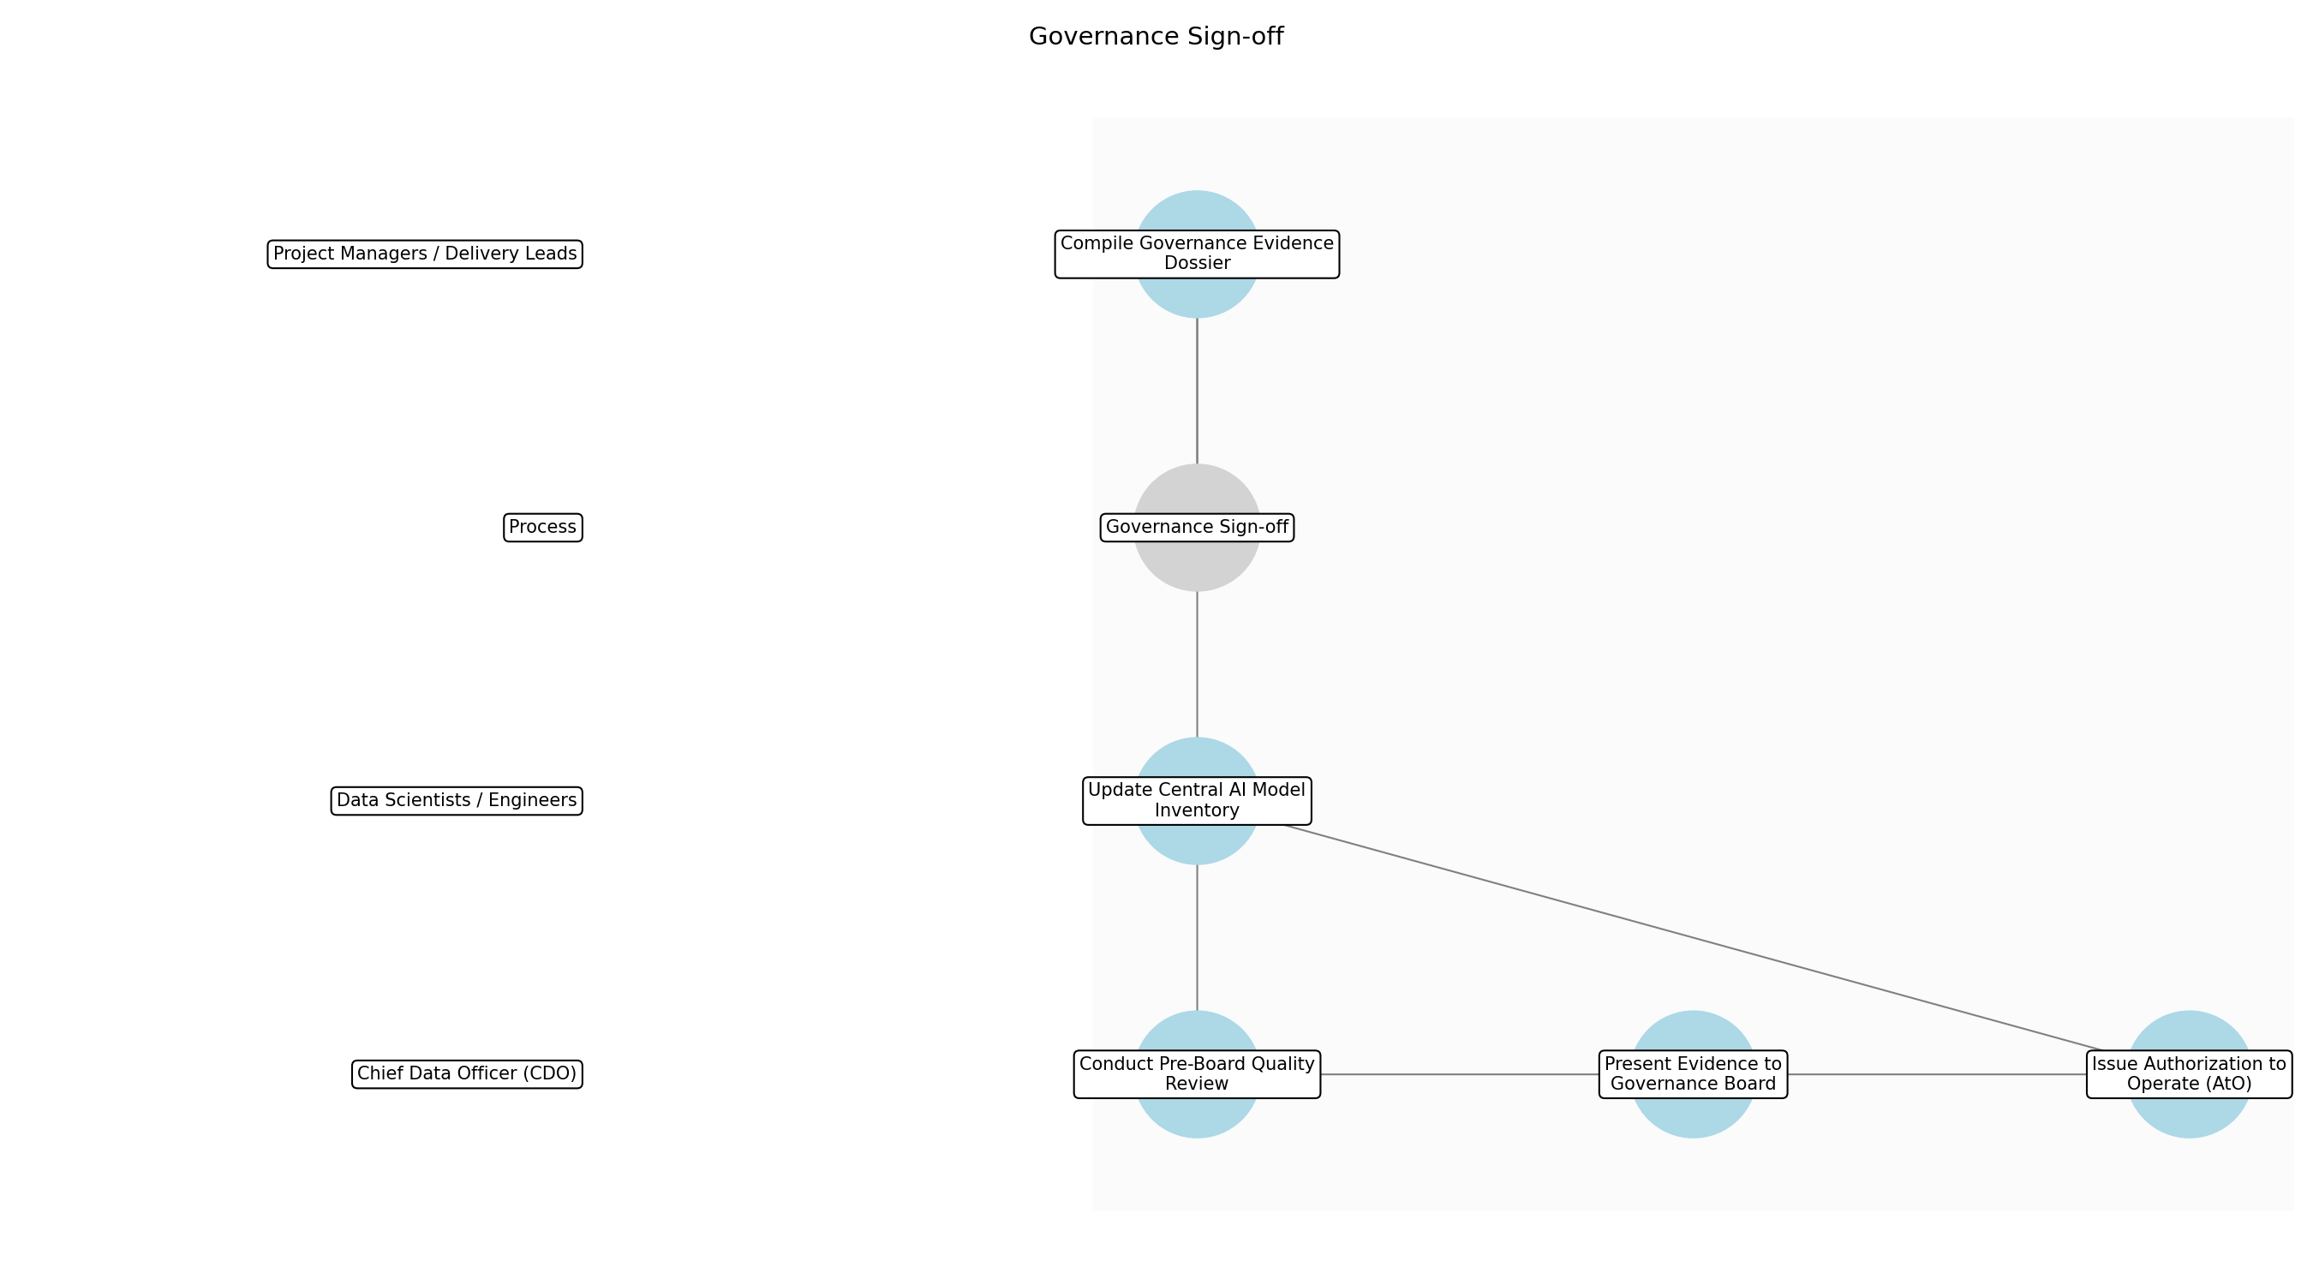

3.6.1 Compile Governance Evidence Dossier
This subprocess describes the activities required to complete 'Compile Governance Evidence Dossier'.

Description:
The project team aggregates all mandatory compliance artifacts into a single, structured dossier for board review. This includes the final Audit Certification, the signed-off DPIA Report, the Risk Mitigation Plan, and technical security documentation to ensure the board has a holistic view of the system's risk posture.

Purpose:
To centralize all evidence required for the formal approval decision.

Scope:
Aggregation of existing project artifacts.

Inputs:
The following inputs are required for this subprocess:
• Audit Certification
• DPIA Report
• Risk Mitigation Plan
• Security Controls Documentation

Outputs:
This subprocess produces the following outputs:
• Governance Evidence Dossier

Success Criteria:
Success for this subprocess is measured by:
• All mandatory documents are present and correctly formatted.
• Dossier is uploaded to the central governance portal.

Triggers:
This subprocess is initiated by:
• Audit certification issued

End Conditions:
This subprocess is considered complete when:
• Dossier finalized and ready for review

Governance Requirements:
The following governance requirements apply:
• Adherence to MoJ documentation standards

Risks and Controls:
The following risks and controls apply:
• Risk: Incomplete evidence leading to board rejection.
• Control: Mandatory checklist validation prior to submission.

Change Management:
The following change management rules apply:
• Change Request Process: Standard project change request.
• Versioning Rules: Dossier versioning linked to project ID.

Continuous Improvement:
The following continuous improvement practices apply:
• Review Frequency: Quarterly
• Improvement Inputs:
• Board feedback on dossier quality

Estimated Duration:
The estimated duration for this subprocess is:
• 1 day

Process Owner:
The following process owner is accountable:
• Chief Data Officer (CDO)

Responsible Party:
The following parties are responsible for this subprocess:
• Project Managers / Delivery Leads

3.6.2 Conduct Pre-Board Quality Review
This subprocess describes the activities required to complete 'Conduct Pre-Board Quality Review'.

Description:
The Chief Data Officer or a designated governance lead performs a preliminary review of the dossier to ensure it meets the necessary quality and compliance thresholds. This step acts as a filter to prevent incomplete or low-quality submissions from reaching the Governance Board, thereby optimizing board time.

Purpose:
To ensure the quality and completeness of the submission before formal board review.

Scope:
Internal review of the evidence dossier.

Inputs:
The following inputs are required for this subprocess:
• Governance Evidence Dossier

Outputs:
This subprocess produces the following outputs:
• QA Approval Memo

Success Criteria:
Success for this subprocess is measured by:
• CDO confirms dossier readiness for board presentation.
• No critical gaps identified in the evidence.

Triggers:
This subprocess is initiated by:
• Dossier submission to the Data Office

End Conditions:
This subprocess is considered complete when:
• QA Approval Memo issued

Dependencies:
This subprocess depends on the following:
• Compile Governance Evidence Dossier

Governance Requirements:
The following governance requirements apply:
• Internal Data Office oversight

Risks and Controls:
The following risks and controls apply:
• Risk: Subjective review criteria.
• Control: Use of a standardized QA rubric.

Change Management:
The following change management rules apply:
• Change Request Process: Governance appeal process.
• Versioning Rules: N/A

Continuous Improvement:
The following continuous improvement practices apply:
• Review Frequency: Quarterly
• Improvement Inputs:
• QA findings trends

Estimated Duration:
The estimated duration for this subprocess is:
• 1 day

Process Owner:
The following process owner is accountable:
• Chief Data Officer (CDO)

Responsible Party:
The following parties are responsible for this subprocess:
• Chief Data Officer (CDO)

3.6.3 Present Evidence to Governance Board
This subprocess describes the activities required to complete 'Present Evidence to Governance Board'.

Description:
The project lead and CDO present the AI system's compliance posture, ethical considerations, and risk mitigation strategies to the MoJ Governance Board. This session allows board members to ask clarifying questions and scrutinize the evidence provided in the dossier.

Purpose:
To provide the board with the necessary context to make an informed approval decision.

Scope:
Formal board presentation and Q&A.

Inputs:
The following inputs are required for this subprocess:
• Governance Evidence Dossier
• QA Approval Memo

Outputs:
This subprocess produces the following outputs:
• Board Meeting Minutes
• Decision Record

Success Criteria:
Success for this subprocess is measured by:
• Formal presentation completed.
• All board queries addressed or logged for follow-up.

Triggers:
This subprocess is initiated by:
• Scheduled board meeting date

End Conditions:
This subprocess is considered complete when:
• Board session concluded

Dependencies:
This subprocess depends on the following:
• Conduct Pre-Board Quality Review

Governance Requirements:
The following governance requirements apply:
• Board Approval

Risks and Controls:
The following risks and controls apply:
• Risk: Lack of board quorum.
• Control: Advance scheduling and mandatory attendance tracking.

Change Management:
The following change management rules apply:
• Change Request Process: Governance appeal process.
• Versioning Rules: N/A

Continuous Improvement:
The following continuous improvement practices apply:
• Review Frequency: Quarterly
• Improvement Inputs:
• Governance board feedback

Estimated Duration:
The estimated duration for this subprocess is:
• 2 hours

Process Owner:
The following process owner is accountable:
• Chief Data Officer (CDO)

Responsible Party:
The following parties are responsible for this subprocess:
• Chief Data Officer (CDO)

3.6.4 Issue Authorization to Operate (AtO)
This subprocess describes the activities required to complete 'Issue Authorization to Operate (AtO)'.

Description:
Following a positive board decision, the CDO formally signs and issues the Authorization to Operate (AtO). This document serves as the official permit for the AI system to transition into the live production environment, signifying that all governance requirements have been met.

Purpose:
To grant formal organizational approval for live operation.

Scope:
Formal documentation and signing.

Inputs:
The following inputs are required for this subprocess:
• Decision Record
• Board Meeting Minutes

Outputs:
This subprocess produces the following outputs:
• Formal Approval Document
• Authorization to Operate (AtO)

Success Criteria:
Success for this subprocess is measured by:
• AtO is signed by the CDO.
• AtO is distributed to the project team and DPO.

Triggers:
This subprocess is initiated by:
• Positive board decision

End Conditions:
This subprocess is considered complete when:
• AtO issued

Dependencies:
This subprocess depends on the following:
• Present Evidence to Governance Board

Governance Requirements:
The following governance requirements apply:
• Executive sign-off

Risks and Controls:
The following risks and controls apply:
• Risk: Unauthorized issuance of AtO.
• Control: Digital signature and secure document storage.

Change Management:
The following change management rules apply:
• Change Request Process: Governance appeal process.
• Versioning Rules: N/A

Continuous Improvement:
The following continuous improvement practices apply:
• Review Frequency: Quarterly
• Improvement Inputs:
• AtO issuance cycle time

Estimated Duration:
The estimated duration for this subprocess is:
• 1 day

Process Owner:
The following process owner is accountable:
• Chief Data Officer (CDO)

Responsible Party:
The following parties are responsible for this subprocess:
• Chief Data Officer (CDO)

3.6.5 Update Central AI Model Inventory
This subprocess describes the activities required to complete 'Update Central AI Model Inventory'.

Description:
The final step involves updating the MoJ's central AI model inventory to reflect the system's new 'Authorized' status. This includes uploading the AtO and linking it to the project's registration record to maintain a complete audit trail for the department.

Purpose:
To maintain an accurate and up-to-date record of all authorized AI systems.

Scope:
Data entry and record management in the central inventory.

Inputs:
The following inputs are required for this subprocess:
• Authorization to Operate (AtO)

Outputs:
This subprocess produces the following outputs:
• Updated AI Inventory Record

Success Criteria:
Success for this subprocess is measured by:
• Inventory record reflects 'Authorized' status.
• AtO document is accessible via the central catalog.

Triggers:
This subprocess is initiated by:
• AtO issuance

End Conditions:
This subprocess is considered complete when:
• Inventory update confirmed

Dependencies:
This subprocess depends on the following:
• Issue Authorization to Operate (AtO)

Governance Requirements:
The following governance requirements apply:
• Central AI model inventory entry

Risks and Controls:
The following risks and controls apply:
• Risk: Inventory data drift.
• Control: Automated synchronization with the governance portal.

Change Management:
The following change management rules apply:
• Change Request Process: Standard project change request.
• Versioning Rules: Inventory record versioning.

Continuous Improvement:
The following continuous improvement practices apply:
• Review Frequency: Quarterly
• Improvement Inputs:
• Inventory accuracy audits

Estimated Duration:
The estimated duration for this subprocess is:
• 4 hours

Process Owner:
The following process owner is accountable:
• Chief Data Officer (CDO)

Responsible Party:
The following parties are responsible for this subprocess:
• Data Scientists / Engineers

3.7 Operational Monitoring

Description:
Ongoing tracking of model performance and data drift. Once operational, the system is continuously monitored to detect any degradation in performance or shifts in data patterns that could impact the accuracy or fairness of the AI model.

Purpose:
To ensure continued accuracy and safety of the AI system.

Scope:
Operational AI system.

Inputs:
The following inputs are required for this step:
• Live System Data
• Model Performance Baselines

Outputs:
This step produces the following outputs:
• Monitoring Alerts

Success Criteria:
Success for this step is measured by:
• Model performance remains within defined thresholds.

Process Triggers:
This step is initiated by:
• System Go-Live

Process End Conditions:
This step is considered complete when:
• System decommissioning

Dependencies:
This step depends on the following:
• Governance Sign-off

Deliverables:
This step produces the following deliverables:
• Monitoring Dashboards
• Performance Reports

Governance Requirements:
The following governance requirements apply:
• Continuous Monitoring Policy

Risks and Controls:
The following risks and controls apply:
• Risk: Model drift or bias.
• Control: Human-in-the-loop validation.

Change Management:
The following change management rules apply:
• Versioning Rules: Model versioning.
• Change Request Process: Model retraining/update process.

Continuous Improvement:
The following continuous improvement practices apply:
• Improvement Inputs:
• Performance logs
• Drift alerts
• Review Frequency: Continuous

Estimated Duration:
The estimated duration for this step is:
• Ongoing

Process Owner:
The following process owner is accountable:
• Chief Data Officer (CDO)

Responsible Parties:
The following parties are responsible for this step:
• Data Scientists / Engineers

Required Sub Process(es) for the Step "Operational Monitoring"
The following details the subprocess flows for the step "Operational Monitoring".
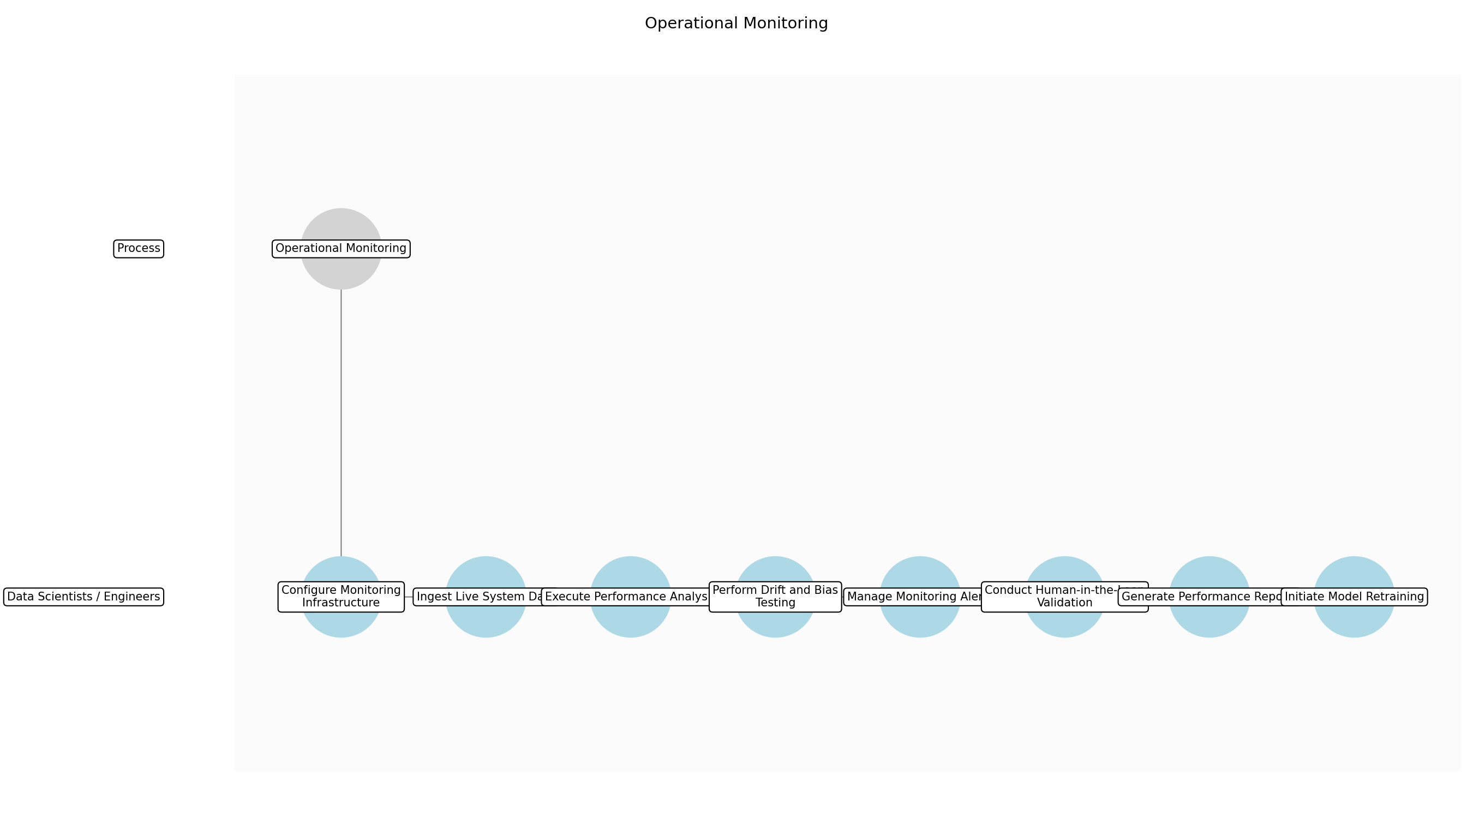

3.7.1 Configure Monitoring Infrastructure
This subprocess describes the activities required to complete 'Configure Monitoring Infrastructure'.

Description:
Establish the technical environment for real-time tracking by configuring the AI Governance Platform and dashboards. This includes setting up telemetry pipelines from the live system and defining threshold-based alert triggers for performance and drift.

Purpose:
To establish the technical environment for real-time tracking.

Scope:
Monitoring tool configuration.

Inputs:
The following inputs are required for this subprocess:
• Model Performance Baselines
• System Requirements

Outputs:
This subprocess produces the following outputs:
• Monitoring Dashboards
• Alert Configurations

Success Criteria:
Success for this subprocess is measured by:
• Dashboards are active and receiving test telemetry.
• Alert thresholds are documented and implemented.

Triggers:
This subprocess is initiated by:
• System Go-Live

End Conditions:
This subprocess is considered complete when:
• Monitoring tools are fully operational.

Governance Requirements:
The following governance requirements apply:
• Continuous Monitoring Policy

Risks and Controls:
The following risks and controls apply:
• Risk: Incorrect alert threshold settings.
• Control: Peer review of monitoring configurations.

Change Management:
The following change management rules apply:
• Change Request Process: Standard technical change control.
• Versioning Rules: Configuration versioning.

Continuous Improvement:
The following continuous improvement practices apply:
• Review Frequency: Quarterly
• Improvement Inputs:
• Alert accuracy logs

Estimated Duration:
The estimated duration for this subprocess is:
• 2–3 days

Process Owner:
The following process owner is accountable:
• Chief Data Officer (CDO)

Responsible Party:
The following parties are responsible for this subprocess:
• Data Scientists / Engineers

3.7.2 Ingest Live System Data
This subprocess describes the activities required to complete 'Ingest Live System Data'.

Description:
Establish secure data pipelines to ingest live inference data and ground truth into the monitoring environment. This ensures the monitoring system has a representative and up-to-date view of current operational patterns.

Purpose:
To provide the raw data necessary for performance monitoring.

Scope:
Data ingestion and pre-processing.

Inputs:
The following inputs are required for this subprocess:
• Live System Data
• Monitoring Dashboards

Outputs:
This subprocess produces the following outputs:
• Processed Telemetry Data

Success Criteria:
Success for this subprocess is measured by:
• Data flows continuously without loss or corruption.
• Data latency remains within defined limits.

Triggers:
This subprocess is initiated by:
• System Go-Live

End Conditions:
This subprocess is considered complete when:
• Data ingestion pipeline is active.

Dependencies:
This subprocess depends on the following:
• Configure Monitoring Infrastructure

Governance Requirements:
The following governance requirements apply:
• GSC Compliance
• UK GDPR

Risks and Controls:
The following risks and controls apply:
• Risk: Data leakage during ingestion.
• Control: Encryption in transit and secure data environments (SDE).

Change Management:
The following change management rules apply:
• Change Request Process: Data schema update request.
• Versioning Rules: Data versioning policy.

Continuous Improvement:
The following continuous improvement practices apply:
• Review Frequency: Monthly
• Improvement Inputs:
• Pipeline performance logs

Estimated Duration:
The estimated duration for this subprocess is:
• Ongoing

Process Owner:
The following process owner is accountable:
• Chief Data Officer (CDO)

Responsible Party:
The following parties are responsible for this subprocess:
• Data Scientists / Engineers

3.7.3 Execute Performance Analysis
This subprocess describes the activities required to complete 'Execute Performance Analysis'.

Description:
Compare the processed telemetry data against established model performance baselines. This involves calculating key performance indicators such as accuracy, precision, and recall to detect any degradation in model effectiveness.

Purpose:
To quantify current model accuracy and effectiveness.

Scope:
Statistical performance evaluation.

Inputs:
The following inputs are required for this subprocess:
• Processed Telemetry Data
• Model Performance Baselines

Outputs:
This subprocess produces the following outputs:
• Performance Metrics

Success Criteria:
Success for this subprocess is measured by:
• Metrics are calculated and updated on dashboards.
• Performance remains within 5% of baseline.

Triggers:
This subprocess is initiated by:
• New data ingestion

End Conditions:
This subprocess is considered complete when:
• Metrics are published to dashboards.

Dependencies:
This subprocess depends on the following:
• Ingest Live System Data

Governance Requirements:
The following governance requirements apply:
• Continuous Monitoring Policy

Risks and Controls:
The following risks and controls apply:
• Risk: Undetected performance degradation.
• Control: Automated daily metric calculation.

Change Management:
The following change management rules apply:
• Change Request Process: Metric definition update process.
• Versioning Rules: N/A

Continuous Improvement:
The following continuous improvement practices apply:
• Review Frequency: Quarterly
• Improvement Inputs:
• Performance logs

Estimated Duration:
The estimated duration for this subprocess is:
• Daily

Process Owner:
The following process owner is accountable:
• Chief Data Officer (CDO)

Responsible Party:
The following parties are responsible for this subprocess:
• Data Scientists / Engineers

3.7.4 Perform Drift and Bias Testing
This subprocess describes the activities required to complete 'Perform Drift and Bias Testing'.

Description:
Run statistical tests to identify data drift and concept drift. Additionally, evaluate the model for bias against protected characteristics to ensure fairness and compliance with ethical standards.

Purpose:
To detect shifts in data patterns or emerging unfairness.

Scope:
Drift and bias detection.

Inputs:
The following inputs are required for this subprocess:
• Processed Telemetry Data
• Model Performance Baselines

Outputs:
This subprocess produces the following outputs:
• Drift Analysis Report
• Bias Assessment Results

Success Criteria:
Success for this subprocess is measured by:
• Drift and bias scores are within acceptable MoJ thresholds.
• Reports are generated and logged.

Triggers:
This subprocess is initiated by:
• Scheduled weekly review

End Conditions:
This subprocess is considered complete when:
• Analysis reports are finalized.

Dependencies:
This subprocess depends on the following:
• Ingest Live System Data

Governance Requirements:
The following governance requirements apply:
• AI Ethical Risk Assessment standards

Risks and Controls:
The following risks and controls apply:
• Risk: Model bias affecting judicial outcomes.
• Control: Automated bias detection algorithms.

Change Management:
The following change management rules apply:
• Change Request Process: Threshold adjustment request.
• Versioning Rules: N/A

Continuous Improvement:
The following continuous improvement practices apply:
• Review Frequency: Quarterly
• Improvement Inputs:
• Drift alerts
• Legal updates

Estimated Duration:
The estimated duration for this subprocess is:
• Weekly

Process Owner:
The following process owner is accountable:
• Chief Data Officer (CDO)

Responsible Party:
The following parties are responsible for this subprocess:
• Data Scientists / Engineers

3.7.5 Manage Monitoring Alerts
This subprocess describes the activities required to complete 'Manage Monitoring Alerts'.

Description:
Monitor the automated alert system for breaches of performance or drift thresholds. Alerts are triaged based on severity and assigned to the appropriate technical team for immediate investigation.

Purpose:
To ensure timely response to performance issues.

Scope:
Alert management and triage.

Inputs:
The following inputs are required for this subprocess:
• Alert Configurations
• Performance Metrics
• Drift Analysis Report

Outputs:
This subprocess produces the following outputs:
• Monitoring Alerts
• Triage Logs

Success Criteria:
Success for this subprocess is measured by:
• All high-severity alerts are acknowledged within 4 hours.
• Triage logs are complete and accurate.

Triggers:
This subprocess is initiated by:
• Threshold breach

End Conditions:
This subprocess is considered complete when:
• Alert is triaged and assigned.

Dependencies:
This subprocess depends on the following:
• Execute Performance Analysis
• Perform Drift and Bias Testing

Governance Requirements:
The following governance requirements apply:
• Continuous Monitoring Policy

Risks and Controls:
The following risks and controls apply:
• Risk: Alert fatigue leading to missed incidents.
• Control: Alert severity classification and escalation paths.

Change Management:
The following change management rules apply:
• Change Request Process: Alert logic update.
• Versioning Rules: N/A

Continuous Improvement:
The following continuous improvement practices apply:
• Review Frequency: Monthly
• Improvement Inputs:
• Incident response times

Estimated Duration:
The estimated duration for this subprocess is:
• Real-time

Process Owner:
The following process owner is accountable:
• Chief Data Officer (CDO)

Responsible Party:
The following parties are responsible for this subprocess:
• Data Scientists / Engineers

3.7.6 Conduct Human-in-the-Loop Validation
This subprocess describes the activities required to complete 'Conduct Human-in-the-Loop Validation'.

Description:
Subject matter experts and data scientists review flagged anomalies or threshold breaches. This manual validation determines if the alert represents a genuine risk to judicial outcomes or a false positive.

Purpose:
To provide expert oversight on automated findings.

Scope:
Expert review of anomalies.

Inputs:
The following inputs are required for this subprocess:
• Monitoring Alerts
• Live System Data

Outputs:
This subprocess produces the following outputs:
• Validation Findings

Success Criteria:
Success for this subprocess is measured by:
• Root cause of the alert is identified and documented.
• Validation report is signed off by a Senior Data Scientist.

Triggers:
This subprocess is initiated by:
• High-severity alert triage

End Conditions:
This subprocess is considered complete when:
• Validation report finalized.

Dependencies:
This subprocess depends on the following:
• Manage Monitoring Alerts

Governance Requirements:
The following governance requirements apply:
• Ethical AI Principles

Risks and Controls:
The following risks and controls apply:
• Risk: Human error in validation.
• Control: Human-in-the-loop validation by multiple experts.

Change Management:
The following change management rules apply:
• Change Request Process: N/A
• Versioning Rules: N/A

Continuous Improvement:
The following continuous improvement practices apply:
• Review Frequency: Annual
• Improvement Inputs:
• Validation feedback

Estimated Duration:
The estimated duration for this subprocess is:
• 1–2 days

Process Owner:
The following process owner is accountable:
• Chief Data Officer (CDO)

Responsible Party:
The following parties are responsible for this subprocess:
• Data Scientists / Engineers

3.7.7 Generate Performance Reports
This subprocess describes the activities required to complete 'Generate Performance Reports'.

Description:
Compile performance metrics, drift analysis, and validation findings into comprehensive performance reports. These reports provide the Chief Data Officer with evidence of continued compliance and system safety.

Purpose:
To inform stakeholders of system health and compliance.

Scope:
Stakeholder reporting.

Inputs:
The following inputs are required for this subprocess:
• Performance Metrics
• Validation Findings
• Drift Analysis Report

Outputs:
This subprocess produces the following outputs:
• Performance Reports

Success Criteria:
Success for this subprocess is measured by:
• Reports are delivered and reviewed by the CDO.
• Reports contain all mandatory compliance data.

Triggers:
This subprocess is initiated by:
• End of month

End Conditions:
This subprocess is considered complete when:
• Report distribution complete.

Dependencies:
This subprocess depends on the following:
• Execute Performance Analysis
• Conduct Human-in-the-Loop Validation

Governance Requirements:
The following governance requirements apply:
• Bi-annual compliance audits

Risks and Controls:
The following risks and controls apply:
• Risk: Inaccurate reporting to leadership.
• Control: Automated report generation from verified data sources.

Change Management:
The following change management rules apply:
• Change Request Process: Report template update.
• Versioning Rules: N/A

Continuous Improvement:
The following continuous improvement practices apply:
• Review Frequency: Quarterly
• Improvement Inputs:
• Stakeholder feedback

Estimated Duration:
The estimated duration for this subprocess is:
• 1 day

Process Owner:
The following process owner is accountable:
• Chief Data Officer (CDO)

Responsible Party:
The following parties are responsible for this subprocess:
• Data Scientists / Engineers

3.7.8 Initiate Model Retraining
This subprocess describes the activities required to complete 'Initiate Model Retraining'.

Description:
If monitoring reveals significant drift or performance loss that cannot be resolved through configuration, a formal change request is initiated to retrain or update the AI model logic.

Purpose:
To remediate performance degradation through model updates.

Scope:
Remediation initiation.

Inputs:
The following inputs are required for this subprocess:
• Performance Reports
• Validation Findings

Outputs:
This subprocess produces the following outputs:
• Change Request for Model Update

Success Criteria:
Success for this subprocess is measured by:
• Change request is logged in the central inventory.
• CDO approves the retraining initiation.

Triggers:
This subprocess is initiated by:
• Performance remains below threshold after validation

End Conditions:
This subprocess is considered complete when:
• Transition to Model Retraining process.

Dependencies:
This subprocess depends on the following:
• Generate Performance Reports

Governance Requirements:
The following governance requirements apply:
• Maintenance of a central AI model inventory

Risks and Controls:
The following risks and controls apply:
• Risk: Uncontrolled model updates.
• Control: Mandatory re-assessment for any updates to AI model logic.

Change Management:
The following change management rules apply:
• Change Request Process: Model retraining/update process.
• Versioning Rules: Model versioning.

Continuous Improvement:
The following continuous improvement practices apply:
• Review Frequency: Continuous
• Improvement Inputs:
• Performance logs

Estimated Duration:
The estimated duration for this subprocess is:
• 1 day

Process Owner:
The following process owner is accountable:
• Chief Data Officer (CDO)

Responsible Party:
The following parties are responsible for this subprocess:
• Data Scientists / Engineers

4.0 Supporting Systems and Tools
The following tools and platforms support this process:
Category | Tools
Data Governance | Collibra, AI Governance Platform
Data Quality & Security | Automated Data Profiling tools, Secure Data Environments (SDE)

5.0 Metrics and Key Performance Indicators (KPIs)
The following metrics help monitor performance and ensure alignment with business objectives.
Metric | Description | Measurement / Frequency | Target
Compliance Rate | Percentage of projects passing governance gates. | Monthly | 100%
Data Quality Index (DQI) | Scores for critical justice datasets. | Quarterly | >95%
Security Incidents | Number of data security incidents involving AI systems. | Real-time | 0
Approval Lead Time | Average lead time for governance approval cycles. | Monthly | <10 business days

6.0 Critical Success Factors (CSF)
The following is a list of key CSFs associated with this process.
Success Factor | Description
Executive Mandate | Executive mandate from MoJ leadership for framework adherence.
Automated Tooling | Integrated automated scanning for data classification and quality.
Ethical Alignment | Clear communication of ethical AI principles across the department.

7.0 Critical Failure Factors (CFF)
The following is a list of key CFFs associated with this process.
Failure Factor | Description
Bureaucratic Bottlenecks | Overly bureaucratic approval processes leading to 'Shadow AI'.
Undefined Data Ownership | Lack of clear data ownership at the project level.
Resource Constraints | Inadequate funding for automated data quality tooling.

8.0 Reporting and Analytics
The following reporting and analytics capabilities support monitoring and decision-making:
Report / Dashboard | Description
Report | Enterprise-wide compliance dashboards.
Report | Project-level data quality scorecards.

9.0 System Requirements
The following system requirements are essential for the successful implementation of this process.
Name | Details
Governance Platforms | Enterprise Data Catalog (e.g., Collibra) and AI Governance Platform.
Data Infrastructure | Secure Data Environments (SDE) and Automated Data Profiling tools.

10.0 Process Flow Diagram
The following diagram provides a high-level visualization of the process flow.
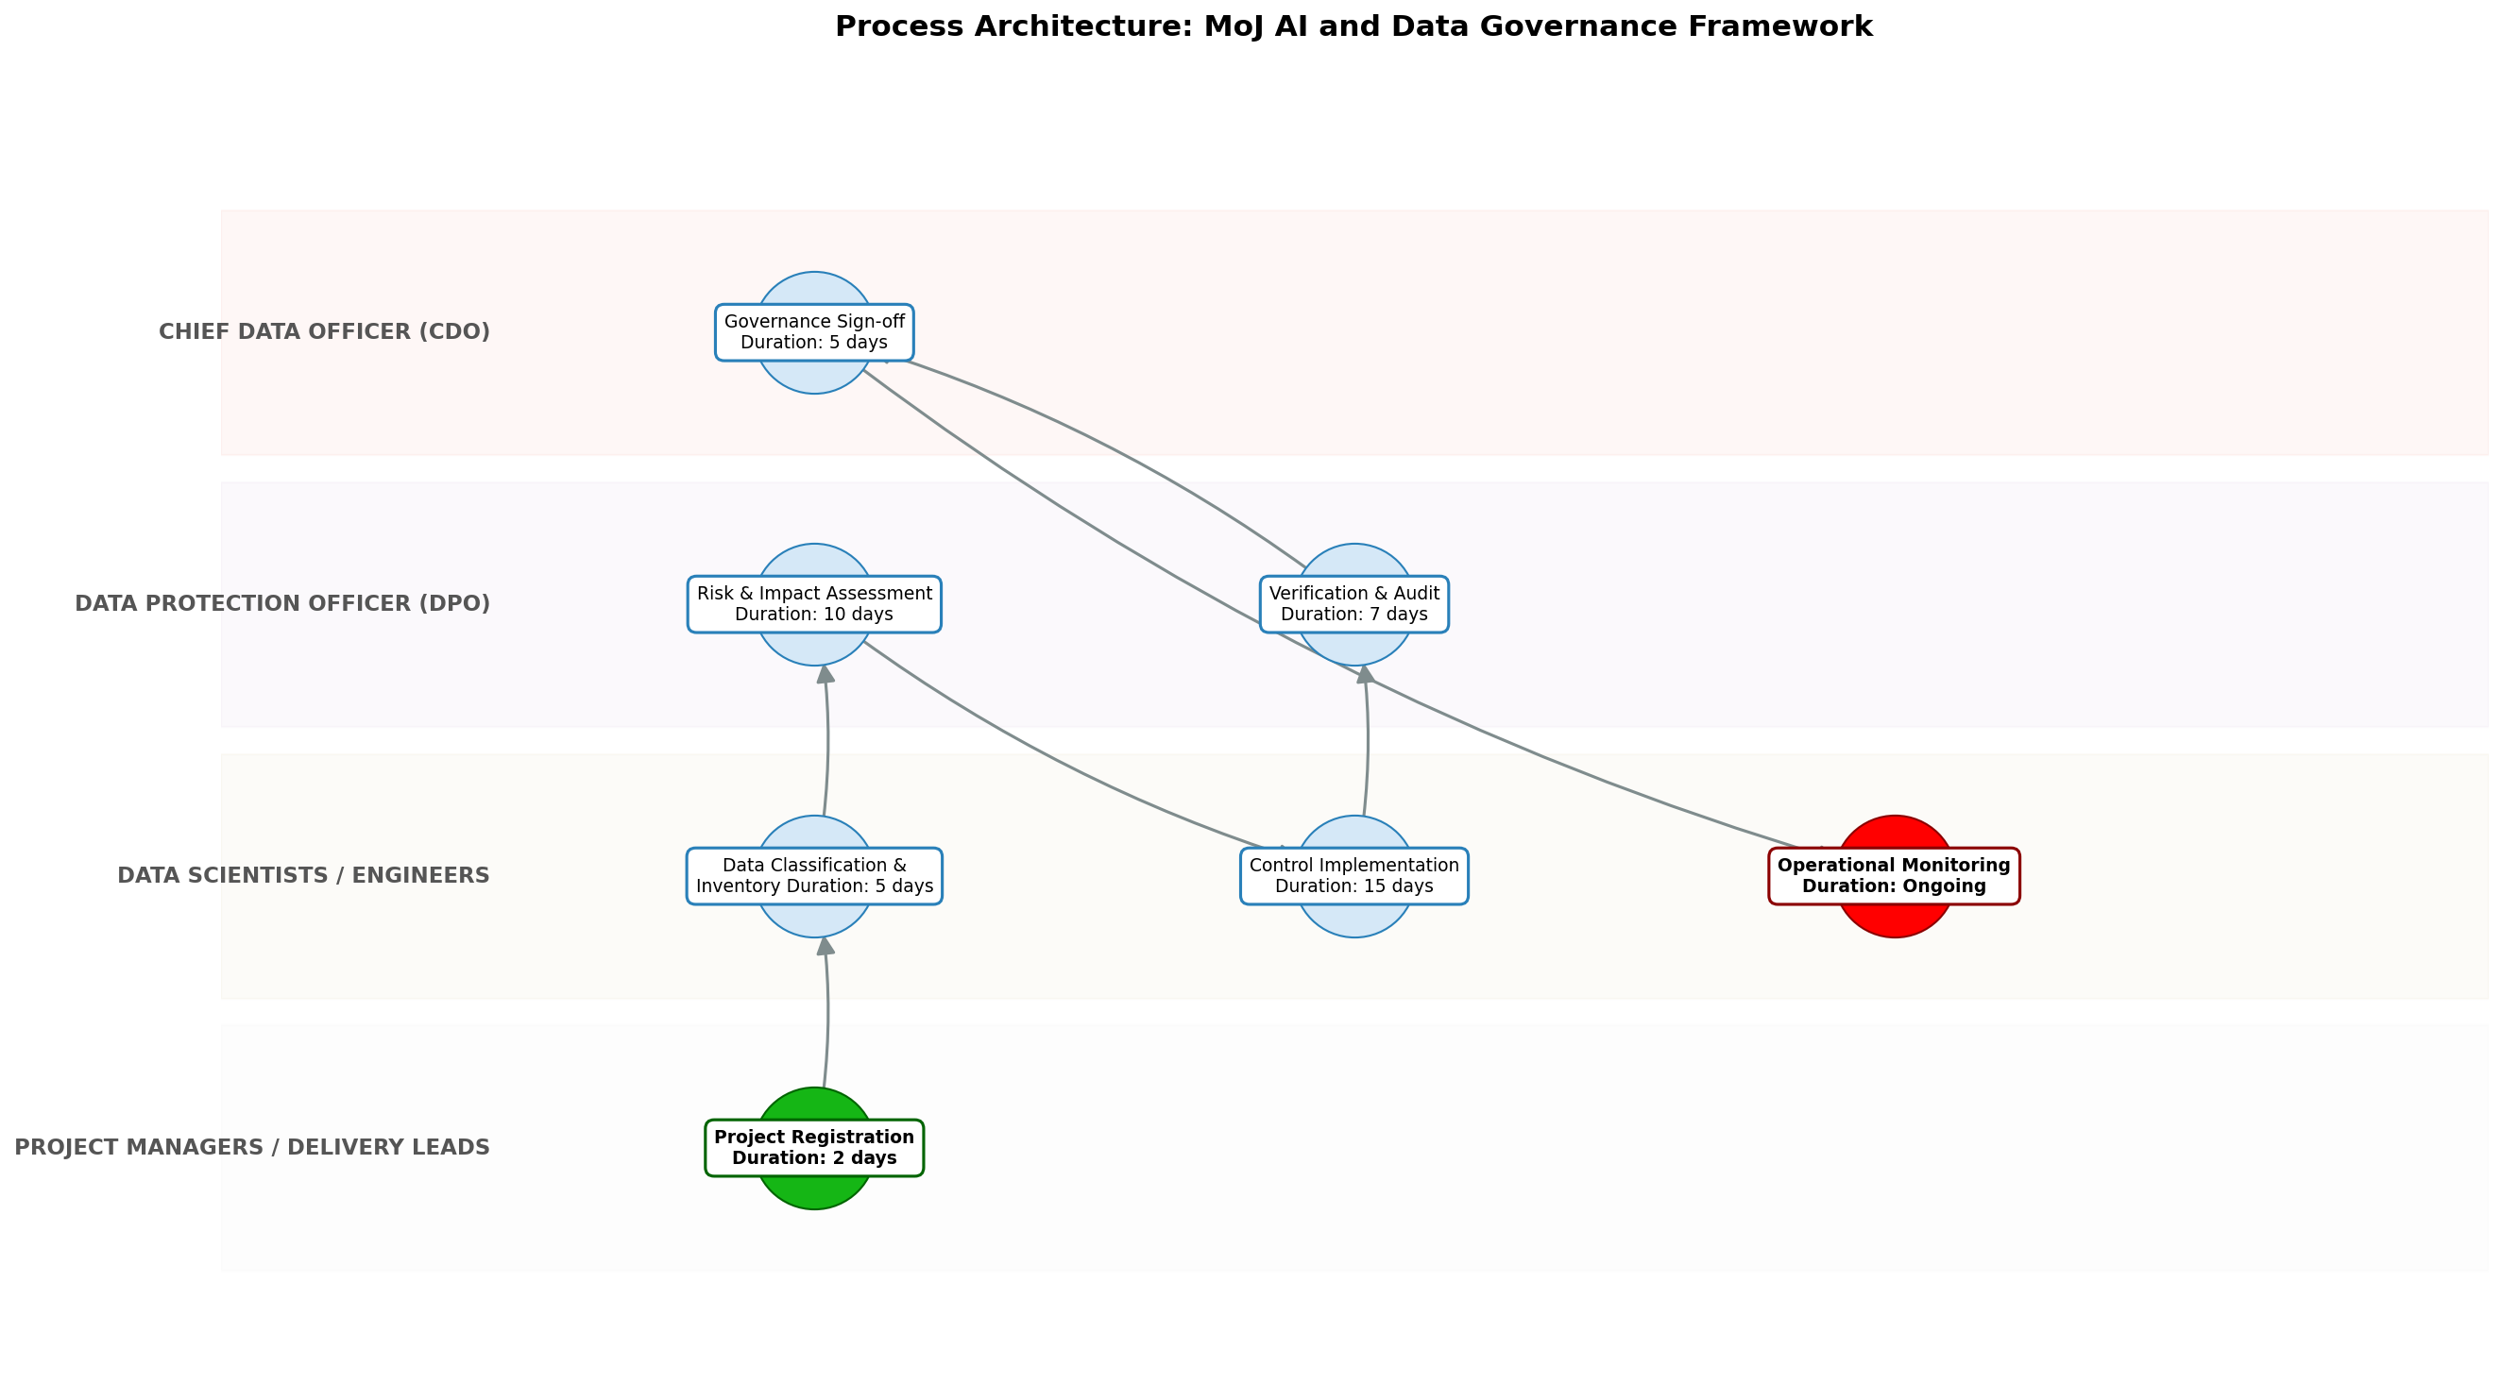

11.0 Process Performance Report
The following metrics are based on a Monte Carlo discrete-event simulation running 2,000 iterations. All time-based values are reported in days.
Operational Metric | Simulated Value
Average Cycle Time | 59.93 days
Cycle Time Variance | 6.49 days
Contention Risk Profile | Low

Identified Bottlenecks
- Control Implementation
- Risk & Impact Assessment
- Verification & Audit

Detailed Step Performance
Process Step | Avg. Duration (days)
Project Registration | 2.65
Data Classification & Inventory | 6.69
Risk & Impact Assessment | 13.24
Control Implementation | 20.06
Verification & Audit | 9.26
Governance Sign-off | 6.69
Operational Monitoring | 1.34

12.0 Governance Requirements
The following governance requirements apply to this process:
• Bi-annual compliance audits
• Maintenance of a central AI model inventory
• Documented Data Protection Impact Assessments (DPIAs)

13.0 Risks and Controls
The following risks and associated controls apply to this process:
Risk | Control
Bias or inaccuracy in AI models affecting judicial outcomes. | Mandatory human-in-the-loop validation for high-impact AI decisions.
Unauthorized access or leakage of sensitive person-identifiable information (PII). | Encryption at rest/transit and automated classification labelling.

14.0 Process Triggers
The following triggers initiate this process:
• Initiation of a new digital project or a significant change to an existing data-driven system.

15.0 Process End Conditions
The following conditions indicate completion of the process:
• Issuance of a formal Authorization to Operate (AtO) or system decommissioning.

16.0 Change Management
The following change management practices apply to this process:
• Change Request Process: Mandatory re-assessment for any updates to AI model logic or underlying data schemas.
• Versioning Rules: Semantic versioning for models and data schemas; all changes logged in central inventory.

17.0 Continuous Improvement
The following continuous improvement practices apply to this process:
• Review Frequency: Quarterly
Improvement Inputs:
• Internal performance metrics
• Evolving UK AI regulations

Appendix B: Additional Source Data
This appendix contains additional structured data from the normalized source JSON that is not covered in the main sections.
Field | Value
Scope | All internal MoJ digital projects and third-party vendor solutions processing justice-related data or utilizing AI.
Process Owner | Chief Data Officer (CDO)
Purpose | To establish a consistent, secure, and ethical framework for AI and data management within the Ministry of Justice to mitigate risk and improve public service outcomes.

Appendix C: Glossary
This glossary contains definitions of common terms used in the process documentation:
Term | Definition
Business Process | A set of related activities or tasks performed to achieve a specific organizational goal.
KPI | Key Performance Indicator used to measure the success or health of a process.
Stakeholder | Any individual or group with an interest in the outcomes of the process.
Continuous Improvement | Ongoing effort to improve products, services, or processes.

