Inventory Stock-out Handling Process
This process outlines the steps for handling inventory stock-outs in a retail environment, from identification to prevention. The primary goal is to minimize lost sales and customer dissatisfaction by ensuring product availability through proactive monitoring, efficient inter-departmental communication, and effective inventory management practices. The process encompasses identifying stock-outs, verifying the shortage, performing a root cause analysis, taking immediate actions, placing replenishment orders, fulfilling the order, replenishing the inventory, and implementing preventive measures to minimize future stock-out occurrences. Version 1.4 addresses bottlenecks identified in Preventive Measures, Inventory Replenishment, and Stock-out Identification.
Industry / Domain: Retail
Version: 1.4
Generated On: 2026-01-04 12:38:20

Document Control
Version | Date | Author | Description
1.4 | 2026-01-04 | Process Architect | Initial generated process specification

Table of Contents

1.0 Process Overview
This process outlines the steps for handling inventory stock-outs in a retail environment, from identification to prevention. The primary goal is to minimize lost sales and customer dissatisfaction by ensuring product availability through proactive monitoring, efficient inter-departmental communication, and effective inventory management practices. The process encompasses identifying stock-outs, verifying the shortage, performing a root cause analysis, taking immediate actions, placing replenishment orders, fulfilling the order, replenishing the inventory, and implementing preventive measures to minimize future stock-out occurrences. Version 1.4 addresses bottlenecks identified in Preventive Measures, Inventory Replenishment, and Stock-out Identification.
Industry Sector: Retail

2.0 Stakeholders and Responsibilities
The following is a list of key stakeholders involved in this process. Understanding their roles and responsibilities is crucial for successful implementation.
Stakeholder | Responsibilities
Store Manager | Overseeing all store operations.  Making decisions related to inventory management.  Ensuring compliance with the stock-out handling process.  Approving orders for inventory replenishment.
Inventory Management Team | Monitoring inventory levels.  Analyzing stock-out data.  Implementing corrective actions.  Verifying reported stock-outs.  Performing root cause analysis.  Placing replenishment orders.  Updating system records upon inventory receipt.  Implementing preventive measures.
Sales Associates | Identifying stock-outs on the sales floor.  Reporting stock-outs to the Inventory Management Team immediately.  Assisting customers with alternative products when a stock-out occurs.  Restocking shelves with replenished inventory.
Purchasing Department | Replenishing inventory based on stock-out data and demand forecasts.  Processing orders from the Inventory Management Team.  Communicating with suppliers to ensure timely delivery of inventory.  Monitoring lead times and adjusting order quantities as needed.
Warehouse Staff | Fulfilling orders from the Purchasing Department.  Shipping inventory to the store.  Ensuring accurate and timely delivery of inventory.  Maintaining inventory accuracy in the warehouse.

3.0 Process Workflow
The following is a list of key steps in the process workflow.

3.1 Stock-out Identification
Sales associates identify stock-outs on the sales floor by observing empty shelves or customer inquiries regarding unavailable products. To improve speed and accuracy, the store has implemented real-time shelf monitoring using RFID tags and sensors. Sales associates are alerted via their handheld devices when a stock-out is detected. The effectiveness of RFID tag placement and sensor sensitivity is regularly evaluated and adjusted to ensure optimal performance. Sales associates must promptly report stock-outs to the Inventory Management Team, providing details such as the product ID, location on the sales floor, and estimated time the stock-out was noticed. This can be done manually using a stock-out reporting form or electronically using handheld devices to scan the shelf and compare it to the system inventory. Accurate and timely identification is crucial for initiating the stock-out handling process effectively.
Responsible Parties: Sales Associates
Success Criteria:
- Stock-outs are identified and reported within 5 minutes of occurrence.
- Stock-out reports contain accurate product and location information.

Required Sub Process(es) for the Step "Stock-out Identification"
The following details the subprocess flows for the step "Stock-out Identification".
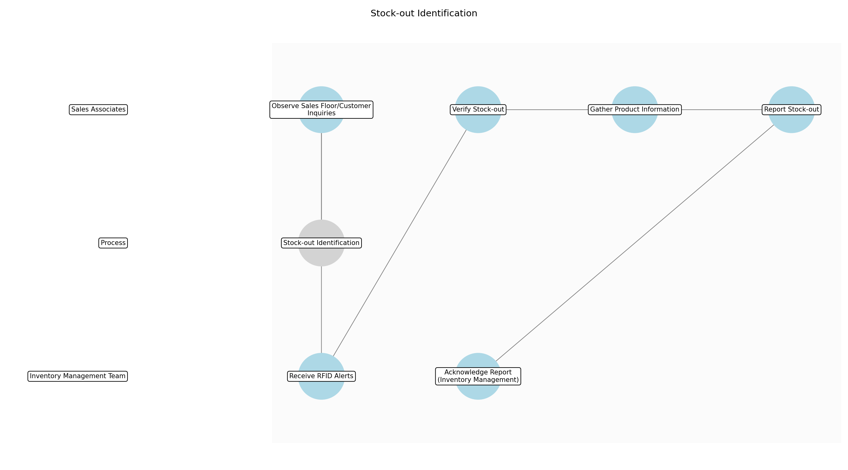

Stock-out Identification – Observe Sales Floor/Customer Inquiries
Description: Sales associates continuously monitor the sales floor visually, paying attention to shelf emptiness and customer inquiries about product availability.
Responsible Parties: Sales Associates
Inputs:
Outputs:
Dependencies:
Estimated Duration: Ongoing
Success Criteria:
- Sales associates actively scan the sales floor during their shifts.
- Customer inquiries are promptly addressed.

Stock-out Identification – Receive RFID Alerts
Description: Sales associates receive automated alerts on their handheld devices when RFID sensors detect a stock-out.
Responsible Parties: Inventory Management Team
Inputs:
Outputs:
Dependencies:
Estimated Duration: Real-time
Success Criteria:
- RFID system is functioning correctly and sending alerts.
- Sales associates are receiving and acknowledging alerts.

Stock-out Identification – Verify Stock-out
Description: Upon observation or alert, sales associates physically verify the stock-out by checking the shelf and immediate surrounding area.
Responsible Parties: Sales Associates
Inputs:
Outputs:
Dependencies:
- Observe Sales Floor/Customer Inquiries
- Receive RFID Alerts
Estimated Duration: 30-60 seconds
Success Criteria:
- Physical confirmation of stock-out on the shelf.

Stock-out Identification – Gather Product Information
Description: Sales associates gather necessary product information, including product ID, location on the sales floor (aisle, shelf number), and estimated time the stock-out was noticed.
Responsible Parties: Sales Associates
Inputs:
Outputs:
Dependencies:
- Verify Stock-out
Estimated Duration: 30-60 seconds
Success Criteria:
- All required product information is accurately collected.

Stock-out Identification – Report Stock-out
Description: Sales associates report the stock-out to the Inventory Management Team using either the manual stock-out reporting form or the electronic reporting function on their handheld devices.
Responsible Parties: Sales Associates
Inputs:
Outputs:
- Stock-out report (manual or electronic)
Dependencies:
- Gather Product Information
Estimated Duration: 1-2 minutes
Success Criteria:
- Stock-out report is submitted to the Inventory Management Team.
- Report includes all necessary product and location details.

Stock-out Identification – Acknowledge Report (Inventory Management)
Description: The Inventory Management Team acknowledges receipt of the stock-out report.
Responsible Parties: Inventory Management Team
Inputs:
- Stock-out report (manual or electronic)
Outputs:
Dependencies:
- Report Stock-out
Estimated Duration: 1 minute
Success Criteria:
- Inventory Management Team has acknowledged receipt of the report.

3.2 Verification and Documentation
Upon receiving a stock-out report, the Inventory Management Team verifies the stock-out by checking physical inventory in the back stock and on the sales floor, as well as system records in the Inventory Management System. If the stock-out is confirmed, the Inventory Management Team documents the stock-out details, including the product ID, quantity, time of occurrence, potential causes, and the sales associate who reported the stock-out. Proper documentation is essential for analyzing stock-out trends and implementing effective preventive measures, and is stored for later review.
Responsible Parties: Inventory Management Team
Success Criteria:
- Stock-outs are verified within 30 minutes of being reported.
- Stock-out documentation is complete and accurate.

Required Sub Process(es) for the Step "Verification and Documentation"
The following details the subprocess flows for the step "Verification and Documentation".
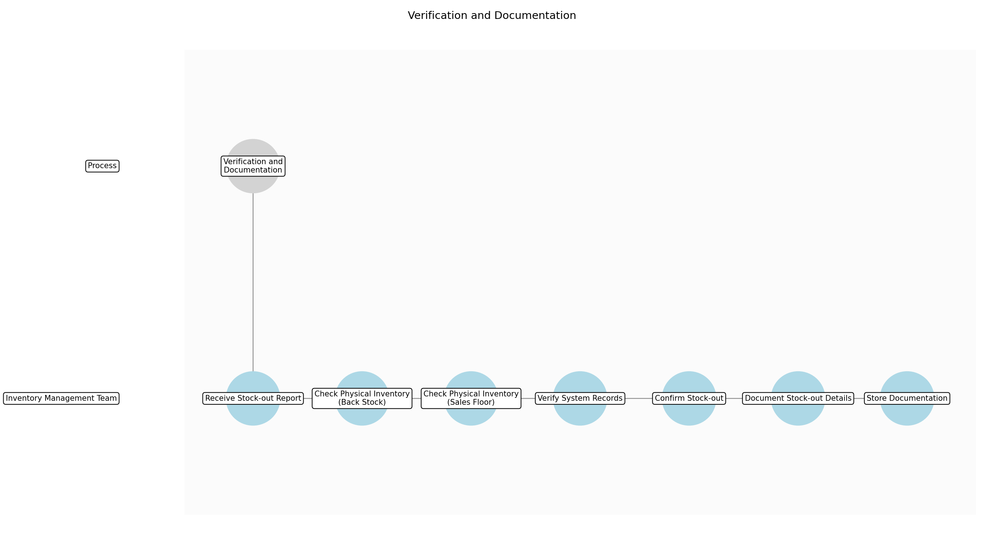

Verification and Documentation – Receive Stock-out Report
Description: The Inventory Management Team receives the stock-out report from the sales associate, either manually or electronically.
Responsible Parties: Inventory Management Team
Inputs:
- Stock-out report (manual or electronic)
Outputs:
Dependencies:
Estimated Duration: Instantaneous
Success Criteria:
- Stock-out report is successfully received by the Inventory Management Team.

Verification and Documentation – Check Physical Inventory (Back Stock)
Description: The Inventory Management Team checks the back stock area for the product identified in the stock-out report.
Responsible Parties: Inventory Management Team
Inputs:
Outputs:
Dependencies:
- Receive Stock-out Report
Estimated Duration: 3-5 minutes
Success Criteria:
- Back stock area has been thoroughly checked for the product.

Verification and Documentation – Check Physical Inventory (Sales Floor)
Description: If the product is not found in the back stock, the Inventory Management Team re-verifies the stock-out location on the sales floor to ensure the initial report was accurate and that no remaining items are present.
Responsible Parties: Inventory Management Team
Inputs:
Outputs:
Dependencies:
- Check Physical Inventory (Back Stock)
Estimated Duration: 2-3 minutes
Success Criteria:
- Sales floor location has been re-verified for the product.

Verification and Documentation – Verify System Records
Description: The Inventory Management Team verifies the inventory levels in the Inventory Management System to confirm the stock-out and check for any discrepancies between physical inventory and system records.
Responsible Parties: Inventory Management Team
Inputs:
Outputs:
Dependencies:
- Check Physical Inventory (Sales Floor)
Estimated Duration: 2-3 minutes
Success Criteria:
- Inventory levels in the system have been verified against the physical inventory.

Verification and Documentation – Confirm Stock-out
Description: Based on the physical inventory checks and system record verification, the Inventory Management Team confirms whether a true stock-out has occurred.
Responsible Parties: Inventory Management Team
Inputs:
Outputs:
- Stock-out confirmation
Dependencies:
- Verify System Records
Estimated Duration: 1 minute
Success Criteria:
- A decision has been made whether the reported issue is a valid stock-out.

Verification and Documentation – Document Stock-out Details
Description: If the stock-out is confirmed, the Inventory Management Team documents all relevant details, including product ID, quantity out of stock, time of occurrence, potential causes (if known), and the sales associate who reported the stock-out. They should also note the verification steps taken.
Responsible Parties: Inventory Management Team
Inputs:
- Stock-out confirmation
Outputs:
- Verified stock-out documentation
Dependencies:
- Confirm Stock-out
Estimated Duration: 5-10 minutes
Success Criteria:
- Complete and accurate documentation of the stock-out details.

Verification and Documentation – Store Documentation
Description: The verified stock-out documentation is stored in the designated location (either physical or electronic) for later review and analysis.
Responsible Parties: Inventory Management Team
Inputs:
- Verified stock-out documentation
Outputs:
Dependencies:
- Document Stock-out Details
Estimated Duration: 1 minute
Success Criteria:
- Stock-out documentation is stored in the correct location and is easily accessible.

3.3 Root Cause Analysis
The Inventory Management Team conducts a thorough root cause analysis to determine the underlying cause of the stock-out. To expedite the process, the team now utilizes a standardized checklist and decision tree to guide the analysis. This involves analyzing sales data, reviewing past orders, checking for discrepancies in inventory records, identifying potential supply chain issues, and considering factors such as unexpected demand surges, delays in delivery, or errors in inventory management practices. The root cause analysis should identify the primary reason for the stock-out to prevent similar incidents in the future. The analysis needs to be documented and tracked, along with any shortfalls or errors.
Responsible Parties: Inventory Management Team
Success Criteria:
- Root cause analysis is completed within 90 minutes of stock-out verification.
- Root cause analysis identifies the primary reason for the stock-out.

Required Sub Process(es) for the Step "Root Cause Analysis"
The following details the subprocess flows for the step "Root Cause Analysis".
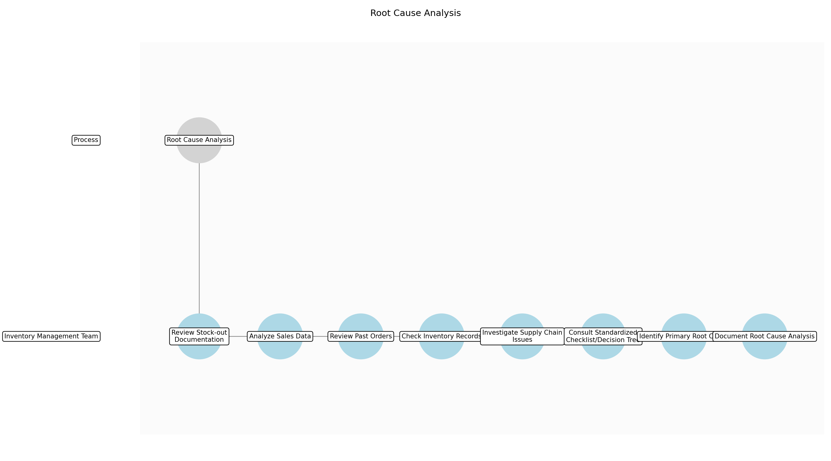

Root Cause Analysis – Review Stock-out Documentation
Description: The Inventory Management Team reviews the verified stock-out documentation to understand the initial circumstances surrounding the stock-out.
Responsible Parties: Inventory Management Team
Inputs:
- Verified stock-out documentation
Outputs:
Dependencies:
Estimated Duration: 5-10 minutes
Success Criteria:
- The Inventory Management Team has reviewed the stock-out documentation.

Root Cause Analysis – Analyze Sales Data
Description: The team analyzes recent sales data for the product to identify any unusual trends or spikes in demand that may have contributed to the stock-out.
Responsible Parties: Inventory Management Team
Inputs:
Outputs:
Dependencies:
- Review Stock-out Documentation
Estimated Duration: 10-15 minutes
Success Criteria:
- Sales data for the product has been analyzed for recent trends.

Root Cause Analysis – Review Past Orders
Description: The team reviews past orders for the product to check for any delays, discrepancies, or unusual order patterns.
Responsible Parties: Inventory Management Team
Inputs:
Outputs:
Dependencies:
- Review Stock-out Documentation
Estimated Duration: 10-15 minutes
Success Criteria:
- Past orders for the product have been reviewed for any issues.

Root Cause Analysis – Check Inventory Records
Description: The team checks inventory records for discrepancies, errors, or inconsistencies that may have led to the stock-out.
Responsible Parties: Inventory Management Team
Inputs:
Outputs:
Dependencies:
- Review Stock-out Documentation
Estimated Duration: 10-15 minutes
Success Criteria:
- Inventory records have been thoroughly checked for errors.

Root Cause Analysis – Investigate Supply Chain Issues
Description: The team investigates potential supply chain issues, such as delays in delivery, supplier shortages, or transportation problems.
Responsible Parties: Inventory Management Team
Inputs:
Outputs:
Dependencies:
- Review Stock-out Documentation
Estimated Duration: 10-20 minutes
Success Criteria:
- Potential supply chain issues have been investigated.

Root Cause Analysis – Consult Standardized Checklist/Decision Tree
Description: The team uses the standardized checklist and decision tree to guide the root cause analysis process and ensure all relevant factors are considered.
Responsible Parties: Inventory Management Team
Inputs:
Outputs:
Dependencies:
- Analyze Sales Data
- Review Past Orders
- Check Inventory Records
- Investigate Supply Chain Issues
Estimated Duration: 5-10 minutes
Success Criteria:
- The standardized checklist and decision tree have been consulted.

Root Cause Analysis – Identify Primary Root Cause
Description: Based on the analysis and checklist, the team identifies the primary root cause of the stock-out.
Responsible Parties: Inventory Management Team
Inputs:
Outputs:
- Primary root cause of stock-out
Dependencies:
- Consult Standardized Checklist/Decision Tree
Estimated Duration: 5-10 minutes
Success Criteria:
- The primary root cause of the stock-out has been identified.

Root Cause Analysis – Document Root Cause Analysis
Description: The team documents the entire root cause analysis process, including the identified root cause, supporting evidence, and any shortfalls or errors encountered during the analysis.
Responsible Parties: Inventory Management Team
Inputs:
- Primary root cause of stock-out
Outputs:
- Root cause analysis report
Dependencies:
- Identify Primary Root Cause
Estimated Duration: 5-10 minutes
Success Criteria:
- The root cause analysis report is complete and accurate.

3.4 Immediate Action
If possible, the Inventory Management Team takes immediate action to address the stock-out and minimize its impact on customers. A designated team member is now responsible for coordinating immediate actions, ensuring quicker response times. This may involve checking the back stock for additional inventory, contacting other stores for inventory transfer, or expediting the next order from the supplier. The Inventory Management Team should communicate with sales associates to inform them of the actions taken and provide them with alternative product suggestions to offer to customers. Any immediate actions are taken to remedy the stock-out issue immediately for the customer.
Responsible Parties: Inventory Management Team
Success Criteria:
- Immediate action is taken within 45 minutes of root cause analysis.
- Temporary stock-out resolution is achieved whenever possible.

Required Sub Process(es) for the Step "Immediate Action"
The following details the subprocess flows for the step "Immediate Action".
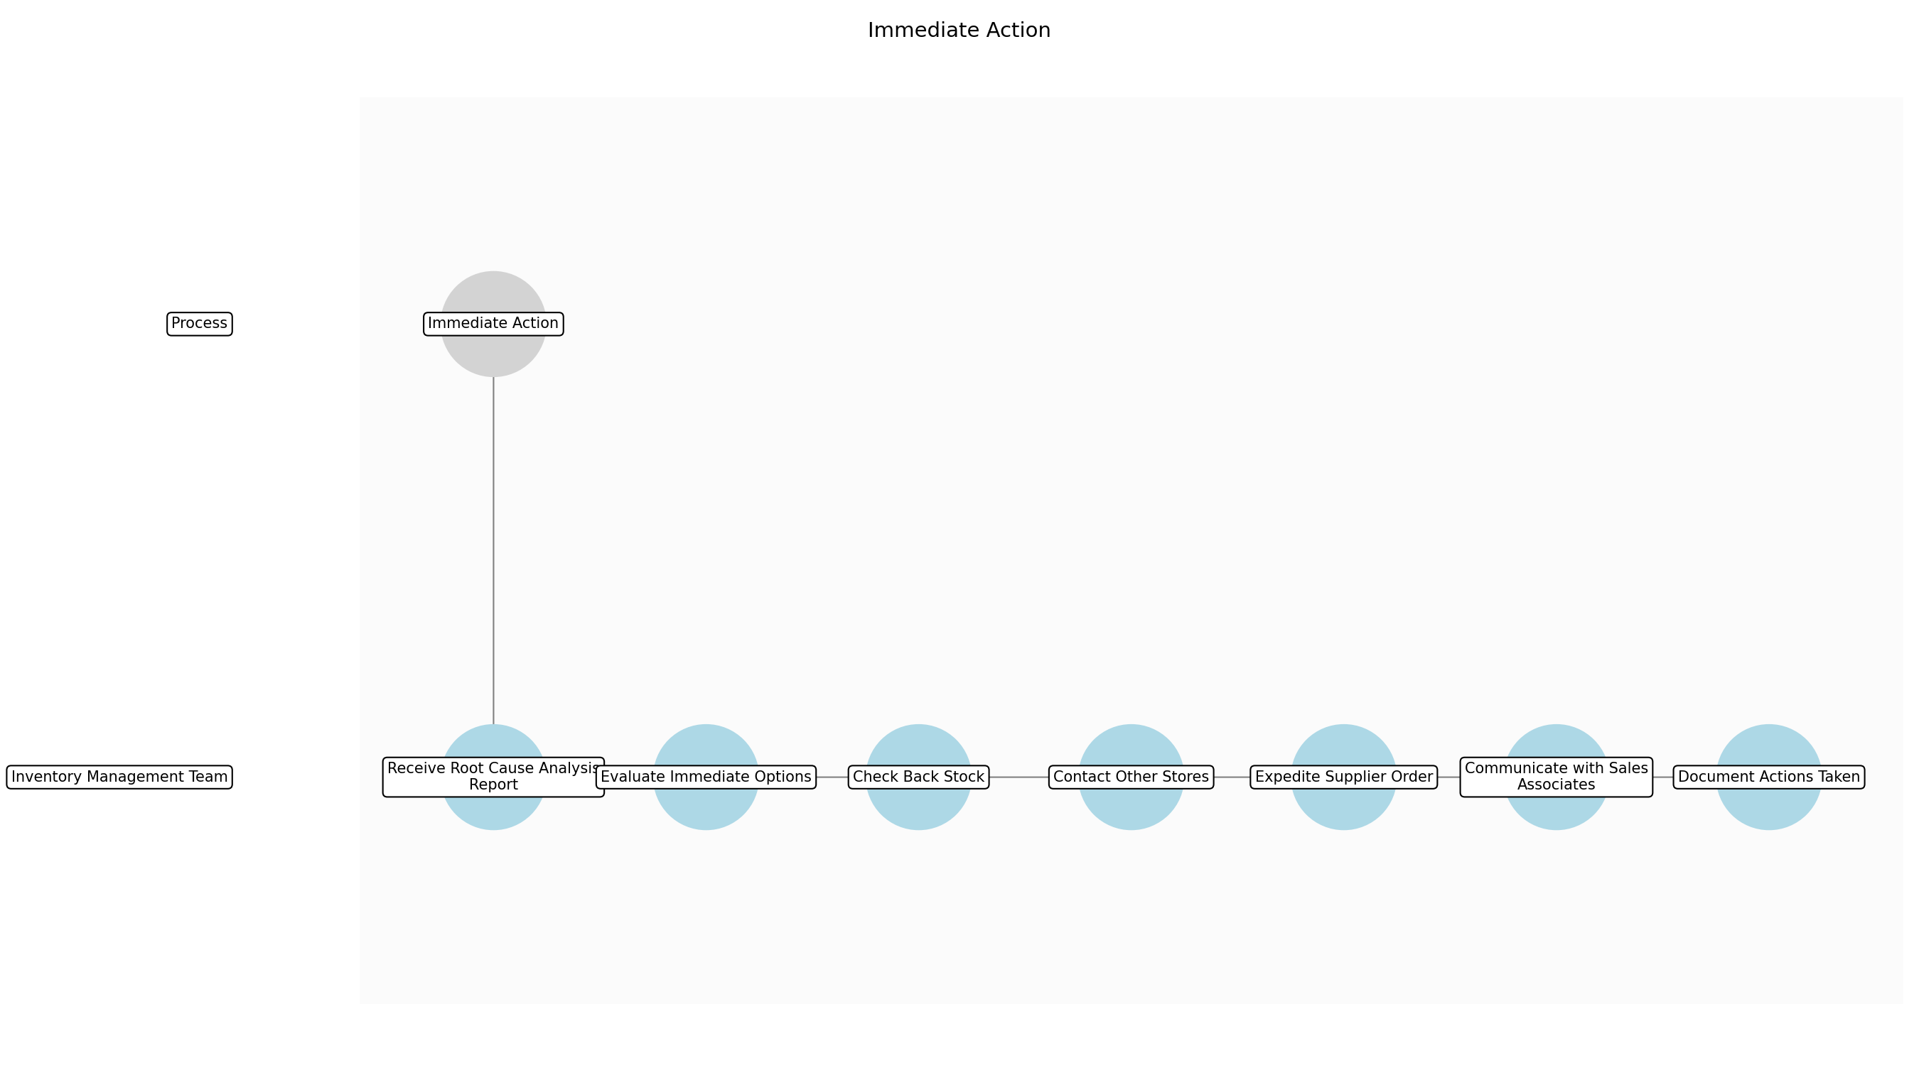

Immediate Action – Receive Root Cause Analysis Report
Description: The designated Inventory Management Team member receives the Root Cause Analysis Report to understand the reason for the stock-out.
Responsible Parties: Inventory Management Team
Inputs:
- Root cause analysis report
Outputs:
Dependencies:
Estimated Duration: Instantaneous
Success Criteria:
- Designated team member has received the Root Cause Analysis Report.

Immediate Action – Evaluate Immediate Options
Description: The designated team member evaluates the available options for immediate action based on the root cause and current inventory levels.
Responsible Parties: Inventory Management Team
Inputs:
Outputs:
Dependencies:
- Receive Root Cause Analysis Report
Estimated Duration: 5-10 minutes
Success Criteria:
- Possible immediate actions have been identified and assessed.

Immediate Action – Check Back Stock
Description: The team member checks the back stock for any additional inventory of the stocked-out product.
Responsible Parties: Inventory Management Team
Inputs:
Outputs:
Dependencies:
- Evaluate Immediate Options
Estimated Duration: 5-10 minutes
Success Criteria:
- Back stock has been thoroughly checked for the product.

Immediate Action – Contact Other Stores
Description: If back stock is unavailable, the team member contacts other store locations to inquire about inventory transfer possibilities.
Responsible Parties: Inventory Management Team
Inputs:
Outputs:
Dependencies:
- Check Back Stock
Estimated Duration: 5-15 minutes
Success Criteria:
- Other store locations have been contacted regarding inventory transfer.

Immediate Action – Expedite Supplier Order
Description: If inventory transfer is not possible, the team member contacts the supplier to expedite the next order of the stocked-out product.
Responsible Parties: Inventory Management Team
Inputs:
Outputs:
Dependencies:
- Contact Other Stores
Estimated Duration: 5-10 minutes
Success Criteria:
- Supplier has been contacted to expedite the next order.

Immediate Action – Communicate with Sales Associates
Description: The team member communicates the actions taken to sales associates and provides them with alternative product suggestions to offer to customers.
Responsible Parties: Inventory Management Team
Inputs:
Outputs:
Dependencies:
- Check Back Stock
- Contact Other Stores
- Expedite Supplier Order
Estimated Duration: 2-5 minutes
Success Criteria:
- Sales associates are informed of the situation and provided with alternative product suggestions.

Immediate Action – Document Actions Taken
Description: The team member documents all actions taken to address the stock-out, including the outcome of each action.
Responsible Parties: Inventory Management Team
Inputs:
Outputs:
- Documentation of immediate actions
Dependencies:
- Communicate with Sales Associates
Estimated Duration: 2-5 minutes
Success Criteria:
- All actions taken have been documented.

3.5 Order Placement
If the stock-out cannot be resolved immediately through checking back stock or transferring inventory, the Inventory Management Team places an order with the Purchasing Department to replenish the inventory. To streamline this step, the Inventory Management Team now utilizes pre-approved order templates for frequently stocked-out items. The order quantity is determined based on demand forecasts, lead times, safety stock levels, and the identified root cause of the stock-out. The Inventory Management Team communicates the urgency of the order to the Purchasing Department to ensure timely replenishment. They ensure sufficient justification for the order is given to the purchasing department for reconciliation.
Responsible Parties: Inventory Management Team
Success Criteria:
- Replenishment order is placed within 20 minutes of determining the need.
- Order quantity is based on accurate demand forecasts and lead times.

Required Sub Process(es) for the Step "Order Placement"
The following details the subprocess flows for the step "Order Placement".
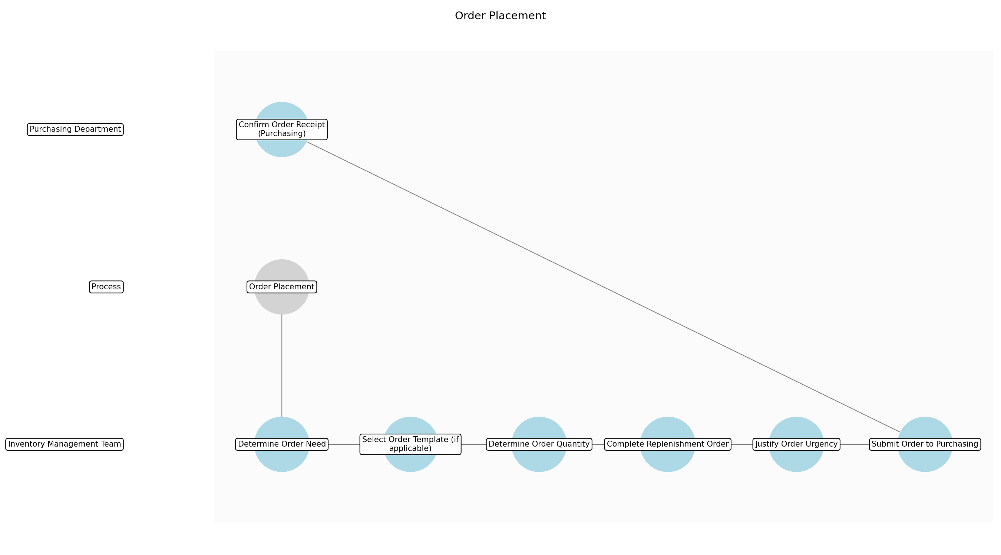

Order Placement – Determine Order Need
Description: Confirm that the stock-out cannot be resolved through immediate actions (back stock, transfers, etc.) and that a replenishment order is necessary.
Responsible Parties: Inventory Management Team
Inputs:
- Documentation of immediate actions
Outputs:
Dependencies:
Estimated Duration: 2 minutes
Success Criteria:
- Confirmation that a replenishment order is required.

Order Placement – Select Order Template (if applicable)
Description: If the stocked-out item is a frequently stocked-out item, select the pre-approved order template for that item.
Responsible Parties: Inventory Management Team
Inputs:
Outputs:
Dependencies:
- Determine Order Need
Estimated Duration: 1-2 minutes
Success Criteria:
- Appropriate order template has been selected (if available).

Order Placement – Determine Order Quantity
Description: Determine the order quantity based on demand forecasts, lead times, safety stock levels, and the identified root cause of the stock-out. Adjust the quantity from the template if needed.
Responsible Parties: Inventory Management Team
Inputs:
Outputs:
Dependencies:
- Determine Order Need
Estimated Duration: 3-5 minutes
Success Criteria:
- Order quantity is accurately calculated based on relevant factors.

Order Placement – Complete Replenishment Order
Description: Complete the replenishment order form (either manual or electronic) with all necessary information, including product ID, order quantity, and delivery instructions.
Responsible Parties: Inventory Management Team
Inputs:
Outputs:
- Replenishment order
Dependencies:
- Determine Order Quantity
Estimated Duration: 2-3 minutes
Success Criteria:
- Replenishment order form is complete and accurate.

Order Placement – Justify Order Urgency
Description: Provide sufficient justification for the urgency of the order, referencing the stock-out situation and potential impact on sales and customer satisfaction.
Responsible Parties: Inventory Management Team
Inputs:
Outputs:
Dependencies:
- Complete Replenishment Order
Estimated Duration: 1-2 minutes
Success Criteria:
- Clear and compelling justification for order urgency is provided.

Order Placement – Submit Order to Purchasing
Description: Submit the completed replenishment order to the Purchasing Department.
Responsible Parties: Inventory Management Team
Inputs:
- Replenishment order
Outputs:
Dependencies:
- Justify Order Urgency
Estimated Duration: 1 minute
Success Criteria:
- Replenishment order has been successfully submitted to the Purchasing Department.

Order Placement – Confirm Order Receipt (Purchasing)
Description: The Purchasing Department confirms receipt of the replenishment order.
Responsible Parties: Purchasing Department
Inputs:
Outputs:
Dependencies:
- Submit Order to Purchasing
Estimated Duration: 1 minute
Success Criteria:
- Purchasing Department has confirmed receipt of the replenishment order.

3.6 Order Fulfillment
The Purchasing Department sends the order to the warehouse. To expedite order fulfillment, the warehouse has implemented a dedicated picking and packing team for urgent stock-out replenishment orders and negotiated faster shipping times with carriers. Warehouse staff receives the order, picks the inventory from the warehouse shelves, packs it securely, and ships the inventory to the store using expedited shipping options. The warehouse staff ensures accurate order fulfillment and timely dispatch of the inventory. The warehouse staff must update the inventory management system to account for the reduced stock amounts in the warehouse. The Purchasing Department tracks the order and communicates any delays or issues to the Inventory Management Team.
Responsible Parties: Purchasing Department, Warehouse Staff
Success Criteria:
- Order is fulfilled and shipped within the agreed lead time.
- Inventory is accurately picked and packed for shipment.

Required Sub Process(es) for the Step "Order Fulfillment"
The following details the subprocess flows for the step "Order Fulfillment".
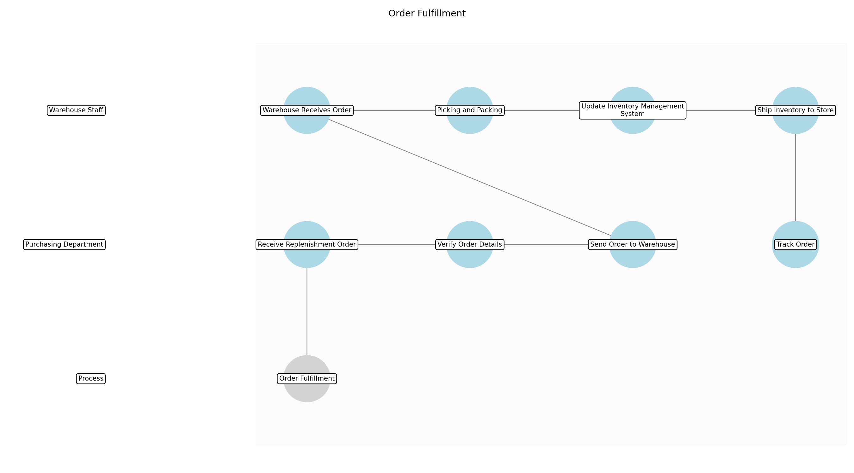

Order Fulfillment – Receive Replenishment Order
Description: The Purchasing Department receives the replenishment order from the Inventory Management Team.
Responsible Parties: Purchasing Department
Inputs:
- Replenishment order
Outputs:
Dependencies:
Estimated Duration: Instantaneous
Success Criteria:
- Replenishment order is received by the Purchasing Department.

Order Fulfillment – Verify Order Details
Description: The Purchasing Department verifies the order details, including product ID, quantity, and delivery instructions, against the pre-approved order templates (if used) and current supplier agreements.
Responsible Parties: Purchasing Department
Inputs:
Outputs:
Dependencies:
- Receive Replenishment Order
Estimated Duration: 1-2 hours
Success Criteria:
- Order details are verified for accuracy and compliance.

Order Fulfillment – Send Order to Warehouse
Description: The Purchasing Department sends the verified replenishment order to the warehouse for fulfillment.
Responsible Parties: Purchasing Department
Inputs:
Outputs:
Dependencies:
- Verify Order Details
Estimated Duration: Instantaneous
Success Criteria:
- Replenishment order is sent to the warehouse.

Order Fulfillment – Warehouse Receives Order
Description: Warehouse staff receives the replenishment order from the Purchasing Department.
Responsible Parties: Warehouse Staff
Inputs:
Outputs:
Dependencies:
- Send Order to Warehouse
Estimated Duration: Instantaneous
Success Criteria:
- Replenishment order is received by the warehouse staff.

Order Fulfillment – Picking and Packing
Description: The dedicated picking and packing team picks the inventory from the warehouse shelves, packs it securely, and prepares it for shipment to the store.
Responsible Parties: Warehouse Staff
Inputs:
Outputs:
Dependencies:
- Warehouse Receives Order
Estimated Duration: 2-4 hours
Success Criteria:
- Inventory is accurately picked and securely packed for shipment.

Order Fulfillment – Update Inventory Management System
Description: Warehouse staff updates the inventory management system to account for the reduced stock amounts in the warehouse.
Responsible Parties: Warehouse Staff
Inputs:
Outputs:
Dependencies:
- Picking and Packing
Estimated Duration: 30 minutes
Success Criteria:
- Inventory management system is updated with accurate stock levels.

Order Fulfillment – Ship Inventory to Store
Description: The warehouse ships the packed inventory to the store using expedited shipping options.
Responsible Parties: Warehouse Staff
Inputs:
Outputs:
Dependencies:
- Update Inventory Management System
Estimated Duration: 6-48 hours
Success Criteria:
- Inventory is shipped to the store within the agreed lead time.

Order Fulfillment – Track Order
Description: The Purchasing Department tracks the order and communicates any delays or issues to the Inventory Management Team.
Responsible Parties: Purchasing Department
Inputs:
Outputs:
Dependencies:
- Ship Inventory to Store
Estimated Duration: Ongoing
Success Criteria:
- Order is tracked and any issues are communicated promptly.

3.7 Inventory Replenishment
Upon receiving the inventory shipment, the Inventory Management Team verifies the received quantity against the order and updates the system records. To streamline replenishment, the store has implemented a dedicated overnight restocking crew. The layout of the storage area has been optimized, and the shelving configuration has been refined to improve the speed of the overnight restocking crew. A dedicated restocking team, composed of both Inventory Management and Sales Associates, now handles shelf replenishment during off-peak hours to minimize customer disruption. Sales associates assist with restocking the shelves, ensuring products are placed in the correct location, and updating shelf labels. The Inventory Management Team monitors the sales floor to ensure that shelves are adequately stocked and that stock-outs are avoided. This includes verifying the correct number of units shipped from the warehouse.
Responsible Parties: Inventory Management Team, Sales Associates
Success Criteria:
- Inventory is replenished within 1.5 hours of receiving the shipment.
- System records are updated accurately to reflect the replenished inventory.

Required Sub Process(es) for the Step "Inventory Replenishment"
The following details the subprocess flows for the step "Inventory Replenishment".
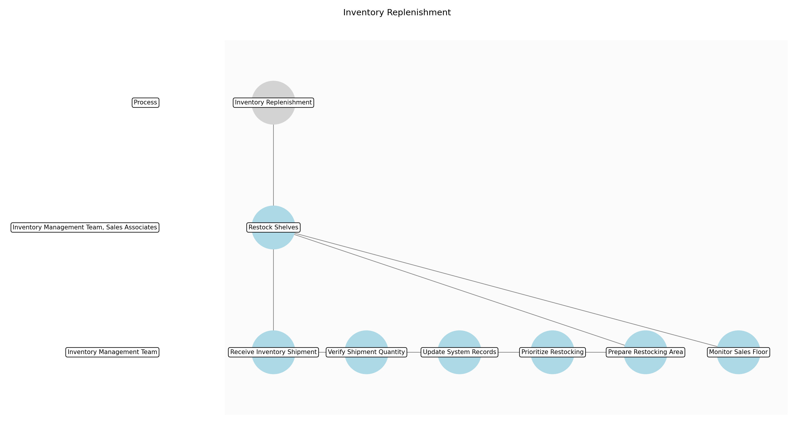

Inventory Replenishment – Receive Inventory Shipment
Description: The Inventory Management Team receives the inventory shipment from the warehouse.
Responsible Parties: Inventory Management Team
Inputs:
- Inventory shipment to the store
Outputs:
Dependencies:
Estimated Duration: Instantaneous
Success Criteria:
- Inventory shipment is received by the Inventory Management Team.

Inventory Replenishment – Verify Shipment Quantity
Description: The Inventory Management Team verifies the received quantity against the original order and packing slip to ensure accuracy.
Responsible Parties: Inventory Management Team
Inputs:
Outputs:
Dependencies:
- Receive Inventory Shipment
Estimated Duration: 30 minutes
Success Criteria:
- Received quantity matches the order and packing slip.

Inventory Replenishment – Update System Records
Description: The Inventory Management Team updates the inventory management system to reflect the received inventory.
Responsible Parties: Inventory Management Team
Inputs:
Outputs:
Dependencies:
- Verify Shipment Quantity
Estimated Duration: 30 minutes
Success Criteria:
- Inventory management system is updated with accurate stock levels.

Inventory Replenishment – Prioritize Restocking
Description: Determine the products which need to be restocked urgently, based on sales data and stock-out duration.
Responsible Parties: Inventory Management Team
Inputs:
Outputs:
Dependencies:
- Verify Shipment Quantity
Estimated Duration: 15 minutes
Success Criteria:
- Prioritization of products to be restocked is completed

Inventory Replenishment – Prepare Restocking Area
Description: Clear the designated restocking area and gather necessary equipment (e.g., carts, shelf labels).
Responsible Parties: Inventory Management Team
Inputs:
Outputs:
Dependencies:
- Prioritize Restocking
Estimated Duration: 15 minutes
Success Criteria:
- Restocking area is prepared and ready for restocking.

Inventory Replenishment – Restock Shelves
Description: The dedicated overnight restocking crew and sales associates restock the shelves, ensuring products are placed in the correct location and updating shelf labels as needed.
Responsible Parties: Inventory Management Team, Sales Associates
Inputs:
Outputs:
- Replenished shelves
Dependencies:
- Prepare Restocking Area
Estimated Duration: 30-90 minutes
Success Criteria:
- Shelves are replenished with the received inventory.
- Products are placed in the correct location.
- Shelf labels are updated as needed.

Inventory Replenishment – Monitor Sales Floor
Description: The Inventory Management Team monitors the sales floor to ensure that shelves are adequately stocked and that stock-outs are avoided.
Responsible Parties: Inventory Management Team
Inputs:
Outputs:
Dependencies:
- Restock Shelves
Estimated Duration: Ongoing
Success Criteria:
- Sales floor is regularly monitored for stock levels.
- Stock-outs are avoided.

3.8 Preventive Measures
Based on the root cause analysis of stock-outs, the Inventory Management Team implements preventive measures to avoid future occurrences. To improve the effectiveness of preventive measures, the team focuses on better data analysis and more proactive supplier communication. This may include adjusting safety stock levels, improving demand forecasting methods, optimizing inventory control procedures, strengthening supplier relationships, and providing additional training to staff. The Inventory Management Team regularly reviews stock-out data and adjusts preventive measures as needed. The team also looks to identify opportunities for improvement and address any new stock-out patterns that emerge.
Responsible Parties: Inventory Management Team
Success Criteria:
- Stock-out rate is reduced by at least 20% within 3 months.
- Inventory turnover rate is maintained at an optimal level.
- Preventive measures are implemented within 1 week of root cause analysis completion.

Required Sub Process(es) for the Step "Preventive Measures"
The following details the subprocess flows for the step "Preventive Measures".
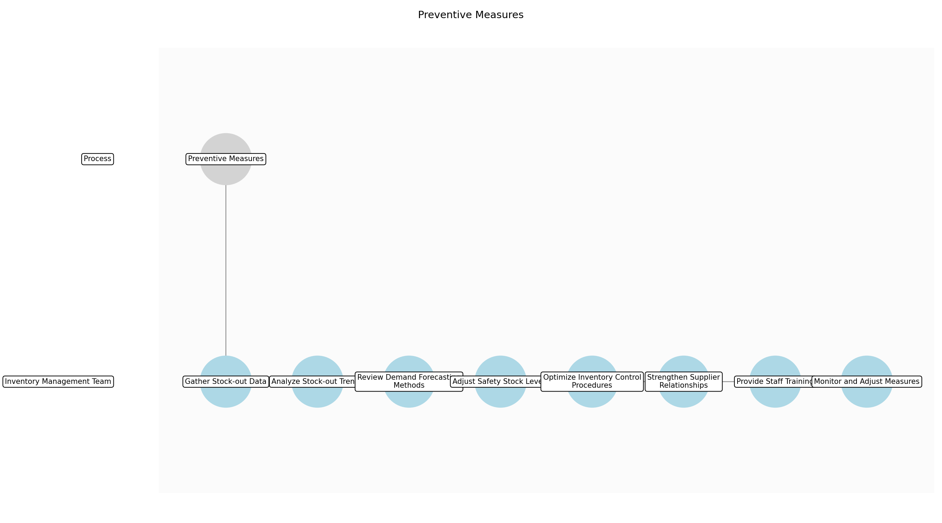

Preventive Measures – Gather Stock-out Data
Description: Collect all available stock-out data, including frequency, duration, product types, locations, and root causes.
Responsible Parties: Inventory Management Team
Inputs:
Outputs:
Dependencies:
Estimated Duration: Weekly
Success Criteria:
- Comprehensive stock-out data is collected and organized.

Preventive Measures – Analyze Stock-out Trends
Description: Analyze the collected stock-out data to identify patterns, trends, and recurring root causes.
Responsible Parties: Inventory Management Team
Inputs:
Outputs:
Dependencies:
- Gather Stock-out Data
Estimated Duration: Weekly
Success Criteria:
- Significant stock-out trends and patterns are identified.

Preventive Measures – Review Demand Forecasting Methods
Description: Evaluate the effectiveness of current demand forecasting methods and identify areas for improvement.
Responsible Parties: Inventory Management Team
Inputs:
Outputs:
Dependencies:
- Analyze Stock-out Trends
Estimated Duration: Monthly
Success Criteria:
- Demand forecasting methods are reviewed and areas for improvement are identified.

Preventive Measures – Adjust Safety Stock Levels
Description: Adjust safety stock levels for specific products based on the analysis of stock-out trends and demand forecasting.
Responsible Parties: Inventory Management Team
Inputs:
Outputs:
- Adjusted safety stock levels
Dependencies:
- Analyze Stock-out Trends
- Review Demand Forecasting Methods
Estimated Duration: Weekly
Success Criteria:
- Safety stock levels are adjusted to minimize stock-outs while maintaining optimal inventory turnover.

Preventive Measures – Optimize Inventory Control Procedures
Description: Review and optimize inventory control procedures, such as reorder points, order quantities, and inventory tracking methods.
Responsible Parties: Inventory Management Team
Inputs:
Outputs:
- Optimized inventory control procedures
Dependencies:
- Analyze Stock-out Trends
Estimated Duration: Monthly
Success Criteria:
- Inventory control procedures are optimized for efficiency and accuracy.

Preventive Measures – Strengthen Supplier Relationships
Description: Communicate proactively with suppliers to address any supply chain issues, negotiate better lead times, and improve delivery reliability.
Responsible Parties: Inventory Management Team
Inputs:
Outputs:
- Strengthened supplier relationships
Dependencies:
- Analyze Stock-out Trends
Estimated Duration: Monthly
Success Criteria:
- Supplier relationships are strengthened, leading to improved supply chain performance.

Preventive Measures – Provide Staff Training
Description: Provide additional training to staff on inventory management procedures, stock-out reporting, and the importance of accurate data collection.
Responsible Parties: Inventory Management Team
Inputs:
Outputs:
Dependencies:
Estimated Duration: Quarterly
Success Criteria:
- Staff is adequately trained on inventory management procedures.

Preventive Measures – Monitor and Adjust Measures
Description: Regularly monitor the effectiveness of preventive measures and adjust them as needed based on ongoing stock-out data and performance metrics.
Responsible Parties: Inventory Management Team
Inputs:
Outputs:
Dependencies:
- Adjust Safety Stock Levels
- Optimize Inventory Control Procedures
- Strengthen Supplier Relationships
- Provide Staff Training
Estimated Duration: Ongoing
Success Criteria:
- Preventive measures are continuously monitored and adjusted for optimal effectiveness.

4.0 Supporting Systems and Tools
The following tools and platforms support this process:
Category | Tools
Dedicated Picking And Packing Team | Warehouse resource for expedited order fulfillment.
Point Of Sale (Pos) System | Provides accurate sales data and stock-out reporting functionality.
Enhanced Data Analytics Software | For improved analysis of stock-out patterns and trends.
Pre-Approved Order Templates | Streamlines the order placement process for frequently stocked-out items.
Inventory Management System | Essential for real-time inventory tracking and automated alerts.
Mobile Devices | Facilitate stock-out reporting on the sales floor.
Standardized Checklist And Decision Tree | Aids in faster and more consistent root cause analysis.
Rfid Tags And Sensors | Enable real-time shelf monitoring for automated stock-out detection.
Reporting And Analytics Tools | Enable analysis of sales data and inventory performance metrics.

5.0 Metrics and Key Performance Indicators (KPIs)
The following is a list of key metrics associated with this process. These metrics help monitor performance and ensure alignment with business objectives.

Stock-out Rate
Percentage of time a product is unavailable when a customer wants to purchase it. Target: <1%.

Customer Satisfaction
Measured through surveys and feedback forms. Target: >90% satisfaction with stock availability.

Revenue Loss Due to Stock-outs
Total revenue lost due to inability to fulfill customer demand. Target: Minimize revenue loss.

Inventory Turnover Rate
How quickly inventory is sold and replenished. Target: Maintain optimal turnover rate for each product category.

6.0 Reporting and Analytics
The following are key reporting and analytics associated with this process.
- Stock-out Reports: Daily and weekly reports showing the number and duration of stock-outs by product and location.
- Sales Data Analysis: Analysis of sales trends and patterns to identify products with high demand and potential stock-out risks.
- Inventory Performance Metrics: Tracking of inventory turnover rate, fill rate, and other key performance indicators to assess inventory management effectiveness.
- Customer Feedback Analysis: Analysis of customer surveys and feedback forms to identify issues related to stock availability and customer satisfaction.
- Real-time Shelf Monitoring Data: Data from RFID tags and sensors to track shelf inventory levels in real-time.
- Supplier Performance Reports: Tracking of supplier lead times and delivery reliability.

7.0 System Requirements
The following system requirements are essential for the successful implementation of this process.
- Inventory Management System: Real-time tracking of inventory levels, automated alerts for low stock, demand forecasting capabilities, and integration with sales and purchasing systems, including support for pre-approved order templates and RFID data integration.
- Point of Sale (POS) System: Accurate sales data capture, integration with the Inventory Management System, and stock-out reporting functionality.
- Reporting and Analytics Tools: Tools to analyze sales data, stock-out trends, inventory performance metrics, and RFID data.
- Mobile Devices: Handheld devices for sales associates to scan products, report stock-outs, and receive real-time alerts.
- Dedicated Communication Channels: Communication channels between sales associates, inventory management and purchasing departments.
- RFID Infrastructure: RFID tags on products and sensors on shelves for real-time shelf monitoring.
- Advanced Demand Forecasting Software: Software to predict demand fluctuations and optimize inventory levels.
- Supplier Relationship Management (SRM) System: System for managing communication and performance with suppliers.

8.0 Process Flow Diagram
The following diagram provides a high-level visualization of the process flow as defined in the normalized JSON source.
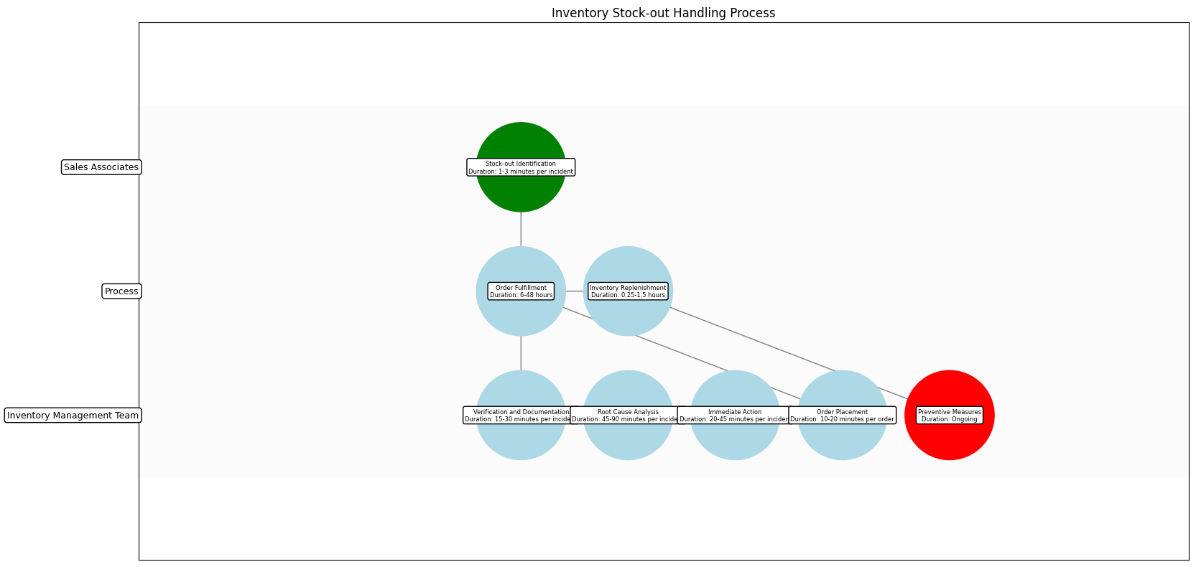

9.0 Process Performance Report
The following metrics are based on a Monte Carlo discrete-event simulation running 2,000 iterations. All time-based values are reported in minutes.
Operational Metric | Simulated Value
Average Cycle Time | 10.65 minutes
Cycle Time Variance | 0.90 minutes
Contention Risk Profile | Low

Identified Bottlenecks
- Preventive Measures
- Inventory Replenishment
- Stock-out Identification

Detailed Step Performance
Process Step | Avg. Duration (minutes)
Stock-out Identification | 1.34
Verification and Documentation | 1.33
Root Cause Analysis | 1.32
Immediate Action | 1.33
Order Placement | 1.33
Order Fulfillment | 1.33
Inventory Replenishment | 1.34
Preventive Measures | 1.34

Appendix A: Reference Documents
The following appendix contains reference materials related to the process.

Pre-Approved Order Templates (Sample)
- Examples of pre-approved order templates for frequently stocked-out items.

Inventory Replenishment Policy
- Detailed guidelines for determining order quantities and safety stock levels.

Stock-Out Reporting Form
- A sample form for sales associates to report stock-outs manually.

Rfid Implementation Guide
- Guidelines for implementing and maintaining the RFID infrastructure for shelf monitoring.

Root Cause Analysis Checklist
- A standardized checklist to guide the root cause analysis process.

Data Analysis Procedures
- Detailed procedures for analyzing stock-out data and identifying trends.

Supplier Communication Protocols
- Protocols for communicating with suppliers regarding inventory replenishment and potential supply chain disruptions.

Appendix C: Glossary
This glossary contains definitions of common terms used in the process documentation.
Term | Definition
Business Process | A set of related activities or tasks performed to achieve a specific organizational goal.
KPI | Key Performance Indicator used to measure the success or health of a process.
Stakeholder | Any individual or group with an interest in the outcomes of the process.
Continuous Improvement | Ongoing effort to improve products, services or processes.

