SAFe SDLC Process
The Scaled Agile Framework (SAFe) is a widely recognized and adopted set of organization and workflow patterns designed to guide enterprises in scaling lean and agile practices effectively. This Software Development Life Cycle (SDLC) process leverages the principles and practices of SAFe to provide a structured and comprehensive framework for developing and delivering software products at the enterprise level. By implementing this SAFe-based SDLC, organizations can ensure enhanced alignment by establishing a common vision and priorities across all teams, improved collaboration through standardized processes and communication channels, and consistent value delivery by focusing on delivering incremental value to customers throughout the development lifecycle. SAFe's principles of alignment, built-in quality, transparency, and decentralized decision-making are crucial for the success of enterprise-level software development, enabling organizations to respond quickly to changing market demands, reduce time to market, and improve the quality of their products.
Industry / Domain: Software Development
Version: 1.0
Generated On: 2026-01-19 15:45:36

Document Control
Version | Date | Author | Description
1.0 | 2026-01-19 | Process Architect | Initial generated process specification

Table of Contents

1.0 Process Overview
The Scaled Agile Framework (SAFe) is a widely recognized and adopted set of organization and workflow patterns designed to guide enterprises in scaling lean and agile practices effectively. This Software Development Life Cycle (SDLC) process leverages the principles and practices of SAFe to provide a structured and comprehensive framework for developing and delivering software products at the enterprise level. By implementing this SAFe-based SDLC, organizations can ensure enhanced alignment by establishing a common vision and priorities across all teams, improved collaboration through standardized processes and communication channels, and consistent value delivery by focusing on delivering incremental value to customers throughout the development lifecycle. SAFe's principles of alignment, built-in quality, transparency, and decentralized decision-making are crucial for the success of enterprise-level software development, enabling organizations to respond quickly to changing market demands, reduce time to market, and improve the quality of their products.

1.1 Assumptions
- Teams are trained in SAFe principles
- Stakeholders are engaged and supportive
- Infrastructure is adequate for CI/CD
- There is clear alignment between business and development

1.2 Constraints
- Budget limitations
- Regulatory compliance (e.g., HIPAA, GDPR)
- Limited resources (e.g., personnel, infrastructure)

1.3 Purpose
This process aims to provide a structured framework for developing and delivering software products at the enterprise level, aligning with strategic business goals and delivering value to stakeholders through Agile and SAFe methodologies. It ensures that software development efforts are aligned with business objectives by prioritizing features that directly contribute to key performance indicators (KPIs) such as increased revenue, reduced costs, or improved customer satisfaction. For example, a key performance indicator (KPI) directly impacted by this process could be a reduction in time-to-market for new features, an increase in customer satisfaction scores, or a decrease in development costs. The process promotes collaboration and communication across teams through standardized processes and regular synchronization meetings, and enables the delivery of high-quality software products in a timely and efficient manner by leveraging continuous integration and continuous delivery (CI/CD) practices.

1.4 Scope
This process encompasses all software development activities from initial planning and requirements gathering to production deployment and ongoing maintenance. It includes program management, release train coordination, team-level execution, and applies to large-scale enterprise projects that require cross-team coordination and alignment with strategic business goals. For example, this process would be used for developing a new e-commerce platform, migrating a legacy system to the cloud, or building a new customer relationship management (CRM) platform. This process excludes small, isolated projects that do not require significant cross-team coordination or alignment with enterprise-level objectives, such as developing a simple mobile app, creating a single landing page, or developing a proof-of-concept application.

1.5 Industry Sector
Software Development

2.0 Stakeholders and Responsibilities
The following is a list of key stakeholders involved in this process. Understanding their roles and responsibilities is crucial for successful implementation.
Stakeholder | Responsibilities
Program Manager | Program vision and roadmap  Budget and resource allocation  Stakeholder management  Risk and dependency management
Release Train Engineer (RTE) | ART facilitation  Program execution  Impediment removal  SAFe adoption
System Architect | Architectural runway  Technical guidance  System design
Development Teams | Feature development  Testing  Iteration planning
Product Management | Program backlog  Prioritization  Feature definition
System Team | Build and test automation  Environment provisioning  DevOps support
Business Owners | Provide business context  Validate value delivery  Participate in PI Planning

3.0 Process Workflow
The following is a list of key steps in the process workflow.

3.1 Pre-PI Planning
Description:
- During Pre-PI Planning, the program vision is refined, and the program backlog is prepared to ensure alignment with strategic objectives and market demands. This involves identifying and prioritizing features, defining acceptance criteria, and estimating the effort required for each feature. The outputs of this step include a refined program backlog and a vision document that provides a clear understanding of the program's goals and objectives.
Responsible Parties:
- Product Management
Inputs:
- Business strategy
- Market analysis
Outputs:
- Refined program backlog
- PI Planning inputs
Success Criteria:
- Program backlog is prioritized and ready for PI Planning.

Required Sub Process(es) for the Step "Pre-PI Planning"
The following details the subprocess flows for the step "Pre-PI Planning".
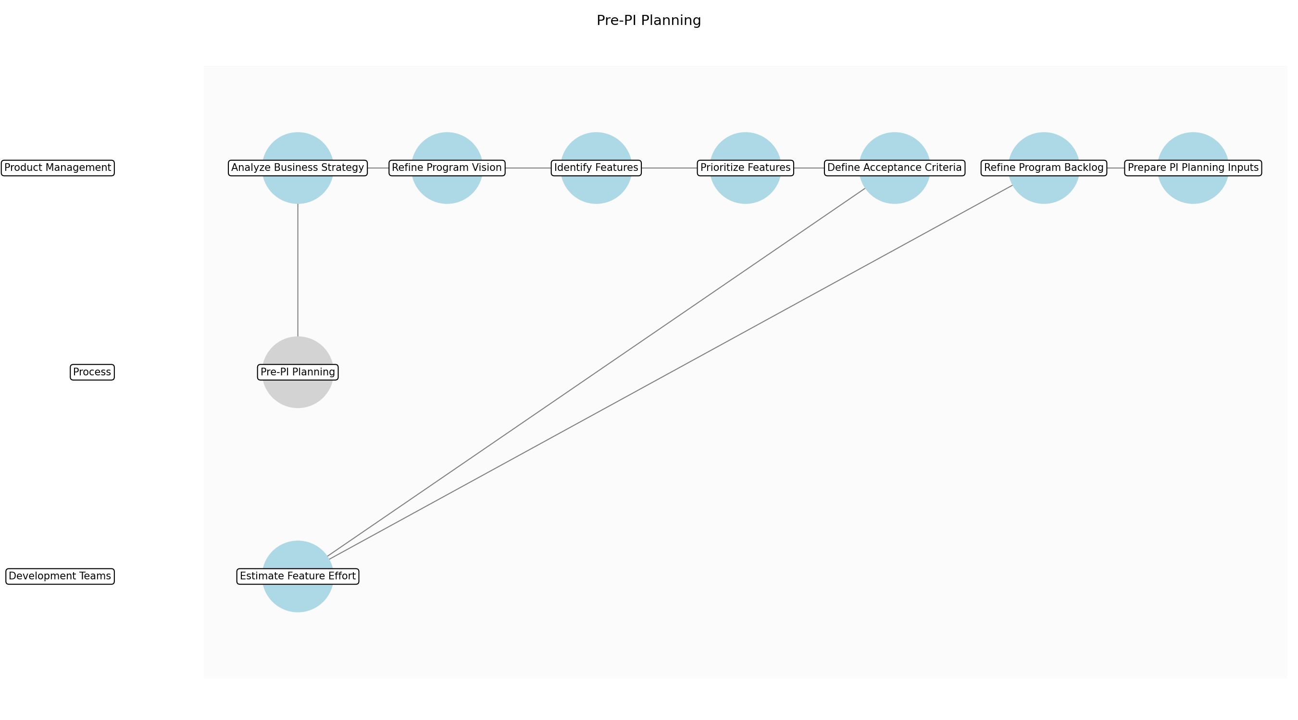

Pre-PI Planning – Analyze Business Strategy
Description:
- The Product Management team analyzes the current business strategy to identify key objectives and priorities for the upcoming Program Increment (PI). This involves reviewing market trends, customer feedback, and competitive analysis to ensure that the program backlog aligns with the overall business direction. The team also assesses any new business opportunities or regulatory requirements that may impact the program backlog.
Responsible Party:
- Product Management
Inputs:
- Business strategy
- Market analysis
Outputs:
- Business strategy summary
- Market analysis summary
Estimated Duration:
- 2 days
Dependencies:
Success Criteria:
- Business strategy is clearly understood
- Market analysis is completed
Purpose:
- To ensure alignment with business objectives.
Scope:
- Analysis of business strategy and market trends.
Process Owner:
- Product Manager
Triggers:
- New business strategy
- Market change
End Conditions:
- Business strategy summary completed
- Market analysis summary completed
Step Risks and Controls:
- Risk: Misinterpretation of business strategy
- Control: Regular meetings with business stakeholders
Governance Requirements:
- Stakeholder review of business strategy summary
Change Management:
- Change Request Process: Formal change request
- Versioning Rules: Document versioning
Continuous Improvement:
- Review Frequency: Monthly
Improvement Inputs:
- Feedback from stakeholders

Pre-PI Planning – Refine Program Vision
Description:
- Based on the business strategy analysis, the Product Management team refines the program vision to articulate the desired future state of the product. This involves defining the key themes and objectives for the upcoming PI, ensuring that they align with the overall business goals. The team also identifies any potential risks or dependencies that may impact the program vision.
Responsible Party:
- Product Management
Inputs:
- Business strategy summary
- Market analysis summary
Outputs:
- Refined program vision
- Key themes and objectives
Estimated Duration:
- 1 day
Dependencies:
- Analyze Business Strategy
Success Criteria:
- Program vision is clearly defined
- Key themes and objectives are identified
Purpose:
- To articulate the desired future state of the product.
Scope:
- Refinement of program vision and identification of key themes.
Process Owner:
- Product Manager
Triggers:
- Business strategy summary completed
- Market analysis summary completed
End Conditions:
- Refined program vision completed
- Key themes and objectives completed
Step Risks and Controls:
- Risk: Unclear program vision
- Control: Regular communication with stakeholders
Governance Requirements:
- Stakeholder review of program vision
Change Management:
- Change Request Process: Formal change request
- Versioning Rules: Document versioning
Continuous Improvement:
- Review Frequency: Monthly
Improvement Inputs:
- Feedback from stakeholders

Pre-PI Planning – Identify Features
Description:
- The Product Management team identifies potential features that align with the refined program vision and key themes. This involves brainstorming sessions, reviewing customer feedback, and analyzing market trends to generate a comprehensive list of potential features. The team also considers any technical constraints or dependencies that may impact the feasibility of each feature.
Responsible Party:
- Product Management
Inputs:
- Refined program vision
- Key themes and objectives
Outputs:
- List of potential features
- Feature descriptions
Estimated Duration:
- 3 days
Dependencies:
- Refine Program Vision
Success Criteria:
- Comprehensive list of potential features is generated
- Feature descriptions are created
Purpose:
- To generate a comprehensive list of potential features.
Scope:
- Identification of potential features and creation of descriptions.
Process Owner:
- Product Manager
Triggers:
- Refined program vision completed
- Key themes and objectives completed
End Conditions:
- List of potential features completed
- Feature descriptions completed
Step Risks and Controls:
- Risk: Missing key features
- Control: Regular brainstorming sessions with stakeholders
Governance Requirements:
- Stakeholder review of potential features
Change Management:
- Change Request Process: Formal change request
- Versioning Rules: Document versioning
Continuous Improvement:
- Review Frequency: Monthly
Improvement Inputs:
- Feedback from stakeholders

Pre-PI Planning – Prioritize Features
Description:
- The Product Management team prioritizes the identified features based on their alignment with the program vision, business value, and technical feasibility. This involves using a prioritization framework such as Weighted Shortest Job First (WSJF) or MoSCoW to rank the features and determine which ones should be included in the upcoming PI. The team also considers any dependencies or constraints that may impact the prioritization process.
Responsible Party:
- Product Management
Inputs:
- List of potential features
- Feature descriptions
Outputs:
- Prioritized feature list
- Feature ranking
Estimated Duration:
- 2 days
Dependencies:
- Identify Features
Success Criteria:
- Features are prioritized based on business value and technical feasibility
- Feature ranking is completed
Purpose:
- To prioritize features based on business value and technical feasibility.
Scope:
- Prioritization of features and creation of ranking.
Process Owner:
- Product Manager
Triggers:
- List of potential features completed
- Feature descriptions completed
End Conditions:
- Prioritized feature list completed
- Feature ranking completed
Step Risks and Controls:
- Risk: Incorrect prioritization of features
- Control: Regular review of prioritization with stakeholders
Governance Requirements:
- Stakeholder review of prioritized feature list
Change Management:
- Change Request Process: Formal change request
- Versioning Rules: Document versioning
Continuous Improvement:
- Review Frequency: Monthly
Improvement Inputs:
- Feedback from stakeholders

Pre-PI Planning – Define Acceptance Criteria
Description:
- For each prioritized feature, the Product Management team defines clear and measurable acceptance criteria to ensure that the feature meets the desired requirements. This involves collaborating with stakeholders to define the specific conditions that must be met for the feature to be considered complete. The team also considers any potential risks or dependencies that may impact the acceptance criteria.
Responsible Party:
- Product Management
Inputs:
- Prioritized feature list
- Feature ranking
Outputs:
- Acceptance criteria for each feature
- Feature acceptance tests
Estimated Duration:
- 3 days
Dependencies:
- Prioritize Features
Success Criteria:
- Acceptance criteria are clearly defined for each feature
- Feature acceptance tests are created
Purpose:
- To define clear and measurable acceptance criteria for each feature.
Scope:
- Definition of acceptance criteria and creation of acceptance tests.
Process Owner:
- Product Manager
Triggers:
- Prioritized feature list completed
- Feature ranking completed
End Conditions:
- Acceptance criteria for each feature completed
- Feature acceptance tests completed
Step Risks and Controls:
- Risk: Unclear acceptance criteria
- Control: Regular review of acceptance criteria with stakeholders
Governance Requirements:
- Stakeholder review of acceptance criteria
Change Management:
- Change Request Process: Formal change request
- Versioning Rules: Document versioning
Continuous Improvement:
- Review Frequency: Monthly
Improvement Inputs:
- Feedback from stakeholders

Pre-PI Planning – Estimate Feature Effort
Description:
- The Development Teams estimate the effort required to develop and test each feature. This involves using estimation techniques such as story points or t-shirt sizing to assign a relative size to each feature. The team also considers any technical complexities or dependencies that may impact the estimation process. The System Architect provides guidance on architectural runway and technical feasibility.
Responsible Party:
- Development Teams
Inputs:
- Acceptance criteria for each feature
- Feature acceptance tests
Outputs:
- Effort estimates for each feature
- Feature story points
Estimated Duration:
- 2 days
Dependencies:
- Define Acceptance Criteria
Success Criteria:
- Effort estimates are completed for each feature
- Feature story points are assigned
Purpose:
- To estimate the effort required to develop and test each feature.
Scope:
- Estimation of feature effort and assignment of story points.
Process Owner:
- Development Team
Triggers:
- Acceptance criteria for each feature completed
- Feature acceptance tests completed
End Conditions:
- Effort estimates for each feature completed
- Feature story points completed
Step Risks and Controls:
- Risk: Inaccurate effort estimates
- Control: Regular review of estimates with development teams
Governance Requirements:
- Development Team review of effort estimates
Change Management:
- Change Request Process: Iteration change request
- Versioning Rules: Version control system
Continuous Improvement:
- Review Frequency: Sprint retrospective
Improvement Inputs:
- Team feedback

Pre-PI Planning – Refine Program Backlog
Description:
- The Product Management team refines the program backlog based on the prioritized features, acceptance criteria, and effort estimates. This involves creating user stories for each feature, adding them to the program backlog, and ensuring that they are properly tagged and categorized. The team also identifies any dependencies or constraints that may impact the program backlog.
Responsible Party:
- Product Management
Inputs:
- Effort estimates for each feature
- Feature story points
Outputs:
- Refined program backlog
- User stories for each feature
Estimated Duration:
- 2 days
Dependencies:
- Estimate Feature Effort
Success Criteria:
- Program backlog is refined with user stories
- User stories are properly tagged and categorized
Purpose:
- To refine the program backlog with user stories.
Scope:
- Refinement of program backlog and creation of user stories.
Process Owner:
- Product Manager
Triggers:
- Effort estimates for each feature completed
- Feature story points completed
End Conditions:
- Refined program backlog completed
- User stories for each feature completed
Step Risks and Controls:
- Risk: Incomplete program backlog
- Control: Regular review of program backlog with stakeholders
Governance Requirements:
- Stakeholder review of program backlog
Change Management:
- Change Request Process: Formal change request
- Versioning Rules: Document versioning
Continuous Improvement:
- Review Frequency: Monthly
Improvement Inputs:
- Feedback from stakeholders

Pre-PI Planning – Prepare PI Planning Inputs
Description:
- The Product Management team prepares the inputs for the upcoming PI Planning session. This involves creating a draft PI plan, identifying any potential risks or dependencies, and communicating the program vision and key themes to the Agile Release Train (ART). The team also ensures that all necessary documentation and resources are available for the PI Planning session.
Responsible Party:
- Product Management
Inputs:
- Refined program backlog
- User stories for each feature
Outputs:
- Draft PI plan
- PI Planning inputs
Estimated Duration:
- 1 day
Dependencies:
- Refine Program Backlog
Success Criteria:
- Draft PI plan is created
- PI Planning inputs are prepared
Purpose:
- To prepare the inputs for the upcoming PI Planning session.
Scope:
- Preparation of PI Planning inputs and creation of draft PI plan.
Process Owner:
- Product Manager
Triggers:
- Refined program backlog completed
- User stories for each feature completed
End Conditions:
- Draft PI plan completed
- PI Planning inputs completed
Step Risks and Controls:
- Risk: Inadequate PI Planning inputs
- Control: Regular review of PI Planning inputs with stakeholders
Governance Requirements:
- Stakeholder review of PI Planning inputs
Change Management:
- Change Request Process: Formal change request
- Versioning Rules: Document versioning
Continuous Improvement:
- Review Frequency: Monthly
Improvement Inputs:
- Feedback from stakeholders

3.2 PI Planning
Description:
- PI Planning is a big room planning event where all teams within the Agile Release Train (ART) come together to align on a common mission and plan the upcoming Program Increment (PI). During this event, teams review the program backlog, identify dependencies, and commit to PI Objectives. The outputs of this step include a set of PI Objectives and team iteration plans that provide a roadmap for the upcoming PI.
Responsible Parties:
- Release Train Engineer (RTE)
Success Criteria:
- Teams commit to PI Objectives and dependencies are identified.

Required Sub Process(es) for the Step "PI Planning"
The following details the subprocess flows for the step "PI Planning".
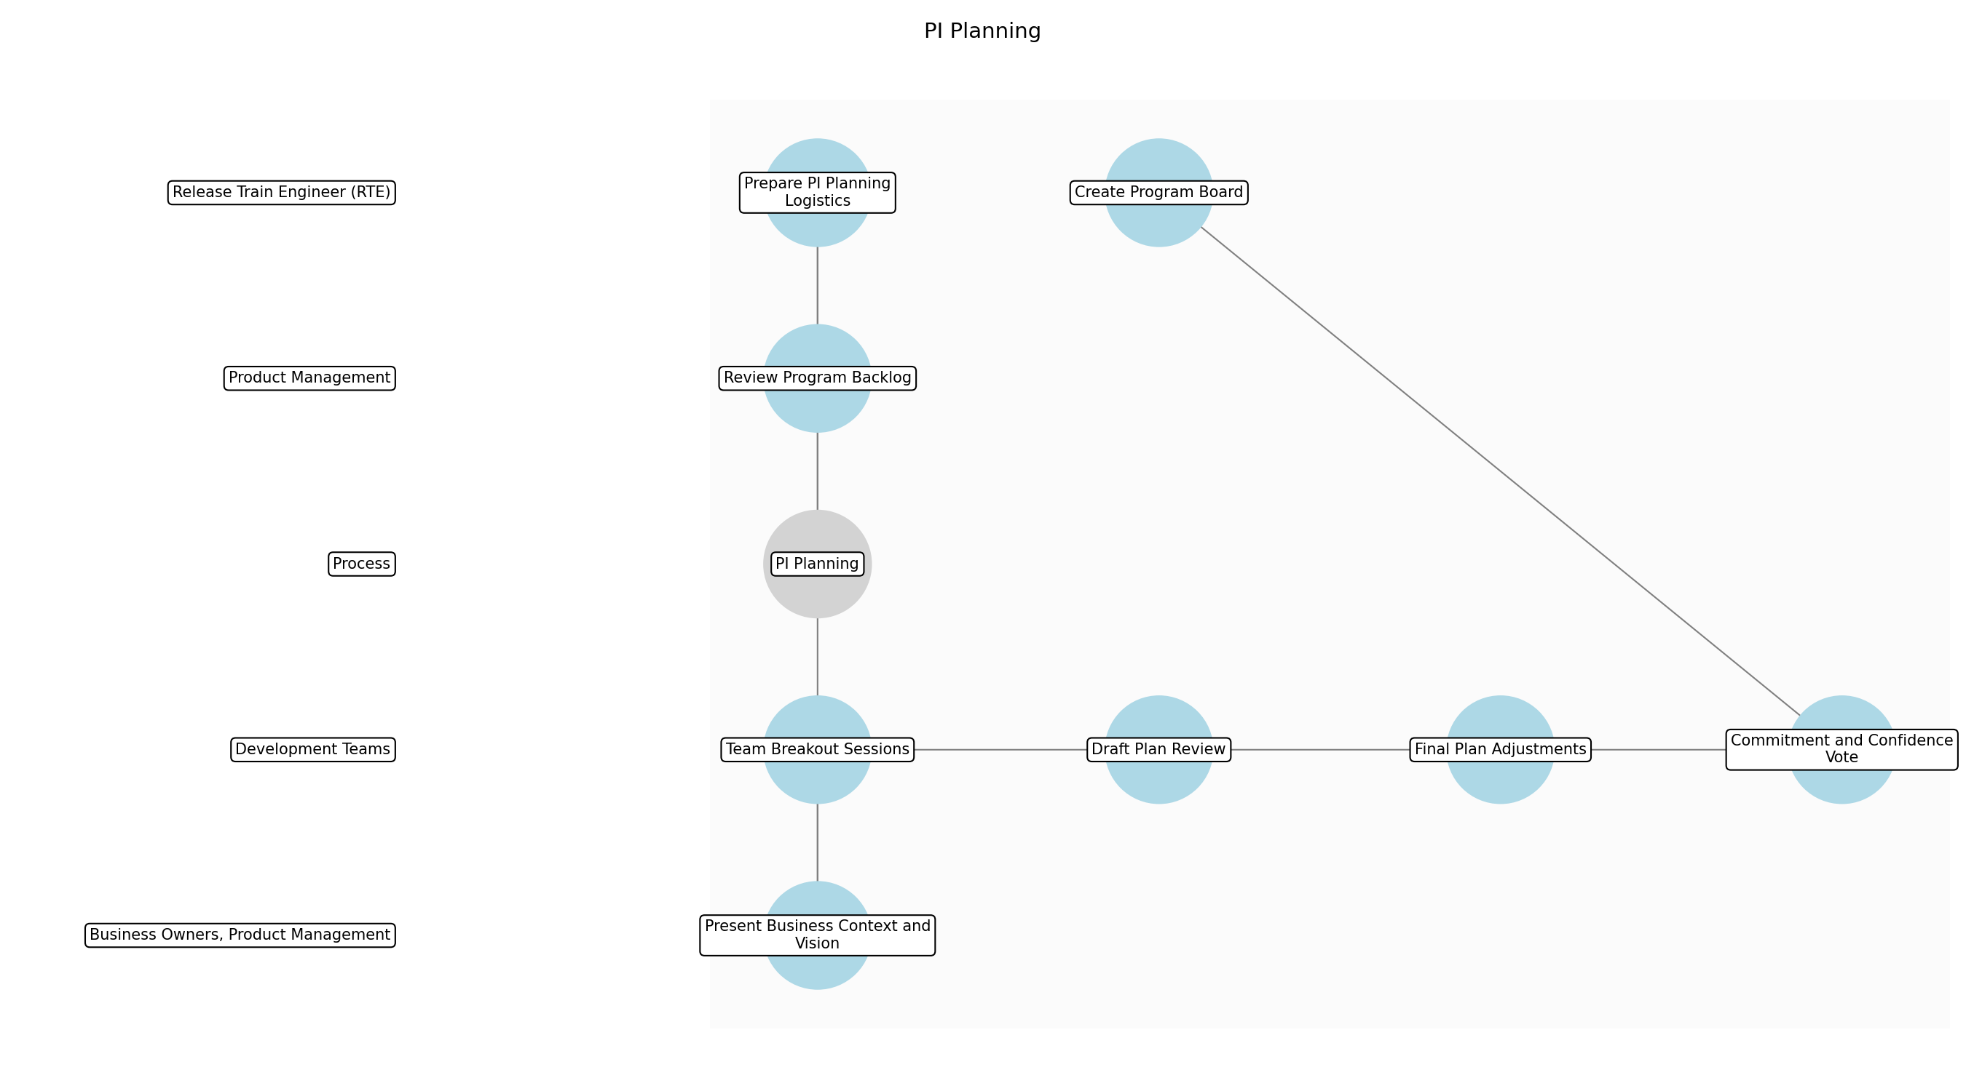

PI Planning – Prepare PI Planning Logistics
Description:
- The Release Train Engineer (RTE) is responsible for coordinating and preparing the logistics for the PI Planning event. This includes scheduling the event, booking the venue, arranging for necessary equipment (projectors, whiteboards, collaboration tools), and communicating the event details to all participants. Ensuring smooth logistics is crucial for a productive and efficient PI Planning session.
Responsible Party:
- Release Train Engineer (RTE)
Inputs:
Outputs:
- PI Planning schedule
- Venue booking confirmation
- Equipment checklist
- Communication to participants
Estimated Duration:
- 1 week
Dependencies:
Success Criteria:
- PI Planning event is scheduled and confirmed
- Venue is booked and equipped
- Participants are informed of event details
Purpose:
- Ensure all logistical aspects of PI Planning are in place for a smooth event.
Scope:
- Program level
Process Owner:
- Release Train Engineer (RTE)
Triggers:
- Scheduled PI Planning event
End Conditions:
- Logistics are confirmed and communicated
Step Risks and Controls:
- Risk: Venue unavailability
- Control: Book venue well in advance and have backup options
Governance Requirements:
Change Management:
- Change Request Process: Changes to logistics require RTE approval
- Versioning Rules: Track changes to schedule and venue
Continuous Improvement:
- Review Frequency: Post-PI Planning
Improvement Inputs:
- Team feedback on logistics

PI Planning – Review Program Backlog
Description:
- Product Management reviews the program backlog with key stakeholders to ensure it is prioritized and reflects the current business needs. This involves refining user stories, defining acceptance criteria, and estimating story points. A well-groomed backlog ensures that teams have clear and actionable items to plan during PI Planning.
Responsible Party:
- Product Management
Inputs:
- Business strategy
- Market analysis
- Customer feedback
Outputs:
- Prioritized program backlog
- Refined user stories
Estimated Duration:
- 2 days
Dependencies:
- Prepare PI Planning Logistics
Success Criteria:
- Program backlog is prioritized and refined
- User stories have clear acceptance criteria
- Story points are estimated
Purpose:
- Ensure the program backlog is ready for teams to plan their iterations.
Scope:
- Program level
Process Owner:
- Product Management
Triggers:
- Scheduled PI Planning event
End Conditions:
- Program backlog is reviewed and prioritized
Step Risks and Controls:
- Risk: Misaligned priorities
- Control: Regular backlog refinement sessions with stakeholders
Governance Requirements:
- Stakeholder review of backlog
Change Management:
- Change Request Process: Changes to backlog require Product Management approval
- Versioning Rules: Track changes to user stories and priorities
Continuous Improvement:
- Review Frequency: Post-PI Planning
Improvement Inputs:
- Team feedback on backlog clarity

PI Planning – Present Business Context and Vision
Description:
- Business Owners and Product Management present the current business context, strategic vision, and top priorities to the Agile Release Train (ART). This provides teams with the necessary information to make informed decisions during planning. A clear understanding of the business context is essential for aligning team efforts with overall business goals.
Responsible Party:
- Business Owners, Product Management
Inputs:
- Prioritized program backlog
- Business strategy
- Market analysis
Outputs:
- Business context presentation
- Vision document
Estimated Duration:
- 2–4 hours
Dependencies:
- Review Program Backlog
Success Criteria:
- Business context and vision are clearly communicated
- Teams understand top priorities
Purpose:
- Provide teams with the necessary context to align their planning with business goals.
Scope:
- Program level
Process Owner:
- Product Management
Triggers:
- Start of PI Planning event
End Conditions:
- Business context and vision are presented
Step Risks and Controls:
- Risk: Misunderstanding of business goals
- Control: Interactive Q&A session after presentation
Governance Requirements:
Change Management:
- Change Request Process: Changes to vision require Business Owner approval
- Versioning Rules: Track changes to vision document
Continuous Improvement:
- Review Frequency: Post-PI Planning
Improvement Inputs:
- Team feedback on presentation clarity

PI Planning – Team Breakout Sessions
Description:
- Teams break out to plan their individual iterations for the upcoming Program Increment (PI). This involves selecting user stories from the program backlog, identifying dependencies, and estimating the work required. Effective team breakout sessions are crucial for creating realistic and achievable iteration plans.
Responsible Party:
- Development Teams
Inputs:
- Business context presentation
- Vision document
- Prioritized program backlog
Outputs:
- Team iteration plans
- Identified dependencies
Estimated Duration:
- 1 day
Dependencies:
- Present Business Context and Vision
Success Criteria:
- Teams create realistic iteration plans
- Dependencies are identified and documented
Purpose:
- Enable teams to create detailed plans for their iterations within the PI.
Scope:
- Team level
Process Owner:
- Development Team
Triggers:
- After business context presentation
End Conditions:
- Team iteration plans are created
Step Risks and Controls:
- Risk: Unrealistic commitments
- Control: Capacity planning and risk assessment
Governance Requirements:
Change Management:
- Change Request Process: Changes to iteration plans require team agreement
- Versioning Rules: Track changes to iteration plans
Continuous Improvement:
- Review Frequency: Post-PI Planning
Improvement Inputs:
- Team feedback on planning process

PI Planning – Draft Plan Review
Description:
- Each team presents their draft iteration plans to the rest of the Agile Release Train (ART) for review and feedback. This allows teams to identify potential dependencies and conflicts early in the planning process. Constructive feedback during the draft plan review is essential for ensuring a cohesive and aligned PI plan.
Responsible Party:
- Development Teams
Inputs:
- Team iteration plans
- Identified dependencies
Outputs:
- Feedback on iteration plans
- Identified dependencies and conflicts
Estimated Duration:
- 2–4 hours
Dependencies:
- Team Breakout Sessions
Success Criteria:
- Teams present their draft plans
- Feedback is provided and documented
- Dependencies and conflicts are identified
Purpose:
- Identify dependencies and conflicts early in the planning process.
Scope:
- Program level
Process Owner:
- Release Train Engineer (RTE)
Triggers:
- After team breakout sessions
End Conditions:
- Draft plans are reviewed and feedback is provided
Step Risks and Controls:
- Risk: Lack of participation
- Control: Encourage active participation from all teams
Governance Requirements:
Change Management:
- Change Request Process: Changes to plans based on feedback require team agreement
- Versioning Rules: Track changes to plans based on feedback
Continuous Improvement:
- Review Frequency: Post-PI Planning
Improvement Inputs:
- Team feedback on review process

PI Planning – Final Plan Adjustments
Description:
- Teams adjust their iteration plans based on the feedback received during the draft plan review. This involves resolving dependencies, addressing conflicts, and ensuring that the plans are realistic and achievable. Making necessary adjustments is crucial for creating a final PI plan that is aligned and executable.
Responsible Party:
- Development Teams
Inputs:
- Feedback on iteration plans
- Identified dependencies and conflicts
- Team iteration plans
Outputs:
- Adjusted team iteration plans
Estimated Duration:
- 2–4 hours
Dependencies:
- Draft Plan Review
Success Criteria:
- Iteration plans are adjusted based on feedback
- Dependencies and conflicts are resolved
Purpose:
- Create a final PI plan that is aligned and executable.
Scope:
- Team level
Process Owner:
- Development Team
Triggers:
- After draft plan review
End Conditions:
- Iteration plans are adjusted
Step Risks and Controls:
- Risk: Incomplete resolution of dependencies
- Control: Facilitate dependency resolution workshops
Governance Requirements:
Change Management:
- Change Request Process: Changes to plans require team agreement
- Versioning Rules: Track changes to plans
Continuous Improvement:
- Review Frequency: Post-PI Planning
Improvement Inputs:
- Team feedback on adjustment process

PI Planning – Commitment and Confidence Vote
Description:
- Teams commit to their final iteration plans and provide a confidence vote indicating their level of confidence in achieving the PI Objectives. This provides a transparent view of the ART's overall commitment and identifies potential risks. A high level of commitment and confidence is essential for a successful PI.
Responsible Party:
- Development Teams
Inputs:
- Adjusted team iteration plans
Outputs:
- Committed iteration plans
- Confidence vote results
Estimated Duration:
- 1 hour
Dependencies:
- Final Plan Adjustments
Success Criteria:
- Teams commit to their plans
- Confidence vote is conducted
Purpose:
- Provide a transparent view of the ART's overall commitment and identify potential risks.
Scope:
- Program level
Process Owner:
- Release Train Engineer (RTE)
Triggers:
- After final plan adjustments
End Conditions:
- Teams commit to plans and confidence vote is conducted
Step Risks and Controls:
- Risk: Low confidence
- Control: Address concerns and adjust plans as needed
Governance Requirements:
Change Management:
- Change Request Process: Changes after commitment require RTE approval
- Versioning Rules: Track changes to plans after commitment
Continuous Improvement:
- Review Frequency: Post-PI Planning
Improvement Inputs:
- Team feedback on commitment process

PI Planning – Create Program Board
Description:
- The Release Train Engineer (RTE) creates a program board that visualizes the PI Objectives, dependencies, and risks for the upcoming Program Increment (PI). This provides a clear and transparent view of the overall plan and facilitates communication across teams. A well-maintained program board is crucial for tracking progress and managing dependencies throughout the PI.
Responsible Party:
- Release Train Engineer (RTE)
Inputs:
- Committed iteration plans
- Confidence vote results
- Identified dependencies
Outputs:
- Program board
Estimated Duration:
- 2–4 hours
Dependencies:
- Commitment and Confidence Vote
Success Criteria:
- Program board is created and visualized
- PI Objectives, dependencies, and risks are clearly displayed
Purpose:
- Visualize the PI plan and facilitate communication across teams.
Scope:
- Program level
Process Owner:
- Release Train Engineer (RTE)
Triggers:
- After commitment and confidence vote
End Conditions:
- Program board is created
Step Risks and Controls:
- Risk: Inaccurate representation of dependencies
- Control: Validate dependencies with teams
Governance Requirements:
Change Management:
- Change Request Process: Changes to program board require RTE approval
- Versioning Rules: Track changes to program board
Continuous Improvement:
- Review Frequency: Post-PI Planning
Improvement Inputs:
- Team feedback on program board clarity

3.3 Iteration Execution
Description:
- During Iteration Execution, development teams build and test features based on the iteration plans created during PI Planning. This involves writing code, conducting unit tests, integrating code changes, and performing system testing. The outputs of this step include working software and tested features that are ready for integration and demonstration.
Responsible Parties:
- Development Teams
Success Criteria:
- Features are developed, tested, and integrated.

Required Sub Process(es) for the Step "Iteration Execution"
The following details the subprocess flows for the step "Iteration Execution".
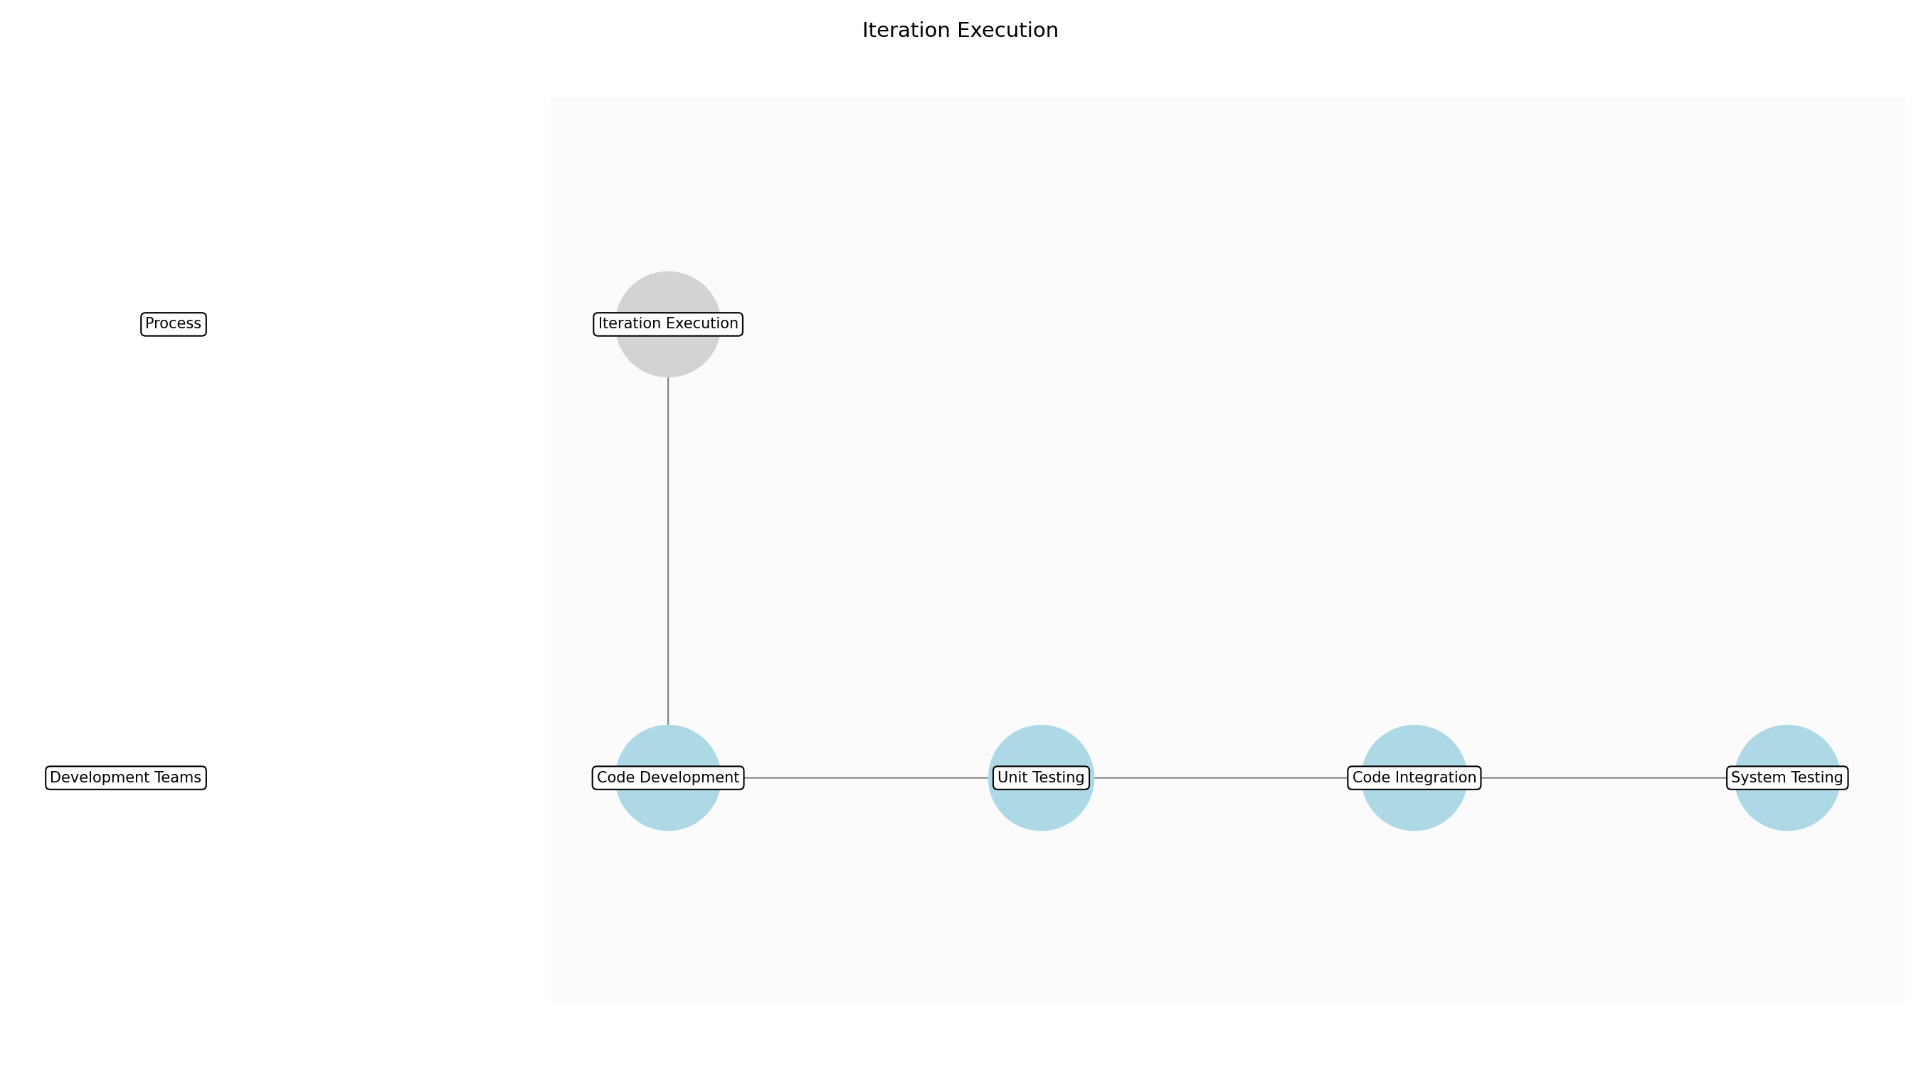

Iteration Execution – Code Development
Description:
- Development teams begin writing code based on the user stories and tasks defined in the iteration plan. This involves adhering to coding standards, utilizing appropriate design patterns, and implementing the necessary functionality to meet the acceptance criteria. Developers work collaboratively, often using pair programming or code reviews, to ensure code quality and knowledge sharing.
Responsible Party:
- Development Teams
Inputs:
- Iteration Plan
- User Stories
- Acceptance Criteria
Outputs:
- Source Code
- Code Documentation
Estimated Duration:
- 3-5 days
Dependencies:
Success Criteria:
- Code meets acceptance criteria
- Code adheres to coding standards
- Code is documented
Purpose:
- To implement the features and functionalities defined in the iteration plan.
Scope:
- Team level
Process Owner:
- Development Team
Triggers:
- Start of iteration
End Conditions:
- Code development complete for all tasks
Step Risks and Controls:
- Risk: Code defects
- Control: Code reviews and unit testing
- Risk: Misinterpretation of requirements
- Control: Daily stand-ups and clarification with product owner
Governance Requirements:
- Coding standards compliance
- Code review sign-off
Change Management:
- Change Request Process: Iteration change request
- Versioning Rules: Version control system
Continuous Improvement:
- Review Frequency: Sprint retrospective
Improvement Inputs:
- Team feedback
- Code quality metrics

Iteration Execution – Unit Testing
Description:
- Developers create and execute unit tests to verify the correctness of individual components and functions. This involves writing test cases that cover various scenarios, including positive and negative cases, boundary conditions, and error handling. Unit tests are automated and integrated into the CI/CD pipeline to ensure continuous feedback on code quality.
Responsible Party:
- Development Teams
Inputs:
- Source Code
- Test Cases
Outputs:
- Unit Test Results
- Code Coverage Metrics
Estimated Duration:
- 1-2 days
Dependencies:
- Code Development
Success Criteria:
- Unit tests pass
- Code coverage meets defined threshold
- No critical defects found
Purpose:
- To ensure the correctness and reliability of individual code components.
Scope:
- Team level
Process Owner:
- Development Team
Triggers:
- Code development complete for a component
End Conditions:
- Unit testing complete for all components
Step Risks and Controls:
- Risk: Insufficient test coverage
- Control: Code coverage analysis and test case review
- Risk: Flaky tests
- Control: Test isolation and retry mechanisms
Governance Requirements:
- Test case documentation
- Code coverage reporting
Change Management:
- Change Request Process: Iteration change request
- Versioning Rules: Version control system
Continuous Improvement:
- Review Frequency: Sprint retrospective
Improvement Inputs:
- Team feedback
- Test execution metrics

Iteration Execution – Code Integration
Description:
- Integrated code changes into the shared repository. This involves resolving conflicts, merging code branches, and ensuring that the integrated code builds successfully. Continuous integration practices are followed to automate the integration process and provide rapid feedback on integration issues. The System Team may be involved to assist with environment provisioning and build automation.
Responsible Party:
- Development Teams
Inputs:
- Source Code
- Unit Test Results
Outputs:
- Integrated Codebase
- Build Status
Estimated Duration:
- 1 day
Dependencies:
- Unit Testing
Success Criteria:
- Code integrates without conflicts
- Build is successful
- All unit tests pass after integration
Purpose:
- To combine code changes from multiple developers into a single, working codebase.
Scope:
- Team level
Process Owner:
- Development Team
Triggers:
- Completion of unit testing
End Conditions:
- Code integration complete and build is successful
Step Risks and Controls:
- Risk: Integration conflicts
- Control: Frequent integration and automated conflict resolution tools
- Risk: Build failures
- Control: Automated build verification and rollback mechanisms
Governance Requirements:
- Build automation compliance
- Version control system compliance
Change Management:
- Change Request Process: Iteration change request
- Versioning Rules: Version control system
Continuous Improvement:
- Review Frequency: Sprint retrospective
Improvement Inputs:
- Team feedback
- Build success rate

Iteration Execution – System Testing
Description:
- The integrated codebase is subjected to system testing to verify that the system as a whole meets the defined requirements and acceptance criteria. This involves executing test cases that cover various aspects of the system, including functionality, performance, security, and usability. The System Team often assists with setting up the test environment and providing test automation support.
Responsible Party:
- Development Teams
Inputs:
- Integrated Codebase
- Test Cases
- Acceptance Criteria
Outputs:
- System Test Results
- Defect Reports
Estimated Duration:
- 2-3 days
Dependencies:
- Code Integration
Success Criteria:
- System meets acceptance criteria
- No critical defects found
- Performance meets defined thresholds
Purpose:
- To validate that the integrated system meets the defined requirements and acceptance criteria.
Scope:
- Team level
Process Owner:
- Development Team
Triggers:
- Successful code integration
End Conditions:
- System testing complete and all critical defects resolved
Step Risks and Controls:
- Risk: System defects
- Control: Thorough test case design and execution
- Risk: Performance bottlenecks
- Control: Performance testing and optimization
Governance Requirements:
- Test execution reporting
- Defect tracking and resolution
Change Management:
- Change Request Process: Iteration change request
- Versioning Rules: Version control system
Continuous Improvement:
- Review Frequency: Sprint retrospective
Improvement Inputs:
- Team feedback
- Defect density

3.4 System Demos
Description:
- System Demos are conducted at the end of each iteration to showcase the integrated system functionality to stakeholders. This provides an opportunity to gather feedback, identify potential issues, and ensure that the system is meeting the needs of its users. The outputs of this step include a working system demo and feedback from stakeholders that can be used to improve the system.
Responsible Parties:
- System Team
Inputs:
- Iteration Review Feedback
- Test Results
- Feature Documentation
Success Criteria:
- Integrated system functionality is demonstrated to stakeholders.

Required Sub Process(es) for the Step "System Demos"
The following details the subprocess flows for the step "System Demos".
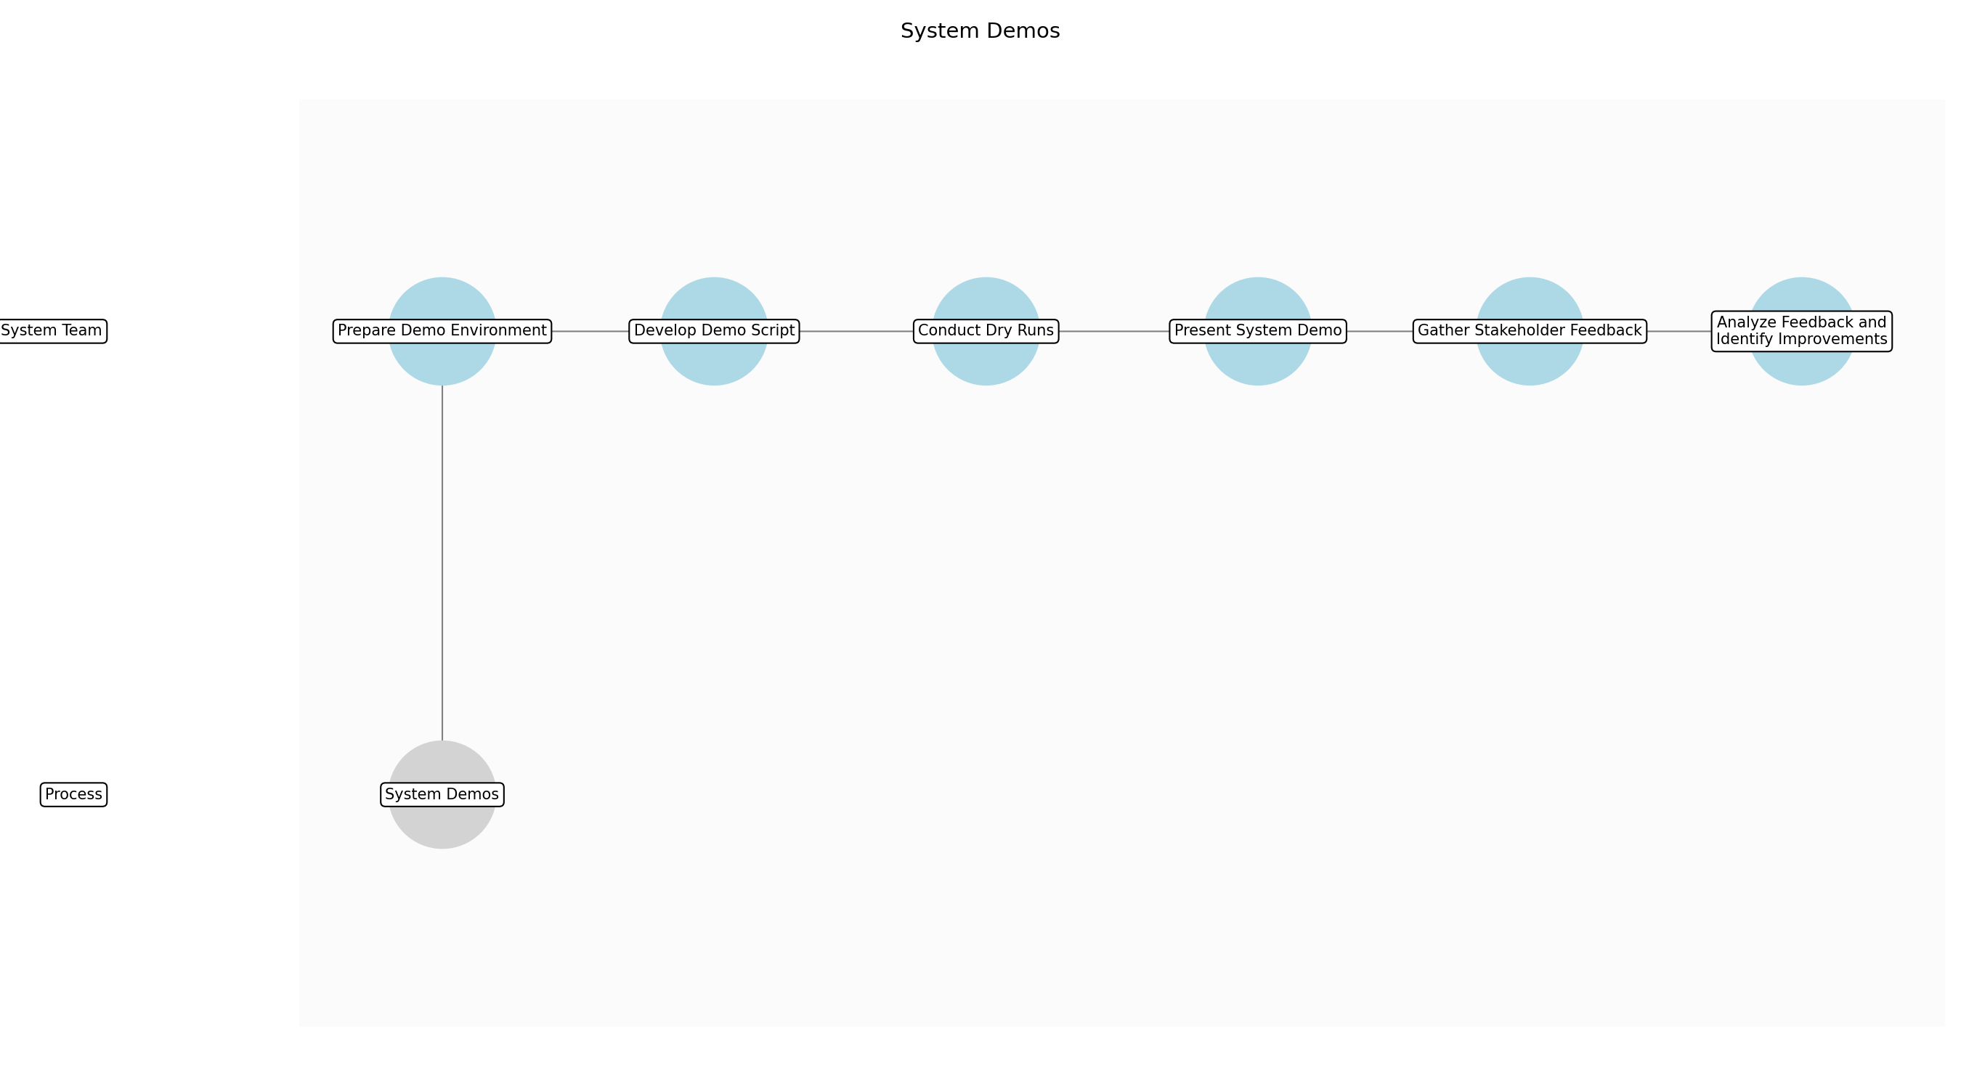

System Demos – Prepare Demo Environment
Description:
- The System Team prepares the demo environment by ensuring all necessary components are correctly configured and running. This includes deploying the latest build, configuring necessary data, and verifying network connectivity. A stable and representative environment is crucial for a successful demo.
Responsible Party:
- System Team
Inputs:
- Test Results
- Feature Documentation
- Deployment Scripts
Outputs:
- Prepared Demo Environment
- Environment Configuration Documentation
Estimated Duration:
- 4-8 hours
Dependencies:
Success Criteria:
- Environment is stable and representative
- All components are correctly configured
- Network connectivity is verified
Purpose:
- To ensure a stable and representative environment for the system demo.
Scope:
- Program level
Process Owner:
- System Team
Triggers:
- End of iteration
- Notification of upcoming demo
End Conditions:
- Demo environment is fully configured and tested
Step Risks and Controls:
- Risk: Environment instability
- Control: Automated deployment and configuration scripts
Governance Requirements:
- Environment configuration documentation
- Change management approval for environment changes
Change Management:
- Change Request Process: Standard change management process
- Versioning Rules: Version control for environment configuration scripts
Continuous Improvement:
- Review Frequency: Post-demo
Improvement Inputs:
- Demo feedback
- Environment performance metrics

System Demos – Develop Demo Script
Description:
- The System Team develops a demo script that showcases the integrated system functionality and highlights key features. This script should be concise, engaging, and tailored to the interests of the stakeholders. The script should also include contingency plans for potential issues that may arise during the demo.
Responsible Party:
- System Team
Inputs:
- Feature Documentation
- Iteration Review Feedback
- Stakeholder Profiles
Outputs:
- Demo Script
- Contingency Plans
Estimated Duration:
- 2-4 hours
Dependencies:
Success Criteria:
- Demo script is concise and engaging
- Key features are highlighted
- Contingency plans are in place
Purpose:
- To create a structured and engaging presentation of the system functionality.
Scope:
- Program level
Process Owner:
- System Team
Triggers:
- End of iteration
- Feature completion
End Conditions:
- Demo script is finalized and approved
Step Risks and Controls:
- Risk: Demo script is not engaging
- Control: Review and feedback from stakeholders
Governance Requirements:
- Stakeholder approval of demo script
Change Management:
- Change Request Process: Demo script change request process
- Versioning Rules: Version control for demo script
Continuous Improvement:
- Review Frequency: Post-demo
Improvement Inputs:
- Stakeholder feedback
- Demo effectiveness metrics

System Demos – Conduct Dry Runs
Description:
- The System Team conducts dry runs of the demo to identify and resolve any potential issues. This includes practicing the demo script, verifying environment stability, and testing contingency plans. Dry runs are essential for ensuring a smooth and professional demo.
Responsible Party:
- System Team
Inputs:
- Demo Script
- Prepared Demo Environment
Outputs:
- Identified Issues
- Revised Demo Script
- Environment Fixes
Estimated Duration:
- 2-4 hours
Dependencies:
- Prepare Demo Environment
- Develop Demo Script
Success Criteria:
- Demo runs smoothly without issues
- Environment is stable during the demo
- Contingency plans are tested and effective
Purpose:
- To identify and resolve any potential issues before the actual demo.
Scope:
- Program level
Process Owner:
- System Team
Triggers:
- Completion of demo script
- Availability of demo environment
End Conditions:
- Dry runs are completed and all issues are resolved
Step Risks and Controls:
- Risk: Unidentified issues during the demo
- Control: Multiple dry runs with different team members
Governance Requirements:
- Documentation of dry run results
Change Management:
- Change Request Process: Demo script change request process
- Versioning Rules: Version control for demo script
Continuous Improvement:
- Review Frequency: Post-demo
Improvement Inputs:
- Dry run results
- Team feedback

System Demos – Present System Demo
Description:
- The System Team presents the system demo to stakeholders, showcasing the integrated system functionality and highlighting key features. This includes following the demo script, engaging with the audience, and addressing any questions or concerns. A professional and engaging presentation is crucial for gathering valuable feedback.
Responsible Party:
- System Team
Inputs:
- Demo Script
- Prepared Demo Environment
Outputs:
- Stakeholder Feedback
- Identified Issues
Estimated Duration:
- 1-2 hours
Dependencies:
- Conduct Dry Runs
Success Criteria:
- Integrated system functionality is demonstrated
- Stakeholders are engaged and provide feedback
- Questions and concerns are addressed
Purpose:
- To showcase the integrated system functionality and gather feedback from stakeholders.
Scope:
- Program level
Process Owner:
- System Team
Triggers:
- End of iteration
- Scheduled demo time
End Conditions:
- Demo is completed and stakeholder feedback is received
Step Risks and Controls:
- Risk: Technical issues during the demo
- Control: Backup environment and contingency plans
Governance Requirements:
- Stakeholder attendance and feedback
Change Management:
- Change Request Process: Demo feedback process
- Versioning Rules: Track feedback and changes
Continuous Improvement:
- Review Frequency: Post-demo
Improvement Inputs:
- Stakeholder feedback
- Demo effectiveness metrics

System Demos – Gather Stakeholder Feedback
Description:
- The System Team actively gathers feedback from stakeholders following the system demo. This includes soliciting feedback on the system functionality, user interface, and overall value. Gathering comprehensive feedback is crucial for identifying areas for improvement and ensuring that the system meets the needs of its users.
Responsible Party:
- System Team
Inputs:
- System Demo
- Stakeholder Attendance
Outputs:
- Compiled Stakeholder Feedback
- Feedback Summary Report
Estimated Duration:
- 30 minutes - 1 hour
Dependencies:
- Present System Demo
Success Criteria:
- Feedback is gathered from all key stakeholders
- Feedback is comprehensive and addresses key areas
- Feedback is documented and summarized
Purpose:
- To collect comprehensive feedback from stakeholders to identify areas for improvement.
Scope:
- Program level
Process Owner:
- System Team
Triggers:
- Completion of system demo
End Conditions:
- Stakeholder feedback is compiled and summarized
Step Risks and Controls:
- Risk: Incomplete or biased feedback
- Control: Structured feedback forms and follow-up interviews
Governance Requirements:
- Documentation of stakeholder feedback
Change Management:
- Change Request Process: Demo feedback process
- Versioning Rules: Track feedback and changes
Continuous Improvement:
- Review Frequency: Post-demo
Improvement Inputs:
- Stakeholder feedback
- Feedback analysis

System Demos – Analyze Feedback and Identify Improvements
Description:
- The System Team analyzes the stakeholder feedback to identify potential issues and areas for improvement. This includes categorizing feedback, prioritizing issues, and developing action plans. Analyzing feedback and identifying improvements is crucial for ensuring that the system continuously evolves to meet the needs of its users.
Responsible Party:
- System Team
Inputs:
- Compiled Stakeholder Feedback
- Test Results
Outputs:
- Prioritized Issues List
- Action Plans
- Updated Backlog Items
Estimated Duration:
- 2-4 hours
Dependencies:
- Gather Stakeholder Feedback
Success Criteria:
- Feedback is categorized and prioritized
- Action plans are developed for key issues
- Backlog items are updated to reflect feedback
Purpose:
- To analyze stakeholder feedback and identify actionable improvements for the system.
Scope:
- Program level
Process Owner:
- System Team
Triggers:
- Completion of feedback gathering
End Conditions:
- Feedback is analyzed, and action plans are developed
Step Risks and Controls:
- Risk: Misinterpretation of feedback
- Control: Cross-validation with stakeholders and product owners
Governance Requirements:
- Documentation of feedback analysis and action plans
Change Management:
- Change Request Process: Standard change management process
- Versioning Rules: Track changes to backlog items
Continuous Improvement:
- Review Frequency: Post-demo
Improvement Inputs:
- Action plan effectiveness
- Stakeholder satisfaction

3.5 Release
Description:
- The Release step involves deploying features to production, making them available to end-users. This includes packaging the software, deploying it to the production environment, and conducting post-deployment testing to ensure that everything is working as expected. The outputs of this step include deployed features and release notes that document the changes made in the release.
Responsible Parties:
- Deployment Management, Release Train Engineer, System Architect
Success Criteria:
- Features are successfully deployed to production.

Required Sub Process(es) for the Step "Release"
The following details the subprocess flows for the step "Release".
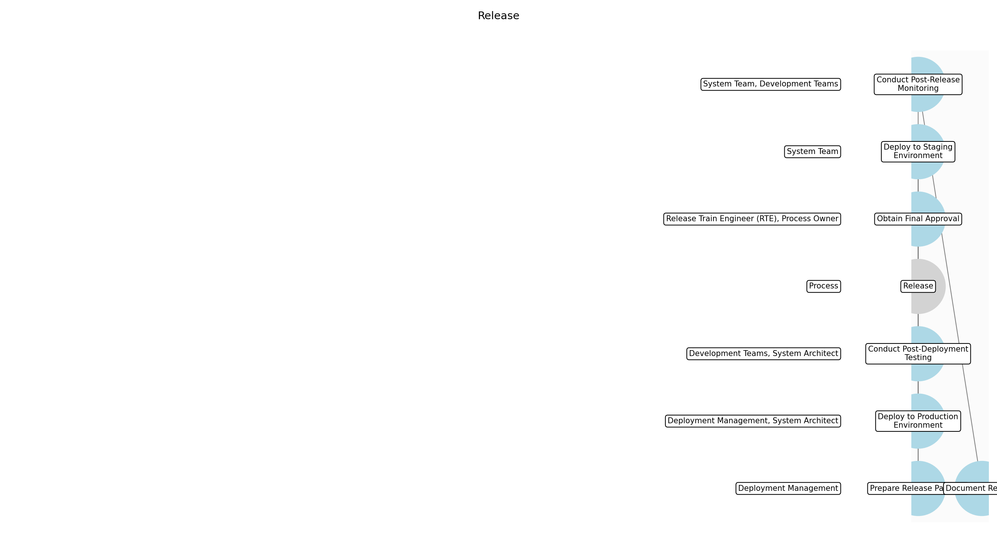

Release – Prepare Release Package
Description:
- The first step in the release process is to prepare the release package. This involves gathering all the necessary components, including the software binaries, configuration files, and any supporting documentation. The package is then versioned and tagged for easy identification and tracking. This ensures that all components are properly assembled and ready for deployment.
Responsible Party:
- Deployment Management
Inputs:
- Software binaries
- Configuration files
- Release notes
- Supporting documentation
Outputs:
- Versioned release package
Estimated Duration:
- 1 day
Dependencies:
Success Criteria:
- Release package is complete and versioned
Purpose:
- Assemble all necessary components into a deployable package.
Scope:
- Packaging of software and related artifacts.
Process Owner:
- Deployment Management
Triggers:
- Release candidate ready
End Conditions:
- Release package created
Step Risks and Controls:
- Risk: Incomplete release package
- Control: Checklist and verification process
Governance Requirements:
- Version control
- Change management approval
Change Management:
- Change Request Process: Release change request
- Versioning Rules: Release versioning
Continuous Improvement:
- Review Frequency: Post-release
Improvement Inputs:
- Deployment feedback

Release – Deploy to Staging Environment
Description:
- Before deploying to production, the release package is deployed to a staging environment. This environment closely mirrors the production environment and is used to perform final testing and validation. This step helps to identify any potential issues or conflicts before they impact the live system. The deployment process is automated to ensure consistency and reduce the risk of human error.
Responsible Party:
- System Team
Inputs:
- Versioned release package
Outputs:
- Deployed features in staging environment
Estimated Duration:
- 2 days
Dependencies:
- Prepare Release Package
Success Criteria:
- Successful deployment to staging environment
Purpose:
- Validate the release package in a production-like environment.
Scope:
- Deployment and configuration in staging.
Process Owner:
- System Team
Triggers:
- Release package created
End Conditions:
- Staging deployment complete
Step Risks and Controls:
- Risk: Deployment failure in staging
- Control: Automated deployment scripts and rollback plan
Governance Requirements:
- Environment validation
- Security review
Change Management:
- Change Request Process: Release change request
- Versioning Rules: Release versioning
Continuous Improvement:
- Review Frequency: Post-release
Improvement Inputs:
- Deployment feedback

Release – Conduct Post-Deployment Testing
Description:
- Once the release package is deployed to the staging environment, a series of post-deployment tests are conducted. These tests include functional testing, performance testing, and security testing to ensure that the system is working as expected and that there are no vulnerabilities. The System Architect and Development Teams collaborate to validate the deployed features and ensure they meet the defined success criteria.
Responsible Party:
- Development Teams, System Architect
Inputs:
- Deployed features in staging environment
Outputs:
- Test results
- Validation report
Estimated Duration:
- 2 days
Dependencies:
- Deploy to Staging Environment
Success Criteria:
- All tests pass successfully
- Validation report approved
Purpose:
- Ensure the deployed features function correctly and meet quality standards.
Scope:
- Testing and validation in staging.
Process Owner:
- Development Teams
Triggers:
- Staging deployment complete
End Conditions:
- Testing complete and validation report approved
Step Risks and Controls:
- Risk: Defects found in staging
- Control: Defect tracking and resolution process
Governance Requirements:
- Test coverage
- Defect tracking
Change Management:
- Change Request Process: Release change request
- Versioning Rules: Release versioning
Continuous Improvement:
- Review Frequency: Post-release
Improvement Inputs:
- Test results

Release – Obtain Final Approval
Description:
- After successful testing in the staging environment, final approval is obtained from the process owner and relevant stakeholders. This approval confirms that the release is ready for deployment to production. The Release Train Engineer (RTE) ensures that all governance requirements have been met and that all stakeholders are aligned on the release plan.
Responsible Party:
- Release Train Engineer (RTE), Process Owner
Inputs:
- Validation report
Outputs:
- Final approval
Estimated Duration:
- 1 day
Dependencies:
- Conduct Post-Deployment Testing
Success Criteria:
- Final approval obtained from all stakeholders
Purpose:
- Secure stakeholder agreement before production deployment.
Scope:
- Stakeholder sign-off and governance.
Process Owner:
- Release Train Engineer (RTE)
Triggers:
- Testing complete and validation report approved
End Conditions:
- Final approval received
Step Risks and Controls:
- Risk: Release not approved
- Control: Clear communication and escalation process
Governance Requirements:
- Stakeholder sign-off
- Compliance review
Change Management:
- Change Request Process: Release change request
- Versioning Rules: Release versioning
Continuous Improvement:
- Review Frequency: Post-release
Improvement Inputs:
- Stakeholder feedback

Release – Deploy to Production Environment
Description:
- With final approval in hand, the release package is deployed to the production environment. This deployment is carefully monitored to ensure that everything goes smoothly. The Deployment Management team uses automated deployment tools to minimize downtime and ensure consistency. The System Architect oversees the deployment to ensure architectural integrity and stability.
Responsible Party:
- Deployment Management, System Architect
Inputs:
- Final approval
- Versioned release package
Outputs:
- Deployed features in production
Estimated Duration:
- 4 hours
Dependencies:
- Obtain Final Approval
Success Criteria:
- Successful deployment to production environment
Purpose:
- Make the new features available to end-users.
Scope:
- Deployment and configuration in production.
Process Owner:
- Deployment Management
Triggers:
- Final approval received
End Conditions:
- Production deployment complete
Step Risks and Controls:
- Risk: Deployment failure in production
- Control: Automated deployment scripts and rollback plan
Governance Requirements:
- Change management approval
- Security compliance
Change Management:
- Change Request Process: Release change request
- Versioning Rules: Release versioning
Continuous Improvement:
- Review Frequency: Post-release
Improvement Inputs:
- Deployment feedback

Release – Conduct Post-Release Monitoring
Description:
- After the deployment to production, the system is closely monitored to ensure that everything is working as expected. This includes monitoring system performance, error logs, and user feedback. The System Team and Development Teams collaborate to quickly address any issues that arise. This monitoring continues for a defined period to ensure stability and performance.
Responsible Party:
- System Team, Development Teams
Inputs:
- Deployed features in production
Outputs:
- Monitoring reports
- Error logs
- User feedback
Estimated Duration:
- 3 days
Dependencies:
- Deploy to Production Environment
Success Criteria:
- System performance is stable
- No critical errors reported
Purpose:
- Ensure the deployed features are stable and perform as expected in production.
Scope:
- Monitoring and issue resolution in production.
Process Owner:
- System Team
Triggers:
- Production deployment complete
End Conditions:
- Monitoring period complete and system stable
Step Risks and Controls:
- Risk: System instability
- Control: Automated monitoring tools and incident response plan
Governance Requirements:
- Performance monitoring
- Incident management
Change Management:
- Change Request Process: Release change request
- Versioning Rules: Release versioning
Continuous Improvement:
- Review Frequency: Post-release
Improvement Inputs:
- Monitoring reports
- User feedback

Release – Document Release
Description:
- Finally, the release is documented, including any changes made, issues encountered, and resolutions implemented. This documentation is stored in a central repository for future reference. The Release Notes are updated to reflect the final state of the release, and any lessons learned are captured for continuous improvement. This ensures that the organization has a clear record of the release process and can learn from past experiences.
Responsible Party:
- Deployment Management
Inputs:
- Monitoring reports
- Error logs
- User feedback
Outputs:
- Updated release notes
- Release documentation
Estimated Duration:
- 4 hours
Dependencies:
- Conduct Post-Release Monitoring
Success Criteria:
- Release documentation is complete and accurate
Purpose:
- Maintain a record of the release for future reference and continuous improvement.
Scope:
- Documentation and archiving of release information.
Process Owner:
- Deployment Management
Triggers:
- Monitoring period complete and system stable
End Conditions:
- Release documentation complete
Step Risks and Controls:
- Risk: Incomplete documentation
- Control: Documentation checklist and review process
Governance Requirements:
- Documentation standards
- Archival policy
Change Management:
- Change Request Process: Release change request
- Versioning Rules: Release versioning
Continuous Improvement:
- Review Frequency: Post-release
Improvement Inputs:
- Documentation feedback

3.6 Inspect and Adapt
Description:
- The Inspect and Adapt (I&A) event is a significant event, held at the end of each PI, where the current state of the solution is demonstrated and evaluated by the teams. Teams then identify improvement items via a structured, problem-solving workshop. The outputs of this step include an improvement plan and action items that are incorporated into the next PI Planning session to drive continuous improvement.
Responsible Parties:
- Release Train Engineer (RTE)
Success Criteria:
- Identified process improvements and action items.

Required Sub Process(es) for the Step "Inspect and Adapt"
The following details the subprocess flows for the step "Inspect and Adapt".
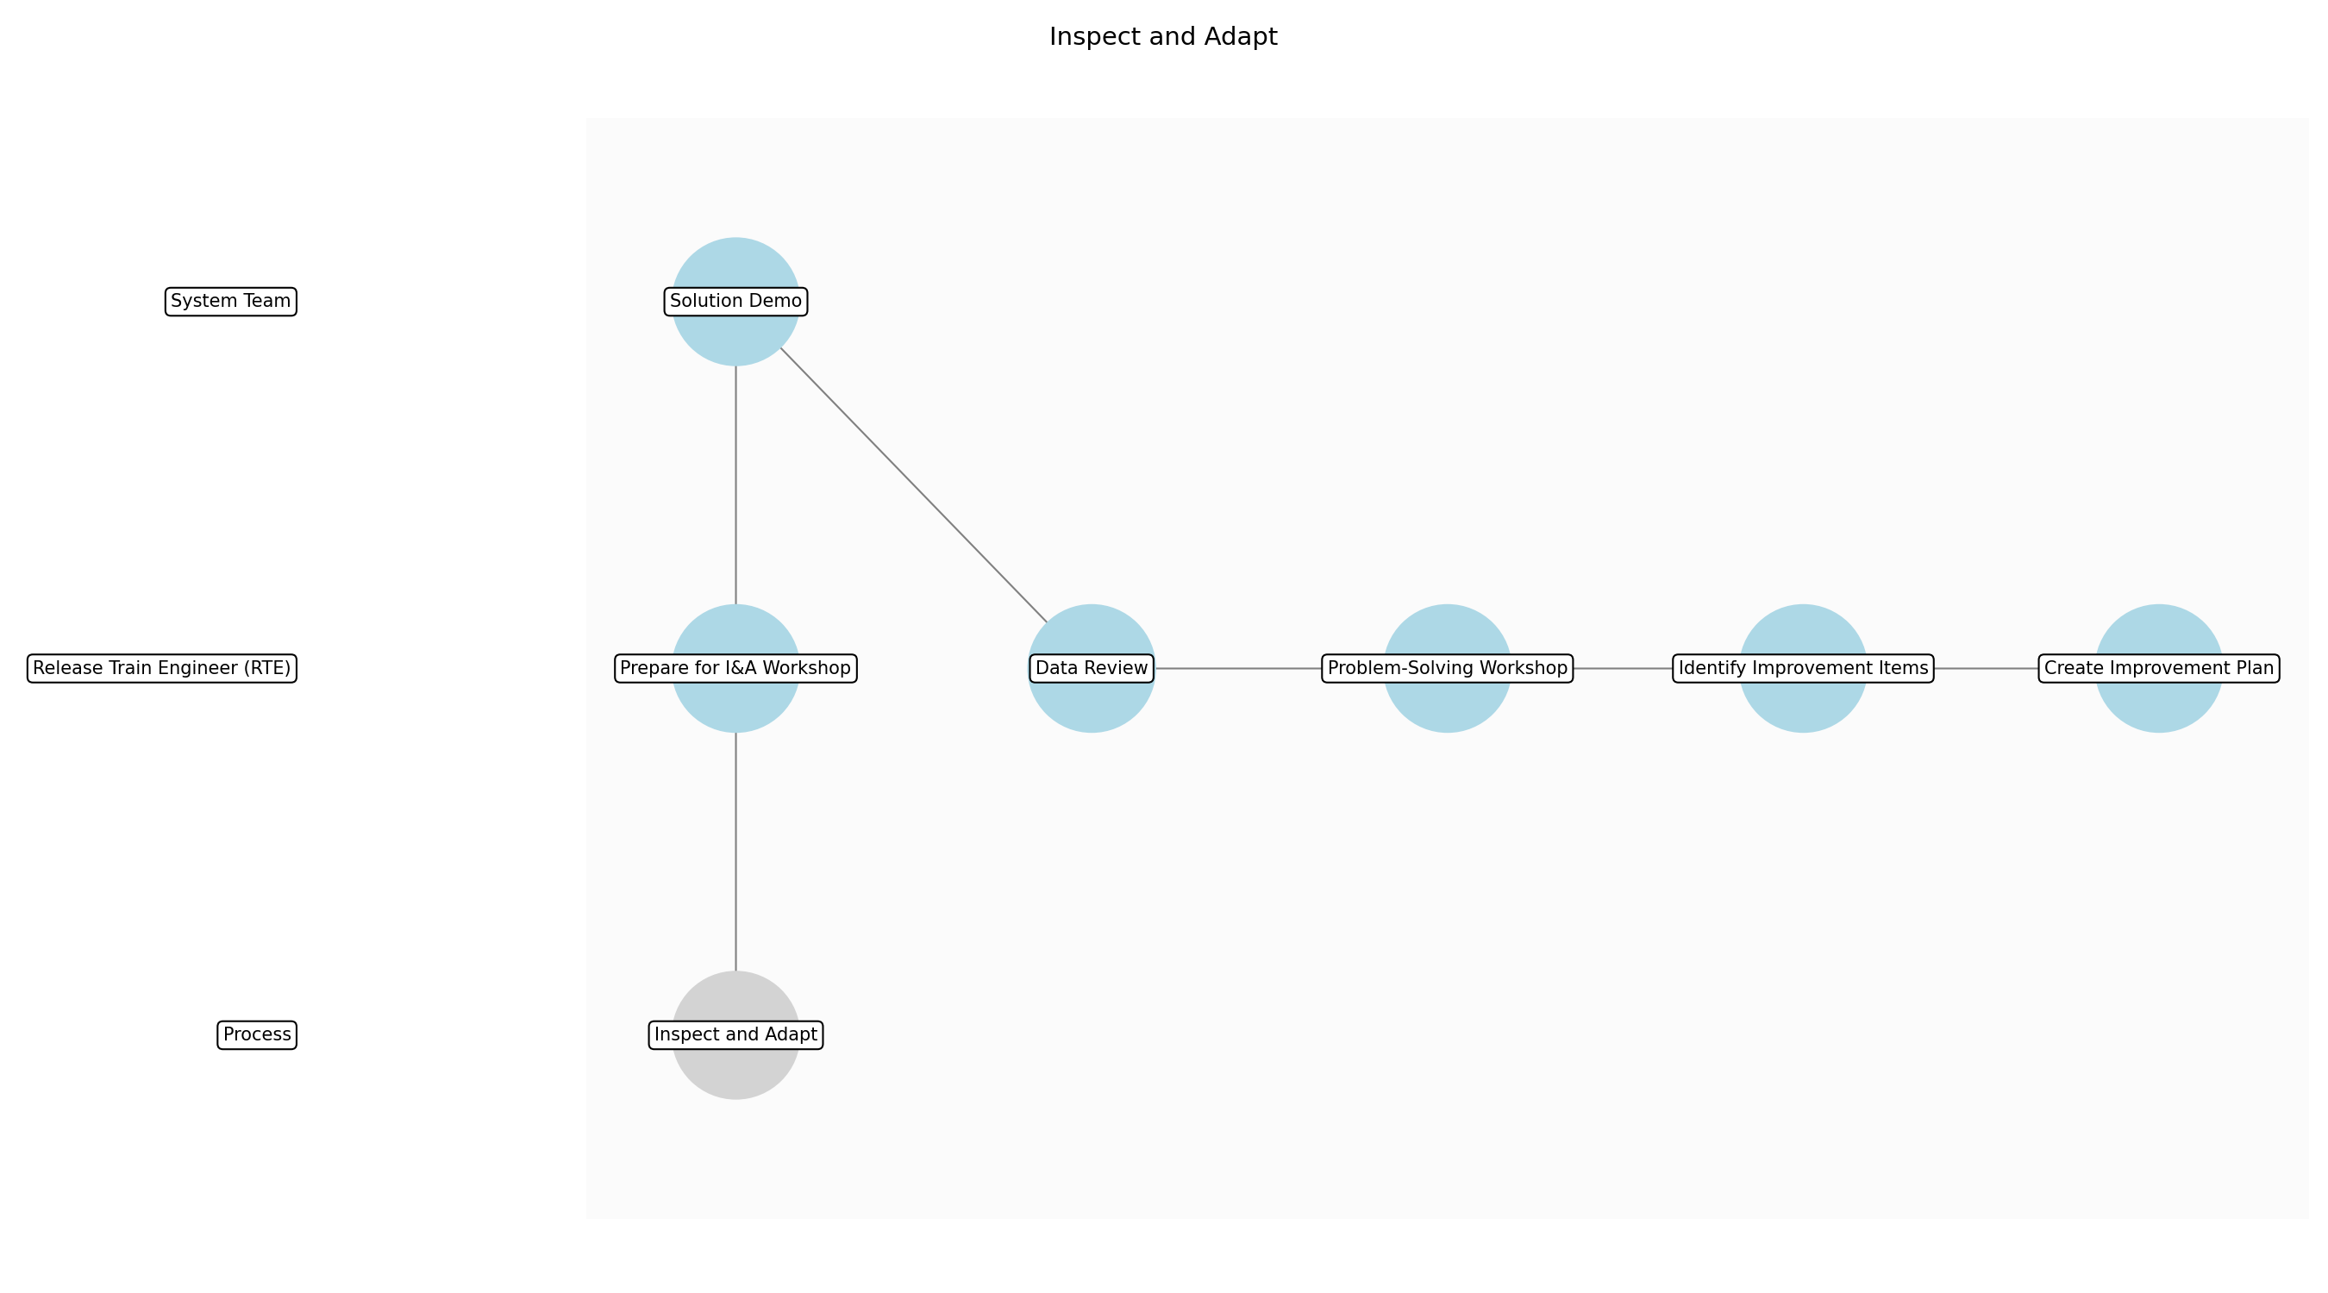

Inspect and Adapt – Prepare for I&A Workshop
Description:
- The Release Train Engineer (RTE) schedules the Inspect and Adapt (I&A) workshop, ensuring all relevant stakeholders are invited, including representatives from each team, product management, system architects, and business owners. The RTE also prepares the agenda, ensuring it covers the demonstration of the current solution, data review, problem-solving workshop, and identification of improvement items. Finally, the RTE ensures the necessary tools and materials are available, such as collaboration platforms, whiteboards, and data reports.
Responsible Party:
- Release Train Engineer (RTE)
Inputs:
Outputs:
- I&A Workshop agenda
- List of attendees
- Required tools and materials
Estimated Duration:
- 2 hours
Dependencies:
Success Criteria:
- Workshop scheduled with all stakeholders
- Agenda prepared and communicated
- Tools and materials ready
Purpose:
- To ensure the I&A workshop is well-organized and productive.
Scope:
- Program level
Process Owner:
- Release Train Engineer (RTE)
Triggers:
- End of PI
End Conditions:
- Workshop agenda finalized
- Attendees confirmed
- Materials prepared
Step Risks and Controls:
- Risk: Poor attendance
- Control: Send reminders and emphasize the importance of the workshop
Governance Requirements:
- Stakeholder attendance
Change Management:
- Change Request Process: Email to RTE
- Versioning Rules: Track changes to agenda
Continuous Improvement:
- Review Frequency: Post-workshop
Improvement Inputs:
- Attendee feedback

Inspect and Adapt – Solution Demo
Description:
- The System Team, along with representatives from the development teams, demonstrates the current state of the solution to all stakeholders. This demonstration should cover all key features and functionalities delivered during the PI, highlighting any significant achievements or challenges encountered. The demonstration should be interactive, allowing stakeholders to ask questions and provide feedback on the solution's performance and usability. The System Architect provides context on architectural decisions.
Responsible Party:
- System Team
Inputs:
Outputs:
- Working system demo
- Stakeholder feedback
Estimated Duration:
- 2 hours
Dependencies:
- Prepare for I&A Workshop
Success Criteria:
- All key features demonstrated
- Stakeholder feedback collected
Purpose:
- To provide stakeholders with a clear understanding of the current state of the solution.
Scope:
- Program level
Process Owner:
- System Team
Triggers:
- Start of I&A Workshop
End Conditions:
- Solution demo completed
- Feedback documented
Step Risks and Controls:
- Risk: Demo failure
- Control: Prepare backup plans and dry runs
Governance Requirements:
- Stakeholder attendance and feedback
Change Management:
- Change Request Process: Verbal feedback during demo
- Versioning Rules: Track feedback and changes
Continuous Improvement:
- Review Frequency: Post-demo
Improvement Inputs:
- Stakeholder feedback

Inspect and Adapt – Data Review
Description:
- The RTE presents data related to the PI's performance, including metrics such as program predictability, team velocity, defect density, and release frequency. This data should be presented in a clear and concise manner, highlighting any trends or areas of concern. The RTE facilitates a discussion around the data, encouraging stakeholders to share their insights and perspectives on the PI's performance. The RTE also presents data on dependencies and risks encountered during the PI.
Responsible Party:
- Release Train Engineer (RTE)
Inputs:
Outputs:
- PI performance data
- Stakeholder insights
Estimated Duration:
- 1 hour
Dependencies:
- Solution Demo
Success Criteria:
- PI performance data presented
- Stakeholder insights documented
Purpose:
- To provide stakeholders with a data-driven understanding of the PI's performance.
Scope:
- Program level
Process Owner:
- Release Train Engineer (RTE)
Triggers:
- Completion of Solution Demo
End Conditions:
- Data review completed
- Insights documented
Step Risks and Controls:
- Risk: Data misinterpretation
- Control: Provide clear explanations and context
Governance Requirements:
- Data accuracy
Change Management:
- Change Request Process: Email to RTE
- Versioning Rules: Track changes to data presentation
Continuous Improvement:
- Review Frequency: Post-workshop
Improvement Inputs:
- Stakeholder feedback

Inspect and Adapt – Problem-Solving Workshop
Description:
- Facilitated by the RTE, stakeholders participate in a structured problem-solving workshop to identify the root causes of any issues or challenges encountered during the PI. This workshop should follow a defined process, such as the 5 Whys or Fishbone diagram, to ensure a thorough analysis. The workshop should be collaborative, encouraging all stakeholders to contribute their ideas and perspectives. The System Architect provides technical insights.
Responsible Party:
- Release Train Engineer (RTE)
Inputs:
Outputs:
- Identified root causes
- Potential solutions
Estimated Duration:
- 3 hours
Dependencies:
- Data Review
Success Criteria:
- Root causes identified
- Potential solutions generated
Purpose:
- To identify the root causes of issues and generate potential solutions.
Scope:
- Program level
Process Owner:
- Release Train Engineer (RTE)
Triggers:
- Completion of Data Review
End Conditions:
- Problem-solving workshop completed
- Root causes and solutions documented
Step Risks and Controls:
- Risk: Lack of participation
- Control: Encourage active participation and create a safe environment
Governance Requirements:
- Action item tracking
Change Management:
- Change Request Process: Verbal feedback during workshop
- Versioning Rules: Track feedback and changes
Continuous Improvement:
- Review Frequency: Post-workshop
Improvement Inputs:
- Attendee feedback

Inspect and Adapt – Identify Improvement Items
Description:
- Based on the identified root causes and potential solutions, stakeholders identify specific improvement items that can be implemented in the next PI. These improvement items should be actionable, measurable, achievable, relevant, and time-bound (SMART). The improvement items should be prioritized based on their potential impact and feasibility. The RTE ensures that the improvement items are documented and assigned to responsible parties.
Responsible Party:
- Release Train Engineer (RTE)
Inputs:
- Identified root causes
- Potential solutions
Outputs:
- Prioritized improvement items
- Assigned responsible parties
Estimated Duration:
- 2 hours
Dependencies:
- Problem-Solving Workshop
Success Criteria:
- SMART improvement items identified
- Improvement items prioritized
- Responsible parties assigned
Purpose:
- To identify and prioritize actionable improvement items for the next PI.
Scope:
- Program level
Process Owner:
- Release Train Engineer (RTE)
Triggers:
- Completion of Problem-Solving Workshop
End Conditions:
- Improvement items documented
- Priorities set
- Assignments made
Step Risks and Controls:
- Risk: Unrealistic improvement items
- Control: Ensure improvement items are SMART
Governance Requirements:
- Action item tracking
Change Management:
- Change Request Process: Email to RTE
- Versioning Rules: Track changes to improvement items
Continuous Improvement:
- Review Frequency: Post-PI
Improvement Inputs:
- Team feedback

Inspect and Adapt – Create Improvement Plan
Description:
- The RTE compiles all identified improvement items into a comprehensive improvement plan. This plan should include a description of each improvement item, the responsible party, the expected benefits, and the timeline for implementation. The improvement plan should be communicated to all stakeholders and incorporated into the next PI Planning session. The RTE tracks the progress of the improvement plan and reports on its effectiveness.
Responsible Party:
- Release Train Engineer (RTE)
Inputs:
- Prioritized improvement items
- Assigned responsible parties
Outputs:
- Improvement plan
Estimated Duration:
- 2 hours
Dependencies:
- Identify Improvement Items
Success Criteria:
- Improvement plan created
- Plan communicated to stakeholders
Purpose:
- To create a roadmap for implementing the identified improvement items.
Scope:
- Program level
Process Owner:
- Release Train Engineer (RTE)
Triggers:
- Completion of Improvement Item Identification
End Conditions:
- Improvement plan finalized
- Plan communicated
Step Risks and Controls:
- Risk: Lack of implementation
- Control: Track progress and report on effectiveness
Governance Requirements:
- Action item tracking
Change Management:
- Change Request Process: Email to RTE
- Versioning Rules: Track changes to improvement plan
Continuous Improvement:
- Review Frequency: Ongoing
Improvement Inputs:
- Team feedback

3.7 Innovation and Planning (IP) Iteration
Description:
- The Innovation and Planning (IP) Iteration provides dedicated time for innovation, learning, and PI Planning preparation. During this iteration, teams can explore new technologies, experiment with new ideas, and prepare for the upcoming PI Planning session. The outputs of this step include innovation prototypes, learning summaries, and PI Planning inputs that can be used to drive innovation and improve the overall SDLC process.
Responsible Parties:
- Development Teams
Success Criteria:
- Innovation prototypes and PI Planning inputs are created.

Required Sub Process(es) for the Step "Innovation and Planning (IP) Iteration"
The following details the subprocess flows for the step "Innovation and Planning (IP) Iteration".
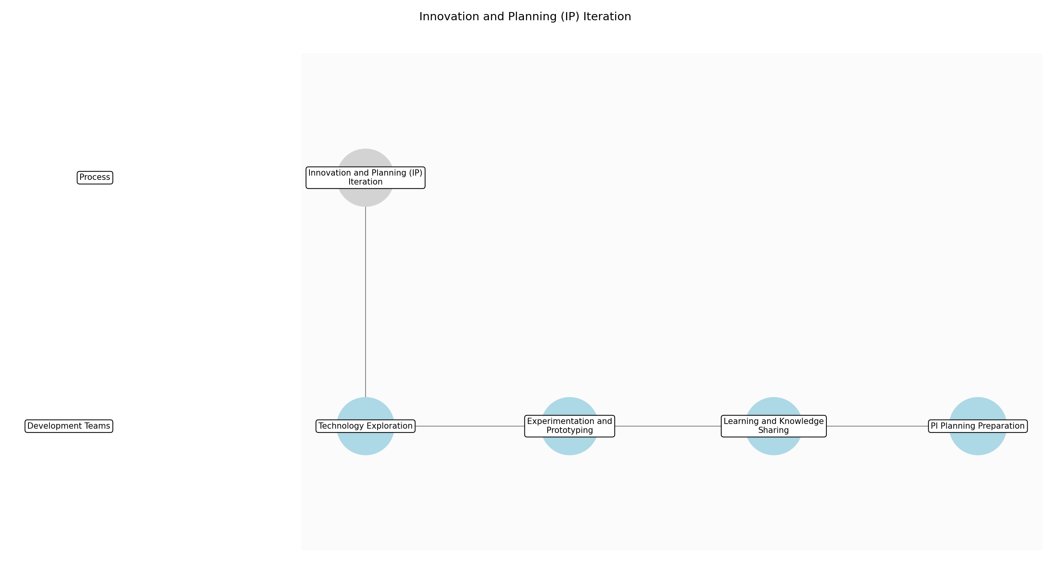

Innovation and Planning (IP) Iteration – Technology Exploration
Description:
- Development teams dedicate time to explore new technologies relevant to the program's architectural runway and future product capabilities. This involves researching emerging trends, evaluating potential tools and frameworks, and conducting proof-of-concept experiments to assess their feasibility and value. The goal is to identify technologies that can enhance the program's ability to deliver innovative solutions and improve its overall technical agility.
Responsible Party:
- Development Teams
Inputs:
Outputs:
- Technology evaluation reports
- Proof-of-concept prototypes
Estimated Duration:
- 3 days
Dependencies:
Success Criteria:
- Relevant new technologies are identified and evaluated.
- Proof-of-concept prototypes demonstrate the feasibility of selected technologies.
Purpose:
- Identify and evaluate new technologies for potential adoption within the program.
Scope:
- Team level
Process Owner:
- Development Teams
Triggers:
- Scheduled IP Iteration
End Conditions:
- Technology evaluation reports and proof-of-concept prototypes are completed.
Step Risks and Controls:
- Risk: Selection of inappropriate technologies
- Control: Conduct thorough evaluations and involve system architects in the decision-making process.
Governance Requirements:
Change Management:
- Change Request Process: Innovation request
- Versioning Rules: Track technology changes
Continuous Improvement:
- Review Frequency: Post-IP Iteration
Improvement Inputs:
- Team feedback
- Technology performance data

Innovation and Planning (IP) Iteration – Experimentation and Prototyping
Description:
- Teams engage in experimentation and prototyping to explore new ideas and validate potential solutions. This involves creating rapid prototypes, conducting user testing, and gathering feedback to iterate on designs and refine concepts. The focus is on fostering a culture of experimentation and learning, where teams are empowered to take risks and explore unconventional approaches to problem-solving.
Responsible Party:
- Development Teams
Inputs:
- Technology evaluation reports
Outputs:
- Innovation prototypes
- User feedback summaries
Estimated Duration:
- 5 days
Dependencies:
- Technology Exploration
Success Criteria:
- Innovation prototypes are created and tested with users.
- User feedback is gathered and incorporated into prototype designs.
Purpose:
- Explore new ideas and validate potential solutions through experimentation and prototyping.
Scope:
- Team level
Process Owner:
- Development Teams
Triggers:
- Scheduled IP Iteration
End Conditions:
- Innovation prototypes are tested and user feedback is summarized.
Step Risks and Controls:
- Risk: Wasting time on unpromising ideas
- Control: Establish clear criteria for evaluating ideas and conduct regular reviews to assess progress.
Governance Requirements:
Change Management:
- Change Request Process: Innovation request
- Versioning Rules: Track prototype changes
Continuous Improvement:
- Review Frequency: Post-IP Iteration
Improvement Inputs:
- Team feedback
- User feedback summaries

Innovation and Planning (IP) Iteration – Learning and Knowledge Sharing
Description:
- Teams document their learning and share their knowledge with the broader organization. This involves creating learning summaries, conducting presentations, and participating in knowledge-sharing sessions. The goal is to disseminate insights gained during the IP Iteration and promote a culture of continuous learning and improvement across the program.
Responsible Party:
- Development Teams
Inputs:
- User feedback summaries
- Innovation prototypes
Outputs:
- Learning summaries
- Presentation materials
Estimated Duration:
- 2 days
Dependencies:
- Experimentation and Prototyping
Success Criteria:
- Learning summaries are created and shared with the organization.
- Presentations are conducted to disseminate insights gained during the IP Iteration.
Purpose:
- Disseminate insights gained during the IP Iteration and promote a culture of continuous learning.
Scope:
- Team level
Process Owner:
- Development Teams
Triggers:
- Scheduled IP Iteration
End Conditions:
- Learning summaries and presentation materials are completed.
Step Risks and Controls:
- Risk: Knowledge is not effectively shared
- Control: Establish clear guidelines for documenting learning and provide incentives for knowledge sharing.
Governance Requirements:
- Innovation showcase
Change Management:
- Change Request Process: Innovation request
- Versioning Rules: Track learning changes
Continuous Improvement:
- Review Frequency: Post-IP Iteration
Improvement Inputs:
- Team feedback
- Feedback from knowledge-sharing sessions

Innovation and Planning (IP) Iteration – PI Planning Preparation
Description:
- Teams prepare for the upcoming PI Planning session by reviewing the program backlog, identifying dependencies, and estimating the effort required for each feature. This involves collaborating with product management and other stakeholders to refine the backlog and ensure that it is aligned with strategic objectives. The goal is to ensure that the PI Planning session is productive and efficient, and that teams are able to commit to realistic PI Objectives.
Responsible Party:
- Development Teams
Inputs:
- Learning summaries
- Program backlog
Outputs:
- PI Planning inputs
Estimated Duration:
- 4 days
Dependencies:
- Learning and Knowledge Sharing
Success Criteria:
- PI Planning inputs are created and shared with stakeholders.
- Teams are prepared to commit to realistic PI Objectives.
Purpose:
- Prepare for the upcoming PI Planning session and ensure that teams are able to commit to realistic PI Objectives.
Scope:
- Team level
Process Owner:
- Development Teams
Triggers:
- Scheduled IP Iteration
End Conditions:
- PI Planning inputs are completed.
Step Risks and Controls:
- Risk: Inadequate preparation for PI Planning
- Control: Establish clear guidelines for PI Planning preparation and provide teams with the necessary resources and support.
Governance Requirements:
Change Management:
- Change Request Process: Innovation request
- Versioning Rules: Track PI Planning input changes
Continuous Improvement:
- Review Frequency: Post-IP Iteration
Improvement Inputs:
- Team feedback
- Feedback from PI Planning session

4.0 Supporting Systems and Tools
The following tools and platforms support this process:
Category | Tools
Agile Project Management | Jira, Azure DevOps
CI/CD | Jenkins, GitLab CI
Collaboration | Slack, Microsoft Teams
Testing Automation | Selenium, JUnit
Version Control | Git
Security Scanning | SonarQube, Fortify

5.0 Metrics and Key Performance Indicators (KPIs)
The following is a list of key metrics associated with this process. These metrics help monitor performance and ensure alignment with business objectives.
Metric | Description | Measurement / Frequency | Target
Program Predictability Measure | Measures the predictability of delivering PI Objectives. | Per PI | 80%
Team Velocity | Measures the rate at which teams deliver value, providing insights into team performance and identifying potential bottlenecks. | Per iteration | Consistent velocity
Defect Density | Measures the number of defects per line of code, providing an indication of code quality and the effectiveness of testing efforts. | Per release | <1 defect/1000 LOC
Release Frequency | Measures the frequency of releases to production, indicating the organization's ability to deliver value to customers quickly and reliably. | Monthly | Monthly releases
Customer Satisfaction | Measures customer satisfaction with delivered features, providing valuable feedback for continuous improvement and ensuring that the organization is meeting customer needs. | Post-release | 4.5/5 rating

6.0 Critical Success Factors (CSF)
The following is a list of key CSFs associated with this process.
Success Factor | Description
Effective PI Planning | Effective PI Planning ensures alignment and commitment across teams, leading to more predictable and successful outcomes.
Strong RTE leadership | Strong RTE leadership facilitates program execution, removes impediments, and ensures that teams are working towards common goals.
Cross-functional collaboration | Cross-functional collaboration ensures smooth communication and collaboration across teams, leading to more efficient and effective development.
Continuous Integration/Continuous Delivery (CI/CD) | Continuous Integration/Continuous Delivery (CI/CD) enables frequent and reliable releases, allowing organizations to deliver value to customers more quickly.
Alignment with business goals | Alignment with business goals ensures that development efforts are aligned with business objectives, leading to more valuable and impactful outcomes.

7.0 Critical Failure Factors (CFF)
The following is a list of key CFFs associated with this process.
Failure Factor | Description
Poor communication | Poor communication between teams and stakeholders can lead to misunderstandings, delays, and ultimately, project failure.
Lack of stakeholder engagement | A lack of stakeholder engagement can result in misaligned priorities and unmet expectations, leading to dissatisfaction and project failure.
Unrealistic expectations | Setting unrealistic expectations can cause frustration and burnout among team members, negatively impacting morale and productivity.
Technical debt | Accumulating technical debt can slow down development, increase maintenance costs, and make it more difficult to implement new features.
Inadequate testing | Inadequate testing can result in defects, customer dissatisfaction, and ultimately, damage to the organization's reputation.

8.0 Reporting and Analytics
The following are key reporting and analytics associated with this process.
Description | Metric
Provides an overview of program progress and risks, enabling stakeholders to make informed decisions and take corrective actions as needed. | Program progress reports
Tracks the progress of releases, providing insights into the organization's ability to deliver value to customers on a regular basis. | Release burndown charts
Measures team velocity and identifies bottlenecks, enabling teams to improve their performance and optimize their workflows. | Team velocity reports
Tracks the number and severity of defects, providing an indication of code quality and the effectiveness of testing efforts. | Defect tracking reports
Identifies bottlenecks and inefficiencies in the value stream, enabling organizations to streamline their processes and improve their overall efficiency. | Value stream mapping

9.0 System Requirements
The following system requirements are essential for the successful implementation of this process.
Details | Name
Used for managing the program and team backlogs, tracking progress, and facilitating collaboration. | Agile project management software (e.g., Jira, Azure DevOps)
Used for automating the build, test, and deployment processes. | CI/CD pipeline (e.g., Jenkins, GitLab CI)
Used for facilitating communication and collaboration across teams. | Collaboration tools (e.g., Slack, Microsoft Teams)
Used for automating the testing process and ensuring code quality. | Testing automation tools
Used for managing source code and tracking changes. | Version control system (e.g., Git)
Used for identifying security vulnerabilities and ensuring code security. | Security scanning tools (e.g., SonarQube, Fortify)

10.0 Process Flow Diagram
The following diagram provides a high-level visualization of the process flow as defined in the normalized JSON source.
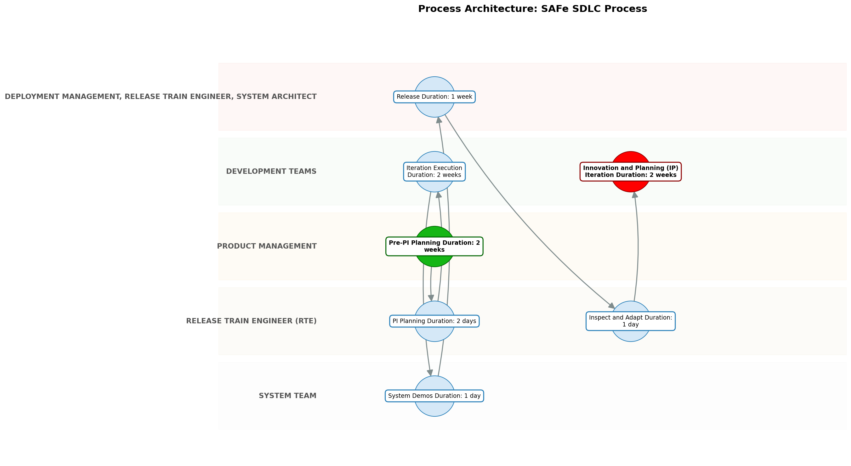

11.0 Process Performance Report
The following metrics are based on a Monte Carlo discrete-event simulation running 2,000 iterations. All time-based values are reported in weeks.
Operational Metric | Simulated Value
Average Cycle Time | 12.10 weeks
Cycle Time Variance | 1.20 weeks
Contention Risk Profile | Low

Identified Bottlenecks
- Pre-PI Planning
- PI Planning
- Iteration Execution

Detailed Step Performance
Process Step | Avg. Duration (weeks)
Pre-PI Planning | 2.70
PI Planning | 2.69
Iteration Execution | 2.69
System Demos | 1.35
Release | 1.34
Inspect and Adapt | 1.33
Innovation and Planning (IP) Iteration | 2.67

12.0 Governance Requirements
There following are the list of governance requirements used in this process.
- Regular audits of SAFe implementation
- Compliance with industry standards
- Stakeholder reviews of program progress

13.0 Risks and Controls
The following risks and associated controls apply to this process.
Risk | Control
Dependency conflicts | Dependency mapping and proactive communication
Scope creep | Strict change management process and backlog prioritization
Technical debt | Dedicated time for refactoring and technical improvements

14.0 Process Triggers
There following are triggers that kick processes off.
- New feature request
- Business opportunity
- Market change
- Regulatory requirement

15.0 Process End Conditions
There following are a list of the process end conditions.
- Feature deployed to production
- Value delivered to customer
- Release objectives met

16.0 Change Management
There following are list of the change management procedures.
- Change Request Process: Formal change request process
- Versioning Rules: Document versioning control

17.0 Continuous Improvement
The following are the items used for continuous improvement.
- Review Frequency: Regularly
Improvement Inputs:
- Regular retrospectives
- Value stream mapping
- Kaizen workshops
- Feedback loops with stakeholders

Appendix B: Additional Source Data
This appendix contains additional structured data from the normalized source JSON that is not covered in the main sections.
Purpose: This process aims to provide a structured framework for developing and delivering software products at the enterprise level, aligning with strategic business goals and delivering value to stakeholders through Agile and SAFe methodologies. It ensures that software development efforts are aligned with business objectives by prioritizing features that directly contribute to key performance indicators (KPIs) such as increased revenue, reduced costs, or improved customer satisfaction. For example, a key performance indicator (KPI) directly impacted by this process could be a reduction in time-to-market for new features, an increase in customer satisfaction scores, or a decrease in development costs. The process promotes collaboration and communication across teams through standardized processes and regular synchronization meetings, and enables the delivery of high-quality software products in a timely and efficient manner by leveraging continuous integration and continuous delivery (CI/CD) practices.
Process Owner: Program Manager/Release Train Engineer
Scope: This process encompasses all software development activities from initial planning and requirements gathering to production deployment and ongoing maintenance. It includes program management, release train coordination, team-level execution, and applies to large-scale enterprise projects that require cross-team coordination and alignment with strategic business goals. For example, this process would be used for developing a new e-commerce platform, migrating a legacy system to the cloud, or building a new customer relationship management (CRM) platform. This process excludes small, isolated projects that do not require significant cross-team coordination or alignment with enterprise-level objectives, such as developing a simple mobile app, creating a single landing page, or developing a proof-of-concept application.

Appendix C: Glossary
This glossary contains definitions of common terms used in the process documentation.
Term | Definition
Business Process | A set of related activities or tasks performed to achieve a specific organizational goal.
KPI | Key Performance Indicator used to measure the success or health of a process.
Stakeholder | Any individual or group with an interest in the outcomes of the process.
Continuous Improvement | Ongoing effort to improve products, services or processes.

