AI-Enhanced Process
Process Model Document

Industry / Domain: General
Version: 1.0
Generated On: 2026-02-23 16:56:20

Document Control
Version | Date | Author | Description
1.0 | 2026-02-23 | Process Architect | Initial generated process specification

Table of Contents
Document Control 2
Table of Contents 3
1.0 Process Overview 5
1.1 Assumptions 5
1.2 Constraints 5
1.3 Purpose 5
1.4 Scope 5
1.5 Industry Sector 5
2.0 Stakeholders and Responsibilities 6
3.0 Process Workflow 7
3.1 Data Collection and Preparation 7
Required Sub Process(es) for the Step "Data Collection and Preparation" 9
3.2 AI Model Training and Validation 20
Required Sub Process(es) for the Step "AI Model Training and Validation" 22
3.3 AI Model Deployment 31
Required Sub Process(es) for the Step "AI Model Deployment" 33
3.4 AI-Powered Service Usage 44
Required Sub Process(es) for the Step "AI-Powered Service Usage" 46
3.5 Performance Monitoring and Feedback 57
Required Sub Process(es) for the Step "Performance Monitoring and Feedback" 59
4.0 Supporting Systems and Tools 73
5.0 Metrics and Key Performance Indicators (KPIs) 74
6.0 Critical Success Factors (CSF) 75
7.0 Critical Failure Factors (CFF) 76
8.0 Reporting and Analytics 77
9.0 System Requirements 78
10.0 Process Flow Diagram 79
11.0 Process Performance Report 80
Identified Bottlenecks 80
Detailed Step Performance 80
12.0 Governance Requirements 81
13.0 Risks and Controls 82
14.0 Process Triggers 83
15.0 Process End Conditions 84
16.0 Change Management 85
17.0 Continuous Improvement 86
Appendix B: Additional Source Data 88
Appendix C: Glossary 89

1.0 Process Overview
This process leverages AI to improve efficiency, decision-making, and accessibility, ensuring responsible use, scalability, and real-world benefits for diverse users.

1.1 Assumptions
- Data availability
- User willingness to adopt AI
- Stable infrastructure

1.2 Constraints
- Budget limitations
- Regulatory constraints
- Data privacy

1.3 Purpose
To improve efficiency, decision-making, and accessibility using AI

1.4 Scope
All relevant business processes

1.5 Industry Sector
General

2.0 Stakeholders and Responsibilities
The following is a list of key stakeholders involved in this process. Understanding their roles and responsibilities is crucial for successful implementation.
Stakeholder | Responsibilities
Process Owner | Oversee process execution  Ensure compliance  Drive continuous improvement
AI Specialist | Develop and maintain AI models  Monitor AI performance  Address technical issues
End User | Provide feedback  Utilize AI tools  Report issues
Data Scientist | Analyze data  Improve AI models  Ensure data quality

3.0 Process Workflow
The following is a list of key steps in the process workflow.

3.1 Data Collection and Preparation

Description:
Gather and prepare data for AI model training and usage.

Purpose:
To ensure high-quality data for AI models

Scope:
All relevant data sources

Inputs:
The following inputs are required for this step:
• Raw data sources

Outputs:
This step produces the following outputs:
• Prepared dataset

Success Criteria:
Success for this step is measured by:
• Data quality
• Completeness
• Accuracy

Process Triggers:
This step is initiated by:
• New data available
• Scheduled updates

Process End Conditions:
This step is considered complete when:
• Dataset prepared and validated

Deliverables:
This step produces the following deliverables:
• Cleaned and labeled dataset

Governance Requirements:
The following governance requirements apply:
• Data privacy regulations
• Compliance standards

Risks and Controls:
The following risks and controls apply:
• Control: Data validation and cleaning procedures
• Risk: Data quality issues

Change Management:
The following change management rules apply:
• Change Request Process: Standard change management process
• Versioning Rules: Semantic versioning

Continuous Improvement:
The following continuous improvement practices apply:
• Improvement Inputs:
• User feedback
• Performance metrics
• Review Frequency: Monthly

Estimated Duration:
The estimated duration for this step is:
• 1 week

Process Owner:
The following process owner is accountable:
• Process Owner

Responsible Parties:
The following parties are responsible for this step:
• Data Scientist

Required Sub Process(es) for the Step "Data Collection and Preparation"
The following details the subprocess flows for the step "Data Collection and Preparation".
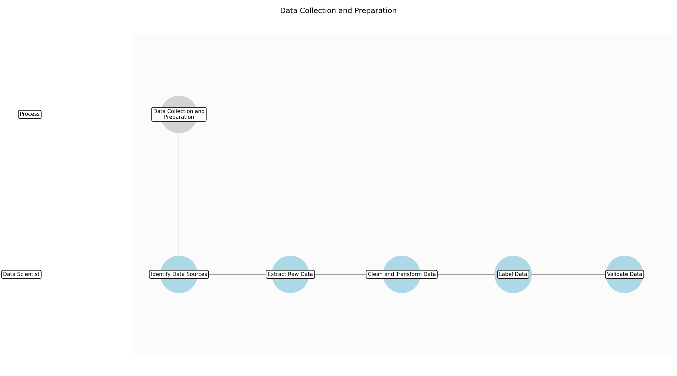

3.1.1 Identify Data Sources
This subprocess describes the activities required to complete 'Identify Data Sources'.

Description:
The initial step involves identifying all potential data sources relevant to the AI model's objectives. This includes internal databases, external APIs, data lakes, and any other repositories containing information that could be valuable for training or usage. A comprehensive understanding of available data is crucial for ensuring the model's accuracy and effectiveness.

Purpose:
To identify all relevant data sources for AI model training and usage.

Scope:
All internal and external data repositories.

Inputs:
The following inputs are required for this subprocess:
• Business requirements
• AI model objectives

Outputs:
This subprocess produces the following outputs:
• List of potential data sources
• Data source assessment report

Success Criteria:
Success for this subprocess is measured by:
• Comprehensive list of data sources
• Assessment of data source relevance and accessibility

Triggers:
This subprocess is initiated by:
• New AI model requirements
• Periodic data source review

End Conditions:
This subprocess is considered complete when:
• Data sources identified and documented

Governance Requirements:
The following governance requirements apply:
• Data cataloging standards
• Data source documentation

Risks and Controls:
The following risks and controls apply:
• Risk: Missing relevant data sources
• Control: Conduct thorough data source discovery and documentation.

Change Management:
The following change management rules apply:
• Change Request Process: Standard change management process
• Versioning Rules: Semantic versioning

Continuous Improvement:
The following continuous improvement practices apply:
• Review Frequency: Monthly
• Improvement Inputs:
• Data source usage metrics
• User feedback

Estimated Duration:
The estimated duration for this subprocess is:
• 2 days

Process Owner:
The following process owner is accountable:
• Process Owner

Responsible Party:
The following parties are responsible for this subprocess:
• Data Scientist

3.1.2 Extract Raw Data
This subprocess describes the activities required to complete 'Extract Raw Data'.

Description:
Once the data sources are identified, the next step is to extract the raw data from these sources. This involves using appropriate tools and techniques to retrieve the data in its original format. The extraction process should be efficient and reliable, ensuring that all necessary data is obtained without errors or omissions. This step may involve setting up data pipelines or using APIs to access the data.

Purpose:
To extract raw data from identified sources for further processing.

Scope:
Data extraction from all identified data sources.

Inputs:
The following inputs are required for this subprocess:
• List of potential data sources
• Data source assessment report

Outputs:
This subprocess produces the following outputs:
• Raw data files
• Data extraction logs

Success Criteria:
Success for this subprocess is measured by:
• Successful extraction of raw data from identified sources
• Complete and accurate data extraction logs

Triggers:
This subprocess is initiated by:
• New data available
• Scheduled data extraction

End Conditions:
This subprocess is considered complete when:
• Raw data extracted and stored

Dependencies:
This subprocess depends on the following:
• Identify Data Sources

Governance Requirements:
The following governance requirements apply:
• Data extraction protocols
• Data integrity checks

Risks and Controls:
The following risks and controls apply:
• Risk: Data extraction errors
• Control: Implement data validation and error handling procedures.

Change Management:
The following change management rules apply:
• Change Request Process: Standard change management process
• Versioning Rules: Semantic versioning

Continuous Improvement:
The following continuous improvement practices apply:
• Review Frequency: Monthly
• Improvement Inputs:
• Data extraction performance metrics
• Error rates

Estimated Duration:
The estimated duration for this subprocess is:
• 2 days

Process Owner:
The following process owner is accountable:
• Process Owner

Responsible Party:
The following parties are responsible for this subprocess:
• Data Scientist

3.1.3 Clean and Transform Data
This subprocess describes the activities required to complete 'Clean and Transform Data'.

Description:
This critical step involves cleaning and transforming the raw data to ensure its quality and suitability for AI model training. Cleaning includes handling missing values, removing outliers, and correcting inconsistencies. Transformation involves converting data into a suitable format, such as scaling numerical features or encoding categorical variables. High-quality data is essential for building accurate and reliable AI models.

Purpose:
To clean and transform raw data into a suitable format for AI model training.

Scope:
Data cleaning and transformation for all extracted data.

Inputs:
The following inputs are required for this subprocess:
• Raw data files
• Data extraction logs

Outputs:
This subprocess produces the following outputs:
• Cleaned and transformed data
• Data cleaning and transformation report

Success Criteria:
Success for this subprocess is measured by:
• Data quality
• Data completeness
• Data consistency

Triggers:
This subprocess is initiated by:
• Raw data available
• Data quality issues identified

End Conditions:
This subprocess is considered complete when:
• Data cleaned and transformed
• Data quality checks passed

Dependencies:
This subprocess depends on the following:
• Extract Raw Data

Governance Requirements:
The following governance requirements apply:
• Data quality standards
• Data transformation protocols

Risks and Controls:
The following risks and controls apply:
• Risk: Data quality issues
• Control: Implement data validation and cleaning procedures.

Change Management:
The following change management rules apply:
• Change Request Process: Standard change management process
• Versioning Rules: Semantic versioning

Continuous Improvement:
The following continuous improvement practices apply:
• Review Frequency: Monthly
• Improvement Inputs:
• Data quality metrics
• User feedback

Estimated Duration:
The estimated duration for this subprocess is:
• 2 days

Process Owner:
The following process owner is accountable:
• Process Owner

Responsible Party:
The following parties are responsible for this subprocess:
• Data Scientist

3.1.4 Label Data
This subprocess describes the activities required to complete 'Label Data'.

Description:
For supervised learning models, labeling the data is a crucial step. This involves assigning appropriate labels or categories to the data points, enabling the model to learn the relationship between the input features and the desired output. Accurate and consistent labeling is essential for ensuring the model's predictive performance. This step may involve manual labeling by domain experts or automated labeling using existing knowledge bases.

Purpose:
To label the data for supervised learning models.

Scope:
Data labeling for all relevant data points.

Inputs:
The following inputs are required for this subprocess:
• Cleaned and transformed data
• Data cleaning and transformation report

Outputs:
This subprocess produces the following outputs:
• Labeled dataset
• Data labeling guidelines

Success Criteria:
Success for this subprocess is measured by:
• Data labeled accurately and consistently
• Data labeling guidelines documented

Triggers:
This subprocess is initiated by:
• Cleaned and transformed data available
• New labeling requirements

End Conditions:
This subprocess is considered complete when:
• Data labeled and validated

Dependencies:
This subprocess depends on the following:
• Clean and Transform Data

Governance Requirements:
The following governance requirements apply:
• Data labeling standards
• Data validation protocols

Risks and Controls:
The following risks and controls apply:
• Risk: Inaccurate data labeling
• Control: Implement data validation and quality control procedures.

Change Management:
The following change management rules apply:
• Change Request Process: Standard change management process
• Versioning Rules: Semantic versioning

Continuous Improvement:
The following continuous improvement practices apply:
• Review Frequency: Monthly
• Improvement Inputs:
• Data labeling accuracy metrics
• User feedback

Estimated Duration:
The estimated duration for this subprocess is:
• 1 day

Process Owner:
The following process owner is accountable:
• Process Owner

Responsible Party:
The following parties are responsible for this subprocess:
• Data Scientist

3.1.5 Validate Data
This subprocess describes the activities required to complete 'Validate Data'.

Description:
The final step is to validate the prepared dataset to ensure its quality and suitability for AI model training. This involves performing various checks and tests to verify the data's accuracy, completeness, and consistency. Validation may include statistical analysis, data profiling, and manual review. Addressing any issues identified during validation is crucial for building reliable AI models.

Purpose:
To validate the prepared dataset for AI model training.

Scope:
Data validation for the entire dataset.

Inputs:
The following inputs are required for this subprocess:
• Labeled dataset
• Data labeling guidelines

Outputs:
This subprocess produces the following outputs:
• Validated dataset
• Data validation report

Success Criteria:
Success for this subprocess is measured by:
• Data validated successfully
• Data validation report documented

Triggers:
This subprocess is initiated by:
• Labeled data available
• Scheduled data validation

End Conditions:
This subprocess is considered complete when:
• Data validated and approved

Dependencies:
This subprocess depends on the following:
• Label Data

Governance Requirements:
The following governance requirements apply:
• Data validation standards
• Data quality metrics

Risks and Controls:
The following risks and controls apply:
• Risk: Data validation errors
• Control: Implement data validation and quality control procedures.

Change Management:
The following change management rules apply:
• Change Request Process: Standard change management process
• Versioning Rules: Semantic versioning

Continuous Improvement:
The following continuous improvement practices apply:
• Review Frequency: Monthly
• Improvement Inputs:
• Data validation performance metrics
• Error rates

Estimated Duration:
The estimated duration for this subprocess is:
• 1 day

Process Owner:
The following process owner is accountable:
• Process Owner

Responsible Party:
The following parties are responsible for this subprocess:
• Data Scientist

3.2 AI Model Training and Validation

Description:
Train and validate AI models using the prepared dataset.

Purpose:
To develop accurate and reliable AI models

Scope:
All relevant AI models

Inputs:
The following inputs are required for this step:
• Prepared dataset

Outputs:
This step produces the following outputs:
• Trained AI model
• Performance metrics

Success Criteria:
Success for this step is measured by:
• Model accuracy
• Performance metrics
• Generalization

Process Triggers:
This step is initiated by:
• New dataset available
• Model performance degradation

Process End Conditions:
This step is considered complete when:
• Model trained and validated

Dependencies:
This step depends on the following:
• Data Collection and Preparation

Deliverables:
This step produces the following deliverables:
• Trained AI model
• Validation report

Governance Requirements:
The following governance requirements apply:
• Model explainability
• Bias detection

Risks and Controls:
The following risks and controls apply:
• Control: Cross-validation techniques
• Risk: Model overfitting
• Risk: Data privacy violations
• Control: Implement data anonymization and pseudonymization techniques. Ensure compliance with GDPR and other relevant data privacy regulations.

Change Management:
The following change management rules apply:
• Versioning Rules: Semantic versioning
• Change Request Process: Standard change management process

Continuous Improvement:
The following continuous improvement practices apply:
• Review Frequency: Monthly
• Improvement Inputs:
• User feedback
• Performance metrics

Estimated Duration:
The estimated duration for this step is:
• 2 weeks

Process Owner:
The following process owner is accountable:
• Process Owner

Responsible Parties:
The following parties are responsible for this step:
• AI Specialist

Required Sub Process(es) for the Step "AI Model Training and Validation"
The following details the subprocess flows for the step "AI Model Training and Validation".
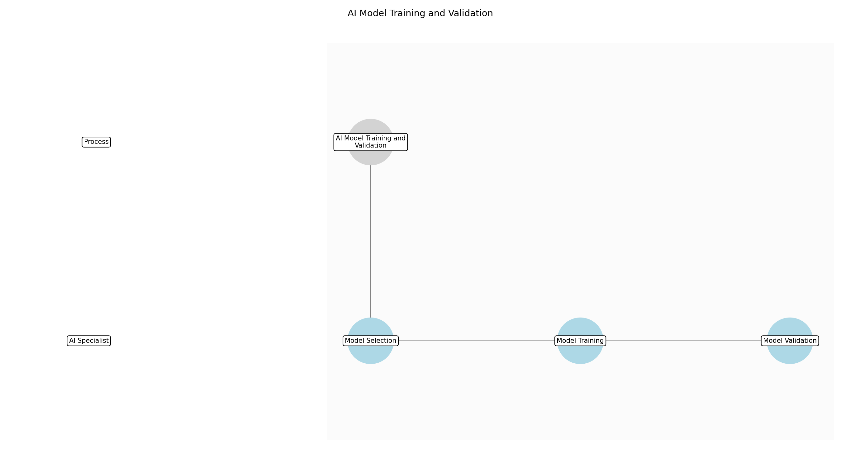

3.2.1 Model Selection
This subprocess describes the activities required to complete 'Model Selection'.

Description:
The AI Specialist selects the appropriate AI model architecture based on the nature of the prepared dataset and the desired outcomes. This involves evaluating various algorithms, such as neural networks, decision trees, or support vector machines, considering factors like data dimensionality, complexity, and interpretability. The selection process also includes defining the model's hyperparameters and configuration settings to optimize its performance for the specific task.

Purpose:
To choose the most suitable AI model for the given task.

Scope:
All relevant AI model architectures

Inputs:
The following inputs are required for this subprocess:
• Prepared dataset
• Problem definition
• Success criteria

Outputs:
This subprocess produces the following outputs:
• Selected AI model architecture
• Hyperparameter configuration

Success Criteria:
Success for this subprocess is measured by:
• Appropriate model architecture selected
• Hyperparameters configured for optimal performance

Triggers:
This subprocess is initiated by:
• Prepared dataset available

End Conditions:
This subprocess is considered complete when:
• AI model architecture selected and configured

Governance Requirements:
The following governance requirements apply:
• Model explainability
• Bias detection

Risks and Controls:
The following risks and controls apply:
• Risk: Inappropriate model selection
• Control: Conduct thorough model evaluation and comparison.

Change Management:
The following change management rules apply:
• Change Request Process: Standard change management process
• Versioning Rules: Semantic versioning

Continuous Improvement:
The following continuous improvement practices apply:
• Review Frequency: Monthly
• Improvement Inputs:
• User feedback
• Performance metrics

Estimated Duration:
The estimated duration for this subprocess is:
• 1 day

Process Owner:
The following process owner is accountable:
• Process Owner

Responsible Party:
The following parties are responsible for this subprocess:
• AI Specialist

3.2.2 Model Training
This subprocess describes the activities required to complete 'Model Training'.

Description:
The AI Specialist trains the selected AI model using the prepared dataset. This involves feeding the dataset into the model and iteratively adjusting the model's parameters to minimize the difference between its predictions and the actual values. The training process includes techniques like gradient descent, backpropagation, and optimization algorithms to improve the model's accuracy and generalization ability. Regular monitoring of the model's performance during training helps to identify and address issues like overfitting or underfitting.

Purpose:
To develop an accurate and reliable AI model.

Scope:
All relevant AI models

Inputs:
The following inputs are required for this subprocess:
• Selected AI model architecture
• Hyperparameter configuration
• Prepared dataset

Outputs:
This subprocess produces the following outputs:
• Trained AI model
• Training logs
• Performance metrics

Success Criteria:
Success for this subprocess is measured by:
• Model trained to desired accuracy
• Training logs generated
• Performance metrics within acceptable range

Triggers:
This subprocess is initiated by:
• AI model architecture selected and configured

End Conditions:
This subprocess is considered complete when:
• AI model trained and performance metrics generated

Dependencies:
This subprocess depends on the following:
• Model Selection

Governance Requirements:
The following governance requirements apply:
• Model explainability
• Bias detection

Risks and Controls:
The following risks and controls apply:
• Risk: Model overfitting
• Control: Implement regularization techniques and cross-validation.
• Risk: Data privacy violations
• Control: Implement data anonymization and pseudonymization techniques. Ensure compliance with GDPR and other relevant data privacy regulations.

Change Management:
The following change management rules apply:
• Change Request Process: Standard change management process
• Versioning Rules: Semantic versioning

Continuous Improvement:
The following continuous improvement practices apply:
• Review Frequency: Monthly
• Improvement Inputs:
• User feedback
• Performance metrics

Estimated Duration:
The estimated duration for this subprocess is:
• 3-5 days

Process Owner:
The following process owner is accountable:
• Process Owner

Responsible Party:
The following parties are responsible for this subprocess:
• AI Specialist

3.2.3 Model Validation
This subprocess describes the activities required to complete 'Model Validation'.

Description:
The AI Specialist validates the trained AI model using a separate validation dataset to assess its generalization ability and prevent overfitting. This involves evaluating the model's performance on unseen data and comparing it to the training performance. Validation metrics like accuracy, precision, recall, and F1-score are used to quantify the model's performance. The validation process also includes techniques like cross-validation and hyperparameter tuning to optimize the model's performance and ensure its reliability.

Purpose:
To ensure the AI model is accurate and reliable.

Scope:
All relevant AI models

Inputs:
The following inputs are required for this subprocess:
• Trained AI model
• Validation dataset
• Performance metrics

Outputs:
This subprocess produces the following outputs:
• Validation report
• Performance metrics
• Validated AI model

Success Criteria:
Success for this subprocess is measured by:
• Model validated with acceptable performance metrics
• Validation report generated
• Model generalizes well to unseen data

Triggers:
This subprocess is initiated by:
• AI model trained and performance metrics generated

End Conditions:
This subprocess is considered complete when:
• AI model validated and validation report generated

Dependencies:
This subprocess depends on the following:
• Model Training

Governance Requirements:
The following governance requirements apply:
• Model explainability
• Bias detection

Risks and Controls:
The following risks and controls apply:
• Risk: Model overfitting
• Control: Cross-validation techniques
• Risk: Bias in validation data
• Control: Ensure validation data is representative of real-world data.

Change Management:
The following change management rules apply:
• Change Request Process: Standard change management process
• Versioning Rules: Semantic versioning

Continuous Improvement:
The following continuous improvement practices apply:
• Review Frequency: Monthly
• Improvement Inputs:
• User feedback
• Performance metrics

Estimated Duration:
The estimated duration for this subprocess is:
• 2-3 days

Process Owner:
The following process owner is accountable:
• Process Owner

Responsible Party:
The following parties are responsible for this subprocess:
• AI Specialist

3.3 AI Model Deployment

Description:
Deploy the trained AI model to production.

Purpose:
To make AI models accessible to end-users

Scope:
All relevant applications

Inputs:
The following inputs are required for this step:
• Trained AI model

Outputs:
This step produces the following outputs:
• AI-powered service

Success Criteria:
Success for this step is measured by:
• Model availability
• Scalability
• Performance

Process Triggers:
This step is initiated by:
• Model validation complete
• New application requirements

Process End Conditions:
This step is considered complete when:
• Model deployed and monitored

Dependencies:
This step depends on the following:
• AI Model Training and Validation

Deliverables:
This step produces the following deliverables:
• Deployed AI model
• API endpoints

Governance Requirements:
The following governance requirements apply:
• Security protocols
• Access control

Risks and Controls:
The following risks and controls apply:
• Control: Rollback procedures
• Risk: Deployment failures

Change Management:
The following change management rules apply:
• Change Request Process: Standard change management process
• Versioning Rules: Semantic versioning

Continuous Improvement:
The following continuous improvement practices apply:
• Improvement Inputs:
• User feedback
• Performance metrics
• Review Frequency: Monthly

Estimated Duration:
The estimated duration for this step is:
• 1 week

Process Owner:
The following process owner is accountable:
• Process Owner

Responsible Parties:
The following parties are responsible for this step:
• AI Specialist

Required Sub Process(es) for the Step "AI Model Deployment"
The following details the subprocess flows for the step "AI Model Deployment".
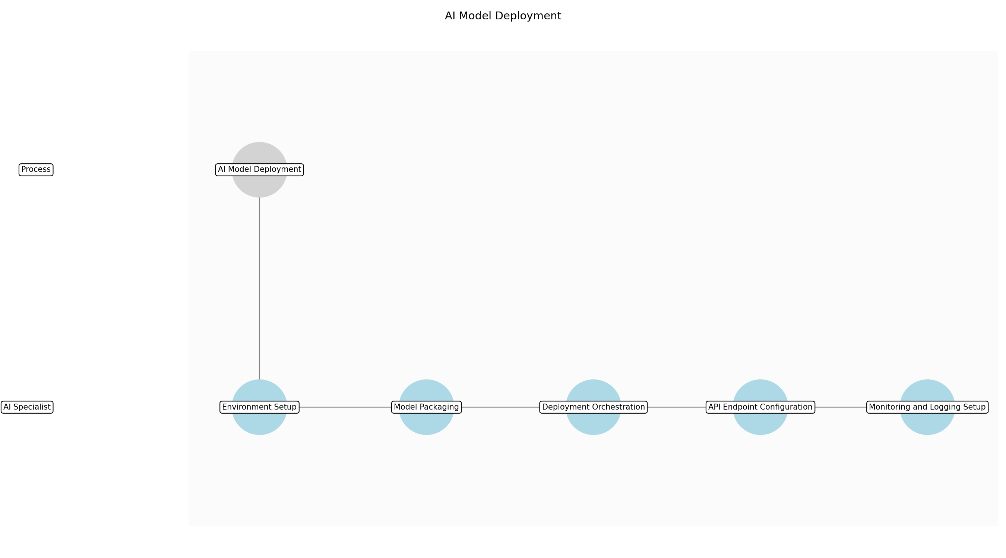

3.3.1 Environment Setup
This subprocess describes the activities required to complete 'Environment Setup'.

Description:
Provision and configure the deployment environment, ensuring it meets the AI model's requirements. This includes setting up necessary infrastructure components such as servers, networking, and storage. The environment should be scalable and secure, adhering to organizational security policies and governance requirements. Proper environment setup is critical for the model's performance and availability.

Purpose:
To prepare the necessary infrastructure for deploying the AI model.

Scope:
Deployment environment

Outputs:
This subprocess produces the following outputs:
• Deployment environment

Success Criteria:
Success for this subprocess is measured by:
• Environment configured
• Infrastructure provisioned
• Security protocols in place

Triggers:
This subprocess is initiated by:
• AI Model Training and Validation complete

End Conditions:
This subprocess is considered complete when:
• Deployment environment is ready

Governance Requirements:
The following governance requirements apply:
• Security protocols
• Access control

Risks and Controls:
The following risks and controls apply:
• Risk: Environment misconfiguration
• Control: Configuration management tools
• Risk: Security vulnerabilities
• Control: Security audits

Change Management:
The following change management rules apply:
• Change Request Process: Standard change management process
• Versioning Rules: Semantic versioning

Continuous Improvement:
The following continuous improvement practices apply:
• Review Frequency: Monthly
• Improvement Inputs:
• User feedback
• Performance metrics

Estimated Duration:
The estimated duration for this subprocess is:
• 2 days

Process Owner:
The following process owner is accountable:
• Process Owner

Responsible Party:
The following parties are responsible for this subprocess:
• AI Specialist

3.3.2 Model Packaging
This subprocess describes the activities required to complete 'Model Packaging'.

Description:
Package the trained AI model and its dependencies into a deployable artifact. This involves creating a container image using tools like Docker, ensuring that all necessary libraries, frameworks, and configurations are included. The packaged model should be lightweight and optimized for efficient deployment and execution. Proper model packaging ensures consistency and reproducibility across different environments.

Purpose:
To create a deployable artifact of the AI model.

Scope:
AI model

Inputs:
The following inputs are required for this subprocess:
• Trained AI model

Outputs:
This subprocess produces the following outputs:
• Packaged AI model

Success Criteria:
Success for this subprocess is measured by:
• Model packaged
• Dependencies included
• Container image created

Triggers:
This subprocess is initiated by:
• Environment Setup complete

End Conditions:
This subprocess is considered complete when:
• AI model is packaged

Dependencies:
This subprocess depends on the following:
• Environment Setup

Governance Requirements:
The following governance requirements apply:
• Security protocols
• Access control

Risks and Controls:
The following risks and controls apply:
• Risk: Dependency conflicts
• Control: Dependency management tools
• Risk: Large image size
• Control: Image optimization techniques

Change Management:
The following change management rules apply:
• Change Request Process: Standard change management process
• Versioning Rules: Semantic versioning

Continuous Improvement:
The following continuous improvement practices apply:
• Review Frequency: Monthly
• Improvement Inputs:
• User feedback
• Performance metrics

Estimated Duration:
The estimated duration for this subprocess is:
• 1 day

Process Owner:
The following process owner is accountable:
• Process Owner

Responsible Party:
The following parties are responsible for this subprocess:
• AI Specialist

3.3.3 Deployment Orchestration
This subprocess describes the activities required to complete 'Deployment Orchestration'.

Description:
Orchestrate the deployment of the packaged AI model to the deployment environment. This involves using container orchestration platforms like Kubernetes to manage the deployment process, ensuring scalability, high availability, and fault tolerance. The deployment should be automated and repeatable, with proper monitoring and logging in place. Effective deployment orchestration is crucial for the model's reliability and performance.

Purpose:
To deploy the AI model to the deployment environment.

Scope:
Deployment environment

Inputs:
The following inputs are required for this subprocess:
• Packaged AI model

Outputs:
This subprocess produces the following outputs:
• Deployed AI model

Success Criteria:
Success for this subprocess is measured by:
• Model deployed
• Scalability achieved
• High availability ensured

Triggers:
This subprocess is initiated by:
• Model Packaging complete

End Conditions:
This subprocess is considered complete when:
• AI model is deployed

Dependencies:
This subprocess depends on the following:
• Model Packaging

Governance Requirements:
The following governance requirements apply:
• Security protocols
• Access control

Risks and Controls:
The following risks and controls apply:
• Risk: Deployment failures
• Control: Rollback procedures
• Risk: Resource contention
• Control: Resource allocation strategies

Change Management:
The following change management rules apply:
• Change Request Process: Standard change management process
• Versioning Rules: Semantic versioning

Continuous Improvement:
The following continuous improvement practices apply:
• Review Frequency: Monthly
• Improvement Inputs:
• User feedback
• Performance metrics

Estimated Duration:
The estimated duration for this subprocess is:
• 1 day

Process Owner:
The following process owner is accountable:
• Process Owner

Responsible Party:
The following parties are responsible for this subprocess:
• AI Specialist

3.3.4 API Endpoint Configuration
This subprocess describes the activities required to complete 'API Endpoint Configuration'.

Description:
Configure API endpoints to expose the deployed AI model's functionality to end-users and applications. This involves setting up API gateways, defining request and response formats, and implementing authentication and authorization mechanisms. The API endpoints should be well-documented and easy to use, adhering to industry standards and best practices. Proper API endpoint configuration is essential for the model's accessibility and usability.

Purpose:
To expose the AI model's functionality through API endpoints.

Scope:
API endpoints

Inputs:
The following inputs are required for this subprocess:
• Deployed AI model

Outputs:
This subprocess produces the following outputs:
• API endpoints

Success Criteria:
Success for this subprocess is measured by:
• API endpoints configured
• Authentication implemented
• Documentation created

Triggers:
This subprocess is initiated by:
• Deployment Orchestration complete

End Conditions:
This subprocess is considered complete when:
• API endpoints are configured

Dependencies:
This subprocess depends on the following:
• Deployment Orchestration

Governance Requirements:
The following governance requirements apply:
• Security protocols
• Access control

Risks and Controls:
The following risks and controls apply:
• Risk: API vulnerabilities
• Control: Security testing
• Risk: Performance bottlenecks
• Control: Load balancing

Change Management:
The following change management rules apply:
• Change Request Process: Standard change management process
• Versioning Rules: Semantic versioning

Continuous Improvement:
The following continuous improvement practices apply:
• Review Frequency: Monthly
• Improvement Inputs:
• User feedback
• Performance metrics

Estimated Duration:
The estimated duration for this subprocess is:
• 1 day

Process Owner:
The following process owner is accountable:
• Process Owner

Responsible Party:
The following parties are responsible for this subprocess:
• AI Specialist

3.3.5 Monitoring and Logging Setup
This subprocess describes the activities required to complete 'Monitoring and Logging Setup'.

Description:
Set up monitoring and logging infrastructure to track the deployed AI model's performance, health, and usage. This involves configuring monitoring tools like Prometheus and Grafana to collect metrics, setting up logging systems like ELK stack to capture logs, and defining alerts for critical events. The monitoring and logging should provide insights into the model's behavior and identify potential issues. Effective monitoring and logging are crucial for the model's reliability and maintainability.

Purpose:
To monitor the AI model's performance and health.

Scope:
Monitoring and logging infrastructure

Inputs:
The following inputs are required for this subprocess:
• API endpoints

Outputs:
This subprocess produces the following outputs:
• Monitoring and logging infrastructure

Success Criteria:
Success for this subprocess is measured by:
• Monitoring configured
• Logging set up
• Alerts defined

Triggers:
This subprocess is initiated by:
• API Endpoint Configuration complete

End Conditions:
This subprocess is considered complete when:
• Monitoring and logging are set up

Dependencies:
This subprocess depends on the following:
• API Endpoint Configuration

Governance Requirements:
The following governance requirements apply:
• Security protocols
• Access control

Risks and Controls:
The following risks and controls apply:
• Risk: Inadequate monitoring
• Control: Regular audits
• Risk: Log data breaches
• Control: Data encryption

Change Management:
The following change management rules apply:
• Change Request Process: Standard change management process
• Versioning Rules: Semantic versioning

Continuous Improvement:
The following continuous improvement practices apply:
• Review Frequency: Monthly
• Improvement Inputs:
• User feedback
• Performance metrics

Estimated Duration:
The estimated duration for this subprocess is:
• 1 day

Process Owner:
The following process owner is accountable:
• Process Owner

Responsible Party:
The following parties are responsible for this subprocess:
• AI Specialist

3.4 AI-Powered Service Usage

Description:
End-users utilize the AI-powered service.

Purpose:
To provide value to end-users

Scope:
All relevant users

Inputs:
The following inputs are required for this step:
• AI-powered service

Outputs:
This step produces the following outputs:
• Improved efficiency
• Better decisions
• Increased accessibility

Success Criteria:
Success for this step is measured by:
• User satisfaction
• Efficiency gains
• Accessibility improvements

Process Triggers:
This step is initiated by:
• User interaction
• Service requests

Process End Conditions:
This step is considered complete when:
• Service provides value to end-users

Dependencies:
This step depends on the following:
• AI Model Deployment

Deliverables:
This step produces the following deliverables:
• Service usage data
• User feedback

Governance Requirements:
The following governance requirements apply:
• User privacy
• Data security

Risks and Controls:
The following risks and controls apply:
• Control: Feedback mechanisms
• Risk: User dissatisfaction

Change Management:
The following change management rules apply:
• Versioning Rules: Semantic versioning
• Change Request Process: Standard change management process

Continuous Improvement:
The following continuous improvement practices apply:
• Review Frequency: Monthly
• Improvement Inputs:
• User feedback
• Performance metrics

Estimated Duration:
The estimated duration for this step is:
• Ongoing

Process Owner:
The following process owner is accountable:
• Process Owner

Responsible Parties:
The following parties are responsible for this step:
• End User

Required Sub Process(es) for the Step "AI-Powered Service Usage"
The following details the subprocess flows for the step "AI-Powered Service Usage".
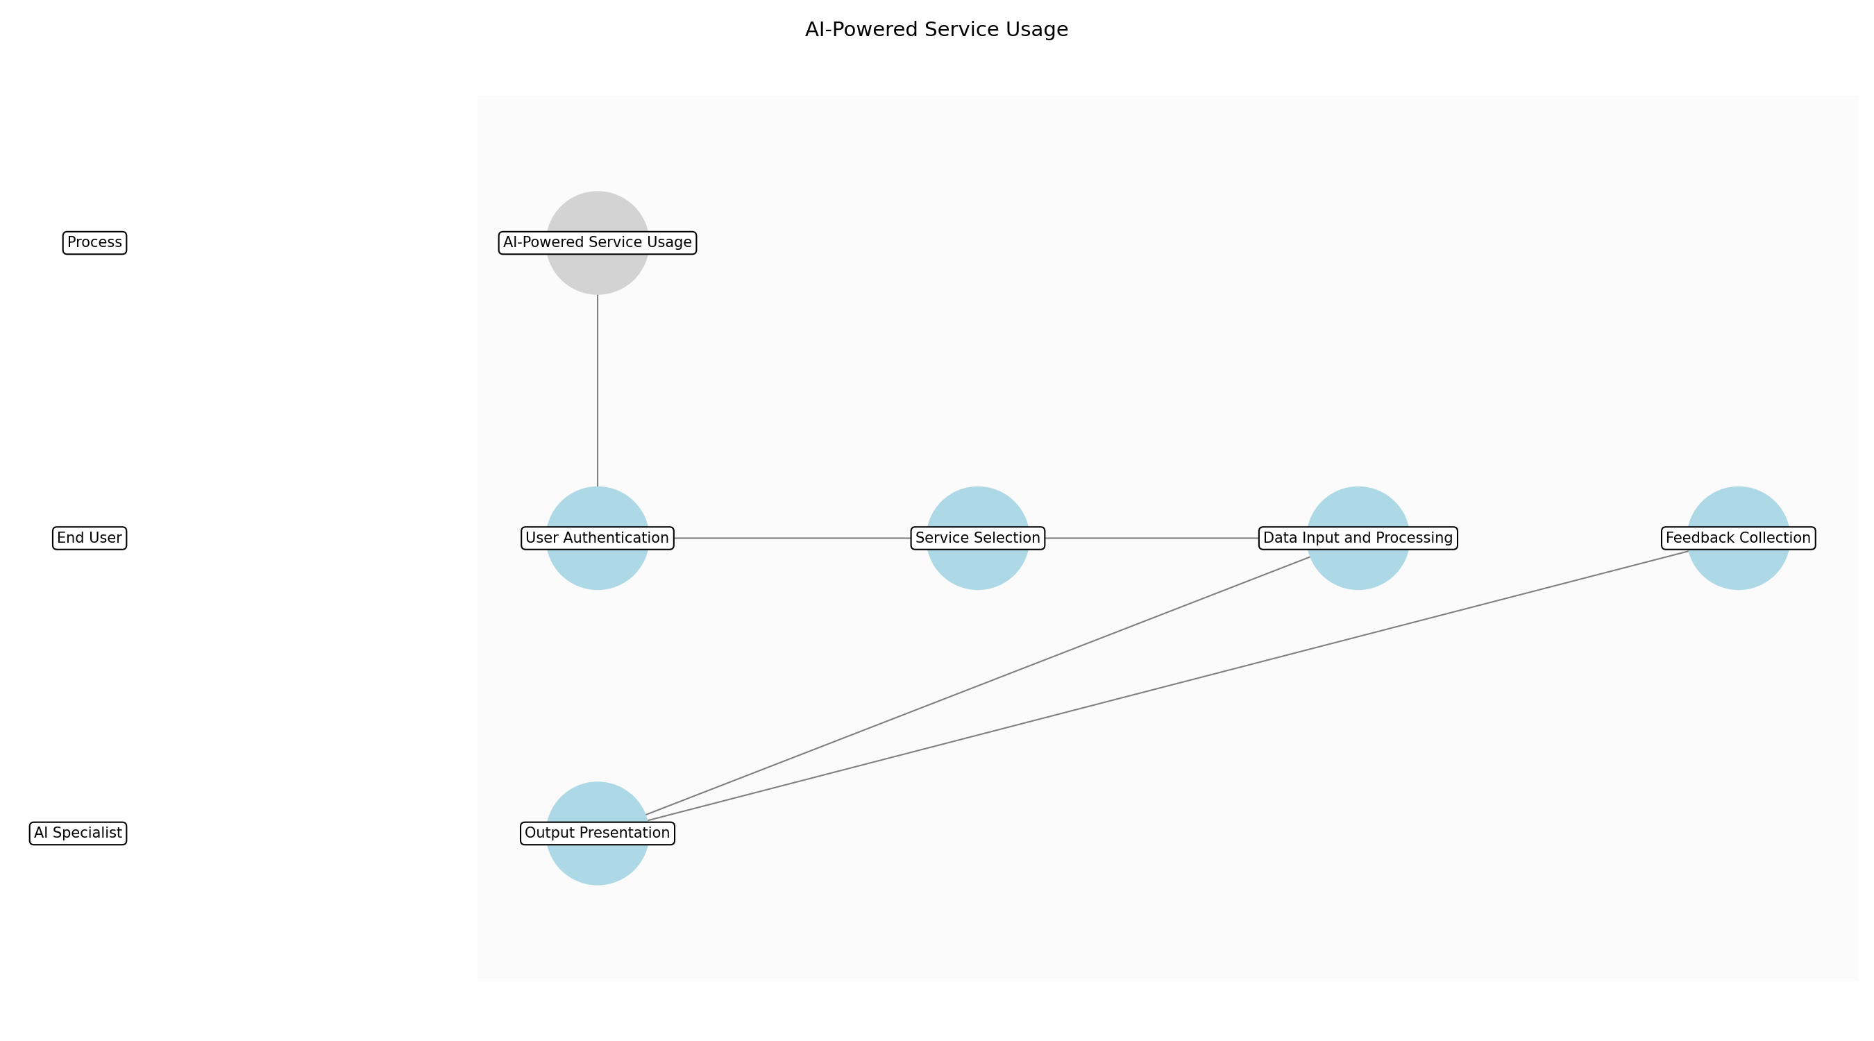

3.4.1 User Authentication
This subprocess describes the activities required to complete 'User Authentication'.

Description:
The end-user initiates the process by authenticating their identity to access the AI-powered service. This involves verifying their credentials against a secure authentication system to ensure only authorized personnel gain access. Successful authentication grants the user permission to utilize the service's features and functionalities, while failed attempts are logged for security monitoring.

Purpose:
To ensure secure access to the AI-powered service.

Scope:
User authentication system

Inputs:
The following inputs are required for this subprocess:
• User credentials
• Authentication system

Outputs:
This subprocess produces the following outputs:
• Authenticated user session
• Access token

Success Criteria:
Success for this subprocess is measured by:
• Successful user login
• Secure session establishment

Triggers:
This subprocess is initiated by:
• User login attempt

End Conditions:
This subprocess is considered complete when:
• User successfully authenticated

Governance Requirements:
The following governance requirements apply:
• User privacy
• Data security

Risks and Controls:
The following risks and controls apply:
• Risk: Unauthorized access
• Control: Multi-factor authentication

Change Management:
The following change management rules apply:
• Change Request Process: Standard change management process
• Versioning Rules: Semantic versioning

Continuous Improvement:
The following continuous improvement practices apply:
• Review Frequency: Monthly
• Improvement Inputs:
• User feedback
• Authentication logs

Estimated Duration:
The estimated duration for this subprocess is:
• 1–2 minutes

Process Owner:
The following process owner is accountable:
• Process Owner

Responsible Party:
The following parties are responsible for this subprocess:
• End User

3.4.2 Service Selection
This subprocess describes the activities required to complete 'Service Selection'.

Description:
Upon successful authentication, the end-user selects the specific AI-powered service they wish to utilize from a menu or dashboard. This selection determines the subsequent actions and data processing performed by the system. The service selection interface should be intuitive and user-friendly, providing clear descriptions of each service's capabilities and intended use.

Purpose:
To allow users to choose the desired AI functionality.

Scope:
Service selection interface

Inputs:
The following inputs are required for this subprocess:
• Authenticated user session
• List of available services

Outputs:
This subprocess produces the following outputs:
• Selected AI-powered service

Success Criteria:
Success for this subprocess is measured by:
• User selects a valid service
• Service selection is recorded

Triggers:
This subprocess is initiated by:
• User navigates to service selection screen

End Conditions:
This subprocess is considered complete when:
• User selects a service

Dependencies:
This subprocess depends on the following:
• User Authentication

Governance Requirements:
The following governance requirements apply:
• User privacy
• Data security

Risks and Controls:
The following risks and controls apply:
• Risk: Incorrect service selection
• Control: Confirmation prompts

Change Management:
The following change management rules apply:
• Change Request Process: Standard change management process
• Versioning Rules: Semantic versioning

Continuous Improvement:
The following continuous improvement practices apply:
• Review Frequency: Monthly
• Improvement Inputs:
• User feedback
• Service usage statistics

Estimated Duration:
The estimated duration for this subprocess is:
• 1–2 minutes

Process Owner:
The following process owner is accountable:
• Process Owner

Responsible Party:
The following parties are responsible for this subprocess:
• End User

3.4.3 Data Input and Processing
This subprocess describes the activities required to complete 'Data Input and Processing'.

Description:
The end-user provides the necessary data inputs required by the selected AI-powered service. This may involve uploading files, entering text, or configuring parameters. The system processes the input data using the underlying AI model, generating relevant outputs or insights. Data validation and sanitization are performed to ensure data quality and prevent malicious inputs.

Purpose:
To enable the AI model to generate outputs based on user input.

Scope:
AI model processing pipeline

Inputs:
The following inputs are required for this subprocess:
• Selected AI-powered service
• User-provided data

Outputs:
This subprocess produces the following outputs:
• Processed data
• AI model outputs

Success Criteria:
Success for this subprocess is measured by:
• Data is successfully processed
• AI model generates outputs

Triggers:
This subprocess is initiated by:
• User submits data for processing

End Conditions:
This subprocess is considered complete when:
• AI model completes processing

Dependencies:
This subprocess depends on the following:
• Service Selection

Governance Requirements:
The following governance requirements apply:
• User privacy
• Data security

Risks and Controls:
The following risks and controls apply:
• Risk: Data corruption
• Control: Data validation and checksums

Change Management:
The following change management rules apply:
• Change Request Process: Standard change management process
• Versioning Rules: Semantic versioning

Continuous Improvement:
The following continuous improvement practices apply:
• Review Frequency: Monthly
• Improvement Inputs:
• User feedback
• Performance metrics

Estimated Duration:
The estimated duration for this subprocess is:
• Ongoing

Process Owner:
The following process owner is accountable:
• Process Owner

Responsible Party:
The following parties are responsible for this subprocess:
• End User

3.4.4 Output Presentation
This subprocess describes the activities required to complete 'Output Presentation'.

Description:
The AI model's outputs are presented to the end-user in a clear and understandable format. This may involve displaying visualizations, generating reports, or providing recommendations. The presentation layer should be designed to maximize user comprehension and facilitate informed decision-making. Accessibility considerations are incorporated to ensure usability for all users, regardless of their abilities.

Purpose:
To present AI outputs in an accessible format.

Scope:
Output presentation layer

Inputs:
The following inputs are required for this subprocess:
• AI model outputs

Outputs:
This subprocess produces the following outputs:
• User-friendly presentation of results

Success Criteria:
Success for this subprocess is measured by:
• Outputs are displayed correctly
• User can understand the results

Triggers:
This subprocess is initiated by:
• AI model completes processing

End Conditions:
This subprocess is considered complete when:
• Outputs are displayed to the user

Dependencies:
This subprocess depends on the following:
• Data Input and Processing

Governance Requirements:
The following governance requirements apply:
• Transparency
• Accountability

Risks and Controls:
The following risks and controls apply:
• Risk: Misinterpretation of results
• Control: Clear and concise explanations

Change Management:
The following change management rules apply:
• Change Request Process: Standard change management process
• Versioning Rules: Semantic versioning

Continuous Improvement:
The following continuous improvement practices apply:
• Review Frequency: Monthly
• Improvement Inputs:
• User feedback
• Usability testing

Estimated Duration:
The estimated duration for this subprocess is:
• 1–5 minutes

Process Owner:
The following process owner is accountable:
• Process Owner

Responsible Party:
The following parties are responsible for this subprocess:
• AI Specialist

3.4.5 Feedback Collection
This subprocess describes the activities required to complete 'Feedback Collection'.

Description:
The end-user is prompted to provide feedback on their experience with the AI-powered service. This feedback is collected through surveys, ratings, or open-ended comments. The collected feedback is used to continuously improve the service's functionality, accuracy, and usability. Privacy considerations are paramount, ensuring user feedback is anonymized and handled securely.

Purpose:
To gather user input for continuous improvement.

Scope:
Feedback collection mechanisms

Inputs:
The following inputs are required for this subprocess:
• User experience

Outputs:
This subprocess produces the following outputs:
• User feedback

Success Criteria:
Success for this subprocess is measured by:
• User provides feedback
• Feedback is recorded

Triggers:
This subprocess is initiated by:
• User completes service usage

End Conditions:
This subprocess is considered complete when:
• User submits feedback

Dependencies:
This subprocess depends on the following:
• Output Presentation

Governance Requirements:
The following governance requirements apply:
• User privacy
• Data security

Risks and Controls:
The following risks and controls apply:
• Risk: Low feedback participation
• Control: Incentives for feedback

Change Management:
The following change management rules apply:
• Change Request Process: Standard change management process
• Versioning Rules: Semantic versioning

Continuous Improvement:
The following continuous improvement practices apply:
• Review Frequency: Monthly
• Improvement Inputs:
• User feedback
• Service usage statistics

Estimated Duration:
The estimated duration for this subprocess is:
• 1–3 minutes

Process Owner:
The following process owner is accountable:
• Process Owner

Responsible Party:
The following parties are responsible for this subprocess:
• End User

3.5 Performance Monitoring and Feedback

Description:
Monitor AI model performance and collect user feedback.

Purpose:
To ensure continuous improvement of AI models

Scope:
All relevant metrics and feedback channels

Inputs:
The following inputs are required for this step:
• AI-powered service
• Service usage data
• User feedback

Outputs:
This step produces the following outputs:
• Insights for improvement

Success Criteria:
Success for this step is measured by:
• Model accuracy
• User satisfaction
• Timely feedback

Process Triggers:
This step is initiated by:
• Scheduled monitoring
• User feedback received

Process End Conditions:
This step is considered complete when:
• Performance reports generated
• Feedback analyzed

Dependencies:
This step depends on the following:
• AI-Powered Service Usage

Deliverables:
This step produces the following deliverables:
• Performance reports
• Feedback summaries

Governance Requirements:
The following governance requirements apply:
• Transparency
• Accountability

Risks and Controls:
The following risks and controls apply:
• Control: Regular audits
• Risk: Inaccurate performance metrics

Change Management:
The following change management rules apply:
• Versioning Rules: Semantic versioning
• Change Request Process: Standard change management process

Continuous Improvement:
The following continuous improvement practices apply:
• Review Frequency: Monthly
• Improvement Inputs:
• User feedback
• Performance metrics

Estimated Duration:
The estimated duration for this step is:
• Ongoing

Process Owner:
The following process owner is accountable:
• Process Owner

Responsible Parties:
The following parties are responsible for this step:
• AI Specialist

Required Sub Process(es) for the Step "Performance Monitoring and Feedback"
The following details the subprocess flows for the step "Performance Monitoring and Feedback".
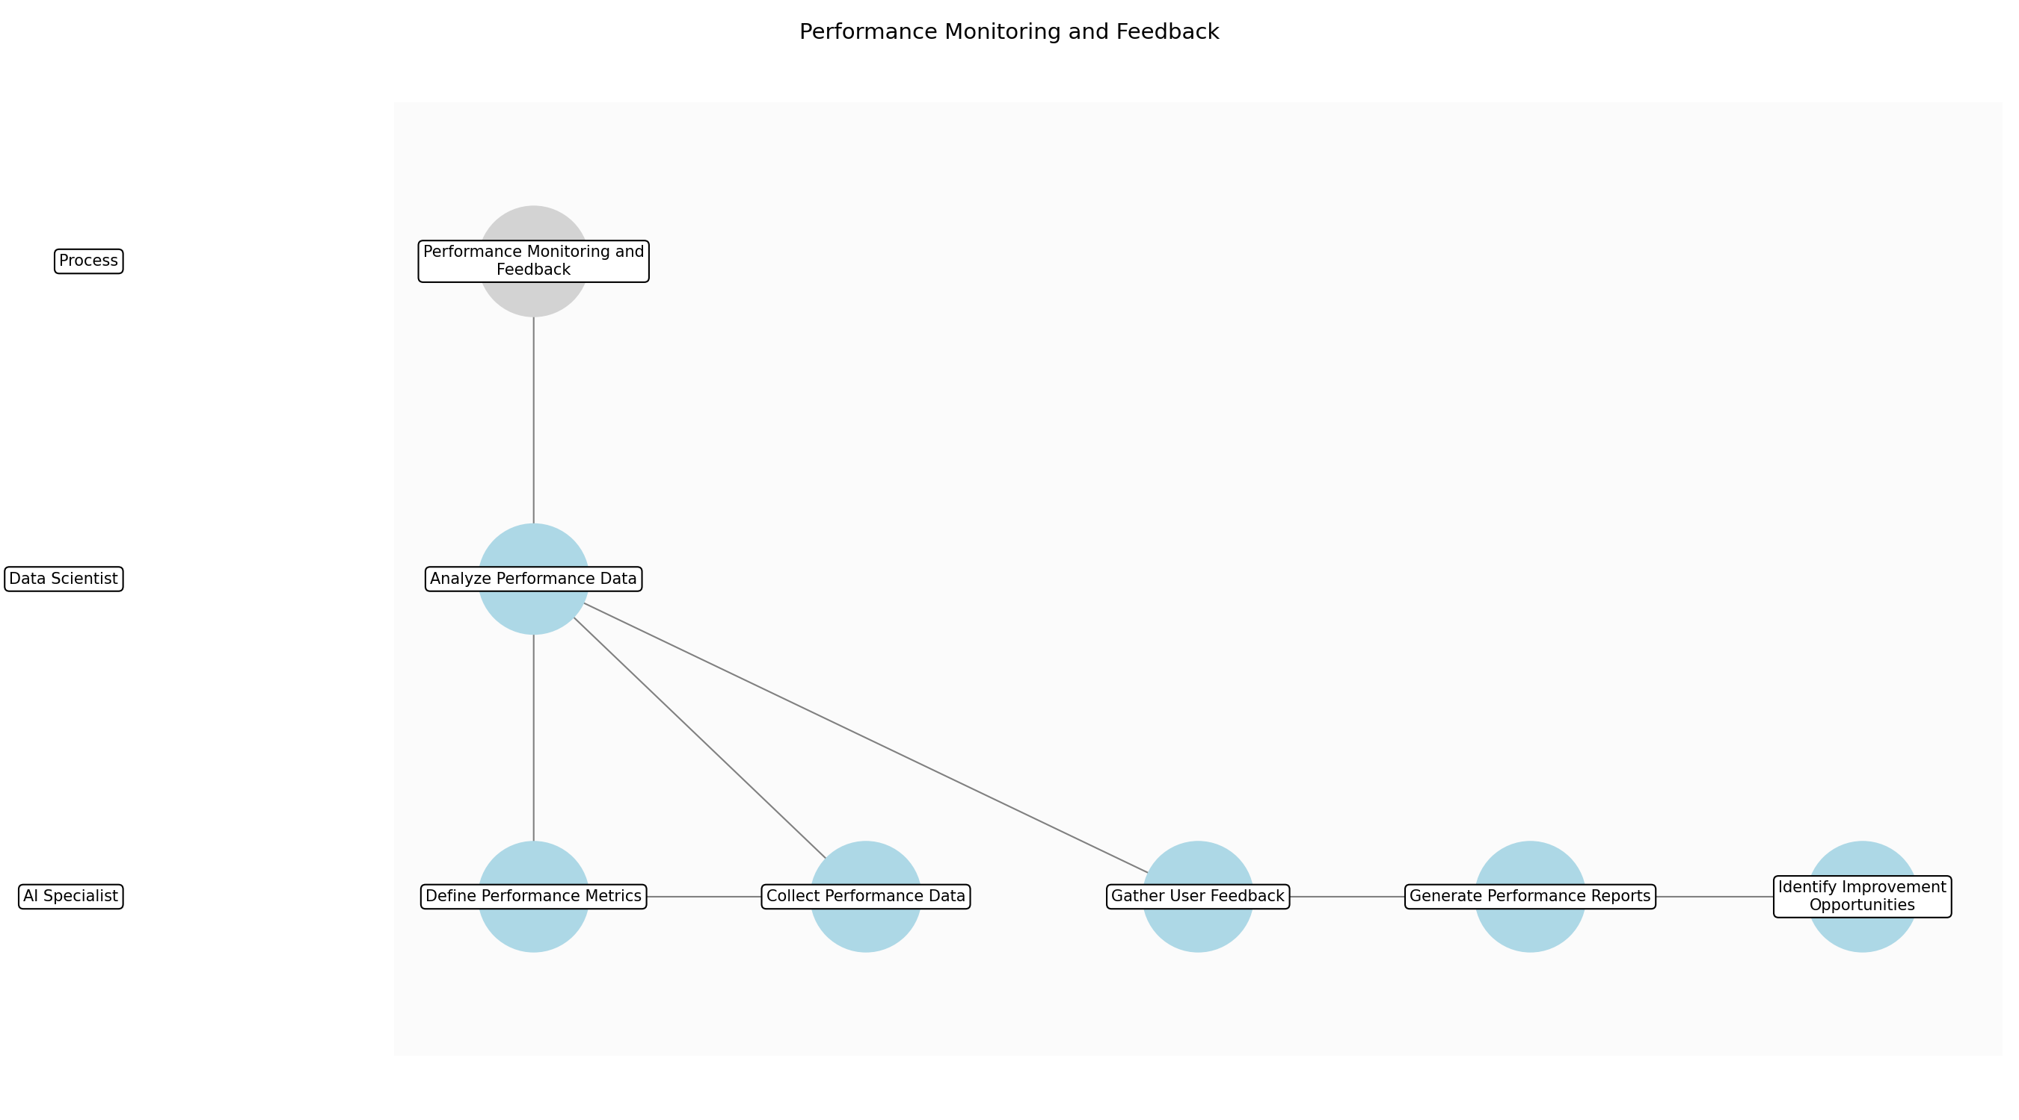

3.5.1 Define Performance Metrics
This subprocess describes the activities required to complete 'Define Performance Metrics'.

Description:
Establish clear, measurable metrics to evaluate AI model performance. This involves identifying key performance indicators (KPIs) that align with business objectives and user needs. The metrics should cover aspects such as accuracy, efficiency, accessibility, and fairness. Document the chosen metrics and their rationale for future reference and consistency.

Purpose:
To establish a clear basis for evaluating AI model performance.

Scope:
All relevant aspects of AI model performance.

Inputs:
The following inputs are required for this subprocess:
• AI-powered service
• Business objectives
• User needs

Outputs:
This subprocess produces the following outputs:
• Defined performance metrics
• KPI documentation

Success Criteria:
Success for this subprocess is measured by:
• Metrics are measurable
• Metrics align with business objectives
• Metrics cover key performance aspects

Triggers:
This subprocess is initiated by:
• Scheduled review
• New AI model deployment

End Conditions:
This subprocess is considered complete when:
• Performance metrics defined and documented

Governance Requirements:
The following governance requirements apply:
• Transparency
• Accountability

Risks and Controls:
The following risks and controls apply:
• Risk: Irrelevant metrics
• Control: Consult stakeholders to ensure metrics align with business goals.

Change Management:
The following change management rules apply:
• Change Request Process: Standard change management process
• Versioning Rules: Semantic versioning

Continuous Improvement:
The following continuous improvement practices apply:
• Review Frequency: Monthly
• Improvement Inputs:
• User feedback
• Performance metrics

Estimated Duration:
The estimated duration for this subprocess is:
• 2–4 hours

Process Owner:
The following process owner is accountable:
• Process Owner

Responsible Party:
The following parties are responsible for this subprocess:
• AI Specialist

3.5.2 Collect Performance Data
This subprocess describes the activities required to complete 'Collect Performance Data'.

Description:
Gather data related to the defined performance metrics from various sources. This includes collecting service usage data, user feedback, and system logs. Ensure data collection methods are reliable and consistent. Implement automated data collection processes where possible to minimize manual effort and ensure timely data availability. Data should be stored securely and in compliance with data privacy regulations.

Purpose:
To gather the necessary data for evaluating AI model performance.

Scope:
All relevant data sources and channels.

Inputs:
The following inputs are required for this subprocess:
• AI-powered service
• Service usage data
• User feedback channels
• System logs

Outputs:
This subprocess produces the following outputs:
• Collected performance data
• Data storage

Success Criteria:
Success for this subprocess is measured by:
• Data is collected from all relevant sources
• Data collection is automated where possible
• Data is stored securely

Triggers:
This subprocess is initiated by:
• Scheduled data collection
• User interaction
• Service requests

End Conditions:
This subprocess is considered complete when:
• Performance data collected and stored

Dependencies:
This subprocess depends on the following:
• Define Performance Metrics

Governance Requirements:
The following governance requirements apply:
• Data security
• User privacy

Risks and Controls:
The following risks and controls apply:
• Risk: Data loss
• Control: Implement data backup and recovery procedures.

Change Management:
The following change management rules apply:
• Change Request Process: Standard change management process
• Versioning Rules: Semantic versioning

Continuous Improvement:
The following continuous improvement practices apply:
• Review Frequency: Monthly
• Improvement Inputs:
• User feedback
• Performance metrics

Estimated Duration:
The estimated duration for this subprocess is:
• Ongoing

Process Owner:
The following process owner is accountable:
• Process Owner

Responsible Party:
The following parties are responsible for this subprocess:
• AI Specialist

3.5.3 Analyze Performance Data
This subprocess describes the activities required to complete 'Analyze Performance Data'.

Description:
Analyze the collected performance data to identify trends, patterns, and anomalies. This involves using statistical analysis and data visualization techniques to gain insights into AI model performance. Compare current performance against established benchmarks and targets. Investigate any deviations from expected performance levels to understand the underlying causes. Ensure the analysis is objective and unbiased.

Purpose:
To gain insights into AI model performance and identify areas for improvement.

Scope:
All relevant performance data.

Inputs:
The following inputs are required for this subprocess:
• Collected performance data
• Defined performance metrics
• Historical performance data

Outputs:
This subprocess produces the following outputs:
• Performance analysis reports
• Identified trends and anomalies

Success Criteria:
Success for this subprocess is measured by:
• Data is analyzed objectively
• Trends and anomalies are identified
• Analysis is compared against benchmarks

Triggers:
This subprocess is initiated by:
• Scheduled analysis
• Performance degradation

End Conditions:
This subprocess is considered complete when:
• Performance data analyzed and reported

Dependencies:
This subprocess depends on the following:
• Collect Performance Data

Governance Requirements:
The following governance requirements apply:
• Transparency
• Accountability

Risks and Controls:
The following risks and controls apply:
• Risk: Biased analysis
• Control: Use objective analysis techniques and involve multiple analysts.

Change Management:
The following change management rules apply:
• Change Request Process: Standard change management process
• Versioning Rules: Semantic versioning

Continuous Improvement:
The following continuous improvement practices apply:
• Review Frequency: Monthly
• Improvement Inputs:
• User feedback
• Performance metrics

Estimated Duration:
The estimated duration for this subprocess is:
• 1–2 days

Process Owner:
The following process owner is accountable:
• Process Owner

Responsible Party:
The following parties are responsible for this subprocess:
• Data Scientist

3.5.4 Gather User Feedback
This subprocess describes the activities required to complete 'Gather User Feedback'.

Description:
Collect user feedback through various channels, such as surveys, interviews, and feedback forms. This involves actively soliciting feedback from end-users regarding their experience with the AI-powered service. Analyze the feedback to identify common themes and areas of concern. Ensure feedback is representative of the diverse user base. Implement mechanisms to address user concerns and suggestions.

Purpose:
To understand user experience and identify areas for improvement.

Scope:
All relevant users and feedback channels.

Inputs:
The following inputs are required for this subprocess:
• AI-powered service
• User feedback channels

Outputs:
This subprocess produces the following outputs:
• User feedback summaries
• Identified user concerns

Success Criteria:
Success for this subprocess is measured by:
• Feedback is collected from diverse users
• Common themes and concerns are identified
• Mechanisms are in place to address feedback

Triggers:
This subprocess is initiated by:
• Scheduled feedback collection
• User interaction
• Service requests

End Conditions:
This subprocess is considered complete when:
• User feedback collected and summarized

Dependencies:
This subprocess depends on the following:
• AI-Powered Service Usage

Governance Requirements:
The following governance requirements apply:
• User privacy
• Transparency

Risks and Controls:
The following risks and controls apply:
• Risk: Unrepresentative feedback
• Control: Use diverse feedback channels and actively solicit feedback from underrepresented users.

Change Management:
The following change management rules apply:
• Change Request Process: Standard change management process
• Versioning Rules: Semantic versioning

Continuous Improvement:
The following continuous improvement practices apply:
• Review Frequency: Monthly
• Improvement Inputs:
• User feedback
• Performance metrics

Estimated Duration:
The estimated duration for this subprocess is:
• Ongoing

Process Owner:
The following process owner is accountable:
• Process Owner

Responsible Party:
The following parties are responsible for this subprocess:
• AI Specialist

3.5.5 Generate Performance Reports
This subprocess describes the activities required to complete 'Generate Performance Reports'.

Description:
Create comprehensive performance reports that summarize the analysis of performance data and user feedback. These reports should include key metrics, trends, anomalies, and user concerns. Present the information in a clear and concise manner, using visualizations where appropriate. Distribute the reports to relevant stakeholders, such as process owners, AI specialists, and management. Ensure the reports are accurate and timely.

Purpose:
To communicate AI model performance and user feedback to stakeholders.

Scope:
All relevant performance data and user feedback.

Inputs:
The following inputs are required for this subprocess:
• Performance analysis reports
• User feedback summaries

Outputs:
This subprocess produces the following outputs:
• Performance reports
• Feedback summaries

Success Criteria:
Success for this subprocess is measured by:
• Reports are accurate and timely
• Reports are clear and concise
• Reports are distributed to relevant stakeholders

Triggers:
This subprocess is initiated by:
• Scheduled reporting
• Significant performance changes

End Conditions:
This subprocess is considered complete when:
• Performance reports generated and distributed

Dependencies:
This subprocess depends on the following:
• Analyze Performance Data
• Gather User Feedback

Governance Requirements:
The following governance requirements apply:
• Transparency
• Accountability

Risks and Controls:
The following risks and controls apply:
• Risk: Inaccurate reports
• Control: Validate data and analysis before generating reports.

Change Management:
The following change management rules apply:
• Change Request Process: Standard change management process
• Versioning Rules: Semantic versioning

Continuous Improvement:
The following continuous improvement practices apply:
• Review Frequency: Monthly
• Improvement Inputs:
• User feedback
• Performance metrics

Estimated Duration:
The estimated duration for this subprocess is:
• 4–8 hours

Process Owner:
The following process owner is accountable:
• Process Owner

Responsible Party:
The following parties are responsible for this subprocess:
• AI Specialist

3.5.6 Identify Improvement Opportunities
This subprocess describes the activities required to complete 'Identify Improvement Opportunities'.

Description:
Based on the performance reports and user feedback, identify opportunities for improving the AI model and service. This involves analyzing the root causes of performance issues and user concerns. Prioritize improvement opportunities based on their potential impact and feasibility. Document the identified opportunities and their rationale for future reference. Ensure the improvement opportunities align with business objectives and user needs.

Purpose:
To identify areas for improving the AI model and service.

Scope:
All relevant aspects of AI model performance and user experience.

Inputs:
The following inputs are required for this subprocess:
• Performance reports
• User feedback summaries

Outputs:
This subprocess produces the following outputs:
• Identified improvement opportunities
• Prioritized list of improvements

Success Criteria:
Success for this subprocess is measured by:
• Improvement opportunities are identified
• Opportunities are prioritized based on impact and feasibility
• Opportunities align with business objectives

Triggers:
This subprocess is initiated by:
• Scheduled review
• Significant performance changes

End Conditions:
This subprocess is considered complete when:
• Improvement opportunities identified and prioritized

Dependencies:
This subprocess depends on the following:
• Generate Performance Reports

Governance Requirements:
The following governance requirements apply:
• Transparency
• Accountability

Risks and Controls:
The following risks and controls apply:
• Risk: Missed opportunities
• Control: Involve multiple stakeholders in the identification process.

Change Management:
The following change management rules apply:
• Change Request Process: Standard change management process
• Versioning Rules: Semantic versioning

Continuous Improvement:
The following continuous improvement practices apply:
• Review Frequency: Monthly
• Improvement Inputs:
• User feedback
• Performance metrics

Estimated Duration:
The estimated duration for this subprocess is:
• 2–4 hours

Process Owner:
The following process owner is accountable:
• Process Owner

Responsible Party:
The following parties are responsible for this subprocess:
• AI Specialist

4.0 Supporting Systems and Tools
The following tools and platforms support this process:
Category | Tools
Data Collection | Data lakes, Data warehouses, APIs
AI Model Training | TensorFlow, PyTorch, Scikit-learn
 | Docker, Kubernetes, Cloud platforms
Monitoring | Prometheus, Grafana, ELK stack

5.0 Metrics and Key Performance Indicators (KPIs)
The following metrics help monitor performance and ensure alignment with business objectives.
Metric | Description | Measurement / Frequency | Target
Model Accuracy | Accuracy of AI models | Monthly | 95%
User Satisfaction | Satisfaction of end-users | Monthly | 80%
Efficiency Gains | Improvement in process efficiency | Monthly | 20%

6.0 Critical Success Factors (CSF)
The following is a list of key CSFs associated with this process.
Success Factor | Description
Data Quality | High-quality data for AI models
Model Accuracy | Accurate and reliable AI models
User Adoption | Widespread adoption of AI-powered services

7.0 Critical Failure Factors (CFF)
The following is a list of key CFFs associated with this process.
Failure Factor | Description
Data Bias | Biased data leading to unfair outcomes
Model Inaccuracy | Inaccurate AI models leading to poor decisions
Lack of User Trust | Lack of User Trust

8.0 Reporting and Analytics
The following reporting and analytics capabilities support monitoring and decision-making:
Report / Dashboard | Description
Report | Track model accuracy over time
Report | Monitor user satisfaction with AI-powered services

9.0 System Requirements
The following system requirements are essential for the successful implementation of this process.
Name | Details
Compute Resources | Sufficient compute resources for AI model training and deployment
Data Storage | Scalable data storage for datasets and models

10.0 Process Flow Diagram
The following diagram provides a high-level visualization of the process flow.
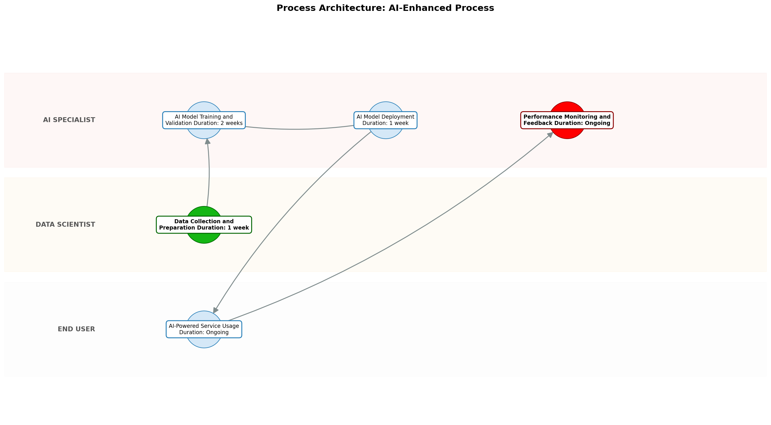

11.0 Process Performance Report
The following metrics are based on a Monte Carlo discrete-event simulation running 2,000 iterations. All time-based values are reported in week.
Operational Metric | Simulated Value
Average Cycle Time | 7.96 week
Cycle Time Variance | 0.84 week
Contention Risk Profile | Low

Identified Bottlenecks
- AI Model Training and Validation
- Performance Monitoring and Feedback
- Data Collection and Preparation

Detailed Step Performance
Process Step | Avg. Duration (week)
Data Collection and Preparation | 1.33
AI Model Training and Validation | 2.66
AI Model Deployment | 1.32
AI-Powered Service Usage | 1.33
Performance Monitoring and Feedback | 1.33

12.0 Governance Requirements
The following governance requirements apply to this process:
• AI ethics guidelines
• Compliance standards

13.0 Risks and Controls
The following risks and associated controls apply to this process:
Risk | Control
AI bias | Bias detection and mitigation techniques
Security breaches | Security protocols and access control

14.0 Process Triggers
The following triggers initiate this process:
• New business requirements
• Technological advancements

15.0 Process End Conditions
The following conditions indicate completion of the process:
• Process achieves its objectives

16.0 Change Management
The following change management practices apply to this process:
• Change Request Process: Standard change management process
• Versioning Rules: Semantic versioning

17.0 Continuous Improvement
The following continuous improvement practices apply to this process:
• Review Frequency: Monthly
Improvement Inputs:
• User feedback
• Performance metrics

Appendix B: Additional Source Data
This appendix contains additional structured data from the normalized source JSON that is not covered in the main sections.
Field | Value
Scope | All relevant business processes
Purpose | To improve efficiency, decision-making, and accessibility using AI
Process Owner | Process Owner

Appendix C: Glossary
This glossary contains definitions of common terms used in the process documentation:
Term | Definition
Business Process | A set of related activities or tasks performed to achieve a specific organizational goal.
KPI | Key Performance Indicator used to measure the success or health of a process.
Stakeholder | Any individual or group with an interest in the outcomes of the process.
Continuous Improvement | Ongoing effort to improve products, services, or processes.

