**Cardiac Output in Sepsis ICU Admissions**

**Aim:**

Evaluate cardiac output during ICU stay. Exclude patients with pacemakers. Compare cardiac output for different patient subgroups, namely vasopressor use, survivors/non-survivors and suppressed/normal/hyperdynamic left-ventricular ejection fraction (LVEF).

**Cohort Summary:**

|  |  |  |  |  |
| --- | --- | --- | --- | --- |
|  | No. | % | Age | Length of Stay (median) |
| Patients | 2817 |  |  |  |
| Gender |  |  |  |  |
| M | 2006 | 56.4 | 62.9(16.7) | 4.6 |
| F | 1573 | 43.5 | 63.4(16.6) | 4.5 |
| Sepsis ICU admissions | 3580 |  |  |  |
| Vasopressors |  |  |  |  |
| Y | 1966 | 54.9 | 63.4(15.7) | 7.1 |
| N | 1614 | 45.1 | 61.8(17.6) | 2.8 |
| 30-day Mortality |  |  |  |  |
| Survivors | 2456 | 68.6 | 61.5(17.2) | 4.6 |
| Non-Survivors | 1124 | 31.4 | 66.8(14.8) | 4.3 |
| Echos – LVEF | 1519 |  |  |  |
| Suppressed (<35) | 40 | 2.6 | 63.0(13.2) | 8.2 |
| Mild Suppression (30-55) | 187 | 12.3 | 60.5(16.1) | 5.8 |
| Normal (55-75) | 1119 | 73.7 | 60.9(15.6) | 5.8 |
| Hyperdynamic (>75) | 173 | 11.4 | 62.6(14.9) | 6.6 |

**Assessing Cardiac Output using MIMIC II**

Stroke volume multiplied by heart rate is the typical way of estimating cardiac output. However, in MIMIC II, stoke volume is only available in a small subset of patients, therefore we have used pulse pressure (systolic minus diastolic blood pressure) as a proxy for stroke volume. The following variables were extracted from MIMIC II with noting the time of the observation as time after ICU admission in minutes:

* HR
* Pulse pressure (both invasive and non-invasive)
* Lactic acid
* Urine output

**Results**

|  |  |  |
| --- | --- | --- |
| Macintosh HD:Users:tombombadl:Research:Projects:Cardiac_Output:Figure:pp_vasopressors.png | Macintosh HD:Users:tombombadl:Research:Projects:Cardiac_Output:Figure:hr_vasopressors.png | |
| Macintosh HD:Users:tombombadl:Research:Projects:Cardiac_Output:Figure:la_vasopressors.png | | Macintosh HD:Users:tombombadl:Research:Projects:Cardiac_Output:Figure:uo_vasopressors.png |

**Figure 1:** Hourly averages of pulse pressure (systolic minus diastolic blood pressure, noninvasive), heart rate, lactic acid and urine output with or without vasopressor therapy

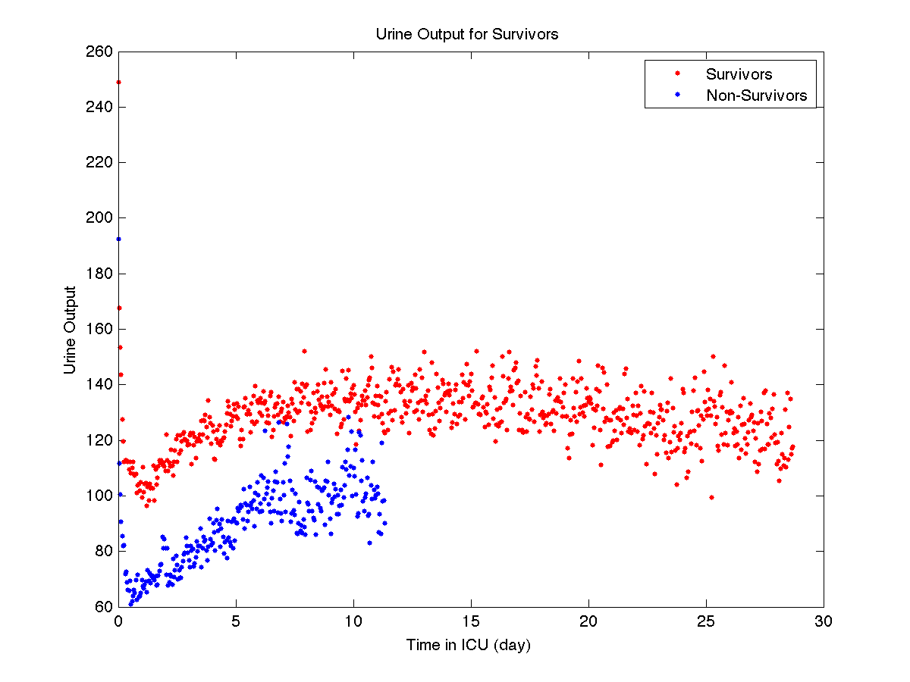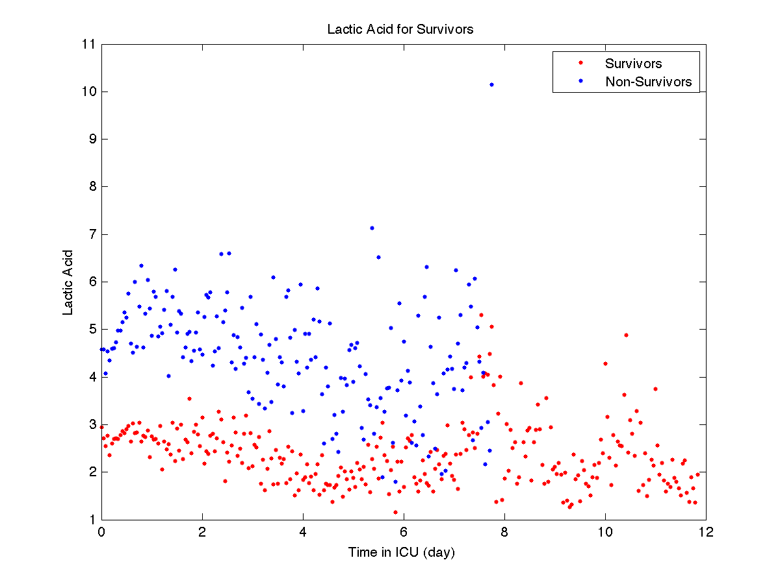

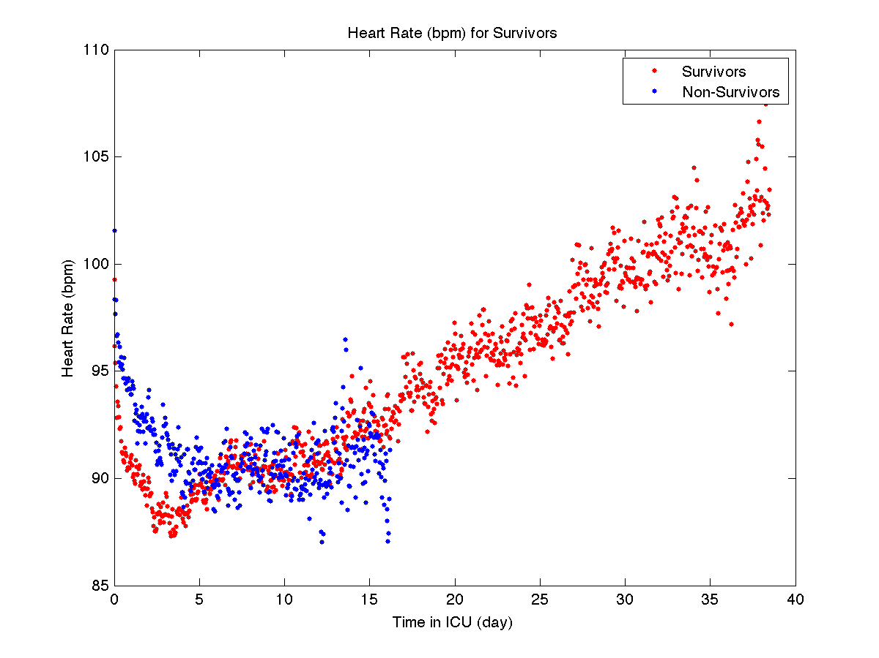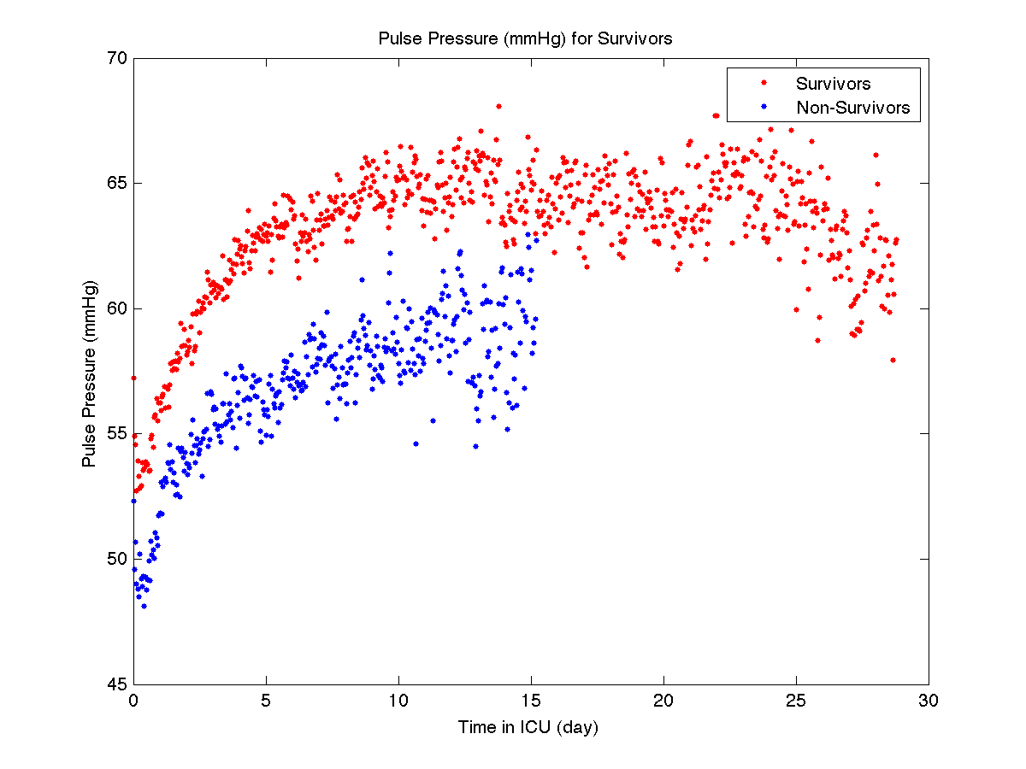**Figure 2:** Hourly averages of pulse pressure (systolic minus diastolic blood pressure, noninvasive), heart rate, lactic acid and urine output for survivors and non-survivors (28-day mortality)

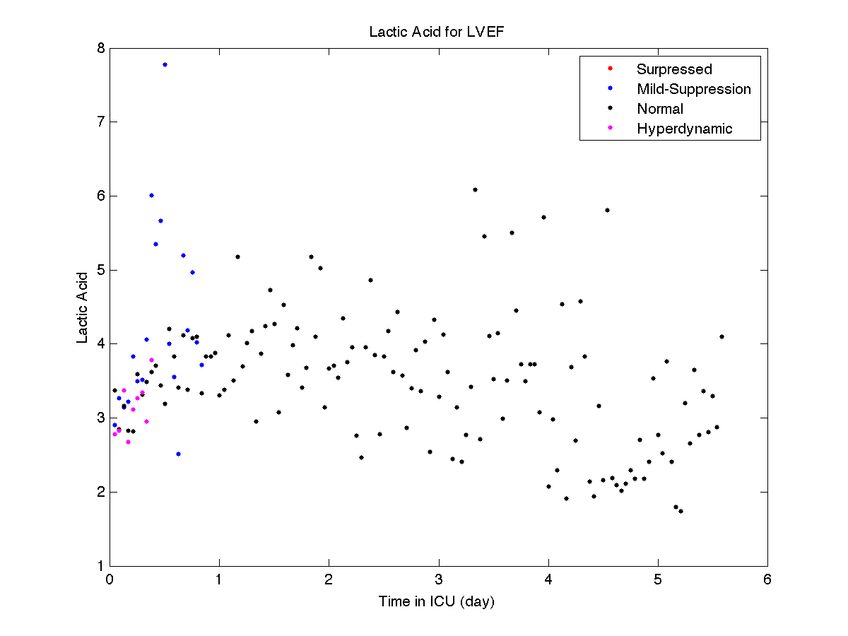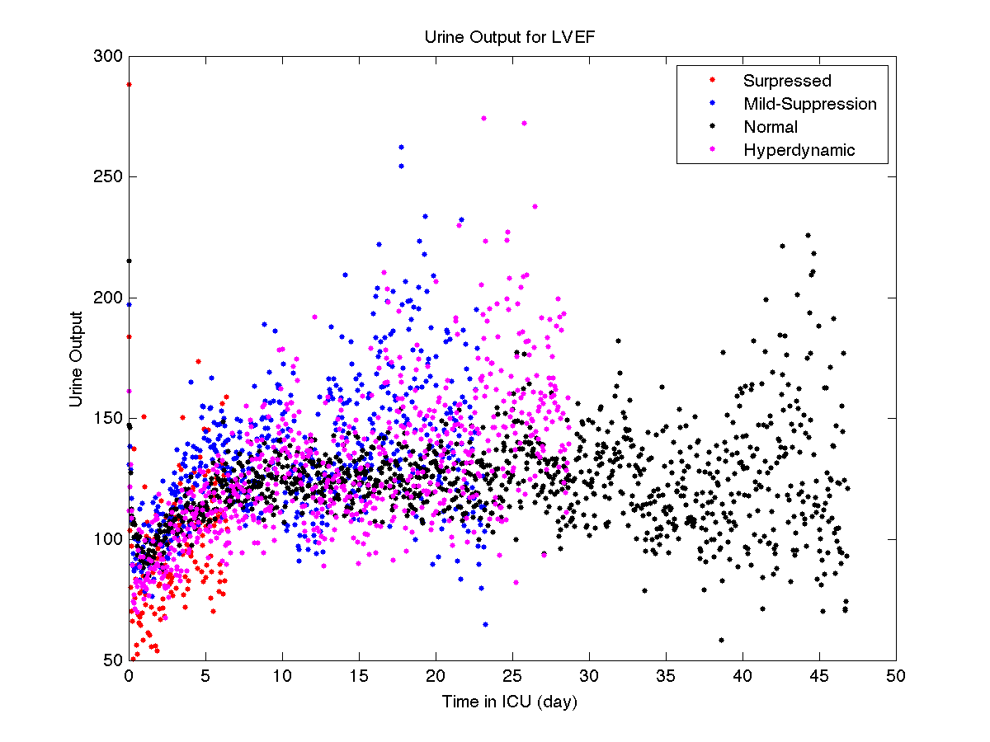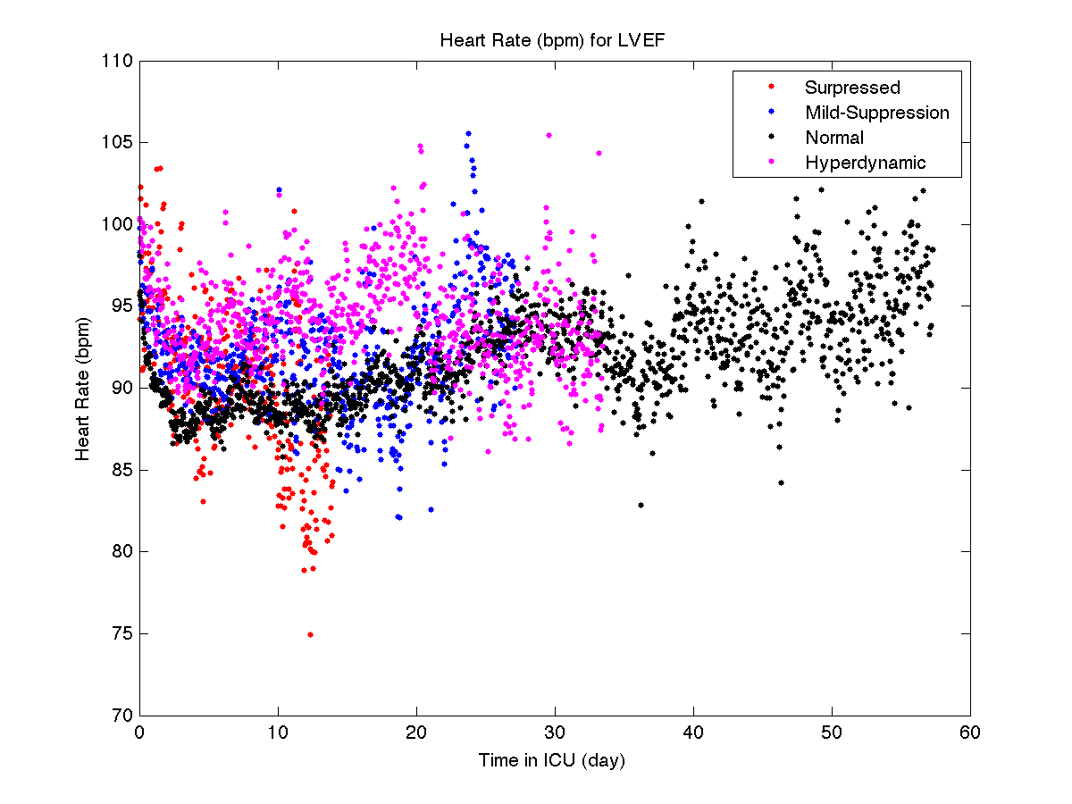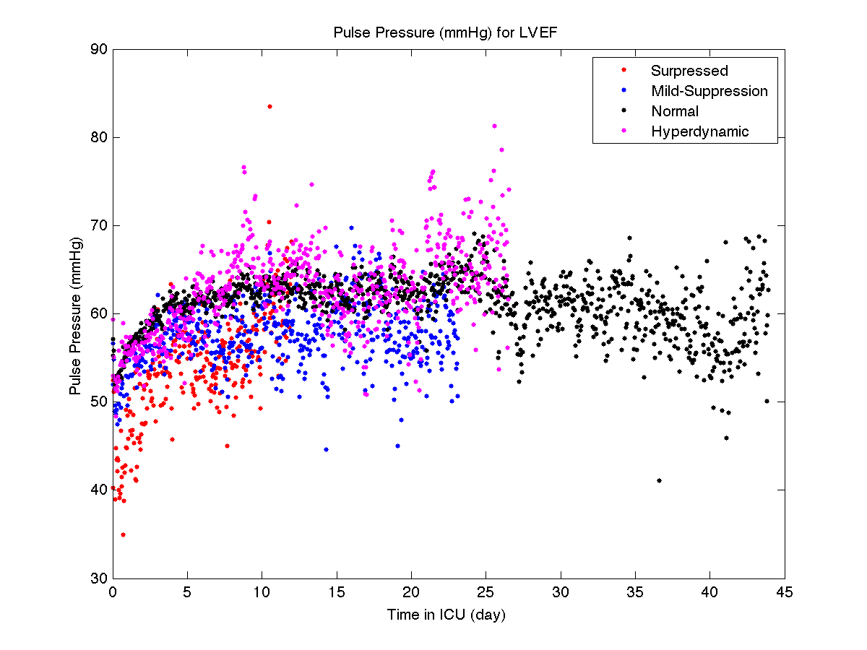**Figure 3:** LV Ejection Fraction: Suppressed (<35%), Mild-surppression (35-55%), Normal (55-70%), Hyperdynamic (>70%)

**Discussion**

1. Look at pulse pressure in first 24 hours with EF
2. Show patient hourly averages underneath errorbars, use ball size to represent amount of patients per hour (greyscale)
3. Show each patient as a data point
4. Check vasopressors groups (vasopressors increase BP)
5. Capture vasopressor therapy (determine average)
6. Send out some data representation options for survivors