Nx AI Manager — Stress Dashboard Post-Processor
A capacity-planning & stress-testing dashboard for the NX AI Manager (Nx Meta and Nx Witness).

Overview
The Stress Dashboard is a custom NX AI Manager post-processor that answers a question every integrator and pre-sales engineer faces: “For this model and this many cameras, what frame rate do I actually get, and how hard is the hardware working?”
It runs alongside any inference pipeline as a transparent pass-through — it measures throughput without altering the inference results — and pairs that with whole-machine CPU, RAM, GPU and NPU load. The result is a live web dashboard plus an exportable, per-run stress-test report.

What it solves
- Capacity planning: Sizing — how many camera channels can a given box sustain with a chosen model before FPS drops?
- Bottleneck identification: which resource saturates first (CPU? GPU? NPU?), so you know what to upgrade or where to offload inference.
- Benchmarking: repeatable, shareable HTML/CSV reports per model + camera-count + hardware combination.

How it works
Two cooperating components, following the standard NX AI Manager external-postprocessor pattern:
- Post-processor: a tiny pass-through post-processor counts inference frames per camera channel (by DeviceID) and forwards per-second counts to the web app. It never modifies the inference results.
- Web app: samples whole-machine CPU/RAM/GPU/NPU once per second, turns frame counts into FPS, serves the live dashboard, records named test runs, and exports reports.
Data path: NX AI Manager → (Unix socket) → Post-processor → (HTTP) → Web app → SQLite → Browser dashboard / Report.

What it measures
- Live resource load: whole-machine CPU, RAM, GPU and NPU load.
- Total throughput: total concurrent inference FPS across every channel running this post-processor.
- Per-channel FPS: per-camera-channel FPS (channels are auto-discovered and can be renamed).
- Stress report: start/stop a named run, then export a self-contained HTML report (charts + avg/peak/min/p95) and CSV (raw per-second time series).
- Portable: auto-detects Nx Meta and Nx Witness install paths; metric sources auto-detect and degrade gracefully.

Metric sources (Linux)
Resource | Source
CPU / RAM | psutil (whole machine)
Intel NPU | intel_vpu sysfs — busy-time → utilisation %, memory, frequency (no root needed)
Intel iGPU | xe / i915 DRM — true engine utilisation via per-client fdinfo (root); frequency-ratio fallback otherwise
NVIDIA GPU | NVML (pynvml) — utilisation, memory, power, temperature

Live Dashboard
The example below is a simulated stress run: 16 cameras analysed with the People Detection model (high accuracy), running inference on the Intel CPU (Core Ultra 7 265).
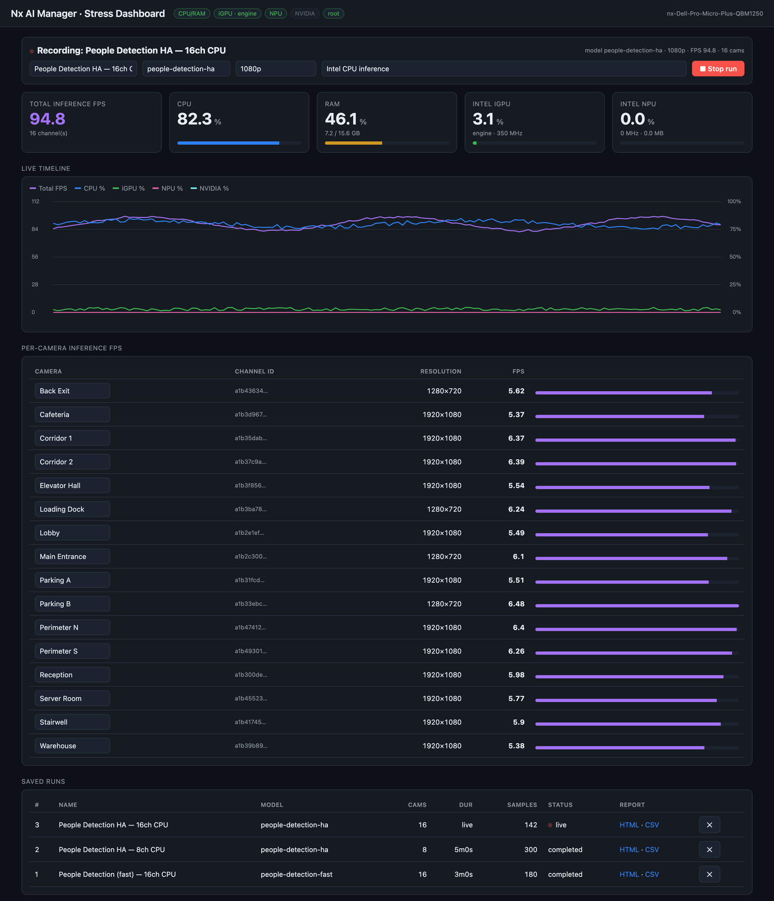
Live dashboard — 16× People Detection (high accuracy), Intel CPU inference.
Reading the example:
- Total throughput: ~94.8 FPS across all 16 channels — roughly 5.9 FPS per camera.
- Where the load is: CPU is the bottleneck at ~82%, while the Intel iGPU (~3%) and NPU (~0%) sit idle — exactly what you expect when inference is pinned to the CPU.
- Trend: the live timeline shows steady FPS (purple) against a CPU line (blue) hovering near 80%, with GPU/NPU flat along the bottom.
- Takeaway: offloading this model to the NPU or iGPU would free substantial CPU headroom and likely raise the achievable channel count — precisely the kind of decision this tool informs.

Stress-Test Report (HTML / CSV export)
Stopping a run produces a self-contained report (opens offline, no server needed). It captures the run configuration, an avg / peak / min / p95 summary for every metric, per-camera FPS, and time-series charts.
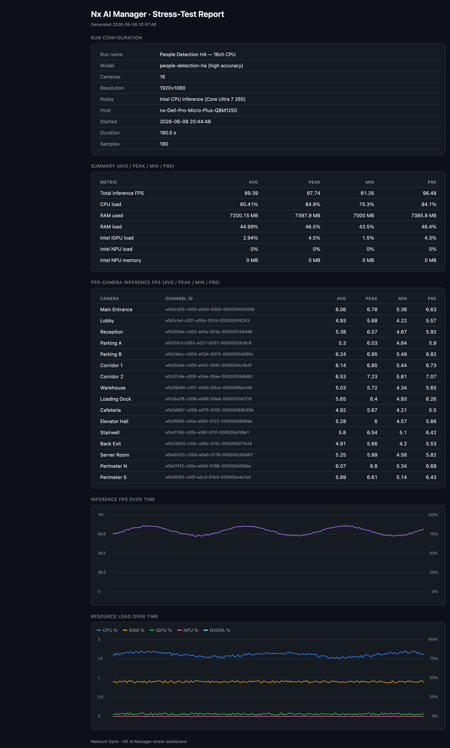
Exported stress-test report for the same 16-camera CPU run (avg ≈ 89 FPS, peak ≈ 98 FPS).

Deployment
One command deploys both components to a server (auto-detects Meta vs Witness, installs deps, registers the post-processor without clobbering existing ones, and starts the web app):
./deploy.sh <server_ip> <ssh_user> <ssh_password> 8120 --start
Then open http://<server>:8120, enable “Stress Dashboard” on the cameras under test, and run the model.
Note: run the web app as root for true Intel iGPU engine utilisation; CPU, RAM and NPU work without root. GPU/NPU load reads ~0 until inference actually runs on that device.

Network Optix · NX AI Manager — Stress Dashboard post-processor

