Reproducible Data Project 1

Tyler Peterson

10/6/2016

setwd("/Users/i64425/GitHub/coursera_5_reproducible_research/Project1")  
 library(dplyr, quietly = TRUE)  
 library(lattice, quietly = TRUE)

## Loading and preprocessing the data

# Read data from .csv and load libraries  
  
 df <- read.csv("activity.csv")  
  
# Explore data  
 #numDates = df %>% distinct(date)  
 #numDates$date  
 str(df)

## 'data.frame': 17568 obs. of 3 variables:  
## $ steps : int NA NA NA NA NA NA NA NA NA NA ...  
## $ date : Factor w/ 61 levels "2012-10-01","2012-10-02",..: 1 1 1 1 1 1 1 1 1 1 ...  
## $ interval: int 0 5 10 15 20 25 30 35 40 45 ...

df$date <- as.Date(df$date, "%Y-%m-%d")  
  
 #numSteps = df %>% distinct(steps)  
 #sort(numSteps$steps)

# What is the mean total number of steps taken per day?

# Calculating and plotting total number of steps per day  
 stepsPerDay <- tapply(df$steps, df$date, FUN = sum, na.rm = TRUE)  
 meanStepsPerDay <- mean(stepsPerDay)  
 medianStepsPerDay <- median(stepsPerDay)  
 hist(stepsPerDay, xlab = "Steps", main = "Number of Steps Per Day")

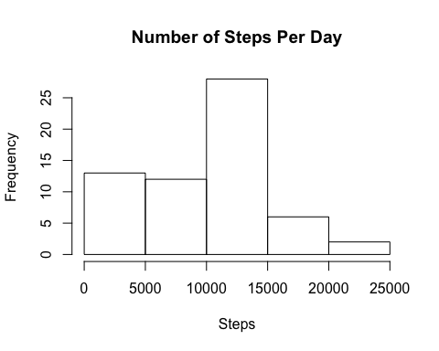

* The mean number of steps taken per day is 9354.2295082, while the median number of steps taken per day is 10395.

# What is the average daily activity pattern?

# Calculate and plot average daily activity  
 meanStepsPerInterval <- tapply(df$steps, df$interval, FUN = mean, na.rm = TRUE)  
 plot(names(meanStepsPerInterval), meanStepsPerInterval, type = "l", ylab = "Mean Number of Steps",   
 xlab = "5 Minute Intervals", main = "Mean Number of Steps At 5 Minute Intervals")

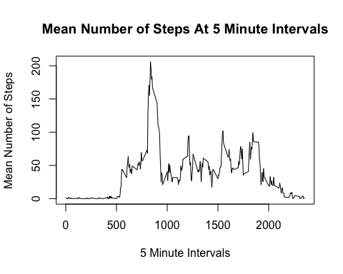

# Determine at which time interval the max number of steps were taken  
 maxSteps <- meanStepsPerInterval[[which.max(meanStepsPerInterval)]]  
 maxInterval <- as.integer(names(meanStepsPerInterval[which.max(meanStepsPerInterval)]))/5  
  
 # Convert that interval to a time of day  
 tempStepTime <- as.integer(names(meanStepsPerInterval[which.max(meanStepsPerInterval)]))/60  
 if(floor(tempStepTime) > 12){  
 stepTime <- paste(floor(tempStepTime)-12, ((tempStepTime - floor(tempStepTime))*60), sep = ":")  
 amPM <- "PM"} else{  
 stepTime <- paste(floor(tempStepTime), ((tempStepTime - floor(tempStepTime))*60), sep = ":")  
 amPM <- "AM"}

* It appears that, on average, the 167th 5 minute interval (which translates to 1:55 PM) contains the maximum number of 206.1698113 steps.

# Imputing missing values

# Calculating total na values  
 naValues <- is.na(df$steps)  
 naValuesTot <- length(naValues[naValues == TRUE])  
   
 # Imputing missing values  
 df2 <- df  
 for (i in 1:nrow(df2)){  
 if (is.na(df2$steps[i])){  
 x <- sample(0:mean(df2$steps, na.rm = TRUE))[1]  
 df2$steps[i] = x  
 }  
 }  
   
 # Determine new total steps per day  
 newStepsPerDay <- tapply(df2$steps, df2$date, FUN = "sum")  
  
 # Plot new total steps per day on a histogram  
 hist(newStepsPerDay, xlab = "Steps Per Day", main = "Number of Steps Per Day")

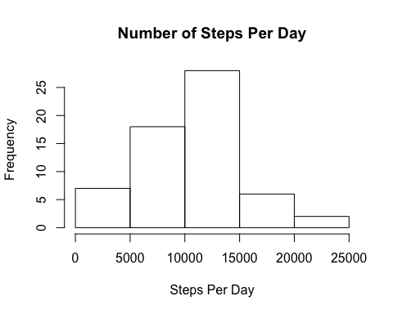

# Calculate new mean and median steps per day  
 meanNewStepsPerDay <- mean(newStepsPerDay)  
 medianNewStepsPerDay <- median(newStepsPerDay)

* There are 2304 NA values in the dataset. After backfilling the NA values in the dataset, it appears that there has only been a slight change in the distribution of steps per day. The new mean steps per day is 1.002813110^{4}, up from 9354.2295082 and the new median steps per day is 1.002813110^{4}, up from 9354.2295082.

# Are there differences in activity patterns between weekdays and weekends?

# Determining patters on weekdays vs. weekends  
 df3 <- df2  
 df3$day_of_week <- weekdays(df3$date)  
 weekends <- c('Saturday', 'Sunday')  
 df3$day_class <- factor(df3$day_of_week %in% weekends, levels = c(TRUE, FALSE), labels = c('Weekend', 'Weekday'))  
  
 xyplot(steps~interval | day_class, data = df3, type = "l", layout = c(1,2),  
 xlab = "Time Interval", ylab = "Number of Steps",   
 main = "Number of Steps by Day Classification")

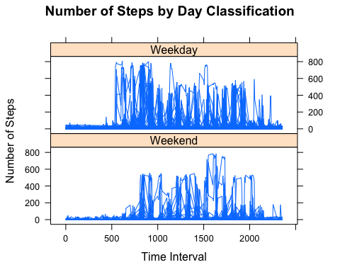

* There appears to be some difference in the frequency of steps on the weekends vs. weekdays. The increase in step frequency occurs later in the day on average during the weekend and the number of steps overall during the day appear to be less frequent. This may indicate that the subject is sleeping in on the weekends and is less active overall.