# Part 1:

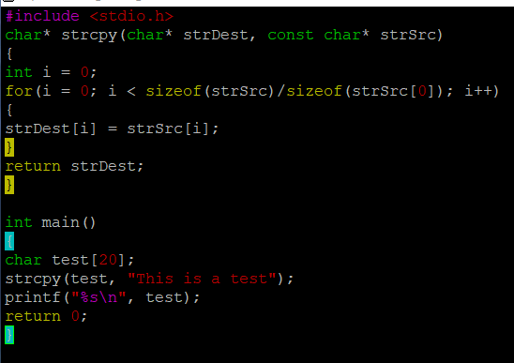

Figure . Source code

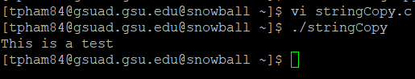

Figure .Test result

We return char* type because it makes it easier for us to use it as a tool to declare another string. It is also because both of the parameters are char*.

# Part 2:

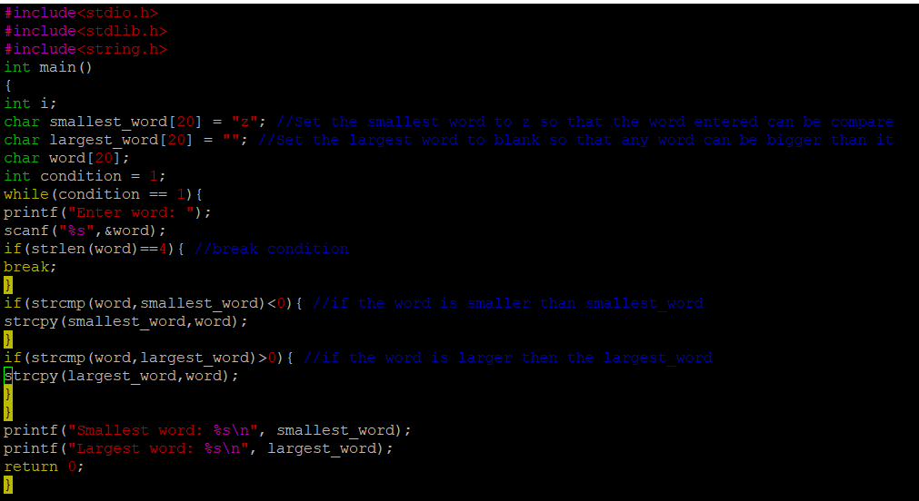

Figure . Source Code

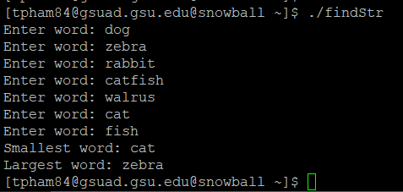

Figure . Result