1. Current directory is /home/tpham84
2. Before making the CSC3320 directory, the ls command does not show anything. After making the CSC3320 directory, the ls command shows the csc3320 directory for the result.
3. pwd
4. mkdir lab2
5. cd lab2
6. The special character “>” is the output redirector that essentially tells the shell that the output after the command will be store in that file. We need to press Ctrl-D at the end to exit, or in other words, the end-of-input has been reached.

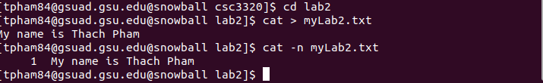

1. 