Lab 4

Thach Pham

4. It will try to match the pattern ‘CSC 3’ in the file and highlight where they find the patterns.

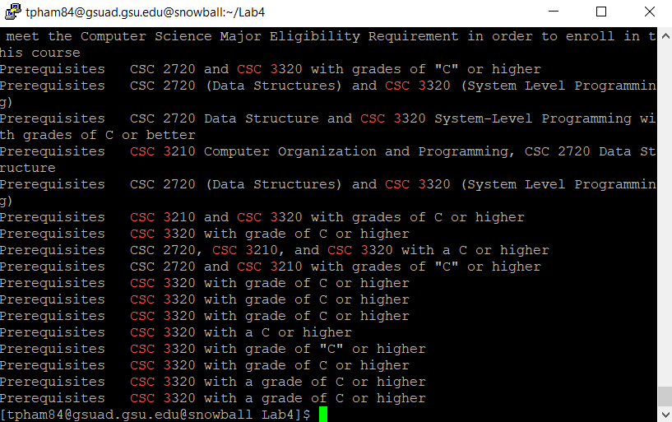

5. The command does not do anything as ‘|’ is not in available as an OR command in grep

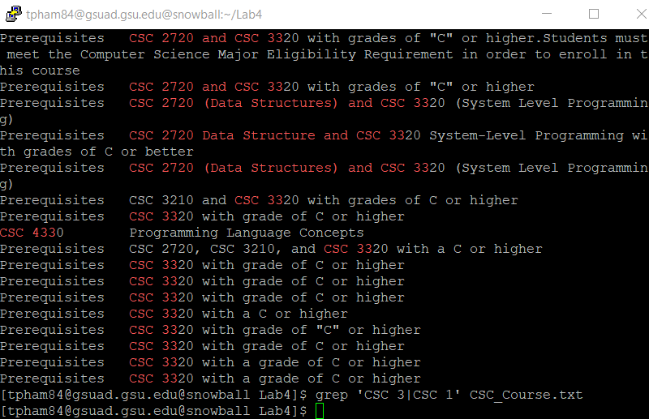

6. The command will match ‘CSC 3’ or ‘CSC 1’.

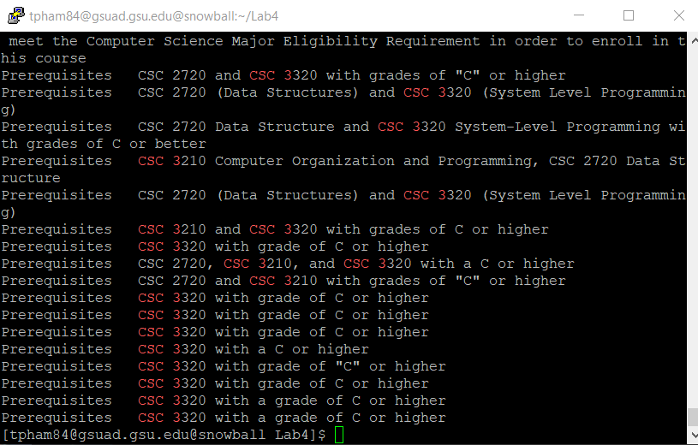

7. The command will perform the same thing as #6 where it matches ‘CSC 3’ or ‘CSC 1’

8. It does not show anything as it does not match any pattern in the file

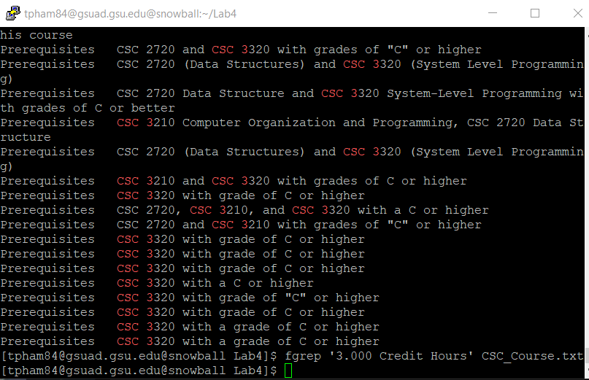

9. It does not show anything as the pattern does not match anything in the file.

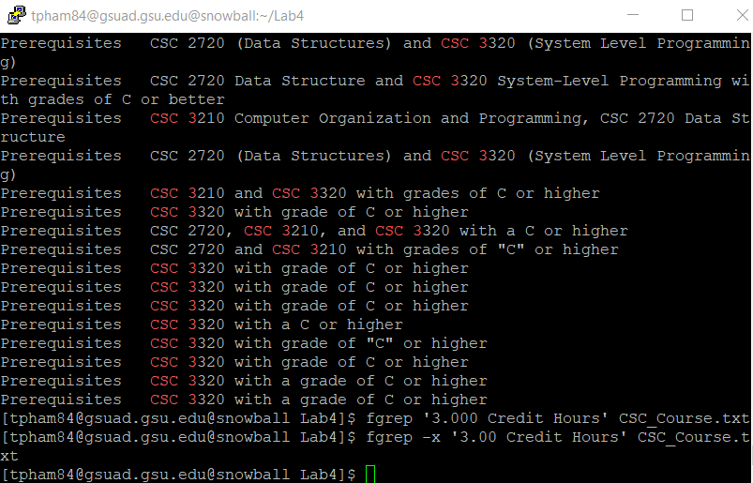

10. The pattern will begin with CSC and end with Programming. In between, there are 0 or more of any characters including white spaces.

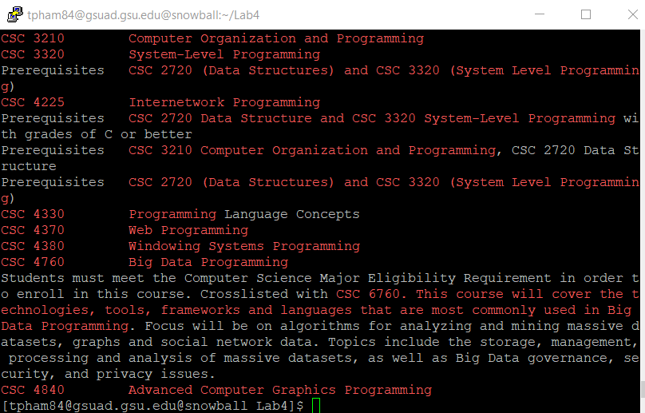

11. The command will search for LINES which starts with CSC and ends with Programming. There can be 0 or more characters in between.

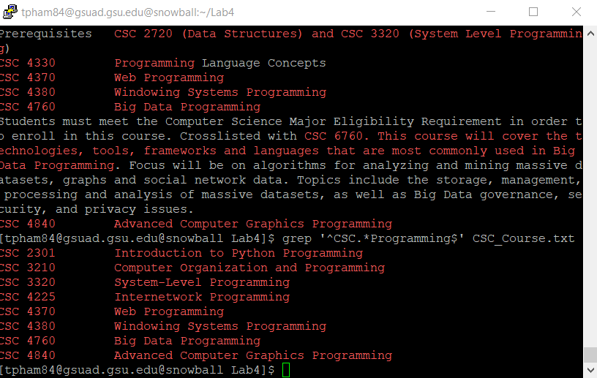

12. This does not show any output as {} is not treated as a special character in grep. This would work for egrep.

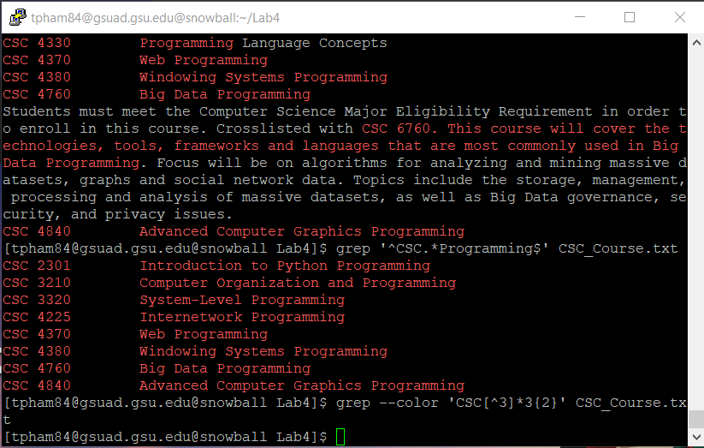

13. This will search for patterns begin with ‘CSC’. After that there can be zero or more occurrence of any words that is not 3. After that it is followed by ‘33’. After that, there can be zero or more occurrence of any words.

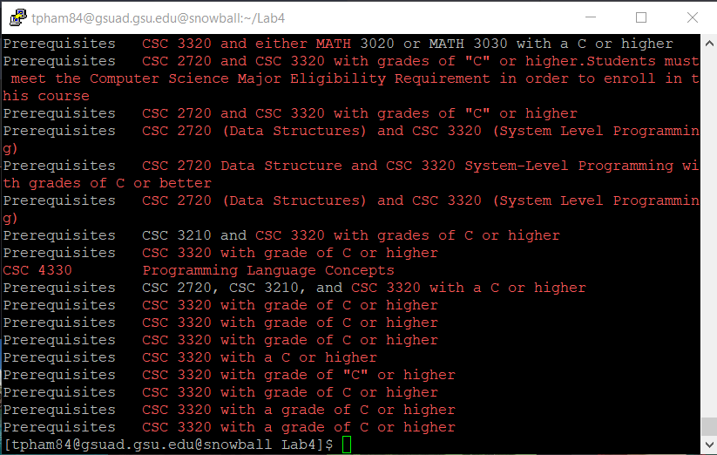

14. This command will not show anything as ‘+’ is not a special character in grep. There is no pattern that ends with two ‘+’ signs.

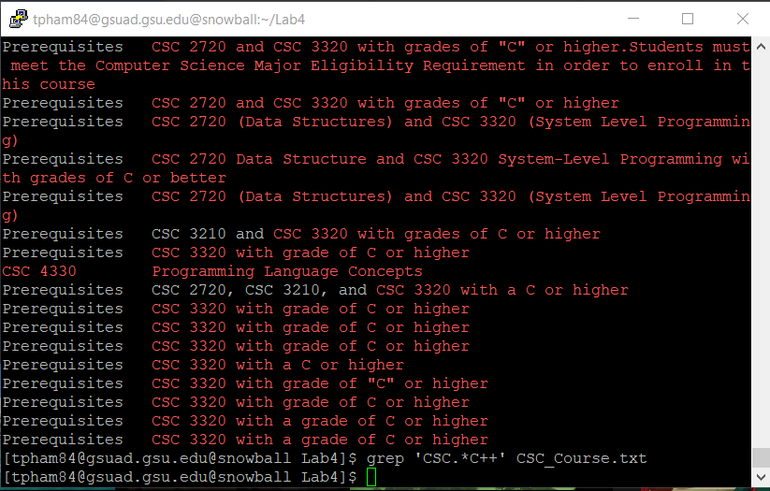

15. This command will also not show any output because this time we are using egrep but we convert the special character ‘+’ back to a normal plus sign.

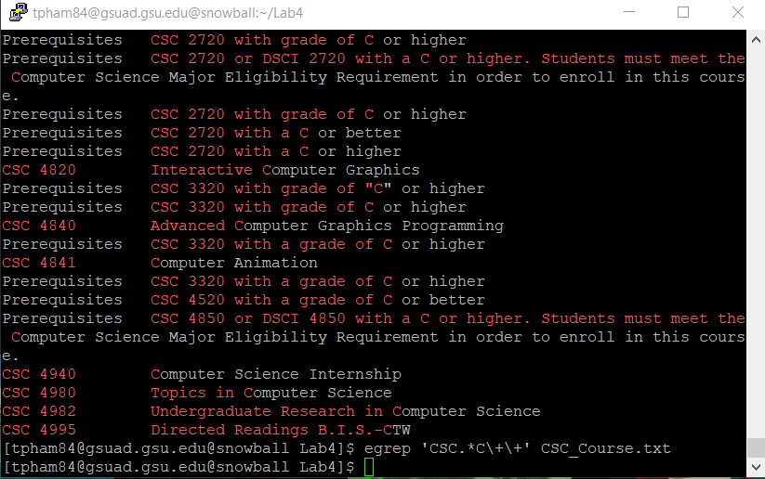

16. This command will search for a pattern that begins with ‘CSC’ and followed by zero or more occurrence of any character. The pattern ends with one or more occurrence of ‘C’

**Optional Part**

1. This command will replace those lines in display with 1. The -n option and /p flag will print the lines that are replaced.

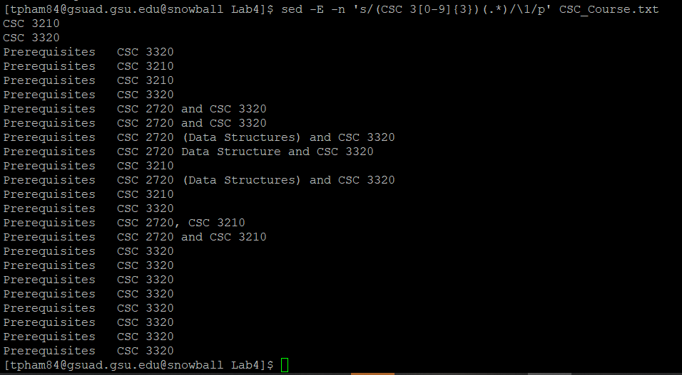

2.This awk command will print the first column of the pattern found. The pattern starts with CSC 3 and 3 other digits from 0-9. The pattern can end with anything.

