**Name:** Thach Pham

**Lab:** 04 Part 2

1. egrep ‘Towns|Union| mountainList.txt
2. grep 'Rabun' mountainList.txt | wc -l
3. grep -c ‘Rabun’ mountainList.txt

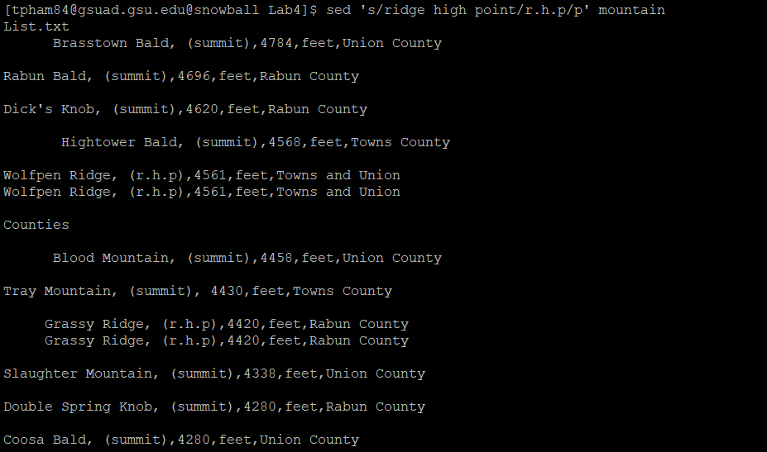



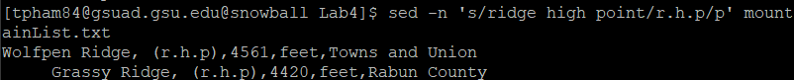

1. The -n option suppresses the automatic printing of pattern space.
2. So, the command in (B) does not print all the text and does not print the lines got replaced twice. Instead, it only prints the lines got replaced once.
3. sed -n ‘s/^ *//p’ mountainList.txt
4. sed ‘s/^ *//g’ mountainList.tx > newList.txt
5. sed -n ‘/^[[:space:]]/p’ mountainList.txt
6. sed ‘/Union County/d’ mountainList.txt
7. sed -r ‘s/(,([^,]*)){3}//g’ mountainList.txt
8. awk gsub'(/(,([^,]*)){3}/,",")' mountainList.txt
9. sed '1 i Table: Eleven highest mountains in Georgia' mountainList.txt
10. sort mountainList.txt
11. sort -r -t, -k3 mountainList.txt
12. 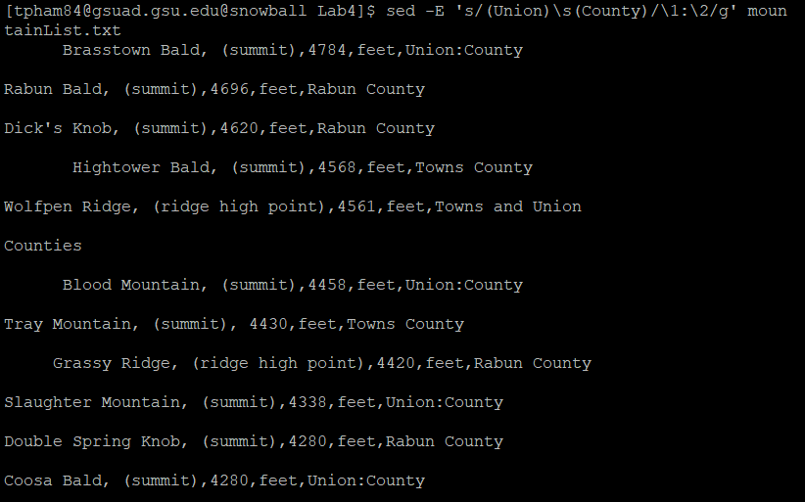
13. sed -r ‘s/((,)([^,]*)){3}\2/\2/g’ mountainList.txt