**Question 1:**

-bash: simple.sh: command not found

**Question 2:**

-bash: ./simple.sh: Permission denied

**Question 3:**

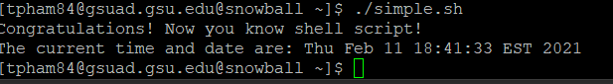

**Question 4:**

The -n option omits trailing newline as we can see that even though we started a new line before inputting the ‘date’ command, the date is displayed in the same line with the phrase “The current time and date are:”

**Question 5:**

“Simple Script” is a comment.

**Question 6:**

“#!/bin/bash” is not a comment. It is telling us that the script is interpreted by bash shell.

**Question 7:**

There are 6 directories in PATH file.

**Question 8:**

There is no error like the one showed in step 9. The reason why we do not need to include ./ before the file name anymore is because whenever the bash shell executes a program, it will search for directories in PATH file to execute. Since the current direction is not in PATH file, we need to tell it that the file is in this current directory by prompting ./ After that we add the current directory to PATH file so there is no need to prompt ./ anymore.

**Question 9:**

No, the current directory is not in PATH file anymore

**Question 10:**

Yes, there is the error command not found. This happens because the current directory is no longer in PATH file, so bash shell does not look for the file in current directory if we don’t prompt ./