Lab: 6

Name: Thach Pham

**Part A**

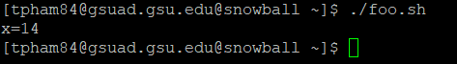

The shell script initialized a x value of 0 and an i value of 1. After that, the shell script starts a while loop. The while loop is as following:

while (i<=3){

s=i*i;

x=s+x;

i =i+1;

}

At the end it will print out the value of x. The first time in the loop, x is 1. The second time, x is 5. The third, and last time, x is 14. Hence the value displayed in the screenshot.

**Part B**



**Part C**

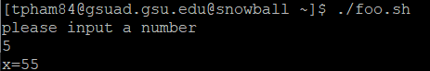

**Part D**

class foo{

public static void main(String[] args) {

int x = 0;

int i = 1;

while(i<=3) {

int s = i*i;

x = s+x;

i = i+1;

}

System.out.println("x= " + x);

}

}

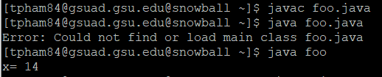

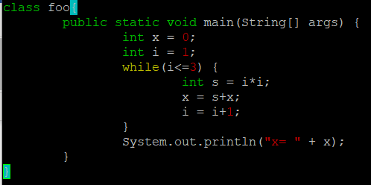

**Part E**

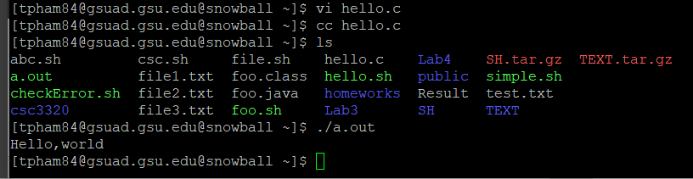

2) The command will generate a hello file.

3)

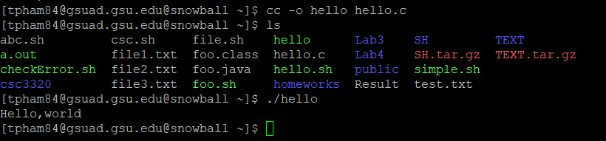

4)

