Lab: 7

Name: Thach Pham

**Part 1:**

#include <stdio.h>

int main(){

char phoneNum[13];

printf("Enter phone number [(999)999-9999]:");

scanf("%s",phoneNum);

char fphoneNum[12];

int i;

for(i=1;i<13;i++){

if(i==4){

fphoneNum[i-1]='-'; //use - instead of )

}

else{

fphoneNum[i-1]=phoneNum[i];

}

}

printf("You entered %s\n",fphoneNum);

return 0;

}

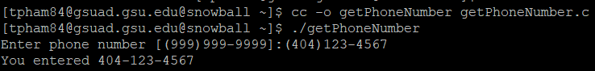

**Part 2:**

#include <stdio.h>

int main(){

//creating variable to store data

int item_number;

double unit_price;

int quantity;

char buy_date[12];

//asking for user input

printf(“Enter item number:”);

scanf(%d,&item_number);

printf(“Enter unit price:);

scanf(“%lf”,&unit_price);

printf(“Enter quantity:”)

scanf(“%d”,&quantity);

printf(“Enter purchase date (mm/dd/yyyy):”);

scanf(“%s”,&buy_date);

//print information

printf(“Item\tUnit Price\tQTY\tPurchase Date\tTotal Amount\n”);

printf(“%-d\t$%9.2lf\t%-d\t%-s\t$9.2lf\n\n”, item_number, unit_price, quantity, buy_date, unit_price*quantity);

return 0; //end the script

}

