Lab 8

Thach Pham

**Part 1:**

4.break 6

4.run

|  |  |  |  |  |
| --- | --- | --- | --- | --- |
|  | 1st iteration | 2nd iteration | 3rd iteration | 4th iteration |
| num | 1125 | 11 | 1 | 0 |
| rev_num | 5 | 52 | 521 | 5211 |

8.The program will reverse a number given in the parameter. First it will create a number rev_num = 0 to hold the value. Then, it takes the modulus 10 of given number to find the right most number. We then multiply rev_num with 10 and add to that right most number we just found. The process is repeated until the given number is no longer greater than 0.

**Part 2:**

Line 11: missing ‘ ‘ to indicate that \n is a character to compare.

Line 13: undeclared variable space.

Line 22: type mismatch. We use int/int so it should have been int instead of float.

*Fixing:

Line 11: ‘\n’

Line 13: declare int space = 0 in any line before the loop.

Line 22: Explicit casting (float) letters/words.

Code after fixing:

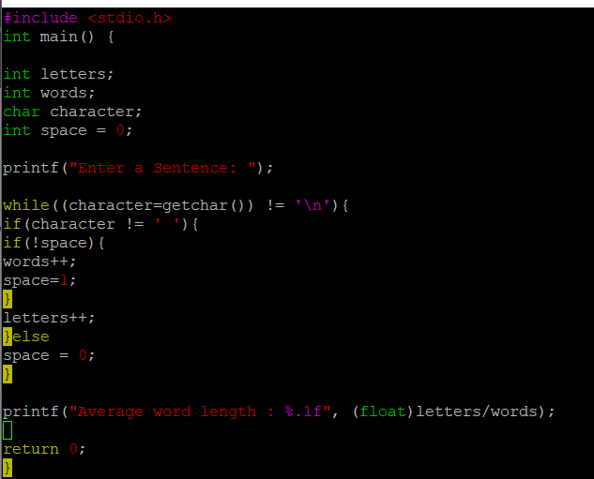

Output:

