**Part 1**

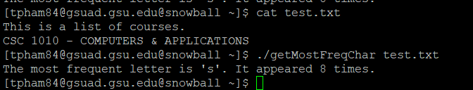

**Part 2**

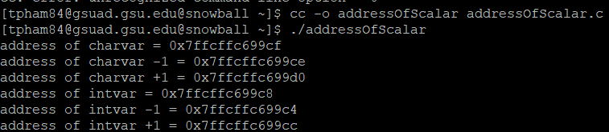

The address of intvar is incremented by 4 because integer is stored using 4 bytes address.

**Part 3**

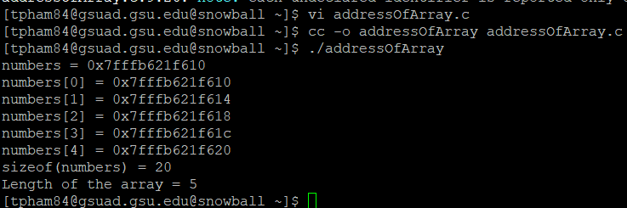

1.The address of the array and the address of the first element in the array is the same.

2.printf(“Length of the array = %lu\m”, sizeof(numbers)/sizeof(numbers[0]));