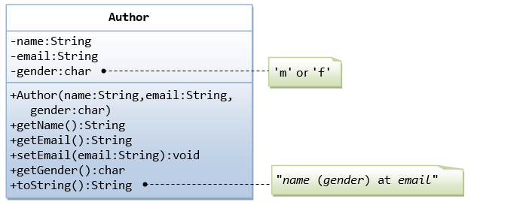

A class called Author is designed as shown in the class diagram. It contains:

* Three private member variables: name (String), email (String), and gender (char of either 'm' or 'f' - you might also use a boolean variable called isMale having value of true or false).
* A constructor to initialize the name, email and gender with the given values.  
  (There is no *default constructor*, as there is no default value for name, email and gender.)
* Public getters/setters: getName(), getEmail(), setEmail(), and getGender().  
  (There are no setters for name and gender, as these properties are not designed to be changed.)
* A toString() method that returns "*name* (*gender*) at *email*", e.g., "Tan Ah Teck (m) at ahTeckm@somewhere.com".

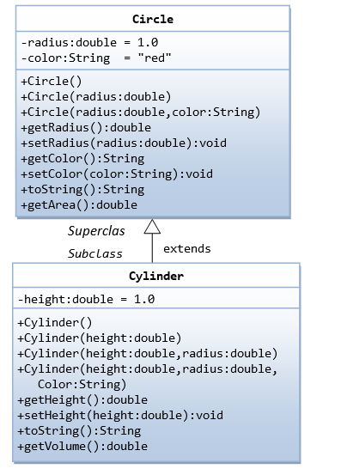

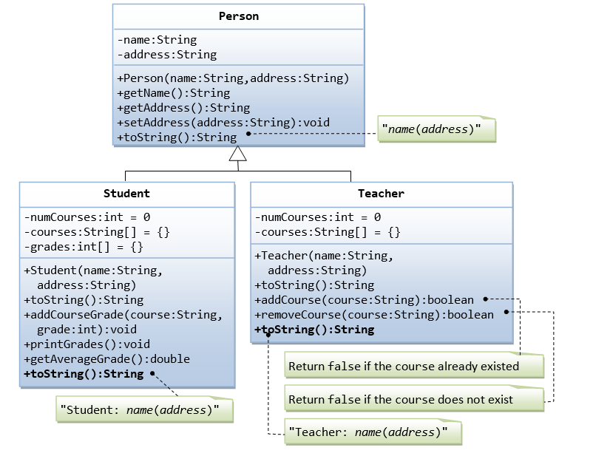

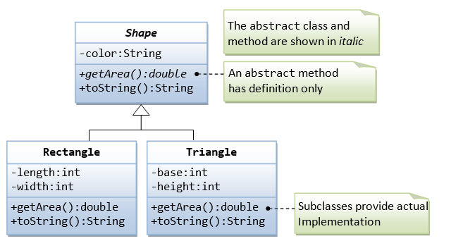

Do the same program using interface.