Programming Assignment 4
50 Points

(Part 1 – 30 Points)

Implement the following class (EmployeeForm) in package program4. The class will display the following GUI (built as a JFrame):
JMenuBar
JMenu

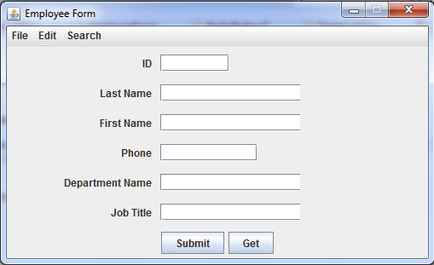

JLabel

JTextField

JButton
Pressing the “File” JMenu results in the following display:

JMenuItem

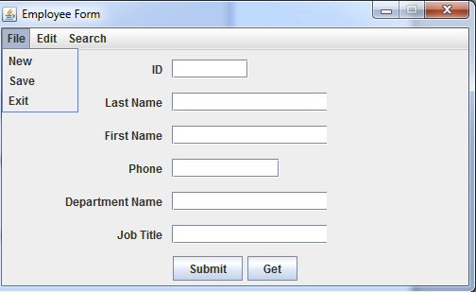
Observe that each JTextField has a variable length based on a specified number of columns that is set by the EmployeeForm Constructor (see EmployeeForm Class section below).

Only File has submenus implemented as JMenuItems embedded within it.

No event handlers are associated with your EmployeeForm class. For this assignment, nothing has to occur when pressing (i.e., activating). any of the displayed JComponents.

EmployeeForm Class

The EmployeeForm must extend JFrame. The constructor for EmployeeForm must be declared as follows:

public EmployeeForm(String title, String[] labels, int[] no_of_columns)

String title – title of JFrame

String[] labels – the String name for each label stored as a parallel array of Strings. The first element corresponds to the top most JLabel displayed in the Employee Form GUI. For this example that label would be ID.

Each subsequent element is displayed as a JLabel from top to bottom.

int[] no_of_columns – A parallel array associated with the 1st parameter – labels. This array specifies the desired number of columns that the corresponding JTextField will display.

Note: Remember that specifying the number of columns when creating a JTextfield does not guarantee that the JTextField will display exactly the specified number of columns. This is only used as a hint to the LayoutManager on how large to display the JTextField.

The entire GUI must be implemented within this Constructor.

You are free to implement any other methods you like to make your application more modular.

Guidelines for main
The only purpose for main is to test your GUI. Testing your GUI consists of the following 3 statements:

- Declare an array of integers that corresponds to the desired number of columns to be displayed by the JTextField. An example of such a declaration corresponding to the example GUI on page 1 is:

int[] no_of_columns = new int[]{7,20,20,10,20,20};

- Declare an array of label names corresponding to the JLabels displayed in the Employee form GUI. An example of such a declaration for the GUI given on page 1 is shown below:

String[] labels = {"ID","Last Name","First Name","Phone",
"Department Name", "Job Title"};

This is a parallel array corresponding to the array declared in step 1.

- Invoke the parameterized Constructor for creating the EmployeeForm class. This constructor takes the 3 parameters shown below:

EmployeeForm employeeform = new EmployeeForm("Employee Form",
labels,
no_of_columns);

Where the 1st parameter is the title of the JFrame
The 2nd and 3rd Parameters are the parallel arrays specified in steps 1 and 2.

The entire EmployeeForm GUI as displayed on page 1, should be displayed once this Constructor completes.

Part 2 (20 Points)

Implement the following class – RadioButtonTest – that displays the following GUI:

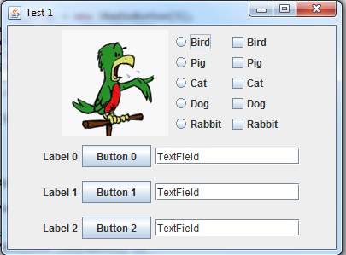
JRadioButton

JCheckBox

JTextField

JButton

JLabel
( Bird.gif)
The JRadioButtons on the left column must be mutually exclusive – only one of the RadioButtons can be selected at a time.

The 5 JRadioButtons should be stored in an Array as they are displayed and are numbered sequentially from 0 to 4 where the top most JRadioButton is numbered 0 (Bird is the label for this one), while the bottom JRadioButton is numbered 4 (Rabbit is the label for this one).

The JCheckBoxes on the right column allow multiple selections.

The 5 JCheckBoxes should be stored in an Array as they are displayed and are numbered sequentially from 0 to 4 where the top most JCheckBox is numbered 0 (Bird is the label for this one) while the bottom JCheckBox is numbered 4 (Rabbit is the label for this one).

The 3 JButtons at the bottom of the GUI should be stored in an Array as they are displayed are numbered from top to bottom as 0, 1 and 2. 0 is the top JButton and 2 for the bottom JButton.

The 3 JTextFields should be stored in an Array as they are displayed and are also numbered from top to bottom from 0 to 2. 0 is the top JTextField while 2 is the bottom JTextField.

The 3 JLabels at the bottom of the GUI should be stored in an Array as they are displayed and are also numbered from 0 to 2. 0 is the top JLabel while 2 is the bottom JLabel.:

Your GUI should be neat, readable and symmetrical and should have a similar arrangement of Components as shown on page 4.

RadioButton Test Class

Implement the following getters for the RadioButtonTest class. These getters will be utilized by the RadioButtonTester used for testing the GUI.

Getters

public JCheckBox getCheckBoxAt(int index)
Returns the corresponding JCheckBox object that corresponds to the input parameter index. The JCheckBoxes are numbered from 0 to 4 as shown on page 4.

public JRadioButton getRadioButtonAt(int index)
Returns the corresponding JRadioButton object that corresponds to the input parameter index. The JRadioButtons are numbered from 0 to 4 as shown on page 4.

public JButton getButtonAt(int index)
Returns the corresponding JButton object that corresponds to the input parameter index. The JButtons are numbered from 0 to 3 as shown on page 4.

public JLabel getLabelAt(int index)
Returns the corresponding JLabel object that corresponds to the input parameter index. The JLabels are numbered from 0 to 3 as shown on page 4

public JTextField getTextAt(int index)
Returns the corresponding JTextField object that corresponds to the input parameter index. The JTextFields are numbered from 0 to 3 as shown on page 4

public JLabel getImage()
Returns the JLabael at the top of the image containing the image.
Constructor

public RadioButtonTest(String str)
Creates the GUI displayed on page 4. The input parameter str contains the title for the GUI – “Test 1” for this example.

main guidelines

Your main instantiates the RadioButtonTest object using the Constructor described above. This should be the only statement for your main.

Class and Package Requirements

You must name your public classes EmployeeForm and RadioButtonTest and they must be stored in a Package named program4. You will be deducted points if you do not follow these naming requirements for the class and package.

You will need to create a jar file that contains all the .java, class and additional files within the program3 package.

You are free to name your jar file anything you like.

Running the bat (Windows ) or .sh (Mac)

The following files – prog4.bat or (prog4.sh for Mac) are provided to you for testing your work,

You will need to create another folder (e.g. c:\jar_test) and place prog4.bat (or prog4.sh) and your jar file in this folder. Four other class files are also provided. They must be placed in the same folder as prog4.bat and your jar file.

EmployeeFormTester.class is provided as a way to test your EmployeeForm class. Observe how the GUI’s components such as the menu items, text fields and buttons appear to be activated programmatically by what appears to be an “invisible man” The EmployeeFormTester.class will display error messages whenever it finds anything wrong with your EmployeeForm class. If no error messages are displayed by EmployeeFormTester.class, you will still need to verify that your GUI is displayed neatly, readable and implements all the specifications provided in the document.

RadioButtonTester.class is also provided as a way to test the RadioButton class. The RadioButtonTester.class will display error messages whenever it finds anything wrong with your RadionButtonTest class. If no error messages are displayed by EmployeeFormTester, you will still need to verify that your GUI is displayed neatly, readable and implements all the specifications provided in the document.

What you Submit
Submit your jar file containing all source (.java), class , and other required files to Blackboard.

