
Supervisor: Assoc. Prof. Pham Hoang Uyen, PhD
Le Ngoc Bao Van, PhD

Student ID | : | K234131613
Full name | : | Huynh Tan Phat
Class | : | K234131613
Subject | : | Data Mining

Ho Chi Minh City, October/2026
Chi Minh City, January/2027
LAB ASSIGNMENT

CELLPHONES WEBSITE CRAWLING AND MINING: UNDERSTANDING, MEASURING, VISUALIZING AND GENERALIZING DATA

FACULTY OF ECONOMICS MATHEMATICS

TABLE OF CONTENTS
1. Dataset Overview and Preprocessing 4
1.1 Method 4
1.2 Result 6
1.3 Interpretation 7
2. Section 3.1 – Data Classification 7
2.1 Method 7
2.2 Result 8
2.3 Interpretation 9
3. Section 3.2 – Descriptive Statistics 9
3.1 Method 9
3.2 Result 10
3.3 Interpretation 10
4. Section 3.3 – Data Visualization 11
4.1 Method 11
4.2 Results and interpretation 12
Histogram – sale price 12
Boxplots – sale price and discount by brand group 12
Quantile plot – sale price 13
Scatter plots – relationships between numeric attributes 13
Multi-attribute plot – price, storage, brand group and product type 14
5. Section 3.4 – Measuring Similarities and Differences 14
5.1 Method 14
5.2 Result 15
5.3 Interpretation 16
6. Section 3.5 – Measuring Data for Classification 17
6.1 Method: target variable and discretisation 17
6.2 Result: entropy and information gain 18
6.3 Result: chi-square tests of independence 19
6.4 Result: correlation 19
7. Section 3.6 – Data Generalization and Summarization 20
7.1 Method 20
7.2 Result: concept hierarchies 21
7.3 Result: data cube 21
7.4 Result: attribute-oriented induction 23
7.5 Discussion: what is lost and what is gained 24
8. Overall Findings and Key Insights 24
Appendix A – Code and Reproducibility 25
Appendix B – Additional Results 25
References 27

1. Dataset Overview and Preprocessing

1.1 Method
The dataset was collected from the public product-listing pages of the Vietnamese electronics retailer CellphoneS (https://cellphones.com.vn) in the previous assignment.

Each row represents one product listing (the model and memory configuration) in the category "mobile" and "tablet". The raw file contains 1019 rows and 7 columns, which is sufficient in terms of record numbers (more than 1000). Prior to any analysis, I checked for missing values, duplicates, data types, and invalid or inconsistent values (Table 2), while some additional attributes were derived from the product title since the crawl only captured seven fields (Table 3). Table 1 presents the original columns.
Table 1. Original columns of cellphones_clean.csv.
Column | Type | Example | Meaning
category | str | mobile / tablet | Listing category on the site
name | str | Samsung Galaxy A07 5G 4GB 128GB | Product title (contains brand, RAM, storage, network)
price_sale | float | 4,990,000 | Current selling price (VND)
price_original | float | 5,890,000 | List price before promotion (VND)
discount | float | 15.0 | Discount shown on the site (%)
url | str | https://cellphones.com.vn/… | Product page address
is_contact | bool | True / False | True = price shown as "Liên hệ" (contact for price)

Table 2. Data-quality checks and decisions.
Check | Finding | Decision
Missing sale price | 628 rows (61.6%) – exactly the rows with is_contact = True | Structural (not random) missingness: the shop hides the price. Rows kept for categorical/structural analysis; all price-based analysis uses the 391 priced listings.
Missing original price / discount | 696 rows (68.3%) = 628 contact listings + 68 priced listings without a list price | The 68 priced-but-no-list-price listings are read as "no discount shown". Not imputed; discount statistics use the 323 listings that show a discount.
Duplicate records | 0 duplicate rows, 0 duplicate URLs, 1 duplicated product name (Realme GT Neo 6, two URLs, both without price) | Second listing removed → 1,018 records.
Data types | category, name, url = text; prices and discount = float; is_contact = boolean | Types are correct; no conversion needed.
Internal consistency | Recomputed discount = 1 − sale/original; maximum difference 0.50 percentage points; sale price > original price in 0 rows | Consistent (differences are rounding on the site).
Invalid values | Non-positive prices: 0. Sale price 0.42–80.99 million VND; discount 1–43% | All values plausible for phones, tablets and feature phones.
Inconsistent label | 13 e-readers (Kindle, Boox) are filed under category = "tablet" | New attribute product_type separates Phone / Tablet / E-reader.
Specs hidden in title | RAM is parsed for 377 and storage for 461 of 1,018 titles; Apple titles state storage but not RAM | Missing RAM/storage kept as "Unknown" where a category is needed; excluded pairwise for numeric statistics.

Table 3. Derived attributes.
Derived attribute | Rule | Non-missing
brand | First word(s) of the title, normalised (iPhone/iPad → Apple, Redmi/POCO → Xiaomi, iQOO → Vivo, Kindle → Amazon …) | 1,018
brand_group | Apple / Samsung / Chinese brands / Vietnamese brands / Other international | 1,018
product_type | Phone / Tablet / E-reader (from category and the words "Máy đọc sách") | 1,018
ram_gb, storage_gb | Regular expression on "8GB 256GB", "12GB/512GB", "1TB" (TB × 1024); single value ≥ 32 GB = storage | 377 / 461
connectivity | 5G, 4G, Wifi or Unspecified (keyword in title) | 1,018
is_official, has_bundle | "Chính hãng" (official) and "Kèm" (with accessories) in title | 1,018
model_year | Four-digit year 2019–2026 in title | 31
storage_tier, ram_tier | Ordered bins: ≤64 / 128 / 256 / ≥512 GB and ≤4 / 6–8 / ≥12 GB (+ Unknown) | 1,018
price_level, price_band, price_tier | Price discretisation / concept hierarchy (Sections 3.5 and 3.6) | 391 (+ "On request" for tier)

1.2 Result
After cleaning, the dataset has 1,018 objects: 839 phone listings and 179 tablet-category listings (of which 13 are e-readers), from 38 brands. Only 391 listings (38.4%) show a price; 627 (61.6%) are "contact for price" listings. Figure 1 shows that this is very uneven across brands.
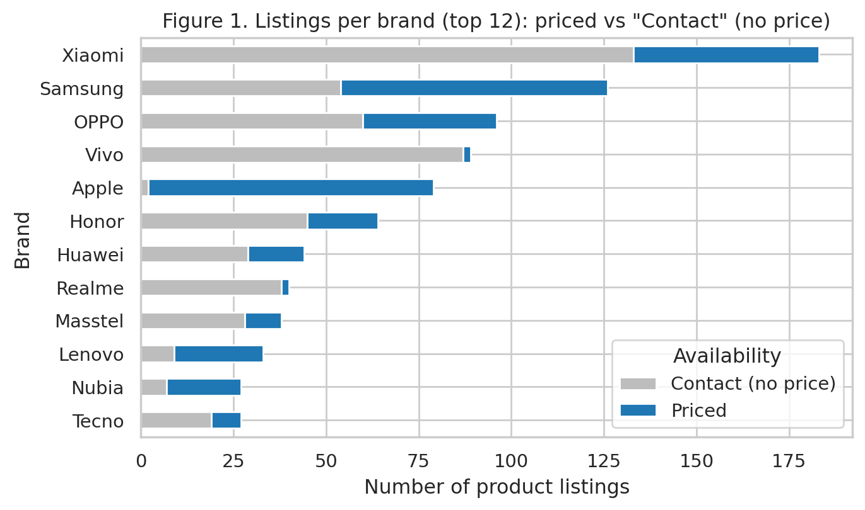

1.3 Interpretation
The missing prices are not random noise: 69% of phone listings are "contact" listings against 25% of tablets, and some brands are almost entirely unpriced (for example Vivo: 2 priced of 89 listings). Many of these listings look like older or discontinued models, but the crawl has no stock or status field, so this can only be a hypothesis. The practical consequence is that every conclusion about price describes the 391 currently priced listings (dominated by Apple, Samsung, Xiaomi and OPPO), not the whole catalogue. This limitation is repeated wherever it affects a result.
- Scope note. Sections 3.1 and 3.6 use all 1,018 listings. Price-based sections (3.2–3.5) use the 391 priced listings; each table states its own n.

2. Section 3.1 – Data Classification

2.1 Method
Objects are the 1,018 product listings. Attributes were classified with the four measurement scales: nominal (labels, no order), ordinal (ordered labels, unequal gaps), interval (equal differences, arbitrary zero) and ratio (equal differences and a true zero). Fourteen attributes – the seven original ones and seven derived ones – are classified in Table 4.

2.2 Result
Table 4. Attribute classification table.
Attribute | Source | Type | Why it belongs to this type | Possible use in later analysis
category | Original | Nominal | Two labels (mobile/tablet) with no order; only equality is meaningful. | Grouping variable; dimension in the data cube.
name | Original | Nominal | Free-text product title; identifies a product but has no order or arithmetic. | Source for brand, RAM, storage, connectivity extraction.
url | Original | Nominal | Unique page address; pure identifier. | Duplicate check; excluded from modelling.
is_contact | Original | Nominal (binary) | True/False flag for "price on request"; categories only. | Availability dimension; explains missing prices.
price_sale | Original | Ratio | Money amount in VND with a true zero; ratios are meaningful (2x as expensive). | Descriptive statistics, distance, class target (price level).
price_original | Original | Ratio | List price before promotion in VND; true zero. | Correlation with sale price; discount check.
discount | Original | Ratio | Percentage off list price; 0% means no discount and 40% is twice 20%. | Variability, outliers, similarity attribute.
brand | Derived | Nominal | Manufacturer extracted from name; no natural order. | Concept hierarchy, chi-square, information gain.
ram_gb | Derived | Ratio | Memory in GB with true zero; 12 GB is 3x of 4 GB. | Correlation with price; ordinal tiers for classification.
storage_gb | Derived | Ratio | Capacity in GB (TB converted to GB); true zero. | Distance, correlation, visualization encoding.
connectivity | Derived | Nominal | 5G / 4G / Wifi / Unspecified network label; no order. | Chi-square and information gain.
price_level | Derived | Ordinal | Low < Medium < High; order exists but gaps are unequal. | Class (target) variable for classification.
storage_tier | Derived | Ordinal | <=64 < 128 < 256 < >=512 GB; ordered categories. | Candidate predictor (information gain).
model_year | Derived | Interval | Calendar year in the title (2019-2026); differences meaningful but year 0 is arbitrary, so no ratios. | Only 31 listings contain it; descriptive use only.

Number of objects: 1,018 records. Number of attributes: 7 original + 16 derived = 23 (14 shown in Table 4; the others – brand_group, product_type, ram_tier, is_official, has_bundle, has_discount, availability, price_band, price_tier – are recodings of attributes in the table).

2.3 Interpretation
The dataset is structurally "thin" and categorical. Of the 7 original attributes only three (price_sale, price_original, discount) are numeric, and all three ratio-scaled: every arithmetic operation including means, ratios and distances is legitimate for them. The remaining original attributes are nominal; two of them (name, url) are identifiers with about 1,018 distinct values and convey no analytical information on their own, which is why information has to be extracted from the product title. The derived RAM and storage attributes are ratio-scaled and strongly related to price, while brand, connectivity and product type are nominal and are therefore suitable for chi-square tests and information gain rather than means. None of the original attribute is interval-scaled; the only interval variable is the release year found in a few titles, which is too sparse (31 listings) to use. Finally, price_level and storage_tier are ordinal: they preserve the order Low < Medium < High but lose the exact amounts.

3. Section 3.2 – Descriptive Statistics

3.1 Method
Five numerical attributes were summarised: sale price, original price and discount (the three numeric columns of the crawl) and the derived storage and RAM. For each attribute I computed the mean, median, minimum, maximum, range, standard deviation, coefficient of variation (CV = SD/mean), the quartiles Q1 and Q3, the IQR (Q3 − Q1), the five-number summary (min, Q1, median, Q3, max) and the skewness. Outliers were flagged with the 1.5 × IQR rule (values below Q1 − 1.5·IQR or above Q3 + 1.5·IQR). Prices are shown in million VND. Each statistic uses all available values of that attribute, so n differs (Table 5).

3.2 Result
Table 5. Central tendency and dispersion.
Attribute | n | Mean | Median | Min | Max | Range | Std. dev. | CV (%)
Sale price (M VND) | 391 | 16.67 | 10.30 | 0.42 | 80.99 | 80.57 | 16.08 | 96.4
Original price (M VND) | 323 | 20.47 | 13.49 | 0.45 | 82.49 | 82.04 | 18.45 | 90.2
Discount (%) | 323 | 14.25 | 13.00 | 1.00 | 43.00 | 42.00 | 9.07 | 63.7
Storage (GB) | 461 | 330.00 | 256.00 | 8.00 | 2,048.00 | 2,040.00 | 378.33 | 114.6
RAM (GB) | 377 | 8.86 | 8.00 | 2.00 | 16.00 | 14.00 | 3.46 | 39.0

Table 6. Five-number summary, IQR, outlier fences and skewness.
Attribute | Min | Q1 | Median | Q3 | Max | IQR | Fences (low / high) | Outliers n (%) | Skew
Sale price (M VND) | 0.42 | 5.14 | 10.30 | 23.49 | 80.99 | 18.35 | -22.4 / 51.0 | 18 (4.6%) | 1.58
Original price (M VND) | 0.45 | 6.49 | 13.49 | 29.14 | 82.49 | 22.65 | -27.5 / 63.1 | 17 (5.3%) | 1.39
Discount (%) | 1.00 | 7.00 | 13.00 | 19.00 | 43.00 | 12.00 | -11.0 / 37.0 | 6 (1.9%) | 0.70
Storage (GB) | 8.00 | 128.00 | 256.00 | 256.00 | 2,048.00 | 128.00 | -64.0 / 448.0 | 100 (21.7%) | 3.40
RAM (GB) | 2.00 | 6.00 | 8.00 | 12.00 | 16.00 | 6.00 | -3.0 / 21.0 | 0 (0.0%) | 0.19
Five-number summary = Min, Q1, Median, Q3, Max (columns 2–6). Price in million VND; discount in %; storage and RAM in GB.
Table 7. Sale price and discount by brand group (priced listings only).
Brand group | n (priced) | Mean price (M VND) | Median price (M VND) | Mean discount (%)
Apple | 77 | 37.29 | 34.29 | 10.4
Samsung | 72 | 20.21 | 18.32 | 18.2
Chinese brands | 207 | 9.73 | 6.54 | 14.8
Other international | 21 | 7.78 | 5.49 | 14.2
Vietnamese brands | 14 | 1.11 | 0.56 | 7.9

3.3 Interpretation
- Skewness of price. The mean sale price (16.67M VND) is 1.6 times the median (10.30M) and skewness is 1.58, so the distribution is clearly right-skewed: most listings are cheap or mid-priced while a small number of very expensive items (2 TB iPhone and iPad Pro configurations at 77–81M VND) pull the mean upward. For this reason the median is the better "typical price" and the mean overstates it. Original price behaves the same way (mean 20.47M vs median 13.49M, skew 1.39).
- Variability and outliers. Price has very high variability (SD 16.08M, CV 96%; the five-number summary runs from 0.42 to 80.99M with Q1 = 5.14M and Q3 = 23.49M). 18 listings (4.6%) lie above the upper fence of 51.0M: 14 Apple, 3 Samsung and 1 Chinese-brand listings. These are real flagship, foldable and high-storage products rather than data errors, so they were kept. Storage has the highest CV (115%) and 22% of listings are flagged as outliers (512 GB, 1 TB and 2 TB versions); because storage only takes a few discrete values, the fence rule is a weak guide here and these are simply premium configurations.
- Discount. Discounts are moderate and fairly symmetric: mean 14.3% vs median 13.0%, skew 0.70, and half of all discounted listings fall between 7% and 19% (IQR = 12 points). 6 listings exceed the 37% fence, the largest being Samsung Galaxy S24 8GB 512GB (43%).
- RAM. RAM is the most homogeneous attribute (CV 39%, skew 0.19, no outliers) because manufacturers use a small set of sizes (4, 6, 8, 12, 16 GB), mostly 8 GB (median 8 GB).
- What this says about the products. The market in this dataset has two layers: a large mass of products under about 10M VND and a long tail of flagships. Table 7 shows that brand explains much of this: Apple's median price (34.3M) is about 5 times that of the Chinese brands (6.5M), and Vietnamese brands are almost entirely entry-level (median 0.56M). Samsung discounts most deeply on average (18.2%), Apple and the Vietnamese brands least (10.4% and 7.9%). All figures are for priced listings only (n = 391).

4. Section 3.3 – Data Visualization

4.1 Method
Six figures were produced, each answering a different question: the shape of the price distribution (histogram), the spread by brand group (boxplot), the cumulative distribution (quantile plot), relationships between numeric pairs (scatter plots) and the joint effect of storage, brand group and product type on price (multi-attribute plot). Prices are in million VND; each figure has a title, axis labels with units and an interpretation below it.

4.2 Results and interpretation

Histogram – sale price
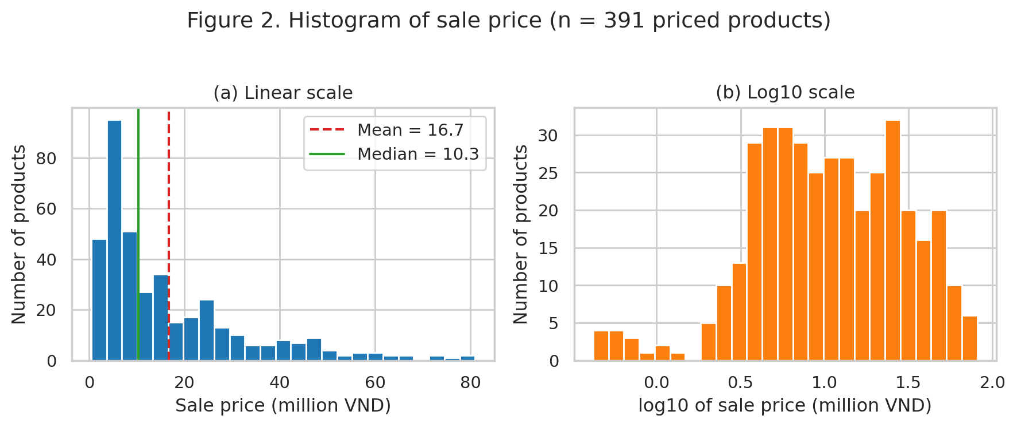
Interpretation. Panel (a) shows a strongly right-skewed shape: the tallest bars are at roughly 4–8M VND, the median (10.3M) sits inside the dense part and the mean (16.7M) lies in the tail, confirming the skewness of 1.58. 17% of priced products cost more than 30M VND. After a log10 transformation (panel b) the distribution becomes much more symmetric and shows two bumps, near 5M (10^0.7) and near 25M (10^1.4). In business terms this suggests two product segments – mass-market devices and premium/flagship devices – rather than one continuous market, and it indicates that log price is the better scale for any model that assumes roughly symmetric data.

Boxplots – sale price and discount by brand group
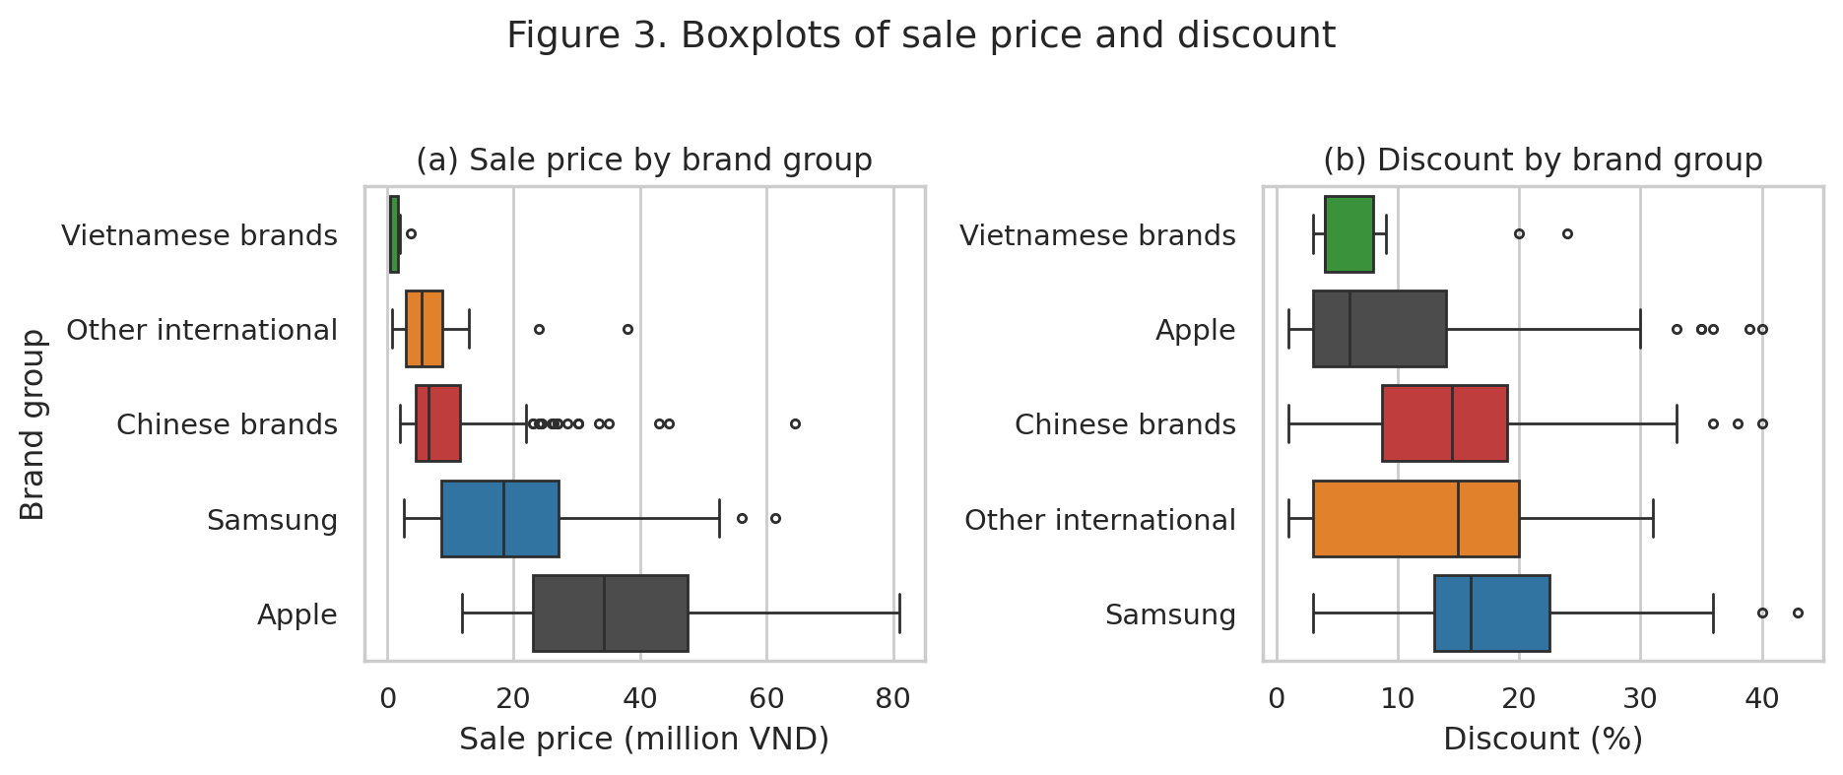
Interpretation. Panel (a) separates the brand groups clearly: Apple has the highest median (about 34.3M) and widest box, Samsung is in the middle (median about 18.3M), while Chinese and other international brands cluster below 12M. The Chinese-brand box is narrow but has many upper outliers up to about 65M, which are their foldable and ultra-premium models. Vietnamese brands are tiny, below 2M, because they sell basic feature phones. Panel (b) shows that discount depth is not ordered the same way as price: Samsung and the Chinese brands discount around 15–16% at the median, Apple only about 6%, though Apple and the Chinese brands both have outliers at 35–40%. Premium price therefore does not imply deeper promotions; the brand strategy matters.

Quantile plot – sale price
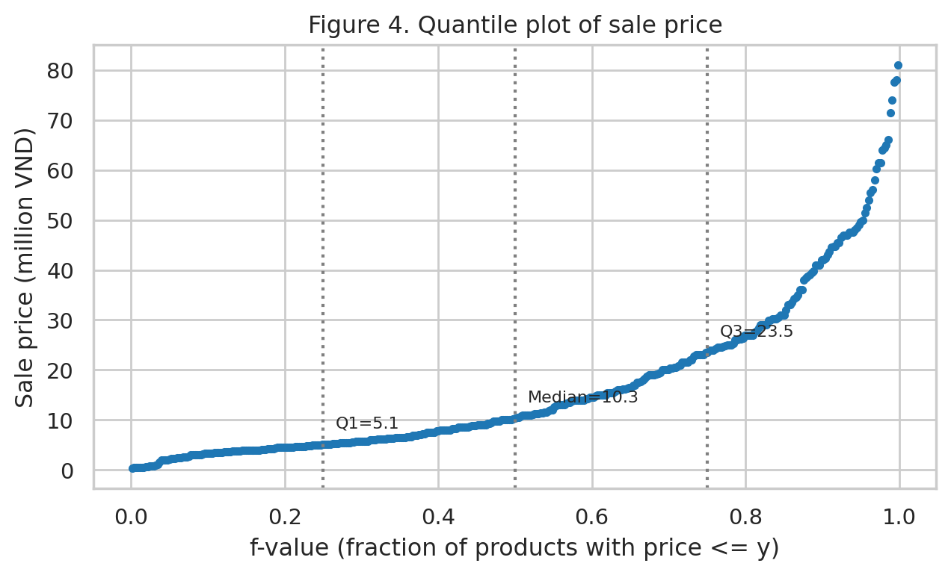
Interpretation. Each point is one product, plotted against the fraction f of products priced at or below it. The curve is shallow up to about f = 0.5 and becomes steep after f = 0.75: half of the priced products cost at most 10.3M VND, 75% cost at most 23.5M, and 90% at most 42.0M, while the most expensive 10% spread from 42M to 81M. The steepening slope is another view of right skew: prices in the upper quartile are far more spread out than in the lower quartiles, so a given price difference means very different numbers of competing products at the low and high ends.

Scatter plots – relationships between numeric attributes
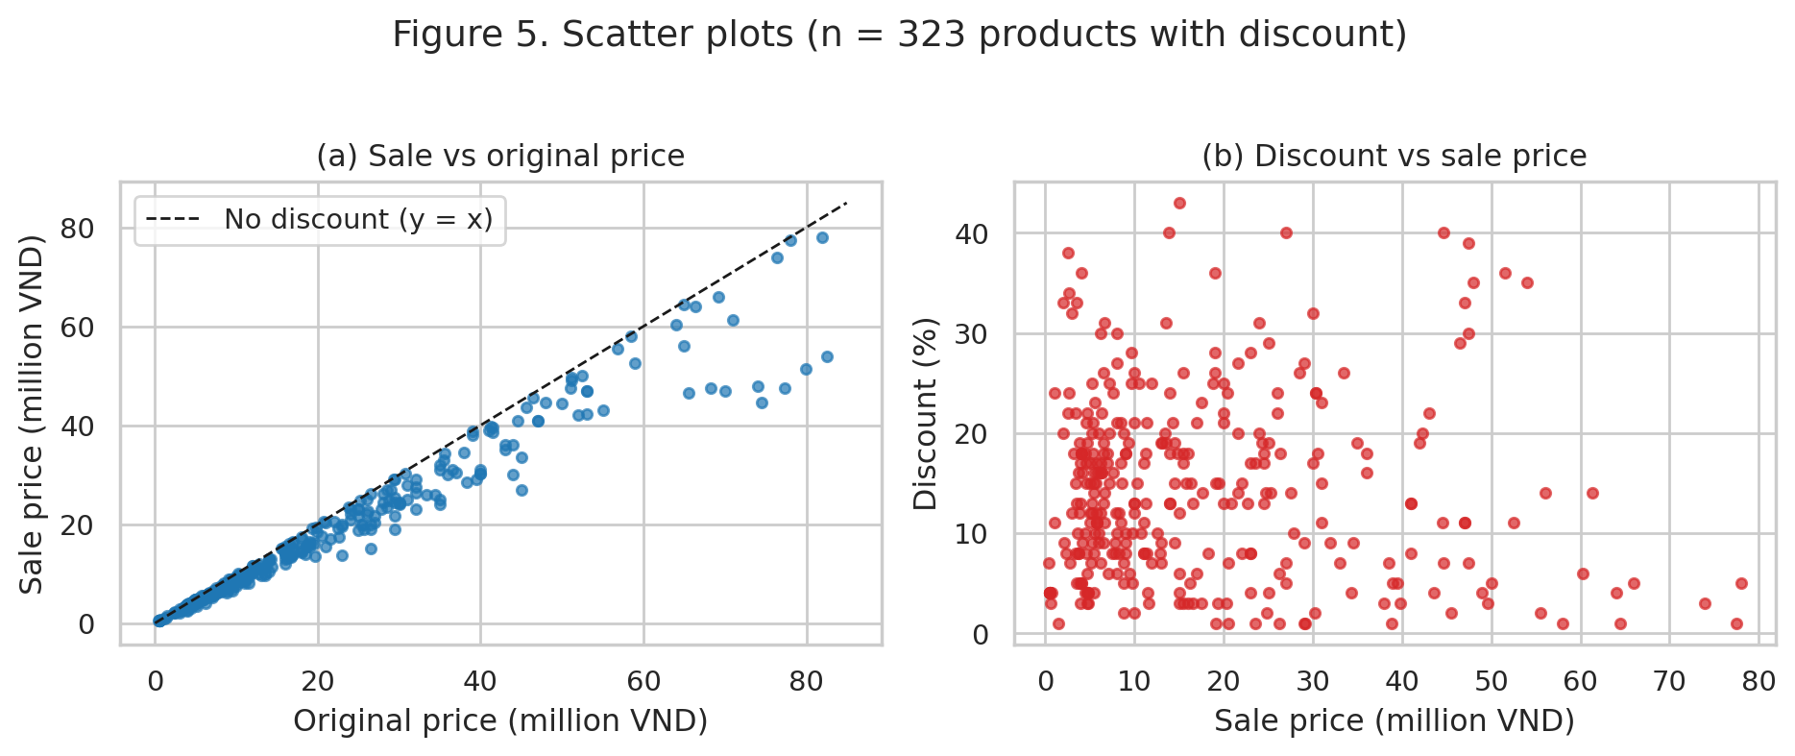
Interpretation. In panel (a) the points lie just below the dashed y = x line and form an almost perfectly straight band (Pearson r = 0.977); the vertical gap between a point and the line is the discount, and it grows in absolute VND for expensive products. Panel (b) shows no visible relationship between sale price and discount percentage (r = -0.05): discounts of about 5–25% appear at every price level. This means the shop sets promotion percentages per product or campaign rather than by price tier, so a cheap phone is as likely to carry a 20% discount as a flagship.

Multi-attribute plot – price, storage, brand group and product type
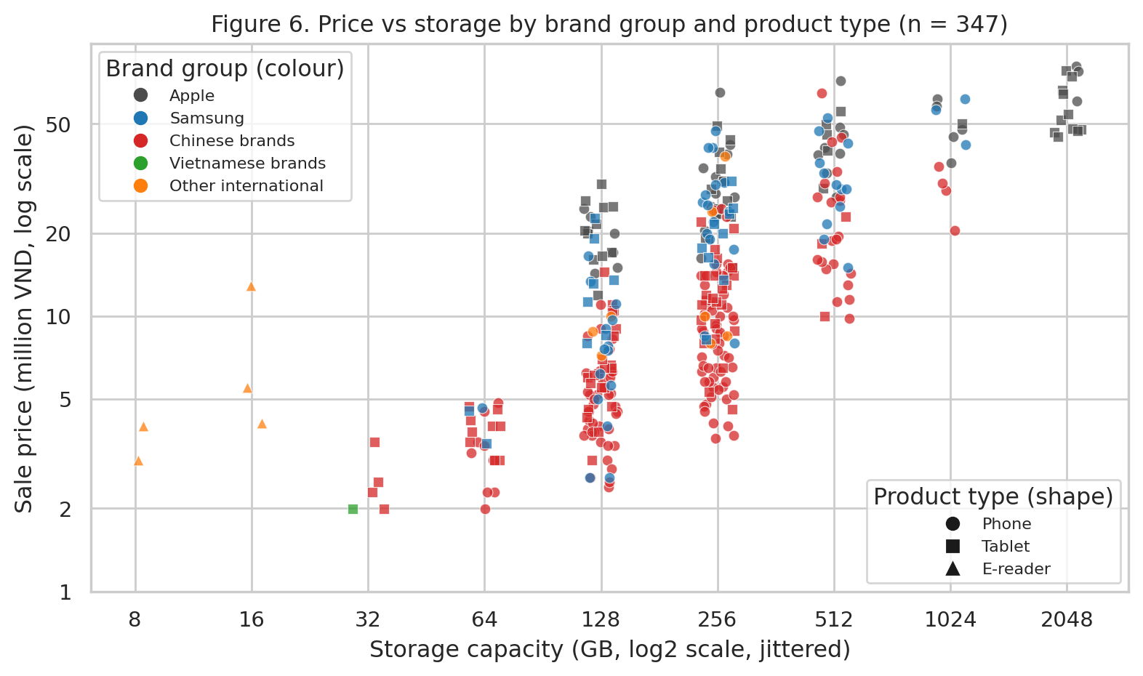
Interpretation. This figure encodes four attributes: storage (x), sale price (y, log scale), brand group (colour) and product type (shape). Price rises steeply with storage: the median is 6.32M VND at 128 GB, 13.5M at 256 GB, 28.99M at 512 GB, 44.69M at 1 TB and 53.99M at 2 TB. Within each storage level the colours are layered: Apple (grey) occupies the top of the band at every capacity (128 GB Apple products cost roughly 15–30M, whereas 128 GB Chinese-brand products are mostly 2.5–10M), so brand carries a price premium that storage alone does not explain. Phones (circles) and tablets (squares) overlap in price, meaning that product type matters little once storage and brand are known, and e-readers (triangles) form a separate low-storage, low-price cluster. Because storage is also a proxy for product tier, the relationship should be read as an association, not as storage causing price.

5. Section 3.4 – Measuring Similarities and Differences

5.1 Method
Three comparable numeric attributes were chosen: sale price, storage capacity and discount. RAM was not used because Apple titles do not state it. Twelve products were selected purposively to cover Apple, Samsung and Chinese brands, phones and tablets, budget to flagship tiers, including two sibling pairs (iPhone 17 Pro / Pro Max, Redmi Note 14 / 15) whose similarity can be checked against common sense. Because the attributes are on widely different scales (price in millions, storage in GB, discount in %), they were standardised with z-scores, z = (x − mean)/SD, using the mean and SD of the 300 priced listings that have all three values (price mean 18.42M, SD 15.75M; storage mean 356 GB, SD 426 GB; discount mean 14.47%, SD 9.07%). Euclidean distance on the z-scores was used as the main measure, and Manhattan distance as a robustness check.
Why this measure? Euclidean distance is appropriate because all three attributes are ratio-scaled numeric variables, so geometric distance has a clear meaning, and after standardisation no attribute dominates only because of its unit. Using population statistics (rather than the 12 products) keeps the scale meaningful for the whole market. Euclidean distance penalises a large gap in a single attribute more than Manhattan does, which is useful for detecting products that differ strongly in one dimension.

5.2 Result
Table 8. The 12 selected products: raw and standardised values.
Product | Price (M VND) | Storage (GB) | Discount (%) | z price | z storage | z discount
iPhone 17 Pro 256 | 31.99 | 256 | 9 | 0.86 | -0.24 | -0.60
iPhone 17 Pro Max 256 | 34.49 | 256 | 9 | 1.02 | -0.24 | -0.60
iPhone 16 Plus 128 | 24.49 | 128 | 13 | 0.39 | -0.54 | -0.16
iPad Air 11 M3 128 | 19.99 | 128 | 21 | 0.10 | -0.54 | 0.72
Galaxy S25 256 | 17.49 | 256 | 23 | -0.06 | -0.24 | 0.94
Galaxy Z Fold7 256 | 40.99 | 256 | 13 | 1.43 | -0.24 | -0.16
Galaxy A07 128 | 4.99 | 128 | 15 | -0.85 | -0.54 | 0.06
Galaxy A17 128 | 6.19 | 128 | 30 | -0.78 | -0.54 | 1.71
Redmi Note 15 128 | 5.19 | 128 | 13 | -0.84 | -0.54 | -0.16
Redmi Note 14 128 | 4.69 | 128 | 4 | -0.87 | -0.54 | -1.15
OPPO A3 128 | 4.50 | 128 | 10 | -0.88 | -0.54 | -0.49
Galaxy Tab A11 64 | 3.44 | 64 | 22 | -0.95 | -0.69 | 0.83

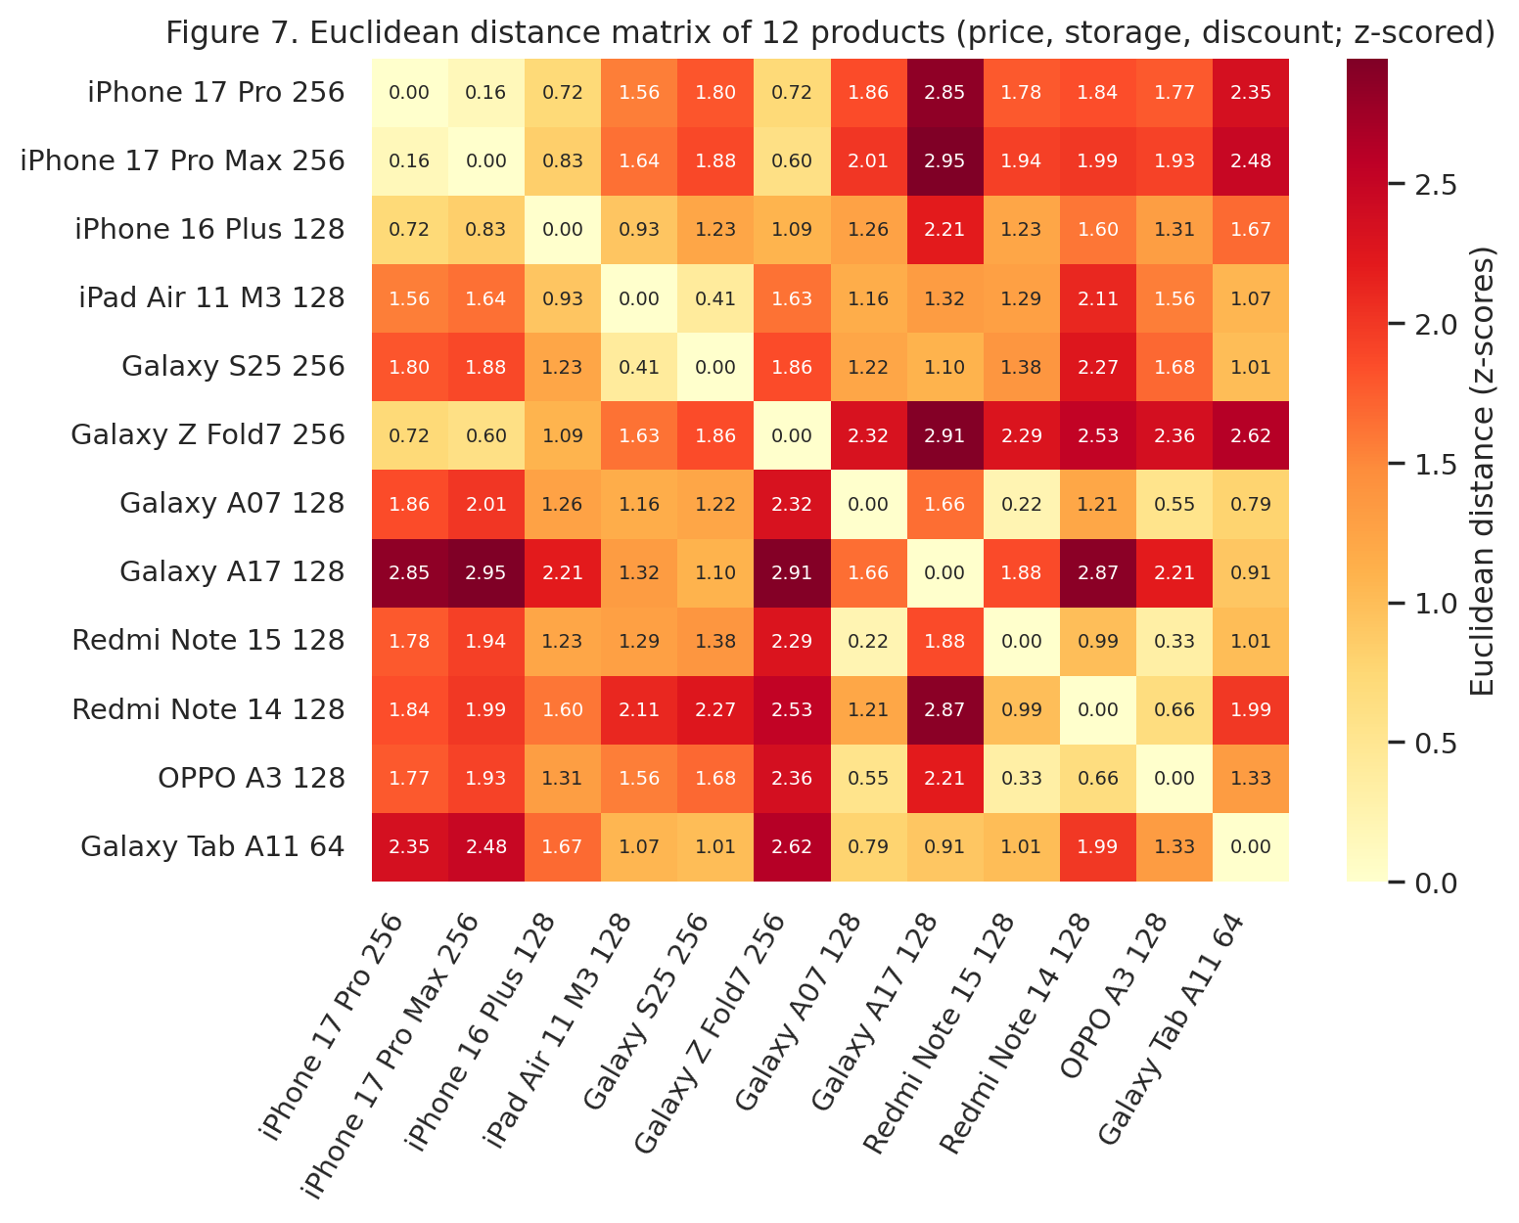
Table 9. The three most similar pairs (smallest Euclidean distance).
Product A | Product B | Euclidean | Manhattan
iPhone 17 Pro 256 | iPhone 17 Pro Max 256 | 0.16 | 0.16
Galaxy A07 128 | Redmi Note 15 128 | 0.22 | 0.23
Redmi Note 15 128 | OPPO A3 128 | 0.33 | 0.37

Table 10. The three most different pairs (largest Euclidean distance).
Product A | Product B | Euclidean | Manhattan
iPhone 17 Pro Max 256 | Galaxy A17 128 | 2.95 | 4.41
Galaxy Z Fold7 256 | Galaxy A17 128 | 2.91 | 4.38
Galaxy A17 128 | Redmi Note 14 128 | 2.87 | 2.96

The Manhattan distance gives the same three most similar pairs and 2 of the same 3 most different pairs (iPhone 17 Pro / Galaxy A17 replaces Galaxy A17 / Redmi Note 14); the Spearman correlation between the two rankings of all 66 pairs is 0.95. The conclusions are therefore not sensitive to the choice of distance.

5.3 Interpretation
- Most similar pairs agree with business intuition. iPhone 17 Pro 256 and iPhone 17 Pro Max 256 are siblings with nearly identical price (31.99M vs 34.49M), storage and discount (both 9%), so a distance of 0.16 is expected. Galaxy A07, Redmi Note 15 and OPPO A3 are three budget phones of different brands (4.5–5.2M VND, 128 GB, discount 10–15%): a shopper would treat them as substitutes, and the distance correctly ignores brand.
- Most different pairs are partly sensible, partly misleading. Galaxy Z Fold7 (41M VND) against Galaxy A17 (6.2M) is a real contrast between flagship and budget. However, Galaxy A17 versus Redmi Note 14 (distance 2.87) is an erroneous comparison as both are budget 128 GB smartphones with almost the same price (6.19M and 4.69M) but A17 has a 30% discount while Note 14 a mere 4% and the difference in discounts makes up almost the whole distance. The same discount reason makes iPhone 17 Pro Max appear much farther from A17 (9% vs 30%).
- Lesson. Discount refers to a temporary price reduction, not a product characteristic. Its inclusion equalizes it with price and storage as product characteristics, which is incorrect. A more accurate approach to identifying similar products would be to consider only the attributes similar to specifications (price, storage, RAM, screen, chipset) or reduce the significance of discount. The lack of information on RAM for Apple and the absence of brand and camera or chipset data illustrate other limitations of the three-characteristic approach.

6. Section 3.5 – Measuring Data for Classification

6.1 Method: target variable and discretisation
The classification task is to predict the price level of a product from its non-price attributes. The class variable price_level was created from sale price by equal-frequency discretisation into three classes (terciles), computed on the 391 priced listings. Cut points are the 1/3 and 2/3 quantiles: 6.29M and 17.99M VND. Equal-frequency intervals were chosen because price is strongly right-skewed (Section 3.2): equal-width intervals would put most products into one class. Table 11 compares the three options.
Table 11. Comparison of discretisation schemes for price level.
Discretisation scheme | Low | Medium | High | Entropy (bits)
Equal-frequency (terciles) - chosen | 133 | 128 | 130 | 1.585
Equal-width (3 bins of equal VND range) | 317 | 59 | 15 | 0.838
Domain thresholds (<5M / 5-15M / >=15M) | 97 | 145 | 149 | 1.560

Table 12. Final class definition (equal-frequency).
Class | Sale price range (million VND) | Products
Low | 0.42 – 6.29 | 133
Medium | 6.34 – 17.99 | 128
High | 18.29 – 80.99 | 130

6.2 Result: entropy and information gain
Entropy of the class is H(class) = −Σ pᵢ log₂ pᵢ = 1.585 bits, essentially the maximum for three classes (log₂3 = 1.585), because the classes are balanced (133 / 128 / 130). The equal-width scheme would give only 0.838 bits (317 / 59 / 15), a poorly balanced and less informative target. Information gain of an attribute A is IG = H(class) − Σ (|Sᵥ|/|S|) · H(class | A = v). Eight candidate attributes were evaluated; the gain ratio (IG divided by split information) is also reported because information gain favours attributes with many values.
Table 13. Information gain ranking for the class price_level (n = 391).
Candidate attribute (ranked by IG) | Levels | H(class | attr) | Information gain (bits) | Gain ratio
ram_tier | 4 | 1.013 | 0.572 | 0.295
storage_tier | 5 | 1.140 | 0.445 | 0.208
brand_group | 5 | 1.176 | 0.408 | 0.227
connectivity | 4 | 1.306 | 0.279 | 0.152
is_official | 2 | 1.387 | 0.198 | 0.302
product_type | 3 | 1.553 | 0.032 | 0.030
has_bundle | 2 | 1.555 | 0.030 | 0.096
has_discount | 2 | 1.562 | 0.023 | 0.035

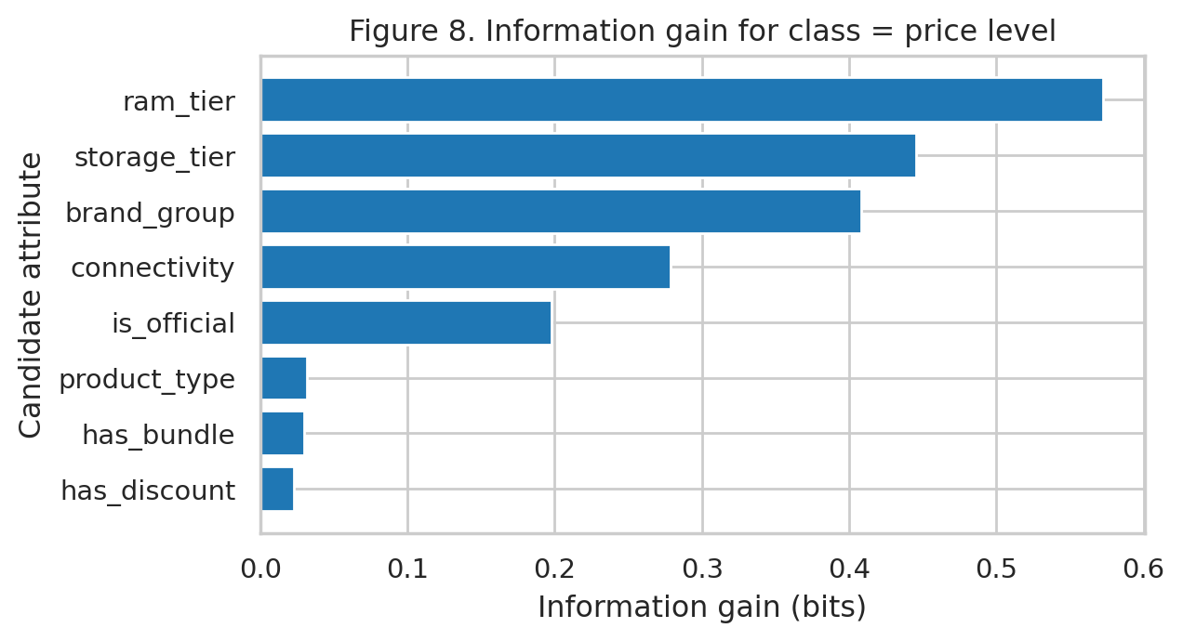
Interpretation. The RAM tier ranks top (IG = 0.572 bits) followed by storage tier (0.445) and brand group (0.408), connectivity is fourth (0.279) and the official-product flag has some information (0.198). Product type, bundle and "discount shown" are virtually useless (IG ≤ 0.032 bits). Two cautions are in order. First, the "Unknown" RAM level (n = 127) is informative in itself: 77 of those 127 are Apple products, the titles of which omit RAM and 68 are in the High price class, so part of the RAM-tier gain is attributable to Apple. Second, information gain favours attributes with more levels; on gain ratio the ranking reverses (official flag 0.302 and RAM tier 0.295 lead). In both rankings, hardware capacity (RAM and storage) and brand are the most useful predictors of price level, consistent with the intuition that capacity and brand determine a product's price band.

6.3 Result: chi-square tests of independence
A chi-square test of independence (H₀: price level and the attribute are independent) was applied to four categorical attributes. For the brand test, Vietnamese brands and other international brands were merged into "Other brands" so that all expected cell counts exceed 5 (the minimum expected count is shown in the table). Cramér's V is reported as an effect size (for 3 classes, about 0.07 = small, 0.21 = medium, 0.35 = large).
Table 14. Chi-square tests between price_level and categorical attributes (α = 0.05).
Attribute | Chi-square | dof | p-value | Cramér's V | Min expected count
Brand group (4 levels) | 192.27 | 6 | 8.4e-39 | 0.496 | 11.5
Category (mobile/tablet) | 5.72 | 2 | 0.057 | 0.121 | 43.9
Connectivity | 133.32 | 6 | 2.6e-26 | 0.413 | 16.7
Storage tier | 223.96 | 8 | 5.6e-44 | 0.535 | 10.1

Interpretation. Brand group (χ² = 192.3, dof = 6, p = 8.4e-39), connectivity (χ² = 133.3, p = 2.6e-26) and storage tier (χ² = 224.0, p = 5.6e-44) are all significant: H₀ is rejected and price level depends on each of them, with large effect sizes (V = 0.50, 0.41, 0.54). Category (mobile vs tablet) is not significant at the 5% level (χ² = 5.72, p = 0.057, V = 0.12): whether a device is a phone or a tablet tells us little about its price level. This agrees with the information-gain ranking, where product type was near the bottom. Contingency tables are in Appendix B. The connectivity result should be read carefully, since 5G and Wifi labels also reflect product generation and tablet type, not a direct effect on price.

6.4 Result: correlation
Pearson r (linear association) and Spearman ρ (monotonic association, robust to skew and outliers) were calculated for five pairs of numeric attributes, using the listings where both values exist. Because price is skewed, Spearman is the more reliable of the two here.
Table 15. Correlation between numeric attributes.
Pair | n | Pearson r | p | Spearman ρ | p
price sale vs price original | 323 | 0.977 | 6.6e-217 | 0.994 | 5.1e-307
price sale vs storage gb | 347 | 0.734 | 4.9e-60 | 0.737 | 1.4e-60
price sale vs ram gb | 264 | 0.750 | 6.0e-49 | 0.864 | 3.9e-80
ram gb vs storage gb | 371 | 0.718 | 5.4e-60 | 0.795 | 6.0e-82
price sale vs discount | 323 | -0.052 | 0.355 | -0.030 | 0.585

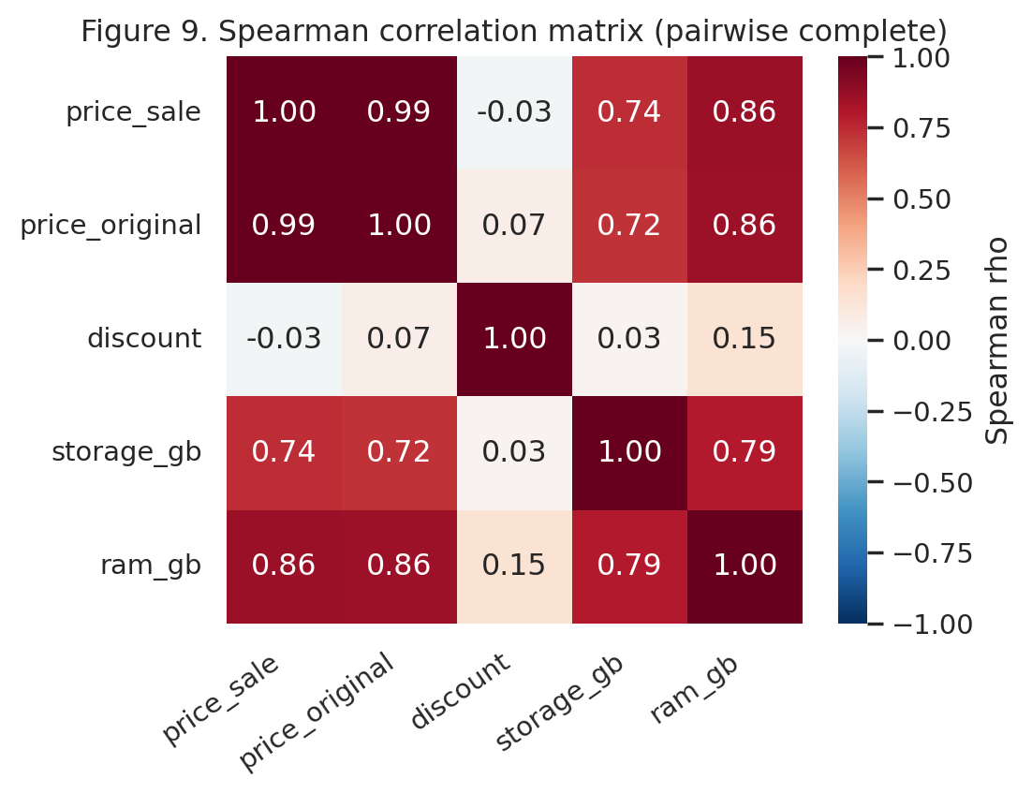
Interpretation. Sale price and original price are almost perfectly and positively correlated (r = 0.977, ρ = 0.994); this is mechanical since sale price = original price × (1 − discount) and discounts are modest, so it is not an interesting finding. Sale price has a strong positive relationship with RAM (r = 0.75, ρ = 0.86) and storage (r = 0.73, ρ = 0.74): larger memory is associated with higher prices, and the RAM rank correlation is stronger than the linear one because it is monotonic but not straight. RAM and storage are themselves strongly correlated (r = 0.72), so they contain overlapping information and a classifier would gain less from using both. Discount and sale price are essentially uncorrelated (r = -0.05, p = 0.35), matching the scatter plot in Section 3.3. Correlation does not imply causation: greater storage does not by itself make a phone expensive; RAM, storage and price all rise because they are set by the same product tier and brand positioning (and the RAM and storage results exclude Apple, whose RAM is missing).

7. Section 3.6 – Data Generalization and Summarization

7.1 Method
Generalization replaces detailed values by higher-level concepts using concept hierarchies, and summarizes the results via a data cube and attribute-oriented induction (AOI). Two hierarchies were built (Table 16 and Table 17): Product → Brand → Brand group (nominal) and Exact price → Price band → Price tier (numeric, business-defined with nested boundaries, Budget < 5M, Mid-range 5–15M, Premium 15–30M, Flagship ≥ 30M VND). The hierarchy of price tiers is deliberately different from the tercile classes of Section 3.5, as it needs to be nested and understandable for business users, whereas classes were made to balance. Listings without a price form the member "On request".

7.2 Result: concept hierarchies
Table 16. Concept hierarchy 1: Product → Brand → Brand group.
Level (low → high) | Distinct values
Product (name) | 1,018
Brand | 38
Brand group | 5

Table 17. Concept hierarchy 2: Exact price → Price band → Price tier.
Level (low → high) | Distinct values
Exact price (priced products) | 217
Price band | 8
Price tier | 4

Table 18. Mapping from price band to price tier (priced listings).
Price band (million VND) | Price tier | Products
<3M | Budget | 36
3-5M | Budget | 61
5-10M | Mid-range | 97
10-15M | Mid-range | 48
15-20M | Premium | 32
20-30M | Premium | 52
30-50M | Flagship | 47
>=50M | Flagship | 18

Interpretation. Generalization compresses 1,018 products into 38 brands and 5 brand groups, and 217 distinct prices into 8 bands and 4 tiers (Tables 16–18). The tier sizes are reasonably balanced (Budget 97, Mid-range 145, Premium 84, Flagship 65), so the tiers are usable summary categories.

7.3 Result: data cube
A three-dimensional cube was built with the dimensions Brand group, Product type and Price tier (including "On request") and the measures product count, average sale price and average discount. Table 19 shows the 2-D cuboid Brand group × Price tier (count). Table 20 is a roll-up over the other dimensions to Brand group, and Table 21 drills down into Apple by product type and price tier.
Table 19. 2-D cuboid: number of products by Brand group × Price tier.
Brand group | Budget | Mid-range | Premium | Flagship | On request | Total
Apple | 0 | 4 | 29 | 44 | 2 | 79
Chinese brands | 66 | 109 | 25 | 7 | 470 | 677
Other international | 9 | 10 | 1 | 1 | 66 | 87
Samsung | 8 | 22 | 29 | 13 | 54 | 126
Vietnamese brands | 14 | 0 | 0 | 0 | 35 | 49
Total | 97 | 145 | 84 | 65 | 627 | 1018

Table 20. Roll-up to Brand group (measures aggregated over product type and price tier).
Brand group | Products | Priced | Avg price (M VND) | Median price (M VND) | Avg discount (%)
Chinese brands | 677 | 207 | 9.73 | 6.54 | 14.8
Samsung | 126 | 72 | 20.21 | 18.32 | 18.2
Other international | 87 | 21 | 7.78 | 5.49 | 14.2
Apple | 79 | 77 | 37.29 | 34.29 | 10.4
Vietnamese brands | 49 | 14 | 1.11 | 0.56 | 7.9

Table 21. Drill-down: Apple by Product type × Price tier.
Product type | Price tier | Products | Avg price (M VND) | Avg discount (%)
Phone | Flagship | 21 | 48.89 | 6.9
Phone | Mid-range | 2 | 14.64 | 6.0
Phone | On request | 2 | – | –
Phone | Premium | 11 | 22.82 | 10.1
Tablet | Flagship | 23 | 49.41 | 15.3
Tablet | Mid-range | 2 | 13.44 | 5.5
Tablet | Premium | 18 | 22.30 | 7.8

Interpretation. The cube shows the structure of the catalog at a glance. Chinese brands dominate the number of listings (677 of 1,018) but 470 have no price and the priced are concentrated in the Budget and Mid-range tiers (175 listings). Apple has almost the opposite profile: only 79 listings, nearly all priced, and 73 of 79 in the Premium or Flagship tier with an average price of 37.3M VND and the lowest average discount of the large brands (10.4%). Samsung is spread from Mid-range to Flagship and Vietnamese brands are all Budget or unpriced. Drill down reveals that Apple tablets are discounted more on average (15.3% for flagship-tier tablets) than Apple phones (6.9%), a nuance hidden in the roll-up. A larger 3-D cuboid is given in Appendix B.

7.4 Result: attribute-oriented induction
AOI was run on all 1,018 listings. Steps: (1) start from the product-level relation; (2) remove the attribute name (about 1,018 distinct values and no concept hierarchy; URL was removed for the same reason); (3) generalize each remaining attribute along its hierarchy – brand → brand group, price → price tier, storage → storage class (Small ≤128 GB / Large ≥256 GB / Unknown), connectivity → network (Cellular / Wifi / Unspecified); (4) merge identical generalized tuples and accumulate the count (t-weight = count / 1,018); (5) repeat generalization until the relation is small enough to read. The number of distinct tuples falls as follows.
Table 22. Reduction of the relation during attribute-oriented induction.
Generalization step | Distinct tuples
Product-level relation (brand, type, price, storage, connectivity) | 495
After generalizing brand, price, storage and connectivity | 112
After dropping network and merging Tablet/E-reader | 71
After also dropping storage (brand group, type, price tier) | 38
After merging brands to Apple / Samsung / Other and tiers to Mass-market / High-end | 17

Table 23. Final generalized relation (summary of all 1018 listings).
Brand group | Product type | Price level | Count | t-weight (%)
Other brands | Phone | On request | 531 | 52.2
Other brands | Phone | Mass-market (<15M) | 141 | 13.9
Other brands | Tablet/E-reader | Mass-market (<15M) | 67 | 6.6
Samsung | Phone | On request | 49 | 4.8
Apple | Tablet/E-reader | High-end (>=15M) | 41 | 4.0
Other brands | Tablet/E-reader | On request | 40 | 3.9
Samsung | Phone | High-end (>=15M) | 33 | 3.2
Apple | Phone | High-end (>=15M) | 32 | 3.1
Other brands | Phone | High-end (>=15M) | 28 | 2.8
Samsung | Phone | Mass-market (<15M) | 21 | 2.1
Samsung | Tablet/E-reader | High-end (>=15M) | 9 | 0.9
Samsung | Tablet/E-reader | Mass-market (<15M) | 9 | 0.9
Other brands | Tablet/E-reader | High-end (>=15M) | 6 | 0.6
Samsung | Tablet/E-reader | On request | 5 | 0.5
Apple | Phone | On request | 2 | 0.2
Apple | Tablet/E-reader | Mass-market (<15M) | 2 | 0.2
Apple | Phone | Mass-market (<15M) | 2 | 0.2

Interpretation. The generalized relation can be expressed as characteristic rules: (a) 52.2% of all listings are phones from brands other than Apple and Samsung whose price is shown only on request; (b) 20.4% are non-Apple, non-Samsung phones or tablets priced below 15M VND – the typical priced product; (c) 73 of Apple's 77 priced listings (95%) are high-end (≥ 15M VND), against 42 of Samsung's 72 (58%); (d) Apple listings are almost all high-end, in both phones (32) and tablets (41).

7.5 Discussion: what is lost and what is gained
- Information lost. The exact prices, individual models and their storage/RAM configurations are lost: an iPhone 17 Pro 256 GB phone at 31.99M and a Galaxy Z Fold7 at 40.99M phone will both turn into a "Premium/Flagship" category; two Chinese-brand budget phones with different chipsets will become the same tuple. The within-tiers spread is collapsed, hence a price tier cannot demonstrate that "Flagship" phones' prices vary from 30-81M. There are also boundary effects: a 14.9M priced phone is "Mid-range", while a 15.0M priced phone is "Premium". The merging of brands into "Other brands" category destroys any differentiation between Xiaomi, OPPO and Honor, while using the "Unknown" storage as a category confuses missing data with a real class. AOI only reports counts, hence averaging operations (e.g. discount) are no longer available in the final relation.
- Analytical benefits. The catalog decreases from 1,018 detailed rows to 17 readable tuples and a few small cuboids, revealing the major patterns (most listings are non-Apple/Samsung phones, over half the listings have no price, and Apple is concentrated at the high-end), generalize away noise due to unique prices, allow large enough categories for reliable counts and chi-square tests, enable roll-up and drill-down to the level needed to answer the question, and facilitate communication with non-technical readers. The rule of thumb is to keep the detailed table for modelling and use the generalized views for reporting.

8. Overall Findings and Key Insights
- Data limitation comes first. Only 391 of 1,018 listings (38%) have a price. Missing prices are structural ("contact" listings) and concentrated in phones and certain brands, so conclusions on price describe the priced part of the catalogue. Collecting stock status and specifications (RAM, chipset, screen, release date) would improve the next stage.
- Price is right-skewed and two-segmented. Median 10.3M VND against mean 16.7M; the histogram on a log scale shows mass-market and premium segments, and the 18 high outliers are genuine flagship products.
- Brand and capacity drive price. Apple's median price is about five times that of Chinese brands; price rises steeply with storage (6.3M at 128 GB to 54M at 2 TB); RAM, storage and brand group have the highest information gain, and price level is significantly dependent on brand group, storage tier and connectivity (large effects) but not clearly on phone-vs-tablet.
- Discount is independent of price level. Discount is unrelated to sale price (r = -0.05); Samsung discounts most on average and Apple least. Because it reflects campaigns rather than the product, it distorted the similarity analysis (A17 vs Redmi Note 14) and should be down-weighted in product comparison.
- Methodological lessons. Equal-frequency discretisation gave a balanced class (entropy 1.585 bits) where equal-width did not; Spearman was more suitable than Pearson for skewed price; information gain should be read together with gain ratio and with the effect of "Unknown" categories; and correlation (for example storage vs price) shows association, not causation.
- Summary view. The generalized relation shows that over half of the catalogue is non-Apple/Samsung phones without a public price, that the typical priced product is a non-premium phone or tablet below 15M VND, and that Apple is almost entirely high-end.

Appendix A – Code and Reproducibility
The complete analysis is implemented in one Jupyter notebook that reads cellphones_clean.csv and regenerates every table and figure. The full code is listed in Appendix C.
Notebook link:
https://colab.research.google.com/drive/1gJGiB_GiHn2hoRZa0oz0JAAWCksIMpb0?usp=sharing
Environment: Python 3.12; pandas, NumPy, SciPy (chi2_contingency, pearsonr, spearmanr, skew), Matplotlib, seaborn. Random seed 42 is used only for the horizontal jitter in Figure 6.

Appendix B – Additional Results
Table 24. Contingency table: price level by brand group (4 levels).
Brand group (4 levels) | Low | Medium | High
Apple | 0 | 9 | 68
Chinese brands | 97 | 86 | 24
Other brands | 26 | 7 | 2
Samsung | 10 | 26 | 36

Table 25. Contingency table: price level by category (mobile/tablet).
Category (mobile/tablet) | Low | Medium | High
mobile | 98 | 78 | 81
tablet | 35 | 50 | 49

Table 26. Contingency table: price level by connectivity.
Connectivity | Low | Medium | High
4G | 51 | 0 | 0
5G | 11 | 52 | 48
Unspecified | 59 | 52 | 59
Wifi | 12 | 24 | 23

Table 27. Contingency table: price level by storage tier.
Storage tier | Low | Medium | High
128 GB | 52 | 39 | 13
256 GB | 21 | 67 | 47
<=64 GB | 30 | 1 | 0
>=512 GB | 0 | 11 | 66
Unknown | 30 | 10 | 4

Table 28. 3-D cuboid Brand group × Product type × Price tier (15 largest cells).
Brand group | Product type | Price tier | Products | Avg price (M VND) | Avg discount (%)
Chinese brands | Phone | On request | 433 | – | –
Chinese brands | Phone | Mid-range | 69 | 8.50 | 15.2
Other international | Phone | On request | 65 | – | –
Samsung | Phone | On request | 49 | – | –
Chinese brands | Phone | Budget | 45 | 3.81 | 11.2
Chinese brands | Tablet | Mid-range | 36 | 9.50 | 12.7
Chinese brands | Tablet | On request | 35 | – | –
Vietnamese brands | Phone | On request | 33 | – | –
Apple | Tablet | Flagship | 23 | 49.41 | 15.3
Samsung | Phone | Premium | 21 | 22.96 | 21.5
Apple | Phone | Flagship | 21 | 48.89 | 6.9
Chinese brands | Tablet | Budget | 19 | 3.68 | 21.1
Chinese brands | Phone | Premium | 19 | 21.29 | 20.3
Apple | Tablet | Premium | 18 | 22.30 | 7.8
Samsung | Phone | Mid-range | 15 | 9.29 | 19.9

References
- CellphoneS. Product listing pages of phones and tablets, https://cellphones.com.vn (crawled by the author for the previous assignment; [add crawl date]).
- Han, J., Kamber, M. and Pei, J. (2011). Data Mining: Concepts and Techniques, 3rd ed. Morgan Kaufmann. (attribute types, descriptive statistics, entropy/information gain, chi-square, correlation, data cube and attribute-oriented induction).
- Pandas, NumPy, SciPy, Matplotlib and seaborn documentation (software used for the analysis).

