
FACULTY OF ECONOMICS MATHEMATICS

MIDTERM PROJECT REPORT
ESTIMATING THE PROBABILITY OF DEFAULT ON THE HOME CREDIT DATASET
Supervisor: Lê Thị Thanh An Dr.
Students: K234131613 – Huỳnh Tấn Phát
K234131591 – Nguyễn Ngọc Anh Duy
Class: K234131613
Subject: Thematic unit 1
Subject code: 261EMM401001

Ho Chi Minh City, October/2026
ABSTRACT
This report describes the construction of a credit-risk scoring workflow using the Home Credit Default Risk dataset available on Kaggle. The dataset is provided as seven interconnected tables: current applications, credit-bureau records, previous loans, instalment payments, point-of-sale balances, credit-card balances, and monthly bureau balances. These tables were aggregated into a single row per applicant, yielding 301 predictors that capture each individual's profile, repayment history, and the external credit scores included with the data.
Four models were compared: two logistic regressions and two LightGBM models. An isotonic calibration step is applied on top of the second LightGBM model. On a held-out test set comprising 7,500 applicants, the calibrated LightGBM model achieved an AUC of 0.758 and a KS of 0.375. With the threshold set at 0.05, which maximises F1, the model identifies 86.2% of defaulters.
The calibrated probabilities were subsequently converted into a score, anchored at 600 points with 20 points assigned for each doubling of the odds. Applicants were allocated to five rating bands. Observed default rates rise consistently across these bands, from 1.92% in band A to 30.04% in band E.
The entire analysis can be reproduced from a single notebook, and the final model is deployed via a Streamlit application packaged as a Docker image. One limitation should be noted: only a 12,750-row subsample was available, so the results are subject to considerable sampling uncertainty (discussed in Chapter 4). Training on the complete dataset would likely yield improved results.
Keywords: credit risk, probability of default, scorecard, gradient boosting, probability calibration, Home Credit, LightGBM, KS statistic.

ACKNOWLEDGEMENTS
I wish to express my gratitude to my instructors in the Applied Mathematics in Economics and Finance program, in particular Le Thi Thanh An of the Faculty of Economics Mathematics, for the guidance and feedback they provided as this project developed. Through their questions, I was frequently prompted to pause and defend decisions that I had previously regarded as self-evident, including how the target should be defined, how the data should be partitioned, and how a metric ought to be interpreted before it is relied upon. A considerable portion of what is valuable in this report derives from those exchanges, whereas any errors that remain are attributable to me alone.
I am likewise indebted to the open-source community. The developers and maintainers of Python, scikit-learn, LightGBM, Optuna, Matplotlib and Streamlit produced meticulously engineered libraries that rendered this work feasible for a single student. With tools of this kind, I was able to devote my time to the modelling questions instead of reconstructing fundamental infrastructure. The lucid documentation and public discussion threads surrounding these tools also imparted a great deal of knowledge to me throughout the process.
I extend my thanks to Kaggle and Home Credit Group for making the dataset publicly available. Genuine, richly structured data of this kind is difficult to obtain, and the availability of seven linked tables afforded me a substantially more realistic understanding of credit-risk modelling than a tidy textbook example would have permitted.
Lastly, I am grateful to my family and friends for their patience and encouragement, particularly throughout the extended periods of debugging, rerunning notebooks, and revising chapters. Their support made it considerably easier for me to carry the project through to its conclusion.

TABLE OF CONTENTS
CHAPTER 1: OVERVIEW 1
1.1. Topic Overview 1
1.2. Dataset Overview 2
1.3. Related Work 4
CHAPTER 2: THEORETICAL BACKGROUND 5
2.1. Probability of Default in Consumer Credit 5
2.2. Logistic Regression 5
2.3. Gradient-Boosted Decision Trees 5
2.4. Probability Calibration 6
2.5. Scorecards and Risk Bands 6
2.6. Evaluation Metrics for Imbalanced Binary Classification 7
2.7. Threshold Selection 7
CHAPTER 3: METHODOLOGY 8
3.1. Pipeline Overview 8
3.2. Data Partitioning 8
3.3. Preprocessing 8
3.4. Feature Engineering 9
3.5. Candidate Models 10
3.6. Calibration and Threshold Selection 10
3.7. Scorecard Construction 10
3.8. Implementation and Reproducibility 11
CHAPTER 4: RESULTS AND DISCUSSION 12
4.1. Overall Model Performance 12
4.2. Evaluation Curves 12
4.3. Feature Importance 14
4.4. Scorecard and Risk Bands 15
4.5. Business Impact 16
4.6. Statistical Uncertainty 16
4.7. Comparison with Published Results 17
4.8. Deployment 17
4.9. Limitations 17
CHAPTER 5: CONCLUSION AND FUTURE WORK 19
5.1. Conclusion 19
5.2. Future Work 19
REFERENCES 20
LIST OF FIGURES
Figure 1. Home Credit business overview.
Figure 2. Target distribution (counts, pie) and default rate by age group.
Figure 3. Top 20 columns by missing rate.
Figure 4. Summary of the seven input tables.
Figure 5. Stratified split used in this work.
Figure 6. Block diagram of the data-preprocessing pipeline.
Figure 7. Block diagram of the modelling pipeline.
Figure 8. ROC curves for the four candidate models (test set).
Figure 9. Precision–Recall curves for the two LightGBM models (test set).
Figure 10. Kolmogorov–Smirnov plots for the two LightGBM models (test set).
Figure 11. Reliability (calibration) plot for the selected model (test set).
Figure 12. Top-25 features by LightGBM gain.
Figure 13. Score distribution and risk-band boundaries.
Figure 14. Empirical default rate by risk band.
Figure 15. Streamlit Predict page: interactive scoring form.
Figure 16. Streamlit Performance page: evaluation dashboard.
LIST OF TABLES
Table 1. Source tables of the Home Credit Default Risk dataset.
Table 2. Stratified partition of the sample.
Table 3. Blocks of engineered features.
Table 4. Models compared in this study.
Table 5. Best LightGBM hyperparameters found by Optuna.
Table 6. Test-set metrics for the four candidate models.
Table 7. Risk-band distribution and observed default rate (test set).
Table 8. Capture rate and lift over the base rate by risk band (test set).
Table 9. Approximate 95% intervals for key test metrics (calibrated LightGBM).
LIST OF ABBREVIATIONS
Abbreviation | Full term
AUC | Area Under the ROC Curve
Brier | Brier score (mean squared error of probability forecasts)
EDA | Exploratory Data Analysis
F1 | Harmonic mean of precision and recall
FE | Feature Engineering
GBDT | Gradient-Boosted Decision Tree
Gini | Gini coefficient (= 2·AUC − 1)
HC | Home Credit Group
KS | Kolmogorov–Smirnov statistic
LR | Logistic Regression
ML | Machine Learning
PD | Probability of Default
PDO | Points to Double the Odds
PR-AUC | Area Under the Precision–Recall Curve
PSI | Population Stability Index
ROC | Receiver Operating Characteristic
SHAP | SHapley Additive exPlanations
τ | Decision threshold

CHAPTER 1: OVERVIEW

1.1. Topic Overview

1.1.1. Rationale for Topic Selection
Home Credit Group lends to people that conventional banks tend to overlook: borrowers in emerging markets who hold little or no formal credit history. For these applicants a bureau score either does not exist or says very little, and a lender that relies on it alone ends up shutting out entire segments of the population. Estimating the probability of default (PD) for such applicants is therefore the central problem in the company’s underwriting. In 2018 the company released a relational extract of its own loan applications through a Kaggle competition, and the resulting prediction task has since become a widely used benchmark in applied credit-risk analytics.
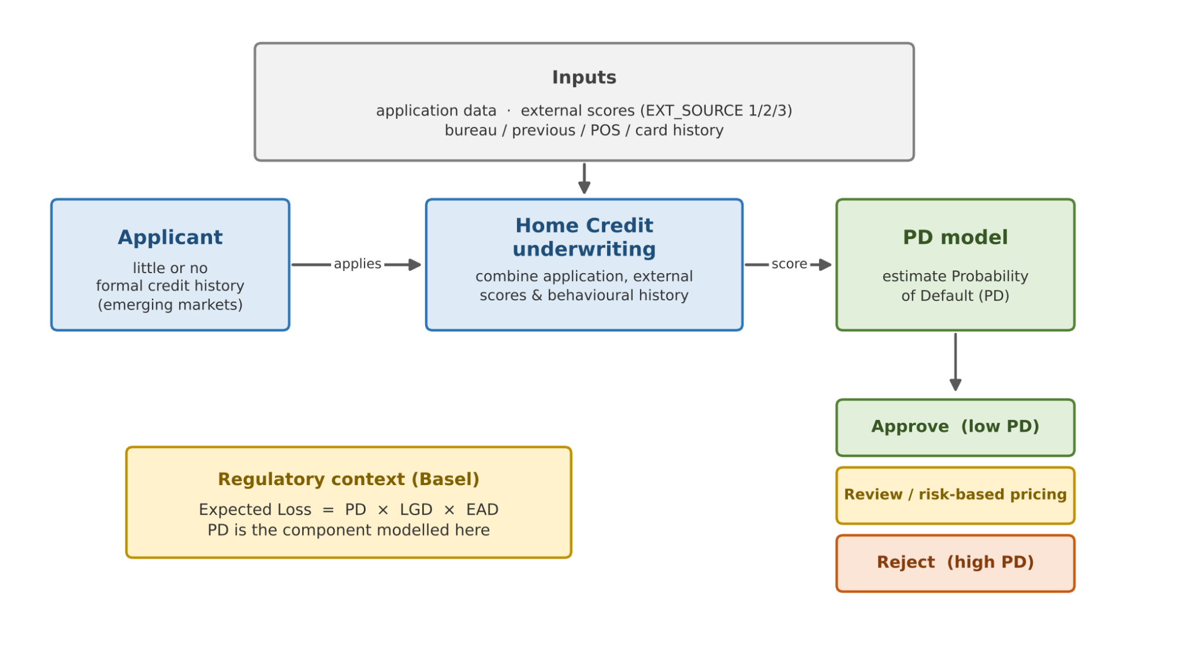
Figure 1. Home Credit business overview.
Credit-risk modelling is also a field where statistical method and regulation meet. Under the internal-ratings-based approach of the Basel framework (Basel Committee on Banking Supervision, 2006), a bank estimates the probability of default, the loss given default and the exposure at default for its portfolio, and the expected loss of an exposure is obtained by multiplying the three. PD is the component this project addresses. A model that ranks borrowers well but produces unreliable probabilities is of limited use for provisioning or pricing, so both discrimination and calibration have to be examined, not just one of them.
From a learning point of view, building a PD model from raw tables is a demanding but worthwhile exercise. It requires decisions about how to join and aggregate relational data, how to treat missing values, which model family to use, how to tune it, how to calibrate it, how to turn probabilities into a score that a credit officer can read, and finally how to put the result in front of users. These are the same steps a production credit team goes through, only at a much smaller scale.

1.1.2. Objectives of the Project
The project has six practical objectives:
- to understand the structure of the seven raw tables and the keys that connect them;
- to engineer more than 200 predictors from application attributes, past behaviour and external credit scores;
- to train and tune a LightGBM classifier and benchmark it against logistic-regression baselines;
- to calibrate the predicted probabilities and choose a decision threshold on business grounds rather than by default;
- to convert PD into a points-based credit score and a small number of risk bands; and
- to make the final model available through a Streamlit web application and a Docker image, so that people without a programming background can use it.
Three questions guide the analysis. First, how much does a gradient-boosted tree ensemble improve on a logistic-regression baseline when both are given the same engineered features? Second, does isotonic calibration improve the quality of the probabilities without damaging the model’s ability to rank applicants? Third, do the resulting rating bands separate good and bad borrowers in a monotonic way, as a usable scorecard should?

1.1.3. Research Subjects and Scope
a. Research subjects
- Applicant-level attributes in application_train.csv, including the target variable, demographic information and financial summaries.
- Behavioural history aggregated from bureau.csv, previous_application.csv, installments_payments.csv, POS_CASH_balance.csv and credit_card_balance.csv.
- The three external credit scores (EXT_SOURCE_1, EXT_SOURCE_2, EXT_SOURCE_3) and the aggregates derived from them.
b. Research scope
- To keep computation manageable on a local machine, the experiments use a subsample of 12,750 rows rather than the full 307,511. Absolute performance on the complete data is likely to be somewhat higher.
- The study is limited to PD estimation. Pricing, expected-loss calculation and capital requirements are outside its scope.
- Deployment takes the form of a Streamlit application and a Docker image. A production-grade REST service is left as future work.

1.1.4. Report Structure
The report is organised in five chapters. Chapter 1 sets out the motivation, objectives and scope and describes the dataset. Chapter 2 reviews the credit-risk and machine-learning concepts on which the pipeline relies. Chapter 3 explains the methodology, from data preparation and feature engineering to model training, calibration and threshold selection. Chapter 4 presents and discusses the results, including model comparison, evaluation curves, feature importance and the business interpretation of the scorecard. Chapter 5 summarises the findings, acknowledges limitations and outlines directions for further work.

1.2. Dataset Overview
The data describe 307,511 loan applicants, each characterised by 122 raw variables in the main application table. Six auxiliary tables hold the applicant’s history with Home Credit and with other lenders. Every applicant is identified by SK_ID_CURR, and may have any number of rows, including none, in each auxiliary table (Table 1). Because an applicant can appear many times in these tables, they cannot be joined to the application table directly; they have to be aggregated to one row per applicant first.
Table 1. Source tables of the Home Credit Default Risk dataset.
Table | Content | Link to applicant
application_train | One row per loan application: demographics, income, loan terms, housing, external scores and the binary target. | SK_ID_CURR
bureau | Credits reported by other financial institutions to the credit bureau. | SK_ID_CURR
bureau_balance | Monthly status history of each bureau credit. | SK_ID_BUREAU
previous_application | Earlier applications made by the same customer at Home Credit. | SK_ID_CURR
installments_payments | Repayment record of previous loans, one row per instalment. | SK_ID_CURR
POS_CASH_balance | Monthly balances of point-of-sale and cash loans. | SK_ID_CURR
credit_card_balance | Monthly balances of credit cards held at Home Credit. | SK_ID_CURR

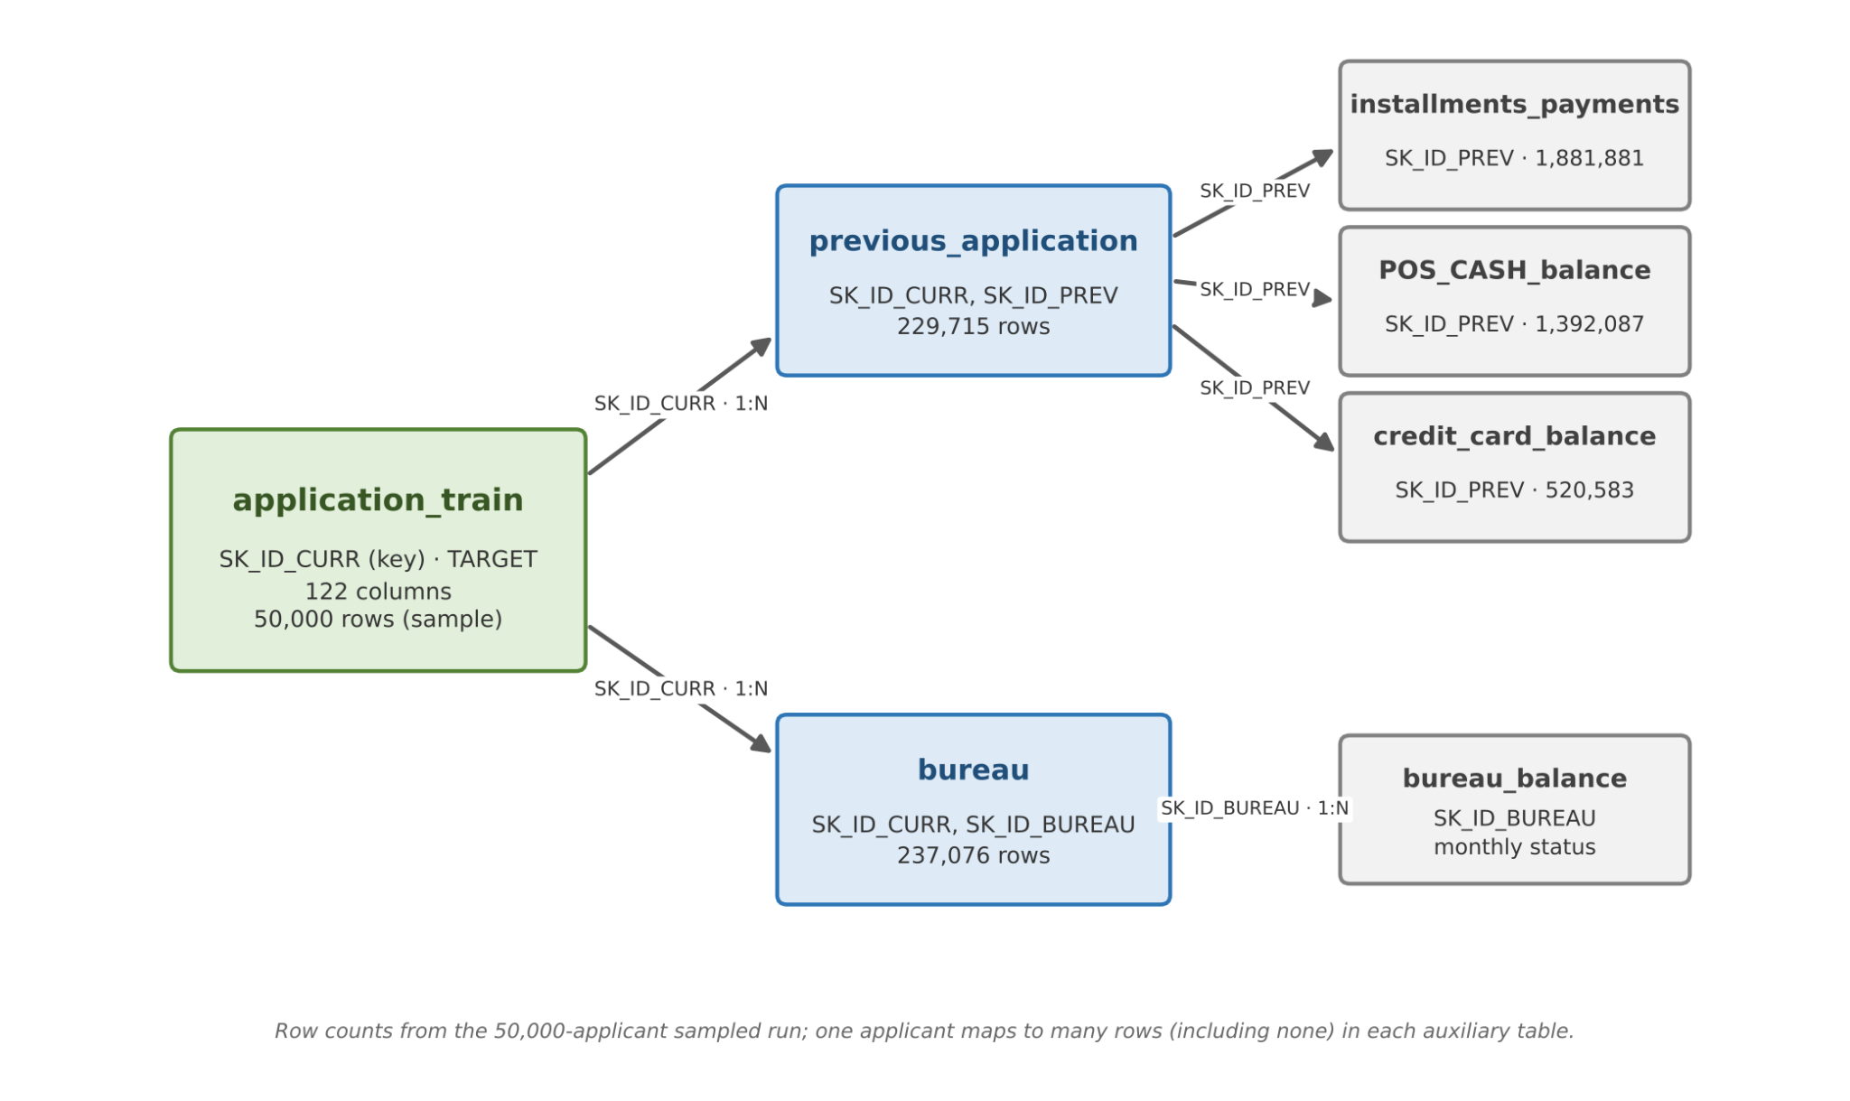
Figure 4. Summary of the seven input tables.
Roughly 8% of applicants default, so the target is moderately imbalanced. A classifier that approves everyone would still be correct about 92% of the time, which is why accuracy carries almost no information in this setting and is not used to compare models. Figure 2 shows the class distribution together with the default rate across age groups.
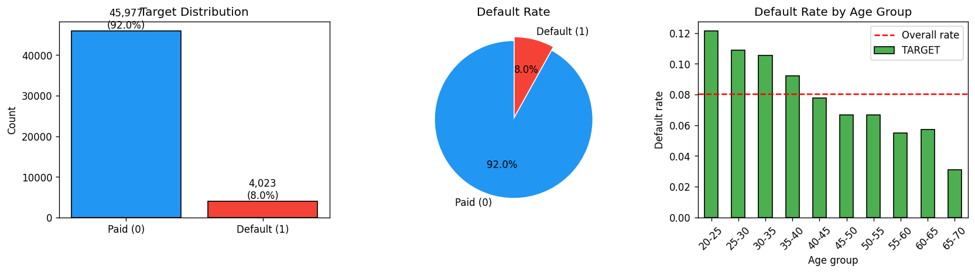
Figure 2. Target distribution (counts, pie) and default rate by age group.
Missing data are another feature of this dataset. About 50 columns have a substantial share of missing values, mostly housing characteristics and the three external scores (Figure 3). Instead of imputing the external scores aggressively, the pipeline records how many of them are present in a variable called EXT_SOURCE_COUNT. The reasoning is that whether an applicant has an external score at all is itself informative about their credit footprint, and that filling the gap with a mean or median would erase that signal.
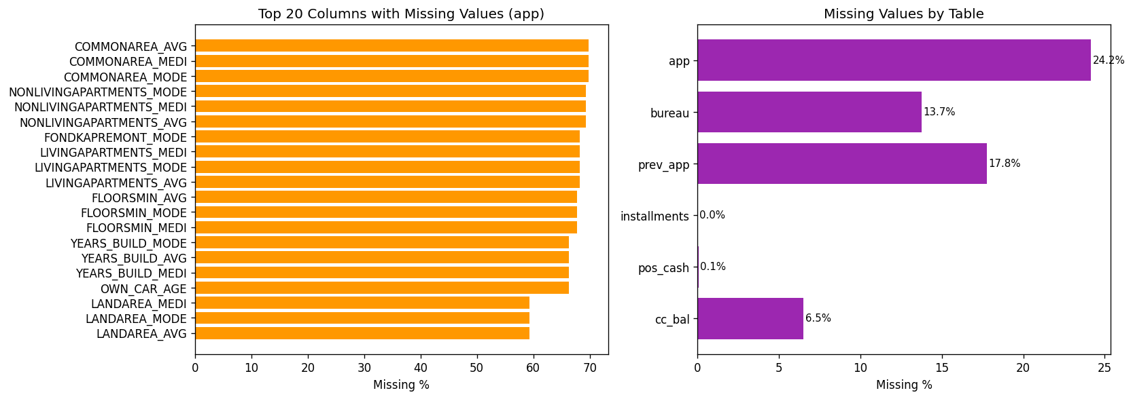
Figure 3. Top 20 columns by missing rate.

1.3. Related Work
Statistical credit scoring has a long history. Hand and Henley (1997) reviewed the methods then in use, among them linear discriminant analysis, logistic regression, and tree- and neighbour-based classifiers, and concluded that no single technique was uniformly superior. Logistic regression nevertheless became the industry standard, largely because its coefficients are easy to explain to regulators and credit officers and because it translates naturally into a points-based scorecard (Siddiqi, 2006; Thomas, Edelman & Crook, 2002).
Later benchmarking studies compared a wider range of algorithms across many credit datasets. Baesens et al. (2003) found that several non-linear methods performed well but that simple linear models remained competitive, while Lessmann et al. (2015) reported that ensemble classifiers tend to outperform individual ones, with logistic regression still a strong reference point. Gradient boosting (Friedman, 2001) and its efficient implementations such as LightGBM (Ke et al., 2017) have since become common choices for tabular risk data.
A separate strand of work concerns the quality of predicted probabilities. Platt scaling (Platt, 1999) and isotonic regression (Zadrozny & Elkan, 2002) were proposed as post-hoc corrections, and Niculescu-Mizil and Caruana (2005) compared them across a range of learners, observing among other things that non-parametric calibration needs enough data to be reliable. This last point matters for the present study and is returned to in Chapter 4.

CHAPTER 2: THEORETICAL BACKGROUND

2.1. Probability of Default in Consumer Credit
The probability of default is the likelihood that a borrower will fail to meet a contractual obligation within a stated time horizon. In consumer lending it feeds into approval decisions, credit limits, pricing and regulatory capital. Corporate and sovereign portfolios can draw on long histories of observed defaults, but consumer PD usually has to be inferred from a snapshot of the applicant’s characteristics and a short behavioural record. That is one reason why flexible machine-learning models have attracted so much interest in this area.
A PD model serves two quite different purposes, and it is worth keeping them apart. The first is discrimination: ordering applicants from safest to riskiest. The second is calibration: making sure that when the model says 10%, roughly one in ten such applicants actually defaults. Approval cut-offs depend mainly on the first; pricing, provisioning and capital depend on the second.

2.2. Logistic Regression
Logistic regression models the log-odds of default as a linear function of the predictors:
ln( p / (1 − p) ) = β₀ + β₁x₁ + … + β_{k}x_{k} (1)
The coefficients are estimated by maximum likelihood. Their sign and size can be read directly, each exponentiated coefficient being an odds ratio, which explains the method’s lasting popularity among lenders. Its weakness is that it cannot capture non-linear effects or interactions unless the analyst constructs them by hand. In this project it plays the role of an interpretable baseline: a gradient-boosted model has to beat it by a meaningful margin to justify its extra complexity.

2.3. Gradient-Boosted Decision Trees
A gradient-boosted decision tree (GBDT) builds its prediction by adding up many small trees, each fitted to correct the errors left by those before it (Friedman, 2001). Formally, at iteration m the model is updated as
F_{m}(x) = F_{m−1}(x) + ν · h_{m}(x) (2)
where h_m is a shallow tree fitted to the negative gradient of the loss at the current predictions and ν is the learning rate, which shrinks each tree’s contribution and acts as a regulariser. For binary classification the loss is the logistic log-loss, and the output of the final sum is passed through the sigmoid function to obtain a probability.
LightGBM (Ke et al., 2017), the implementation used here, speeds up training through several design choices. Continuous variables are bucketed into histograms, so candidate splits are searched over a few hundred bins instead of every distinct value. Trees are grown leaf-wise, always splitting the leaf with the largest loss reduction, and controlled through a maximum number of leaves rather than a maximum depth. Two further techniques, gradient-based one-side sampling and exclusive feature bundling, reduce the cost of large and sparse datasets. Together these make LightGBM fast on tabular problems of the kind studied here.

2.4. Probability Calibration
The raw scores of a boosted ensemble are good for ranking but are not, in general, well-calibrated probabilities. When absolute PD values matter, as they do for expected loss, pricing and scorecards, it is common to add a calibration step. Two approaches are widely used. Platt scaling fits a logistic curve with two parameters to the scores (Platt, 1999); it is stable with little data but assumes a sigmoidal distortion. Isotonic regression fits a monotonic, piecewise-constant function (Zadrozny & Elkan, 2002); it is far more flexible but, being non-parametric, needs a reasonably large calibration set to avoid overfitting (Niculescu-Mizil & Caruana, 2005). The calibrated probability is written as
PD_{cal}(x) = f_{iso}( PD_{raw}(x) ) (3)
where f_iso is the isotonic function learned on held-out data. Because it is monotonic, the transformation can only flatten or merge parts of the ranking, never reverse it, so a small loss of discrimination is possible when several raw scores are mapped to the same calibrated value.

2.5. Scorecards and Risk Bands
A credit score is a monotonic re-expression of PD that is easier to communicate and to embed in lending policy. The usual construction (Siddiqi, 2006) fixes a base score at a chosen level of odds and a number of points that doubles those odds (PDO). The score is linear in the log-odds of default:
Score = Offset − Factor · ln( PD / (1 − PD) ), Factor = PDO / ln 2 (4)
Higher scores therefore indicate lower risk. Scores are then grouped into a small number of bands, typically five to seven, each linked to a policy action such as automatic approval, manual review or rejection, and often to a pricing tier. A good banding scheme balances two demands: bands must be wide enough that decisions do not flip with tiny movements in the score, yet narrow enough to separate meaningfully different levels of risk. A common practice is to place the boundaries at quantiles of the score distribution and then check that the observed default rate rises monotonically from the best band to the worst.

2.6. Evaluation Metrics for Imbalanced Binary Classification
When defaults are rare, accuracy hides more than it shows. The evaluation therefore combines threshold-free measures of ranking quality, a measure of probability accuracy and threshold-dependent measures that reflect the operating decision.
- AUC (area under the ROC curve) is the probability that a randomly chosen defaulter receives a higher risk score than a randomly chosen non-defaulter (Fawcett, 2006). It does not depend on the threshold or on the base rate, but because it aggregates over all thresholds it can conceal weaknesses in the region where decisions are actually made. The Gini coefficient, widely quoted in credit scoring, is a rescaling of AUC: Gini = 2·AUC − 1.
- KS statistic is the largest vertical gap between the cumulative score distributions of defaulters and non-defaulters:
KS = max_{t} | F₁(t) − F₀(t) | (5)
- Brier score is the mean squared difference between the predicted probability and the observed 0/1 outcome (Brier, 1950):
Brier = (1/n) Σ ( p_{i} − y_{i} )² (6)
- Precision, recall, F1 and PR-AUC. Precision is the share of flagged applicants who really default, recall is the share of defaulters that are flagged, and F1 is their harmonic mean. The precision–recall curve is often more informative than the ROC curve when the positive class is rare (Saito & Rehmsmeier, 2015).
Practitioners often quote rules of thumb for KS, with values above roughly 0.30 regarded as acceptable and those above 0.40 as strong, but such benchmarks depend on the portfolio and the population, and they are used below only as loose reference points.

2.7. Threshold Selection
Turning a probability into an accept-or-review decision requires a threshold τ. Missing a defaulter usually costs a lender far more than sending a good applicant to manual review, so a threshold that treats the two errors symmetrically is hard to defend. The rule adopted here picks, on the validation fold, the threshold that maximises F1 among those that achieve at least 80% recall:
τ* = argmax_{τ} F1(τ) subject to Recall(τ) ≥ 0.80 (7)
The recall floor expresses the business preference in a single, easily explained number, while the F1 criterion prevents the threshold from sliding to a trivial value that flags everybody.

CHAPTER 3: METHODOLOGY

3.1. Pipeline Overview
The workflow has four stages. In the first, the six auxiliary tables are summarised to one row per applicant and merged with the application table on SK_ID_CURR. In the second, the combined table is cleaned and enriched with engineered features. In the third, models are trained, tuned and compared. In the fourth, the selected model is calibrated, a threshold is chosen, scores and bands are constructed, and the result is exposed through a web interface. Figure 6 outlines the preprocessing stage and Figure 7 the modelling stage.
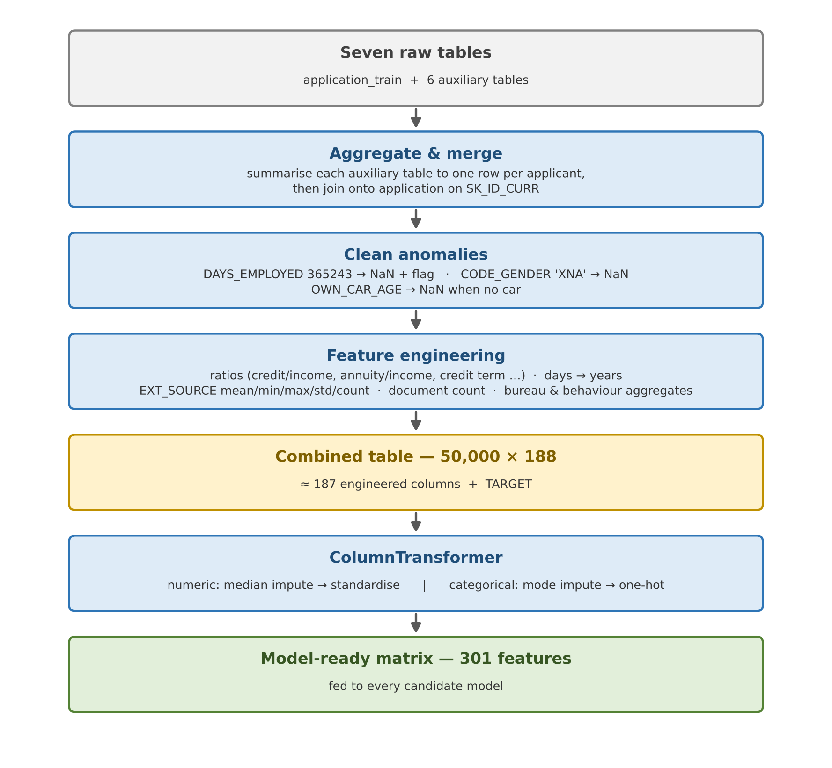
Figure 6. Block diagram of the data-preprocessing pipeline.
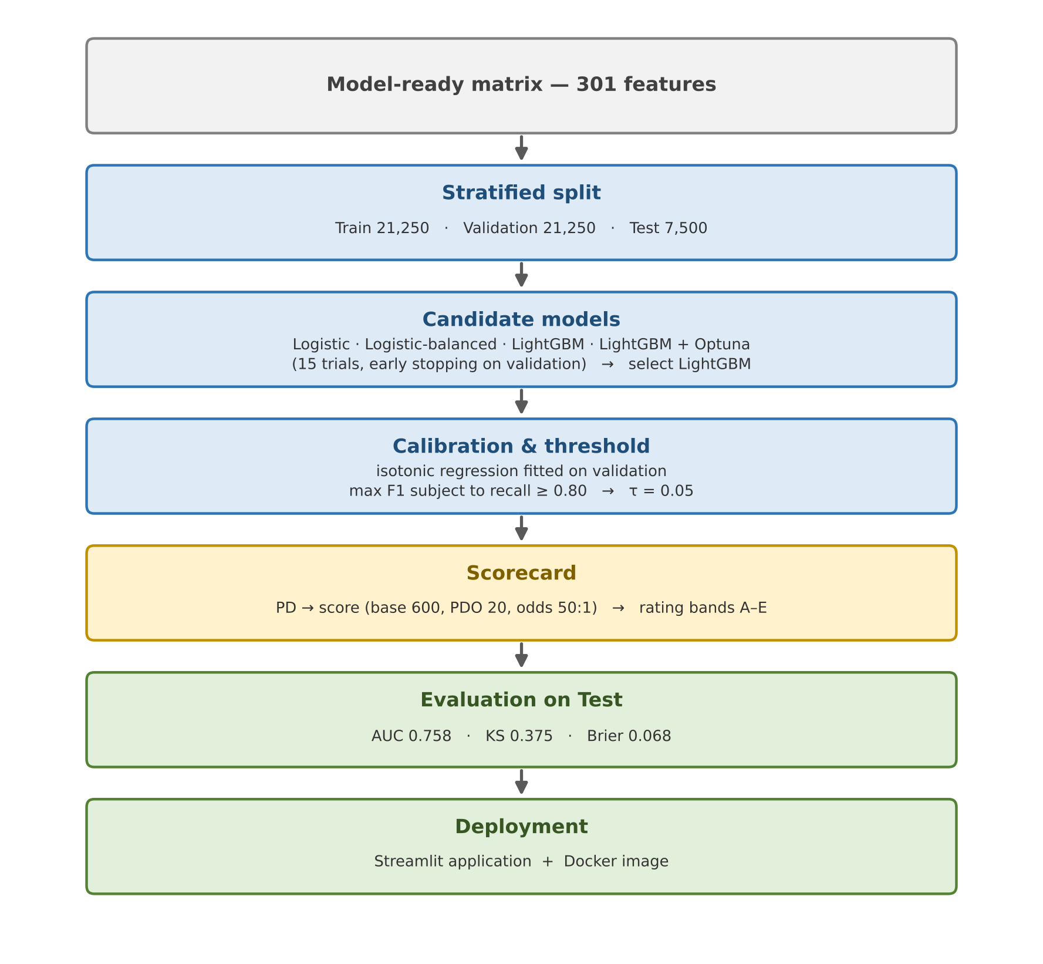
Figure 7. Block diagram of the modelling pipeline.

3.2. Data Partitioning
The sample is divided into training, validation and test folds, stratified on the target so that each fold keeps the same default rate of about 8% (random_state = 42). Each fold has a distinct role. The training fold is used to fit the models. The validation fold is used for early stopping, calibration and threshold selection. The test fold is held back until the very end, so that the metrics reported in Chapter 4 reflect performance on data that played no part in any modelling decision. Table 2 gives the size of each fold.
Table 2. Stratified partition of the sample.
Fold | Rows | Default rate | Stratified on TARGET
Training | 21,250 | 8.0% | Yes
Validation | 21,250 | 8.0% | Yes
Test | 7,500 | 8.0% | Yes
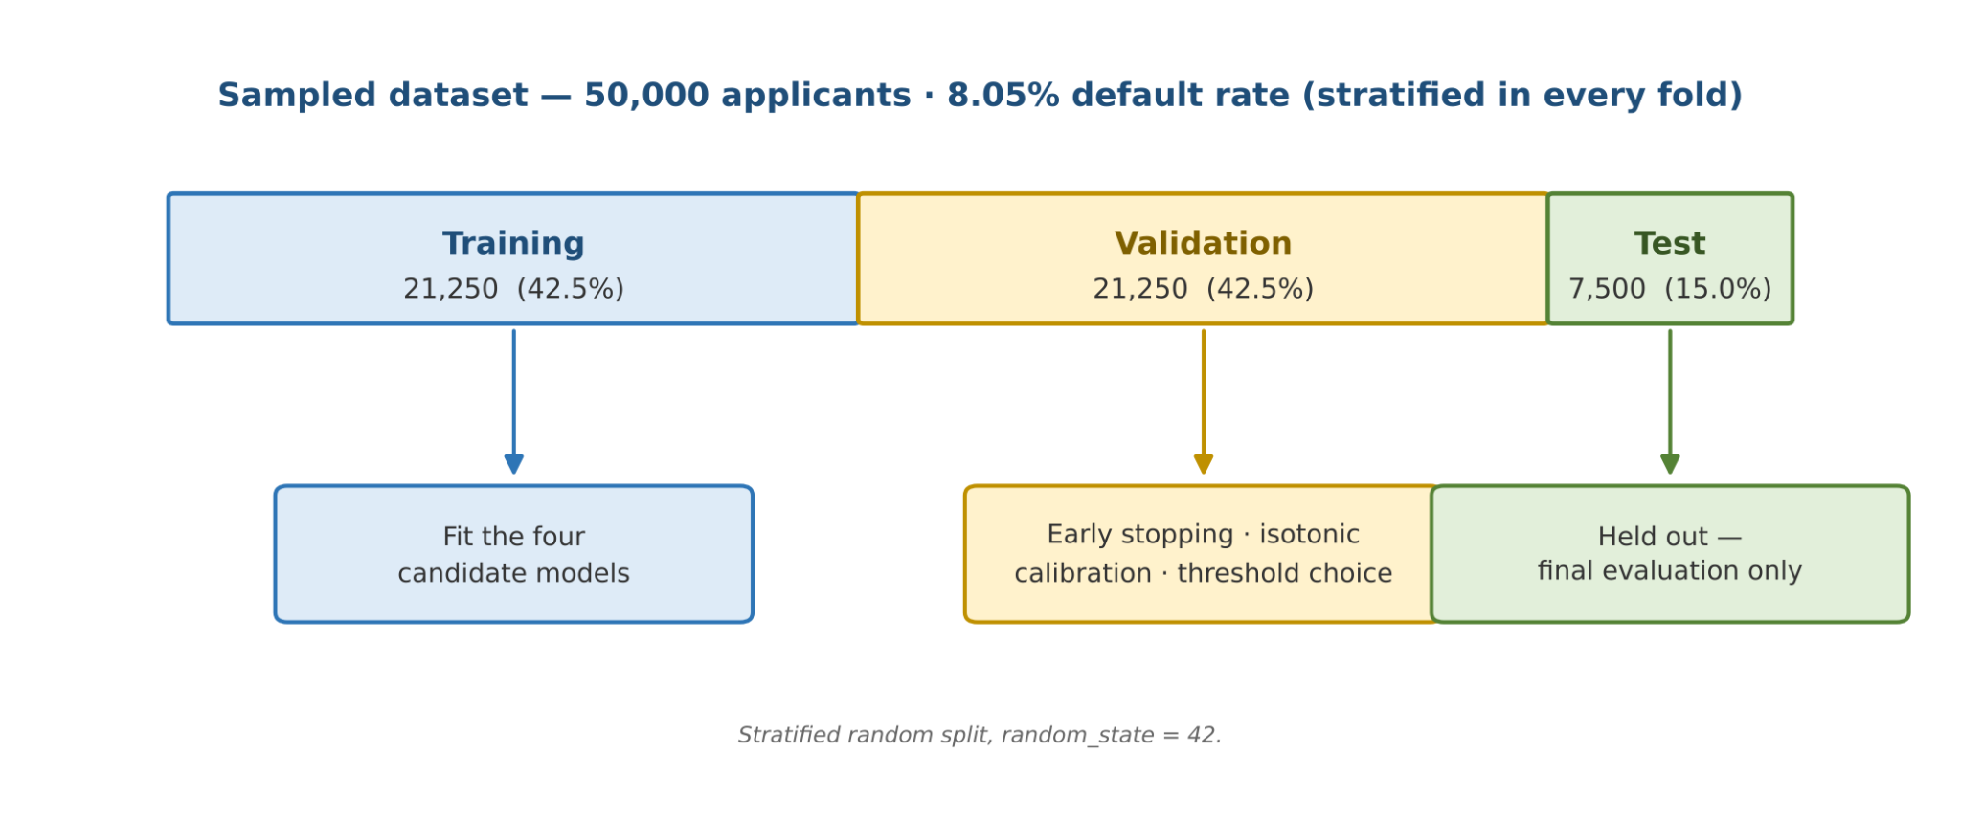
Figure 5. Stratified split used in this work.

3.3. Preprocessing
Preprocessing is handled by a single ColumnTransformer, which keeps the steps identical across models and prevents information from leaking between folds. Numeric variables are imputed with the median and then standardised. Categorical variables are imputed with the most frequent category and one-hot encoded, dropping the first level of each. Every transformer is fitted on the training fold only and then applied unchanged to the validation and test folds.

3.4. Feature Engineering
In total 301 features are constructed, grouped into four blocks (Table 3). The groups follow the structure of the source tables and, within each, combine cleaning, aggregation and ratio features.
Table 3. Blocks of engineered features.
Block | Source tables | Representative features
Application cleaning and ratios | application_train | AGE_YEARS, EMPLOYED_YEARS, CREDIT_INCOME_RATIO, ANNUITY_INCOME_RATIO, CREDIT_TERM, EXT_SOURCE_MEAN
Bureau aggregates | bureau | BUR_ACTIVE_CNT, BUR_DEBT_SUM, BUR_MAX_OVERDUE_DAYS, BUR_DEBT_RATIO, HAS_BUREAU
Earlier applications and instalments | previous_application, installments_payments | PREV_APPROVE_RATE, PREV_CNT_PAYMENT_MEAN, INST_PAY_RATIO, INST_LATE_MEAN
Point-of-sale and credit card | POS_CASH_balance, credit_card_balance | POS_UTIL_MEAN, POS_CNT, CC_UTIL_MEAN

Application block. Several fields carry sentinel values that must not be treated as real numbers. The value 365,243 in DAYS_EMPLOYED is replaced by a missing value and a binary flag, the gender code XNA is set to missing, and OWN_CAR_AGE is set to missing for applicants who do not own a car. Time variables are converted from days to years. Ratio features relate the loan to the applicant’s means, for instance credit to income, annuity to income, credit to goods price, the implied loan term, and income per family member or per child. The external scores are summarised by their mean, minimum, maximum, standard deviation, product and count, and the FLAG_DOCUMENT_* indicators are summed into the number of documents submitted.
Bureau block. Records are grouped by applicant to give the number of active and overdue credits, the total credit and debt amounts, the overdue amount and the longest overdue spell, the number of prolongations and loans, the age of the oldest credit and a debt ratio. Credit types are one-hot encoded, and a flag marks applicants with no bureau record at all.
Earlier applications and instalments. From previous applications the pipeline derives the total and mean amounts requested, the largest credit, the most recent decision date, the mean number of payments and the approval rate. From instalment records it derives the payment-to-due ratio and the mean and 7-day-plus lateness of payments.
Point-of-sale and credit-card block. Utilisation and count features summarise how heavily the applicant uses revolving and short-term products.

3.5. Candidate Models
Four classifiers are compared (Table 4). Plain logistic regression and a class-balanced variant that gives more weight to the minority class serve as baselines. The third model is LightGBM tuned with Optuna (Akiba et al., 2019) over 15 trials, with early stopping on the validation fold. The fourth is the same LightGBM model with an isotonic calibration layer fitted on the validation fold. The hyperparameters of the best trial are listed in Table 5.
Table 4. Models compared in this study.
Model | Type | Notes
Logistic | Baseline | Unweighted; regularisation constant C = 0,5
Logistic_balanced | Baseline | class_weight = 'balanced'
LightGBM | Boosted trees | Optuna, 15 trials; early stopping on the validation fold
LightGBM_calibrated | Boosted trees + calibration | Isotonic regression fitted on the validation fold

Table 5. Best LightGBM hyperparameters found by Optuna.
n_estimators | num_leaves | learning_rate | objective | random_state
205 | 53 | 0.0469 | binary | 42

3.6. Calibration and Threshold Selection
Calibration matters whenever downstream decisions depend on absolute PD values. An isotonic regression is fitted on the validation fold to map the raw LightGBM output to a calibrated probability. The threshold is then chosen on the same fold using the rule in Equation (7), which gives τ = 0.05. On the test fold this threshold recovers 86.2% of defaulters. Because the validation fold is used for early stopping, calibration and threshold choice alike, any optimism in those three steps would show up as a drop between validation and test; the test fold is the only fair reference.

3.7. Scorecard Construction
Calibrated probabilities are mapped to points using Equation (4), with a base score of 600, a PDO of 20 and base odds of 50:1, following the standard scorecard convention (Siddiqi, 2006). Applicants are then assigned to five rating bands, A to E, from lowest to highest risk. The bands are evaluated not by how they look but by whether the observed default rate rises steadily from A to E on the test fold.

3.8. Implementation and Reproducibility
The pipeline is written in Python. Data handling relies on pandas, modelling on scikit-learn (Pedregosa et al., 2011) and LightGBM, tuning on Optuna, plots on Matplotlib and the interface on Streamlit. Seeds are fixed at 42 wherever a random component is involved. The full workflow can be re-run from one notebook, and a pinned requirements.txt together with a Dockerfile freezes the software environment.

CHAPTER 4: RESULTS AND DISCUSSION

4.1. Overall Model Performance
Table 6 reports the test-fold metrics of the four models. The LightGBM family outperforms the logistic baselines on every ranking measure. Compared with plain logistic regression, raw LightGBM gains 0.0142 in AUC and 0.0169 in KS, an improvement that is consistent but not dramatic. This is a common pattern in credit data: much of the signal is carried by a handful of strong variables, such as the external scores and the loan-term ratios, which a linear model can already exploit once they are engineered.
Table 6. Test-set metrics for the four candidate models.
Model | AUC | Gini | KS | Brier | PR-AUC | F1 | Recall | Precision
Logistic | 0.7452 | 0.4904 | 0.3689 | 0.0684 | 0.2350 | 0.2248 | 0.7927 | 0.1310
Logistic_balanced | 0.7412 | 0.4823 | 0.3626 | 0.1940 | 0.2288 | 0.1535 | 1.0000 | 0.0831
LightGBM | 0.7594 | 0.5188 | 0.3858 | 0.0677 | 0.2365 | 0.2294 | 0.8375 | 0.1329
LightGBM_calibrated | 0.7582 | 0.5164 | 0.3751 | 0.0678 | 0.2282 | 0.2232 | 0.8624 | 0.1282

The class-balanced logistic regression deserves a comment. Its recall of 1.0000 together with a precision of 0.0831, almost identical to the 8.0% base rate, shows that at its operating threshold it flags virtually every applicant, which is useless as a decision rule. Its Brier score of 0.1940 is also about three times larger than the others, because re-weighting the classes pushes the predicted probabilities far above the true default frequency. The case illustrates why class weights are a poor remedy when calibrated probabilities are needed.
Calibration changed the picture slightly. The calibrated LightGBM gives up 0.0012 of AUC and about 0.011 of KS relative to the raw model, and its Brier score is marginally worse (0.0678 against 0.0677), so on this test fold the calibration step did not measurably improve the probability error. It did, however, move the operating point to a higher recall (86.2% against 83.8%) and, as Section 4.2 shows, bring predicted probabilities closer to observed frequencies over most of the score range. The calibrated model is retained for production because the scorecard in Section 4.4 requires probabilities rather than bare scores, and because the loss in ranking quality is small.

4.2. Evaluation Curves
Figures 8 to 11 show the ROC curves, the precision–recall curves, the KS plot and the reliability diagram. The ROC curves lie well above the diagonal. The precision–recall curves show that, at low and moderate recall, precision is several times the base rate of 0.08, although it falls steadily as recall rises, which is the usual price of pushing a model towards catching nearly every defaulter. The KS statistic of the calibrated model peaks at 0.375, comfortably above the informal 0.30 benchmark mentioned in Section 2.6. The reliability diagram indicates that calibrated probabilities track observed default frequencies closely across most of the range, with mild over-confidence between 0.1 and 0.3, an artefact that isotonic regression sometimes produces when the calibration set is small.
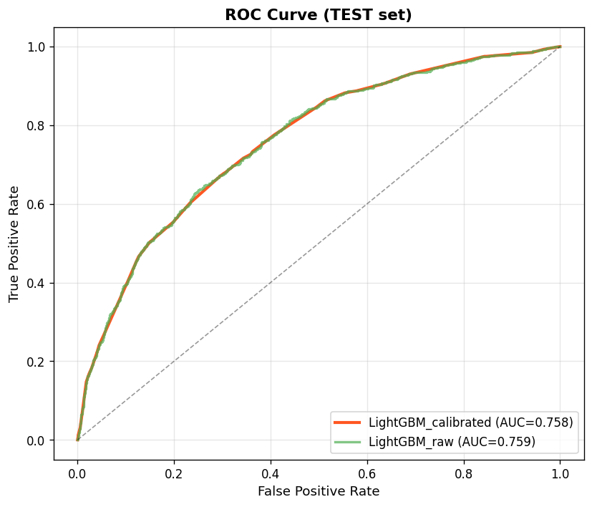
Figure 8. ROC curves for the four candidate models (test set).
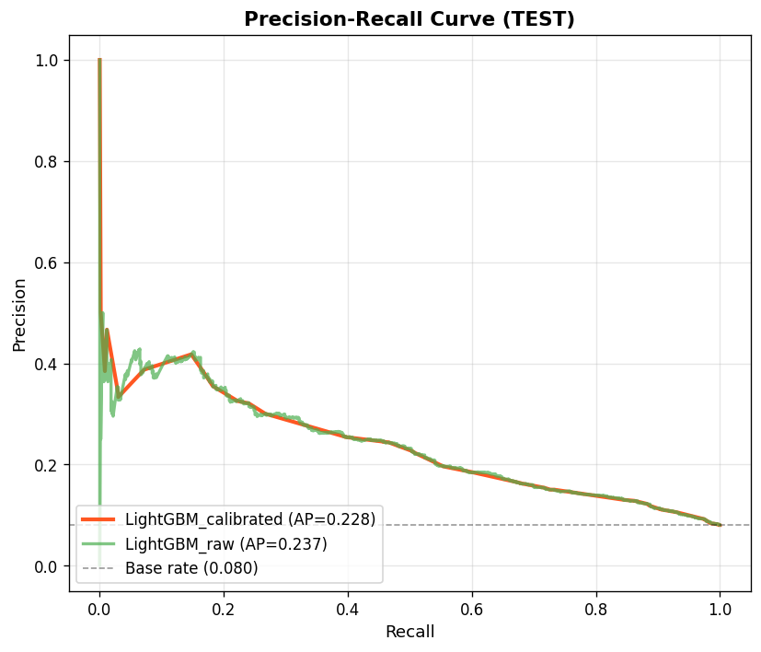
Figure 9. Precision–Recall curves for the two LightGBM models (test set).
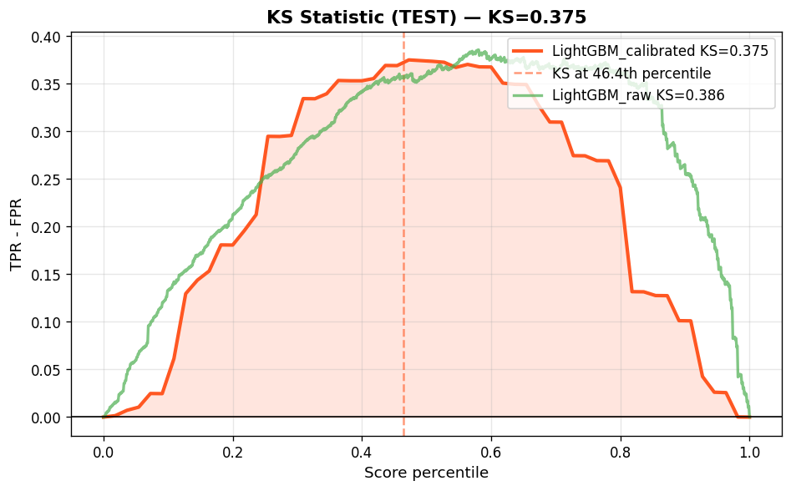
Figure 10. Kolmogorov–Smirnov plots for the two LightGBM models (test set).
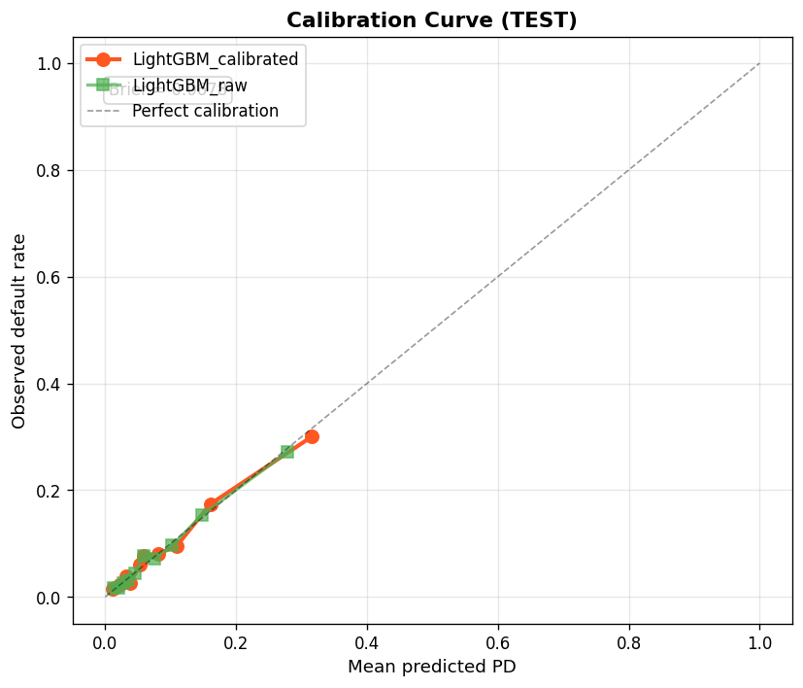
Figure 11. Reliability (calibration) plot for the selected model (test set).

4.3. Feature Importance
Figure 12 ranks the 25 most important features by LightGBM gain, that is, by the total reduction in loss attributable to splits on each feature. Engineered ratios and behavioural summaries dominate the list: PREV_CNT_PAYMENT_MEAN, CREDIT_TERM, EXT_SOURCE_MEAN, and a range of instalment and point-of-sale features carry most of the model’s discriminating power. Raw demographic variables such as age and gender appear much lower. This is reassuring from two angles. It supports the idea that Home Credit’s edge comes from alternative behavioural data rather than from demographic proxies, and it suggests that the model is not leaning heavily on attributes that are sensitive from a fairness standpoint. Gain-based importance is nevertheless a global summary; it does not say how a particular feature affects an individual decision, for which local explanation methods such as SHAP (Lundberg & Lee, 2017) would be needed.
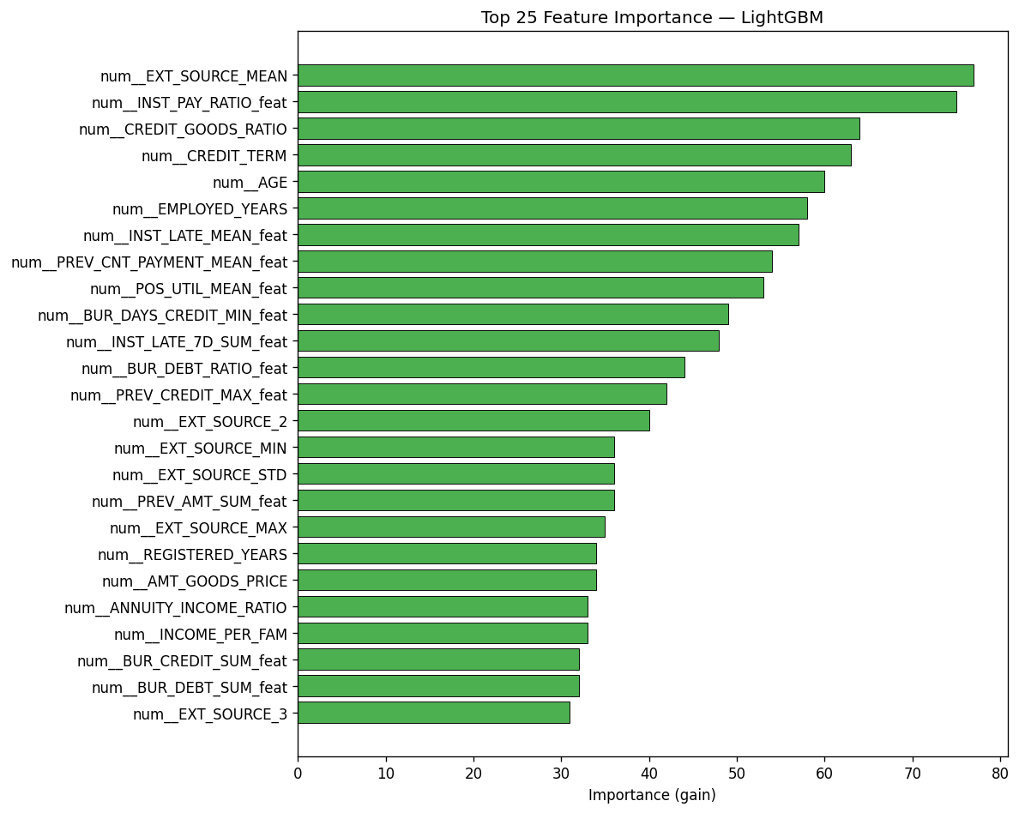
Figure 12. Top-25 features by LightGBM gain.

4.4. Scorecard and Risk Bands
PD is converted to a score using the parameters described in Section 3.7 (base 600, PDO 20, base odds 50:1), and applicants are assigned to five rating bands. Table 7 shows the average predicted PD and the observed default rate of each band on the test fold. Two features of the table support the scorecard. The ordering is strictly monotonic, with the observed default rate rising from 1.92% in band A to 30.04% in band E. And the predicted and observed values agree closely in every band, the largest gap being about 1.5 percentage points in band E, which is itself evidence of reasonable calibration.
Table 7. Risk-band distribution and observed default rate (test set).
Rating | Score range | Average PD | Default rate | Applicants
A | 760 – 1000 | 1.79% | 1.92% | 2,185
B | 640 – 760 | 4.67% | 5.02% | 2,372
C | 480 – 640 | 8.47% | 8.70% | 1,241
D | 360 – 480 | 14.89% | 14.84% | 1,166
E | 0 – 360 | 31.59% | 30.04% | 536

[ Insert Figure 13 here ]
Figure 13. Score distribution and risk-band boundaries.
[ Insert Figure 14 here ]
Figure 14. Empirical default rate by risk band.

4.5. Business Impact
At τ = 0.05 the model flags 4,057 of the 7,500 test applicants (54%) for review. Of these, 520 are genuine defaulters, so the model recovers 86.2% of the 603 defaulters in the test fold, at a precision of 12.8%, about 1.6 times the base rate. The remaining 3,537 flagged applicants are false alarms, which corresponds to a false-positive rate of roughly 51% among good borrowers. That is the price of the high recall target: these applicants are not rejected outright but are directed to manual review or risk-based pricing instead of automatic approval.
Table 8 shows how the defaulters are distributed over the bands. The two riskiest bands, D and E, contain only 22.7% of applicants but account for 55.4% of all defaulters. Adding band C raises the share of defaulters captured to 73.3% while covering 39.2% of applicants. Band A, by contrast, holds nearly 30% of applicants but just 7.0% of defaulters, with a lift of 0.24, so it is a natural candidate for streamlined approval.
Table 8. Capture rate and lift over the base rate by risk band (test set).
Band | Applicants | Defaulters | Capture rate | Lift over base
A | 2,185 | 42 | 7.0% | 0.24×
B | 2,372 | 119 | 19.7% | 0.62×
C | 1,241 | 108 | 17.9% | 1.08×
D | 1,166 | 173 | 28.7% | 1.85×
E | 536 | 161 | 26.7% | 3.74×

4.6. Statistical Uncertainty
The test fold contains 603 defaulters and 6,897 non-defaulters. With so few positive cases, the headline numbers carry noticeable sampling error. Using the Hanley and McNeil (1982) approximation, the standard error of the calibrated model’s AUC is about 0.012, which gives an approximate 95% interval of 0.735 to 0.781. Normal approximations for recall and precision at the chosen threshold are shown in Table 9. The intervals are rough, since they treat the threshold as fixed and ignore variation due to the particular split, but they make a useful point: the AUC gaps between the four models are of the same order as the uncertainty in any single estimate. The difference between the LightGBM models and the logistic baselines is therefore suggestive rather than conclusive, and a repeated or cross-validated comparison on the full data would be needed to settle it.
Table 9. Approximate 95% intervals for key test metrics (calibrated LightGBM).
Metric | Estimate | Approximate 95% interval
AUC | 0.758 | 0.735 – 0.781
Recall at τ = 0.05 | 86.2% | 83.5% – 89.0%
Precision at τ = 0.05 | 12.8% | 11.8% – 13.8%

4.7. Comparison with Published Results
Top solutions in the original Kaggle competition, which used the full data and elaborate blending of many models, reached AUC values in the region of 0.80. The single-model AUC of 0.758 obtained here on a 12,750-row subsample is lower, as expected given the far smaller training set, the single model and the modest tuning budget. The gap should not be over-interpreted: it mixes the effect of sample size with that of ensembling, and the two cannot be separated without further experiments. Training on the full 307,511 rows is the most obvious way to narrow it.

4.8. Deployment
The final model is made available through a Streamlit application with four tabs: Overview, EDA, Predict and Performance. The Predict tab (Figure 15) takes a customer’s feature values and returns the predicted PD, the score and the risk band in real time, and the Performance tab (Figure 16) reproduces the evaluation results. A Dockerfile and a pinned requirements.txt make the application portable, and a single docker-compose command starts the container.
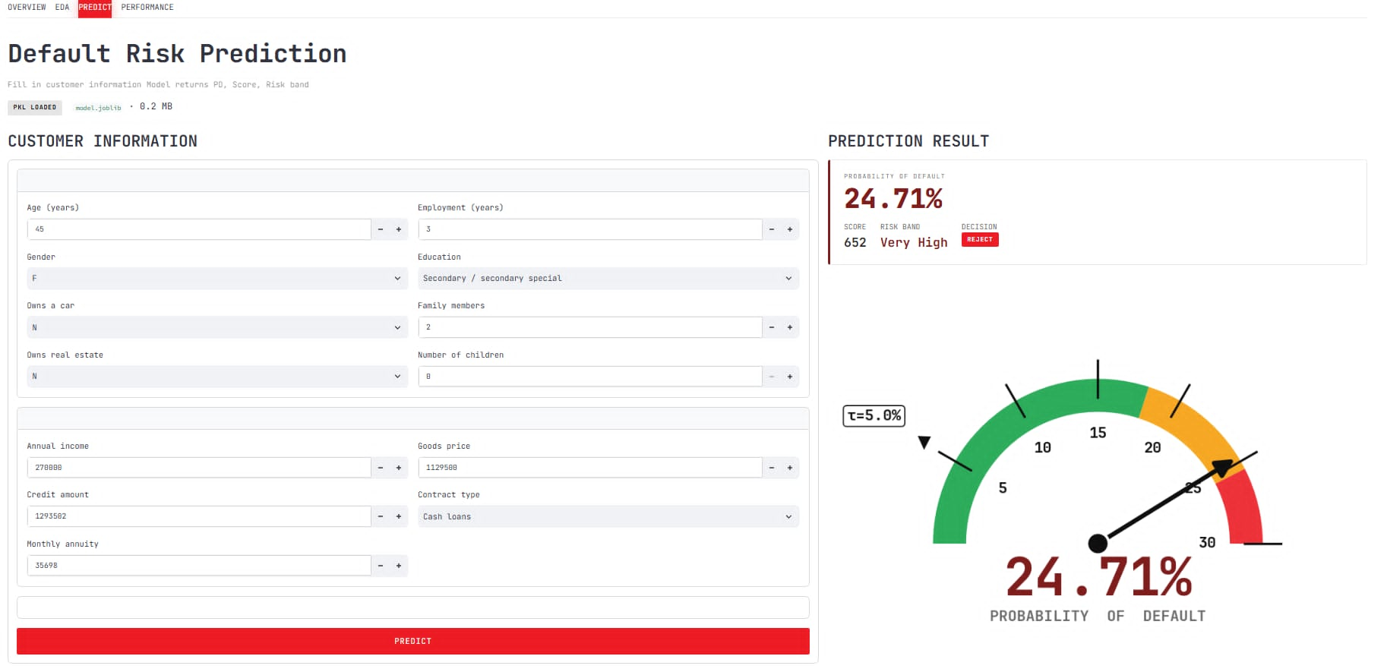
Figure 15. Streamlit Predict page: interactive scoring form.
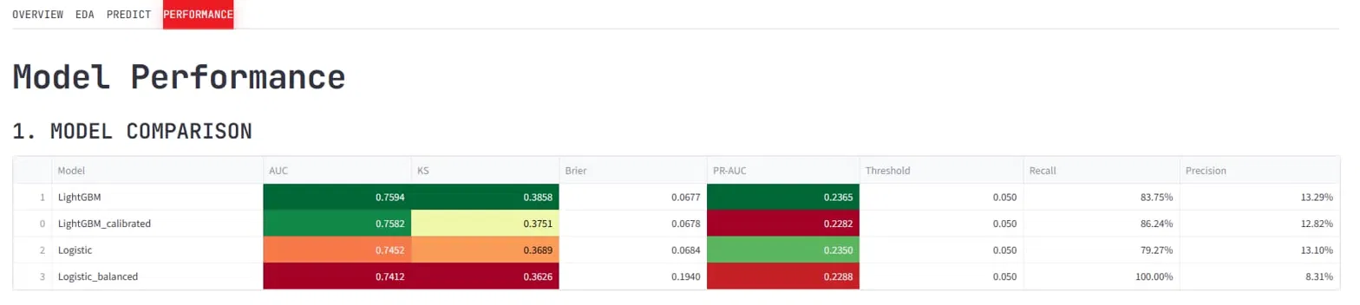
Figure 16. Streamlit Performance page: evaluation dashboard.

4.9. Limitations
Several limitations should be kept in mind when reading the results. The sample is small, which widens the uncertainty around every metric (Section 4.6). The validation fold has only 21,250 rows and therefore about 1,710 defaulters, which is thin support for a non-parametric calibrator and may explain the mild over-confidence in the 0.1–0.3 range; Platt scaling or a larger calibration set could behave better. All results come from one random split, so the effect of a different partition is unknown. Finally, the training data contain only applicants whose loans were approved, so the model has never seen the outcomes of rejected applicants, which introduces a selection bias that is discussed in the next chapter.

CHAPTER 5: CONCLUSION AND FUTURE WORK

5.1. Conclusion
This project built a complete credit-risk scoring pipeline, starting from seven raw tables and ending with a deployable PD model, a points-based scorecard and a set of risk bands. The selected model, LightGBM with isotonic calibration, reaches an AUC of 0.758 and a KS of 0.375 on a test fold of 7,500 applicants and, at a threshold of 0.05, identifies 86.2% of defaulters. The rating bands separate risk in a clean, monotonic way, from a default rate of 1.92% in the best band to 30.04% in the worst, which is the property a scorecard needs in practice.
Answering the questions posed in Chapter 1, gradient boosting improved on the logistic baseline, but by a modest margin that is comparable to sampling uncertainty at this sample size. Isotonic calibration made the probabilities more usable for scorecard construction and shifted the operating point toward higher recall, though it did not reduce the Brier score and cost a little discrimination. The bands behaved as intended. Taken together, the results show that the pipeline works end to end and forms a sound basis for the extensions below.

5.2. Future Work
The limitations identified above suggest a clear agenda:
- Full-data training. Re-training on all 307,511 applicants should improve performance and tighten the confidence intervals; earlier experience with this dataset suggests a gain of a few AUC points, although this has not been verified here.
- Robust evaluation. Repeated stratified cross-validation would show how much the reported metrics depend on a single split and allow a proper paired comparison of models.
- Calibration choices. Comparing Platt scaling with isotonic regression on a larger calibration set would clarify the over-confidence seen in the 0.1–0.3 range.
- Threshold and policy. The threshold of 0.05 favours recall. A higher value would reduce the review workload at the cost of missing more defaulters, so the final choice should be tested against the lender’s actual loss and review costs.
- Drift monitoring. Portfolios change over time. A production system should track the population stability index and KS drift on the external scores, amount variables and key demographic features.
- Fairness audit. Metrics should be disaggregated by gender, age band and regional rating before any real deployment, to meet the expectations of credit regulation.
- Reject inference. Because the data include only approved loans, reject-inference methods could reduce selection bias, especially in the low-PD tail.
- Richer models. Deep tabular architectures such as TabNet or FT-Transformer, and time-series features built from instalment histories, are promising directions.

REFERENCES
Akiba, T., Sano, S., Yanase, T., Ohta, T., & Koyama, M. (2019). Optuna: A next-generation hyperparameter optimization framework. Proceedings of the 25th ACM SIGKDD International Conference on Knowledge Discovery & Data Mining, 2623–2631.
Baesens, B., Van Gestel, T., Viaene, S., Stepanova, M., Suykens, J., & Vanthienen, J. (2003). Benchmarking state-of-the-art classification algorithms for credit scoring. Journal of the Operational Research Society, 54(6), 627–635.
Basel Committee on Banking Supervision. (2006). International convergence of capital measurement and capital standards: A revised framework (comprehensive version). Bank for International Settlements.
Brier, G. W. (1950). Verification of forecasts expressed in terms of probability. Monthly Weather Review, 78(1), 1–3.
Fawcett, T. (2006). An introduction to ROC analysis. Pattern Recognition Letters, 27(8), 861–874.
Friedman, J. H. (2001). Greedy function approximation: A gradient boosting machine. The Annals of Statistics, 29(5), 1189–1232.
Hand, D. J., & Henley, W. E. (1997). Statistical classification methods in consumer credit scoring: A review. Journal of the Royal Statistical Society: Series A, 160(3), 523–541.
Hanley, J. A., & McNeil, B. J. (1982). The meaning and use of the area under a receiver operating characteristic (ROC) curve. Radiology, 143(1), 29–36.
Kaggle. (2018). Home Credit Default Risk [Data set and competition]. https://www.kaggle.com/c/home-credit-default-risk
Ke, G., Meng, Q., Finley, T., Wang, T., Chen, W., Ma, W., Ye, Q., & Liu, T.-Y. (2017). LightGBM: A highly efficient gradient boosting decision tree. Advances in Neural Information Processing Systems, 30, 3146–3154.
Lessmann, S., Baesens, B., Seow, H.-V., & Thomas, L. C. (2015). Benchmarking state-of-the-art classification algorithms for credit scoring: An update of research. European Journal of Operational Research, 247(1), 124–136.
Lundberg, S. M., & Lee, S.-I. (2017). A unified approach to interpreting model predictions. Advances in Neural Information Processing Systems, 30, 4765–4774.
Niculescu-Mizil, A., & Caruana, R. (2005). Predicting good probabilities with supervised learning. Proceedings of the 22nd International Conference on Machine Learning, 625–632.
Pedregosa, F., Varoquaux, G., Gramfort, A., Michel, V., Thirion, B., Grisel, O., … Duchesnay, É. (2011). Scikit-learn: Machine learning in Python. Journal of Machine Learning Research, 12, 2825–2830.
Platt, J. C. (1999). Probabilistic outputs for support vector machines and comparisons to regularized likelihood methods. In A. J. Smola, P. Bartlett, B. Schölkopf, & D. Schuurmans (Eds.), Advances in large margin classifiers (pp. 61–74). MIT Press.
Saito, T., & Rehmsmeier, M. (2015). The precision-recall plot is more informative than the ROC plot when evaluating binary classifiers on imbalanced datasets. PLoS ONE, 10(3), e0118432.
Siddiqi, N. (2006). Credit risk scorecards: Developing and implementing intelligent credit scoring. Wiley.
Thomas, L. C., Edelman, D. B., & Crook, J. N. (2002). Credit scoring and its applications. SIAM.
Zadrozny, B., & Elkan, C. (2002). Transforming classifier scores into accurate multiclass probability estimates. Proceedings of the 8th ACM SIGKDD International Conference on Knowledge Discovery and Data Mining, 694–699.

