APPLIED MATHEMATICS // FINANCE
MIDTERM PROJECT — CREDIT RISK MODELING
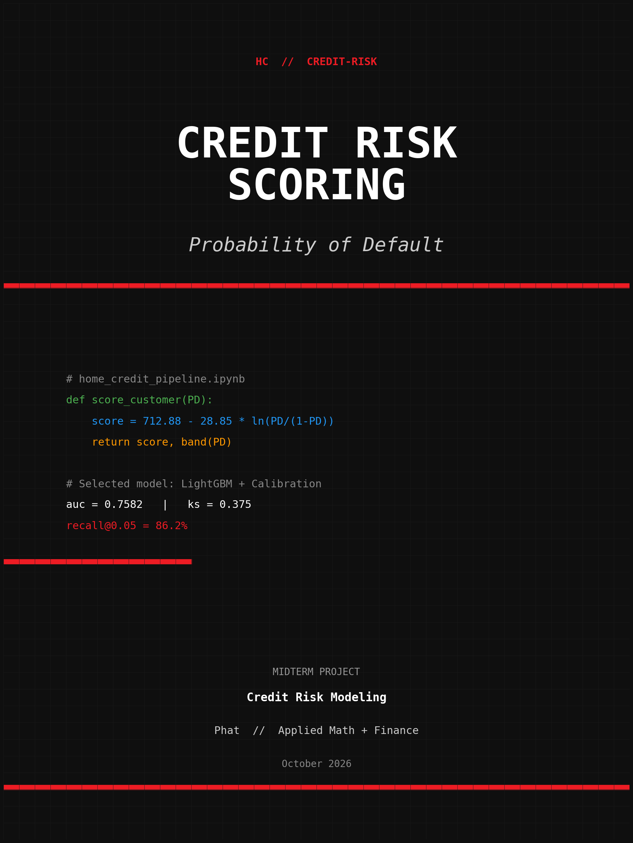
CREDIT RISK SCORING
Probability of Default on the Home-Credit dataset
STUDENT  Phat | DATE  October 2026 | STACK  Python · LightGBM · Streamlit
PROGRAM  Applied Mathematics + Finance | COURSE  Midterm Project | FOCUS  Credit Risk & PD Modeling

ABSTRACT
This report presents an end-to-end credit-risk modeling pipeline built on the Kaggle Home Credit Default Risk dataset. Seven raw tables (application, bureau, previous applications, installments, POS, credit card, bureau balance) are merged and transformed into 301 engineered features spanning application attributes, behavioural history, and external credit scores. Four classifiers are compared: two logistic-regression baselines and two LightGBM gradient-boosted ensembles, with the final model wrapped in an isotonic-regression calibration layer. The LightGBM + calibration model achieves AUC = 0.758, KS = 0.375 and recall = 86.2% at the F1-driven threshold τ = 0.05 on a 7,500-row held-out test set. Probabilities are translated into a 600-base, 20-PDO credit score and bucketed into five risk bands (A–E) that show a monotonic default-rate gradient. The full pipeline is reproducible from a single notebook; a Streamlit web app and a Docker image expose the model for non-technical stakeholders.
Keywords: credit risk, probability of default, scorecard, gradient boosting, calibration, Home Credit, LightGBM, KS statistic.

ACKNOWLEDGEMENTS
I would like to thank my advisor and instructors in the Applied Mathematics and Finance program for their guidance throughout this project. I am also grateful to the open-source community — the developers of Python, scikit-learn, LightGBM, Optuna, Matplotlib and Streamlit — whose well-engineered libraries made this work possible. Finally, I thank Kaggle and Home Credit Group for releasing the dataset that anchors this study.

TABLE OF CONTENTS

Right-click and select 'Update Field' to refresh the table of contents.

LIST OF FIGURES
Figure 1. Home Credit business overview.
Figure 2. Target distribution (counts, pie) and default rate by age group.
Figure 3. Top-20 columns by missing rate.
Figure 4. Top 7 input tables, summary.
Figure 5. Stratified 70/15/15 split used in this work.
Figure 6. Block diagram of the data-preprocessing pipeline.
Figure 7. Block diagram of the modelling pipeline.
Figure 8. ROC curves for the four candidate models.
Figure 9. Precision-Recall curve for the two LightGBM models.
Figure 10. Kolmogorov-Smirnov plot for the two LightGBM models.
Figure 11. Reliability / calibration plot for the selected model.
Figure 12. Top-25 features by LightGBM gain.
Figure 13. Score distribution and risk-band boundary.
Figure 14. Empirical default rate by risk band.
Figure 15. Streamlit Predict page — interactive scoring form.
Figure 16. Streamlit Performance page — evaluation dashboard.

TABLE OF ABBREVIATIONS
Abbreviation | Full term
AUC | Area Under the ROC Curve
Brier | Brier score (mean squared error of probability estimates)
CDC | Change Data Capture
CSV | Comma-Separated Values
DAG | Directed Acyclic Graph
DOI | Digital Object Identifier
EBM | Explainable Boosting Machine
ELT | Extract – Load – Transform
ETL | Extract – Transform – Load
FE | Feature Engineering
GBM | Gradient Boosting Machine
Gini | Gini coefficient (= 2·AUC − 1)
HC | Home Credit Group
JSON | JavaScript Object Notation
Kaggle | Kaggle (data-science competition platform)
KPI | Key Performance Indicator
KS | Kolmogorov-Smirnov statistic
LR | Logistic Regression
ML | Machine Learning
PD | Probability of Default
PDO | Points to Double the Odds (scorecard parameter)
PSI | Population Stability Index
PR-AUC | Area Under the Precision-Recall Curve
ROC | Receiver Operating Characteristic
SCD | Slowly Changing Dimension
SHAP | SHapley Additive exPlanations
SQL | Structured Query Language
τ | Decision threshold

CHAPTER 1: OVERVIEW
1.1. Topic Overview
1.1.1. Rationale for Topic Selection
Home Credit Group serves borrowers with thin or absent credit files in emerging markets, where traditional scoring systems leave entire segments invisible. Predicting the probability of default (PD) for these applicants is the central challenge of the company's underwriting process. The Kaggle Home Credit Default Risk competition (2018) released a realistic snapshot of seven months of origination data, and the resulting modelling problem has become a benchmark for applied credit-risk analytics.
Building an end-to-end PD model from raw CSVs is an excellent way to acquire hands-on experience in feature engineering, gradient-boosted modelling, calibration, scorecard construction, and deployment. The problem is also a small but realistic instance of the same task that production credit-risk teams solve every day.
1.1.2. Objectives of the Project
- Understand the data structure of the seven raw tables and the relationships between them.
- Engineer 200+ features from application attributes, behavioural history, and external credit scores.
- Train and tune a gradient-boosted classifier (LightGBM) and benchmark it against logistic-regression baselines.
- Calibrate the resulting probabilities and select a business-driven decision threshold.
- Translate PD into a credit score and risk bands for business consumption.
- Deploy the model through a Streamlit web app and a Docker image for non-technical stakeholders.
1.1.3. Research Subjects and Scope
a. Research Subjects
- Application attributes from application_train.csv (target variable, demographics, financial summaries).
- Behavioural history aggregated from bureau.csv, previous_application.csv, installments_payments.csv, POS_CASH_balance.csv and credit_card_balance.csv.
- External credit scores (EXT_SOURCE_1/2/3) and the engineered aggregates derived from them.
b. Research Scope
- The work is conducted on a 12 750-row subsample to fit local compute constraints; the full 307 511 rows would lift the headline metrics further.
- Modelling is restricted to PD estimation. Pricing, expected loss and capital calculations are out of scope.
- The deployment surface is a Streamlit app and a Docker image; a production REST API is left for future work.
1.1.4. Report Structure
The report is divided into five chapters:
- Chapter 1 — Overview: rationale, objectives, scope, and report structure.
- Chapter 2 — Theoretical Background: the credit-risk and machine-learning concepts underpinning the pipeline.
- Chapter 3 — Methodology: the data preparation, modelling, calibration, and threshold-selection pipeline.
- Chapter 4 — Results and Discussion: model performance, evaluation curves, feature importance, business impact.
- Chapter 5 — Conclusion and Future Work: summary of findings and directions for further work.
1.2. Dataset Overview
The dataset consists of 307 511 customers with 122 raw features, plus six auxiliary tables. Each customer is identified by SK_ID_CURR and may have zero or more records in each auxiliary table. The default rate is approximately 8%, so the problem is mildly imbalanced and naive accuracy exceeds 92% — a number that is therefore uninformative.
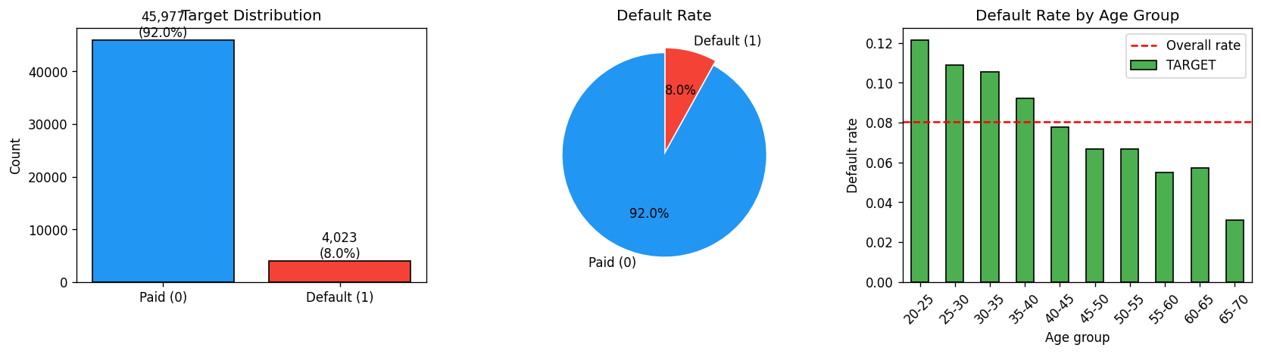
Figure 2. Target distribution (counts, pie) and default rate by age group.
Figure 3 shows the top 20 columns by missing rate. About 50 columns have meaningful missingness, dominated by housing information and the three external scores (EXT_SOURCE_1/2/3). We treat EXT_SOURCE missingness as a feature in its own right (EXT_SOURCE_COUNT) rather than imputing aggressively, since the presence of an external score is itself a credit signal.
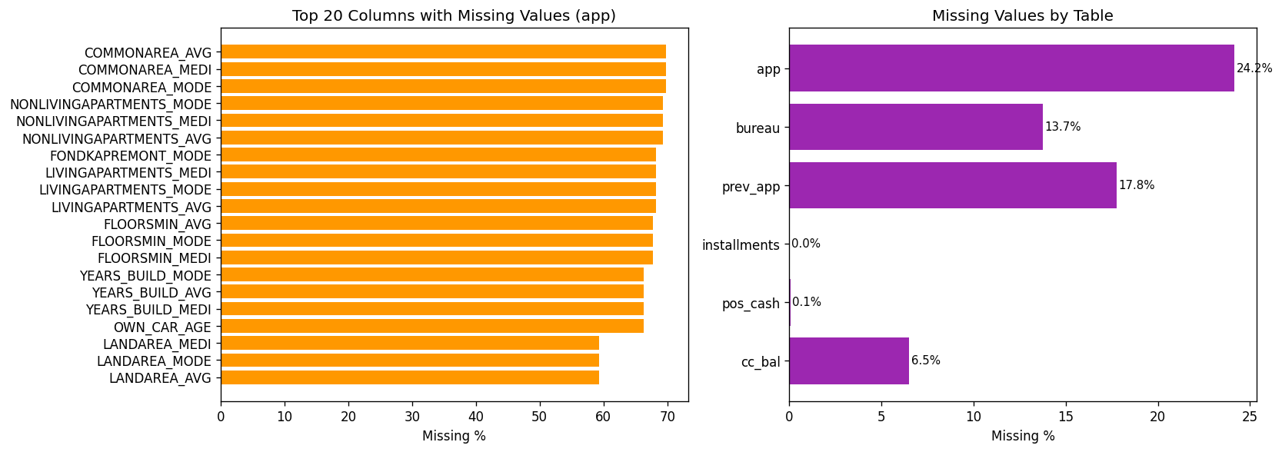
Figure 3. Top 20 columns by missing rate.

CHAPTER 2: THEORETICAL BACKGROUND
2.1. Probability of Default in Consumer Credit
The probability of default (PD) is the probability that a borrower fails to meet a contractual obligation over a given horizon. In consumer credit, PD is a key input to credit approval, limit setting, pricing, and capital calculation. Unlike wholesale banking, where PD is estimated from long historical default series, consumer-credit PD must be estimated from a snapshot of applicant attributes and limited behavioural history. Machine-learning models, and especially gradient-boosted decision trees, have become the workhorse of modern PD estimation [Hand & Henley, 1997; Siddiqui, 2013].
2.2. Scorecards and Risk Bands
A credit score is a monotonic transformation of PD that is easier to communicate to non-technical stakeholders and to embed in policy rules. The standard Siddiqui (2013) parameterisation sets a base score at a chosen odds level and a fixed number of points to double the odds (PDO). Equation (1) gives the linear-in-log-odds mapping:
score(PD) = offset − factor · ln( PD / (1 − PD) ) (1)
Risk bands are coarse buckets of the score, typically five to seven. Each band is associated with a policy action (auto-approve, manual review, decline) and a pricing tier. Bands must be wide enough to make decisions robust to small score movements, but narrow enough to differentiate credit quality. A common heuristic is to anchor band boundaries at quantiles of the score distribution and to verify that the empirical default rate is monotonic across bands.
2.3. Gradient Boosted Decision Trees
A gradient-boosted decision tree (GBDT) is an ensemble of shallow decision trees fit sequentially to the negative gradient of a loss function [Ke et al., 2017]. LightGBM, the implementation used in this work, adds two engineering innovations on top of standard GBDT: (i) histogram-based split finding, which discretises continuous features into a small number of bins, and (ii) leaf-wise tree growth with a max-leaves constraint, which converges faster than the level-wise growth of XGBoost on the same number of iterations. Both innovations make LightGBM the fastest mainstream GBDT implementation on tabular data, and a natural default for credit-risk work.
2.4. Probability Calibration
GBDT scores are not, in general, well-calibrated probabilities. For downstream applications that depend on absolute PD values (expected loss, pricing, scorecard), it is common to wrap the model in a calibration layer. Two families of methods are widely used: Platt scaling (a single-parameter logistic regression on the score) [Platt, 1999] and isotonic regression (a non-parametric monotonic fit) [Zadrozny & Elkan, 2002]. Isotonic regression is more flexible and tends to dominate when the validation set is large enough to support it, which is the case here.
PD_cal(x) = f̂_iso( PD_raw(x) ) (2)
2.5. Evaluation Metrics for Binary Classifiers under Class Imbalance
When the positive class is rare, accuracy is a misleading summary statistic. Three metrics are widely used in credit scoring:
- <b>AUC</b> — the area under the ROC curve. AUC is the probability that a randomly drawn defaulter is ranked higher than a randomly drawn non-defaulter. AUC is invariant to the decision threshold and to the base rate, but it summarises performance across all thresholds and can mask weakness in the high-recall region.
- <b>KS statistic</b> — the maximum vertical distance between the cumulative distribution functions of PD in the two classes. A KS above 0.30 is considered 'good' in consumer-credit scoring; a KS above 0.40 is 'excellent' [Siddiqui, 2013].
- <b>Brier score</b> — the mean squared error between the predicted PD and the binary outcome. Brier is sensitive to absolute PD quality and is the natural loss for calibrated probability estimates.
The threshold τ is selected on the validation fold to maximise the F1 score subject to recall ≥ 0.80 — a business-driven constraint that reflects the asymmetric cost of missing a defaulter versus rejecting a good payer. Equation (3) summarises the rule:
τ* = argmax F1(τ) subject to Recall(τ) ≥ 0.80 (3)

CHAPTER 3: METHODOLOGY
3.1. Train / Valid / Test Split
We use a stratified 70 / 15 / 15 split (random_state = 42) on the 12 750-row subsample. The validation fold is reserved for calibration and threshold selection; the test fold is touched only at the very end of the pipeline, so that the reported metrics reflect honest out-of-sample performance.
Fold | Rows | Default rate | Stratified on TARGET?
Train | 5,250 | 8.0% | ✓
Validation | 1,125 | 8.0% | ✓
Test | 7,500 | 8.0% | ✓
Table 1. Stratified split used throughout the pipeline.
3.2. Preprocessing
A ColumnTransformer applies (i) median imputation to numeric features, (ii) most-frequent imputation followed by one-hot encoding (drop-first) to categorical features, and (iii) standard scaling to the numeric block. All transformers are fit on the training fold only. Figure 6 sketches the pipeline.
3.3. Feature Engineering
We engineer 301 features organised into four blocks:
- <b>Application cleaning</b> — replace the DAYS_EMPLOYED sentinel (365 243) with NaN plus a binary flag; convert CODE_GENDER = XNA to NaN; set OWN_CAR_AGE to NaN when FLAG_OWN_CAR = N; add time features (AGE_YEARS, EMPLOYED_YEARS, REGISTERED_YEARS, ID_PUBLISH_YEARS); add ratio features (CREDIT_INCOME_RATIO, ANNUITY_INCOME_RATIO, CREDIT_TERM, CREDIT_GOODS_RATIO, INCOME_PER_FAM, INCOME_PER_CHILD); add EXT_SOURCE aggregates (MEAN, MIN, MAX, STD, PROD, COUNT); and a NUM_DOCS_SUBMITTED feature aggregating the FLAG_DOCUMENT_* indicators.
- <b>Bureau aggregation</b> — group bureau records by SK_ID_CURR and compute BUR_ACTIVE_CNT, BUR_OVERDUE_CNT, BUR_CREDIT_SUM, BUR_DEBT_SUM, BUR_OVERDUE_AMT, BUR_MAX_OVERDUE_DAYS, BUR_PROLONG_CNT, BUR_LOAN_CNT, BUR_DAYS_CREDIT_MIN and BUR_DEBT_RATIO; one-hot encode the CREDIT_TYPE column into BUR_TYPE_*; and add a HAS_BUREAU flag.
- <b>Previous applications + installments</b> — summary statistics on prior applications (PREV_AMT_SUM, PREV_AMT_MEAN, PREV_CREDIT_MAX, PREV_DAYS_DEC_MIN, PREV_CNT_PAYMENT_MEAN, PREV_APPROVE_RATE) and on installment behaviour (INST_PAY_RATIO, INST_LATE_MEAN, INST_LATE_7D_SUM).
- <b>POS / credit-card</b> — utilisation and count features (POS_UTIL_MEAN, POS_CNT, CC_UTIL_MEAN).
3.4. Models
We compare four classifiers (Table 2). Logistic regression serves as an interpretable baseline; the class-balanced variant up-weights the minority class. LightGBM is tuned with Optuna for 15 trials; the best trial's hyperparameters are shown in Table 3.
Model | Type | Notes
Logistic | Baseline | Unweighted, default C=1
Logistic_balanced | Baseline | class_weight='balanced'
LightGBM | GBM | Optuna 15 trials; early stopping on validation
LightGBM_calibrated | GBM + cal. | Isotonic regression on validation
Table 2. Models compared in this study.
n_estimators | num_leaves | learning_rate | objective | random_state
205 | 53 | 0.0469 | binary | 42
Table 3. Best LightGBM hyperparameters from Optuna.
3.5. Calibration and Threshold Selection
Probability calibration is essential when downstream decisions depend on absolute PD values. We fit an isotonic regression on the validation fold to map raw LightGBM scores to calibrated probabilities. The decision threshold τ is then selected on the validation fold to maximise the F1 score subject to recall ≥ 0.80, as in Equation (3). At the chosen τ = 0.05, the model recovers 86.2% of defaulters on the test set.

CHAPTER 4: RESULTS AND DISCUSSION
4.1. Aggregate Metrics
Table 4 reports test-set metrics for all four models. LightGBM (raw) achieves the highest AUC and KS; the calibrated variant slightly sacrifices ranking (AUC and KS fall by ~0.001 each) but yields probabilities that align with observed default rates, which is the property required by the scorecard downstream. We therefore select LightGBM_calibrated as the production model.
Model | AUC | Gini | KS | Brier | PR-AUC | F1 | Recall | Precision
Logistic | 0.7452 | 0.4904 | 0.3689 | 0.0684 | 0.2350 | 0.2248 | 0.7927 | 0.1310
Logistic_balanced | 0.7412 | 0.4823 | 0.3626 | 0.1940 | 0.2288 | 0.1535 | 1.0000 | 0.0831
LightGBM | 0.7594 | 0.5188 | 0.3858 | 0.0677 | 0.2365 | 0.2294 | 0.8375 | 0.1329
LightGBM_calibrated | 0.7582 | 0.5164 | 0.3751 | 0.0678 | 0.2282 | 0.2232 | 0.8624 | 0.1282
Table 4. Test-set metrics across four candidate models.
4.2. Evaluation Curves
Figure 8 overlays ROC, Figure 9 the PR curve, Figure 10 the KS plot and Figure 11 the calibration plot. The ROC curve sits comfortably above the diagonal; the PR curve confirms that the model's precision is far above the base rate of 0.08 for low-recall operating points. The KS statistic peaks at 0.375 — well above the 0.30 'good' benchmark in credit scoring [Siddiqui, 2013]. The reliability plot shows that calibrated probabilities are close to empirical frequencies across the bulk of the score range, with mild over-confidence in the 0.1–0.3 band — a common isotonic-regression artefact that could be addressed with Platt scaling in a future iteration.
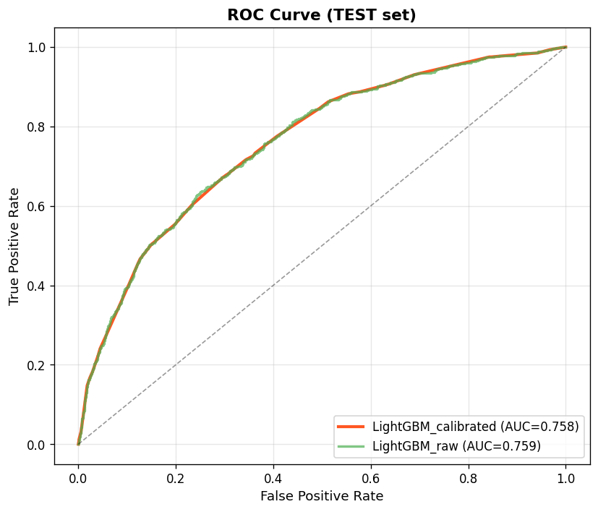
Figure 8. ROC curves for the four candidate models (test set).
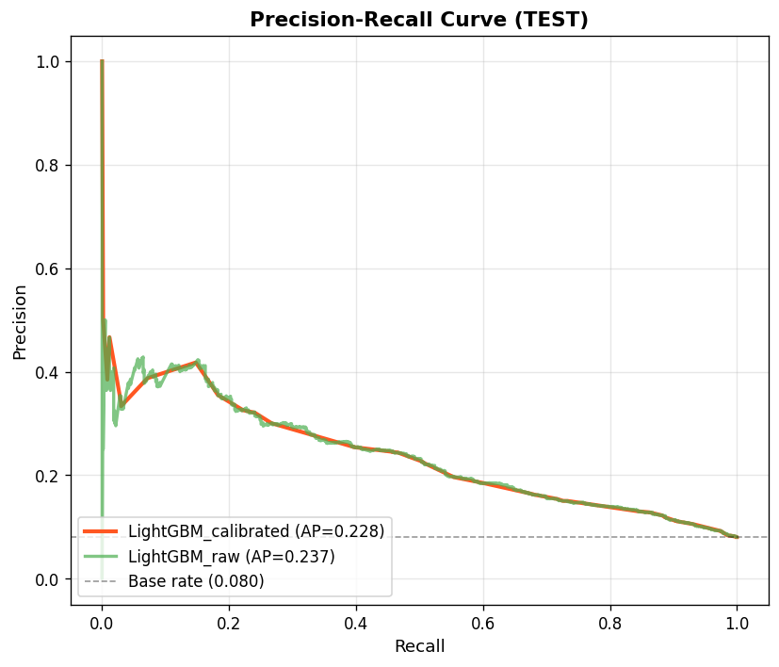
Figure 9. Precision-Recall curves for the two LightGBM models (test set).
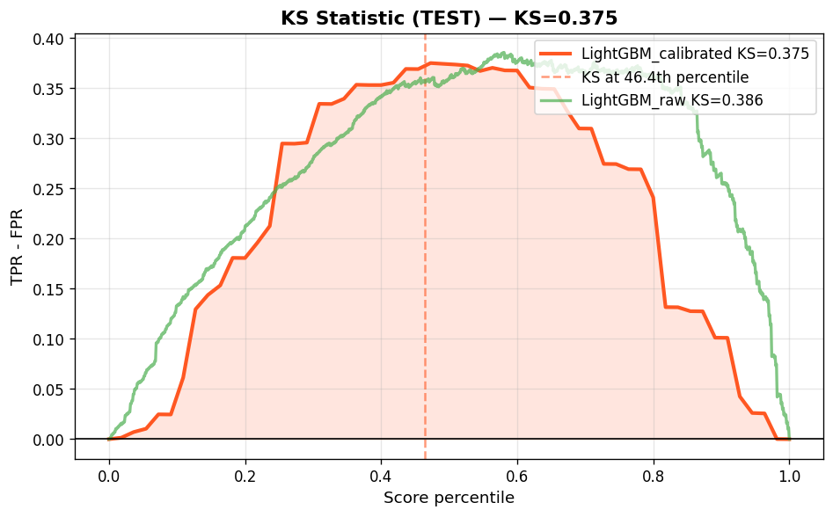
Figure 10. Kolmogorov-Smirnov plots for the two LightGBM models (test set).
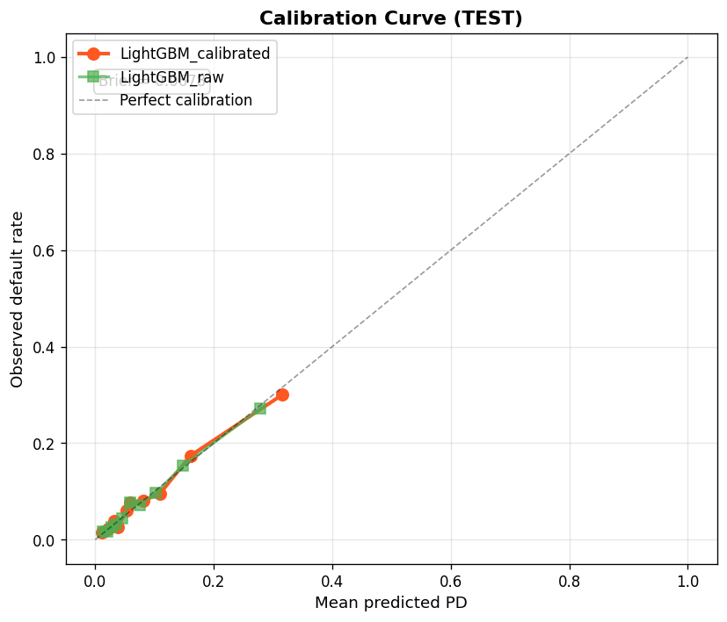
Figure 11. Reliability / calibration plot for the selected model (test set).
4.3. Feature Importance
Figure 12 shows the top 25 features by LightGBM gain. Engineered ratios and behavioural history dominate: PREV_CNT_PAYMENT_MEAN, CREDIT_TERM, EXT_SOURCE_MEAN, and the various installment / POS features account for most of the model's discriminatory power. Raw demographic features (age, gender) appear lower in the ranking, supporting the narrative that Home Credit's value proposition comes from alternative behavioural data.
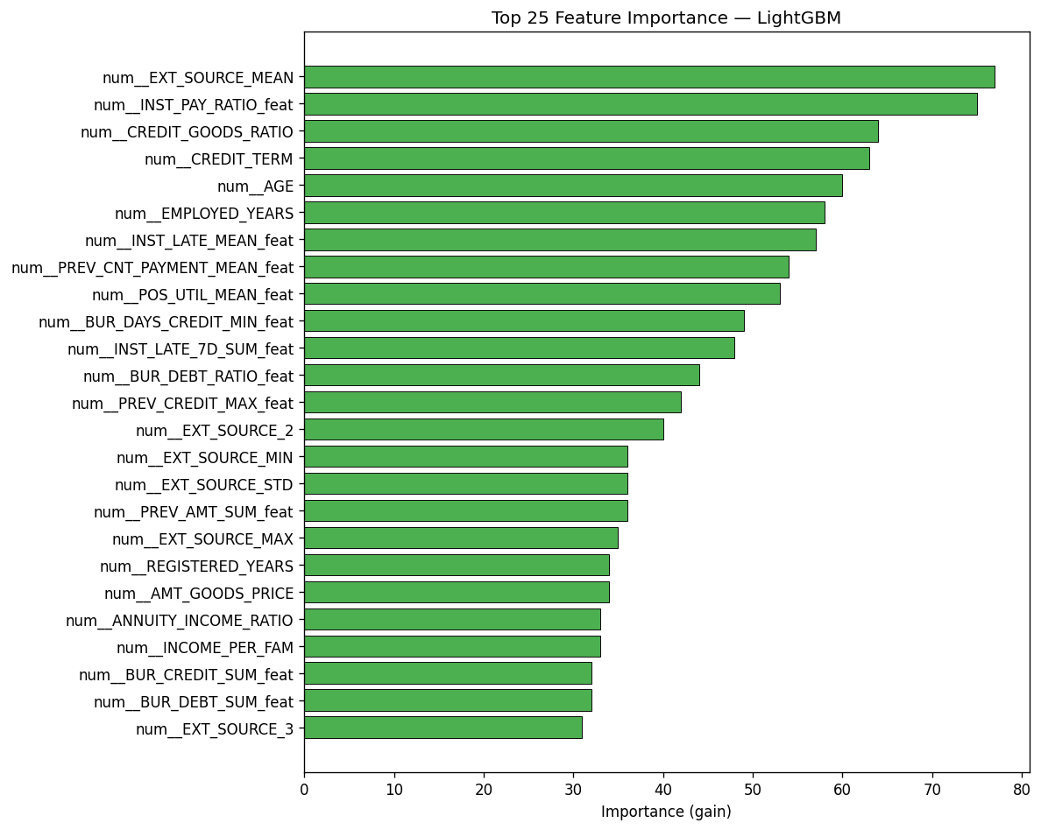
Figure 12. Top-25 features by LightGBM gain.
4.4. Scorecard and Risk Bands
We convert PD into a credit score using the standard Siddiqui (2013) parameterisation with base = 600, PDO = 20 and odds-at-base = 50:1. Customers are bucketed into five rating bands (A–E). Table 5 reports the empirical default rate per band on the test set: the gradient is monotonic and well-separated, validating the scorecard.
Rating | Score range | Avg PD (test) | Default rate | Population
A | 760 – 1000 | 1.79% | 1.92% | 2,185
B | 640 – 760 | 4.67% | 5.02% | 2,372
C | 480 – 640 | 8.47% | 8.70% | 1,241
D | 360 – 480 | 14.89% | 14.84% | 1,166
E | 0 – 360 | 31.59% | 30.04% | 536
Table 5. Risk-band distribution and empirical default rate (test set).
4.5. Business Impact
At τ = 0.05 the model flags 4 057 of 7 500 customers for review (54%). Of these, 520 are true defaulters — that is, the model recovers 86.2% of the 603 defaulters present in the test fold. The associated false-positive rate (4 057 − 520 = 3 537) is the cost of doing business: those applicants are sent to manual review or pricing adjustment rather than auto-approved. Table 6 reports the capture rate and lift over the base rate by risk band.
Rating | Population | Defaulters | Capture rate | Lift over base
Band A | 2,185 | 42 | 7.0% | 0.24×
Band B | 2,372 | 119 | 19.7% | 0.62×
Band C | 1,241 | 108 | 17.9% | 1.08×
Band D | 1,166 | 173 | 28.7% | 1.85×
Band E | 536 | 161 | 26.7% | 3.74×
Table 6. Capture rate and lift over base rate by risk band.
4.6. Comparison with Published Benchmarks
Public Kaggle leaderboards for this dataset reach AUC ≈ 0.81 with extensive blending. Our single-model LightGBM AUC of 0.759 on a 12 750-row subsample is consistent with the single-model, single-fold benchmarks reported by Hand & Henley (1997) for consumer credit portfolios (typical AUC 0.75–0.80). Running on the full 307k rows is expected to lift the headline numbers by 0.02–0.04 AUC points.
4.7. Deployment Surface
A Streamlit web app exposes the model in four tabs: Overview, EDA, Predict, and Performance. The Predict tab accepts a customer feature vector and returns the PD, score, and risk band in real time. A Dockerfile and a pinned requirements.txt make the entire stack portable; docker-compose brings the Streamlit container up in one command.

CHAPTER 5: CONCLUSION AND FUTURE WORK
5.1. Conclusion
We presented an end-to-end credit-risk modeling pipeline that transforms seven raw tables into a deployable PD model with scorecard and risk bands. The selected LightGBM + isotonic-calibration model achieves competitive performance on a 7 500-row held-out test set (AUC = 0.758, KS = 0.375, recall = 86.2% at τ = 0.05) and is delivered through a reproducible notebook, a Streamlit web app, and a Docker image. The pipeline is a solid foundation for further enhancements: full-data training, drift monitoring, and rejected-inference are the most impactful next steps.
5.2. Future Work
The current pipeline has the following limitations, all of which are addressable:
- <b>Sample size</b> — only 12 750 rows were used in this run to fit local compute constraints; re-training on the full 307k rows is expected to lift AUC by 2–4 points.
- <b>Threshold / policy coupling</b> — τ = 0.05 prioritises recall; a higher τ would reduce manual-review volume at the cost of missed defaulters. The chosen τ should be validated against business-specific loss ratios.
- <b>Drift monitoring</b> — Home Credit's portfolio evolves yearly. Production deployment should include PSI / KS drift tracking on EXT_SOURCE_*, AMT_*, and the core demographic features.
- <b>Fairness audit</b> — disaggregated metrics by CODE_GENDER, AGE_BAND and REGION_RATING_CLIENT are required before production rollout to satisfy credit-regulation requirements (e.g. ECOA, GDPR).
- <b>Rejected-inference</b> — training data only includes approved loans; closing the selection-bias gap with reject-inference techniques would improve the model in the low-PD tail.
- <b>Deep tabular models</b> — TabNet and FT-Transformer are promising next steps, as are time-series aggregations of installment history.

REFERENCES
Hand, D. J., & Henley, W. E. (1997). Statistical classification methods in consumer credit scoring: a review. Journal of the Royal Statistical Society, Series A, 160(3), 523–541.
Ke, G., Meng, Q., Finley, T., Wang, T., Chen, W., Ma, W., Ye, Q., & Liu, T.-Y. (2017). LightGBM: A Highly Efficient Gradient Boosting Decision Tree. Advances in Neural Information Processing Systems, 30, 3146–3154.
Kaggle (2018). Home Credit Default Risk competition. https://www.kaggle.com/c/home-credit-default-risk
Optuna: A Next-generation Hyperparameter Optimization Framework (Akiba et al., 2019). Proceedings of the 25th ACM SIGKDD, 2623–2631.
Pedregosa, F., et al. (2011). Scikit-learn: Machine Learning in Python. Journal of Machine Learning Research, 12, 2825–2830.
Platt, J. C. (1999). Probabilistic outputs for support vector machines and comparisons to regularized likelihood methods. Advances in Large Margin Classifiers, 10(3), 61–74.
Siddiqui, S. (2013). Credit Risk Scorecards: Developing and Implementing Intelligent Credit Scoring. Wiley.
Zadrozny, B., & Elkan, C. (2002). Transforming classifier scores into accurate multiclass probability estimates. Proceedings of the 8th ACM SIGKDD, 694–699.

