1. Project Overview and Required Functionality
This project delivers a MongoDB-backed dashboard for Grazioso Salvare to interact with and visualize shelter animal outcome data. The dashboard follows an MVC-style approach where MongoDB stores the model data, Dash components provide the view, and a Python CRUD module acts as the controller interface between the dashboard and the database. The dashboard includes interactive filtering options, an interactive data table, and two data visualizations that update dynamically based on the selected rescue filter. A Grazioso Salvare logo and a unique identifier containing my name are included on the dashboard for identification and documentation purposes.
2. Tools Used and Why
MongoDB was used as the database because it stores the Austin Animal Center Outcomes data as documents, making it flexible for working with real-world datasets that can vary slightly in structure. MongoDB also supports powerful query filters, which allows the dashboard to retrieve specific sets of dogs that match Grazioso Salvare rescue requirements.
PyMongo (through my CRUD module) was used to connect Python to MongoDB and perform database operations. Encapsulating these operations inside a CRUD class keeps the dashboard code cleaner and supports reuse of database logic.
Dash (JupyterDash) and Plotly were used to build the web dashboard because Dash supports interactive UI components such as radio buttons and DataTables, and it integrates directly with Plotly to create charts that automatically update when the data changes.
dash-leaflet was used for the geolocation visualization because it provides an interactive map that can display markers based on latitude and longitude values from the dataset.
3. Steps Taken to Complete the Project
- Connected to MongoDB using the Project One Python CRUD module and verified that data could be retrieved into a pandas DataFrame.
- Built the dashboard layout including the title, Grazioso Salvare logo with an SNHU link, and a unique identifier.
- Added interactive filter controls (radio buttons) to allow selection of rescue types and a reset option.
- Implemented MongoDB queries for each rescue type (Water Rescue, Mountain/Wilderness Rescue, Disaster/Tracking) using breed, sex, and age constraints.
- Created an interactive Dash DataTable that updates based on the active filter.
- Added a pie chart visualization to summarize breed distribution for the filtered data.
- Added a geolocation map that updates based on the selected row in the table.
- Tested each filter and confirmed that the table and both visualizations update correctly.
4. Testing Evidence (Screenshots / Screencast)
Screenshot 1: Reset / Unfiltered View
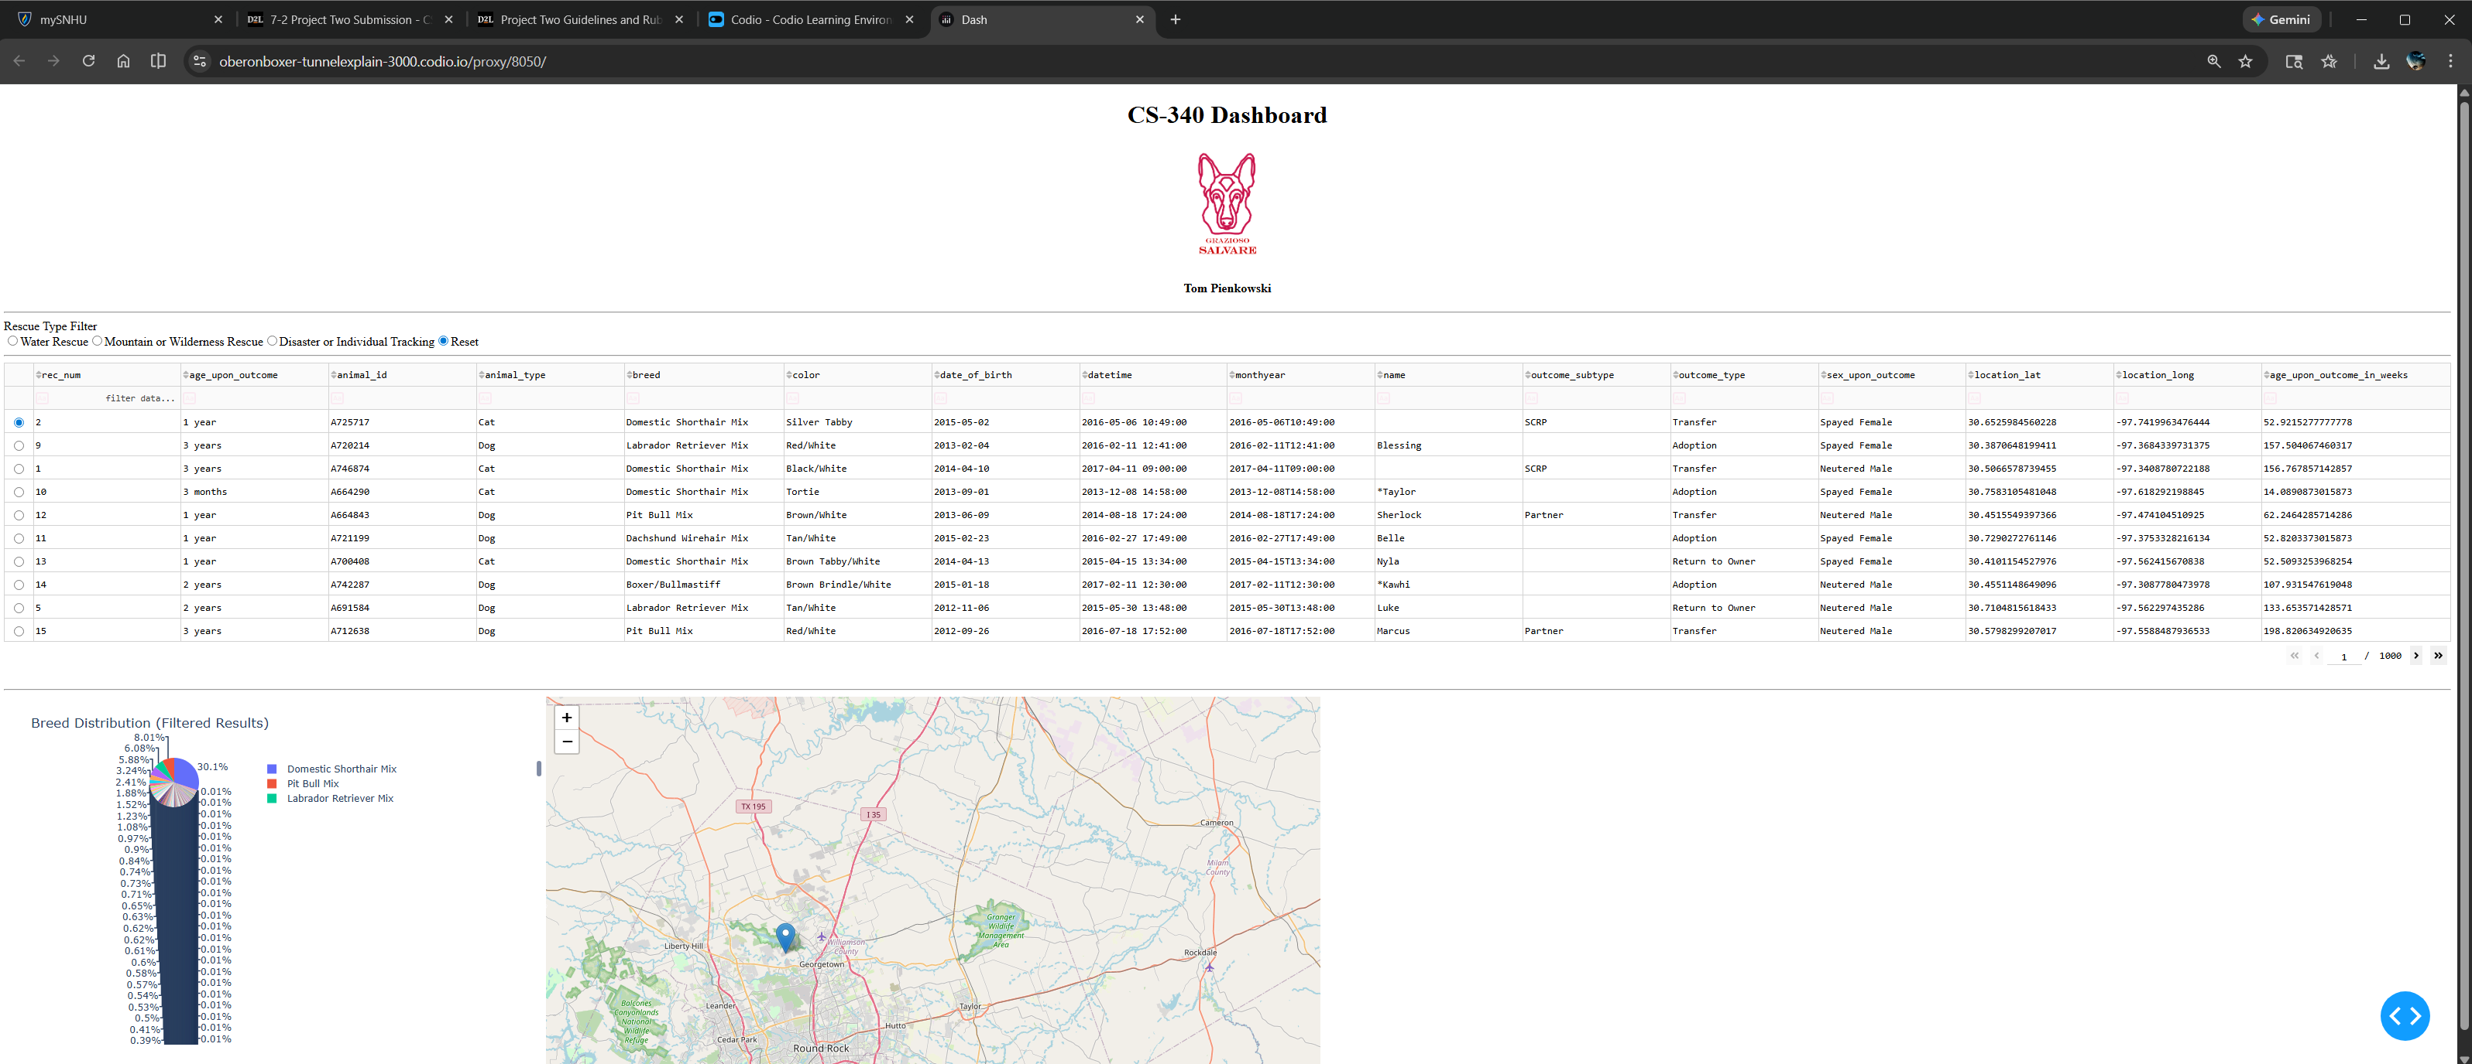
Screenshot 2: Water Rescue Filter Applied
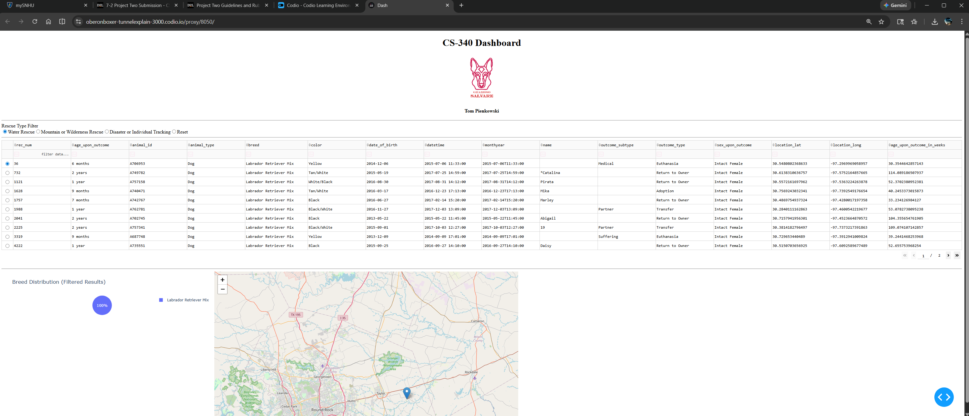
Screenshot 3: Mountain or Wilderness Rescue Filter Applied
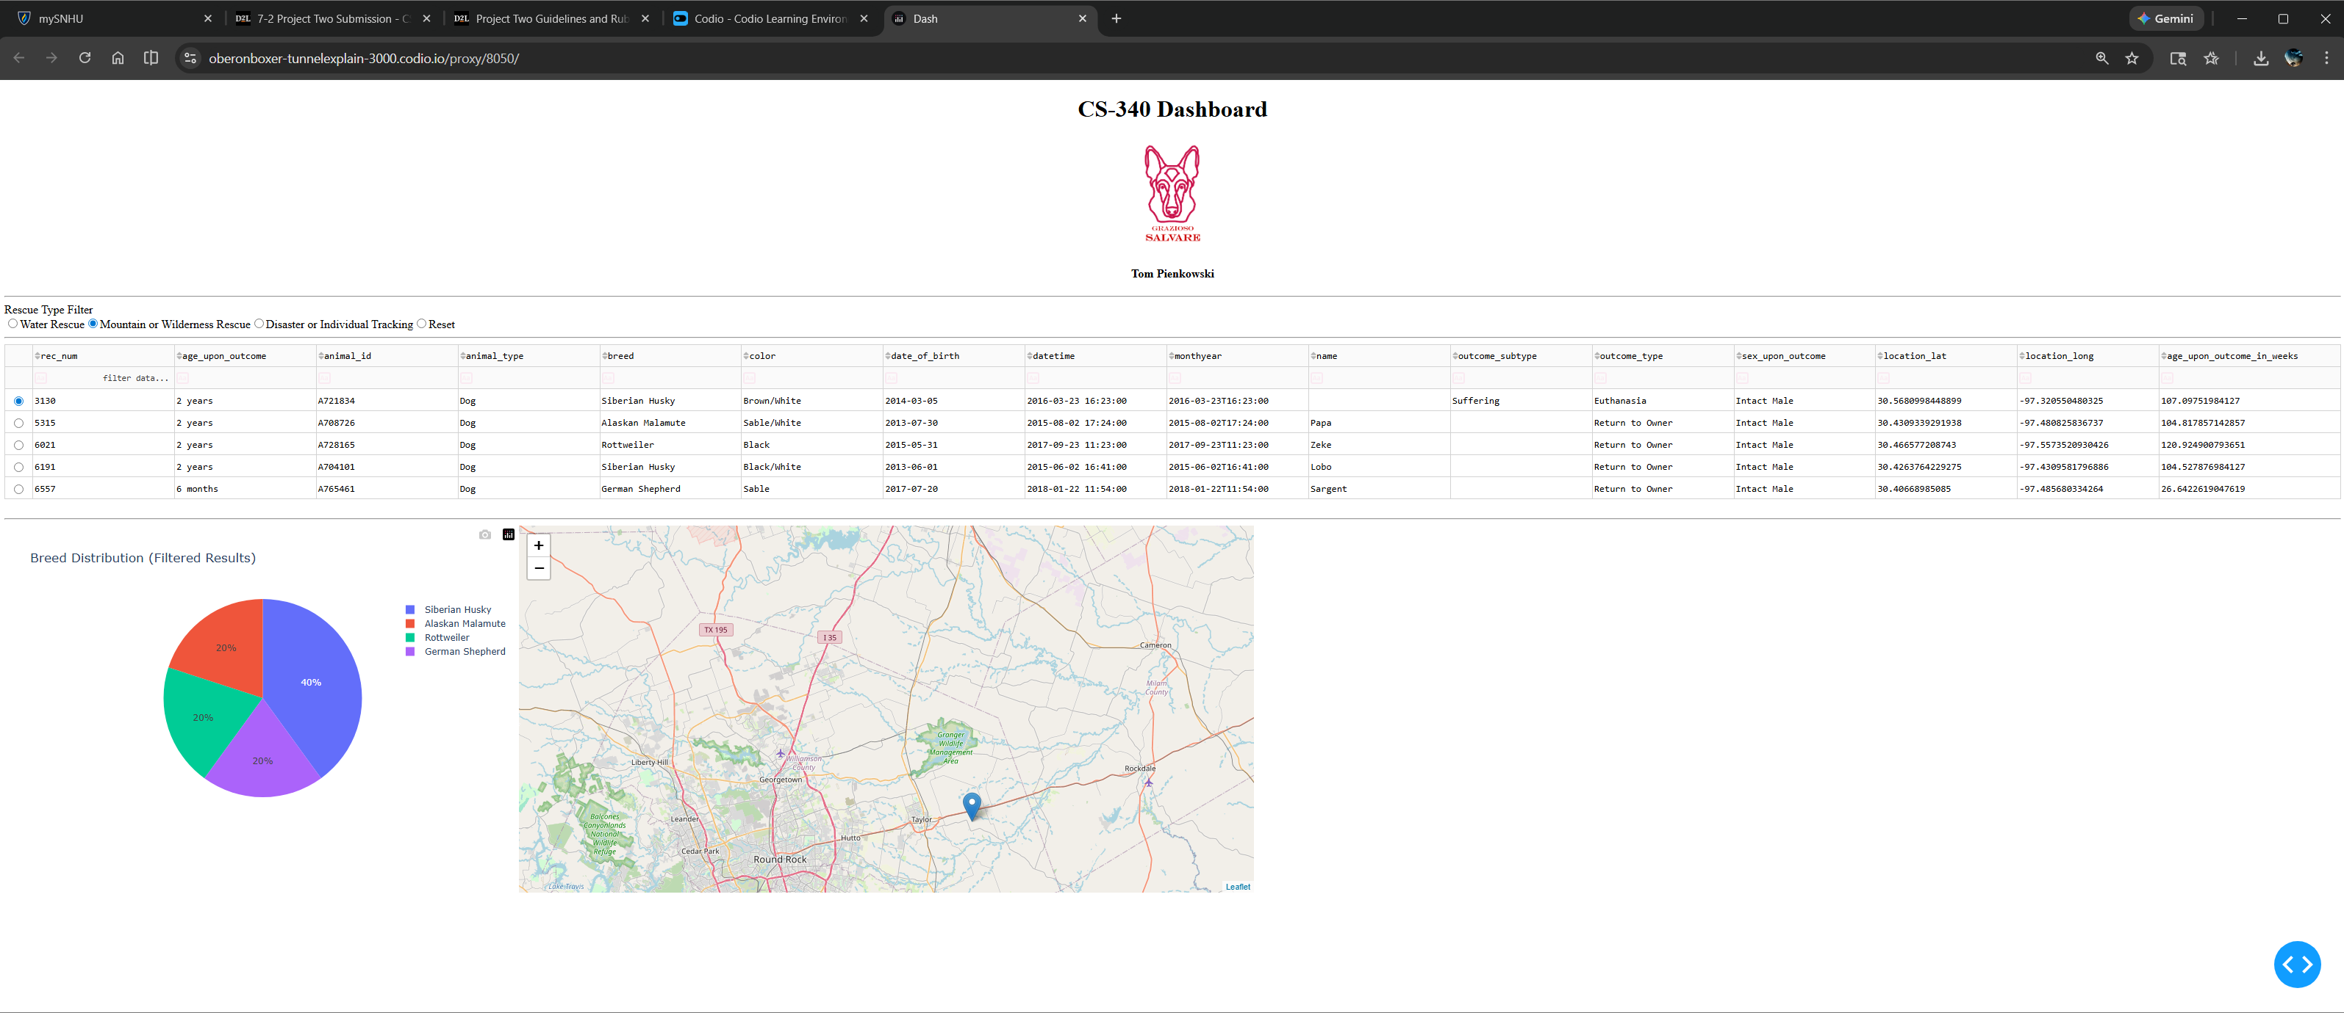
Screenshot 4: Disaster or Individual Tracking Filter Applied
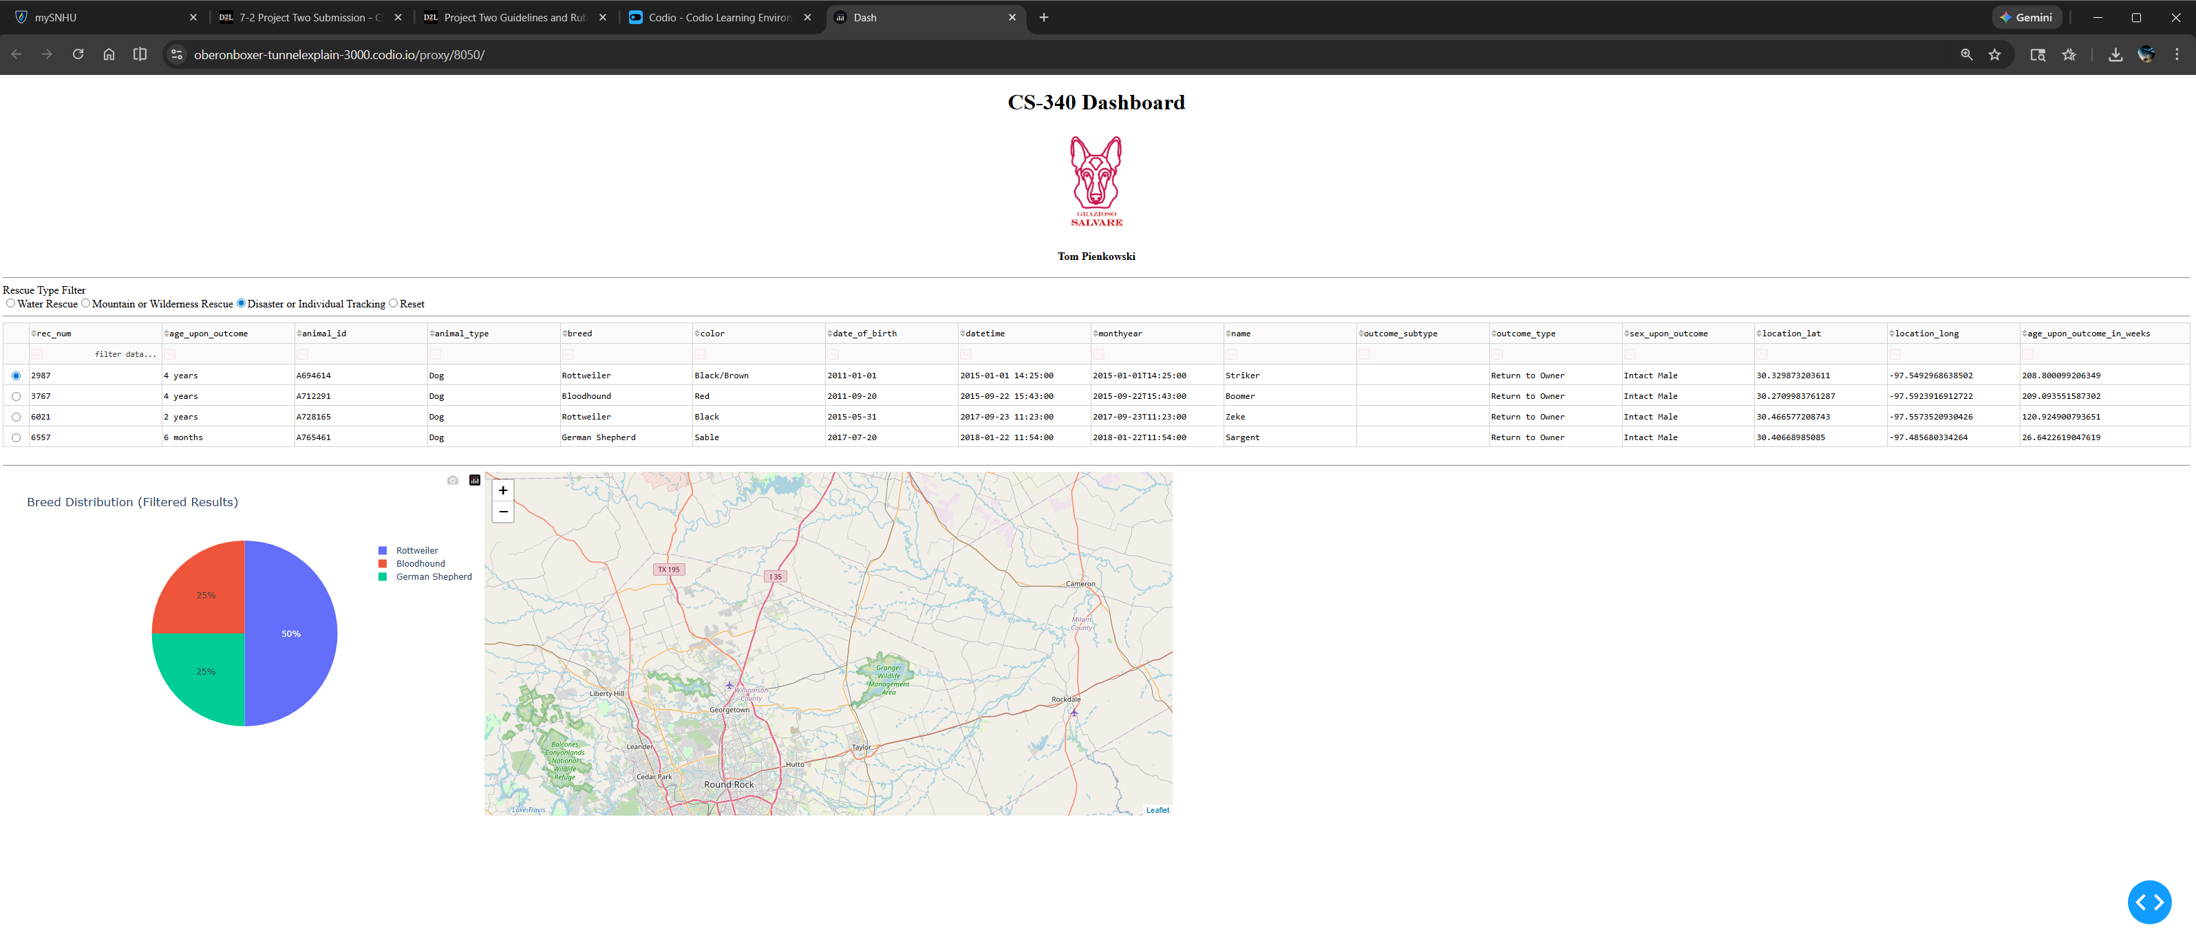
5. Challenges Encountered and How They Were Resolved
One challenge was ensuring the dashboard updated correctly when filters were changed and when no table columns were selected. This was resolved by adjusting Dash callbacks to handle None values safely and ensuring the table, chart, and map were all driven by the filtered dataset. Another challenge was preventing Dash DataTable errors caused by MongoDB ObjectId values; this was resolved by dropping the _id column after loading MongoDB data into the pandas DataFrame.
6. How to Run / Reproduce
- Start MongoDB and ensure the Austin Animal Center dataset is loaded into the animals collection.
- Open the ProjectTwoDashboard.ipynb file in Codio JupyterLab.
- Verify the CRUD module file is present (animal_shelter.py) and the credentials are set correctly.
- Run all notebook cells top to bottom.
- The dashboard will launch in the notebook output area. Use the rescue filter radio buttons to update the table, chart, and map.

