CURL:

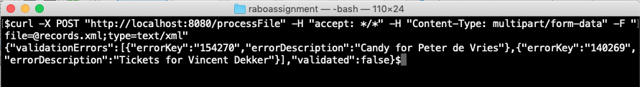

curl -X POST "http://localhost:8080/processFile" -H "accept: \*/\*" -H "Content-Type: multipart/form-data" -F [file=@records.xml;type=text/xml](mailto:file=@records.xml;type=text/xml)

Swagger UI

<http://localhost:8080/swagger-ui.html>

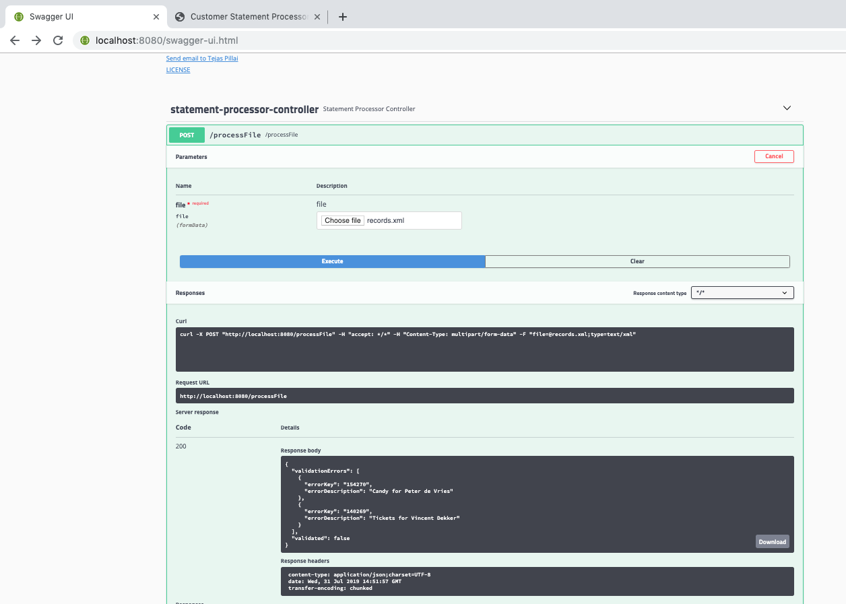

UI

