3GPP TSG-RAN3 Meeting #31 Tdoc R3-022069
Arlanda, Sweden, 19th-23rd August 2002
CR-Form-v7
CHANGE REQUEST
 | 25.413 | CR | 488 |  rev | 1 |  Current version: | 5.1.0 | 
For HELP on using this form, see bottom of this page or look at the pop-up text over the  symbols.

Proposed change affects:  | UICC apps |  | ME |  | Radio Access Network | X | Core Network | X

Title:  | CRRM Corrections
Source:  | Vodafone Ltd
Work item code:  | TEI |  |  |  |  |  |  | Date:  |  | 19/08/2002
Category:  | F |  |  |  |  |  |  | Release:  |  | Rel-5
 | Use one of the following categories:  F (correction)  A (corresponds to a correction in an earlier release)  B (addition of feature),  C (functional modification of feature)  D (editorial modification)  Detailed explanations of the above categories can  be found in 3GPP TR 21.900. |  |  |  |  |  |  |  | Use one of the following releases:  2 (GSM Phase 2)  R96 (Release 1996)  R97 (Release 1997)  R98 (Release 1998)  R99 (Release 1999)  Rel-4 (Release 4)  Rel-5 (Release 5)  Rel-6 (Release 6)
Reason for change:  |  | During inter-system handover, it is not defined whether the load to be reported by the RNC should take into account the load variation caused by the handover in progress.  Where New BSS to Old BSS Information and Old BSS to New BSS Information IEs are included in various Relocation messages, explicit explanation of whether the cell load information is related to the handover in question is not stated.
Summary of change:  |  | Specification that the load reported by the RNC does not take into consideration the ongoing inter-system handover, with the exception of the target RNC when the Relocation Resource Allocation procedure is successfully completed, the load given in the target cell assumes the successful completion of the inter-system handover.  Impact assessment towards the previous version of the specification (same release):  This CR has isolated impact towards the previous version of the specification (same release).  This CR has an impact under functional point of view.  The impact can be considered isolated because it only affects the procedures Relocation Preparation and Relocation Resource Allocation.
Consequences if   not approved: |  | Ambiguous definition of the value reported by the new BSS. Different implementations of the procedure will lead to a BSC/RNC storing a load value for a cell in another BSC/RNC different from the actual load. This, especially in small cells, will lead to:  - If the load is interpreted to be higher than it actually is, radio spectrum not being fully utilised in the reported cell;  - if the load is interpreted to be lower than it actually is, failed handover procedures towards the reported cell may result.
Clauses affected:  |  | 8.6.2, 8.7.2, 8.7.3
 |  | Y | N
Other specs  |  | x |  | Other core specifications  |  |  | TS 48.008
affected: |  |  | x | Test specifications
 |  |  | x | O&M Specifications
Other comments: 

How to create CRs using this form:
Comprehensive information and tips about how to create CRs can be found at http://www.3gpp.org/specs/CR.htm. Below is a brief summary:
1) Fill out the above form. The symbols above marked  contain pop-up help information about the field that they are closest to.
2) Obtain the latest version for the release of the specification to which the change is proposed. Use the MS Word "revision marks" feature (also known as "track changes") when making the changes. All 3GPP specifications can be downloaded from the 3GPP server under ftp://ftp.3gpp.org/specs/ For the latest version, look for the directory name with the latest date e.g. 2001-03 contains the specifications resulting from the March 2001 TSG meetings.
3) With "track changes" disabled, paste the entire CR form (use CTRL-A to select it) into the specification just in front of the clause containing the first piece of changed text. Delete those parts of the specification which are not relevant to the change request.

8.6 Relocation Preparation

8.6.2 Successful Operation
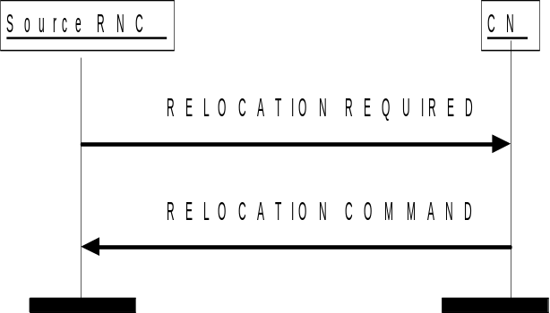

Figure 1: Relocation Preparation procedure. Successful operation.
The source RNC shall initiate the procedure by generating RELOCATION REQUIRED message. The source RNC shall decide whether to initiate the intra-system Relocation or the inter-system handover. In case of intra-system Relocation the source RNC shall indicate in the Source ID IE the RNC-ID of the source RNC and in the Target ID IE the RNC-ID of the target RNC. In case of inter-system handover the source RNC shall indicate in the Source ID IE the Service Area Identifier and in the Target ID IE the cell global identity of the cell in the target system. The source RNC shall indicate the appropriate cause value for the Relocation in the Cause IE. Typical cause values are "Time critical Relocation", "Resource optimisation relocation", "Relocation desirable for radio reasons" , "Directed Retry", "Reduce Load in Serving Cell".
The source RNC shall determine whether the relocation of SRNS shall be executed with or without involvement of UE. The source RNC shall set the Relocation Type IE accordingly to "UE involved in relocation of SRNS " or "UE not involved in relocation of SRNS ".
In case of intra-system Relocation, the source RNC shall include in the RELOCATION REQUIRED message the Source RNC to Target RNC Transparent Container IE. This container shall include the Relocation Type IE and the number of Iu signalling connections existing for the UE by setting correctly the Number of Iu Instances IE . If available, this container shall further include the Chosen Integrity Protection Algorithm IE and the Integrity Protection Key IE. If ciphering is active, this container shall include, for ciphering information of signalling data, the Chosen Encryption Algorithm IE and the Ciphering Key IE, for ciphering information of CS user data the Chosen Encryption Algorithm CS IE and for ciphering information of PS user data the Chosen Encryption Algorithm PS IE. This container shall include the RRC Container IE. If the Relocation Type IE is set to "UE not involved in relocation of SRNS" and the UE is using DCH(s), DSCH(s) or USCH(s), the Source RNC to Target RNC Transparent Container IE shall include the mapping between each RAB subflow and transport channel identifier(s), i.e. if the RAB is carried on a DCH(s), the DCH ID(s) shall be included, and when it is carried on DSCH(s) or USCH(s), the DSCH ID(s) or USCH ID(s) respectively shall be included. If the Relocation Type IE is set to "UE not involved in relocation of SRNS", the d-RNTI IE shall be included in the Source RNC to Target RNC Transparent Container IE. If the Relocation Type IE is set to "UE involved in relocation of SRNS", the Target Cell ID IE shall be included in the Source RNC to Target RNC Transparent Container IE.
In case of inter-system handover to GSM the RNC:
- shall include MS Classmark 2 and MS Classmark 3 IEs received from the UE in the RELOCATION REQUIRED message to the CN.
- shall include the Old BSS to New BSS Information IE within the RELOCATION REQUIRED message only if the information is available. This information shall include, if available, the current traffic load in the source cell, i.e. prior to the inter-system handover attempt.
The source RNC shall send the RELOCATION REQUIRED message to the CN and the source RNC shall start the timer T_{RELOCprep.}
When the preparation including resource allocation in the target system is ready and the CN has decided to continue the relocation of SRNS, the CN shall send RELOCATION COMMAND message to the source RNC and the CN shall start the timer T_{RELOCcomplete}.
If the Target RNC To Source RNC Transparent Container IE or the L3 information IE is received by the CN from the relocation target, it shall be included in the RELOCATION COMMAND message.
The RELOCATION COMMAND message may also contain the Inter-System Information Transparent Container IE.
For each RAB successfully established in the target system and originating from the PS domain, the RELOCATION COMMAND message shall contain at least one pair of Iu transport address and Iu transport association to be used for the forwarding of the DL N-PDU duplicates towards the relocation target. If more than one pair of Iu transport address and Iu transport association is included, the source RNC shall select one of the pairs to be used for the forwarding of the DL N-PDU duplicates towards the relocation target. Upon reception of the RELOCATION COMMAND message from the PS domain, the source RNC shall start the timer T_{DATAfwd.}
The Relocation Preparation procedure is terminated in the CN by transmission of RELOCATION COMMAND message.
If the target system (including target CN) does not support all existing RABs, the RELOCATION COMMAND message shall contain a list of RABs indicating all the RABs that are not supported by the target system. This list is contained in the RABs to Be Released IE. The source RNC shall use this information to avoid transferring associated contexts where applicable and may use this information e.g. to decide if to cancel the relocation or not. The resources associated with these not supported RABs shall not be released until the relocation is completed. This is in order to make a return to the old configuration possible in case of a failed or cancelled relocation.
Upon reception of RELOCATION COMMAND message the source RNC shall stop the timer T_{RELOCprep}, RNC shall start the timer T_{RELOCOverall} and RNC shall terminate the Relocation Preparation procedure. The source RNC is then defined to have a Prepared Relocation for that Iu signalling connection.
When Relocation Preparation procedure is terminated successfully and when the source RNC is ready, the source RNC should trigger the execution of relocation of SRNS.

Interactions with other procedures:
If, after RELOCATION REQUIRED message is sent and before the Relocation Preparation procedure is terminated, the source RNC receives a RANAP message initiating an other connection oriented RANAP class 1 or class 3 procedure (except IU RELEASE COMMAND message, which shall be handled normally) via the same Iu signalling connection, the source RNC shall either:
1. cancel the Relocation Preparation procedure i.e. execute Relocation Cancel procedure with an appropriate value for the Cause IE, e.g. "Interaction with other procedure", and after successful completion of Relocation Cancel procedure, the source RNC shall continue the initiated RANAP procedure;
or
2. terminate the initiated RANAP procedure without any changes in UTRAN by sending appropriate response message with the cause value “Relocation Triggered” to the CN. The source RNC shall then continue the relocation of SRNS.
If during the Relocation Preparation procedure the source RNC receives a DIRECT TRANSFER message it shall be handled normally.
If during the Relocation Preparation procedure the source RNC receives connection oriented RANAP class 2 messages (with the exception of DIRECT TRANSFER message) it shall decide to either execute the procedure immediately or suspend it. In the case the relocation is cancelled the RNC shall resume any suspended procedures (if any).
After Relocation Preparation procedure is terminated successfully, all RANAP messages (except IU RELEASE COMMAND message, which shall be handled normally) received via the same Iu signalling bearer shall be ignored by the source RNC.

8.7 Relocation Resource Allocation

8.7.2 Successful Operation
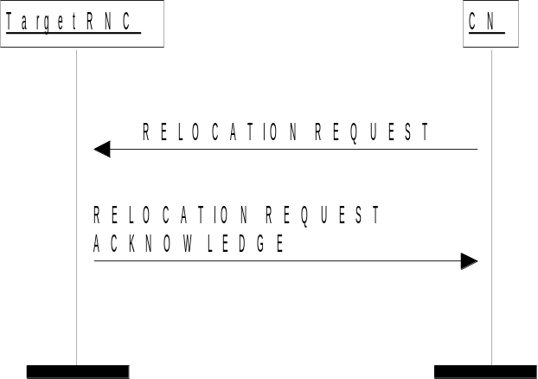

Figure 2: Relocation Resource Allocation procedure. Successful operation.
The CN shall initiate the procedure by generating RELOCATION REQUEST message. In a UTRAN to UTRAN relocation, this message shall contain the information (if any) required by the UTRAN to build the same RAB configuration as existing for the UE before the relocation. The CN may indicate that RAB QoS negotiation is allowed for certain RAB parameters and in some cases also which alternative values to be used in the negotiation.
The CN shall transmit the RELOCATION REQUEST message to target RNC and the CN shall start the timer T_{RELOCalloc.}
When a RELOCATION REQUEST message is sent from a CN node towards an RNC for which the sending CN node is not the default CN node, the Global CN-ID IE shall be included.
Upon reception of the RELOCATION REQUEST message, the target RNC shall initiate allocation of requested resources.
The RELOCATION REQUEST message shall contain following IEs
- Permanent NAS UE Identity IE (if available)
- Cause
- CN Domain Indicator
- Source RNC To Target RNC Transparent Container
- Iu Signalling Connection Identifier
- Integrity Protection Information IE (if available)
For each RAB requested to relocate (or to be created e.g. in the case of inter-system handover), the message shall contain following IEs:
- RAB-ID
- NAS Synchronisation Indicator IE (if the relevant NAS information is provided by the CN)
- RAB parameters
- User Plane Information
- Transport Layer Address
- Iu Transport Association
- Data Volume Reporting Indication (only for PS)
- PDP Type Information (only for PS)
The RELOCATION REQUEST message may include following IEs:
- Encryption Information (shall not be included if the Integrity Protection Information IE is not included)
For each RAB requested to relocate the message may include following IEs:
- Service Handover.
- Alternative RAB Parameter Values.
The following information elements received in RELOCATION REQUEST message require the same special actions in the RNC as specified for the same IEs in the RAB Assignment procedure:
- RAB-ID
- User plane Information(i.e. required User Plane Mode and required User Plane Versions)
- Priority level, queuing and pre-emption indication
- Service Handover
The SDU Format Information Parameter IE in the RAB Parameters IE shall be present only if the User Plane Mode IE is set to “support mode for pre-defined SDU sizes” and the Traffic Class IE is set to either “Conversational” or “Streaming”.
If the RELOCATION REQUEST message includes the PDP Type Information IE, the UTRAN may use this IE to configure any compression algorithms.

The Cause IE shall contain the same value as the one received in the related RELOCATION REQUIRED message.
The Iu Signalling Connection Identifier IE contains an Iu signalling connection identifier which is allocated by the CN, and which the RNC is required to store and remember for the duration of the Iu connection.
The algorithms within the Integrity Protection Information IE and the Encryption Information IE shall be ordered in preferred order with the most preferred first in the list.
The Permitted Encryption Algorithms IE within the Encryption Information IE may contain “no encryption” within an element of its list in order to allow the RNC not to cipher the respective connection. This can be done either by not starting ciphering or by using the UEA0 algorithm. In the absence of the Encryption Information IE, the RNC shall not start ciphering.
The Global CN-ID IE contains the identity of the CN node that sent the RELOCATION REQUEST message, and it shall, if included, be stored together with the Iu signalling connection identifier. If the Global CN-ID IE is not included, the RELOCATION REQUEST message shall be considered as coming from the default CN node for the indicated CN domain.
Following additional actions shall be executed in the target RNC during Relocation Resource Allocation procedure:
If the Relocation Type IE is set to "UE involved in relocation of SRNS":
- The target RNC may accept a requested RAB only if the RAB can be supported by the target RNC.
- Other RABs shall be rejected by the target RNC in the RELOCATION REQUEST ACKNOWLEDGE message with an appropriate value for Cause IE, e.g. "Unable to Establish During Relocation".
- The target RNC shall include information adapted to the resulting RAB configuration in the target to source RNC transparent container to be included in the RELOCATION REQUEST ACKNOWLEDGE message sent to the CN. If the target RNC supports triggering of the Relocation Detect procedure via the Iur interface, the RNC shall assign a d-RNTI for the context of the relocation and include it in the container. If two CNs are involved in the relocation of SRNS, the target RNC may, however, decide to send the container to only one CN.
- If any alternative RAB parameter values have been used when allocating the resources, these RAB parameter values shall be included in the RELOCATION REQUEST ACKNOWLEDGE message within the Assigned RAB Parameter Values IE.
If the Relocation Type IE is set to "UE not involved in relocation of SRNS":
- The target RNC may accept a RAB only if the radio bearer(s) for the RAB either exist(s) already, and can be used for the RAB by the target RNC, or does not exist before the relocation but can be established in order to support the RAB in the target RNC.
- If existing radio bearers are not related to any RAB that is accepted by target RNC, the radio bearers shall be ignored during the relocation of SRNS and the radio bearers shall be released by radio interface protocols after completion of relocation of SRNS.
- If any alternative RAB parameter values have been used when allocating the resources, these RAB parameter values shall be included in the RELOCATION REQUEST ACKNOWLEDGE message within the Assigned RAB Parameter Values IE. It should be noted that the usage of alternative RAB parameter values is not applicable to the UTRAN initiated relocation of type "UE not involved in relocation of SRNS".
After all necessary resources for accepted RABs including the initialised Iu user plane, are successfully allocated, the target RNC shall send RELOCATION REQUEST ACKNOWLEDGE message to the CN.
For each RAB successfully setup the RNC shall include following IEs:
- RAB ID
- Transport Layer Address (when no ALCAP has been used)
- Iu Transport Association (when no ALCAP has been used)
Two pairs of Transport Layer Address IE and Iu Transport Association IE may be included for RABs established towards the PS domain.
For each RAB the RNC is not able to setup during Relocation Resource Allocation the RNC shall include the RAB ID IE and the Cause IE within the RABs Failed To Setup IE. The resources associated with the RABs indicated as failed to set up shall not be released in the CN until the relocation is completed. This is in order to make a return to the old configuration possible in case of a failed or cancelled relocation.
The RELOCATION REQUEST ACKNOWLEDGE message sent to by the CN shall, if applicable and if not sent via the other CN domain, include the Target RNC To Source RNC Transparent Container IE .This container shall be transferred by CN to the source RNC or the external relocation source while completing the Relocation Preparation procedure.
If the target RNC supports cell load-based inter-system handover, then in the case of inter-system handover, the New BSS to Old BSS Information IE may be included in the RELOCATION REQUEST ACKNOWLEDGE message. This information shall include, if available, the current traffic load in the target cell assuming a successful completion of the handover in progress.
If the Integrity Protection Information IE was included in the RELOCATION REQUEST message, the RNC shall include the Chosen Integrity Protection Algorithm IE within the RELOCATION REQUEST ACKNOWLEDGE message, if the Encryption Information IE was included, the RNC shall include the Chosen Encryption Algorithm IE.
If one or more of the RABs that the target RNC has decided to support can not be supported by the CN, then these failed RABs shall not be released towards the target RNC until the relocation is completed.
If the NAS Synchronisation Indicator IE is contained in the RELOCATION REQUEST message, the target RNC shall pass it to the source RNC within the RRC Container IE contained in the Target RNC to Source RNC Transparent Container IE.
Transmission and reception of RELOCATION REQUEST ACKNOWLEDGE message terminates the procedure in the UTRAN and the CN respectively.
Before reporting the successful outcome of the Relocation Resource allocation procedure, the RNC shall have executed the initialisation of the user plane mode as requested by the CN in the User Plane Mode IE. If the RNC can not initialise the requested user plane mode for any of the user plane mode versions in the UP Mode Versions IE according to the rules for initialisation of the respective user plane mode versions, as described in [6], the RAB Relocation shall fail with the cause value "RNC unable to establish all RFCs".

8.7.3 Unsuccessful Operation
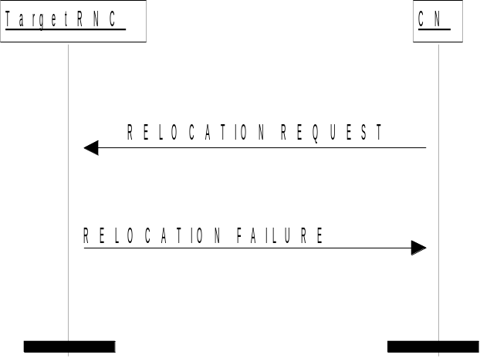

Figure 3: Relocation Resource Allocation procedure: Unsuccessful operation.
If the target RNC can not even partially accept the relocation of SRNS or a failure occurs during the Relocation Resource Allocation procedure in the target RNC, the target RNC shall send RELOCATION FAILURE message to the CN.
Transmission and reception of RELOCATION FAILURE message terminates the procedure in the UTRAN and the CN respectively.
When CN has received RELOCATION FAILURE message from target RNC, CN shall stop timer T_{RELOCalloc} and shall assume possibly allocated resources within target RNC completely released.
In the case of inter-system handover, and if the target RNC supports cell load-based inter-system handover, then
- the NewBSS to Old BSS Information IE may be included in the RELOCATION FAILURE message. This information shall include, if available, the current traffic load in the target cell.
- the RELOCATION FAILURE message may contain the appropriate value in the Cause IE, e.g. "No Radio Resources Available in Target Cell".

