Does causal probing resist spurious features better than diagnostic probing?
A finite-complexity view
Tiago Pimentel
ETH Zürich
tiago.pimentel@inf.ethz.ch
2026-06-02

The question
Two recent results put diagnostic and causal probing in the same uncomfortable place. A sufficiently powerful diagnostic probe always recovers a target property from a model’s representations (Pimentel et al. 2020); and a sufficiently complex alignment map makes any algorithm a distributed abstraction of any network (Sutter et al. 2025). Both are statements about a limit: at infinite complexity either method can fit any target—random ones included—so its reported score says nothing about the network. Read at face value, the causal result says that causal probing is no better than diagnostic probing: it leaves us where diagnostic probing did.
But that is a claim about the limit, and we never work there. At finite complexity and finite data neither method can fit everything, and the extra structure in a causal probe—it must act through the frozen network rather than emit a label directly—might make it harder to fit spurious patterns than a diagnostic probe of comparable power. If so, causality helps in practice even though both methods fail in the limit. This note asks whether it does.

A shared measure of spuriousness
We measure how readily a method fits structure that is not there: relabel the data at random and see how well the method still fits it. The expected best fit a hypothesis class achieves on such random targets is, up to scaling, its empirical Rademacher complexity (Bartlett and Mendelson 2002). We use it, in accuracy space, as a spurious-fitting capacity that applies unchanged to both methods—random labels for a diagnostic probe, a randomly relabelled counterfactual target for causal probing (DAS; (Geiger et al. 2024)). Both methods fail in the limit, but they may fail at different rates, and the method that fits random labels less readily is the safer one to use.

Setup
We use the hierarchical equality task of Sutter et al. (2025): the input is two pairs of vectors and the label is whether the pairs are both equal or both unequal, $O=(W​=​X)=(Y​=​Z)$. We train a small MLP to solve it and study the intermediate concept $WX=(W​=​X)$. The diagnostic probe is a linear classifier on the MLP’s first-layer activations; causal probing is linear DAS—a learned rotation of those activations with an interchange intervention on the WX subspace. We sweep the number of training examples $n$ and record each method’s train-set fit on the correct labels (signal) and on a fixed random relabelling (spurious capacity).

Findings
Both methods recover the concept on the correct labels: the probe decodes WX at $≈0.98$, and linear DAS reaches $≈0.999$ interchange-intervention accuracy. So the feature is at once decodable and interveneable.
The comparison that matters is on the random labels (Figure 1, dashed). Both methods memorise the smallest dataset ($n=30$) and both decay toward chance as $n$ grows. In between—where capacity, not data, is the binding constraint—DAS fits the random labels less readily than the probe at most sizes, most clearly at $n=90$ (probe $≈0.86$, DAS $≈0.66$). Taken at face value, DAS reaches the same signal while fitting noise less readily: its spurious-fitting capacity is the smaller of the two. That is the direction the finite-complexity hypothesis predicts—causal probing as the safer tool—even though, in the limit, both are equally vacuous.
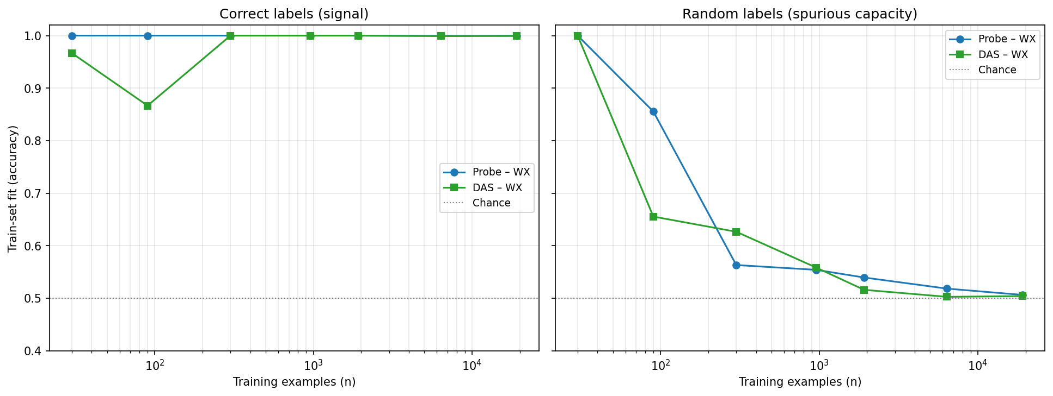
Train-set fit vs. number of training examples $n$, for the diagnostic probe and linear DAS, on correct labels (signal, solid) and a fixed random relabelling (spurious capacity, dashed). Both recover WX on the correct labels; on random labels both fall from perfect memorisation at small $n$ toward chance, and DAS’s curve lies at or below the probe’s at most sizes (most clearly at $n=90$), indicating lower spurious-fitting capacity. Single seed.
We report this as suggestive, not settled. The curves are single-seed and noisy—they cross once (at $n=300$), and DAS’s correct-label fit wobbles at the smallest $n$—so the gap, which rests largely on the $n=90$ point, needs averaging over seeds before it is leaned on.

What this is, and what it is not
This is a single-seed, single-task, linear-vs-linear comparison, with the “complexity” axis instantiated as dataset size rather than probe or alignment-map complexity proper. Two notes from building it. First, an earlier version measured DAS at chance and we nearly reported it as a negative result; that was an artefact of a multi-intervention data generator—the joint intervention produced label-homogeneous batches with no training signal—not a property of linear alignment, and restricting to a single, balanced intervention fixed it. Second, causal-probe training must be judged by a held-out, order-independent evaluation, not the running training accuracy, which drifts misleadingly. The natural next steps are averaging over seeds and sweeping a genuine complexity axis (deeper probes; non-linear RevNet alignment maps), the regime in which the limit results of Pimentel et al. (2020) and Sutter et al. (2025) guarantee that both methods must eventually fail.
Bartlett, Peter L., and Shahar Mendelson. 2002. “Rademacher and Gaussian Complexities: Risk Bounds and Structural Results.” Journal of Machine Learning Research 3: 463–82.
Geiger, Atticus, Zhengxuan Wu, Christopher Potts, Thomas Icard, and Noah D. Goodman. 2024. “Finding Alignments Between Interpretable Causal Variables and Distributed Neural Representations.” Causal Learning and Reasoning.
Pimentel, Tiago, Josef Valvoda, Rowan Hall Maudslay, Ran Zmigrod, Adina Williams, and Ryan Cotterell. 2020. “Information-Theoretic Probing for Linguistic Structure.” Proceedings of the 58th Annual Meeting of the Association for Computational Linguistics, 4609–22.
Sutter, Denis, Julian Minder, Thomas Hofmann, and Tiago Pimentel. 2025. “The Non-Linear Representation Dilemma: Is Causal Abstraction Enough for Mechanistic Interpretability?” Advances in Neural Information Processing Systems.

