Summary of Aim 1 (Chapter 3): results by figure.

Part 1. Control during high- vs. low-conflict language production 2
Figure 1 - Comparison of prediction accuracy from three classifiers. 2
Figure 2 - group-level per electrode classification (FDR-correction) 2

Part 2. Temporal localization of control. 4
Figure 3 - Timeline of Conflict 4
Figure 4 - Two examples of participant-level timelines. 6

Part 3. Generalizability of cognitive control across participants 7
Figure 5 - Comparison between within and across-participant decoding. 7

Appendix A: 8
Figure A-1 - Per electrode, participant results (uncorrected) 8
Figure A-2 - Per participant temporal generalization of within-classification results. 9
Figure A-3 - Per participant temporal generalization of cross-participant classification. 10

Control during high- vs. low-conflict language production: Can we distinguish between conflict states from EEG data?

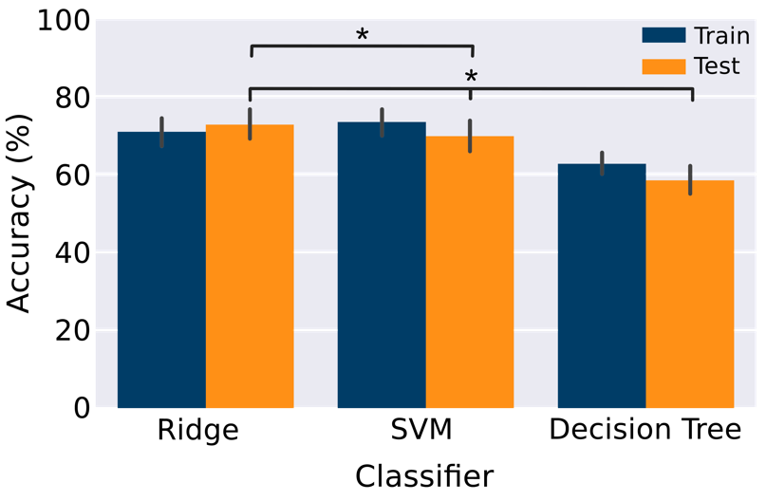
Figure 1 - Comparison of prediction accuracy from three classifiers.

Figure 1. Comparison of prediction accuracy from three classifiers, Ridge classifier, SVM, and Decision tree. The training accuracy determined by the inner cross-validation is shown in blue. Test accuracy, based on held-out blocks, is shown in orange. (SVM=support vector machine).
Methods: We compared the performance of three classifiers in determining conflict—decoding in congruent and incongruent conditions of Experiment 1. Each classifier was trained and evaluated on the average of eight repetitions of EEG recordings spanning the full trial time window (cue to 1000ms). EEG trials and corresponding labels were split into train, validation, and test using a 5-fold nested cross-validation scheme, stratified by trial blocks, accuracy is calculated and averaged per fold across participants. We measured model performance through classification accuracy for each test set. Significance was measured through permutation testing to determine the distribution under the null hypothesis and define significant confidence intervals per model.
Results: Of the three classifiers, the ridge and the SVM both performed significantly above chance (69.6%, SD=10.6 and 72.6%, SD = 10.2, respectively), but the DT classifier did not (53.8%, SD=11.6). Furthermore, using linear regression, the ridge classifier decoded the conditions significantly better than SVM and Decision Tree (see Figure 3.1).
Implications: Our results indicate that the neural signatures of conflict, as measured through simple classifiers, can decode congruent and incongruent trials with a ridge regression classifier that performs optimally. Overall, the results imply that, despite signal noise, the condition effects are robust at a group level and suitable for subsequent analyses.

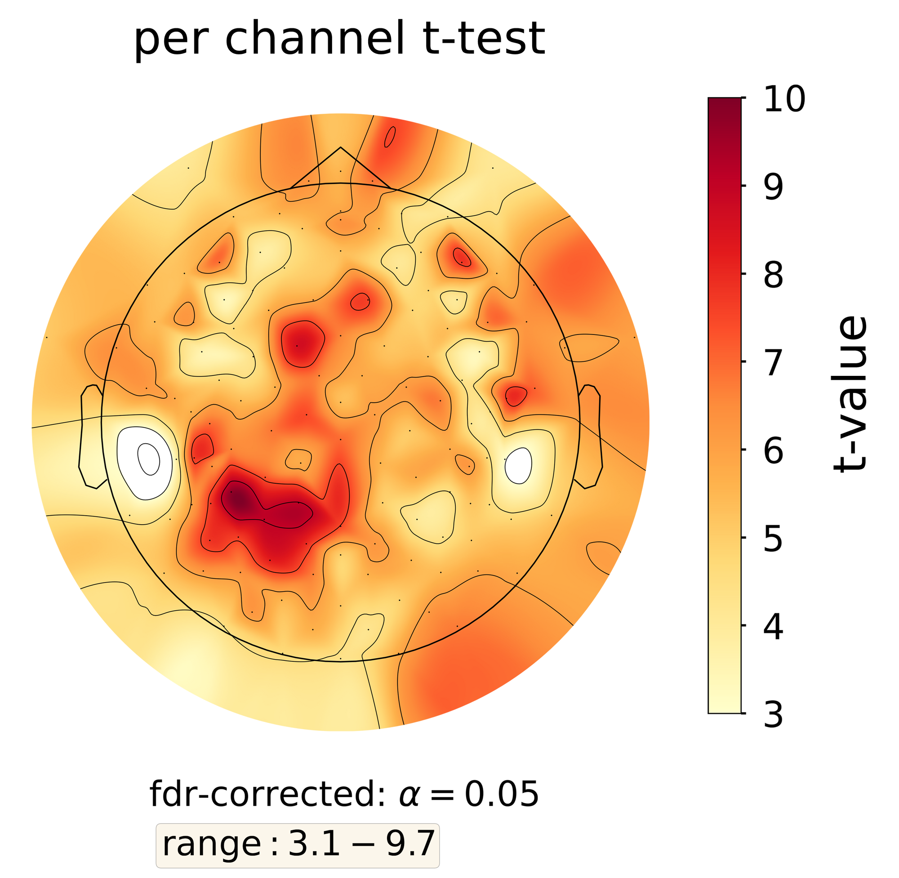
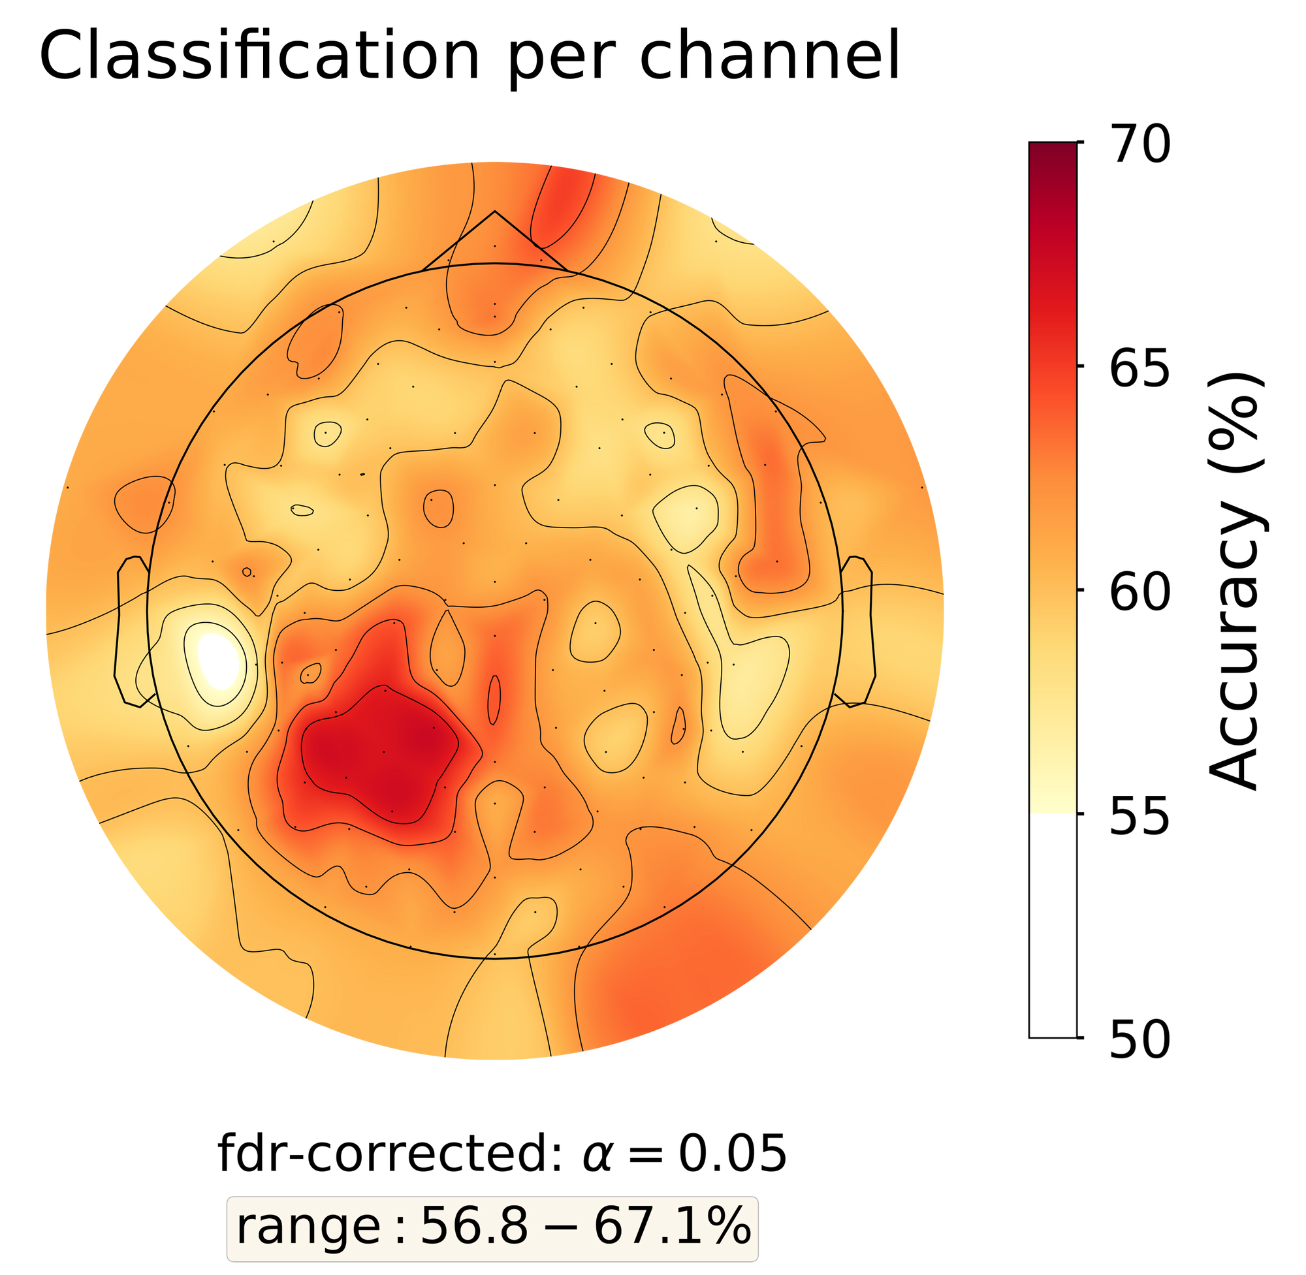
Figure 2 - group-level per electrode classification (after FDR-correction)

(a)
(b)
Figure 2. Classifier performance per EEG electrode averaged for all participants. (a) The classification accuracy averaged per electrode. (b) Results of the t-test comparing high vs. low conflict classification accuracy. The resulting accuracies were thresholded at 55% and corrected for FDR (= 0.05). The optimal classifier from the full trial analysis (Section 3.2.1) was selected, trained, and tested on each electrode for each participant.

Methods: Classification of high- and low-conflict states tested per participant at each EEG electrode across the full trial period. A one-sided t-test was completed using a population mean of 50% and observed classification accuracies thresholded at 55% [1]. False positives were controlled using the Benjamini-Hochberg FDR correction with α=.05, to determine the significance of the classification accuracy of each electrode in all participants.
Results/implications: The electrodes with the highest t-values that remain significant after the FDR correction are typically located in the central posterior area. We do not find that electrodes placed around the face are the sole electrodes able to classify above chance. According to these findings, we deny the notion that the above-mentioned chance classification accuracy is caused by electrodes that are linked to an increase in muscle tension during more difficult situations.

Temporal localization of control: What is the timeline of resolving conflict in the brain?

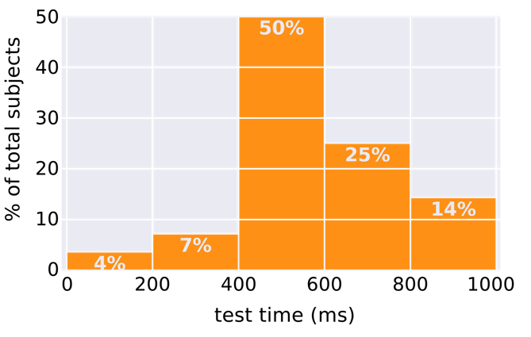
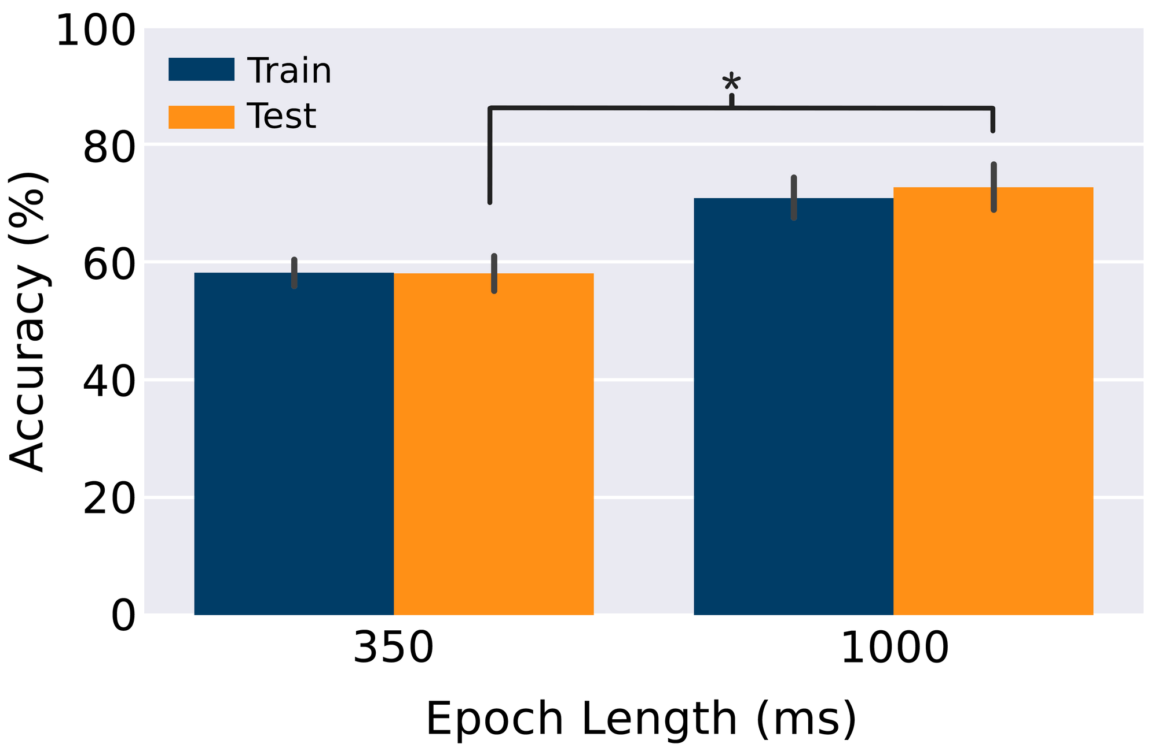
Figure 3 - Timeline of conflict

(a)
(b)
Figure 3. Timeline of control. (a) Comparison of ridge classifier performance within an early epoch (350ms) vs. full trial (1000ms). The training accuracy is shown in blue. Test accuracy, based on held-out blocks, is shown in orange. (b) Percent distribution of participants’ peak performance train-test time window. Train-test time window where the classifier performs optimally per participant is shown in histogram with 200ms bin width.
Figure 3a - Comparison between lexical selection window with full trial duration.
Methods: We compared the performance of ridge classifiers trained and tested on the full trial window (cue to 1000ms) to that of those trained and tested on the expected lexical selection window (cue to 350ms extended beyond 300ms to account for response time variation).
Results: We found that the classification accuracy of models trained and tested on full trials was significantly higher when the entire time window was used, compared to an earlier window usually considered relevant to lexical selection.
Implications: The results suggest that neural signatures of conflict at the group level, measured by the classification of congruent and incongruent trials, are observed throughout the timeline of picture naming to word production, extending beyond the expected time window of ’lexical selection,’ as described by Indefrey and Levelt (2004). Based on these results, we reject the hypothesis that all information attributing to high vs. low-conflict conditions is limited to the proposed lexical selection time window in every participant.

Figure 3b - Individual timelines in cognitive control: distribution of peak accuracy
Methods: We implemented a sliding-window analysis using a ridge classifier trained on 50ms segments of EEG trials. Each full 1000ms trial is segmented into overlapping time windows of 50ms duration and 10ms step size. An individual classifier is trained on epochs within a 50ms time window and tested on all epochs in all time windows. The peak test accuracy is identified across classifiers trained and tested along an expanded diagonal per participant. Temporal localization is defined as the test time window when the peak test accuracy occurs. For each model, cluster-wise significance was measured after non-parametric multiple-comparisons correction with a p<0.05. Participant-wise distributions of cluster sizes under the null hypothesis were acquired through permutations, with an initial classification accuracy cutoff of 55%.
Results: We found that the ridge classifier successfully decodes high and low-conflict conditions, which are expected to recruit cognitive control, when given only 50 ms of EEG recordings. The observed time of peak accuracy per participant is dispersed across the entire 1000ms trial window. While some participants show early peak test accuracy, most peak after 400ms. Two examples of participant-level results are shown in Figure 3.
Implications: The dynamics in classification accuracy across time indicate that even lexical competition resolution, which has been traditionally expected in early (200-250 ms) time windows, can emerge much later in some speakers, highlighting the critical importance of individual differences in models of language production. The observed variability in peak time windows, reinforced by the findings from Section 3.4.1, motivates further participant-level analyses.

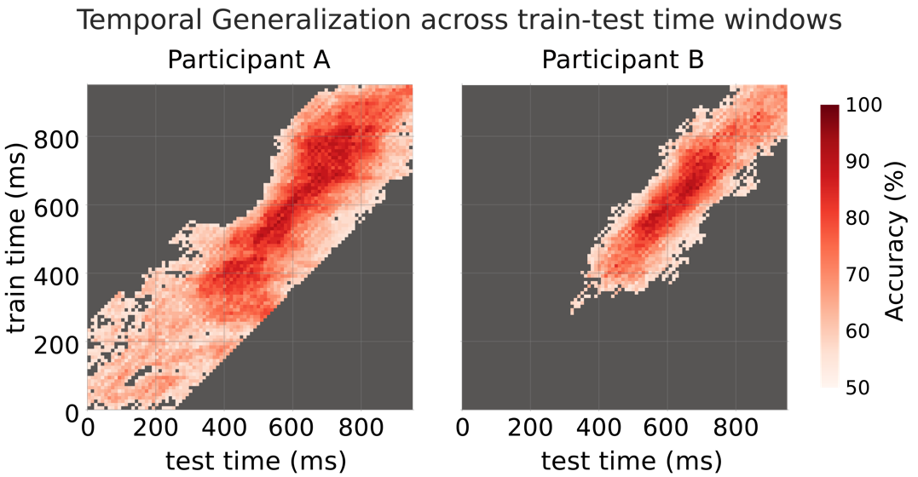
Figure 4 - Two examples of participant-level results (Individual timelines in cognitive control)

Figure 4. Temporal generalization plots in example participants. Example participants A (left) and B (right) show classifier train-test performance averaged on CV folds. y-axis: classifiers’ training epoch time window, x-axis: test epoch time windows, color map: performance accuracy threshold at >55% accuracy.

Note: Methods are described in previous section.

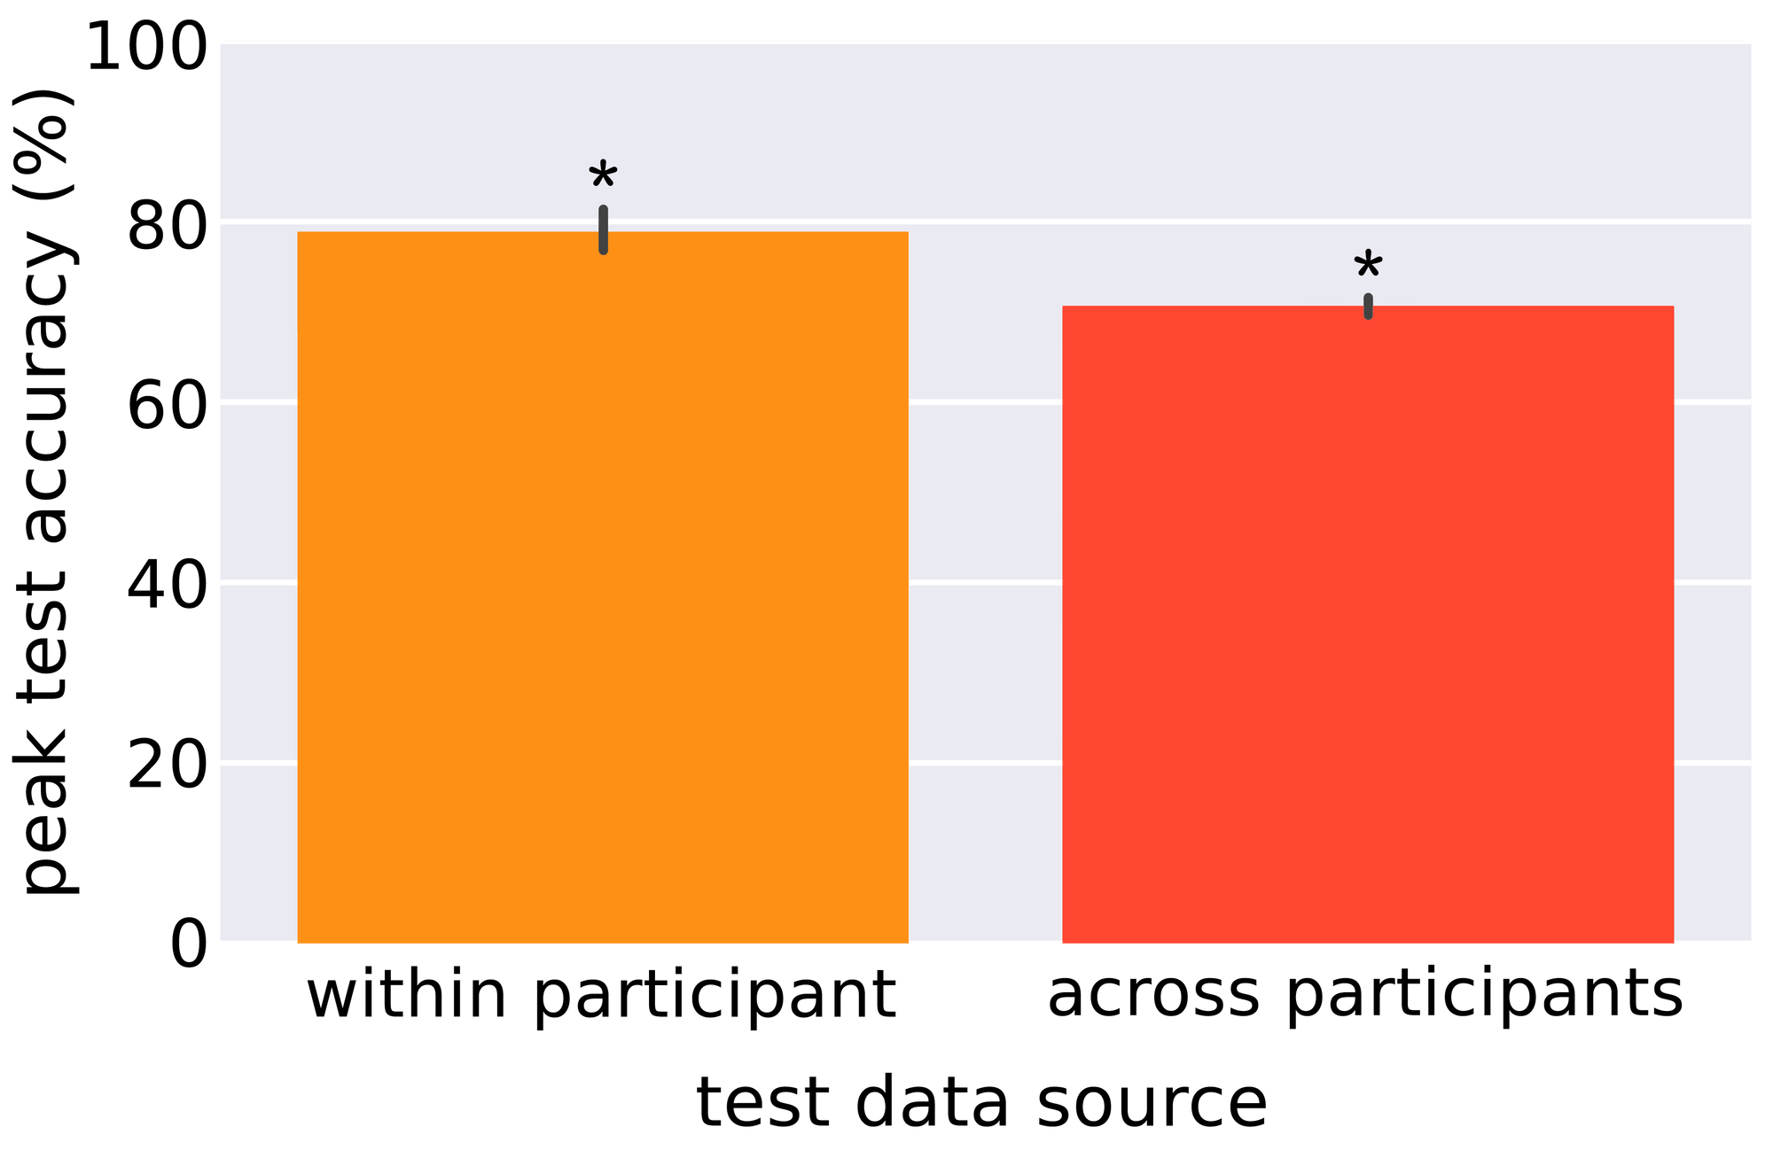
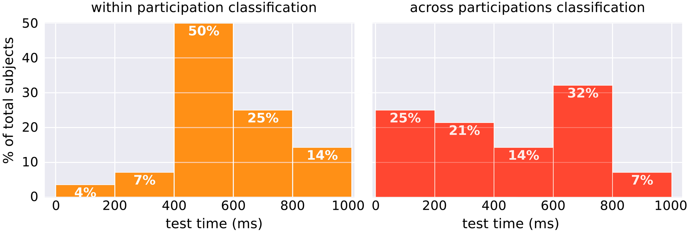
Generalizability of cognitive control across participants: Is there a commonality in how we resolve conflict?

(a)
(b)
Figure 5. Comparison between within and across-participant decoding. (a) Group-level cross-participant decoding: a comparison of peak performance accuracy of within- vs. across-participants trained classifiers. The maximal test accuracy is identified across classifiers trained and tested along an expanded diagonal per participant. (b) Timeline of conflict: Percent distribution of participants’ peak performance train-test time window. Train-test time window where the classifier performs optimally per participant is shown in the histogram with 200ms bin width.

Figure 5 - Comparison between within and across-participant decoding.
Methods: Each within-participant classifier is trained and tested on the same participant. Each across-participants classifier is trained on all but a single left-out test participant. To obtain the peak test accuracy value, trials are segmented into 146 overlapping epochs of 50ms in duration and 10ms step size. Individual classifiers were trained on epochs within a single 50ms time window and tested on all possible epochs from the entire trial length.
Results: Compared to the peak performance time window in within-participant versus across-participant classification, we see that the classifiers can decode conflict states above chance accuracy in both cases but greater in the within-participant classifiers.
Implications: Successful decoding suggests that participants’ neural signatures of conflict can be shifted in time. Furthermore, there are characteristics shared across participants that vary in temporal presentation from one participant to another.

Appendix A:

Figure A-1 - Per electrode, participant results (uncorrected)

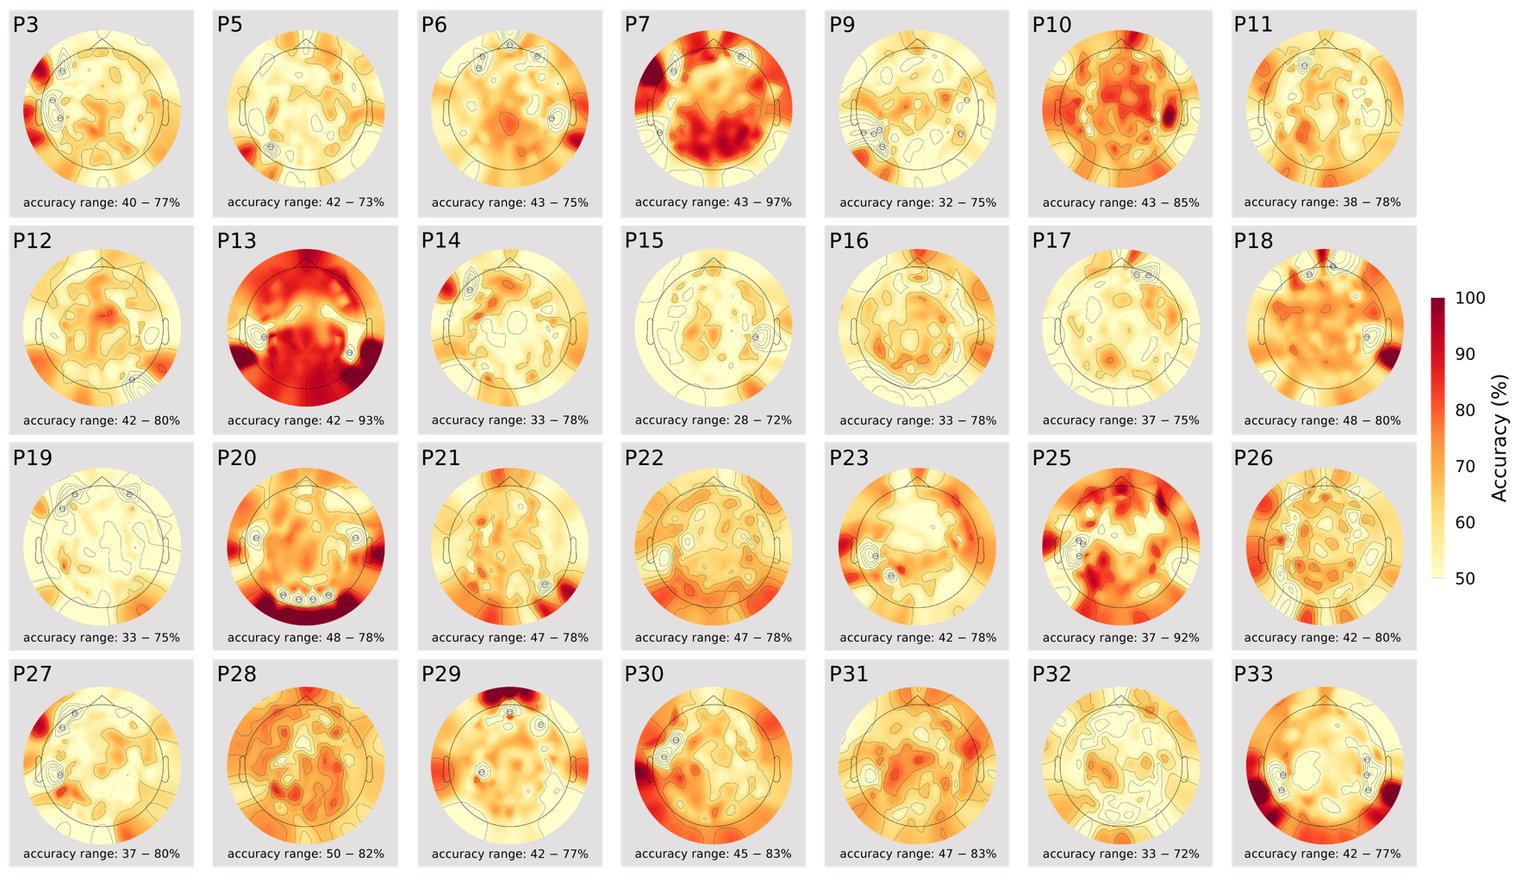

Figure A1. Classifier performance per EEG electrode per individual participant (a) The accuracy of decoding high vs low-conflict classification accuracy. Results for each participant were thresholded at 50% accuracy.

Figure A-2 - Per participant temporal generalization of within-classification results.
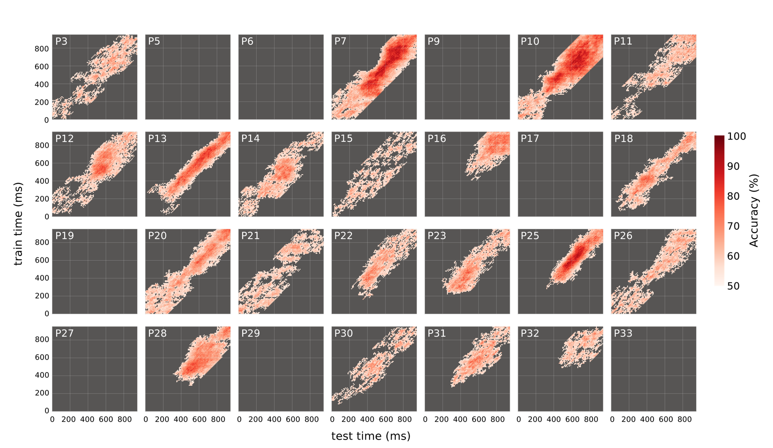

Figure A2. Within-participant classification across time. The temporal generalization plots for our 28 subjects of classifier train-test performance averaged on CV folds. Results demonstrate that 20 of them achieved classification accuracy that was higher than what would be expected by chance. y-axis: classifiers’ training epoch time window, x-axis: test epoch time windows, color map: performance accuracy clusters threshold at >55% accuracy, corrected for multiple comparisons with FDR correction across train-time windows.

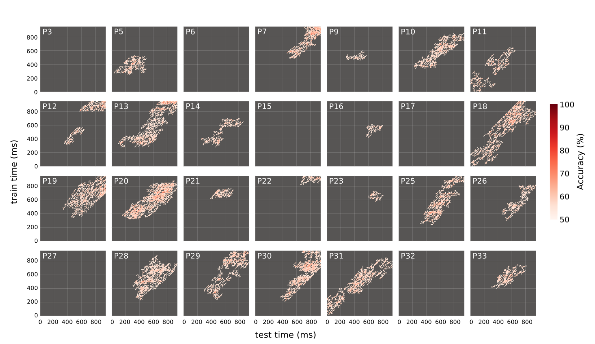
Figure A-3 - Per participant temporal generalization of cross-participant classification results.

Figure A3. The cross-participant temporal generalization plots for our 28 subjects of classifier train-test performance averaged on CV folds. Results demonstrate that 20 of them achieved classification accuracy that was higher than what would be expected by chance. y-axis: classifiers’ training epoch time window, x-axis: test epoch time windows, color map: performance accuracy clusters threshold at >55% accuracy, corrected for multiple comparisons with FDR correction across train-time windows.

Note: There are four participants where within-participant classification did not show any significant clusters but do show significant clusters in the cross-participant classification. This suggests that potentially there are some participants where their data may be noisy, but the shared neural signature across participants allows us to decode the two conflict states. There are also participants that we were able to classify within-participant with above-chance accuracy but not in the cross-participant classification. This suggests that these participants may be using a different strategy that is not common across all of them.

