

University of Cincinnati

College of Engineering and Applied Science

Implementing Monte Carlo Localization with the Lego Mindstorm

Senior Design Project  
Winter-Spring 2011

Seniors

Andrew Larger  
Zihao Lu  
Trevor Plassman  
Matt Schmucki  
Alicia Zwiebel

Advisor

Professor Dan Humpert

# Executive Summary

[insert text]

**Table of Contents**

Executive Summary 2

**1.** **Introduction** 4

**2.** **Background** 4

**3.** **Development** 4

3.1 Constructing the Course 4

3.2 Constructing the Robot 5

3.3 Programming the Robot 7

3.4 A* Navigation 7

3.5 Programming Monte Carlo Localization 7

3.5.1 Theory 8

3.5.2 Programming MCL 8

3.6 Difficulties 8

3.7 Testing 8

3.8 Future Work 8

**4.** **Conclusions** 8

**5.** **References** 9

**6.** **Appendix** 10

1. **Introduction**
2. **Background**
3. **Development**
   1. Constructing the Course

The robot needed to exist in a world of known exterior boundaries and variable interior boundaries. To achieve this, a large piece of plywood was offered and used as the base of this course. Interior dimensions were taken that would allow for maximum possible area while having perfect 90 degree corners. The dimensions allowed for the total length of the course to be 140 cm and 63 cm tall with a notch cut in one of the long ends 20 cm deep, 20 cm long and centered along the length of the plywood. Once the dimensions were marked off on the plywood base, a band saw was used to cut the piece to the exact dimensions.

The robot needed to be able to get the distances to these edges to accurately perform its task. To accomplish this, walls were measured out, cut with the band saw and screwed in place on these edges standing roughly 10 cm above the base level.

During testing of the robot, it was noticed that the marble on the robot used for turning was picking up quite a bit of resistance from the plywood due to its uneven surface. To smooth this out without creating an entirely new base piece, three pieces of poster board were cut up, laid on the course and then taped together.

With the exterior wall dimensions set, several smaller movable walls were put together to allow for some degree of variability in the course layout. These walls were made at 10, 15, and 20 cm long and stand slightly higher than the other walls due to the bases nailed on the bottom of them which add stability. These bases for the walls do not add additional length to the walls but do add approximately ½ cm of width on either side.

To complete the course, it was decided that it should be made easier to determine the actual location of the robot visually to compare with the results on screen. The poster board pieces were marked up with a square pattern of 5 cm by 5 cm to more accurately allow the group to determine visually the robot position on the map as well as determine the distances the robot should be reading and displaying. Along the interior walls, labels were then put in place showing the total length of each wall.

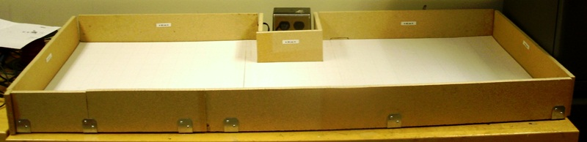

Figure 3.1.1: Completed Course

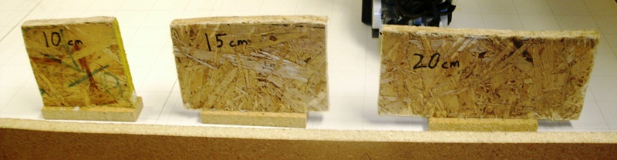

Figure 3.1.2: Mobile Walls

* 1. Constructing the Robot

The robot was designed and built using the Lego Mindstorm and compatible pieces. The major components are the control brick, two motors to control the two wheels, the compass sensor to get direction and allow for accurate 90 degree turns and the distance sensor to determine the distance to the nearest wall approximately straight out from the robot. A non-Lego component was used to allow the robot to turn with the least resistance possible. This piece is a marble held in place by an inverted wheel well. The marble will rotate in place and is located on the back end to balance the robot on three points, including the two wheels.

To design the robot, we first had to account for the two motors we had which would drive the robot, the control brick which would have to be situated somewhere above the motors, and the distance sensor. Our group decided to put the distance sensor beneath the control brick so as to not put it too high, which would have required taller walls as well as creating more potential variance in the readings if the sensor was angled too far down. Many different methods were attempted to create a rear wheel or wheels which would both balance the robot as well as allow for smooth turning in place. After several weeks, it was decided that a small marble could be held in place by one of the available wheel wells and that this would suffice for both turning smoothly and balance of the robot.

The compass sensor was acquired much later to better facilitate accurate turns of 90 degrees. However, it was discovered that the motors actually created some interference with the compass readings and the solution was to have to the sensor located at least 4 to 6 inches away from the motors. From the control brick, support beams were built up to a height sufficient to alleviate these interference issues.

[talk about sensor reading at an angle, catching wall]

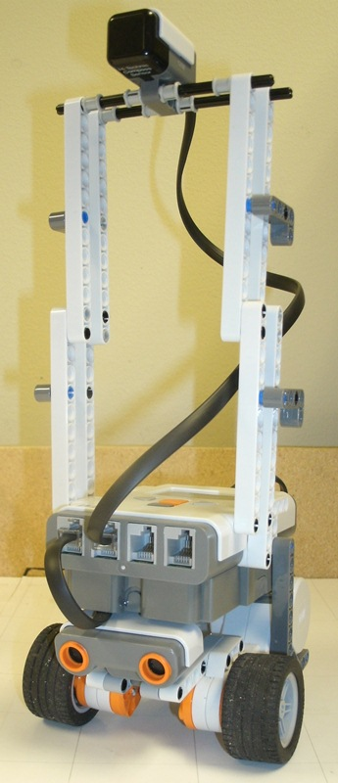

Figure 3.2.1: Completed Robot

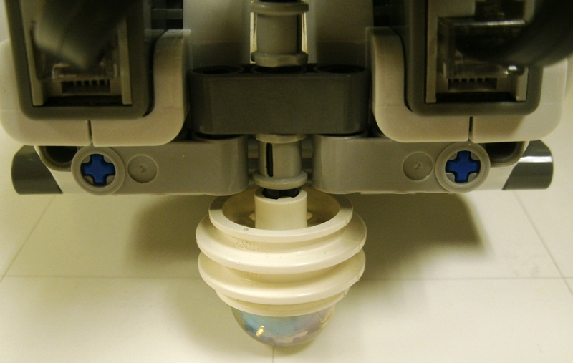

Figure 3.2.2: Marble Wheel Base Design

* 1. Programming the Robot
  2. A* Navigation
  3. Programming Monte Carlo Localization
     1. Theory

The basic theory of Monte Carlo Localization (MCL) is as follows. A large number of possible locations and orientations for the robot are initially created. At each updated reading of the distance and compass sensors, as well as each move, these possible locations and headings are updated. As the locations become impossible (possibly due to going out of bounds) or as the possibility becomes very low, they are removed and the grid is updated to reflect the remaining possible locations and headings with higher probabilities. As the moves continue, the map of locations continues to be updated until, theoretically, only one possible position remains. Realistically it may not be possible to reduce the possibilities to one, so often times these locations will appear as several clouds within a small area which will continuously be knocked out until only one of these clouds remains.

<<<<Insert pictures of map simplifying over several moves>>>>

* + 1. Programming MCL
  1. Difficulties
  2. Testing
  3. Future Work

1. **Conclusions**
2. **References**
3. **Appendix**