2 terminal ferroelectric capacitor CapacitorFerroelectric

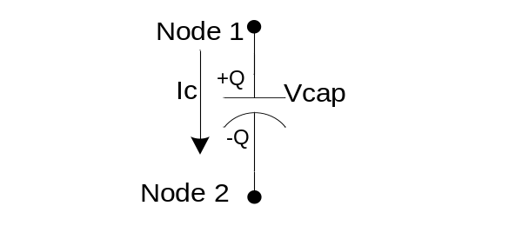
Fig 1: Ferroelectric capacitor element

Form: capacitorferroelectric:<instance name> n1 n2 <parameter list>
n1, n2 are the element terminals

Parameters:

Parameter | Type | Default Value | Required?
epsid: Interfacial capacitance density (F/m²) | DOUBLE | 32e-3 | no
epsb0: Bulk capacitance zero-bias permittivity (F/m) | DOUBLE | 170 | no
a: Area of cross-section of the parallel plate capacitor (m²⁾ | DOUBLE | n/a | yes
d: Total capacitor thickness (m) | DOUBLE | n/a | yes
t: 2 * (Interfacial Capacitor thickness at the plate dielectric interface) (m) | DOUBLE | 5e-9 | no
k: Fringing capacitance constant (F) | DOUBLE | 1.6e-15 | no
alpha3: Describes the non-linearity of the material in the Landau-Devonshire-Ginzburg model (m²/C²F) | DOUBLE | 3.3e-3 | no
T0: Curie-Weiss temperature for a particular BST film thickness (deg C) | DOUBLE | -167 | no
T: Current Temperature of the sample (deg C) | DOUBLE | -73 | no
beta: Temperature Coefficient of Capacitance (TCC) at zero bias (ppm/deg C) | DOUBLE | 600 | no
p: Device periphery for fringing capacitance calculations (m) | DOUBLE | n/a | yes

Example:

.model c_ferro capacitorferroelectric ( epsid =50e-3 epsb0=170 a=2000e-12 t=5e-9
+ k=2.0e-15 alpha3=3.3e-3 T0=-167 T=-80 beta=1000 p=240e-9)
capacitorferroelectric: cf1 3 0 model=”c_ferro” d=125e-9

Details:

This element models a non-linear ferroelectric capacitor. A parallel plate physical model of the capacitor is considered although this concept can be further extended to model ferroelectric IDCs (inter-digitated capacitors) and gap capacitors. This model accounts for interfacial, bulk capacitance and fringing capacitance. It also considers thickness and temperature dependence of the high-permittivity ferroelectric material. This model can be used during time-domain analysis. Leakage and breakdown currents are not modeled.

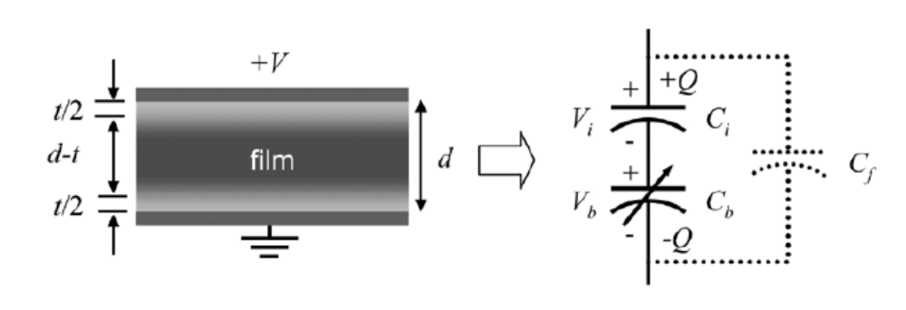
Fig 2: Ferroelectric capacitor model that includes the effect of the interfacial capacitance, bulk capacitance and fringing capacitance[2].

Data collected from experiments indicates that a “dead” layer non-tunable capacitance exists in series with a bulk non-linear capacitance. The voltage applied is dropped across a series combination of the interface capacitance at the two plate dielectric interfaces and the bulk ferroelectric dielectric material. While this model characterizes large area capacitors ( 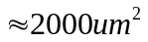) very well, small area capacitors need an additional fringing capacitance in parallel as shown in Fig. 2 to account for their reduced tunability compared to large area capacitors[2]. This model ignores the space-charge buildup near the electrodes.

With reference to Fig 2, both the interfacial capacitances are collectively described by a linear charge-voltage equation:

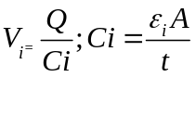
Here the interfacial capacitance density 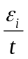is determined experimentally from a series of devices of varying thickness.

The bulk is described by a nonlinear equation from the Landau-Devonshire-Ginzburg (LDG) model [1] by:
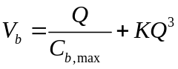 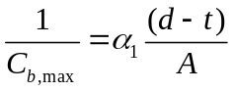 and 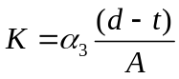

The total voltage across the device is then:

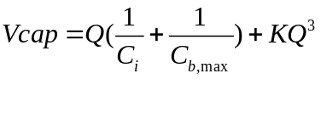
The fringing capacitance is independent of the field and thickness and is given by
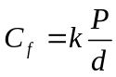
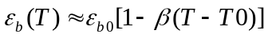
In the equations above
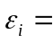 Interfacial material dielectric permittivity (F/m²)
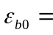 Bulk dielectric material zero-bias permittivity (F/m)
 Area of cross-section of the parallel plate capacitor (m²)
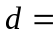 Total capacitor thickness (m)
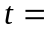 Interfacial capacitance thickness (m)
 Fringing capacitance constant (F)
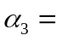Describes the non-linearity of the material in the Landau-Devonshire-Ginzburg
model (m²/C²F)
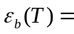Temperature dependent bulk dielectric zero-bias permittivity (F/m)
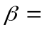Temperature Coefficient of capacitance (TCC) at zero bias (ppm/deg C)
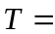Current Temperature of the sample (deg C)
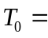Curie-Weiss temperature for a particular BST film thickness (deg C)
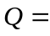 Charge on the capacitor (C )

Netlist file circuit:

The netlist model used to prove the correctness of the model is a RC coupling circuit. The netlist is run with three different values of output resistance ‘R’ to change the RC time-constant of the circuit as shown in the fig 3. The input square wave changes shape based on the RC time constant in comparison with the ‘T’ – the time period of the square wave.

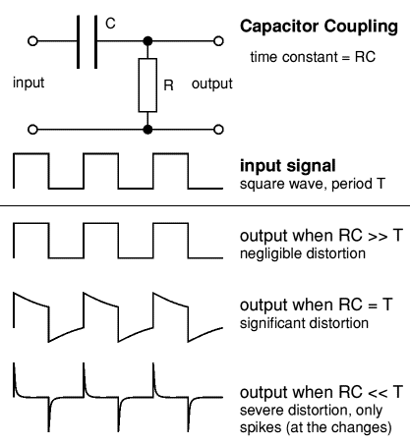

Fig3. Input square wave and output signal wave shapes based on the RC time constant value in comparison with ‘T’ – the time period of the wave [6].

Example of Transient analysis (.TRAN2) Fixed time steps, time-stepping nonlinear analysis

Netlist File:

*** Transient Analysis for the Ferroelectric capacitor

.options verbose
*.svtr tstop = 2e-5 n_freqs = 70 tstep = 0.25e-6
*.svtr tstop = 1e-4 n_freqs = 70 tstep = 0.25e-6

.tran2 tstop = 1e-4 tstep = 0.50e-6 out_steps=1 im=2

*vsource:1 1 0 vac=1.0 f=0.3e5 phase=90

vpulse:v1 1 0 v1=0 v2=5 td=0 tr=0.05e-5 tf=0.05e-5 pw=1.5e-5 per=3.5e-5
capacitorferroelectric:cf1 1 2 a=6500e-12 d=150e-9 p=160e-9

*RC time constant << T
*resistor:rin1 2 0 r=1000

*RC time constant ~ T
*resistor:rin1 2 0 r=25000

*RC time constant >> T
resistor:rin1 2 0 r=1000000

.options gnuplot
*.options postamble1 = "using 2:3"

.options plotVT1Preamble="set term x11 font 'helvetica,13';
set title 'Ferroelectric capacitor Voltage';
set xlabel 'TIME (microseconds)'; set ylabel 'VOLTAGE (V)'"
.out plot element "capacitorferroelectric:cf1" 0 ut 1e6 scalex plotVT1Preamble in "capacitorferroelectric_v.out"

.options plotVT1Preamble="set term x11 font 'helvetica,13';
set title 'Ferroelectric capacitor Current';
set xlabel 'TIME (microseconds)'; set ylabel 'Current (A)'"
.out plot element "capacitorferroelectric:cf1" 0 it 1e6 scalex plotVT1Preamble in "capacitorferroelectric_i.out"

.options plotVT1Preamble="set term x11 font 'helvetica,13';
set title 'Input Voltage Source';
set xlabel 'TIME (microseconds)'; set ylabel 'Voltage (V)'"
.out plot term 1 vt 1e6 scalex plotVT1Preamble in "source_v.out"

.options plotVT1Preamble="set term x11 font 'helvetica,13';
set title 'Voltage across resistor';
set xlabel 'TIME (microseconds)'; set ylabel 'Voltage (V)'"
.out plot term 2 vt 1e6 scalex plotVT1Preamble in "res_v.out"

*pack in "capacitorferroelectric_combo.out"
*.out plot "capacitorferroelectric_combo.out" postamble
**.out plot element "capacitorferroelectric22:cf1" 0 xt in "capacitorferroelectric_x.out"
*.out plot element "capacitorferroelectric22:cf1" 0 ut stripx in "capacitorferroelectric_v.out"
.end
Log File:

********** fREEDA 1.3 running on Sun Apr 20 22:54:49 2008 **********

*** Parsing input netlist ...

*** Expanding subcircuits ... done.

*** Initializing Elements ...cmax: 2.08002e-10
done.

*** Checking reference terminals ... done.

*** Starting analysis ...

-----------------------------------------------------------------------------
Matrix size = 3
Matrix nnz = 6
equed = 7.95719e-305
recip_pivot_growth = 1
1 / Condition number = 0.840131
info = 0
ferr = 9.70941e-308
berr = 1
No of nonzeros in factor L = 6
No of nonzeros in factor U = 6
No of nonzeros in L+U = 9
L\U MB 0.000 total MB needed 0.001 expansions 0
Using line search method.
Nonlinear analysis tolerance (ftol) = 6.12865e-06
Maximum number of nonlinear iterations per time-point (maxit) = 250
Using Lee and Lee's quasi-Newton updates.
--- Starting transient simulation ...

Number of nonlinear state variables: 1
-----------------------------------------------------------------------------------------
| Step | Time (s) | Residual | Recent Max | Max |
-----------------------------------------------------------------------------------------
| 0 | 0.000000e+00 | 0.000000e+00 | 0.000000e+00 *| 0.000000e+00 |
| 1 | 5.000000e-07 | 6.274981e-13 | 6.274981e-13 | 6.274981e-13 |
| 2 | 1.000000e-06 | 1.785239e-13 | 1.785239e-13 | 6.274981e-13 |
| 3 | 1.500000e-06 | 1.865175e-14 | 1.865175e-14 | 6.274981e-13 |
| 4 | 2.000000e-06 | 1.152591e-01 | 1.152591e-01 *| 1.152591e-01 |
| 5 | 2.500000e-06 | 1.152591e-01 | 1.152591e-01 *| 1.152591e-01 |
| 6 | 3.000000e-06 | 1.152591e-01 | 1.152591e-01 *| 1.152591e-01 |
| 7 | 3.500000e-06 | 1.152591e-01 | 1.152591e-01 *| 1.152591e-01 |
| 8 | 4.000000e-06 | 1.152591e-01 | 1.152591e-01 *| 1.152591e-01 |
| 9 | 4.500000e-06 | 1.152591e-01 | 1.152591e-01 *| 1.152591e-01 |
| 10 | 5.000000e-06 | 1.152591e-01 | 1.152591e-01 *| 1.152591e-01 |

: : : : : :
: : : : : :

| 190 | 9.500000e-05 | 1.124087e-01 | 1.124087e-01 *| 1.152591e-01 |
| 191 | 9.550000e-05 | 1.124087e-01 | 1.124087e-01 *| 1.152591e-01 |
| 192 | 9.600000e-05 | 1.124087e-01 | 1.124087e-01 *| 1.152591e-01 |
| 193 | 9.650000e-05 | 1.124087e-01 | 1.124087e-01 *| 1.152591e-01 |
| 194 | 9.700000e-05 | 1.124087e-01 | 1.124087e-01 *| 1.152591e-01 |
| 195 | 9.750000e-05 | 1.124087e-01 | 1.124087e-01 *| 1.152591e-01 |
| 196 | 9.800000e-05 | 1.124087e-01 | 1.124087e-01 *| 1.152591e-01 |
| 197 | 9.850000e-05 | 1.124087e-01 | 1.124087e-01 *| 1.152591e-01 |
| 198 | 9.900000e-05 | 1.124087e-01 | 1.124087e-01 *| 1.152591e-01 |
| 199 | 9.950000e-05 | 1.124087e-01 | 1.124087e-01 *| 1.152591e-01 |
| 200 | 1.000000e-04 | 1.124087e-01 | 1.124087e-01 *| 1.152591e-01 |
--- Maximum Residual: 0.115259
-----------------------------------------------------------------------------

Plotting output file: capacitorferroelectric_v.out.
Plotting output file: capacitorferroelectric_i.out.
Plotting output file: source_v.out.
Plotting output file: res_v.out.

************** fREEDA 1.3 stopping on Sun Apr 20 22:54:52 2008 ***********

Simulation Results in fREEDA:

Input Voltage Pulse:

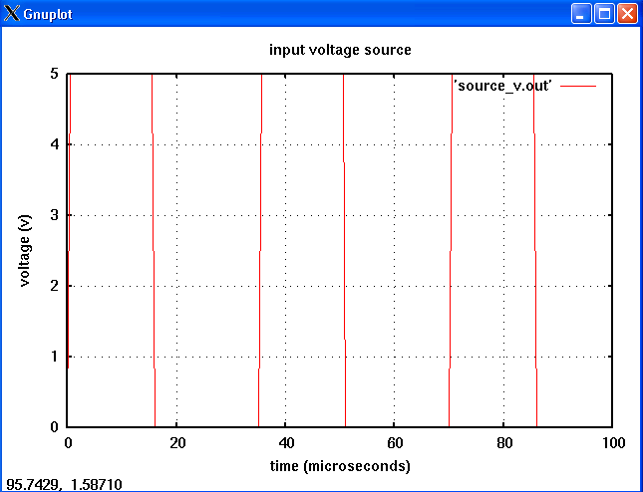

RC time constant ~ T:

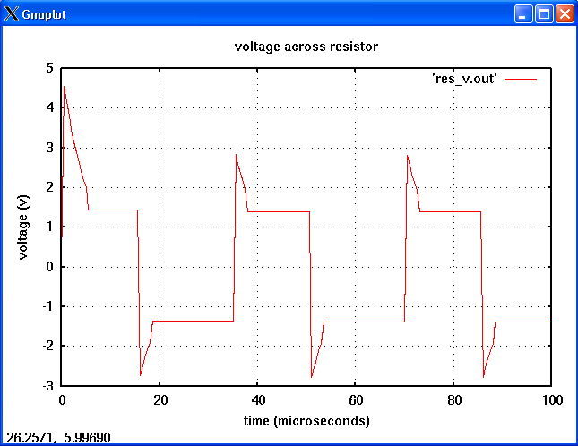

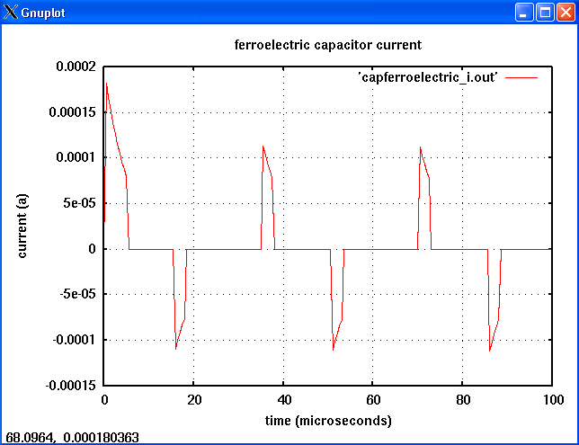

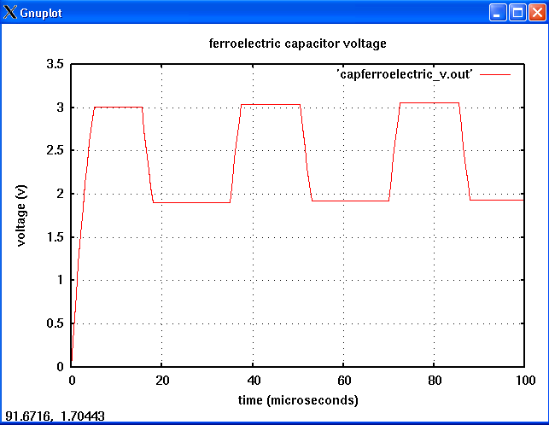

RC time constant << T:

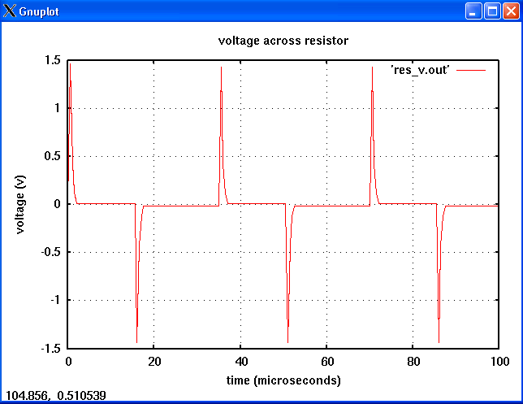

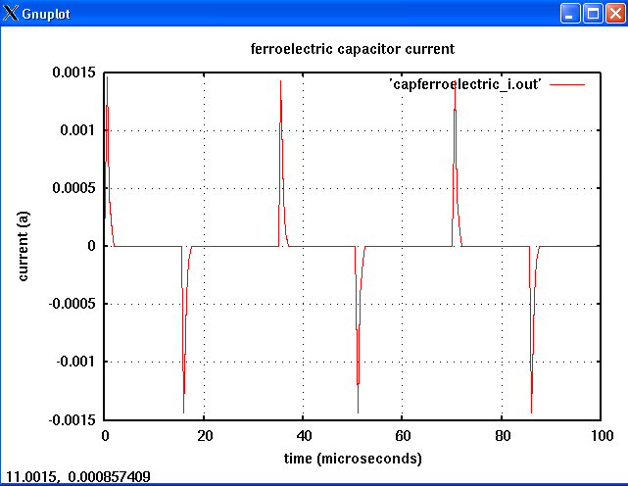

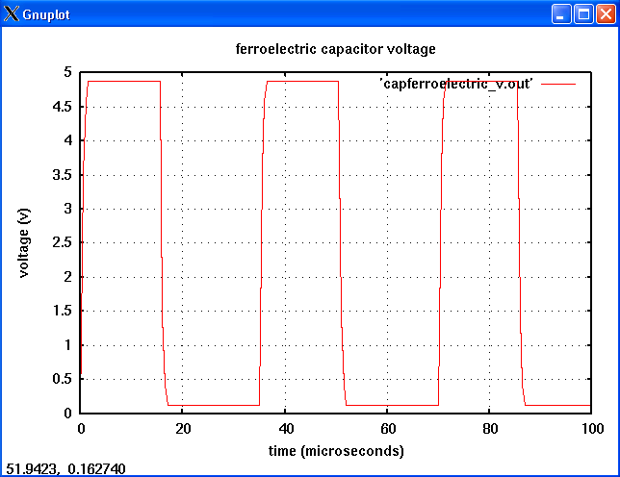
RC time constant >> T:

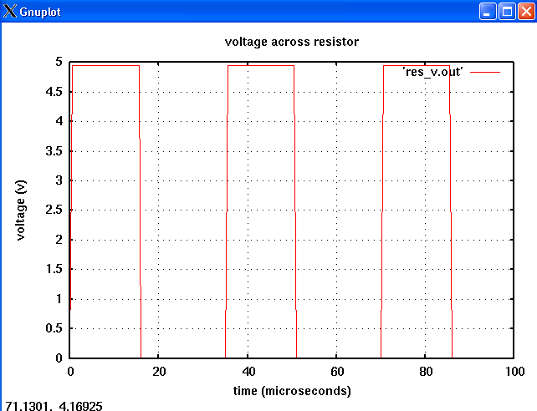

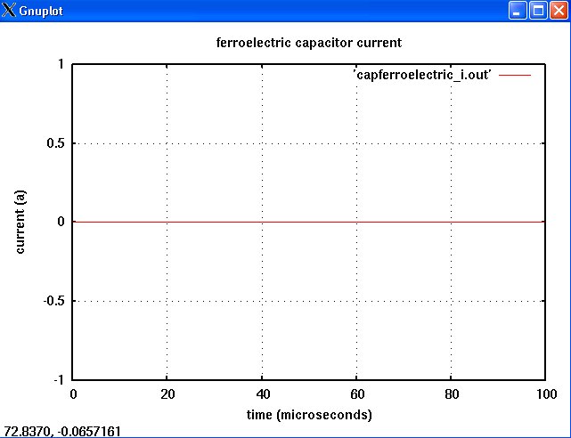

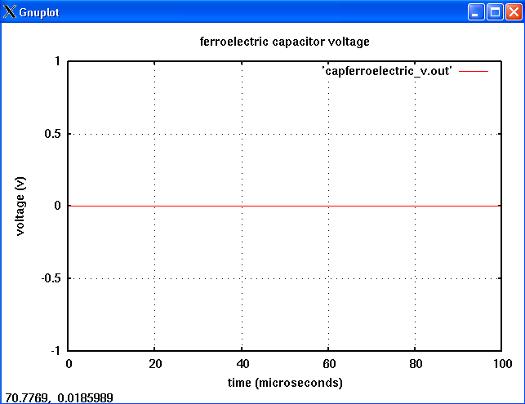

Version:
2008.04.20(2008 April 20)

Credits:
Name Affiliation Date Links
Vrinda Haridasan NC State University April 2008 
vharida@ncsu.edu

References:

- David R. Chase, Lee-Yin Chen, Robert York, “Modeling the Capacitive Nonlinearity in Thin-Film BST Varactors”, IEEE MTT-S Vol 53 Oct, 2005.
- Michael B. Steer, W. Devereux Palmer, Robert York, “Multifunctional Adaptive Microwave Circuits and systems”, Chap 4, 2008 Edition
- S.K. Streiffer, Cem Basceri, C.B. Parker, S.E.Lash, Angus I. Kingon, “Ferroelectricity in thin films: The dielectric response of fiber-textured
(Ba_{x}Sr_{1-x})Ti_{1+y}O thin films grown by chemical vapor deposition”, J. Appl. Phys, Vol 86, N0.8, Oct 1999
- Cem Basceri, S.K. Streiffer, Angus I. Kingon, “The dielectric response as a function of temperature and film thickness of fiber-textured (Ba,Sr)TiO₃ thin films grown by chemical vapor deposition, J. Appl. Phys Vol 82, Sept 1997
- J.D.Baniecki, T.Shioga, K. Kurihara, N.Kamehara, “A study of current transport in thin-film capacitors containing a voltage-dependent interface state charge distribution.”, J. Appl Phys, Vol 97, May 2005
- http://www.kpsec.freeuk.com/capacit.htm

