Chebyshev Lumped Highpass Filter chebyshevHPF

TYPE I: (not implemented)

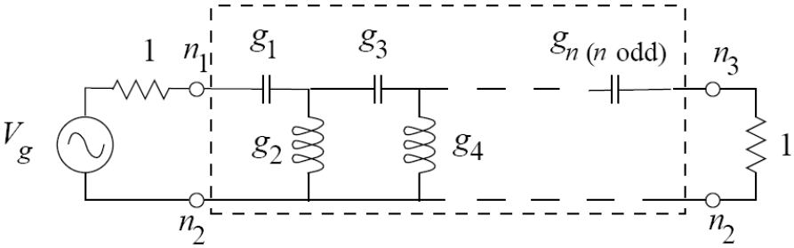
(a)

TYPE II:
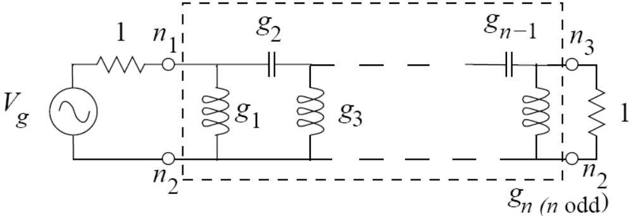
(b)

Figure 1: Highpass filter prototype. The 1 Ohm source and load impedances are scaled by Z₀. The circuit implemented is inside the dashed box.

Form: cheyshevHPF:(instance name) n1 n2 n3 (parameter list)
n1, n2 and n3 are the element terminals. Terminal n2 is the element reference terminal, n1 is the input terminal and n3 is the output terminal.

_______________________________________________________
Parameters:
Parameter | Type | Default Value | Required?
n: Filter Order (must be odd, no limit) | Integer | 3 | No
f0: Corner Frequency | Double | None | Yes
z0: Characteristic Impedance | Double | None | Yes
ripple: Filter ripple (in dB) | Double | 1 | No
Ql: inductor Q | Double | 10000 | No
Qc: capacitor Q | Double | 10000 | No
Type: Filter Type, Type I or Type II (only type II) | Integer | 2 | No
Note only Type = 2 filter is supported currently.

Details:
This is a linear element, comprised of ideal inductors and capacitors. Chebyshev filters of odd order are usually used. If an even order is specified, the element includes a resistor in parallel with the output to control the ripple.

chebyshevHPF:f1 2 0 3 n=21 f0=300e6 z0=50 ripple=1 ql=1000 qc=1000
Here, node 2 is the input, node 0 is the local reference, and node 3 is the output. This is a 21st-order highpass filter with 1 dB of ripple, 50 ohm impedance, and a 300 MHz corner frequency.

Example of Transient Analysis (.TRAN2) Fixed times steps, time-stepping nonlinear analysis.
netlist: chebyshevHPF.net:

* Transient chebyshevfilter test
.options verbose

.tran2 tstop=80ns tstep=0.01ns out_steps=200
vsource:1 1 0 vac=1 f=300e6 phase=90
R:Rin 1 2 r=10
chebyshevHPF:f1 2 0 3 n=7 f0=300e6 z0=10 type=2 ripple=0.1
R:Ro 3 0 r=10
.options gnuplot
.options plotVT1Preamble="set xlabel 'Time (s)'; set ylabel 'Magnitude (V)"
.out plot term 3 vt plotVT1Preamble in "out.tran.value"
.end
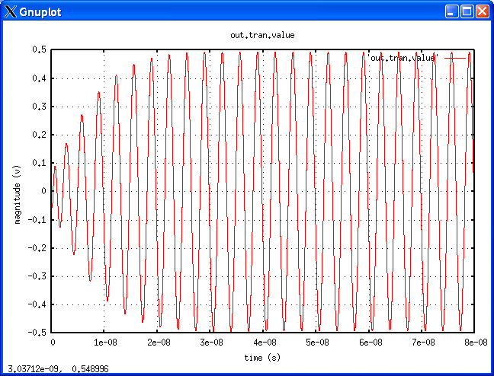
Example of AC analysis
Netlist file: chebyshevHPFAC.net:

* AC Analysis
.ac start = 1e6 stop = 1GHz n_freqs=100

vsource:v2 4 0 vac= 5
resistor:rs2 4 5 r=50
chebyshevHPF:f2 5 0 6 n=21 f0=300e6 z0=50 ripple=1 ql=1000 qc=1000
resistor:rl2 6 0 r=50

.options gnuplot

.options preample1="set logscale x; set term x11 font 'helvetica,13';
set title 'Chebyshev Filter Magnitude Response'; set xlabel 'FREQUENCY (MHz)';
set ylabel 'MAGNITUDE (dB)"
.out plot term 6 vf term 4 vf div mag 2 mult db 1e-6 scalex preample1 in "chebyshevhpf.ac.mag"

.options preample2="set logscale x; set term x11 font 'helvetica,13';
set title 'Chebyshev Filter Phase Response'; set xlabel 'FREQUENCY (MHz)';
set ylabel 'phase (DEGREES)"
.out plot term 6 vf term 4 vf div prinphase 1e-6 scalex rad2deg preample2 in "chebyshevhpf.ac.phase"

.end

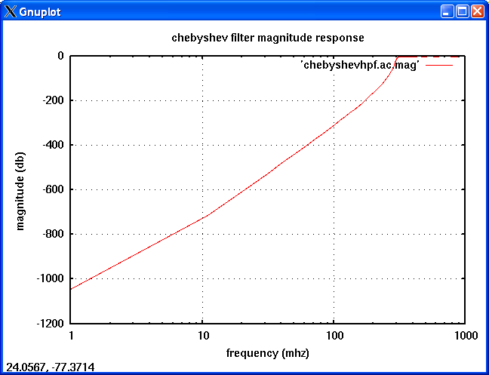

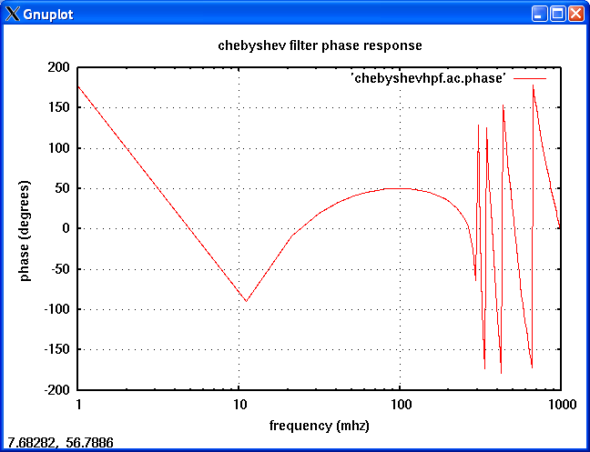

_______________________________________________________
Version:
2008.05.11 (2008 May 11)

_______________________________________________________
Credits:
Name Affiliation Date Links
Michael Bucher NC State University April 2008 
mdbucher@gmail.com www.ncsu.edu
Michael Steer NC State University May 2008
mbs@ncsu.edu www.ncsu.edu

