Circulator cir

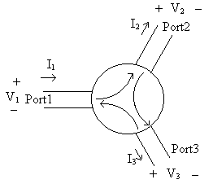

Description:
The three-port circulator passes an input signal to the next port, but not to the third port. A signal will pass from port 1 to port2, but not port 3; from port 2 to port 3, but not port 1; and from port 3 to port 1, but not port 2.

Form:
cir:<instance name> n₁ n₂ n₃ n₄ n₅ n₆ <parameter list>
instance name is the model name
n₁ is the port #1 signal input terminal
n₂ is the port #2 signal input terminal
n₃ is the port #3 signal input terminal
n₄ is the port #1 reference terminal
n₅ is the port #2 reference terminal
n₆ is the port #3 reference terminal

Parameters:
Parameter | Type | Default Value | Required?
r: Resistance looking into port (ohms) | DOUBLE | 0* | no
g: Conductance looking into port (siemens) | DOUBLE | 0* | no

*The default value is zero if the other parameter is listed. If neither parameter is listed, then the default conductance value is 0.02 siemens, which is equivalent to a 50 ohm resistance value.

Examples:
cir:circulator1 2 3 4 0 0 0 r=50
cir:cir1 2 3 4 0 0 0 g=0.02

Model Documentation:
The circulator model is based on the combination of three gyrators. The Y matrices of the gyrators were combined in the proper order to obtain the Y matrix for the circulator. The admittance matrix for ideal gyrator: 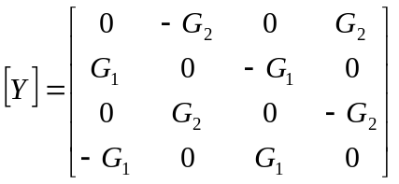, the total admittance matrix for the circulator: 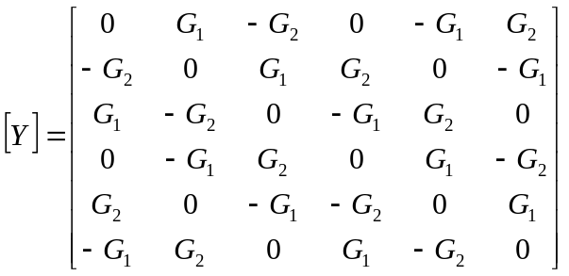. This was used to create the admittance stamp for the circulator model.

The following is an example of the proper way to use this element in a fREEDA netlist:

cir:cir1 2 3 4 0 0 0 r=50

Notice in this example first the declaration of the element used—cir:cir1. cir is the element itself (similar to using R in SPICE) and cir1 is simply the name assigned to the particular circulator. The second thing to notice is that there are 6 terminals listed, corresponding to terminals 1, 2, 3, 4, 5, and 6 of the element. Remember the way the terminals are described in the circulator model:

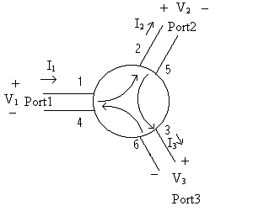

The numbers on the command line representing terminals (in this case, 2 3 4 0 0 0 ) are the numbers of the terminals in the whole circuit created inside the .net file. In this case, nodes 2, 3, and 4 in the circuit are the terminals 1, 2, and 3 of the circulator. Terminals 4, 5, and 6 of the circulator are grounded, as indicated by the fact that they are all terminal 0 in the circuit.

The possible inputs on the command line for the circulator are:
r – resistance looking into all ports
g – conductance looking into all ports

If no parameters are specified, then the conductance looking into all ports defaults to .02 siemens, which equals 50 ohms resistance. Otherwise, the user has the option of specifying either a conductance or a resistance.

References:
Adam, Davis, Dionne, Schloemann, Stitzer. “Ferrite Devices and Materials.” IEEE Transactions on Microwave Theory and Techniques vol. 50 (March 2002):721-736.
Carr, J. Elements of Microwave Electronics Technology. New York: Harcourt Brace Jovanovich, Inc., 1989.
Fay, C. and von Aulock, W. Linear Ferrite Devices For Microwave Applications. New York: Academic Press, Inc., 1968.
Helszajn, J. Waveguide Junction Circulators. New York: John Wiley & Sons, Inc., 1998.
Pozar, D. Microwave Engineering. New York: John Wiley & Sons, Inc., 1998.
Roberts, J. High Frequency Applications of Ferrites. Princeton, NJ: D. Van Nostrand Co., Inc., 1960.

Sample Netlist:
Circulator Test Netlist 1

.tran2 tstart=0.1e-6 tstop=5e-6 tstep=.01e-6

vsource:vin 1 0 vac=2 f=1e6
cir:cir1 2 3 4 0 0 0 r=50
res:rin 1 3 r=50
res:rload1 2 0 r=50
res:rload2 4 0 r=50

.out plot term 4 vt in "v4.out"
.out plot term 3 vt in "v3.out"
.out plot term 2 vt in "v2.out"
.out plot term 1 vt in "v1.out"
.end

Validation:
The circulator model is validated by inputting a signal into each port individually and monitoring the outputted signal on the other two ports. Three similar netlists were used, with the input rotated to each port of the circulator. The results of the three simulations were identical in that the proper signal was present at the other ports. The following three plots were derived from the sample netlist above. The signal was inputted to port #2, so the same signal should appear at port #3, with no signal at port #1.

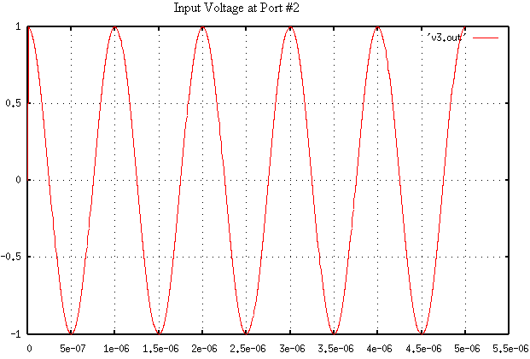
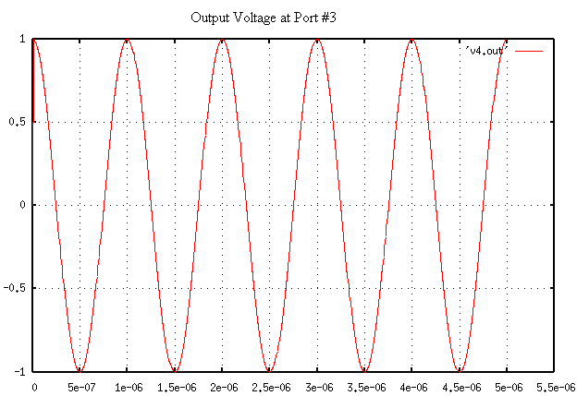
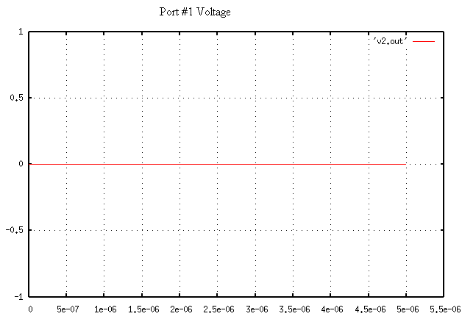

Known Bugs:
Ideal circulator only.

Local reference terminals are implemented within the circulator code, but have not yet been tested. Tying all the reference terminals to terminal 0 (ground) works fine for now.

Notes:
Three gyrators connected together can describe a three-port circulator. A circulator can have more than three ports, but such a circulator will need to be described as a separate element or as combinations of the current implemented element.
The circulator model is ideal. All of the ports have the same input impedance. This impedance is real with no reactive component.

Version: 2003.05.15

Credits:
Names Affiliation Date Links
Isac Lima islima@ncsu.edu NC State University April 2003 www.ncsu.edu
Daryl Lindsey sdlindse@ncsu.edu
Don Widdows dwiddow@ncsu.edu

