CMOS 2 Input NAND Gate cmos2nandx

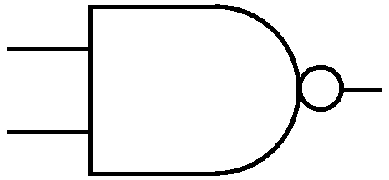
IN1
OUT
IN2

Description:
This is an Extrinsic Super Element which models a 2 Input CMOS NAND gate utilizing the EKV model.

Form: cmos2nandx:<instance name> n1 n2 n3 n4 n5 <parameter list>

n1 is the high voltage source (Vdd) terminal,
n2 is the first input terminal,
n3 is the second input terminal,
n4 is the output terminal,
n5 is the ground or Vss terminal

Parameters:

Parameter | Type | Default Value | Required
ln: Channel Length of NMOS (m) | TR_DOUBLE | 1.0e-6 | No
wn: Channel Width of NMOS (m) | TR_DOUBLE | 1.0e-6 | No
lp: Channel Length of PMOS (m) | TR_DOUBLE | 1.0e-6 | No
wp: Channel Width of PMOS (m) | TR_DOUBLE | 1.0e-6 | No

Example:
cmos2nandx:nand 1 2 3 4 0

Notes:
This implementation of cmos nand gate is based on EKV 2.6 [1] mosfet model.

Known Bugs:
No known bugs.

Implementation Details:
This element is implemented as a fREEDA Extrinsic Super Element based on EKV 2.6 MOSFET model [1]. The element has 12 state variables: 3 corresponding to each transistor. Following is the schematic and truth table of 2-input nand gate:

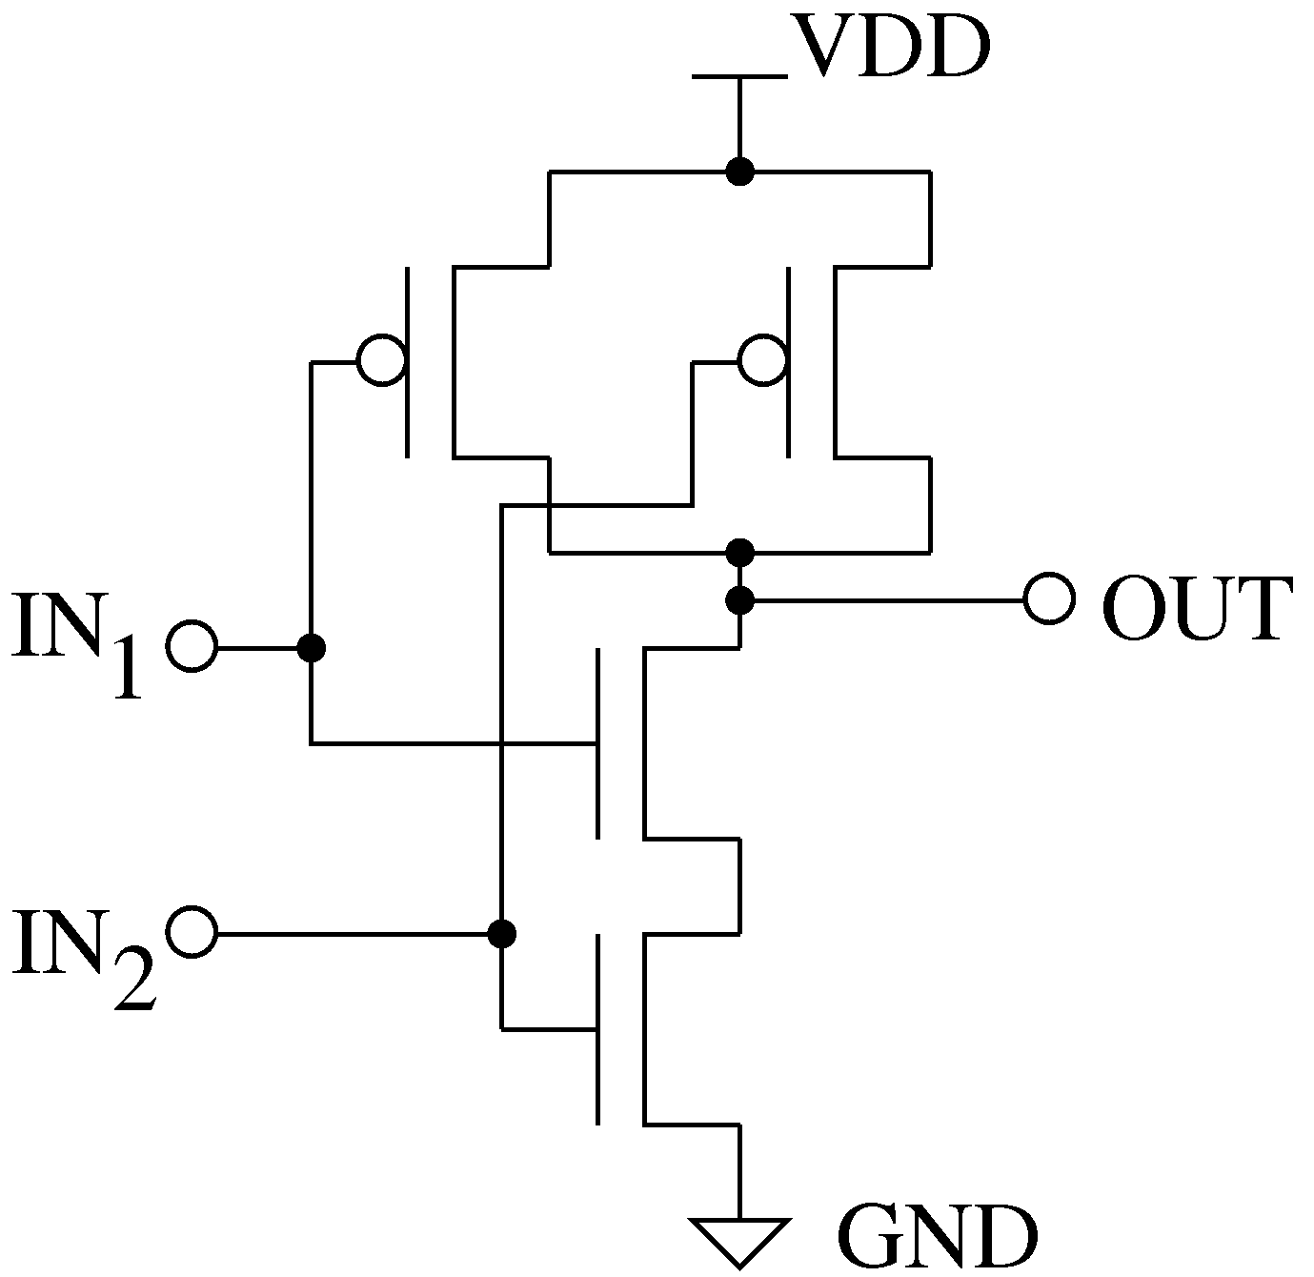

IN1 | IN2 | OUT
0 | 0 | 0
0 | 1 | 0
1 | 0 | 0
1 | 1 | 1

References:
[1] The EKV 2.6 Documentation: http://legwww.epfl.ch/ekv/pdf/ekv_v262.pdf

Sample Netlist:
- DC Analysis
The following netlist plots the output voltage of the CMOS gate for an input voltage range of 0 ~ 5V for V_{in1} and constant V_{in2} = 5V.
* CMOS Nand DC Analysis
***This netlist is for DC Analysis of 2 input Cmos Nand Gate ***
.dc sweep="vsource:Vin1" start=0 stop=5 step=0.01
*** DC Sweep First input
vsource:Vin1 22 0
*** Tie Second input to Vdd
vsource:Vin2 33 0 vdc=5
*** Vdd connection
vsource:Vdd 1 0 vdc=5
***Nand Instantiation
cmos2nandx:nand 1 2 3 4 0
** Source Resistance and Capacitance
r:in2 22 2 r=10
r:in3 33 3 r=10
c:in2 2 0 c=1e-12
c:in3 3 0 c=1e-12
****Output Resistance and Capacitance
r:R 4 0 r=1000000
c:C 4 0 c=1e-12
.options gnuplot
.out plot term 4 vt in "vout.out"
.out plot term 22 vt in "vin1.out"
.out plot term 33 vt in "vin2.out"
.end

Validation:
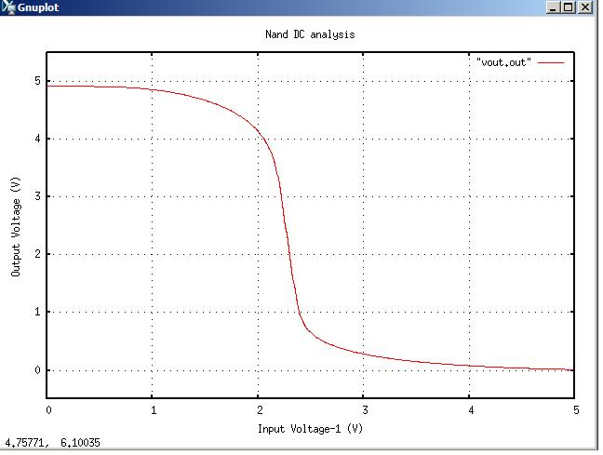
The output graph from the above netlist is shown below:

- Transient Analysis
* CMOS Nand Transient Analysis

*** This netlist is for Transient analysis of Cmos 2 input Nand Gate***
.tran2 tstop=8e-6 tstep=1e-9 out_steps=1
vpulse:Vin2 22 0 v1=0 v2=5 td=1e-6 per=4e-6 pw=2e-6 tr=0.002e-6 tf=0.002e-6
vpulse:Vin3 33 0 v1=0 v2=5 per=4e-6 pw=2e-6 tr=0.002e-6 tf=0.002e-6
**** Vdd connection
vsource:Vdd 1 0 vdc=5
***** Nand instantiation
cmos2nandx:nand 1 2 3 4 0
** Source Resistance and Capacitance
r:in2 22 2 r=10
r:in3 33 3 r=10
c:in2 2 0 c=1e-12
c:in3 3 0 c=1e-12
*** Load Resistance and Capacitance
r:R 4 0 r=1000000
c:C 4 0 c=1e-12
.options gnuplot
.out plot term 4 vt in "vout.out"
.out plot term 22 vt in "vin1.out"
.out plot term 33 vt in "vin2.out"
.end

Validation:
The output graph from the above netlist is shown below:
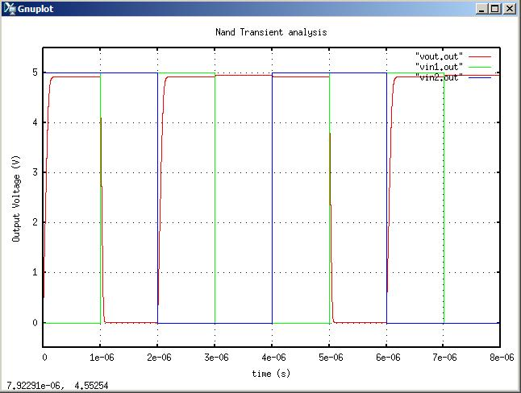

Version: 2009.04.30

Credits:
Name Affiliation Date Links
Shivam Priyadarshi NCSU April, 2009 http://www.ncsu.edu/
shivam.priyadarshi@gmail.com

Nikhil Kriplani NCSU April, 2009 http://www.ncsu.edu/
nkriplani@gmail.com

