CMOS S-R Nand Latch cmoslatchsrnandx
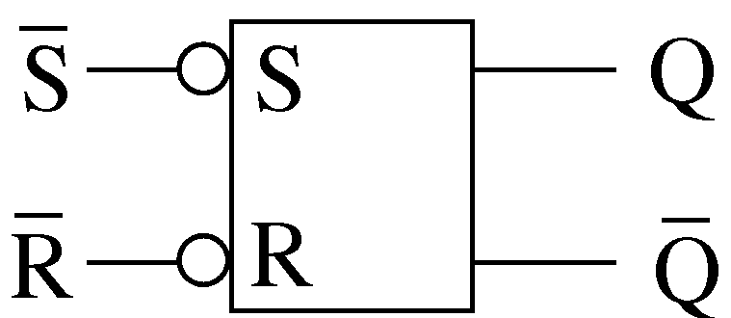

Description:
This is an Extrinsic Super Element which models a nand gate based S-R latch.

Form: cmoslatchsrnandx:<instance name> n1 n2 n3 n4 n5 n6 <parameter list>

n1 is the high voltage source (Vdd) terminal,
n2 is S terminal
n3 is R terminal,
n4 is Q terminal,
n5 is Q terminal,
n6 is the ground or Vss terminal

Parameters:

Parameter | Type | Default Value | Required
ln: Channel Length of NMOS (m) | TR_DOUBLE | 1.0e-6 | No
wn: Channel Width of NMOS (m) | TR_DOUBLE | 1.0e-6 | No
lp: Channel Length of PMOS (m) | TR_DOUBLE | 1.0e-6 | No
wp: Channel Width of PMOS (m) | TR_DOUBLE | 1.0e-6 | No

Example:
cmoslatchsrnandx: srlatch 1 2 3 4 5 0

Notes:
This implementation of SR latch is based on nand gate

Known Bugs:
No known bugs.

Truth Table
The latch is based on following truth table:

S | R | Q | Q | Operation
0 | 1 | 1 | 0 | Set
1 | 0 | 0 | 1 | Reset
1 | 1 | H | H | Hold the previous values
0 | 0 | 1 | 1 | Restricted combination

Schematic
Following is the schematic of latch:
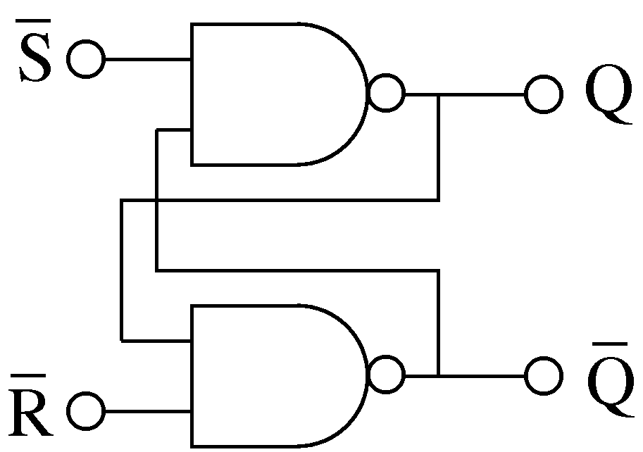

Sample Netlist:
*** Nand based SR Latch
* **This netlist is for Transient Analysis of Nand based SR Latch***
.tran2 tstop=16e-6 tstep=10e-9
vpulse:Vin2 2 0 v1=0 v2=5 td=1e-6 per=4e-6 pw=2e-6 tr=0.005e-6 tf=0.005e-6
vpulse:Vin5 5 0 v1=0 v2=5 per=4e-6 pw=2e-6 tr=0.005e-6 tf=0.005e-6
****** Vdd Connection
vsource:Vdd 1 0 vdc=5
****** Instantiation
cmoslatchsrnandx:latch 1 2 5 4 3 0
*** Load Resistance and Capacitance
r:R1 4 0 r=1000000
r:R2 3 0 r=1000000
.options gnuplot
.out plot term 2 vt in "sb.out"
.out plot term 5 vt in "rb.out"
.out plot term 4 vt in "Q_output.out"
.out plot term 3 vt in "Qbar_output.out"

Validation:
The output graph from the above netlist is shown below:

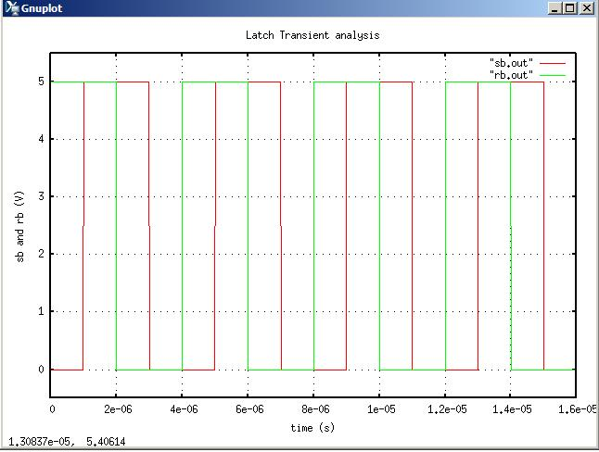

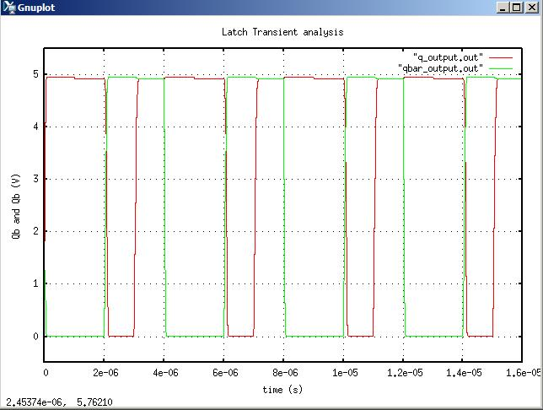

Version: 2009.04.30

Credits:
Name Affiliation Date Links
Shivam Priyadarshi NCSU April, 2009 http://www.ncsu.edu/
shivam.priyadarshi@gmail.com

Nikhil Kriplani NCSU April, 2009 http://www.ncsu.edu/
nkriplani@gmail.com

